***PL/SQL***

***2022503003***

***R.Prabhakara Arjun***



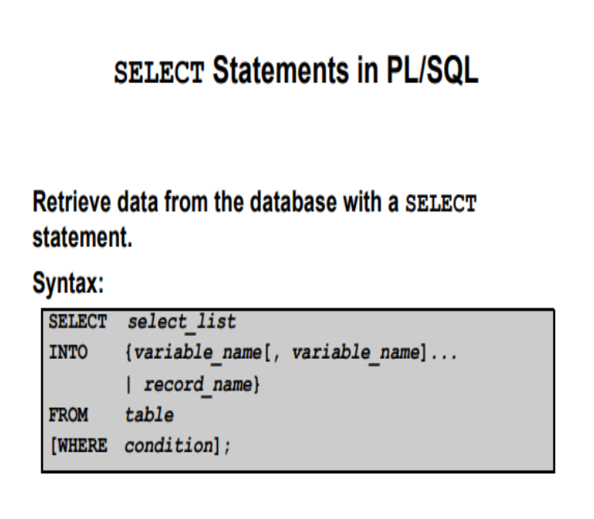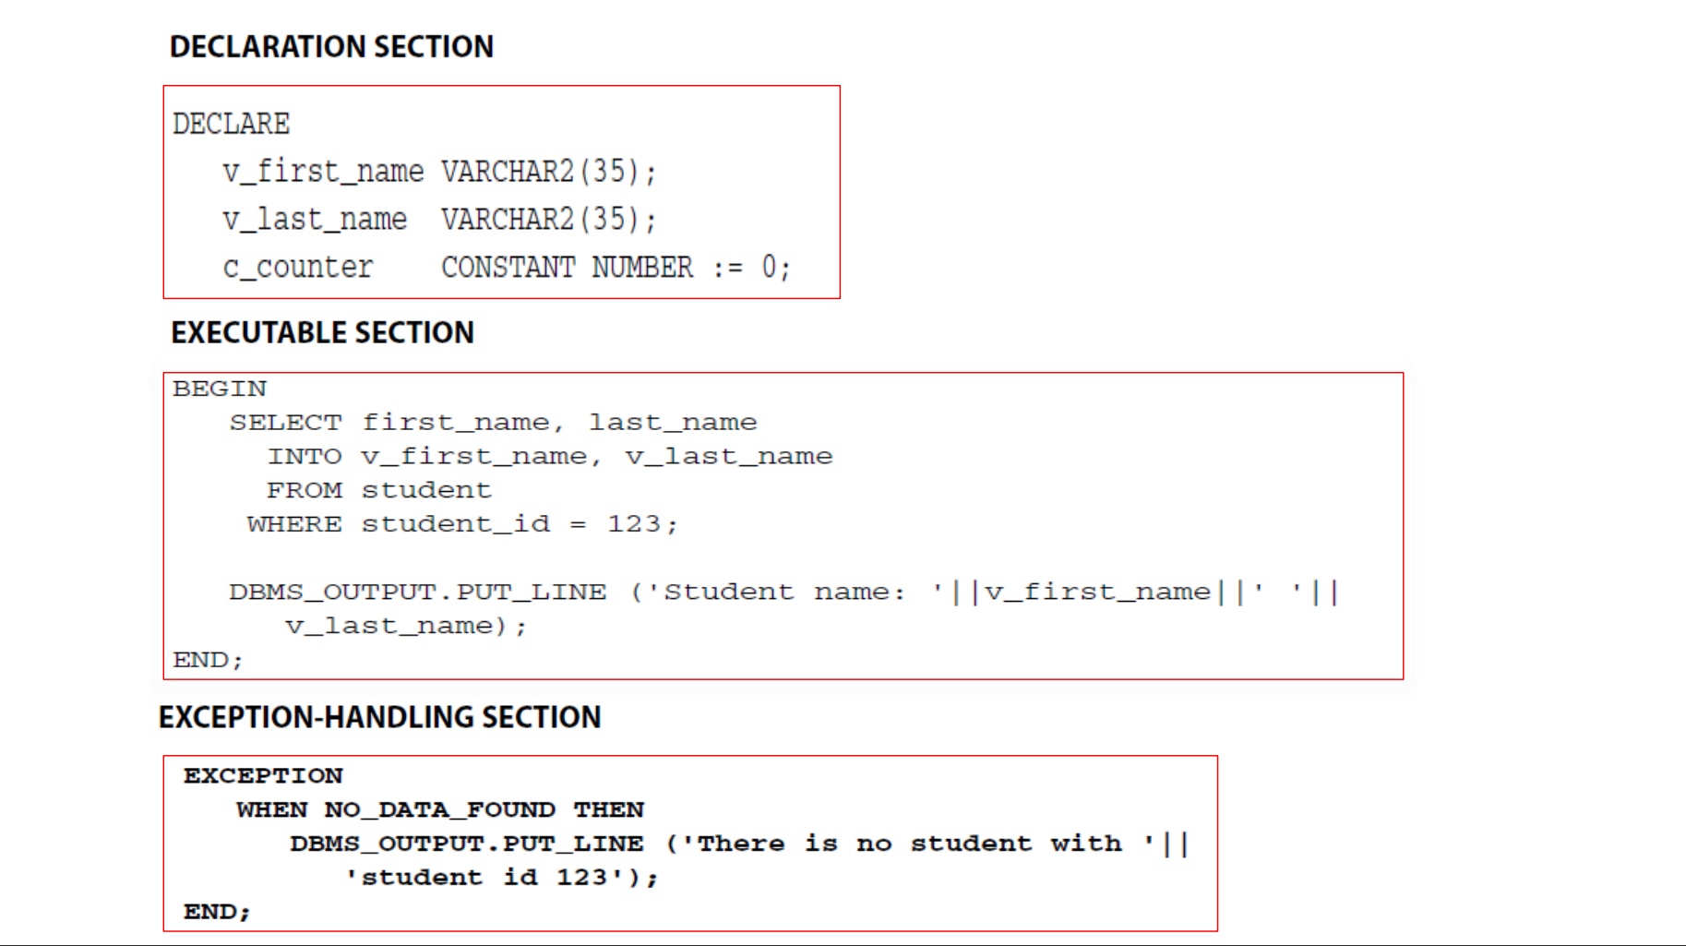

DECLARE

v_fname emp_503003.fname%TYPE;

v_lname emp_503003.lname%TYPE;

BEGIN

SELECT fname,lname INTO v_fname,v_lname

FROM emp_503003

WHERE fname='John';

DBMS_OUTPUT.PUT_LINE('the full name whose name start with john is '||v_fname||' '||v_lname);

EXCEPTION

WHEN NO_DATA_FOUND THEN

DBMS_OUTPUT.PUT_LINE('No data was found!!');

WHEN OTHERS THEN

DBMS_OUTPUT.PUT_LINE('An unexpected error occurred: ' );

END;

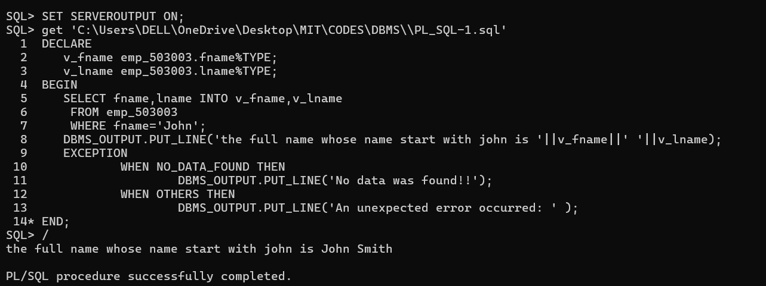

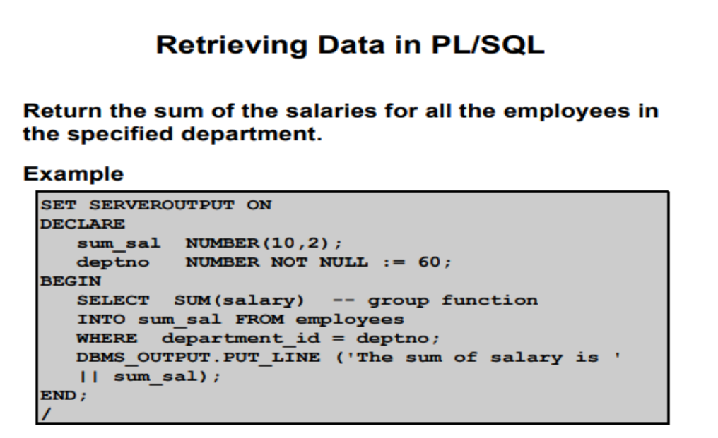

DECLARE

sum_sal emp_503003.salary%TYPE;

BEGIN

SELECT sum(salary)

INTO sum_sal

FROM emp_503003 WHERE dno=5;

DBMS_OUTPUT.PUT_LINE('the sum of salary who are in department 5 is '||sum_sal);

EXCEPTION

WHEN NO_DATA_FOUND THEN

DBMS_OUTPUT.PUT_LINE('No data found!');

END;

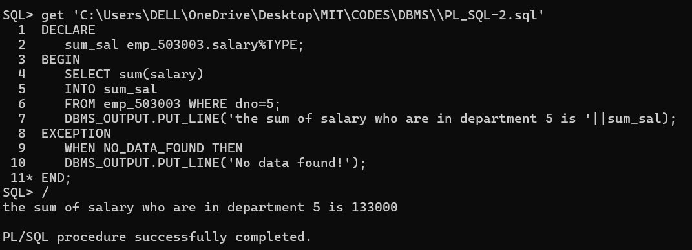

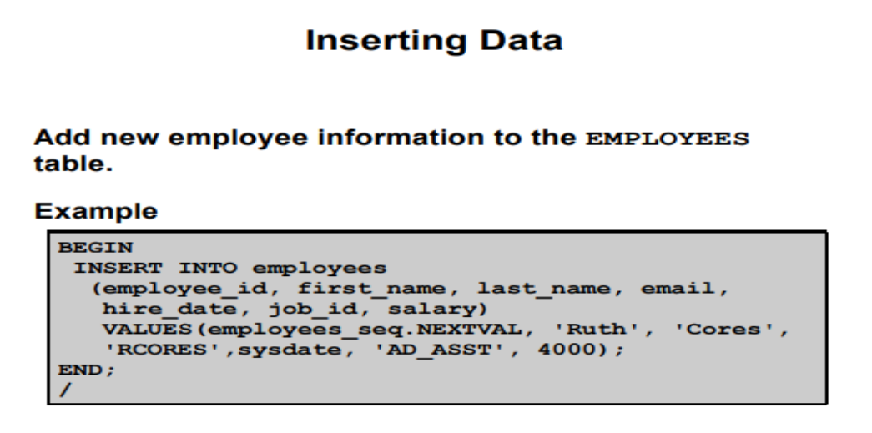

BEGIN

INSERT INTO emp_503003 values('Abirama', 'V', 'Varshin1', 967706686, to_date('2004-05-12', 'yyyy-mm-dd'), '731 Fondren, Houston, TX', 'F', 30000, 333445555, 5);

END;

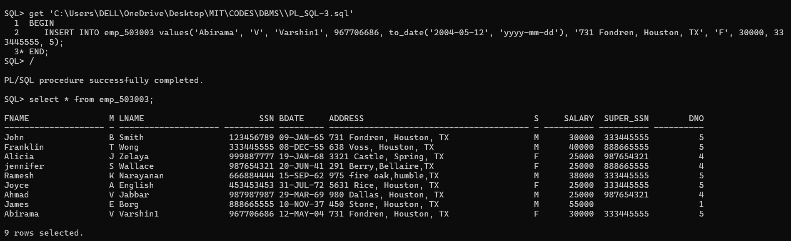

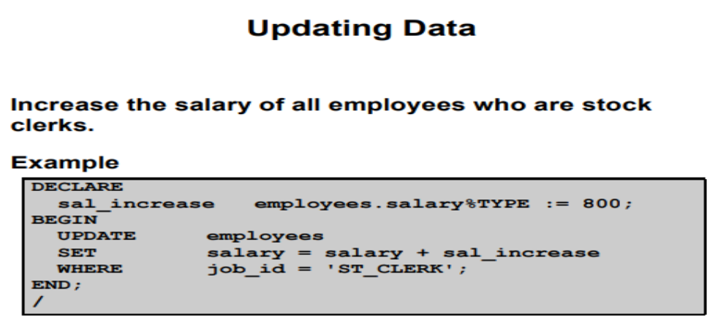

DECLARE

bonus emp_503003.salary%TYPE:=1500;

BEGIN

UPDATE emp_503003

SET salary=salary+bonus WHERE salary>26000;

END;

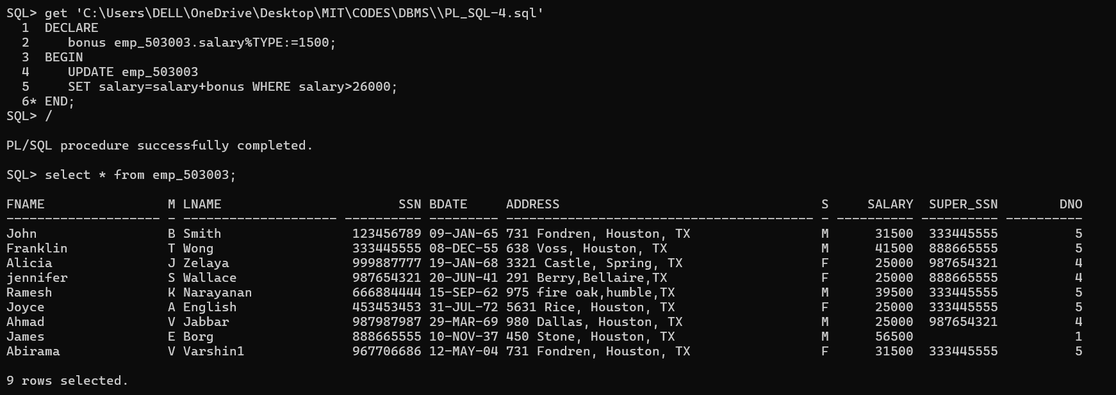

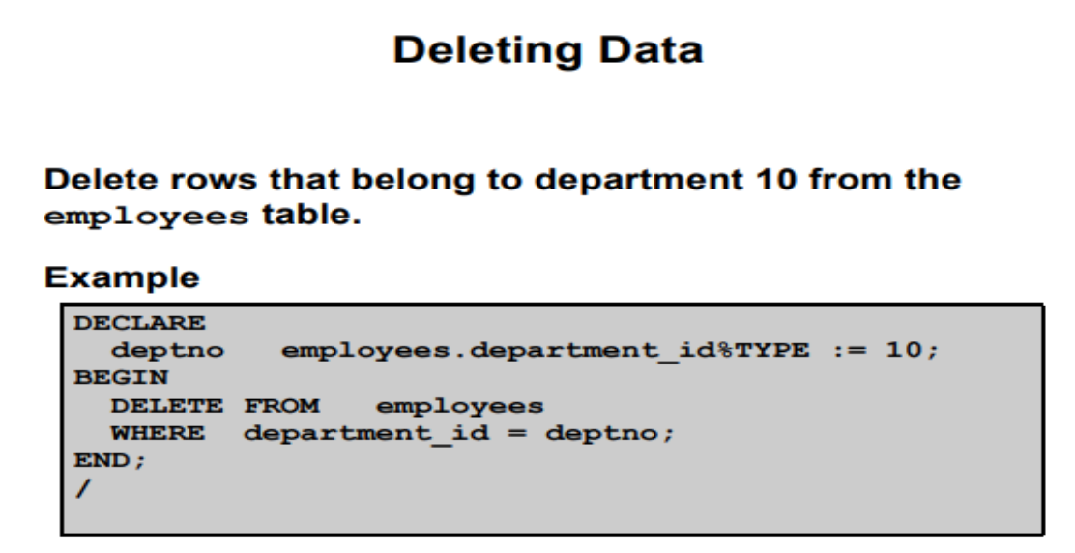

BEGIN

DELETE FROM emp_503003 WHERE fname='Abirama';

END;

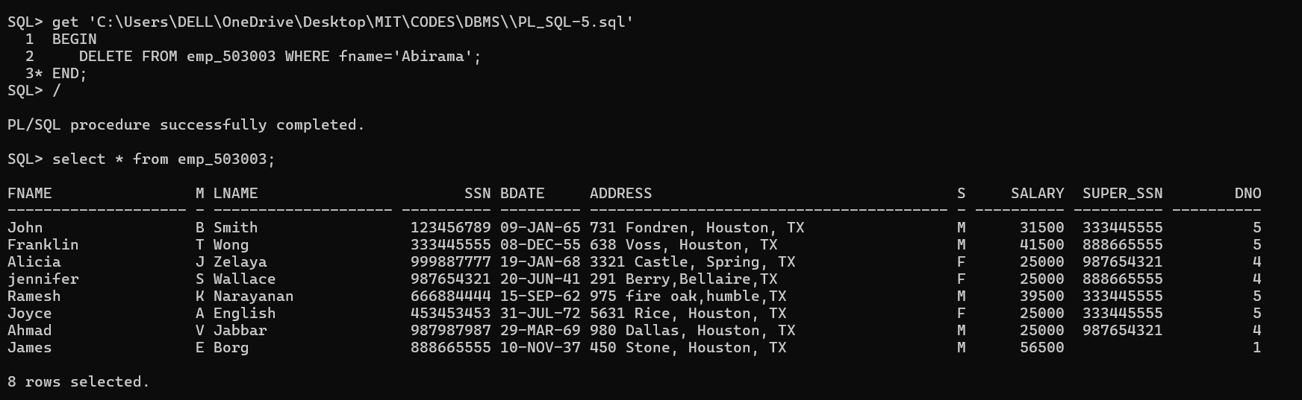

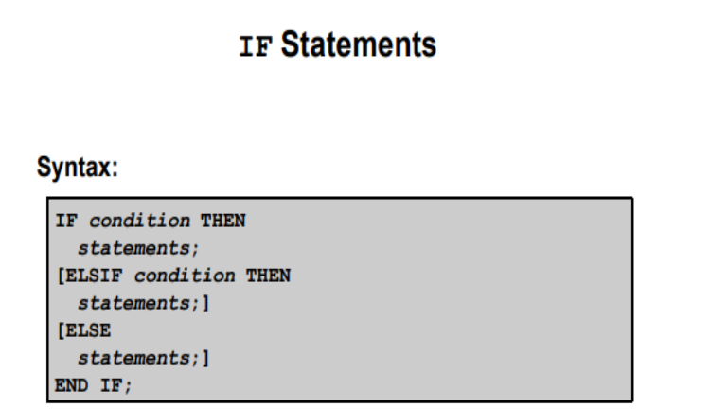

DECLARE

age number:=&your_age;

BEGIN

IF age>18 AND age<100 THEN

DBMS_OUTPUT.PUT_LINE('U are eligible to Vote');

ELSIF age>18 AND age>100 THEN

DBMS_OUTPUT.PUT_LINE('Nah u r expired!!');

ELSE

DBMS_OUTPUT.PUT_LINE('Grow up!!');

END IF;

END;

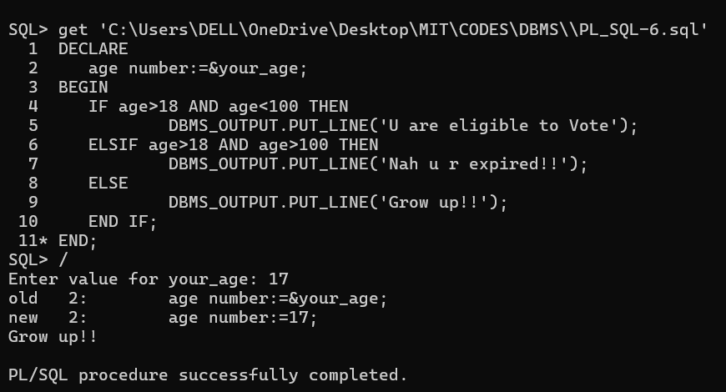

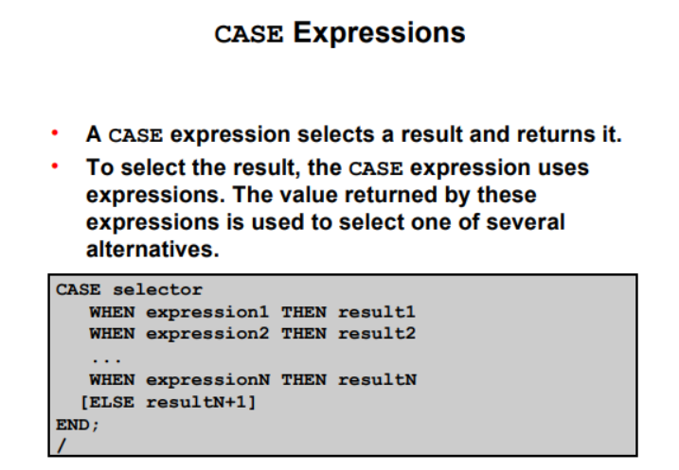

DECLARE

grade varchar2(2):='&enter_a_letter'; – u can use UPPER(‘&enter a letter)’

BEGIN

CASE

WHEN grade IN ('A','E','I','O','U','a','e','i','o','u')THEN

DBMS_OUTPUT.PUT_LINE(grade||' is a vowel!!!');

ELSE

DBMS_OUTPUT.PUT_LINE(grade||' is a NOT vowel!!!');

END CASE;

END;

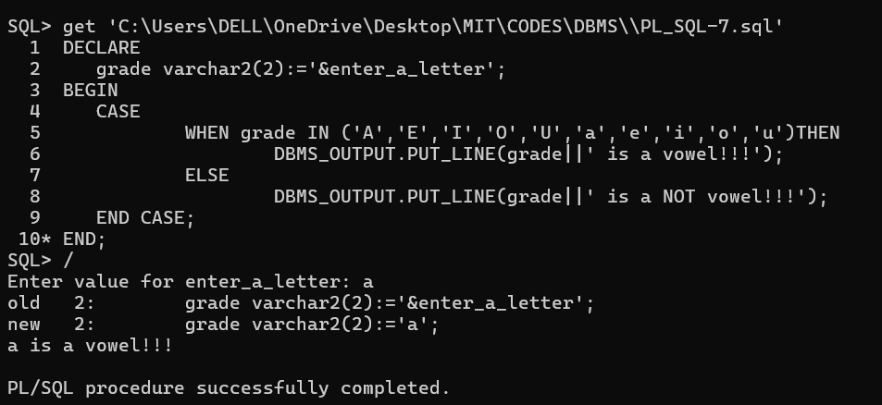

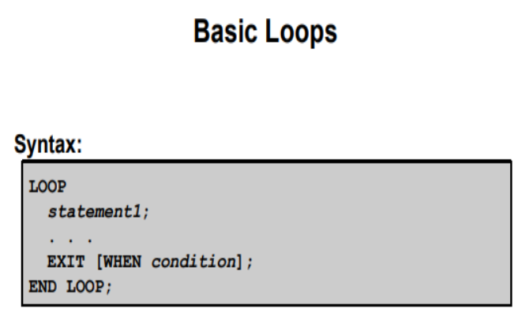

DECLARE

n number:=&enter_a_number;

counter number:=0;

BEGIN

LOOP

DBMS_OUTPUT.PUT_LINE(counter);

counter:=counter+1;

EXIT WHEN counter=n;

END LOOP;

END;

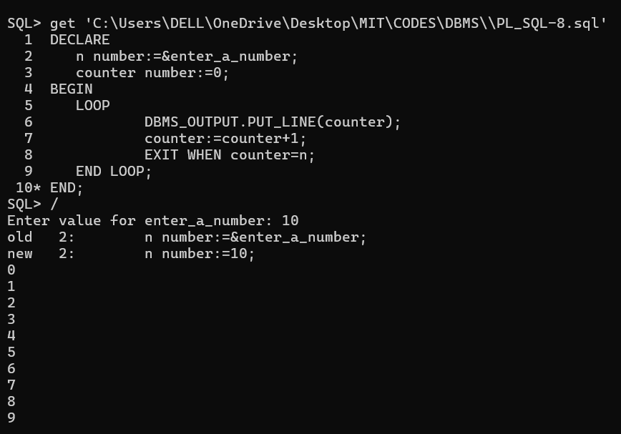

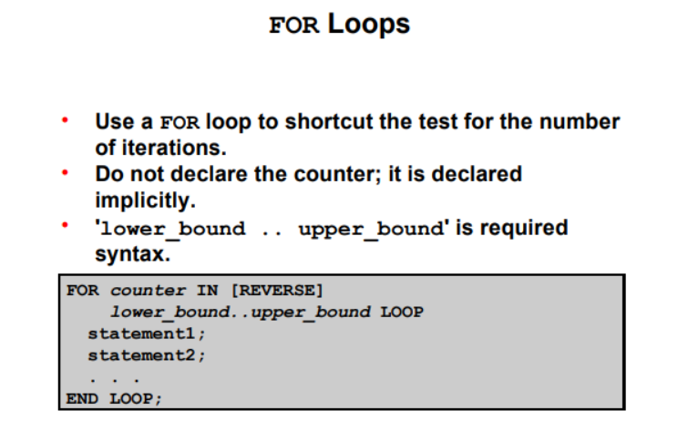

DECLARE

row number:=10;

BEGIN

FOR i IN 1..row LOOP

FOR j IN 1..i LOOP

DBMS_OUTPUT.PUT('*');

END LOOP;

DBMS_OUTPUT.NEW_LINE();

END LOOP;

END;

