**2022503003**

**week-12**

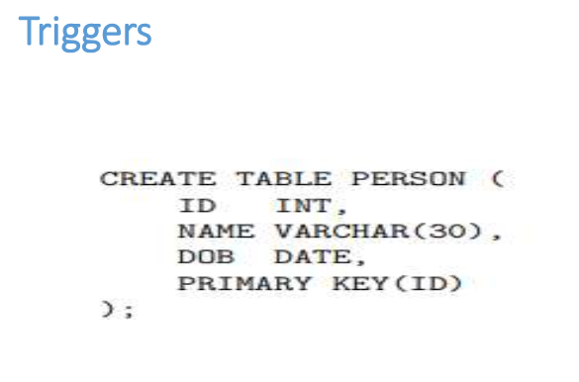

CREATE TABLE person_3003(

id number(10),

name varchar(20),

dob date,

constraint id primary key(id)

);

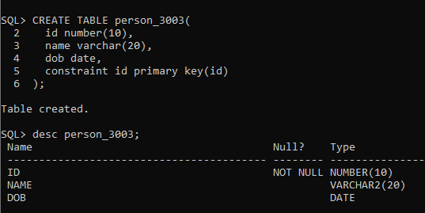

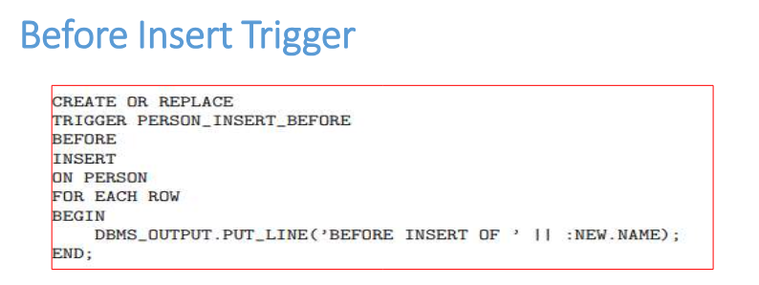

CREATE OR REPLACE TRIGGER BEFORE_INSERT_PERSON

BEFORE INSERT ON person_3003

for each row

begin

dbms_output.put_line('this trigger got triggered befor the insertion'||:new.name);

end;

**THEN**

/

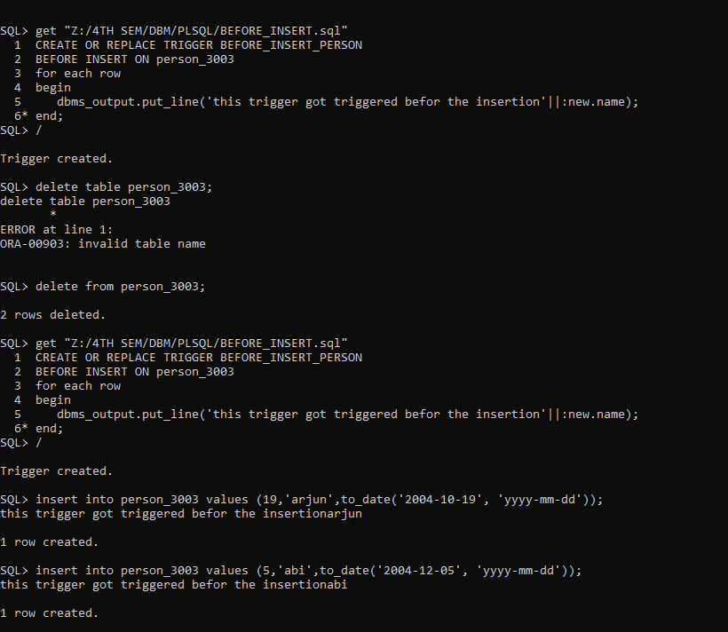

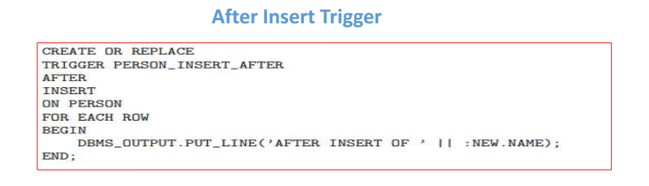

CREATE OR REPLACE TRIGGER AFTER_INSERT_PERSON

after INSERT ON person_3003

for each row

begin

dbms_output.put_line('this trigger got triggered after the insertion:'||:new.name);

end;

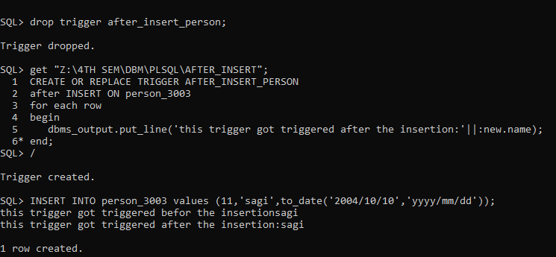

INSERT INTO person_3003 values (11,'sagi',to_date('2004/10/10','yyyy/mm/dd'));

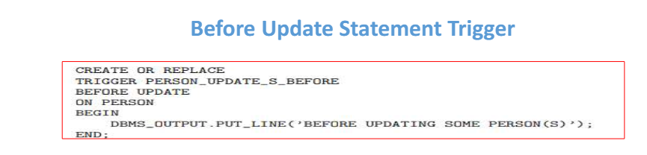

CREATE OR REPLACE TRIGGER BEFORE_UPDATE

BEFORE update on person_3003

for each row

begin

dbms_output.put_line('before updation:'||chr(30)||'old value is:'||:old.name||chr(30)||'new value is:'||:new.name);

end;

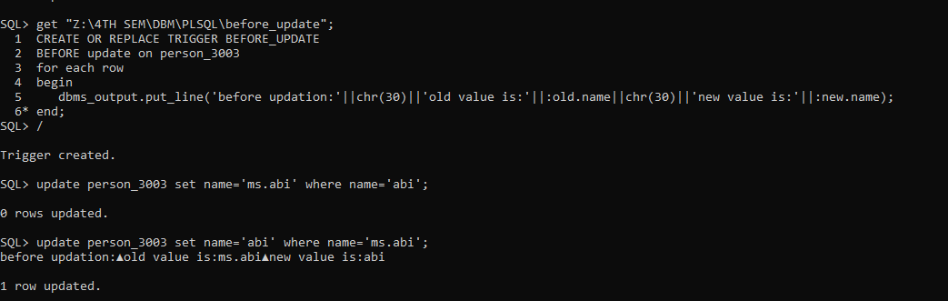

update person_3003 set name='abi' where name='ms.abi';

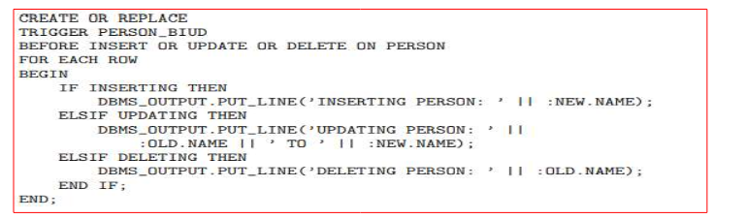

CREATE OR REPLACE TRIGGER INSERT_UPDATE_DEL

BEFORE INSERT OR UPDATE OR DELETE on PERSON_3003

FOR EACH ROW

BEGIN

IF INSERTING THEN

dbms_output.put_line('this trigger got triggered before the insertion:'||:new.name);

ELSIF UPDATING THEN

dbms_output.put_line('before updation:'||chr(10)||'old value is:'||:old.name||chr(10)||'new value is:'||:new.name);

ELSIF DELETING THEN

dbms_output.put_line('before deletion:'||chr(10)||'old value is:'||:old.name||chr(10)||'new value is:'||:new.name);

END IF;

END;

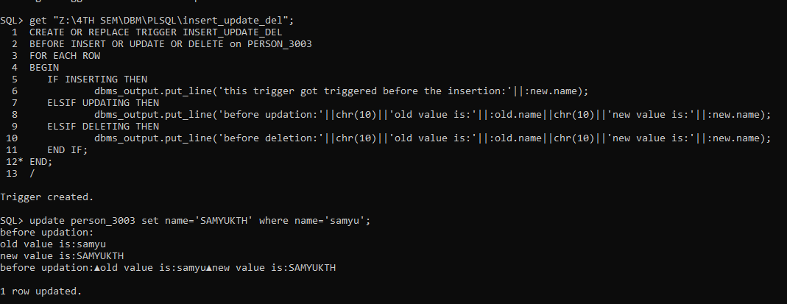

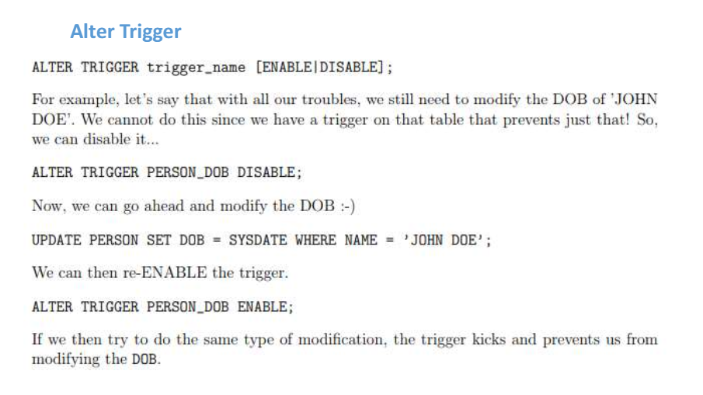

alter trigger before_update disable;

alter trigger before_update enable;

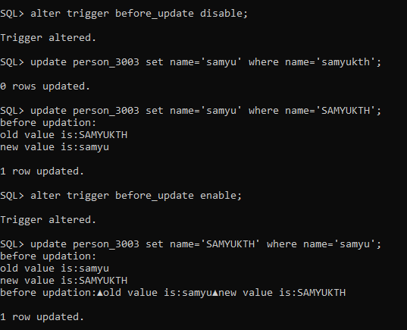

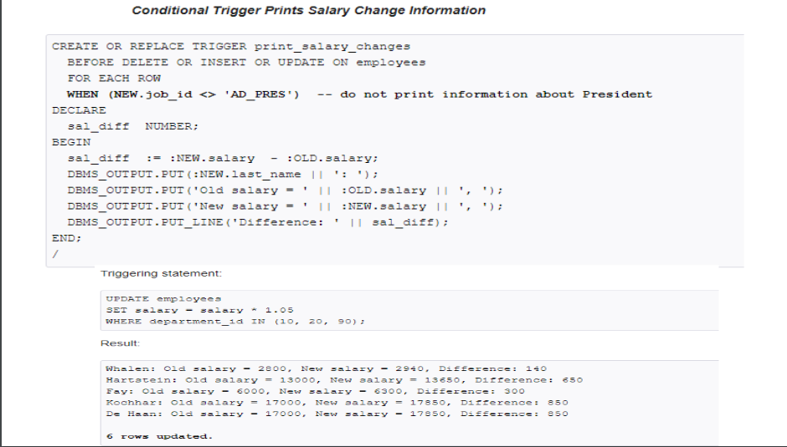

‘ EMP_503003’

select * from emp_503003;

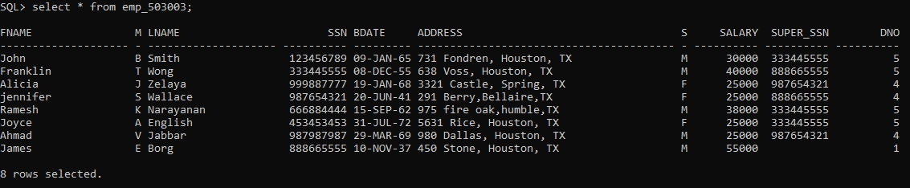

create or replace trigger salary

after insert or update or delete on emp_503003

for each row

when (old.salary>26000)

declare

diff number;

begin

diff:=:new.salary-:old.salary;

dbms_output.put_line('this trigger got triggered before the insertion:'||diff);

END;

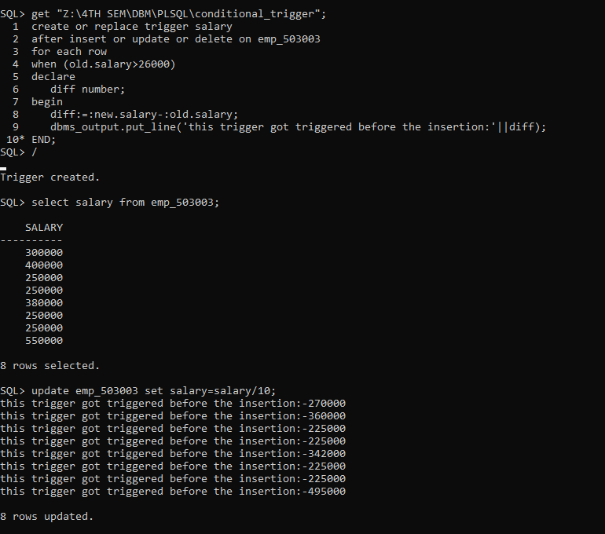

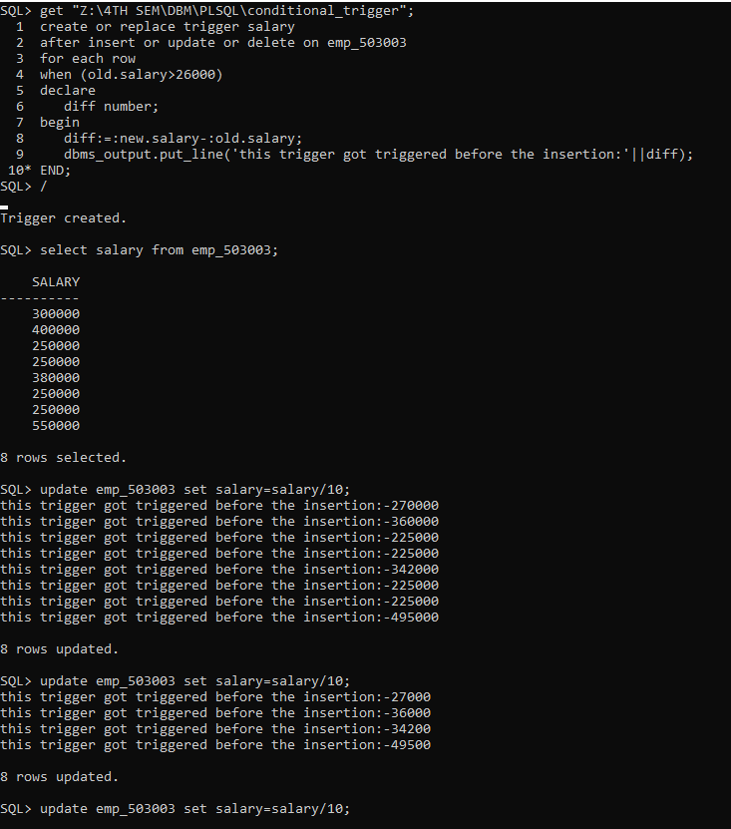

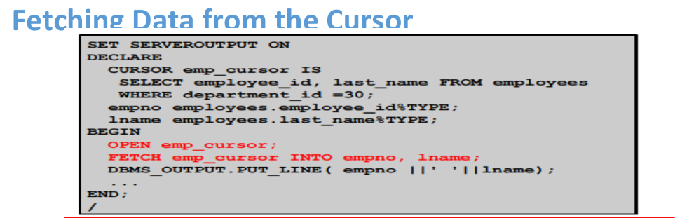

DECLARE

CURSOR emp_cursor

IS SELECT ssn,fname,lname FROM emp_503003

WHERE dno=5;

emp_ssn emp_503003.ssn%TYPE;

emp_fname emp_503003.fname%type;

emp_lname emp_503003.lname%type;

BEGIN

OPEN emp_cursor;

LOOP

FETCH emp_cursor INTO emp_ssn,emp_fname,emp_lname;

EXIT WHEN emp_cursor%NOTFOUND;

DBMS_OUTPUT.PUT_LINE('The ssn of ' ||emp_fname||' '||emp_lname||' is '||emp_ssn);

END LOOP;

CLOSE emp_cursor;

END;

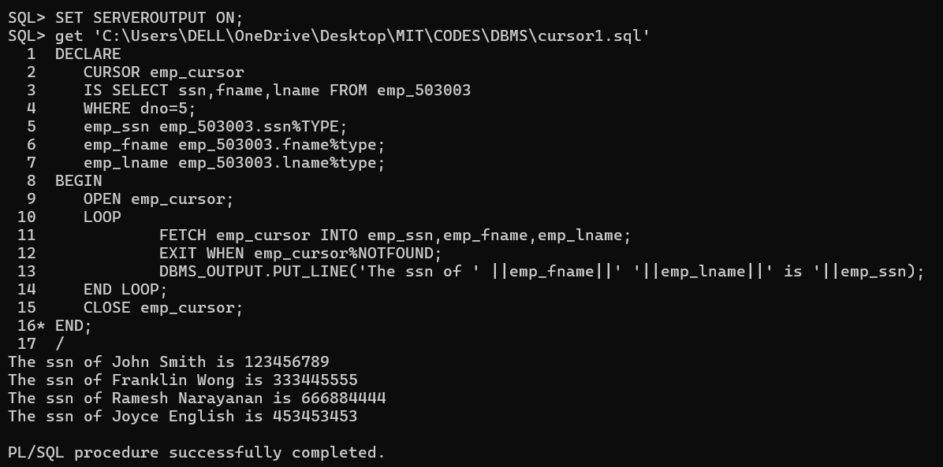

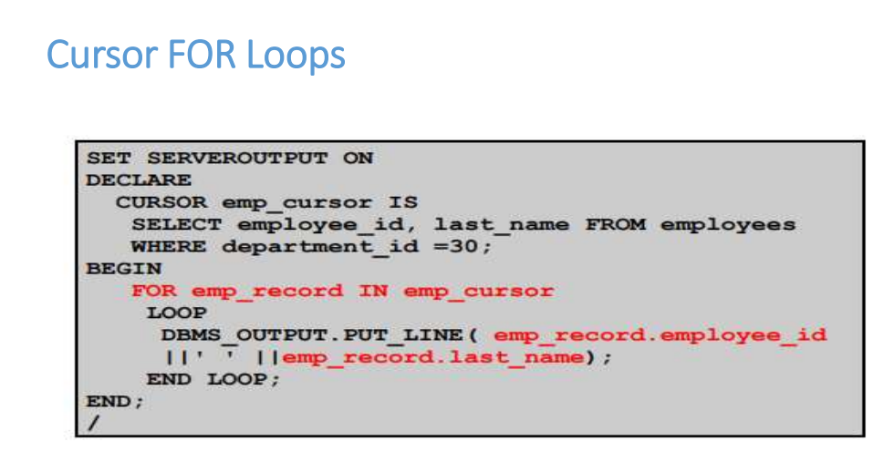

DECLARE

CURSOR emp_cursor_1 IS SELECT

DNO,LNAME,FNAME,SSN FROM emp_503003

WHERE dno=4;

BEGIN

FOR emp_record IN emp_cursor_1

LOOP

DBMS_OUTPUT.PUT_LINE('The ssn of ' ||emp_record.fname||' '||emp_record.lname||' is '||emp_record.ssn||' whose dno is'||emp_record.dno);

END LOOP;

END;

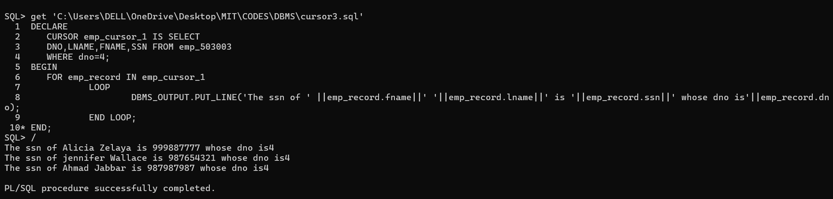

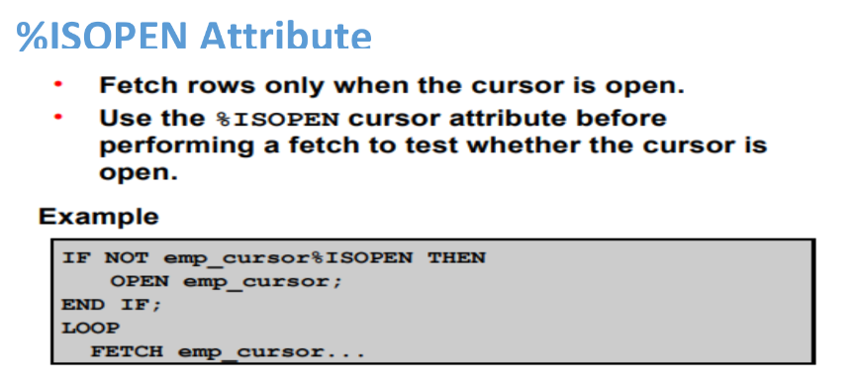

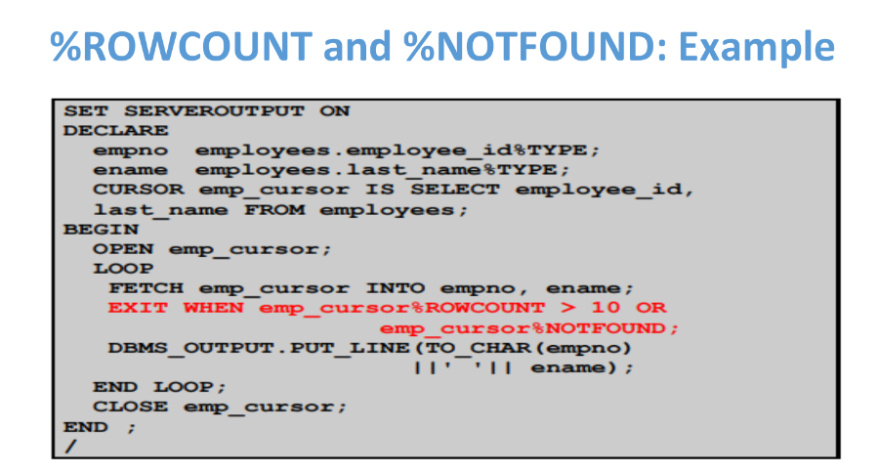

DECLARE

CURSOR emp_cursor

IS SELECT ssn,fname,lname FROM emp_503003

WHERE dno=5;

emp_ssn emp_503003.ssn%TYPE;

emp_fname emp_503003.fname%type;

emp_lname emp_503003.lname%type;

BEGIN

IF NOT emp_cursor%ISOPEN THEN

OPEN emp_cursor;

END IF;

LOOP

FETCH emp_cursor INTO emp_ssn,emp_fname,emp_lname;

EXIT WHEN emp_cursor%NOTFOUND or emp_cursor%ROWCOUNT>3;

DBMS_OUTPUT.PUT_LINE('The ssn of ' ||emp_fname||' '||emp_lname||' is '||emp_ssn);

END LOOP;

CLOSE emp_cursor;

END;

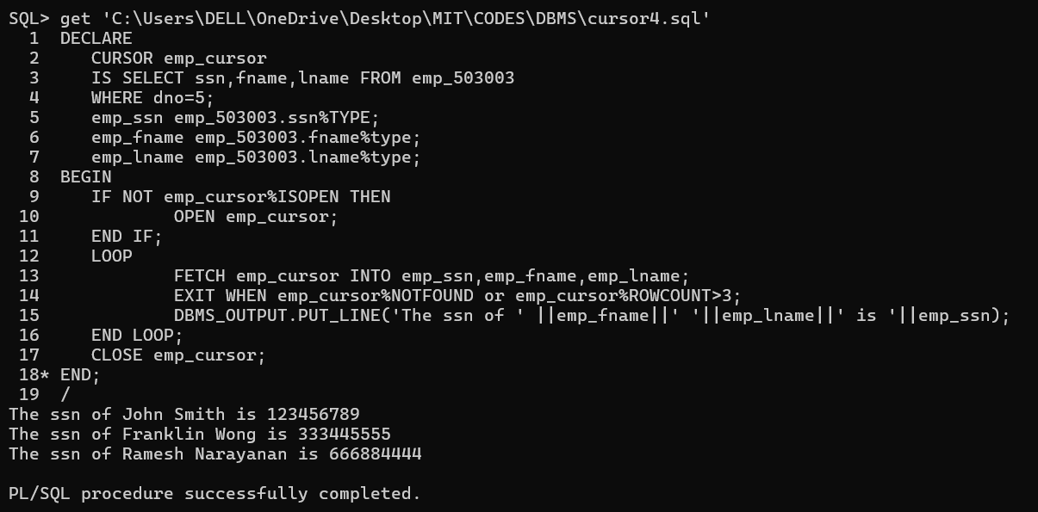

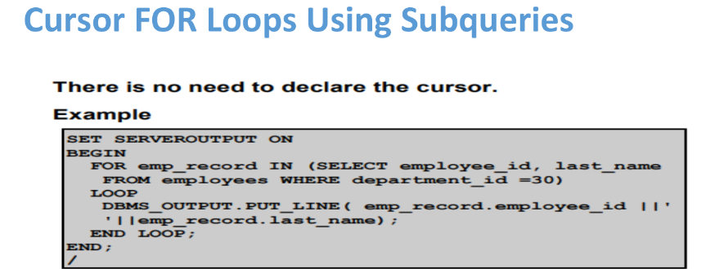

DECLARE

CURSOR emp_cursor_1 IS SELECT

DNO,LNAME,FNAME,SSN FROM emp_503003

WHERE dno=4;

BEGIN

FOR emp_record IN (SELECT

DNO,LNAME,FNAME,SSN FROM emp_503003

WHERE dno=4)

LOOP

DBMS_OUTPUT.PUT_LINE('The ssn of ' ||emp_record.fname||' '||emp_record.lname||' is '||emp_record.ssn||' whose dno is'||emp_record.dno);

END LOOP;

END;

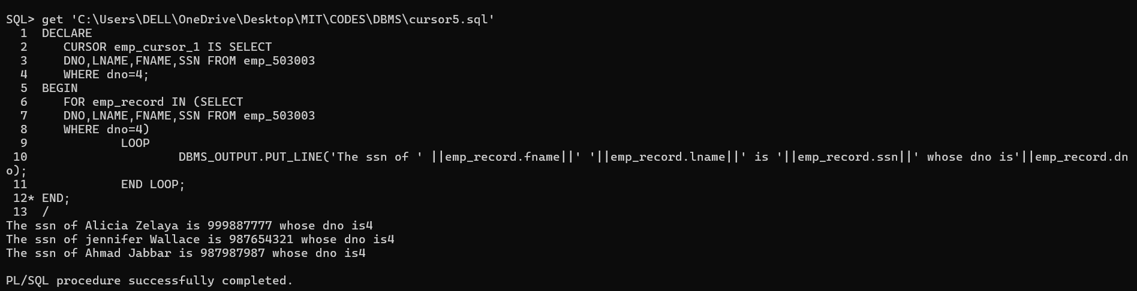

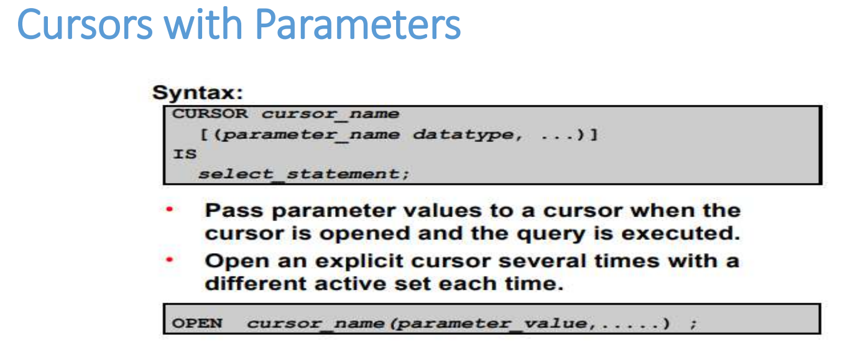

DECLARE

CURSOR emp_cursor (dept_id NUMBER) IS

SELECT ssn, fname, lname

FROM emp_503003

WHERE dno = dept_id;

emp_ssn emp_503003.ssn%TYPE;

emp_fname emp_503003.fname%TYPE;

emp_lname emp_503003.lname%TYPE;

emp_dept_id NUMBER;

BEGIN

emp_dept_id:= &emp_dept_id;

OPEN emp_cursor(emp_dept_id);

LOOP

FETCH emp_cursor INTO emp_ssn, emp_fname, emp_lname;

EXIT WHEN emp_cursor%NOTFOUND;

DBMS_OUTPUT.PUT_LINE('The SSN of ' || emp_fname || ' ' || emp_lname || ' is ' || emp_ssn);

END LOOP;

CLOSE emp_cursor;

END;

