SUB QUERIES

LAB-13!

2022503003



select * from emp_503003 where dno in (select dnumber from dept_locations_3003 where dlocation='New york');





select ssn from emp_503003 where dno in (select dnumber from dept_503003 where mgr_ssn in (select ssn from emp_503003 where fname='John' and lname='Smith'));





select fname||' '||lname as "full name" from emp_503003 where salary>(select avg(salary) from emp_503003 where dno in (select unique dnumber from dept_503003));

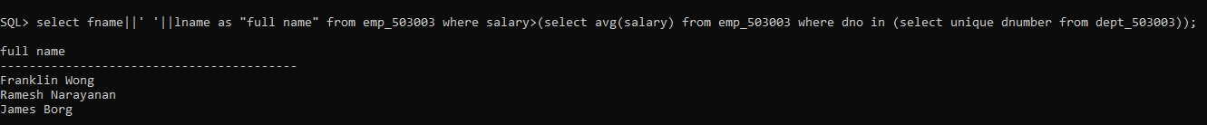

CREATE TABLE PROJECT:

CREATE TABLE project_503003

( Pname VARCHAR(15) NOT NULL,

Pnumber INT NOT NULL,

Plocation VARCHAR(15),

Dnum INT NOT NULL,

PRIMARY KEY (Pnumber),

UNIQUE (Pname),

FOREIGN KEY (Dnum) REFERENCES dept_503003(dnumber) );

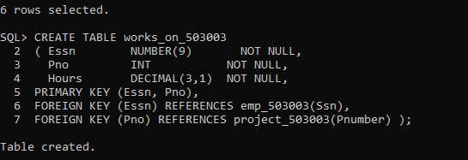

INSERT INTO project_503003

VALUES ('ProductX',1,'Bellaire',5);

INSERT INTO project_503003

VALUES ('ProductY',2,'Sugarland',5);

INSERT INTO project_503003

VALUES ('ProductZ',3,'Houston',5);

INSERT INTO project_503003

VALUES ('Computerization',10,'Stafford',4);

INSERT INTO project_503003

VALUES ('Reorganization',20,'Houston',1);

INSERT INTO project_503003

VALUES ('Newbenefits',30,'Stafford',4); 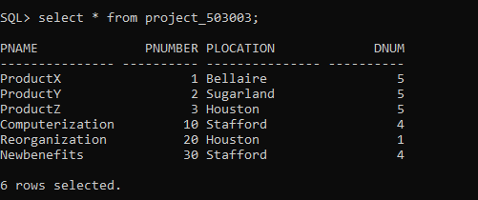

**CREATE TABLE WORKS ON:**

CREATE TABLE works_on_503003

( Essn NUMBER(9) NOT NULL,

Pno INT NOT NULL,

Hours DECIMAL(3,1) NOT NULL,

PRIMARY KEY (Essn, Pno),

FOREIGN KEY (Essn) REFERENCES emp_503003(Ssn),

FOREIGN KEY (Pno) REFERENCES project_503003(Pnumber) );

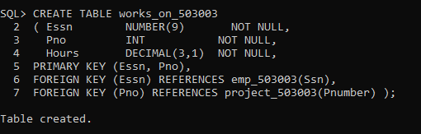

INSERT INTO works_on_503003 VALUES (123456789,1,32.5);

INSERT INTO works_on_503003 VALUES (123456789,2,7.5);

INSERT INTO works_on_503003 VALUES (666884444,3,40.0);

INSERT INTO works_on_503003 VALUES (453453453,1,20.0);

INSERT INTO works_on_503003 VALUES (453453453,2,20.0);

INSERT INTO works_on_503003 VALUES (333445555,2,10.0);

INSERT INTO works_on_503003 VALUES (333445555,3,10.0);

INSERT INTO works_on_503003 VALUES (333445555,10,10.0);

INSERT INTO works_on_503003 VALUES (333445555,20,10.0);

INSERT INTO works_on_503003 VALUES (999887777,30,30.0);

INSERT INTO works_on_503003 VALUES (999887777,10,10.0);

INSERT INTO works_on_503003 VALUES (987987987,10,35.0);

INSERT INTO works_on_503003 VALUES (987987987,30,5.0);

INSERT INTO works_on_503003 VALUES (987654321,30,20.0);

INSERT INTO works_on_503003 VALUES (987654321,20,15.0);

INSERT INTO works_on_503003 VALUES (888665555,20,16.0);

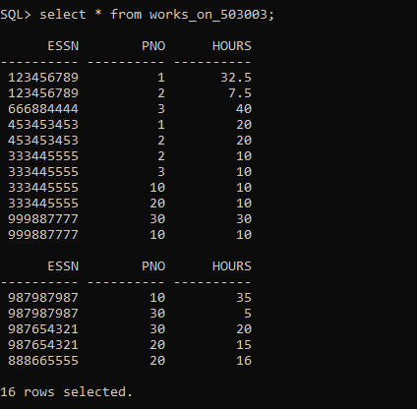



select essn from works_on_503003 where essn in (select ssn from emp_503003 where dno=5);

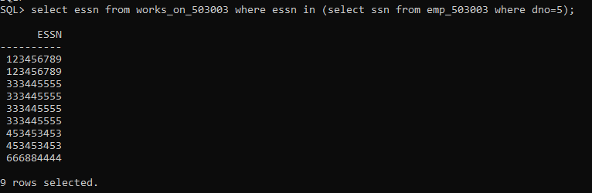



select fname||' '||lname as "full name" from emp_503003 e where ssn in(select essn from works_on_503003 group by essn having count(pno)>1);

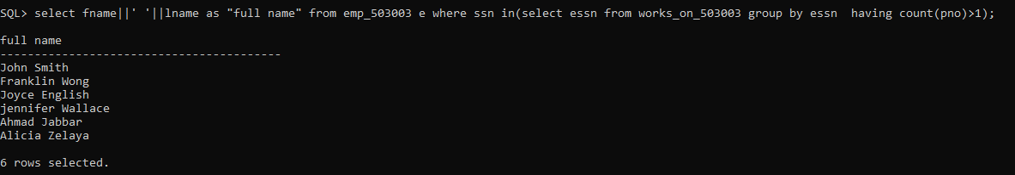



Select ssn from emp_503003 e where ssn in(select essn from works_on_503003 group by essn having count(pno)>1);





select ssn from emp_503003 where super_ssn in (select super_ssn from emp_503003 where ssn=987654321);

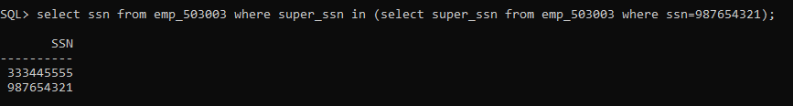



select fname||' '||lname as "full name" from emp_503003 e where ssn in(select essn from works_on_503003 where pno (select pnumber from project_503003 where pname='ProductX'));





Select ssn from emp_503003 e where ssn in(select essn from works_on_503003 group by essn having count(pno)>1);





select fname||' '||lname as "full name" from emp_503003 e where salary=(select salary from emp_503003 d where fname='John' and lname='smith');





select fname||' '||lname as "full name" from emp_503003 e where salary>(select avg(salary) from emp_503003);

