**SQL Week 2 Assignment**

**Topic: ER Diagram**

***Instructions:***

***1. Draw an ER diagram using any free drawing software/tool.***

***2. To verify that the work was completed by you, a textbox or comment***

***with your name and register number should be drawn in the ER***

***diagram.***

***3. A record with your name and register number details must be***

***inserted in any two entity of each scenario in order to confirm that***

***the task was accomplished by you.***

**Q.No 1** Draw the ER diagram for the given scenario.

The company is organized into departments. Each department

has a name, an unique number, and a particular employee who

manages the department. We keep track of the start date when

the employee began managing the dept. A dept may have

several locations. A dept controls a number of projects, each of

which has a name, unique number, and single location. We

store each employee’s name, SSN, address, salary, sex, and

DOB. An employee is assigned to one dept but may work on

several projects, which are not necessary controlled by the

same dept. We keep track of the number of hours per week

that an employee works for each project. We also keep track of

the direct supervisor of each employee. We want to keep track

of the dependents of each employee for insurance purpose. We

keep each dependent’s first name sex, DOB, and relationship to

the employee.

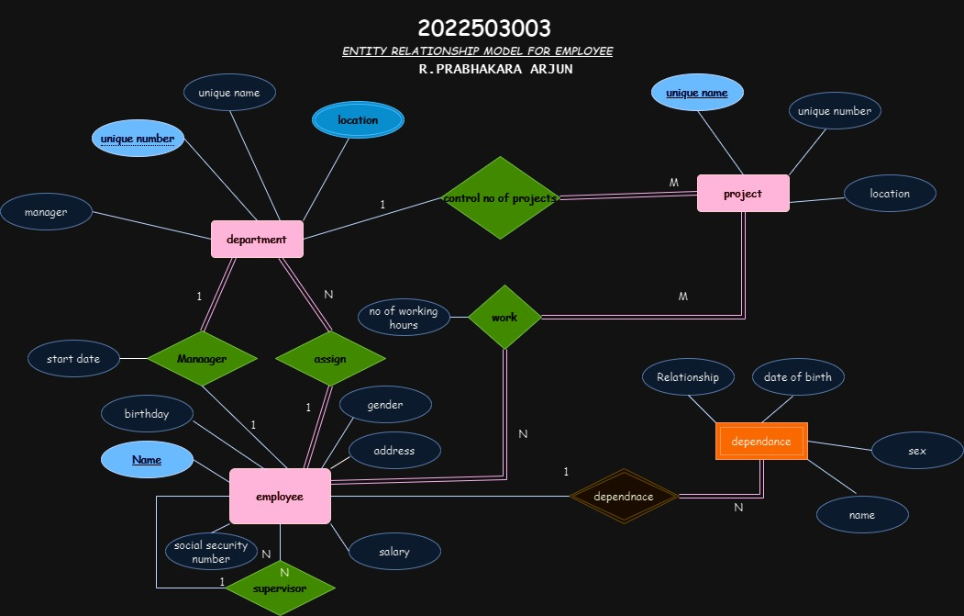

**Q.No 2** Draw the ER diagram for the Swiggy, an online

food delivery platform.

a)Customer represents individual users who place orders on

Swiggy. Each customer is defined by CustomerID, Name,

Email, and Phone Number. Each customer can place

multiple orders, but each order is placed by exactly one

customer.

b)Restaurant represents the restaurants partnered with

Swiggy. Each restaurant is described by the RestaurantID,

Name, Address, Cuisine. Each restaurant can serve multiple

food items, but each food item is served by exactly one

restaurant.

c)Order represents individual orders placed by customers.

Each order is identified by a unique OrderID and has

attributes such as OrderDate and TotalAmount. Each order

can have one delivery, and each delivery corresponds to

exactly one order.

d) Item represents individual food items available for order.

Each item is described by the ItemID and has attributes

such as Name, Description and Price. Each order can

contain multiple items, and each item can be part of

multiple orders.

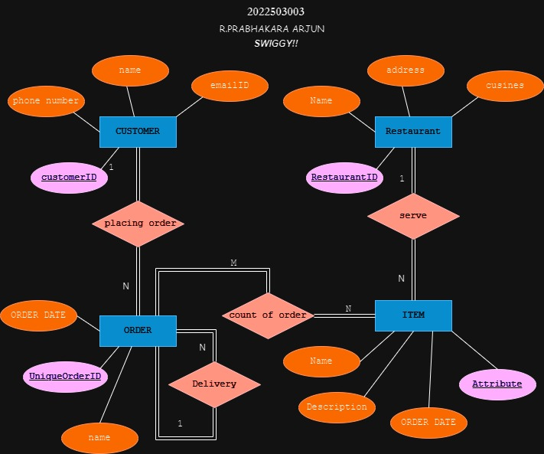

**Q.No 3** Draw the ER diagram for the given scenario.

Consider the following set of requirements for a UNIVERSITY

database that is used to keep track of students' transcripts.

(a) The university keeps track of each student's name, student

number, social security number, current address and phone,

permanent address and phone, birthdate, sex, class (freshman,

sophomore, ..., graduate), major department, minor

department (if any), and degree program (B.A., B.S., ..., Ph.D.).

Some user applications need to refer to the city, state, and zip

of the student's permanent address, and to the student's last

name. Both social security number and student number have

unique values for each student.

(b) Each department is described by a name, department code,

office number, office phone, and college. Both name and code

have unique values for each department.

(c) Each course has a course name, description, course number,

number of semester hours, level, and offering department. The

value of course number is unique for each course.

(d) Each section has an instructor, semester, year, course, and

section number. The section number distinguishes different

sections of the same course that are taught during the same

semester/year; its values are 1, 2, 3, ..., up to the number of

sections taught during each semester.

(e) A grade report has a student, section, letter grade,

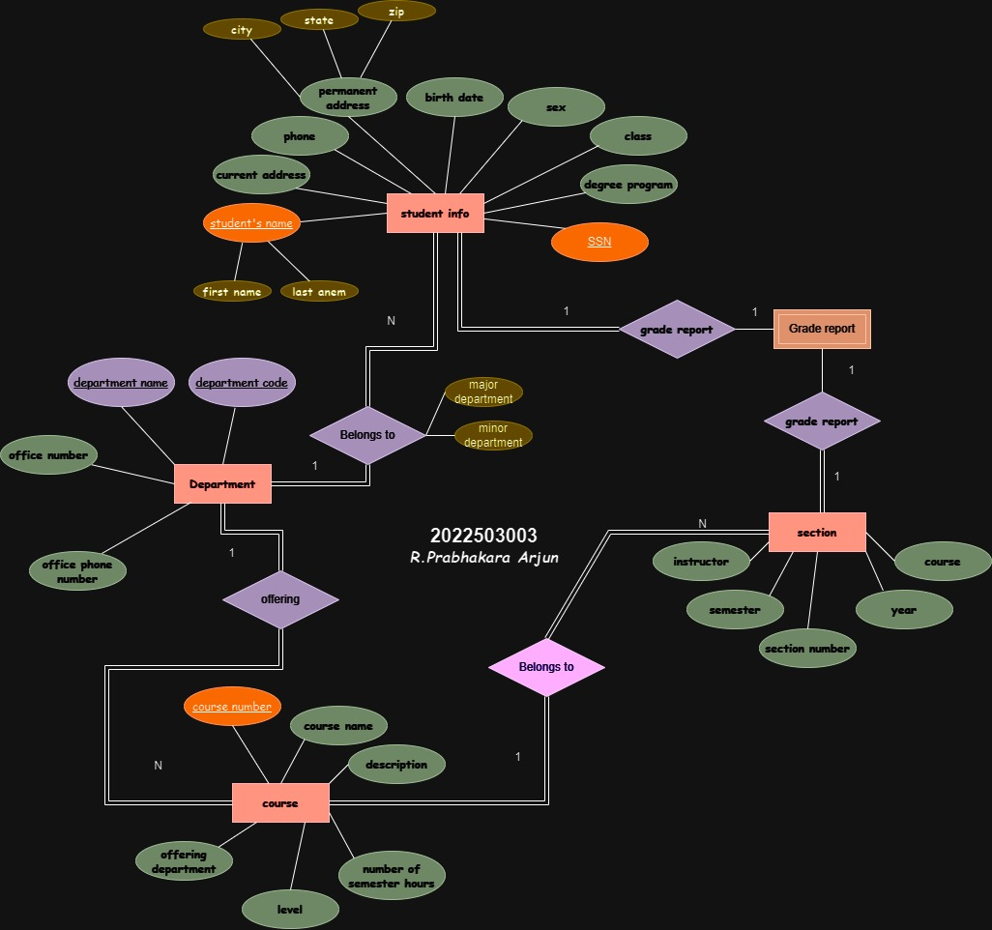andnumeric grade (0, 1, 2, 3, 4 for F, D, C, B, A, respectively).