**LAB ASSIGNMENT-4**

**2022503003**

**1.SWIGGY:**

**A.CREATING ENTITY CUSTOMER:**

create table customer_3003(

customer_id varchar(10) primary key,

phone_no number(10) not null,

emailID varchar(20),

name varchar(25) not null);

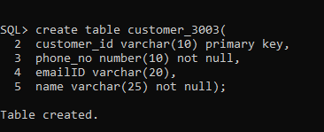

Desc customer_3003;

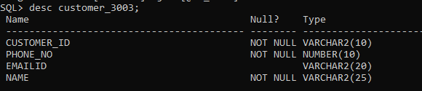

**B.CREATING ENTITY ORDER:**

create table order_3003(

order_date date not null,

name varchar2(20) not null,

uniqueorderID varchar(10) primary key,

placing_order varchar(10) not null,

delivery varchar(10) not null,

constraint placingorder foreign key(placing_order) references customer_3003(customer_id),

constraint deliv foreign key(delivery) references customer_3003(customer_id)

);

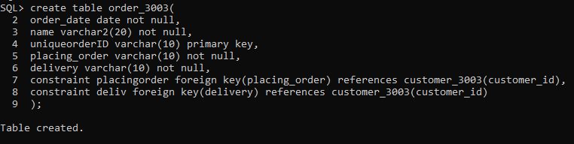

Desc order_3003;

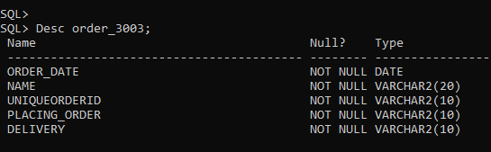

**C.CREATING ENTITY RESTAURANT:**

create table restaurant_3003(

address varchar(30) not null,

name varchar2(20) not null,

restaurantID varchar(10) primary key,

cusines varchar(10) not null

);

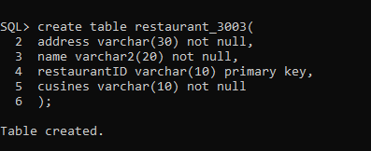

Desc restaurant_3003;

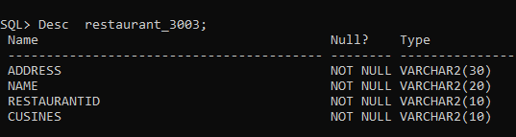

**D.CREATING ENTITY ITEM:**

create table item_3003(

description varchar(30) not null,

name varchar2(20) not null,

attributes varchar(10) primary key,

order_date date not null,

serve varchar(10) not null,

constraint servee foreign key(serve) references restaurant_3003(restaurantID)

);

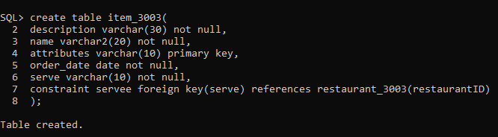

Desc item_3003;

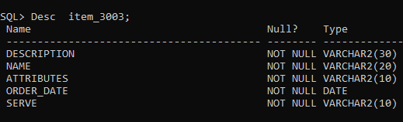

**E.CREATING RELATIONSHIP COUNT OF ORDER:**

create table corder_3003(

orderID varchar(10) not null,

itemID varchar(10) not null,

constraint pk primary key(orderID,itemID),

constraint oid foreign key(orderID) references order_3003(uniqueorderid),

constraint iid foreign key(itemID) references item_3003(attributes)

);

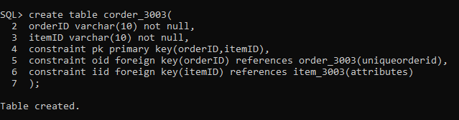

Desc corder_3003;

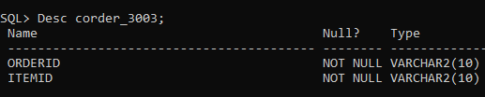

**2.STUDENTS:**

**A.CREATING ENTITY DEPARTMENT:**

create table departments_3003(

department_name varchar(25) primary key,

department_code number(20) unique,

department_phonno number(10),

college_address varchar(30),

department_office varchar(30)

);

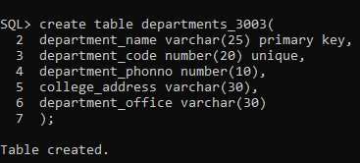

Desc students_3003;

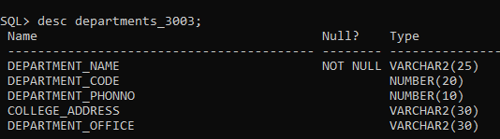

**B.CREATING ENTITY STUDENTS:**

create table students_3003(

class varchar(10),

sex char(1) not null,

firstname varchar(20),

lastname varchar(20),

middlename varchar(20),

student_number number(15) primary key,

ssn number(20) unique,

street_address varchar(10),

city varchar(5),

state varchar(5),

pin_code varchar(5),

phone number(20) unique,

degreeprogram varchar(20),

parent_phonno number(10),

parent_addres varchar(30),

major_department varchar(15),

minor_department varchar(15),

constraint mad foreign key(major_department) references departments_3003(department_name),

constraint mid foreign key(minor_department) references departments_3003(department_name)

);

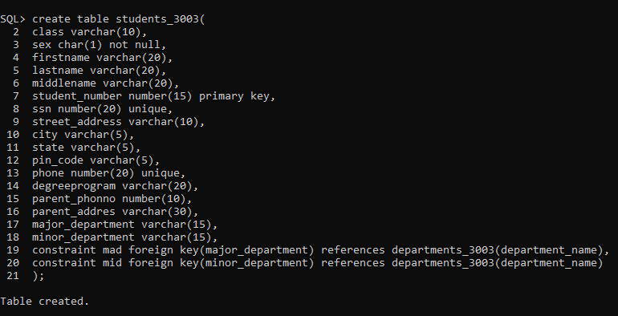

Desc departments_3003;

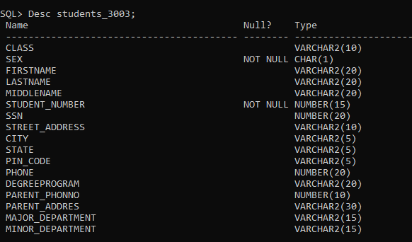

**C.CREATING ENTITY GRADE:**

create table grade_3003(

numeric_grade number(3),

letter_grade char(3)

);

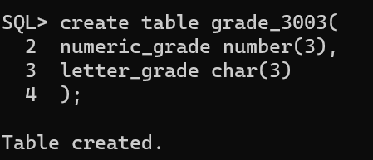

Desc grade_3003;

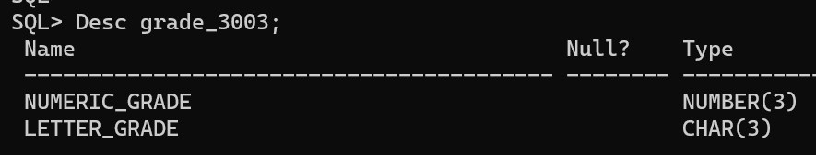

ALTER TABLE grade_3003 add grade varchar(1);

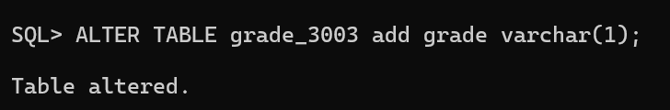

**D.CREATING WEAK ENTITY SECTION:**

create table section_3003(

partial_key number(10),

instructor varchar(25),

sno number(15),

constraint sec foreign key(sno) references students_3003(student_number)

);

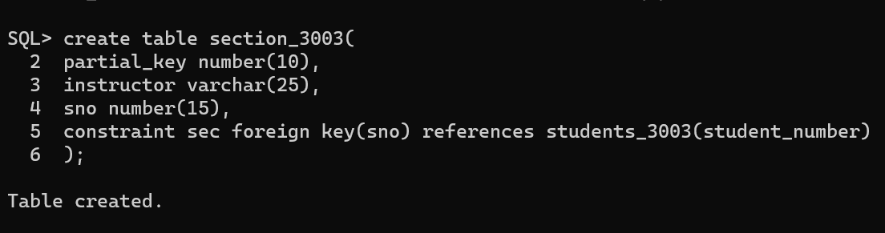

Desc section_3003;

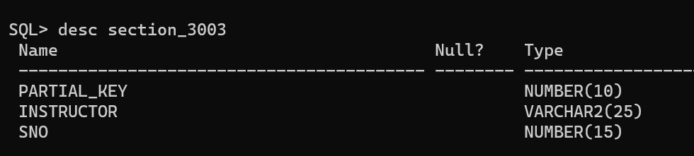

**E.CREATING ATTRIBUTE PARTIAL KEY:**

create table partial_key_3003(

snumber number(10),

semester char(1),

year date,

sec number(15),

constraint se foreign key(sec) references students_3003(student_number)

);

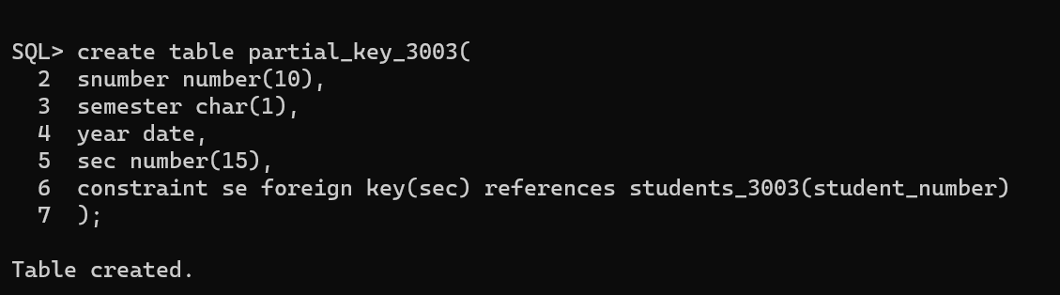

DESC partial_key_3003;

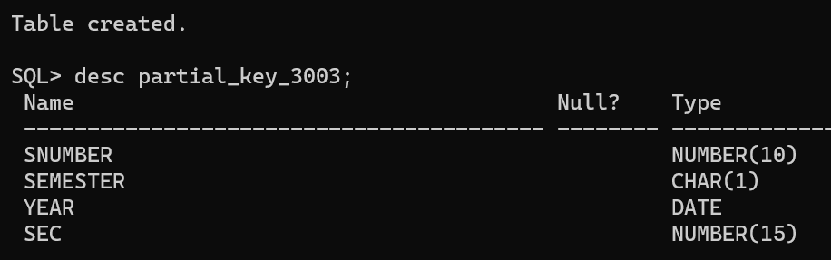

**F.CREATING ENTITY DEPARTMENT:**

create table courses_3003(

semester_hours number(10),

course_name varchar(10),

description varchar(15),

course_number number(10) primary key,

courses_sec number(15),

leveleh char(1),

constraint std foreign key(courses_sec) references students_3003(student_number)

);

Desc courses_3003;

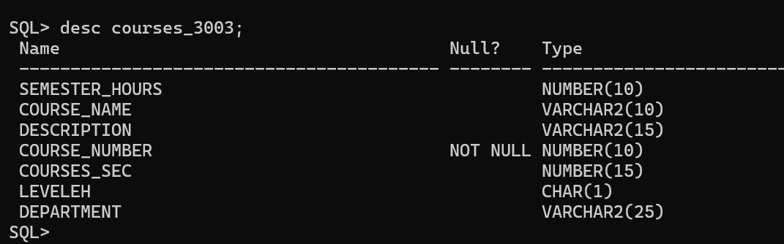

ALTER TABLE courses_3003 ADD CONSTRAINT d foreign key(department) references departments_3003(department_name);



**G.CREATING RELATIONSHIP STUDENT_SEC:**

create table STUD_SEC_3003(

student number(15),

gradey varchar(1),

sec number(10),

constraint studr foreign key(sec) references students_3003(student_number)

);

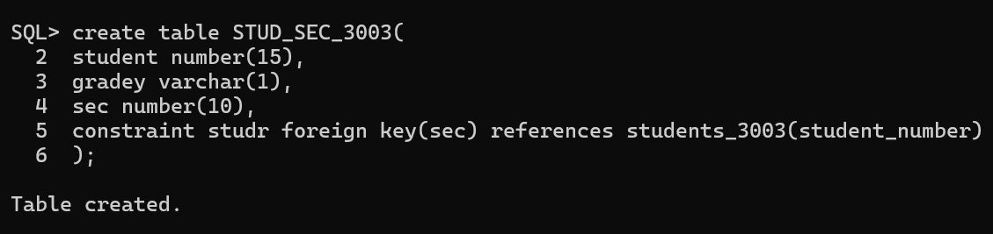

**3.EMPLOYEE**

**A.CREATING ENTITY EMPLOYEE:**

create table departmentss_3003(

unique_number number(25) primary key,

unique_name varchar(20) unique

);

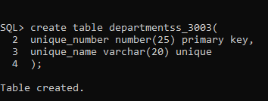

desc departmentss_3003;

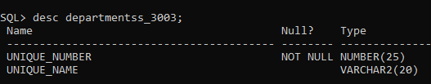

**B.CREATING WEAK ATTRIBUTE IN DEPARTMENT:**

create table location_3003(

dno number(25) not null,

address varchar(30) not null,

constraint loc foreign key(dno) references departmentss_3003(unique_number)

);

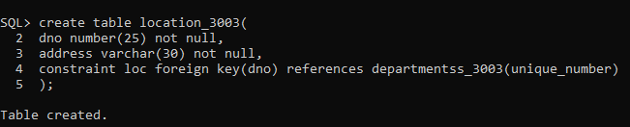

desc location_3003;

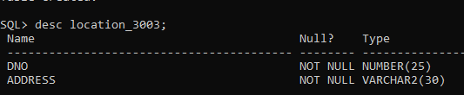

**C.CREATING ENTITY PROJECT:**

create table project_3003(

unique_name varchar(25) primary key,

unique_number number(30) not null,

location varchar(20),

nop number(25) not null,

constraint prmk foreign key(nop) references departmentss_3003(unique_number)

);

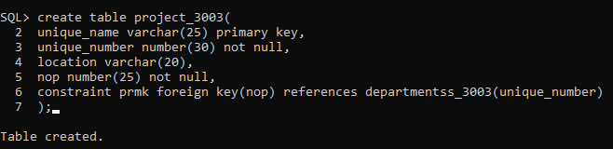

desc project_3003;

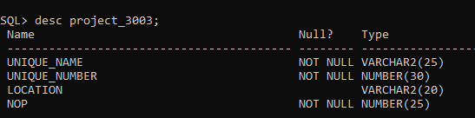

**D.CREATING ENTITY EMPLOYEE:**

create table emp_3003(

name varchar(25) primary key,

bday date not null,

gender char(1),

ssn number(25) unique,

assign number(25) not null,

start_date date not null,

supervisor varchar(20),

constraint prmke foreign key(assign) references departmentss_3003(unique_number)

);

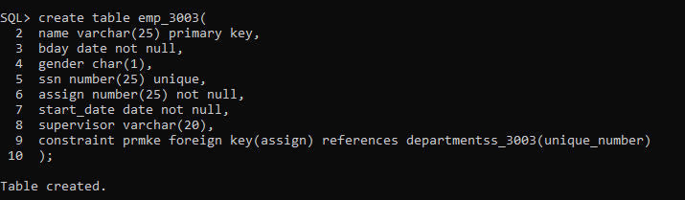

desc emp_3003;

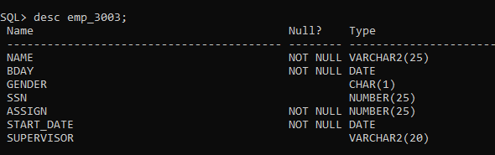

**E.CREATING RELATION WORK:**

create table work_3003(

employe varchar(25) unique,

project varchar(25) unique,

constraint e foreign key(employe) references emp_3003(name),

constraint p foreign key(project) references project_3003(unique_name)

);

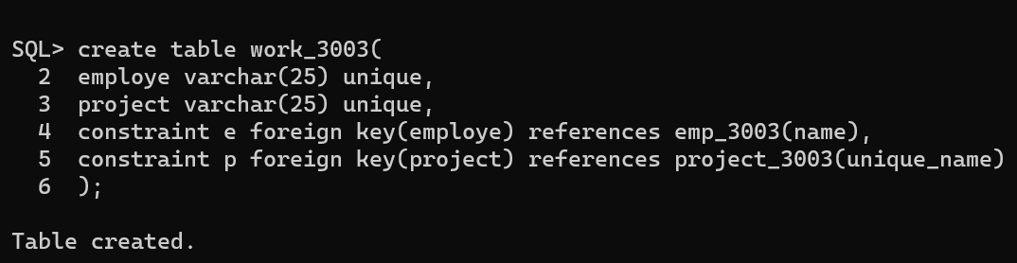

desc work_3003;

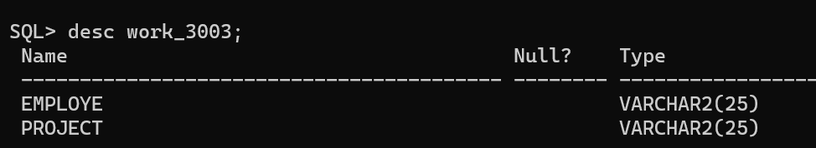alter table work_3003 add No_of_working_hrs number(10);

desc work_3003;

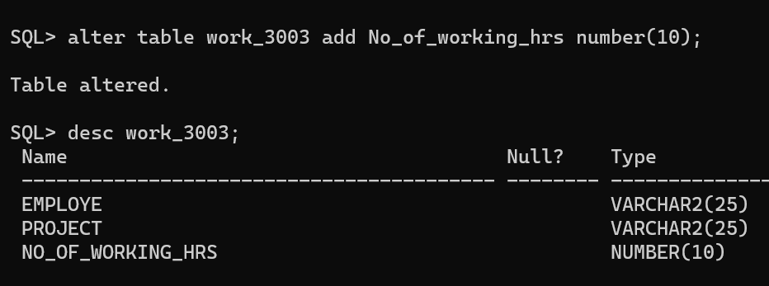

**F.CREATING ENTITY DEPENDENCE:**

create table dependance_3003(

dob date,

sex char(1),

name varchar(25) not null,

relationship varchar(25),

dependance varchar(25) primary key not null,

constraint ee foreign key(dependance) references emp_3003(name)

);

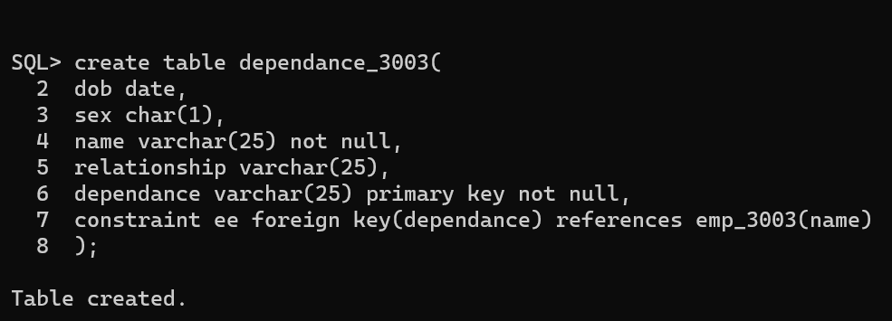

desc dependance_3003;

