**2022503003**

**DBMS LAB 5**

**1. Report the employee full name who has the Task no greater than 50.**

select lastname||' '||firstname as "full name" from PROGRAMMER_503003 where taskno>50;

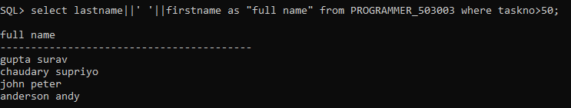

**2. Report the employee details who had hired in the year 1999.**

select * from PROGRAMMER_503003 where to_char(hiredate,'yy')=99;

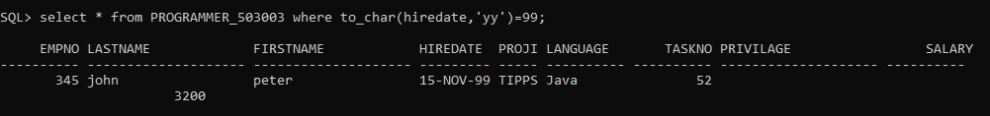

**3. Report the employee details whose ProjId is TIPPS and Programming**

**language is Java.**

select * from PROGRAMMER_503003 where projid='TIPPS' and language='Java';



**4. Report on unique ProjId values from the PROGRAMMER table.**

select distinct projid from PROGRAMMER_503003;

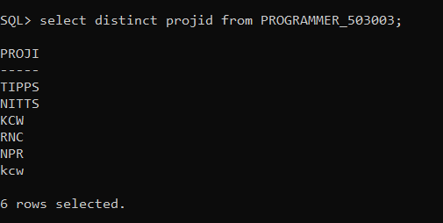

**5. Use different way to return all columns and rows of data from the**

**PROGRAMMER table.**

select * from  PROGRAMMER_503003;

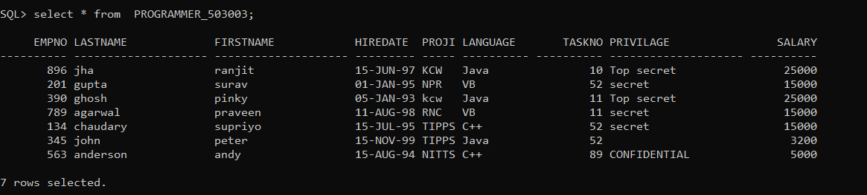

Select

empno,lastname,firstname,hiredate,projid,language,taskno,privilage,salary from  PROGRAMMER_503003;

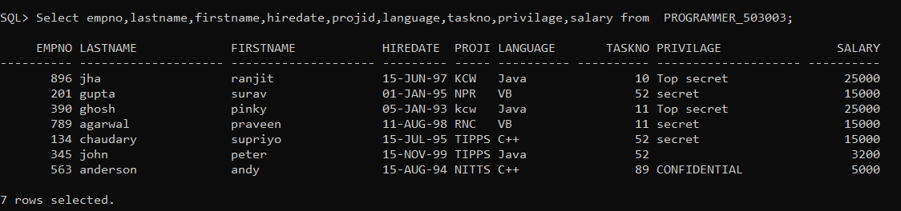

**6. Report the employee details whose length of full name is greater than 10Letters.**

Select * from  PROGRAMMER_503003 where length(concat('firstname','lastname'))>10;

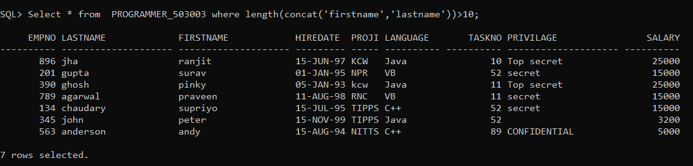

**7. Report the employee ProjId and Task no Whose Privilege is Secret but startsat position 5.**

Select  projid,taskno  from  PROGRAMMER_503003 where SUBSTR(privilage,5,6)='secret';

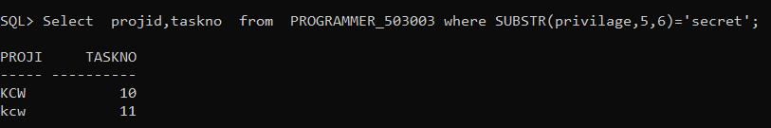

**8. Report the employee who has hired earlier than all others**

 Select * from  PROGRAMMER_503003 order by(hiredate) fetch first 1 row only;

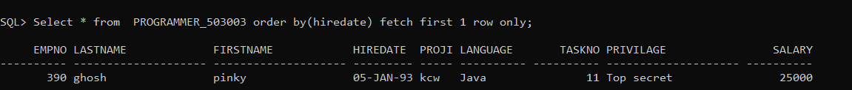

**9. List the employee project details whose name is “JOHN PETER” and**

**“GHOSH PINKY”.**

 select * from PROGRAMMER_503003 where upper(lastname||' '||firstname) in ('GHOSH PINKY','JOHN PETER');

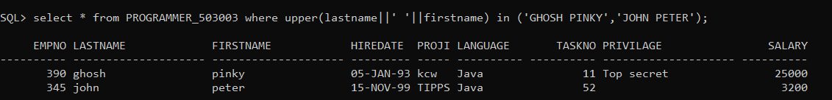

**10.Report the project details of an employee by reading their empno at run** **Time.**

 select * from PROGRAMMER_503003 where empno='&empoyee_no';

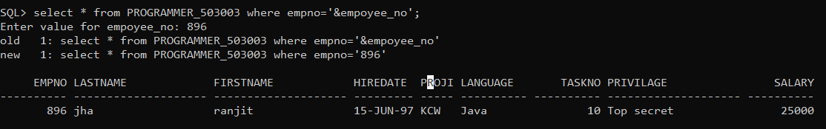

**11.Obtain the information about the employee who has recruited 30 days**

**before 13/06/95.**

select * from PROGRAMMER_503003 where hiredate = TO_DATE('13/06/95', 'DD/MM/YY') - 30;

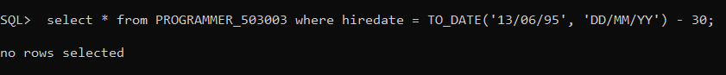

**12.Find the details of the employee whose first letter of full name and first** **letter of last name starts with same character.**

select * from PROGRAMMER_503003 where substr(firstname,1,1)=substr(lastname,1,1);

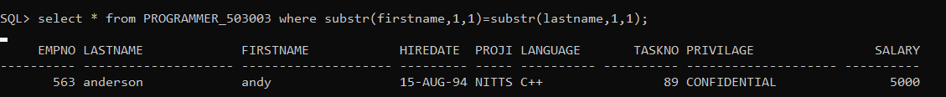

**13.Find the details of the employee whose first letter of full name and firstletter of last name not starts with same character.**

select * from PROGRAMMER_503003 where substr(firstname,1,1)!=substr(lastname,1,1);

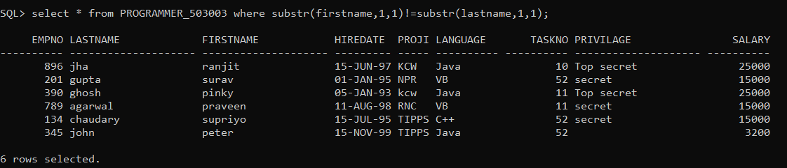

alter table PROGRAMMER_503003 add comission number(5);

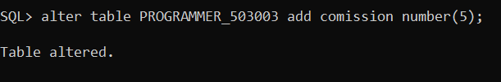

desc programmer_503003;

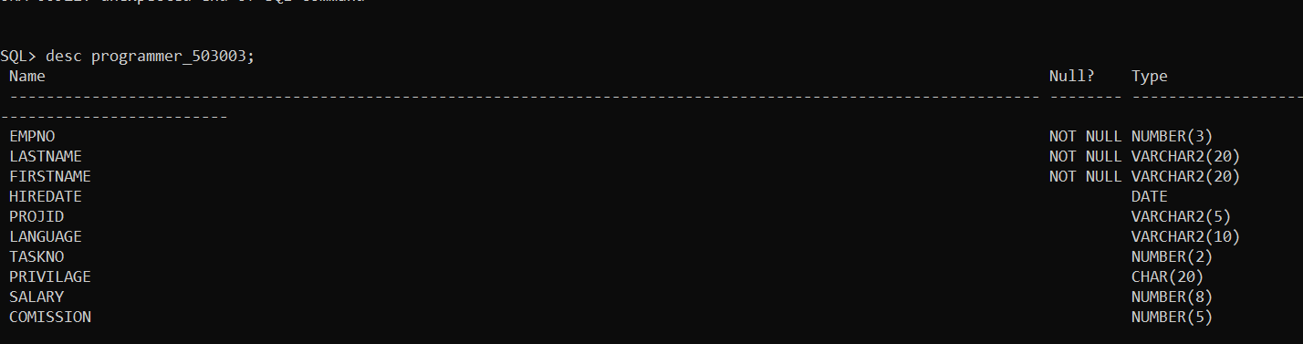

Update PROGRAMMER_503003 set comission=1 where privilage=’secret’;

Update PROGRAMMER_503003 set comission=2 where privilage=’Top secret’;

Update PROGRAMMER_503003 set comission=0 where privilage=’CONFIDENTIAL’;

Update PROGRAMMER_503003 set comission=4 where privilage is null;

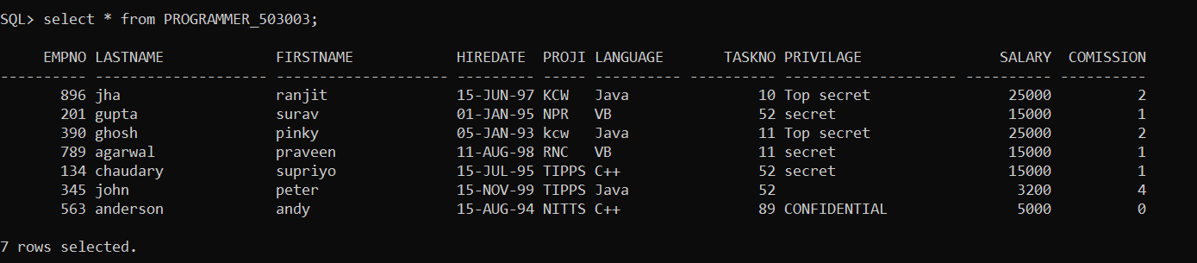

**14.Find the details of the employee with FIRST_NAME values that do NOT** **begin with the letter “A” or those that do NOT comply with a COMMISSION** **greater than 2% percent.**

select * from PROGRAMMER_503003 where substr(firstname,1,1)!='a' and not comission>2;

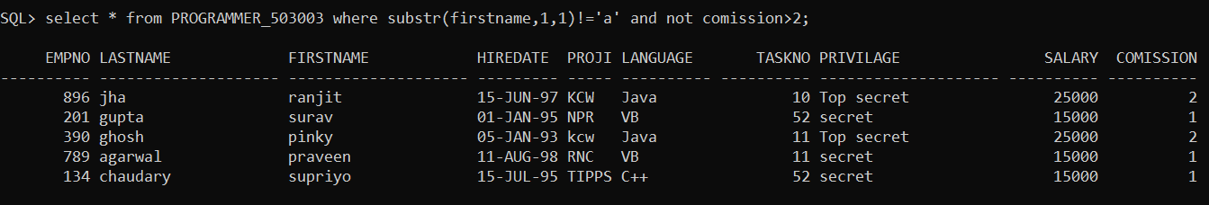

**15.Find the details of the employee whose lastname contains “u” letter and** **had the salary greater than 5000 bearing taskno 89 or 52 or 10 whose** **commission calculated should not be null.**

select * from PROGRAMMER_503003 where lower(lastname) like '%u%' and salary>5000 and taskno in (89,52,10) and comission is not null;

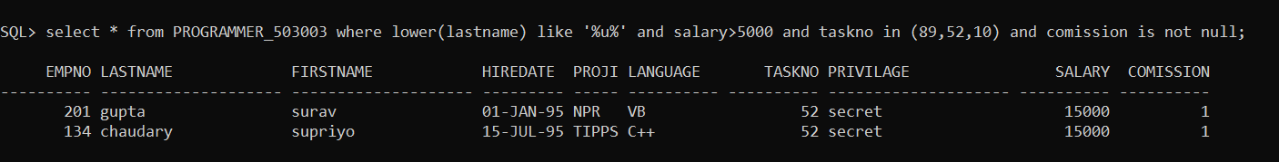

**16.Report the details of the employee whose hire date is in the month that** **starts with ‘J’(i.e January or june).**

 select * from PROGRAMMER_503003 where substr(to_char(hiredate,'month'),1,1)='j';

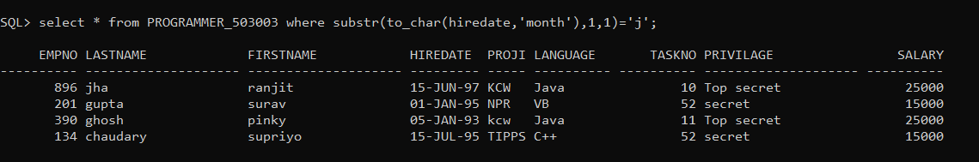

**17.Query the ProjId from Programmer table. i.e ., The Project Id for the**

**<FirstName> <LastName> ‘s project is: < ProjId >, where the ProjId being**

**concatenated to the statement so as to create the single expression aliased** **as Project Description. The literal "'s project is:" is then concatenated with** **this text, and the ProjId field is concatenated after that.Example:** **Project Description“The project Id for the Saurav Gupta’s Project is: NPR.”**

select 'The project ID for'||firstname||' '||lastname||'''s  project is:'||projid as "Project Description" from PROGRAMMER_503003;

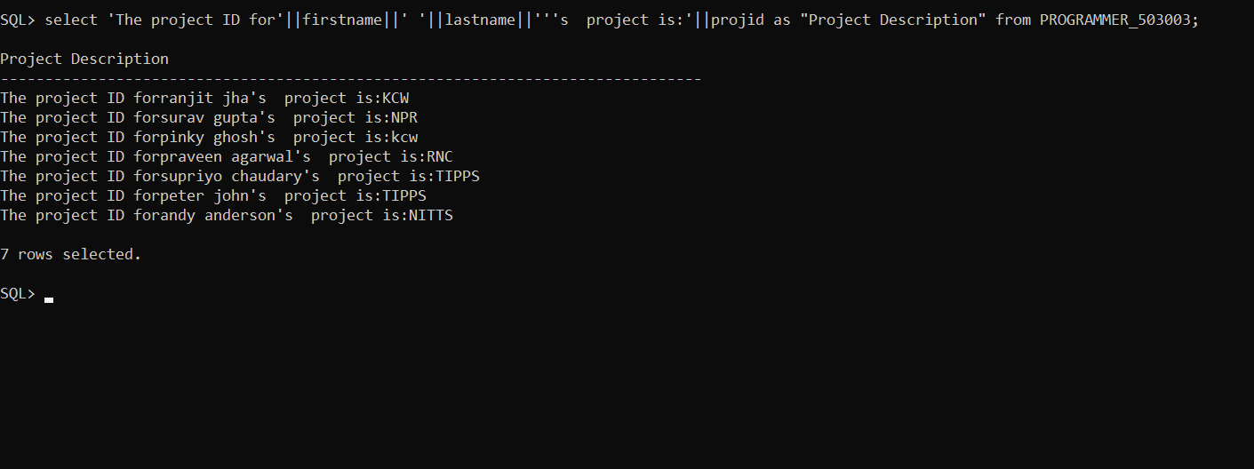

update PROGRAMMER_503003 set hiredate=to_date(to_char(hiredate,'dd')||'-'||to_char(hiredate,'mm')||'-'||(to_char(hiredate,'yyyy')-100),'dd-mm-yyyy');



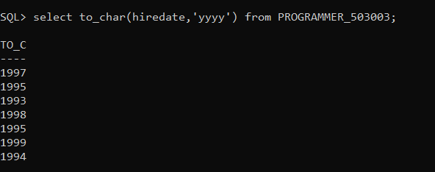

**18.Find the the number of days for which staff were employed in a job. Create** **an alias for the expression column in your query using Days Employed.**

select current_date-hiredate as "Days Employed" from PROGRAMMER_503003;

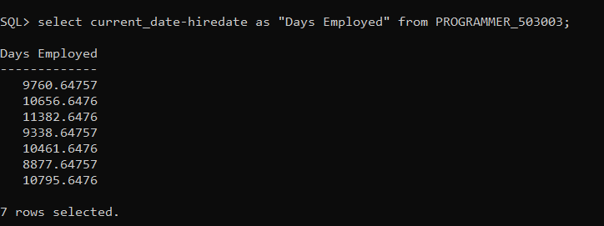

**19.Write an SQL query to determine the number of years each staff member**

**has been employed in a job. Display the employee number (EmpNo),**

**project ID (ProjId), hire date (HireDate), and create an alias for the**

**expression column representing the number of years employed using the**

**name 'Years Employed'. Consider that there are 365 days in a year.**

select empno as "employee number",projid as " project ID",hiredate as "hire date",to_char(current_date,'yyyy')-to_char(hiredate,'yyyy') as "years employed" from PROGRAMMER_503003;

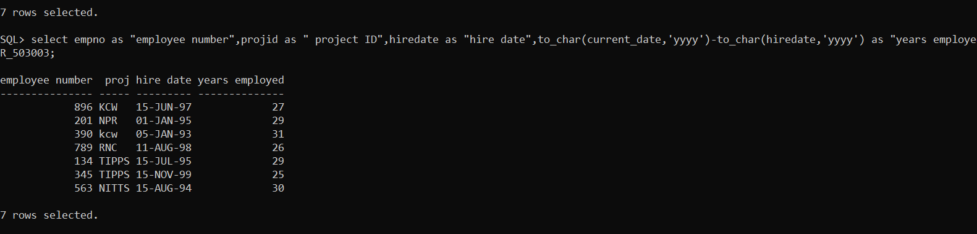

**20.Display the salary of each employee in the following format: '$9.999.000'.**

SQL> select to_char(salary,'$999,999,999.00') as salary from PROGRAMMER_503003;

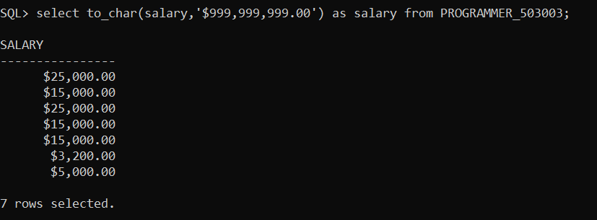

**21.Create an SQL query to show the hire date of employees, with the month** **expressed in full name format.**

select to_char(hiredate,'dd-month-yy') as "hire date of employee" from PROGRAMMER_503003;

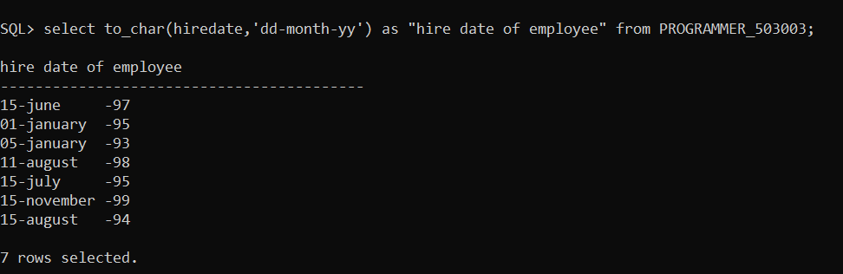

**22.Write an SQL query to display employee details, showing the hire date inthe 'yyyy' format.**

select empno,lastname,firstname,to_char(hiredate,'dd-mm-yyyy') as "hire date of employee",projid,language,taskno,salary from PROGRAMMER_503003;

