**CS6106 DATABASE MANAGEMENT SYSTEMS**

**ASSIGNMENT 6**

**Course Instructor: V P JAYACHITRA Date: 12-03-24 Views**

∙ A **view** is a logical representation of a table or combination of tables. ∙ Views can provide a different representation (such as subsets or supersets) of the data that resides within other tables and views.

∙ Views are very powerful because they allow you to tailor the presentation of data to different types of users.

∙ A view derives its data from the tables on which it is based. These tables are called **base tables**. Base tables might in turn be actual tables or might be views themselves.

∙ All operations performed on a view actually affect the base table of the view. ∙ Use views in almost the same way as tables. i.e We can query, update, insert into, and delete from views, just as we can standard tables.

**Example:**

**CREATE VIEW emp_dept AS**

**SELECT emp.empno, emp.ename, emp.deptno, emp.sal, dept.dname, dept.loc**

**FROM emp, dept**

**WHERE emp.deptno = dept.deptno**

**AND dept.loc IN ('DALLAS', 'NEW YORK', 'BOSTON');**

**UPDATE Statements**

The following example shows an UPDATE statement that successfully modifies the emp_dept view:

**UPDATE emp_dept**

**SET sal = sal * 1.10**

**WHERE deptno = 10;**

The following UPDATE statement would be disallowed on the emp_dept view:

**UPDATE emp_dept**

**SET loc = 'BOSTON'**

**WHERE ename = 'SMITH'**;

This statement fails with an error (ORA-01779 cannot modify a column which maps to a non key preserved table), because it attempts to modify the base dept table, and the dept table is not key-preserved in the emp_dept view.

**UPDATE emp_dept**

**SET deptno = 10**

**WHERE ename = 'SMITH';**

The statement fails because it is trying to update a join column.

create table dept_503003(

dname varchar(15) NOT NULL,

dnumber number(2) primary key,

mgr_ssn number(9) NOT NULL,

mgr_start_date date

);

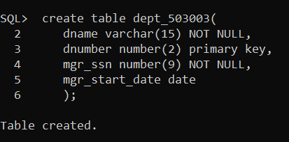

dept_503003;

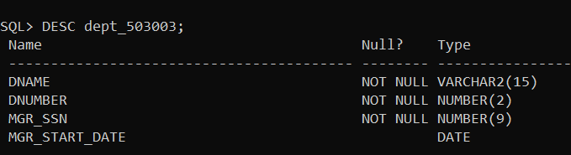

CREATE TABLE emp_503003(

Fname varchar2(20) NOT NULL,

Minit char(1),

Lname varchar2(20) not null,

ssn number(9) primary key,

bdate date not null,

address varchar2(40),

sex char(1) check(sex in ('M','F')),

salary number(6),

super_ssn number(9),

Dno number(2)

) ;

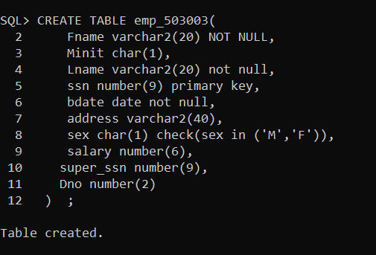

desc emp_503003;

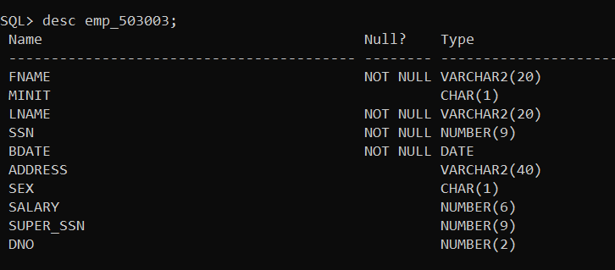

alter table dept_503003 add constraint manager foreign key(mgr_ssn) references emp_503003(ssn);

alter table emp_503003 add constraint SUPERVISOR foreign key(dno) references dept_503003(DNUMBER);

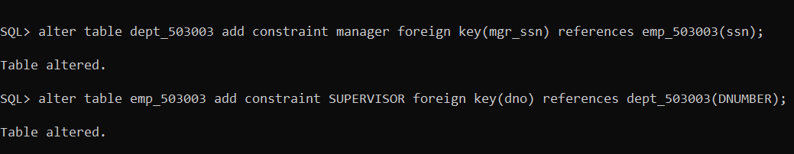

alter table emp_503003 drop constraint supervisor;

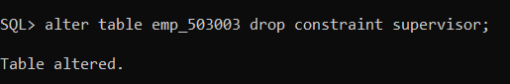

alter table emp_503003 add constraint dept foreign key(dno) references dept_503003(dnumber);

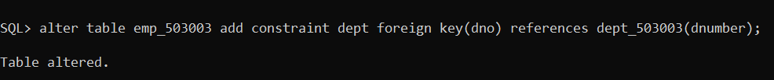

insert into emp_503003 values('John', 'B', 'Smith', 123456789, to_date('1965-01-09', 'yyyy-mm-dd'), '731 Fondren, Houston, TX', 'M', 30000, 333445555, 5);

insert into emp_503003 values('Franklin', 'T', 'Wong', 333445555, to_date('1955-12-08', 'yyyy-mm-dd'), '638 Voss, Houston, TX', 'M', 40000, 888665555, 5);

insert into emp_503003 values('Alicia', 'J', 'Zelaya', 999887777, to_date('1968-01-19', 'yyyy-mm-dd'), '3321 Castle, Spring, TX', 'F', 25000, 987654321, 4);

insert into emp_503003 values('jennifer', 'S', 'Wallace', 987654321, to_date('1941-06-20', 'yyyy-mm-dd'),'291 Berry,Bellaire,TX',’F’,25000,888665555,4);

Insert into emp_503003 values('Ramesh', 'K', 'Narayanan', 666884444, to_date('1962-09-15', 'yyyy-mm-dd'),'975 fire oak,humble,TX','M',38000,333445555,5);

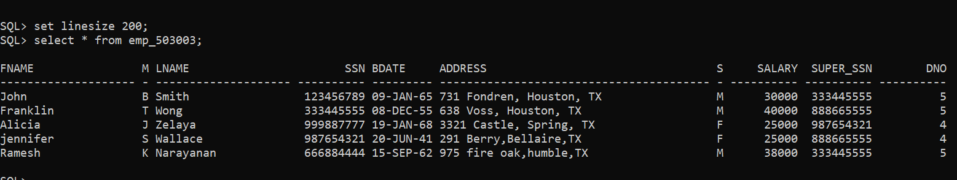

insert into dept_503003 values('Research', 5, 333445555, to_date('1988-05-22', 'yyyy-mm-dd'));

insert into dept_503003 values('Administration',4,987654321,to_date('1995-01-01','yyyy-mm-dd'));

insert into dept_503003 values('Headquaters',1,123456789,to_date('1981-06-19','yyyy-mm-dd'));

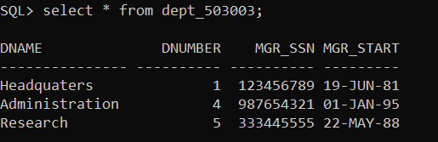

**Verify the following**

**1. Insert , update, delete on simple views that reflects views and base table.**

CREATION:

create view emp_view_503003 as select fname,lname,ssn,dno from emp_503003;

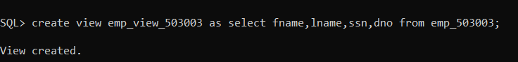

desc emp_view_503003;

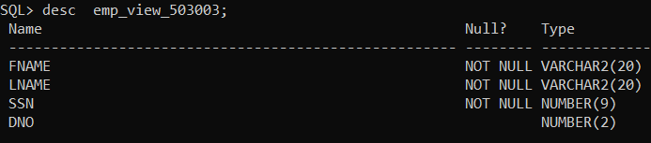

INSERTION:

INSERT into emp_view_503003 values('arjun','abi',191040512,5,to_date('2004-12-05','yyyy-mm-dd'));

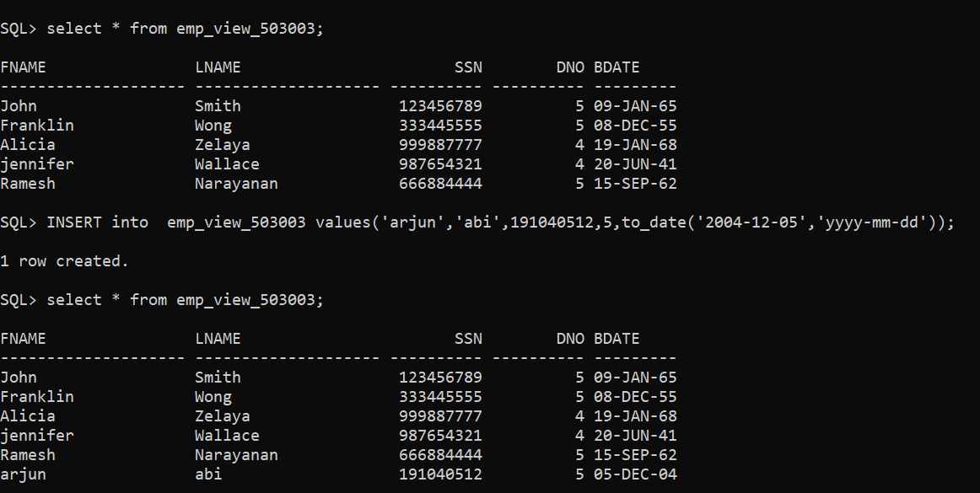

UPDATION:

update emp_view_503003 set lname='abirami' where lname='abi';

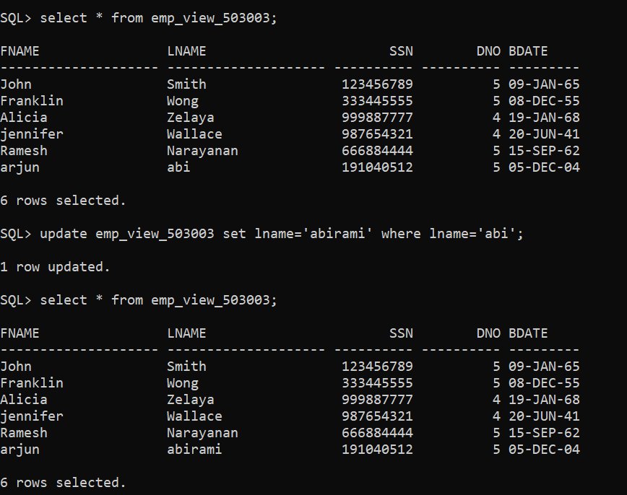

DELETION:

delete from emp_view_503003 where ssn=191040512;

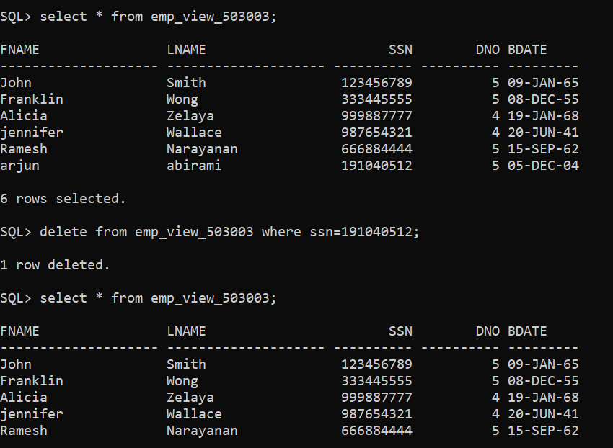

**2. Insert, delete, update on simple views that violate the constraint such as primary key. Note: primary key of a table is a foreign key on other table.**

INSERT:

INSERT into emp_view_503003 (fname) values('arjun');

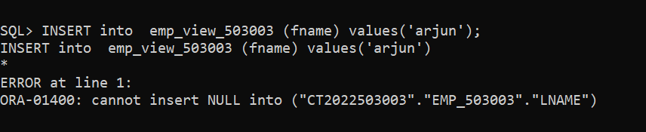

INSERT into emp_view_503003 values('arjun','abi',123456789,5,to_date('2004-12-05','yyyy-mm-dd'));

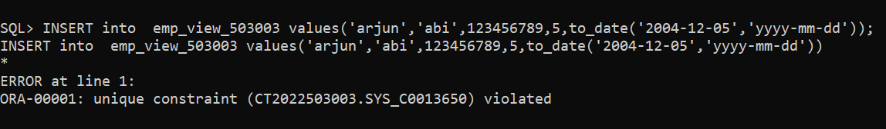

UPDATE:

update emp_view_503003 set ssn='123456789' where lname='Wong';

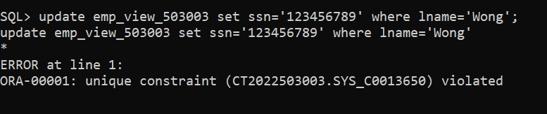

**3. Insert, update, delete on complex views that reflects views and base table.**

CREATION:  
create view comp_view_503003 as select emp_503003.fname,emp_503003.lname,emp_503003.ssn,emp_503003.bdate,

dept_503003.dnumber from emp_503003,dept_503003 where emp_503003.dno=dept_503003.dnumber;

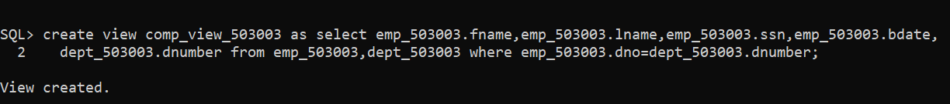

select * from comp_view_503003;

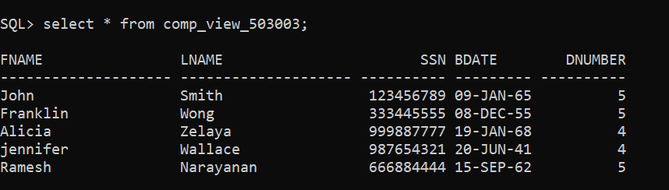

INSERT:

INSERT into comp_view_503003 values('arjun','abi',222222222,to_date('2004-12-05','yyyy-mm-dd'),5);

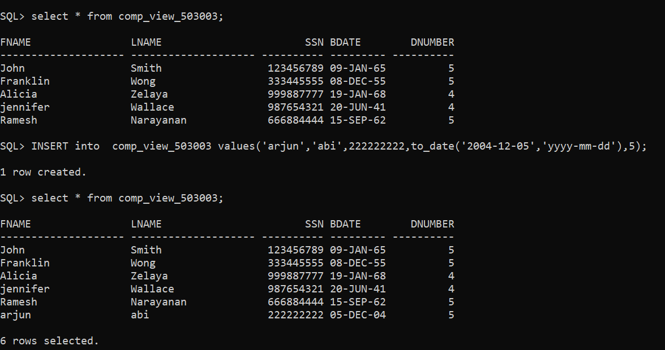

UPDATION:

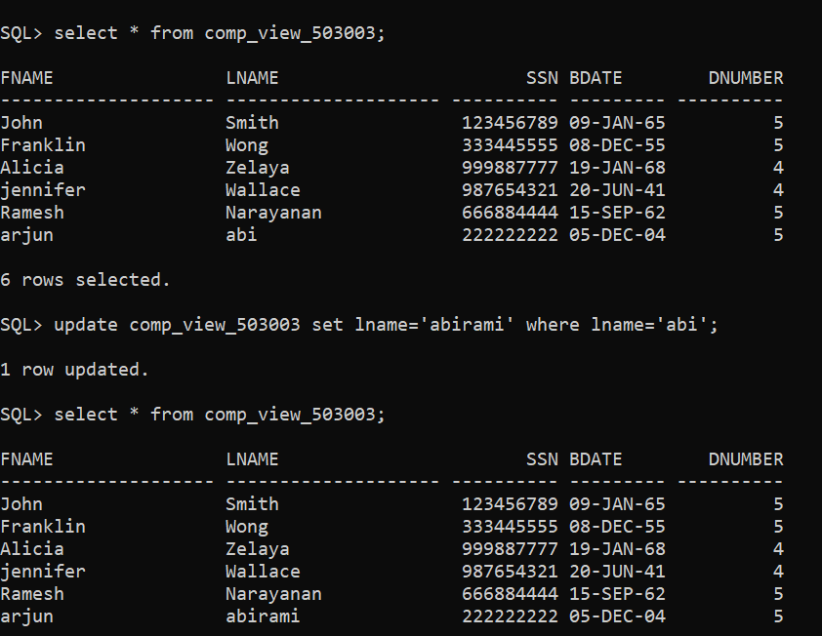

DELETION:

delete from comp_view_503003 where ssn=222222222;

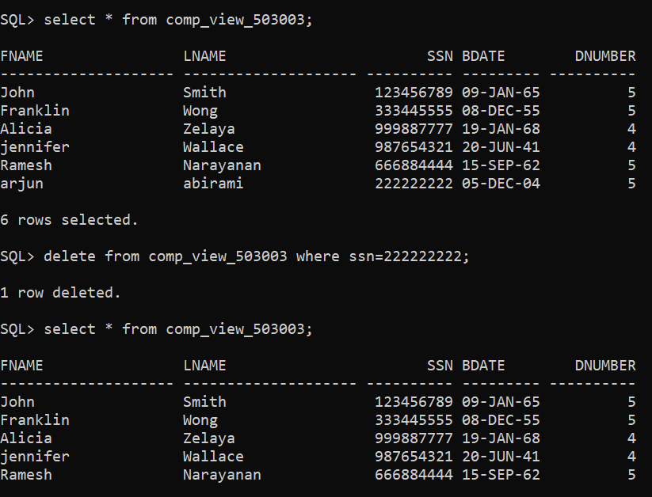

**4. Drop view and perform query on base table and vice versa.**

alter table emp_503003 drop constraint manager foreign key(mgr_ssn) references emp_503003(ssn);

**5. Drop column in base table after creation of view with the respective column and perform select query on view.**

select * from emp_503003;

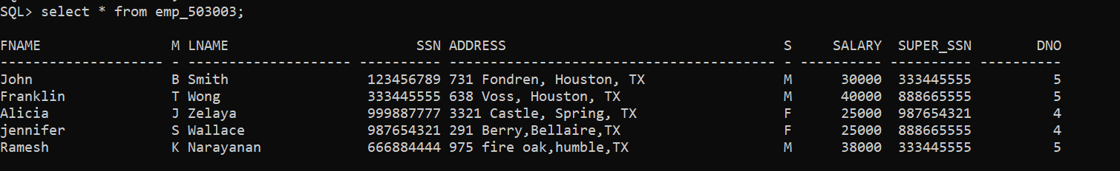

alter table emp_503003 drop column bdate;

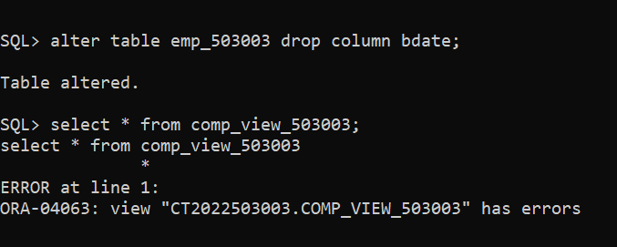

**6. Rename column in base table after creation of view with the respective column and perform select query on view.**

create view emp_view_2_503003 as select fname,lname,ssn,dno from emp_503003;

alter table emp_503003 rename column lname to lastname;

select * from emp_view_2_503003;

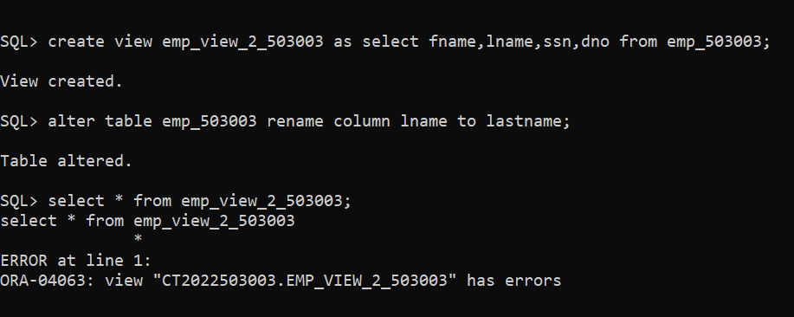

**7. Rename table in base table after creation of view and perform select query on view.**

create view emp_view_3_503003 as select fname,lastname,ssn,dno from emp_503003 ;

alter table emp_503003 rename to emp2_503003;

select * from emp_view_3_503003;

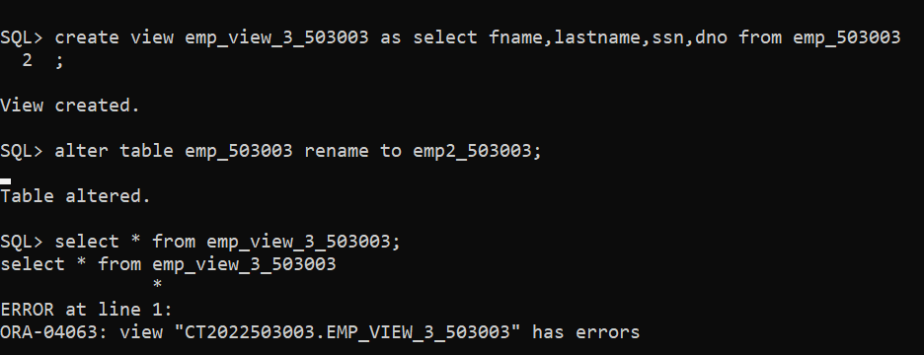

**8. Modify data type of a column in base table after creation of view with the respective column and perform select query on view.**

create view emp_view_4_503003 as select fname,lastname,ssn,dno from emp2_503003 ;



Alter table emp2_503003 add lastname varchar(30);

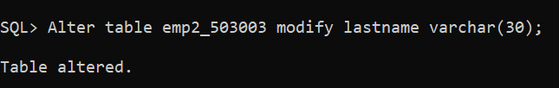

select * from emp_view_4_503003;

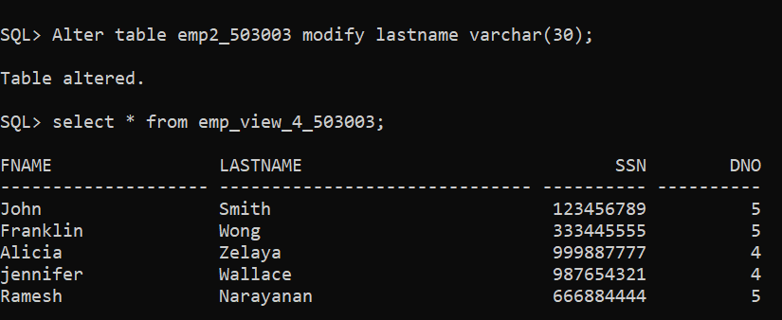

**9. Create a view from existing view**

create view emp_view_5_503003 as select fname,lastname,ssn,dno from emp2_503003 ;

create view emp_view_6_503003 as select * from emp2_503003 ;

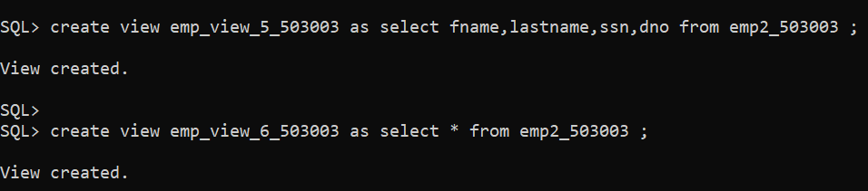

select * from emp_view_5_503003;

select * from emp_view_6_503003;

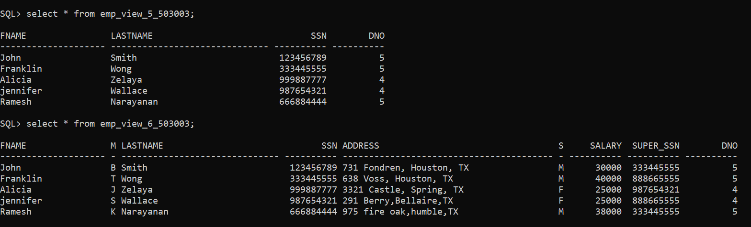

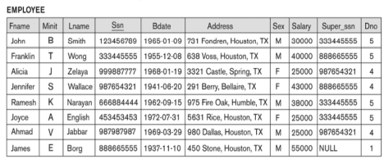 **Note: Insert sample 5 records**

