

**2022503003**

**CREATE EMP TABLE:**

CREATE TABLE emp_503003(

Fname varchar2(20) NOT NULL,

Minit char(1),

Lname varchar2(20) not null,

ssn number(9) primary key,

bdate date not null,

address varchar2(40),

sex char(1) check(sex in ('M','F')),

salary number(6),

super_ssn number(9),

Dno number(2)

) ;

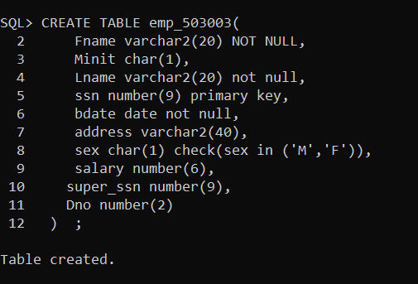

insert into emp_503003 values('John', 'B', 'Smith', 123456789, to_date('1965-01-09', 'yyyy-mm-dd'), '731 Fondren, Houston, TX', 'M', 30000, 333445555, 5);

insert into emp_503003 values('Franklin', 'T', 'Wong', 333445555, to_date('1955-12-08', 'yyyy-mm-dd'), '638 Voss, Houston, TX', 'M', 40000, 888665555, 5);

insert into emp_503003 values('Alicia', 'J', 'Zelaya', 999887777, to_date('1968-01-19', 'yyyy-mm-dd'), '3321 Castle, Spring, TX', 'F', 25000, 987654321, 4);

insert into emp_503003 values('jennifer', 'S', 'Wallace', 987654321, to_date('1941-06-20', 'yyyy-mm-dd'),'291 Berry,Bellaire,TX',’F’,25000,888665555,4);

Insert into emp_503003 values('Ramesh', 'K', 'Narayanan', 666884444, to_date('1962-09-15', 'yyyy-mm-dd'),'975 fire oak,humble,TX','M',38000,333445555,5);

insert into emp_503003 values('Joyce', 'A', 'English', 453453453, to_date('1972-07-31', 'yyyy-mm-dd'),'5631 Rice, Houston, TX','F',25000,333445555,5);

insert into emp_503003 values('Ahmad', 'V', 'Jabbar', 987987987, to_date('1969-03-29', 'yyyy-mm-dd'),'980 Dallas, Houston, TX','M',25000,987654321,4);

insert into emp_503003 values('James', 'E', 'Borg', 888665555, to_date('1937-11-10', 'yyyy-mm-dd'),'450 Stone, Houston, TX','M',55000,NULL,1);

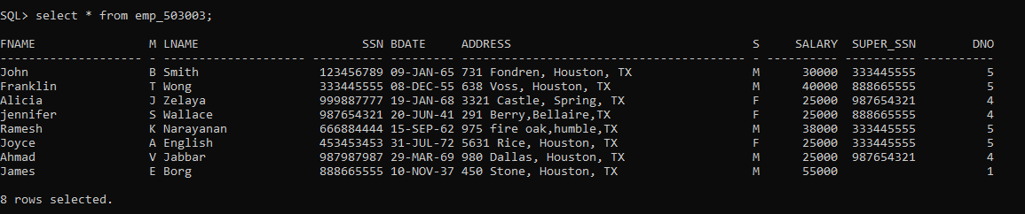

**CREATE DEPT_503003 TABLE:**

create table depart_503003(

dname varchar(15) NOT NULL,

dnumber number(2) primary key,

mgr_ssn number(9),

mgr_start_date date,

);

insert into dept_503003 values('Research', 5, 333445555, to_date('1988-05-22', 'yyyy-mm-dd'));

insert into dept_503003 values('Administration',4,987654321,to_date('1995-01-01','yyyy-mm-dd'));

insert into dept_503003 values('Headquaters',1,123456789,to_date('1981-06-19','yyyy-mm-dd'));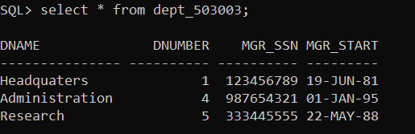

**CRATE TABLE dept_locations_3003**

create table dept_locations_3003(

Dnumber number(2),

Dlocation varchar(10),

constraint ckey primary key(Dnumber,Dlocation)

);

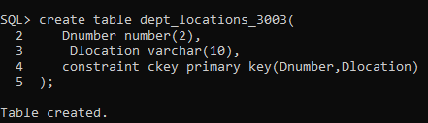

Desc dept_locations_3003;

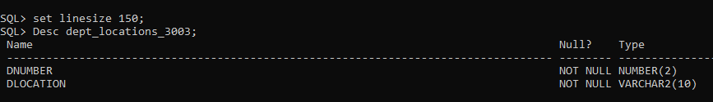

insert into dept_locations_3003 values(1,'Houston');

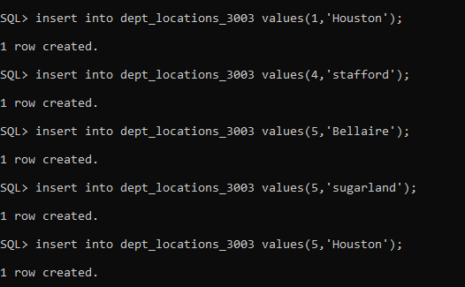

Select * from dept_locations_3003;

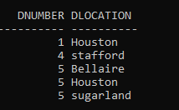

ADDING CONSTRAINTS:

alter table emp_503003 add constraint new foreign key(dno) references dept_503003(dnumber);



alter table dept_locations_3003 add constraint n foreign key(dnumber) references dept_503003(dnumber);



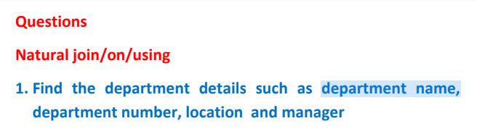

select dname,dnumber,dlocation,mgr_ssn from dept_503003 natural join dept_locations_3003;

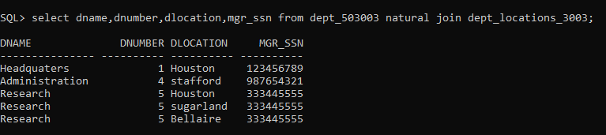



select e.fname||' '||e.lname as "employee name",d.dname,d.mgr_ssn,d.mgr_start_date,d.dnumber,dl.dlocation from

dept_503003 d join dept_locations_3003 dl on d.dnumber= dl.dnumber

join emp_503003 e on d.dnumber=e.dno;

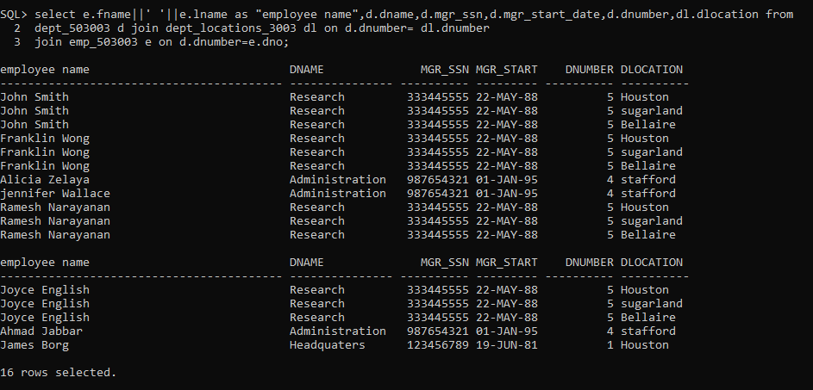

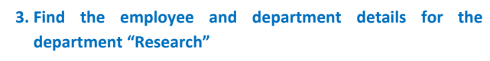

select e.fname||' '||e.lname as "employee name",d.dname,d.mgr_ssn,d.mgr_start_date,d.dnumber,dl.dlocation from

dept_503003 d join dept_locations_3003 dl on d.dnumber= dl.dnumber

join emp_503003 e on d.dnumber=e.dno where d.dname='Research';

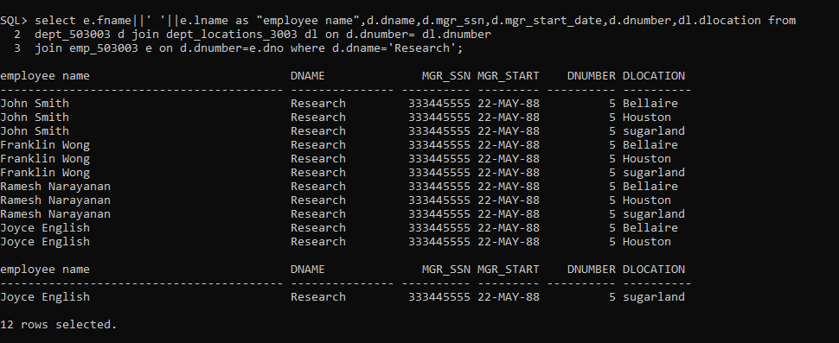

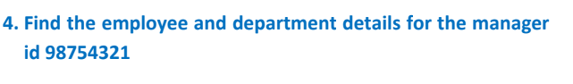

select e.fname||' '||e.lname as "employee name",d.dname,d.mgr_ssn,d.mgr_start_date,d.dnumber,dl.dlocation from dept_503003 d join dept_locations_3003 dl on d.dnumber= dl.dnumber join emp_503003 e on d.dnumber=e.dno where e.super_ssn='987654321';

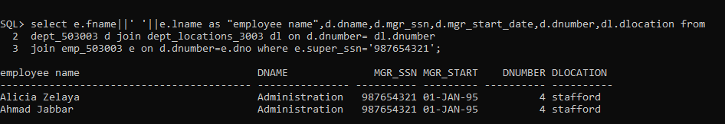



select e.fname||' '||e.lname as "employee name",d.dname,d.mgr_ssn,d.mgr_start_date,d.dnumber,dl.dlocation from

dept_503003 d join dept_locations_3003 dl on d.dnumber= dl.dnumber

join emp_503003 e on d.dnumber=e.dno where dl.dlocation='Houston';

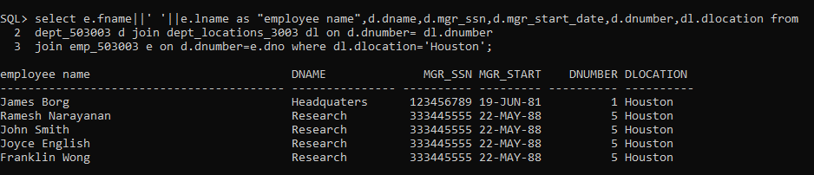

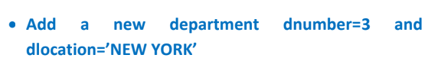

insert into dept_503003 values('Development',3, 453453453,'');

select * from dept_503003;

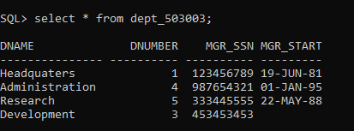

insert into dept_locations_3003 values (3,'New york');



select * from dept_locations_3003;

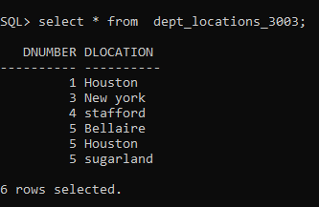



insert into emp_503003 values('Abirama', 'E', 'varshini', 96776686, to_date('2004-12-05', 'yyyy-mm-dd'),'450 Stone, Houston, TX','F',95000,NULL,3);

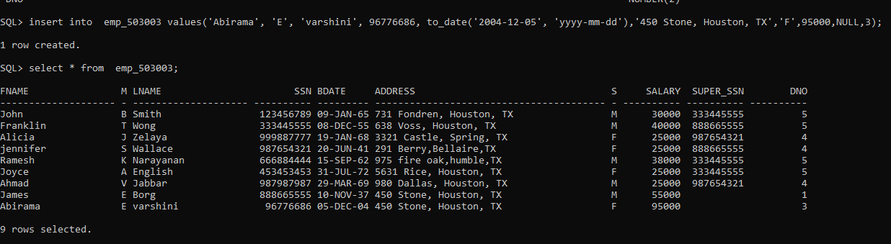

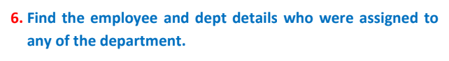

select e.fname||' '||e.lname as "employee name",d.dname,d.mgr_ssn,d.mgr_start_date,d.dnumber,dl.dlocation from

dept_503003 d join dept_locations_3003 dl on d.dnumber= dl.dnumber

join emp_503003 e on d.dnumber=e.dno;





select distinct d.dname,d.mgr_ssn,d.mgr_start_date,d.dnumber,dl.dlocation from

dept_503003 d join dept_locations_3003 dl on d.dnumber= dl.dnumber

join emp_503003 e on d.dnumber=e.dno;

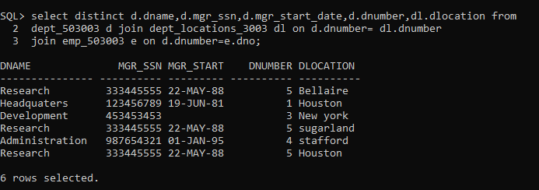





select d.dname,d.dnumber,e.fname||' '||e.minit||' '||e.lname as "Employee name",m.fname||' '||m.minit||' '||m.lname as "Manager name"

from emp_503003 e join dept_503003 d

on d.dnumber=e.dno join emp_503003 m

on m.ssn = d.mgr_ssn

order by d.dnumber;

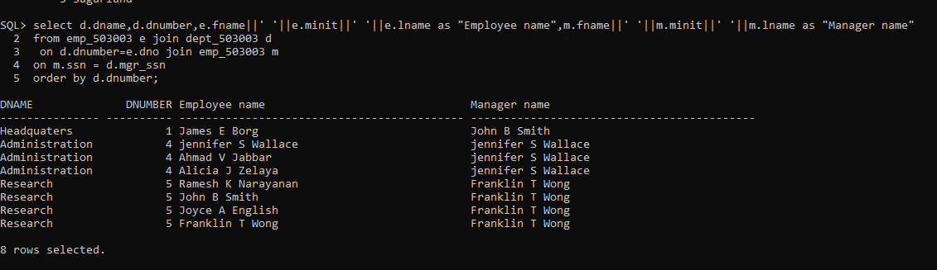

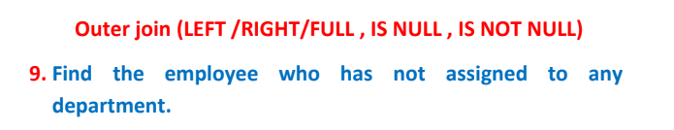

select e.fname||' '||e.minit||' '||e.lname as "Employee name",ssn,super_ssn,bdate salary from emp_503003 e where dno is null;





select d.dname,d.dnumber,dl.dlocation,d.mgr_ssn

from dept_locations_3003 dl join dept_503003 d

on d.dnumber = dl.dnumber

left join emp_503003 e

on d.dnumber=e.dno

where e.dno is null;

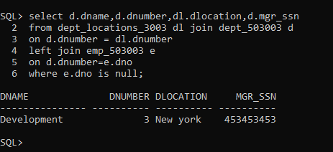

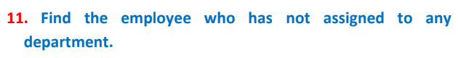

select e.fname||' '||e.minit||' '||e.lname as "Employee name",ssn,super_ssn,bdate salary from emp_503003 e where dno is null;



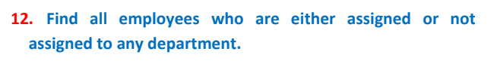

select fname||' '||minit||' '||lname as Name, ssn, salary, bdate

from emp_503003 e

left join dept_503003 d

on e.dno = d.dnumber;

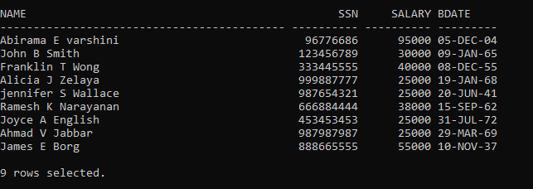

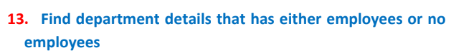

select distinct d.dname, d.dnumber, dl.dlocation, d.mgr_ssn

from dept_locations_3003 dl

join dept_503003 d

on d.dnumber = dl.dnumber

left join emp_503003 e

on d.dnumber = e.dno

order by d.dnumber;

