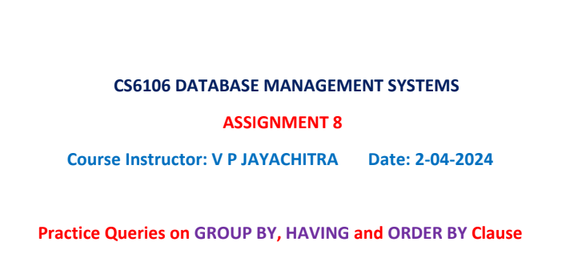

2022503003

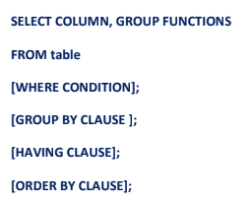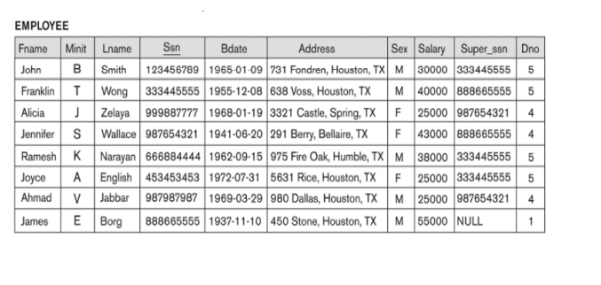

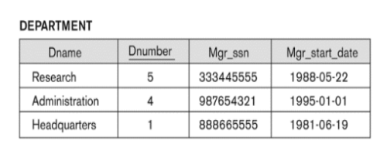



select d.dname,e.dno,count(*) as "no of employees in the department"

from dept_503003 d,emp_503003 e

where e.dno=d.dnumber

group by d.dname,e.dno;

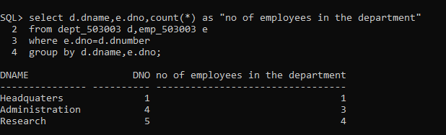

select dno,count(*) as "no of employees in the department" from emp_503003 group by dno;

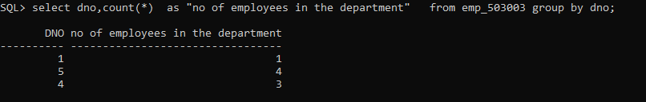



select dno,count(*) as "no of employees in the department",avg(salary) as "average of salary" from emp_503003 group by dno;

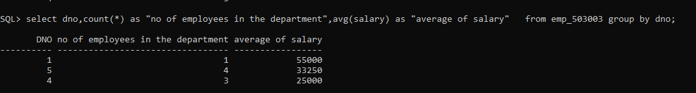

select d.dname,e.dno,count(*) as "no of employees in the department" ,

avg(e.salary) as "average of salary"

from dept_503003 d,emp_503003 e

where e.dno=d.dnumber

group by d.dname,e.dno;

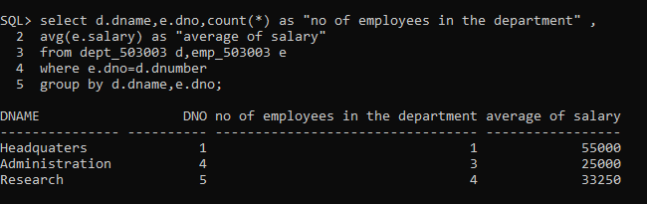



select dno,count(*) as "no of employees in the department",avg(salary) as "average of salary" from emp_503003 group by dno having count(*)>10;





select dno,sum(salary) as "average of salary" from emp_503003 group by dno;

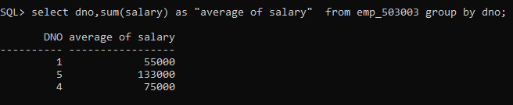



select count(*) as "No of employees wheo have salary grater than 50k" from emp_503003 where salary>50000;

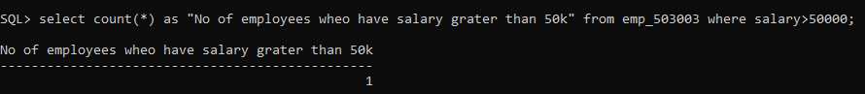



SELECT max(salary) as "Max salary" from emp_503003;

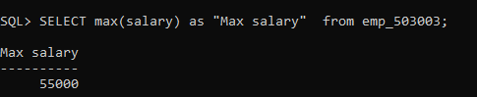



select m.super_ssn,count(*) as "no of emp managed by each emp"

from emp_503003 e join emp_503003 m on m.super_ssn=e.ssn group by m.super_ssn;

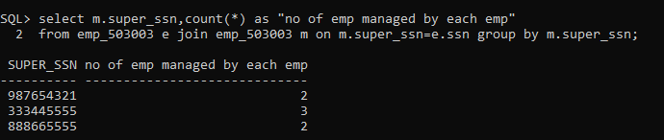



select salary,count(*) as "emp having same salary" from emp_503003 group by salary;

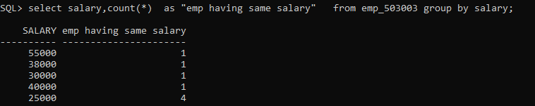



select dno,avg(salary) from emp_503003 group by dno order by avg(salary) desc fetch first 1 rows only;

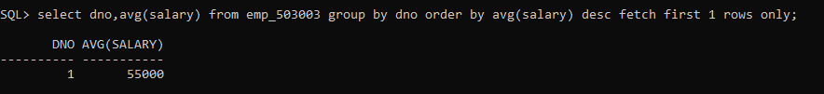



select to_char(bdate,'yyyy'),count(*) as "no of emps born each year" from emp_503003 group by to_char(bdate,'yyyy');

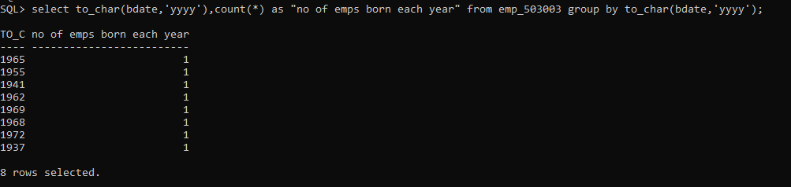



select sex,sum(salary) as "salary for genders" from emp_503003 group by sex;

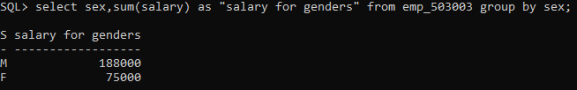



select lname,count(*) as "same last name" from emp_503003 group by lname;

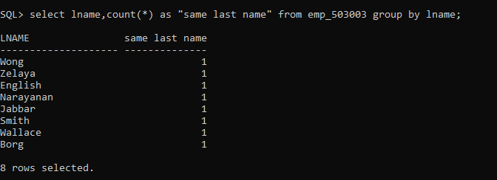



select dno,count(*) as "most emps" from emp_503003 group by dno order by count(*) desc fetch first 1 rows only;

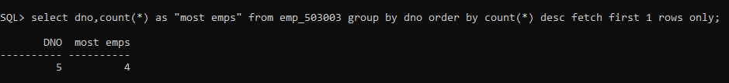



select dno,avg(to_char(current_date,'yyyy')-to_char(bdate,'yyyy')) as "average bdate" from emp_503003 group by dno;

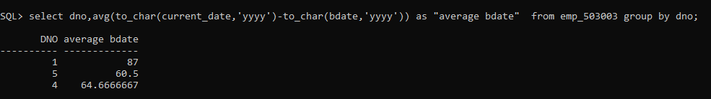



select count(*) as "emps having salary within range" from emp_503003 where salary>&start_salary and salary<&end_salary;

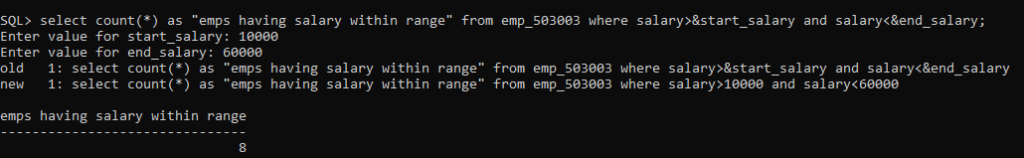

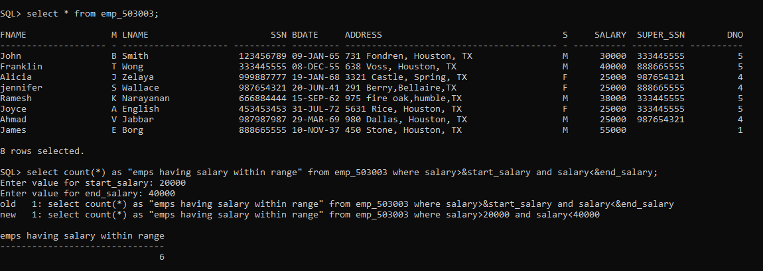



select m.super_ssn,sum(e.salary) as "total salary expense",count(*) as "no of emp managed by each emp"

from emp_503003 e join emp_503003 m on m.super_ssn=e.ssn group by m.super_ssn;

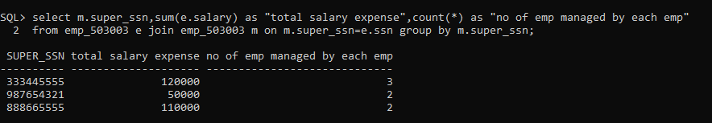



select bdate,count(*) as "unique bdate" from emp_503003 group by bdate;

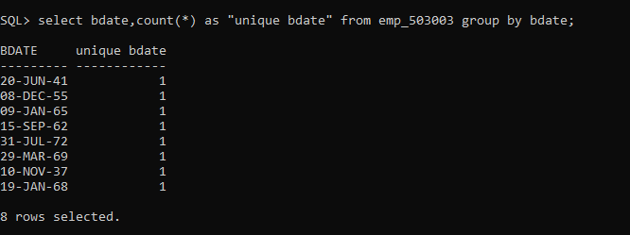



select dno,sum(salary) as "highest salary " from emp_503003 group by dno order by sum(salary) desc fetch first 1 rows only;





select to_char(bdate,'yyyy'),avg(salary) as "avg salary in each year" from emp_503003 group by to_char(bdate,'yyyy');

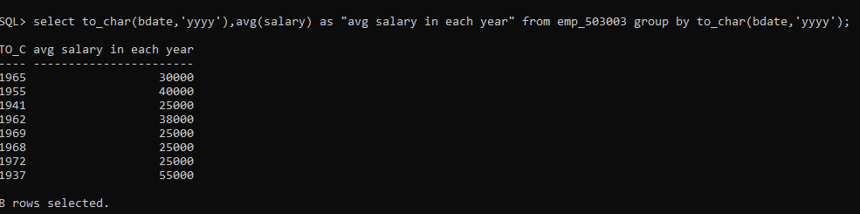



select substr(address, instr(address, ',') + 1, instr(substr(address, instr(address, ',') + 1), ',') - 1)as CITY, count(*) as "NO OF EMPLOYEES"

from emp_503003

group by substr(address, instr(address, ',') + 1, instr(substr(address, instr(address, ',') + 1), ',') - 1);

