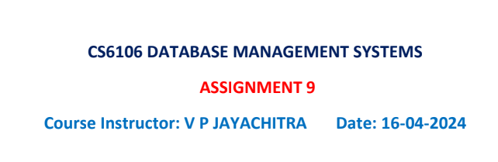

***2022503003***

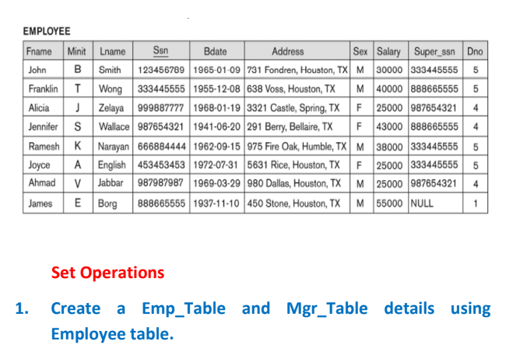

create table emp_table_3003 as select fname,minit,lname,bdate,ssn,super_ssn,dno from emp_503003;

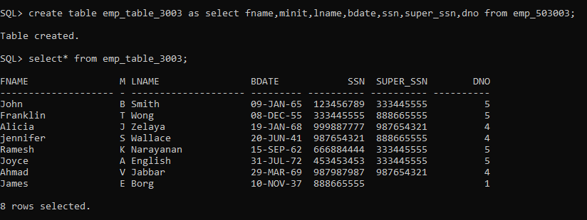

create table mgr_table_3003 as select fname,minit,lname,

ssn,dno from emp_503003 where ssn in (select super_ssn from emp_503003);

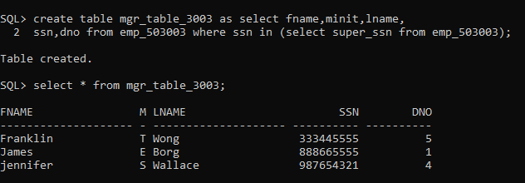

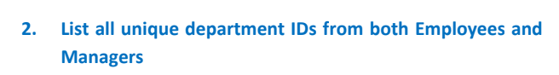

select distinct dno from emp_table_3003 union select distinct dno from mgr_table_3003;

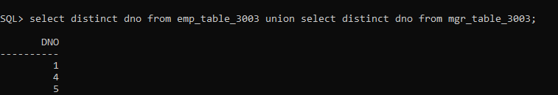

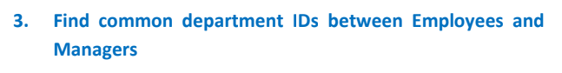

select distinct dno from emp_table_3003 intersect select distinct dno from mgr_table_3003;

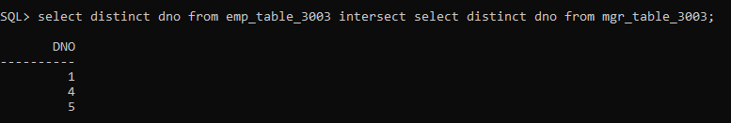

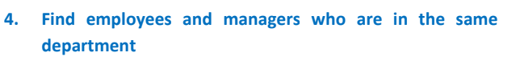

select * from emp_table_3003 e join mgr_table_3003 m on e.super_ssn=m.ssn and e.dno=m.dno;

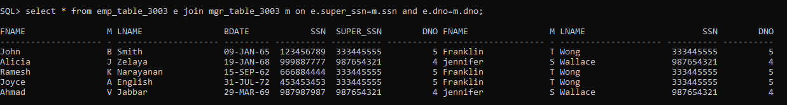

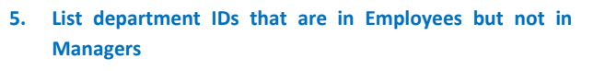

select dno from emp_table_3003 minus select dno from mgr_table_3003;

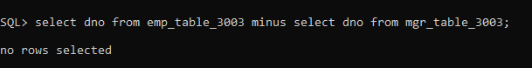



select fname||' '||lname as "employee name",dno,ssn from emp_table_3003 union select fname||' '||lname as "employee name",dno,ssn from mgr_table_3003;

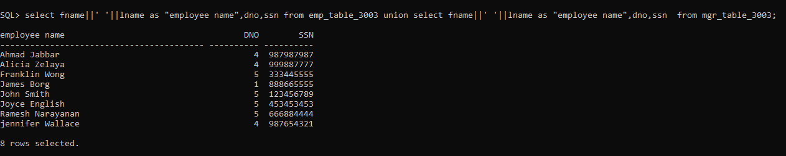



select fname||' '||lname as "employee name",dno,ssn from emp_table_3003 minus select fname||' '||lname as "employee name",dno,ssn from mgr_table_3003;

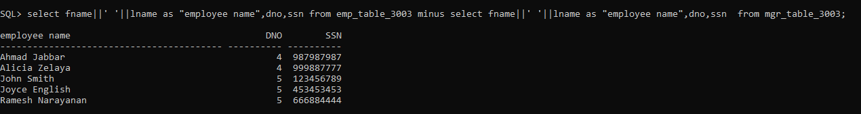



select dno from emp_table_3003 minus select dno from mgr_table_3003;



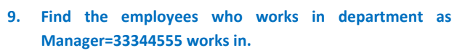

select * from emp_table_3003 where dno in (select dno from mgr_table_3003 where ssn=333445555);

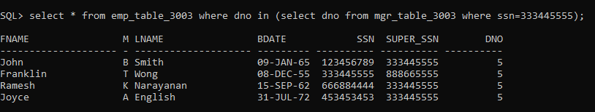

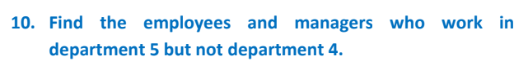

select * from(select fname||' '||lname as "employee name",dno,ssn from emp_table_3003 union select fname||' '||lname as "employee name",dno,ssn from mgr_table_3003

) where dno=5 and dno!=4;

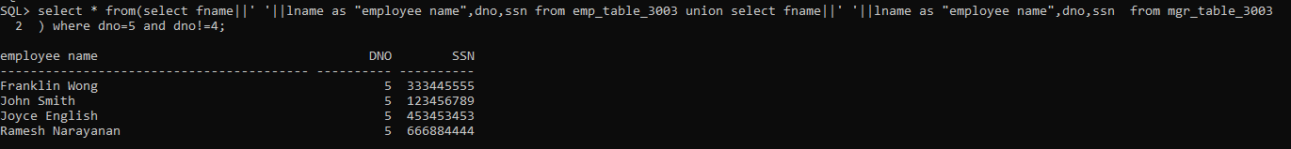

Select fname||' '||lname as "employee name",dno,ssn from emp_table_3003 where dno=5 minus select fname||' '||lname as "employee name",dno,ssn from mgr_table_3003 where dno=4;



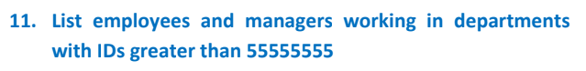

select * from(select fname||' '||lname as "employee name",dno,ssn from emp_table_3003 union select fname||' '||lname as "employee name",dno,ssn from mgr_table_3003

) where dno>55555555;

