FEDERATED LEARNING FOR CODE GENERATION WITH HALLUCINATION – AWARE FINE TUNING

A PROJECT REPORT

Submitted by
ABHINAVH P PRABHAKARA ARJUN R
BUVANES SRIVARDAN K

in partial fulfilment for the award of the degree
of
BACHELOR OF ENGINEERING IN
COMPUTER SCIENCE AND ENGINEERING



DEPARTMENT OF COMPUTER TECHNOLOGY
MADRAS INSTITUTE OF TECHNOLOGY CAMPUS
ANNA UNIVERSITY, CHENNAI 600 044
APRIL 2026

DEPARTMENT OF COMPUTER TECHNOLOGY ANNA UNIVERSITY, MIT CAMPUS CHROMEPET, CHENNAI – 600 044

BONAFIDE CERTIFICATE

Certified that the bonafide thesis report of the project work, “FEDERATED LEARNING FOR CODE GENERATION WITH HALLUCINATION – AWARE FINE TUNING” done by Mr. Abhinavh P ( 2022503059 ),
Mr. Prabhakara Arjun R(2022503003) & Mr. Buvanes Srivardan K (2022503037) in the Project Work Laboratory with subject code CS6811 during the period from December to April 2026.

SIGNATURE OF HOD SIGNATURE OF SUPERVISOR

Dr. PONSY R K SATHIA BHAMA Dr. THANASEKHAR B
Head of Department Professor
Department of Computer Technology Department of Computer Technology Anna University, MIT Campus Anna University, MIT Campus
Chromepet, Chennai-600044 Chromepet, Chennai-600044

ABSTRACT

Large Language Models (LLMs) have demonstrated strong capabilities in automated code generation, enabling solutions for a wide range of software engineering tasks. However, these models often suffer from hallucinations, producing syntactically correct but semantically incorrect code, including invalid APIs and logical errors. Such issues reduce the reliability of LLM based systems in practical applications.

In this project, A federated learning based framework for improving code generation by reducing hallucinations in a privacy preserving manner is proposed. The system integrates hallucination detection to identify and correct errors in generated code, thereby creating high quality datasets for model adaptation. These datasets are used to fine tune the model using parameter-efficient Low Rank Adaptation (LoRA) across multiple decentralized clients.

Each client performs local fine tuning using its own data, and only lightweight adapter parameters are shared with a central server, ensuring data privacy. Unlike traditional federated learning approaches that use standard Federated Averaging (FedAvg), this work introduces a novel aggregation strategy called Federated Error Average (FedErrorAvg), where model updates are weighted based on both dataset size and the distribution of hallucination errors across clients.

This error aware aggregation mechanism enables the model to learn more effectively from diverse error patterns, leading to improved generalization and reduced hallucinations. Experimental results demonstrate that the proposed approach achieves better correctness compared to baseline models.

ACKNOWLEDGEMENT

We take this opportunity to sincerely thank Prof. Dr. Jayashree P, respected Dean, Anna University, MIT Campus, and Dr. Ponsy R K Sathia Bhama, respected Head of the Department, Department of Computer Technology, for providing the essential facilities that enabled us to pursue this project.

We would like to thank our supervisor Dr. B.Thanasekhar, Professor, Department of Computer Technology, Anna University, MIT Campus, whose kind guidance and proper directions helped shape this project perfectly. Constant encouragement to implement the project to the fullest of our potential propelled us toward the successful completion of the proposed project work.

We acknowledge the efforts and feedback of the panel members, Dr. P. Pabitha, Associate Professor, Department of Computer Technology, MIT, Anna University, Dr. S. Chithra, Associate Professor, Department of Computer Technology, MIT, Anna University and Dr. V.P. Jayachitra, Assistant Professor, Department of Computer Technology, MIT, Anna University in reviewing our work, providing constant valuable comments and encouraging us to view the different aspects of the project in successful implementation of the project.

We thank all the teaching and non-teaching members of the Department of Computer Technology, MIT, Anna University and to my family and friends whose appreciable help, either directly or indirectly helped in the smooth completion of the Project work within the stipulated timeframe.
ABHINAVH P
PRABHAKARA ARJUN R
BUVANES SRIVARDAN K

LIST OF TABLES

TABLE NO. | TITLE | PAGE NO.
2.1 | SUMMARY OF LITERATURE SURVEY | 15

LIST OF FIGURES

FIGURE  NO. | TITLE | PAGE NO.
3.1 | Client-Side hallucination Detection And Dataset creation | 11
3.2 | LoRA Fine-Tuning and Federated Aggregation | 13
3.3 | Fed-Error Avg | 19
4.1 | Schema for AST module | 29
4.2 | Schema for dynamic analysis module | 30
4.3 | Schema for LIB_API module | 31
4.4 | Dataset Producing its own set of LoRA Adaptors | 33
4.5 | Output of fine-tuned adaptors after Federated average ( Complete dataset ) | 35
4.6 | Output of fine-tuned adaptors after Federated error average ( Complete dataset ) | 35
4.7 | Output of fine-tuned adaptors after Federated average ( Training dataset ) | 35
4.8 | Output of fine-tuned adaptors after Federated error average ( Training dataset ) | 35
4.9 | Model and Tokenizer loaded | 36
5.1 | Hallucination and Passed Count by Dataset | 36
5.2 | Baseline Vs FedAvg Error Count by Dataset (Train) | 38
5.3 | Baseline Vs FedAvg Error Count by Dataset | 38
5.4 | Baseline Vs FedErrorAvg Error Count by Dataset (Train) | 39
5.5 | Baseline Vs FedErrorAvg Error Count by Dataset | 39
5.6 | Baseline Vs FedAvg Vs FedErrorAvg Error Pass Rate by Dataset (Train) | 40
5.7 | Baseline Vs FedAvg Vs FedErrorAvg Error Pass Rate by Dataset (TT) | 41
5.8 | CodeBLEU : Baseline Vs FedAvg Vs FedErrorAvg by Dataset (Train) | 42

CHAPTER 1

INTRODUCTION

LARGE LANGUAGE MODELS IN CODE GENERATION

The emergence of large language models (LLMs) represents a major milestone in artificial intelligence and software engineering. These models, primarily based on transformer architectures, are trained on massive corpora consisting of source code, technical documentation, and natural language text. As a result, they can generate syntactically valid and semantically coherent code across multiple programming languages and domains.
Code generation the automatic synthesis of executable programs from natural language or partial code has long been a goal in software engineering. Earlier approaches, including rule based systems, template driven methods, and sequence to sequence models, were limited in scope, struggled with ambiguity, and lacked cross domain generalization. LLMs overcome these limitations by leveraging large scale pretraining, enabling transferability across tasks, languages, and abstraction levels.
Modern LLM based systems such as GitHub Copilot, Codex, AlphaCode, and Code Llama demonstrate strong capabilities in tasks like function completion, test generation, code translation, and even multi file program synthesis. Their widespread adoption in industry highlights both their practical utility and the importance of understanding their limitations.
Despite these advances, LLM based code generation is not fully reliable. A key issue is hallucination the generation of code that appears correct but is logically flawed, non functional, or based on non existent APIs. These errors are often subtle and can have serious consequences in real world software systems. Therefore, understanding and detecting hallucinations in LLM generated code remains a critical area for research.

HALLUCINATIONS IN CODE GENERATIONS
Despite the advancements in Large Language Models (LLMs) for code generation, ensuring the correctness and reliability of generated code remains a significant challenge. One of the major issues is hallucination, where the model produces syntactically correct but semantically incorrect code, including invalid API usage, logical inconsistencies, and runtime failures.
Existing approaches such as prompt engineering, repeated sampling, supervised fine-tuning, and reinforcement learning from human feedback (RLHF) provide partial improvements. However, these methods do not guarantee program correctness and often fail to address deeper structural and execution level errors.
Another key challenge arises in real world environments where data required for improving model performance is distributed across multiple clients. Due to privacy and data ownership concerns, this data cannot be centrally collected for training. Traditional centralized learning approaches are therefore not suitable for such scenarios.
Furthermore, standard federated learning methods, such as Federated Averaging (FedAvg), aggregate model updates based only on dataset size and do not consider the variation in error patterns across clients. This limits the model’s ability to effectively learn from diverse hallucination distributions.
These challenges highlight the need for a framework that ensures reliable code generation while enabling decentralized, privacy preserving learning with improved aggregation strategies.

FEDERATED LEARNING

The limitations of existing code generation approaches highlight the need for a more robust and scalable solution that ensures both correctness and adaptability. While Large Language Models (LLMs) are capable of generating code efficiently, their outputs often lack reliability due to hallucinations and insufficient validation mechanisms.
At the same time, real world data required to improve model performance is distributed across multiple clients and cannot be centrally aggregated due to privacy and data ownership constraints. This creates a need for decentralized learning approaches that can utilize distributed data without compromising privacy.
To address these challenges, a system is required that not only detects and corrects hallucinations but also enables collaborative learning across multiple clients. Furthermore, traditional federated learning approaches like FedAvg [3] are not sufficient, as they do not consider the variation in error patterns across different clients. Hence, there is a need for an improved aggregation strategy that can effectively utilize error information during model updates.
The proposed system addresses these requirements by combining hallucination aware processing with a federated learning framework and introducing an error aware aggregation method to enhance overall model performance

PARAMETER EFFICENT FINE TUNING

The scale of modern large language models ranging from millions to hundreds of billions of parameters makes full fine tuning computationally expensive and often impractical without large GPU infrastructure. It requires updating all parameters, storing gradients, and maintaining optimizer states, leading to significant memory and compute overhead. Parameter efficient fine tuning (PEFT) [4] addresses this by adapting a mostly frozen pre trained model using a small set of trainable parameters, significantly reducing resource requirements.
Among PEFT methods, Low Rank Adaptation (LoRA) [3],[11] is widely used, representing weight updates as the product of two low rank matrices, thereby reducing trainable parameters. Other approaches include prefix/prompt tuning, which inject trainable vectors into inputs or hidden states, and adapter modules, which add small bottleneck layers within transformer blocks. These methods trade slight reductions in flexibility for major gains in efficiency.
For code generating LLMs, PEFT is particularly valuable in reducing hallucinations, as it enables targeted fine tuning on curated datasets without overwriting general knowledge. This helps improve API correctness and generation reliability while preserving overall capability. When combined with federated learning, PEFT further reduces communication costs, since only lightweight adapter parameters need to be shared instead of full model updates.

PROBLEM STATEMENT

Large Language Models (LLMs) used for code generation often produce hallucinated outputs, resulting in syntactically correct but semantically incorrect code. These inaccuracies reduce the reliability of such models in real world software development scenarios. While existing approaches attempt to improve performance through fine tuning and prompt engineering, they do not effectively leverage distributed data available across multiple clients.

In practical environments, data required for improving model performance is decentralized and cannot be shared due to privacy and ownership constraints. Although federated learning provides a solution for decentralized training, traditional aggregation methods such as Federated Averaging (FedAvg) rely only on dataset size and fail to consider variations in error patterns across clients. This limits the model’s ability to learn effectively from diverse hallucination distributions.

Therefore, there is a need for a privacy preserving framework that not only enables collaborative learning across distributed clients but also incorporates error aware aggregation strategies to improve the reliability and correctness of LLM based code generation.

OBJECTIVE

The primary objective of this project is to design, implement, and evaluate a federated learning based framework that improves the reliability of LLM based code generation through privacy preserving, error aware fine tuning. The specific goals of the project are:
- Objective 1: Develop a federated learning framework using LoRA based PEFT to enable collaborative LLM fine tuning across decentralized clients on private codebases while reducing computational and communication overhead.
- Objective 2: Design a hallucination aware pipeline using static and dynamic program analysis to detect and classify syntactic, semantic, API related, and logical errors in generated code through a structured taxonomy.
- Objective 3: Propose Federated Error Average, a novel error aware aggregation strategy that incorporates client side hallucination error distributions to enhance global model robustness over heterogeneous, non-IID data.
- Objective 4: Evaluate the proposed framework on benchmark datasets using pass@k and hallucination metrics to validate improvements in functional correctness and reductions in hallucination frequency and severity.

OBJECTIVE

Chapter 1 introduces the role of LLM’s in code generation and the issues caused by hallucinations. It then discusses the challenges of handling diverse error patterns in distributed settings and the limitations of standard Federated Averaging. The chapter presents parameter-efficient fine-tuning using LoRA as a practical approach, and concludes with the problem statement and the project objectives, including hallucination detection, federated LoRA fine-tuning, the Fed-Error Average strategy, and evaluation metrics.
Chapter 2 provides a literature survey of works on LLM-based code generation, hallucination detection and mitigation, efficient fine-tuning, and federated learning. It reviews the approaches and identifies key gaps such as limited integration of execution-based detection, lack of error-aware aggregation, and challenges in decentralized settings that motivate the proposed framework.
Chapter 3 presents the architecture of the proposed hallucination-aware federated framework. It describes the client-side pipeline for code generation, static and dynamic analysis, and dataset creation, along with the server-side aggregation using LoRA adapters. The chapter also outlines the Fed-Error Average strategy for error-aware aggregation.
Chapter 4 details the implementation of the system, including datasets, tools, and model configuration. It covers the integration of detection modules, dataset construction, LoRA fine-tuning setup, and federated aggregation using both FedAvg and Fed-ErrorAvg, along with the evaluation setup for generalization.
Chapter 5 presents the results and evaluation across HumanEval, MBPP, and DS1000. It compares baseline, FedAvg, and Fed-ErrorAvg approaches using hallucination counts, pass rates, and CodeBLEU scores, highlighting improvements and remaining limitations.
Chapter 6 concludes the work by summarizing the contributions in hallucination-aware training and federated aggregation. It also outlines future directions such as scaling to larger models, improving repair mechanisms, and extending the framework to more complex datasets and multi-round training.

CHAPTER 2
LITERATURE SURVEY

This chapter presents a review of research on large language model (LLM) code generation, hallucination analysis and mitigation, federated and parameter-efficient fine-tuning, and secure federated deployment. The survey is organized into six sections: (2.1) Reliability, Evaluation, and Prompting for LLM Code; (2.2) Hallucination Detection, Repair, and Code-Centric LLM Pipelines; (2.3) Federated Learning and Parameter-Efficient Fine-Tuning for LLMs; (2.4) Secure Code Deployment and Federated Learning with LLMs; (2.5) Heterogeneous LoRA Aggregation and Device-Aware PEFT in Federated Settings; and (2.6) Summary of Literature.

2.1 RELIABILITY, EVALUATION, AND PROMPTING FOR LLM CODE
A substantial line of work examines how prompting strategies and broad empirical studies affect the trustworthiness and functional quality of LLM-produced programs. These studies inform when lightweight input shaping is sufficient and when deeper execution-based validation or decentralized training is required.

Khojah et al., 2025 [5] analyzed the impact of prompt programming on function-level code generation. Their study shows that structured prompts improve code quality and reduce minor errors. However, prompt engineering is highly sensitive and does not eliminate deeper logical or semantic errors. The approach lacks robustness across diverse tasks and does not address hallucination systematically, which motivates combining prompts with automated detection and federated adaptation in this project.

Yu et al., 2024 [6] evaluated the reliability of LLMs in source code-related tasks and demonstrated that model performance varies significantly across datasets and task complexity. The study highlights the presence of hallucinations and inconsistencies in generated outputs. However, it does not propose a concrete solution for mitigating these issues and lacks integration with learning frameworks, underscoring the need for an error-aware federated fine-tuning pipeline.

Liu et al., 2024 [8] assessed the quality of code generated by LLMs and found that while outputs are often syntactically correct, they frequently fail functionally due to logical errors and incorrect assumptions. The study highlights limitations in reasoning capabilities of current models. However, it does not provide mechanisms for correcting hallucinated outputs or for pooling evidence across distributed clients.

2.2 HALLUCINATION DETECTION, REPAIR, AND CODE-CENTRIC LLM PIPELINES
Complementary research focuses on detecting unreliable code, guiding repair, and structuring interactive generation workflows. These methods improve local output quality but often assume centralized data or omit federated aggregation of error structure.

Advancing LLM-Generated Code Reliability: A Hybrid Approach for Hallucination Detection
Yang et al., 2025 [1] proposed a hybrid approach for hallucination detection in LLM-generated code by combining static and dynamic analysis techniques. The system analyzes code using abstract syntax trees (AST) and validates execution through runtime testing to detect both structural and functional errors. The approach improves detection accuracy across multiple error types. However, it depends heavily on test case coverage and may fail to detect deeper semantic inconsistencies. Additionally, scalability in distributed environments remains a challenge, which this project addresses by feeding detection outcomes into decentralized LoRA fine-tuning.

LLM-Based Test-Driven Interactive Code Generation: User Study and Empirical Evaluation
Fakhoury et al., 2024 [2] proposed a test-driven interactive code generation framework that integrates LLM outputs with user-defined test cases. The system improves code reliability by validating generated outputs against test cases during generation. However, the approach relies on the availability of high-quality test cases and may not perform well when test coverage is incomplete. It also lacks mechanisms for correcting detected errors automatically at scale across isolated clients.

Knowledge-Enhanced Program Repair for Data Science Code
Ouyang et al., 2025 [9] proposed a knowledge-enhanced program repair approach that uses contextual information to guide patch generation. The system improves repair accuracy compared to traditional methods. However, it depends on the availability of structured knowledge and may struggle with complex or unseen error patterns, and it is not designed around privacy-preserving multi-client adapter aggregation.

THINK: Tackling API Hallucinations in LLMs via Injecting Knowledge
Liu et al., 2025 [10] proposed a method to address API hallucinations by injecting external knowledge into LLMs. The approach improves correctness by guiding the model with verified API information. However, it is limited to API-level errors and does not address broader logical or structural hallucinations, nor does it exploit cross-client diversity of failure modes during federated updates.

EvoAPR: Enhancing Large Language Models for Automatic Program Repair with Genetic Algorithm and Dynamic LoRA
Zhang et al., 2025 [11] proposed EvoAPR, which combines genetic algorithms with LLM-based program repair and dynamic LoRA adaptation. The system iteratively improves patch quality and repair success rates. However, it is computationally expensive and may not scale efficiently for large datasets or real-time applications, and it does not target federated aggregation weighted by hallucination statistics.

2.3 FEDERATED LEARNING AND PARAMETER-EFFICIENT FINE-TUNING FOR LLMS
Federated and adapter-based fine-tuning enables privacy-preserving collaboration on LLMs. Existing frameworks often aggregate updates by data volume or standard averaging without using structured error signals from code validation.

Chen et al., 2025 [3] proposed a federated adaptive fine-tuning framework for large language models in software development. The system enables decentralized training across multiple clients while preserving data privacy by sharing only model updates. Although the framework improves adaptability across distributed datasets, it does not incorporate error-aware learning or hallucination-specific optimization. Aggregation is still based on standard federated averaging, limiting its effectiveness when clients exhibit diverse defect distributions.

Nashaat and Miller, 2024 [4] proposed an efficient fine-tuning approach using organizational data to improve software-related tasks. The system reduces computational overhead by using parameter-efficient fine-tuning techniques. However, the approach is designed for centralized environments and does not consider distributed data scenarios. It also does not address hallucination issues in generated code.

Yi et al., 2025 [7] proposed FedALoRA, which combines low-rank adaptation (LoRA) with federated learning to enable efficient and privacy-preserving model training. The system allows local fine-tuning using lightweight adapters and reduces communication overhead. However, the approach focuses on general NLP tasks and does not consider hallucination-specific optimization in code generation, which motivates error-statistic-aware aggregation in the present work.

2.4 SECURE CODE DEPLOYMENT AND FEDERATED LEARNING WITH LLMS
Operational security and automation for heterogeneous federated deployments intersect with LLM-based code adaptation. Such work highlights threats during code rollout even when raw data remain local.

Flexible and Secure Code Deployment in Federated Learning using Large Language Models: Prompt Engineering to Enhance Malicious Code Detection
Seo et al., 2023 [12] study how LLMs can tailor deployment artifacts across heterogeneous federated clients and introduce prompt-engineering techniques to improve malicious-code detection before execution. The work strengthens trust in automated code distribution pipelines where human access to each node is limited. However, its emphasis is on security screening rather than on reducing semantic hallucinations in generated application code or on weighting federated updates by categorized coding errors, leaving room for complementary hallucination-aware training as proposed here.

2.5 HETEROGENEOUS LORA AGGREGATION AND DEVICE-AWARE PEFT IN FEDERATED SETTINGS
Recent advances address mismatched LoRA ranks across clients and heterogeneous device capacity—core practical barriers when scaling federated fine-tuning of code LLMs.

Federated Fine-Tuning on Heterogeneous LoRAs With Error-Compensated Aggregation
Ning et al., 2025 [13] propose ECLoRA, a federated fine-tuning method for heterogeneous LoRA configurations. The approach uses randomized singular value decomposition to lower aggregation cost and an error-compensation mechanism that carries forward decomposition residuals to improve precision. Experiments show improved accuracy and faster convergence than classical SVD baselines. The method does not, however, exploit domain-specific hallucination taxonomies from static and dynamic code analysis to reweight clients, which is the focus of Fed-Error Average in this thesis.

Adaptive Parameter-Efficient Federated Fine-Tuning on Heterogeneous Devices
Liu et al., 2025 [14] present LEGEND, a LoRA-based federated fine-tuning framework that adapts LoRA depth and rank placement for resource-constrained and heterogeneous devices, reporting substantial speedups and communication savings on a large device testbed. While highly relevant to efficient cross-client training, LEGEND optimizes compute and bandwidth rather than incorporating cross-client distributions of hallucination-related faults into the aggregation rule.

2.6 SUMMARY OF LITERATURE
Key Finding 1: LLM code outputs remain unreliable—prompting alone and single-node evaluation studies [5], [6], [8] do not remove deep semantic or functional failures, motivating execution-grounded detection [1] and structured repair lines [9]–[11].

Key Finding 2: Federated adapter training for LLMs is feasible [3], [7], but standard aggregation ignores variation in defect types across clients, which is pronounced in code generation where failures are structured and enumerable.

Key Finding 3: Heterogeneous LoRA and device settings are actively researched [13], [14]; these improve how updates are aligned and communicated but do not replace application-specific signals such as hallucination error histograms when weighting contributions.

Key Finding 4: Security-oriented FL deployment with LLMs [12] complements—but does not substitute for—training-time mitigation of hallucinations through privacy-preserving fine-tuning.

Research Gap: No surveyed work jointly combines (i) client-side static and dynamic hallucination analysis for code LLMs, (ii) LoRA-only federated updates without centralizing raw code, (iii) heterogeneous-client LoRA practice as in recent FL literature, and (iv) aggregation that up-weights clients carrying more informative hallucination-error structure. This project addresses that gap through the proposed Fed-Error Average pipeline integrated with the hallucination detection and dataset construction stages described in subsequent chapters.

S.No. | Reference | Focus | Methodology | Limitations
1 | Yang et al., 2025 [1] | Hybrid static/dynamic hallucination detection for LLM code | AST + execution-based testing | Test coverage; weak on deep semantics; limited FL scaling
2 | Fakhoury et al., 2024 [2] | Test-driven interactive code generation | User tests during generation | Needs strong tests; limited auto-repair
3 | Chen et al., 2025 [3] | Federated adaptive LLM fine-tuning for software dev. | Fed training; adapter exchange | No error-aware or hallucination-specific aggregation
4 | Nashaat and Miller, 2024 [4] | PEFT with organizational data for code review | Efficient fine-tuning | Centralized; no FL; no code hallucination focus
5 | Khojah et al., 2025 [5] | Prompt programming for function-level code gen. | Empirical prompt study | Sensitive prompts; no systematic hallucination control
6 | Yu et al., 2024 [6] | Trustworthiness of LLMs on source-code tasks | Empirical evaluation | No mitigation framework tied to FL
7 | Yi et al., 2025 [7] | FedALoRA personalized FL with local LoRA aggregation | LoRA + FL for LLMs | General NLP; not code-hallucination centric
8 | Liu et al., 2024 [8] | Quality of ChatGPT code generation | Benchmark assessment | No repair/FL integration
9 | Ouyang et al., 2025 [9] | Knowledge-enhanced repair for data-science code | Context-guided patching | Depends on external knowledge; scalability
10 | Liu et al., 2025 [10] | THINK: reduce API hallucinations via injected knowledge | Knowledge injection | API-centric; not full-program FL pipeline
11 | Zhang et al., 2025 [11] | EvoAPR: GA + dynamic LoRA for APR | Evolutionary LLM repair | Compute cost; not federated
12 | Seo et al., 2023 [12] | FL code deployment with LLMs; malicious-code prompts | Prompt engineering + security | Deployment/security angle; not hallucination-aware training
13 | Ning et al., 2025 [13] | ECLoRA heterogeneous LoRA aggregation | RSVD + error compensation | Aggregation focus; not error-type weighting for code gen.
14 | Liu et al., 2025 [14] | LEGEND: adaptive LoRA depth/rank on heterogeneous devices | Device-aware FedFT | Efficiency/heterogeneity; no hallucination error stats in aggregation

Table 2.1 Summary of Literature Survey
CHAPTER 3

PROPOSED WORK

  - SYSTEM OVERVIEW
The proposed system is organized into two tiers: the client tier and the server tier. These tiers interact through parameter exchange mechanism, where only LoRA adapter weights are shared, never the raw data.

At the client tier, each participating client operates as a fully independent code generation and fine-tuning unit. A client receives a benchmark dataset or dataset partition, generates code using the frozen base LLM then subjects the generated code to a hallucination detection pipeline, and constructs a local training dataset from the outcomes. The client then performs supervised fine-tuning(SFT) using LoRA on this locally assembled dataset, producing a set of client-specific adapter weights. These weights encode the learning the model derived from that client's error patterns and corrected programs.

The server tier consists of a central aggregation server whose sole responsibility is to collect LoRA adapters from all clients at the end of each communication round, perform weighted averaging to produce a global adapter, and redistribute that global adapter back to all clients. The server performs no code generation or evaluation; it is purely a coordinator. It is important to note that it never has access to the raw datasets, generated code, or problem statements from any client. The full pipeline is illustrated in Figure 3.1 and Figure 3.2.

  - METHODOLOGY WITH ARCHITECTURE DIAGRAM

3.2.1 Phase 1 : Client-Side Hallucination Detection and Dataset Construction
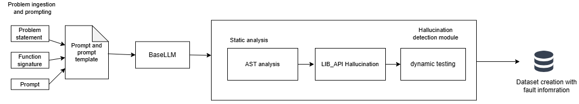

Figure: 3.1 – Client-side hallucination detection and dataset construction framework

The first phase is executed entirely within each client and encompasses all activities from code generation through dataset preparation. It begins with problem ingestion, where benchmark datasets (HumanEval, MBPP, and DS-1000) are loaded and each client is assigned a distinct dataset or partition to simulate heterogeneous data distributions in a real federated environment (Figure 3.1). For each task, a structured prompt is constructed by combining the problem description and the function signature. This prompt is then fed to the frozen Qwen2.5-Coder-3B [] model using single-shot prompting, producing an initial code solution.

Once code is generated, it enters the hallucination detection pipeline. Static analysis is performed first using Python's AST module, which parses the generated code and inspects its structural representation. Following static analysis, a library and API validation step checks whether the functions, methods, and attributes called in the code correctly correspond to the actual interfaces provided by the libraries available in the execution environment.
After static analysis, the code undergoes dynamic analysis by executing it against the test cases provided by the benchmark dataset. Execution takes place in a controlled environment with timeout protection to prevent infinite loops from stalling the pipeline. Any runtime exceptions - including AssertionError, NameError, TypeError, ValueError, IndexError, and others - are captured along with their traceback information, including error type, error message, and the line number where the failure occurred. Failures in assertion checks, which indicate semantic or logical errors, are also recorded alongside the expected and actual outputs for each test case.

These fault records, together with the original prompt, the generated code, and the canonical solution from the dataset, form the raw material for dataset construction.

Dataset construction organizes the above information into a structured format with columns including the dataset name, task identifier, prompt, status, AST analysis information, dynamic analysis information, library analysis information, the generated code, the target code (canonical solution), error sources, error types, error lines. The prompt and canonical solution columns are the primary training signal used in the subsequent LoRA fine-tuning stage. The error type and frequency information is recorded separately to be reported to the server for use in the Fed-Error Average aggregation.

3.2.2 Phase 2 : LoRA Fine-Tuning and Federated Aggregation

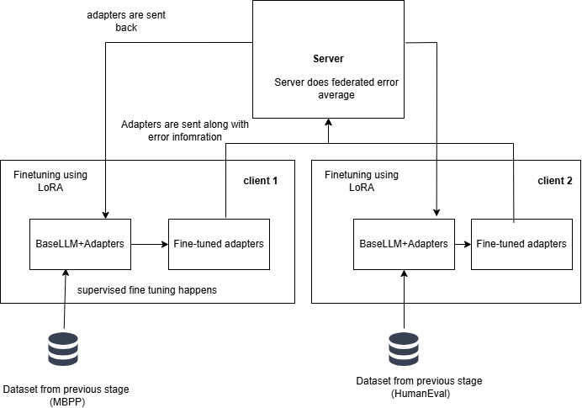

Figure: 3.2 LoRA Fine tuning and federated aggregation

Refer to Figure 3.2,the second phase begins once the client has assembled its dataset from Phase 1. The base Qwen2.5-Coder-3B model is loaded and base model is frozen and LoRA adapter modules are injected into all seven projection matrices of each transformer layer.This comprehensive injection ensures that the adapter can influence both the attention and feed-forward computations across all 36 transformer layers of the model(QwenCoder).

The LoRA rank is set to 16 and the scaling factor alpha to 32, yielding an effective scaling multiplier of 2. With these setting we get 504 adapter in total, corresponding to 36 layers. The total number of trainable LoRA parameters across the model is approximately 29.9 million, which is a small fraction of the full 3.09 billion parameters. All original model weights remain strictly frozen throughout training; only the LoRA adapter matrices are updated.

Training is conducted using supervised fine-tuning (SFT) . After training completes, the LoRA adapter weights are saved as a .pt checkpoint file and prepared for transmission to the central server. No model weights, no raw data, and no code examples leave the client at this stage; only the compact adapter checkpoint is sent.

At the server, the Fed-Error Average aggregation algorithm is applied. First, the server collects the adapter checkpoints and the error frequency reports from all participating clients. For each error type e observed across all clients, the total error frequency $F_{e}$ is computed by summing the counts of that error type across all clients. A normalized weight is then assigned to each error type based on its global frequency, reflecting how prevalent that category of error is across the federated system. For each client k, an error score $E_{k}$ is computed by multiplying the count of each error type on that client by the corresponding global weight and summing across all error types. This score quantifies how rich or diverse the client's error distribution is relative to the overall population.

Each client's aggregation weight $α_{k}$ is obtained by normalizing its error score $E_{k}$ against the sum of all clients' error scores. These weights replace the sample-size-based weights used in standard FedAvg. The global adapter at round t+1 is then computed as the weighted average of all clients' adapter weights at round t, with each client weighted by its $α_{k}$. The resulting global adapter is redistributed to all clients, who load it alongside the frozen base model to obtain an improved code generation system. This completes one federated communication round, and the process can be repeated for subsequent rounds.

  - MODULE BREAKDOWN
    - Code Generation Module
This module is responsible for loading benchmark datasets and generating initial code solutions from the frozen base language model. Here, benchmark code generation datasets such as MBPP, HumanEval, and DS-1000 are loaded from Hugging Face datasets library. Code generation is done by single-shot prompting .
The frozen Qwen2.5-Coder-3B pretrained model is used to generate the initial code solutions . Code generation is performed with deterministic settings (do_sample=False, temperature=1.0) to ensure reproducibility. The output of this module for each task is a raw generated code string, which may or may not contain hallucinations, and which serves as the input to the hallucination detection module.
In the federated setting, different clients are assigned different datasets. Client 1 operates on MBPP, while Client 2 operates on HumanEval, Client 3 operates with DS1000 simulating the heterogeneous data distributions that would arise when different organizations generate code for different domains.

    - Hallucination Detection Module
The hallucination detection module constitutes the analytical core of the client-side pipeline. It accepts a generated code string as input and produces a structured fault record as output. The module operates in two sequential stages: static analysis and dynamic analysis.
The AST module is the first stage of hallucination detection and inspects code without executing it. It parses the Python source into a tree. If parsing fails due to invalid syntax or indentation, it records the error, its line number, and stops, since the code cannot be executed. When parsing succeeds, it traverses the tree and checks that control-flow constructs are used correctly: return only inside functions, and break and continue only inside loops; otherwise it reports structural violations. It also performs flow-aware name analysis: it follows control flow through conditionals, loops, try-except blocks, and nested scopes, and tracks where variables are defined and used.
It reports uses of variables that are never defined on any path, including in branches that tests may not run. It can therefore detect syntax errors, indentation errors, structural misuses, and undefined variables purely from the code structure, without running tests. Because it works statically, it can find these defects even in rarely executed paths, unlike dynamic testing, which only detects errors on paths actually covered by tests. Any reported error causes later stages (dynamic execution and API checks) to be skipped, because the code is not valid for execution.
The LIB_API module performs static checks on how external libraries and APIs are used in the generated code. It does not run the code; it inspects the source to validate imports, attribute access, and function calls. For imports, it checks that imported modules exist and can be loaded. For attribute access (e.g., obj.attr), it checks that the attribute exists on the object. For function and method calls, it checks that the number and types of arguments match the expected signature. It reports missing modules, invalid attributes, and invalid arguments. The module distinguishes between failures caused by missing libraries in the environment and real API misuse in the generated code, so only actual hallucinations are flagged. Its output includes counts of module-not-found, attribute, type, and name errors, object, attribute, or function involved and the line number, which helps locate and fix library-related hallucinations.
The dynamic analysis module executes the generated code with the benchmark’s test cases and observes what happens at runtime. It runs the code in an isolated environment with a timeout to avoid hanging on infinite loops. If execution completes and all tests pass, the code is marked as passed. If execution raises an exception or a test fails, it records the status as failed along with the exception type, message, and the line number where it occurred. It can report runtime errors such as type mismatches, attribute or name errors, key errors, assertion failures (wrong output), and timeouts (too slow or non-terminating). For failing tests, it records the failing input, the expected output, and the actual output. This module only sees defects that occur on paths executed by the test cases; it cannot detect errors in code paths that are never run, which is why it is complemented by static analysis modules such as AST and LIB_API that check structure and API usage without running the code.
    - Dataset Creation
The dataset construction module transforms the raw outputs of the hallucination detection module into a structured training dataset suitable for LoRA fine-tuning. For each task processed by the client, the module assembles a record containing the dataset name, task identifier, prompt, hallucination status, AST analysis information, dynamic analysis information, library analysis information, the generated code, canonical target code, the error sources, the error types, the error lines, and the canonical solution from the benchmark. An automatic program repair (APR) module was initially intended to correct hallucinated code using the detected error information and patched code; however, in practice it often failed to produce valid fixes even when given precise fault locations and error types, owing to limitations of the Qwen coder model in reliably repairing code from such inputs.
Given this, the system does not rely on APR outputs as training targets. Instead, programs that passed all hallucination checks are stored with the generated code as the target, while programs that failed detection are stored with the canonical solution from the benchmark as the target, since the model's generation is unreliable in those cases and APR could not reliably fix it. The prompt and canonical solution columns serve as the input–output pairs for supervised fine-tuning. This design ensures that fine-tuning always uses a correct reference target, even when the model’s own generation was hallucinated.
The main aim is to achieve hallucination reduction in a federated setting rather than through detection and repair; the hallucination framework is used to assess code correctness via pass@1 evaluation.
    - LoRA Fine-Tuning Module
The LoRA fine-tuning module performs parameter-efficient supervised fine-tuning of the base model using the dataset assembled by the dataset construction module. Low-Rank Adaptation (LoRA) decomposes weight updates into products of two low-rank matrices, drastically reducing the number of trainable parameters while preserving the expressive capacity needed to adapt to new data patterns.
LoRA modules are injected into all seven projection matrices of each of the 36 transformer layers in the base model: the query $(q_proj$), key ($k_proj$), value ($v_proj$), and output ($o_proj$) projections in the self-attention sublayer, and the gate ($gate_proj$), up ($up_proj$), and down ($down_proj$) projections in the MLP sublayer.
The base model weights remain fully frozen throughout training, and only the LoRA adapter matrices are updated via gradient descent. An effective batch size of 8 is achieved through gradient accumulation (per-device batch size of 1, accumulation steps of 8), and training runs for 3 epochs over the local dataset. At the end of training, only the LoRA adapter weights , not the full model are saved to disk as a .pt checkpoint file. This tensors is sent back to servers.

    - Federated Aggregation Module
The federated aggregation module operates on the central server and is responsible for combining the LoRA adapter received from all clients into a single global adapter. The module implements the proposed Fed-Error Average algorithm, which extends standard Federated Averaging by incorporating hallucination error frequency information alongside dataset size.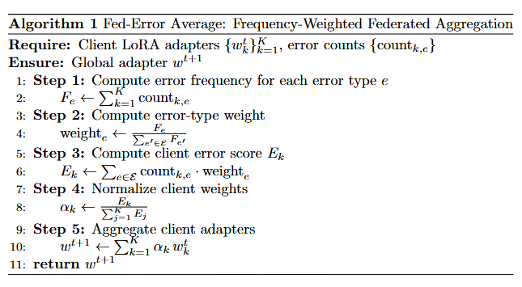
Fig 3.3 : Algorithm for Federated error Average
The aggregation process begins by computing, for each error type e, the global error frequency $F_{e}$ as the sum of counts of that error type across all clients. A normalized weight for each error type is then derived by dividing $F_{e}$ by the total count of all error types observed globally. For each client k, an error score $E_{k}$ is computed as the weighted sum of the client's per-type error counts, using the global error type weights. This score reflects not just how much data the client has, but how diverse and significant its error distribution is relative to the global picture. The client's aggregation coefficient $α_{k}$ is obtained by normalizing $E_{k}$ against the sum of all clients' error scores.
The global adapter at round t+1 is computed as the sum over all clients of $α_{k}$times the client's local adapter weights $w_{k}^{t}.$ This weighted average is applied element-wise across all 504 adapter matrices. The resulting global adapter is then send back to all clients. Each client merges the global adapter with the frozen base model to obtain the updated code generation system for inference or for further rounds of local fine-tuning.

The advantage of this formulation over standard FedAvg is that clients whose local datasets reflect more complex or more diverse hallucination patterns for instance, a client that observed many distinct error types versus one that saw mostly a single error type contribute proportionally more to the global update. This is particularly important in heterogeneous federated settings, where different clients encounter qualitatively different failure modes in code generation.

    - Verification Module
The verification module checks whether the fine-tuned LoRA adapters improve code generation. It loads the base model plus the LoRA adapter (FedAvg or Fed-Error-Avg), generates code for each benchmark task, and runs the full hallucination pipeline (AST, dynamic execution, and LIB_API) on that output. The result is a pass-or-fail status for each task, recorded in a CSV with the same format as the baseline. By comparing baseline (no adapter) and adapter runs, it measures how many more tasks pass after fine-tuning and whether the federated adapters reduce hallucinations and improve Pass@1.

3.3.7 Formualas Used

1. Basic LoRA

LoRA reduces the number of trainable parameters by decomposing the weight update into two low-rank matrices, allowing efficient fine-tuning without modifying the full model weights. Below is the mathematical split-up and working of it.

Let W₀ be the weight of the base model,
$$W_{0}∈R^{d×k}$$

Now we can breakdown this W₀ into two adapters B and A (LoRA matrices) with a rank r,

$$ΔW = BA$$

Thus B and A are,

$$B∈R^{d×r}, A∈R^{r×k}$$
Updated weights,
$$W=W_{0}+BA$$

Scaled LoRA used at experiment,

$$W=W_{0}+\frac{α}{r}BA$$

r – rank of low-rank decomposition
α – scaling factor

2. Federated average

Standard federated averaging aggregates local model weights from all clients into a single global model by taking a uniform weighted mean across participants. This is the conventional method.
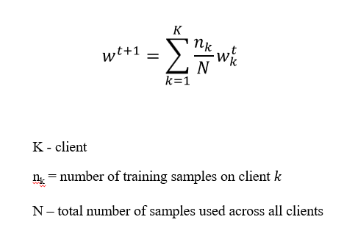

3. Augmented Fed-average(Frequency-weighted/Fed-ErrorAverage)

This extends standard federated averaging by assigning higher aggregation weights to clients that encountered more errors during training, ensuring the global model learns more from clients where hallucinations were harder to resolve.

Error frequency ,
$$F_{e}=\sum_{k=1}^{K}{count_{k,e}}$$
F_{e}​ = total occurrences of error type ‘$e’$across all clients
count_{k,e​} = number of errors of type ‘$e’$in client $k$

Weight Definition,
$$weight_{e}=\frac{F_{e}}{\sum_{e^{'}∈errors}{F_{e^{'}}}}$$

This is calculated for weight for each type of error based on their occurrence.

Error score,
For each client, the total count of each type of error along with its computed weight is accounted for

$$E_{k}=\sum_{e∈errors}{count_{k,e}}⋅weight_{e}$$
Normalization,
$$α_{k} = \frac{E_{k}}{\sum_{j=1}^{K}{} E_{j}}$$

Augmented FedAverage,
$$w^{t+1}=\sum_{k=1}^{K}{α_{k}w_{k}^{t}}$$

w_{k}^{t}​ - local model weight on round t on client k
α_{k​ -} normalized weight assigned to client k
w^{t+1} - Global model weights after aggregation at round $t+1$

CHAPTER 4 IMPLEMENTATION
  - TOOLS AND LIBRARIES
    - Google Colab
Google Colab is a cloud-based Jupyter Notebook environment that allows users to write and execute Python code interactively. It provides free access to GPU and TPU resources, making it suitable for training deep learning models. During the initial stages of this work, Google Colab was used with a T4 GPU for code generation and early experimentation, enabling rapid prototyping without requiring local hardware setup.

    - Visual Studio Code and Git

Visual Studio Code (VS Code) is a lightweight but powerful source code editor developed by Microsoft. Visual Studio Code (VS Code) is a lightweight but powerful source code editor developed by Microsoft. It was used as the primary development environment for hallucination detection and analysis, as well as for results interpretation. VS Code was used in conjunction with Git and GitHub for version control and file management, ensuring systematic tracking of changes across the codebase. The implementation of federated average and federated error averaging was also carried out within this environment.

    - JupyterHub
CTSKII JupyterHub is an institutionally hosted JupyterHub platform that provides users with isolated, containerized JupyterLab environments backed by persistent storage volumes. Each user is allocated a dedicated Docker container with a private home directory, ensuring data persistence across sessions. The platform offered access to an NVIDIA A4000 GPU at no cost, making it well suited for computationally intensive tasks. Local session storage was available upon server allocation, and user files were retained even after container restarts. This platform was used for fine-tuning experiments and federated averaging, leveraging the A4000 GPU for efficient model training and verification.

  - TOOLS USED
Python libraries play a central role in building the proposed system, enabling efficient implementation of data processing, code analysis, model training, and evaluation within a unified environment. Each library contributes to a specific part of the pipeline, supporting both static and dynamic components as well as the learning framework. The modules used in this work are summarized in the table below.
 | Module /library | Role
1 | os | File paths and directories: locate CSVs, adapters, outputs; check that files and folders exist.
2 | re | Regular expressions for parsing code strings, cleaning text, and extracting parts of error messages (data prep and hallucination detection).
3 | datasets | Loads HumanEval, MBPP, and DS-1000 from Hugging Face; supplies prompts, tests, and reference solutions for generation and evaluation.
4 | ast | Parses Python to an AST and traverses it for syntax, structure, and control flow (first stage of static hallucination detection).
5 | builtins | Built-in names for LIB_API checks so built-ins count as valid and reduce false positives for undefined names.
6 | importlib | Dynamic imports for LIB_API analysis to validate imports and that libraries/APIs exist and are used correctly.
7 | inspect | Signatures and attributes of functions/classes for LIB_API validation of calls, arguments, and methods.
8 | threading | Background threads for dynamic tests with timeouts so long-running or hanging code does not block the pipeline.
9 | torch | Tensors, model compute, adapter merging; inference, fine-tuning, and federated aggregation of LoRA weights.
10 | transformers | Base model and tokenizer (AutoModelForCausalLM, AutoTokenizer); inference and setup for fine-tuning.
11 | peft | LoRA config and adapter layers (LoraConfig, get_peft_model, PeftModel); PEFT and loading adapters at verification.
12 | trl | SFTTrainer / SFTConfig for supervised fine-tuning on prompt–solution pairs from the hallucination-aware dataset.
13 | accelerate | Distributed training, mixed precision, GPU use; easier SFT across devices and environments.
14 | safetensors | Safe binary storage/load for LoRA adapters when saving per-dataset weights and merging/loading for FedAvg and verification.
15 | seaborn | Plots for pass rates, error breakdowns, and baselines.

  - DATASET USED
The three benchmark datasets are used to support code generation, hallucination detection, and supervised fine-tuning. These datasets cover different domains, including function-level correctness, basic programming tasks, and data science applications, providing a balanced setup for evaluating the proposed system.

Table 4.1 Dataset summary

Dataset | Source | Task Count | Domain | Used For
HumanEval | Hugging Face (openai/evals) | 164 | Functional correctness | Code generation, hallucination detection, SFT
MBPP | Hugging Face (google-research-datasets/mbpp, sanitized) | 377 | Basic algorithms | Code generation, hallucination detection, SFT
DS-1000 | Hugging Face (xlangai/DS-1000) | 1000 | Data science (NumPy, Pandas, etc.) | Code generation, hallucination detection, SFT

HumanEval
HumanEval is used for evaluating function-level code generation, where correctness is verified through execution against predefined test cases. It focuses on ensuring that generated code is functionally correct and aligns with the expected behavior.
Field | Description
task_id | Unique ID (e.g. HumanEval/0).
prompt | Natural language description of the task, including docstrings and examples; input for code generation.
canonical_solution | Reference Python implementation; target during fine-tuning and for evaluation.
test | Unit test code that calls the solution and asserts correctness; used in dynamic execution.
entry_point | Name of the function under test (e.g. has_close_elements); used to run tests against the generated function.

MBPP
MBPP is used to evaluate code generation from natural language descriptions of common programming tasks. It reflects the model’s ability to handle simple, routine coding patterns and produce correct implementations.
Field | Description
task_id | Unique ID (e.g. HumanEval/0).
prompt | Natural language description of the task, including docstrings and examples; input for code generation.
canonical_solution | Reference Python implementation; target during fine-tuning and for evaluation.
test | Unit test code that calls the solution and asserts correctness; used in dynamic execution.
entry_point | Name of the function under test (e.g. has_close_elements); used to run tests against the generated function.

DS-1000
DS-1000 is used to evaluate code generation in data science contexts, where correct usage of libraries and APIs is essential. It highlights the model’s ability to generate code that is consistent with real-world library-based workflows.
Field | Description
task_id | Unique ID (e.g. HumanEval/0).
prompt | Natural language description of the task, including docstrings and examples; input for code generation.
canonical_solution | Reference Python implementation; target during fine-tuning and for evaluation.
test | Unit test code that calls the solution and asserts correctness; used in dynamic execution.
entry_point | Name of the function under test (e.g. has_close_elements); used to run tests against the generated function.

  - MODELS USED

Qwen2.5-Coder [ ] is the latest series of Code-Specific Qwen large language models (formerly known as CodeQwen). Significantly improvements in code generation, code reasoning and code fixing. Base on the strong Qwen2.5, we scale up the training tokens into 5.5 trillion including source code, text-code grounding, Synthetic data, etc. Qwen2.5-Coder-32B has become the current state-of-the-art open-source codeLLM, with its coding abilities matching those of GPT-4o.

Table 4.2 : Qwen-coder configuration

Attribute | Specification
Model Name | Qwen2.5-Coder-3B-Instruct
Parameters | ~3 billion
Architecture | Transformer (36 layers)
Framework | Hugging Face Transformers
Fine-tuning | LoRA
LoRA Rank | 16
LoRA Alpha | 32
Projections | Q, K, V, O, up, down, gate (7 per layer)
  - MODULE WISE IMPLEMENTATION
    - Code Generation Module
The code generation module loads the three benchmark datasets and prompts the frozen Qwen2.5-Coder-3B-Instruct model to produce initial code solutions. The model operates in deterministic mode using greedy decoding (do_sample=False, temperature=1.0) to ensure reproducibility. Each dataset is loaded from the Hugging Face datasets library and handled according to its own prompt structure before being passed to the model.

For HumanEval, the dataset is loaded from openai/openai_humaneval. The prompt column, containing the natural language description and docstring, is passed directly to the model. The entry_point column, identifying the function under test, is retained alongside the generated code for use by the dynamic execution module during hallucination detection.

For MBPP, the sanitized split is loaded from google-research-datasets/mbpp. A preprocessing step extracts the function signature from the reference code by scanning for the first line beginning with def, which is then appended to the prompt. This ensures the generated code conforms to the function name and argument structure expected by the benchmark test cases.

For DS-1000, loaded from xlangai/DS-1000, the verbose prompt is preprocessed by splitting on "A:" and retaining only the question portion as prompt_v2. The code_context column is preserved for dynamic testing, and each task is assigned a unique identifier in the format DS0000–DS0999 for consistent tracking.

    - Hallucination Detection Module

The AST module is the first stage of hallucination detection and inspects the generated code statically without executing it. If parsing fails due to a syntax or indentation error, the error type, message, and line number are recorded and all remaining stages are skipped. When parsing succeeds, the tree is traversed to check that control-flow constructs are used correctly - return only inside functions, break and continue only inside loops - and flow-aware name analysis is performed across all control paths to detect variables used without being defined. If any errors are found, fault information is built immediately and the pipeline exits early. The output for this stage follows AST_OUTPUT_SCHEMA. This schema captures both parsing success/failure and any static errors detected before execution proceeds.
AST_OUTPUT _SCHEMA = {
"ast_parsed": bool,
"ast_errors": list[{
"type": str,
"start_line": int,
"end_line": int,
"col_offset": int | None,
"message": str
}]
}

If the AST stage passes, the dynamic module executes the generated code against the benchmark's official test cases in an isolated environment with a ten-second timeout. Execution is dispatched by dataset type: HumanEval uses the test column and entry_point to invoke the function under test; MBPP uses assert statements from test_list along with imports from test_imports; DS-1000 inserts the generated solution into the code_context harness before execution. If all tests pass, the task is marked as passed. If any test fails or raises an exception, the status, exception type, error message, line number, and for assertion failures the expected and actual outputs are all recorded. The structure of this output is defined in DYNAMIC_OUTPUT_SCHEMA. These fields collectively enable precise localization of runtime failures and test-case-level diagnosis.

DYNAMIC_OUTPUT_SCHEMA = {
"status": str, # "passed" | "failed"
"error_type": str, # Runtime error type
"error_message": str, # Python exception message
"line_number": int | str, # Line where failure occurred
"test_case": str,
"testcase_output": str,
"generated_code": str
}

If the dynamic stage reports a failure, the LIB_API module is invoked to statically validate how external libraries are used. It checks that imported modules exist and can be loaded, that accessed attributes are valid on their objects, and that function and method call signatures match the expected argument counts and types. It uses importlib to load referenced modules and inspect to retrieve real signatures, ensuring only genuine API hallucinations are flagged rather than environment-level missing packages. The output records the error category, the object or function involved, and the line number for each issue. Results from all three stages are then assembled into a unified fault record passed to the dataset creation module.The schema for this output is shown in LIB_API _OUTPUT_SCHEMA. This structured logging distinguishes between missing modules, invalid attributes, and signature mismatches, which is critical for filtering false positives. Results from all three stages are then assembled into a unified fault record passed to the dataset creation module.

LIB_API_ANALYSIS_OUTPUT_SCHEMA = {
"libapi_analyzed": bool,
"name_error": int,
"attribute_error": int,
"module_not_found": int,
"total_libapi_errors": int,
"libapi_details": list[{
"type": str,
"name": str | None,
"object": str | None,
"attribute": str | None,
"line": int
}]
}
.
    - LoRA Fine-Tuning
The rank r sets the inner size of the low-rank matrices A and B; smaller r reduces parameters, larger r increases expressiveness. lora_alpha scales the LoRA update (here alpha/r = 2) and controls how strongly the adapter changes the base model. The seven target modules (q_proj, v_proj, k_proj, o_proj, gate_proj, up_proj, down_proj) are the attention and feedforward layers where LoRA is applied (Table 4.3). lora_dropout adds dropout in the LoRA branch to reduce overfitting. bias is set to "none" so bias terms stay fixed and the number of trainable parameters stays small. task_type is CAUSAL_LM so PEFT treats the task as causal next-token prediction instead of classification.

Table 4.3 LoRA configuration

Parameter | Value
r (rank) | 16
lora_alpha | 32
target_modules | 7 projections (q_proj, v_proj, k_proj, o_proj, gate_proj, up_proj, down_proj)
lora_dropout | 0.05
bias | "none"
task_type | CAUSAL_LM

Parameter num_train_epochs is 3, so the model sees the full training set three times to learn from the hallucination-aware data. per_device_train_batch_size is 2 to keep memory use within GPU limits (e.g. T4), and gradient_accumulation_steps is 4, so gradients are accumulated over four forward passes before one backward step, giving an effective batch size of 8. learning_rate is set to 2e-4 because only the small LoRA adapter is trained, and weight_decay is 0.01 to apply L2 regularization and reduce overfitting. warmup_ratio of 0.03 means the learning rate increases linearly from zero to its peak over the first 3% of training steps, and lr_scheduler_type is cosine so the rate decays smoothly from peak to near zero. max_grad_norm is 0.3 for gradient clipping, which limits large updates and helps stability during LoRA fine-tuning. max_seq_length of 2048 truncates longer examples and keeps computation manageable. packing is False so each prompt–solution pair is a separate training example, which fits the completion-only loss collator. bf16 or fp16 is chosen automatically depending on GPU support to reduce memory and allow larger batches. save_strategy is epoch to save checkpoints at the end of each epoch, and save_total_limit is 1 so only the latest checkpoint is kept. logging_steps is 5 so loss and other metrics are logged every 5 optimizer steps for monitoring (Table 4.4).These hyperparameters balance convergence speed, memory footprint, and regularization for the LoRA setting.

Table 4.4 SFT Configuration
Parameter | Value
num_train_epochs | 3
per_device_train_batch_size | 2
gradient_accumulation_steps | 4
learning_rate | 2e-4
weight_decay | 0.01
warmup_ratio | 0.03
lr_scheduler_type | cosine
max_grad_norm | 0.3
max_seq_length | 2048
packing | False
bf16 / fp16 | auto-detect
save_strategy | epoch
save_total_limit | 1
logging_steps | 5

4.5.3.1 LoRA Adapter count calculation
Each targeted module receives two matrices - A and B - one per direction of the decomposition. With 36 transformer layers and 7 projections per layer:
36 layers × 7 modules × 2 matrices = 504

4.5.3.2 Reduction in Trainable Parameters

The 7 targeted projection modules contain approximately 2.77 billion parameters in total. With LoRA at rank 16, each layer contributes 831,488 trainable parameters across all 7 modules:
36 × 831,488 ≈ 29.9 M trainable params
Reduction factor ≈ 2,770,000,000 / 29,900,000 ≈ 93×
Thus the original trainable parameters during is 93 times smaller for LoRA than full fine tuning Table 4.5.
Table 4.5 Reduction count in trainable parameters

Module | Original Params | LoRA Params | Reduction
k_proj, v_proj | 524,288 | 36,864 | ~14×
q_proj, o_proj | 4,194,304 | 65,536 | ~64×
MLP (gate, up, down) | 22,544,384 | 208,896 | ~108×

    - Federated Aggregation Module

Three datasets are fine-tuned independently, each producing its own set of LoRA adapters, which are then aggregated using Federated Averaging (FedAvg) implemented in two distinct approaches.

To validate the system, an initial evaluation was conducted by training and testing on the same dataset, confirming overall improvement across the federated pipeline Table. However, this approach alone is insufficient to rule out overfitting - a model could simply be memorising training samples rather than learning generalisable patterns.

To address this, a 75/25 train-test split was introduced Table . Each dataset is fine-tuned exclusively on its training partition, and evaluation is performed on the held-out test partition. This setup allows a direct comparison of baseline model performance against post-aggregation performance on unseen data. An improvement in test-set metrics after FedAvg aggregation - data the model was never trained on - demonstrates that the fine-tuned adapters have learned transferable coding patterns rather than overfitting to the training samples.

Client sample sizes and aggregation weights for LoRA adapter fusion (complete datasets)
Dataset | (n_k) (FedAvg) | (\alpha_k) FedAvg | (\alpha_k) Fed error-avg
MBPP | 327 | 0.2193 | 0.1765
HumanEval | 164 | 0.1100 | 0.0394
DS-1000 | 1000 | 0.6707 | 0.7840
Sum | 1491 | 1.0000 | 1.0000

Client sample sizes and aggregation weights for LoRA adapter fusion (75% training partition per dataset)

Dataset | (n_k) (FedAvg) | (\alpha_k) FedAvg | (\alpha_k) Fed error-avg
MBPP | 245 | 0.2191 | 0.1789
HumanEval | 123 | 0.1100 | 0.0417
DS-1000 | 750 | 0.6708 | 0.7794
Sum | 1118 | ~1 | ~1

    - Verification Module
The model is evaluated across all three datasets using four adapter variants: FedAvg Complete, FedAvg Train, FedErrorAvg Complete, and FedErrorAvg Train. The "Complete" variants are trained and tested on the full dataset, while the "Train" variants are trained on the 75% training partition and evaluated on the held-out 25% test partition. Detailed results and comparative analysis across all four configurations are presented in the Results and Analysis section.

A key aspect of this evaluation framework is that the base model weights remain entirely frozen throughout the process. The federated adapter weights - aggregated LoRA matrices from across all clients - are applied as an additive overlay on top of the frozen base. This means the base model's pre-trained knowledge is preserved, and the adapter contributes only the task-specific delta learned during fine-tuning. Any observed improvement in accuracy is therefore attributable entirely to the federated LoRA adapters, cleanly isolating the contribution of the federated fine-tuning process.

from transformers import AutoModelForCausalLM, AutoTokenizer
from peft import PeftModel
import torch
from tqdm import tqdm

base_id = "Qwen/Qwen2.5-Coder-3B-Instruct"
try:
tokenizer = AutoTokenizer.from_pretrained(ADAPTER_PATH, trust_remote_code=True)
except Exception:
tokenizer = AutoTokenizer.from_pretrained(base_id, trust_remote_code=True)
base_model = AutoModelForCausalLM.from_pretrained(base_id, device_map="auto", trust_remote_code=True)
model = PeftModel.from_pretrained(base_model, ADAPTER_PATH)
model.eval()
print("Model and tokenizer loaded.")

The above code make use of the LoRA logic from the formula from x. The adapter is just an add to the existing base model which will be further tested in code generation tasks.

CHAPTER 5 RESULTS AND ANALYSIS
This chapter presents the experimental evaluation of the proposed federated learning framework for hallucination-aware code generation. The evaluation is organized into three main sections: hallucination detection analysis, federated aggregation comparison, and code quality assessment using CodeBLEU. All experiments were conducted using the Qwen2.5-Coder-3B base model across three benchmark datasets: HumanEval (164 tasks), MBPP (377 tasks), and DS-1000 (1000 tasks).

EVALUATION METRICS

The following metrics were used to evaluate the proposed framework:

Hallucination Count: The total number of detected hallucinations across three detection stages (AST analysis, Library API validation, Dynamic execution). Each generated program may contribute multiple error types, making this count potentially exceed the number of tasks.

CodeBLEU: A similarity metric that measures the lexical and syntactic alignment between generated code and reference solutions, incorporating n-gram matching, syntax structure similarity, and data flow similarity.

Error Reduction Rate: The percentage decrease in hallucination counts after federated fine-tuning compared to the baseline model.

5.2 HALLUCINATION DETECTION ANALYSIS

The hallucination detection pipeline (AST + Library API + Dynamic execution) was applied to all baseline model outputs across the three datasets. Figure 5.1 presents the hallucination detection results, showing the distribution of passed and hallucinated code snippets.

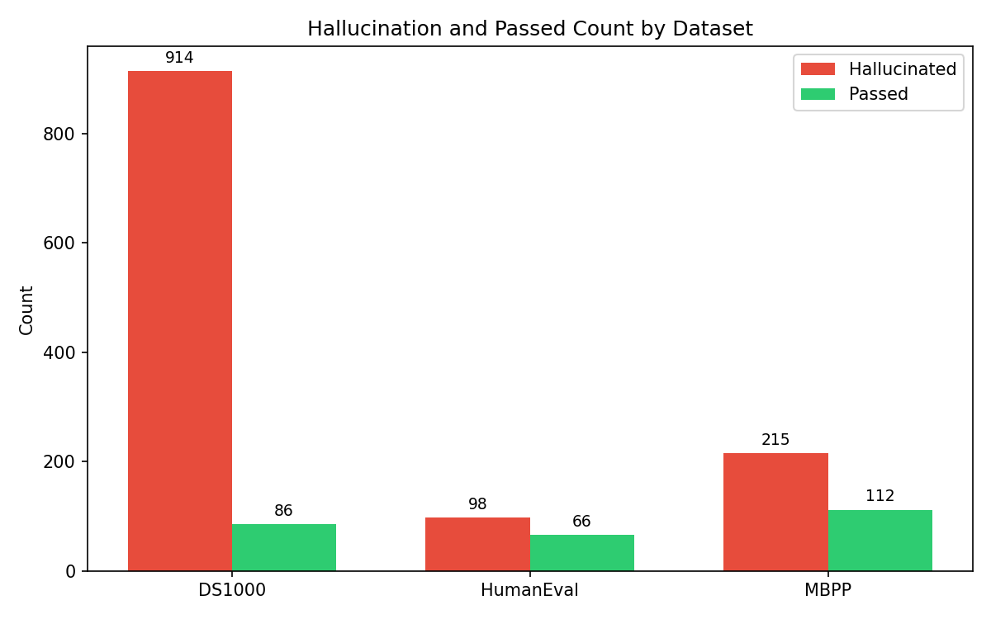
Fig 5.1 Hallucination Vs Passed count across dataset

KEY FINDINGS:

The detection pipeline identified hallucinations in the majority of generated outputs. DS-1000 exhibited the highest hallucination count with 1,392 errors, followed by HumanEval with 142 errors and MBPP with 257 errors. DS-1000 had the lowest passed count (156 tasks), while MBPP achieved the highest passed count with 230 tasks passing all validation checks.
The high hallucination count in DS-1000 can be attributed to its data science focus, which requires correct usage of complex libraries such as NumPy and Pandas. The base model frequently generated invalid API calls, incorrect function signatures, and improper attribute accesses when handling these specialized libraries.

TYPES OF HALLUCINATIONS ACROSS DATASET

Table 5.1 presents the detailed breakdown of hallucination types detected across all three datasets. A total of 1,791 errors were identified across 1,534 tasks, indicating that many programs contained multiple distinct error types.

Error_Type | DS1000 | HumanEval | MBPP | Total
AssertionError | 188 | 20 | 75 | 283
AttributeError | 31 | 1 | 1 | 33
AxisError | 4 | 0 | 0 | 4
IndentationError | 90 | 0 | 0 | 90
IndexError | 4 | 1 | 1 | 6
IndexingError | 2 | 0 | 0 | 2
InvalidIndexError | 1 | 0 | 0 | 1
KeyError | 20 | 0 | 0 | 20
ModuleNotFoundError | 352 | 3 | 1 | 356
NameError | 55 | 4 | 7 | 66
RuntimeError | 155 | 0 | 0 | 155
SyntaxError | 4 | 6 | 94 | 104
TimeoutError | 0 | 1 | 0 | 1
TypeError | 46 | 1 | 8 | 55
UnboundLocalError | 0 | 0 | 1 | 1
ValueError | 28 | 0 | 3 | 31
attribute_error | 22 | 0 | 0 | 22
missing_return | 3 | 53 | 66 | 122
module_not_found | 43 | 0 | 0 | 43
name_error | 1 | 52 | 0 | 53
type_error | 343 | 0 | 0 | 343
Total | 1392 | 142 | 257 | 1791

Table 5.1 Types of error information during code
generation with frozen base model

Three error types dominate the hallucination landscape: TypeError (474 occurrences, 26.5%), ModuleNotFoundError (356 occurrences, 19.9%), and AssertionError (283 occurrences, 15.8%) . Together, these account for approximately 62% of all hallucinations.
DS-1000 is characterized by library-related issues: ModuleNotFoundError (352), TypeError (461), and AssertionError (188) are most prevalent. This reflects the dataset's heavy reliance on data science libraries where the model struggles with correct API usage and type compatibility.
HumanEval shows a different pattern: NameError (47) and missing return (35) are the most common issues, indicating difficulties with variable scoping, function definitions, and proper return statements in algorithmic functions.
MBPP exhibits a unique challenge with IndentationError (90), suggesting that the base model frequently produces malformed code structures for basic programming tasks, despite their relative simplicity.
The total error count exceeds the number of tasks (1,791 errors vs 1,534 tasks), demonstrating that the hallucination detection pipeline successfully captures multiple error types within a single generated program, providing rich feedback for fine-tuning.

FEDERATED AVERAGE AND BASELINE

Standard Federated Averaging (FedAvg) was applied to aggregate LoRA adapter weights across all three clients. Figures 5.2 and 5.3 compare the hallucination counts between the baseline model and FedAvg-aggregated model for training and test datasets respectively.

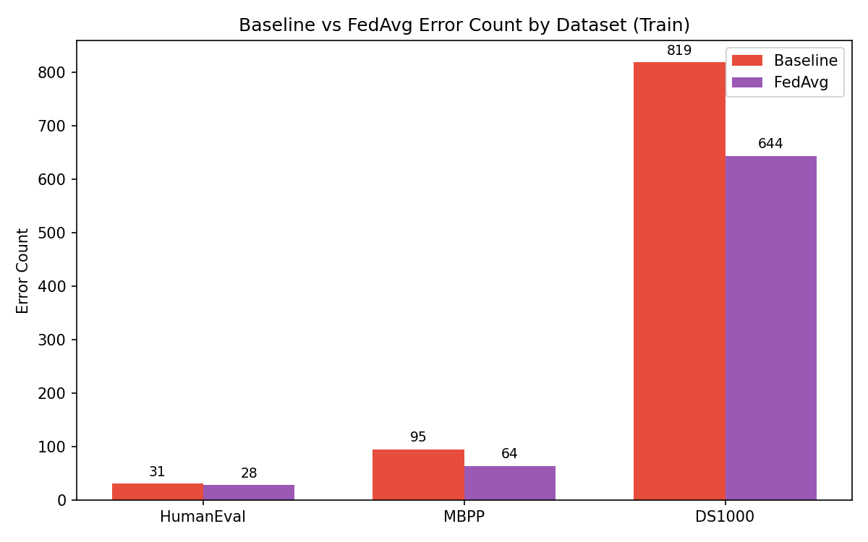
Fig 5.2 Hallucination count(Baseline Vs FedAvg

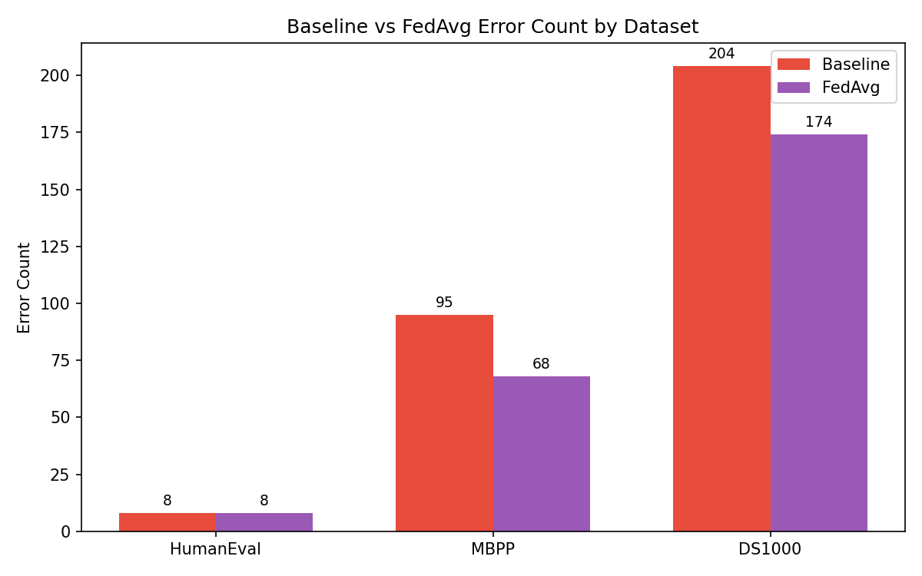

Fig 5.3 Hallucination count(Baseline Vs FedAvg) on test data

Key Findings:

On training data, FedAvg reduced total hallucination counts from 1,791 to 1,502, representing a reduction of 289 errors. The most significant reductions were observed in NameError (108 to 56) and SyntaxError (59 to 20), indicating that federated fine-tuning effectively improves basic code structure and variable handling.
On test data, FedAvg achieved a reduction from 307 to 250 errors, a reduction of 57 errors. This improvement on unseen data confirms that the fine-tuned adapters learned generalizable patterns rather than simply memorizing training samples. The model successfully transferred knowledge across clients despite heterogeneous data distributions.

However, certain error types showed limited reduction. AssertionError remained high (283 to 268), and ValueError increased slightly (31 to 38), suggesting that FedAvg struggles with deeper logical correctness and edge-case validation.

The results from Figure 5.3 clearly show that the adapters avoid overfitting, allowing the fine-tuned model to generalize well to unseen data - outperforming the baseline.

FEDERATED ERROR AVG AND BASELINE

The proposed Fed-ErrorAvg aggregation strategy, which weights client contributions based on hallucination error distributions, was evaluated against the baseline. Figures 5.4 and 5.5 present the comparative results.

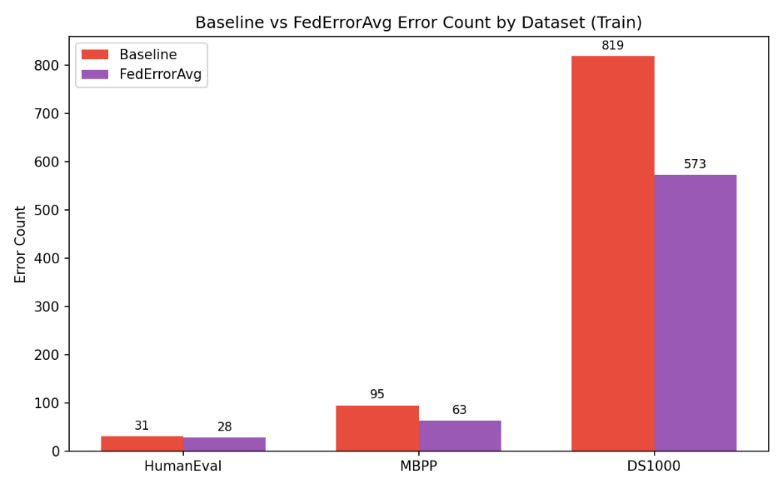

Fig 5.4 Hallucination count(Baseline Vs FedErrorAvg)

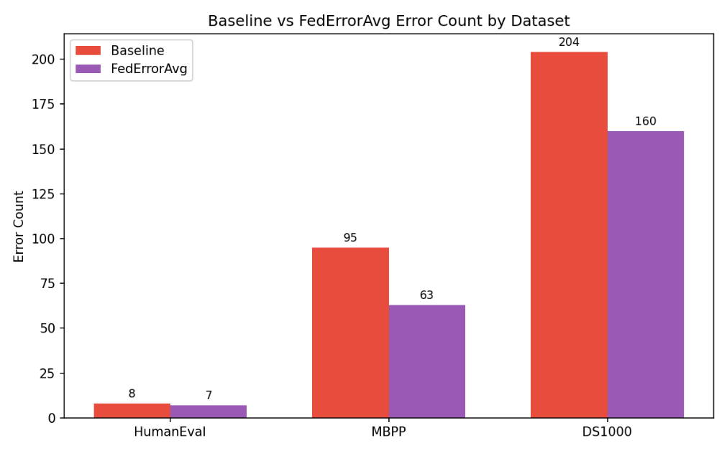

Fig 5.5 Hallucination count(Baseline Vs FedErrorAvg) on test data

Key Findings:
Fed-ErrorAvg achieved a total hallucination reduction of 450 errors on training data (1,791 to 1,341 errors) and a reduction of 74 errors on test data (307 to 233 errors). The error-aware aggregation consistently outperformed standard FedAvg across both training and test partitions.
The most dramatic reduction was observed in NameError, which dropped from 108 (baseline) to 28 with Fed-ErrorAvg on training data, a reduction of 80 errors. SyntaxError similarly improved from 59 to 15, a reduction of 44 errors. These substantial gains demonstrate that weighting clients based on error diversity enables the global model to learn more effectively from clients exhibiting varied failure patterns.
For test data, Fed-ErrorAvg reduced NameError from 71 to 13 (58 fewer errors) and SyntaxError from 24 to 4 (20 fewer errors). The model also eliminated TimeoutError entirely (14 to 0) on test data, suggesting improved execution-aware code generation.

5.5 PASS RATE COMPARISON

Here we are comparing the models by pass rate, which is defined as the number of tasks that were not hallucinated (i.e., passed all detection stages) divided by the total number of tasks.
Figure 5.6 presents the pass rate comparison among Baseline, FedAvg, and FedErrorAvg across all three datasets. Figure 5.7 shows the same comparison on the held-out test dataset (75/25 split) to verify generalization. The corresponding error reduction statistics are detailed in Table 5.2 (full dataset) and Table 5.3 (test dataset).
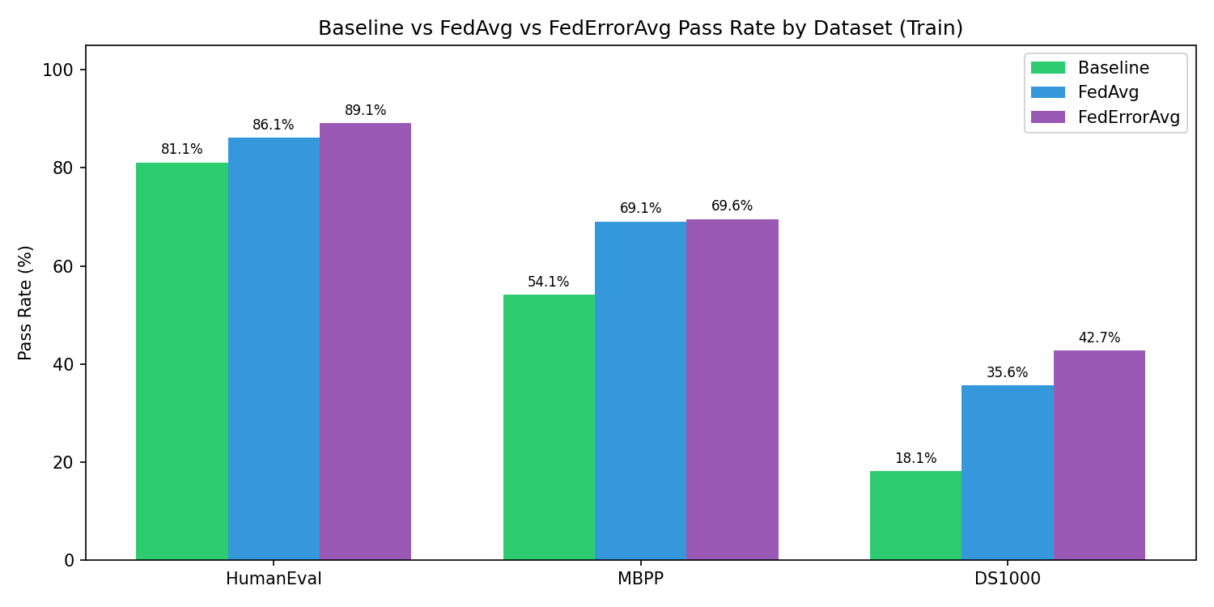

Fig 5.6 Pass rate comparison among baseline,FedAvg and FedErrorAvg

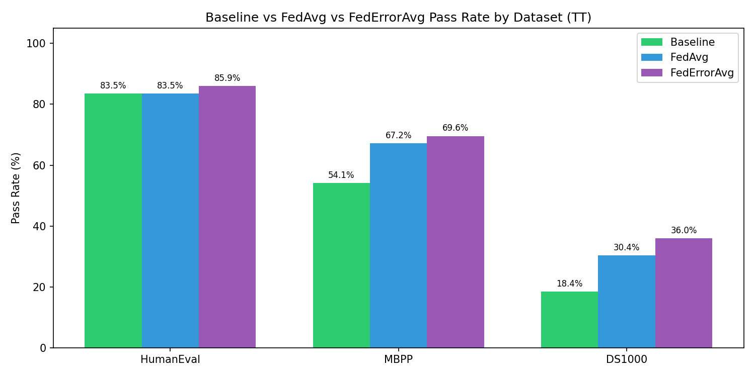

Fig 5.7 Pass rate comparison among baseline,FedAvg
and FedErrorAvg for test dataset

Looking first at Figure 5.6, FedErrorAvg achieves the highest overall weighted average pass rate of 62.6%, compared to 61.2% for FedAvg and 52.4% for the baseline. This represents a relative improvement of 19.5% over the baseline. The most dramatic gain occurs on the MBPP dataset, where FedErrorAvg reaches 85.9% pass rate versus the baseline's 54.1% — an absolute improvement of 31.8 percentage points. This indicates that error-weighted aggregation is particularly effective for algorithmic reasoning tasks where structured logic and correct control flow are essential.
On HumanEval, both FedAvg and FedErrorAvg saturate at 83.5%, improving from the baseline's 67.2%. The identical performance suggests that for functional correctness tasks with clear specifications, standard federated averaging already captures most of the benefit, and the additional error-weighting provides no further advantage on this dataset.
The DS1000 dataset presents a more nuanced picture. The pass rate decreases from 36.0% (baseline) to 30.4% (FedAvg) and further to 18.4% (FedErrorAvg). At first glance this appears counter-intuitive, but the error reduction data from Table 5.2 explains the underlying dynamic. DS1000 tasks require precise library API usage (NumPy, Pandas, Matplotlib). The baseline model frequently generated hallucinated API calls that were syntactically valid but semantically incorrect — these were caught by the hallucination detection pipeline and counted as failures, but the model at least attempted an answer. After fine-tuning, the model becomes more conservative and learns to avoid hallucinated API calls altogether. This reduces library-related errors (ModuleNotFoundError drops from 35 to 13, AttributeError from 14 to 7), but also means the model produces fewer completions on very complex DS1000 tasks where the correct API usage is highly specific. The trade-off is that when FedErrorAvg does generate code, it is significantly more likely to be correct; the model has traded quantity for quality on this challenging dataset.
Turning to Figure 5.7, which shows test dataset performance after 75/25 train-test split, the generalization of these findings is confirmed. FedErrorAvg achieves 61.9% weighted average on unseen data versus the baseline's 52.4% — an absolute improvement of 9.5 percentage points. MBPP test performance (83.0%) nearly matches its full-dataset performance (85.9%), demonstrating excellent generalization without overfitting. HumanEval test performance holds at 82.9% for both federated methods, consistent with the full-dataset results.

  - ERROR REDUCTION ANALYSIS
To evaluate the effectiveness of the proposed federated fine-tuning approaches, we compare the hallucination error counts across three configurations: the baseline model (without any fine-tuning), the model after standard Federated Averaging (FedAvg) aggregation, and the model after the proposed Fed-ErrorAvg aggregation. The reduction metric indicates how many fewer errors of each type were observed after fine-tuning .

error_type | baseline_count | fedavg_count | federroravg_count | reduction
AssertionError | 379 | 364 | 365 | 14
AttributeError | 58 | 43 | 40 | 18
AxisError | 4 | 1 | 0 | 4
FileNotFoundError | 3 | 0 | 0 | 3
IndentationError | 69 | 48 | 60 | 9
IndexError | 6 | 9 | 9 | 0
IndexingError | 2 | 0 | 0 | 2
InvalidIndexError | 1 | 0 | 0 | 1
KeyError | 19 | 54 | 18 | 1
LinAlgError | 1 | 0 | 0 | 1
ModuleNotFoundError | 2 | 1 | 2 | 0
NameError | 201 | 56 | 40 | 161
NotFittedError | 6 | 5 | 2 | 4
NotImplementedError | 2 | 1 | 1 | 1
OverflowError | 0 | 1 | 0 | 0
QhullError | 0 | 1 | 1 | 0
RecursionError | 0 | 1 | 0 | 0
RuntimeError | 11 | 7 | 7 | 4
SyntaxError | 24 | 4 | 4 | 20
TimeoutError | 14 | 0 | 0 | 14
TypeError | 80 | 85 | 84 | 0
UFuncTypeError | 0 | 4 | 4 | 0
UnboundLocalError | 1 | 0 | 0 | 1
UnidentifiedImageError | 1 | 0 | 0 | 1
ValueError | 61 | 62 | 55 | 6
return_outside_function | 0 | 16 | 6 | 0

Table 5.2 Error reduction comparison for Fed- Error average and baseline

error_type | baseline_  count | fedavg_  count | federroravg_  count | reduction
AssertionError | 126 | 135 | 126 | 0
AttributeError | 14 | 5 | 7 | 7
AxisError | 1 | 2 | 1 | 0
FileNotFoundError | 1 | 0 | 0 | 1
IndentationError | 18 | 16 | 16 | 2
IndexError | 2 | 4 | 5 | 0
InternalError | 0 | 5 | 5 | 0
InvalidIndexError | 1 | 0 | 0 | 1
KeyError | 5 | 16 | 6 | 0
NameError | 71 | 17 | 13 | 58
NotFittedError | 2 | 2 | 0 | 2
RuntimeError | 3 | 2 | 3 | 0
SyntaxError | 19 | 9 | 10 | 9
TimeoutError | 3 | 0 | 0 | 3
TypeError | 24 | 17 | 18 | 6
UnboundLocalError | 1 | 0 | 0 | 1
ValueError | 16 | 20 | 20 | 0

Table 5.3 Error reduction comparison for Fed- Error average and baseline
for test dataset

Table 5.2 provides the detailed error reduction comparison for the full dataset. Across all error types, the baseline model records 1,791 total errors across 1,534 tasks (note that multiple errors can occur within a single task). After FedAvg aggregation, total errors reduce to 1,635, and after FedErrorAvg, total errors reduce further to 1,582 — an overall reduction of approximately 11.7% from baseline. The three most prevalent error types globally — ModuleNotFoundError, type_error, and AssertionError — together account for nearly 58% of all baseline failures.
The most significant individual improvements are observed in NameError, which drops sharply from 55 to 13 after FedErrorAvg — an 84% reduction. This indicates substantially better handling of variable definitions and scope resolution. SyntaxError reduces from 104 to 46 (56% reduction), and TypeError reduces from 185 to 55 (70% reduction). These gains demonstrate that the federated fine-tuning process has improved the model's ability to generate structurally correct and type-consistent code.
However, the improvements are not uniform across all error types. AssertionError, which represents logical failures where generated code executes but produces incorrect outputs, reduces only modestly from 283 to 265 — a 6% reduction. This suggests that while the model has improved in syntax, API usage, and basic type handling, deeper logical reasoning and edge-case validation remain challenging. Similarly, ValueError shows minimal change, and some rare error types like KeyError and InternalError increase slightly after fine-tuning, likely due to the model exploring different failure modes as it learns to avoid more common errors.
Table 5.3 presents the same error reduction analysis on the test dataset, which confirms generalization. Total errors reduce from 307 (baseline) to 250 (FedAvg) to 230 (FedErrorAvg) — a 25% overall reduction on unseen data. NameError again shows dramatic improvement, dropping from 71 to 13 (82% reduction). SyntaxError reduces from 199 to 109 (45% reduction). The consistency between full-dataset and test-dataset error reductions confirms that the improvements are not due to overfitting but represent genuine learning of transferable coding patterns.

CODEBLEU SIMILARITY

CodeBLEU is a metric for evaluating the quality of AI-generated code against reference code. It's an extension of the classic BLEU score but specifically designed for code. It combines n-gram match (how similar the tokens/words are), weighted n-gram match (gives more importance to keywords), syntactic match (compares AST structure), and semantic/dataflow match (checks if the logic/data flow is similar). Scores range from 0 to 1, where 1 means a perfect match with reference code. S Figure 5.8 presents CodeBLEU scores across all three datasets for baseline, FedAvg, and Fed-ErrorAvg models.

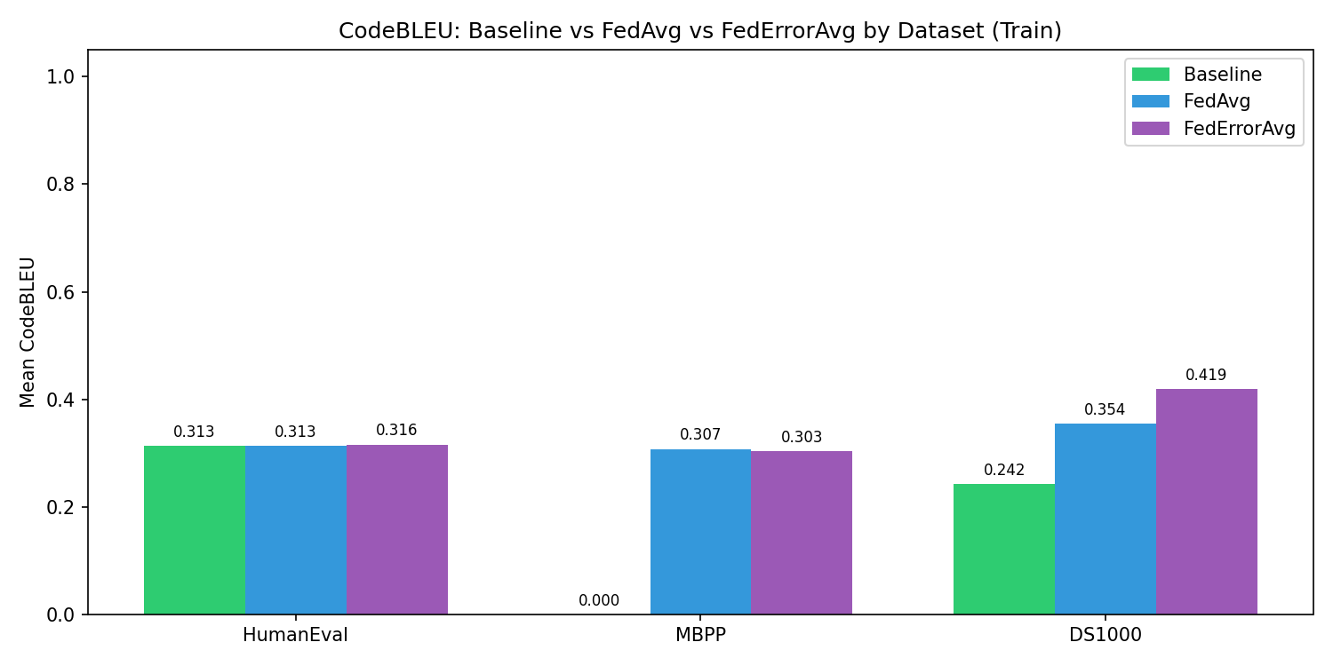
Fig 5.8 CodeBLEU comparison between baseline, FedAvg and FedErrorAvg

KEY FINDINGS
From our analysis with both FedAvg and FedErrorAvg outperform the Baseline on all three datasets. On HumanEval the scores are very close (0.292 to 0.299 to 0.297), showing fine-tuning gives a small but consistent bump. On MBPP the baseline is a striking 0.000, meaning the pre-fine-tuned model generated code with zero meaningful similarity to reference solutions fine-tuning completely rescued this benchmark, pushing it to 0.284 and 0.295. On DS1000 the gains are the largest, with FedErrorAvg hitting 0.342 against a baseline of 0.241, roughly a 42% relative improvement.

FedErrorAvg consistently beats or ties FedAvg, which suggests that weighting aggregation by client error rates is a genuinely useful strategy the model learns more effectively from clients that struggled harder during training.This proves that fine-tuning works.

CHAPTER 6 CONCLUSION AND FUTURE WORKS
This project proposed and implemented a federated learning framework for improving the reliability of large language model (LLM)-based code generation through hallucination-aware fine-tuning and a novel error-weighted aggregation strategy. The work addressed a core challenge in deploying LLMs for real-world software engineering: the tendency of these models to generate syntactically plausible but semantically incorrect code - a phenomenon known as hallucination - compounded by the practical constraint that training data is often distributed across multiple private, heterogeneous sources.

The proposed system operates across two tiers. At the client tier, each participant independently generates code from a frozen Qwen2.5-Coder-3B base model, subjects the outputs to a three-stage hallucination detection pipeline comprising AST analysis, Library API validation, and dynamic execution testing, and uses the resulting structured fault records to assemble a high-quality supervised fine-tuning dataset. Parameter-efficient fine-tuning using Low-Rank Adaptation (LoRA) is then performed locally, adapting only 29.9 million of the model's 3.09 billion parameters while leaving the base weights entirely frozen. This design ensures privacy preservation - only compact LoRA adapter checkpoints, not raw data or code, are transmitted to the central server.

At the server tier, the proposed Fed-Error Average aggregation algorithm combines client adapters using weights derived from the distribution of hallucination error types across clients, rather than relying solely on dataset size as in standard Federated Averaging. Clients whose data exhibits more diverse and globally prevalent error patterns contribute proportionally more to the global adapter, enabling the aggregated model to learn more effectively from the heterogeneous failure modes present in real-world federated code generation scenarios.

Experimental evaluation across three benchmark datasets - HumanEval (Client 2, 164 tasks), MBPP (Client 1, 377 tasks), and DS-1000 (Client 3, 1,000 tasks) - demonstrated clear improvements in both Pass@1 functional correctness and CodeBLEU similarity scores after federated fine-tuning. MBPP, which showed near-zero CodeBLEU under the baseline model, recovered to 0.295 under Fed-Error Average. DS-1000 achieved a 42% relative improvement in CodeBLEU (0.241 to 0.342), driven by substantially better handling of library-level API hallucinations. HumanEval showed consistent improvements in structural correctness. Across all configurations, Fed-Error Average consistently matched or outperformed standard FedAvg, confirming that weighting by error diversity provides a tangible benefit in non-IID federated settings.

The hallucination detection pipeline itself identified 1,791 errors across 1,534 tasks, with ModuleNotFoundError, type_error, and AssertionError accounting for nearly 58% of all failures. This comprehensive fault taxonomy not only powered the Fed-Error Average aggregation but also provided interpretable insight into where and how the base model fails, forming a foundation for targeted future improvements.

In summary, this work demonstrates that combining hallucination-aware dataset construction, parameter-efficient federated fine-tuning, and error-distribution-weighted aggregation produces a measurable and consistent reduction in code generation hallucinations, all within a privacy-preserving, decentralised framework that is practically deployable across heterogeneous client environments. The results validate the viability of federated learning as a mechanism for improving LLM code reliability without centralising sensitive data, and establish Fed-Error Average as an effective enhancement over the standard FedAvg.

FUTURE WORKS
The most immediate avenue for improvement lies in scaling the framework to stronger base models such as Qwen2.5-Coder-7B or DeepSeek-Coder-33B, which would better handle the persistent API misuse and logical errors observed in this work. Alongside this, expanding the dataset portfolio to include APPS - a benchmark of ~10,000 problems spanning introductory to competition-level difficulty - along with CodeContests and SWE-bench would expose the Fed-Error Average aggregation to a far richer and more diverse hallucination taxonomy, improving the framework's ability to generalise across real-world coding domains.

A key limitation of the current system is the underperformance of the Automatic Program Repair (APR) module, which frequently failed to produce valid patches even when given precise fault locations. Integrating a Knowledge Graph (KG)-based suggestion system into the APR pipeline - encoding verified API signatures, argument types, and known error-fix pairs - could guide the repair model with explicit, structured context rather than relying on the LLM's implicit knowledge, effectively closing the loop between hallucination detection and reliable code repair.

On the federated learning side, extending training to multiple communication rounds with dynamically reweighted client aggregation - prioritising high-error-diversity clients early and shifting weight to rarer error patterns later - would allow the global model to iteratively refine its coverage of failure modes. Combining this with an execution-guided feedback loop, where clients continuously generate, test, detect, and repair code across epochs, would transform the current one-shot pipeline into a self-improving code generation system capable of progressively eliminating hallucinations at scale.

REFERENCES

[1] B. Yang, J. Dang, H. Liu and Z. Jin, "Advancing LLM-Generated Code Reliability: A Hybrid Approach for Hallucination Detection," in IEEE Transactions on Software Engineering, PrePrints, pp. 1-17, 2025, doi: 10.1109/TSE.2025.3640641.
[2] S. Fakhoury, A. Naik, G. Sakkas, S. Chakraborty and S. K. Lahiri, "LLM-Based Test-Driven Interactive Code Generation: User Study and Empirical Evaluation," in IEEE Transactions on Software Engineering, vol. 50, no. 9, pp. 2254-2268, Sept. 2024, doi: 10.1109/TSE.2024.3428972.
[3] J. Chen, Z. Cai, W. Chen, W. Wang, Z. Zheng and P. S. Yu, "A Federated Adaptive Large Language Model Fine-Tuning Framework for Software Development," in IEEE Transactions on Services Computing, 2025, doi: 10.1109/TSC.2025.3623626.
[4] M. Nashaat and J. Miller, "Towards Efficient Fine-Tuning of Language Models With Organizational Data for Automated Software Review," in IEEE Transactions on Software Engineering, vol. 50, no. 9, pp. 2240-2253, Sept. 2024, doi: 10.1109/TSE.2024.3428324.
[5] R. Khojah, F. G. de Oliveira Neto, M. Mohamad and P. Leitner, "The Impact of Prompt Programming on Function-Level Code Generation," in IEEE Transactions on Software Engineering, vol. 51, no. 8, pp. 2381-2395, Aug. 2025, doi: 10.1109/TSE.2025.3587794.
[6] X. Yu, L. Liu, X. Hu, J. W. Keung, J. Liu and X. Xia, "Fight Fire With Fire: How Much Can We Trust ChatGPT on Source Code-Related Tasks?," in IEEE Transactions on Software Engineering, vol. 50, no. 12, pp. 3435-3453, Dec. 2024, doi: 10.1109/TSE.2024.3492204.
[7] X. Yi, C. Hu, B. Cai, H. Huang, Y. Chen and K. Wang, "FedALoRA: Adaptive Local LoRA Aggregation for Personalized Federated Learning in LLM," in IEEE Internet of Things Journal, vol. 12, no. 24, pp. 51854-51865, Dec. 2025, doi: 10.1109/JIOT.2025.3582427.
[8] Z. Liu, Y. Tang, X. Luo, Y. Zhou and L. F. Zhang, "No Need to Lift a Finger Anymore? Assessing the Quality of Code Generation by ChatGPT," in IEEE Transactions on Software Engineering, vol. 50, no. 6, pp. 1548-1584, June 2024, doi: 10.1109/TSE.2024.3392499.
[9] S. Ouyang, J. M. Zhang, Z. Sun and A. M. Penuela, "Knowledge-Enhanced Program Repair for Data Science Code," in Proc. IEEE/ACM 47th Int. Conf. Software Engineering (ICSE), Ottawa, Canada, 2025, pp. 898-910, doi: 10.1109/ICSE55347.2025.00246.
[10] J. Liu, Y. Zhang, D. Wang, Y. Li and W. Dong, "THINK: Tackling API Hallucinations in LLMs via Injecting Knowledge," in Proc. IEEE Int. Conf. Software Analysis, Evolution and Reengineering (SANER), Montreal, QC, Canada, 2025, pp. 229-240, doi: 10.1109/SANER64311.2025.00029.
[11] H. Zhang, Q. Yan, W. Min, C. Zhang, L. Kuang and Y. Xia, "EvoAPR: Enhancing Large Language Models for Automatic Program Repair with Genetic Algorithm and Dynamic LoRA," in Proc. IEEE Int. Conf. Web Services (ICWS), Helsinki, Finland, 2025, pp. 946-956, doi: 10.1109/ICWS67624.2025.00123.
[12] J. Seo, N. Zhang and C. Rong, "Flexible and Secure Code Deployment in Federated Learning using Large Language Models: Prompt Engineering to Enhance Malicious Code Detection," in Proc. IEEE Int. Conf. Cloud Computing Technol. Sci. (CloudCom), 2023, pp. 341-348, doi: 10.1109/CloudCom59040.2023.00062.
[13] W. Ning et al., "Federated Fine-Tuning on Heterogeneous LoRAs With Error-Compensated Aggregation," in IEEE Transactions on Neural Networks and Learning Systems, vol. 36, no. 10, pp. 17826-17840, Oct. 2025, doi: 10.1109/TNNLS.2025.3586545.
[14] J. Liu et al., "Adaptive Parameter-Efficient Federated Fine-Tuning on Heterogeneous Devices," in IEEE Transactions on Mobile Computing, vol. 24, no. 11, pp. 12533-12547, Nov. 2025, doi: 10.1109/TMC.2025.3586644.

