# AstraZenca

**AstraZeneca plc** ([/ˌæstrəˈzɛnəkə/](https://en.wikipedia.org/wiki/Help:IPA/English)) (**AZ**) is a British-Swedish[[2]](https://en.wikipedia.org/wiki/AstraZeneca#cite_note-2)[[3]](https://en.wikipedia.org/wiki/AstraZeneca#cite_note-3)[[4]](https://en.wikipedia.org/wiki/AstraZeneca#cite_note-:2-4) multinational [pharmaceutical](https://en.wikipedia.org/wiki/Pharmaceutical_industry) and [biotechnology](https://en.wikipedia.org/wiki/Biotechnology) company with its headquarters at the [Cambridge Biomedical Campus](https://en.wikipedia.org/wiki/Cambridge_Biomedical_Campus) in [Cambridge](https://en.wikipedia.org/wiki/Cambridge), United Kingdom.[[5]](https://en.wikipedia.org/wiki/AstraZeneca#cite_note-5) It has a portfolio of products for major diseases in areas including [oncology](https://en.wikipedia.org/wiki/Oncology), [cardiovascular](https://en.wikipedia.org/wiki/Circulatory_system), [gastrointestinal](https://en.wikipedia.org/wiki/Gastroenterology), [infection](https://en.wikipedia.org/wiki/Infectious_disease), [neuroscience](https://en.wikipedia.org/wiki/Neuroscience), [respiratory](https://en.wikipedia.org/wiki/Pulmonology), and [inflammation](https://en.wikipedia.org/wiki/Inflammation).

Relating to [medicinal](https://www.google.com/search?sca_esv=fcc8a1ce826a5642&rlz=1C1RXQR_enIN1100IN1100&sxsrf=AHTn8zqd409I9p9P7wgYLTycCQeEmWFGuw:1738847535254&q=medicinal&si=APYL9bvtFLj-ISwFDyvbg6-m4pTq6hSJ4Ybc7uupVpmnetnPgA4RqTrOS7Z4BnIOk2m_JM7AOA0s9BUW2qq1WiZabvlpF7nBrmPm2mBpwVQqylQf8ArPtf8%3D&expnd=1&sa=X&ved=2ahUKEwjc2qDtj6-LAxUq4jgGHQ8bBJsQyecJegQIGxAb) drugs, or their preparation, use, or sale.

## Motto

**We are a global, science-led, patient-focused pharmaceutical company. We are dedicated to transforming the future of healthcare by unlocking the power of what science can do for people, society and the planet.**

## Our Stratergy

**We are a global, science-led, patient-focused pharmaceutical company seeking to unlock the power of what science can do. Our strategy is consistent but dynamic.**

**Science & Innovation**

* **Invest in new technologies and modalities**
* **Leverage global R&D network**

**Growth & Therapy Area Leadership**

* **Transform patient outcomes through novel medicines and combinations**

**Global Footprint**

* **Broad-based network**
* **Differentiated Emerging Markets presence**

**Sustainability**

* **Expand access, build health system resilience**
* **Drive industry-leading climate agenda**

# Our organisation and main disease areas

## Oncology

**We are leading a revolution in oncology to redefine cancer care. Our ambition is to follow the science to discover, develop and deliver life-changing treatments that transform outcomes and increase the potential for cure.**

## BioPharmaceuticals

**We are transforming care for billions of people living with chronic diseases and delivering long-lasting immunity. Our ambition is to intervene earlier to protect vital organs, slow or reverse disease progression, and achieve remission for these often degenerative, debilitating, and life-threatening conditions, so many more people can live better, healthier lives.**

## Rare Disease

**Our mission is to transform the lives of people affected by rare diseases through the development and delivery of innovative medicines as well as supportive technologies and healthcare services.**

## Our Purpose and Values

**Inspired by our Values and what science can do, we are focused on accelerating the delivery of life-changing medicines that create enduring value for patients, society and our shareholders.**

**We are committed to operating sustainably, in a way that recognises the interconnection between business growth, the needs of society and the limitations of our planet.**

**We push the boundaries of science to deliver life-changing medicines.**

**Our Purpose underpins everything we do. It gives us a reason to come to work every day. It reminds us why we exist as a company. *It helps us deliver benefits to patients and create value for shareholders.***

*We follow the science. We put patients first. We play to win. We do the right thing. We are entrepreneurial.*

*Our Values determine how we work together and the behaviours that drive our success. They guide our decision making and define our beliefs.*

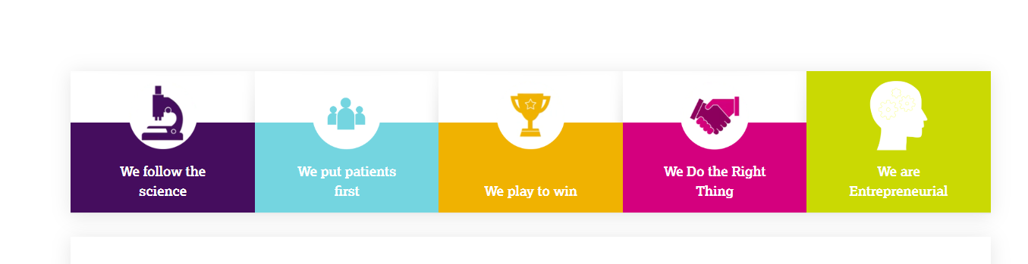

# ATOLA

**The ATOLA model is a framework for answering behavioral interview questions. It's used to structure responses by describing actions, thinking, outcomes, learnings, and applications.**

**What does ATOLA stand for?**

* **Actions: How did you approach the situation?**
* **Thinking: Why did you approach it that way?**
* **Outcome: What was the result?**
* **Learnings: What did you take away from this?**
* **Application: When did you use what you learned in a different situation?**

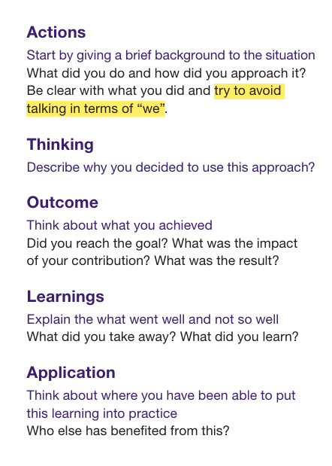

**A KPI dashboard displays key performance indicators in interactive charts and graphs, allowing for quick, organized review and analysis. Key performance indicators are quantifiable measures of performance over time for specific strategic objectives.**