

**[github.com/themysterysolver](https://github.com/themysterysolver)**



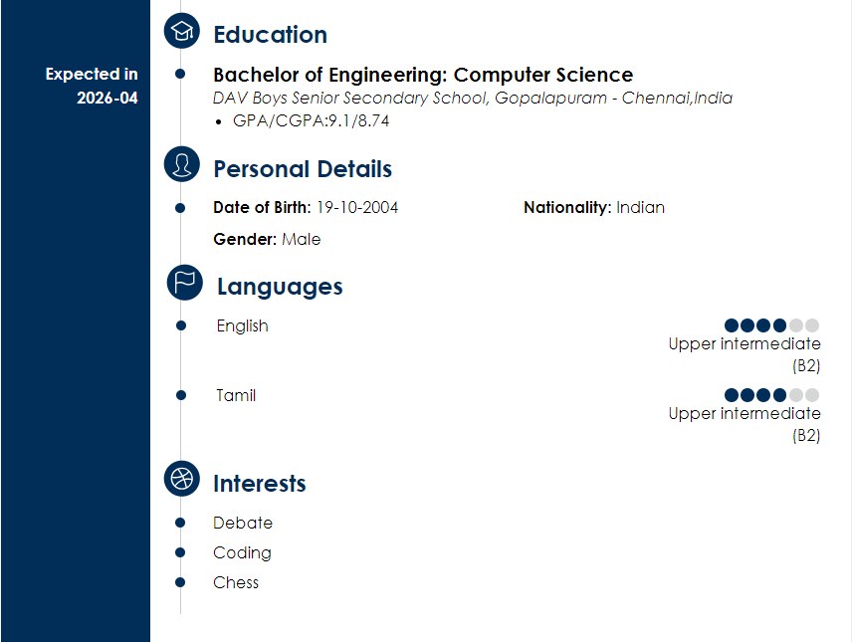

[***https://leetcode.com/u/arjunprabhakar1910/***](https://leetcode.com/u/arjunprabhakar1910/)

[***https://www.hackerrank.com/profile/arjunprabhakar19***](https://www.hackerrank.com/profile/arjunprabhakar19)

*9445462959*

[***arjunprabhakar1910@gmail.com***](mailto:arjunprabhakar1910@gmail.com)