**2022503003**

**Date: 27/09/2024**

**1. Write a program to perform unchecked exception. Use appropriate try-catch blocks to handle these exceptions and provide meaningful error messages**

***Code:***

import java.sql.SQLOutput;

import java.util.ArrayList;

import java.util.List;

public class differentTypesOfException {

static void checkAge(int a){

if(a<18){

throw new IllegalArgumentException("Age must be greater than 18");

}

}

public static void main(String[] args){

System.out.println("R.Prabhakara Arjun\n2022503003\n");

Integer[] arr=new Integer[5];

try{

int a=arr[5];

System.out.println();

} catch(IndexOutOfBoundsException e) {

System.out.println("Exception:"+e.getClass().getName());

System.out.println("Exception message:"+e.getMessage());

System.out.println();

}

try{

Object[] x=new String[3];

x[0]=1;

}

catch(ArrayStoreException e){

System.out.println("Exception:"+e.getClass().getName());

System.out.println("Exception message:"+e.getMessage());

System.out.println();

}

try{

Object a="hello";

Integer b=(Integer)a;

}

catch(ClassCastException e){

System.out.println("Exception:"+e.getClass().getName());

System.out.println("Exception message:"+e.getMessage());

System.out.println();

}

try{

checkAge(15);

}

catch(IllegalArgumentException e){

System.out.println("Exception:"+e.getClass().getName());

System.out.println("Exception message:"+e.getMessage());

System.out.println();

}

try{

ArrayList<Integer> arr1=new ArrayList<>();

arr1.add(1);

System.out.println(arr1.get(2));

}

catch(IndexOutOfBoundsException e){

System.out.println("Exception:"+e.getClass().getName());

System.out.println("Exception message:"+e.getMessage());

System.out.println();

}

try{

String[] arr2=new String[-5];

}

catch(NegativeArraySizeException e){

System.out.println("Exception:"+e.getClass().getName());

System.out.println("Exception message:"+e.getMessage());

System.out.println();

}

try{

String b=(null);

b.toUpperCase();

}

catch(NullPointerException e){

System.out.println("Exception:"+e.getClass().getName());

System.out.println("Exception message:"+e.getMessage());

System.out.println();

}

try{

String her="abi!!";

her.charAt(10);

}

catch(StringIndexOutOfBoundsException e){

System.out.println("Exception:"+e.getClass().getName());

System.out.println("Exception message:"+e.getMessage());

System.out.println();

}

try{

List<String> unmodifieable= List.of("A","B");

System.out.println(unmodifieable);

unmodifieable.add("c");

}

catch(UnsupportedOperationException e){

System.out.println("Exception:"+e.getClass().getName());

System.out.println("Exception message:"+e.getMessage());

System.out.println();

}

}

}

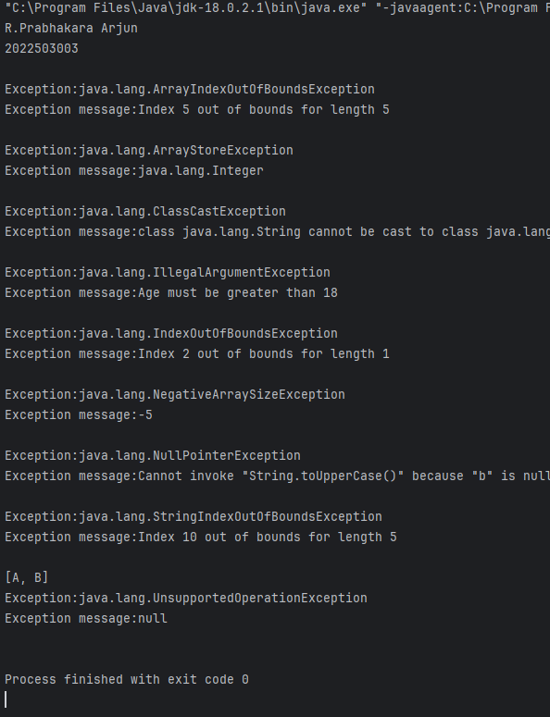

**2. Write a program that demonstrates different try-catch-finally block combinations**

**a. Try without catch block Apps**

**b. Try without finally block**

**c. Try with catch and finally block**

**d. Try with multiple catch block**

**e. Nested try catch finally block**

**f. Try with resources**

import javax.naming.AuthenticationNotSupportedException;

import java.io.BufferedReader;

import java.io.FileNotFoundException;

import java.io.FileReader;

import java.io.IOException;

public class combinationTryCatchFinal {

public static void main(String[] args){

System.out.println("R.Prabhakara Arjun\n2022503003\n");

try {

System.out.println("TRY:try without catch");

}

finally {

System.out.println("CATCH:try without catch\n");

}

try{

throw new IOException("TRY:with try-catch");

}

catch (IOException E){

System.out.println(E.getMessage());

System.out.println("CATCH:with try-catch\n");

}

try{

throw new IOException("TRY:with try-catch with finally");

}

catch (IOException E){

System.out.println(E.getMessage());

System.out.println("CATCH:with try-catch with finally");

}

finally {

System.out.println("FINALLY:with try-catch with finally\n");

}

try{

throw new IOException("TRY1:with try with multiple catch");

//throw new ArithmeticException("TRY1:with try with multiple catch");

//unreachable state

}

catch (IOException E){

System.out.println(E.getMessage());

System.out.println("CATCH1:with try with multiple catch");

}

catch(ArithmeticException e){

System.out.println(e.getMessage());

System.out.println("CATCH2:with try with multiple catch\n");

}

try{

try{

int a=5/0;

}

catch(ArithmeticException e){

System.out.println("Catch Inner!");

}

finally {

System.out.println("Inner finally!");

}

throw new NullPointerException();

}

catch(Exception b){

System.out.println("Catch outter!!");

}

finally {

System.out.println("outter catch!!\n");

}

try(BufferedReader a=new BufferedReader(new FileReader("hello.txt"))){

System.out.println("File found!");

}

catch(IOException O){

System.out.println("CATCH:file not found");

System.out.println(O.getMessage());

System.out.println();

}}}

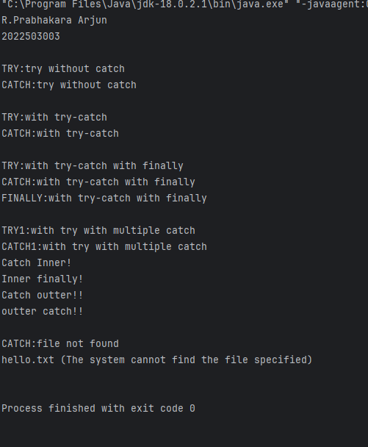

**3. Create a custom exception class called InvalidMarkException that extends Exception. Then, write a Student class with a method to set marks that throws this custom exception if the mark is out of range (e.g., less than 0 or greater than 100).**

***Code:***

class invalidMarkException extends Exception{

public invalidMarkException(String message){

super(message);

}

}

class Student{

int marks;

void setMark(int mark) throws invalidMarkException{

if(mark<0 || mark>100){

throw new invalidMarkException("The mark you tried to set is out of bound()");

}

marks=mark;

}

int getMark(){

return marks;

}

}

public class markHandling {

public static void main(String[] args){

System.out.println("2022503003\nR.Prabhakara Arjun\n");

Student s=new Student();

try {

s.setMark(101);

}catch(invalidMarkException e){

System.out.println(e.getMessage());

}

System.out.println("s.setMark(101):"+s.getMark());

s.getMark();

try {

s.setMark(55);

}catch(invalidMarkException e){

System.out.println(e.getMessage());

}

System.out.println("s.setMark(55):"+s.getMark());

}

}

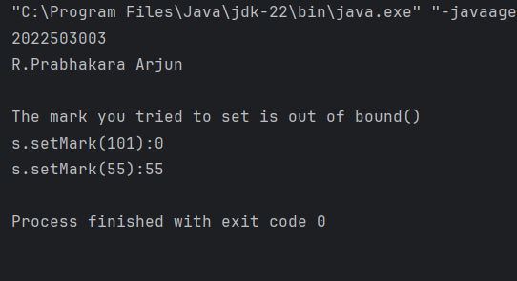

**4. Write a program to illustrate the propagation of checked and unchecked exception.**

***Code:***

class myException extends Exception{

myException(String msg){

super(msg);

}

}

public class propagationChechedUnchecked {

static void checkedException() throws myException{

throw new myException("This is my custom exception");

}

static void uncheckedException(){

int result=10/0;

System.out.println("Result"+result);

}

public static void main(String[] args) {

System.out.println("2022503003\nR.Prabhakara Arjun\n");

try{

uncheckedException();

}catch(Exception e){

System.out.println("Unchecked exception:"+e.getMessage());

}

try{

checkedException();

}

catch(Exception e){

System.out.println("Checked exception:"+e.getMessage());

}

}

}

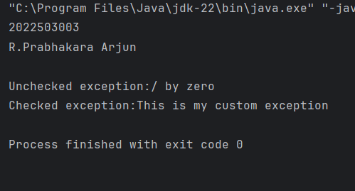

**5. Write a program to illustrate the method overloading in exception handling mechanism for checked and unchecked exception**

***Code:***

class myCustomException extends Exception{

myCustomException(){

super("DEFAULT SAME CUSTOM MESSAGE");

}

}

class checker{

void method(int num){

int result=num/0;

System.out.println("Result"+result);

}

void method(String msg) throws myCustomException{

throw new myCustomException();

}

}

public class methodOverloadingCheckedUnchecked {

public static void main(String[] args) {

checker check=new checker();

System.out.println("2022503003\nR.Prabhakara Arjun\n");

try{

check.method(5);

}catch(Exception e){

System.out.println("UNCHECKED EXCEPTION:"+e.getMessage());

}

try{

check.method("Abi!!");

} catch (myCustomException e) {

System.out.println("CHECKED EXCEPTION:"+e.getMessage());

}

}

}

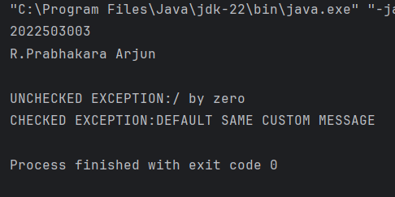

**6. Implement a base class and a derived class to demonstrate exception handling in method overriding:**

**a) Overriding a method that throws an unchecked exception**

**b) Overriding a method that throws a checked exception**

***Code:***

class myCustomException2 extends Exception{

myCustomException2(){

super("Ha Ha Ha....This is a default message!");

}

}

class baseClass{

void unChecked(){

throw new IndexOutOfBoundsException("base class index out of bound!");

}

void checked() throws myCustomException,myCustomException2{

throw new myCustomException();

}

}

class dervidedClass extends baseClass{

void unChecked(){

throw new ArithmeticException("derived class arithmetic exception");

}

void checked() throws myCustomException2{

throw new myCustomException2();

}

}

public class overrideCheckedUnchecked {

public static void main(String[] args) {

System.out.println("2022503003\nR.Prabhakara Arjun\n");

baseClass derive = new dervidedClass();

try {

derive.unChecked();

}catch (Exception e){

System.out.println("This is a unchecked exception from derived class:"+e.getMessage());

}

try {

derive.checked();

}

catch(Exception e){

System.out.println("This is a checked exception from derived class:"+e.getMessage());

}

baseClass base=new baseClass();

try {

base.unChecked();

}catch (Exception e){

System.out.println("This is a unchecked exception from base class:"+e.getMessage());

}

try {

base.checked();

}

catch(Exception e){

System.out.println("This is a checked exception from base class:"+e.getMessage());

}

}

}

