**📌 Parts of a QR Code**

A QR code consists of several key elements that allow it to store and retrieve data efficiently.

**1️⃣ Finder Patterns**

* Three large square patterns located at three corners of the QR code.
* Help scanners detect the QR code's orientation.

**2️⃣ Alignment Pattern**

* A smaller square pattern found in larger QR codes.
* Ensures proper alignment when scanning a distorted or tilted QR code.

**3️⃣ Timing Pattern**

* Alternating black and white modules between finder patterns.
* Helps the scanner determine the size of the QR code grid.

**4️⃣ Format Information**

* Stores information about error correction level (L, M, Q, H) and data mask pattern.

**5️⃣ Data and Error Correction Codewords**

* The actual data encoded along with error correction bits using the Reed-Solomon algorithm.

**6️⃣ Quiet Zone**

* 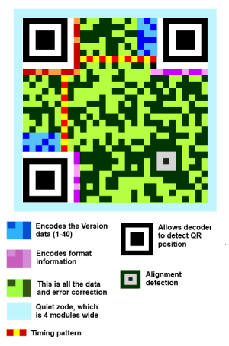A white margin around the QR code, ensuring that scanners can recognize the code easily.

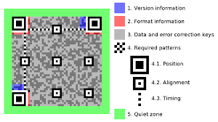

**🔹 Different Types of QR Codes**

**1️⃣ Numeric QR Code**

* Stores only numbers (digits 0-9).
* Can store up to **7,089** numeric characters.

**2️⃣ Alphanumeric QR Code**

* Stores numbers (0-9), uppercase letters (A-Z), and a few symbols ($ % * + - . / :).
* Can store up to **4,296** characters.

**3️⃣ Byte QR Code**

* Stores ASCII and binary data.
* Can store up to **2,953** bytes.

**4️⃣ Kanji QR Code**

* Optimized for **Japanese Kanji** characters.
* Can store up to **1,817 Kanji** characters.

**5️⃣ Micro QR Code**

* A smaller QR code with only one finder pattern.
* Used in compact spaces (e.g., packaging).

**6️⃣ QR Code Model 1 & Model 2**

* Model 1: Early version, supports fewer data sizes.
* Model 2: The current standard, supports larger data capacity and error correction.

**7️⃣ iQR Code**

* A variant that allows rectangular and inverted (light-on-dark) designs.

**8️⃣ Frame QR Code**

* A QR code with a designated **center area** for branding or logos.

**9️⃣ Secure QR Code (SQRC)**

* Used for **private data** with encryption, allowing restricted access.

**🔟 High-Capacity Colored 2D (HCC2D) QR Code**

* Uses **color** to increase data storage, mainly for industrial applications.