**USE CASE DIAGARM**

R.Prabhakara Arjun(2022.503003)

V. Guru Aravindan(2022503001)

**CASE DIAGRAMA AND TEMPLATE**

**Requirement-1:** **Vehicle Entry and Exit Management**

*Description:*entry of a vehicle is marks,slot is booked and entry and exit is managed by system.

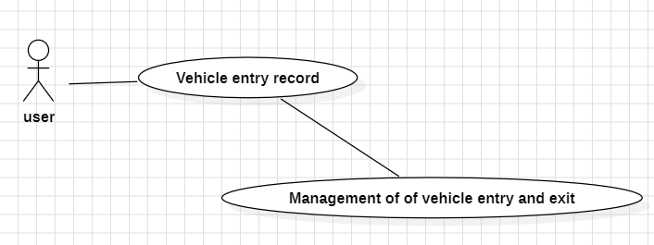

**Requirement-2: Parking Space Allocation**

*Description*:park slot is allocated in such a way that to achieve maximum area.This is handled by system.

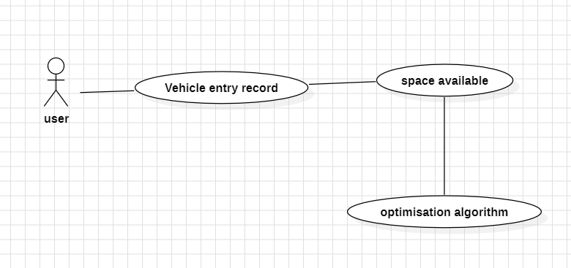

**Requirement-3: Reservation System**

*Decription:* reservation can be done by both user,slot handler.

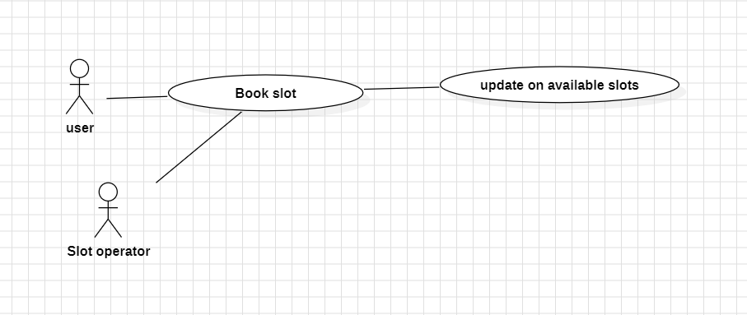

**Requirement-4: Real-Time Availability Tracking**

*Decription:*availability of checks is checked or displayed in the apps!

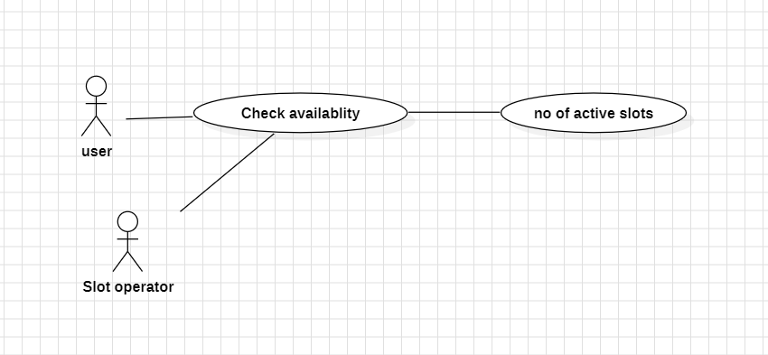

**Requirement-5: Multi-Level Facility Support**

*Decription(optional)*

**Requirement-6: Payment and Billing**

*Decription: Payment tells about the vehicle number,time on that slot then claculate calaculation*

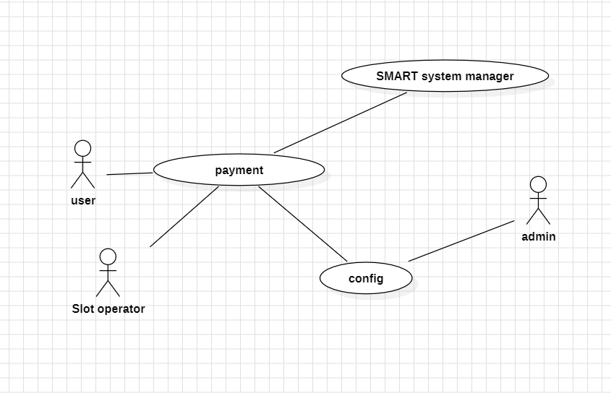

**Requirement-7: Report Generation**

*Decription*: this give daily,weekly,monthly progress and profit gain:

