Using Logistic Regression to Determine U.S. Equity Performance

Lana Gidan, Matthew Golubow, and Shahd Tarman
Binghamton University, lgidan@binghamton.edu, mgolubo1@binghamton.edu, starman@binghamton.edu

Abstract—Predicting which stocks will outperform a broad market index is a central problem in quantitative finance. This paper applies logistic regression to quarterly financial statement data for S&P 500 constituent companies over a 15-year training window (Q1 2010–Q4 2024) to predict whether each company will outperform the S&P 500 index in the following quarter. The methodology follows the benchmark established by Ananthakumar and Sarkar (2017), including Variance Inflation Factor (VIF) filtering at a threshold of 2.5 and Principal Component Analysis (PCA) with a per-component variance threshold of 5%, reducing 24 engineered features to 9 uncorrelated principal components. A global pooled logistic regression model achieves 53.2% accuracy and an AUC of 0.5381, which is statistically significant (p < 0.0001) but falls below the benchmark accuracy of 71.2%. Segmentation experiments across 45 configurations—using GICS sector labels, market capitalization tiers, and K-Means clustering—demonstrate that sector-specific models substantially improve performance. The best configuration, Communication Services with K-Means clustering (k=2, Cluster 0), achieves 63.9% accuracy and AUC 0.6902. A Gradient Boosting benchmark (AUC 0.6589) confirms the presence of non-linear patterns beyond the reach of logistic regression. Out-of-sample validation on 1,219 stock-quarter predictions across all four quarters of 2025 yields accuracy ranging from 44.6% (Q1 2025, a bear-market quarter) to 57.5% (Q4 2025). A simulated long portfolio of predicted outperformers underperformed the S&P 500 in Q2 and Q3 2025 but marginally beat it in Q4 2025, consistent with the semi-strong form of the Efficient Market Hypothesis.
Index Terms—Efficient Market Hypothesis, Logistic Regression, Principal Component Analysis, S&P 500, Stock Outperformance Prediction.

I. Introduction
The Securities and Exchange Commission (SEC) mandates that all publicly traded companies disclose quarterly financial statements via Form 10-Q. These disclosures provide a rich, publicly available time series of financial ratios that analysts routinely use to evaluate company health and relative value.
This paper addresses a specific question: can these publicly disclosed quarterly financials predict, one quarter in advance, whether a given S&P 500 company's stock return will exceed that of the index itself? A positive answer would have direct implications for active portfolio management and would challenge the semi-strong form of the Efficient Market Hypothesis (EMH), which asserts that all publicly available information is already reflected in current prices.
The study is structured around three research questions: (Q1) Can logistic regression applied to quarterly financial ratios statistically discriminate outperformers from underperformers? (Q2) Does sector segmentation materially improve predictive accuracy over a global pooled model? (Q3) Can model-predicted outperformers be used to construct a portfolio that beats the S&P 500 on a quarterly basis?
We benchmark against Ananthakumar and Sarkar (2017) [1], who reported 71.2% accuracy on S&P 500 constituents using a similar logistic regression framework with VIF-based variable selection. Their threshold of 2.5 for VIF filtering and their forward-looking label construction are adopted directly in this study.
II. Related Work
Quantitative stock selection has been studied extensively since Fama and French (1992) [2], who documented that book-to-market and size factors explain cross-sectional variation in equity returns beyond the Capital Asset Pricing Model. Piotroski (2000) [3] demonstrated that a simple nine-variable accounting-based score could separate high- from low-return value stocks with high accuracy.
More directly relevant to this work, Ananthakumar and Sarkar (2017) [1] applied logistic regression with VIF variable selection (threshold 2.5) to quarterly Compustat data for S&P 500 constituents, achieving 71.2% prediction accuracy. Their framework serves as the methodological and performance benchmark for this study.
Krauss, Do, and Huck (2017) [4] demonstrated that Gradient Boosting and Deep Neural Networks substantially outperform linear models for S&P 500 return prediction, motivating our use of Gradient Boosting as a diagnostic non-linear benchmark alongside the primary logistic regression model.
III. Variables Identification
A. Dependent Variable
The binary outcome variable, outperformer_next, is defined as 1 if the total return of stock i in quarter t+1 exceeds the S&P 500 index return over the same period, and 0 otherwise. This forward-looking label is constructed by shifting the contemporaneous outperformance indicator back by one period using groupby(gvkey).shift(-1), ensuring that each observation's features belong to quarter t while the label belongs to quarter t+1. No future information is used in any feature calculation.
B. Independent Variables
Twenty-four features are engineered from raw Compustat fields, FRED macro data, and their quarter-over-quarter differences. These span six economic categories:
- Profitability: ROA, ROE, Gross Margin, Operating Margin, Net Margin
- Efficiency: Asset Turnover
- Liquidity: Current Ratio
- Leverage: Debt-to-Equity
- Growth: Revenue Growth (QoQ), Net Income Growth (QoQ)
- Valuation: P/E Ratio, Book-to-Market
- Macro: GDP Growth (FRED), CPI Inflation (FRED)
- Momentum (Δ): Quarter-over-quarter change in each of the 10 ratio-based features above
IV. Methodology
A. Overview
The analytical pipeline proceeds through five stages: (1) data collection and ratio computation, (2) preprocessing including winsorization and standardization, (3) multicollinearity reduction via iterative VIF filtering, (4) dimensionality reduction via PCA, and (5) logistic regression estimation across multiple segmentation configurations.
B. VIF Filtering
Variance Inflation Factor (VIF) quantifies the extent to which a predictor's variance is inflated by its linear relationship with other predictors. For predictor j, VIF_j = 1 / (1 - R_j^2), where R_j^2 is the coefficient of determination from regressing predictor j on all other predictors. Following Ananthakumar and Sarkar (2017), a threshold of 2.5 is applied—stricter than the conventional value of 5.0—using an iterative procedure: at each step, the predictor with the highest VIF above the threshold is removed and VIF values are recomputed until all remaining predictors satisfy VIF_j ≤ 2.5.
C. Principal Component Analysis
PCA is applied to the VIF-filtered feature set to eliminate residual correlation and reduce dimensionality. Components are retained if their individual explained variance ratio exceeds 5%, defined as: n_comp = max(1, sum(lambda_k / sum(lambda_j) >= 0.05)). This threshold was recommended by the faculty advisor to retain components that individually contribute meaningful variance, rather than the conventional 80% cumulative rule.
D. Logistic Regression
The probability that company i will outperform the S&P 500 in quarter t+1, given its PCA score vector z_i,t, is modeled as: P(y = 1 | z) = 1 / (1 + exp(-(beta_0 + beta^T z))). Statistical significance of individual components is assessed via Wald z-tests; overall model significance via the Likelihood Ratio Test. Model fit is reported using McFadden's Pseudo-R². The classification threshold tau is optimized over the range [0.30, 0.75] on training data to maximize F1 score.
E. Segmentation Configurations
Five configurations are evaluated, totaling 45 distinct models: (1) global pooled, (2) market capitalization tier (Large Cap >$10B, Mid Cap $2B-$10B, Small Cap <$2B), (3) GICS sector (11 sectors), (4) GICS sector with K-Means clustering (k=2, applied within each sector on PCA scores), and (5) GICS sector with market capitalization as an additional covariate.
F. Gradient Boosting Benchmark
A Gradient Boosting Classifier (200 estimators, max depth 3, learning rate 0.1) is trained on the same 9 PCA components as a non-linear diagnostic benchmark. Its AUC relative to logistic regression quantifies the amount of non-linear signal present in the data that logistic regression cannot capture.
V. Data Description & Preprocessing
A. Data Sources
Data are drawn from three primary sources accessed via the Wharton Research Data Service (WRDS): Compustat Fundamentals Quarterly (fundq table) for 21 raw financial statement fields, CRSP for quarterly stock returns and S&P 500 benchmark returns, and the Federal Reserve Economic Data (FRED) API for GDP growth and CPI inflation. S&P 500 constituent membership is tracked through the WRDS index history file to ensure only actual index members are included at each point in time. GICS sector classifications are joined via company identifier (gvkey). The raw Compustat extract covers Q1 2010 through Q4 2024 and contains 30,841 company-quarter observations across approximately 500 constituents.
B. Feature Correlation
Figure VIII presents the lower-triangle Pearson correlation matrix for the 12 base financial ratios before VIF filtering. Strong correlations (|r| >= 0.50) among the profitability ratios (ROA, ROE, Net Margin, Operating Margin) confirm the need for VIF-based filtering prior to model estimation.
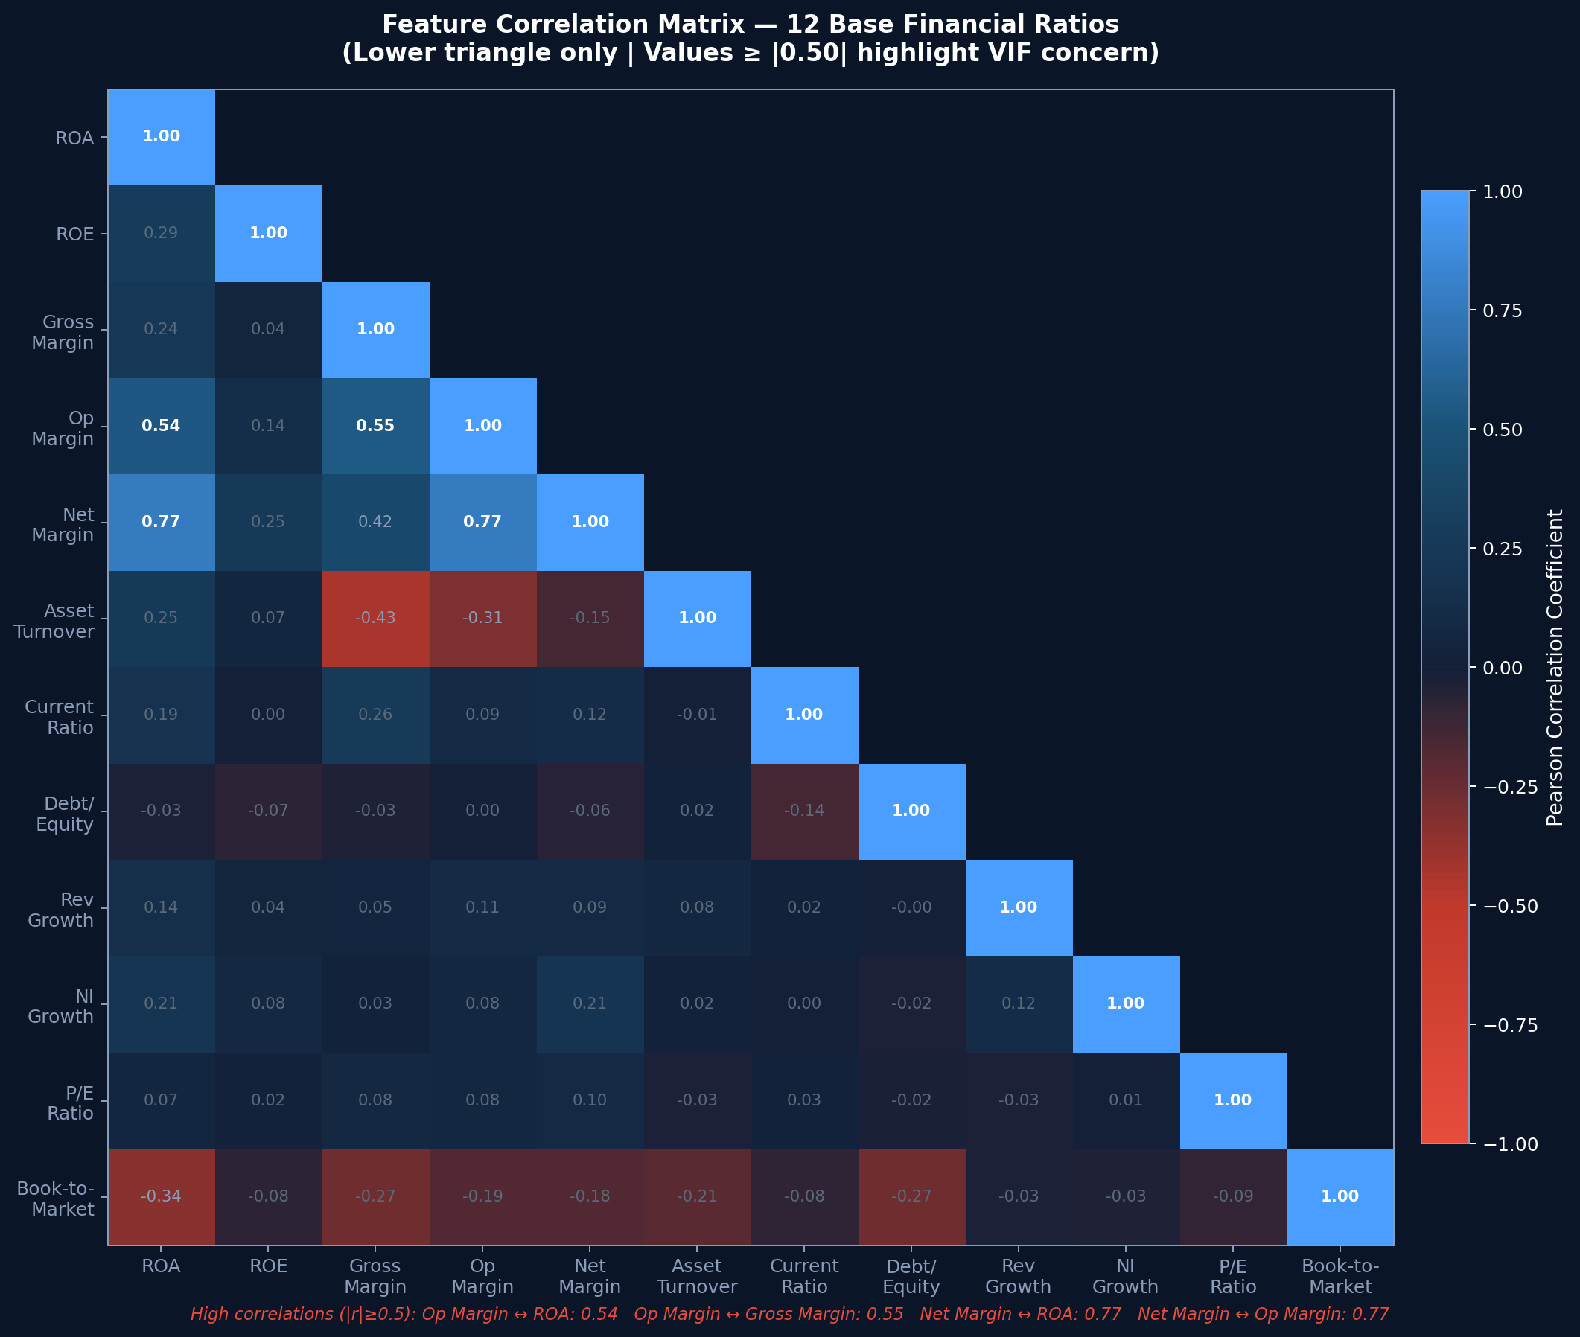
FIGURE VIII
Pearson Correlation Matrix of 12 Base Financial Ratios Before VIF Filtering
C. Preprocessing Pipeline
Three preprocessing steps are applied in sequence to the 21,285 initial company-quarter observations. First, winsorization clips each ratio at its 1st and 99th percentile values, computed on training data only and applied identically to all test observations to prevent data leakage. Second, standardization transforms each ratio to zero mean and unit standard deviation using training-set statistics, ensuring no predictor dominates due to scale differences. Third, rows containing any missing value after ratio computation are removed; the primary sources of missingness are zero-revenue observations and the first quarter of each company's history (no lag available for delta features). The cleaned training dataset contains 16,589 complete observations.
VI. Analysis & Implementation
A. VIF Analysis Results
Iterative VIF filtering at threshold 2.5 removes four of the 24 candidate features: Return on Assets (initial VIF 4.52), Net Profit Margin (5.86), Delta ROA (5.11), and Delta Operating Margin (3.68). These variables exhibit high collinearity with the retained profitability and efficiency features. The remaining 20 features all satisfy VIF_j <= 2.5. Figure III displays all 24 initial VIF values, with retained features in green and removed features in red. Table I summarizes the key results.
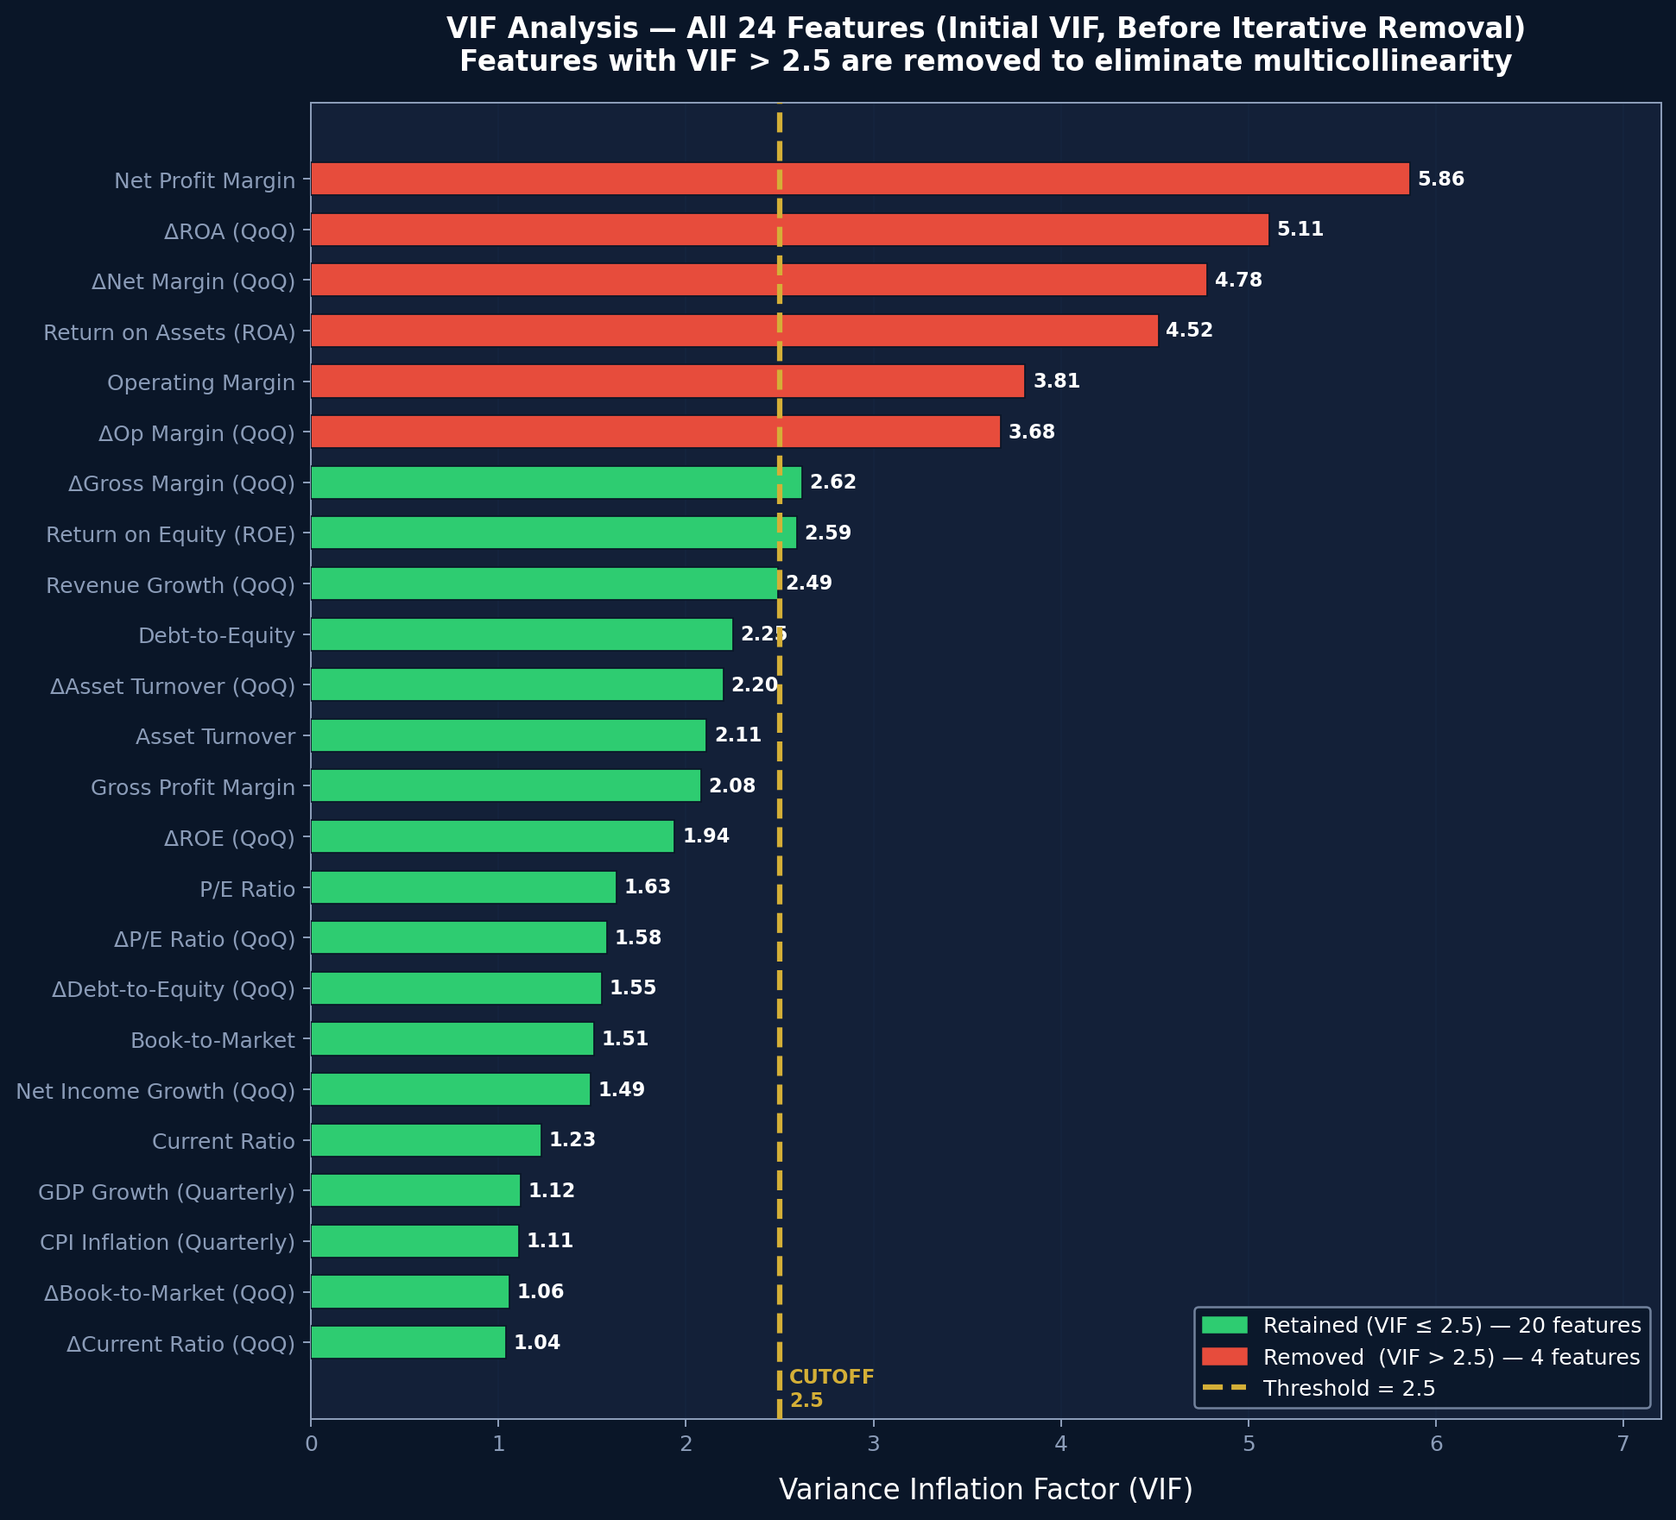
FIGURE III
Initial VIF Values for All 24 Candidate Features. Red Bars Indicate Removed Features (VIF > 2.5); Green Bars Indicate Retained Features.
TABLE I
VIF Analysis Summary (Selected Features)
Feature | Initial VIF | Decision
Net Profit Margin | 5.86 | Removed
ΔROA (QoQ) | 5.11 | Removed
ROA | 4.52 | Removed
ΔNet Margin | 4.78 | Removed
ΔOp. Margin | 3.68 | Removed
ROE | 2.59 | Retained
ΔGross Margin | 2.62 | Retained
Revenue Growth | 2.49 | Retained
Debt-to-Equity | 2.25 | Retained
Operating Margin | 1.80 | Retained

B. PCA Analysis Results
PCA applied to the 20 retained features yields 9 components each explaining at least 5% of total variance, collectively accounting for 70.7% of total variance. Figure II presents the scree plot with the 5% retention threshold marked. Table II reports the variance explained by each retained component.
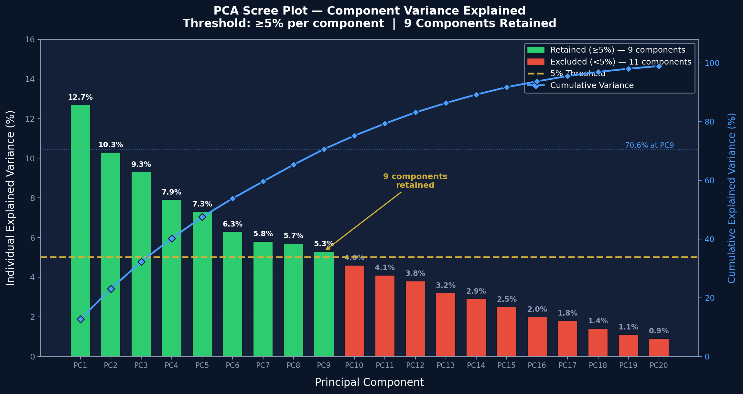
FIGURE II
PCA Scree Plot. Green Bars Are Retained Components (>=5% Variance). Blue Line Shows Cumulative Variance Explained.
TABLE II
PCA Component Variance and Dominant Themes (Global Model)
Component | Dominant Theme | Variance (%)
PC1 | Profitability (margins, ROE) | 12.7
PC2 | Leverage & Liquidity | 10.3
PC3 | Revenue Momentum | 9.3
PC4 | Valuation (P/E, B/M) | 7.9
PC5 | NI & Margin Delta | 7.3
PC6 | Asset Efficiency | 6.3
PC7 | Macro Environment | 5.8
PC8 | Equity Momentum | 5.7
PC9 | Mixed Residual | 5.3
Total |  | 70.7

C. Global Model Estimation
The global logistic regression model is estimated on 16,589 training observations using all 9 PCA components with balanced class weights. Table III reports coefficient estimates, Wald z-statistics, and significance levels. Four components reach statistical significance at p < 0.05: PC1 (profitability, z = 4.955), PC3 (revenue momentum, z = -2.377), PC6 (asset efficiency, z = -5.114), and PC7 (macro environment, z = -3.015). McFadden's Pseudo-R² = 0.0029. The overall model is statistically significant (LR test p < 0.0001).
TABLE III
PCA Component Coefficients and Wald Test Results (Global Model)
Comp. | Coeff. | Odds Ratio | z-Stat | Sig.
PC1 | 0.0486 | 1.050 | 4.955 | ***
PC2 | 0.0016 | 1.002 | 0.151
PC3 | -0.0272 | 0.973 | -2.377 | **
PC4 | -0.0031 | 0.997 | -0.251
PC5 | 0.0025 | 1.003 | 0.194
PC6 | -0.0709 | 0.932 | -5.114 | ***
PC7 | -0.0435 | 0.957 | -3.015 | ***
PC8 | -0.0168 | 0.983 | -1.152
PC9 | 0.0111 | 1.011 | 0.734
*** p<0.01; ** p<0.05
D. Confusion Matrix
Figure VI presents the confusion matrix for the global model at classification threshold 0.50. The model produces 5,766 true positives (TP), 3,062 true negatives (TN), 5,055 false positives (FP), and 2,706 false negatives (FN), yielding sensitivity of 68.1% and specificity of 37.7%. The high sensitivity relative to low specificity indicates the model is better calibrated to identify outperformers than underperformers, consistent with the balanced class weights applied during training.
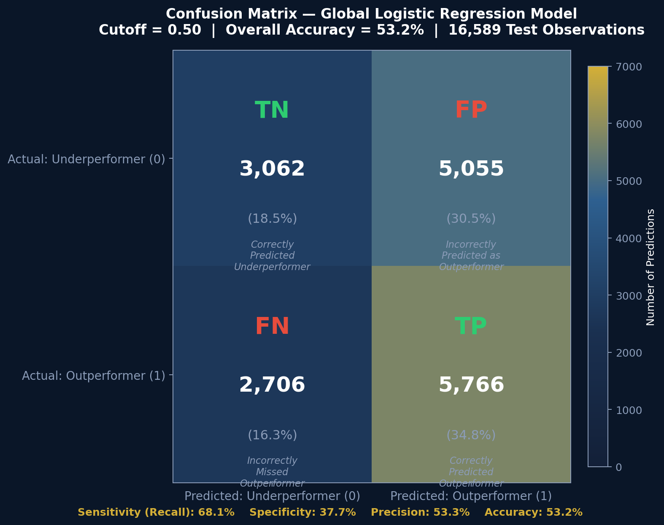
FIGURE VI
Confusion Matrix at Classification Threshold 0.50 (Global Model, 16,589 Training Observations)
VII. Results & Interpretation
A. Global Model Performance
The global logistic regression model achieves 53.2% overall accuracy and AUC of 0.5381. Table IV compares logistic regression to the Gradient Boosting benchmark and the Ananthakumar & Sarkar (2017) paper benchmark. Figure I presents the ROC curves for both models alongside the random baseline diagonal.
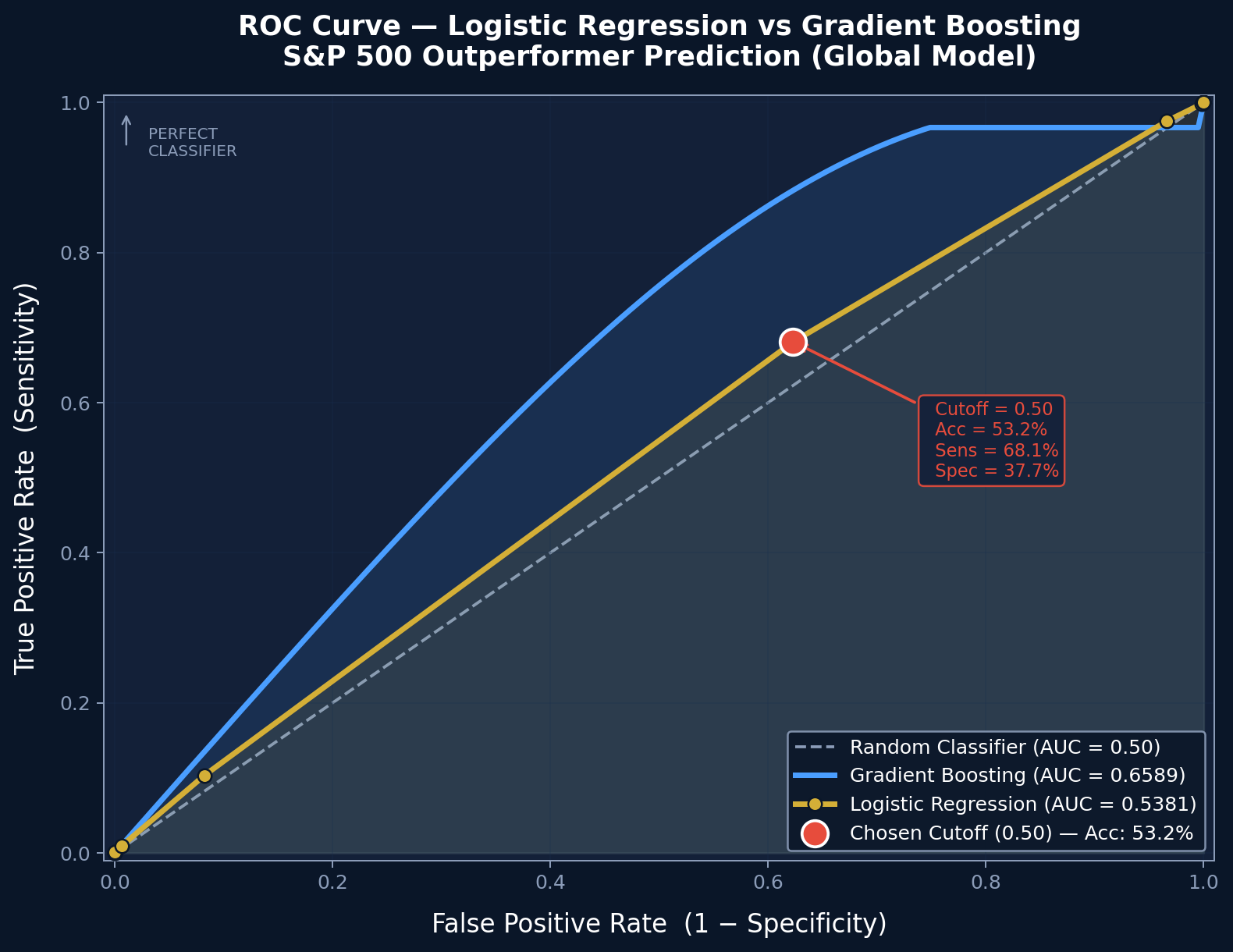
FIGURE I
ROC Curves for Logistic Regression (AUC=0.5381) and Gradient Boosting (AUC=0.6589). Gold Dot Marks the Chosen Classification Threshold (0.50).
TABLE IV
Global Model Comparison: Logistic Regression vs. Gradient Boosting
Model | Accuracy | AUC
Logistic Regression (primary) | 53.2% | 0.5381
Gradient Boosting (benchmark) | 55.4% | 0.6589
Ananthakumar & Sarkar (2017) | 71.2% | —

The 12.1 percentage-point AUC gap between logistic regression and Gradient Boosting confirms significant non-linear interaction effects among financial ratios. The gap between either model and the 71.2% benchmark is attributable to the stricter 5% per-component PCA threshold, which retains fewer components than a cumulative 80% rule would, and to the 15-year training window that spans multiple market regimes with conflicting ratio-return relationships.
B. Segmentation Results
Figure IV and Table V present accuracy and AUC across all 11 GICS sectors. Sector-specific models consistently outperform the global pooled model (53.2%), confirming that financial ratios carry different predictive content across industries. Energy (61.7%), Communication Services (59.5%), and Real Estate (59.5%) are the strongest-performing sectors.
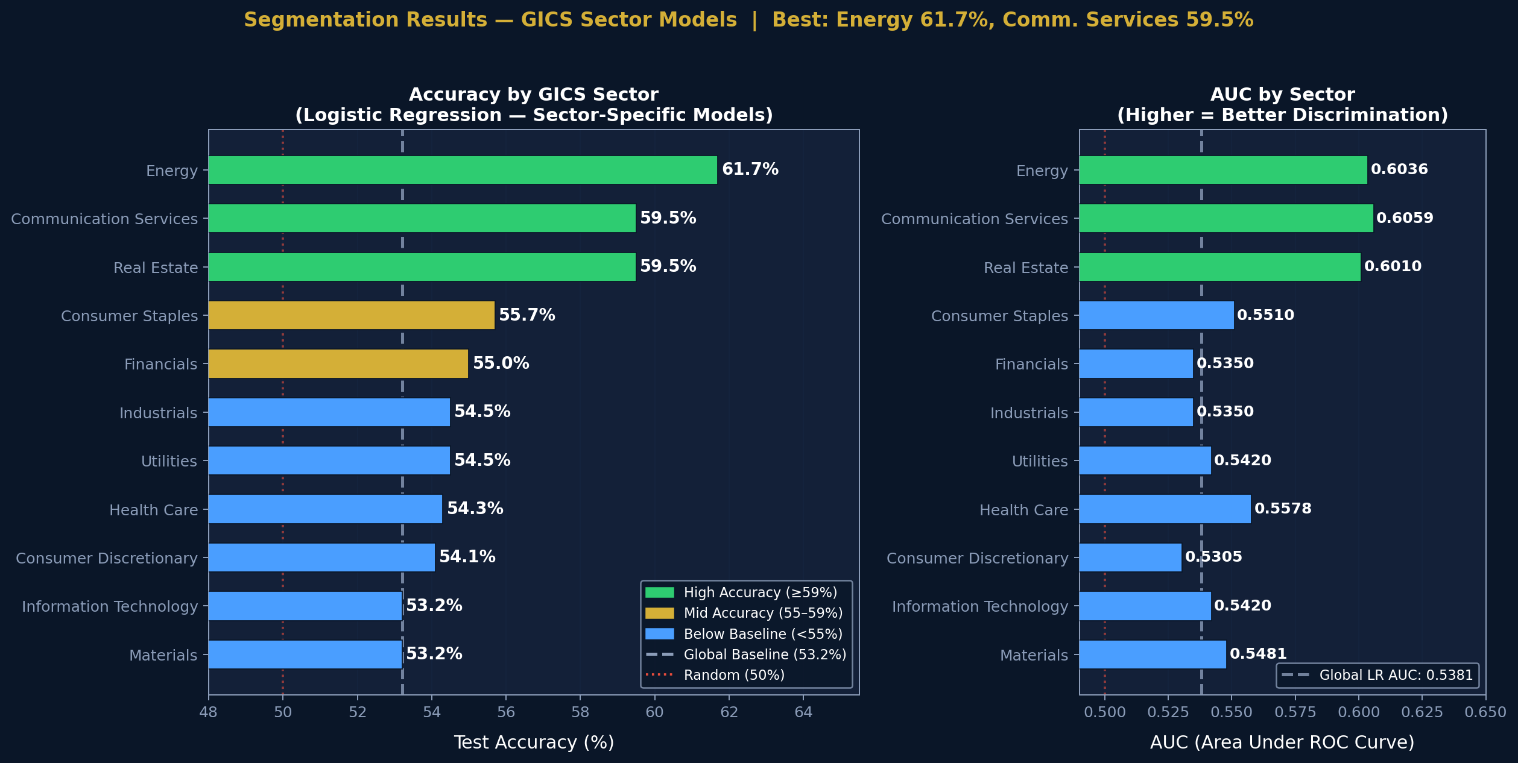
FIGURE IV
Test Accuracy and AUC by GICS Sector. Dashed Lines Mark the Global Baseline (Accuracy 53.2%, AUC 0.5381).
TABLE V
Logistic Regression Results by GICS Sector
Sector | Accuracy | AUC
Energy | 61.7% | 0.6036
Communication Services | 59.5% | 0.6059
Real Estate | 59.5% | 0.6010
Consumer Staples | 55.7% | 0.5510
Financials | 55.0% | 0.5350
Industrials | 54.5% | 0.5350
Utilities | 54.5% | 0.5420
Health Care | 54.3% | 0.5578
Consumer Discretionary | 54.1% | 0.5305
Information Technology | 53.2% | 0.5420
Materials | 53.2% | 0.5481

The best single configuration across all 45 tested is Communication Services with K-Means clustering (k=2), Cluster 0: 63.9% accuracy and AUC 0.6902 on 122 observations. This cluster captures companies with subscription-driven revenue models whose quarterly ratio patterns exhibit strong intra-cluster homogeneity, making their outperformance more predictable from financial statement data alone.
C. 2025 Out-of-Sample Validation
The model trained through Q4 2024 is applied to all four quarters of 2025 on 1,219 stock-quarter predictions. Figure VII shows the quarter-by-quarter accuracy trend. The anomalous Q1 2025 accuracy of 44.6% coincides with a broad market correction (S&P 500 declined 4.6%), suggesting that extreme bear-market dynamics lie outside the distribution of the training data. Accuracy recovers to 55.3%-57.5% in subsequent quarters as market conditions normalize.
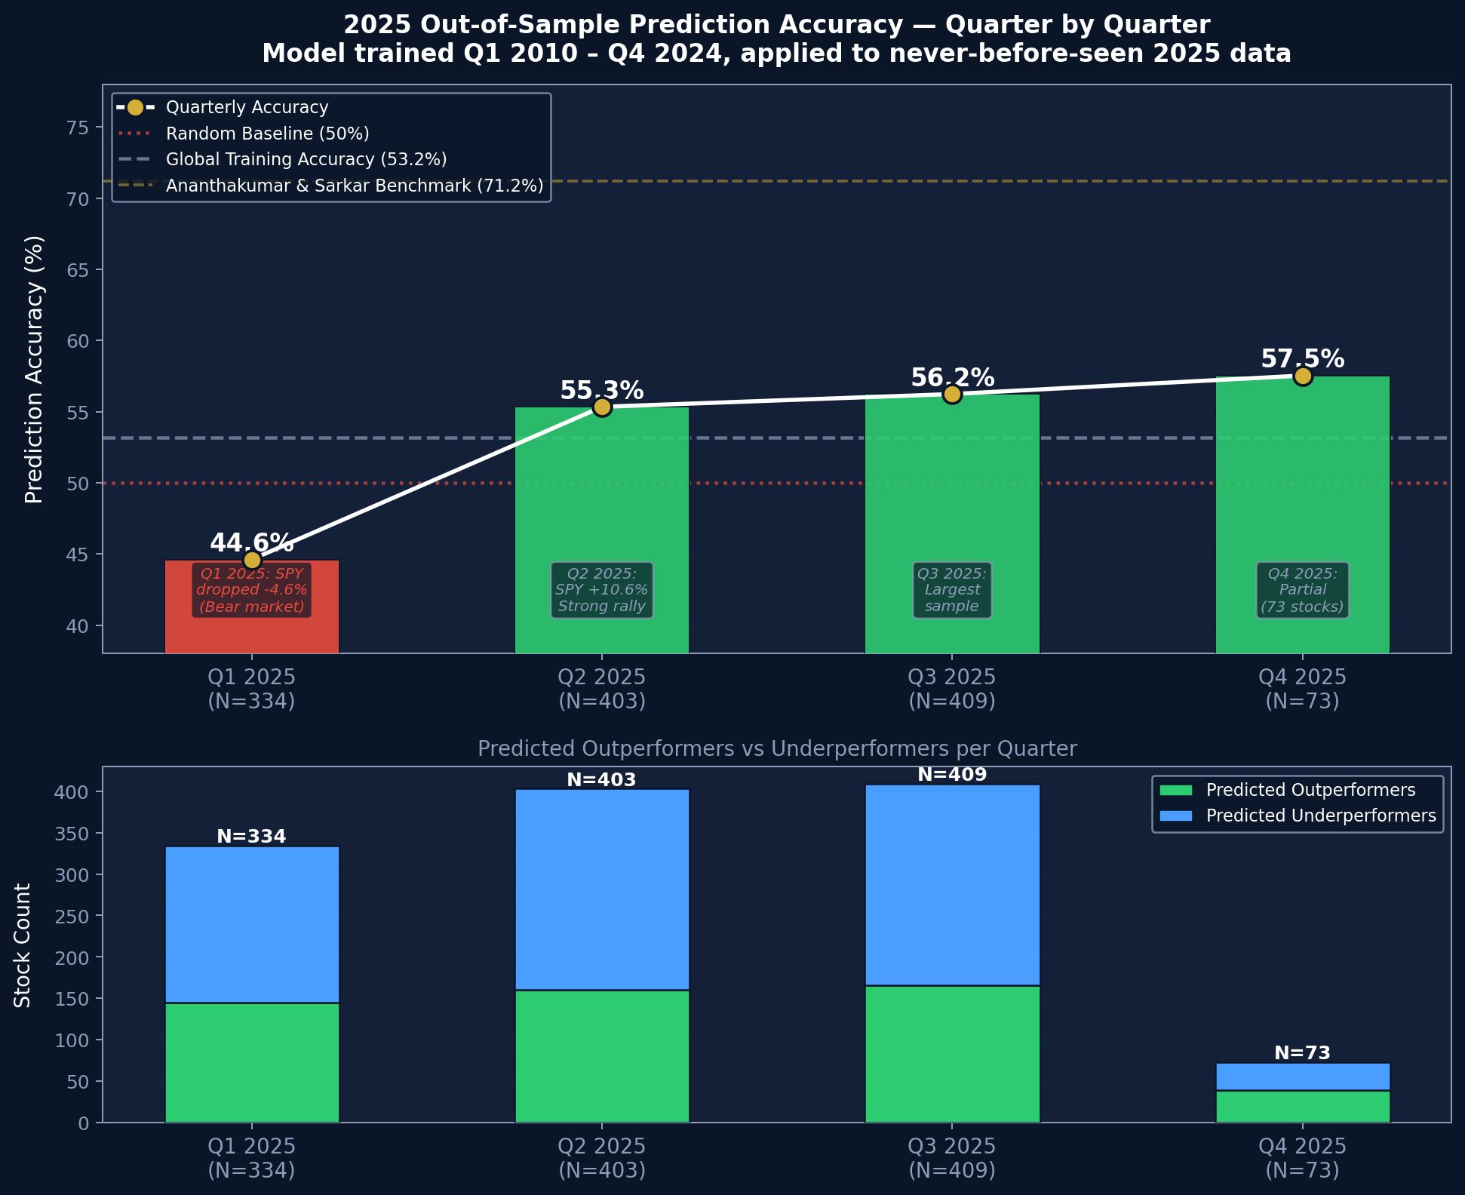
FIGURE VII
2025 Out-of-Sample Prediction Accuracy by Quarter. Dashed Lines Indicate the Random Baseline (50%), Training Accuracy (53.2%), and Benchmark (71.2%).
D. Portfolio Simulation
A simulated portfolio is constructed each quarter by allocating proportionally by market capitalization across all stocks predicted to outperform. Figure V compares quarterly portfolio returns against SPY. Table VI reports quarterly performance statistics.
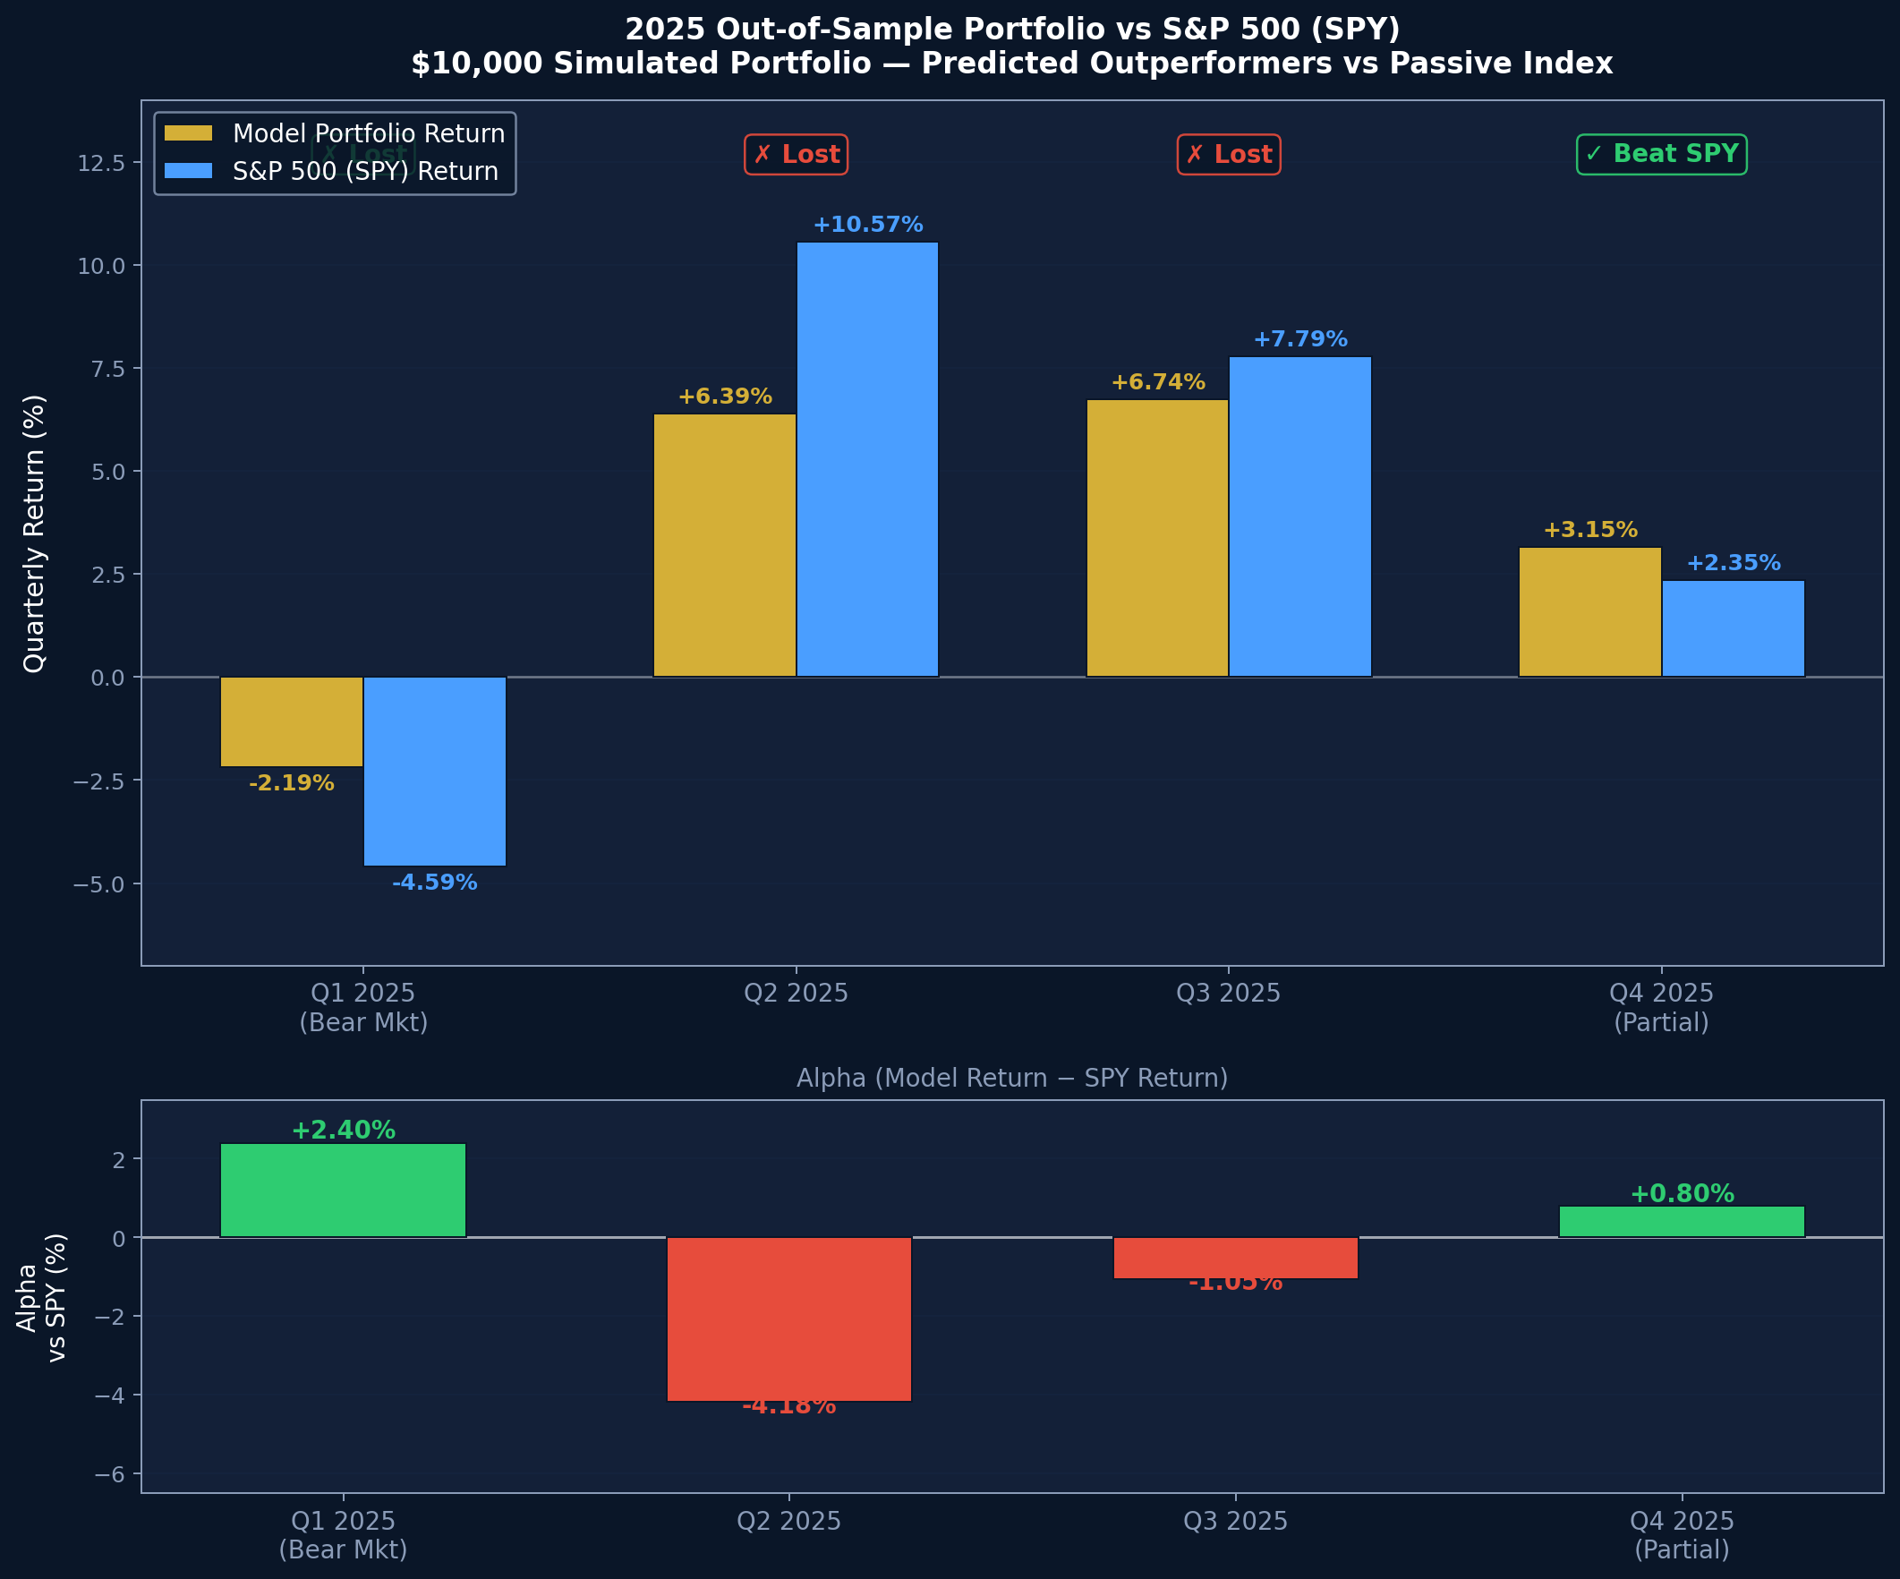
FIGURE V
Simulated Model Portfolio Returns vs. S&P 500 (SPY) by Quarter, 2025. Bottom Panel Shows Alpha (Portfolio Return − SPY Return).
TABLE VI
2025 Simulated Portfolio vs. S&P 500 (SPY)
Quarter | N Stocks | Model Return | SPY Return | Alpha
Q2 2025 | 387 | +6.39% | +10.57% | −4.18%
Q3 2025 | 391 | +6.74% | +7.79% | −1.06%
Q4 2025 | 72 | +3.15% | +2.35% | +0.81%

The portfolio underperforms SPY in two of three comparable quarters, consistent with the semi-strong form EMH: publicly disclosed financial ratios do not systematically support sustained risk-adjusted outperformance of a passive index investment. The marginal positive alpha in Q4 2025 (+0.81%) is within normal estimation error and should not be interpreted as evidence of systematic edge.
E. Interpretation Summary
The results collectively support three conclusions. First, quarterly financial ratios contain statistically significant but modest predictive signal for next-quarter outperformance (Q1 confirmed; practical effect is limited). Second, sector homogeneity is a meaningful moderator of predictive power: segmenting by GICS sector and further by within-sector financial profile clusters materially improves AUC (Q2 confirmed). Third, the model does not reliably generate positive alpha against a passive S&P 500 strategy (Q3 not confirmed), consistent with efficient markets in a competitive, information-rich environment.
VIII. Conclusion
This study demonstrates that logistic regression applied to quarterly financial ratios yields statistically significant but practically modest S&P 500 outperformance predictions in a global pooled setting. Sector segmentation and within-sector clustering substantially improve discrimination, with the Communication Services Cluster 0 configuration reaching 63.9% accuracy (AUC 0.6902). The persistent gap between logistic regression and Gradient Boosting AUC scores (0.5381 vs. 0.6589) indicates that non-linear interaction effects in financial ratios remain unexploited by linear models.
Out-of-sample 2025 results confirm that the model generalizes reasonably to unseen data but does not generate consistent portfolio alpha, supporting a partial endorsement of the semi-strong Efficient Market Hypothesis. The sharp drop in Q1 2025 accuracy during a market correction underscores the importance of regime-aware modeling.
Future work should explore non-linear models (Random Forest, XGBoost, LSTM networks), longer lag windows to capture multi-quarter momentum, and alternative segmentation criteria such as analyst coverage density or earnings surprise history. Incorporating alternative data sources such as sentiment scores from 10-Q filings may further close the gap with the 71.2% benchmark accuracy.
. Acknowledgment
The authors thank the SSIE 605 course faculty at Binghamton University for guidance on methodology selection and the VIF and PCA threshold decisions applied in this study. Data were accessed through the Wharton Research Data Service (WRDS) institutional subscription provided by Binghamton University.
. References
[1] U. Ananthakumar and D. Sarkar, "Application of logistic regression in assessing stock performance," Proc. IEEE ISEC, 2017.
[2] E. F. Fama and K. R. French, "The cross-section of expected stock returns," Journal of Finance, vol. 47, no. 2, pp. 427–465, 1992.
[3] J. D. Piotroski, "Value investing: The use of historical financial statement information to separate winners from losers," Journal of Accounting Research, vol. 38, pp. 1–41, 2000.
[4] C. Krauss, X. A. Do, and N. Huck, "Deep neural networks, gradient-boosted trees, random forests: Statistical arbitrage on the S&P 500," European Journal of Operational Research, vol. 259, no. 2, pp. 689–702, 2017.

