Using Logistic Regression to Determine U.S. Equity Alpha
Lana Gidan, Matthew Golubow, and Shahd Tarman
Binghamton University, lgidan@binghamton.edu, mgolubo1@binghamton.edu, starman@binghamton.edu

Abstract – Generating outsized returns relative to a benchmark remains a central objective in quantitative finance. This paper applies logistic regression to 15 years’ worth of financial data to determine if alpha can be generated against the Standard and Poor’s 500 quarter over quarter performance. The study incorporates company specific financial reports and macroeconomic datapoints to determine if outperformers of an index can be accurately determined for the subsequent quarter, based on available current quarter information. Techniques applied in this study include multicollinearity correction mechanisms, data standardization, and optimal value cutoff determination. Full model logistic regression performance is compared against models bifurcated according to market capitalization and sector, and gradient boosted analogs to determine the best predictive efficacy. Accuracy scores ranging from 53-61% are demonstrated, posing a moderate challenge to the Efficient Market Hypothesis.

Index Terms – alpha, efficient market hypothesis, logistic regression, multicollinearity, principal component analysis (PCA) , Standard & Poor’s (S&P) 500 Index.
Introduction
The 1970 addendum to the Securities Exchange Act of 1934 mandates that all publicly traded companies disclose quarterly financial statements [1]. Originally created as a mechanism to mitigate fraudulent behavior and ensure symmetric information availability in the markets, these disclosures provide a rich, publicly available time series of financial information that investors routinely use to evaluate company health and relative value. The reports provide a time-stamped snapshot of company performance and include information regarding assets, debt, and other measurements pertinent to monetary valuation [2].
The Standard and Poor’s (S&P) 500 index is one of the most actively traded indices in the world, and provides investors with an opportunity to directly participate in the ownership of the largest 500 publicly traded companies in America. The S&P 500 is a broad market index that is weighted by market cap by company, and is often used to describe wider American economic performance. Passive investing, a long-term buy and hold strategy, is often closely associated with purchasing S&P 500 exchange trade fund (ETF) shares to capture broad market upside and widen risk exposure. According to the Efficient Market Hypothesis, an investor, on average, can do no better than purchasing an S&P 500 ETF for a long-time horizon, and should maintain an investment prescription in kind [3].
This paper addresses a specific question: can these publicly disclosed quarterly financial statements, in conjunction with macro level indicators, accurately predict, one quarter in advance, whether a given S&P 500 company's stock return will exceed that of the index itself? A positive answer would have direct implications for active portfolio management and would challenge the semi-strong form of the Efficient Market Hypothesis (EMH), which asserts that all publicly available information is already reflected in current prices [4]. A positive response would also provide investors with a repeatable mechanism to determine what equities to buy, sell, and hold, at quarter end, to increase returns and mitigate.
This study is structured around four primary research questions: (Q1) Can logistic regression be applied to quarterly financial ratios to statistically discriminate outperformers from underperformers? (Q2) Does equity segmentation affect model accuracy when compared to a total index model? (Q3) Can other procedures such as Gradient Boosting be used to further enhance performance? (Q4) Can model-predicted outperformers be used to construct a portfolio that consistently beats an S&P 500 Index on a quarterly basis? Note that any company whose next-quarter performance was better than the S&P 500’s total return is labelled an ‘Outperformer’ and as an ‘Underperformer’ otherwise.
We benchmark against Ananthakumar and Sarkar (2017) [5], who reported 71.2% accuracy while studying the Bombay Stock Exchange (BSE) constituents using a similar logistic regression framework with VIF-based variable selection. Their threshold of 2.5 for VIF filtering and many of the variables under scrutiny are adopted in this study.
Related Work
Quantitative stock selection has been studied extensively since Fama and French (1992) [6], who reported that book-to-market and size factors can explain cross-sectional variation in equity returns beyond the Capital Asset Pricing Model. Piotroski (2000) [7] demonstrated that a simple nine-variable accounting-based score could separate high- from low-return value stocks with high accuracy.
More directly relevant to this work, Ananthakumar and Sarkar (2017) [5] applied logistic regression with VIF variable selection (threshold 2.5) to annual data for Bombay Stock Exchange (BSE) constituents, achieving 71.2% prediction accuracy. Their framework serves as the methodological and performance benchmark for this study. The analysis applied herein seeks to generate quarterly based American Exchange alpha, while Ananthakumar looks strictly at in-sample annual categorization of the BSE.
Krauss, Do, and Huck (2017) [8] demonstrated that Gradient Boosting can substantially outperform linear models for S&P 500 return prediction. This motivates our use of Gradient Boosting as a diagnostic non-linear benchmark alongside the primary logistic regression model.
Variable Creation and Identification
- Dependent Variable
The binary outcome variable, outperformer_next, is defined as ‘1’ if the total return of stock i in quarter t+1 exceeds the S&P 500 index return over the same period, and ‘0’ otherwise. In this way, we utilize information available at the current time step to predict performance at the next time step. Note that equity quarter over quarter percentage performance is the benchmark for this measurement, and is directly measured against the S&P 500 quarter over quarter performance for the same period. If, for example, a company saw a 1% increase in its stock price from the end of Q1-2022 to the end of Q2-2022, and the S&P 500 returned 0.75%, this company, for Q1-2022, would be deemed an outperformer.
- Independent Variables
Twenty-four features are engineered from the raw Compustat fields, Financial Reserve Economic Data (FRED) macro observations, and quarter-over-quarter difference calculations from both sources. Data capture is further expanded upon in the Data Description section. The data captured covers six main economic categories:
- Profitability: Return On Assets, Return On
Equity, Gross Margin, Operating Margin, Net Profit Margin
- Efficiency: Asset Turnover
- Liquidity: Current Ratio
- Leverage: Debt-to-Equity
- Growth: Revenue Growth, Net Income
- Valuation: Price-to-Earnings Ratio (P/E Ratio), Book-to-Market Ratio
- Macro Level: Gross Domestic Product (GDP) Growth, Consumer Price Index (CPI) Growth
- Momentum: QoQ change for all ratio based features

These ratios are calculated from raw, end-of-quarter financial information. The conventional quarterly calendar cycle is used in this analysis and appropriately synchronizes against fiscal reporting cycles. As company reports do not strictly follow the standard calendar quarters, this adjustment is necessary for data quality assurance. The below schema is applied to assign any report released within the boundary to the appropriate calendar quarter:
- Q1: Jan 1st-March 31st
- Q2: April 1st to June 30th
- Q3: July 1st to September 30th
- Q4: October 1st to December 31st

This step was vital to ensure that records were being compared against the same time period, regardless of the specific company’s time of filing.
Methodology
I. Overview
The analysis pipeline proceeds through seven stages: 1-Data collection and ratio computation, 2-Data preprocessing and cleaning via winsorization and standardization, 3- Multicollinearity reduction via iterative VIF filtering, 4-Dimensionality reduction via Principal Component Analysis (PCA), 5-Full model logistic regression estimation, 6- Segmentation analysis by sector and market capitalization, and 7-Predicting performance of a portfolio built using the model. Note 5 and 6 includes deeper analysis with regards to individual measure statistical significance, parsimonious model favorability, and probability cutoff value optimization analysis. Step 5 also includes a Gradient Boosted Model for comparison.
II. VIF Filtering
Variance Inflation Factor (VIF) quantifies the extent to which a predictor's variance is inflated by its linear relationship with other predictors. For predictor j,

${VIF}_{j}= \frac{1}{1- R_{j}^{2}}$ (1)

where is$R_{j}^{2}$ the coefficient of determination from regressing predictor j on all other predictors. This means that two variables may be expressing the same information within the model, and one can be removed. Following Ananthakumar and Sarkar (2017), any variable with a VIF higher than 2.5 is filtered out of the model. VIF is calculated for all predictors simultaneously at a particular iteration. The predictor with the highest VIF above the threshold is removed, and VIF values are recomputed on the following iteration until all remaining predictors satisfy ${VIF}_{j}$≤2.5. Once these multicollinear variables are removed, we have confidence that the predictors used in the resulting analysis represent the largest information carry, while removing duplicate effects.
III. Principal Component Analysis
PCA is then applied to the VIF-filtered feature set to eliminate residual correlation, reduce dimensionality, and increase interpretability. Components are retained if their individual explained variance ratio exceeds 5%. This threshold filters out low-variance components that do not meaningfully contribute to the total variance in the system.
IV. Logistic Regression
The probability that company i will outperform the S&P 500 in quarter t+1, given its PCA score ${vector z}_{i,t}$, is modeled as:

$P\left(y=1 \right| z)= \frac{1}{1+e^{-(β_{0}+β^{T}*z)}}$ (2)

Where (2) represents the standard logistic regression formula, and T represents the principal component vector for a given row record. Overall model statistical significance is assessed via the Likelihood Ratio Test, individual components via Wald z-tests, and model fit is reported using McFadden's Pseudo-R². The classification threshold, , which is the probability cutoff for an out/underperformer, was also adjusted on a range [0.30, 0.75] on the training data to maximize F1 score.
V. Segmentation Configurations
Five configurations are evaluated, totaling 45 distinct logistic regression models: (a) a global pooled model containing all companies and observations, (b) a market capitalization tier containing three approximately evenly split buckets (Large Cap >$10B, Mid Cap $2B-$10B, Small Cap <$2B), (c) a Global Industry Classification Standard (GICS) sector (11 sectors) model, (d) GICS sector with K-Means clustering (k=2, applied within each sector on PCA scores), and (e) GICS sector with market capitalization as an additional covariate. Note that GICS sector analysis buckets the companies based on their primary source of revenue. The driving factor for this analysis and further segmentation was to determine the effects that various bifurcations had on model performance. Does the model predict better on one GICS sector against another? How influential is market cap on that same prediction? These questions were under consideration and prompted the team to determine what factors influenced accuracy within these models.
VI. Gradient Boosting Benchmark
As the logistic regression model evaluated assumed strictly linear relationships between the covariates, the team also analyzed a Gradient Boosting Classifier to determine the accuracy score of a model that was free from this bias. A model with 200 estimators, max depth of 3, and a learning rate of 0.1 is trained on the same 9 PCA components. Area Under Curve (AUC) comparison relative to logistic regression quantifies the amount of non-linear signal present in the data that logistic regression cannot capture. Results are discussed in the Analysis section.
Data Description and Preprocessing
I. Data Sources
Data are drawn from three primary sources accessed via the Wharton Research Data Service (WRDS) hosted by the University of Pennsylvania. The Compustat Fundamentals Quarterly (fundq table) provides 22 raw financial statement fields, the Center for Research Security Prices (CRSP) provides quarterly stock and S&P 500 returns, and the Federal Reserve Economic Data (FRED) API provides macro level indicators: GDP growth and CPI inflation. S&P 500 constituent membership is tracked through the WRDS index history file to ensure only actual index members are included at each point in time. As the S&P 500 constituent members are adjusted quarterly, the team is diligent in ensuring accurate membership tracking through time. GICS sector classifications are then joined via the company identifier (gvkey). The raw Compustat extract covers Q1 2010 through Q4 2024 and contains 30,841 company-quarter observations. This is in line with the expected amount of 30,000 (15 years * 4 quarters * 500 companies) samples and the team attributes the extra records due to certain quarters containing slightly more than 500 companies, which can occur when companies included have different share tiering available [9].
II. Feature Correlation
Figure I presents the Pearson correlation ($R$) matrix for the 12 base financial ratios before VIF filtering is applied.
As certain ratios have strong correlations, especially pertaining to Profitability, the team’s decision to apply VIF filtering is appropriate.

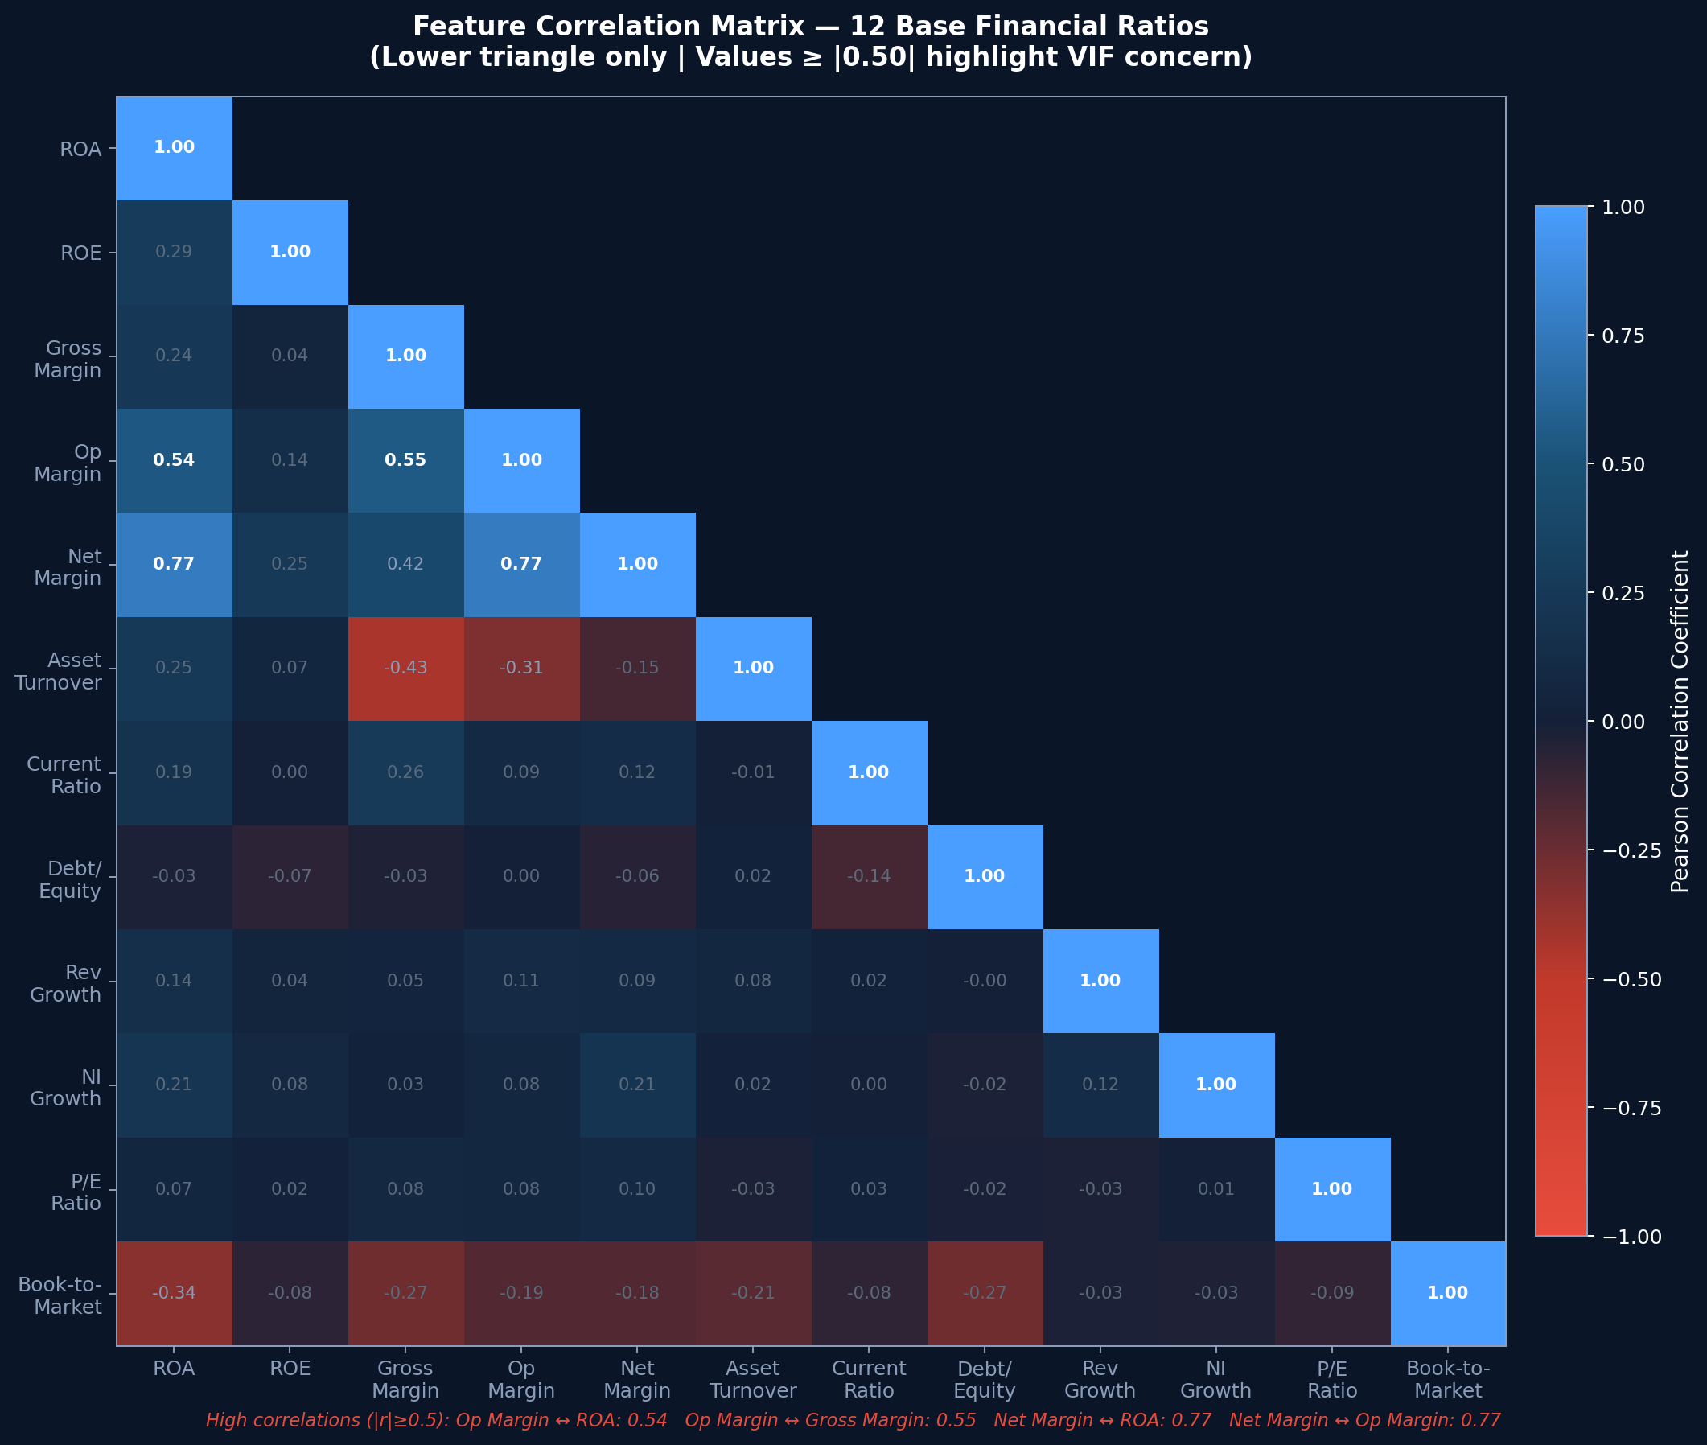
Figure I
Pearson Correlation Matrix of 12 Base Financial Ratios Before VIF Filter Application

III. Preprocessing Pipeline
Three preprocessing steps are applied in sequence to the initial company-quarter-year observations. First, winsorization clips each data point at its 1st and 99th percentile values; computed on training data only. Winsorization is applied identically to all test observation columns to ensure proper data quality on the training set. Second, standardization transforms each data element to have zero mean and unit standard deviation. This ensures no predictor dominates due to scale differences naturally present in the data (i.e, comparing a market capitalization of trillions to a percentage based QoQ ROA). Third, rows containing any missing values after ratio computation are removed; the primary sources for missing data are zero-revenue observations and the lack of lagged responses on the first quarter measured. Compustat has no guarantee of record capture for a particular data element, resulting in some NA values in the dataset, which were also removed. The final cleaned training dataset utilized 16,589 complete observations each having 24 intendent variables.
Analysis and Implementation
I. VIF Analysis Results
Iterative VIF filtering at threshold 2.5 removes four of the 24 candidate features: Net Profit Margin, Delta ROA, Return on Assets, and Delta Operating Margin. These variables exhibit high collinearity with the retained profitability and efficiency features. The remaining 20 features all satisfy ${VIF}_{j}≤2.5$. Figure II displays all 24 initial VIF values, with low VIF features in green, and high VIF features in red. Table I summarizes the key results.

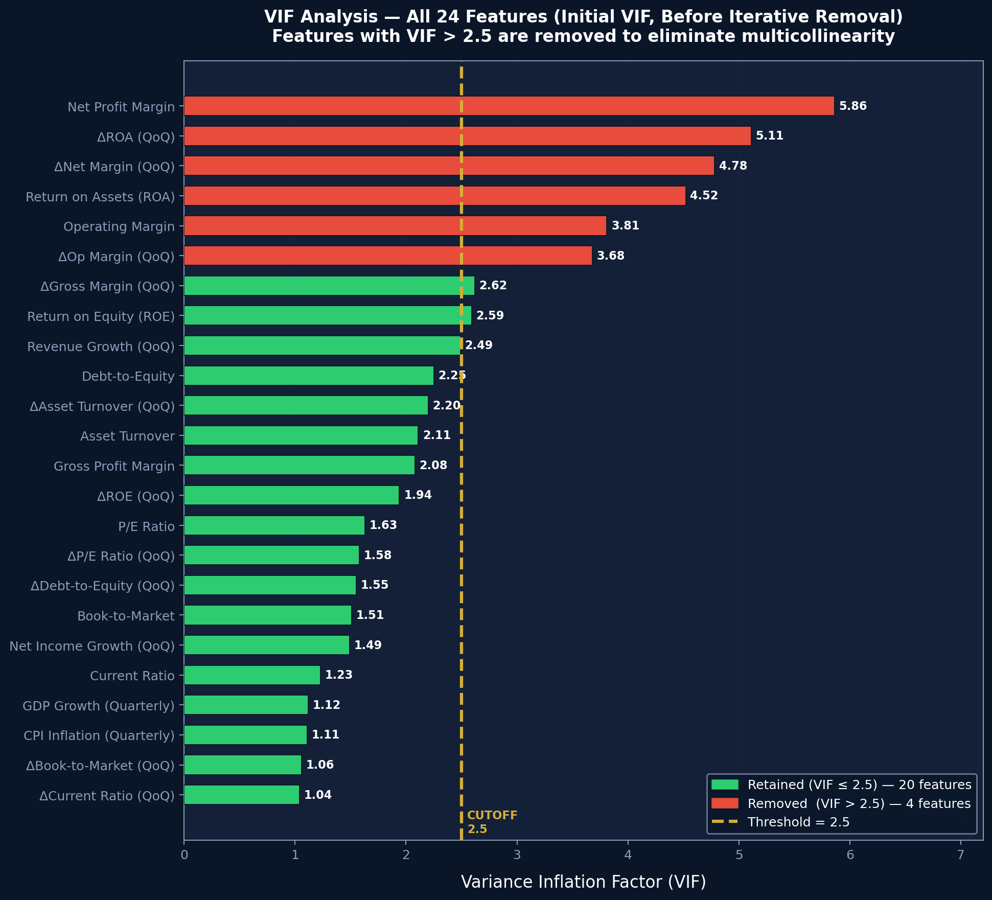
Figure II
Initial VIF Calculation for 24 Candidate Features

Note that in Figure II, 6 variables are above the threshold because it is the initial iteration of the VIF calculation. After the maximum VIF score variable is removed on this iteration, the VIF calculation is re-ran, and the model sees only 4 variables exit, as shown in Table 1.

TABLE I
VIF Analysis Summary
Feature | Initial VIF | Decision
Net Profit Margin | 5.86 | Removed
ΔROA (QoQ) | 5.11 | Removed
ΔNet Margin | 4.78 | Retained
ROA | 4.52 | Removed
Operating Margin | 3.81 | Retained
ΔOperating Margin | 3.68 | Removed
ROE | 2.59 | Retained
ΔGross Margin | 2.62 | Retained
Revenue Growth | 2.49 | Retained
Debt-to-Equity | 2.25 | Retained

Table one highlights that initial VIF calculations may not actually lead to removal in subsequent iterations, as seen with ΔNet Margin and Operating Margin.
II. PCA Analysis Results
PCA is next applied to the 20 remaining features and results in 9 components - each of which explains at least 5% of total system variance. Collectively, all 9 components account for 70.7% of total data variance. Figure III presents the scree plot with the 5% retention threshold marked. Table II reports the variance explained by each retained component. An approximate elbow point is seen at PC3, but components are maintained according to the 5% heuristic, and lack of distinct slope change for cumulative variance.

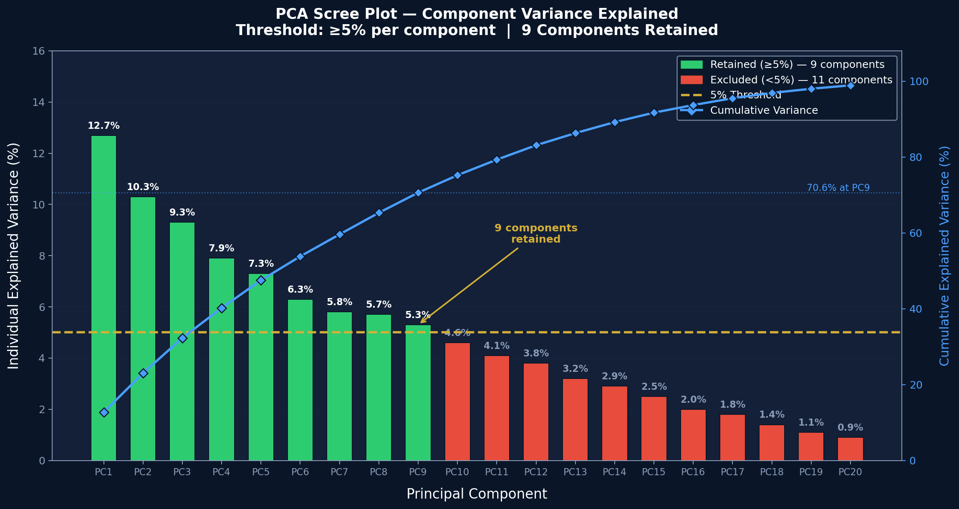
Figure III
PCA Scree Plot
TABLE II
Global Pooled Model PCA Component and Variance Percentage
Component | Dominant Theme | Variance (%)
PC1 | Profitability (margins, ROE) | 12.7
PC2 | Leverage & Liquidity | 10.3
PC3 | Revenue Momentum | 9.3
PC4 | Valuation (P/E, B/M) | 7.9
PC5 | NI & Margin Delta | 7.3
PC6 | Asset Efficiency | 6.3
PC7 | Macro Environment | 5.8
PC8 | Equity Momentum | 5.7
PC9 | Mixed Residual | 5.3
Total |  | 70.7

III. Global Model Estimation
The global logistic regression model is estimated on 16,589 training observations using all 9 PCA components with balanced class weights assumed (number of outperformers equaling number of underperformers). Table III reports the diagnostic results such as coefficient estimates, Wald z-statistics, and significance levels. The Logistic Regression training procedure results in four components reaching statistical significance at a 95% confidence interval (p < 0.05): PC1 (profitability, z=4.955), PC3 (revenue momentum, z=-2.377), PC6 (asset efficiency, z=-5.114), and PC7 (macro environment, z=-3.015). McFadden's Pseudo-R² = 0.0029. The overall model is also statistically significant (LR test p < 0.0001).
IV. Confusion Matrix

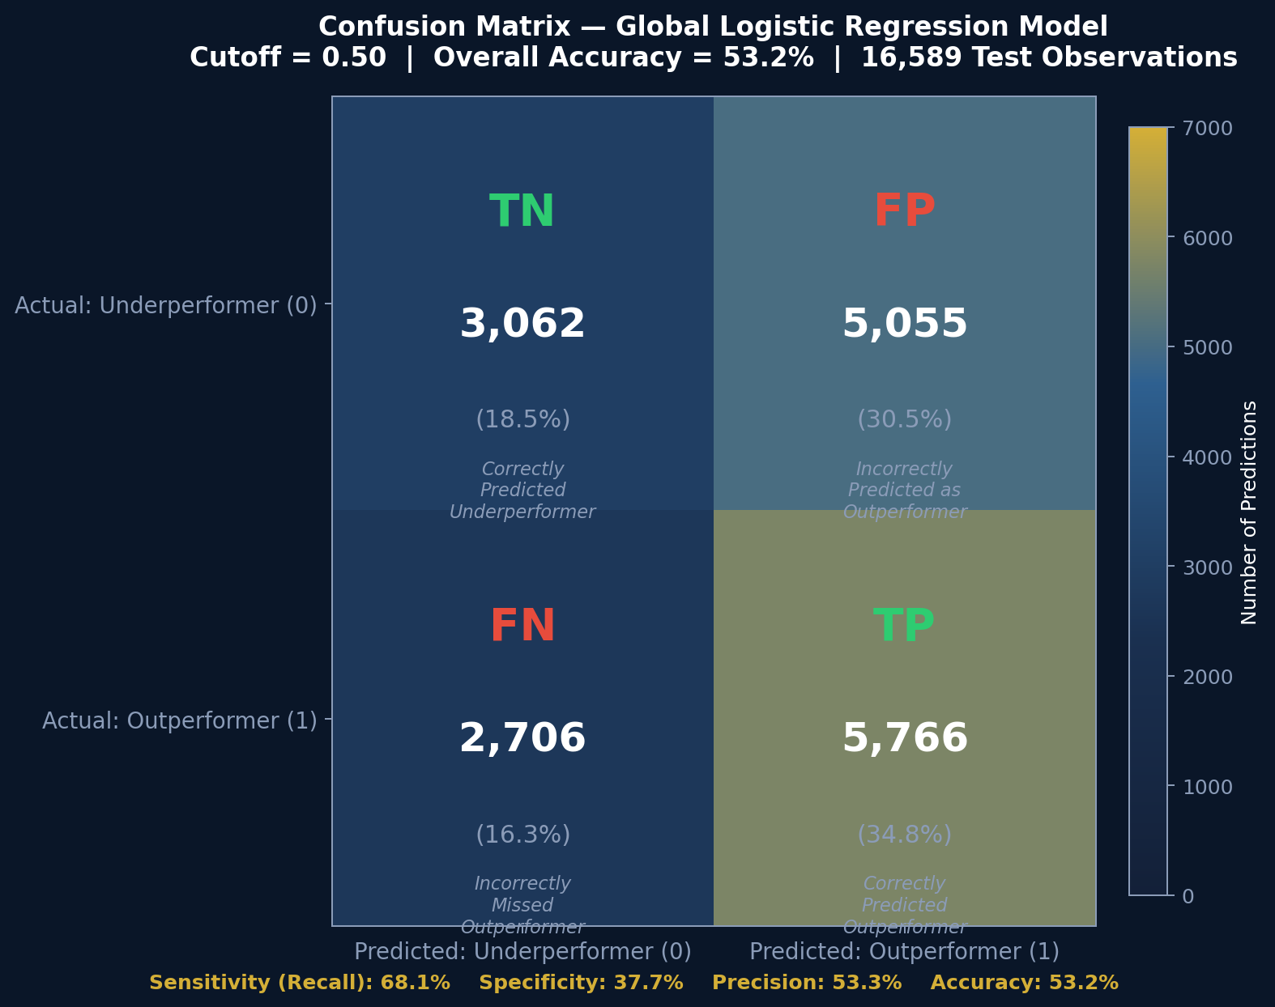
Figure IV
CONFUSION MATRIX AT CLASSIFICATION THRESHOLD 0.50 (GLOBAL MODEL, 16,589 TRAINING OBSERVATIONS)
Fairly high sensitivity is reported at 68.1%, specificity is low at only 37.7%, and accuracy is slightly better than random at 53.2%. Despite being only 3.2% better than random, this may still be materially impactful if portfolio construction garners meaningful alpha. Please refer to the results section for this analysis.
Results and Interpretation
I. Global Model Performance
The global logistic regression model achieves 53.2% overall accuracy and AUC of 0.5381. Table IV compares logistic regression to the Gradient Boosting benchmark and the Ananthakumar & Sarkar (2017) paper benchmark. Figure V presents the ROC curves for both models alongside the random baseline diagonal.

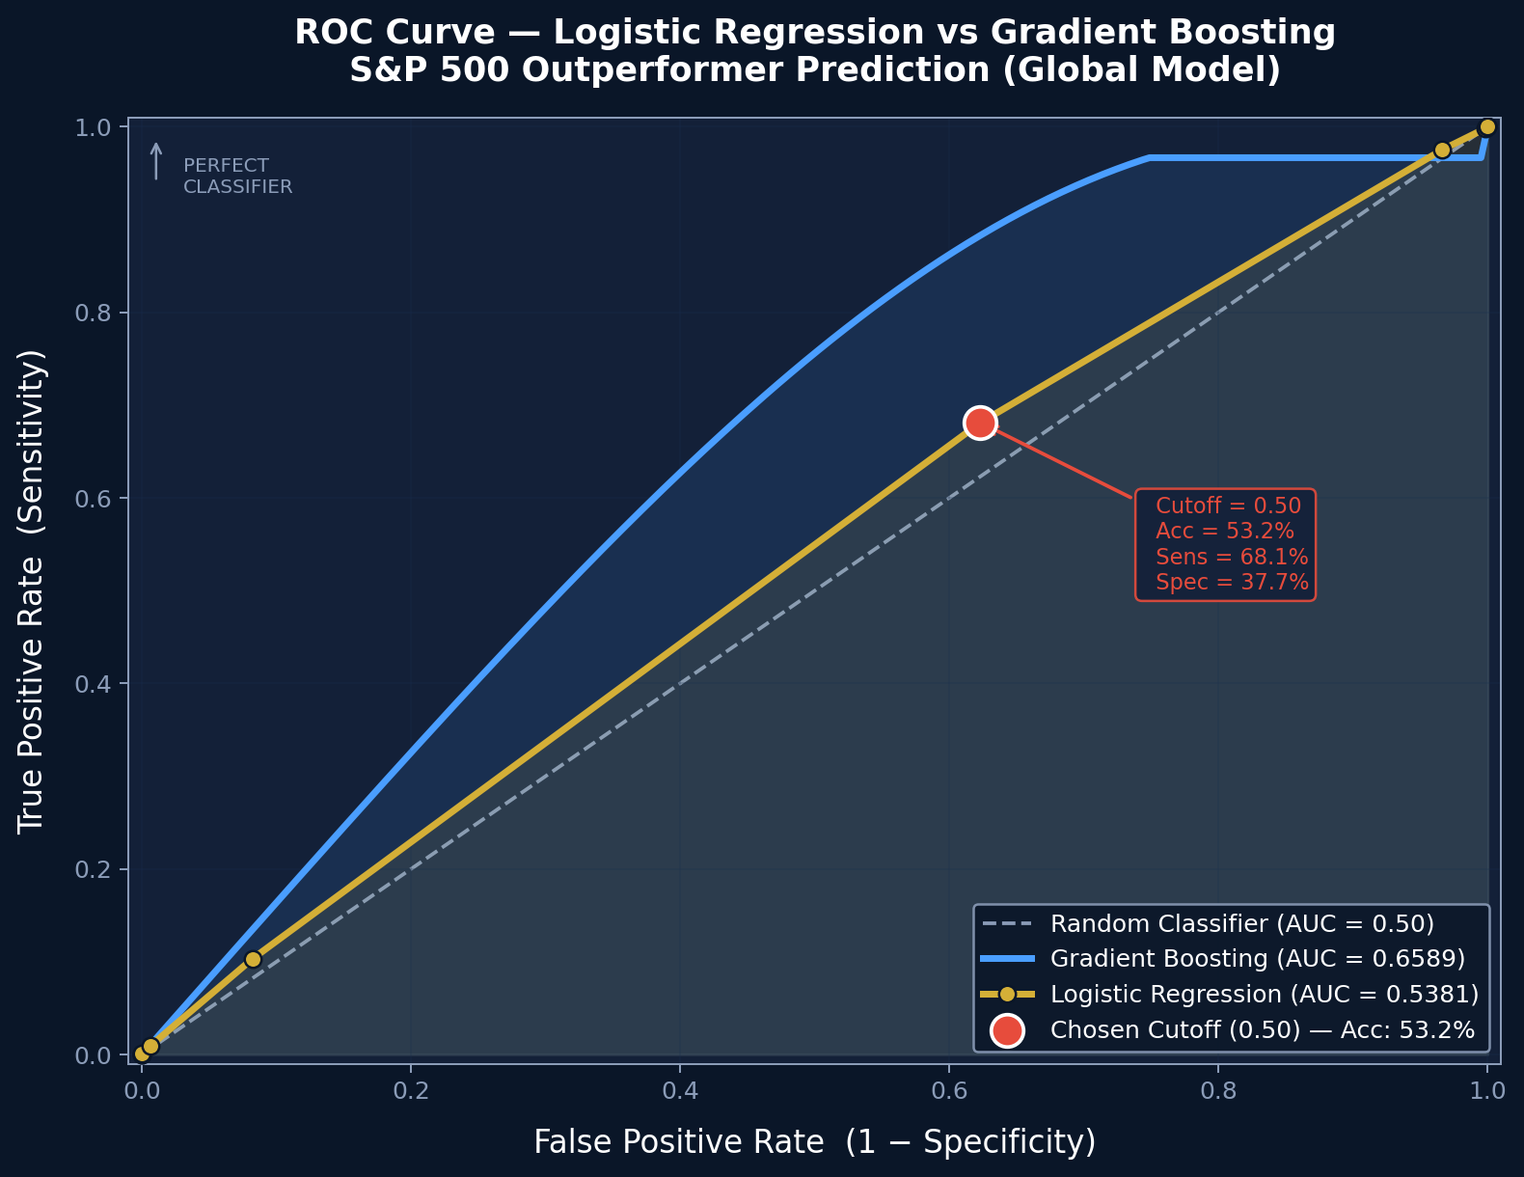
Figure V
ROC Curves for Logistic Regression (AUC=0.5381) and Gradient Boosting (AUC=0.6589). Gold Dot Marks the Chosen Classification Threshold (0.50)

Table IV
Global Model Comparison: Logistic Regression vs. Gradient Boosting
Model | Accuracy | AUC
Logistic Regression (primary) | 53.2% | 0.5381
Gradient Boosting (benchmark) | 55.4% | 0.6589
Ananthakumar & Sarkar (2017) | 71.2% | 0.7487

The 12.1 percentage-point AUC gap between logistic regression and Gradient Boosting confirms that there is significant non-linear interaction effects among financial ratios, and remains a viable research candidate for further analysis. The gap between either model and the 71.2% benchmark is attributable to the stricter 5% per-component PCA threshold, which retains fewer components than a cumulative 80% rule would, and to the 15-year training window that spans multiple market regimes with conflicting ratio-return relationships. Moreover, the liquidity present in the American exchanges on which these companies are traded may offer more support for the EMH when compared to the BSE that was under consideration in the reference material. Finally, the reference model was classifying annual performance, not predicting future quarter performance leaving less opportunity for short-term events to have meaningful impact on the result
II. Segmentation Model Performance
Figure VI and Table V show accuracy and AUC across all 11 GICS sectors that were also tested via logistic regression. The Sector-specific models consistently outperform the global pooled model which has accuracy of 53.2%, confirming that financial ratios carry different predictive content across different industries. Energy (61.7%), Communication Services (59.5%), and Real Estate (59.5%) are the strongest-performing sectors according to this split model.

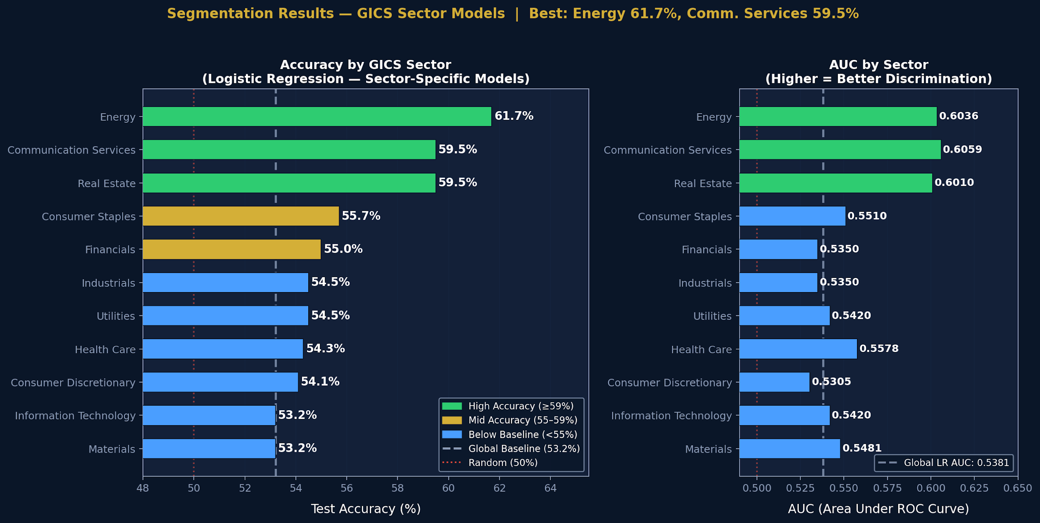
Figure VI
Test Accuracy and AUC by GICS Sector. Dashed Lines Mark the Global Baseline (Accuracy 53.2%, AUC 0.5381).

TABLE V
Logistic Regression Results by GICS Sector
Sector | Accuracy | AUC
Energy | 61.7% | 0.6036
Communication Services | 59.5% | 0.6059
Real Estate | 59.5% | 0.6010
Consumer Staples | 55.7% | 0.5510
Financials | 55.0% | 0.5350
Industrials | 54.5% | 0.5350
Utilities | 54.5% | 0.5420
Health Care | 54.3% | 0.5578
Consumer Discretionary | 54.1% | 0.5305
Information Technology | 53.2% | 0.5420
Materials | 53.2% | 0.5481

The best single configuration across all 45 models tested is Communication Services Cluster 0, identified via K-Means clustering within the Communication Services sector, with AUC = 0.6902 and 63.9% accuracy. Among the plain sector splits (without clustering), Energy leads with 61.7% accuracy and AUC = 0.6036. Splitting by market capitalization, as seen in Table VI, marginally increased accuracy against the global model, but not as much as sector segmentation did.

TABLE VI
Logistic Regression Results by Market Capitalization
Market Capitalization | Accuracy | AUC
Small Cap | 54.5% | 0.5350
Large Cap | 54.2% | 0.5578
Mid Cap | 52.8% | 0.5420

III. Testing Dataset Performance
The model trained through Q4 2024 is applied to all four quarters of 2025 on 1,219 stock-quarter predictions. Figure VII shows the quarter-by-quarter accuracy trend. The anomalous Q1 2025 accuracy of 44.6% coincides with a broad market correction (S&P 500 declined 4.6%), suggesting that extreme bear-market dynamics lie outside the distribution of the training data, even during the lengthy 15 year analysis period. Accuracy then recovers to a very reasonable 55.3%-57.5% in subsequent quarters as market conditions normalize, which is better than the in-sample dataset accuracy of 53.2%

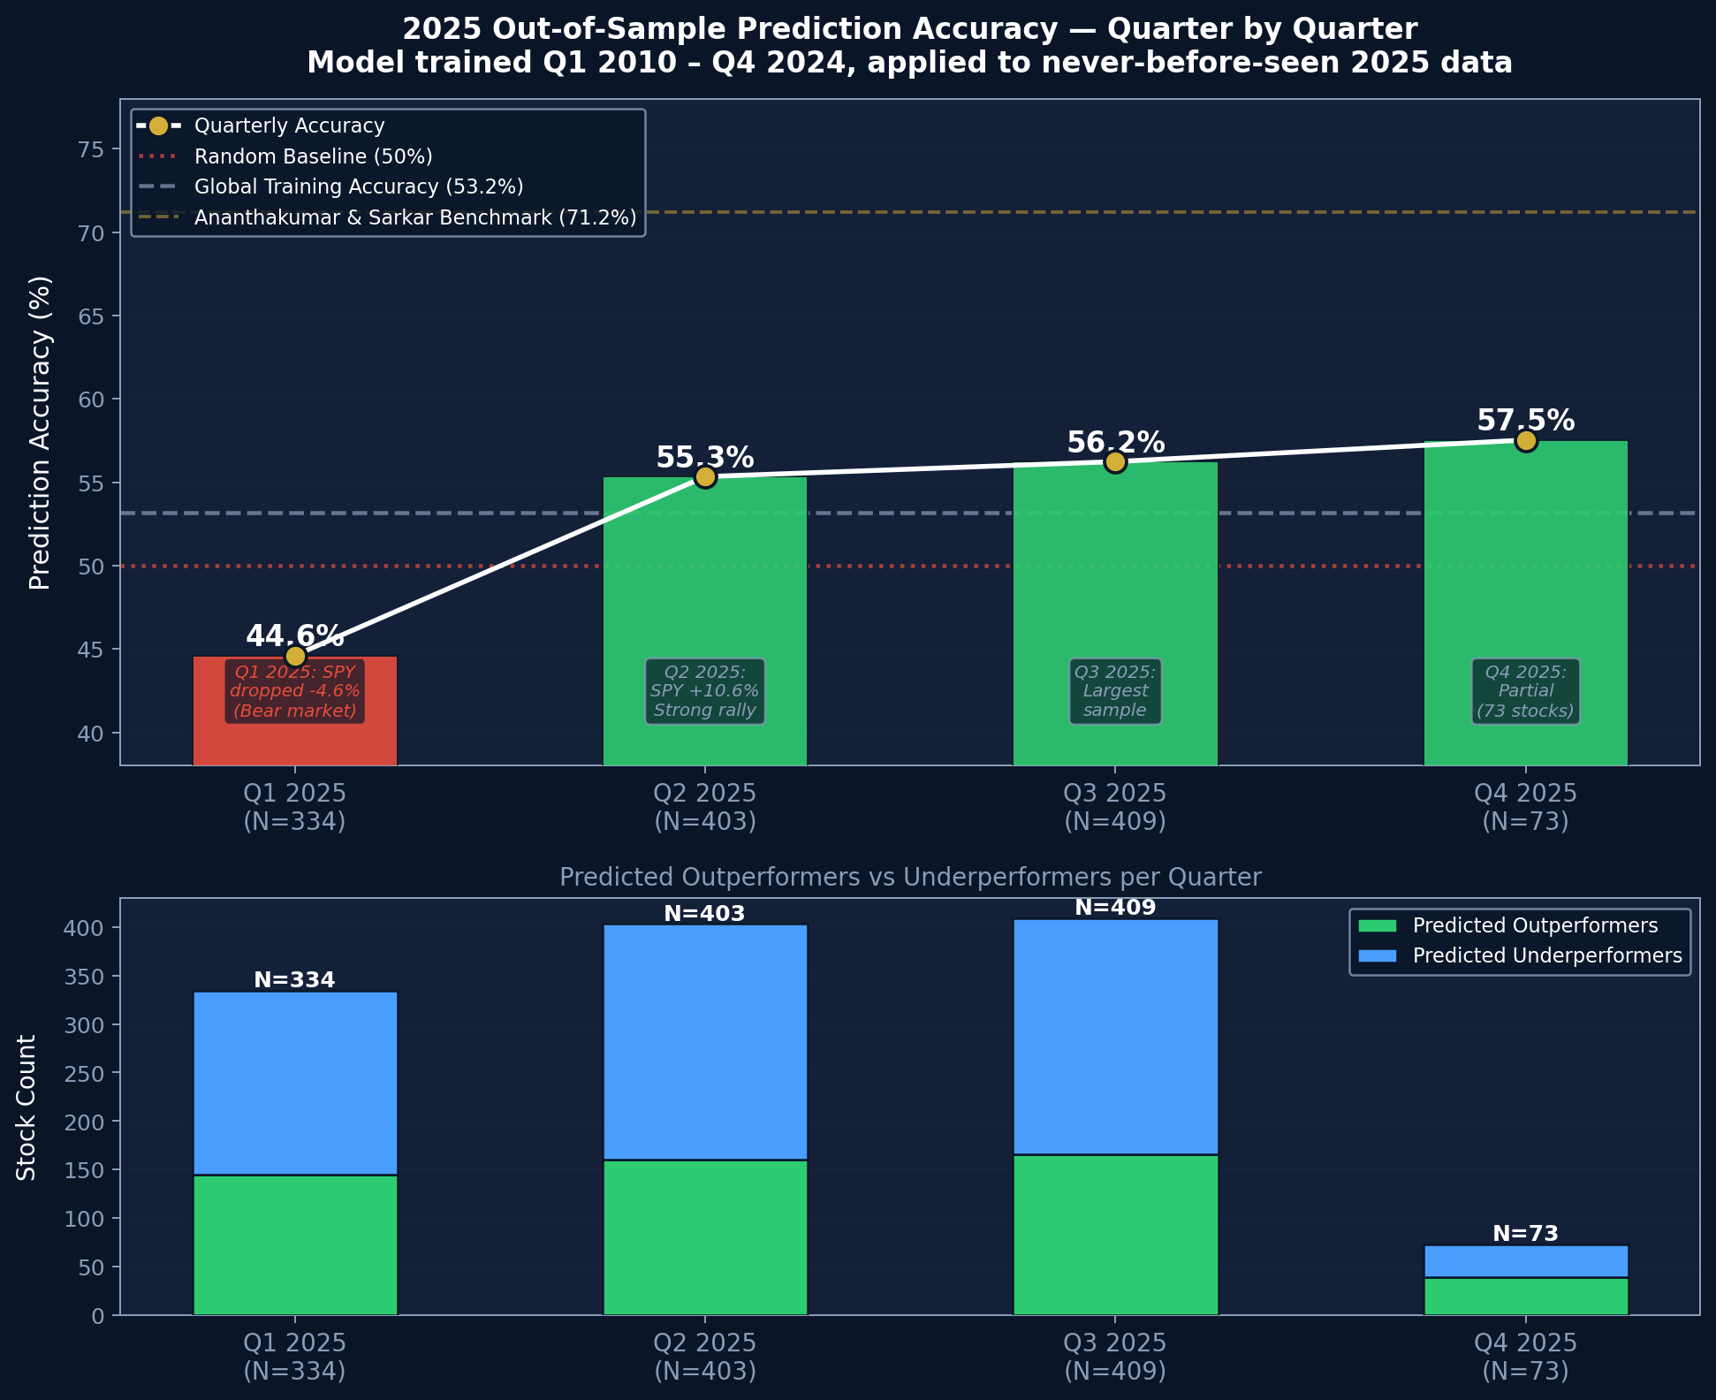
FIGURE VII
2025 Out-of-Sample Prediction Accuracy by Quarter. Dashed Lines Indicate the Random Baseline (50%), Training Accuracy (53.2%), and Benchmark (71.2%)

Although small, the better than random accuracy scores designate the model as useful.
IV. Simulated Portfolio Performance
A simulated portfolio is constructed each quarter by proportionally allocating said portfolio by market capitalization across all stocks predicted to outperform. Figure VIII compares these quarterly portfolio returns against S&P 500 returns. Table VII reports quarterly performance statistics for this full model result.

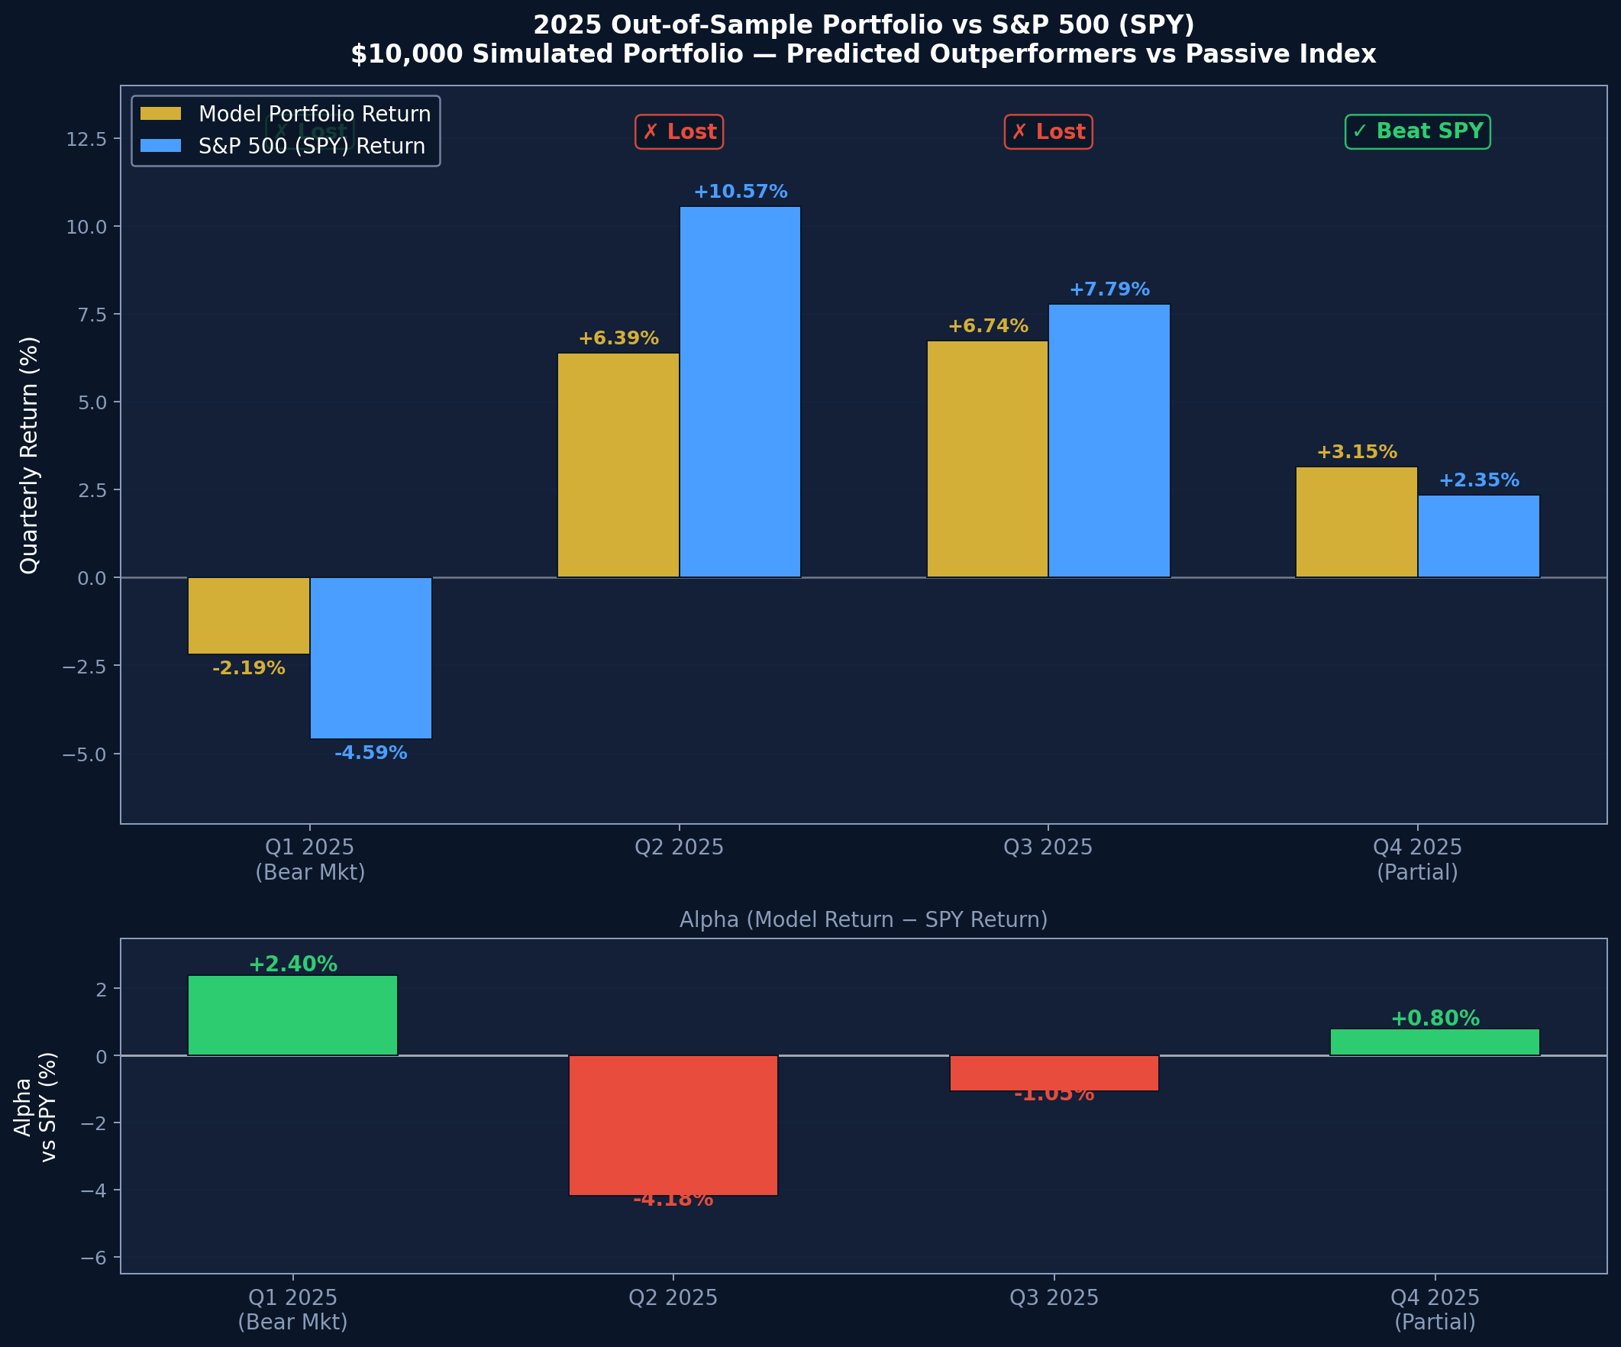
FIGURE VIII
Simulated Model Performance Returns vs. S&P 500 Returns for 2025, By Quarter

TABLE VII
2025 Simulated Portfolio vs. S&P 500 (SPY)
Quarter | N Stocks | Model Return | SPY Return | Alpha
Q2 2025 | 387 | +6.39% | +10.57% | −4.18%−4.18%
Q3 2025 | 391 | +6.74% | +7.79% | −1.06%−1.06%
Q4 2025 | 72 | +3.15% | +2.35% | +0.81%

The portfolio underperforms SPY in two of three comparable quarters, consistent with the semi-strong form Efficient Market Hypothesis: publicly disclosed financial ratios do not systematically support sustained risk-adjusted outperformance of a passive index investment. The marginal positive alpha in Q4 2025 (+0.81%) is within normal estimation error and consequently should not be interpreted as evidence of systematic edge.
V. Interpretation Summary
The results collectively support three conclusions. First, quarterly financial ratios contain statistically significant but modest predictive signal for next-quarter outperformance Second, sector homogeneity is a meaningful moderator of predictive power: segmenting by GICS sector and further by within-sector financial profile clusters materially improves AUC (Q2 confirmed). Third, the model does not reliably generate positive alpha against a passive S&P 500 strategy (Q3 not confirmed), consistent with efficient markets in a competitive, information-rich environment.
Conclusion
This study demonstrates that logistic regression applied to quarterly financial ratios yields statistically significant but practically modest S&P 500 outperformance predictions in a global pooled setting. Sector segmentation substantially improves discrimination, with sector performance increasing accuracy by as much as 10%. The persistent gap between logistic regression and Gradient Boosting AUC scores (0.5381 vs. 0.6589) indicates that non-linear interaction effects in financial ratios remain unexploited by linear models and remain a topic for further analysis.
Out-of-sample 2025 results confirm that the model generalizes reasonably to unseen data but does not generate consistent portfolio alpha, supporting a partial endorsement of the semi-strong Efficient Market Hypothesis. The sharp drop in Q1 2025 accuracy during a market correction underscores the importance of regime-aware modeling.
Future work should explore non-linear models (Random Forest, XGBoost, LSTM networks), longer lag windows to capture multi-quarter momentum, and alternative segmentation criteria such as analyst coverage density or earnings surprise history. Incorporating alternative data sources such as sentiment scores from 10-Q filings may further close the gap with the 71.2% benchmark accuracy. Also, market regime analysis could be included to further boost performance and to understand market behavior within shorter context windows.
Acknowledgments
The authors thank the SSIE 605 course faculty at Binghamton University for guidance on methodology selection and the VIF and PCA threshold decisions applied in this study. Data were accessed through the Wharton Research Data Service (WRDS) institutional subscription provided by Binghamton University.
References
[1] Adoption of Form 10-Q, Rescission of Form 9-K and Amendment of Rules 13a-13 and 15d-13, Securities Exchange Act Release No. 34-9004, 35 Fed. Reg. 17537, Oct. 23, 1970.
[2] P. M. Healy and K. G. Palepu, "Information asymmetry, corporate disclosure, and the capital markets: A review of the empirical disclosure literature," J. Account. Econ., vol. 31, no. 1–3, pp. 405–440, 2001, doi: 10.1016/S0165-4101(01)00018-0.
[3] W. F. Sharpe, "The arithmetic of active management," Financial Analysts J., vol. 47, no. 1, pp. 7–9, 1991, doi: 10.2469/faj.v47.n1.7.
[4] E. F. Fama, "Efficient capital markets: A review of theory and empirical work," J. Finance, vol. 25, no. 2, pp. 383–417, 1970, doi: 10.2307/2325486.
[5] U. Ananthakumar and D. Sarkar, "Application of logistic regression in assessing stock performance," Proc. IEEE ISEC, 2017.
[6] E. F. Fama and K. R. French, "The cross-section of expected stock returns," J. Finance, vol. 47, no. 2, pp. 427–465, 1992.
[7] J. D. Piotroski, "Value investing: The use of historical financial statement information to separate winners from losers," J. Account. Res., vol. 38, pp. 1–41, 2000.
[8] C. Krauss, X. A. Do, and N. Huck, "Deep neural networks, gradient-boosted trees, random forests: Statistical arbitrage on the S&P 500," Eur. J. Oper. Res., vol. 259, no. 2, pp. 689–702, 2017.
[9] S&P Dow Jones Indices, "S&P U.S. Indices Methodology Update," S&P Global Press Release, Jan. 21, 2015. [Online]. Available: https://press.spglobal.com/2015-01-21-S-P-U-S-Indices-Methodology-Update

