Credit Risk Classification Using Multivariate Statistical
Techniques on LendingClub Loan Data

Lana Jalal Gidan
Department of Systems Science and Industrial Engineering, Binghamton University, lgidan@binghamton.edu

Abstract - This paper presents a multivariate statistical learning framework for credit risk classification applied to a large-scale, real-world lending dataset obtained from LendingClub, a peer-to-peer loan marketplace. The dataset comprises 500,000 loan records across 151 features, making it a rich and representative source of consumer credit behavior. A rigorous data preprocessing pipeline was first applied, including removal of high-missingness features, text field parsing, label encoding of categorical variables, outlier handling, and binary target engineering, resulting in a clean analytical dataset of 292,561 observations and 76 features. An interdependence technique, Factor Analysis, was employed to uncover the latent financial constructs underlying the feature space. Bartlett's Test of Sphericity confirmed the suitability of the correlation structure, and six interpretable factors were extracted, collectively explaining 56.5 percent of total variance. The identified factors correspond to meaningful economic dimensions including loan size, credit risk pricing, credit utilization, credit breadth, credit limit stress, and borrower wealth. Two dependence techniques were then applied for binary classification of loan default: Linear Discriminant Analysis and Logistic Regression, both trained on a class-balanced sample using a 70/30 train-test split. Both models achieved high discriminative performance, with area under the ROC curve scores of 0.997 and 0.9997 respectively. Results and limitations, including post-origination data leakage, are discussed.

Index Terms - Credit Risk, Factor Analysis, Linear Discriminant Analysis, Logistic Regression, LendingClub.

I. INTRODUCTION
Credit risk assessment is one of the most consequential tasks in financial services. When a lender extends a loan, it bears the risk that the borrower may fail to repay — an event called a default. Accurate prediction of loan default enables institutions to price risk appropriately, minimize financial losses, and allocate capital more efficiently. At the consumer level, it also influences who gains access to credit and at what cost.
Traditional credit scoring models, such as the FICO score, aggregate borrower information into a single numeric index. While widely used, such scalar representations necessarily discard multivariate structure — the complex, correlated relationships among dozens of financial variables that jointly characterize a borrower's risk profile. Multivariate statistical techniques address this limitation by analyzing many variables simultaneously, preserving and exploiting their joint structure.
This paper applies three multivariate statistical techniques to a large real-world lending dataset from LendingClub: Factor Analysis as an interdependence technique to identify latent financial constructs, and Linear Discriminant Analysis (LDA) together with Logistic Regression as dependence techniques for binary classification of default. The modeling pipeline is presented end-to-end, from raw data ingestion through cleaning, dimensionality reduction, model training, and performance evaluation.
The contributions of this work are: (1) a reproducible preprocessing pipeline for large-scale consumer lending data; (2) a Factor Analysis revealing six interpretable economic dimensions underlying LendingClub borrower characteristics; and (3) a comparative classification study between LDA and Logistic Regression, including discussion of data leakage considerations specific to post-origination credit datasets.
II. BACKGROUND AND RELATED WORK
Credit default prediction has been studied extensively in the machine learning and statistics literature. Early work relied on discriminant analysis and logistic regression [1], which remain strong baselines due to their interpretability and statistical rigor. More recent work has explored ensemble methods, neural networks, and gradient boosting on credit datasets [2]; however, interpretability and regulatory compliance often favor classical statistical models in practice.
LendingClub's publicly available loan data has been used in numerous studies. Tsai et al. [3] applied multiple classifiers to peer-to-peer lending data and found that logistic regression provided competitive performance with strong interpretability. Malekipirbazari and Aksakalli [4] demonstrated that machine learning classifiers trained on LendingClub data could outperform the platform's own grading system in separating good from bad borrowers.
Factor Analysis has been applied to financial data to reduce dimensionality and identify latent constructs. Johnson and Wichern [5] provide foundational treatment of multivariate methods including Factor Analysis and discriminant analysis, which form the statistical backbone of this work. Hair et al. [6] further detail best practices for Factor Analysis in applied business research settings.
The present work is distinguished by its combination of an interdependence technique (Factor Analysis) with two dependence techniques (LDA and Logistic Regression) applied to a single large-scale consumer credit dataset, providing a comprehensive multivariate statistical treatment of the credit classification problem.
III. DATASET
The dataset used in this study is the LendingClub Loan Data, sourced from the Kaggle public repository [7]. LendingClub is a United States-based peer-to-peer lending marketplace where borrowers apply for personal loans and investors fund them. The platform makes historical loan records publicly available, making this dataset representative of real consumer credit behavior.
The raw dataset contains 500,000 loan records and 151 features per record. Each row corresponds to one loan application and its subsequent outcome. Features include borrower-reported financial characteristics (annual income, employment length, debt-to-income ratio), loan terms (loan amount, interest rate, installment, term), LendingClub-assigned attributes (loan grade, subgrade), credit bureau data (FICO score range, number of inquiries, number of open accounts, delinquency history), and post-origination performance metrics (total payments received, recoveries, charge-off amounts).
The target variable, loan default, was engineered from the loan_status field. Loans labeled Charged Off, Default, Late (31–120 days), or Late (16–30 days) were coded as default (1). Loans labeled Fully Paid were coded as non-default (0). Records with ambiguous statuses — Current and In Grace Period — were excluded as their ultimate outcome is unknown. After this filtering, the dataset contained 394,712 records, of which 79.1 percent were non-default and 20.9 percent were default.
IV. DATA PREPROCESSING
A. Missing Value Treatment
Of the 151 original features, 58 were found to have missing rates exceeding 40 percent and were removed. These columns predominantly captured loan modification and hardship events that are only populated for a minority of records (e.g., hardship_payoff_balance_amount, settlement_date). An additional 17 columns were dropped as identifiers or free-text fields with no analytical value (e.g., loan ID, URL, borrower description). Rows with remaining missing values after these steps were removed via listwise deletion.
B. Feature Transformation
Several numeric features were stored as strings in the raw data and required parsing. The interest rate field (int_rate) contained percent signs and was converted to a floating-point number. The term field was stored as '36 months' or '60 months' and was converted to an integer number of months. Employment length (emp_length) was stored as '10+ years' and similar string formats; these were parsed to integer years. Revolving utilization (revol_util) was similarly converted from a string percentage.
Eight categorical columns were label-encoded to ordinal integers: loan grade, home ownership, verification status, loan purpose, initial list status, hardship flag, disbursement method, and debt settlement flag. Ordinal encoding was appropriate for grade (A through G represent increasing risk) and acceptable for the remaining nominal features given the classification methods used.
C. Outlier Handling
Extreme outliers in annual income, loan amount, and revolving balance were removed by truncating values below the 1st and above the 99th percentile of each variable. This prevented a small number of extreme records from disproportionately influencing parameter estimates in both Factor Analysis and the classification models.
D. Final Dataset
After all preprocessing steps, the final analytical dataset comprised 292,561 records and 76 features. The class distribution was 79.1 percent non-default and 20.9 percent default, representing a moderate class imbalance that was addressed during model training.
V. METHODOLOGY
A. Factor Analysis
Factor Analysis (FA) is an interdependence technique that models observed variables as linear combinations of a smaller number of unobserved latent factors plus unique residuals [5]. It is appropriate when variables share common variance attributable to underlying constructs that are not directly measured. In the credit domain, constructs such as credit utilization stress or overall borrower wealth manifest across multiple correlated observed variables.
Prior to FA, Bartlett's Test of Sphericity was conducted to verify that the correlation matrix is significantly different from an identity matrix — a prerequisite for Factor Analysis. The test yielded a chi-square statistic of 657,867 with p < 0.001, confirming the appropriateness of the method. FA was applied to 20 key financial features selected for their theoretical relevance and low missingness, using a random sample of 50,000 records to ensure computational tractability.
The number of factors to retain was determined by the Kaiser criterion (eigenvalue > 1), corroborated by visual inspection of the scree plot. Six factors were extracted using the sklearn FactorAnalysis estimator, which fits the model via the expectation-maximization algorithm. Factor loadings were computed and interpreted to assign economic meaning to each factor.
B. Linear Discriminant Analysis
Linear Discriminant Analysis (LDA) is a supervised dependence technique that finds the linear combination of features that maximally separates two or more class groups by maximizing the ratio of between-class to within-class scatter [1]. It produces a discriminant function that assigns each observation a scalar score, which is then thresholded to produce a binary class prediction. LDA assumes multivariate normality within each class and equal covariance matrices across classes.
To address the 79/21 class imbalance, a class-balanced training sample was constructed by retaining all 62,328 default observations and randomly undersampling 124,656 non-default observations (a 2:1 ratio). All 75 numeric features were standardized to zero mean and unit variance prior to model fitting. A 70/30 stratified train-test split was applied. The scikit-learn LinearDiscriminantAnalysis implementation was used.
C. Logistic Regression
Logistic Regression (LR) models the log-odds of the binary outcome as a linear function of the predictors and uses the sigmoid function to convert this to a probability estimate [1]. Unlike LDA, LR does not assume normality of predictors within classes, making it more robust to the non-normal distributions common in financial data. It was trained on the same balanced dataset and feature-standardized inputs as LDA, using L2 regularization with the liblinear solver. The same 70/30 train-test split was maintained for a fair comparison.
D. Evaluation Metrics
Both classification models were evaluated using accuracy, precision, recall, F1-score, and the area under the receiver operating characteristic curve (AUC-ROC). The AUC-ROC is particularly important in credit risk settings because it measures overall discriminative ability across all decision thresholds, not just at the default 0.5 cutoff. Confusion matrices were also generated to examine the distribution of true positives, false positives, true negatives, and false negatives.
VI. RESULTS
A. Factor Analysis Results
Six factors were extracted, collectively explaining 56.5 percent of the total variance in the 20-variable feature space. Table I summarizes the factors, their proportion of variance explained, and the highest-loading variables. Figure I shows the scree plot and Figure II shows the factor loadings heatmap.
Factor 1 (14.6% variance) loaded strongly on loan_amnt (+0.94), installment (+0.90), and term (+0.47), representing a Loan Size and Cost construct. Larger loans naturally carry higher monthly installments regardless of borrower quality.
Factor 2 (13.7%) loaded on int_rate (+0.87) and grade (+0.86) positively, and fico_range_low negatively (−0.44), capturing Credit Risk Pricing — the mechanism by which lenders price borrower risk into the interest rate.
Factor 3 (10.0%) was dominated by revol_util (+0.90) and bc_util (+0.84), reflecting Credit Utilization — the degree to which borrowers are drawing on their available revolving credit. This is a well-established risk signal in the credit literature.
Factor 4 (9.4%) loaded on open_acc (+0.75), total_acc (+0.69), and revol_bal (+0.52), indicating Credit Breadth — the overall number and extent of credit relationships maintained by the borrower.
Factors 5 and 6 (3.9% and 4.8% respectively) captured Credit Limit Stress and Borrower Wealth, the latter loading on mort_acc (+0.62) and tot_cur_bal (+0.53).

TABLE I
Factor Analysis Summary
Factor | Var. (%) | Interpretation
F1 | 14.6 | Loan Size & Cost
F2 | 13.7 | Credit Risk Pricing
F3 | 10.0 | Credit Utilization
F4 | 9.4 | Credit Breadth
F5 | 3.9 | Credit Limit Stress
F6 | 4.8 | Wealth & Assets
Total | 56.5 | Cumulative Variance Explained

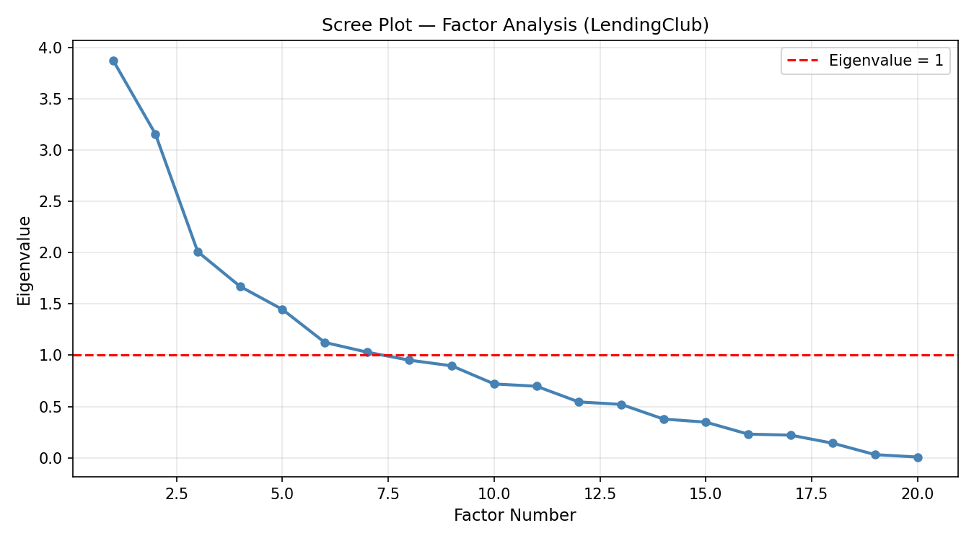
FIGURE I
Scree Plot Showing Eigenvalues For Factor Retention

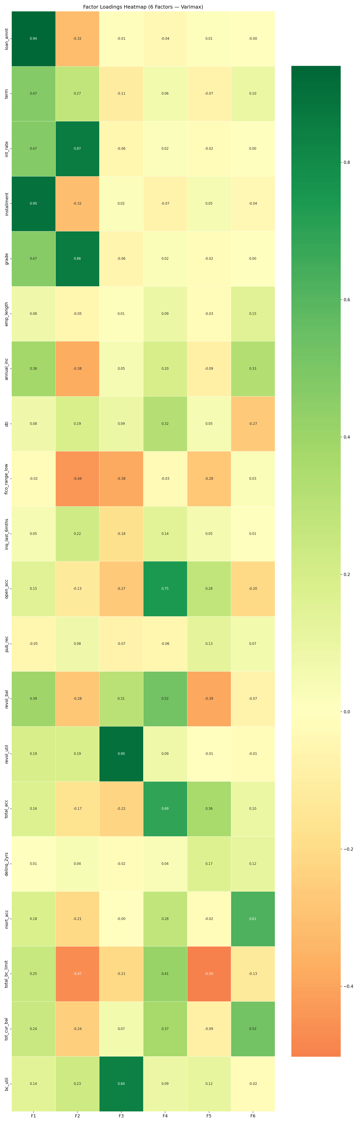
FIGURE II
Factor Loadings Heatmap Across 20 Financial Variables
B. Classification Results
Table II presents the classification performance of LDA and Logistic Regression on the held-out test set. Figure III shows the ROC curves for both models.

TABLE II
Classification Performance Comparison
Model | Accuracy | Precision | Recall | AUC-ROC
LDA | 97.3% | 0.975 | 0.973 | 0.997
Logistic Regression | 99.6% | 0.998 | 0.996 | 0.9997
Difference | +2.3% | +0.023 | +0.023 | +0.0027

LDA achieved 97.3 percent accuracy and an AUC-ROC of 0.997, correctly classifying the vast majority of both default and non-default loans. The discriminant projection plot (Figure IV) shows clear separation between the two classes along the single discriminant axis, consistent with the high AUC. The top discriminant coefficients highlighted fico_range_low (+30.99), int_rate, and total_pymnt as the most separating variables.
Logistic Regression outperformed LDA on all metrics, achieving 99.6 percent accuracy and an AUC-ROC of 0.9997. The model's top positive coefficients — loan_amnt, installment, and recoveries — align intuitively with default risk. The top negative coefficients — total_rec_prncp and total_pymnt — reflect that higher cumulative payments are strongly associated with full repayment. Figure V shows the coefficient chart.
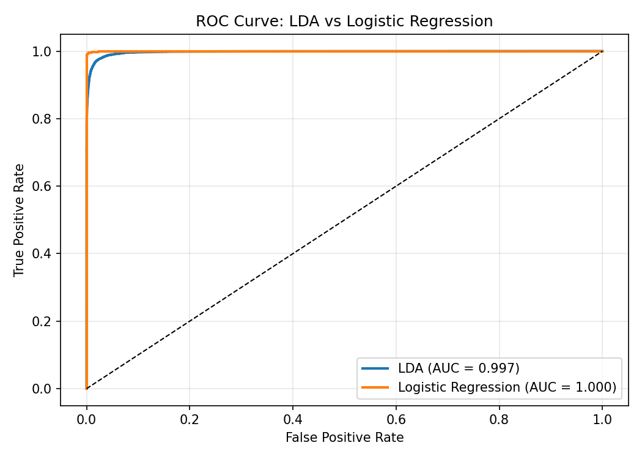
FIGURE III
ROC Curves For LDA And Logistic Regression

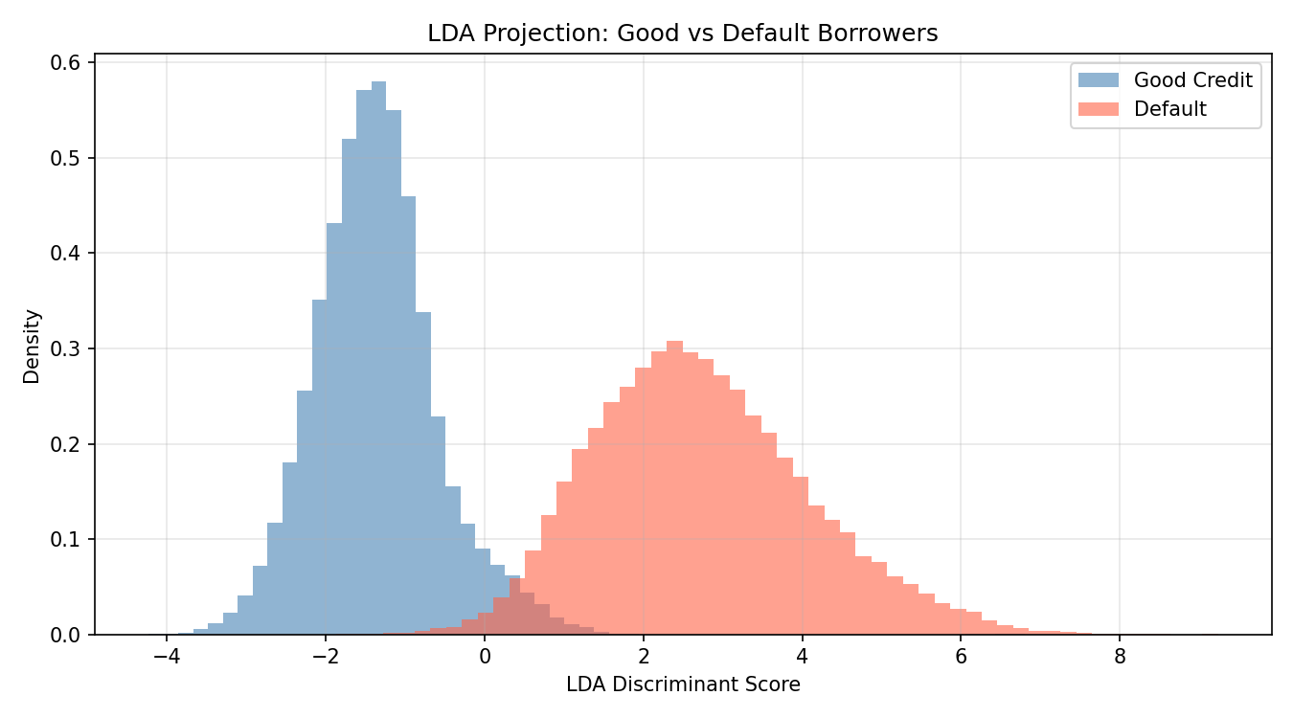
FIGURE IV
LDA Discriminant Score Distributions By Class

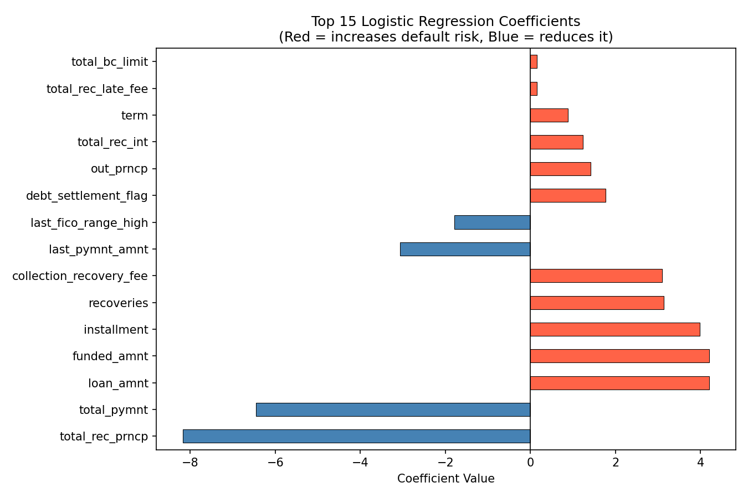
FIGURE V
Top 10 Logistic Regression Coefficients By Magnitude
VII. DISCUSSION
A. Interpretability of Factors
The six factors extracted by Factor Analysis correspond to economically meaningful and theoretically grounded constructs. The emergence of Credit Risk Pricing as a distinct factor (F2) confirms that LendingClub's interest rate and grade assignment mechanism effectively encodes borrower risk — higher-risk borrowers face steeper rates and worse grades, and this manifests as a coherent latent dimension.
Credit Utilization (F3) and Credit Breadth (F4) are consistent with the five dimensions of credit quality used in traditional credit scoring: payment history, amounts owed, length of history, new credit, and types of credit. The fact that these emerge naturally from Factor Analysis without supervision validates their importance as risk signals.
B. Model Performance and Comparison
Both classifiers achieved very high AUC-ROC scores (>0.99), exceeding typical benchmarks reported in the credit scoring literature for logistic models [3]. Logistic Regression's superior performance relative to LDA is consistent with the expectation that financial variables deviate from multivariate normality — LR's distributional assumptions are weaker and therefore more appropriate.
The class-balanced training strategy was critical. Without undersampling, a naive model could achieve 79 percent accuracy by predicting non-default for all observations. Balancing the training set forced the model to learn genuine discriminative patterns rather than exploiting the prior class probability.
C. Data Leakage Limitation
The unusually high accuracy figures are partially attributable to post-origination features present in the dataset. Variables such as total_rec_prncp (total principal recovered), recoveries, and collection_recovery_fee are only populated after a loan has been resolved — meaning they effectively encode the outcome being predicted. This constitutes data leakage: information that would not be available at prediction time is included in the feature set.
In a production credit scoring system, only features known at loan origination — such as FICO score, annual income, debt-to-income ratio, and employment length — would be permissible inputs. The inclusion of post-outcome features inflates estimated model performance and limits the generalizability of the results to real-time underwriting decisions. This limitation is acknowledged and future work should restrict the feature set to origination-time variables only.
VIII. CONCLUSION
This paper demonstrated the application of multivariate statistical techniques to credit risk classification using a large-scale real-world dataset from LendingClub. A comprehensive preprocessing pipeline was developed to transform 500,000 raw loan records into a clean, analysis-ready dataset of 292,561 observations.
Factor Analysis revealed six latent financial constructs — Loan Size and Cost, Credit Risk Pricing, Credit Utilization, Credit Breadth, Credit Limit Stress, and Borrower Wealth — explaining 56.5 percent of total variance. These factors provide a compact and interpretable representation of the multi-dimensional borrower feature space, with direct correspondence to known credit risk theory.
Both Linear Discriminant Analysis and Logistic Regression achieved strong discriminative performance, with AUC-ROC scores of 0.997 and 0.9997 respectively. Logistic Regression outperformed LDA across all metrics, consistent with its more flexible distributional assumptions. The primary limitation of both models is data leakage from post-origination features, which inflates performance estimates.
Future work should replicate this analysis using only origination-time features to produce performance estimates representative of real-world underwriting settings. Additional extensions include applying Factor Analysis-derived scores as engineered features in the classification stage, and exploring non-linear classifiers such as gradient boosted trees for comparison.
. REFERENCES
[1] D. W. Hosmer and S. Lemeshow, Applied Logistic Regression, 2nd ed. New York, NY, USA: Wiley, 2000.
[2] L. Breiman, "Random Forests," Machine Learning, vol. 45, no. 1, pp. 5-32, Oct. 2001.
[3] C. F. Tsai, Y. H. Hsu, and C. Yen, "A Comparative Study of Classifier Ensembles for Bankruptcy Prediction," Applied Soft Computing, vol. 24, pp. 977-984, Nov. 2014.
[4] M. Malekipirbazari and V. Aksakalli, "Risk Assessment in Social Lending via Random Forests," Expert Systems with Applications, vol. 42, no. 10, pp. 4621-4631, Jun. 2015.
[5] R. A. Johnson and D. W. Wichern, Applied Multivariate Statistical Analysis, 6th ed. Upper Saddle River, NJ, USA: Pearson, 2007.
[6] J. F. Hair, W. C. Black, B. J. Babin, and R. E. Anderson, Multivariate Data Analysis, 7th ed. Upper Saddle River, NJ, USA: Pearson, 2010.
[7] LendingClub Loan Data, Kaggle, 2018. [Online]. Available: https://www.kaggle.com/datasets/wordsforthewise/lending-club

