so we want to build a sentiment analysis system to understand the reaction of the people online. this info can be used to show companies how their advertising is doing. this can also be use to see what event is doing great. also we can publish articles to promote unpopular event based on that sentiment analysis.

1. We get the text based tweets or some other social media through api or scraping [take the tweets with the #olympic]
2. We visualize the tweets according to different categories to gain insights on what’s popular.
3. Get the sentiment analysis of all the texts.
4. Then visualize the sentiments in user friendly way in a pretty web app

| Id | tweet | sentiment | sentiment_score |
| --- | --- | --- | --- |
| 1. | I love you | Positive | 0.99999 |
|  |  |  |  |
|  |  |  |  |
|  |  |  |  |

We can apply filters to the tweets and show visualizations.

EG. we can filter all the tweets that have football in it. Then we can visualize all the tweets about football and see the sentiments of audience

This can be done for the advertising brands.

Olympics can use the visualizations to take actions to promote less loved or less popular events

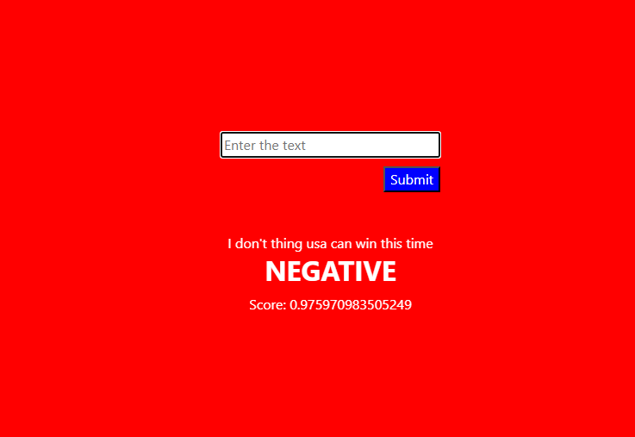

TODO:

1. We already have a working sentiment analysis system.
2. Now we need to make make visualization and web app