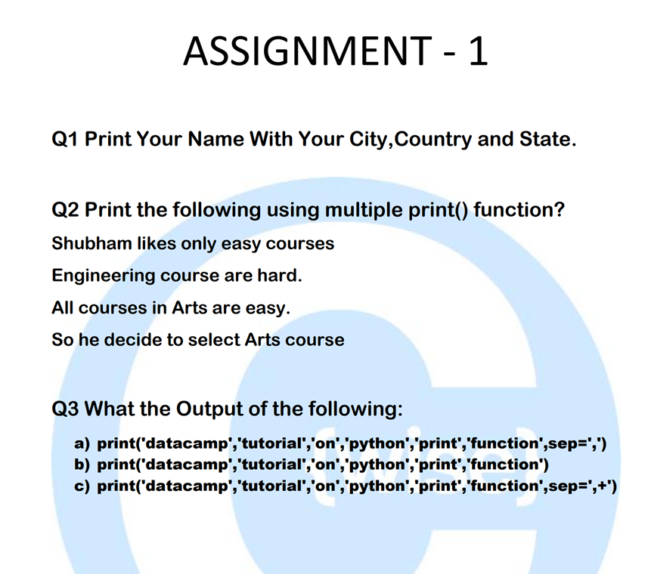

Answers:

Answer to Q1:

print(“Maulik Gupta, Bhilwara, India, Rajasthan”)

Answer to Q2:

print(“Shubham likes only easy courses”)

print(“Engineering courses are hard.”)

print(“All courses in Arts are easy”)

print(“So he decice to select Arts course”)

Answers to Q3:

1. datacamp,tutorial,on,python,print,function
2. datacamp tutorial on python print function
3. datacamp,+tutorial,+on,+python,+print,+function