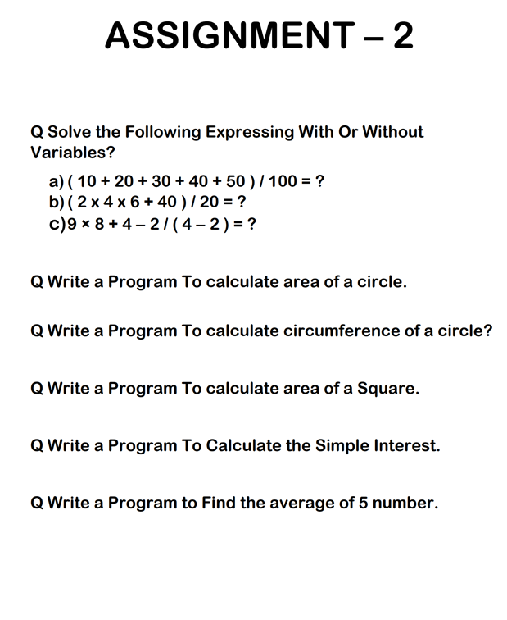

Answers to Assignment 2:-

Ans. To Q1:

1. 1.5
2. 4.4
3. 75.0

Ans. to Q2 :

pi = 3.14

r = float(input("Please enter the radius of circle(in cm): ")) # radius

if r <= 0:

    print("The radius should be greater than 0")

area = (pi * r**2)

print("The area of the circe is: ", area, "cms. squared")

Ans. to Q3 :

pi = 3.14

rad = float(input("Please ente the value of radius (in cms.): "))

circumference = 2 * pi * rad

print("The circumference of the circle of given radisu i.e. ", rad," cms. is ",circumference, "cms.")

Ans. to Q4:

side = float(input("Please enter the length of the square's side (in cms.): "))

area_of_square = side**2

print("The area of the square of given length i.e.", side,"cms. is", area_of_square, "cms. squared")

Ans. to Q5:

P = int(input("Enter the principal amount: "))

R = float(input("Enter the rate of interest: "))

T = int(input("Enter the time frame (in years):  "))

SI = (P*R*T)/100

print("The simple interest on your principle amount i.e.", P, " with the rate", R, " and the time frame of", T," year(s) is Rs ", SI)

print("Then the final amount payable at the end of your time frame will be: Rs ",P+SI)

Ans. to Q6:

First = int("Enter marks in first subject: ")

Second = int("Enter marks in second subject: ")

Third = int("Enter marks in third subject: ")

Fourth = int("Enter marks in fourth subject: ")

Fifth = int("Enter marks in fifth subject: ")

avg = (First + Second + Third + Fourth + Fifth)/5

print("The average marks are: ", avg)