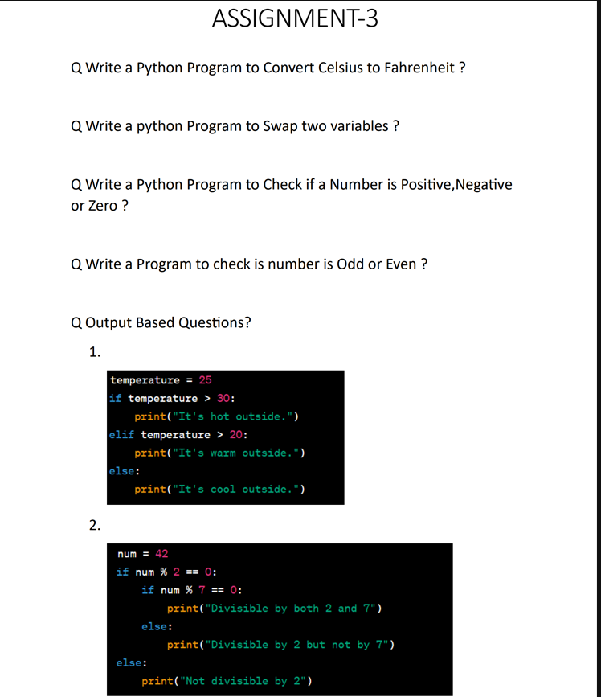

Answers to Assignment 3:-

Ans. To Q1:

print("Welcome to the celsius to farenheit converter")

Temp_C = float(input("Please enter the temperature in Celsius: "))

Temp_F = (Temp_C * (9/5)) + 32

print("The temperature in deg. Celsius is:", Temp_C)

print("The temperature in deg. Farenheit is:", Temp_F)

Ans. To Q2:

x = 21

y = 18

swap = x

x = y

y = swap

print('The value of x after swapping: ', x)

print('The value of y after swapping: ', y)

Ans. To Q3:

x = int(input("Please enter a integer value"))

if x==0:

print("The Entered number is zero.")

elif x<0:

print("The Entered number is negative.")

else:

print("The Entered number is positive.")

Ans. To Q4:

print("Welcome to Odd or Even Checker")

num = int(input("Please enter a number: "))

if num % 2 == 0:

    print("The entered number i.e.", num, "is even.")

else:

    print("The entered number i.e.", num, "is odd.")

Ans. To Q5:

1. The O/P will be :  
    **It’s warm outside**.
2. The O/P will be :  
    **Divisible by both 2 and 7**