**IOT BASED AIR QUALITY MONITORING SYSTEM**

**A PROJECT REPORT**

**Submitted by**

**RAMMOHAN SHARMA(1904712)**

**KAMALKANT UPADHYAY(1904699)**

**ABHISHEK SHARMA (1904682)**

**DHANANJAY DIXIT(1904690)**

*in partial fulfillment for the award of the degree*

*of*

**B.VOC**

*in*

**IOT**

**DAYALBAGH EDUCATIONAL INSTITUTE DAYALBAGH AGRA(UP)-28200**

**CERTIFICATE**

**Certified that this project report “iot based air quality monitoring system” is the bonafide work of “Rammohan,Abhishek,Dhananjay,kamalkant” who carried out the project work under my supervision.**

# **Guide Name**

Mrs. Vandana Akella

|  |  |  |
| --- | --- | --- |
|  |  |  |

**DEPARTMENT OF PHYSICS & COMPUTER SCIENCE FACULTY OF SCIENCE**

ii

**ACKNOWLEDGEMENT**

I would love to specific my unique thank you of gratitude to our reputable instructor Mrs.Vandana Akella who gave me the golden possibility to try this excellent challenge at the iot primarily based totally air best tracking machine, which additionally helped me in doing a number of studies and that i got here to understand approximately such a lot of new matters I am certainly grateful to them. Secondly I could additionally want to thank my mother and father and pals who helped me loads in finalizing this challenge in the constrained time frame.

|  |  |
| --- | --- |
| Date : 17-05-2022 | RAMOHAN SHARMA  DHANANJAY DIXIT  KAMALKANT UPADHYAY  ABHISHEK SHARMA |
| Place : Hathras |  |
|  |  |

**TABLE OF CONTENTS**

|  |  |  |
| --- | --- | --- |
|  | **TITLE** | 1 |
|  | **ABSTRACT** | 2 |
|  |  |  |
|  | **LIST OF FIGURES** | 3 |
|  | **LIST OF SYMBOLS AND ABBREVIATIONS** | 4 |
| **1.0** | **INTRODUCTION** | **1** |
|  | 1.1 Sub section | 1 |
|  |  | 1 |
| **2.0** | **LITERATURE REVIEW** | **2** |
|  | 2.1 Sub section | 2 |
|  | 2.2 Sub section | 2 |
| **3.0** | **METHODOLOGY** | **3** |
|  | 3.1 Sub section | 3 |
| **4.0** | **RESULT AND DISCUSSION** | **4** |
|  | 4.1 Sub section | 4 |
|  | 4.2 Sub section |  |
| **5.0** | **DOCUMENT ALIGNMENT** | **5** |
|  | 5.1 Sub section | 5 |
| **6.0** | **CONCLUSION** | **6** |
| **7.0** | **FUTURE SCOPE** | **7** |
| **8.0** | **REFERENCES** | **8** |
|  |  |  |
|  |  |  |
|  |  |  |
|  |  |  |

|  |  |  |
| --- | --- | --- |
|  |  |  |
|  |  |  |

**ABSTRACT**

When air get combined with dangerous gases and materials it's far referred to as air pollutants The important pollution of air are gases together with ammonia,corbon monoxide,sulpur dioxide, nitrous oxides, methane etc. The reassets of pollution are business emission, unsafe emissions shape vechicles,burning of fossil fuels etc. Pollutant air can reasons extreme fitness consequences together with coronary heart disease, lungs cancer, respiration infections etc.

**LIST OF FIGURES**

|  |  |  |
| --- | --- | --- |
| **Figure No.** | **Title** | **Page No**. |
| Figure 1.1 | Block diagram of sending data to thingsspeak using node mcu | 12 |
| Figure 1.2 | MQ 135 Sensor | 13 |
| Figure 1.3  Figure 1.4  Figure 1.5  1.6  1.7 | O LED Display  Node MCU  Project real Images | 14  15  16  17 |

|  |  |
| --- | --- |
|  |  |

1. **INTRODUCTION**

Continued publicity to environments with terrible air best is a primary public fitness difficulty in evolved and growing countries. It is predicted that the pollution liable for terrible air best reason almost 2.five million untimely deaths in line with yr international-wide. Significantly, round 1.five million of those deaths are because of polluted indoor air, and it's far counseled that terrible indoor air best might also additionally pose a massive fitness hazard to extra than 1/2 of of the international populace. Due to its hyperlink with industrialisation, societal fitness troubles related to terrible air best disproportionately impacts evolved and growing nations â€“ it's far predicted that air pollutants is liable for the untimely deaths. Remedial movement to enhance air best is regularly clean to enforce as soon as airborne pollution had been detected.

1. **LITERATURE REVIEW**

1. IOT Based Air Quality Monitoring System Using Node MCU Arduino Poonam Pal1, Ritik Gupta2 The degree of pollutants has accelerated with instances with the aid of using lot of things just like the boom in populace, accelerated car use, industrialization and urbanization which ends up in dangerous consequences on human wellness with the aid of using at once affecting fitness of populace uncovered to it. In order to reveal In this challenge we're going to make an IOT Based Air Pollution Monitoring System wherein we can reveal the Air Quality over an internet server the usage of net whilst there are enough quantity of dangerous gases are gift withinside the air like CO2, smoke, alcohol, benzene and NH3. It will display the air best in PPM at the LCD and in addition to on web site in order that we are able to reveal it very easily..

2.IOT Based Air Quality Monitoring System Ch.V.Saikumar,M.Reji,P.C.Kishoreraja. This offer a actual-time low price tracking machine over using low price, low records price, and little manage wi-fi communique technology. its output voltage stages varies and indicates unexpected values because of inadequate drive. So we used a 9V battery and a 7805 own circle of relatives REGULATOR for the CO sensor MQ7. For MQ135 we've got given the strength from nodemcu simplest

1. **METHODOLOGY**

We used Thingspeak IoT platform and we honestly described the derivations that mentions the precise ppm at the display with accurate calibration. We have carried out it with much less value i.e., whilst we're pushing the facts to the cloud. When we're focused on IoT as a platform, our intension ought to be to offer the concept on net the usage of the structures like thinger.io or thingspeak or Cayenne internet site which can be superbly designed to offer the output or even capable of down load the dataset. When doing an test air best tracking, no want to apply LPG or methane detecting sensors as it's far used for Home/workplace safety. We have used WiFi to push the facts onto the cloud instead the usage of GSM or GPRS module . The trouble in any other paper that referred to at hasnâ€™t calibrated the sensor and now no longer even transformed the sensor output fee into PPM. As in line with the suggestions with the aid of using UN Data, zero-50 PPM is SAFE fee, 51-a hundred is slight as proven in parent 1. Delhi is the maximum polluted town withinside the international recorded round 250PPM. As we're the usage of mq135 sensors, it have inner warmth element, it attracts extra strength(P= V*I), so aleven though the sensors are became ON, its output voltage stages varies and indicates unpredictable values because of inadequate strength drive. So we used a 9V battery and In order to offer WiFi Support for it, we've got used value powerful Air Quality Monitoring System ESP-8266 WiFi module which facilitates us to connect with the ThingSpeak Platform. The connections among them is noted withinside the connections diagram four

**4.DOCUMENT ALIGNMENT**:

The machine supplied on this paper is a sophisticated actual time air best reporting machine supported with Internet Of matters (IOT) architecture. Degrading air best has been a depend of difficulty these days and actual time tracking of air best facilitates us to hold a take a look at on it.Air Quality Index(AQ I) is the size to degree how polluted the air is. Greater AQI suggests extra risky air is for human fitness. The version supplied right here makes use of a aggregate of the Arduino UNO software program and hardware in conjunction with a Gas sensors - MQ135, MQ7 and dirt sensor GP2Y1010AU0F which assist in detecting gases like NO2, CO and PM2.five even as measuring their quantity decently. Further, this studies paintings reveal the Air Quality over an IOT analytics platform – Thing Speak the usage of net related with the hardware thru the Wi-Fi module ESP8266.

**BLOCK DIAGRAM:**

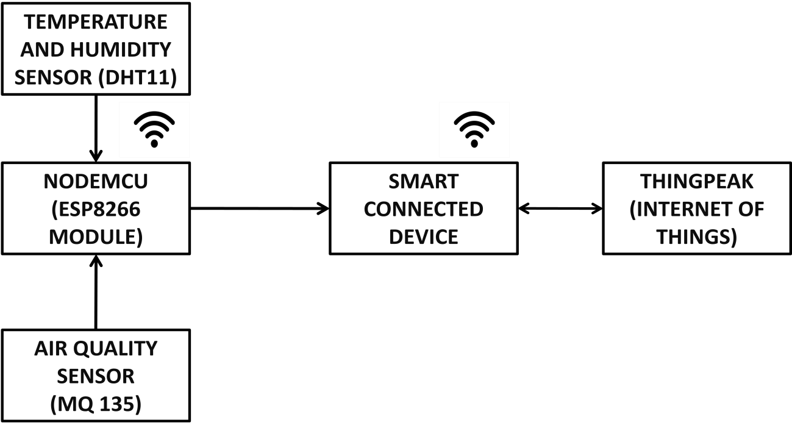

Fig 1.1): Block Diagram of sending the data to THINGSPEAK using NodeMCU

HARDWARE REQUIREMENTS:

* + For Different Parameter Sensing:-
* Air Quality sensor (MQ 135)
* O Led Panel
* NodeMCU 8266
* Jumper Wire

SOFTWARE REQUIREMENTS:

* Arduino IDE
* THINGSPEAK website

COMPONENT DESCRIPTION:

Air Quality Sensor (MQ135):-

**Product Description:**

Air Quality Sensor (MQ135):- Product Description: Air best click on is appropriate for detecting ammonia (NH3), nitrogen oxides (NOx) benzene, smoke, CO2 and different dangerous or toxic gases that effect air best. The MQ-a hundred thirty five sensor unit has a sensor layer manufactured from tin dioxide (SnO2), an inorganic compound which has decrease conductivity in easy air than whilst polluting gases are gift. To calibrate Air best, use the on-board potentiometer to alter the burden resistance at the sensor circuit. Fig. 1.2: MQ135 Sensor

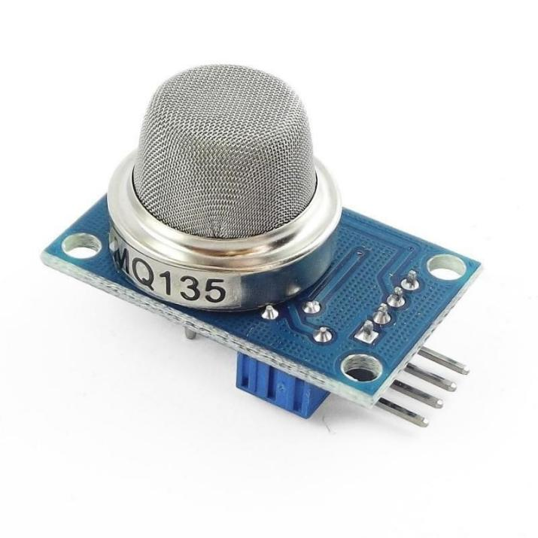

Fig. 1.2: MQ135 Sensor

**Pin Description:**

1, the VDD strength deliver 5V DC 2,GND , used to attach the module to machine floor three, DIGITAL OUT, You also can use this sensor to get virtual output from this pin, with the aid of using putting a threshold fee the usage of the potentiometer four, ANALOG OUT, This pin outputs zero-5V analog voltage primarily based totally at the depth of the gas.

O Led Panel:-

**Product Description:**

An natural mild-emitting diode (OLED or natural LED), additionally referred to as natural electroluminescent (natural EL) diode, is a mild-emitting diode (LED) wherein the emissive electroluminescent layer is a movie of natural compound that emits mild in reaction to an electric powered current. This natural layer is located among electrodes; typically, at the least this kind of electrodes is transparent..Pin Description: Pin No Function Name 1 Ground (0V) Ground three Contrast adjustment; via a variable resistor VEE four Selects command check in whilst low; and facts check in whilst excessive Register Select five Low to put in writing to the check in; High to study from the check in Read/write Table 1: Pin Description of 16x2 LCD Panel Fig 1.three O Led Display

**Pin Description:**

|  |  |  |
| --- | --- | --- |
| **Pin No** | **Function** | **Name** |
| 1 | Ground (0V) | Ground |
| 3 | Contrast adjustment; through a variable resistor | VEE |
| 4 | Selects command register when low; and data register when high | Register Select |
| 5 | Low to write to the register; High to read from the register | Read/write |

Table 1: Pin Description of 16x2 LCD Panel

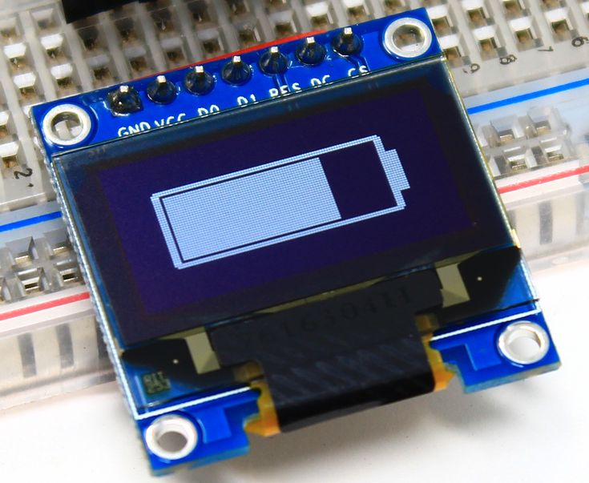

Fig 1.3 O Led Display

Node MCU:-

**Product Description:**

Node MCU is an open supply IoT platform. It consists of firmware which runs at the ESP8266WiFiSoCfrom Espress if Systems ,and hardware that's primarily based totally at the ESP-12 module. The term "NodeMCU" with the aid of using default refers back to the firmware as opposed to the improvement kits. The firmware makes use of the Lua scripting language. It is primarily based totally at the eLua challenge, and constructed at the Espress if NonOS SDK for ESP8266. Fig 1.four NodeMCU COST ESTIMATION STRUCTURE: Sl. No. Name of Components Cost (Rs.) three. Bread board 60 four. Jumper Wires 10/piece 9. Q Led a hundred and forty 10. MQ a hundred thirty five one hundred fifty 11. NodeMCU four hundred Total 730 Table four: Cost of various Components

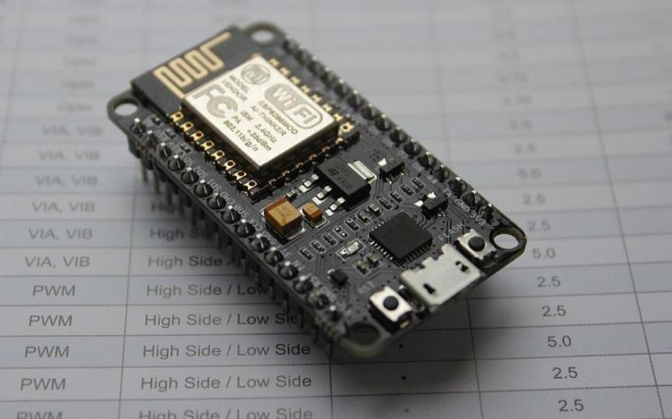

Fig 1.4 NodeMCU

COST ESTIMATION STRUCTURE:

|  |  |  |
| --- | --- | --- |
| Sl. No. | Name of Components | Cost (Rs.) |
| 3. | Bread board | 60 |
| 4. | Jumper Wires | 10/piece |
| 9. | Q Led | 140 |
| 10. | MQ 135 | 150 |
| 11. | NodeMCU | 400 |
|  |  |  |
|  | Total | 730 |
|  |  |  |
|  |  |  |
|  |  |  |
|  |  |  |
|  |  |  |
|  |  |  |
|  |  |  |
|  |  |  |
|  |  |  |
|  |  |  |

Table 4: Cost of different Components

**Connections:**

MQ135 voltage and floor are related to +5V and 0V and analog output pin is attached to analog Pin A0 of Arduino Uno. Q Led RS pin to virtual pin 12, Enable pin to virtual pin 11,D4 pin to virtual pin five, D5 pin to virtual pin four, D6 pin to virtual pin three, D7 pin to virtual pin 2, R/W pin to floor, VSS pin to floor, VCC pin to 5V, 10K resistor ends to +5V and floor and wiper to LCD VO pin. Fig1.five Fig1.6 Fig1.7

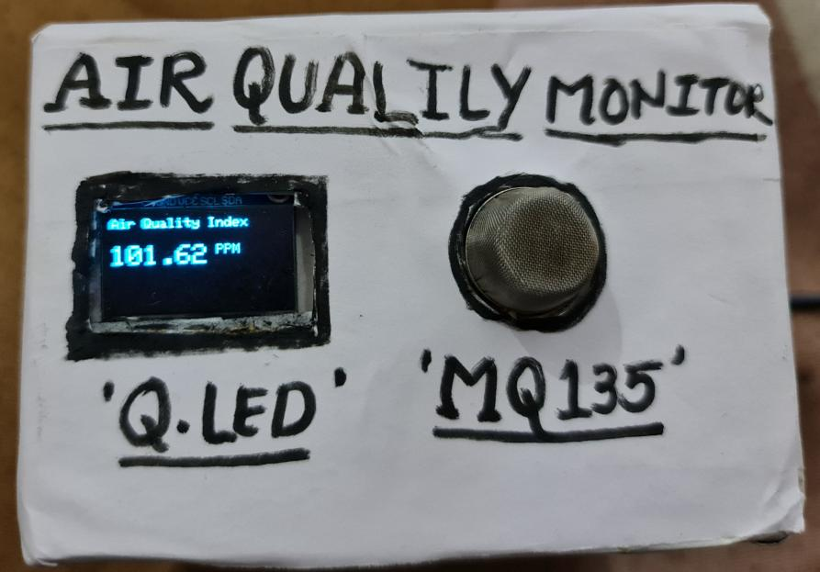

Fig1.5

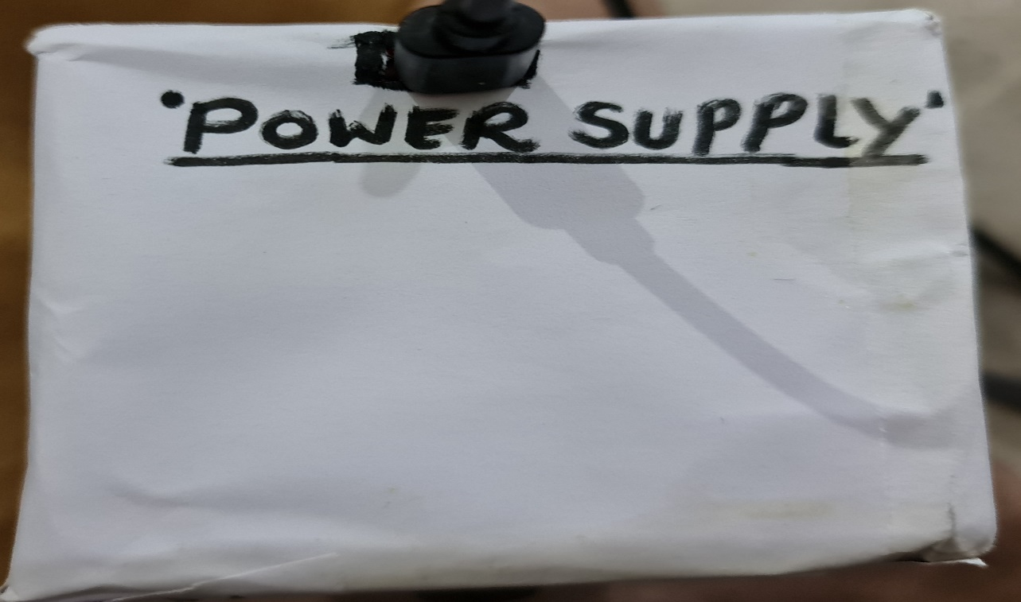

Fig1.6



Fig1.7

**Flowchart for THINGSPEAK:**

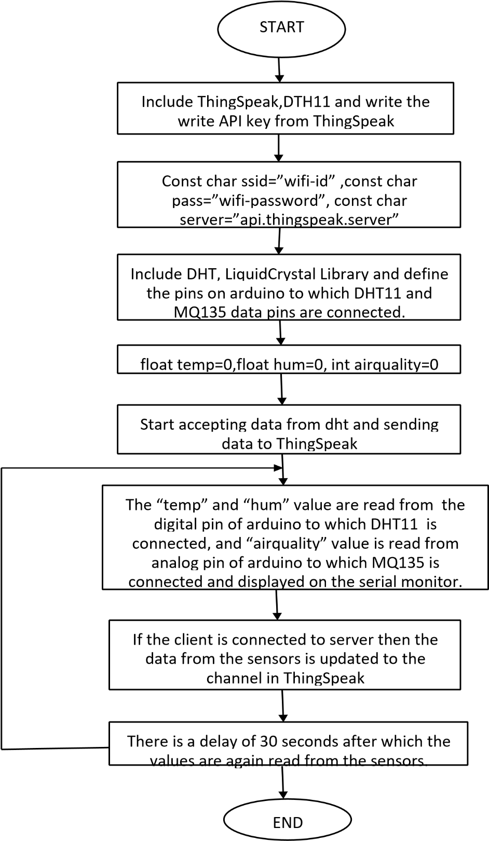

**RESULT**

After connecting the wifi efficaciously to the ESP-8266, it receives set up with Thingspeak account with the assist of the API key of our account provided. Thingspeak desires 15 seconds of refresh c language to push to the facts. Fig 7 indicates the sphere charts of MQ135 sensor values which made to transform to PPM [7] [8]. Fig eight displaying the graphical evaluation of the values accumulated with time on X axis and AirQuality PPM on Y axis. four

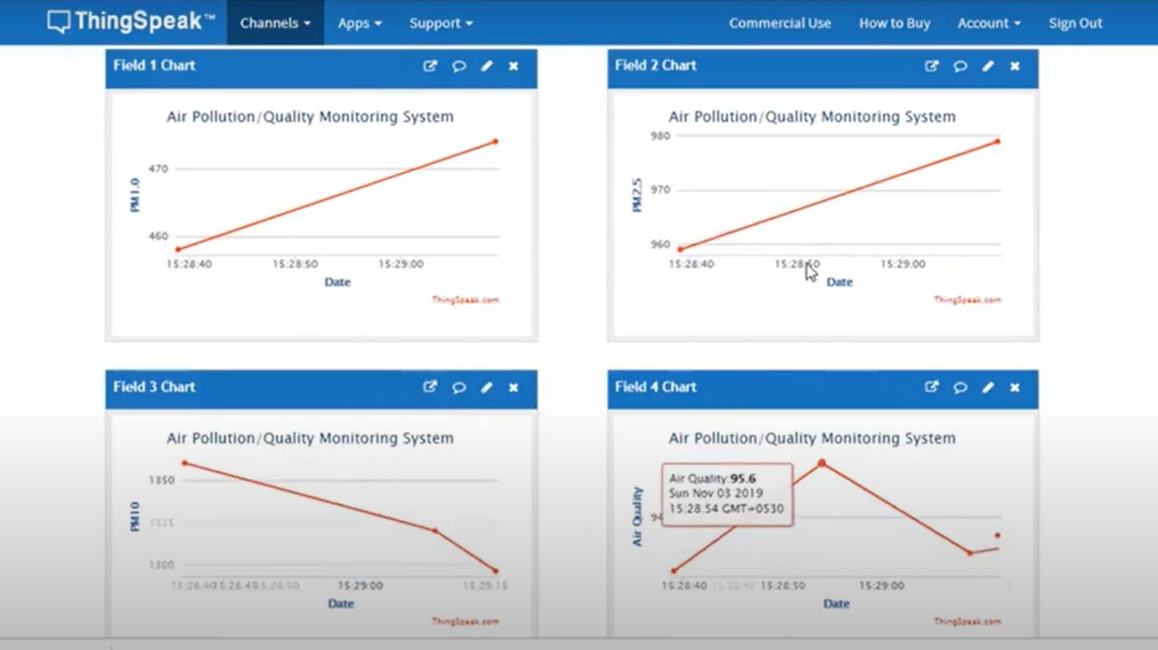

**4.CONCLUSION**

Monitoring the environmental parameters in particular with appreciate air performs very essential function to make sure wholesome surroundings for dwelling beings. We have visible numerous dangers being triggered at Delhi because of air pollutants. There are many motives for inflicting air pollutants however understanding their attention at numerous places facilitates to take selections on prevention measures. The proposed software works at the precept of IOT, facts study from sensor are processed with the aid of using the processor (ESP8266) then uploaded to database, those facts are analyzed and exhibited to users, and person ought to fetch this records over telecellsmartphone or webserver and take right movement to save you pollutants.

**REFERENCES**

1. Poonam Paul, Ritik Gupta, Sanjana Tiwari, Ashutosh Sharma, “IoT primarily based totally Air Pollution Monitoring System with nodemcu”, IJART, May 2021.
2. Zishan Khan, Abbas Ali, Moin Moghal, ”IoT based Air Pollution the usage of NodeMCU and Thingspeak”, IRANS, pp. 11-sixteen, March 2019.
3. SaiKumar, M. Reji, P.C. KishoreRaja ”AirQuality Index in India”, IEEE conference Chennai, August 2014.
4. Mohan Joshi, ”Research Paper on IoT primarily based on Air and Sound Pollution tracking machine”, IETS convention, pp. 11-17, September 2022.
5. ”Malaya Ranjan, Rai kumar, ”Understanding Parts in the line with million in actual time air.