**PROJECT REPORT**

**ON**

**IOT BASED**

**SMART BABY CRADLE SYSTEM**

**USING ESP32**

A Sixth semester project submitted for the evaluation of the

6th semester course IOT605 (Project VI)

**PROJECT REPORT**

*to be submitted by*

**Nitin singh chauhan (1904708)**

**Ritik singh (1904696)**

**Devendra singh (1904689)**

**Ravi yadav(1904713)**

**Shalini singh(1904716) & Radha(1904711)**

**B.VOC (IOT, 3rd year)**

DEPARTMENT OF PHYSICS & COMPUTER SCIENCE

FACULTY OF SCIENCE

DAYALBAGH EDUCATIONAL INSTITUTE

DAYALBAGH

AGRA(UP)-282005

**CERTIFICATE**

This is to certify that the project entitled **Smart Baby Cradle System using IOT & sensors** Submitted by in partial fulfilment of the requirement **Nitin singh Chauhan, Devendra singh, Ravi Yadav, Hritik singh, Radha verma, Shalini singh** for the award of degree of **bachelor of vocation (IOT),** to the **dayalbagh educational institute ,Dayalbagh ,Agra** is a record of their own work carried out under my supervision ,The information included in this project has not been submitted for the award of any other degree.

**DECLARATION**

I hereby declare that the Major Project study course work entitled ―”IOT based smart baby Cradle system”submitted to the DayalBagh Educational Institute, Agra, is a record of an original work by me under the guidance of Mr. Amarjeet singh chauhan and this work is submitted in the partial fulfillment of the requirements for the completion of the major project course of B.voc Course .The results embodied in this report have not been submitted to any other University or Institute for the completion of course.

Date: 13-05-2022 Nitin singh chauhan & team

**ACKNOWLEDGEMENT**

We are very thankful to our highly guide Mr. Amarjeet singh chauhan & Vandna Akella for his guidance encouragement and help for completing this project . we are sincerely thankful for this cooperative behavior, useful suggestion and providing us this opportunity to create project related to IOT and Its application & programming. we greatful to our teachers for their constant support and guidance. At the end  I would like to express my thanks to all my friends and family members who helped us directly or indirectly during this project work.

Date: 15/05/2022

Place: Agra

**CONTENTS**

CERTIFICATE……………………………………………………………………………………2

DECLARATION………………………………………………………………………………….3

ACKNOWLEDGEMENT…………………………………………………………………….......4

ABSTRACT……………………………………………………………………………………. . 6

CHAPTER- 1 INTRODUCTION……………………………………………………………… ...7

(i) Introduction…………………………………………………………………...……......7

(ii) Objective of the project……………………………………………………..………....8

CHAPTER-2 LITREATURE REVIEW & METHODOLOGY…………………………………..9

(i) Literature review………………………………..………………………………….....10

(ii) Methodology………………………………………………………………………....11

CHAPTER-3 MATERIALS AND METHOD…………………………………………………..12

(i) Components Required………………………………………………………………...13

(ii) Designing of the cradle model……………………………………………………….15

(iii) Procured and propose material…………...………………………………………….18

(iv) project image & circuit diagram…………………………………………………….20

CHAPTER-4 RESULT AND DISSCUSSION………………………………………………….22

(1) The Assembled device……………………………………………………………….23

CHAPTER-5 CONCLUSION…………………………………………………………………...24

(i) Conclusion…………………………………………………………………………....26

CHAPTER-6 FUTURE SCOPE AND REFRENCES…………………………………………. 27

(i) Future scope------------------------------------------------------------------------------------- 29

(ii) References-------------------------------------------------------------------------------------- 30

# **ABSTRACT**

Since we are in the twenty first century parents of small child are do jobs or work. They might have work to be done at home also. So simultaneously doing work and monitoring the baby could be trouble. So, for these many kinds of parent we are developing a cradle which consist of too many useful features. Cradle system has ability to send alert when baby is crying, it can also swing automatically when baby is crying. Cradle system also gives alert when baby does potty in the cradle. Cradle also has the ability to send alert regarding body temperature of the baby. There is some High alert also available regarding babies’ health. Likewise, there are multiple features in the cradle system.

**Chapter 1: INTRODUCTION**

1. **Introduction**

We know that trending Era of every device becomes smart by features , so we are use IOT and embedded tools to make this device smarter, Now this device called as **Smart Baby Cradle System .** So by that project, We can easily monitoring the activities of the baby. Whole system is connect to cloud so we get notified.

* Additionally to our understanding of the challenges parents face raising an infant while working with both parents, we also understand the challenges parents face when they are raising their children.
* Giving parents 24 hours of time is next to impossible in such cases.
* Working parents either send their babies to their parents or have babysitters care for them while they work. Some parents are concerned about the safety of their babies when they leave them with others.
* In this regard, we would like to develop something that can allow Parents to see/monitor constantly their babies and can notify them when the said situation arises.

Our solution is to develop a Smart Cradle System using IOT, which will allow parents to monitor their children from remote places even if they are away from home and monitor every baby's activity.

1. **Objective of the project**

The Internet of Things-based Baby Monitoring System (IoT-BBMS) has been proposed as a method of monitoring in real-time that is cost-efficient and efficient. Furthermore, for our system, we also proposed a new algorithm that plays a vital role in providing better baby care when parents are away. Working mothers currently have a greater presence in the workforce.

* As a result, many families find that baby care has become part of their daily chores. In most cases, parents send their newborns to their grandparents or to a childcare facility.
* The parents, however, can not continuously monitor their babies' conditions both during normal and abnormal conditions of the project

**CHAPTER-2**

**LITREATURE REVIEW & METHODOLOGY**

1. **Literature review**

There are various health care and health management system designed to look after the health of adults and aged persons. They can monitor various health statuses, automatically send alerts and also have many other features. But this system cannot be practically put under practice for infants as they need to be used under caution. Unlike adults, infants require a completely different approach to healthcare as they are totally dependent on their parents. Infants cannot give feedback about health conditions as their only way to express discomfort is by crying. Hence a specially designed healthcare system is needed to take care of the infants. It would gradually decrease the burden on parents, especially mothers. In support of above theory authors have developed a system that is based on commercial GSM network. Vital baby parameters such as body temperature using LM35 sensor, heart rate using IR transmitter and receiver, respiratory rate by using Piezo sensor located on patient’s chest are sensed, filtered, and given to microcontroller. A wet sensor detects urine condition in the cradle and all

ther data is given to the microcontroller. The authors also proposed the idea of mounting a camera on the cradle, so the parents can get live images of the infant inside the cradle when they are away. A speaker communication system to help calm the baby by hearing the parent’s voice. Also a mobile toy over the baby sleeping area to ease the baby. A remote subsystem with a GSM module receives data and sends it to a microcontroller for processing. In Paper [1] Author had made a cradle to swing/oscillate without human Intervention /Automatic by the sensors. The Slider-crank mechanism is used to transform rotational motion into translational motion by means of a rotating driving beam, The lead-acid battery, A motion detector is a device that detects moving objects, particularly people, Sound sensors detect both decibels [dB] and adjusted decibels [dBA]. A decibel is a

measurement of sound pressure. The limitation of this paper is it creates more noise due to which the baby gets disturbed. The proposed system is not skilled enough for handling sound. In Paper [2] Author decided to make a Cradle that should be controllable by a smartphone, as well as send data to it, such as video/audio stream. It should have an automatic way to comfort the baby if the parent can’t get to the baby right away. After coming up with a couple of features. They have used a Micro-controller, Wi-Fi module shield, Router, Stepper motor, Speaker, mic. The drawbacks of this paper are the Baby’s curiousness: Besides the risk of electrical shock, the components may fall off or be broken by the baby and the baby might even try to bite or eat the parts. Parents’ worries: Parents consider the safety issues much more than the features of products.

1. **Methodology**

The proposed prototype of a smart baby cradle will monitor the activities of the infant. The cradle has a motor which will rotate the mobile toy. The smart baby cradle has noise detection which will sense the noise when the baby is crying or making a loud noise. A servo motor will rotate (swing) the cradle up to an angle that is safe when the infant is inside the cradle. A camera will be used to track the baby inside the crib. A GSM module to communicate with a remote device that is operated by parents. And an Arduino microcontroller to control and monitor the activities of the cradle.

**CHAPTER-3**

**MATERIALS AND METHOD**

1. **Components Required**

Hardware Requirement

* ESP32 Development Board
* Ardiuno UNO
* Camera module
* Servo Motor
* Surface temperature sensor
* PCB for web sensing
* Breadboard
* Jumper wire
* Battery

Software Requirement

* Arduino IDE
* VScode (For making web page)
* Arduino IOT cloud

**Arduino Uno**

This microcontroller is a single board, smaller scale device that is used for intuitive protests and situations. It have digital and analog pin by which we connect sensor & peripheral devices. Arduino Uno can sense the environment by using the sensor. Sensor receives the signal from the environment and sends it to the input part of Arduino.it give the output from the output part as the programming burns in the microcontroller. Arduino accept a programming software called sketch. An Arduino can program infinite time. If a new program burn in the Arduino, then the previous program will automatically vanish. We can use multiple sensors at a time and all the instructions should be in one program.

**Applications of Arduino**

* To develop any prototype model.
* Interfacing each sensors by which you can get data**.**

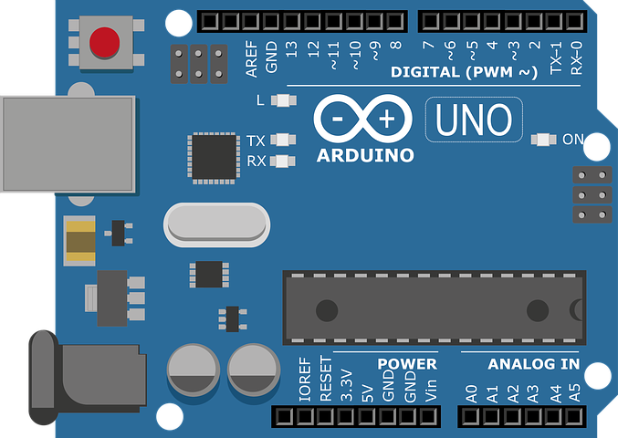

**ESP32 Development board**

ESP means **Espressif Systems** & 32 is the version number of that microcontroller. It is very intelligent microcontroller with built in with WiFi & Bluetooth module and dual core. It is technically a chip or development which is used to perform the given task. It has 48 GPIO (General Purpose Input Output Pins) pins with multiple functionalities.

**Applications of ESP32**

* To perform the given task.
* Used to build many projects.

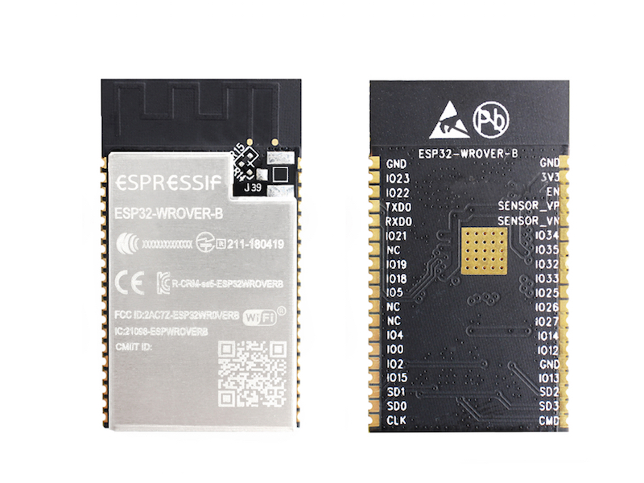

**Servo motor**

Servo motor is a type of motor. It is controlled by PWM (Pulse with Modulation) This motor is rotate at an angle of 90o , 1800  or at any given angle, in this project we use servo motor to swing the cradle at defined angle, when the user gives command by web server.

**Application of servo motor**

* Robotics toys
* Robotic hand
* Used to swing cradle

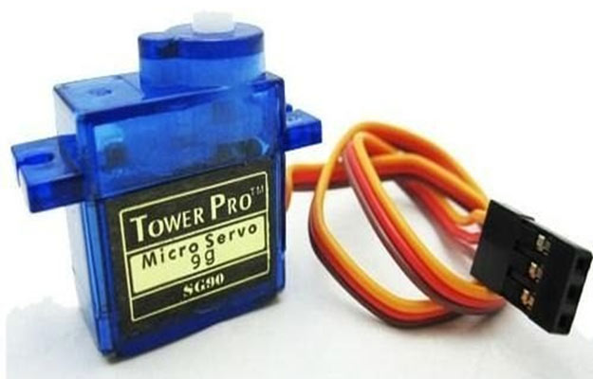

**Camera module (USB & ESP camera module )**

Camera module is used to capture image or surveillance the current scenario. In this project we use camera module for monitoring the activities of the baby. We can use any camera module like USB camera or ESP32 camera module.

**Applications of camera module**

* Survillancing the current situation
* Capturing images

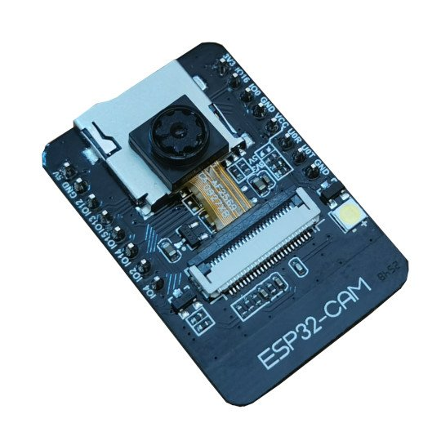

**Surface temperature sensor**

This is a very intelligent sensor when get attach directly to any surface and it can measure the temperature by physically contact. It can operate at the temperature range of -40° to +150°C. We can use this sensor for checking temperature of baby, when the temperature gets high, the system can give notification directly to the user.

**Applications of Surface temperature sensor**

* It can measure the temperature when humen body contacts physically.
* It can used for medical purpose.
* It have Accuracy: ±0.2°C at 0°C, ±0.5°C at 100°C

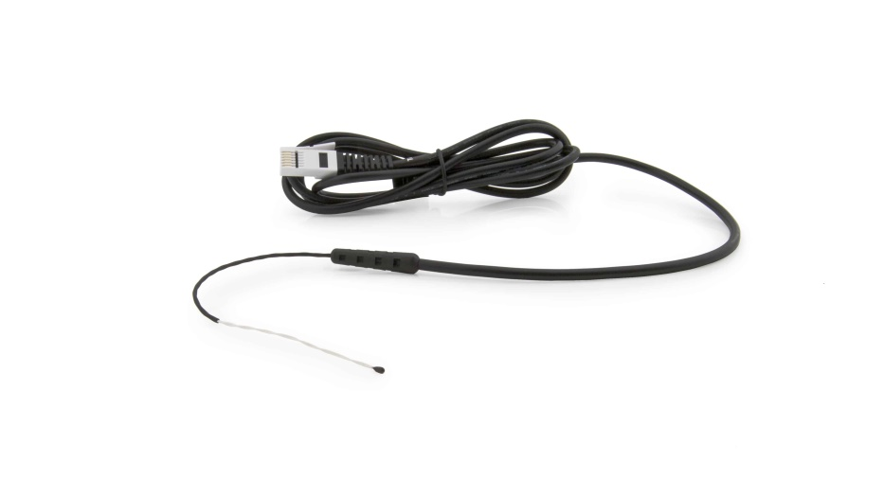

**Wet sensor (made on PCB Board)**

For making this sensor we use the voltage divide technique and the use of resistance below a certain limit. When it get contact with wet surface or water it can sound a beep or given notified. In our project when baby do toilet on the cradle then cradle becomes wet. Then it will give notification on the web server.

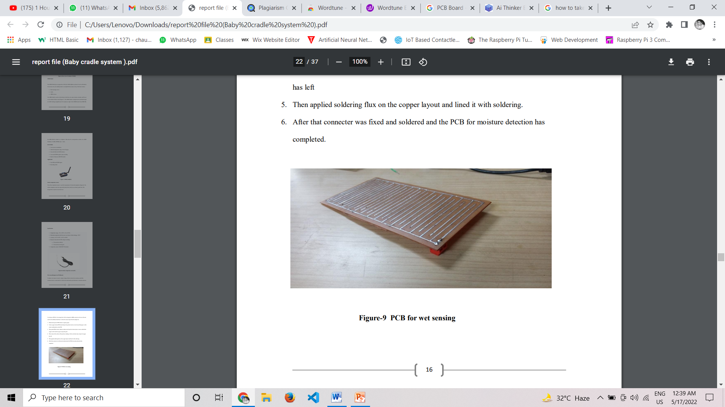

Breadbord

This board is use to make connection. This board is horizontally and vertically short by which you can make connection by pusing jumper wires in it.

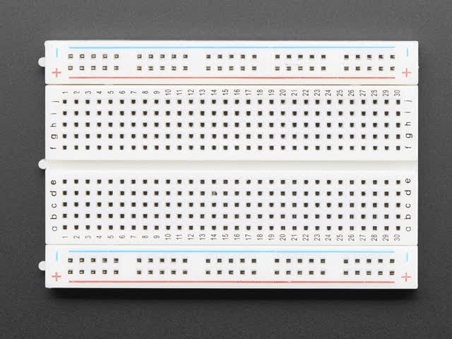

**Jumper wire**

These are the wires used to make connections from microcontroller to the peripheral device & sensors.

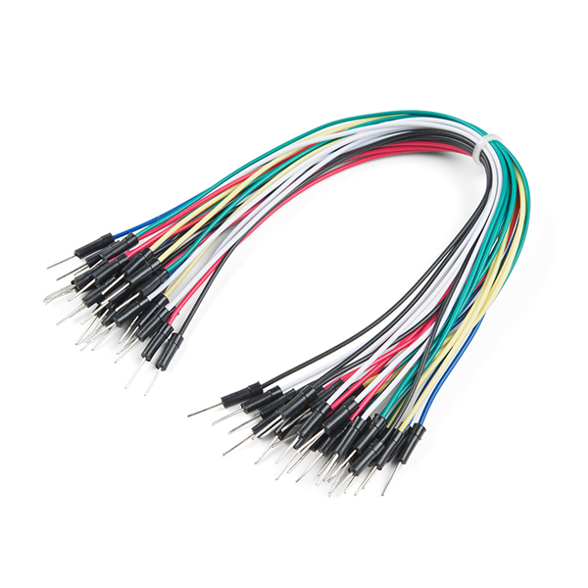

**Battery**

Battery is used to give power to the whole device. Which can operate at 5-9 Volt.

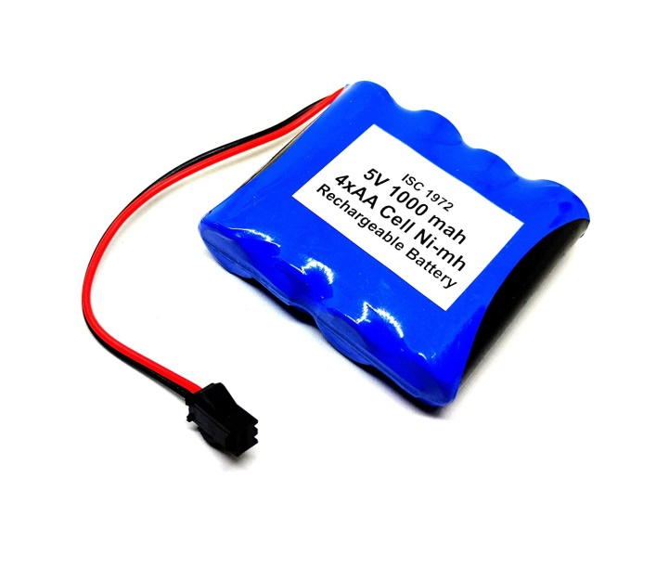

**(ii)PROCURED AND PURPOSE OF MATERIAL**

In this we have understand the whole project and the system. ESP32 development board is the heart of the system which give command to all the pheripherals. Which can directly communicate the web server and take command form web server as input and doing there task and shows at output.

Servo motor is used to swing the cradle at clockwise degree of 45 and anticlockwise degree of 45 angle . it can take input form website or web server from where you can ON and OFF the swing the cradle

Camera module is used for monitoring the activity of the baby. When baby gets incurred then it can give notification to the user. We use ESP32 camera module this system.

Wet sensor , we can mindly used PCB as a wet sensor by shorting their connection whenever it can wet by baby toilet then it sound beep.

Whole system can operate by the battery of 5 to 9 volt.

1. **project image & circuit diagram**

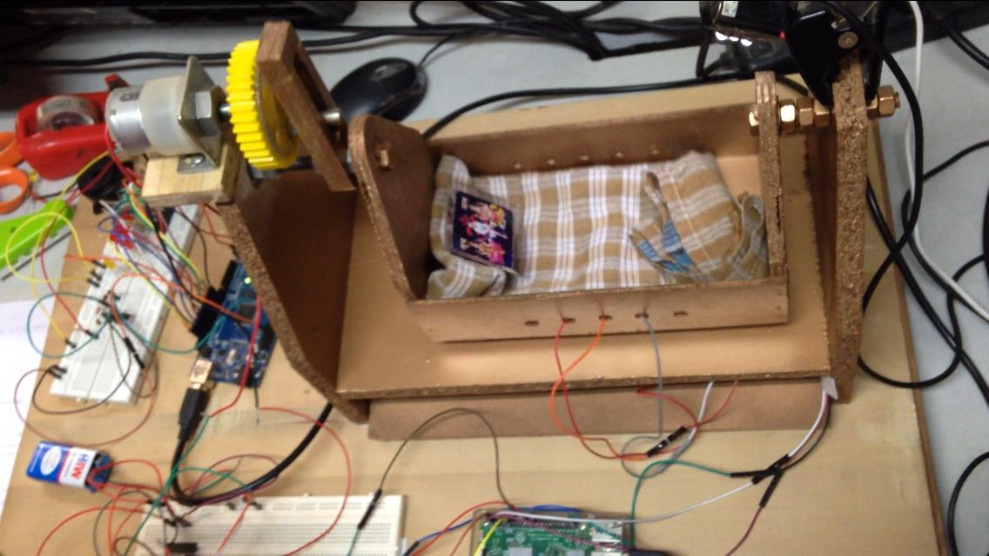

**Overall system**

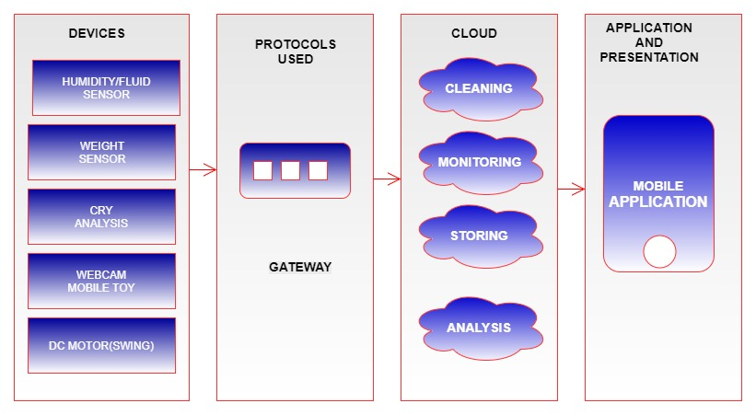

**Webpage of the project**

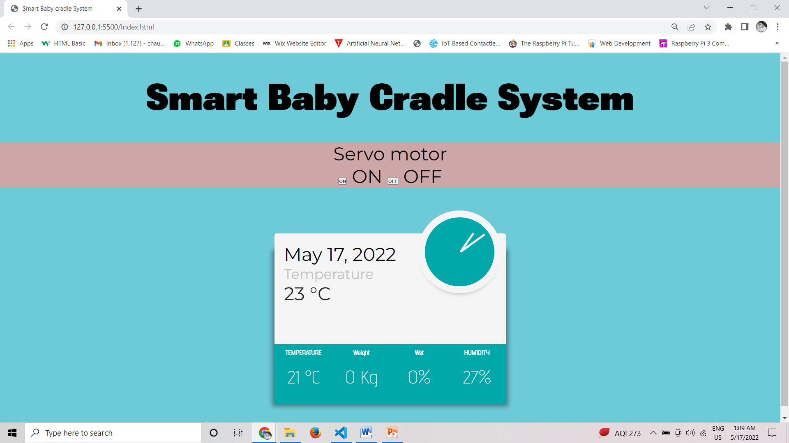

**CHAPTER-4**

**RESULT AND DISSCUSSION**

1. **Result**

This project is totally safe in terms of electricity & other hazards for the Baby/Infant. Only sources required are the 9v batteries & the Adapter to turn on the Raspberry Pi. The whole system is compact and the important modules can be merged into a box kept aside from the sleeping bed of the Baby. The system is going to be 24 hour Nanny of the Baby with constant monitoring . We can say that noise detection and urine detection are modulated and implemented. Modules to engage in our future scope period include a A toy which we can use to comfort the baby when he is bored or Weeping A set of servo motors will be used to move the cradle, A camera will also be installed to watch the movement of The baby is inside the crib. all components of the cradle will be synced with.

Some nannies were being paid to take care of a child. There are also some baby health care centers that charge a lot of money and offer baby monitors or baby pacifiers. As time goes by, a lot of frauds have been detected in such centers from newspapers and news channels which we get to know about. Some cradles are also designed, but they usually only have one or two features. With that one or two features, they themselves were making it difficult to care for the child or disturbing the child's sleep. Before dismantling the system that we have to build, we surveyed some papers and they were found with the following problems! The cradle will swing by itself. But the proposed system was making the swing too noisy due to which the child was getting disturbed from sleeping.



**CHAPTER-5 CONCLUSION**

1. **Conclusion**

The proposed idea of a smart cradle is a less expensive and easier system to use. It can help improve the quality of the child care system. This system will provide assurance to the parents that their the babies are well taken care of. Helps in continuous capturing and monitoring of various biomedical parameters of the child Mother to understand the internal health status of the child. as in gsm technology is used it helps the user to communicate for a longer period of time. It is a convenient system to monitor the health of the baby care from any distance.

**CHAPTER-6**

**FUTURE SCOPE AND REFRENCES**

1. **Future scope**

In this technology era people will more smart than that because people will covered by the technologies and they need anyone to take care of their babies so the smart baby cradle system will take care of their babies as well as they can monitor and watch it when they will be busy with their work and can take action when they will be far from home. It will be automated and will give a peaceful sleep and entertain as well.

Here are the some key points of future scope-

1. It will save the baby to avoid wetness. And also will avoid from the infection from the unhygienic.

2. Smart cradle system will protect the baby during the mid night without disturbing parents.

3. It drops the notification when the baby will cry and It'll also entertain the baby with fitted toys and songs as well.

4. It will give the notification when the baby will do pee.

As per the smartness of it's cradle it will do the work that a maid does. It will be trusted system to keep save the baby.

And in the end we would like to implement in it as the babies will smart in upcoming generation.

1. **Reference**

[1] "Baby cradle-like carrier," ed: Google Patents, 1966.

[2] M. Blea and M. Harper, "Automatically rocking baby cradle," ed: Google Patents, 1973.

[3] Y. George, "Baby cradle rocked by electricity," ed: Google Patents, 1949.

[4] G. Wong, "Automatic baby crib rocker," ed: Google Patents, 1976.

[5] B. Song, H. Choi, and H. S. Lee, "Surveillance tracking system using passive infrared motion sensors in wireless sensor network," in Information Networking, 2008. ICOIN 2008. International Conference on, 2008, pp. 1-5.

[6] P. Jamieson, "Arduino for teaching embedded systems. are computer scientists and engineering educators missing the boat?," Proc. FECS, pp. 289-294, 2010.

[7] M. S. Zaghloul, "GSM-GPRS Arduino Shield (GS-001) with SIM 900 chip module in wireless data transmission system for data acquisition and control of power induction furnace," International Journal of Scientific & Engineering Research, vol. 5, 2014.

[8] M. Margolis, Make an Arduino-controlled robot: " O'Reilly Media, Inc.", 2012.

[9] R. S. Byrd, M. Weitzman, N. E. Lanphear, and P. Auinger, "Bed-wetting in US children: epidemiology and related behavior problems," Pediatrics, vol. 98, pp. 414-419, 1996.

[10] J.-H. Choi and V. Loftness, "Investigation of human body skin temperatures as a biosignal to indicate overall thermal sensations," Building and Environment, vol. 58, pp. 258-269, 2012.