**SMART GLASSES**

Using Arduino

**REPORT**

**MAJOR PROJECT**

Submitted for the partial fulfillment of the requirements for the

Degree of

**Bachelor’s in Vocation**

**In**

**Internet Of Things**

Submitted by

**Jaya Shukla (1904697)**

**Koyana Singh (1703684)**

**Sandhya Kushwah (1904715)**

**Shweta Rani (1904721)**

**Mr. Amarjeet Singh Chauhan**

Supervisor

Department of Physics & Computer Science

FACULTY OF SCIENCE

**DAYALBAGH EDUCATIONAL INSTITUTE**

DAYALBAGH, AGRA 282005

**ACKNOWLEDGEMENT**

I would like to express my gratitude to my supervisor Mr.**Amarjeet Singh Chauhan,** Department of Physics & Computer Science , Faculty of Science , Dayalbagh Educational Institute (D.E.I), Agra for his whole hearted efforts and the valuable guidance at each stage of the development of this course work.

I would also like to thank **Mrs. Vandana Akella**, Faculty of Science, D.E.I. for providing me facilities during the work.

I am grateful to **Prof. Sanjay Saini**, Department of Physics & Computer Science for his uniting help at different stages of this course work.

Finally, I am thankful to my all near and dear ones who supported me in the completion of this course work.

Date: 15-04-2022

Place: Agra

Ms. Jaya Shukla

Ms. Koyana Singh

Ms. Sandhya Kushwah

Ms. Shweta Rani

**CERTIFICATE**

This is to certify that **Ms. Jaya Shukla, Ms. Koyana Singh, Ms. Sandhya Kushwah** and **Ms. Shweta Rani** have carried out the major project presented in this report titled **“Smart Glasses”** for the completion of B.Voc. course in Internet of Things from Faculty of Science, Dayalbagh Educational Institute, Agra, under my supervision. The report embodies result of original work and studies carried out by students themselves and the contents of the report do not form the basis for the award of any other course to the candidate or to anybody else.

**SUPERVISOR**

**Mr. Amarjeet Singh Chauhan**

Department of Physics & Computer Science

Dayalbagh Educational Institute

Agra, Uttar Pradesh – 282005

**H.O.D**

**Prof. Sanjay Saini**

Department of Physics & Computer Science

Dayalbagh Educational Institute

Agra, Uttar Pradesh – 282005

**ABSTRACT**

This venture is developed via the usage of an Arduino Microcontroller having ATmega328p microprocessor, which is programmed to connect with smart-phones through a smart mobile phone application.

Our task is a wearable computing device used as an extension, which may be connected to the spectacles or shades of the wearer, and can be paired with Smart Phones, via Bluetooth.

This mission includes a Bluetooth module, named HC-05, is interfaced with ATmega328p, that is used to connect to smart-telephones. A battery / Rechargeable battery of 5V is used as power deliver for Smart-Glass.

An SSD1306, 0.Ninety six” OLED show is interfaced with ATmega328p, it's used to reveal the statistics received from Smart-phones. Smart-Phone software is used to transmit facts of the phone, i.e. Date, Time, Notifications of Phone call and Text message.

**CONTENT**

CHAPTER 1 INTRODUCTION…………………………………………………….6

CHAPTER 2 LITERATURE ……………………………………………………….7

CHAPTER 3 METHODOLGY ……………………………………………………..9

3.1 CONCEPTUAL FRAMEWORK ……………………………………….…9

3.2 STUDY OF SYSTEM COMPONENTS…………………………………...9

3.2.1 INTRODUCTION…………………………………………………..9

3.2.2 LIST OF COMPONENTS…………………………………………..9

3.3 SOFTWARE DESIGN……………………………………………….…...13

3.4 CONCLUSION…………………………………………………………...14

CHAPTER 4 IMPLEMENTATION……………………………………………….15

4.1 TEST SCHEDULE………………………………………………………..15

4.2 ROLES & RESPONSIBILITIES…………………………………………15

4.3 RISKS/ ASSUMPTIONS………………………………………………...15

CHAPTER 5 FUTURE SCOPE…………………………………………………...16

CHAPTER 6 CONCLUSION……………………………………………………..17

**CHAPTER: 1**

**INTRODUCTION**

In the contemporary world, as the technology in every field is growing rapidly with the high rate. So, we are making smart glasses for the people to experience the magic of technology in today’s era.

Our wearable glasses aim is to make life easier. Technically, the motive of this smart glass project is to get all the notifications that come up on the mobile display or mobile screen would show on the wearable glass display or wearable smart glasses.

Taking a token of help from Google, we tried to make a wearable prototype which would be similar with Google glass. Nowadays, Google glass has attract so many people by their futuristic idea for the future generation that is coming on the way.

Basically, the main advantage or use case of this project is that like this can be useful for all kind of people groups either childhood for fun or for handicapped/disabled ones who can’t able to do something with their disability.

In this project we have done so may advanced things to make our glasses smart or to convert simple wearable glasses into smart wearable glasses that can work like Google glasses.

These smart wearable glasses will show all the notifications on the corner of your glass so that you can catch it soon and don’t need to see you mobile screen again and again.

This project would be quite interesting for all groups of people and head a great future ahead.

**CHAPTER: 2**

**LITERATURE**

According to Niek Zuidhof research paper, smart glasses increased the technology in both of the areas one is research area and the other one is consumer market area. As the technology growing up with the explosive rate so smart glasses is also updating with a deep study.

In the market area, smart glasses is on the high demand for all the people either they are from younger age group or from handicapped/disabled group.

Niek Zuidhof described various types of smart glasses which is similar to the Google glasses. He also gave an example of smart glasses are also known as smart eye wear computing.

Over recent decades smart glasses have gained increased attention in both the research area and recently also in the consumer market, even though there is not yet a clear definition of what exactly smart glasses entail and underexposed perspectives are not represented. This study used a rapid review to assess the current understanding of smart glasses with the aim of defining them.

Searches were performed across six databases, followed-up by a content-based evaluation of title and abstract. A total set of 14 relevant publications was identified to help arrive at a definition and characteristics of smart glasses.

As a result, it was observed in both the research literature and in the public domain that many different names are used for smart glasses, and that in some cases there is unclear about what constitute smart glasses. Therefore, an adapted definition of smart glasses is developed based on the existing original rationale of ubiquitous computing and taking the current state-of-the-art knowledge into account.

This article provides an overview of and suggestion for defining smart glasses from a social sciences’ perspective to better inform researchers, developers, designers and companies who are involved in the design, development, research of smart glasses.

According to the another author’s research paper by Leonardo Oliveira, they talk about the security features about the smart glasses.

Leonardo Oliveira has written about the cryptography techniques to make the data secure that is transferred from sender to receiver through RSA and ECC based techniques.

They used two types of languages such as C and C++ for making these smart glasses.

According to Peter-Paul Verbeek , smart glasses can be a boon for the disabled people who are not able to do their work properly as the normal people can do.

They talked about the different section of smart glasses like how can it be a better option for the upcoming generation or the future generation. They briefly discussed about the history and origin relevant to the concepts of head- mounted displays(HMD), ubiquitous computing, AR and augmentation. Smart glasses can create the relationship between the humans and the technology. At the end of research paper, they talked about the conclusion brought from it.

**CHAPTER: 3**

**METHODOLOGY**

### 3.1 CONCEPTUAL FRAMEWORK

The version begins off advanced at the left component with an define of the 5 categorizations of goals, wherein each of them is conceptually linked to a broader category of gratifications. These gratifications may be predominantly acquired from the device itself (top factors) or from the medium (i.e., AR; bottom factors). In addition, the model proposes that the strengths of those consequences

could probable fluctuate primarily based definitely at the context (lifestyles of other human beings or no longer), the tool (style, generation, or style + generation), and the person (e.g. Self-presentation). In addition, the model proposes that the degree to which a human need is satisfied determines the importance of precise gratifications.

### 3.2 STUDY OF SYSTEM COMPONENTS

3.2.1 INTRODUCTION

When designing digital circuits (or diagrams), a terrific knowledge of the components for use is essential. Concerning this challenge, to reach the said aim and objectives that's to build smart glasses for the customers, we should first take a look at some key additives.

### 3.2.2 LIST OF COMPONENTS

This project is constituted by the following named components:

* **Arduino Nano (ATMega328p)**

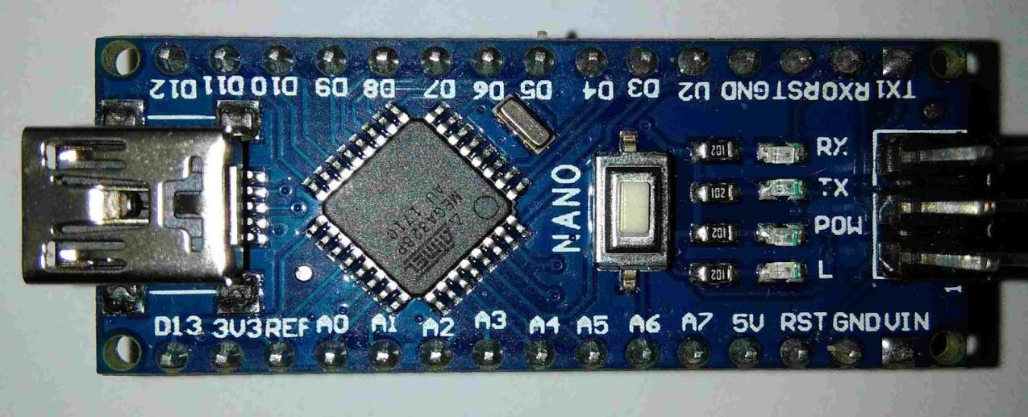The Arduino Nano is a small, entire, and breadboard-friendly board based totally at the ATmega328 (Arduino Nano 3.x). It has more or much less the equal functionality of the Arduino Duemilanove, however in a different package. It lacks best a DC strength jack, and works with a Mini-B USB cable in preference to a standard one.

* **Bluetooth module (HC-05)**

It is used for lots packages like Wi-Fi headset, sport controllers, wireless mouse, Wi-Fi keyboard and lots of greater customer packages. It has an expansion up to <100m which relies upon upon transmitter and receiver, environment, geographic & city situations. It is IEEE 802.15.1 standardized protocol, through which it is simple to build wireless Personal Area Network (PAN). It makes use of frequency-hopping unfold spectrum (FHSS) radio technology to ship statistics over air. It makes use of serial communique to speak with devices. It communicates with a micro controller the use of a serial port (USART).

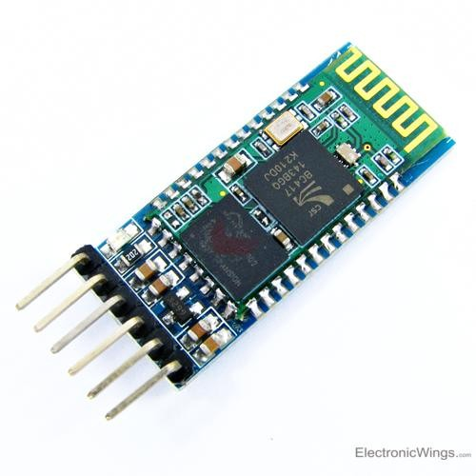

* **OLED Display**

SSD1306 is a single-chip CMOS OLED/PLED driving pressure with a controller for an organic / polymer mild emitting diode dot-matrix picture display machine. It includes 128 segments and 64commons. This IC is designed for Common Cathode type OLED panels. The SSD1306 embeds with assessment manage, display RAM and oscillator, which reduces the quantity of outside components and power intake. It has 256-step brightness control. Data/Commands are despatch from popular MCU thru the hardware selectable 6800/8000 collection nicely ideal Parallel Interface, I 2 C interface or Serial Peripheral Interface. It is appropriate for lots compact transportable programs, together with cellular cellphone sub-display, MP3 player and calculator, and plenty of others.

### 3.3 SOFTWARE DESIGN

The software development unit consists of Arduino IDE.

### **ARDUINO IDE**

The Arduino Integrated Development Environment (IDE) is a pass-platform utility (for Windows, mac OS, Linux) this is written in abilities from C and C++. It is used to install writing and add applications to Arduino well suited boards, but moreover, with the assist of 1/three-celebration cores, distinctive seller improvement boards.

Arduino IDE is a spin off of the Processing IDE, however as of model 2.Zero, the Processing IDE will get replaced with the Visual Studio Code-primarily based absolutely Eclipse Theia IDE framework.



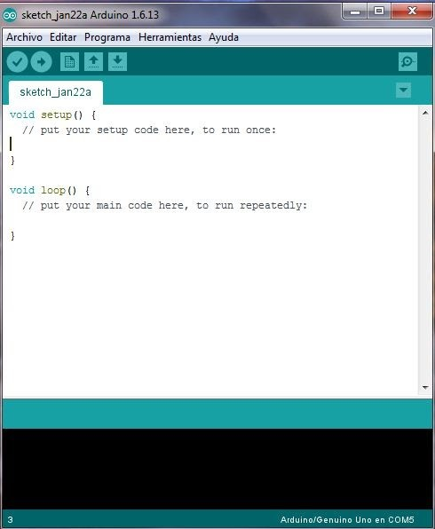

### 3.4 CONCLUSION

In this chapter, we have presented the components and methods used in designing the smart glasses.

**CHAPTER: 4**

**IMPLEMENTATION**

4.1 TEST SCHEDULE

|  |  |  |
| --- | --- | --- |
| **TESTING** | **START DATE** | **END DATE** |
| Unit Testing | 5 February | 8 March |
| Integration Testing | 9 March | 17 April |
| System Testing | 18 April | 12 May |

4.2 ROLES & RESPONSIBILITY

|  |  |
| --- | --- |
| Jaya Shukla | Coding |
| Koyana Singh | Testing |
| Shweta Rani | A user friendly device |
| Sandhya Kushwah | Hardware connections |

4.3 RISKS/ASSUMPTIONS

Risks involve powering device at more than 5Volts as this will result in burning of Arduino Nano, OLED or the Bluetooth module.

**CHAPTER: 5**

**FUTURE SCOPE**

Imagine being able to replace the knowledge you want at once to an eyewear database. This state of affairs permits a hands-unfastened body of people with instant get proper of access to to focused know-how at once in their location of view. Such an implementation could in the end increase first-rate manage, enhance protection, offer faster and extra reliable answers, save money on control and education, facilitate a long way off help, to name some.

Technological advances in computer generation are the prerequisite for the emergence of smart glasses. However, as stated previously, this is not because of the reality smart glasses are a today's phenomenon. As the preceding segment confirmed, there were some of very useful products available on the market in view that 2000 and onwards, and Mann and Starner led the manner. But there are numerous premises in the cutting-edge improvement, which collectively reason the supposition that perhaps we're able to see a huge software of clever glasses.

However, most commentators accept as true with that improvement will take much less than 10 years. When Google Glass hits the market in overdue 2014, the maximum possibly situation is that a huge quantity of first movers will buy a pair of glasses straight away. Within the subsequent 3-5 years there will in all likelihood be a sturdy and widely anchored marketplace for the sale of smart glasses of a few type or another. BI Intelligence are awaiting that 22 million of these glasses can be sold on the world marketplace by the use of 2018.

**CHAPTER: 6**

**CONCLUSION**

This report consists of the look at the design course of wearable computer. In stylish, clever glasses end up taken into consideration as a useful tool especially in situations that fingers had been excited about unique activities and the smart glasses should help the man or woman to multitask and be more effective. Also, it helped to enhance using a clever-cellphone with the use of the telephone software program with out taking the cellphone out of pocket. Moreover, troubles related to privacy and social acceptance of the tool raised.

With this article we've got proven how smart glasses own relevance in phrases of increasing manner overall performance thru an stepped forward expertise management. The use instances we've got provided best cowl few applications; capability makes use of of the technology look like more numerous and a few not even located but. However, any use can handiest be the impact of previous adoption.

Organizational and individual adoption comes with diverse boundaries that need to be overcome. In this newsletter, we have tested problems, what to consider and made pointers on how these boundaries may be triumph over via using management. Our framework may additionally characteristic a basis to in addition research on this vital difficulty count number or for example of approaches framework development in a totally new technological context can be performed.