**DOMAIN NAME: INTERNET OF THINGS (IOT)**

**PROJECT NAME: SMART WATER MANAGEMENT**

Welcome to our Smart Water Management Project, where we're using modern technology to make water use smarter and more efficient. Our project is all about using sensors and smart devices to collect data on water usage. By analyzing this data, we can predict trends and find ways to use water more wisely. We aim to build a system that not only helps conserve water but also keeps you informed about your usage.

**SYSTEM ARCHITECTURE:**

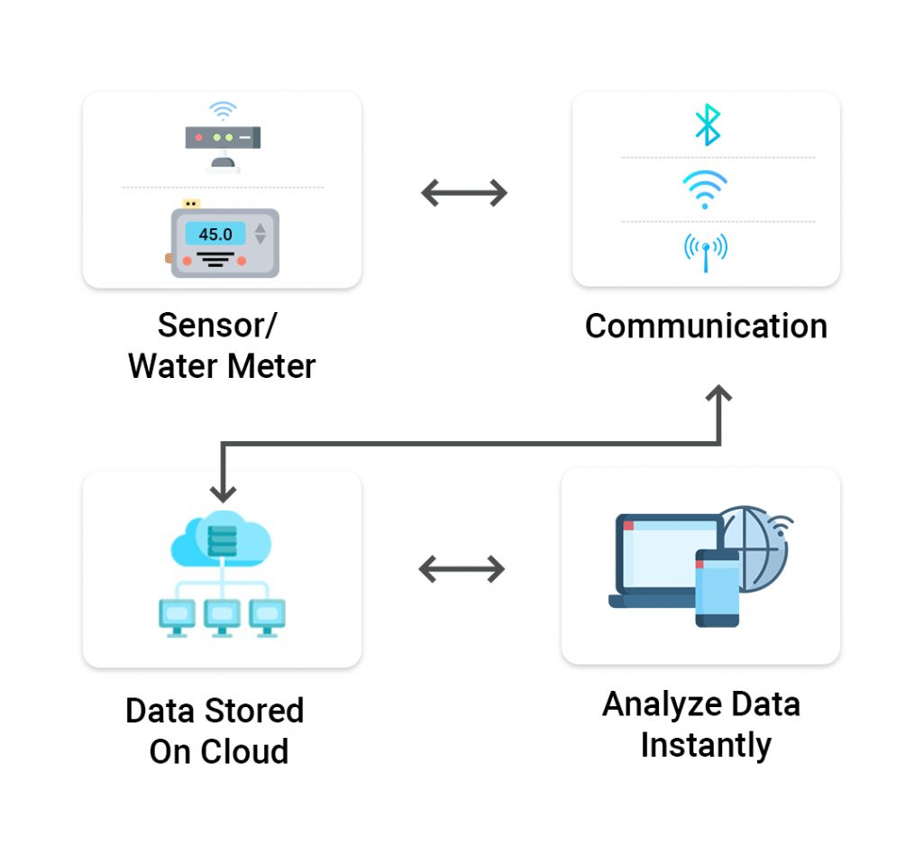

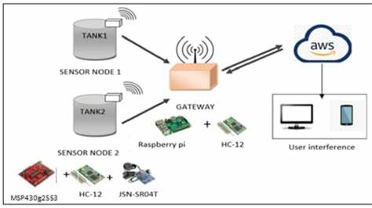

**MODULES INVOLVED IN THE SYSTEM:**

**1. Data Collection Module:**

- Sensors: Employ various types of sensors, such as flow sensors, pressure sensors, water level sensors, and quality sensors (for parameters like pH, turbidity, contaminants) to monitor different aspects of water systems.

- IoT Devices: Utilize Internet of Things (IoT) devices to collect real-time data from sensors and transmit it to the central system for further analysis and decision-making.

**2. Data Processing and Analysis Module:**

- Data Processing: Process the raw data collected from sensors to extract meaningful information, clean outliers, and aggregate data for analysis.

-Analytics and Algorithms: Implement data analytics algorithms and machine learning models to analyze the processed data, identify patterns, predict water usage trends, and detect anomalies like leaks or unusual consumption.

**3. User Interface Module:**

- Web/Mobile Application: Develop an intuitive and user-friendly web or mobile application that allows users to monitor their water consumption in real-time, set consumption goals, receive alerts, and visualize their usage through graphs and charts.

- Alerts and Notifications: Enable the system to send alerts and notifications to users regarding high consumption, leaks, or water quality issues.

**4. Automated Control Module:**

- Valves and Pumps: Integrate automated valves and pumps that can adjust water flow and pressure based on real-time demand and system conditions, optimizing distribution and minimizing wastage.

- Weather Integration: Incorporate weather forecasting data to adjust irrigation schedules and water distribution in response to anticipated weather conditions.

**5. Leak Detection and Prevention Module:**

- Leak Detection Algorithms: Implement algorithms that continuously monitor the system for anomalies in flow rates or pressure, flagging potential leaks for further investigation.

-Automated Shut-off Valves: Integrate automated shut-off valves that can isolate affected areas in the event of a detected leak, minimizing water loss and damage.

**6. Water Quality Monitoring Module:**

- Sensor Integration: Integrate sensors that monitor water quality parameters (e.g., pH, turbidity, contaminants) and provide real-time data on water quality.

- Alerting System: Configure an alerting system to notify users and authorities in case of poor water quality, prompting appropriate actions.

**7. Billing and Reporting Module:**

- Usage Reports: Generate detailed usage reports for individual users or communities, summarizing water consumption and providing insights to encourage water conservation.

- Billing Integration:Integrate with billing systems to accurately calculate water usage and generate bills based on consumption.

**8. Integration and Connectivity Module:**

- APIs: Develop APIs to facilitate integration with other smart city systems, allowing for seamless communication and data sharing.

- Centralized Monitoring: Establish a central server that aggregates data from various sources and provides a centralized platform for monitoring and managing the water system.

**9. Energy Efficiency Module:**

- Optimization Algorithms: Create algorithms to optimize energy usage in water pumping and treatment, aligning energy consumption with demand and minimizing waste.

- Renewable Energy Integration: Integrate renewable energy sources (e.g., solar panels, wind turbines) to power the system, enhancing its sustainability and reducing reliance on non-renewable sources.

**10. Feedback and Optimization Module:**

- Feedback Mechanisms: Implement feedback mechanisms within the application to allow users to report issues, provide feedback, and suggest improvements.

- Continuous Improvement: Leverage user feedback and system performance data to iteratively improve the system, addressing issues and enhancing its functionality.

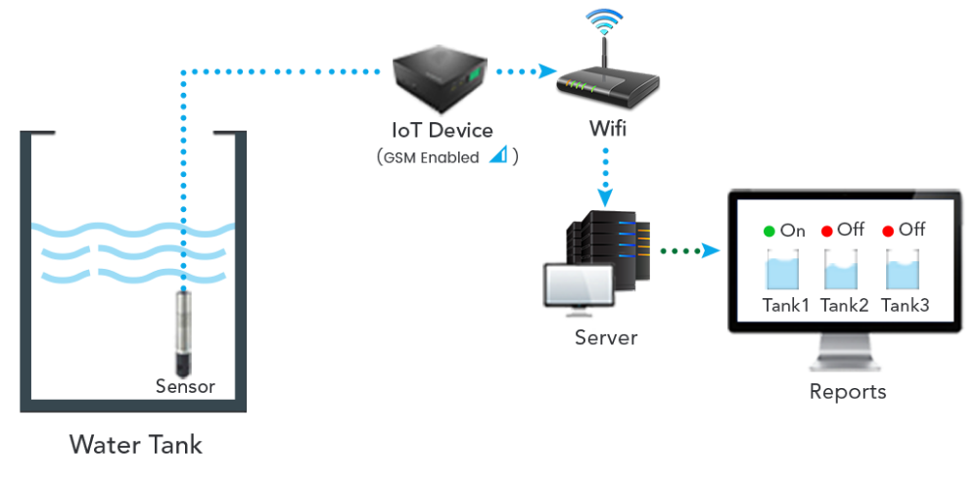

Thereby designing and implementing these modules, we can create a comprehensive smart water management system that efficiently monitors, manages, and optimizes water usage while promoting sustainability and water conservation.