**USGS Website (Draft)**

**Perspectives on Building/Applying Models**

**Models Models Everywhere**

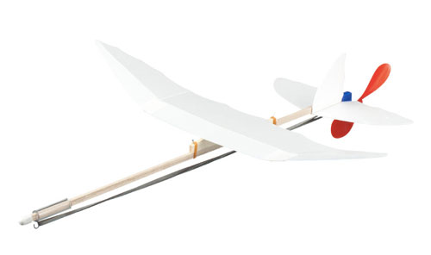

[This Photo](http://theworldsbestever.com/2014/06/26/better-average-balsa-wood-gliders/) by Unknown Author is licensed under [CC BY-SA](https://creativecommons.org/licenses/by-sa/3.0/)

Models are everywhere—sometimes behind the scenes and sometimes right out front. Weather forecasts are models. Measuring the state of the economy is a model. Assessing the condition of a landscape is a model. Forecasting almost anything (a pandemic for example) is model. Many things we call “measurements” are actually models, such as Site Index, and on and on and on. Even a “map” is a model.

Some models are simple:

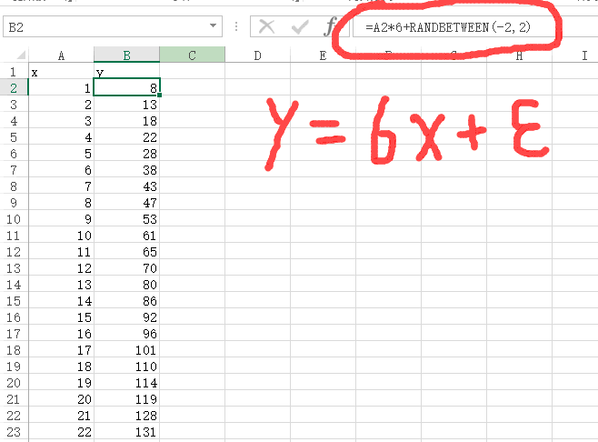

[This Photo](https://stackoverflow.com/questions/44886757/simple-linear-regression-failed-to-converge-in-tensorflow) by Unknown Author is licensed under [CC BY-SA](https://creativecommons.org/licenses/by-sa/3.0/)

[This Photo](http://math.stackexchange.com/questions/50518/need-help-in-taylor-series-expansion) by Unknown Author is licensed under [CC BY-SA](https://creativecommons.org/licenses/by-sa/3.0/)

Some models are complicated:

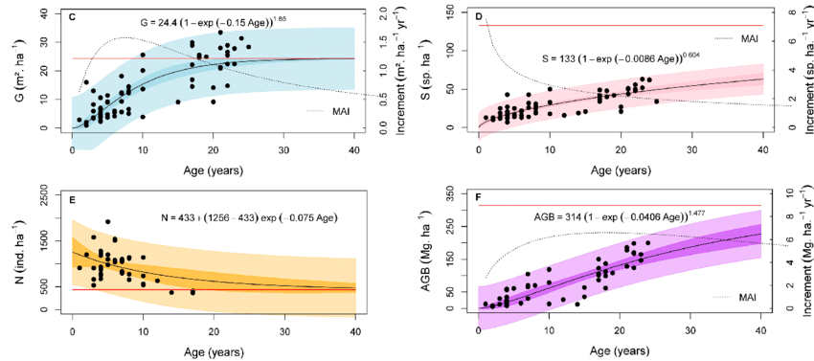

[This Photo](http://math.stackexchange.com/questions/50518/need-help-in-taylor-series-expansion) by Unknown Author is licensed under [CC BY-SA](https://creativecommons.org/licenses/by-sa/3.0/)

Regardless of their complexity, ALL models are by definition a simplification of reality. Like the model airplane shown above….it “flies” like an airplane but it cannot carry cargo or passengers.

George Box famously said that all models are wrong, so why do we create and use them? We create and use models because George Box also said they can be useful. In fact, Box used the better word “illuminating”. Models can illuminate through prediction or explanation, i.e., they can promote understanding and/or exploration if used properly. However, what makes a model illuminating: balance and relevance.

**Understanding the Keys**

For the model developer the key is to balance precision and bias of the outputs with the usability of the model usability……hit the application sweet spot. The model should provide useful information but must also function for the user, i.e., have just the right level of complexity. See the graph below take from Pochetti.

For the user the key is to understand the characteristics of the model. What factors/inputs does it include? What factors/inputs does it not include? Can you provide the inputs? What modeling technique was used? How was the model intended to be applied? What is the “scale” of the model? Like all tools, models can be used correctly or incorrectly. Review the documentation. Communicate with the modeler. It is your choice.

**Responsibilities**Models can be useful and even *illuminating* if used properly. Models can be very harmful, unfortunately very obfuscating if used improperly. It is the modeler’s duty to document the model thoroughly and make that information available to potential users. However, it is the duty of the model user to know what they really need and to review the model and model information to decide *for themselves* if it is appropriate for their situation or not.

*(Does anyone have the picture of Menakis at a RA workshop?)*

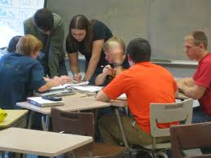

[This Photo](http://philbasiceducation.blogspot.com/2012/06/why-so-many-elementary-students-arent.html) by Unknown Author is licensed under [CC BY-NC](https://creativecommons.org/licenses/by-nc/3.0/)

**Background and Recommendations**

As you move into and through this current condition modeling process, here are some things you should remember that may help you succeed.

LANDFIRE models

* LF Biophysical Settings models were created using a set of strict rules about allowable states and transitions. You are not limited by those rules by the software modeling platform (ST-Sim).
* LF Biophysical Settings models were developed to reflect the average historic dynamics of an Ecological System across an entire NLCD map zone or set of NLCD Map Zones (see graphic). That is their “scale”, which may or may not be appropriate for you and your work. If your area of interest is significantly larger or smaller that may require adjustments to the model.

NLCD Map Zones

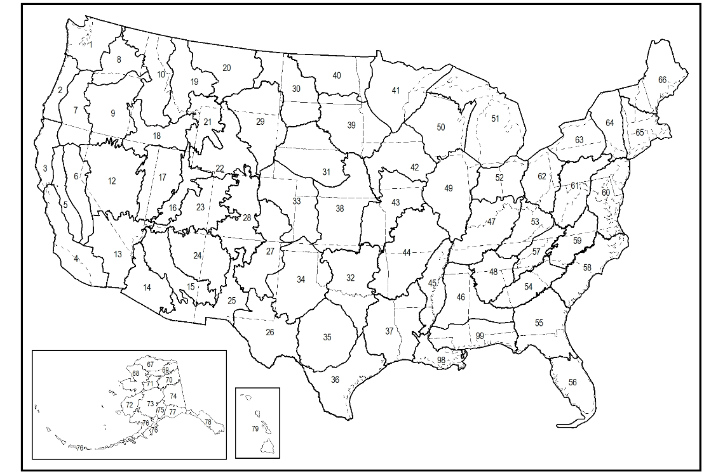

Current Condition Models

* Have a goal and a plan. Don’t just wing it as that often results in wasted time.
* Keep the model as simple as possible. As the model becomes more complicated it becomes more difficult to create, parametrize, understand, modify and utilize appropriately.
* If modeling standards are established, adhere to them. If you do not, comparisons can be confounded, results lose their applicability and future changes become more complicated.
* Document, document and document some more. Do not expect to remember what you did, or why, when you were creating a model.
* Expect the unexpected. If you knew the answer with certainty you probably did not need the model. An answer that seems strange to you may be correct….and indeed most *illuminating*.