USGS Website Text

Outline/pages

OUTLINE

Numbers are “Tabs” or separate pages. Bullets, sub bullets, etc. will be headers of corresponding levels.

1. HOME Megan
2. State and Transition Models Kori
3. LANDFIRE STMs Randy
4. Review your LANDFIRE models Randy
5. Using the model to answer your very own question (video based…probably us) Randy/Kim
6. Advanced modeling options-how far are we going into this? Does climate change go here? (Could be under 5; also could be “hidden” so you can click to it but it’s not in the top navigation) Jim
7. Contacts and Additional resources (here or embedded on other pages?) Kori
8. Examples—information on our demo models (Ones that Jim, Kori and Randy developed) Team
9. Perspectives—a more personable exploration of modeling, data limits, expectations, etc. Jim
10. HOME

Megan’s welcome video etc.

1. State and Transition Models

**State and Transition Simulation Models**

A state-and-transition model (STM) conceptualizes vegetation in terms of discrete states and the transitions or pathways between them (Westoby 1989). States are often used to represent discrete development (seral) stages, and transitions may represent disturbances such as hurricanes, fire, or grazing, but can also represent management actions such as thinning, livestock management, or herbicide application. Conceptual state-and-transition models, called [Environmental Site Descriptions](https://www.nrcs.usda.gov/wps/portal/nrcs/main/national/technical/ecoscience/desc/) (ESDs), have been developed through a partnership between the US Department of Interior’s Bureau of Land Management and Natural Resources Conservation Service the U.S. Department of Agriculture’s Forest Service, and widely used to monitor, evaluate and mange federal rangelands (RIESM 2010).

Add stm diagram

When an STM is built in a software environment with rates of growth between states and probabilities for each transition it is known as a state-and-transition simulation model (STSM; Daniel et al. 2016). An STSM can be used to simulate the dynamics of a system over time and sometimes space. STSMs have been widely applied in natural resource management to estimate historical conditions (Donato et al. 2020, Blankenship et al.2012), simulate the spread of invasive species (Thomas et al. 2019, Jarnevich et al. 2019), test various management scenarios (Low et al. 2010, Costanza et al. 2015a), and forecast future landscape conditions under different climates (Provencher et al. 2016, Swearingen et al. 2015, Costanza et al. 2015b).

Add stsm diagram

**State-and-transition modeling software**

LANDFIRE currently uses the [SyncroSim](https://syncrosim.com/) software (ST-Sim package) as the modeling platform to develop and deliver its STSMs. SyncroSim is available for free online, and is the latest in a series of related STSM software packages including Path and the [Vegetation Dynamics Development Tool](https://essa.com/explore-essa/tools/vddt/) (VDDT). SyncroSim is a flexible modeling platform that can be used to simulate virtually any ecosystem and provides user control over much of its functionality. The model is stochastic and can be run either spatially or non-spatially.

**Getting started in SyncroSim**

The native environment of LANDFIRE BpS models is SyncroSim. If you want to explore or use the BpS models you will want to familiarize yourself with and download the software:

1. Learn more about SyncroSim with the Overview of [SyncroSim](http://docs.syncrosim.com/getting_started/overview.html).
2. Download and install [SyncroSim](https://syncrosim.com/download/) and the [ST-Sim](https://syncrosim.com/packages/) package.
3. Complete the [Quickstart: An Introduction to SyncroSim](http://docs.syncrosim.com/getting_started/quickstart.html) tutorial.

**References**

Costanza, J.K., A.J. Terando, A.J. Mckerrow, and J.A. Collazo. 2015b. Modeling climate 634change, urbanization, and fire effects on Pinus palustrisecosystems of the southeastern U.S. 635Journal of EnvironmentalManagement151:186–99.

1. LANDFIRE STMs Randy

Background knowledge

Starting in 2005 the LANDFIRE program (www.landfire.gov) started the development of Biophysical Settings and models. These products represent ecosystems under natural disturbance regimes, capturing how they “looked” (e.g., structure and composition) and “functioned” (e.g., succession and disturbances). The descriptions are text; the models are in the software SyncroSim (<https://syncrosim.com/>).

What is LANDFIRE and why did they create these models?

LANDFIRE is a multi-partner program that “provides 20+ national geo-spatial layers (e.g. vegetation, fuel, disturbance, etc.), databases, and ecological models that are available to the public for the US and insular areas” (from www.landfire.gov).

One of the goals of LANDFIRE was to understand the condition of our ecosystems. The metric they created for this is called “Vegetation Departure” (VDep), which generally compares current vegetation structure and composition to “reference” structure and composition (see blue Vegetation Departure box below).

Development of reference conditions had these general steps:

1. Classify and define the ecosystems. LANDFIRE calls the historic ecosystems “Biophysical Settings”, and used NatureServe’s Ecological Systems classification as the “list”.
2. Hold expert workshops to:
   * Describe the BpSs, including their nested Succession Classes, up to 5 for each BpS including their canopy height, composition and percent cover.
   * Use state and transition modeling techniques to get an estimate of how much of each succession class would have been on the landscape historically, i.e., just prior to European settlement. The estimated amount of each succession class depends on the natural disturbance regimes that the experts input into the modeling software (just like you will be doing soon!).

Recently, TNC’s LANDFIRE team led a review of these models and descriptions, adding some new features to all of them (e.g., disturbance information), and updating content for over 300 of them.

We are happy to walk you through the history and methods at any time.

Vegetation Departure (VDep), from www.landfire.gov: Vegetation Departure (VDep) indicates how different current vegetation on a landscape is from estimated historical conditions. VDep is based on changes to species composition, structural stage, and canopy closure using methods originally described in the Interagency Fire Regime Condition Class Guidebook (<https://www.landfire.gov/frcc/documents/FRCC_Guidebook_2010_final.pdf>), but is not identical to those methods. LANDFIRE (LF) VDep is based only on departure of current vegetation conditions from reference vegetation conditions, whereas the Guidebook approach includes departure of current fire regimes from those of the reference period.

So what are these descriptions and models?

Each BpS (e.g., North Central Interior Dry-Mesic Oak Forest and Woodland) has 3 associated products:

1. Description
2. State and transition model
3. Spatial data (not described here)

Descriptions

As you will soon see, a model without a description is rather mysterious. We generally started the BpS modeling process with collecting information on each BpS including:

* Biophysical Setting Name and Number
* Map Zones the description covers
* Descriptive Geographic Range text
* Biophysical Site Description
* Disturbance description
* Descriptions of each succession class
* Relevant literature

Models

When we refer to “models” we are essentially talking about the information contained in SyncroSim libraries. What? We’ll get to the SyncroSim and library parts soon, but in the meantime models are collections of information on: 1. The “states” or succession classes of each BpS. This information is derived from the descriptions 2.

* covers all lands in the United States including the insular islands
* delivers products covering “historical” (just prior to major European settlement) and “current” time periods.
* not all products cover both time periods-which is why you are here! The LANDFIRE models only cover historical. Bringing them up to current might be one of your tasks.
* Some products are delivered by “Map Zone” (see map).

What do the models represent (historic)

What are they and how are they linked (model and description)

Application scale of the models

Can use: * <https://www.youtube.com/watch?v=e1BBcbImrrM&list=PLDFF9036BBFE46CE6&index=6&t=0s> which is a Kori/Randy intro, 5 minutes * How to Alter and Run a LANDFIRE Model in ST-Sim, <https://www.youtube.com/watch?v=XUUm-RG4eK0&list=PLDFF9036BBFE46CE6&index=7&t=0s>

1. Review your LANDFIRE models Randy

Let’s jumpstart your modeling experience

On this page we intend to help you 1) get and 2) explore and 3) understand one or more LANDFIRE models and descriptions as a way to launch your modeling skills. This will set the stage for you to model the present, and beyond.

Get a LANDFIRE model and description

First you need to know that there are hundreds of Biophysical Settings in the United States, and some of them occur in more than one Map Zone. What is a Map Zone? It’s basically a product delivery and summary polygon. The polygons are from the National Landcover Database Program (see https://www.mrlc.gov/national-land-cover-database-nlcd-2016).

Find your Map Zone of interest here:

Pan, zoom, scroll to your area of interest, then hover over the Map Zone you need the number for. A tooltip will pop up with that info. Take note of it for the next step.

Get your LANDFIRE Model Description

Each Biophysical Setting has a description that covers BLAH BLAH BLAH.

How to find your model(s) go to landfirereview.org

Read the description (do we provide a form or guidance or checklist…help guiden them to the changes they will need to make)

Running the model…do the results match the description? Video? Printable instructions?

Use Jim’s Potential Modifications document…internal link

1. Modifying a Model

No content yet?

1. Climate change/advanced

Climate change and BpS models

**Introduction**

Directional changes in climate factors, such as increases in minimum or maximum temperatures, changes in precipitation patterns, and increases in evaporation and transpiration rates, are influencing vegetation dynamics through many mechanisms operating at a range of scales, from genes to biomes. Observed changes, in addition to ecological theory, allow us to generate hypotheses on how these changes may play out that we can explore with models. As noted in a previous sections (link to Modeling perspectives), all models are a simplification of reality, and there are many different aspects of climate change that you might be interested in exploring with a model. The goal of this section on climate change is to help you identify questions that the LANDFIRE BpS models, with their built-in simplifications, strengths, and constraints, are best suited to help you explore.

Climate drivers like temperature and moisture availability play critical roles in shaping the life history of plants and associated species in terrestrial ecosystems. As anthropogenic factors have acted to accelerate the rate of climate change, we are seeing a wide array of responses in plants, and other species that strongly influence vegetation dynamics. The most frequently documented responses to climate change include changes in phenology (the timing of seasonal events, such as budburst), spatial shifts in range boundaries, and shifts in density patterns within a species’ range due to changes in recruitment or mortality as site conditions change. Given that over evolutionary time, each species has developed a set of traits that reflect climate, abiotic factors, and competition for resources and other types of species interactions, we expect that the suite of species that make up an ecosystem will not all respond in the same way, leading to shifts in plant community composition.

Notably for applications with BpS models, changes in climate are influencing disturbance regimes, with drought tending to lengthen fire seasons and increase fire intensity, and higher temperatures (or temperature gradients) increasing the intensity and dominant direction of wind patterns, and probability of severe storms like hurricanes. Increasing temperatures also strongly affect poikilothermic (cold-blooded) species associated with vegetation, contributing to increased growth rates, and higher numbers of generations per growing season for insects that make a living by consuming the leaves or sap of trees.

**Linking climate change and BpS models**

Before we shift to how to model climate change, here’s a reminder of the nuts and bolts of our modeling tools. As described here (link to a section on model structure), LANDFIRE BpS models are comprised of a set of states and transitions. Each state is a recognizable seral stage or “condition” of a particular vegetation type, and these states are linked by deterministic transitions (usually representing growth towards an older, taller age class), and stochastic transitions representing disturbances such as fire (with an associated probability land intensity), windthrow, insect outbreak, etc. These transitions describe how one vegetation state is changed to a different state. For some vegetation states, there is a dominant species – maybe Ponderosa pine, or sage-brush (need good examples) in these cases, the growth and response to disturbances primarily reflect that species’ biology. In other vegetation classes with higher tree species diversity, such as mixed hardwood forests of the southern Appalachians, transitions represent an average across multiple species that are likely responding to climate drivers in different ways.

The structure of the BpS models provides a clear indication of the ecological level at which these models operate, and can be usefully applied to address questions about climate change. While range shifts are some of the most studied aspects of climate change responses, these models are not spatial, and tend to “lump” all species within a vegetation class together within a series of states. If you are interested in exploring vegetation responses *within* what the BpS models consider a “state” – for example, exploring changes in species composition that might occur as a result of changes in tree competitive ability as growing seasons lengthen due to a warming climate – BpS models are likely not the best hammer for that nail!

**Changes in disturbance regime**

The “sweet spot” for LANDFIRE BpS models in a climate change context is exploring how climate change can influence disturbance regimes, and as a result influence the relative proportion of each ecosystem state over time. These tools allow users to consider time periods much longer than human experience (i.e., hundreds or thousands of years) and “illuminate” (link to Jim’s overview) how events with a range of different frequencies can interact to shape the distribution of vegetation classes on the landscape. However, remember that while the impacts of climate change on ecological systems are complex, this does not mean you should try to capture the full range of complexity in your model. For example, the interaction between drought, insect outbreaks, and fire is an example of a multi-factor, climate-related driver of change in forested ecosystem, especially notable now in forest of the western US. While you could take an existing BpS model and add a drought factor, modify the current fire disturbances, and add an insect pest factor, if in effect these three drivers tend to operate together, we suggest at least starting your modeling work by treating this complex of drivers as one disturbance, potentially starting with the one for which you have the best information on rates (this might be fire regime). As you gain experience and insight, you can consider what additional things you might learn by trying to tease apart these interacting factors – for example by bringing in insect outbreaks as a separate factor, but with rates that recognize the role of drought conditions in both disturbance pathways (fire and insects). In the bulleted sections below, we link climate-related changes to how you would model them in the BpS-in-SyncroSim platform, moving from the basics to more specific hypotheses of change.

You can alter disturbances by:

* Adding or removing a type of disturbance
* Modifying the intensity, or distribution across intensity levels (e.g., low, med, high)
* Changing the rate (probability) – with the caveat that the models are aspatial, so if spread of the disturbance across the landscape is a process you want to understand, you will likely want to complement your work with additional tools.
* Incorporating a rate multiplier, which allows the probability of a disturbance to change over time

You can alter states by:

* Adding or removing vegetation classes. This can include adding a new invasive plant species that is favored by some aspect of climate change.
* Slowing down or speeding up succession to represent a change in growth rates, or slower recovery.
* Transitioning a vegetation class to a new BpS (? Not sure you want this here??)

Some more specific examples:

* Increases in the **intensity of fires**, a trend that has been observed in forests with high vegetation density, often in combination with drought. To represent this process, you would increase the probablility of high intensity fires in your model – or potentially add this type of disturbance if it was not already in the model.
* Extension of the **duration of the fire season** due to climate change (e.g., Cattau et al. 2020 --this paper looks at both natural ignition sources and human-caused fires). Within this modeling platform, looking at this question would involve increasing the rate of fire return.
* Similarly, **increasing the spatial extent** of fires – mechanistically, this also involves increasing the rate of fires, so it’s hard to separate the two mechanism of change using the LANDFIRE BpS model.
* **Insect outbreaks** that promote a state change in vegetation are not included in the “out of the box” BpS models, but can be added, and then varied, in all of the ways described above for fire. As warming temperatures increase the overwinter survival of insects, increase the number of generations possible in a single season, and increase growth rates, adding a separate insect outbreak component may be highly relevant, especially if there is evidence to support impacts that are independent of other drivers. In the case of drought-stressed trees contributing to high tree mortality, undertstanding variations in drought risk, for example associated with topography or soil water holding capacity, may allow you to partition out impacts by site conditions (see last bullet).

**Transitions in vegetation classes**

* In some vegetation systems, managers have observed that increases in the intensity or extent of fires is leading to a failure of the ecological system to regenerate – reasons may include a loss of organic soil horizons in the intense fire, or a lack of seed sources close to the newly burned area. This observation could be modeled by adding **a new vegetation class** (perhaps a grass or shrub class, if the intent is to explore how this shift might drive an ecological transformation), or by increasing the duration of transition from the post-fire seral stage back to forest, to represent slower regrowth of trees, perhaps aided by active seed additions.

**Representing variations in climate change exposure, or adaptive capacity within an assessment region**

* While BpS models are aspatial, if you have information on how vegetation dynamics might vary within an assessment area, you can capture that variation by developing separate iterations of the same model. For example, topographic factors or soil moisture may strongly influence the sensitivity of a system to a disturbance, the rate of recovery after a disturbance, or the probability that a disturbance will shift a vegetation type to a new class.

The influence of native and non-native **insect pests** is changing due to climate change, a pattern that can have major impacts on forest health when combined with a change in tree health due to drought exposure. Like fire, changes in the impact of insects can occur through changes in intensity, and/or duration of exposure (i.e., warmer temperatures are increasing overwinter

1. Contacts and Additional resources (here or embedded on other pages?)

**Contacts and Additional Resources**

**Getting help**

If you need help with LANDFIRE data, contact [helpdesk@landfire.gov](mailto:helpdesk@landfire.gov).

If you need help with Syncrosim software, try posting a question on the [SyncroSim forum](https://syncrosim.com/forums/).

**Important Links**

[LANDFIRE BpS model download](http://www.landfirereview.org/search.php)

[LANDFIRE homepage](https://www.landfire.gov/)

[LANDFIRE Guides and Tutorials](https://www.conservationgateway.org/ConservationPractices/FireLandscapes/LANDFIRE/Library/Pages/library.aspx)

[ApexRMS](http://www.apexrms.com/) (website for SyncroSim software)

[SyncroSim documentation](http://docs.syncrosim.com/)

[SyncroSim publications](http://docs.stsim.net/publications.html)

**References and Additional Resources**

Blankenship, K., L. Frid, J. L. Smith. 2015. [A state-and-transition simulation modeling approach for estimating the historical range of variability](https://www.aimspress.com/article/10.3934/environsci.2015.2.253). AIMS Environmental Science 2:253-268.

Blankenship, K., J. Smith, R. Swaty, A. J. Shlisky, J. Patton, and S. Hagen. 2012. [Modeling on the grand scale: LANDFIRE lessons learned](https://www.fs.fed.us/pnw/pubs/pnw_gtr869/pnw_gtr869_004.pdf). Pages 43-56 *in* B. K. Kerns, A. J. Shlisky, and C. J. Daniel, editors. Proceedings of the first landscape state-and-transition simulation modeling conference, Portland, Oregon June 14–16, 2011. PNW-GTR-869. USDA Forest Service, Paciﬁc Northwest Research Station, Portland, Oregon, USA.

Costanza, J. K., R. C. Abt, A. J. McKerrow, J. A. Collazo. 2015a. [Linking state-and-transition simulation and timber supply models for forest biomass production scenarios](https://www.aimspress.com/article/10.3934/environsci.2015.2.180). AIMS Environmental Science 2:180-202.

Costanza, J. K., A. J. Terando, A. J. Mckerrow, and J. A. Collazo. 2015b. [Modeling climate change, urbanization, and fire effects on Pinus palustris ecosystems of the southeastern U.S.](https://www.sciencedirect.com/science/article/pii/S0301479714006112) Journal of Environmental Management 151:186–99.

Czembor, C. A., W. K. Morris, B. A. Wintle, and P. A. Vesk. 2011. [Quantifying variance components in ecological models based on expert opinion](https://besjournals.onlinelibrary.wiley.com/doi/full/10.1111/j.1365-2664.2011.01971.x). Journal of Applied Ecology 48: 736-745.

Daniel, C. J., L. Frid, B. M. Sleeter, and M. -J.Fortin. 2016. [State-and-transition simulation models: a framework for forecasting landscape change](https://besjournals.onlinelibrary.wiley.com/doi/full/10.1111/2041-210X.12597). Methods in Ecology and Evolution 7:1413–23.

Donato, D. C., J. S. Halofsky, and M. J. Reilly. 2020. [Corralling a black swan: natural range of variation in a forest landscape driven by rare, extreme events](https://esajournals.onlinelibrary.wiley.com/doi/full/10.1002/eap.2013). Ecological Applications 30:e02013.

Jarnevich, C. S., C. Cullinane Thomas, N. E. Young, D. Backer, S. Cline, L. Frid, and P. Grissom. 2019. [Developing an expert elicited simulation model to evaluate invasive species and fire management alternatives](https://esajournals.onlinelibrary.wiley.com/doi/full/10.1002/ecs2.2730). Ecosphere 10.

Low, G., L. Provencher, and S. L. Abele. 2010. Enhanced conservation action planning: assessing landscape condition and predicting benefits of conservation strategies. Journal of Conservation 6:36-60.

Provencher, L., L. Frid, C. Czembor, and J. T. Morisette. 2016. State‐and‐transition models: conceptual versus simulation perspectives, usefulness and breadth of use, and land management applications. Pages 371-407 in J. M. Germino, C. J. Chambers, and S. C. Brown, editors. [Exotic brome‐grasses in arid and semiarid ecosystems of the western US: causes, consequences, and management implications](https://www.springer.com/gp/book/9783319249285). Springer International Publishing, Germany.

RIESM. 2010. [Rangeland interagency ecological site manual](https://directives.sc.egov.usda.gov/OpenNonWebContent.aspx?content=27123.wba). First edition.

Rollins, M. G. 2009. [LANDFIRE: a nationally consistent vegetation, wildland fire, and fuel assessment](https://www.publish.csiro.au/wf/WF08088). International Journal of Wildland Fire 18:235-249.

Swearingen, A., J. Price, J. Silbernagel, R. Swaty, and N. Miller. 2015. [State-and-transition simulation modeling to compare outcomes of alternative management scenarios under two natural disturbance regimes in a forested landscape in northeastern Wisconsin, USA](https://www.aimspress.com/fileOther/PDF/environmental/201503737.pdf). AIMS Environmental Science 2:737-63.

Thomas, C.M., Sofaer, H.R., Cline, S.A. and Jarnevich, C.S., 2019. [Integrating landscape simulation models with economic and decision tools for invasive species control](https://www.reabic.net/journals/mbi/2019/1/MBI_2019_CullinaneThomas_etal.pdf). Management of Biological Invasions 10:6-22.

Westoby, M., B. Walker, and I. Noy-Meir. 1989. Opportunistic management for rangelands not at equilibrium. Journal of Range Management. 42:266-274.

1. **USGS Website: Modeling Perspectives (Draft)**
2. **Models, Models Everywhere**



[This Photo](http://theworldsbestever.com/2014/06/26/better-average-balsa-wood-gliders/) by Unknown Author is licensed under [CC BY-SA](https://creativecommons.org/licenses/by-sa/3.0/)

Models are everywhere—sometimes behind the scenes and sometimes right out front. Weather forecasts are models. Measuring the state of the economy is a model. Assessing the condition of a landscape is a model. Forecasting almost anything (a pandemic for example) is a model. Many things we call “measurements” are actually models, such as Site Index, and on and on and on. Even a “map” is a model.

Some models are simple:

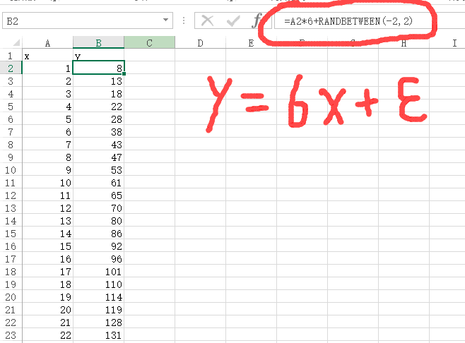

[This Photo](https://stackoverflow.com/questions/44886757/simple-linear-regression-failed-to-converge-in-tensorflow) by Unknown Author is licensed under [CC BY-SA](https://creativecommons.org/licenses/by-sa/3.0/)

[This Photo](http://math.stackexchange.com/questions/50518/need-help-in-taylor-series-expansion) by Unknown Author is licensed under [CC BY-SA](https://creativecommons.org/licenses/by-sa/3.0/)

Some models are complicated:

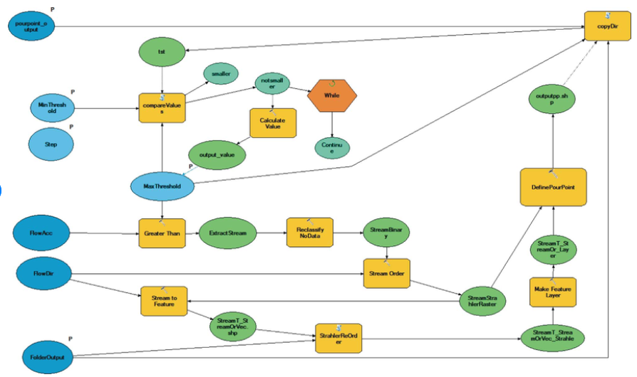

From “[New ArcGIS tools developed for stream network extraction and basin delineations using Python and java script](https://www.researchgate.net/publication/304110197_New_ArcGIS_tools_developed_for_stream_network_extraction_and_basin_delineations_using_Python_and_java_script)”.

Regardless of their complexity, **ALL** models are *by definition* a simplification of reality. Like the model airplane shown above….it “flies” like an airplane but it cannot carry cargo or passengers.

George Box famously said that all models are wrong, so why do we create and use them? We create and use models because George Box also said they can be useful. In fact, Box used the better word “illuminating”. Models can illuminate through prediction or explanation. They can promote understanding and exploration if used properly. Balance and relevance are what can make a model illuminating.

1. **Developers vs Users: Understanding the Key Considerations**

For the model developer, the key is to balance precision and bias of the outputs with the relevance of the model……hit YOUR application sweet spot (Pochetti figure from francescopochetti.com). The model should provide useful information but must also function for the user, i.e., have the right level of complexity. Complexity should have a purpose……provide more or more refined information, or in some cases provide the same information with more fidelity. Complex models typically require more input information, are more difficult to develop and de-bug, and take longer to run. LANDFIRE BpS models, with their limited number of states and transitions, live near the lower end of the complexity scale and provide relatively few and coarser level outputs than some other models, but are also easier to create and use. Models such as SIMPPLLE and LANDIS II sit nearer the middle or upper end of the complexity scale and can provide more types of outputs but at higher operational cost, sometimes too high a cost.

(francescopochetti.com)

The considerations are different for the model user and his/her objectives: the key is to understand the characteristics of the model. What factors/inputs does it include? What factors/inputs does it not include? Can you provide the inputs at the level of accuracy required? What modeling technique was used? How was the model intended to be applied? What is the “scale” of the model? Like all tools, models can be used correctly or incorrectly. Can a modified LANDFIRE BpS model provide the information you need with the right level of quality? Only the user can answer those questions, so it is imperative that you review the documentation. Communicate with the modeler if you have questions. It is your responsibility.

1. **Responsibilities**

Models can be useful and even *illuminating* if used properly. Models can be very harmful, unfortunately very obfuscating if used improperly. It is the modeler’s duty to document the model thoroughly and make that information available to potential users. However, it is the duty of the model user to know what they really need and to review the model and model information to decide *for themselves* if it is appropriate for their situation or not.

*(Does anyone have the picture of Menakis at a RA workshop for instance—this is not the picture I want to use but collaborative review is what I want to show) I found the three below in the archives. Not sure about quality.*

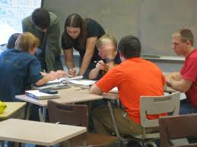

[This Photo](http://philbasiceducation.blogspot.com/2012/06/why-so-many-elementary-students-arent.html) by Unknown Author is licensed under [CC BY-NC](https://creativecommons.org/licenses/by-nc/3.0/)

1. **Background and Recommendations**

As you move into and through this current condition modeling process, here are some things you should remember that may help you succeed.

LANDFIRE models

* LF Biophysical Settings models were created using a set of strict rules about allowable states (5 or less) and transitions between states (only historic not current). You are not limited by those rules by the software modeling platform (SyncroSim). You can add new states and transitions. You can modify current states or change transition probabilities. If maintaining compatibility with LANDFIRE models is required that could reduce your modification options. However, we have seen STSM based on LANDFIRE BpS models that had more than 100 states and dozens of transitions. What you include or not is up to you and should be based on your objectives.
* LF Biophysical Settings models were developed to reflect the average historical dynamics of an Ecological System across an entire NLCD map zone or set of NLCD Map Zones (see graphic). That is their “scale”, which may or may not be appropriate for you and your work. If your area of interest is significantly larger or smaller that may require adjustments to the model.

NLCD Map Zones

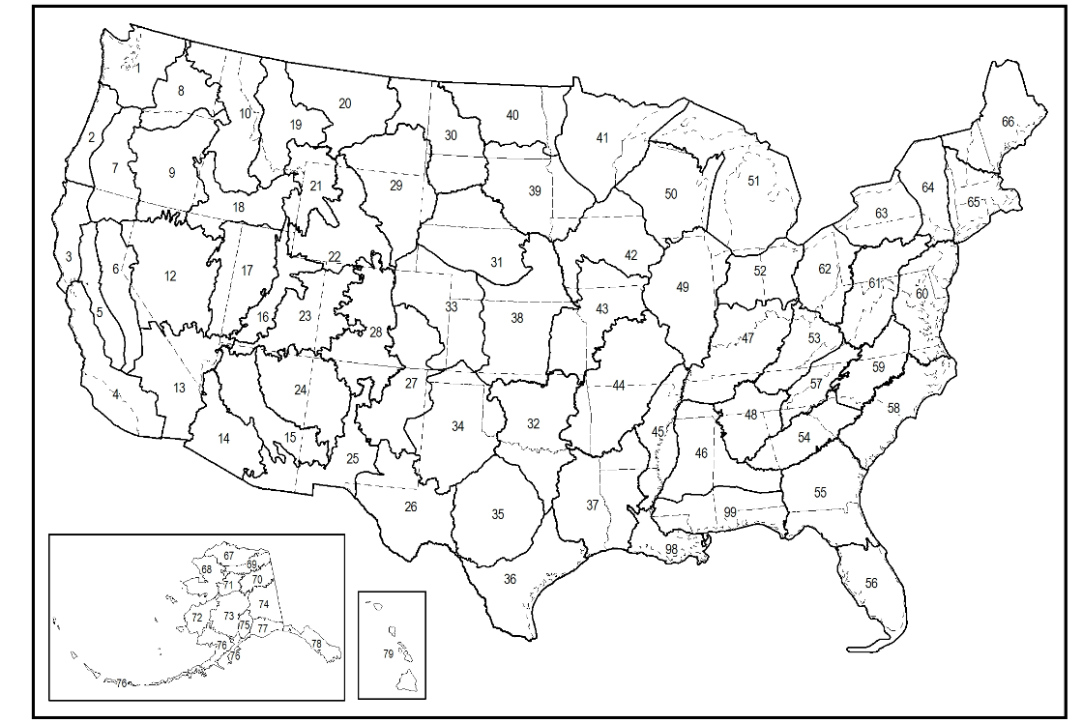

Current Condition Models

* If modeling standards are established, adhere to them. If you do not, comparisons can be confounded, results lose their applicability and future changes become more complicated.
* Have a goal and a plan. Don’t just wing it as that often results in wasted time*. I need a STSM for sage-steppe in Nevada that reflects current conditions, contains a Cheatgrass state, and allows for the integration of climate change effects*.
* Work through the model changes in a stepwise fashion. Add states and associated transitions one at a time and run the model, say a add *Cheatgrass state and associated transitions*. Review the results and plan the next steps.
* We strongly encourage you to keep the model as simple as possible. The number of states directly impacts the number of transitions you need and the amount of information you need to support the model. As the model becomes more complicated it becomes more difficult to create, parametrize, understand, modify and utilize appropriately. If it doesn’t matter whether *Cheatgrass* is at *10%* or *15%* cover, don’t make those separate states.
* Document, document and document some more. Do not expect to remember what you did, or even why you did it later. These models can run so fast you can easily get ahead of yourself.
* Expect the unexpected. If you knew the answer with certainty you probably did not need the model. An answer that seems strange to you may be correct….and indeed *illuminating*.