**CMPT-733, Assignment 3**

1. Dataset = ‘tmax-2’ , Note: in this plot I used average temperature for the same station for each year; therefore, the dots will not be too clustered together.

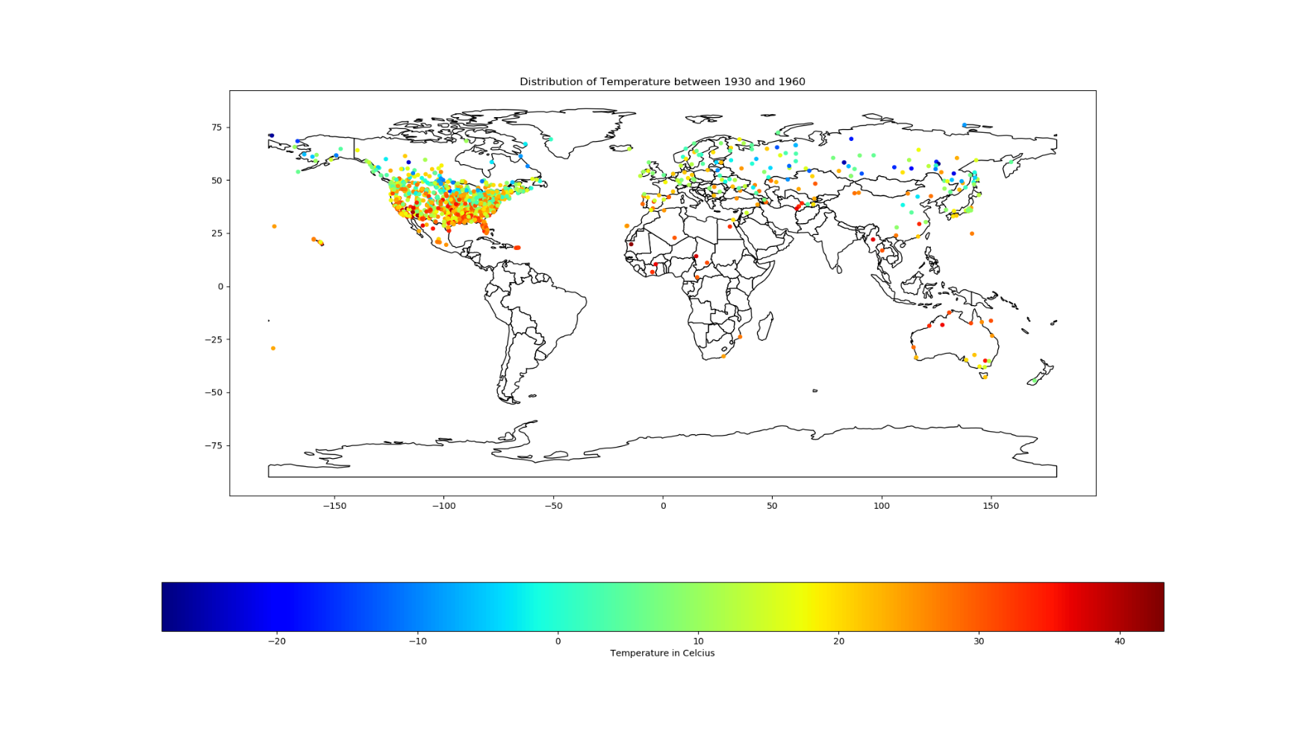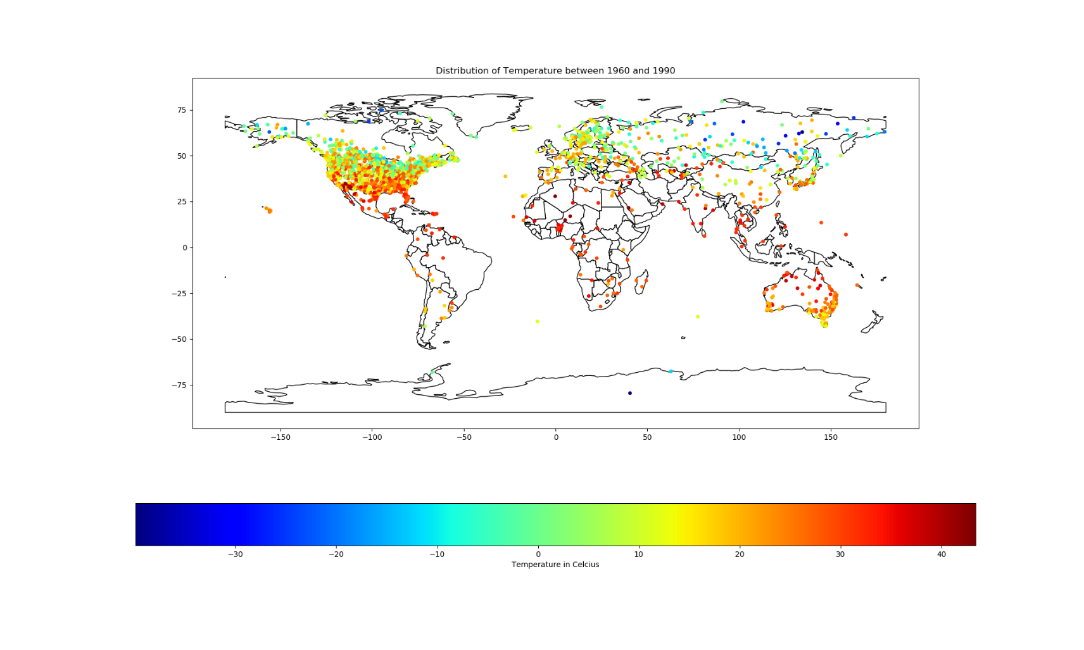For the part A, I am plotting 3 graphs of temperature distribution in different durations: from 1930 to 1960, 1960 to 1990, and 1990 to 2020. We can see some trends in the regions close to and far from the Equator. As the time goes by, the regions close to the Equator tend to get hotter while the region far away from the Equator tend to get colder (look at the Southern Australia where there are more cool-coloured dots in 1990-2020 than 1960-1990).

**B)**Dataset= tmax-2, Model= Random Forest, Test set= CMPT-732 assignment 9.

In the heatmap of predicted temperature, I trained my model with Random Forest and predicted the temperature throughout the world. The regions near the Equator are hotter than the regions far away from the Equator. However, my model is quite unreasonable in predicting the temperature in the Southern part of the world which is supposed to be cold in reality (not as warm as my model has predicted).

The last plot is the distribution of prediction error from our model (predicted_temperature minus test_temperature). There are some outliers in the northern and southern part of our map( the non-blue dots).

