|  |  |  |
| --- | --- | --- |
| Original Dataset (n=28,499) | | |
| Class | Serious | Slight |
| Number of samples | 4,479 | 24,020 |
| Percentage | 15.72% | 84.28% |

|  |  |  |
| --- | --- | --- |
| 10% of Original Dataset (n=2,849) | | |
| Class | Serious | Slight |
| Number of samples | 447 | 2,402 |
| Percentage | 15.69% | 84.31% |

|  |  |  |
| --- | --- | --- |
| 90% of Original Dataset (n=25,650) | | |
| Class | Serious | Slight |
| Number of samples | 4,032 | 21,618 |
| Percentage | 15.72% | 84.28% |

**Approach 1: SMOTE**

|  |  |  |
| --- | --- | --- |
| SMOTE Dataset (n=28,224) | | |
| Class | Serious | Slight |
| Number of samples | 12,096 | 16,128 |
| Percentage | 42.86% | 57.14% |

-10-fold CV

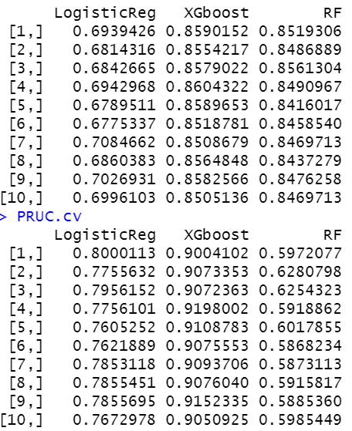

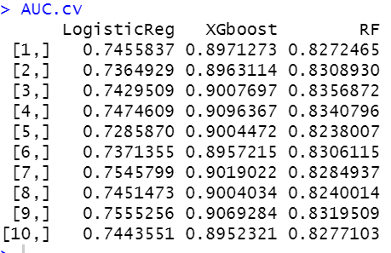

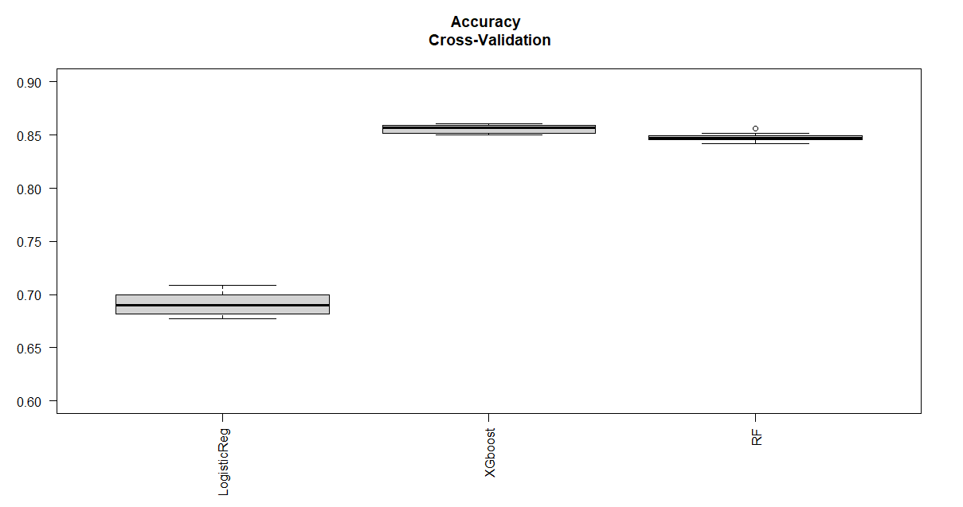

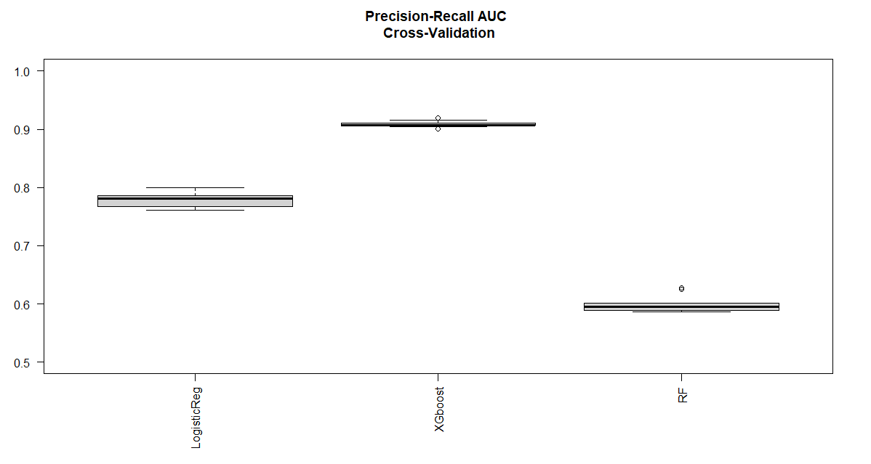

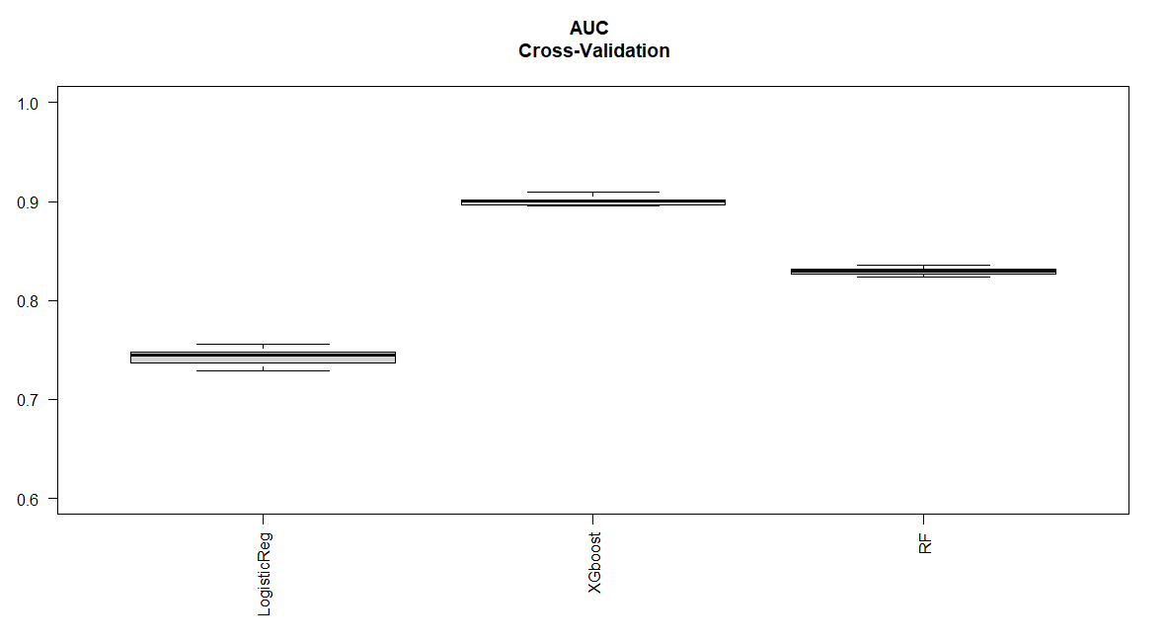

-pick XGboost -> tuning

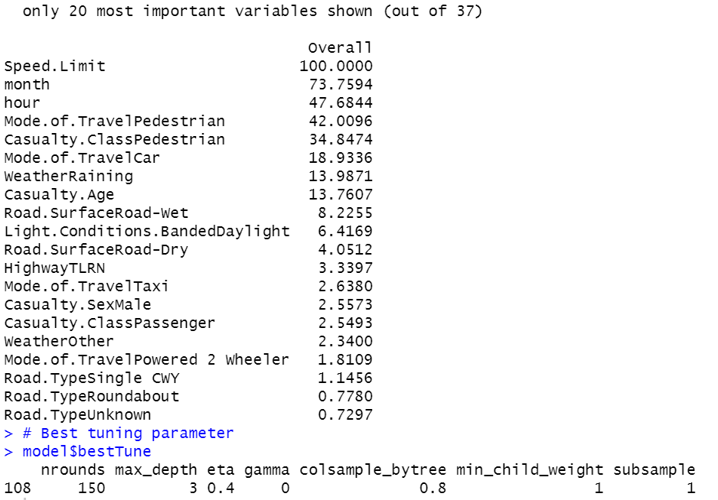

0.85

-making prediction on test dataset

Accuracy= 0.8339

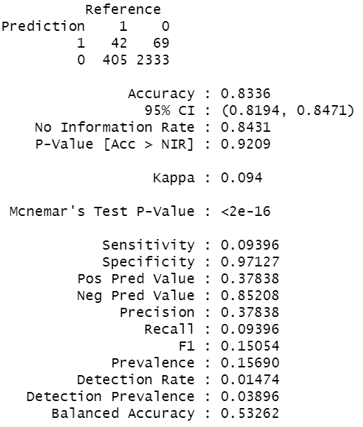

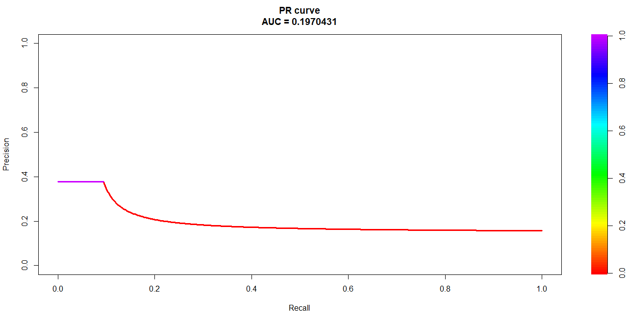

**Approach 2: normal**

|  |  |  |
| --- | --- | --- |
| Normal Dataset (n=25,650) | | |
| Class | Serious | Slight |
| Number of samples | 4,032 | 21,618 |
| Percentage | 15.72% | 84.28% |

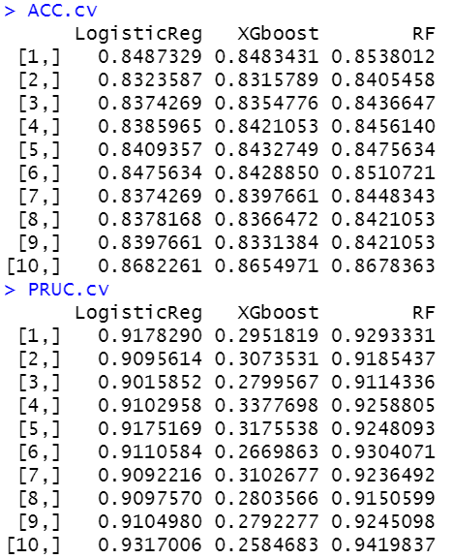

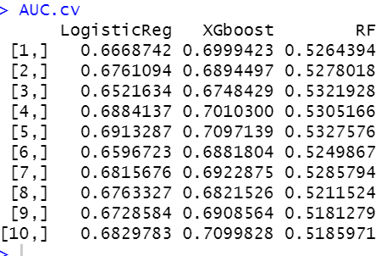

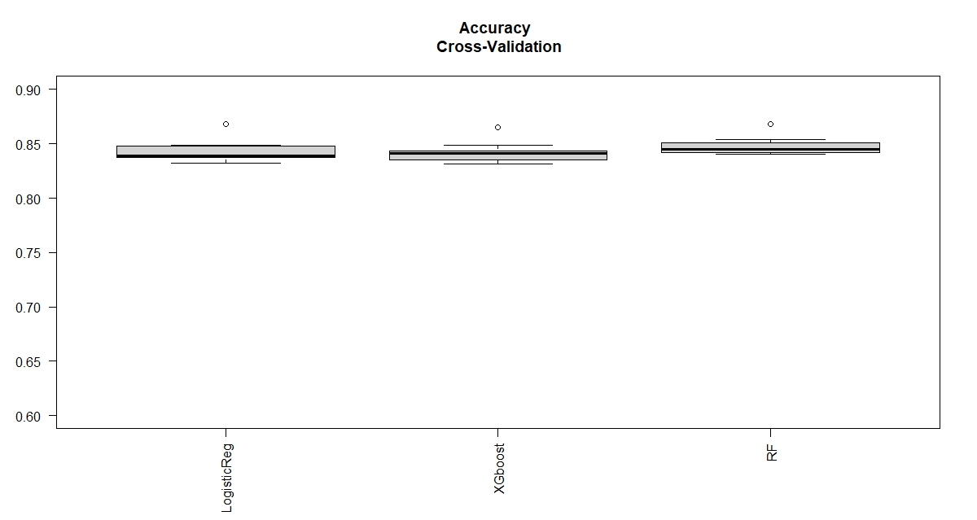

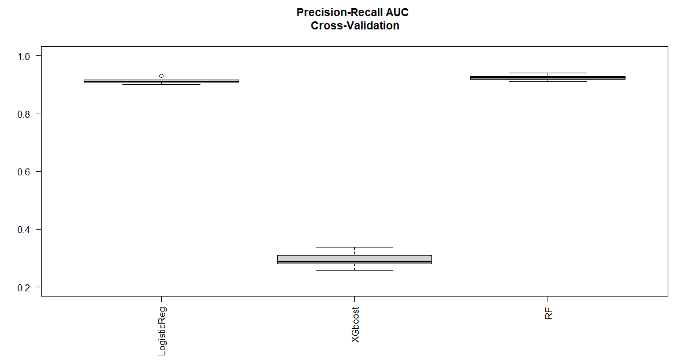

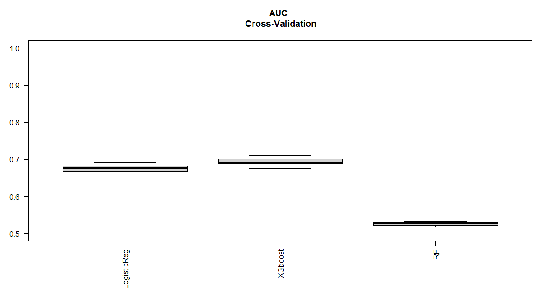

-pick XGboost -> tuning

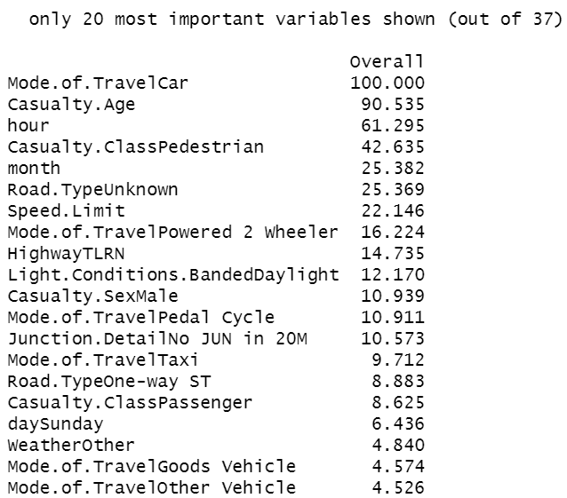



-making prediction on test dataset

0.8431 (predict all 0 class Slight)

