**Test Case Creation**

1. Authentication System Requirements
   1. User Registration

The system does not follow the requirements mentioned in the functional_requirements.md document that specify how a user should register. The form for registering does not validate inputs that the user fills when registering. For example, a user can type “1” as his/her first name and able to register.

The form does not provide field for users to confirm their password and no restrictions on password length requirements although it was mentioned that the password length should be a minimum of 8 characters. And no field for providing user’s cell phone number.

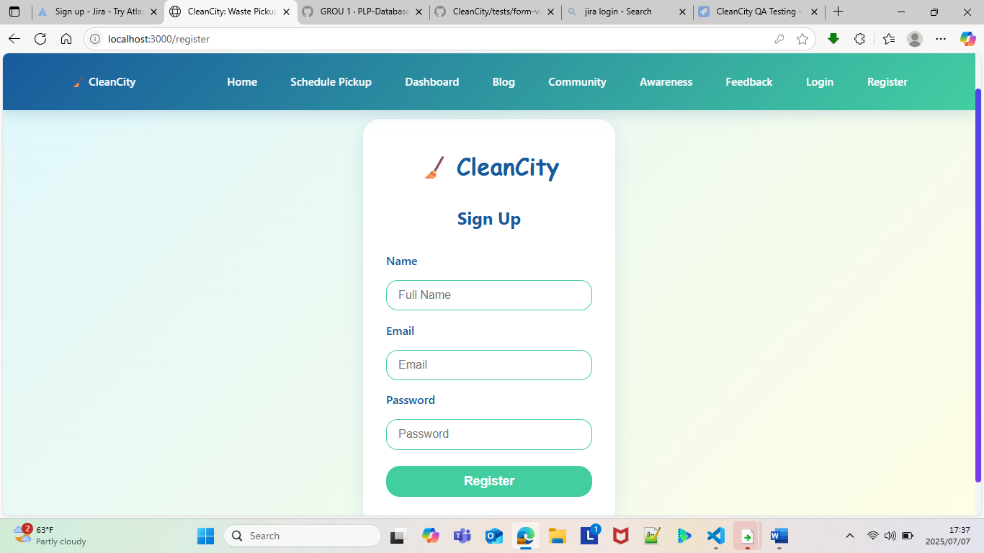

* 1. User’s login

Any user can login to the system without registering, using any email and password. The system does not validate the password for registered users in other words no user authentication.

The login form does not validate the email if is a correct format or not as long as you type “21@g” the system takes that as an email.

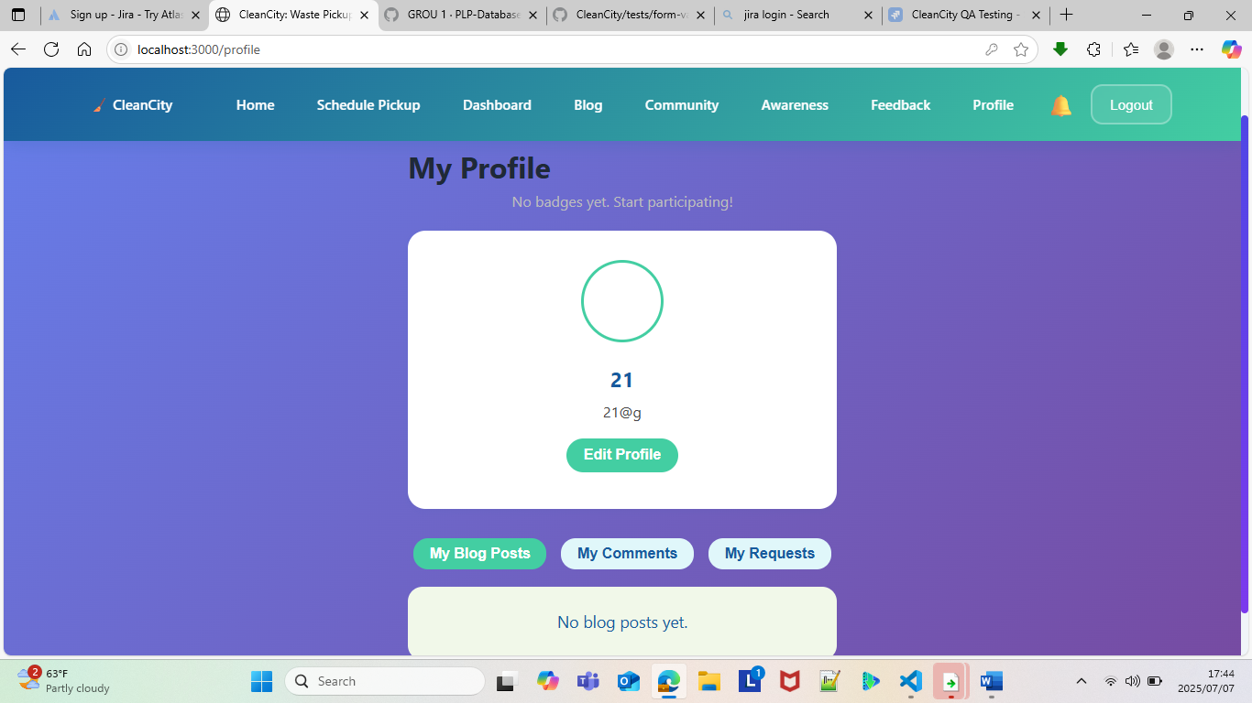

* 1. User logout

According to functional_requirements.md the system shall redirect logged-out users to the login page. But the system redirects users to the home page

1. Waste Management Requirements
   1. Pickup Scheduling

The system allows the pickup date to be an old date for example you can write your pickup date as “2025/01/07” and able to submit your request but according to functional_requirements.md the date must be a future date. The full name field is not validated just like the register form.

The form does not provide a field for quantity. The system allows the user to schedule the pickup without an address.

According to functional_requirements.md the system shall display available time slots for pickup scheduling, but the system does not provide any time slots available. The system allows scheduling multiple pickups for the same date, which is wrong according to the requirements of the system.

* 1. Request Management

The system does not store the pickups that the user has schedule which leads to:

1. The system does not provide the user with an option to check their pickup request history although it supposes to let users view their history pickup request
2. Not able to delete pending pickups
3. Not able to see status of the scheduled pickups.

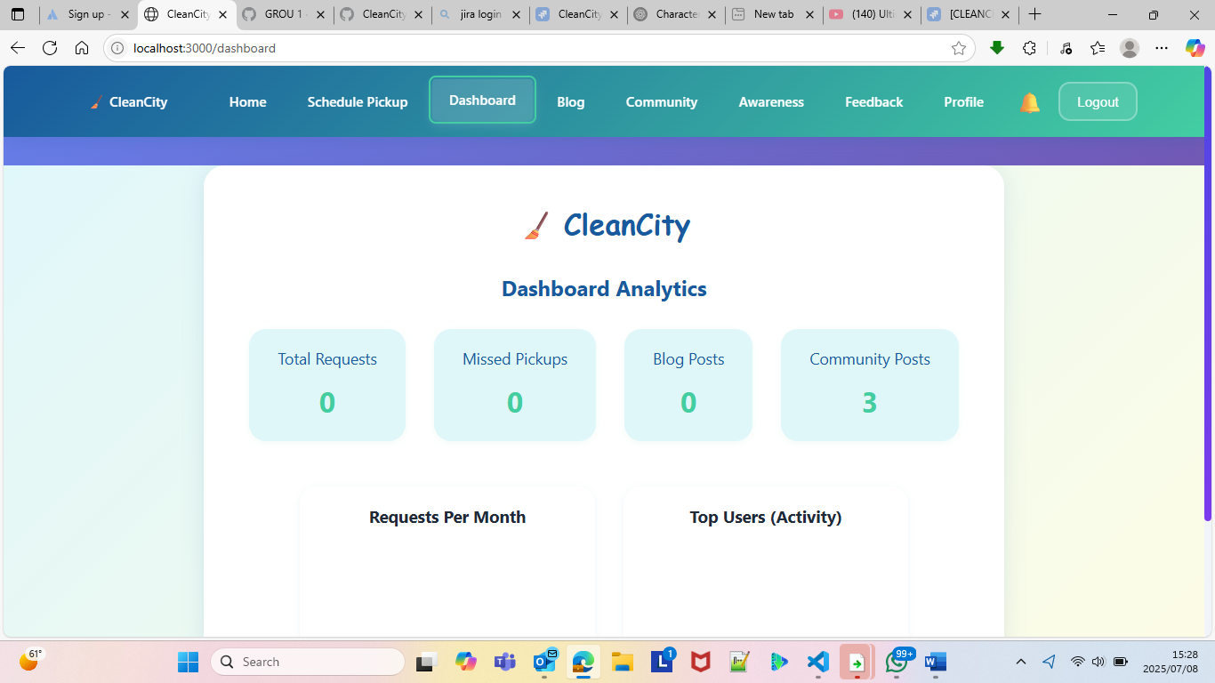

1. Dashboard & Analytics Requirements
   1. User Dashboard

As mentioned above on 2.2 and a picture attached the system do not show any recent pickup requests, upcoming scheduled pickups and achievement badges

* 1. In general (other key aspect)

The system does not provide anything else besides those on the screenshot attached. This can be due to the fact that the system does not save scheduled pickups as if that is the case then a user cannot be awarded a badge.

1. Content Management Requirements
   1. Blog System

Users can comment on articles but once they log out that comment get flushed, meaning the user can only see the comment during that logged session once he/she logs out the user can not see the comment when they log in again and other users can see the comment that another user has commented on a certain article.

* 1. Community Feed

The system does allow the user to comment but does not recognize who commented meaning in every comment will be saying it’s “you” who commented while you have not added a comment

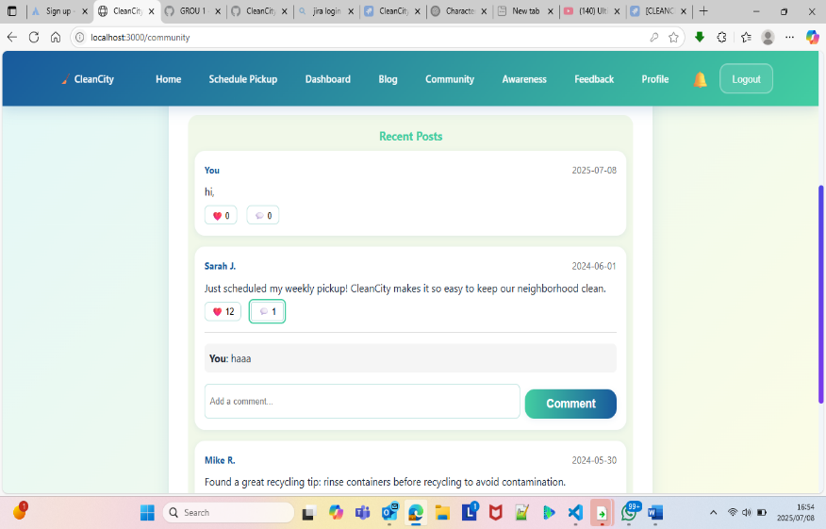

1. Community Features Requirements
   1. User Profiles
2. According to the functional_requirement.md, the system shall display user activity history and achievements, but the system does not show user activity history that I have commented on posts

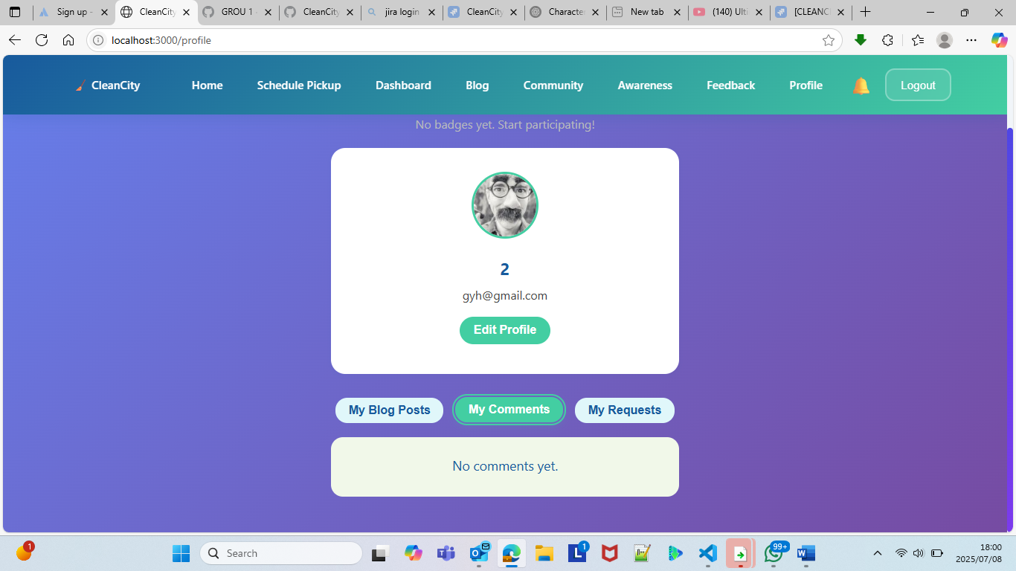

1. The system does not allow users to upload profile pictures. The system only uses the avatar that was provided when an account was created

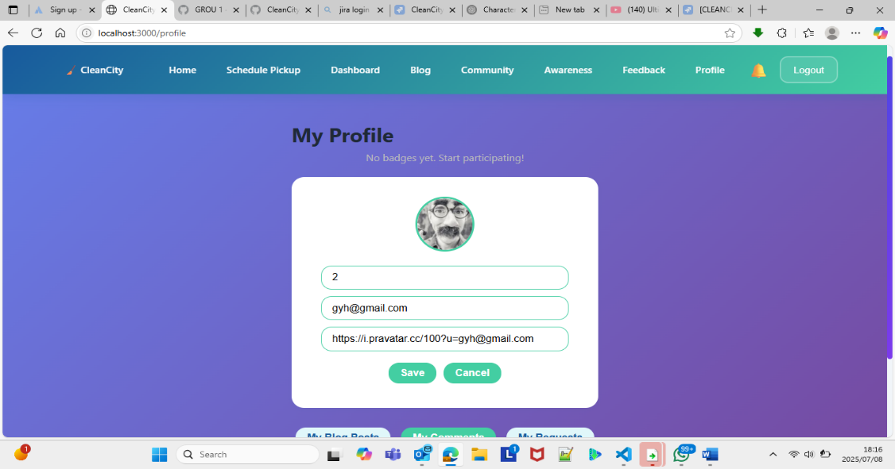

1. Administrative Functions Requirements

6.1 Request Management

The system does not allow the admin to do anything as the scheduled pickups are not saved when a user submit pickups meaning they can not approve, reject, or modify pickup requests. And assign pickup dates and times.

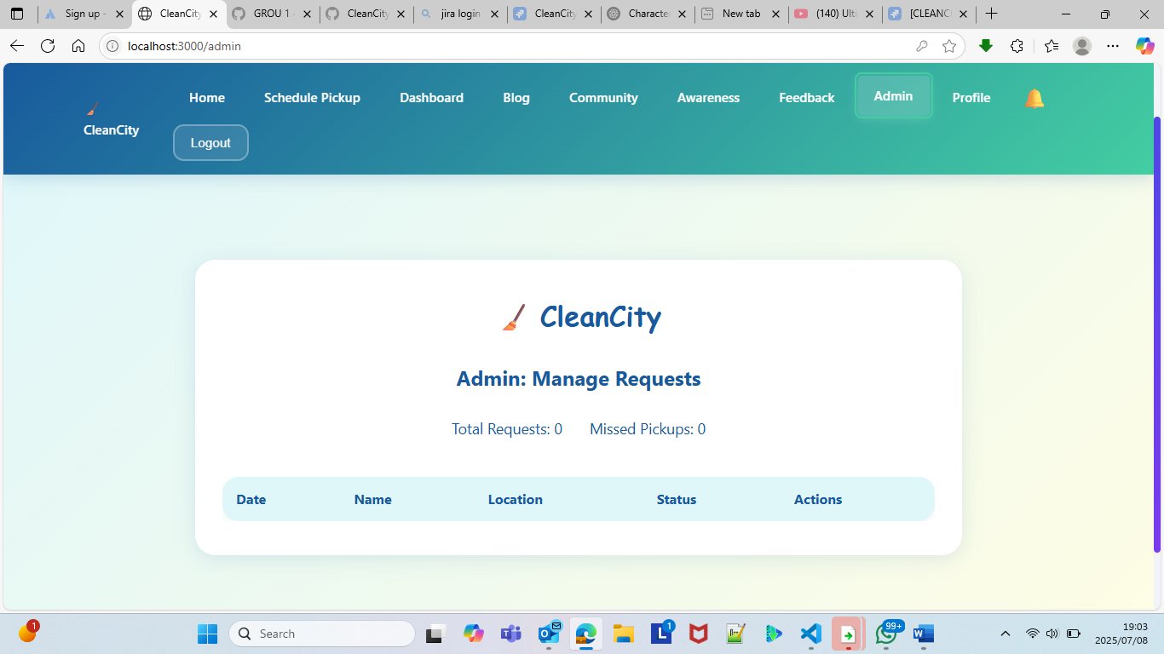

6.2 User Management

The system does not allow the admin to view registered users as any users can just log in to system without registering first. Meaning the admin can not delete accounts for users or suspend accounts for users etc.

6.3 Content Moderation

The system does not allow admins to delete inappropriate content.

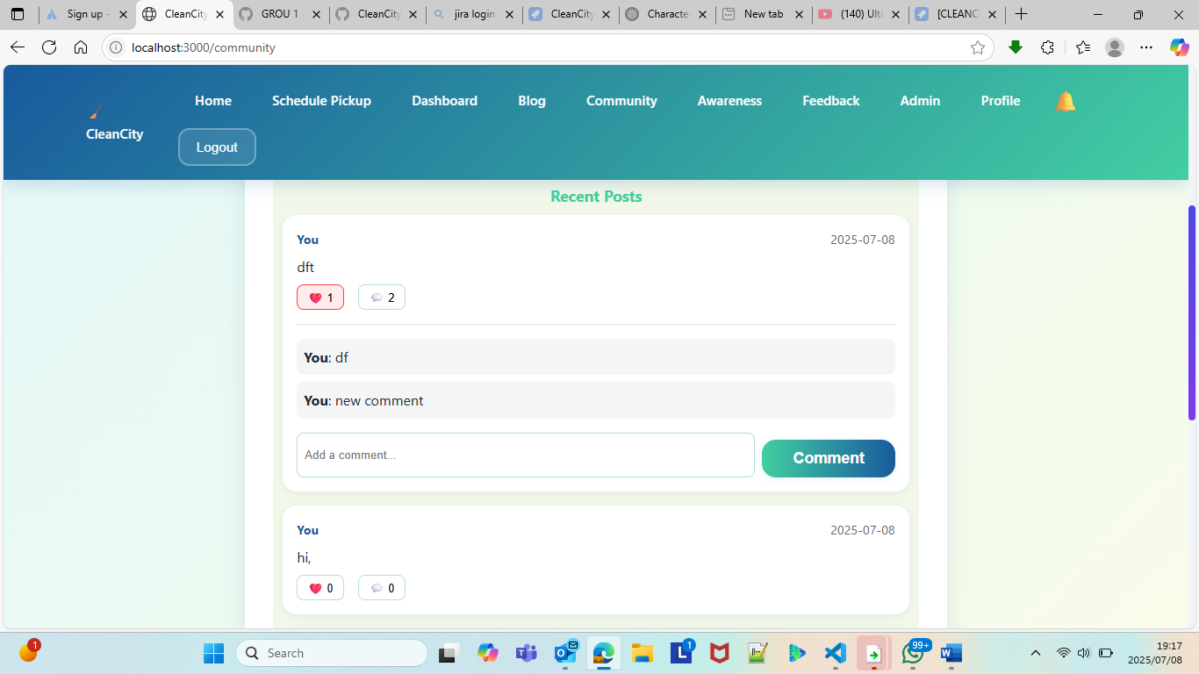

The system does not allow admins to make announcements.

1. User Interface Requirements
   1. Responsive Design

The system is not responsive when it comes to mobile phones (320px to 767px) since the nav bar occupies the whole screen.

