*Thingz* is a simple web application built on top of a RESTful API that helps you keep track of everything you own. Register and start adding everything you care to track – once done with the initial workload, you can be sure that you know exactly where everything is – and what things are stored where.

*Thingz* has two key use cases:

* You need something that hasn't seen use for ages, and need to know where it is.
* Someone broke into your <anything>, and you need to report to your insurance company and/or the police exactly what was taken.

*Thingz* solves both of these problems with a simple user interface right in the browser. A mobile application for actually taking pictures will be part of the tool in the future.

Source code is available at <https://github.com/theneva/thingz>.

The application is live at <http://thingz.theneva.com>.

Team name: DØTTSFELLA 2015

Contact person: Martin Lehmann (918 47 750)

To run the app, install Node/NPM, go to the root directory, and run:

$ npm install -g gulp

$ gulp dev

(you may need to run '$ gulp dev' one or two times).

**Then go to <http://localhost:1234>.**

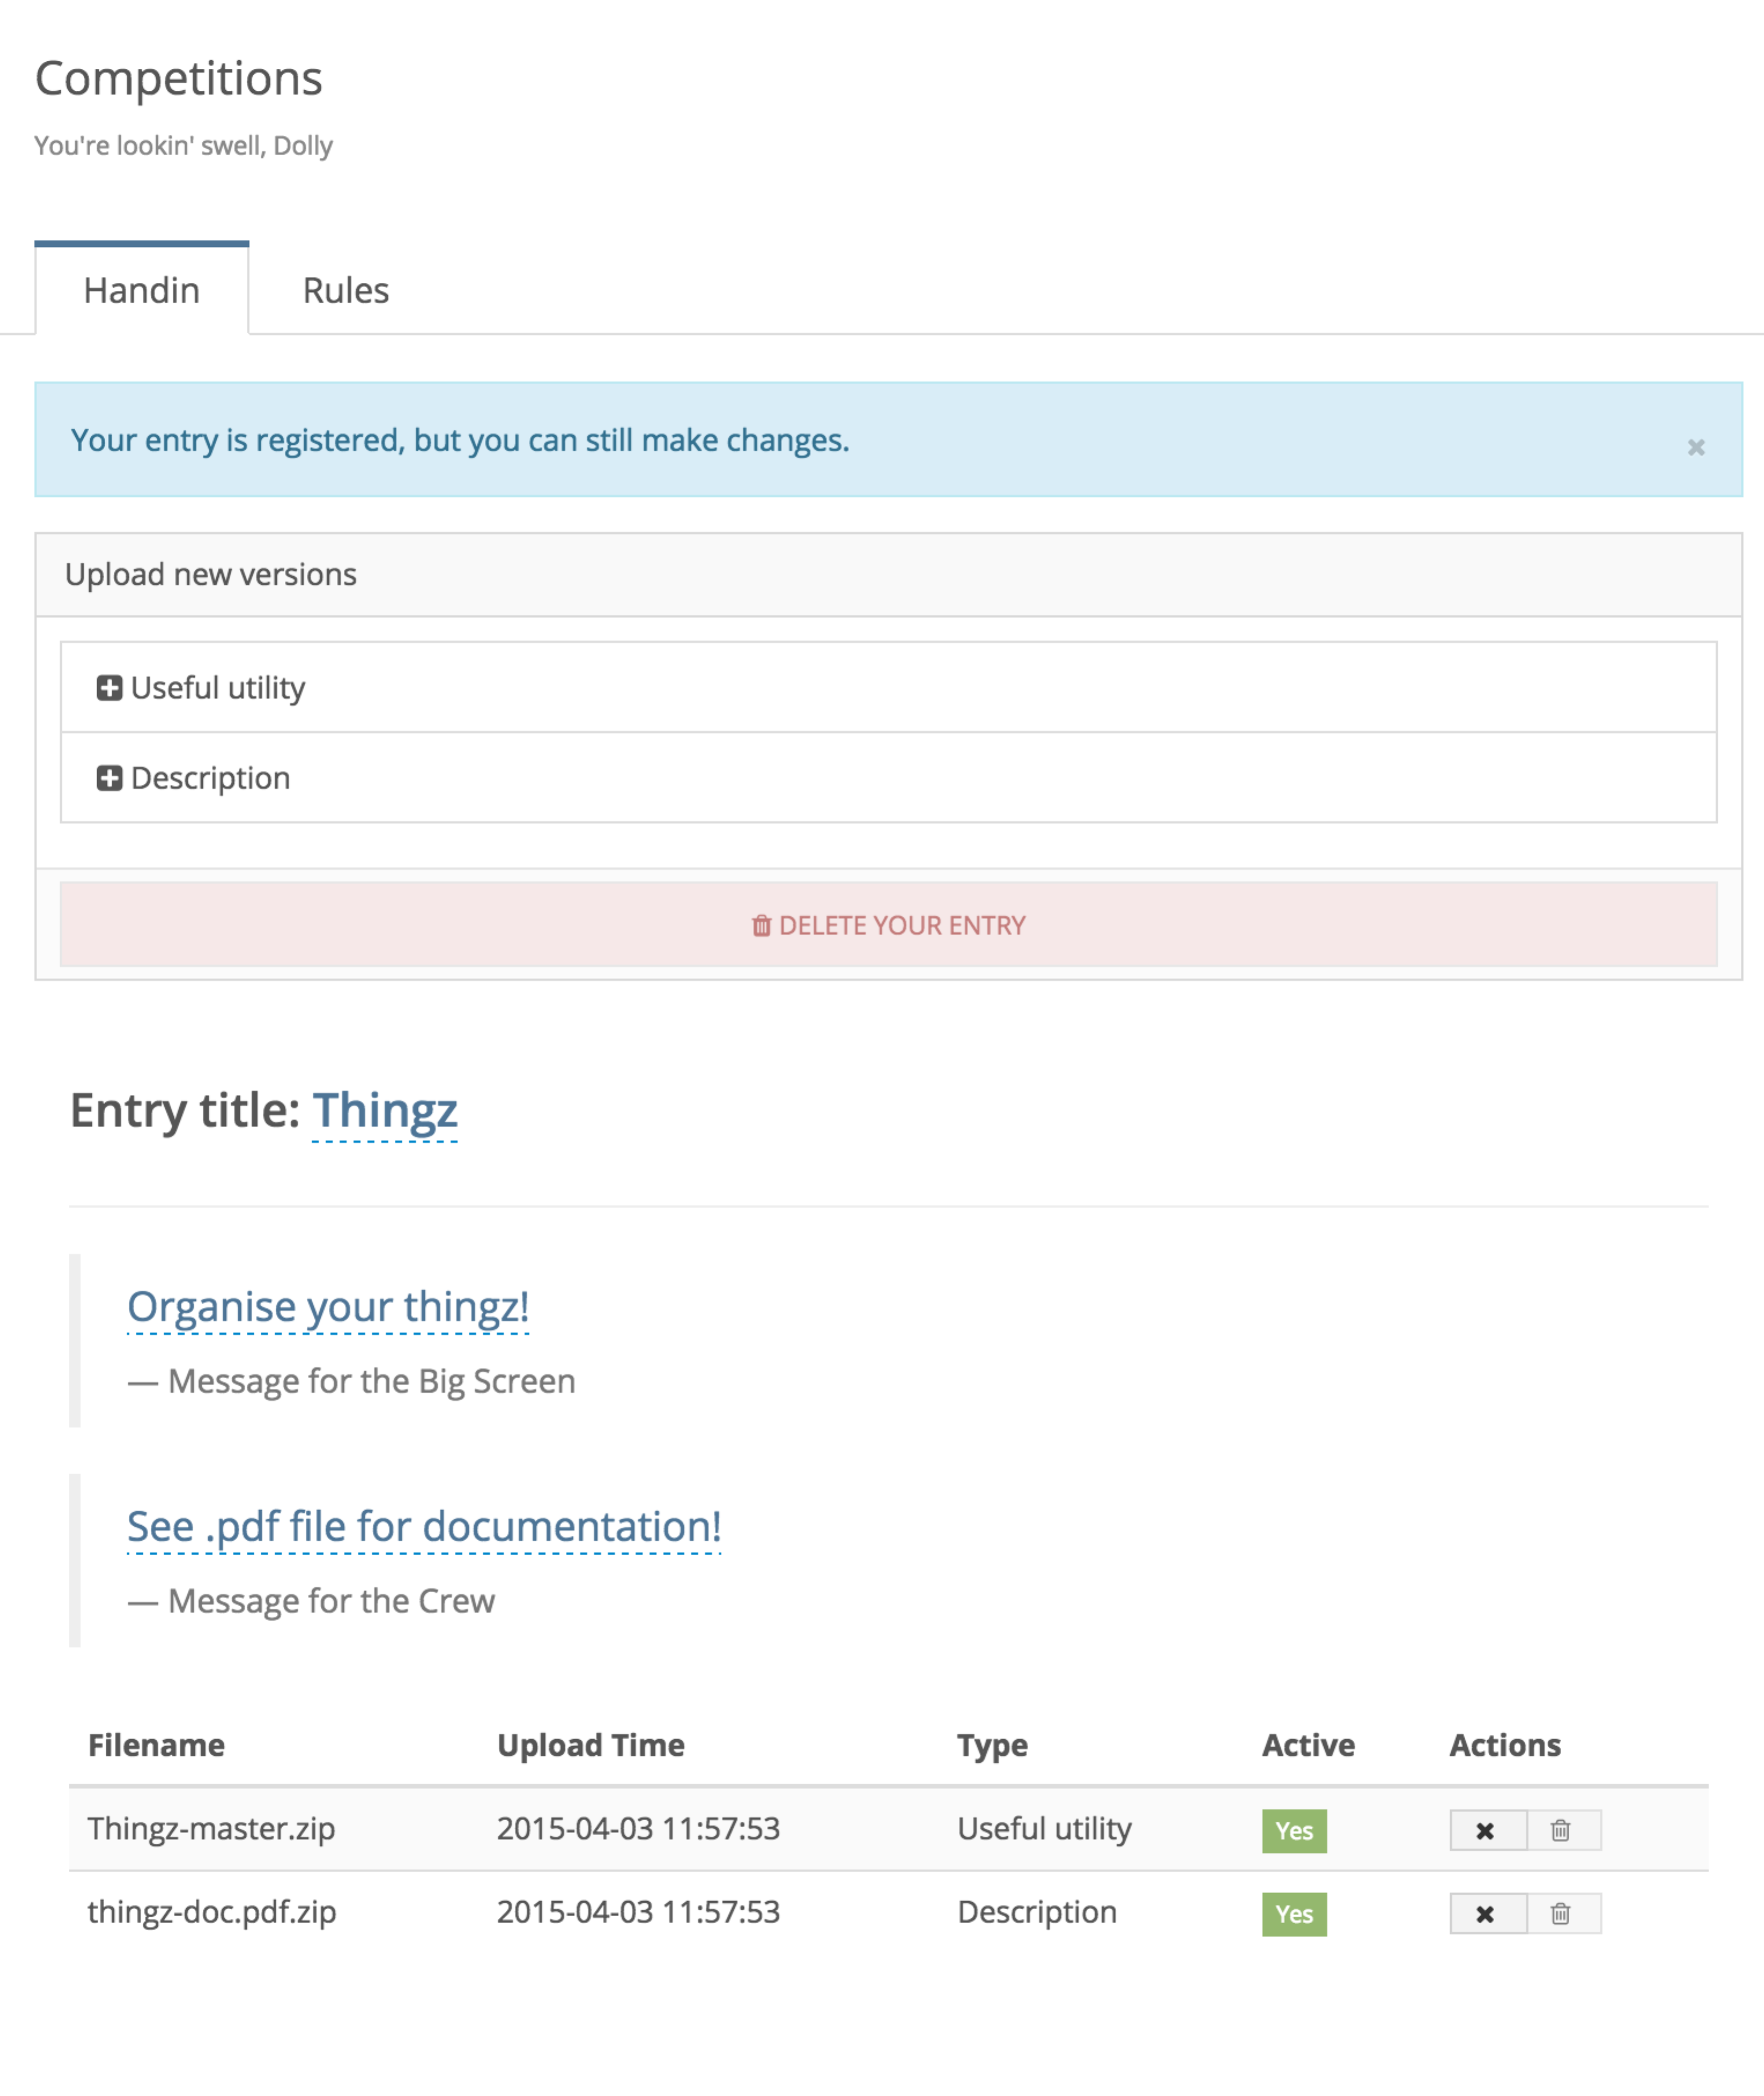

**Screenshots**

You can register if you're new, or sign in if you already have a user account.

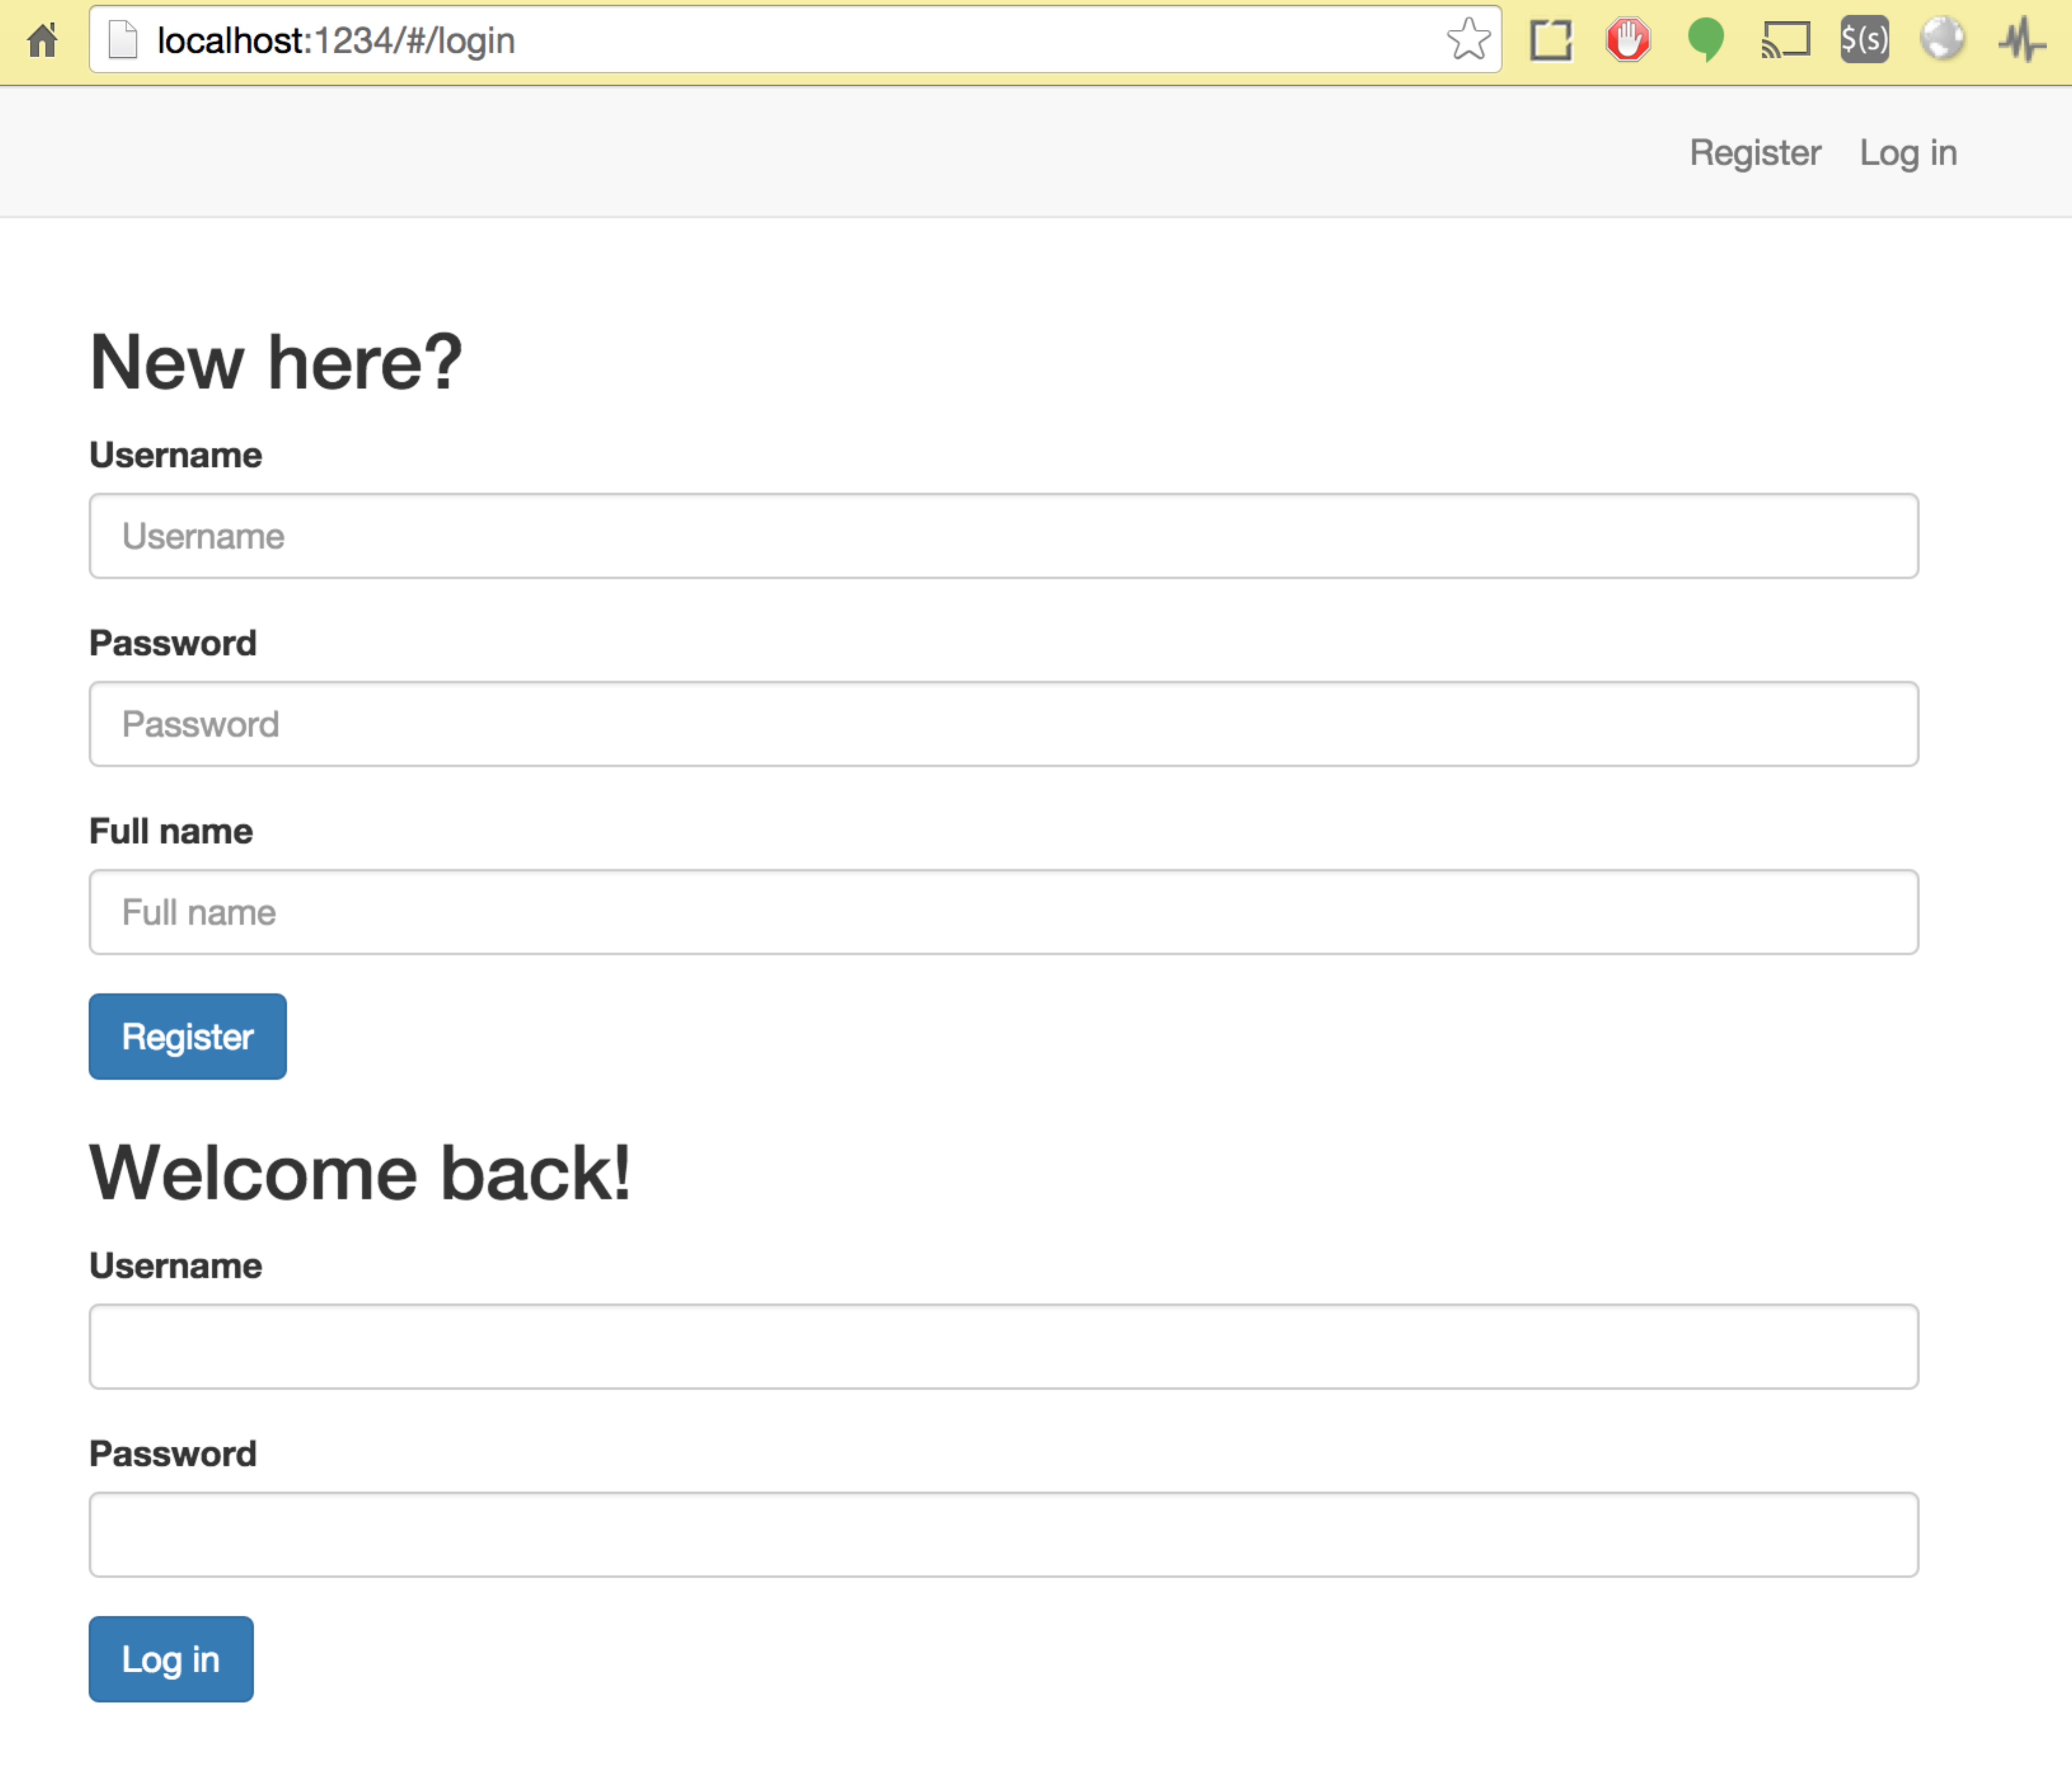

Manage your predefined locations:

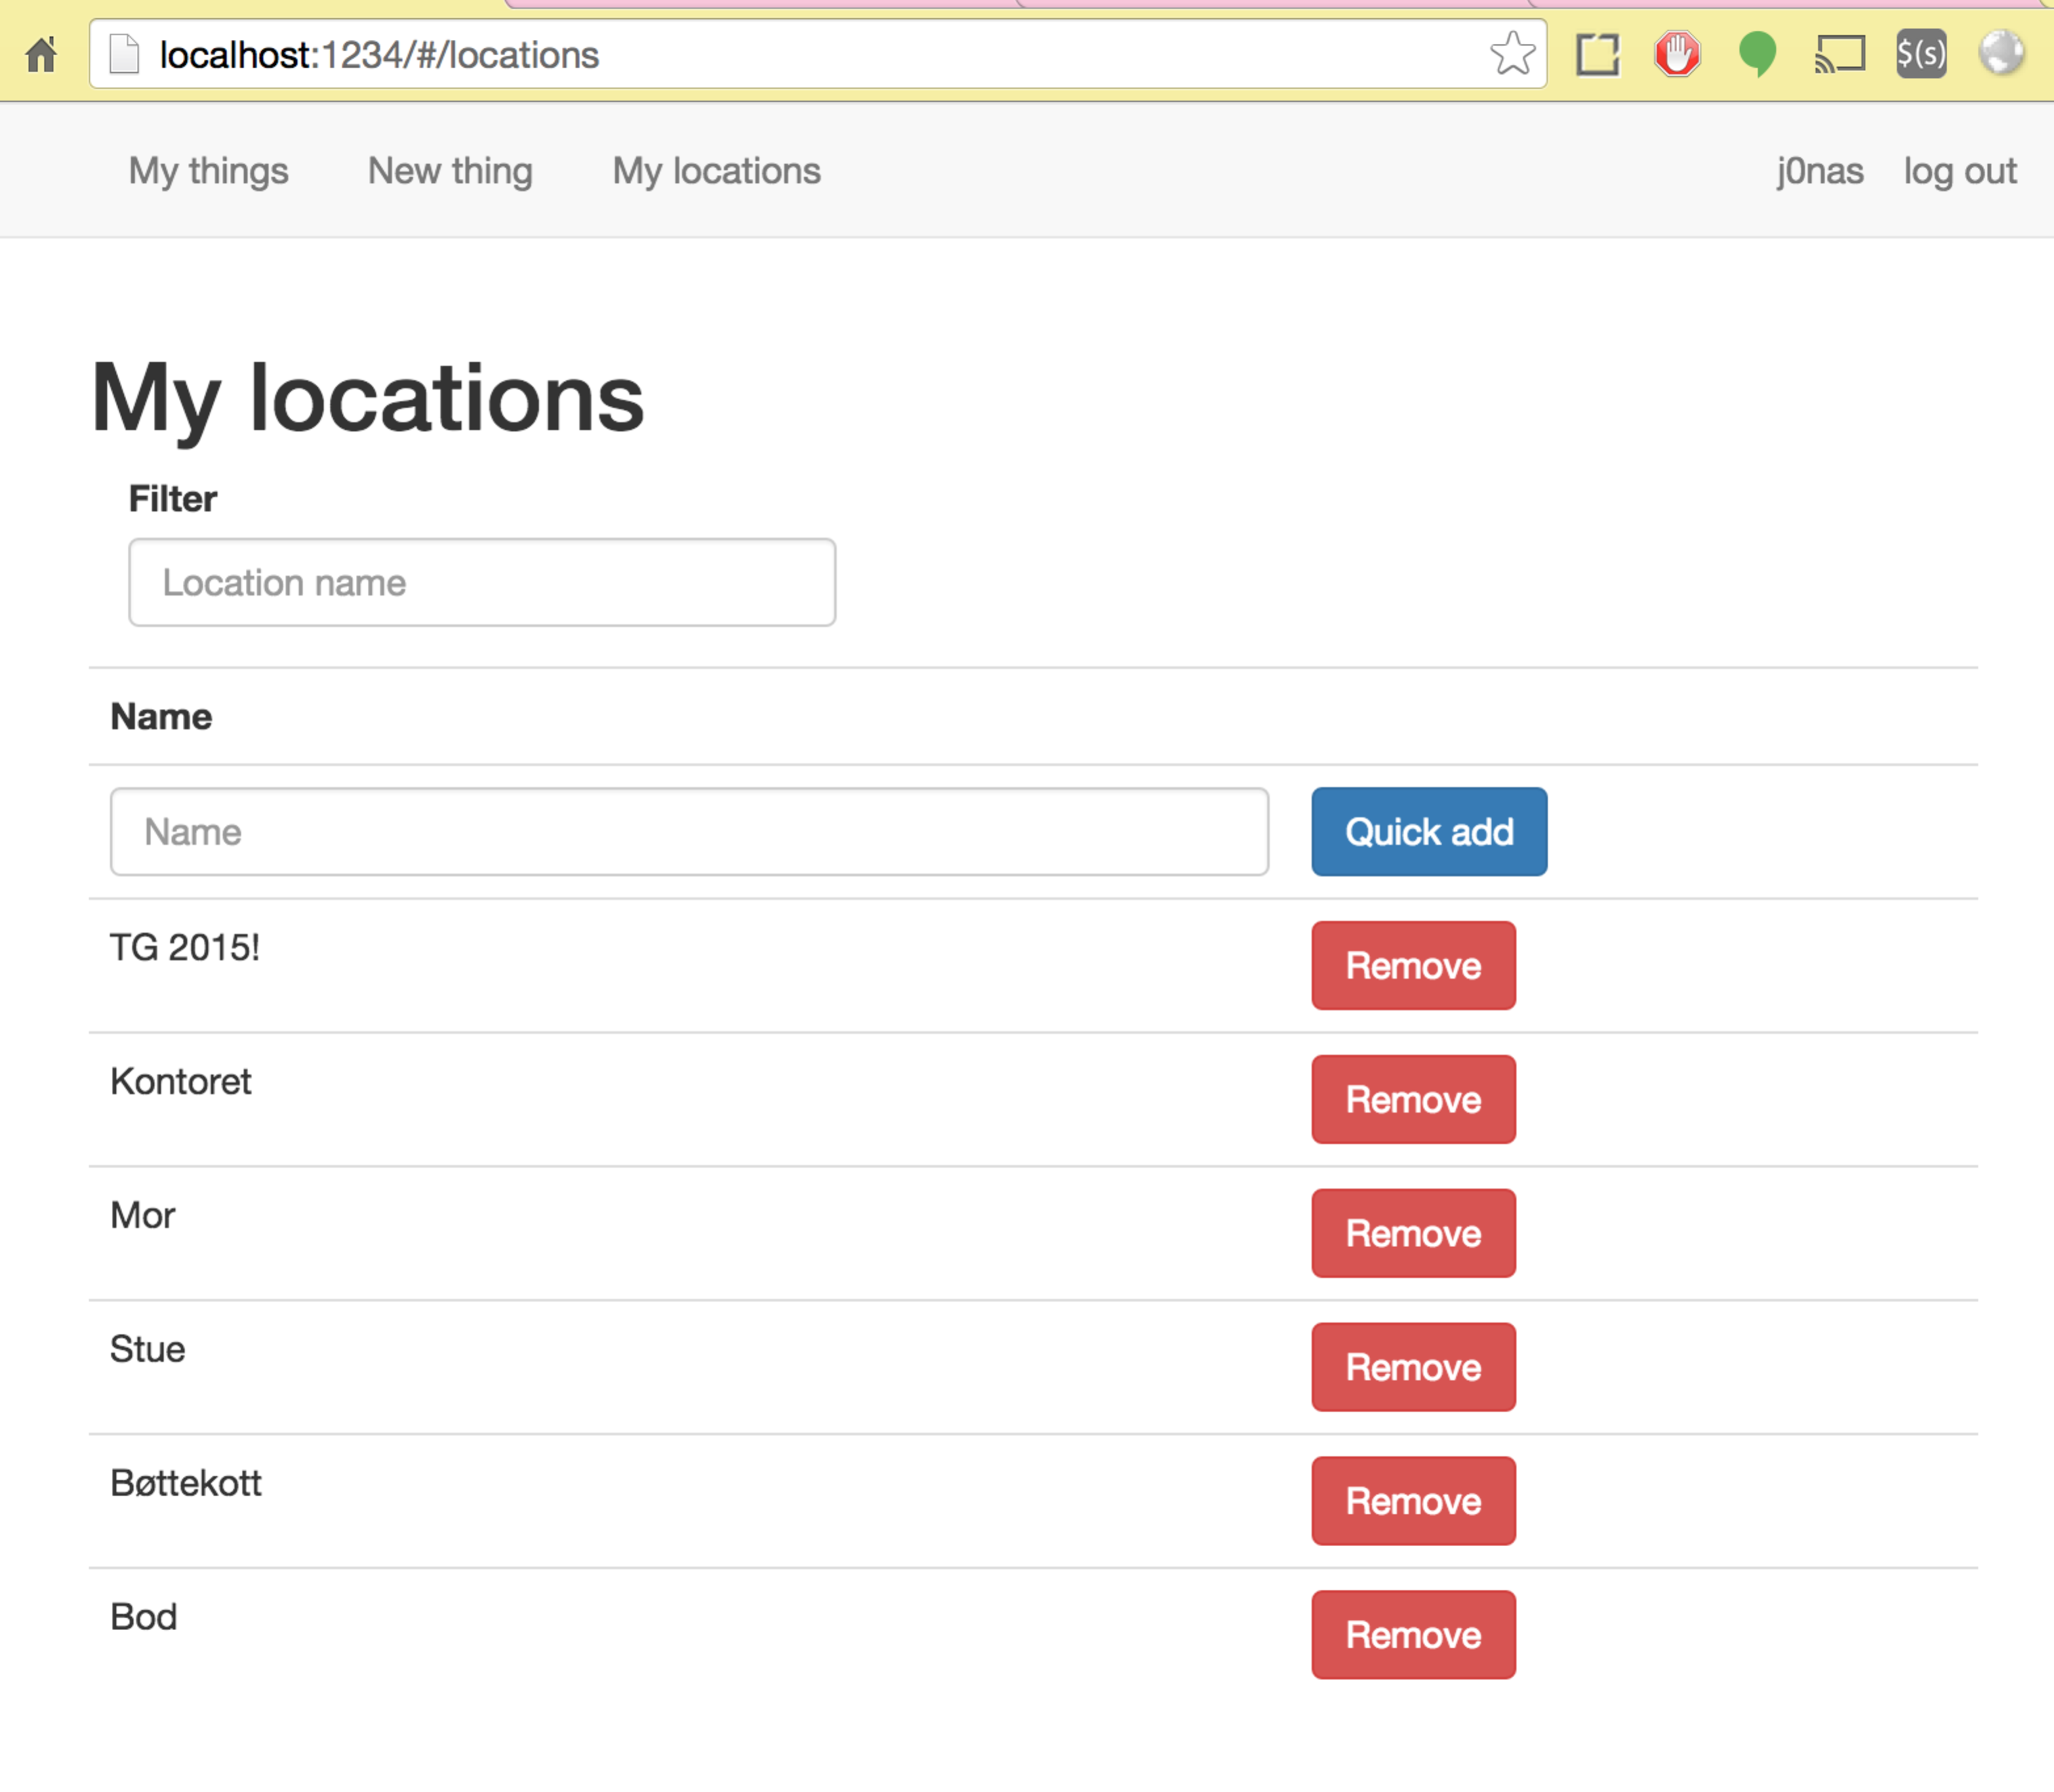

Add a new thing to a location:

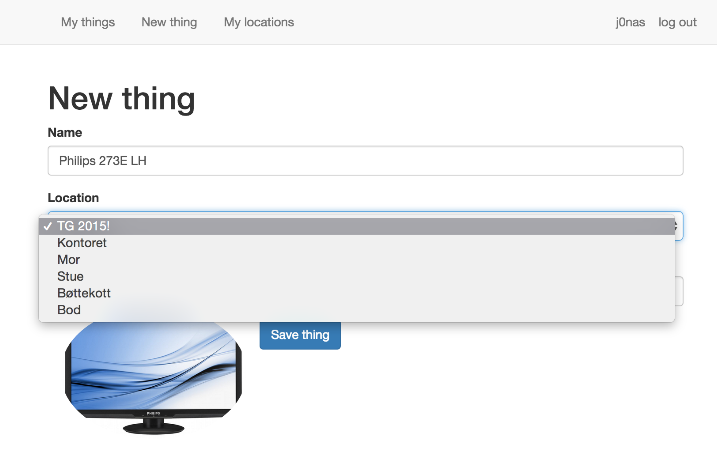

Add a new thing (without the dropdown open):

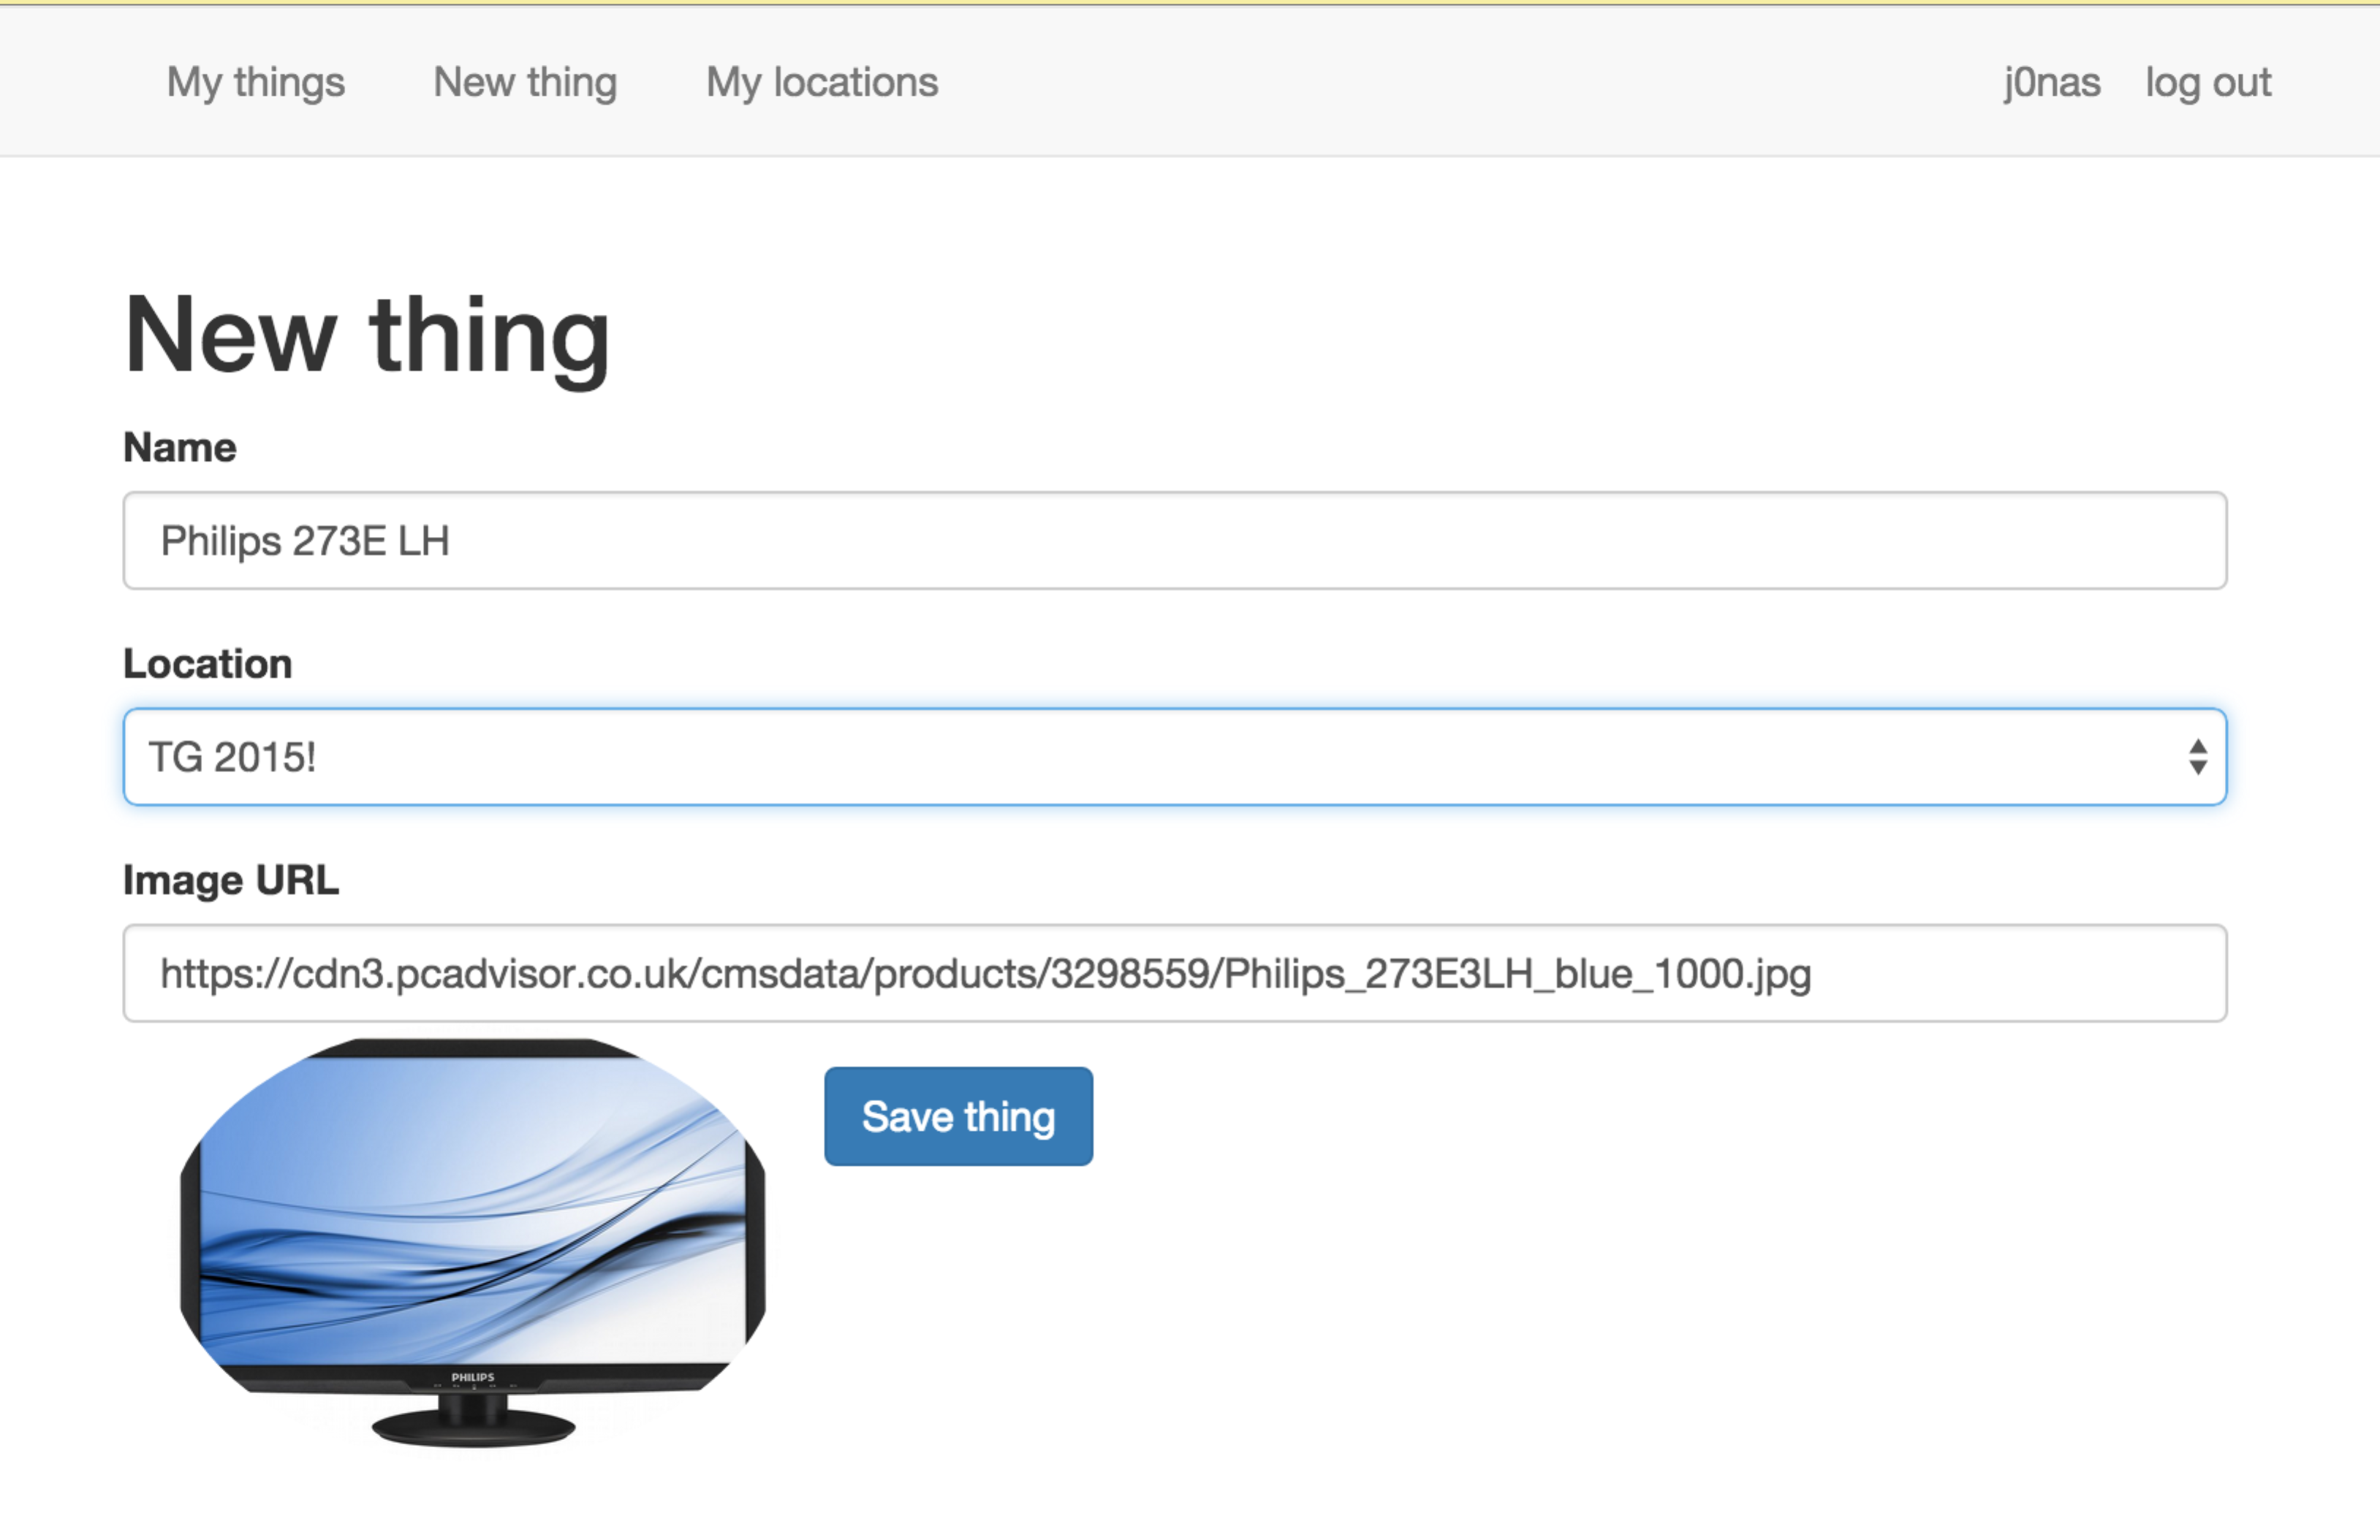

And finally, the main interface: your searchable things.

