**Certification of academic honesty**

I certify that the work presented in the thesis is my own unless referenced.

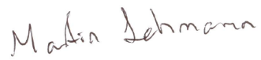

Signature:………………………………

Date: 23/5/2016

Total number of words: 19,537