Machine Learning for Civil Engineering

Vehicle Counting Project — Part 1 Report
Vehicle Detection from a Frozen Pretrained Backbone

1. Objective
Part 1 of the project builds a vehicle detector from scratch on top of a frozen, pretrained CNN backbone. Rather than fine-tuning the backbone itself, only a small detection head is trained, which predicts the presence and location of vehicles on a coarse spatial grid overlaid on each image.

2. Dataset and Preprocessing
The Kaggle “Car Object Detection” dataset was used, consisting of highway images with a single object class (vehicle) and bounding-box annotations provided in a CSV file (image, xmin, ymin, xmax, ymax).
- Images with at least one labeled vehicle: 355 total
- Split: 284 training / 53 validation / 18 test (≈ 80% / 15% / 5%)
- Each image resized to 512×512 pixels and normalized using standard ImageNet statistics
Ground-truth boxes are converted into a 16×16 grid target (matching the backbone's stride of 32). Each grid cell stores 5 values: an objectness flag (1 if a vehicle's center falls in that cell), the center offset within the cell, and the box width/height normalized by image size.

3. Model Architecture
Backbone: MobileNetV3-Small, pretrained on ImageNet, all weights frozen
Head: two 3×3 convolutional layers (256 channels, batch norm, ReLU) followed by a 1×1 convolution producing 5 output channels per grid cell
Only the head's parameters are updated during training; the backbone is used purely as a fixed feature extractor

4. Training Setup
Loss: binary cross-entropy (BCE) for the objectness channel, combined with an L1 regression loss for the box parameters, computed only on cells containing a real vehicle
Optimizer: Adam, learning rate 1e-3
Batch size: 8, trained for 20 epochs
The checkpoint with the lowest validation loss is kept as the final model

5. Tuning Step 1 — Baseline Training Run
The model was first trained with an unweighted BCE loss and an inference objectness threshold of 0.5 (a common default). Both training and validation loss decreased smoothly over 20 epochs with no signs of instability, and the best checkpoint (lowest validation loss) was saved at epoch 18.
However, evaluating this checkpoint on the test set at the required threshold of 0.5 gave:
Run | Precision @ IoU 0.5 | Recall @ IoU 0.5
Baseline (threshold = 0.5) | 0.000 | 0.000
Inspecting the raw model outputs showed the highest objectness confidence on a test image was only about 0.21 — below the 0.5 threshold — even though the model had, in fact, located the correct region. Lowering the threshold to 0.15 as a diagnostic step confirmed this:
Run | Precision @ IoU 0.5 | Recall @ IoU 0.5
Baseline (threshold = 0.15, diagnostic only) | 0.760 | 0.633

6. Diagnosing the Root Cause: Class Imbalance
The 16×16 grid produces 256 cells per image, but almost every image contains only one or a few positive (vehicle-containing) cells — roughly a 255:1 imbalance between negative and positive cells. Under an unweighted BCE loss, the model can achieve a very low overall loss simply by predicting “no vehicle” everywhere, since it is correct on the vast majority of (negative) cells regardless. This explains the model's low confidence even on cells where it had correctly localized a vehicle.
Lowering the inference threshold (as done above) compensates for this after the fact, but does not address the underlying cause, and is not a principled fix on its own.

7. Tuning Step 2 — Weighting the Loss for Class Imbalance
To address the imbalance directly, a pos_weight of 20 was added to the BCE loss term, so that a missed positive (vehicle) cell is penalized 20× more heavily than a misclassified negative cell. This directly counteracts the incentive to under-predict objectness. The model was retrained from scratch with this change; training again converged smoothly, with the best validation loss reached at epoch 14.
Re-evaluating at the standard threshold of 0.5 (now appropriate again, since the model is no longer systematically under-confident):
Run | Precision @ IoU 0.5 | Recall @ IoU 0.5
Baseline (threshold = 0.15) | 0.760 | 0.633
pos_weight = 20 (threshold = 0.5) | 0.619 | 0.867
Using the F1 score (harmonic mean of precision and recall) as a single combined measure: the baseline scores F1 = 0.69, while the pos_weight run scores F1 = 0.72 — a genuine overall improvement, not merely a different trade-off. Recall improved substantially (found ≈87% of vehicles vs. 63%), at a moderate cost to precision.

8. Final Results
The final model (pos_weight = 20, objectness threshold = 0.5, NMS IoU = 0.5) achieves:
Run | Precision @ IoU 0.5 | Recall @ IoU 0.5
Final model | 0.619 | 0.867

9. Sample Visualizations
Predicted boxes (red) are shown alongside ground-truth boxes (green) for five test images.
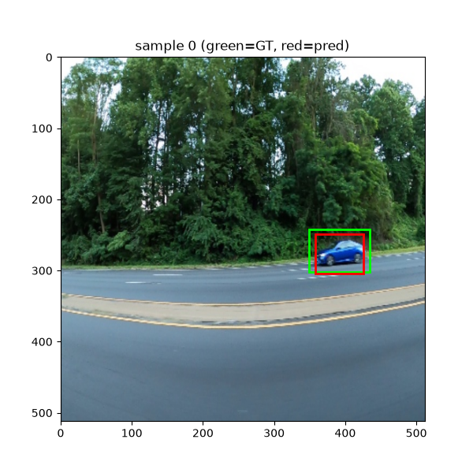
Sample 0 — accurate detection, predicted box closely matches ground truth.
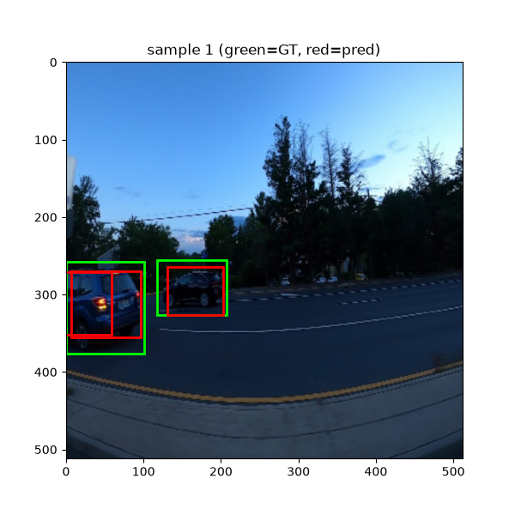
Sample 1 — two adjacent vehicles both correctly detected.
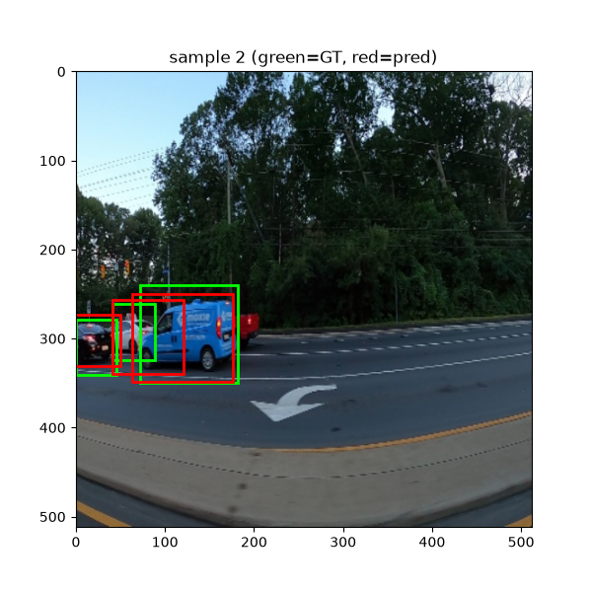
Sample 2 — multiple vehicles detected; note duplicate/overlapping predicted boxes on the left vehicle, suggesting NMS did not fully merge redundant detections at this IoU threshold.
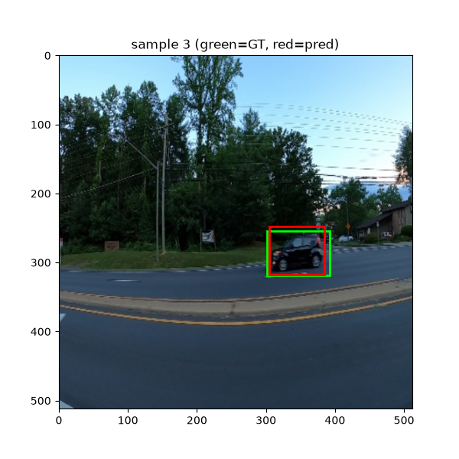
Sample 3 — accurate single-vehicle detection.
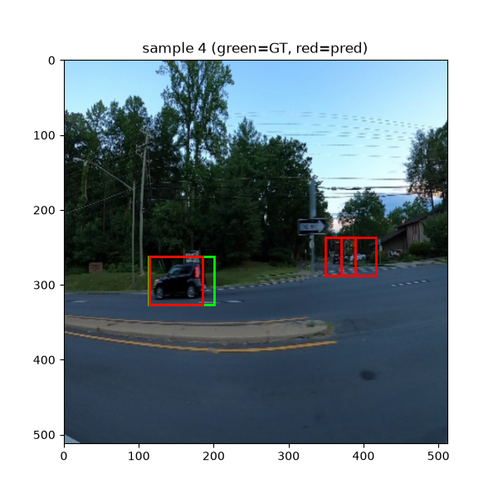
Sample 4 — a predicted box on the right side of the image has no corresponding ground-truth box. This may be a genuine false positive, or an unlabeled vehicle present in the source image but missing from the CSV annotations, which are not guaranteed to be exhaustive.

10. Limitations and Discussion
- Small training set (284 images) limits how well the model generalizes, particularly to less common vehicle sizes, orientations, or lighting conditions (e.g. dusk/night scenes, as in samples 1 and 4).
- The grid-based approach assigns at most one vehicle per cell; closely spaced vehicles whose centers fall in the same cell cannot both be detected (a structural limitation of this simple architecture, unrelated to the loss weighting).
- Some detections flagged as false positives may in fact be correct, unlabeled vehicles, since the dataset's CSV annotations are not guaranteed to be exhaustive.
- NMS occasionally leaves duplicate, overlapping boxes for a single vehicle (see sample 2), suggesting the NMS IoU threshold could be tuned further.
- The precision/recall trade-off from pos_weight could be further tuned (e.g. an intermediate pos_weight value, or threshold sweep) to find an optimal balance for a specific downstream use case.

11. Conclusion
A complete detection pipeline was implemented on top of a frozen pretrained backbone: a custom data loader converting bounding boxes into grid targets, a lightweight trainable detection head, a training loop with combined objectness and box-regression losses, NMS-based inference, and evaluation via precision/recall at IoU 0.5. Diagnosing and correcting for class imbalance in the objectness loss (via pos_weight) improved the model's F1 score from 0.69 to 0.72, primarily by substantially increasing recall (63% → 87%) at a moderate cost to precision.

Vehicle Counting Project — Part 2 Report
Detection, Tracking and Counting on Video with a Fine-Tuned Detector

1. Objective
Part 2 extends the vehicle detection problem to video: a small pretrained detector is fine-tuned on the Part 1 dataset, run frame-by-frame on a traffic video, and its detections are linked across frames with a custom IoU-based tracker. Vehicles are counted once each time they cross a virtual line, separately per direction of travel, and the automatic counts are compared against a manually produced ground truth.

2. Video
The source footage is a public road-traffic video showing a UK motorway from an overhead bridge, with clearly separated carriageways for each direction. A 2-minute (3000-frame, 25 fps, 1280×720) clip was extracted from a representative, actively trafficked section of the full recording for use in this project, since processing and manually verifying the entire multi-hour source video would not be practical.

3. Detector: Fine-Tuning YOLOv8-Nano
Rather than reusing the Part 1 head, a pretrained YOLOv8-nano model (COCO weights) was fine-tuned on the same Kaggle vehicle dataset used in Part 1, reformatted into YOLO's expected label format. The dataset was split 85% / 15% into training and validation images.
- Training images: 302, Validation images: 53
- Epochs: 30, image size: 640×640, batch size: 16
- Optimizer selected automatically by Ultralytics: AdamW, lr 0.002
Fine-tuning results on the validation split:
Metric | Value
Precision | 0.968
Recall | 0.993
mAP50 | 0.993
mAP50-95 | 0.696
These figures are substantially higher than the Part 1 from-scratch head (F1 0.72), which is expected: fine-tuning starts from a detector that already understands generic object shapes, edges and textures from large-scale pretraining, rather than learning detection from nothing with a small dataset and a frozen backbone.

4. Tracker Design
A simple IoU-based multi-object tracker was implemented (no motion prediction, following the assignment's suggested approach):
For each frame, every existing track is greedily matched to the detection with which it has the highest IoU overlap, provided that overlap exceeds a threshold (0.3).
Detections left unmatched start new tracks with a fresh ID.
Tracks left unmatched accumulate a missed-frame counter, and are discarded once this exceeds 10 consecutive frames.
Each track is counted at most once, at the moment its box center crosses the counting line.

5. Counting Methodology
A horizontal counting line was placed at 60% of the frame height, crossing a clear, unobstructed section of both carriageways. A track is counted the first time its center moves from one side of the line to the other; the direction of the crossing (top-to-bottom vs. bottom-to-top) determines whether it is added to the “down” or “up” total.
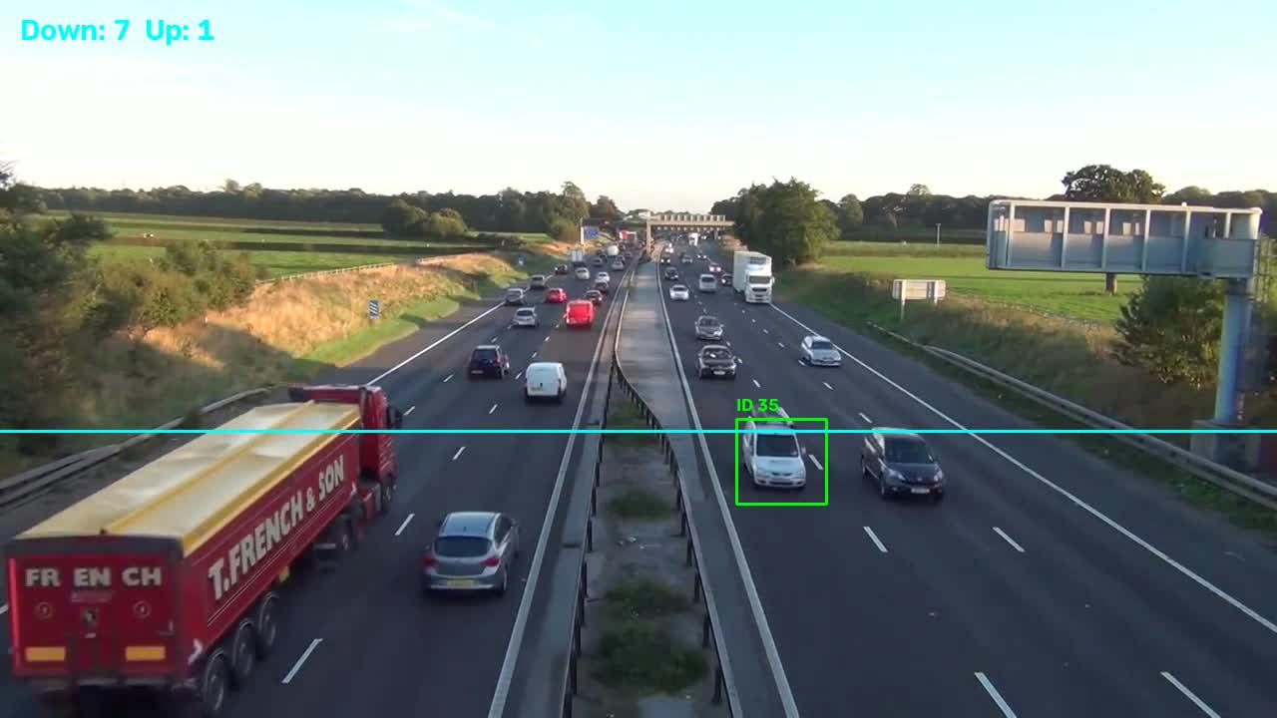
A correctly detected and tracked vehicle (ID 35) approaching the counting line, with running totals overlaid top-left.

6. Results: Automatic vs. Manual Counts
The video was watched in full and every vehicle crossing the counting line was manually tallied per direction, to serve as ground truth. This was compared against the pipeline's automatic counts:
Direction | Automatic count | Manual count (ground truth) | Automatic recall
Down | 37 | 168 | ≈ 22%
Up | 9 | 165 | ≈ 5%
Total | 46 | 333 | ≈ 14%
The automatic pipeline substantially undercounts in both directions, and considerably more so for “up” than “down”.

7. Failure Case Analysis
A large gap between automatic and manual counts of this size warrants a closer look at what is going wrong. Three distinct issues were identified:
7.1 Domain gap between training data and video footage
The detector was fine-tuned exclusively on the Part 1 Kaggle images: close, low-angle, dashcam-style photographs of one or two vehicles per frame. The counting video, by contrast, is a distant, elevated, overhead-bridge shot with many small, densely packed vehicles per frame. This mismatch in scale and viewing angle is the most likely explanation for the low recall: many vehicles are simply too different in appearance from anything the detector saw during fine-tuning.
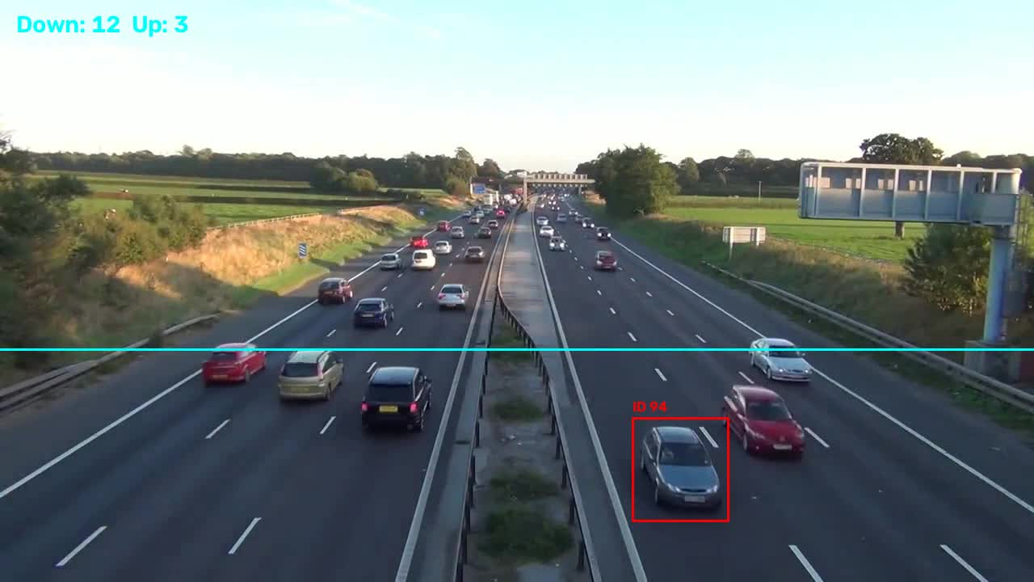
A busy frame with over a dozen visible vehicles, but only one detected — illustrating the domain-gap problem.
7.2 Track fragmentation
Manually reviewing several seconds of the annotated video revealed that a number of individual, physical vehicles were assigned more than one track ID over their time on screen — visible as two overlapping boxes (one already counted, one not) on what is clearly a single car. This happens when a detection is briefly missed for a vehicle (e.g. due to a slightly changed box shape or a one-frame miss from the detector), causing the original track to be dropped and a new one created once the vehicle is detected again, rather than the same identity being preserved.
This is confirmed quantitatively: over the full video, 237 distinct track IDs were created in total, against only 46 vehicles ultimately counted — an average of roughly 5 track IDs per counted vehicle. Since a fragment of an already-counted vehicle can itself cross the line and be counted again under its new ID, this fragmentation is a plausible contributor to (though not the dominant cause of) the gap between automatic and manual counts.
7.3 “Ghost box” display artifact (identified and corrected)
An early version of the output video displayed a track's bounding box even on frames where it was not actually matched to a fresh detection, causing the box to visibly “freeze” in place while the real vehicle continued moving — making tracking look laggy and imprecise. This was a display-only issue: the underlying counting logic was unaffected. It was corrected by only drawing a track's box on frames where it was matched to a detection in that exact frame (i.e. missed_frames == 0), which did not change the final counts but produced a visibly cleaner annotated video.

8. Discussion
- The dominant source of error is missed detections due to the domain gap, not the tracker itself — recall this low cannot be explained by tracking alone.
- Retraining or fine-tuning the detector on images more representative of this specific camera angle and vehicle scale (or simply on a few frames of this video itself) would likely close much of the gap.
- A lower detection confidence threshold could recover some missed vehicles, at the cost of more false positives and likely more fragmented tracks.
- The “up” direction consistently performs worse than “down” across the video, possibly due to lighting/glare on that side of the carriageway or vehicles appearing smaller on that side of the frame; this was not investigated further.
- A more capable tracker (e.g. adding simple motion prediction, or Hungarian instead of greedy matching) could reduce track fragmentation, though the assignment does not require this and greedy IoU matching was sufficient to implement the required counting logic correctly.

9. Conclusion
A complete video pipeline was built: a YOLOv8-nano detector fine-tuned on the Part 1 dataset (precision 0.968, recall 0.993, mAP50 0.993 on held-out images), a custom greedy IoU tracker, and line-crossing counting logic, all evaluated against a manually produced ground truth. While the detector performs very well on images similar to its fine-tuning data, it generalizes poorly to this video's different camera angle and scale, undercounting vehicles by roughly 6× (46 automatic vs. 333 manual). Track fragmentation (237 IDs for 46 counted vehicles) was identified and quantified as a secondary contributing issue. These findings point clearly to the detector's domain gap, rather than the tracking or counting logic, as the primary limitation of the current pipeline.

