

C++ PROJECT

Trimester 2, 2019/2020  
(1920)

PPS0335 - PROBLEM SOLVING AND PROGRAM

(T127)

Title: Library Seat Reservation

Group name: Life of Pi

|  |  |
| --- | --- |
| ID | NAME |
| 1191100477 | THENG YUAN YUAN (L) |
| 1191100713 | TAY YI HONG |
| 1181103074 | TEH WAN XIN |
| 1181103558 | TOH JUN JIE |
| 1191100961 | CHIN WEI SONG |

Table of Contents

Introduction 2

Objective 3

Problem Analysis Chart (PAC) 4

IPO Chart 5

Data Dictionary 6

Pseudocode / Algorithm 7

Flowchart 13

Codes 23

Conclusion 43

# Introduction

Overtime, library has experienced a shift from being a space devoted to store and organise physical and informational materials to become a space that encourages collaborative learning environment. As this space is actually limited, it is essential that we organise it in a proper way for everyone's convenience, especially for student. In particular, implementing a system to manage the seats in a library can prevent the hoarding tendencies exhibited by students within first come first serve system. Thus, our this project is based on the working of a library management which involving the activity of library seat reservation. Currently, our system requires a library to maintain the record manually. All the working hour, user name, type of seat, price and other related information have to be maintained daily in record book for further reference.

This project has been undertaken to automate a library seat management. One entry should be made once and further entries will be fetched as required. This is done so to make the system able to perform in a more efficient way.

Next, here is a brief introduction for our library seat reservation system.This system is completed by us with the use of C++ programming knowledge that we gain in class and also from other sources. Our system has been set to have the working hour from 9.00 a.m. to 9.00 p.m. The type of seats that is available are public seat, single seat, group seat and also private room which is normally used for discussion. In this aspect, only public seat is out of charge where as the others require a payment and there is a 20% discount for student, provided that they provide their school name and student id. When reserving the seat, personal information like name and handphone number is also required. Once all the required information is given and payment is made, then only the reservation will be made. We strongly believe that we are able to improve the performance of a library in managing the seats with this library seat reservation system.

# Objective

Our library seat reservation system has been designed to manage the seats in a library in a more efficient way, so that we can achieve the objectives for creating this system. In this case, our objectives are none other than:

* to create a convenience and favourable learning environment for the citizens
* to avoid people from wasting their time to find or get seat in library
* to create a new system for reserving seats in library
* to improve our members’ skills in C++ programming

# Problem Analysis Chart (PAC)

|  |  |
| --- | --- |
| Given Data | Required Result |
| * Type of seat (Public, Single, Group, Discussion Room) * quantity * duration * Response(student) * Discount 20% for student | * Type of Seat * Quantity * Time * Price * Payable |
| Processing Data | Solution Alternatives |
| * TypeOfSeat * (PublicSeat)=RM 0; * (SingleSeat)=RM 5; * (GroupSeat)=RM 8; * (DiscussionRoom)=RM 15; * Price   TypeOfSeat*quantity*duration   * Discount:   (response==’y’)  Payable=price* 0.8  (response==’n’)  Payable=price | * Define type of seat and discount according to age as a constant * Define hour, quantity and the type of seat as an input value. |

# IPO Chart

|  |  |  |  |
| --- | --- | --- | --- |
| **Input** | **Processing** | **Module Reference** | **Output** |
| typeofseat | Select seat: Public seat(0), single seat,(5) group seat(8) or room (15) | Read | Total_payable |
| quantity | Number of seats | Read |
| d,m,y | Choose date(DD/MM/YYYY) | Read |
| start_time, end_time | Select time start and end(HHMM) | Read |
| name | Enter the name | Read |
| phonenumber | Enter the phone number | Read |
| response | Are you a student?(y/n). If y,enter the name of school and student id. | Read |
| schoolname | Total_payable for student=Type of seat*duration -(type of seat*20/100)  Total_payablet for nonstudent= Type of seat*duration | Calculate |
| studentid | Payment method weather is cash or visa /master card .If using cash, enter the amount you have paid whereas visa or master card have to enter the pin number | Read |
| payment_method | Print total_payable | print |
| pin |

# Data Dictionary

|  |  |  |  |  |
| --- | --- | --- | --- | --- |
| **Item** | **Variable Name** | **Data type** | **Module** | **Scope** |
| Type of seat | typeOfSeat | Numeric-integer | Read/Calc | Parameter |
| Quantity of seats | quantity | Numeric-integer | Read/Calc | Parameter |
| Price per hour | price | Numeric-real | ControlPay | Local |
| Response | response | String | Read | Parameter |
| Start time | startTime | Numeric-integer | Read/Print | Parameter |
| End time | endTime | Numeric-integer | Read/Print | Parameter |
| Duration | duration | Numeric-integer | Read/Calc | Parameter |
| Day | d | Numeric-integer | Read/Print | Parameter |
| Month | m | Numeric-integer | Read/Print | Parameter |
| Year | y | Numeric-integer | Read/Print | Parameter |
| Name | name | String | Read/Print | Parameter |
| Phone number | phonenumber | String | Read/Print | Parameter |
| Student ID | studentid | String | Read/Print | Parameter |
| School name | schoolname | String | Read/Print | Parameter |
| Total to pay | payable | Numeric-real | Print/Calc | Parameter |
| First money paid | paid | Numeric-real | Print/Calc | Parameter |
| Second money paid | paid2 | Numeric-real | Print/Calc | Parameter |
| Money change | change | Numeric-real | Print/Calc | Parameter |
| Payment method | payment_method | Numeric-integer | Read | Parameter |
| Button to proceed | direction | String | Read | Parameter |
| Card pin number | pin | Numeric-integer | Read | Parameter |
| Choice 1 | choose1 | Numeric-integer | Read | Parameter |
| Choice 2 | choose2 | Numeric-integer | Read | Parameter |
| Name of seat | seatname | String | Print | Parameter |

# Pseudocode / Algorithm

Start:

1. declare constant variables

const double PublicSeat=0;

const double SingleSeat=5;

const double GroupSeat=8;

const double Room=15;

2. declare variables

int typeOfSeat;

string seatname;

int quantity;

double price;

string response;

int startTime, endTime;

double duration;

int d,m,y;

string name;

string phonenumber;

string studentid;

string schoolname;

double payable;

double paid, paid2, change;

int payment_method;

string direction;

int pin;

int choose1,choose2;

time_t now = time(0);

3. MENU: output menu

4. choose1=0, choose2=0

5. repeat

read typeOfSeat

if typeOfSeat==-1

goto MENU (3)

until (typeOfSeat==-1||1||2||3||4)

6. repeat

read quantity

if quantity==-1

goto MENU(3)

end if

until quantity>0

7. CHOOSE_DATE:

repeat

read d

if d==-1

goto MENU (3)

end if

read cin.get()

until (cin.get()=='/')

8. read m

9. if cin.get()!='/'

goto CHOOSE_DATE(6)

end if

10. read y

11. CHOOSE_TIME:

repeat

read startTime

if startTime==-1

goto MENU (3)

end if

until (startTime>=900&&startTime<=2000)

12. repeat

read endTime

if endTime==-1

goto MENU

end if

until (endTime>startTime&&endTime<=2100||(endTime-startTime)%100==0)

13. duration=(endTime-startTime)/100

14.CALCULATE_PRICE:

if (typeOfSeat==1)

price=PublicSeat*quantity*duration

seatname="Public Seat"

else if(typeOfSeat==2)

price=SingleSeat*quantity*duration

seatname="Single Seat"

else if(typeOfSeat==3)

price=GroupSeat*quantity*duration;

seatname="Group Seat";

else

price=Room*quantity*duration;

seatname="Room";

end if

15. output seatname, quantity, startTime, endTime, duration, date, price

16. output options

17. if (choose2==1)

output option3

endif

18. repeat

read choose1

if (choose1==-1)

goto MENU(3)

else if (choose2==1&&choose1==3)

goto PAYMENT (number)

else if (choose2==1&&choose1==2)

goto PERSONAL_INFORMATION_OUTPUT

else if (choose1==1)

goto SEAT

end if

until (choose2==0&&(choose1==-1||1||2))||(choose2==1&&(choose1==-1||1||2||3))

19. PERSONAL_INFORMATION:

read name

if (name=="-1")

goto MENU

end if

20. read phonenumber

21. if (phonenumber=="-1")

goto MENU

end if

22. ask_student:

read response

23. if response==“y”||"Y"

read schoolname

read studentid

payable=price*0.8

else if response=="n"||"N"

payable=price

else

"invalid"

goto ask_student

end if

24. PERSONAL_INFORMATION_OUTPUT:

output name, phonenumber

25. if(response=="Y"||"y")

output schoolname, studentid

26. output options

27. repeat

read choose2

if(choose2==-1)

goto MENU

else if (choose2==1)

goto CALCULATE_PRICE

else if (choose2==2)

goto PERSONAL_INFORMATION

else if (choose2==3)

goto PAYMENT

else

"Invalid"

endif

until choose2==-1||1||2||3

28. PAYMENT:

output price, payable

29. repeat

output choose payment method

read payment_method

until payment_method==-1||1||2

30. if(payment_method==-1)

goto MENU

else if(payment_method==1

read paid

while (paid<payable)

read paid2

paid=paid+paid2

end while

change=paid-payable

print change

else if(payment_method==2)

read pin

paid=payable;

end if

31. RECEIPT:

output seatname, quantity, startTime, endTime, duration, price, payable, paid, change, name, phonenumber, schoolname, studentid

32. output "Thank you"

33. output current time.

End:

# Flowchart

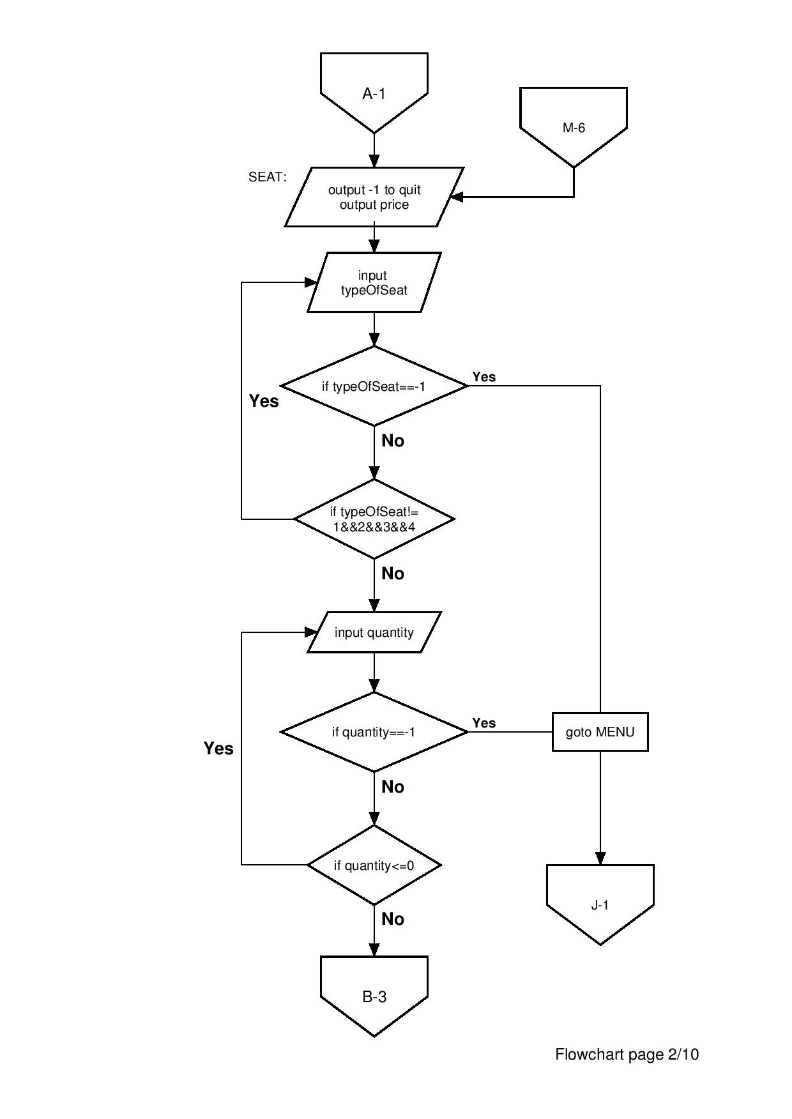

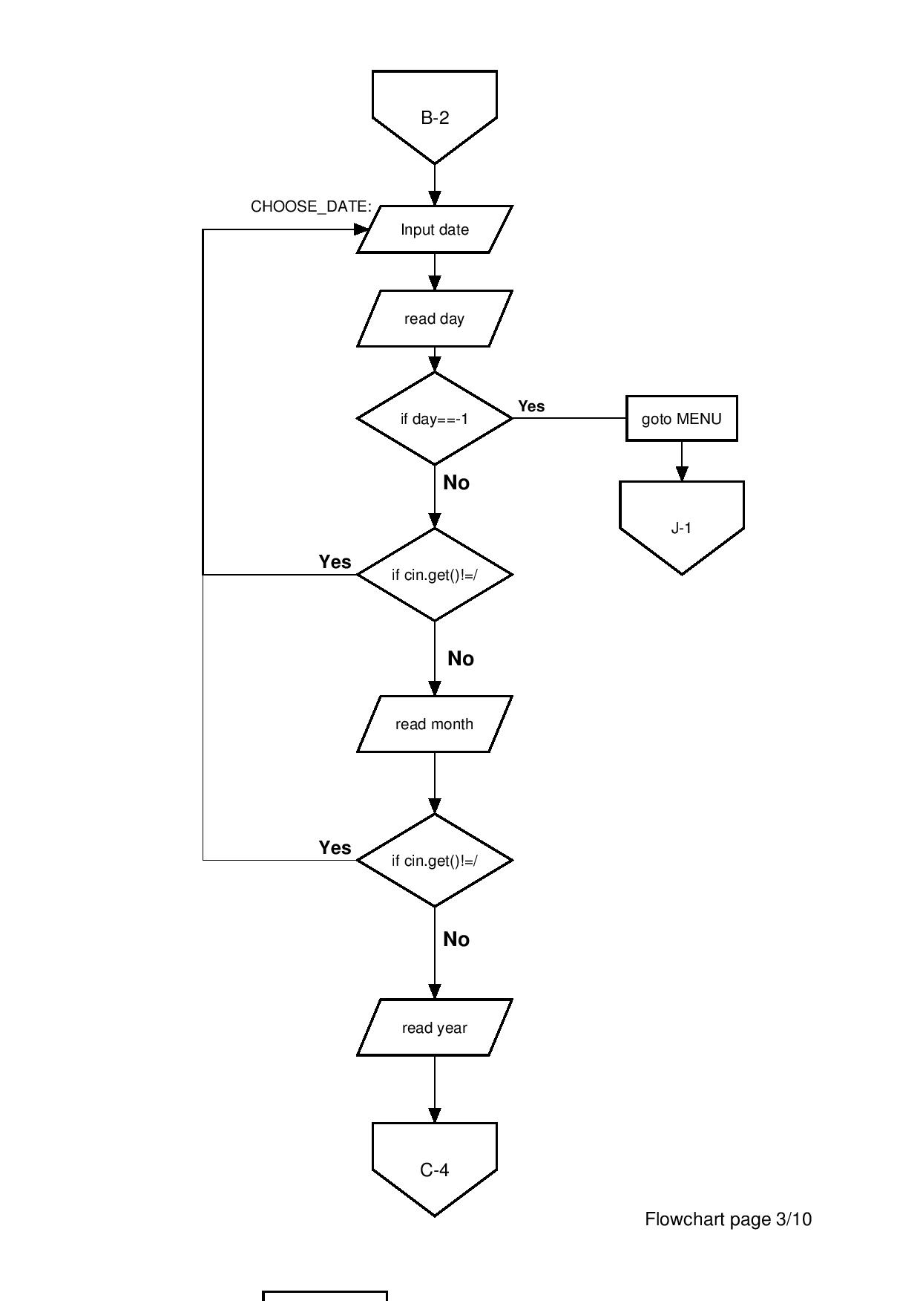

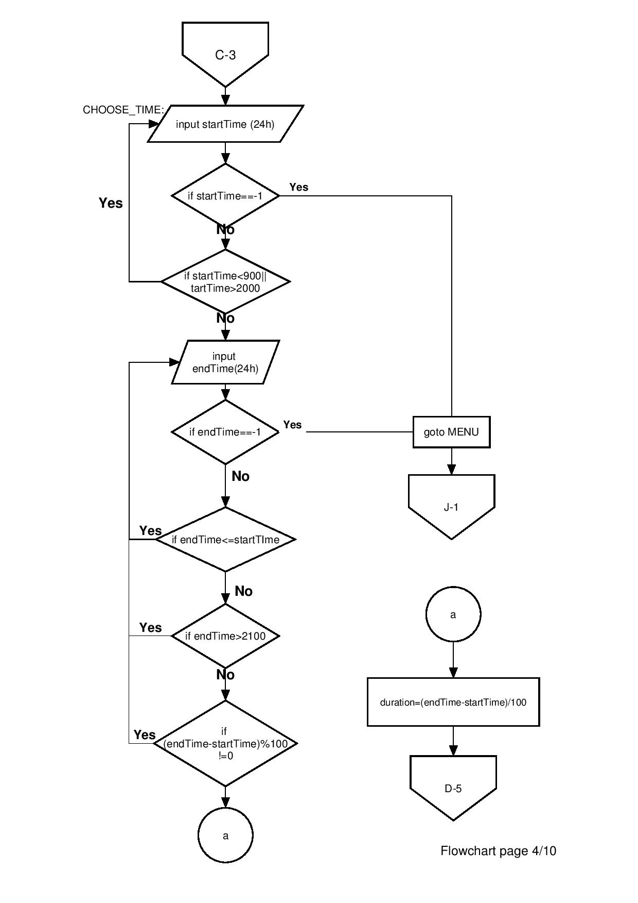

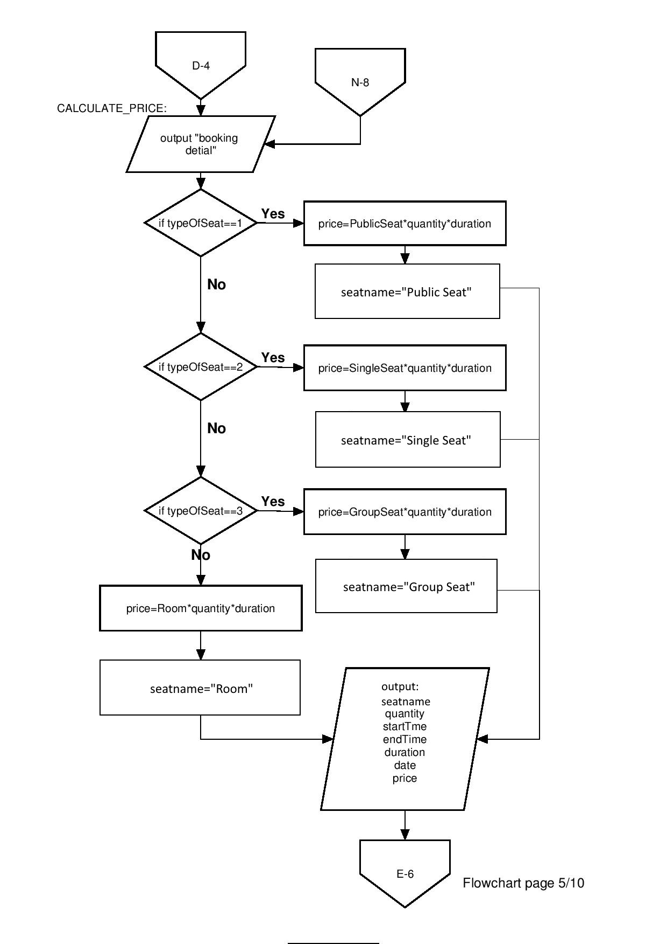

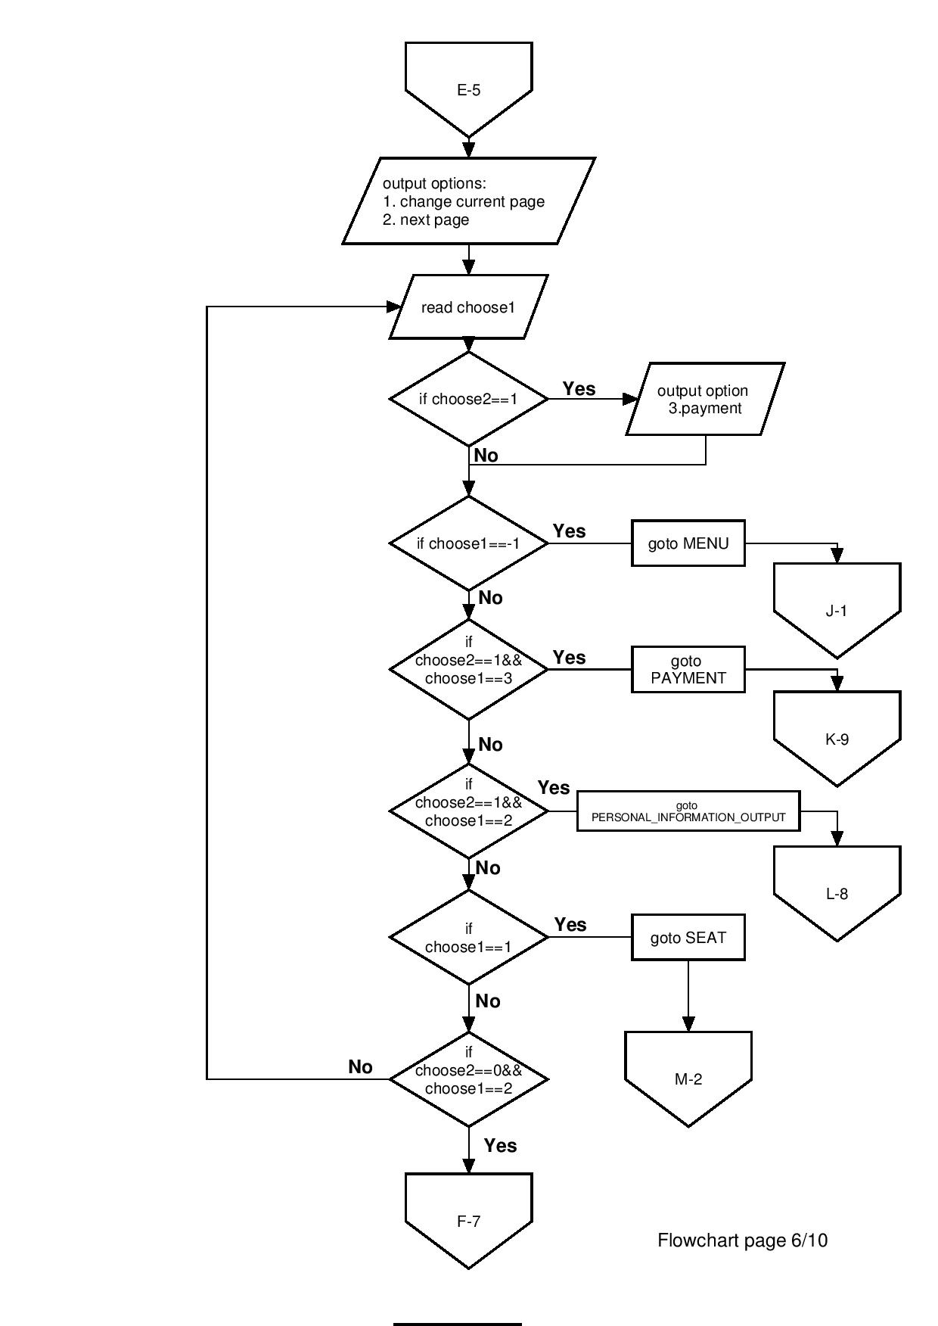

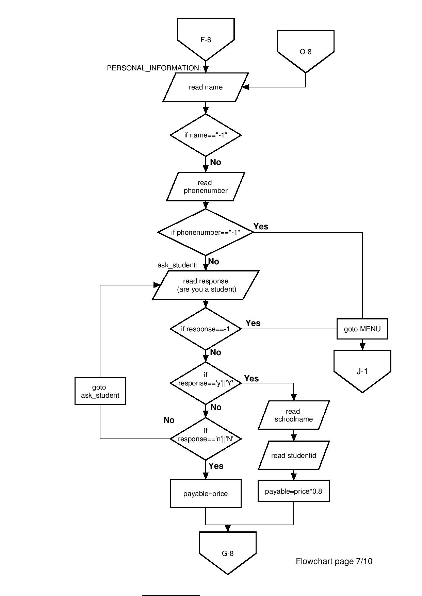

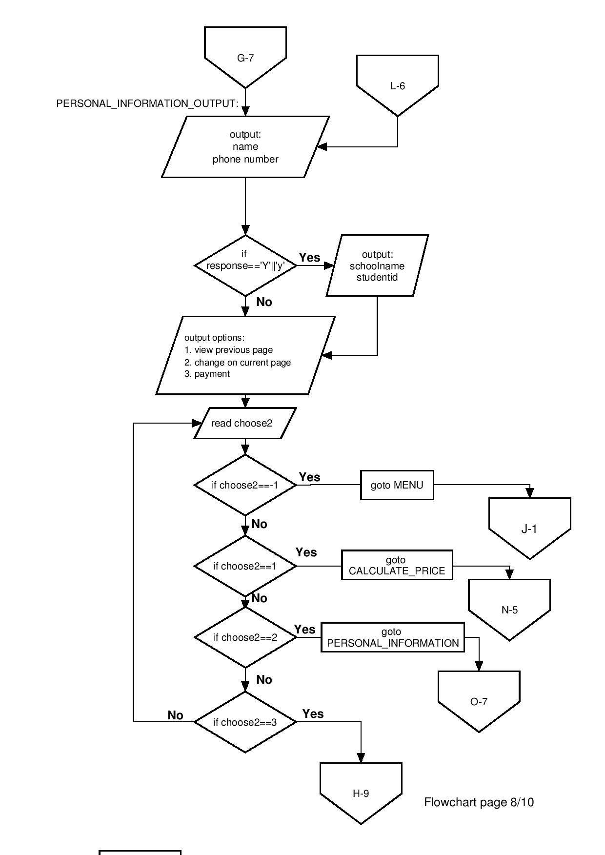

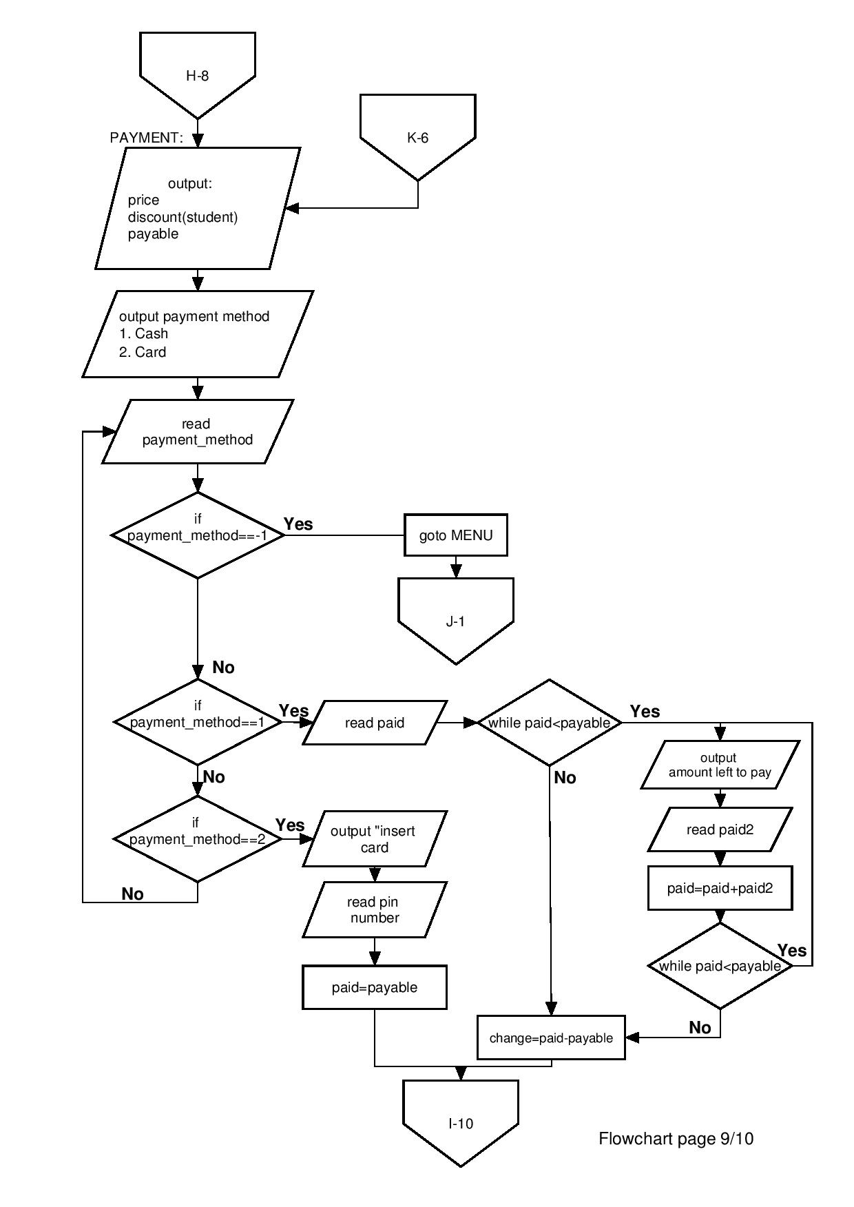

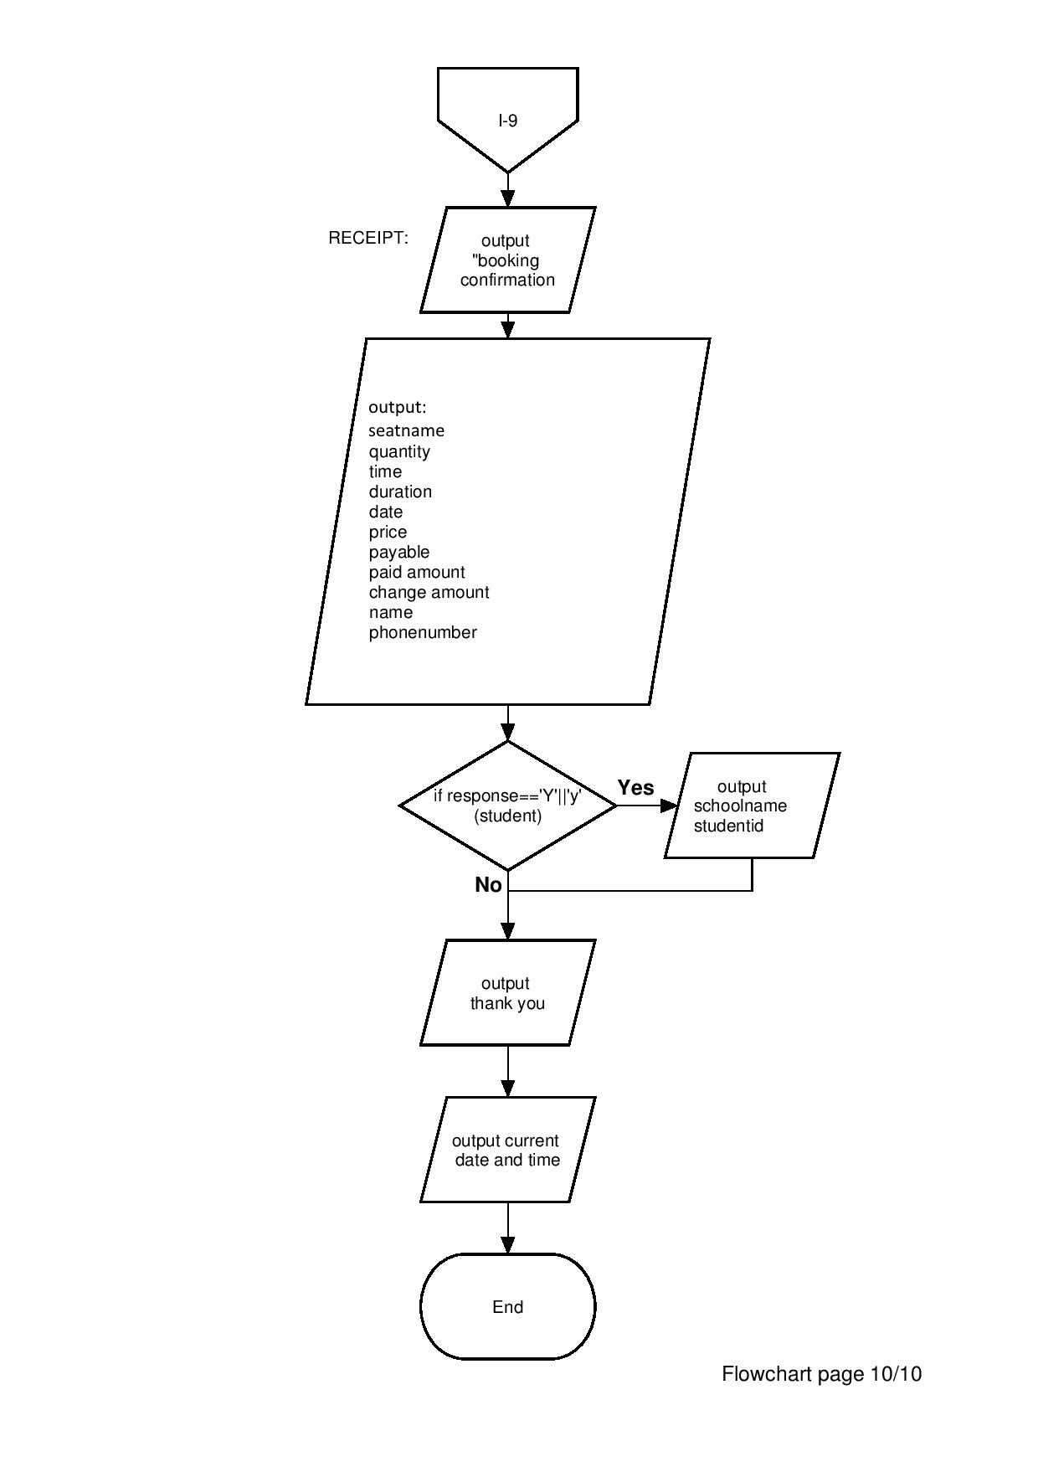

# Codes

#include <iostream>

#include <iomanip>

#include <cstdlib>

#include <string>

#include <ctime>

#include <cmath>

#include <windows.h>

using namespace std;

const double PublicSeat=0;

const double SingleSeat=5;

const double GroupSeat=8;

const double Room=15;

int main()

{

int typeOfSeat;

string seatname;

int quantity;

double price;

string response;

int startTime, endTime;

double duration;

int d,m,y;

string name;

string phonenumber;

string studentid;

string schoolname;

double payable;

double paid, paid2, change;

int payment_method;

int pin;

int choose1,choose2;

time_t now = time(0); //get current date and time

tm *ltm = localtime(&now);

//menu/first page

MENU:

{

cout<<"==========================================="<<endl;

cout<<" Welcome to Pi Library"<<endl;

cout<<"==========================================="<<endl<<endl;

cout<<" Working Hour: 0900-2100"<<endl<<endl;

cout<<"-------------------------------------------"<<endl;

cout<<" Type of seat Price per hour"<<endl;

cout<<"-------------------------------------------"<<endl;

cout<<" Public seat Free"<<endl;

cout<<" Single seat RM 5.00"<<endl;

cout<<" Group seat RM 8.00"<<endl;

cout<<" Room RM15.00"<<endl;

cout<<"-------------------------------------------"<<endl<<endl;

cout<<"******** 20% discount for student ********"<<endl<<endl;

system("pause");

system("cls");

choose1=0,choose2=0;

}

//choose seats

SEAT:

{

cout<<"Enter '-1' to quit reservation"<<endl<<endl;

cout<<"==========================================="<<endl;

cout<<" CHOOSE SEAT"<<endl;

cout<<"==========================================="<<endl<<endl;

cout<<"-------------------------------------------"<<endl;

cout<<" Type of seat Price per hour"<<endl;

cout<<"-------------------------------------------"<<endl;

cout<<" 1. Public seat Free"<<endl;

cout<<" 2. Single seat RM 5.00"<<endl;

cout<<" 3. Group seat RM 8.00"<<endl;

cout<<" 4. Room RM15.00"<<endl;

cout<<"-------------------------------------------"<<endl<<endl;

do{

cout<<"Enter number to choose your seat."<<endl;

cin>>typeOfSeat;

if(typeOfSeat==-1)

{

system("cls");

cout<<"You have quit from the reservation"<<endl;

cout<<"Thank You"<<endl;

Sleep(5000);

system("cls");

goto MENU;

}

else if(typeOfSeat!=1&&typeOfSeat!=2&&typeOfSeat!=3&&typeOfSeat!=4)

{

cout<<"*Please choose a valid number (1, 2, 3 or 4)"<<endl;

}

}while(typeOfSeat!=1&&typeOfSeat!=2&&typeOfSeat!=3&&typeOfSeat!=4&&typeOfSeat!=-1);

do{

cout<<endl<<"How many seats would you like?"<<endl;

cin>>quantity;

if(quantity==-1)

{

system("cls");

cout<<"You have quit from the reservation"<<endl;

cout<<"Thank You"<<endl;

Sleep(5000);

system("cls");

goto MENU;

}

if (quantity<=0)

{

cout<<"*Please choose a valid value"<<endl;

}

}while(quantity<=0);

//choose date

CHOOSE_DATE:

cout<<endl<<"Choose date ( DD / MM / YYYY )"<<endl;

cin >> d; // read the day

if(d==-1)

{

system("cls");

cout<<"You have quit from the reservation"<<endl;

cout<<"Thank You"<<endl;

Sleep(5000);

system("cls");

goto MENU;

}

if(cin.get()!='/')

{

cout<<"*Please follow the format ( DD / MM / YYYY )"<<endl;

goto CHOOSE_DATE;

}

cin >> m; // read the month

if(cin.get()!='/')

{

cout<<"*Please follow the format ( DD / MM / YYYY )"<<endl;

goto CHOOSE_DATE;

}

cin >> y; // read the year

//invalid for passed date (extra);

if((y==1900+ltm->tm_year)&&(m==1+ltm->tm_mon)&&(d<ltm->tm_mday))

{

cout<<"*Please choose a valid date"<<endl;

goto CHOOSE_DATE;

}

if((y==1900+ltm->tm_year)&&(m<1+ltm->tm_mon))

{

cout<<"*Please choose a valid date"<<endl;

goto CHOOSE_DATE;

}

if(y<1900+ltm->tm_year)

{

cout<<"*Please choose a valid date"<<endl;

goto CHOOSE_DATE;

}

//invalid for invalid date (extra)

if(d<1)//day

{

cout<<"*Please choose a valid date"<<endl;

goto CHOOSE_DATE;

}

else if((m>12)||(m<1))//month 1-12

{

cout<<"*Please choose a valid date"<<endl;

goto CHOOSE_DATE;

}

else if ((y%4==0)&&(m==2)&&(d>29)) //February leap year

{

cout<<"*Please choose a valid date"<<endl;

goto CHOOSE_DATE;

}

else if ((y%4!=0)&&(m==2)&&(d>28)) //February common year

{

cout<<"*Please choose a valid date"<<endl;

goto CHOOSE_DATE;

}

else if ((m==1)&&(m==3)&&(m==5)&&(m==7)&&(m==8)&&(m==10)&&(m==12)&&(d>31)) //a solar month of 31 days

{

cout<<"*Please choose a valid date"<<endl;

goto CHOOSE_DATE;

}

else if ((m==4)&&(m==6)&&(m==9)&&(m==11)&&(d>30)) //a lunar month of 30 days

{

cout<<"*Please choose a valid date"<<endl;

goto CHOOSE_DATE;

}

//choose time

CHOOSE_TIME:

do{

cout<<endl<<"Select time start (24h): (HHMM)"<<endl;

cin>>startTime;

if(startTime==-1)

{

system("cls");

cout<<"You have quit from the reservation"<<endl;

cout<<"Thank You"<<endl;

Sleep(5000);

system("cls");

goto MENU;

}

else if((startTime<900) || (startTime>2000))

{

cout<<"*Please choose the time within our working hour(0900-2100)"<<endl<<endl;

}

else if ((startTime%100)>59) //max 59 minutes (extra)

{

cout<<"*Please choose a valid time"<<endl;

}

}while((startTime<900) || (startTime>2000)||(startTime%100>59));

//invalid for passed time (extra)

if((y==1900+ltm->tm_year)&&(m==1+ltm->tm_mon)&&(d==ltm->tm_mday)&&(startTime/100<ltm->tm_hour))//invalid for passed hour

{

cout<<"*Please choose a valid time"<<endl;

goto CHOOSE_TIME;

}

else if((y==1900+ltm->tm_year)&&(m==1+ltm->tm_mon)&&(d==ltm->tm_mday)&&(startTime/100==ltm->tm_hour)&&(startTime%100<=ltm->tm_min))//invalid for passed minutes

{

cout<<"*Please choose a valid time"<<endl;

goto CHOOSE_TIME;

}

do{

cout<<endl<<"Select time end (24h): (HHMM)"<<endl;

cin>>endTime;

if(endTime==-1)

{

system("cls");

cout<<"You have quit from the reservation"<<endl;

cout<<"Thank You"<<endl;

Sleep(5000);

system("cls");

goto MENU;

}

if(endTime<=startTime)

{

cout<<"*Please choose the time after your starting time"<<endl<<endl;

}

else if(endTime>2100)

{

cout<<"*Please choose the time within our working hour(0900-2100)"<<endl<<endl;

}

else if(endTime%100>59) //max 59 minutes (extra)

{

cout<<"*Please choose a valid time"<<endl;

}

else if((endTime-startTime)%100!=0)

{

cout<<"*The time slot available is measured in hour"<<endl;

}

}while((endTime<=startTime)||(endTime>2100)||((endTime%100)>59)||(endTime-startTime)%100!=0);

duration=((endTime-startTime)/100);

}

cout<<endl;

system("pause");

system("CLS");

//calculation for price

CALCULATE_PRICE:

{

cout<<"Enter '-1' to quit reservation"<<endl<<endl;

cout<<"==========================================="<<endl;

cout<<" Booking Details"<<endl;

cout<<"==========================================="<<endl<<endl;

if(typeOfSeat==1)

{

price=PublicSeat*quantity*duration;

seatname="Public Seat";

}

else if(typeOfSeat==2)

{

price=SingleSeat*quantity*duration;

seatname="Single Seat";

}

else if(typeOfSeat==3)

{

price=GroupSeat*quantity*duration;

seatname="Group Seat";

}

else

{

price=Room*quantity*duration;

seatname="Room";

}

cout<<fixed;

cout<<" Type Of Seat : "<<seatname<<endl;

cout<<" Quantity : "<<quantity<<endl;

if(startTime<=900)

cout<<" Time : 0"<<noshowpoint<<setprecision(0)<<startTime<<" - "<<endTime<<endl;

else

cout<<" Time : "<<noshowpoint<<setprecision(0)<<startTime<<" - "<<endTime<<endl;

if(duration>1)

cout<<" Duration : "<<duration<<" hours"<<endl;

else

cout<<" Duration : "<<duration<<" hour"<<endl;

cout<<" Date : "<<d<<"/"<<m<<"/"<<y<<endl;

cout<<" Price : RM "<<setprecision(2)<<price<<endl<<endl;

}

cout<<"Options"<<endl;

cout<<"1. Make change on current page"<<endl;

cout<<"2. Proceed to next page"<<endl;

if(choose2==1)

{

cout<<"3. Proceed to PAYMENT"<<endl;

}

do{

cout<<endl<<"Enter the number: ";

cin>>choose1;

if(choose1==-1)

{

system("cls");

cout<<"You have quit from the reservation"<<endl;

cout<<"Thank You"<<endl;

Sleep(5000);

system("cls");

goto MENU;

}

else if(choose2==1&&choose1==3)

{

system("cls");

goto PAYMENT;

}

else if (choose2==1&&choose1==2)

{

system("cls");

goto PERSONAL_INFORMATION_OUTPUT;

}

else if (choose1==1)

{

system("cls");

goto SEAT;

}

else if (choose2==0&&choose1==2)

{

cout<<endl;

system("cls");

}

if((choose2==0&&choose1!=1&&choose1!=2&&choose1!=-1)||(choose2==1&&choose1!=1&&choose1!=2&&choose1!=3&&choose1!=-1))

{

cout<<"*Please choose a valid option"<<endl;

}

}while ((choose2==0&&choose1!=1&&choose1!=2&&choose1!=-1)||(choose2==1&&choose1!=1&&choose1!=2&&choose1!=3&&choose1!=-1));

//personal information

PERSONAL_INFORMATION:

{

cout<<"Enter '-1' to quit reservation"<<endl<<endl;

cout<<"==========================================="<<endl;

cout<<" Personal Information"<<endl;

cout<<"==========================================="<<endl;

cout<<"Enter your name:"<<endl;

cin.ignore();

getline(cin,name);

if(name=="-1")

{

system("cls");

cout<<"You have quit from the reservation"<<endl;

cout<<"Thank You"<<endl;

Sleep(5000);

system("cls");

goto MENU;

}

cout<<endl<<"Enter your phone number: "<<endl;

cin>>phonenumber;

if(phonenumber=="-1")

{

system("cls");

cout<<"You have quit from the reservation"<<endl;

cout<<"Thank You"<<endl;

Sleep(5000);

system("cls");

goto MENU;

}

ask_student:

cout<<endl<<"Are you a student? (y/n)"<<endl;

cin.ignore();

cin>>response;

if(response=="-1")

{

system("cls");

cout<<"You have quit from the reservation"<<endl;

cout<<"Thank You"<<endl;

Sleep(5000);

system("cls");

goto MENU;

}

else if (response=="y"||response=="Y")

{

cout<<endl<<"Enter the name of your school: "<<endl;

cin.ignore();

getline(cin,schoolname);

if(schoolname=="-1")

{

system("cls");

cout<<"You have quit from the reservation"<<endl;

cout<<"Thank You"<<endl;

Sleep(5000);

system("cls");

goto MENU;

}

cout<<endl<<"Enter your student ID: "<<endl;

cin>>studentid;

if(studentid=="-1")

{

system("cls");

cout<<"You have quit from the reservation"<<endl;

cout<<"Thank You"<<endl;

Sleep(5000);

system("cls");

goto MENU;

}

payable=price*0.8;

}

else if (response=="n"||response=="N")

{

payable=price;

}

else

{

cout<<"*Please enter a valid input"<<endl;

goto ask_student;

}

cout<<endl;

}

system("pause");

system("CLS");

//output for personal information

PERSONAL_INFORMATION_OUTPUT:

{

cout<<"Enter '-1' to quit reservation"<<endl<<endl;

cout<<"=========================================="<<endl;

cout<<" Personal Information"<<endl;

cout<<"=========================================="<<endl<<endl;

cout<<" Name : "<<name<<endl;

cout<<" Phone number : "<<phonenumber<<endl;

if(response=="Y"||response=="y")

{

cout<<" School : "<<schoolname<<endl;

cout<<" Student ID : "<<studentid<<endl;

}

cout<<endl;

}

cout<<"Options"<<endl;

cout<<"1. View previous page"<<endl;

cout<<"2. Make change on current page"<<endl;

cout<<"3. Proceed to PAYMENT"<<endl;

do{

cout<<endl<<"Enter the number: ";

cin>>choose2;

if(choose2==-1)

{

system("cls");

cout<<"You have quit from the reservation"<<endl;

cout<<"Thank You"<<endl;

Sleep(5000);

system("cls");

goto PERSONAL_INFORMATION;

}

else if (choose2==1)

{

system("cls");

goto CALCULATE_PRICE;

}

else if (choose2==2)

{

system("cls");

goto PERSONAL_INFORMATION;

}

else if (choose2==3)

{

system("cls");

goto PAYMENT;

}

else

{

cout<<"*Please choose a valid option"<<endl;

}

}while (choose2!=1&&choose2!=2&&choose2!=3&&choose2!=-1);

system("pause");

system("cls");

//payment

PAYMENT:

{

cout<<"Enter '-1' to quit reservation"<<endl<<endl;

cout<<"==========================================="<<endl;

cout<<" Payment"<<endl;

cout<<"==========================================="<<endl<<endl;

cout<<" Price : RM "<<showpoint<<setprecision(2)<<price<<endl;

if(response=="y"||response=="Y")

cout<<" * Student Price -20% *"<<endl;

cout<<"-------------------------------------------"<<endl;

cout<<" Total Payable : RM "<<payable<<endl;

cout<<"-------------------------------------------"<<endl;

cout<<endl;

do{

cout<<"Choose a payment method"<<endl;

cout<<"1. Cash"<<endl;

cout<<"2. VisaCard / MasterCard"<<endl;

cin>>payment_method;

cout<<endl;

if (payment_method==-1)

{

system("cls");

cout<<"Reservation has been canceled"<<endl;

Sleep(5000);

system("cls");

goto MENU;

}

else if(payment_method==1)

{

cout<<"You have chosen Cash."<<endl<<endl;

cout<<"Enter the amount you have paid "<<endl<<"RM ";

cin>>paid;

while(paid<payable)

{

cout<<"You still have RM "<<payable-paid<<" more to Pay"<<endl;

cout<<"Enter the amount you have paid again"<<endl;

cin>>paid2;

paid=paid+paid2;

}

change=paid-payable;

cout<<"Your payment is successful."<<endl;

if(change>0)

{

cout<<"Your change is RM "<<change<<endl;

}

}

else if (payment_method==2)

{

cout<<"You have chosen VisaCard / MasterCard"<<endl<<endl;

cout<<"Please insert your MasterCard or VisaCard..."<<endl<<endl;

system("pause");

cout<<endl<<"Enter your pin number"<<endl;

cin>>pin;

paid=payable;

}

else

{

cout<<"*Please choose a valid option"<<endl;

}

}while(payment_method!=1&&payment_method!=2&&payment_method!=-1);

}

cout<<endl<<"Your payment has successful"<<endl<<endl;

system("pause");

system("CLS");

//receipt booking confirmation

RECEIPT:

{

cout<<"==========================================="<<endl;

cout<<" Booking Confirmation"<<endl;

cout<<"==========================================="<<endl<<endl;

cout<<" Type Of Seat : "<<seatname;

cout<<" x"<<quantity<<endl;

if(startTime<=900)

cout<<" Time : 0"<<noshowpoint<<setprecision(0)<<startTime<<" - "<<endTime<<endl;

else

cout<<" Time : "<<noshowpoint<<setprecision(0)<<startTime<<" - "<<endTime<<endl;

if(duration>1)

cout<<" Duration : "<<duration<<" hours"<<endl;

else

cout<<" Duration : "<<duration<<" hour"<<endl;

cout<<" Date : "<<d<<"/"<<m<<"/"<<y<<endl;;

cout<<"-------------------------------------------"<<endl;

cout<<" Price : RM "<<showpoint<<setprecision(2)<<price<<endl;

if(response=="y"||response=="Y")

cout<<" * Student Price -20% *"<<endl;

cout<<"-------------------------------------------"<<endl;

cout<<" Total payable : RM "<<payable<<endl<<endl;

cout<<" Paid amount : RM "<<paid<<endl;

cout<<" Change amount : RM "<<change<<endl<<endl<<endl;

cout<<" Name : "<<name<<endl;

cout<<" Phone No : "<<phonenumber<<endl;

if (response=="y"||response=="Y")

{

cout<<" School : "<<schoolname<<endl;

cout<<" Student ID : "<<studentid<<endl<<endl<<endl;

}

cout<<" Thank you for choosing Pi Library"<<endl;

cout<<" Please come again..."<<endl<<endl;

}

//get current date and time

DATE_TIME:

{

if(ltm->tm_mday>=10)

cout<<ltm->tm_mday<<"/";

else

cout<<"0"<<ltm->tm_mday<<"/";

if( 1 + ltm->tm_mon>=10)

cout<<1+ltm->tm_mon<<"/";

else

cout<<"0"<<1+ltm->tm_mon<<"/";

cout<<1900 + ltm->tm_year;

cout << setw(25);

if(ltm->tm_hour>=10)

cout << ltm->tm_hour << ":";

else

cout << "0"<<ltm->tm_hour << ":";

if(ltm->tm_min>=10)

cout << ltm->tm_min << ":";

else

cout <<"0"<< ltm->tm_min << ":";

if(ltm->tm_sec>=10)

cout << ltm->tm_sec << endl;

else

cout <<"0"<< ltm->tm_sec << endl;

}

return 0;

}

# Conclusion

The library seat reservation will manage the information which is chosen by customers. The students can select the type of seat which is suitable to them to study at the best environment. Besides that, it will promote the discount to students to encourage them come to library study, reading and even group discussion also can carry out in a good atmosphere. We believe that with the help of system, the whole process will be more advanced and more students willing to visit our library to promote social reading. During the work cooperation with group members, we got the opportunity to learn a lot of skills of creating a programme and we are able to gain extra knowledge due to the online research to write a program.