State Department   
of Public Health  
  
eReferral System

**Technical Support DocumentatioN**

**eReferral System OVERVIEW**

Contents

Introduction 3

eReferral System Features 3

Use Case Overview 5

Use Case #1 5

Use Case #2 6

Use Case #3 6

Use Case Diagram 6

Documentation Overview 6

Technical Assistance 7

Next Steps 7

Glossary 7

# Introduction

The eReferral System was developed under a CMS State Innovation Model grant beginning in 2014. The State had operated a pilot version of the eReferral System for several years and submitted a proposal to CMMS to expand the system on a larger scale. Additional funding through State sources helped support the expansion of the project to additional healthcare providers in the following years of the project. The eReferral system supports fully integrated referrals and feedback reports between healthcare providers and their community-based partner organizations with a specific goal of supporting social determinants of health. While the eReferral system supports fully integrated referrals with a number of commercial EMR systems, it also provides a browser-based user interface for those organizations that don't require or can't support integration with EMR systems.

# eReferral System Features

The eReferral System has a number of features to support the configuration of the system as well as features to support the processing of referrals between sending and receiving organizations. System features can be broadly categorized as "user" based functions and "system administrator" functions as shown in the figure below. A good understanding of the system must be developed before subsequent steps of the system implementation process (installation, configuration, on-boarding and system operation) are pursued.

As shown in the figure below, there are two points of access to the system via a web browser. The **Main Page** is accessed by the end-user and supports functions associated with processing referrals and maintaining user and organization profiles. The **System Administrator Page** is accessed by the system administrator and provides access to more complex modules associated with configuring and managing the system. The following table describes the major features of the eReferral System.

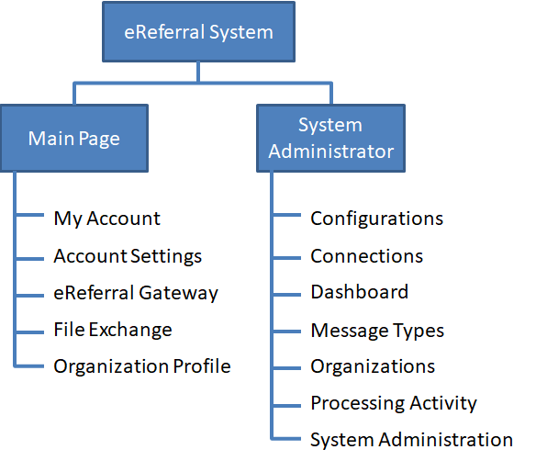

| **eReferral System Feature and Functions** | | |
| --- | --- | --- |
| **Feature** | **Function** | **Guide Reference** |
| **Main Page** |  |  |
| My Account | Returns the user to the Main Page | User Guide |
| Account Settings | Web form for entering user contact information and changing password. | User Guide |
| eReferral Gateway | Web-based tool for submitting (manual data entry) and receiving referrals and feedback reports. | User Guide |
| File Exchange | Web-based tool for submitting and receiving referrals and feedback reports via batch file upload/download. | User Guide |
| Organization Profile | Web form for entering contact information for organization profile. | User Guide |
| **System Administrator** |  |  |
| Configurations | Web form for creating and editing technical specifications for how specific organizations process messages into and out of the eReferral System. | System Administrator Guide |
| Connections | Web form for creating and editing how sending and receiving organizations exchange messages with each other through the eReferral system. | System Administrator Guide |
| Dashboard | Summary view of system settings (organizations, message types, configurations and connections) and processing activity. | System Administrator Guide |
| Message Types | Web form for creating and editing message types for referrals and feedback reports. | System Administrator Guide |
| Organizations | Web form for reviewing and editing organization configuration specifications. | System Administrator Guide |
| Processing Activity | Web form for reviewing and managing message processing activity through the eReferral System. | System Administrator Guide |
| System Administration | Web form for reviewing and editing eReferral system parameters and features. | System Administrator Guide |

# Use Case Overview

To provide context to users of the supplied documentation, a specific set of use cases have been defined to provide clear reference information during the installation, configuration, on-boarding and system operation processes.

## Use Case #1

The **Community Clinic** sends smoking cessation referrals to their community-based partner, **Stop Now**. The Community Clinic has an older EMR system that doesn't directly support referrals. Community Clinic has decided to use the eReferral System user interface (the eReferral Gateway) to send referrals and received feedback reports.

## Use Case #2

The **Family Health Center** sends smoking cessation referrals their community-based partner, StopNow. StopNow is a smoking cessation service provider that provides counseling services for people interested in quitting smoking. The Family Health Center has an EMR system but their system can't support direct integration with the eReferral system. The Family Health Center is able to support batch file processing for both referrals and feedback reports.

## Use Case #3

**StopNow** receives referrals and sends feedback reports primarily through eFax and paper-based fax processes. StopNow uses a commercial EMR system to track referral activity including patient registration and service delivery. StopNow has elected to use the eReferral Gateway to receive referrals and deliver feedback reports with healthcare providers on the eReferral System.

## Use Case Diagram

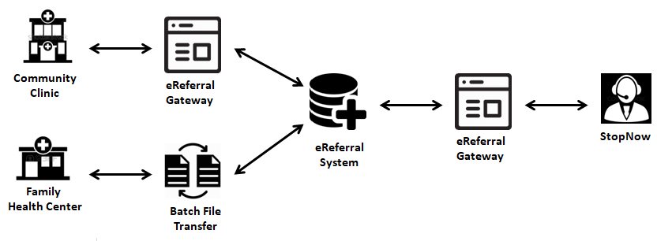

# Documentation Overview

The following technical documents are available to staff responsible for the implementation, configuration, and use of the eReferral System.

**Installation Guide** – The steps to establish the eReferral system, including installing servers and software, and configuring the software to make the system functional.

**Implementation Guide** – The overall process of engaging prospective system users and on-boarding them onto the eReferral System. The process includes: Establishing partnerships, formalizing relationships, defining referral types, referral content and workflow, technical system integration, training and go live.

**System Administrator Guide -** A technical reference for system administrators to support the configuration of the eReferral System as well as the ongoing operation system.

**User Guide** – A technical reference for eReferral System end users.

# Technical Assistance

The eReferral System is supported by BowLink Technologies, Inc. Technical assistance can be obtained by contacting helpdesk@health-e-link.net.

# Next Steps

Other guides are available to assist staff with the installation, configuration, implementation, use and ongoing operation of the eReferral System. The following steps should be followed:

* Use the **Installation Guide** to set up the servers and software and create the baseline configuration of the system.
* Use the **System Administration Guide** configuration section to configure the eReferral System for the specific use cases reviewed above.
* Use the **User Guide** to test the system from an end user perspective after it has been configured.
* After the system is fully configured in a production environment, use the **Implementation Guide** for engaging potential users of the system.
* After users are implemented in the production environment, use the **System Administrator Guide** to monitor and support the system on a day-to-day basis.

# Glossary

The glossary provided here applies to all support documentation.

**Batch -** A batch refers to a message coming into or out of the eReferral system via any transport type (eRG, Web Services, File Upload or SFTP). A batch can be a referral or a feedback report and inside a batch will contain one or more transactions.

**CBO -** Community Based Organization, such as a Visiting Nurse Association (VNA), YMCA, Legal Aid, Smoking Cessation Vendor or Elder Services firm.

**CCD - Continuity of Care Document.** An electronic messaging standard in the healthcare field that contains specific requirements for creating and transferring a patient summary from one healthcare provider to another to support continuity of care. The primary use case is to provide a snapshot in time containing the pertinent clinical, demographic, and administrative data for a specific patient. A CCD is a sub-part of the much larger C-CDA standard (below).

**C-CDA** - The Consolidated Clinical Document Architecture (C-CDA) is a very broad set of standards that provide a common architecture, coding, semantic framework, and markup language for the creation of electronic clinical documents. It can be used to communicate just about any kind of health information created in the context of patient care, as well as a range of administrative or patient population data. CDA documents are templated, which means they use standardized groupings of information organized according to clinical context. They are also object oriented, which means the standard makes use of classes, associations, and inheritance, which allows tremendous flexibility and re-use.

**CDC –** US Centers for Disease Control and Prevention, based in Atlanta, GA; funds state and territorial public health agencies for a range of chronic disease prevention and health promotion programs

**CHC** - Community Health Center.

**CMS –US/Department of Health and Human Services,** Centers for Medicare and Medicaid Services. This is the federal agency funding the State Innovation Model (SIM) grant that resulted in the development of the eReferral System.

**CHW -** Community Health Worker. CHWs are specialists in outreach, education, direct services, and advocacy for the most vulnerable residents in communities across the country.

**CPT Codes** - **Current Procedural Terminology Codes** are coded alphanumeric values assigned to every task and service a medical practitioner may provide to a patient (although not a Medicare patient - see note below) including medical, surgical and diagnostic services. CPT codes are then used by insurers to consistently identify services provided to patients in order to support reimbursement that a practitioner will receive by an insurer when he or she performs that service.

**Dyads -** The term used by the e-referral project to refer to the pairs of clinical and community partners who willsend and receive patient referrals and feedback reports for a selected health condition.

**EMR/EHR -** Electronic medical records or electronic health records are an electronic means of capturing and storing patient medical information. These systems are increasing in use throughout the US healthcare system, in inpatient and outpatient facilities, including hospitals, clinics, and provider practices or networks, spurred by CMS incentives for adoption of and meaningful use of certified EHRs.

**eRG – The Electronic Referral Gateway (eRG).** The Gateway or eRG is a web-enabled exchange portal that allows healthcare providers and their community based organization partners to cost-effectively send, receive, and exchange patient healthcare information.

**Gateway** – See “eRG” above.

**HIE – Health information exchange** (HIE) refers to the transfer of health information (typically, patient information) among healthcare provider organizations. The term health information exchange may also refer to the organization or system that facilitates the exchange. HIE provides the capability to electronically move clinical information among disparate [health care](http://en.wikipedia.org/wiki/Health_care) information systems while maintaining the meaning of the information being exchanged.

**HIT** - health information technology; a general term for the various technologies including systems, networks, databases, software applications and other tools that are used to support the nation's healthcare system.

**HISP - Health Information Service Provider (HISP)** A HISP is an organization that manages security and transport of health information among health care entities or individuals using the Direct standard for transport.  There is no specific legal designation for a HISP, nor are HISPs specifically regulated by Meaningful Use certification rules.  HISP functions can be performed by existing organizations (such as EHR vendors or hospitals or HIE organizations) or by standalone organizations specializing in HISP services.

**ICD-9-CM International Classification of Diseases**, 9th edition, Clinical Modification is a set of **codes** used by physicians, hospitals, and allied health workers to indicate diagnosis for all patient encounters. The National Center for Health Statistics (NCHS) and the [Centers for Medicare and Medicaid Services](http://www.cms.hhs.gov/) are the U.S. governmental agencies responsible for overseeing all changes and modifications to the ICD-9-CM.

**ICD 10** - Please refer to ICD-9 referenced above.

**LOINC - Logical Observation Identifiers Names and Codes (LOINC**) are a set of universal code names and identifiers that consistently represent [medical terminology](http://en.wikipedia.org/wiki/Medical_terminology) related to [electronic health records](http://en.wikipedia.org/wiki/Electronic_health_record). The purpose is to assist in the electronic exchange and gathering of clinical results (such as laboratory tests, clinical observations, outcomes management and research). LOINC has two main parts: laboratory LOINC and clinical LOINC. Clinical LOINC contains a subdomain of Document Ontology which captures types of clinical reports and documents. LOINC codes are maintained by the Regenstrief Institute, a US non-profit medical research organization which provides an electronic database of LOINC codes which is publicly available at no cost.

**HL7** – Health Level Seven is a set of standards for exchanging information between medical applications. This standard defines standard formats for a wide range of healthcare transactions such as admission, discharge, transfer, lab order, lab result and many others.

**MU, Meaningful Use (Stages 1, 2 and 3) -** The American Recovery and Reinvestment Act of 2009 authorizes the Centers for Medicare & Medicaid Services (CMS) to provide incentive payments to eligible professionals (EPs) and hospitals who adopt, implement, upgrade, or demonstrate meaningful use of certified electronic health record (EHR) technology. To receive an EHR incentive payment, providers have to show that they are meaningfully using their EHRs by meeting thresholds for a number of objectives. The EHR Incentive Programs are phased in three stages with increasingly complex and comprehensive requirements. Providers must attest to demonstrating meaningful use **every year** to receive an incentive and avoid a Medicare payment adjustment.

**NextGen-** An electronic health record vendor used by many community health centers and health care providers.

**Onboard, Onboarding –** A sequence of steps needed to prepare healthcare providers and their community based organizations to begin making and receiving e-referrals and feedback reports.

**Pending Delivery** - The eReferral System supports the scheduled delivery of referrals and/or feedback reports. Until the scheduled delivery time is reached, transactions are stored in the system in pending delivery status.

**SFTP** – Secure File Transfer Protocol; a means of sending secure data between partnering organizations via the Internet.

**SIM/ CMS SIM Project -** State Innovations Model Testing Award; These are competitive awards made to states by the Centers for Medicare and Medicaid Services to test innovations. One component of the MA SIM award is to build and pilot the e-referral system.

**Quitline** -The Smoker’s Quitline is a telephone-based statewide support and counseling service for any tobacco user.

**ONC-** The Office of the National Coordinator for Health Information Technology (ONC) is at the forefront of the United States Government's health IT efforts and is a resource to the entire health system to support the adoption of health information technology and the promotion of nationwide health information exchange to improve health care. ONC is organizationally located within the Office of the Secretary for the U.S. Department of Health and Human Services (HHS).

**SSES SNOWMED SNOMED CT ]or SNOMED Clinical Terms** is a systematically organized computer processable collection of [medical terms](http://en.wikipedia.org/wiki/Medical_terms) providing codes, terms, synonyms and definitions used in clinical documentation and reporting. SNOMED CT provides the core general terminology for [electronic health records](http://en.wikipedia.org/wiki/Electronic_health_record). It is considered the most comprehensive, multilingual clinical healthcare terminology in the world for clinical findings, symptoms, diagnoses, procedures, body structures, organisms and other etiologies, substances, pharmaceuticals, devices and specimen.[[3]](http://en.wikipedia.org/wiki/SNOMED_CT#cite_note-http:.2F.2Fwww.ihtsdo.org.2Fsnomed-ct-4) - redundant with the SNOMED reference above. I'd remove this.

**UT, Universal Translator** – a component of the e-Referral System that supports data exchange between healthcare provider EMR systems and the eReferral system. The universal translator supports a wide variety of electronic transport methods, message formats and code sets to enable data translation and data exchange between healthcare providers and their collaborating partners in a minimally burdensome way.