
IT342-Section
SYSTEMS INTEGRATION AND ARCHITECTURE 1

FUNCTIONAL REQUIREMENTS SPECIFICATION (FRS)

Project Title: Mini App - User Registration & Authentication
Prepared By: Niña Nicole S. Villadarez
Date of Submission: 02/11/2026
Version: 2

Table of Contents
1. Introduction 3
1.1. Purpose 3
1.2. Scope 3
1.3. Definitions, Acronyms, and Abbreviations 3
2. Overall Description 3
2.1. System Perspective 3
2.2. User Classes and Characteristics 3
2.3. Operating Environment 3
2.4. Assumptions and Dependencies 3
3. System Features and Functional Requirements 3
3.1. Feature 1: 3
3.2. Feature 2: 3
4. Non-Functional Requirements 3
5. System Models (Diagrams) 4
5.1. ERD 4
5.2. Use Case Diagram 4
5.3. Activity Diagram 4
5.4. Class Diagram 4
5.5. Sequence Diagram 4
6. Appendices 4

Introduction

Purpose
This document defines the functional and non-functional requirements of a mini authentication application for user registration and login.
It is intended for:
- Students
- Developers
- Testers
- Project stakeholders
- Instructors

Scope
In scope:
- User registration with basic information
- User login with credentials
- Token-based authentication
- Access to a protected user profile
- Secure logout
- Password hashing
- Username and email uniqueness validation
Out of scope:
- Password reset / forgot password
- Email verification
- Social login
- Roles and permissions
- Multi-factor authentication
- Profile editing and account deletion

Definitions, Acronyms, and Abbreviations

Term | Definition
JWT | A token used for stateless authentication
API | Application Programming Interface
BCrypt | Secure password hashing algorithm
REST | Web service architecture using HTTP methods
CORS | Security mechanism for cross-origin requests
SPA | Single Page Application
JPA | Java Persistence API for database access

Overall Description

System Perspective
The system provides a basic authentication layer for a web application.
It uses a three-tier structure:
- Presentation Layer – User interface for login and registration
- Business Logic Layer – Handles authentication rules and token validation
- Data Layer – Stores user credentials and profile data
The system communicates using RESTful APIs and maintains authentication through JWT tokens.

User Classes and Characteristics
Guest Users
- Can register and login
- No access to protected pages
Authenticated Users
- Can access profile/dashboard
- Can logout
- Have a valid JWT token

Operating Environment
- Runs on modern web browsers
- Requires internet connection
- Uses a backend server and relational database
- Tokens are stored in browser local storage

Assumptions and Dependencies
Assumptions
- Users have valid emails
- Internet access is available
- Browsers support localStorage
- Database and server are reachable
Dependencies
- Authentication framework
- JWT library
- Password hashing library
- Database driver
- HTTP client

System Features and Functional Requirements
Describe each major feature of the system and its functional requirements.

Feature 1: User Registration
Description: Allows new users to create an account by providing their basic information. The system validates the input, securely stores the credentials, and automatically logs the user in after successful registration.
Functional Requirements:
- Accept username, email, password, first name, last name
- Validate unique username and email
- Validate email format
- Enforce password length (min. 8)
- Hash password before saving
- Store user in database
- Generate JWT token after success
- Return: 201 Created on success, 409 Conflict if username/email exists, 400 Bad Request for validation errors

Feature 2: User Login
Description: Authenticates existing users by verifying their credentials and granting them access to protected areas of the system.
Functional Requirements:
- Accept username and password
- Validate user existence

- Verify password
- Generate JWT token
- Return: 200 OK on success, 401 Unauthorized on failure
- Client stores token and redirects to dashboard
3.3 Feature 3: Profile Access (Protected)
Description: Allows logged-in users to view their profile information. Access is restricted to users with a valid authentication token.
Functional Requirements:
- Require Authorization: Bearer <token>
- Validate token signature and expiration
- Extract username from token
- Fetch user profile
- Exclude password from response
- Return 401 Unauthorized if invalid
3.4 Feature 4: User Logout
Description: Ends the user’s session by invalidating the current token, preventing further access to protected resources.
Functional Requirements:
- Require valid token
- Invalidate token (blacklist)
- Return success message
- Client deletes token and redirects to login

Non-Functional Requirements
Performance
- API responses < 500 ms
- Token validation < 50 ms
- Security
BCrypt password hashing
- Encrypted JWT tokens
- HTTPS enforced
- Input validation
- SQL injection protection
- Token blacklist
Usability
- Clear error messages
- Responsive UI
- Real-time form validation
Reliability
- Graceful error handling
- Authentication error rate < 1%
Maintainability
- Layered architecture
- Centralized business logic
- Externalized configuration
Compatibility
- Works on modern browsers
- Supports relational databases
- REST-compliant API

System Models (Diagrams)

ERD
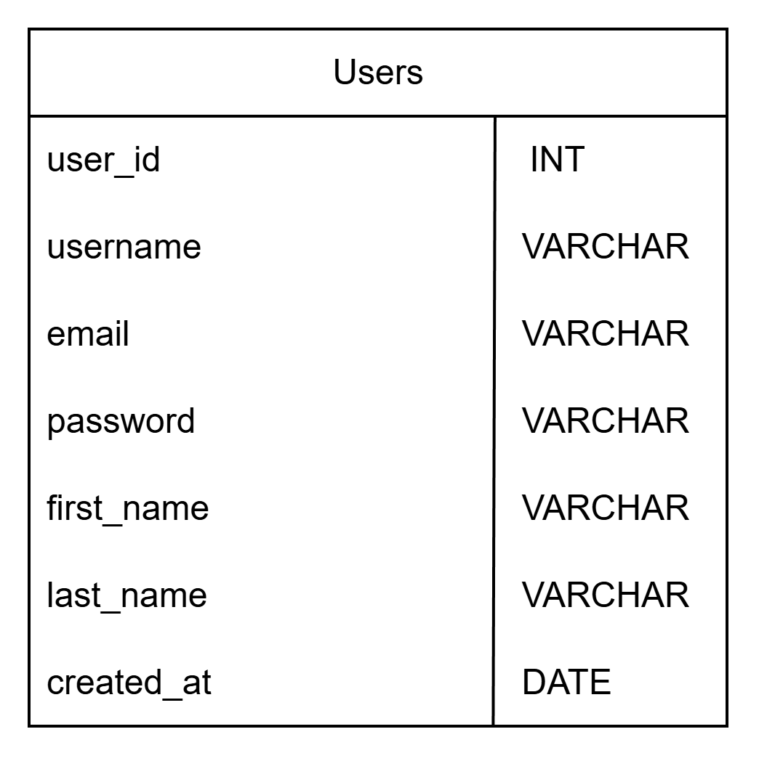
Figure 1.1 ERD

Use Case Diagram
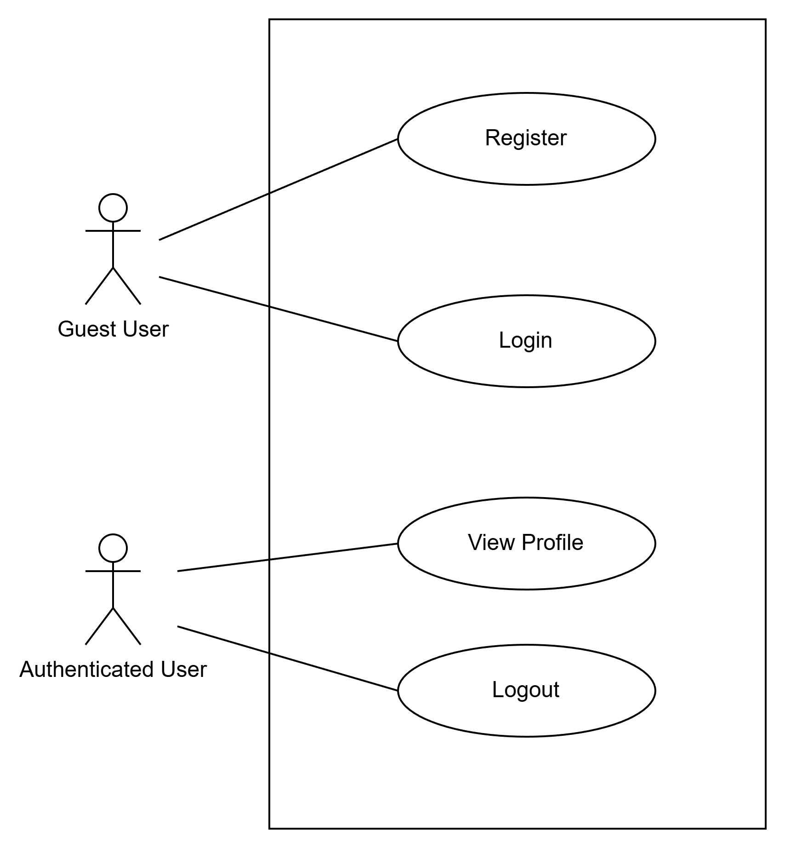
Figure 1.2 Use Case Diagram

Activity Diagram
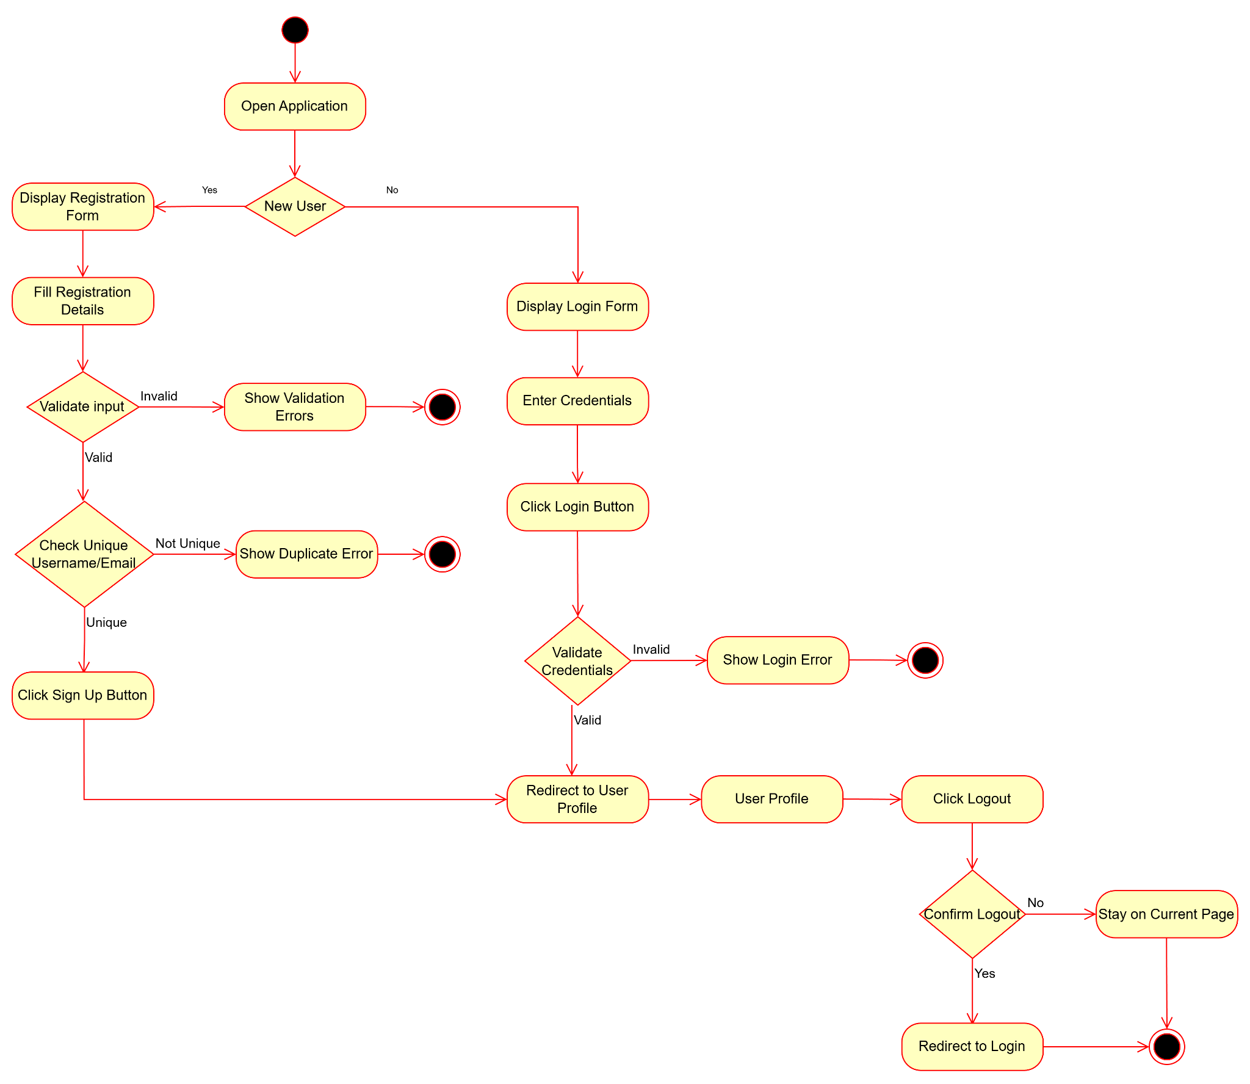
Figure 1.3 Activity Diagram

Class Diagram
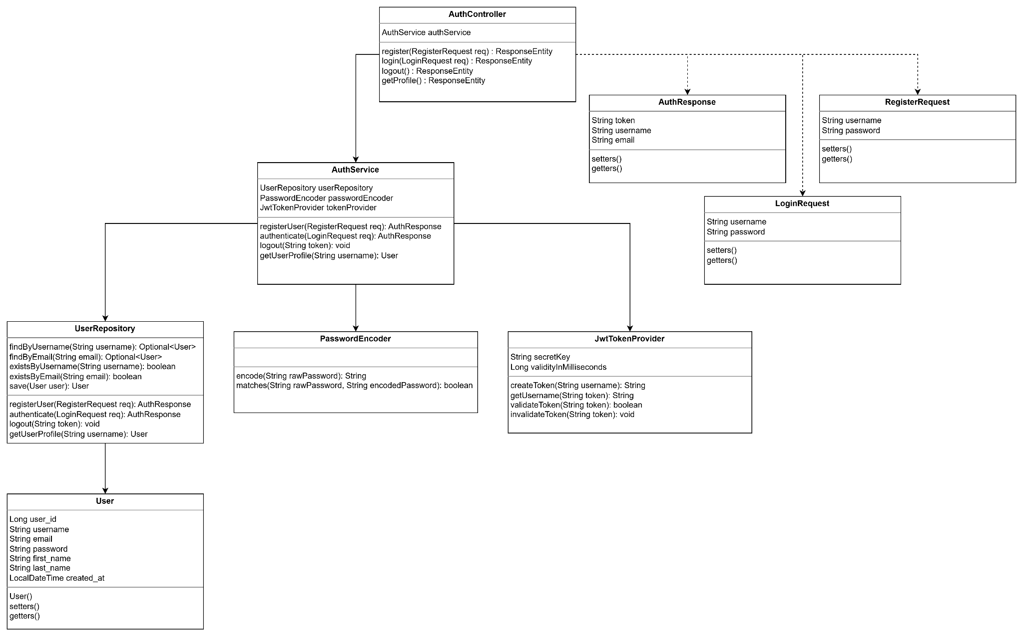
Figure 1.4 Class Diagram

Sequence Diagram
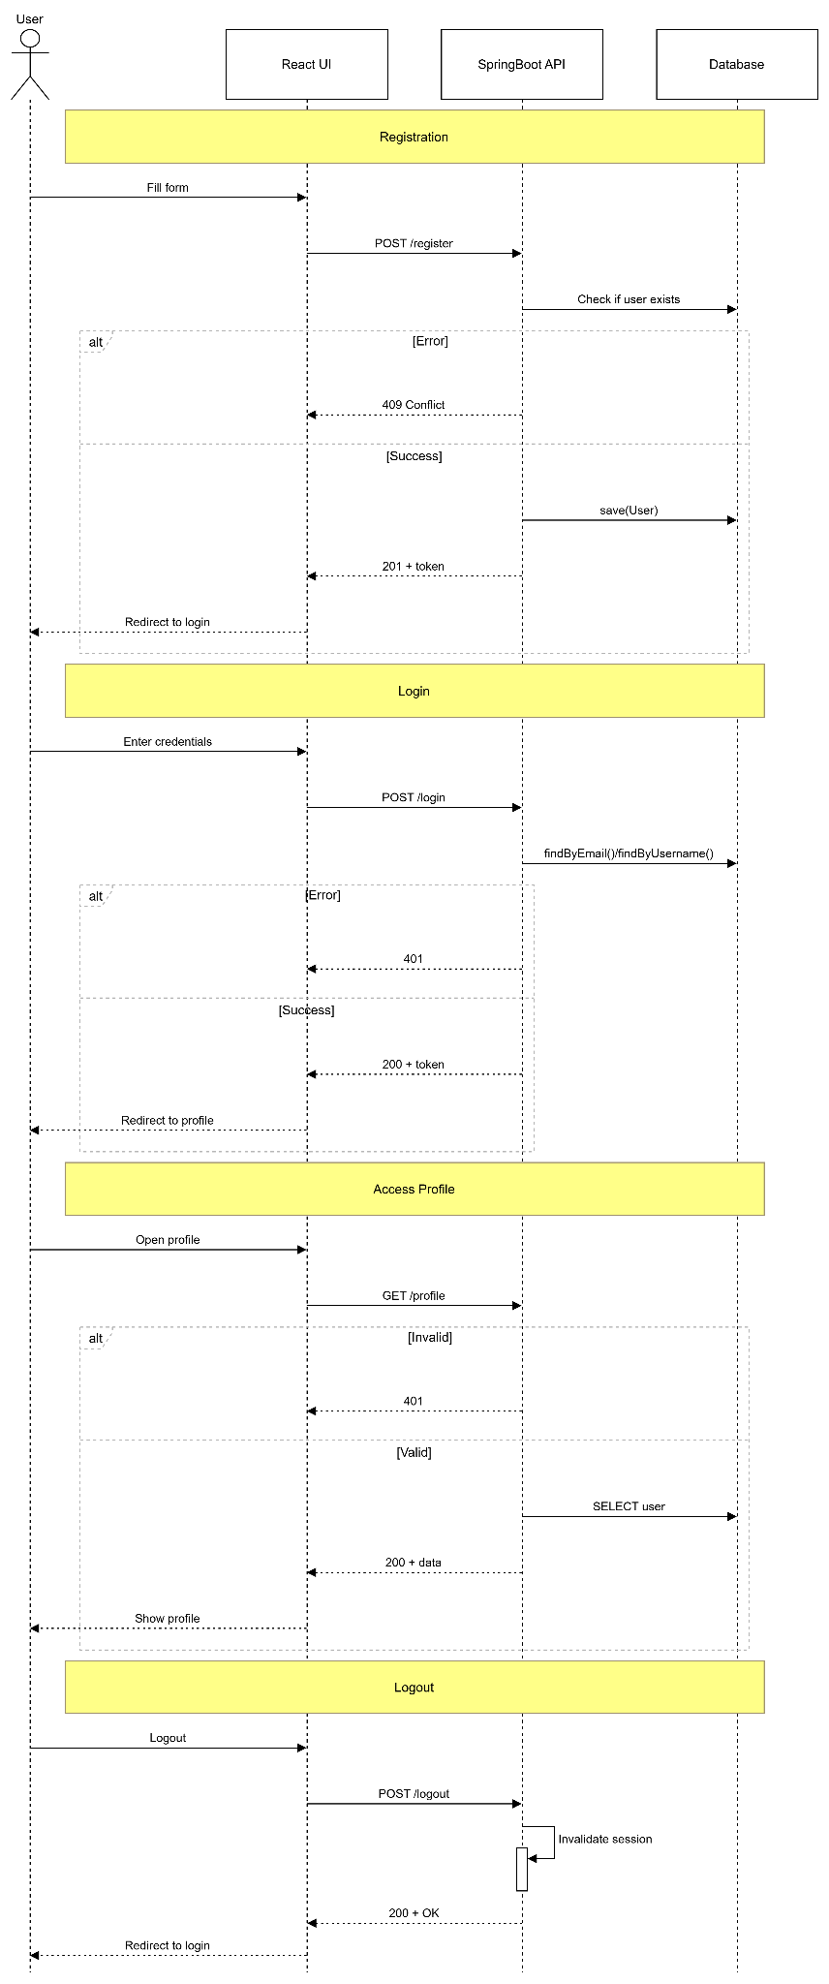
Figure 1.5 Sequence Diagram

Appendices

Appendix A: System Models
Figure 1.1 – Entity Relationship Diagram (ERD)
Figure 1.2 – Use Case Diagram
Figure 1.3 – Activity Diagram
Figure 1.4 – Class Diagram
Figure 1.5 – Sequence Diagram

Appendix B: Screenshots
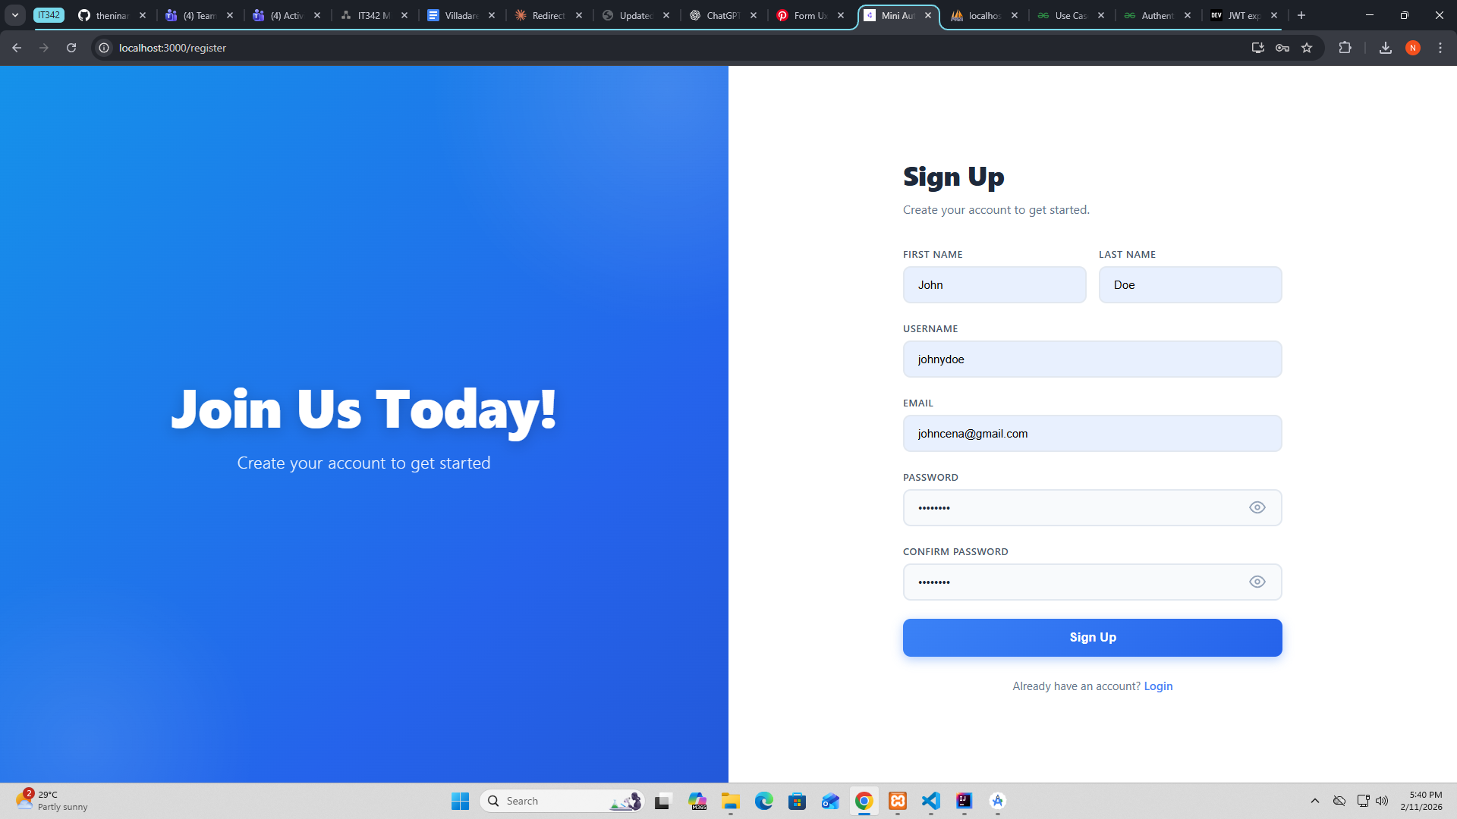
Registration Page
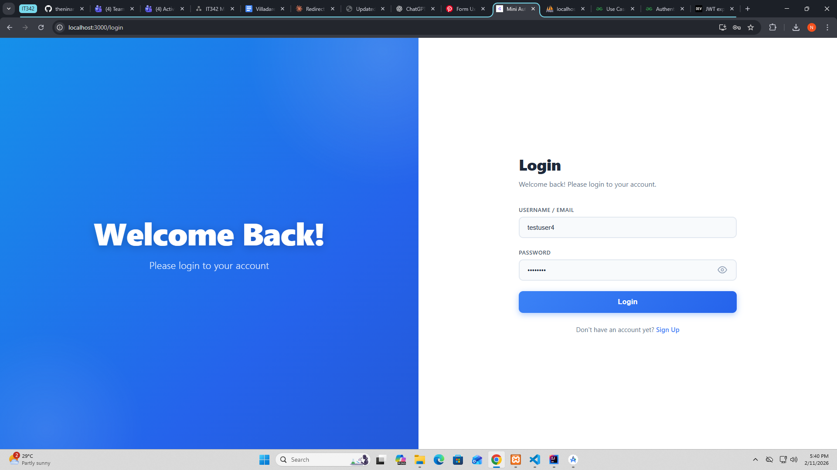
Login Page

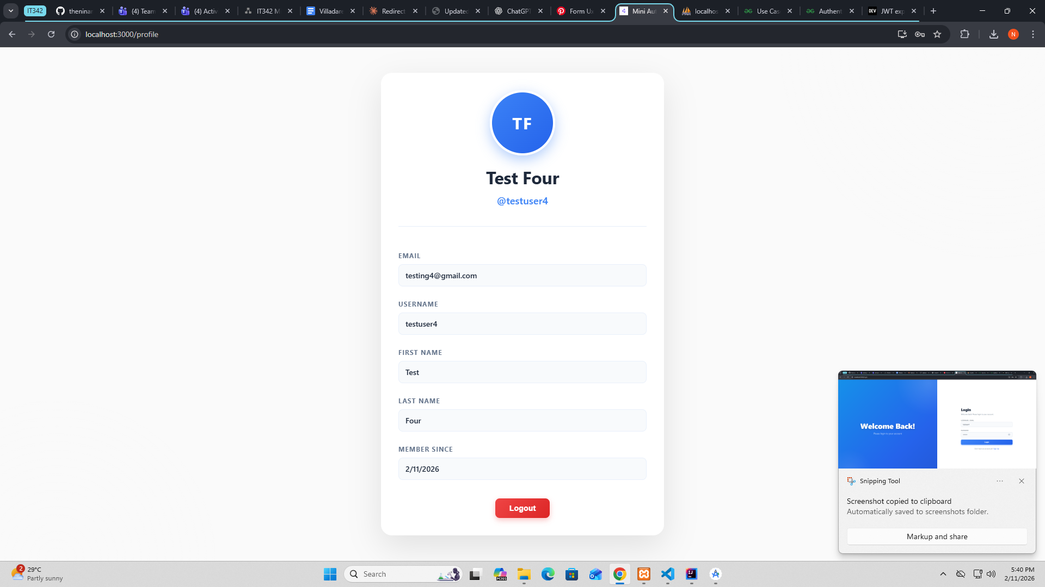
Profile Page

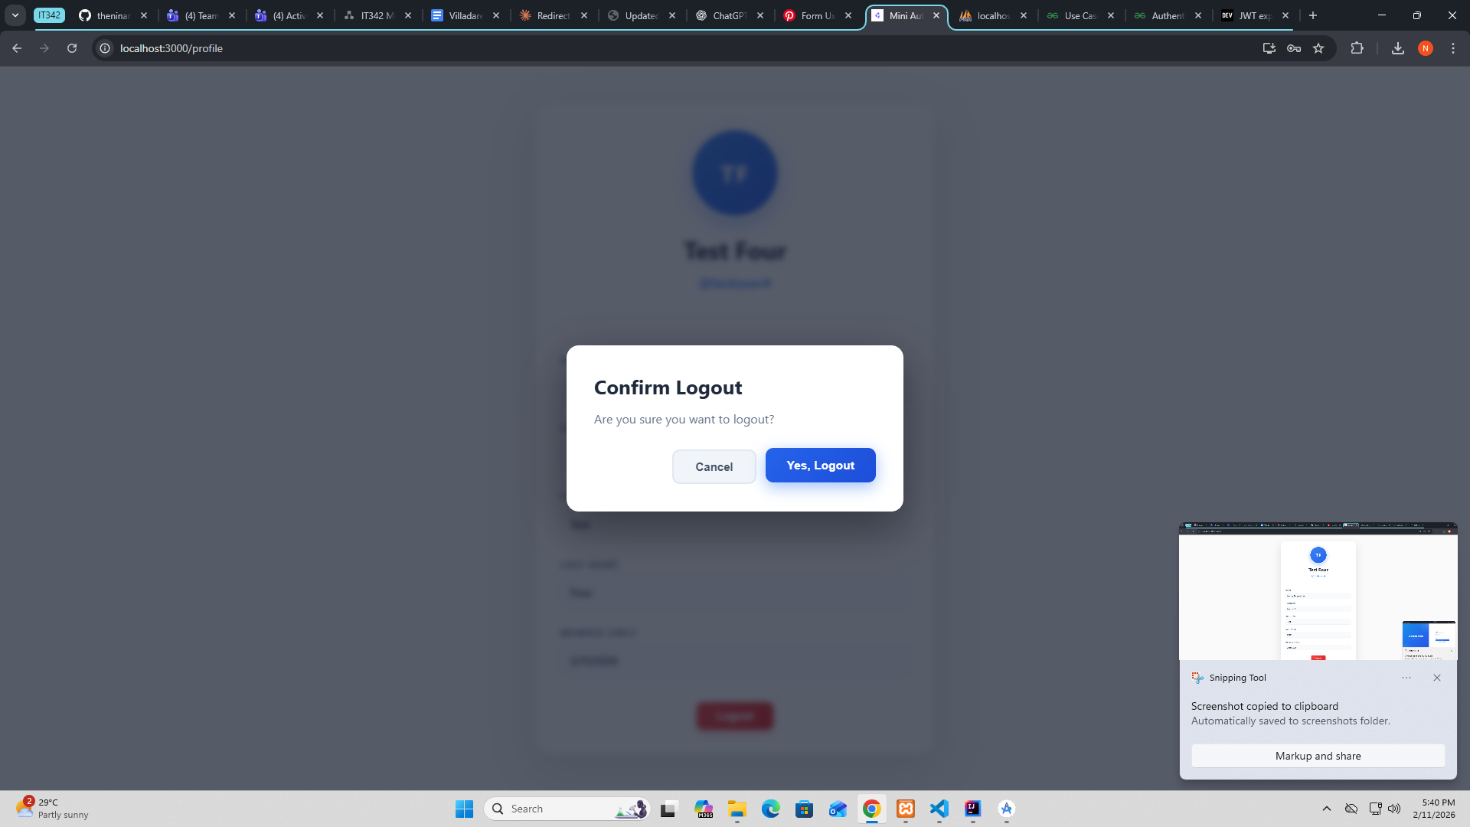
Logout Modal

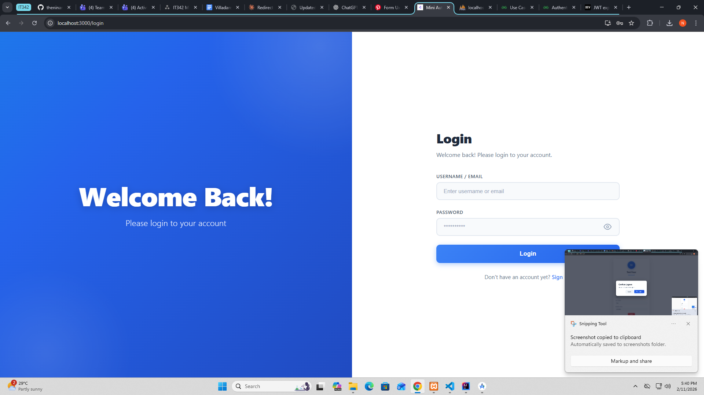
Logout Result: After clicking “Yes, Logout” button

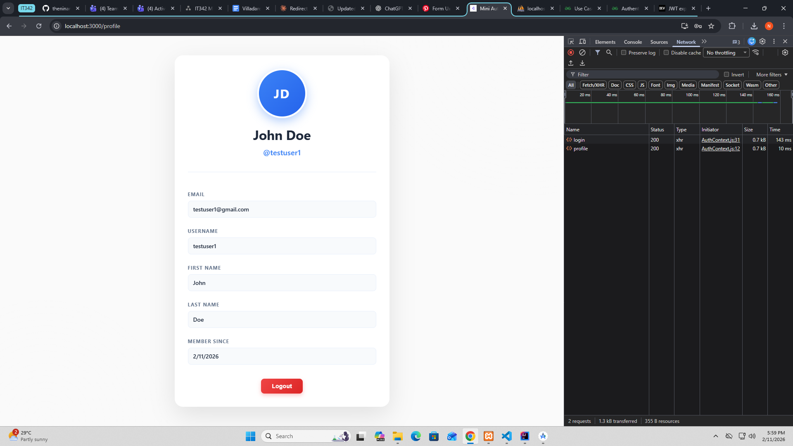
Proof of integration

