CEBU INSTITUTE OF TECHNOLOGY
UNIVERSITY

COLLEGE OF COMPUTER STUDIES

Software Design Description
for
SYNCTRACE

Change History
Version | Date | Author(s) | Changes Made
0.1 | May 22, 2026 | Baritua, Carl Gabriel  Cordero, Camila Rose  Delposo, Kerby  Temperatura, Sharbelle  Villadarez, Niña Nicole | Initial draft of SDD
0.2 | June 12, 2026 | Baritua, Carl Gabriel  Cordero, Camila Rose  Delposo, Kerby  Temperatura, Sharbelle  Villadarez, Niña Nicole

Preface

This Software Design Description (SDD) serves as the architectural and technical blueprint for SyncTrace, an intelligent project continuity and traceability assistant for academic software engineering capstone projects. It expands the Software Requirements Specification (SRS, version 0.6) into a concrete design that the development team will follow during Scrum-based implementation.

The intended audience includes the SyncTrace development team, who will use this document to guide implementation activities; faculty advisers and capstone evaluators, who will reference it to understand the technical complexity and design rationale; and quality assurance reviewers, who will validate that the implementation conforms to the documented design.

The document is organized into three top-level sections. Section 1 introduces the SDD's purpose, scope, definitions, and references. Section 2 presents the overall architectural design, including the layered system structure and the technologies used in each layer. Section 3 details every transaction in each of the three SyncTrace modules, providing front-end and back-end component breakdowns, class and sequence diagrams, and persistent data schemas.

Diagrams in this document are presented as visual UML and ERD figures. The corresponding diagram sources (PlantUML and Mermaid) are maintained alongside the project's source code repository to support version control and future updates.

Table of Contents

1. Introduction 5
1.1. Purpose 5
1.2. Scope 5
1.3. Definitions and Acronyms 5
1.4. References 7
2. Architectural Design 8
3. Detailed Design 11
Module 1 : Project Initialization and Semantic Ingestion 11
1.1 Secure Authentication 11
1.2 Initialize Project Workspace 16
1.3 Register and Synchronize Artifact Sources 20
Module 2: Traceability and Continuity Verification 26
2.1 Generate Traceability Mapping 26
2.2 Detect Continuity Gaps 31
2.3 Generate Diagnostic Guidance 36
2.4 Analyze Source Code Alignment 41
2.5 Generate Diagram Recommendation 46
Module 3 : Continuity Monitoring and Audit Report Export 39
3.1 Student Monitoring Dashboard 39
3.2 Adviser Monitoring Dashboard 47
3.3 View Audit Results 54
3.4 Export Audit Report 59

Introduction

Purpose
This Software Design Description (SDD) specifies the architectural and component-level design of SyncTrace, translating the functional and non-functional requirements defined in the Software Requirements Specification into a concrete system architecture, interface specifications, persistent data structures, and algorithmic descriptions.
This document is intended to guide the SyncTrace development team throughout Scrum-based implementation, serve as a reference for faculty advisers and capstone evaluators reviewing the system's technical soundness, and provide a baseline against which quality assurance reviewers can verify that the delivered implementation conforms to the documented design.

Scope
This SDD covers the complete design of SyncTrace across three functional modules:

Module 1 — Project Initialization and Semantic Ingestion: Google OAuth 2.0 authentication, project workspace creation, team onboarding, cloud-hosted artifact retrieval from Google Drive and GitHub, text extraction, content normalization, semantic chunking, and embedding generation.

Module 2 — Sequential Traceability and Continuity Verification: Sequential traceability link recovery across five predefined artifact pairs (Proposal→SRS, SRS→SDD, SRS→SPMP, SRS→STD, SDD→Source Code), coverage validation (≥90% downstream coverage), gap detection (≥85% precision), terminology drift monitoring, and AI-driven diagnostic guidance using Large Language Models (LLMs).

Module 3 — Continuity Audit Dashboard and Faculty Adviser Review: Interactive outcome matrix, project readiness scoring, centralized faculty monitoring dashboard, and exportable PDF audit reports.
Out of Scope. The following are explicitly outside the scope of this SDD: deployment infrastructure provisioning and DevOps pipeline configuration beyond the technology stack listed in Section 2.2; detailed network and cloud security hardening procedures; penetration testing plans; user acceptance test scripts; data migration procedures from external systems; and post-deployment maintenance procedures.

Definitions and Acronyms
Alignment Gap - Mismatch between the intended objectives of the project and the actual implementation found in downstream documents or source code.
Artifact - Any project-related document or software component used throughout the capstone lifecycle, such as the Proposal, SRS, SDD, STD, and source code.
Sequential Traceability - The process of establishing continuity relationships between predefined downstream project artifact pairs throughout the software development lifecycle.
Document Drift - The gradual divergence of project documents from one another as updates are made inconsistently across phases.
Embedding - A numerical vector representation of textual content used by AI models to analyze semantic similarity between documents.
LLM (Large Language Model) - An artificial intelligence model capable of understanding and generating human-like text for semantic analysis and recommendation generation.
Semantic Consistency – The logical alignment and preservation of meaning across multiple documents and software artifacts.
Terminological Drift – The inconsistent usage or redefinition of technical terms across project documents.
Traceability Matrix – A structured report showing the relationships between objectives, requirements, design components, test cases, and source code.
Vector Database – A specialized database optimized for storing and querying high-dimensional embedding vectors using similarity search (e.g., PGVector, Qdrant).
Acronyms | Abbreviations
AI | Artificial Intelligence
API | Application Programming Interface
CRUD | Create, Read, Update, Delete
DTO | Data Transfer Object
ERD | Entity-Relationship Diagram
GitHub | Cloud-Based Source Code Hosting Platform
Google OAuth 2.0 | Google Authentication Protocol
HTTPS | Hypertext Transfer Protocol Secure
JWT | JSON Web Token
LLM | Large Language Model
MVC | Model-View-Controller
NLP | Natural Language Processing
PDF | Portable Document Format
QA | Quality Assurance
REST | Representational State Transfer
SDD | Software Design Description
SPMP | Software Project Management Plan
SRS | Software Requirements Specification
STD | Software Test Document
UI | User Interface
URL | Uniform Resource Locator

1.4. References
[1] Cebu Institute of Technology – University, Software Requirements Specification for SyncTrace, Version 0.6, College of Computer Studies, 2026.
[2] IEEE, IEEE Std 1016-2009 – IEEE Standard for Information Technology – Systems Design – Software Design Descriptions, IEEE, 2009.
[3] ISO/IEC/IEEE, ISO/IEC/IEEE 29148:2018 – Systems and Software Engineering – Life Cycle Processes – Requirements Engineering, 2018.
[4] D. Hardt, Ed., The OAuth 2.0 Authorization Framework, IETF RFC 6749, October 2012. [Online]. Available: https://datatracker.ietf.org/doc/html/rfc6749
[5] M. Jones, J. Bradley, and N. Sakimura, JSON Web Token (JWT), IETF RFC 7519, May 2015. [Online]. Available: https://datatracker.ietf.org/doc/html/rfc7519
[6] Meta Open Source, React Documentation, 2024. [Online]. Available: https://react.dev
[7] OpenJS Foundation, Express.js Documentation, 2024. [Online]. Available: https://expressjs.com
[8] The PostgreSQL Global Development Group, PostgreSQL 15 Documentation, 2024. [Online]. Available: https://www.postgresql.org/docs/15/
[9] pgvector contributors, pgvector: Open-source vector similarity search for Postgres, 2024. [Online]. Available: https://github.com/pgvector/pgvector
[10] OpenAI, OpenAI API Reference – Embeddings, 2024. [Online]. Available: https://platform.openai.com/docs/api-reference/embeddings
[11] N. Reimers and I. Gurevych, "Sentence-BERT: Sentence Embeddings using Siamese BERT-Networks," in Proceedings of EMNLP-IJCNLP 2019, pp. 3982–3992.
[12] Google Developers, Google Drive API v3 Reference, 2024. [Online]. Available: https://developers.google.com/drive/api/reference/rest/v3
[13] GitHub, Inc., GitHub REST API Documentation, 2024. [Online]. Available: https://docs.github.com/en/rest
[14] Redis Ltd., Redis 7 Documentation, 2024. [Online]. Available: https://redis.io/docs/
[15] Docker, Inc., Docker Documentation, 2024. [Online]. Available: https://docs.docker.com

Architectural Design

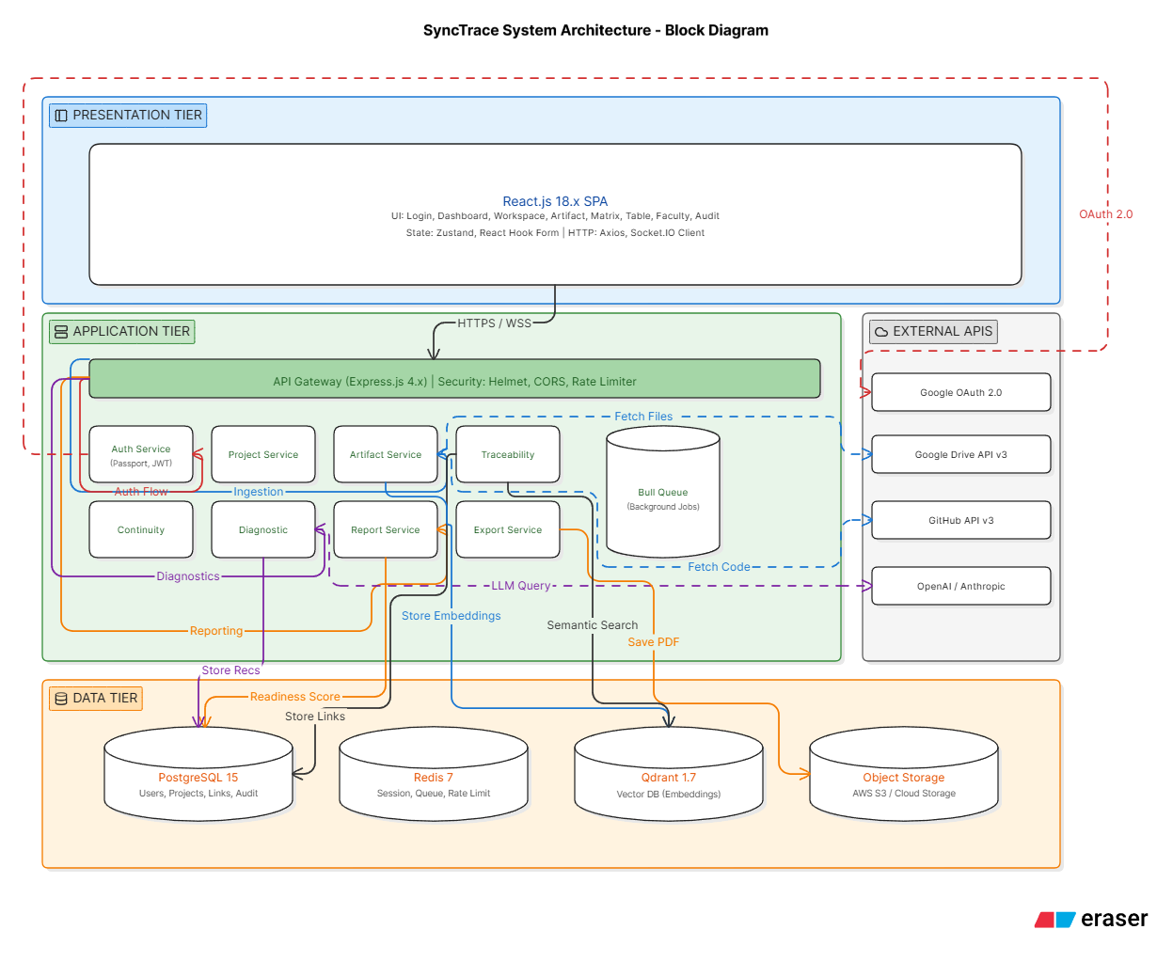
2.1 System Architecture Overview

2.2 Technology Stack

Layer | Technology | Version | Purpose
Frontend | React | 18.2.0 | UI Component Library
 | TypeScript | 5.0.0 | UI Component Library
 | Tailwind CSS | 3.3.0 | Styling and responsive design
 | React Router | 6.14.0 | Client-side routing
 | React Query | 4.32.0 | Server state management
 | Zustand | 4.4.0 | Client state management
 | Axios | 1.4.0 | HTTP client
Backend | Node.js | 20.x | Runtime environment
 | Express.js | 4.18.0 | Web framework
 | TypeScript | 5.0.0 | Type-safe backend
 | Passport.js | 0.6.0 | Authentication middleware
 | Bull | 4.11.0 | Job queue processing
Database | PostgreSQL | 15.0 | Relational database
 | Redis | 7.0 | Cache and session store
 | PGVector | 0.5.0 | Vector similarity search
Storage | AWS S3 / MonIO | - | Raw document storage
Authentication | Google OAuth 2.0 | - | Identity provider
 | JWT | 9.0.0 | Session tokens
AI Services | OpenAI API | TBD | LLM for analysis
 | Sentence Transformers | 2.2.0 | Embedding generation
External APIs | Google Drive API | v3 | Document retrieval
 | Github API | v3 | Source code access
DevOps | Docker | 24.0 | Containerization
 | Github Actions | - | CI/CD pipeline
 | AWS/Vercel | - | Hosting

Detailed Design

Module 1 : Project Initialization and Semantic Ingestion

1.1 Secure Authentication
- User Interface Design
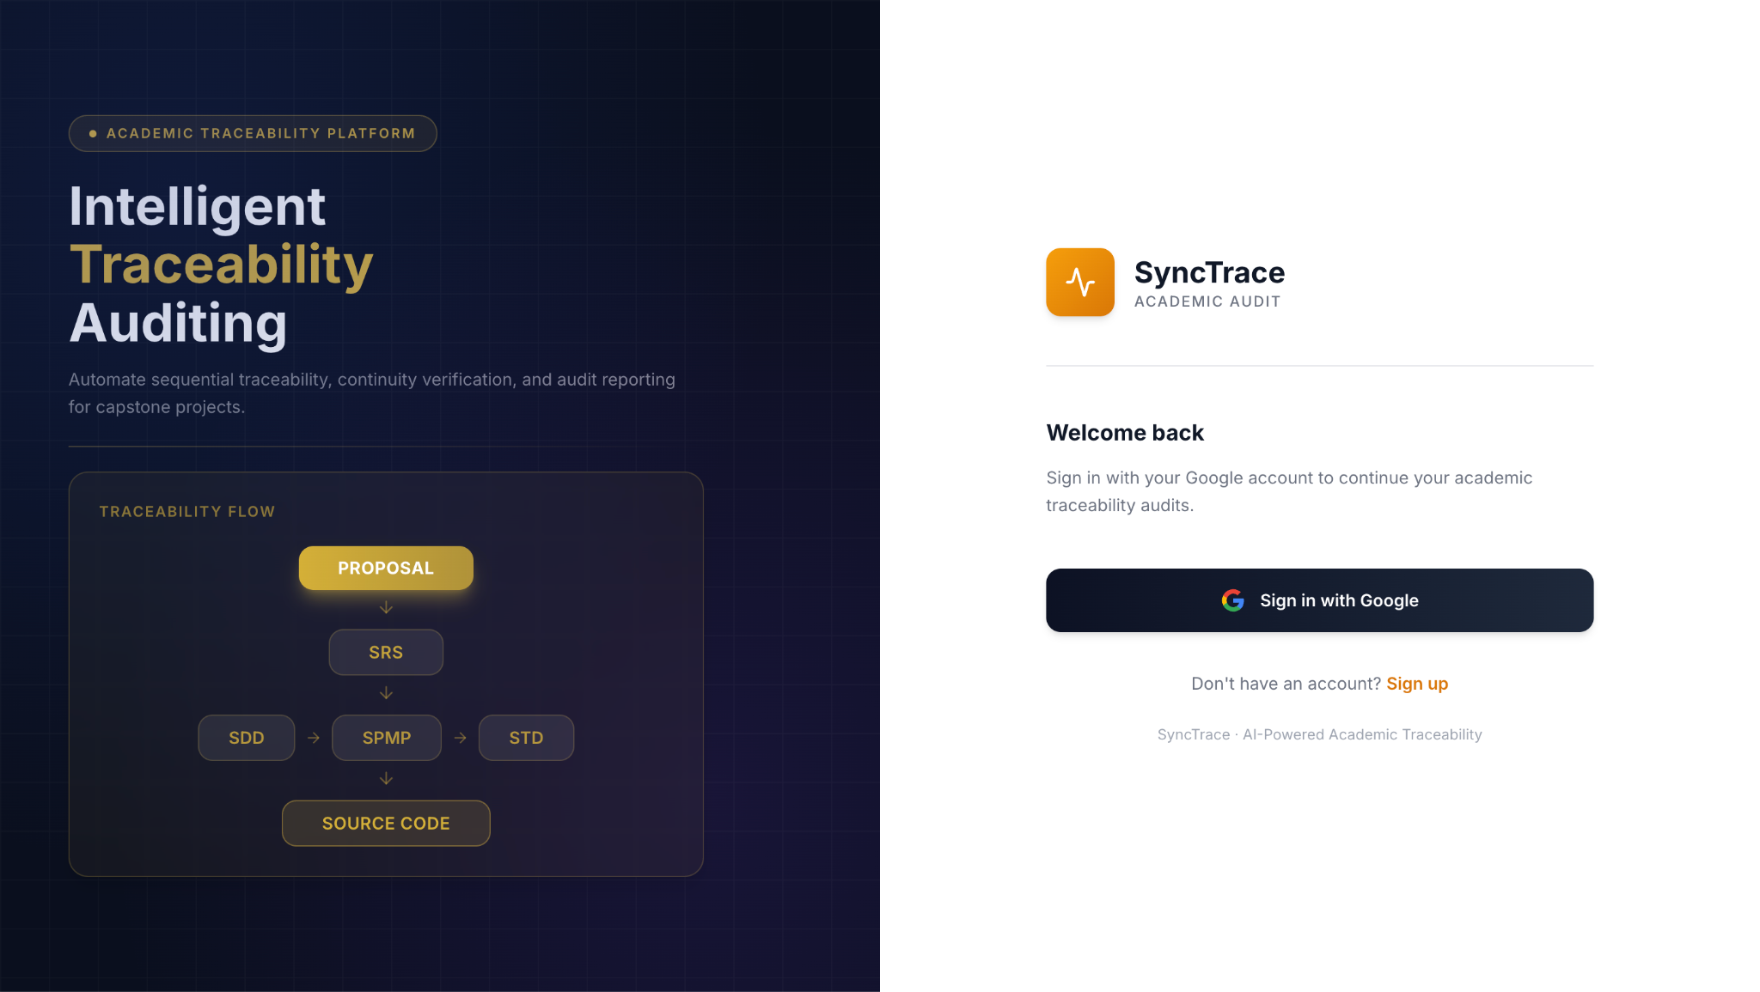
Figure 1.1.1 Sign In Page

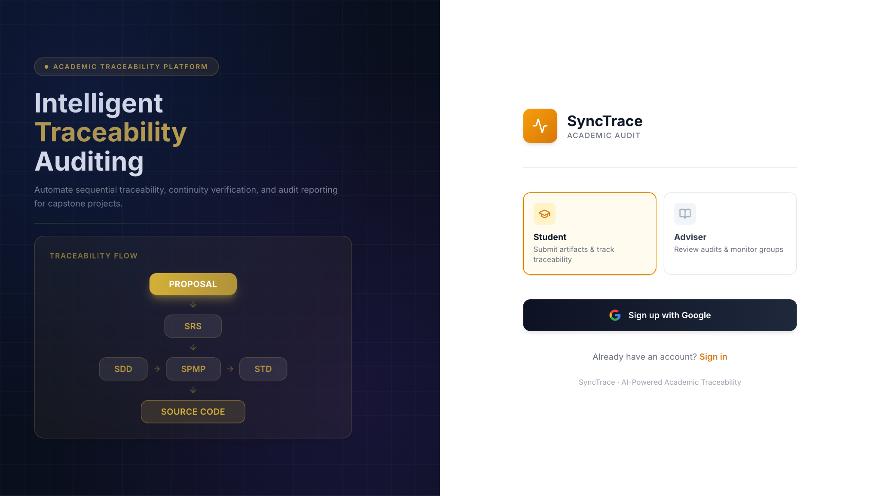
Figure 1.1.2 Sign Up Page
- Front-end component(s)
Component Name | Description and Purpose | Type / Format
LoginPage | Renders the login screen, manages role selection state, and initiates OAuth flow. | React Functional Component (TypeScript)
TraceabilityMappingService | Handles the OAuth redirect callback, extracts authorization code, and exchanges it for session token. | React Component + Custom Hook
SimilarityComputationEngine | Handles the OAuth redirect callback, extracts authorization code, and exchanges it for session token. | React Context API
TraceabilityRepository | Wrapper component that checks authentication before rendering protected pages. | Higher-Order Component / Route Guard

- Back-end component(s)
Component Name | Description and Purpose | Type / Format
AuthController | REST endpoint handler for /api/auth/google, /api/auth/callback, /api/auth/logout, and token validation. | Spring Boot REST Controller (Java) / Express.js Router
OAuthService | Manages Google OAuth 2.0 flow: generates redirect URL, exchanges code for tokens, retrieves user profile (email, name, picture). | Service Class
JwtService | Creates and verifies JSON Web Tokens (JWT) for session management. Issues tokens with role and user ID claims. | Utility Class
UserRepository | Data access layer for retrieving and storing user records (email, role, Google ID, name). | JPA Repository / Prisma Model

- Object-Oriented Components
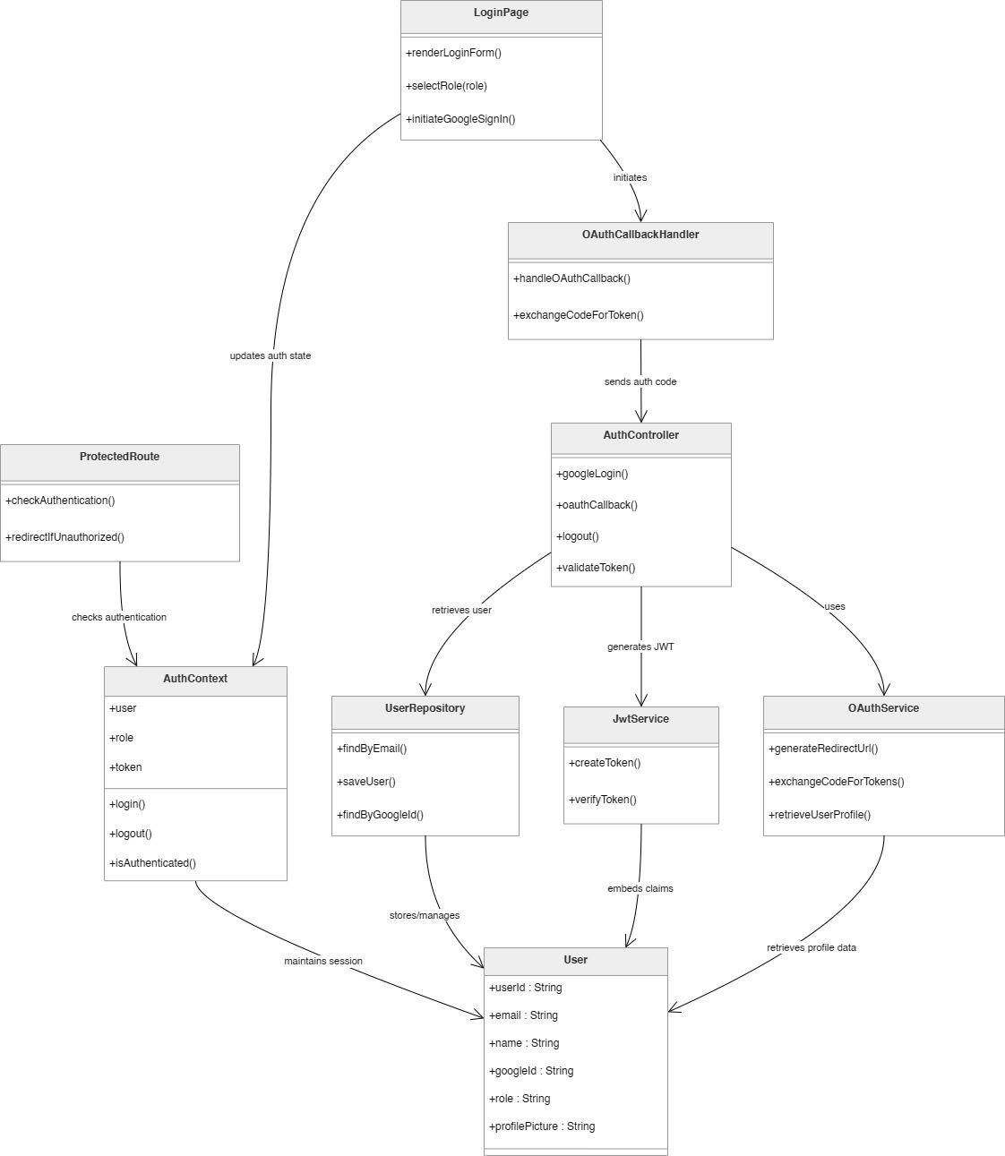
  - Class Diagram

  - Sequence Diagram
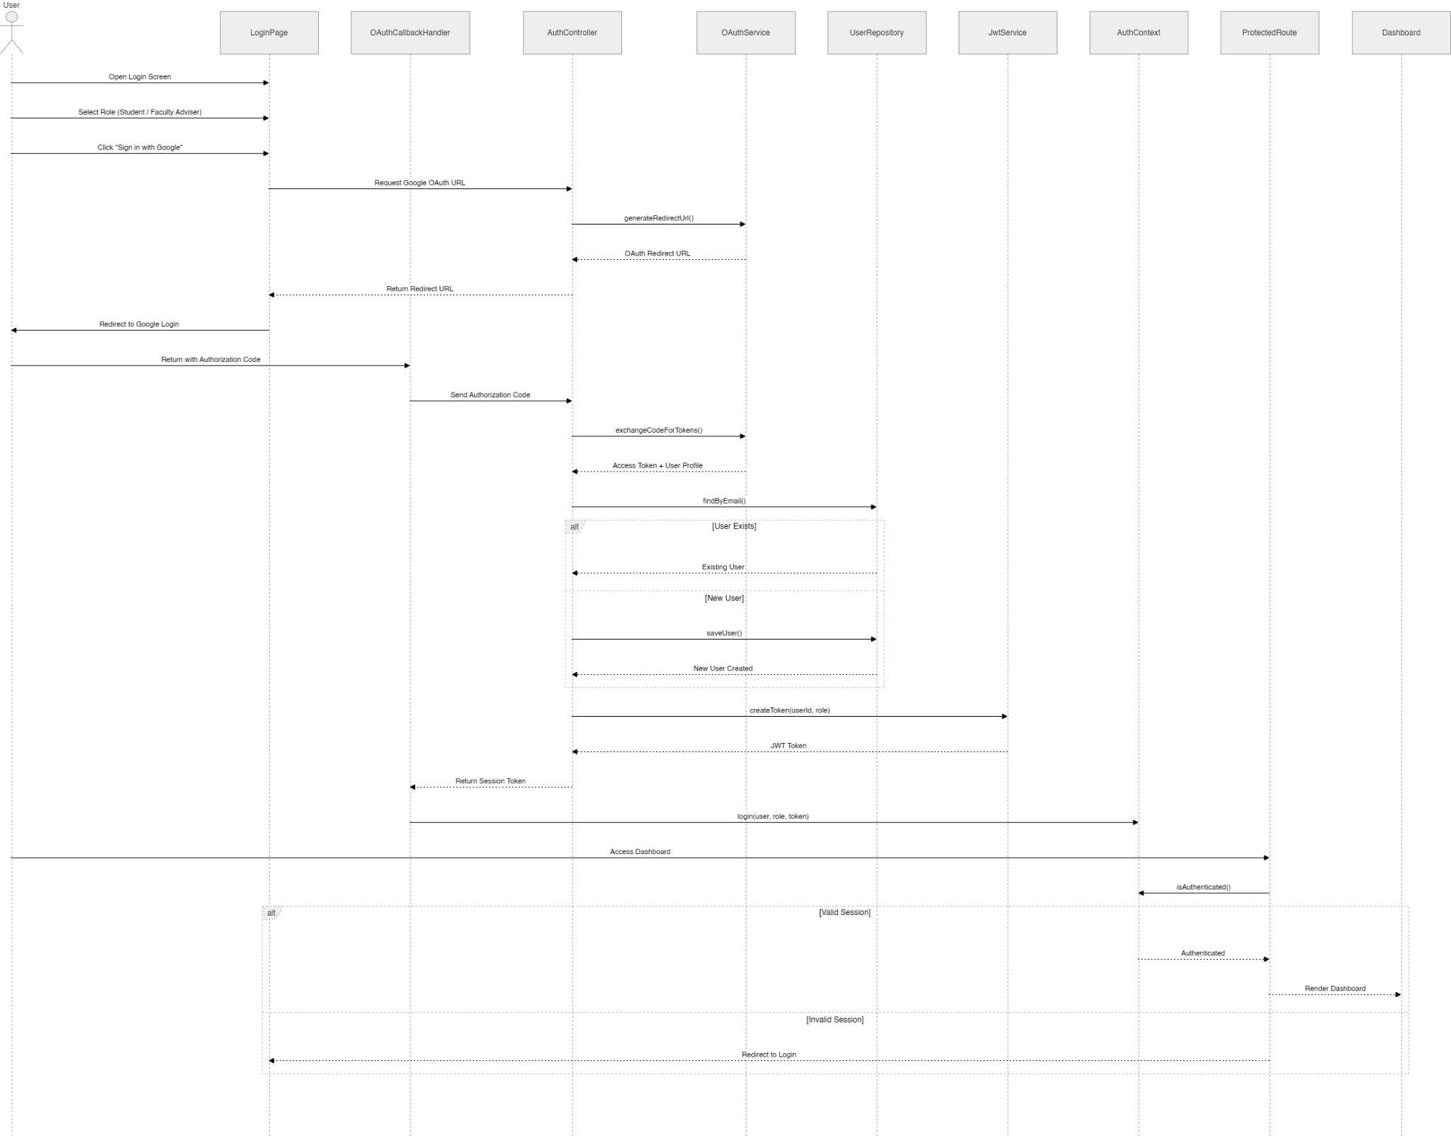
- Data Design
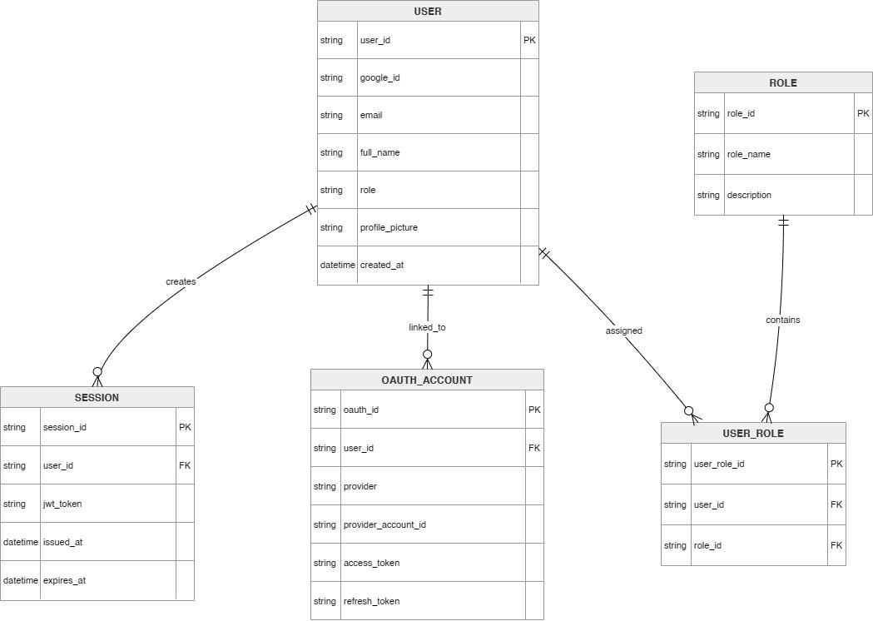
  - ERD or schema

1.2 Initialize Project Workspace
- User Interface Design
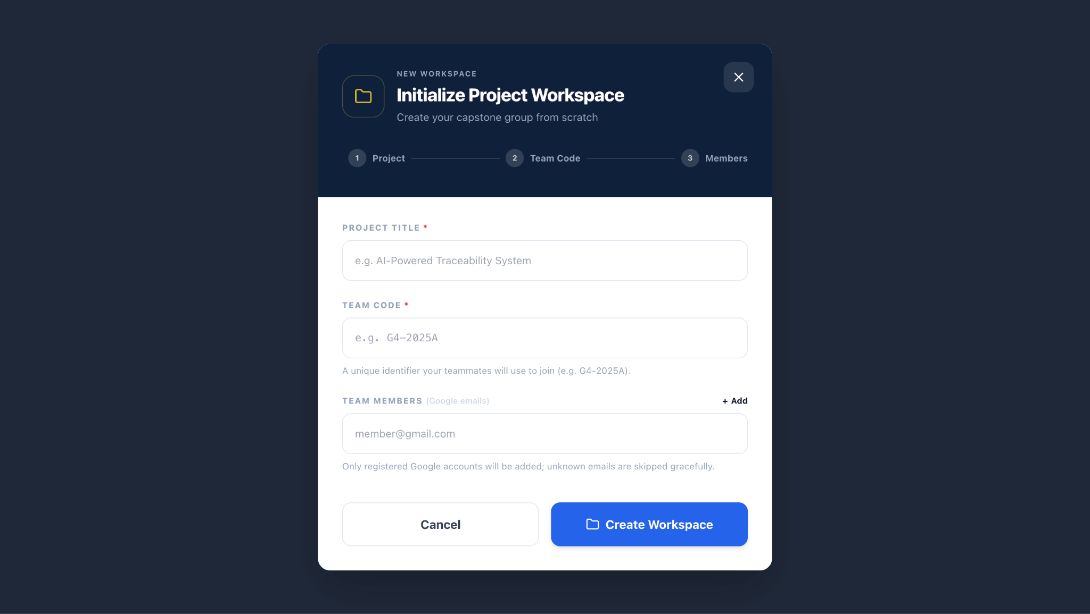
Figure 1.2.1 Initialize Project Workspace

- Front-end component(s)
Component Name | Description and Purpose | Type / Format
WorkspaceSetupPage | Renders the project creation form, manages state, handles dynamic email fields, and submits data. | React Functional Component (TypeScript)
AdviserDropdown | Fetches list of faculty advisers from backend and displays as selectable options. | Reusable UI Component
EmailListInput | Manages a dynamic list of email fields, validates format on blur, provides add/remove buttons. | Custom React Hook + Component
ProjectService | API client method: POST /api/projects with project details and member emails. | TypeScript Class (Axios)

- Back-end component(s)
Component Name | Description and Purpose | Type / Format
ProjectController | REST endpoint POST /api/projects to handle project workspace creation. | Spring Boot REST Controller
ProjectService | Orchestrates project creation: validates inputs, checks team code uniqueness, creates project record, associates members, sends email invitations (optional). | Service Class
UserRepository | Data access to find adviser by ID, validate member emails exist in system (or create pending invitations). | Repository
ProjectRepository | Saves project entity and manages relationships. | Repository
EmailValidationService | Validates email format and checks if domain is Google-friendly (optional: verify Google account existence via People API). | Utility

- Object-Oriented Components
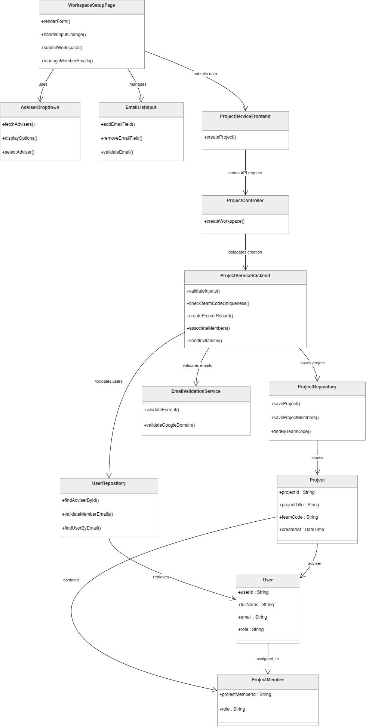
  - Class Diagram

  - Sequence Diagram

- Data Design
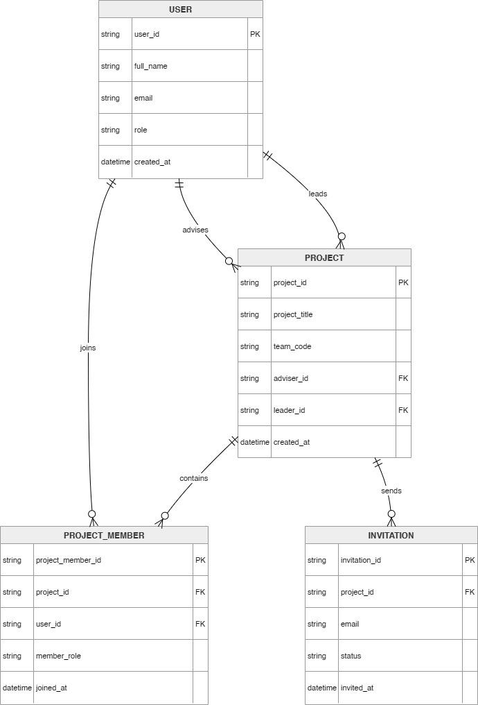
  - ERD or schema

. . .

1.3 Register and Synchronize Artifact Sources
- User Interface Design
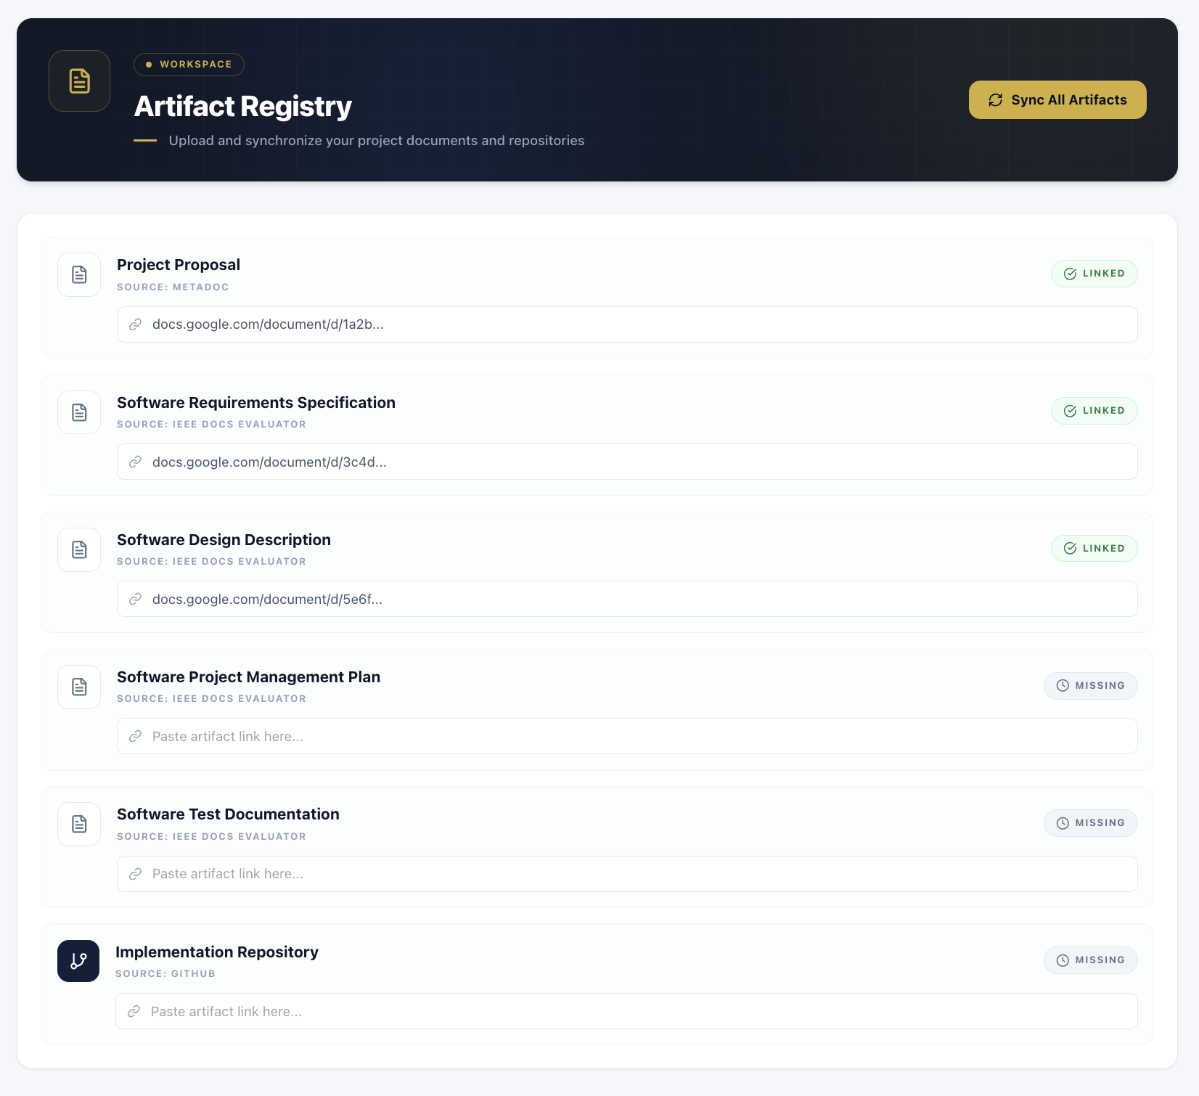
- Front-end component(s)
Component Name | Description and Purpose | Type / Format
ArtifactForm | Renders the URL input fields, manages form state, and validates URL formats before submission. | React Functional Component (TypeScript)
IngestionProgress | Displays real-time progress updates via Server-Sent Events (SSE) or polling. | React Component
ArtifactService | API client service that sends POST /api/projects/{id}/artifacts with URL payload. | TypeScript Class (Axios)
StatusBadge | Visual indicator for each artifact's ingestion status (Pending, Processing, Success, Failed). | Reusable UI Component

- Back-end component(s)
Component Name | Description and Purpose | Type / Format
ArtifactController | REST endpoint for submitting URLs (POST /api/projects/{id}/artifacts) and retrieving ingestion status. | Spring Boot REST Controller
ArtifactIngestionService | Orchestrates the entire ingestion pipeline: validation, fetching, parsing, chunking, embedding, storage. | Service Class
UrlValidatorService | Validates each URL (Google Drive shareable link or GitHub repo URL) and checks accessibility (HTTP 200). | Utility Class
DocumentFetcher | Downloads content from Google Drive (using Google Drive API) and GitHub (using GitHub API). Handles rate limits and retries. | Service Class
TextExtractor | Parses PDF and Google Docs content into plain text; extracts source code files from GitHub repository. | Parser Class
SemanticChunker | Splits text into overlapping or non-overlapping chunks (paragraphs, sections, or fixed token size ~512 tokens). | Algorithm Class
EmbeddingGenerator | Calls LLM API (e.g., OpenAI text-embedding-3-small) to convert each chunk into a 1536-dimensional vector. | API Wrapper Class
VectorStoreService | Stores embeddings in a vector database (e.g., Pinecone, Qdrant, or pgvector) with project ID, artifact type, and chunk metadata. | Repository Class

- Object-Oriented Components
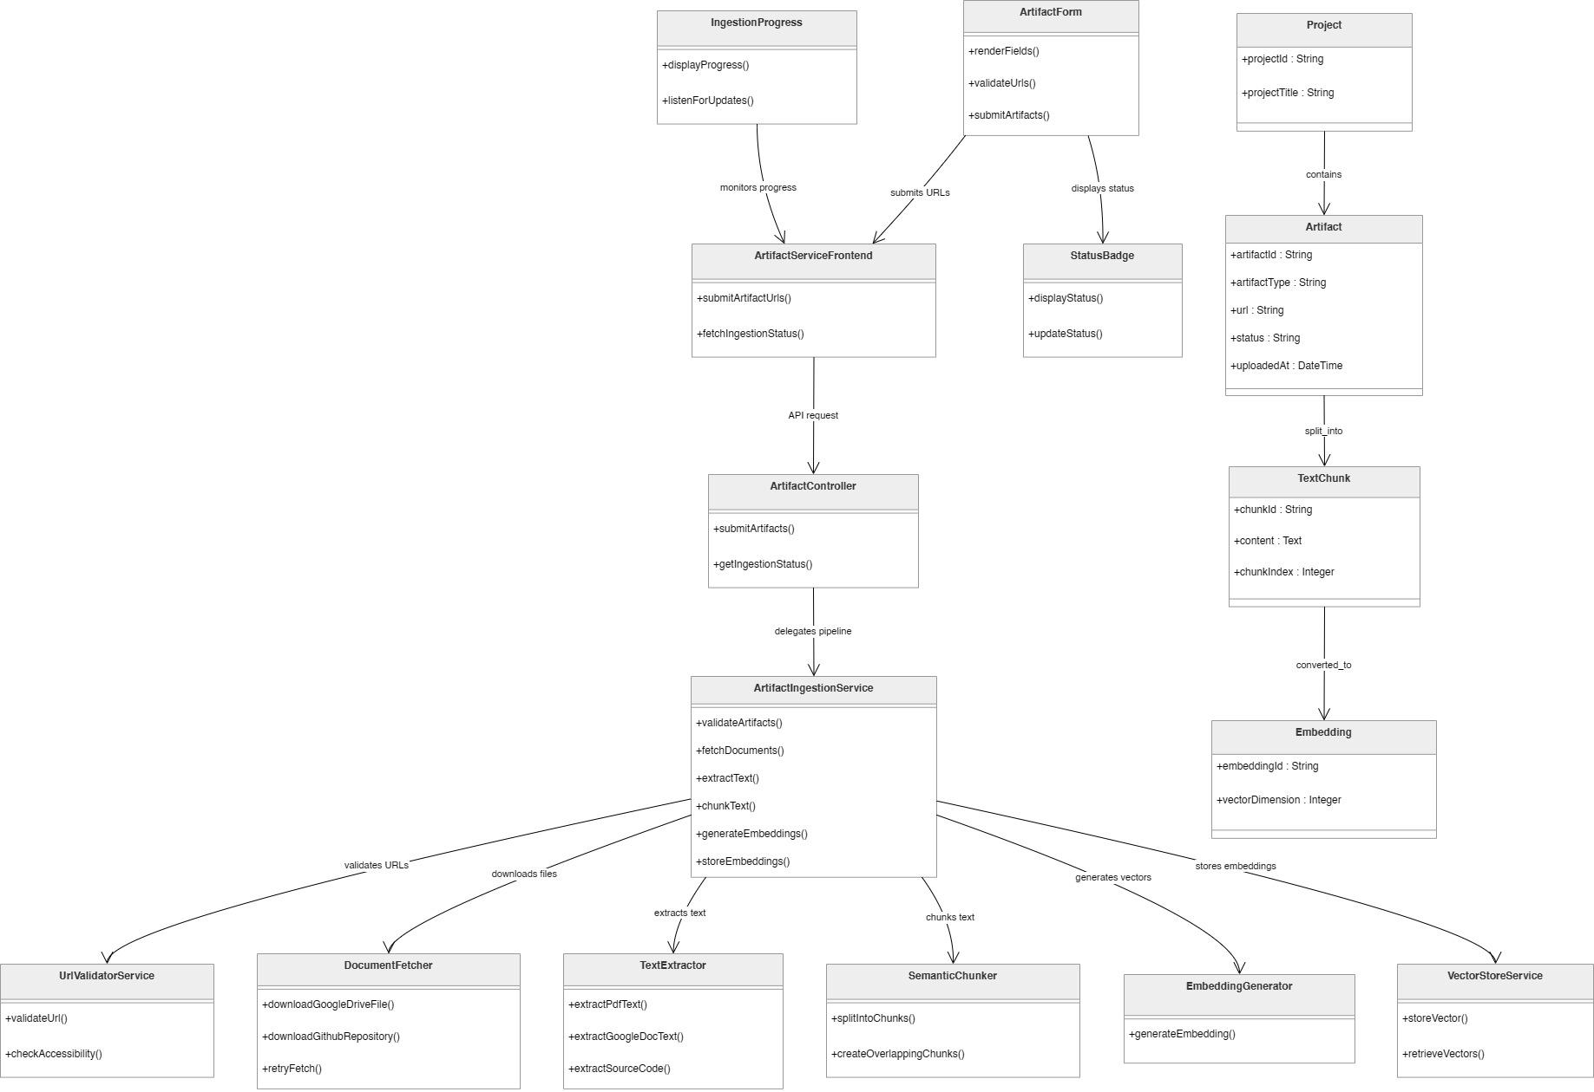
  - Class Diagram
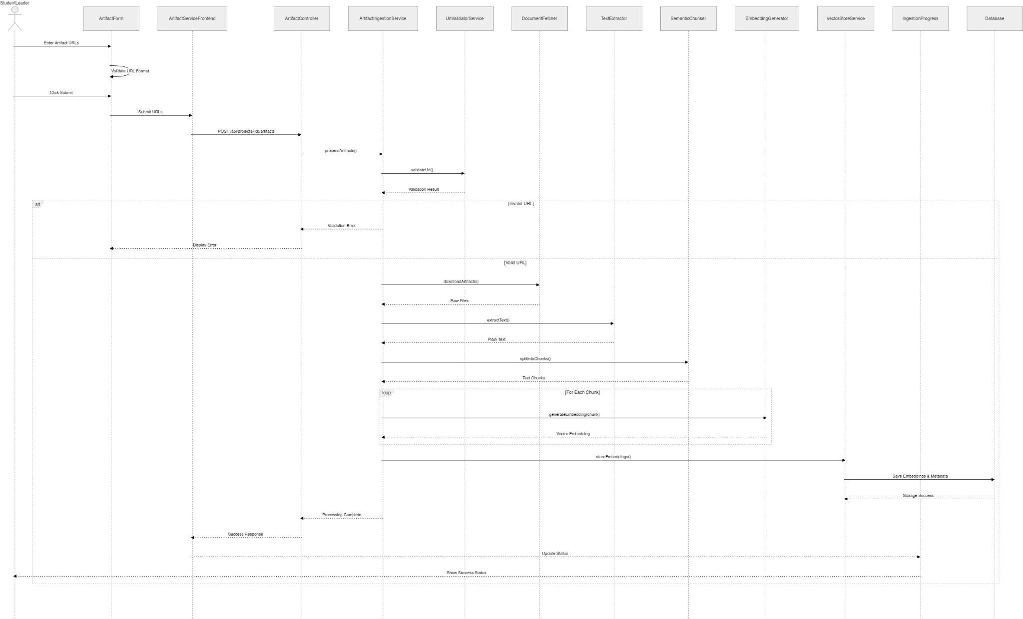
  - Sequence Diagram

- Data Design
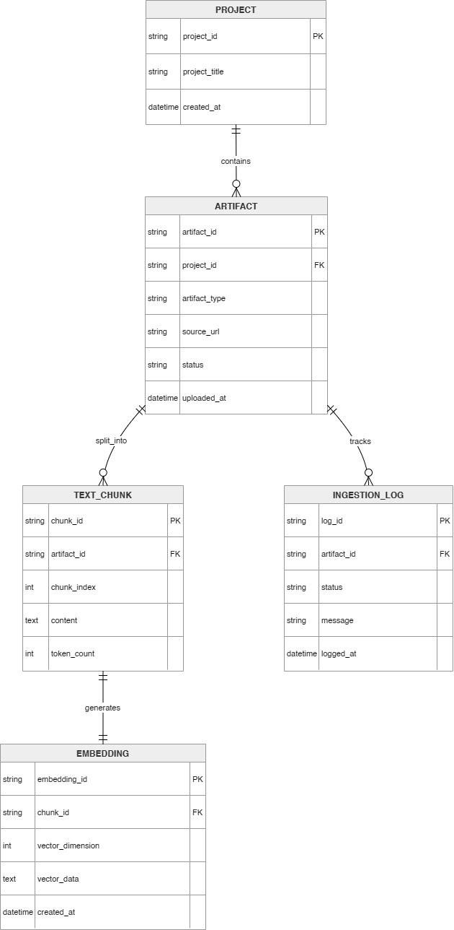
  - ERD or schema

Module 2: Traceability and Continuity Verification

2.1 Generate Traceability Mapping
- User Interface Design
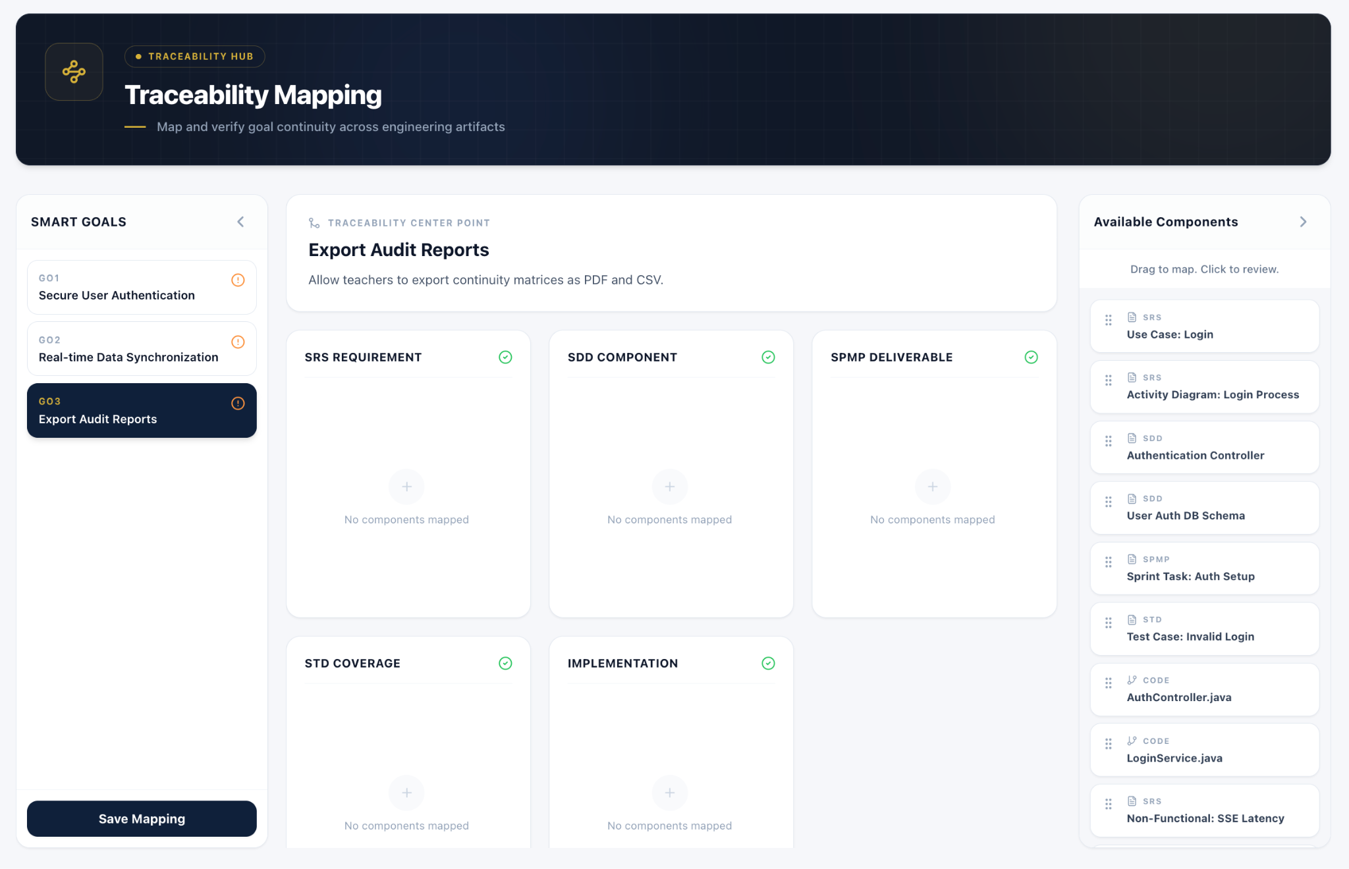
Figure 2.1.1 Traceability Mapping Workspace

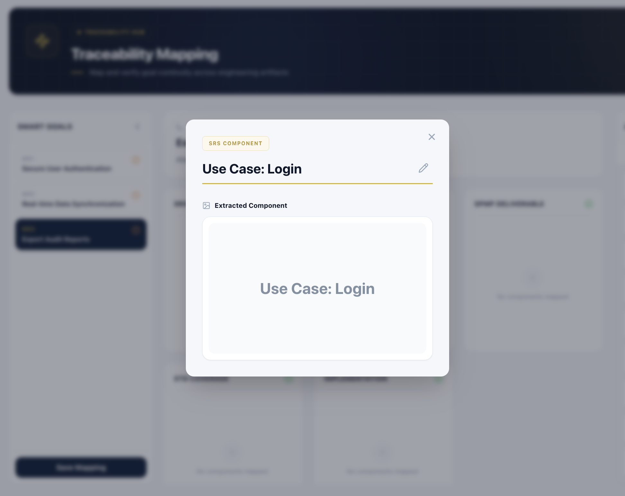
Figure 2.1.2 Preview Component

- Front-end component(s)
Component Name | Description and Purpose | Type / Format
TraceabilityMappingPage | Main page for running and viewing traceability mapping results. | React Functional Component
ProjectSelector | Allows the user to select the project workspace to analyze. | React Component
RunMappingButton | Triggers the traceability mapping process. | React Component
TraceabilityMatrix | Displays mapped artifact relationships and status. | React Component
ArtifactPairSelector | Filters results by artifact pair. | React Component
AlignmentScoreCard | Displays overall alignment score and coverage percentage. | React Component
MappingDetailsPanel | Shows matched source and target evidence. | React Component

- Back-end component(s)
Component Name | Description and Purpose | Type / Format
TraceabilityController | Handles requests for generating and retrieving traceability mappings. | Express.js Router / REST Controller
TraceabilityMappingService | Orchestrates the traceability mapping process across predefined artifact pairs. | Service Class
SimilarityComputationEngine | Computes semantic similarity between artifact embeddings. | Utility / Computation Engine
CoverageValidationService | Calculates whether upstream objectives or requirements are covered downstream. | Service Class
ProcessedArtifactRepository | Retrieves processed artifacts, chunks, and embeddings. | Repository
TraceabilityRepository | Retrieves processed artifacts, chunks, and embeddings. | Repository

- Object-Oriented Components
  - Class Diagram
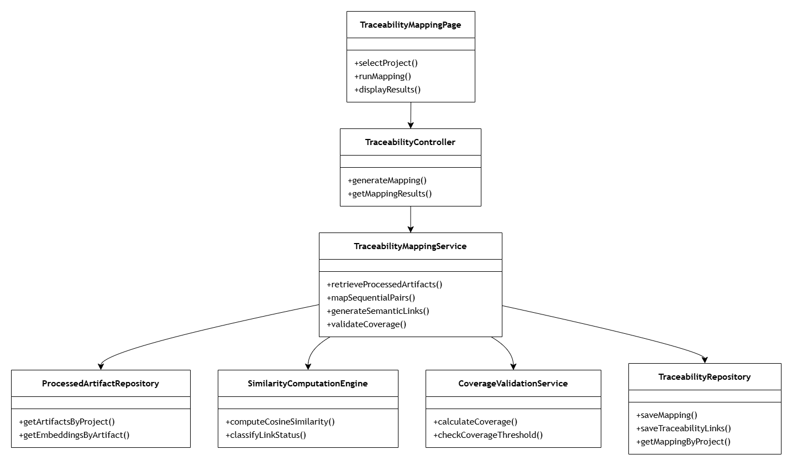

  - Sequence Diagram
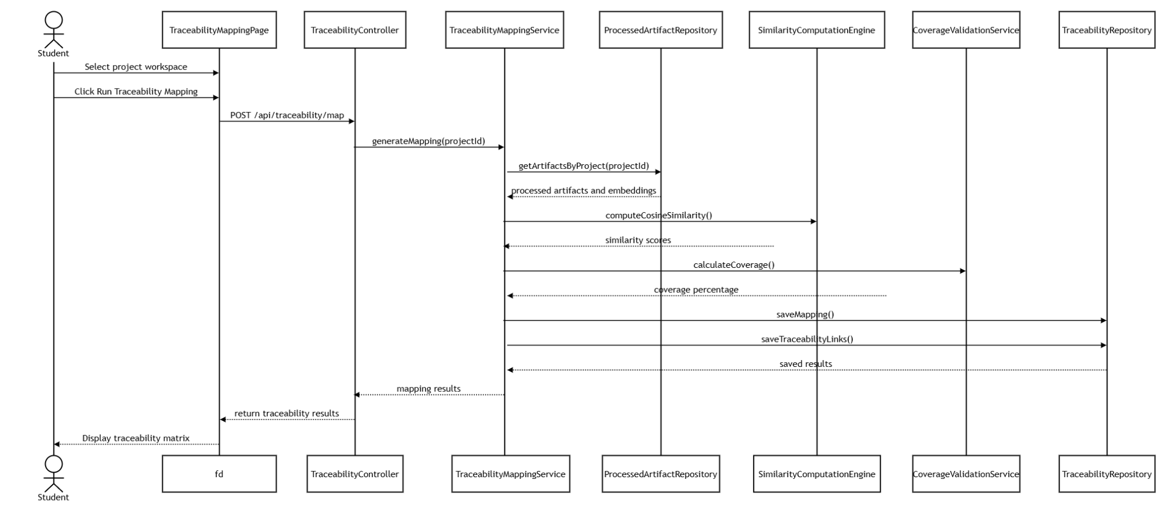

- Data Design
  - ERD for schema
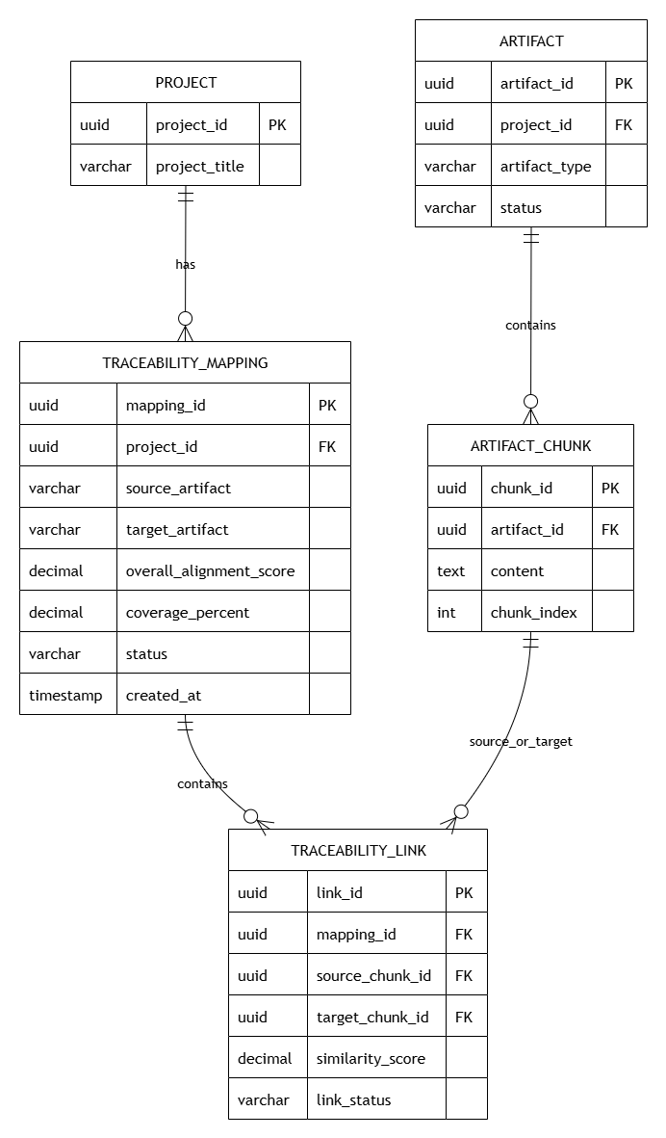

2.2 Detect Continuity Gaps
- User Interface Design
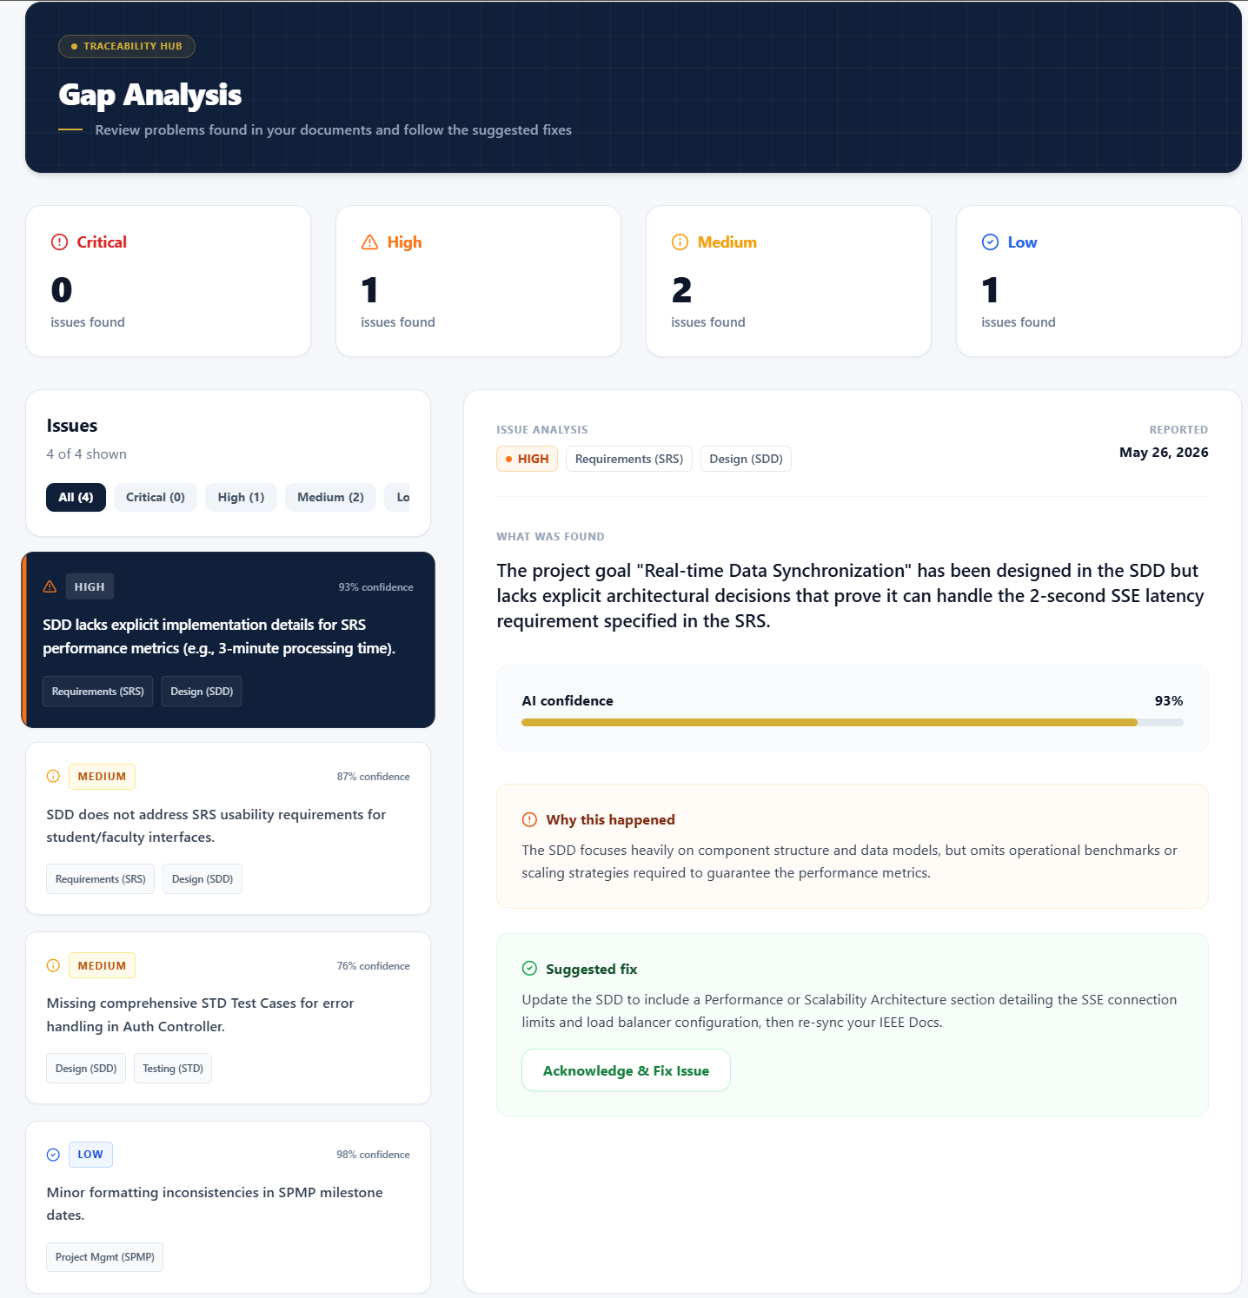

- Front-end component(s)
Component Name | Description and Purpose | Type / Format
ContinuityGapsPage | Main page for displaying detected continuity issues. | React Functional Component
ProjectSelector | Allows the user to select the project workspace. | React Component
RunGapDetectionButton | Triggers the continuity gap detection process. | React Component
GapSummaryBar | Shows total gap count grouped by severity. | React Component
SeverityFilter | Filters gaps by Critical, Warning, or Info. | React Component
ArtifactPairFilter | Filters gaps by artifact pair. | React Component
GapListItem | Displays each detected gap with type, description, artifact pair, and severity. | React Component
GapDetailPanel | Displays detailed evidence and affected artifact sections. | React Component

- Back-end component(s)
Component Name | Description and Purpose | Type / Format
GapAnalysisController | Handles requests for running and retrieving continuity gap analysis. | Express.js Router / REST Controller
ContinuityGapAnalysisService | Analyzes traceability results to identify continuity gaps. | Service Class
TerminologyDriftDetector | Detects inconsistent or changed technical terms across artifacts. | NLP Utility Service
ContradictionDetectionEngine | Detects semantic contradictions between mapped artifact pairs. | Analysis Engine
GapClassificationEngine | Classifies findings according to severity and gap type. | Utility Class
TraceabilityRepository | Retrieves existing traceability mappings and link records. | Repository
ContinuityGapRepository | Stores detected gap findings and severity levels. | Repository

- Object-Oriented Components
  - Class Diagram
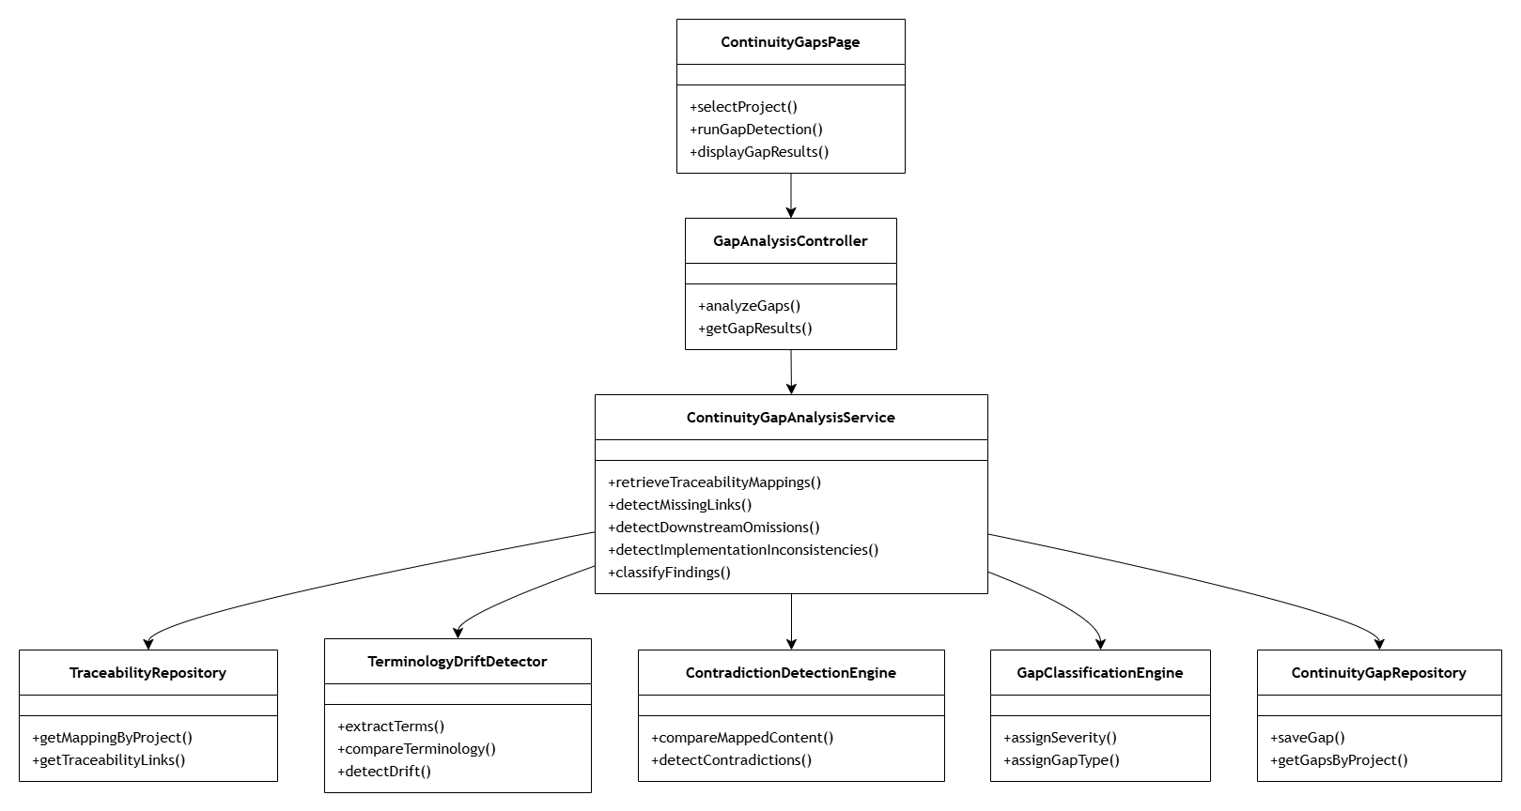

  - Sequence Diagram
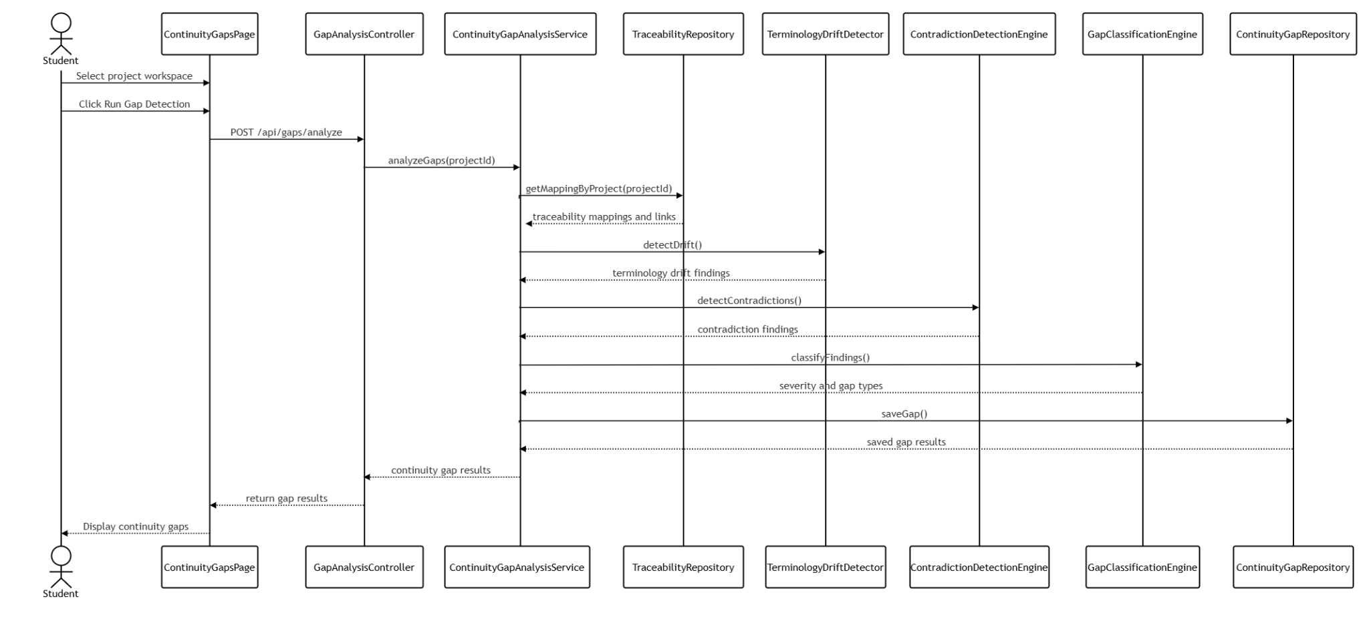

- Data Design
  - ERD for schema
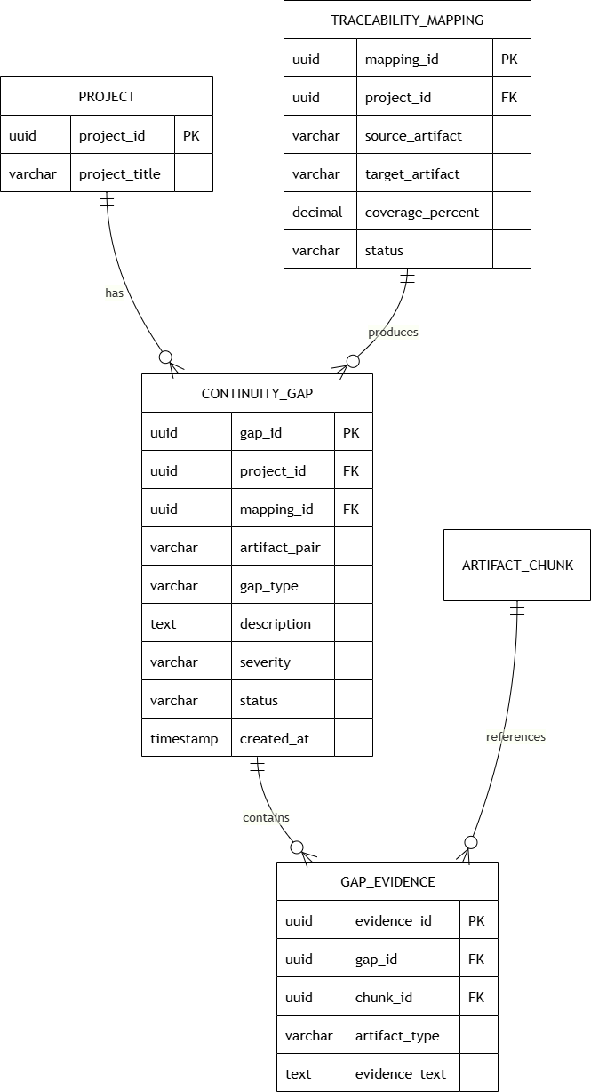

2.3 Generate Diagnostic Guidance
- User Interface Design


- Front-end component(s)
Component Name | Description and Purpose | Type / Format
DiagnosticGuidancePage | Main page for displaying AI-generated guidance. | React Functional Component
ProjectSelector | Allows the user to select a project workspace. | React Component
GenerateGuidanceButton | Triggers diagnostic guidance generation. | React Component
RootCauseCard | Displays AI-generated root cause analysis for a continuity issue. | React Component
RecommendationPanel | Displays corrective recommendations. | React Component
PriorityBadge | Displays recommendation priority level. | React Component
GuidanceDetailPanel | Displays complete recommendation details and supporting explanation. | React Component
GuidanceHistoryPanel | Displays previously generated recommendations. | React Component

- Back-end component(s)
Component Name | Description and Purpose | Type / Format
DiagnosticController | Handles requests for generating and retrieving AI diagnostic guidance. | Express.js Router / REST Controller
DiagnosticGuidanceService | Coordinates diagnostic generation using continuity findings. | Service Class
LLMIntegrationService | Sends continuity findings to the LLM and retrieves AI-generated diagnoses and recommendations. | External AI Service
RootCauseAnalysisEngine | Identifies probable causes of detected continuity failures. | Analysis Engine
RecommendationPrioritizer | Assigns recommendation priority levels. | Utility Class
ContinuityGapRepository | Retrieves detected continuity gaps. | Repository
DiagnosticGuidanceRepository | Stores generated diagnostic guidance. | Repository

- Object-Oriented Components
  - Class Diagram
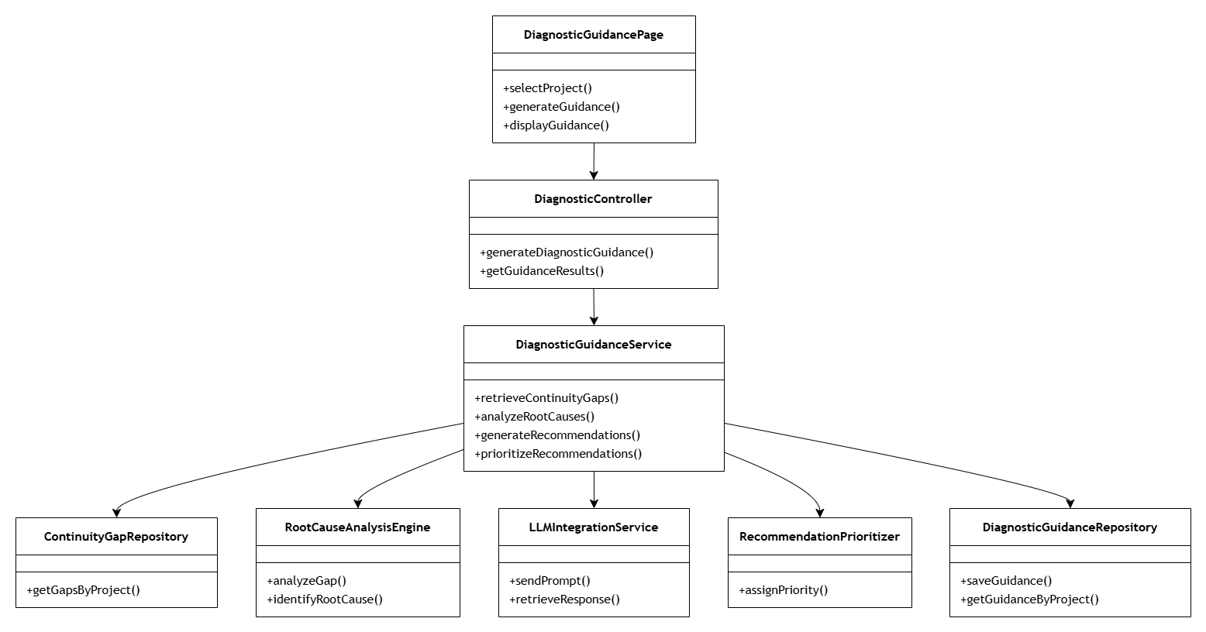

  - Sequence Diagram
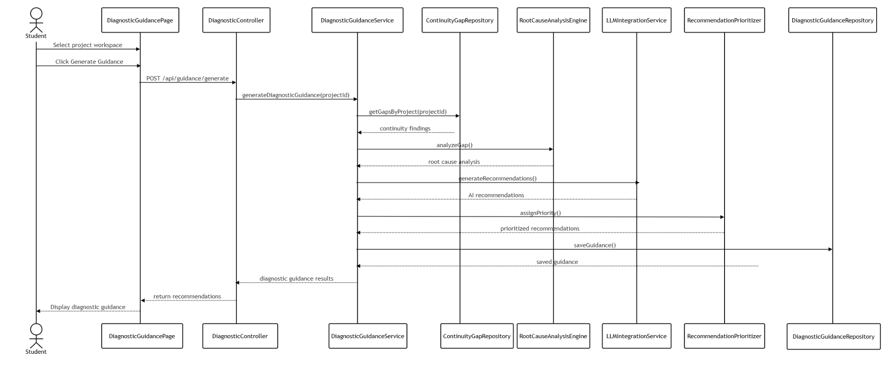

- Data Design
  - ERD for schema
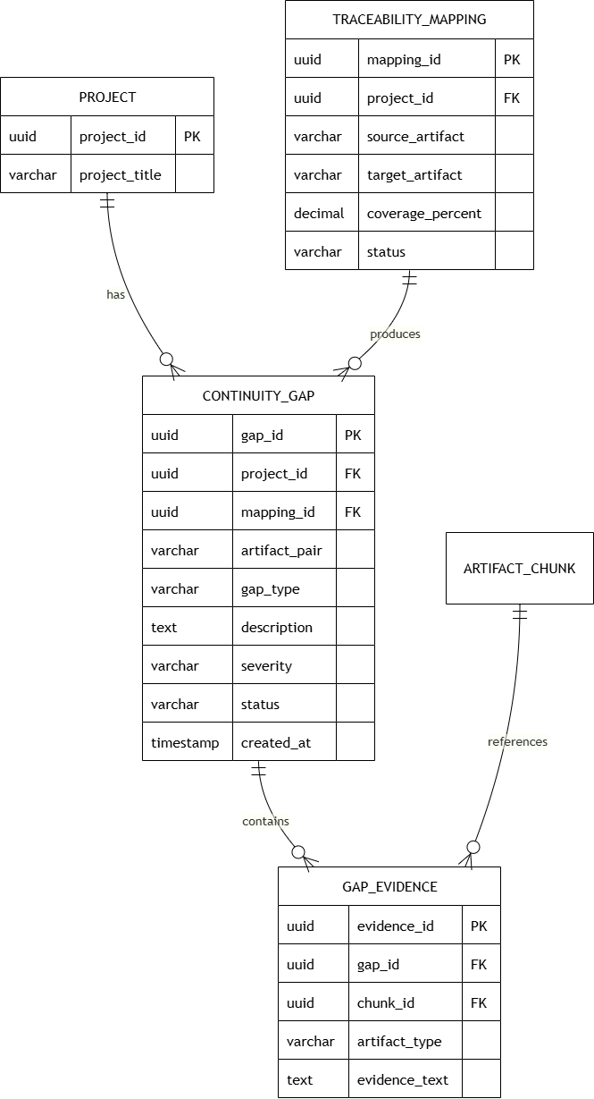

2.4 Analyze Source Code Alignment
- User Interface Design
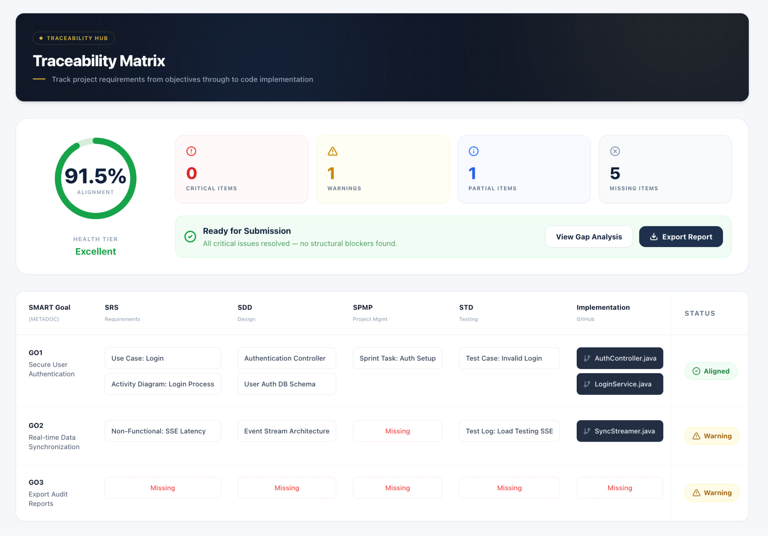
- Front-end component(s)
Component Name | Description and Purpose | Type / Format
SourceCodeAlignmentPage | Main page for source code alignment analysis. | React Functional Component
RepositorySelector | Allows users to select the repository to analyze. | React Component
RunAlignmentButton | Triggers source code alignment analysis. | React Component
AlignmentScoreCard | Displays overall alignment percentage. | React Component
AlignmentResultTable | Displays matched and unmatched design components. | React Component
MissingImplementationPanel | Displays missing classes, methods, or modules. | React Component
StructuralDeviationPanel | Displays deviations between design and implementation. | React Component
AlignmentEvidenceViewer | Displays supporting implementation evidence. | React Component

- Back-end component(s)
Component Name | Description and Purpose | Type / Format
SourceCodeAlignmentController | Handles requests for source code alignment analysis. | Express.js Router / REST Controller
SourceCodeAlignmentService | Coordinates comparison between SDD components and source code. | Service Class
GitHubRepositoryService | Retrieves repository structure and source files through GitHub API. | External API Service
CodeStructureAnalyzer | Extracts classes, methods, functions, and modules from source code. | Analysis Engine
DesignComponentMatcher | Matches SDD components against implementation artifacts. | Matching Engine
AlignmentScoringEngine | Computes alignment percentage and implementation coverage. | Utility Class
SourceCodeAlignmentRepository | Stores source code alignment results. | Repository

- Object-Oriented Components
  - Class Diagram
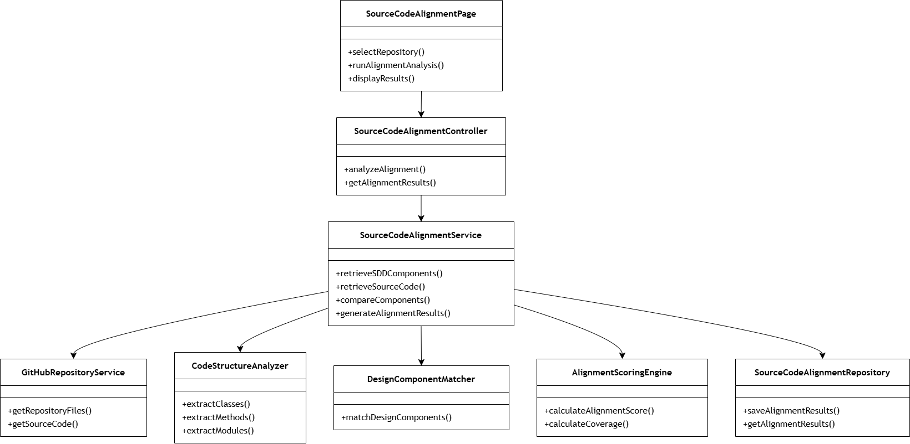

  - Sequence Diagram
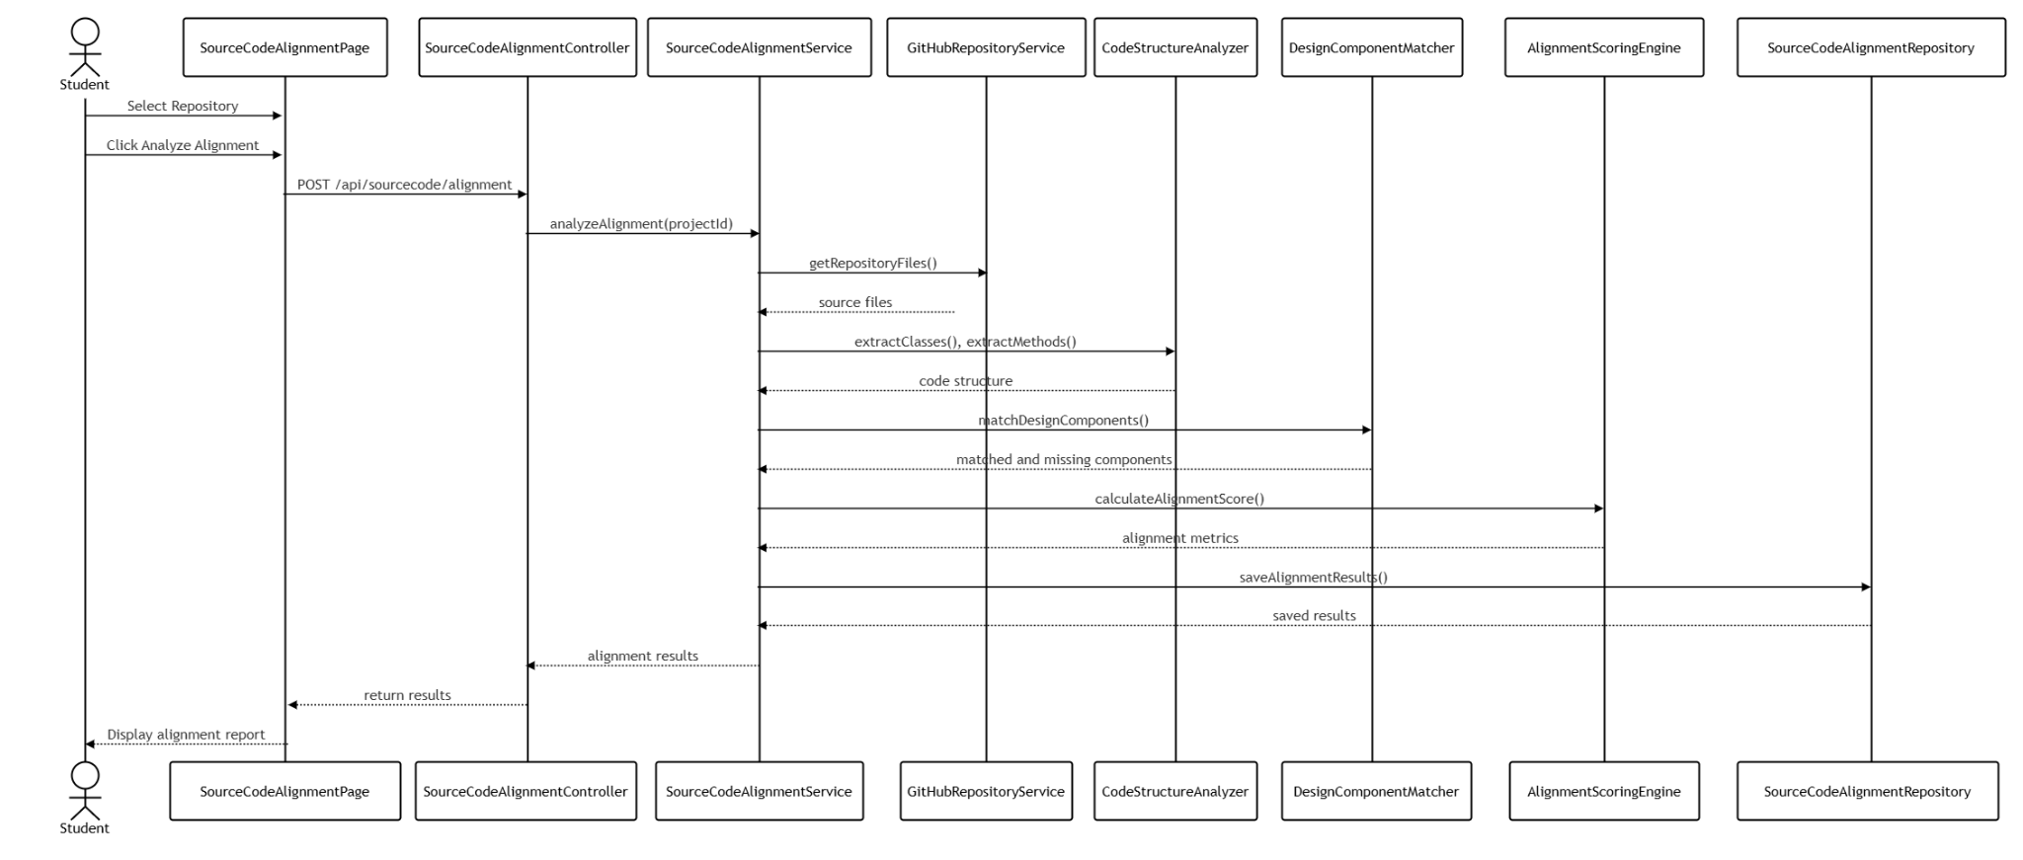

- Data Design
  - ERD for schema
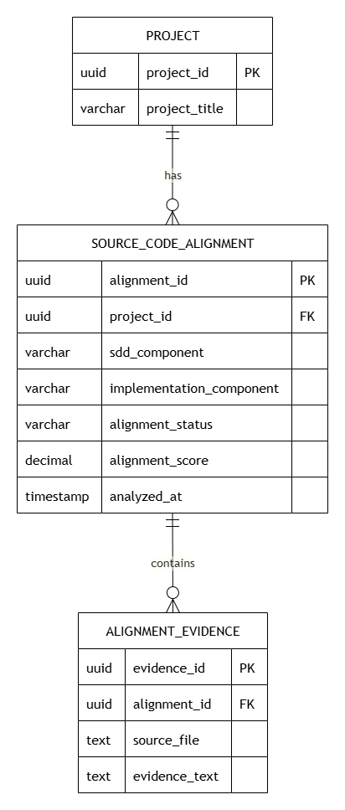

2.5 Generate Diagram Recommendations
- User Interface Design


- Front-end Components
Component Name | Description and Purpose | Type / Format
DiagramRecommendationPage | Main page for viewing AI-generated diagram recommendations. | React Functional Component
DiagramTypeSelector | Allows users to select the diagram type to review. | React Component
GenerateDiagramRecommendationButton | Triggers diagram recommendation generation. | React Component
DiagramRecommendationList | Displays suggested diagram improvements. | React Component
DiagramPreviewPanel | Displays preview of the recommended diagram structure. | React Component
MermaidCodeViewer | Displays generated Mermaid code for diagrams. | React Component
RecommendationDetailPanel | Shows explanation and affected artifact source. | React Component

- Back-end Components

Component Name | Description and Purpose | Type / Format
DiagramRecommendationController | Handles requests for generating and retrieving diagram recommendations. | Express.js Router / REST Controller
DiagramRecommendationService | Coordinates generation of diagram recommendations from gaps and alignment results. | Service Class
DiagramAnalysisEngine | Reviews existing diagram structures and checks missing or inconsistent elements. | Analysis Engine
MermaidGenerationService | Generates Mermaid-compatible diagram code. | Utility Service
LLMIntegrationService | Produces AI-assisted explanations and diagram correction suggestions. | External AI Service
ContinuityGapRepository | Retrieves detected continuity gaps. | Repository
SourceCodeAlignmentRepository | Retrieves source code alignment findings. | Repository
DiagramRecommendationRepository | Stores generated diagram recommendations and Mermaid outputs. | Repository

- Object-Oriented Components
  - Class Diagram
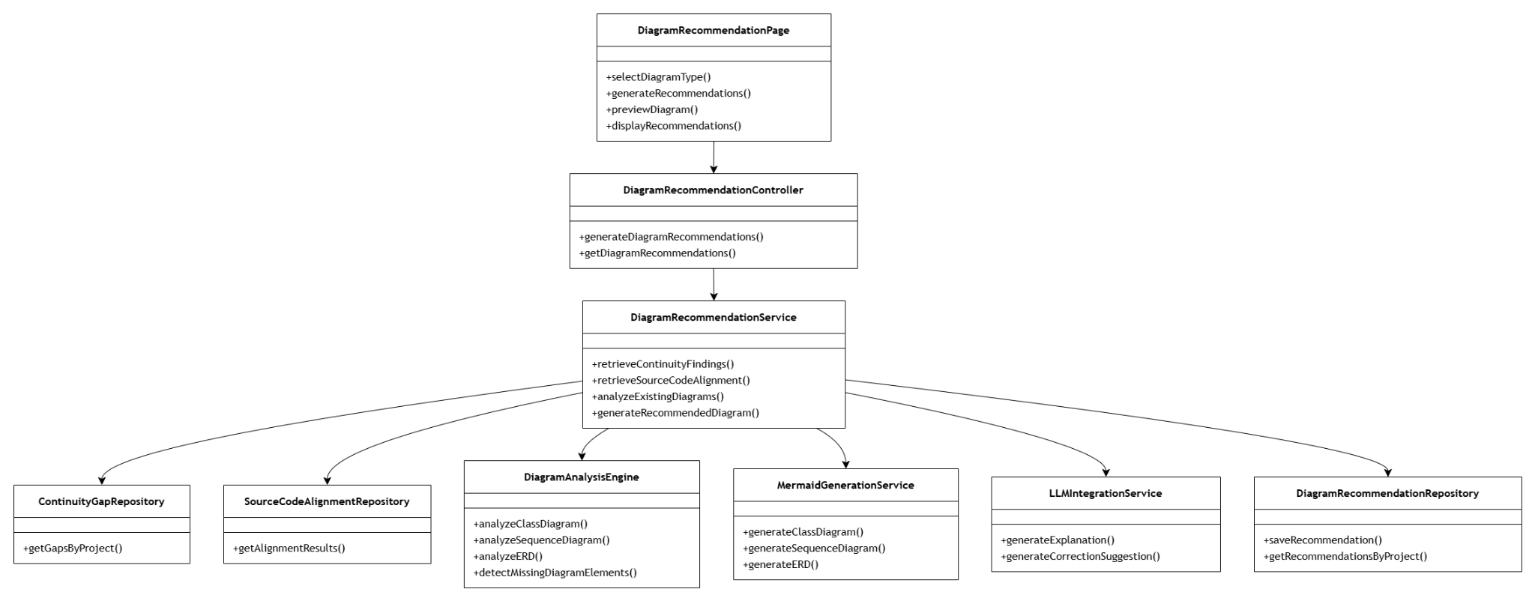

  - Sequence Diagram
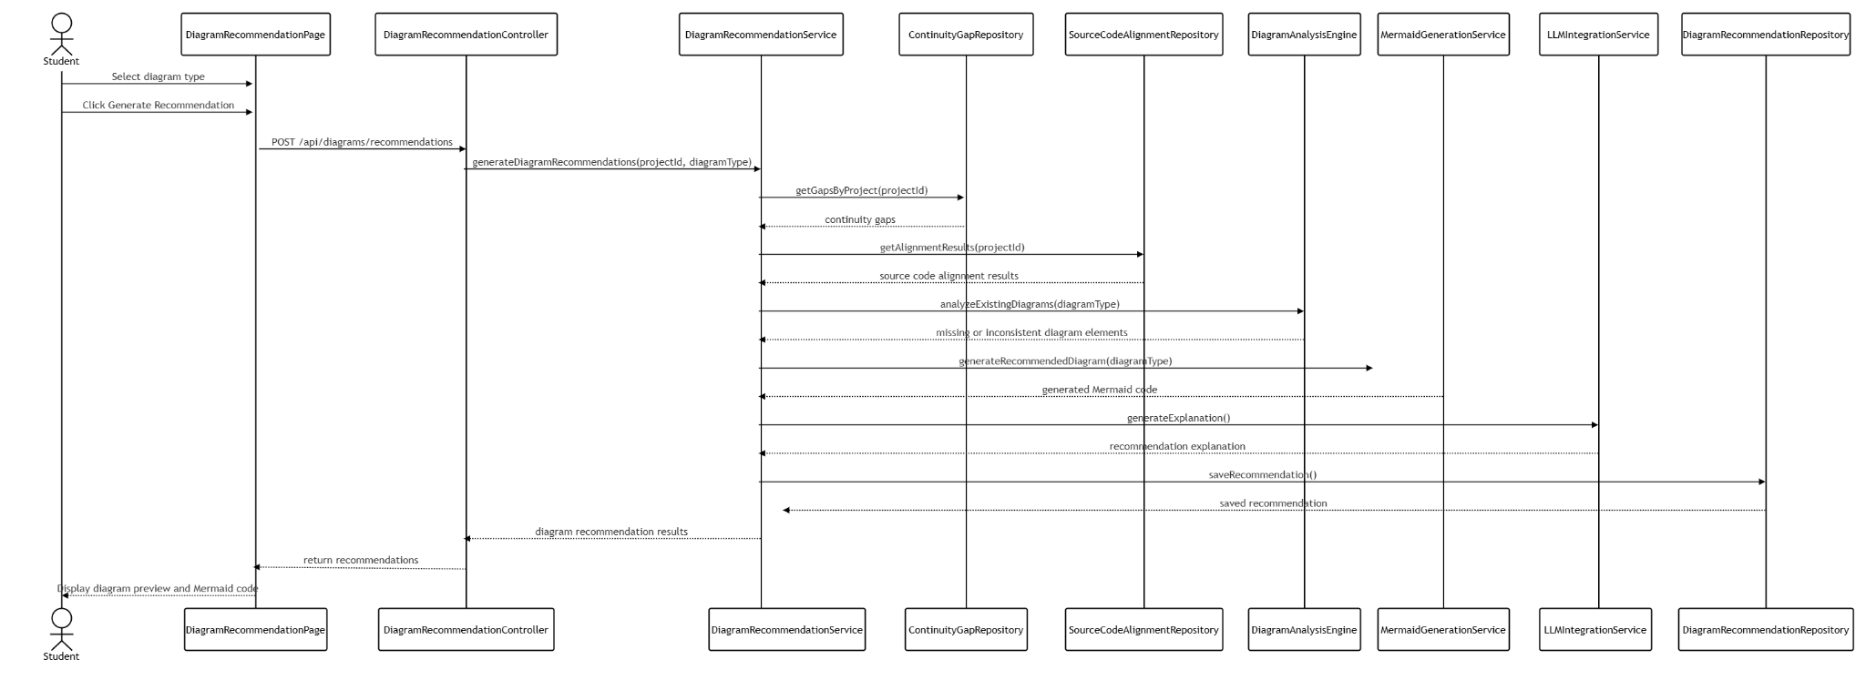

- Data Design
  - ERD for schema
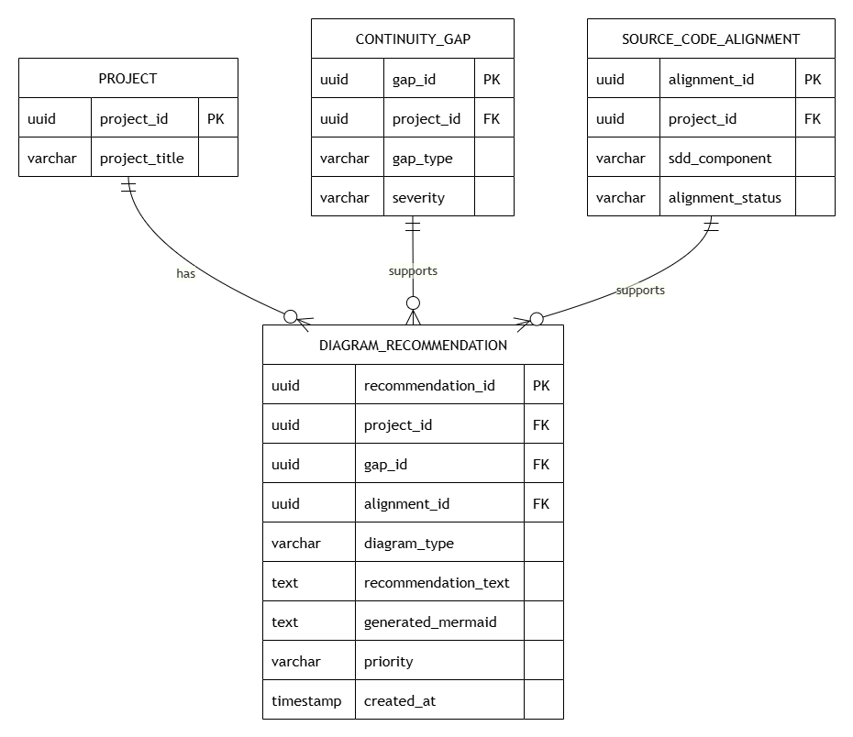

Module 3 : Continuity Monitoring and Audit Report Export

3.1 Student Monitoring Dashboard
- User Interface Design
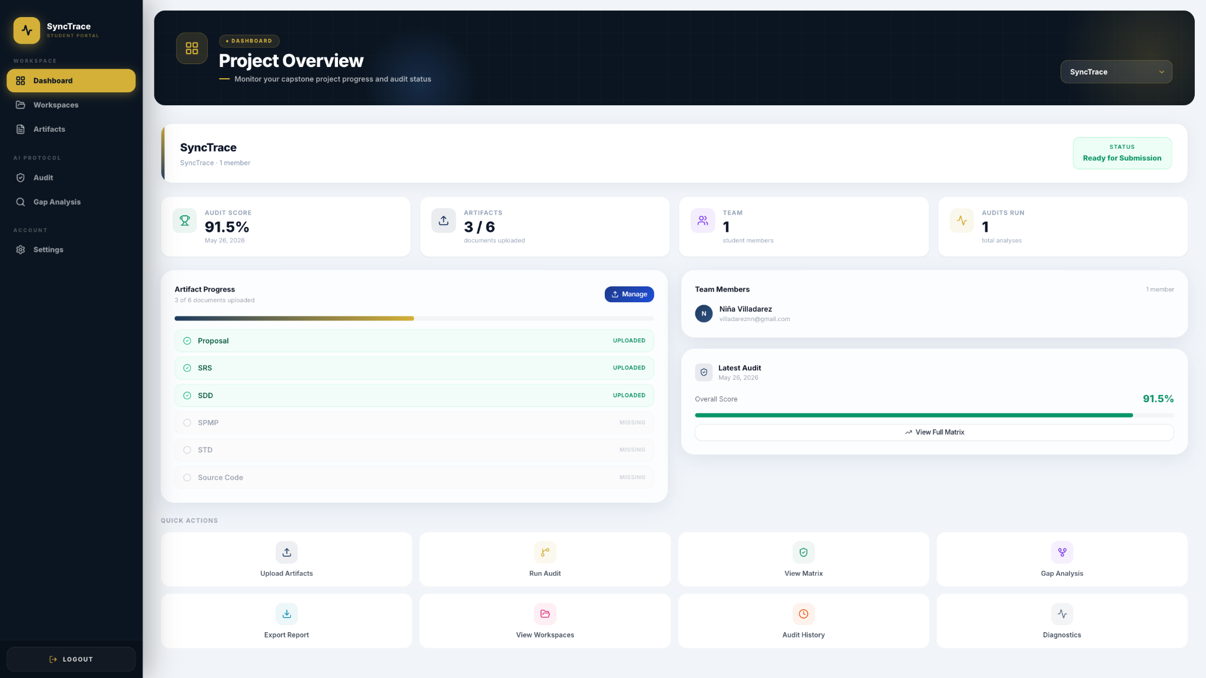
Figure 3.1.1 Student Dashboard

- Front-end component(s)
Component Name | Description and Purpose | Component Type
DashboardPage | Main student dashboard page that fetches project groups from /api/projects, selects the active group, calculates uploaded artifacts, latest audit result, student members, readiness status, and renders the complete dashboard view | React Functional Component
StatCard | Inline reusable dashboard metric card that displays Audit Score, Artifacts, Team, and Audits Run | React Functional Component
Layout | Shared page shell component that renders the sidebar, mobile top bar, dashboard hero/header, title, subtitle, badge, optional header action, and page content area | React Functional Component
Sidebar | Shared navigation component that renders student or faculty navigation links based on the authenticated user role, including Dashboard, Workspaces, Artifacts, Audit, Gap Analysis, Settings, and Logout | React Functional Component
Card | Shared UI wrapper component that wraps dashboard panels such as Artifact Progress, Team Members, and Latest Audit | React UI Component
Button | Shared UI button component that handles dashboard actions such as Manage, View Full Matrix, Run First Audit, and workspace navigation | React UI Component
Project Selector | Inline <select> control inside DashboardPage that appears when the user belongs to multiple groups and updates the selected active project | Inline TSX Component
Project Identity Banner | Inline dashboard section that displays the selected project title, group name, student member count, and readiness status badge | Inline TSX Section
Artifact Progress Panel | Inline dashboard card that displays uploaded artifact count, progress bar, and required artifact checklist | Inline TSX Section
Artifact Status Row | Inline mapped row that renders each required artifact: Proposal, SRS, SDD, SPMP, STD, and Source Code | Inline TSX Section
Team Members Panel | Inline dashboard card that lists student members for the selected group | Inline TSX Section
Team Member Row | Inline mapped row that displays each student member’s initials, name, and email | Inline TSX Section
Latest Audit Panel | Inline dashboard card that shows the latest audit date, overall score, progress bar, and navigation to the matrix page | Inline TSX Section
Quick Actions Grid | Inline dashboard section that contains shortcut buttons for Upload Artifacts, Run Audit, View Matrix, Gap Analysis, Export Report, View Workspaces, Audit History, and Diagnostics | Inline TSX Section
Quick Action Button | Inline mapped <button> that renders each quick action tile with icon, label, color, and navigation target | Inline TSX Section

- Back-end component(s)
Component Name | Description and Purpose | Component Type
projectsRouter | Express router that provides the dashboard’s main data source through GET /api/projects, returning groups for the authenticated student or faculty user with members, artifacts, and latest audit results | Express.js Router
groupInclude | Prisma include configuration that loads members, artifacts, and audit results for dashboard consumption | Prisma Query Configuration
auditInclude | Prisma include configuration that fetches the latest audit result with traceability links and gaps | Prisma Query Configuration
artifactsRouter | Express router that supports artifact creation, listing, and deletion through /api/artifacts; dashboard uses artifact records from the project query to compute progress | Express.js Router
auditRouter | Express router that runs traceability audits and provides the latest audit result through GET /api/audit/:groupId/latest | Express.js Router
authenticate | Authentication middleware that protects project, artifact, and audit routes and scopes dashboard data to the signed-in user | Express Middleware
prisma | Shared Prisma client that queries users, groups, artifacts, audit results, traceability links, and gaps | Prisma Client
User | Prisma model that represents authenticated users, roles, group membership, and export jobs | Prisma Model
FacultyGroup | Prisma model that represents a project workspace/group with project title, team code, adviser, members, artifacts, and audit results | Prisma Model
Artifact | Prisma model that represents uploaded project artifacts such as Proposal, SRS, SDD, SPMP, STD, and Source Code | Prisma Model
AuditResult | Prisma model that represents an audit run with overall score, readiness status, timestamp, traceability links, gaps, and export jobs | Prisma Model
TraceabilityLink | Prisma model that represents upstream/downstream artifact traceability relationships and alignment scores | Prisma Model
Gap | Prisma model that represents detected audit gaps, severity, affected artifacts, root cause, recommendation, and AI confidence | Prisma Model
ReadinessStatus | Prisma enum that defines dashboard readiness states: READY, NEEDS_REVISION, and CRITICAL_GAPS | Prisma Enum
ArtifactType | Prisma enum that defines required dashboard artifact categories: PROPOSAL, SRS, SDD, SPMP, STD, and SOURCE_CODE | Prisma Enum

- Object-Oriented Components
  - Class Diagram
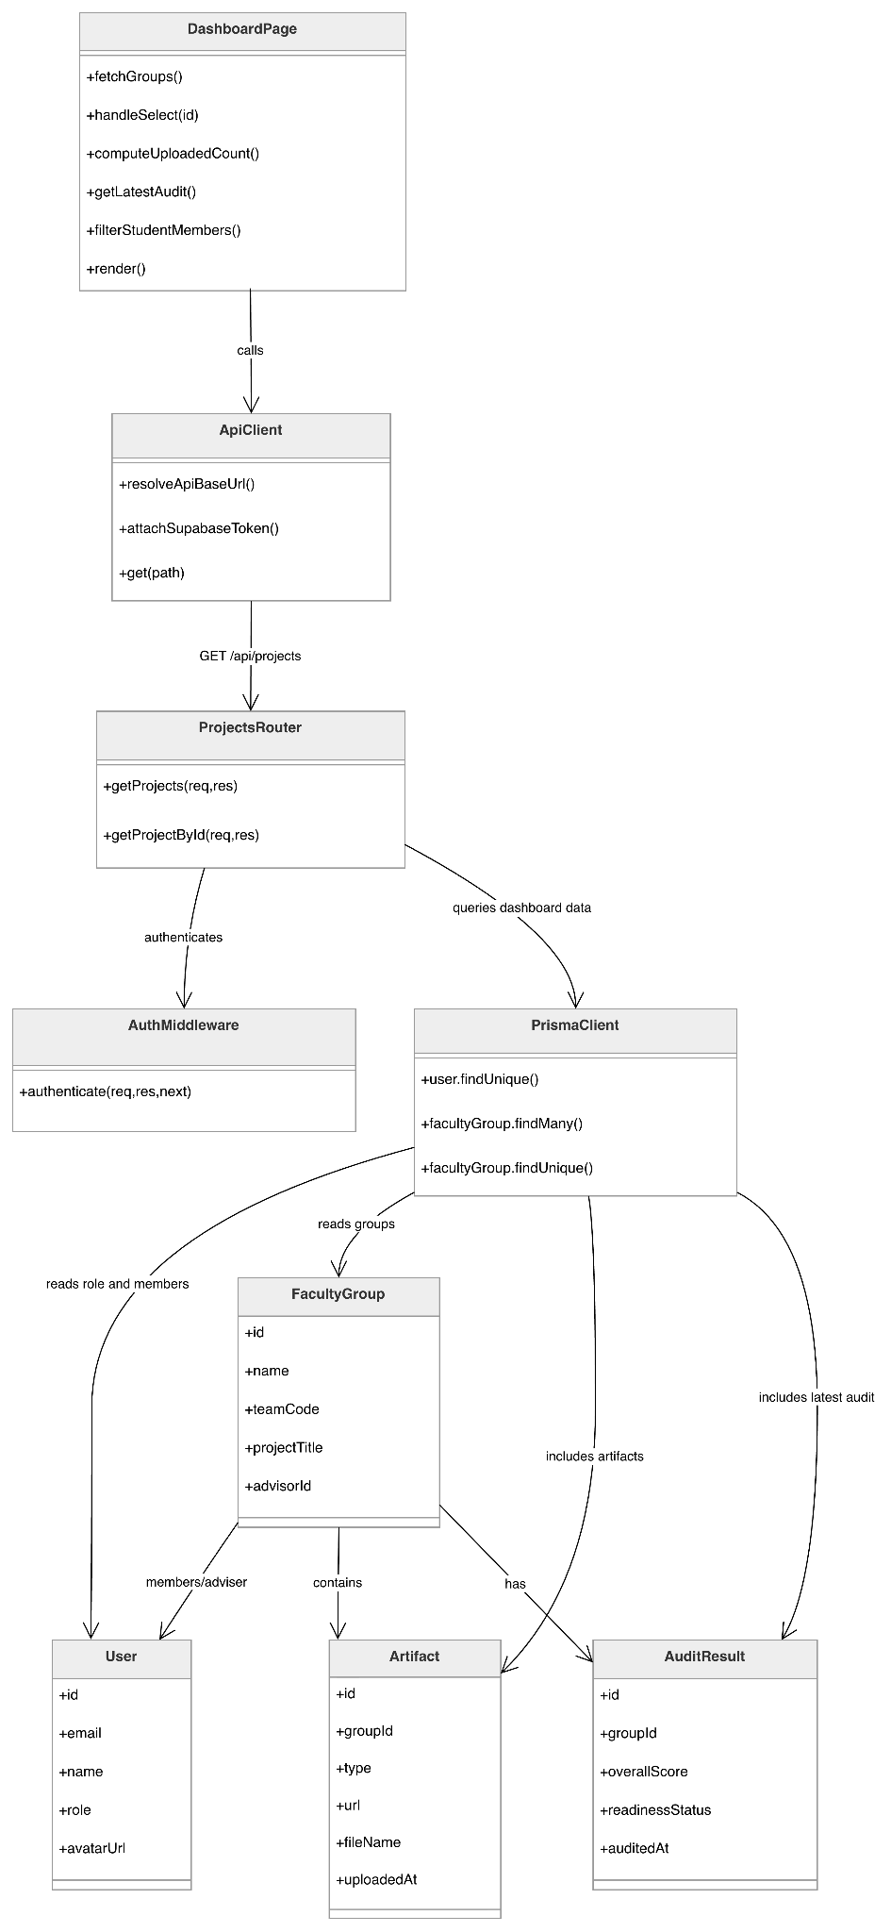

  - Sequence Diagram
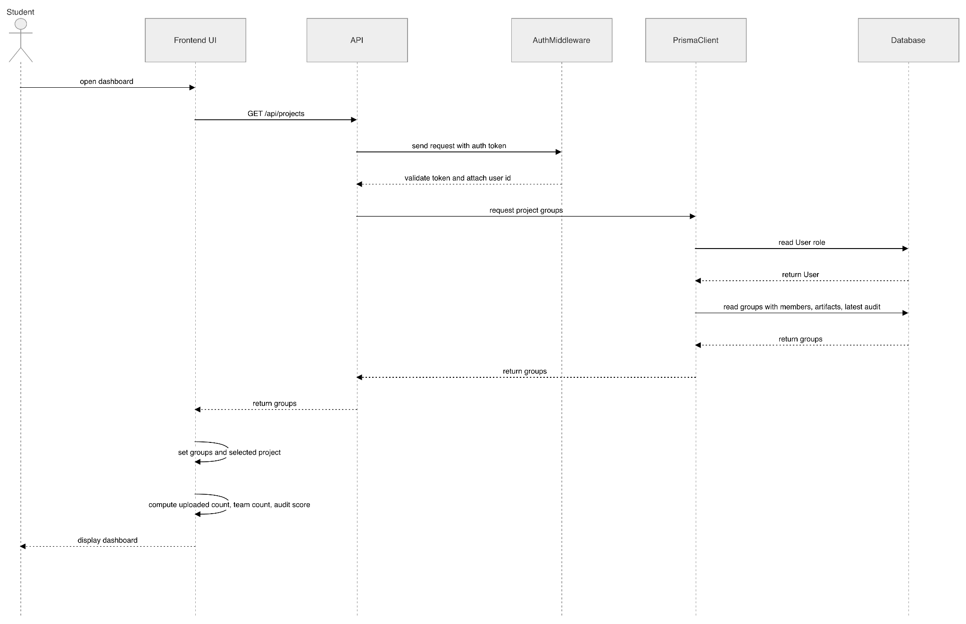

- Data Design
  - ERD for schema

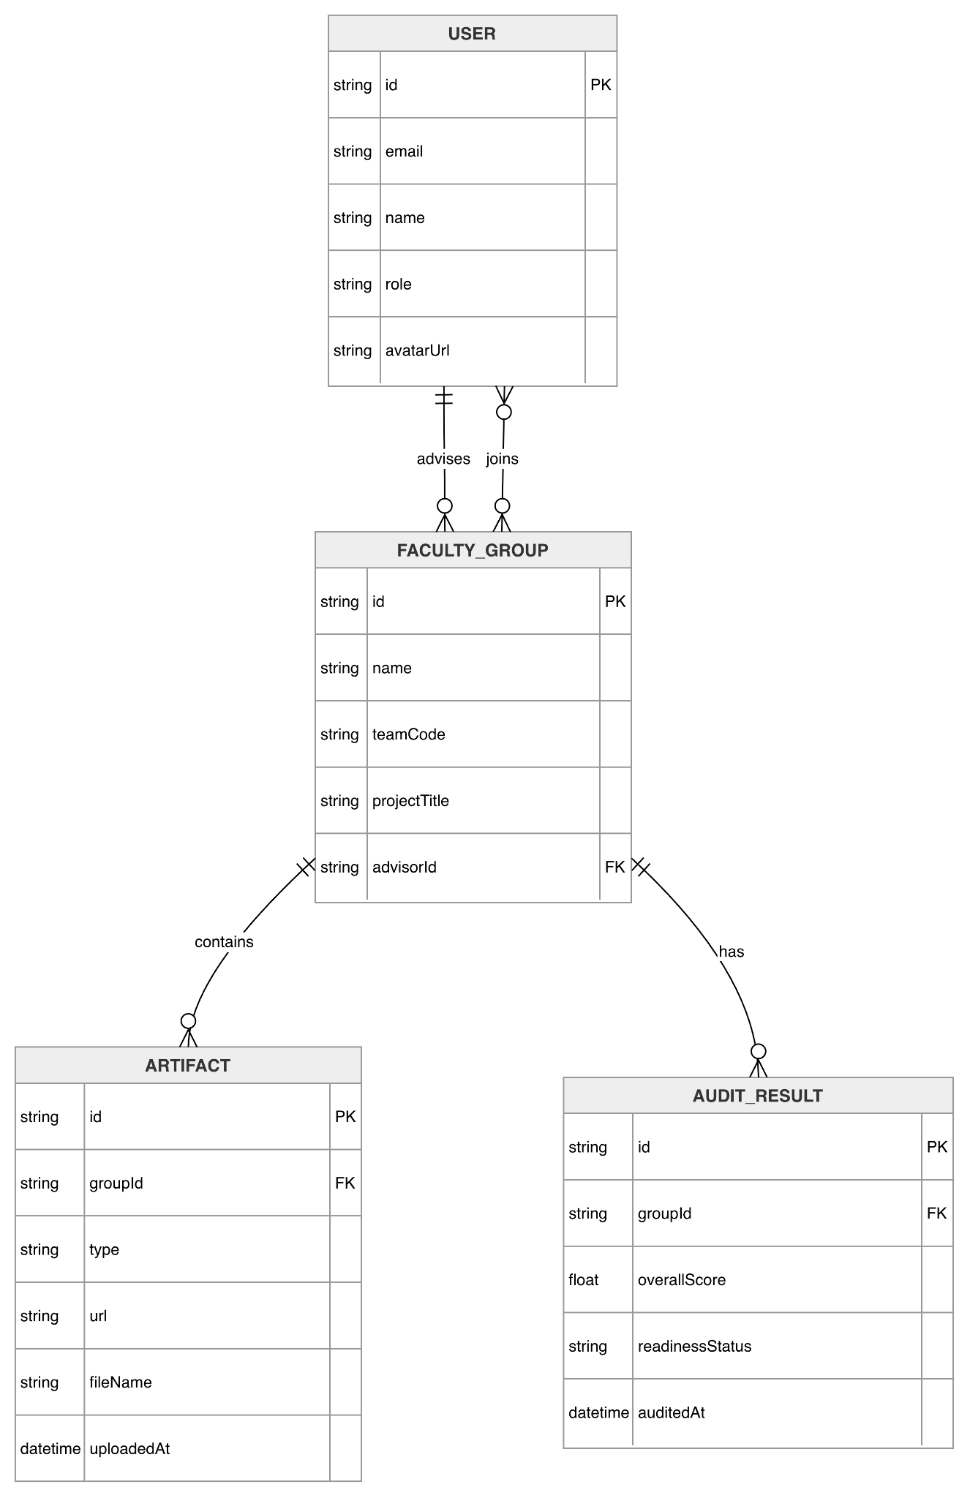

3.2 Adviser Monitoring Dashboard
- User Interface Design
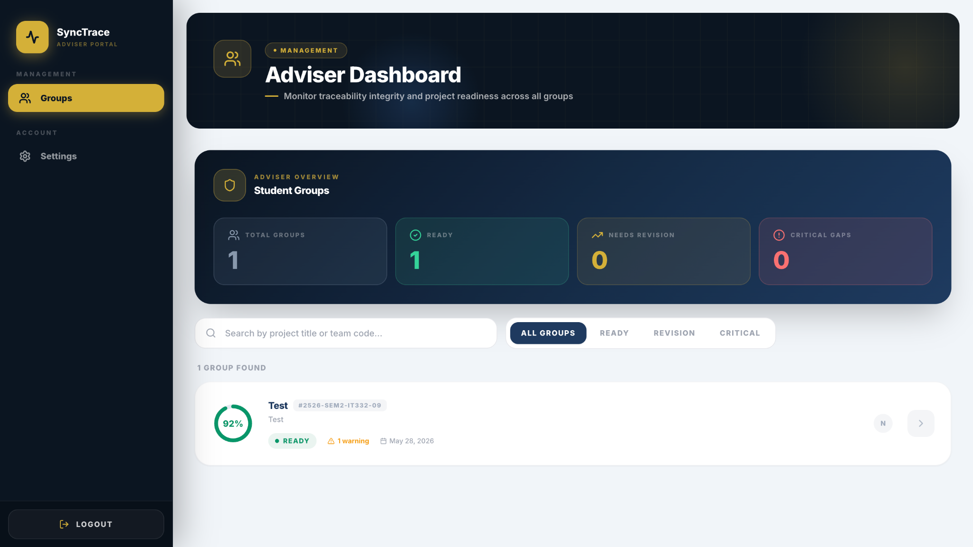
Figure 3.2.1 Adviser Dashboard - Groups List

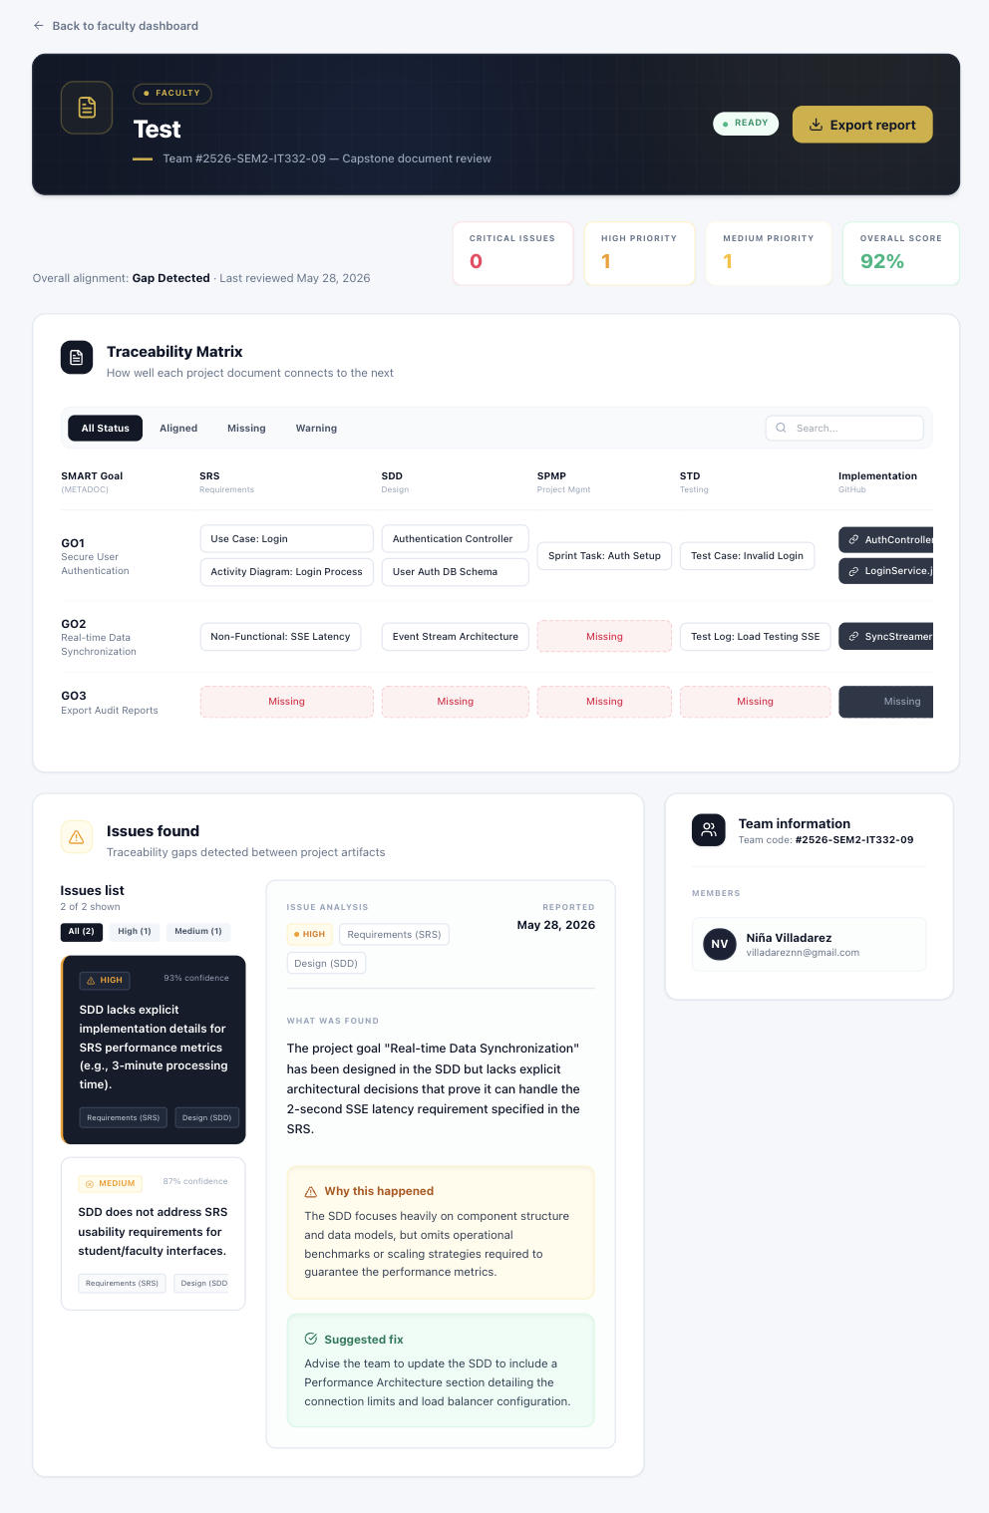
Figure 3.2.2 Adviser Dashboard - Group Detailed View
- Front-end component(s)
Component Name | Description and Purpose | Component Type
FacultyDashboard | Main dashboard component for faculty advisers that displays the list of assigned student groups and provides navigation to group details | React Functional Component
GroupSearchBar | Search input and filter dropdown component that allows faculty advisers to filter groups by name, health score range, or readiness status | React Component
GroupsTable | Data table component displaying assigned groups with columns: Student Group, Health Score, Unresolved Issues, Last Audit Date, and Readiness Status | React Component + React Table
GroupRow | Individual row component for each group with click-to-view functionality that triggers navigation to the group detail view | React Component
GroupDetailView | Detailed view component showing the selected group's complete continuity report including project info, team members, traceability matrix, gaps, and AI diagnostics | React Functional Component
TraceabilityTable | Reusable table component for displaying artifact pair traceability results with alignment scores, coverage percentages, and status indicators | React Component
GapList | List component displaying detected gaps with severity badges (Critical, High, Medium, Low) and brief descriptions | React Component
AIDiagnosticPanel | Panel component displaying AI-generated diagnostic summaries, root cause analyses, and prioritized corrective recommendations | React Component
SeverityBadge | Badge component showing gap severity level with appropriate color coding (Critical = Red, High = Orange, Medium = Yellow, Low = Blue) | React Component

- Back-end component(s)
Component Name | Description and Purpose | Component Type
FacultyController | REST endpoint handler for /api/faculty operations including getting assigned groups, group details, traceability chains, and AI diagnostics | Express.js Router
FacultyService | Service class that manages faculty-specific operations including retrieval of assigned projects, health score calculation, and group search functionality | Service Class
GroupMonitoringService | Service that aggregates group health scores, audit summaries, unresolved issues counts, and readiness trends from multiple data sources | Service Class
TraceabilityEvidenceService | Service that retrieves traceability chain evidence including matched sections, confidence scores, and artifact content for faculty review | Service Class
FacultyRepository | Data access layer for faculty-related database queries including faculty assignments and project lookups | Prisma Model

- Object-Oriented Components
  - Class Diagram
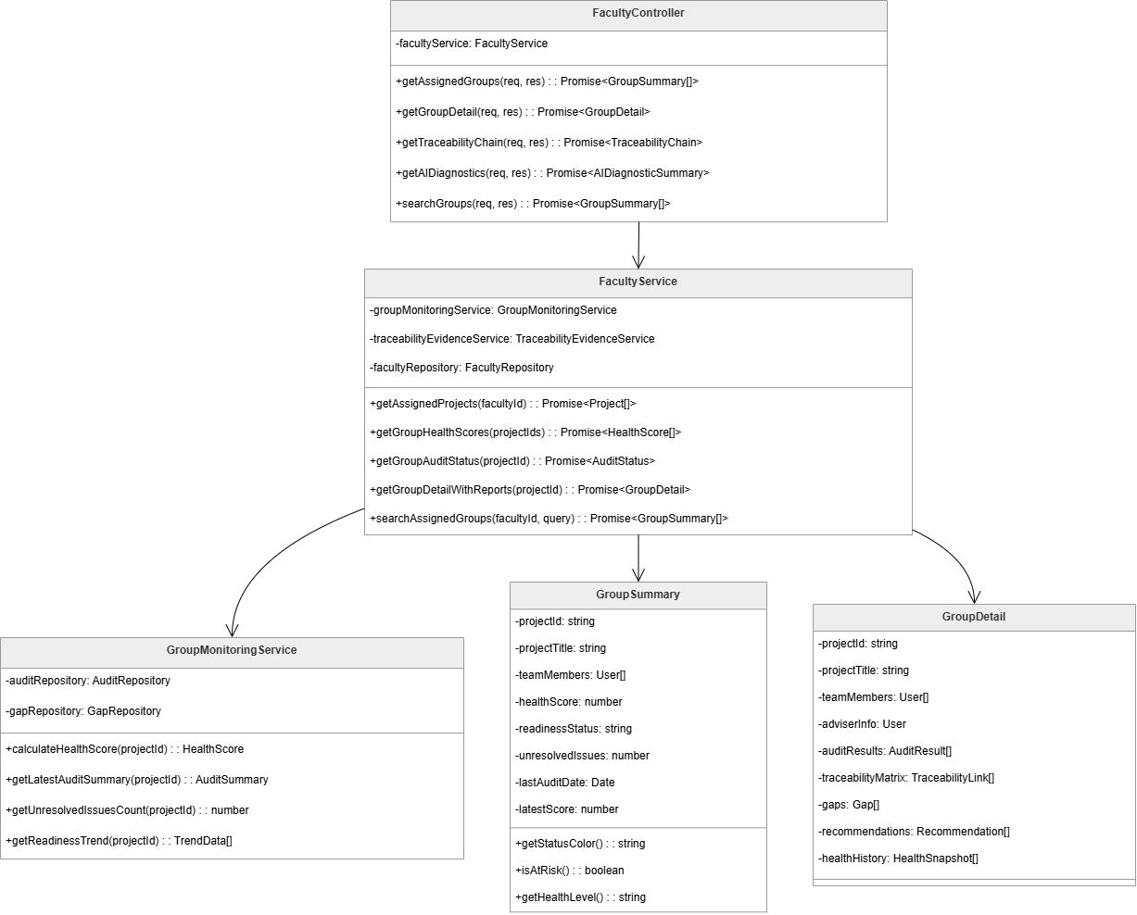

  - Sequence Diagram
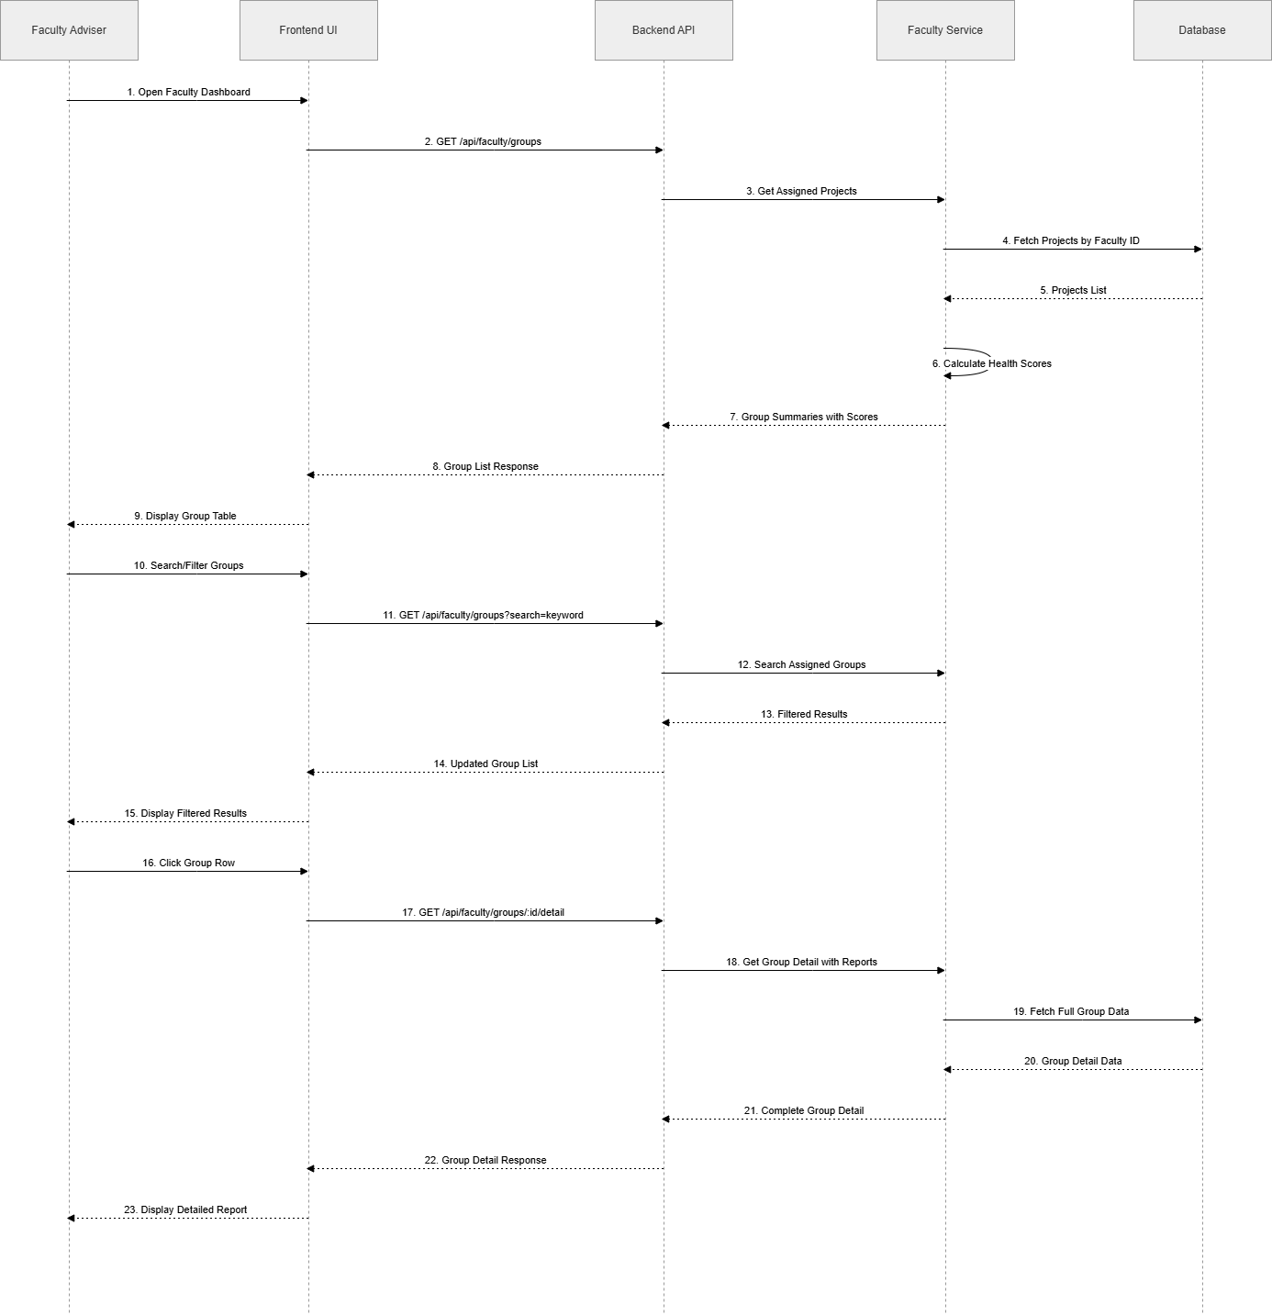

- Data Design
  - ERD for schema
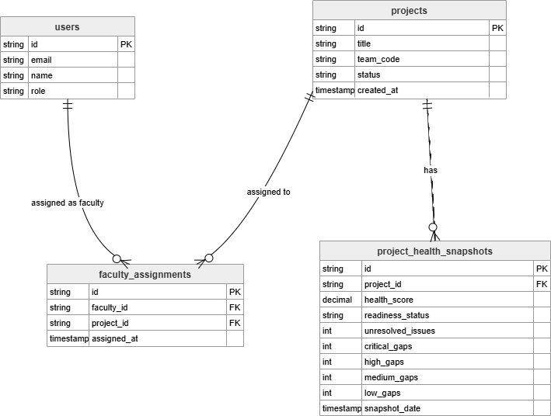

3.3 View Audit Results
- User Interface Design
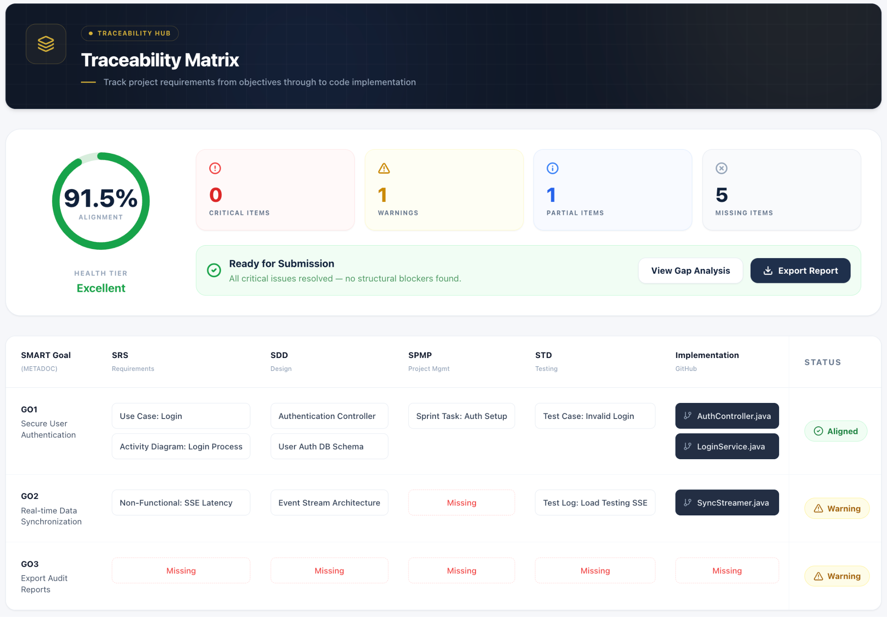
Figure 3.1.1 SyncTrace Traceability Matrix

- Front-end component(s)
Component Name | Description and Purpose | Component Type
TraceabilityMatrix | Main dashboard component that renders the overall alignment score, summary statistics cards, and the project readiness matrix table | React Functional Component
ReadinessScoreCard | Displays overall alignment score as a large percentage with a circular progress indicator and readiness status badge | React Component
StatisticsCards | Renders four summary cards showing critical gaps, warnings, partial alignments, and missing pairs counts | React Component
MatrixTable | Data table component showing SMART goals with alignment scores, coverage percentages, gap counts, and status badges | React Component + React Table
MatrixRow | Individual row component for each SMART goals | React Component
TraceEvidenceModal | Reusable badge component showing status (Ready for Review, Needs Revision, Critical Gaps Exist) with color coding | React Component
StatusBadge | Reusable badge component showing status (Ready for Review, Needs Revision, Critical Gaps Exist) with color coding | React Component

- Back-end component(s)
Component Name | Description and Purpose | Component Type
AuditController | REST endpoint handler for /api/audit operations including matrix retrieval and component details | Express.js Router
AuditService | Orchestrates retrieval of audit results, builds outcome matrix, and calculates alignment scores | Service Class
ReadinessCalculator | Computes overall project readiness status and coverage metrics | Service Class
MatrixBuilder | Constructs the project readiness matrix data structure from traceability links and gap analysis | Service Class
AuditRepository | Data access layer for retrieving audit results, traceability links, and coverage reports | Prisma Model

- Object-Oriented Components
  - Class Diagram
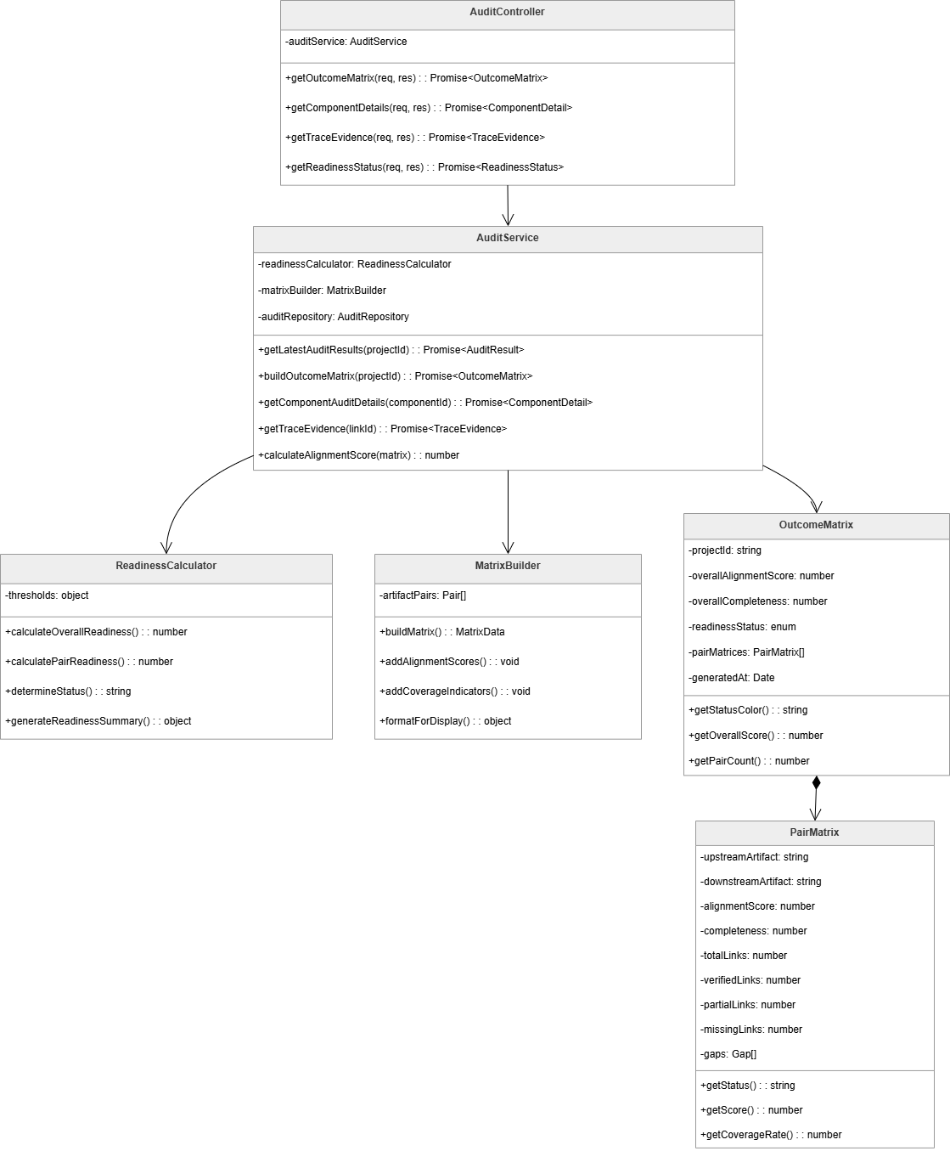

  - Sequence Diagram
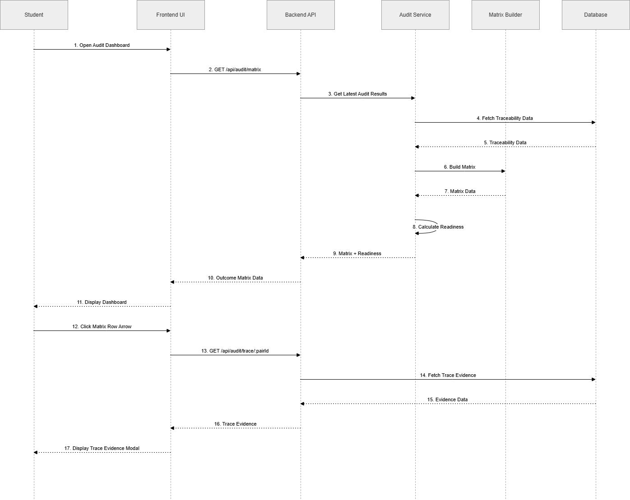

- Data Design
  - ERD for schema
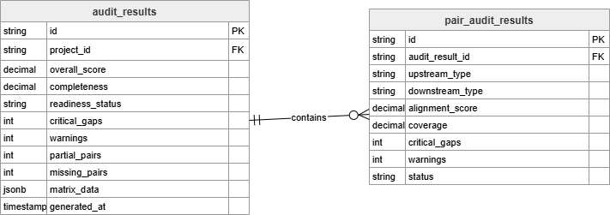

3.4 Export Audit Report
- User Interface Design
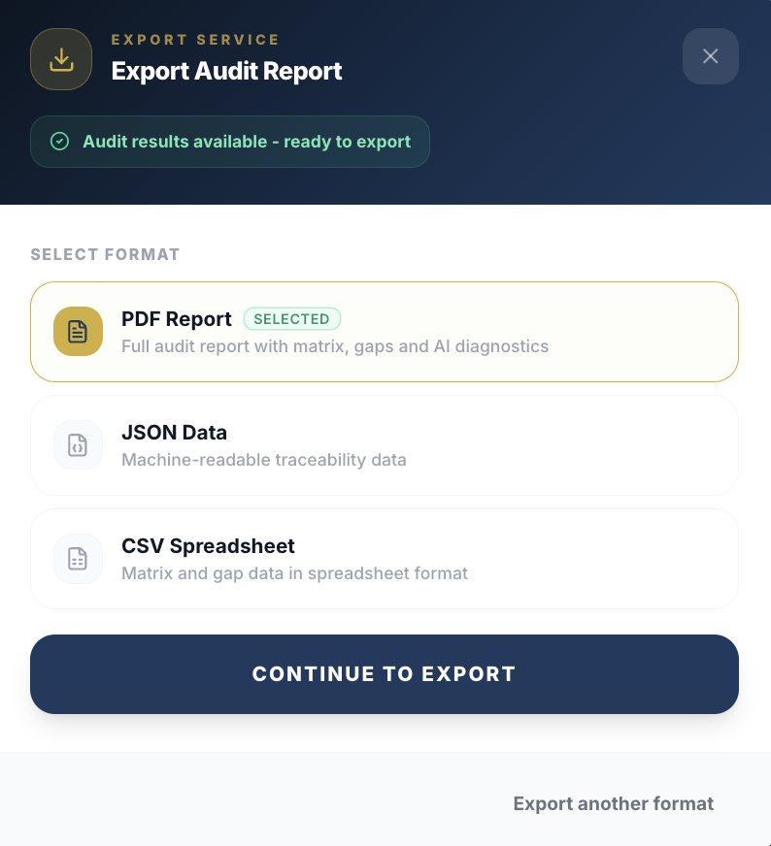
Figure 3.3.1 Export Report Modal


Figure 3.3.2 Download Report Modal

- Front-end component(s)
Component Name | Description and Purpose | Component Type
ExportButton | Button component located in the dashboard toolbar that triggers the report export workflow when clicked | React Component
ExportModal | Modal dialog component that manages the export workflow, displays generation progress, and presents the download option when ready | React Component + Modal Portal
ExportProgressIndicator | Visual progress indicator (spinner or progress bar) showing the current status of PDF generation | React Component
DownloadButton | Button that appears when PDF generation is complete, triggers the file download when clicked | React Component
ExportErrorAlert | Alert component that displays error messages when PDF generation fails, with a retry option | React Component
useExport | Custom React hook that manages export state, handles polling to check job status, and triggers file download when complete | React Custom Hook

- Back-end component(s)
Component Name | Description and Purpose | Component Type
ExportController | REST endpoint handler for /api/export operations including creating export jobs, checking status, and downloading reports | Express.js Router
ExportService | Service that orchestrates PDF generation, manages export job lifecycle, and coordinates between formatter, generator, and repository | Service Class
PDFGenerator | Utility class that generates PDF documents from HTML templates using libraries like Puppeteer or jsPDF | Utility Class
ReportFormatter | Service that formats audit data (traceability matrix, gap list, recommendations, executive summary) for PDF presentation | Service Class
ExportRepository | Data access layer for managing export job records including creation, status updates, and retrieval | Prisma Model

- Object-Oriented Components
  - Class Diagram
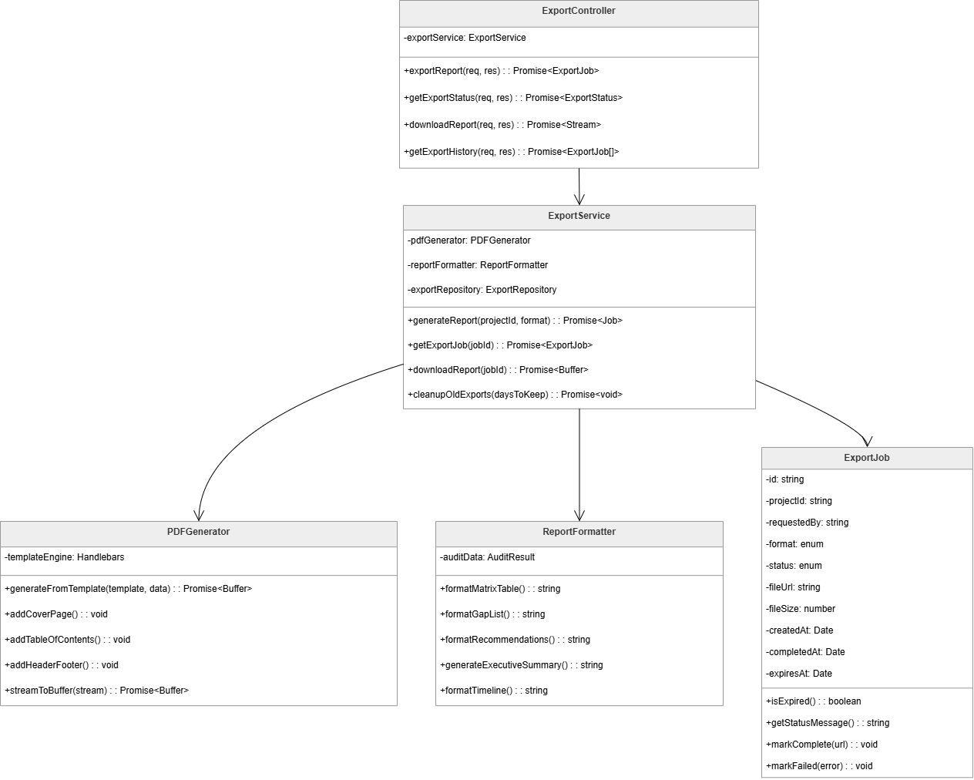
  - Sequence Diagram
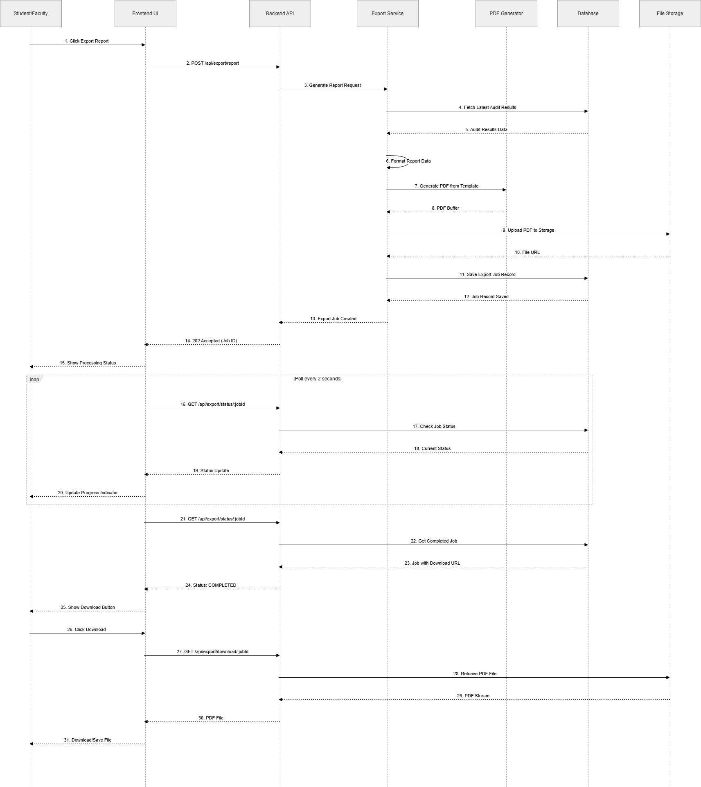

- Data Design
  - ERD for schema
