CEBU INSTITUTE OF TECHNOLOGY
UNIVERSITY

COLLEGE OF COMPUTER STUDIES

Software Requirements Specifications
for
SYNCTRACE

Change History
Version | Date | Author(s) | Changes Made
0.1 | May 16, 2026 | Baritua, Carl Gabriel  Cordero, Camila Rose  Delposo, Kerby  Temperatura, Sharbelle  Villadarez, Niña Nicole | Initial draft of SRS
0.2 | June 10, 2026 | Baritua, Carl Gabriel  Cordero, Camila Rose  Delposo, Kerby  Temperatura, Sharbelle  Villadarez, Niña Nicole

Table of Contents

1. Introduction 4
1.1. Purpose 4
1.2. Scope 4
1.3. Definitions, Acronyms and Abbreviations 5
References 7
2. Overall Description 8
2.1. Product perspective 8
2.2. User characteristics 8
2.4. Constraints 9
2.5. Assumptions and dependencies 9
3. Specific Requirements 10
3.1. External interface requirements 10
3.1.1. Hardware interfaces 10
3.1.2. Software interfaces 10
3.1.3. Communications interfaces 10
3.2. Functional requirements 11
Module 1: Project Initialization and Artifact Synchronization 11
Module 2: Traceability and Continuity Verification 21
Module 3: Continuity Monitoring and Audit Report Export 33
3.4 Non-functional requirements 46
Performance 46
Security 46
Reliability 46
Usability 46

Introduction

Purpose
The purpose of this document is to provide a comprehensive description of SyncTrace, an Intelligent Project Continuity and Traceability Assistant designed for academic software engineering and capstone environments. SyncTrace serves as a centralized submission, synchronization, continuity monitoring, and traceability verification platform that integrates project artifacts, evaluation outputs, and implementation evidence throughout the capstone development lifecycle.

This document serves as a technical reference for students, faculty advisers, and other project stakeholders by defining the system's functional and non-functional requirements, system behavior, interfaces, and operational constraints. It ensures that the implementation of SyncTrace remains aligned with its intended capabilities of authenticating authorized users, synchronizing project artifacts with external evaluation systems, retrieving evaluation outputs and extracted project components, establishing goal-centered traceability relationships, detecting continuity gaps, and generating audit reports that support project monitoring and academic evaluation.

SyncTrace extends the capabilities of MetaDoc and IEEE Docs Evaluator by consolidating project submissions, evaluation results, and implementation evidence into a single platform. Rather than performing standalone document quality evaluation, the system focuses on verifying whether project SMART goals remain consistently represented across requirements, design, project management, testing, and implementation artifacts, thereby improving project continuity, traceability coverage, and alignment throughout the software development lifecycle.

Scope
SyncTrace is a web-based intelligent continuity auditing and traceability platform designed for academic software engineering and capstone projects. The system supports the entire software development lifecycle by integrating project documentation, evaluation outputs, and implementation evidence into a centralized continuity verification environment.

The system accepts cloud-hosted project artifacts and source code repositories, including:
- Project Proposal
- Software Requirements Specification (SRS)
- Software Design Description (SDD)
- Software Project Management Plan (SPMP)
- Software Test Document (STD)
- GitHub Source Code Repository

SyncTrace integrates with the following external systems:
- MetaDoc for proposal evaluation, SMART goal extraction, feedback retrieval, and submission metadata acquisition.
- IEEE Docs Evaluator for evaluation of SRS, SDD, SPMP, and STD artifacts, including extraction of document components, quality assessments, feedback, and evaluation scores.
- GitHub for source code retrieval, repository structure analysis, and implementation evidence collection.

The system follows an Onboard–Ingest–Map–Verify–Report workflow consisting of project initialization, artifact synchronization, traceability mapping, continuity verification, and audit reporting.
After synchronization, SyncTrace retrieves SMART goals, extracted artifact components, evaluation outputs, feedback records, scores, submission metadata, and implementation evidence. Using semantic similarity analysis and AI-assisted verification techniques, the system establishes traceability relationships across the following predefined artifact pairs:
- Proposal → SRS
- SRS → SDD
- SRS → SPMP
- SRS → STD
- SDD → Source Code

The system performs continuity verification by:
- Recovering semantic traceability relationships across project artifacts.
- Validating SMART objective coverage throughout downstream artifacts.
- Detecting continuity gaps, contradictions, downstream omissions, and implementation inconsistencies.
- Identifying terminology drift and inconsistent technical terminology across project artifacts.
- Analyzing source code alignment with SDD design components, including object-oriented and non-object-oriented elements.
- Generating AI-driven root cause diagnoses and corrective recommendations for detected continuity issues.

To support project monitoring and academic evaluation, SyncTrace provides:
- Student Dashboard
- Adviser Dashboard
- Interactive Traceability Matrix
- Project Readiness Evaluation
- Continuity Audit Summaries
- Alignment and Coverage Metrics
- Exportable Audit Reports in PDF, JSON, and CSV formats

The interactive traceability matrix begins with SMART goals extracted from the Proposal and provides visibility into continuity relationships across software engineering artifacts and source code implementation. General Objectives are represented as modules, while Specific Objectives are represented as functions or transactions that serve as traceability anchors throughout the project lifecycle.

The system is intended for educational software engineering environments and supports continuity analysis, traceability verification, and implementation auditing. It does not perform runtime software testing, execute source code, replace existing document evaluation systems, or validate software behavior during execution.

Definitions, Acronyms and Abbreviations
Definitions
- Alignment Score – A calculated metric representing the degree of semantic correspondence and structural adherence across sequential project artifacts and source code modules.
- Artifact – Any project-related document or software component produced throughout the capstone lifecycle, specifically restricted to the Project Proposal, Software Requirements Specification (SRS), Software Design Description (SDD), Software Project Management Plan (SPMP), Software Test Document (STD), and source code repositories.
- Document Drift – The gradual semantic or structural divergence of downstream project artifacts from original objectives and requirements due to uncoordinated or undocumented revisions across lifecycle phases.
- Embedding – A multi-dimensional numerical vector representation of text fragments generated by a semantic engine to evaluate mathematical and contextual similarity between disparate documents.
- Implementation Evidence – Tangible components within a remote source code repository (e.g., classes, methods, modules) that serve as proof of realization for corresponding software design elements.
- Interactive Traceability Matrix – A dynamic visual grid tracing project continuity from foundational proposal objectives through intermediate documentation down to final code implementations, allowing real-time expansion of alignment evidence and gap diagnoses.
- Project Readiness Indicators – A composite set of health metrics, alignment scores, and risk levels that visually denote whether a capstone project is mathematically complete and consistent enough for formal academic defense.
- Sequential Traceability – The systematic methodology of mapping and verifying structural and contextual continuity strictly between consecutive, predefined downstream artifact pairs (Proposal →↮SRS, SRS → SDD, SRS → SPMP, SRS → STD, and SDD → Source Code).
- Terminological Drift – The inconsistent variation, evolution, or unauthorized redefinition of technical terms, acronyms, and concept naming conventions across different project lifecycle documents.
Acronyms and Abbreviations
AI Artificial Intelligence
API Application Programming Interface
CSV Comma-Separated Values
DOCX Microsoft Word Open XML Document
GitHub Cloud-Based Source Code Hosting Platform
Google Auth 2.0 Google Authentication Protocol
IEEE Institute of Electrical and Electronics Engineers
JSON JavaScript Open Systems / Object Notation
LLM Large Language Model
MVP Minimum Viable Product
OCR Optical Character Recognition
PDF Portable Document Format
QA Quality Assurance
RRL Review Related Literature
SDD Software Design Description
SMART Specific, Measurable, Achievable, Relevant, Time-bound
SPMP Software Project Management Plan
SRS Software Requirements Specification
STD Software Test Document
UI User Interface
URL Uniform Resource Locator

References
- Al-Msie’deen, R. (2023). Requirements traceability: Recovering and visualizing traceability links between requirements and source code of object-oriented software systems. arXiv. https://doi.org/10.48550/arxiv.2307.05188
- Biggs, J. (1996). Enhancing teaching through constructive alignment. Higher Education, 32(3), 347–364. https://doi.org/10.1007/BF00138871
- Keogh, K., & Venables, A. (2009). The importance of project management documentation in computing students’ capstone projects. Asia-Pacific Journal of Cooperative Education, 10(3), 151–162. https://vuir.vu.edu.au/4377/1/APJCE_10_3_151_162.pdf
- Mayr-Dorn, C., Vierhauser, M., Bichler, S., Keplinger, F., Cleland-Huang, J., Egyed, A., & Mehofer, T. (2023). ProCon: An automated process-centric quality constraints checking framework. Journal of Systems and Software, 201, 111727. https://doi.org/10.1016/j.jss.2023.111727
- Muram, F. U., Tran, H., & Zdun, U. (2018). Systematic review of software behavioral model consistency checking. ACM Computing Surveys, 50(2), 1–39. https://doi.org/10.1145/3037755
- Neyem, A., Sandoval Alcocer, J. P., Mendoza, M., Centellas-Claros, L., Gonzalez, L. A., & Paredes-Robles, C. (2024). Exploring the impact of generative AI for stand-up report recommendations in software capstone project development. In Proceedings of the 55th ACM Technical Symposium on Computer Science Education (SIGCSE 2024) (pp. 951–957). Association for Computing Machinery. https://doi.org/10.1145/3626252.3630854
- Saqr, M., Fors, U., & Tedre, M. (2025). Bridging the gap between intended and implemented curricula: The role of constructive alignment in medical education. BMC Medical Education, 25, Article 45. https://doi.org/10.1186/s12909-025-06736-4
- Trust Over IP Foundation. (2026). Spec-Up-T: Technical specification and term consistency management. https://trustoverip.github.io/spec-up-t-website/
- Winecoff, A., & Bogen, M. (2025). Improving governance outcomes through AI documentation: Bridging theory and practice. In Proceedings of the 2025 CHI Conference on Human Factors in Computing Systems (pp. 1–18). Association for Computing Machinery. https://doi.org/10.1145/3706598.3713814
- Winkler, S., & von Pilgrim, J. (2010). A survey of traceability in requirements engineering and model-driven development. Software & Systems Modeling, 9(4), 529–565. https://doi.org/10.1007/s10270-009-0145-0
- Zhang, Z., Yao, Q., He, J., Wen, B., Gong, Y., Zhou, L., & Wei, J. (2026). A multi-task framework for intelligent review and semantic consistency detection in scientific project documentation using large language models. Informatica, 50(9). https://doi.org/10.31449/inf.v50i9.12145

Overall Description

Product perspective
SyncTrace is an AI-powered project continuity and traceability companion designed explicitly for academic software engineering capstone structures. It operates as an independent, web-based audit layer that connects disparate software engineering repositories, external document evaluation ecosystems, and version control registries into a unified verification engine.
The system directly ingests machine-readable project artifacts hosted on cloud storage platforms (Google Drive) and source-code endpoints hosted on version control networks (GitHub repositories). Rather than establishing an N × N matrix cross-examining every document simultaneously, SyncTrace imposes a strict, linearly structured validation sequence:
- Proposal → SRS (Ensures foundational scope translation)
- SRS → SDD (Ensures requirements are fully designed)
- SRS →SPMP (Ensures requirements drive project management tasks)
- SRS → STD (Ensures requirements possess explicit test definitions)
- SDD → Source Code (Ensures designed architectural components match physical code implementation)
SyncTrace inherits, synthesizes, and builds upon the localized validation records produced by two predecessor architectures: MetaDoc (which handles document-level ingest and isolated evaluation of Proposal structures) and the IEEE Docs Evaluator (which analyzes stand-alone compliance criteria for software engineering deliverables). SyncTrace bridges these architectures by correlating their metadata and extracted content chunks to execute cross-artifact semantic consistency mapping and source-level verification.

User characteristics
Students (Primary Users): Expected to be senior-level computer science or information technology students executing a capstone project workflow. They possess functional familiarity with documentation practices (IEEE standards), configuration management (Git workflows), and project tracking mechanisms. They interact with the platform to configure workspaces, manage artifact URLs, verify task coverage against original objectives, map implementations to engineering designs, and retrieve AI-guided diagnostic remedies.
Faculty Advisers (Secondary Users): Expected to be academic instructors, technical directors, or evaluation committee members possessing comprehensive knowledge of software engineering documentation metrics and structural evaluation criteria. They use the system to track real-time alignment scores across distributed groups, rapidly diagnose gaps in technical continuity prior to milestones, and inspect auto-generated readiness summaries to accelerate the academic grading and defense authorization processes.

2.4. Constraints
The development and operation of SyncTrace are subject to the following constraints:
- Internet Dependency – The application requires a continuous, high-bandwidth connection to remote network resources. Downtime or latency spikes on Google services, GitHub platforms, or external artificial intelligence hosting nodes directly stalls preprocessing and traceability execution.
- File Format Limitation – Semantic parsing is explicitly optimized for digitized text objects. The architecture strictly demands .docx format for MetaDoc interaction and unencrypted machine-readable .pdf or .docx streams for IEEE Docs Evaluator targets. Scanned physical layouts, handwritten notebook drafts, low-resolution raster graphics, or text payloads stripped of structural encoding cannot be processed.
- LLM Processing and Window Constraints – The depth of multi-document relationship tracing, paragraph breakdown, and context synthesis is bound by the hardware context windows, performance degradation caps, and transaction rate-throttling limits of the underlying large language model infrastructure.
- Third-Party API Limitations – Ingestion operations are strictly governed by consumer thresholds, transaction rate throttling, and payload capacities enforced by the Google Drive API and the GitHub API.
- Static Analysis Scope Boundary – The system performs static document alignment and declarative structural parsing of repository frameworks. SyncTrace does not build binaries, run runtime executions, manage active software testing, process code-coverage instrumentation, or evaluate dynamic runtime behavior.
- Educational Context Restriction – The parsing parameters, compliance templates, lifecycle paths, and operational matrices are custom-configured for academic milestone tracking and capstone evaluation rules. They are not built to scale across massive, multi-tenant enterprise development environments or chaotic, ad-hoc open-source engineering paradigms.

2.5. Assumptions and dependencies
Assumptions:
- Ingested artifacts conform structurally to standard academic templates where structural headings (e.g., General Objectives, Specific Objectives) can be logically isolated during preprocessing.
- Project objectives are explicitly formatted as SMART goals within the Proposal layer to ensure valid anchor extraction.
- GitHub codebases utilize recognizable, standard language directory structures allowing class and module declarations to be matched against design blueprints.
Dependencies:
- Google OAuth 2.0 for identity management and tenant grouping.
- MetaDoc Platform Services for parsing and extracting evaluation states for core Proposal documents.
- IEEE Docs Evaluator Engine for handling structural grading, itemized extraction, and compliance metadata retrieval across engineering documents (SRS, SDD, SPMP, STD).
- GitHub API Endpoint Layer for processing source trees, structural manifests, commit payloads, and module content files.
- Semantic Embedding Engine & LLM APIs for mathematical vector transformations, concept similarity mappings, contradiction checks, and diagnostic reporting.

Specific Requirements

External interface requirements

3.1.1. Hardware interfaces
SyncTrace operates as a cloud-hosted web platform and does not require custom client-side peripheral chipsets or local server setups. To interact with the system's centralized dashboards and execution layouts, users only require a standard computing device (laptop or desktop) with a minimum Dual-Core Intel Core i3 (or equivalent x86_64 or ARM64) processor, 4 GB of physical system RAM, available storage space, and a stable broadband network connection. All resource-intensive processing - including multi-format document parsing and vector conversions is offloaded to cloud microservices. Consequently, local physical interaction is limited to standard human input peripherals and standard SVGA video display monitors. The user interface is built to scale across standard modern web browsers, recommending a minimum resolution of 1280 × 720 pixels to cleanly render interactive traceability matrices, project readiness indicators, progress tracking elements, and multi-document gap summaries.

3.1.2. Software interfaces
The application logic of SyncTrace acts as an intelligent, cross-artifact verification layer that programmatically communicates with multiple external services and system APIs to trace capstone deliverables. Secure user authentication and workspace group structures are managed through the Google OAuth 2.0 API, while document retrieval relies on the Google Drive API. Rather than processing documents completely from scratch, SyncTrace bridges and synthesizes data directly from two predecessor platforms: it orchestrates automated API calls with MetaDoc to extract evaluation outputs and SMART goals from Proposal files, and connects to the IEEE Docs Evaluator API to retrieve compliance tables, scores, and raw document components for the SRS, SDD, SPMP, and STD. To cross-reference text specifications against source repositories, the system utilizes the GitHub REST and GraphQL APIs to ingest codebase trees, commit metadata, and map module evidence across object-oriented and non-object-oriented structures. This multi-source data payload is subsequently compiled via automated Natural Language Processing (NLP) frameworks and multi-task Large Language Model (LLM) services to generate semantic embedding vectors, calculate similarity distances, identify contradictions, and process diagnostic guidance. On the client side, the web application runs securely inside modern browser engines, including Google Chrome, Mozilla Firefox, and Microsoft Edge.

3.1.3. Communications interfaces
Data transactions across the SyncTrace client, backend servers, and distributed software endpoints are mediated through secure internet-based communication protocols. To preserve strict source artifact confidentiality and prevent unauthorized exposure, all transmission channels mandate an over-the-wire encryption baseline utilizing HTTPS via TLS 1.3 protocols. System communication follows an asynchronous client-server architecture, where browser environments trigger automated ingestion, traceability mapping, and reporting actions to the backend web nodes via RESTful API rules using structured, schema-validated JSON payloads. Furthermore, specialized source-code capture routines establish credentialed network connections with GitHub's gateway using authorized HTTPS or Git/SSH file transfer networks to parse raw code files. Because the system relies on real-time external synchronization pipelines to process a complete 50-page document set and repository within three minutes and deliver audit reports within ten seconds, a persistent internet connection is an operational prerequisite to ensure continuous synchronization and prevent transaction timeouts.

Functional requirements

Module 1: Project Initialization and Artifact Synchronization

1.1 Secure Authentication

Use Case Diagram
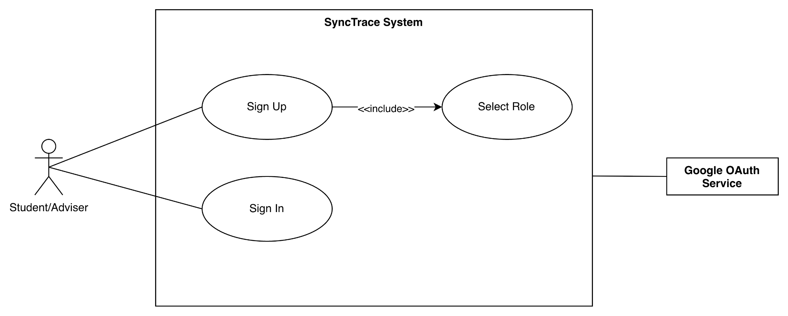

Use Case Description
Item | Description
Use Case Name | Secure Authentication
Primary Actors | Student, Adviser
Supporting Actor | Google OAuth Service
Trigger | User accesses SyncTrace and chooses to sign in or sign up.
Precondition | User has a valid Google account
Main Flow | - User accesses SyncTrace.  - User selects either Sign Up or Sign In.  - If the user selects Sign Up, the system prompts the user to select a role: Student or Adviser.  - User proceeds with Google authentication.  - System redirects the user to Google OAuth.  - Google OAuth verifies the user’s Google account.  - System authenticates the user and creates or retrieves the account information.  - System redirects the user to the appropriate dashboard based on their role.
Alternative Flows | If Google authentication fails, the system displays an error and allows the user to try again.
Postcondition | User is successfully authenticated and redirected based on role.

Activity Diagram
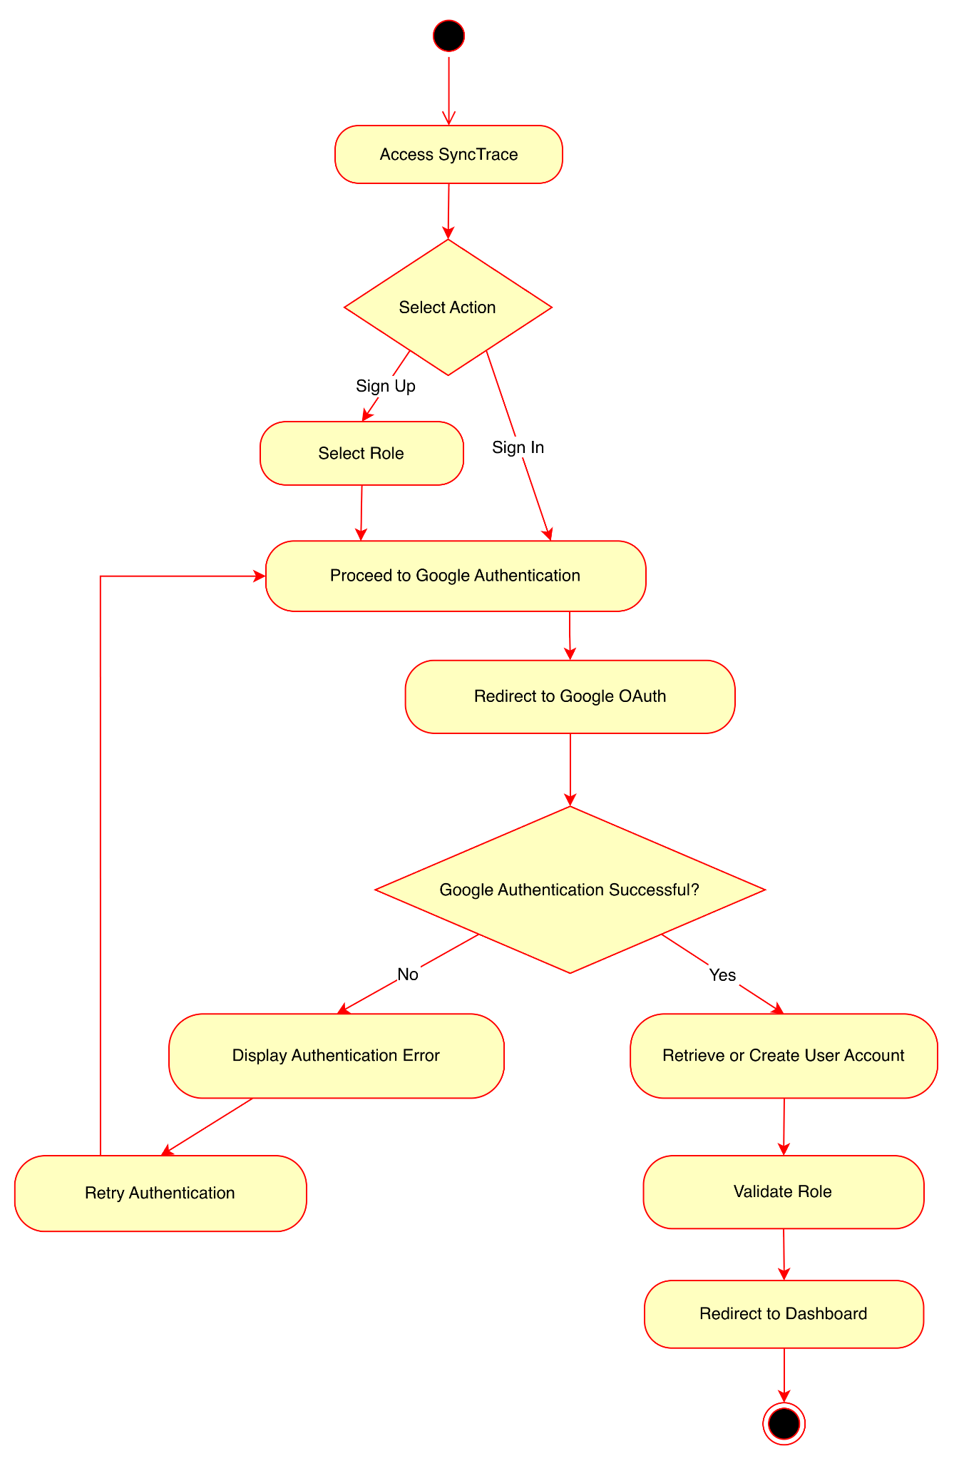

Wireframe
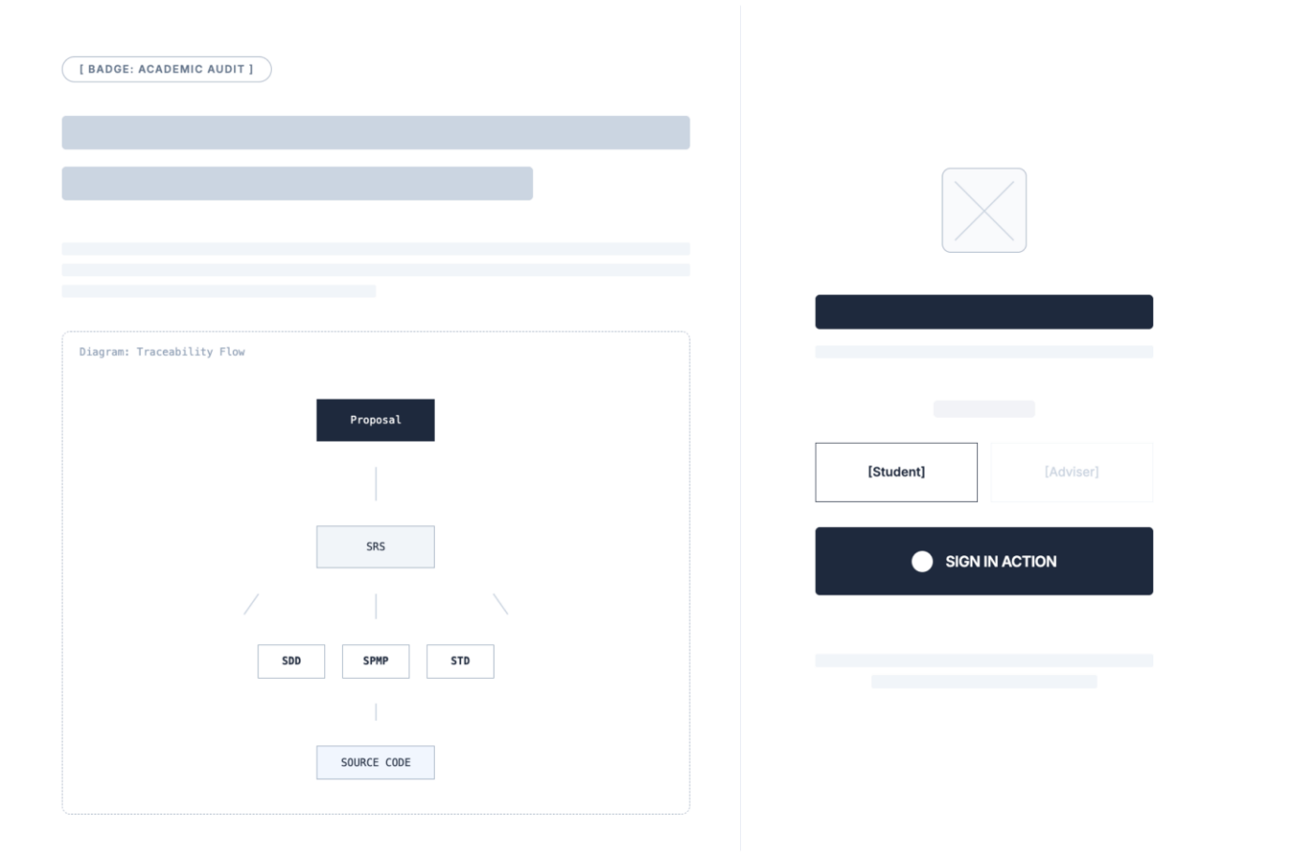

1.2 Initialize Project Workspace

Use Case Diagram
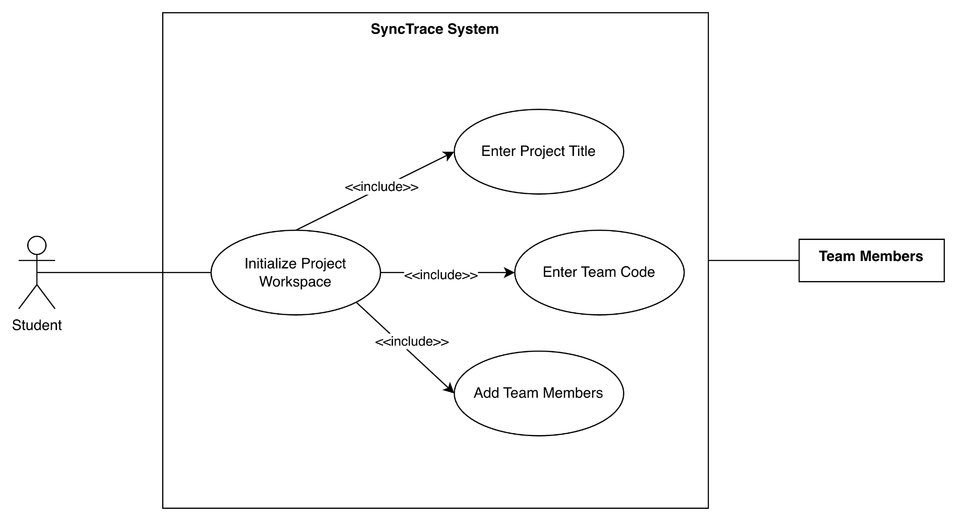

Use Case Description
Item | Description
Use Case Name | Initialize Project Workspace
Primary Actors | Student
Supporting Actor | Team Members
Trigger | Student team leader is redirected to workspace  setup on first sign in if no workspace is associated to their google email.
Precondition | Student is authenticated
Main Flow | - The student enters the project title.  - The student enters the team code.  - The student enters team members’ Google email addresses.  - The system validates the submitted project information.  - The system creates the project workspace and associates with all project members.
Alternative Flow | If required fields are incomplete, the system displays validation errors.
Postcondition | Project workspace is created and linked to team members.

Activity Diagram

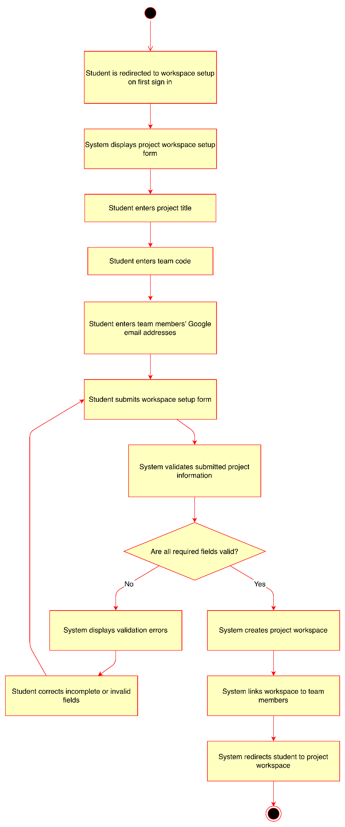

Wireframe
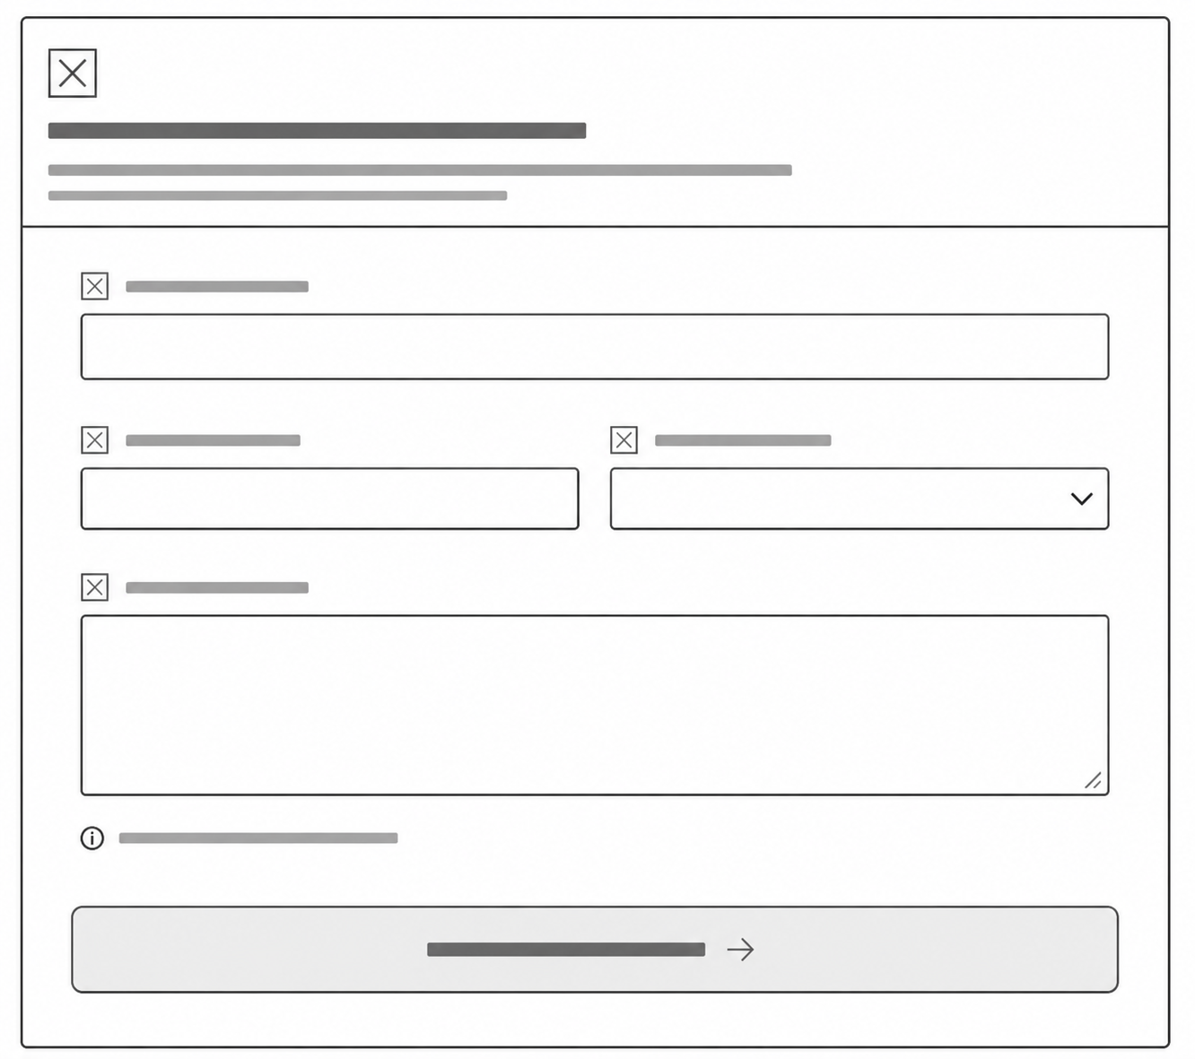

1.3 Register and Synchronize Artifact Sources

Use Case Diagram
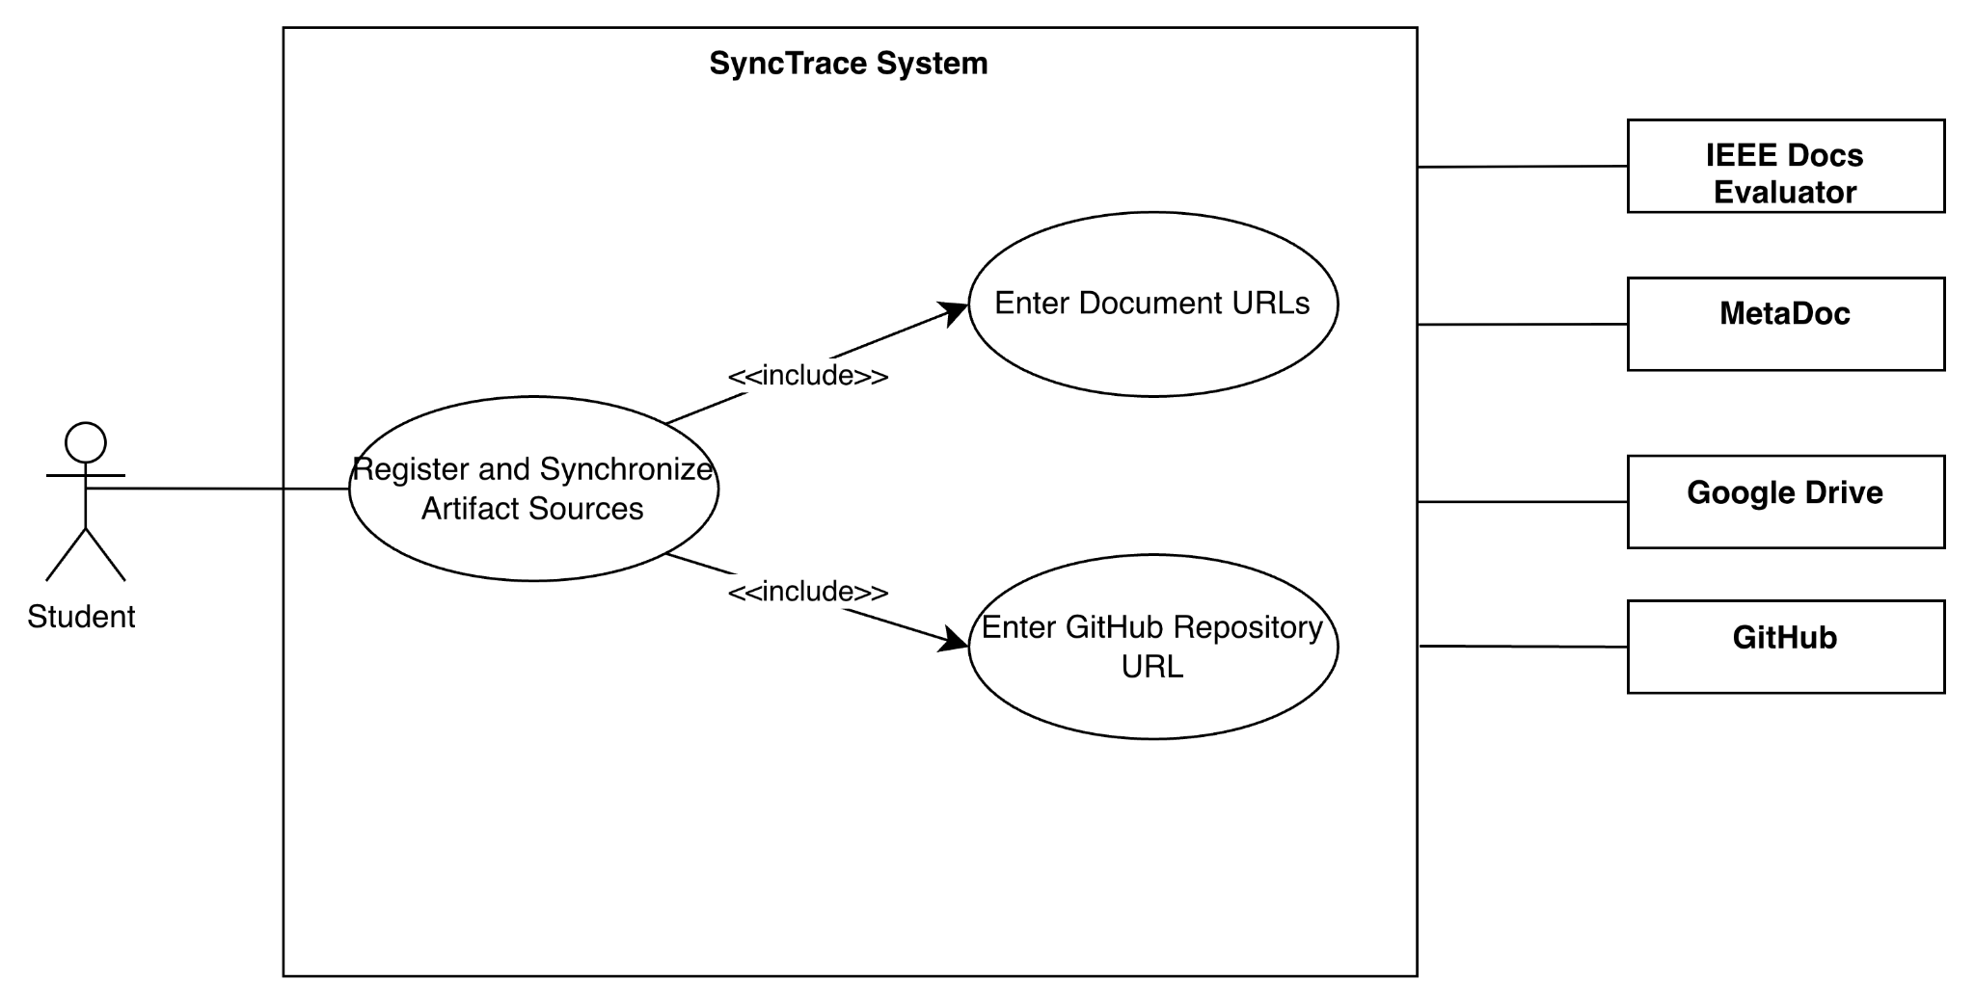

Use Case Description
Item | Description
Use Case Name | Register and Synchronize Artifact Sources
Primary Actors | Student
Supporting Actor | Google Drive, GitHub, MetaDoc, IEEE Docs Evaluator
Trigger | Student registers project artifact sources for synchronization, evaluation retrieval, and continuity analysis
Precondition | Student is authenticated and a project workspace exists
Main Flow | - Student accesses the Artifact Sources page.  - Student enters the Proposal artifact URL.  - Student enters the SRS artifact URL.  - Student enters the SDD artifact URL.  - Student enters the SPMP artifact URL.  - Student enters the STD artifact URL.  - Student enters the GitHub repository URL.  - Student selects Save.  - The system validates the submitted URLs and verifies accessibility of the referenced resources.  - The system saves the artifact source records and associates them with the project workspace.  - The system initiates synchronization of the Proposal artifact with MetaDoc.  - The system initiates synchronization of the SRS, SDD, SPMP, and STD artifacts with IEEE Docs Evaluator.  - The system connects to the GitHub repository and initiates repository ingestion.  - The system records synchronization requests and displays the submission status to the student.
Alternative Flow | A1. One or more URLs are invalid, inaccessible, or unsupported. The system displays validation errors and prompts the student to correct the affected entries.  A2. External synchronization service is temporarily unavailable. The system records the artifact source, marks the synchronization request as pending, and notifies the student.
Postcondition | Artifact source records, evaluation outputs, extracted components, repository metadata, and synchronization results are successfully stored and are available for traceability processing and continuity analysis.

Activity Diagram
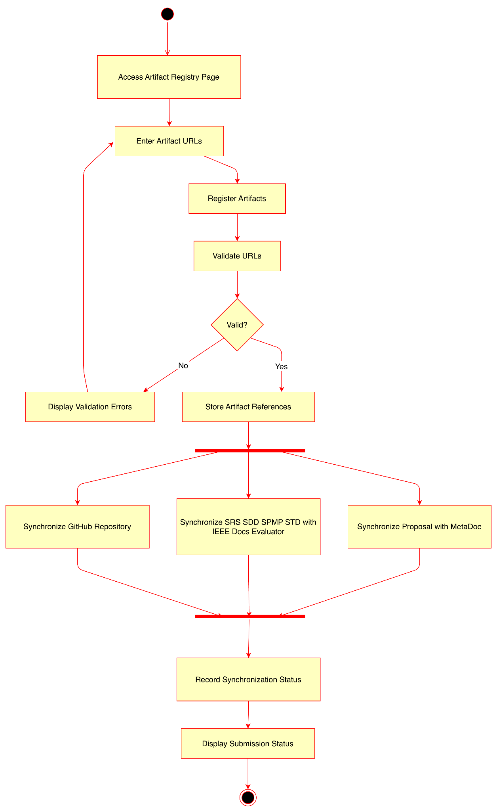

Wireframe
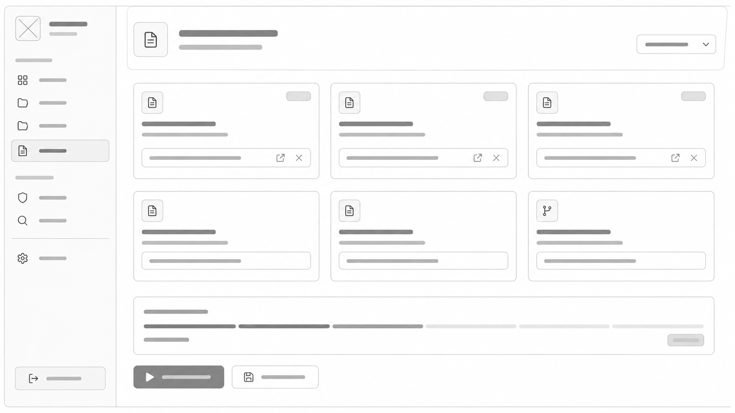

Module 2: Traceability and Continuity Verification

2.1 Generate Traceability Mapping

Use Case Diagram

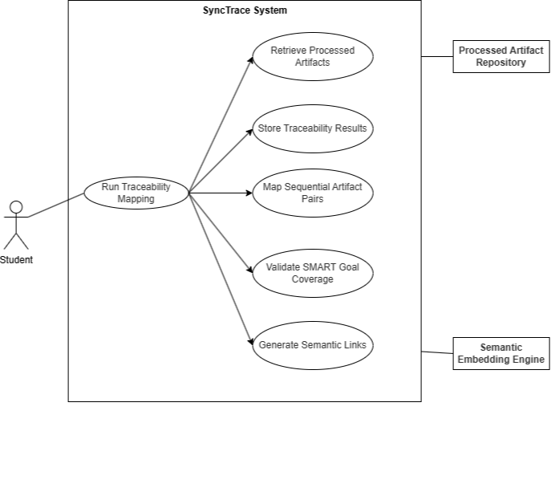

Use Case Description
Item | Description
Use Case Name | Generate Traceability Mapping
Primary Actors | Student
Supporting Actor | Semantic Embedding Engine, Processed Artifact Repository
Trigger | User initiates traceability mapping after artifact synchronization and preprocessing are completed.
Precondition | User initiates traceability mapping after artifact synchronization and preprocessing are completed.
Main Flow | - User opens the Traceability Mapping page.  - User selects a project workspace.  - User clicks Run Traceability Mapping.  - System retrieves processed artifacts, SMART goals, extracted document components, and source code evidence.  - System generates semantic links between predefined artifact pairs.  - System maps Proposal → SRS, SRS → SDD, SRS → SPMP, SRS → STD, and SDD → Source Code.  - System validates whether SMART goals are covered in downstream artifacts.  - 8. System stores the generated traceability results.  - System displays the completed traceability mapping status.
Alternative Flow | If one or more artifacts are missing or not yet processed, the system displays a warning and prevents mapping until required artifacts are available.
Postcondition | Traceability mappings are generated and stored for continuity gap detection, audit reporting, and traceability matrix visualization.

Activity Diagram

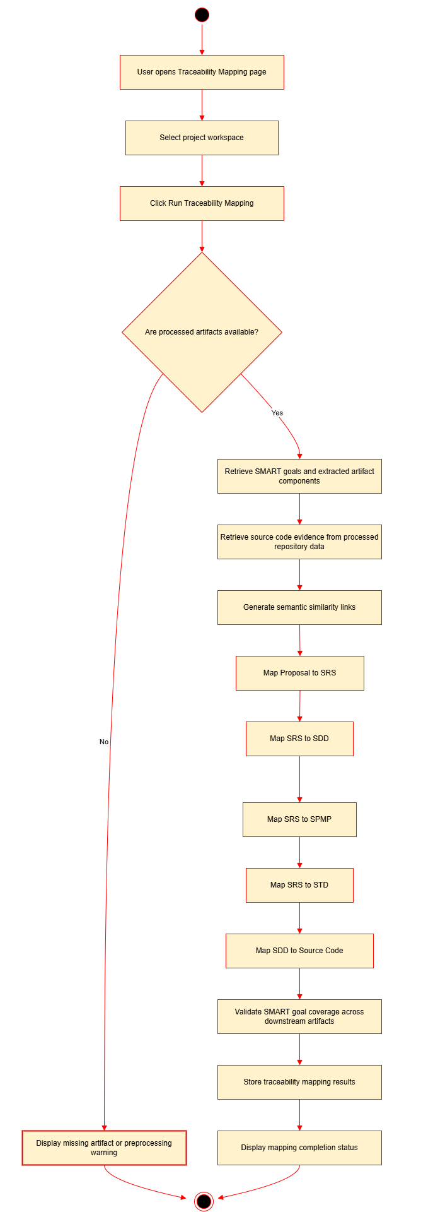

Wireframe

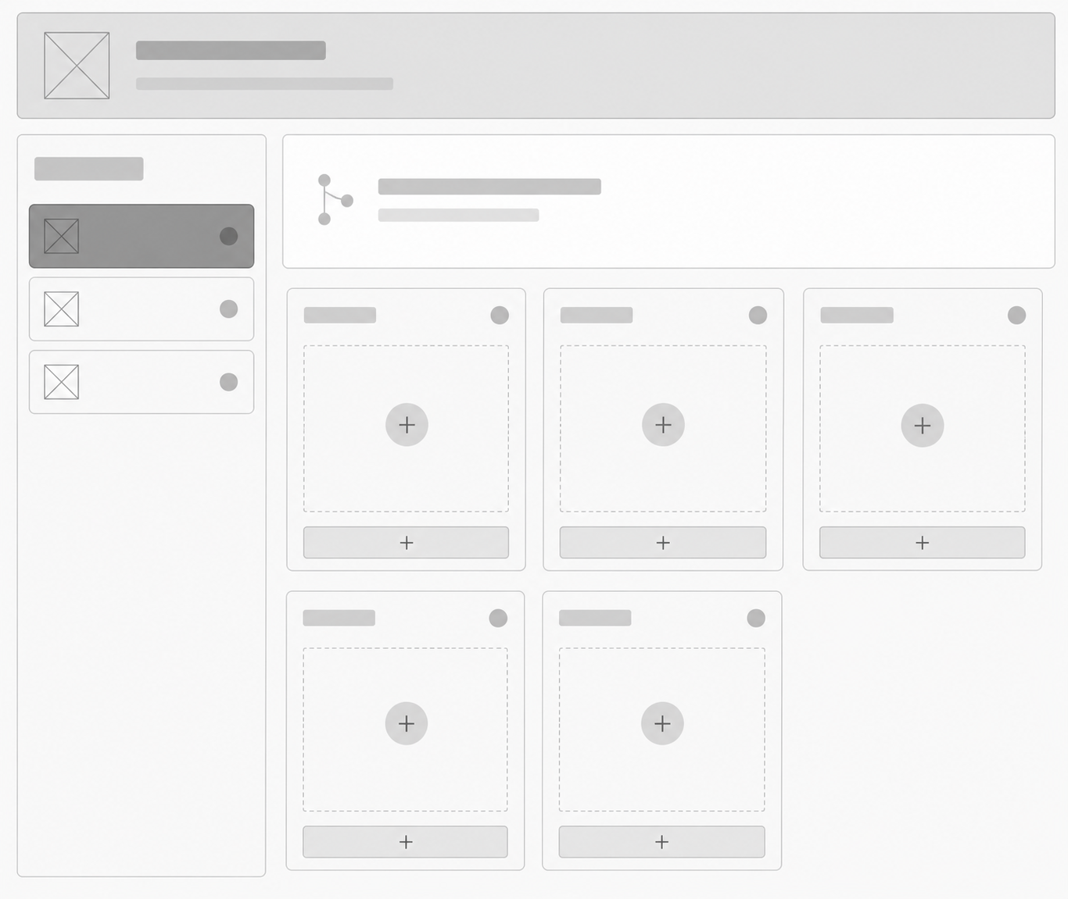

2.2 Detect Continuity Gaps

Use Case Diagram
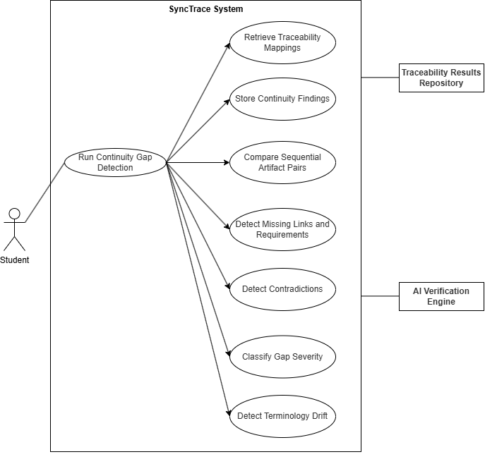

Use Case Description
Item | Description
Use Case Name | Detect Continuity Gaps
Primary Actors | Student
Supporting Actor | AI Verification Engine, Traceability Results Repository
Trigger | Sequential traceability mappings already exist for the selected project workspace.
Precondition | Sequential traceability mappings already exist for the selected project workspace.
Main Flow | - User opens the Continuity Verification page.  - User selects a project workspace.  - User clicks Run Gap Detection.  - System retrieves generated traceability mappings.  - System compares the mapped artifact pairs.  - System detects missing links, missing requirements, downstream omissions, contradictions, terminology drift, and implementation inconsistencies.  - System classifies each detected gap according to severity level.  - System stores the continuity findings.  - System displays the detected continuity gaps to the user.
Alternative Flow | If traceability mappings are missing or incomplete, the system displays a warning and prompts the user to run traceability mapping first.
Postcondition | Continuity gaps are identified, classified, and stored for diagnostic guidance and audit reporting.

Activity Diagram
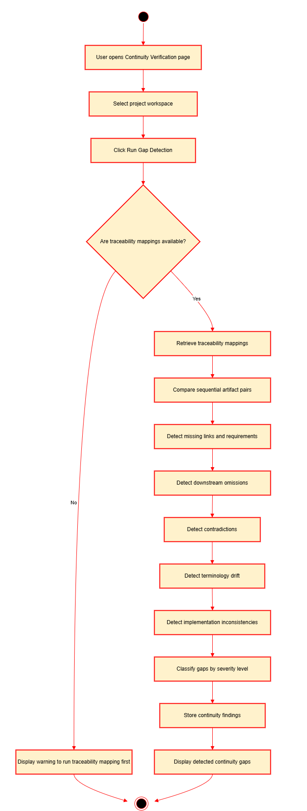

Wireframe

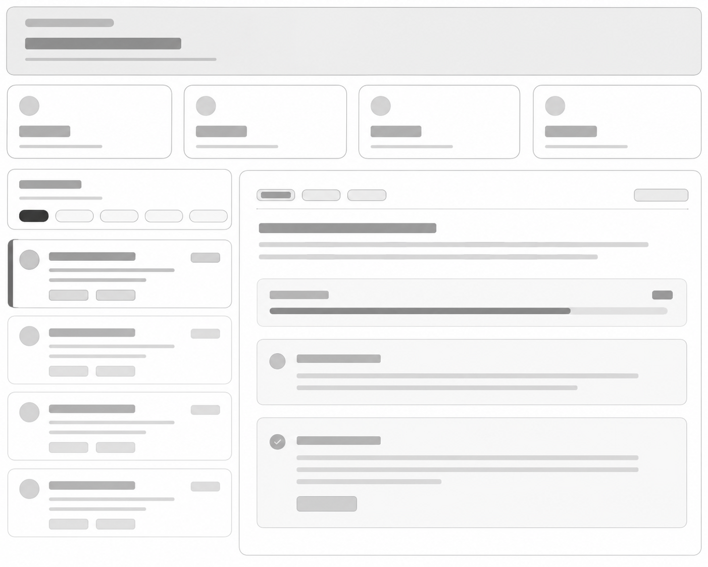

2.3 Generate Diagnostic Guidance

Use Case Diagram

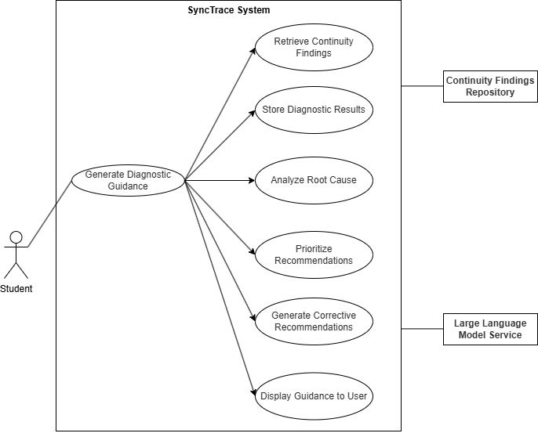

Use Case Description
Item | Description
Use Case Name | Generate Diagnostic Guidance
Primary Actors | Student
Supporting Actor | Large Language Model Service, Continuity Findings Repository
Trigger | User requests diagnostic guidance after continuity gaps have been detected.
Precondition | Continuity findings already exist for the selected project workspace.
Main Flow | - User opens the Diagnostic Guidance page.  - User selects a project workspace.  - User clicks Generate Guidance.  - System retrieves detected continuity gaps and discrepancy findings.  - System analyzes the possible root cause of each continuity issue.  - System generates corrective recommendations, including document revision suggestions and code-level recommendations when applicable.  - System prioritizes recommendations based on severity and continuity impact.  - System stores the generated diagnostic guidance.  - System displays the diagnostic explanation and corrective recommendations to the user.
Alternative Flow | If no continuity findings exist, the system displays a message prompting the user to run continuity gap detection first. If the AI service is unavailable, the system displays an error and allows the user to retry.
Postcondition | Diagnostic explanations and corrective recommendations are generated, stored, and made available for audit reporting.

Activity Diagram

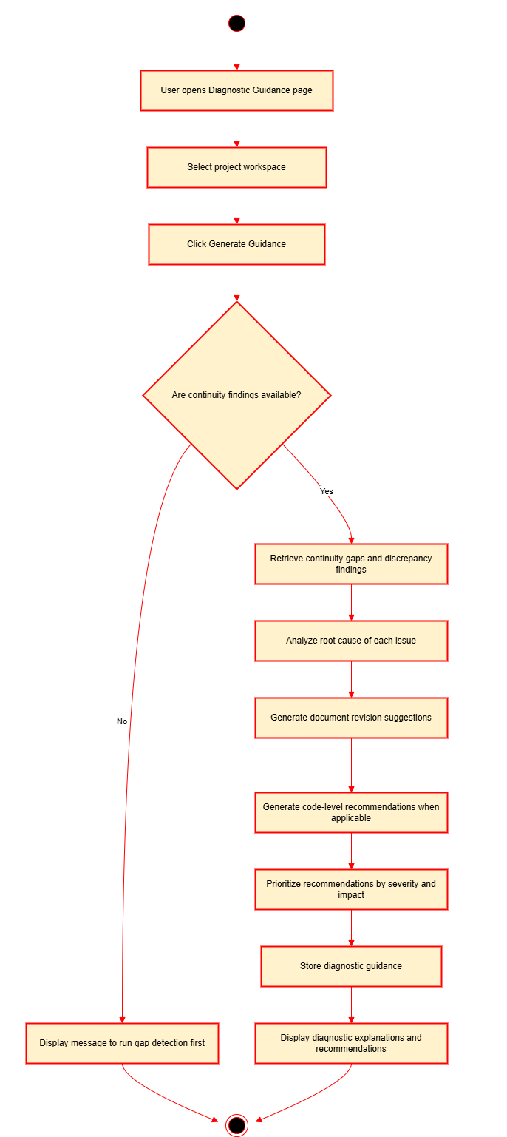

Wireframe


2.4 Analyze Source Code Alignment

Use Case Diagram
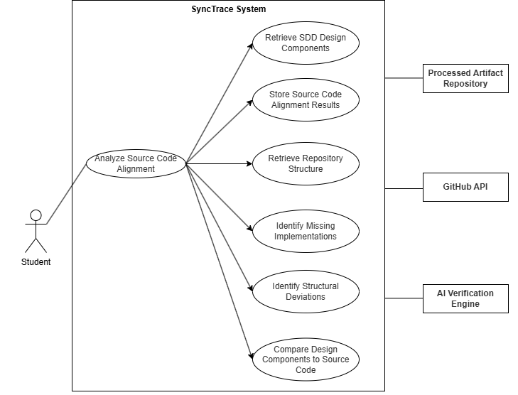

Use Case Description
Item | Description
Use Case Name | Analyze Source Code Alignment
Primary Actors | Student
Supporting Actor | GitHub API, AI Verification Engine, Processed Artifact Repository
Trigger | Student initiates source code alignment analysis after artifact synchronization and traceability mapping are completed.
Precondition | The SDD components and GitHub repository data are already synchronized and processed.
Main Flow | - Student opens the Source Code Alignment page.  - Student selects a project workspace.  - Student clicks Analyze Source Code Alignment.  - System retrieves SDD design components from the processed artifact repository.  - System retrieves GitHub repository structure, source code files, and commit metadata.  - System compares SDD design components against the source code repository.  - System identifies missing class implementations, unimplemented methods, missing modules, structural deviations, and undocumented code modules.  - System stores the source code alignment results.  - System displays the source code alignment summary to the student.
Alternative Flow | If the GitHub repository is inaccessible, the system displays a repository access error and allows the student to update the repository URL. If SDD components are missing, the system prompts the student to synchronize the SDD artifact first.
Postcondition | Source code alignment results are generated and stored for continuity gap detection, diagnostic guidance, and audit reporting.

Activity Diagram

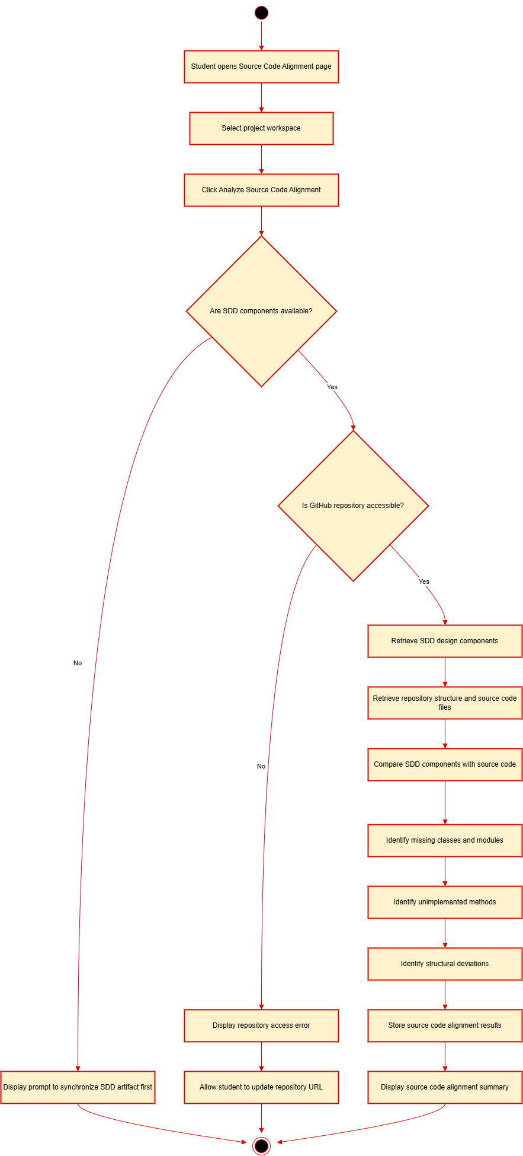

Wireframe
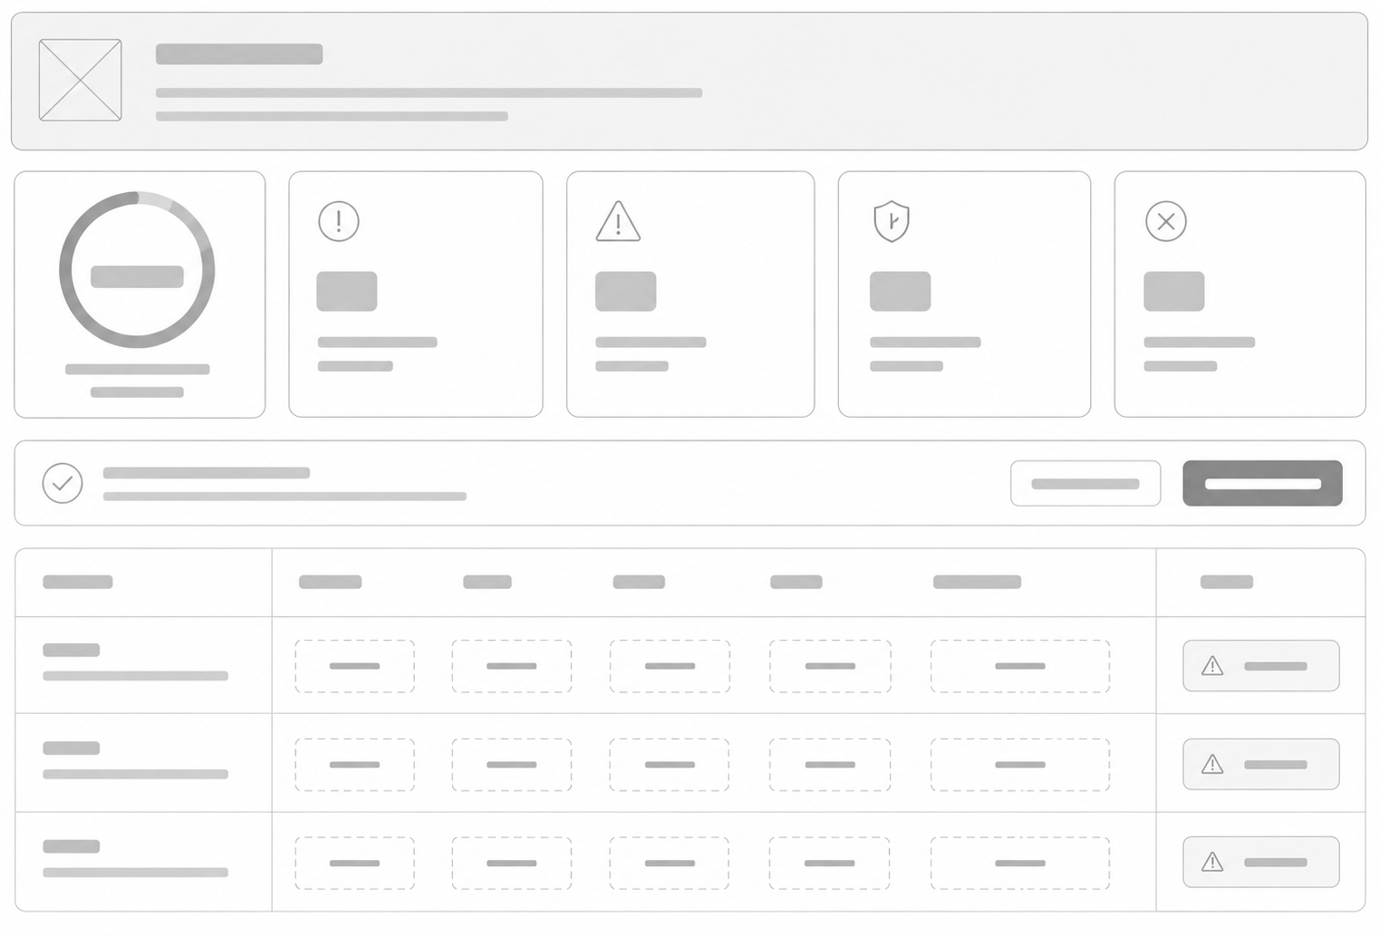

2.5 Generate Diagnostic Recommendations

Use Case Diagram
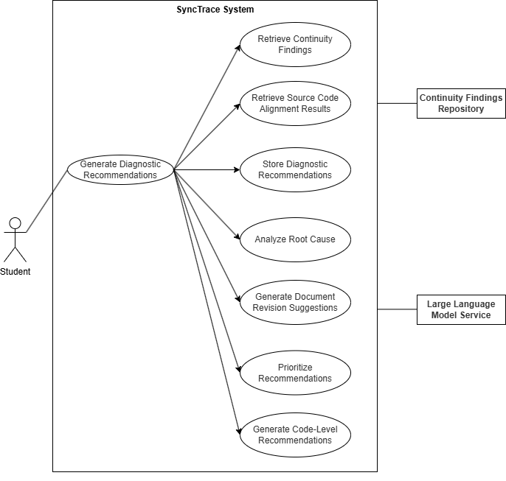

Use Case Description
Item | Description
Use Case Name | Generate Diagnostic Recommendations
Primary Actors | Student
Supporting Actor | Large Language Model Service, Continuity Findings Repository
Trigger | Student requests diagnostic recommendations after continuity gap detection and source code alignment analysis are completed.
Precondition | Continuity findings or source code alignment results already exist for the selected project workspace.
Main Flow | - Student opens the Diagnostic Recommendations page.  - Student selects a project workspace.  - Student clicks Generate Recommendations.  - System retrieves detected continuity gaps and source code alignment results.  - System analyzes the root cause of each detected issue.  - System generates document revision suggestions for inconsistencies found in the Proposal, SRS, SDD, SPMP, or STD.  - System generates code-level recommendations for missing classes, methods, modules, or implementation evidence.  - System prioritizes recommendations based on severity level and continuity impact.  - System stores the generated diagnostic recommendations.  - System displays the recommendations to the student.
Alternative Flow | If no continuity findings or source code alignment results exist, the system displays a message prompting the student to run gap detection or source code alignment analysis first. If the LLM service is unavailable, the system displays an error and allows the student to retry.
Postcondition | Diagnostic explanations and corrective recommendations are generated, stored, and available for the traceability matrix and audit report.

Activity Diagram

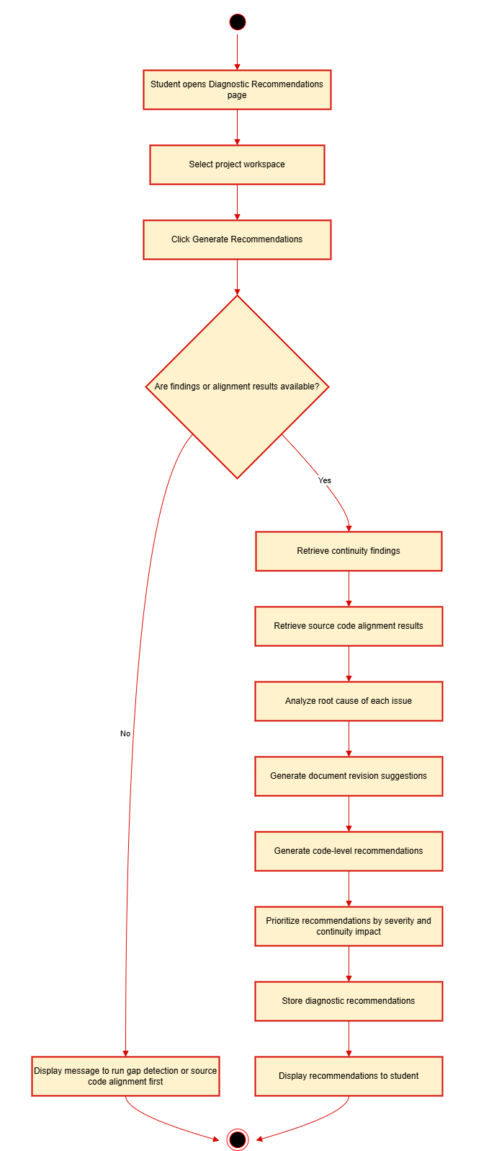

Wireframe


Module 3: Continuity Monitoring and Audit Report Export

3.1 Student Monitoring Dashboard

Use Case Diagram
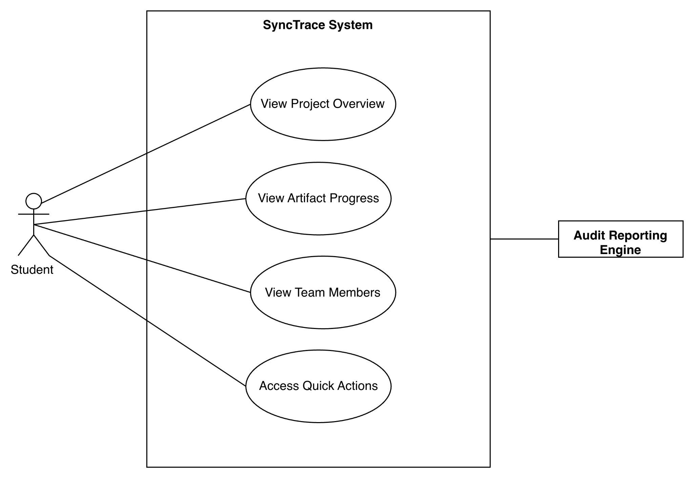

Use Case Description
Item | Description
Use Case Name | View Student Dashboard
Primary Actors | Student
Supporting Actor | Audit Reporting Engine, Continuity Analysis Engine
Trigger | Student opens the Dashboard page.
Precondition | Student is authenticated and belongs to at least one project workspace.
Main Flow | - Student opens the Dashboard page.  - System retrieves the selected project workspace information.  - System retrieves artifact submission and synchronization statuses.  - System retrieves AI evaluation results and feedback from MetaDoc and IEEE Docs Evaluator.  - System displays the latest audit summary, evaluation scores, continuity findings, and overall alignment score.  - System displays available quick actions for workspace management and audit operations.
Alternative Flow | If no workspace exists, the system displays a message prompting the student to create or join a workspace.  If audit data is unavailable, the system displays that no audit results exist yet.
Postcondition | Student successfully views the project overview, artifact progress, audit summary, and available workspace actions.

Activity Diagram
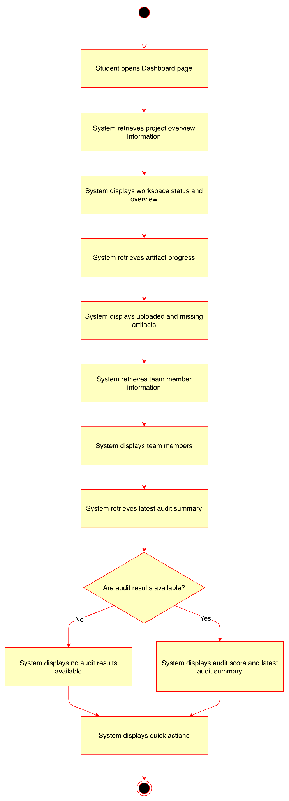

Wireframe
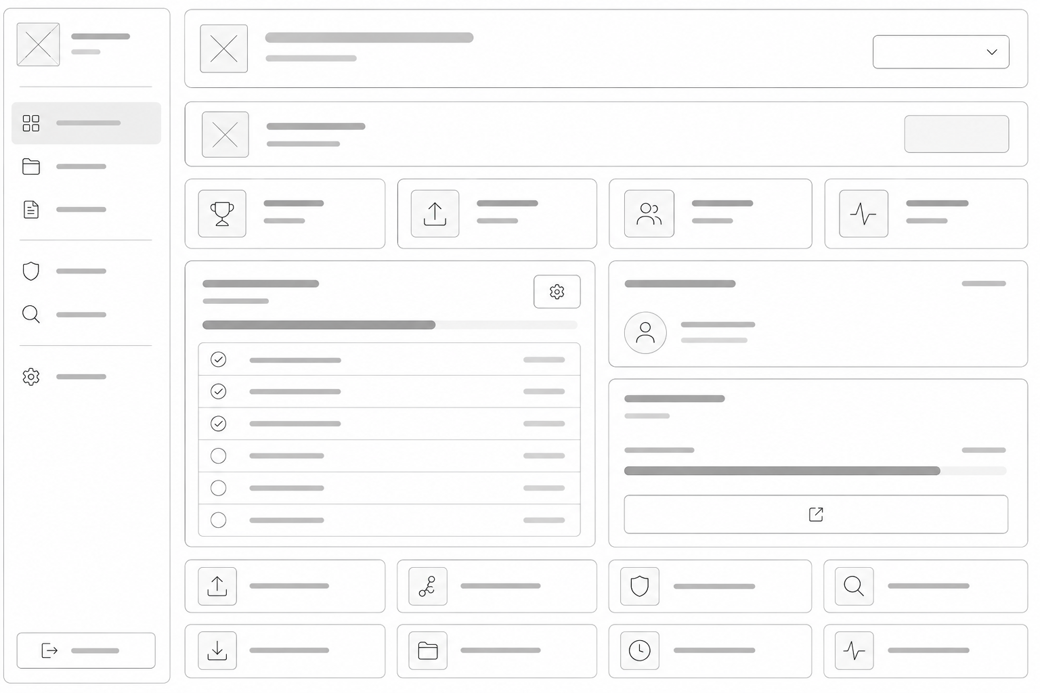

3.2 Adviser Monitoring Dashboard

Use Case Diagram
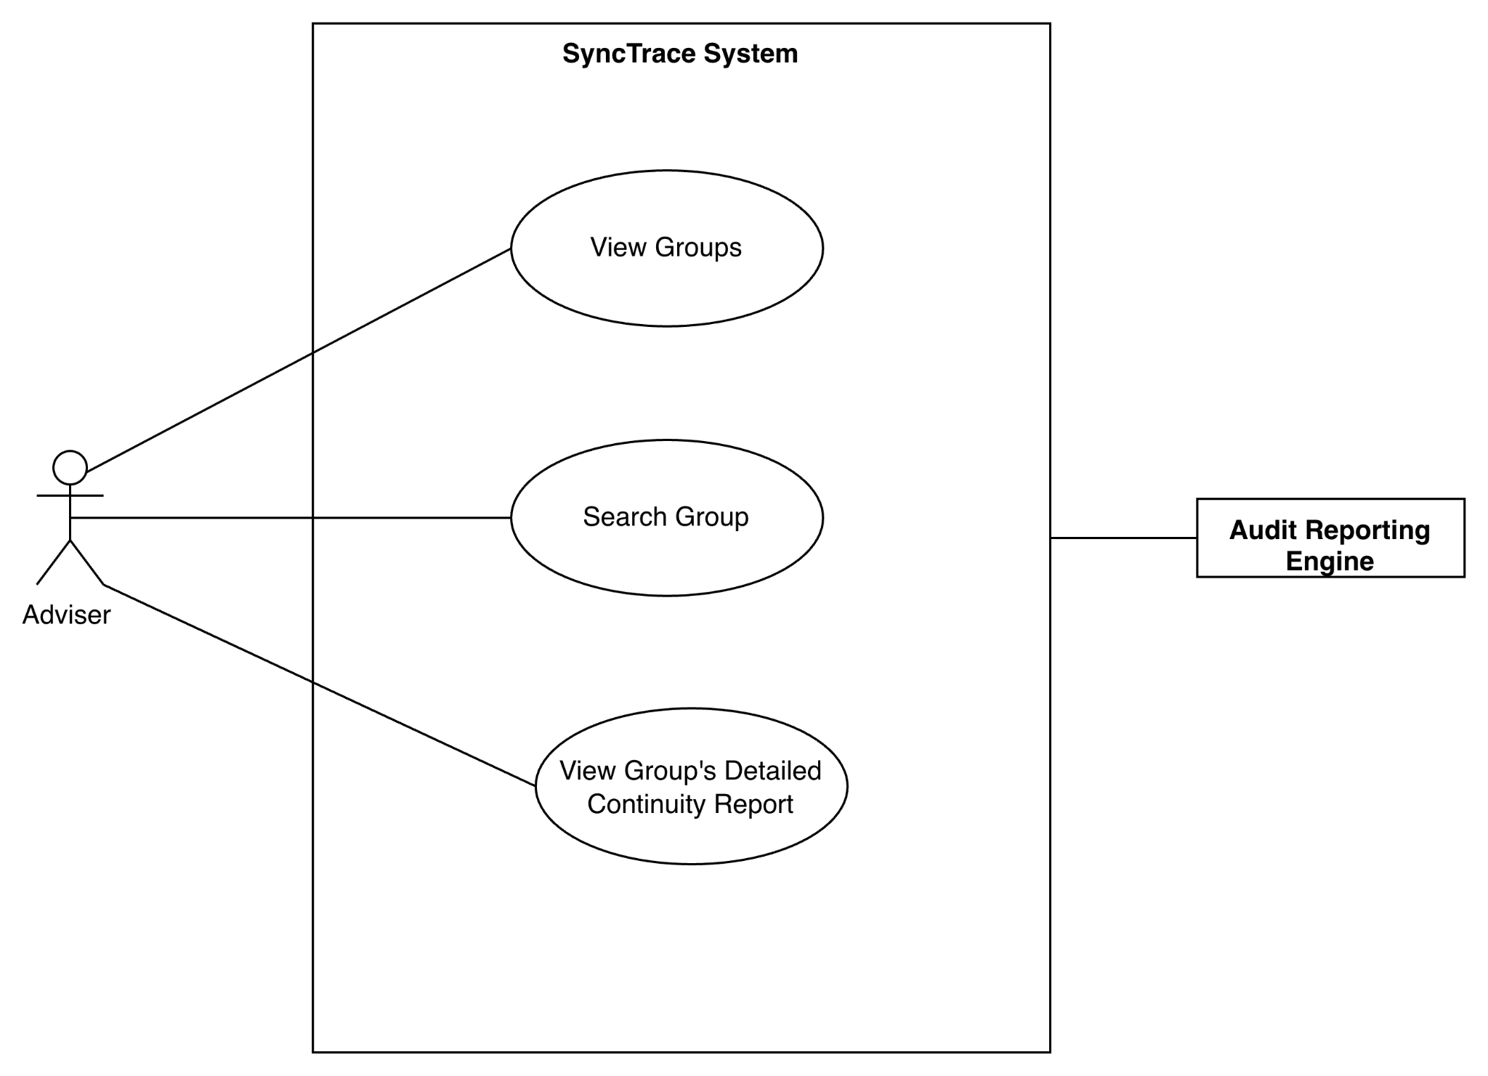

Use Case Description
Item | Description
Use Case Name | View Groups
Primary Actors | Adviser
Supporting Actor | Audit Reporting Engine
Trigger | Adviser opens the adviser dashboard
Precondition | Adviser is authenticated
Main Flow | - The adviser opens the Dashboard.  - The system retrieves the student groups.  - The system displays the list of groups together with audit summaries, alignment scores, and continuity statuses.  - The adviser searches or selects a student group.  - The system retrieves the selected group’s audit results and continuity results.  - The system displays the selected group’s detailed continuity report, traceability matrix, readiness evaluation, and continuity results.
Alternative Flow | If no student groups are found, the system displays a message indicating that no groups are currently available.
Postcondition | Adviser successfully views groups

Activity Diagram
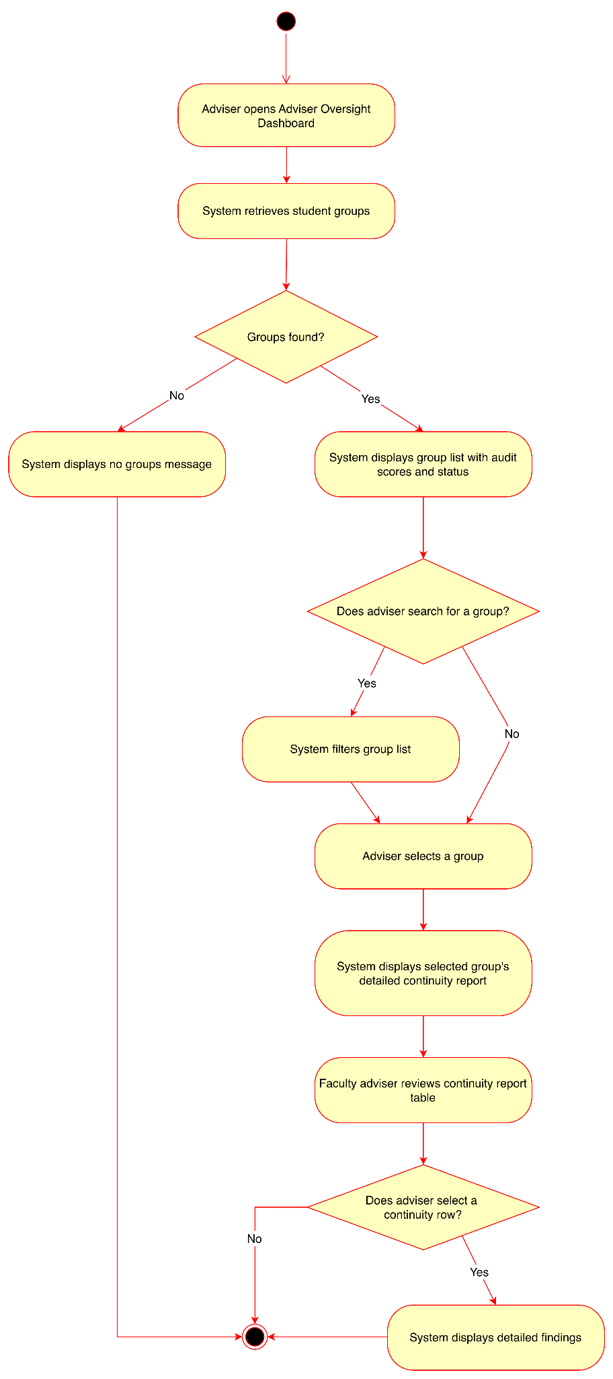

Wireframe
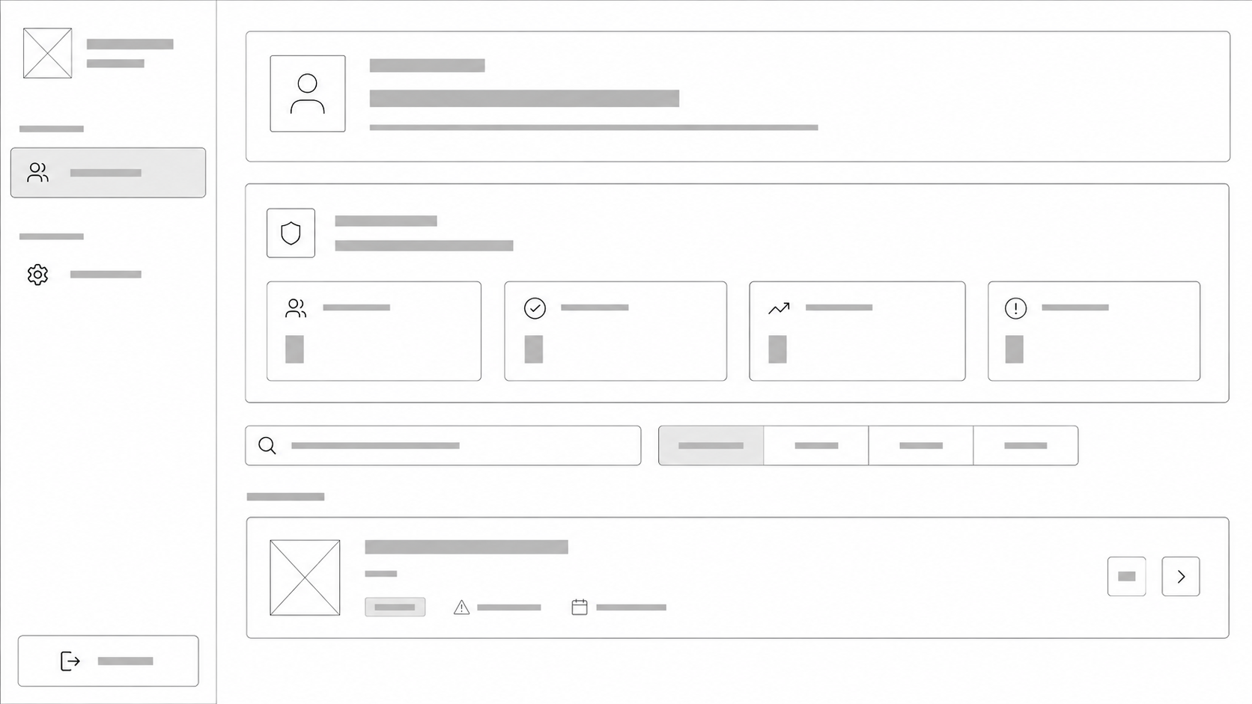
Adviser Dashboard



Group Detailed Audit Report

3.3 View Audit Results

Use Case Diagram
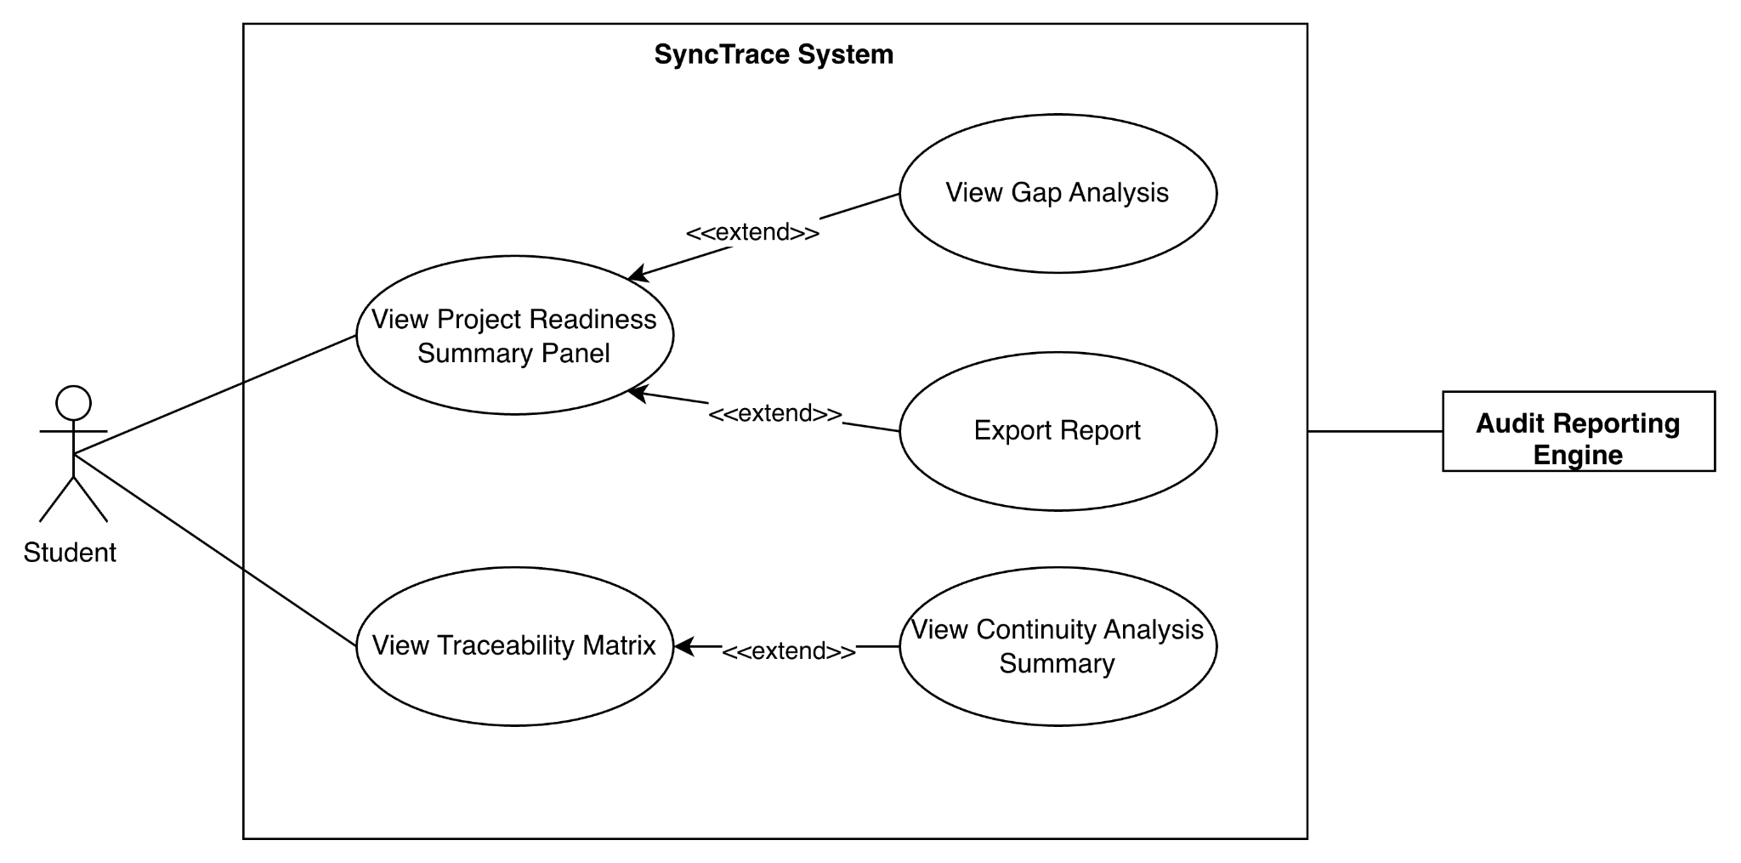

Use Case Description
Item | Description
Use Case Name | View Traceability Matrix
Primary Actors | Student
Supporting Actor | Audit Reporting Engine
Trigger | Continuity verification and AI diagnostics are completed
Precondition | Audit results exist
Main Flow | - User opens the audit dashboard.  - System retrieves the project readiness summary.  - System displays the interactive traceability matrix.  - User reviews project continuity analysis summary.
Alternative Flow | If audit results are unavailable, the system displays a message and prompts the user to run traceability analysis first.
Postcondition | User successfully views project continuity results

Activity Diagram
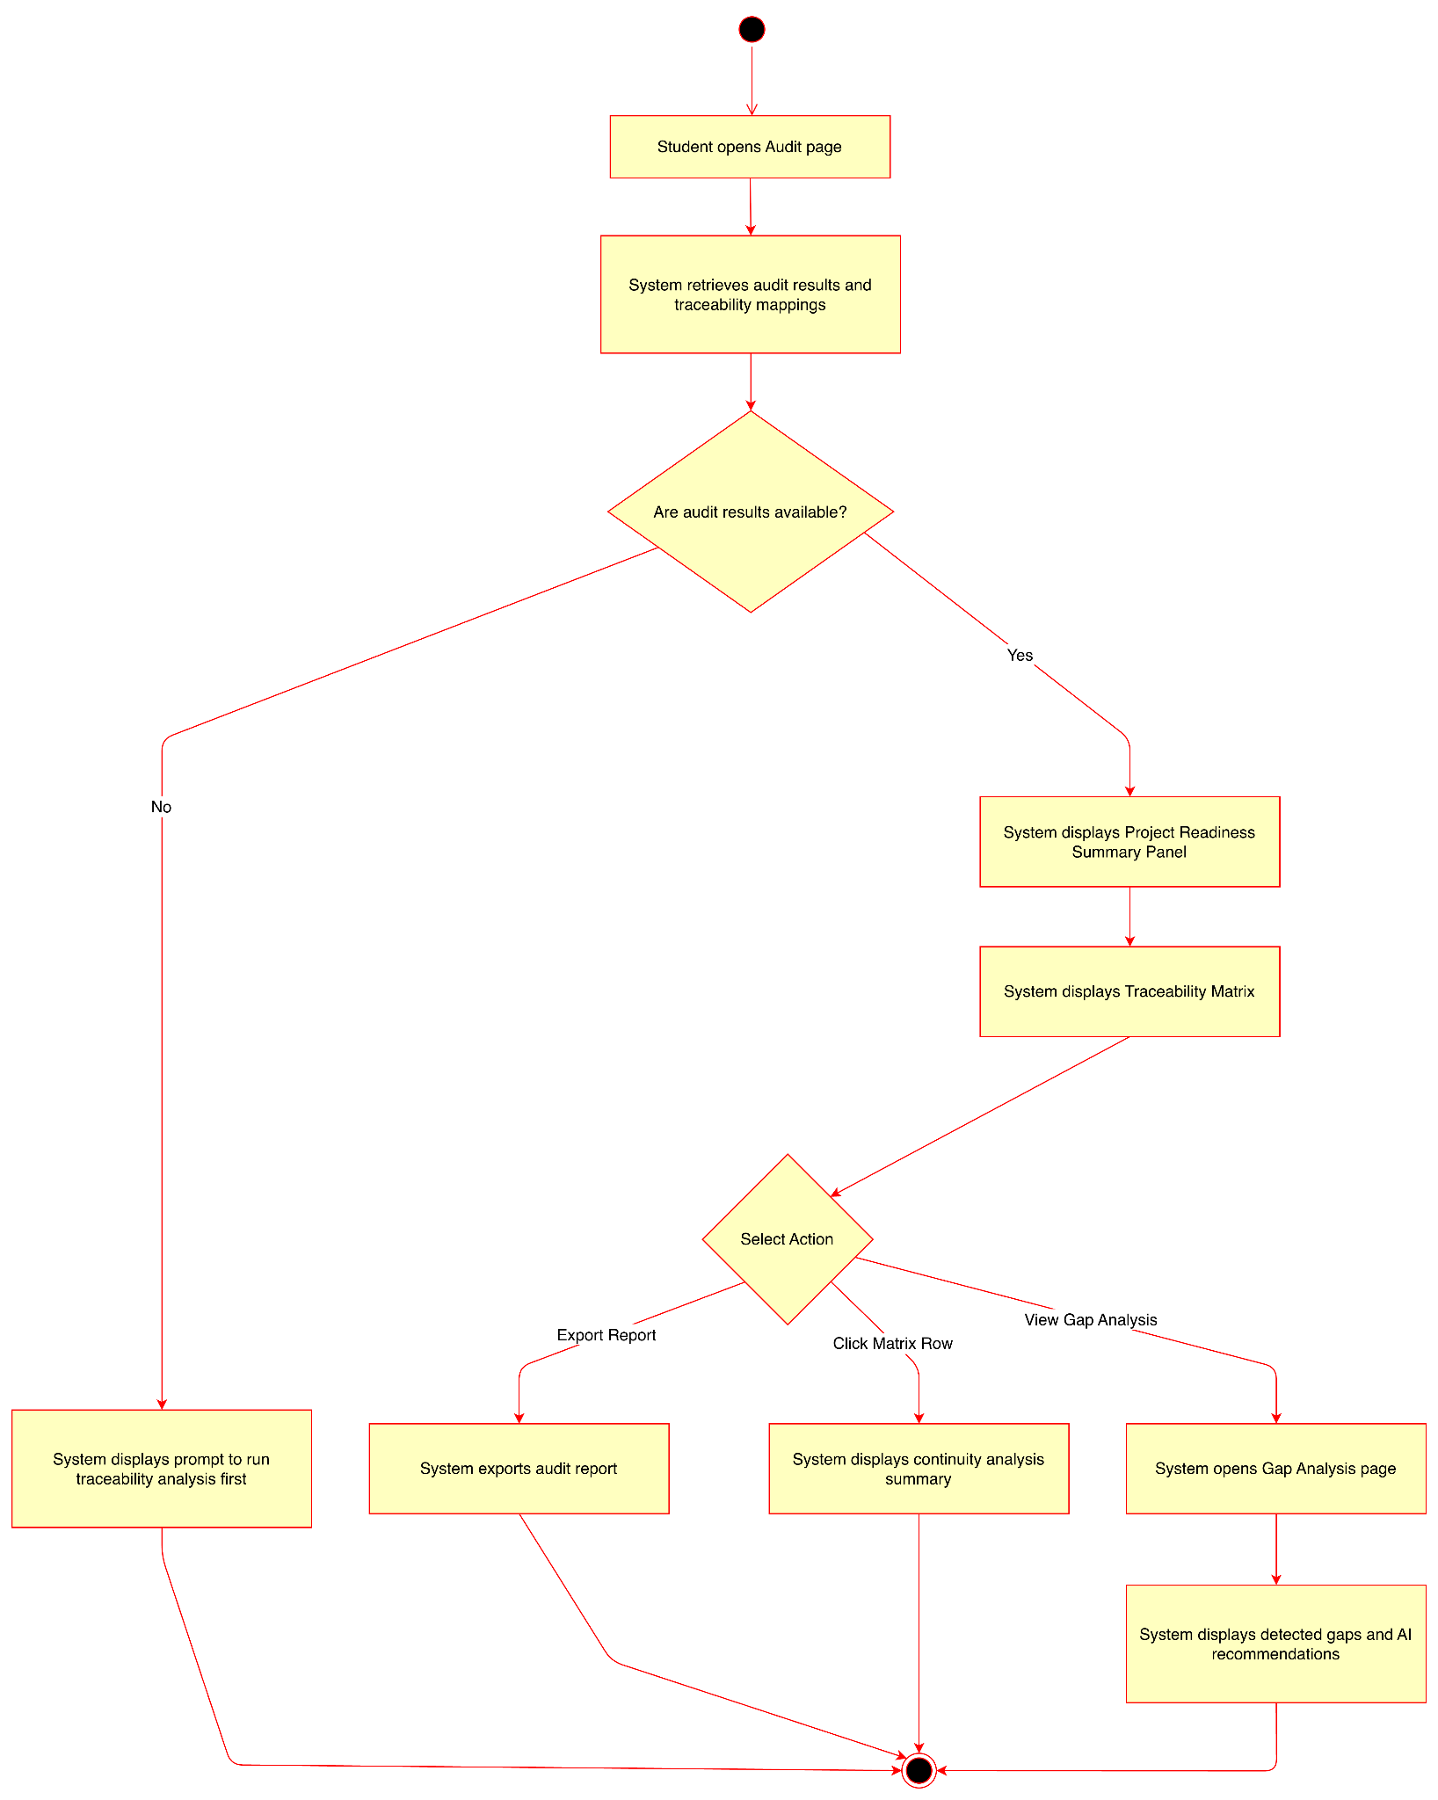

Wireframe
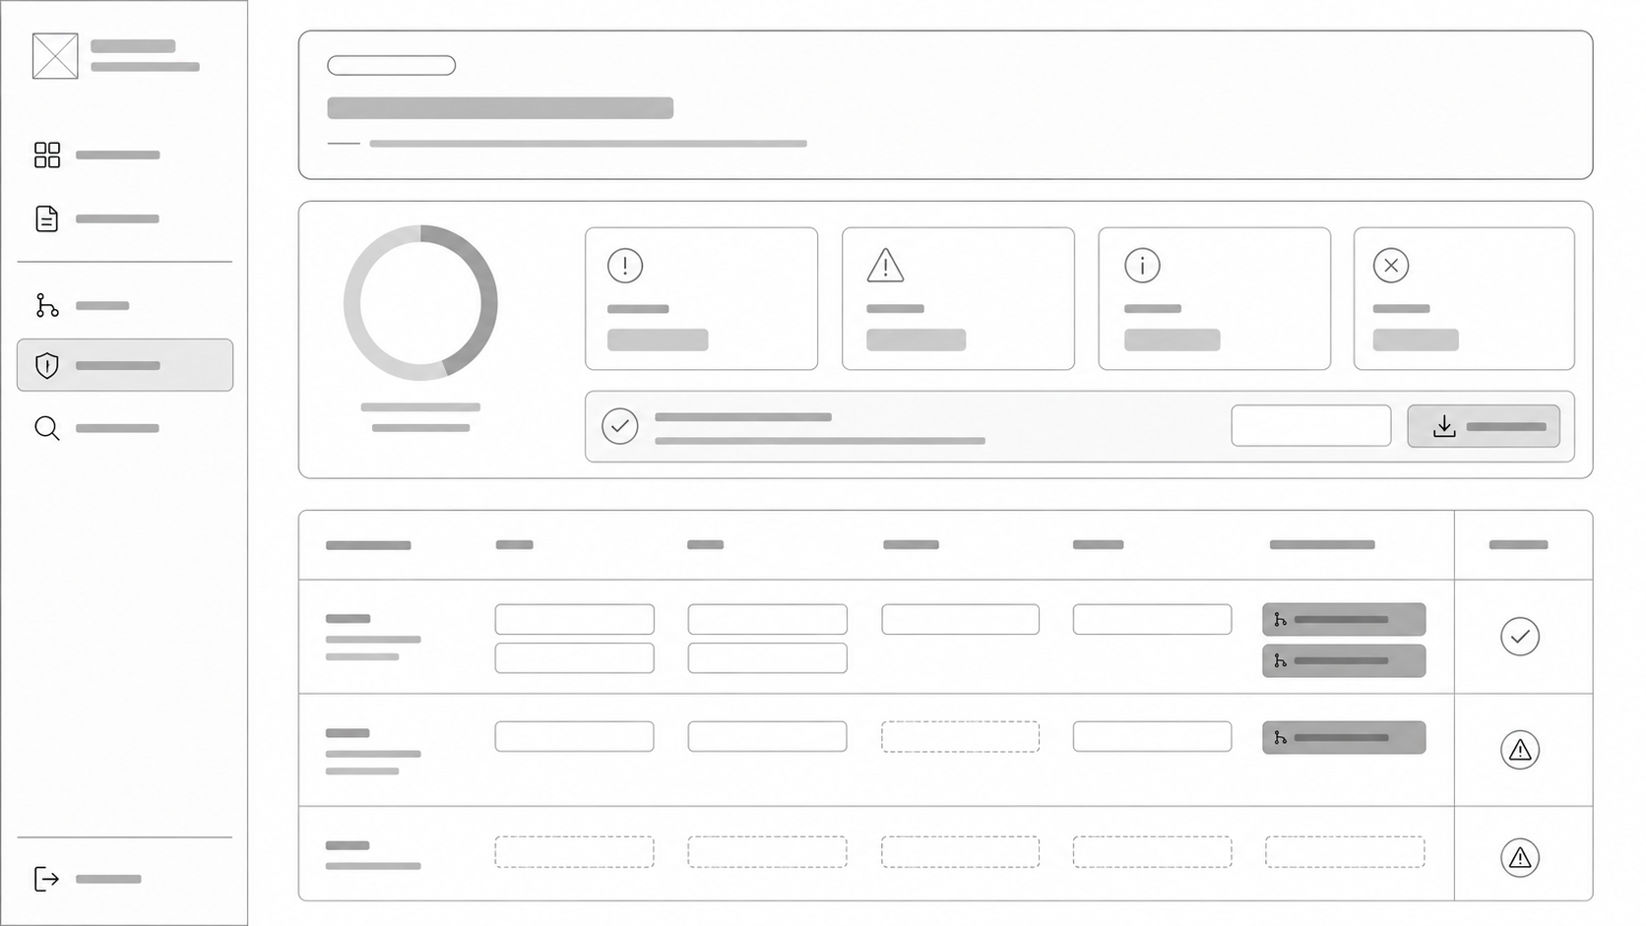

3.4 Export Audit Report

Use Case Diagram
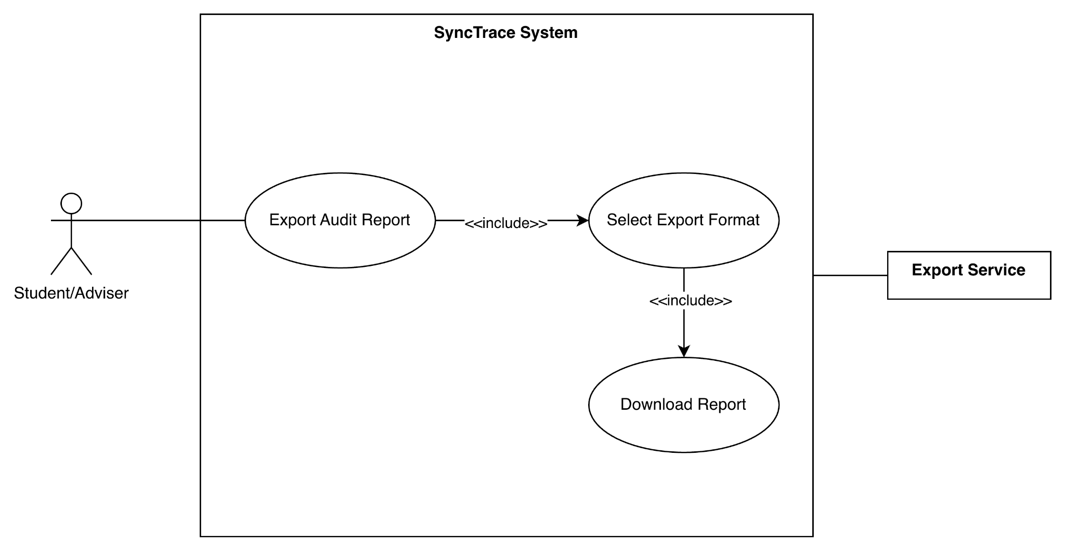

Use Case Description
Item | Description
Use Case Name | Export Audit Report
Primary Actors | Student, Adviser
Supporting Actor | Export Service
Trigger | User selects Export Report
Precondition | Audit results exist for the selected project workspace.
Main Flow | - User opens the audit dashboard.  - System displays the project readiness summary and traceability matrix.  - User selects Export Report.  - System retrieves the latest audit results.  - System displays available export formats: PDF, JSON, and CSV.  - User selects the preferred export format.  - System generates the report in the selected format.  - System provides the exported report to the user.
Alternative Flow | If audit results are unavailable, the system displays a message indicating that there is no audit report to export.
Postcondition | Audit report is successfully exported in the selected format

Activity Diagram
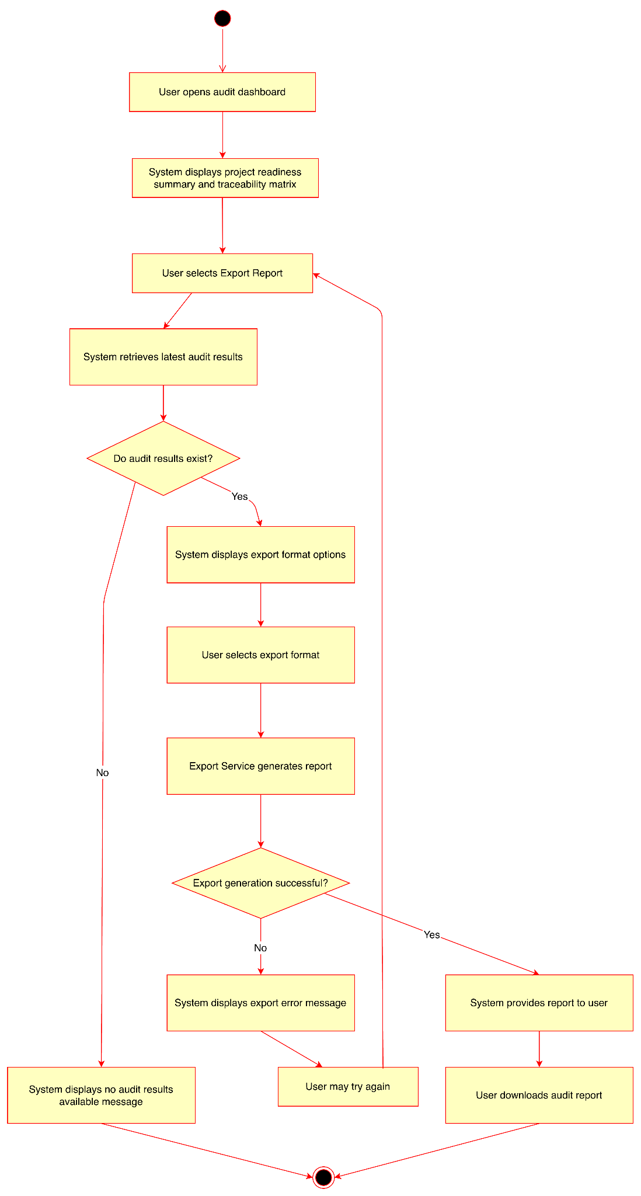

Wireframe
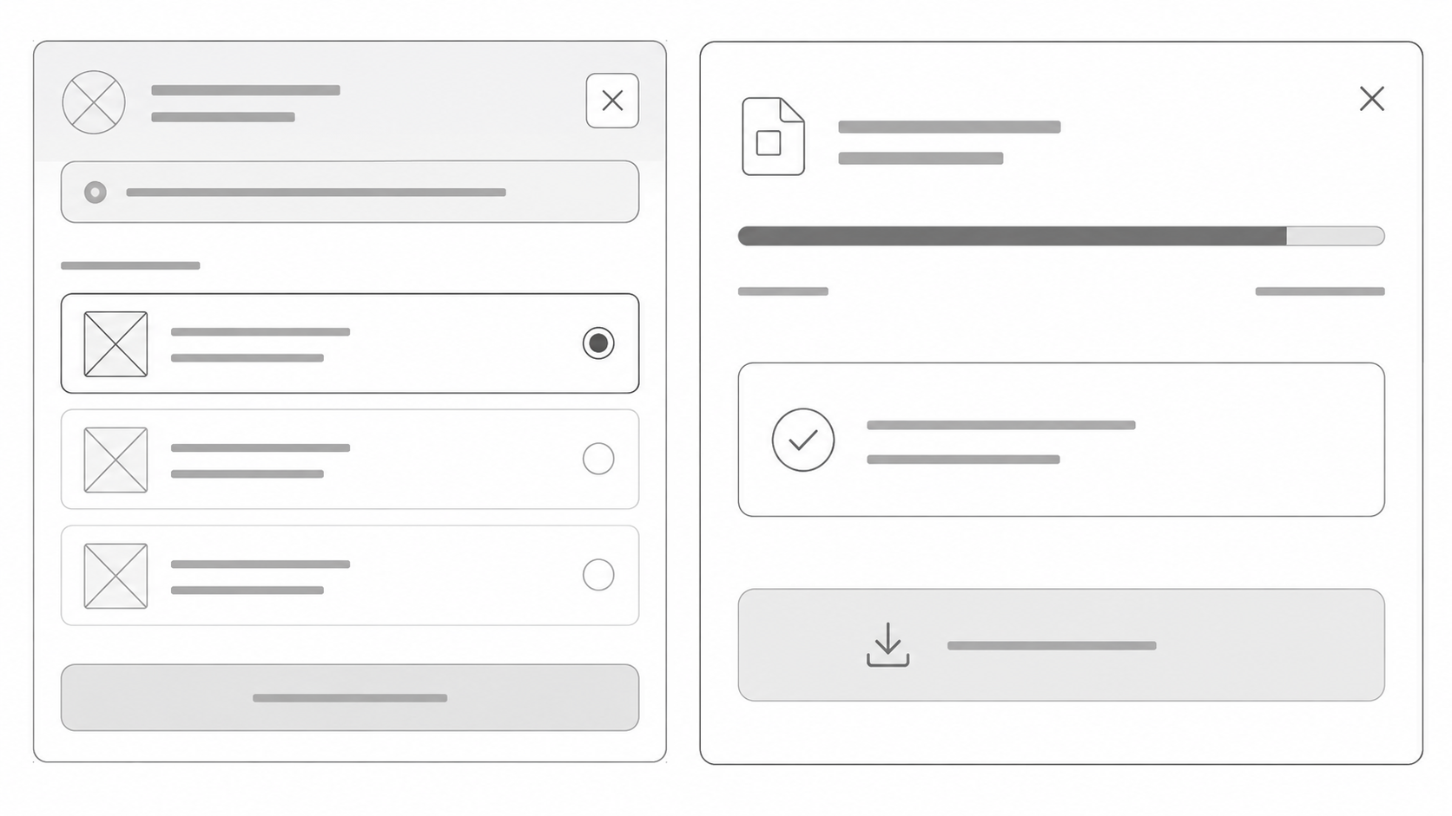

Non-functional requirements

Performance
- The system shall authenticate users through Google OAuth 2.0 within 10 seconds under normal network conditions.
- The system shall create a new project workspace and register team members within 2 minutes after project creation.
- The system shall retrieve evaluation outputs, extracted components, feedback records, and metadata from MetaDoc and IEEE Docs Evaluator within 30 seconds after synchronization request.
- The system shall retrieve repository structures, source code files, and commit metadata from GitHub repositories within 60 seconds for repositories containing up to 10,000 files.
- The system shall generate traceability mappings and continuity verification results within 5 minutes for a complete capstone project dataset.
- The system shall generate and export audit reports in PDF, JSON, or CSV format within 10 seconds.

Security
- The system shall maintain at least 95% availability during scheduled academic periods.
- The system shall automatically preserve synchronized artifacts and continuity analysis results to prevent data loss during unexpected failures.
- The system shall successfully retrieve at least 95% of available evaluation outputs and metadata from integrated external systems.
- If an external service (GitHub, MetaDoc, IEEE Docs Evaluator, or Google Drive) becomes unavailable, the system shall notify the user and continue operating with previously synchronized data.

Reliability
- The system shall implement Google OAuth 2.0 authentication and shall not store user passwords locally.
- The system shall enforce role-based permissions for Students and Advisers.
- All communications between users, SyncTrace, Google APIs, GitHub APIs, MetaDoc, IEEE Docs Evaluator, and AI services shall be encrypted using HTTPS/TLS.
- The system shall securely store project metadata, traceability results, audit reports, and user information using encrypted storage mechanisms.
- The system shall record user login activities, synchronization activities, and audit report exports for accountability and traceability purposes.

Usability
- New users shall be able to create a project workspace and register artifacts with minimal training.
- The system shall maintain a consistent user interface across dashboards, traceability matrices, and audit reporting pages.
- Students and advisers shall be able to access project status, continuity findings, and readiness indicators from a centralized dashboard.
- The system shall provide clear error messages whenever synchronization, authentication, repository access, or report generation fails.

