System Architecture:
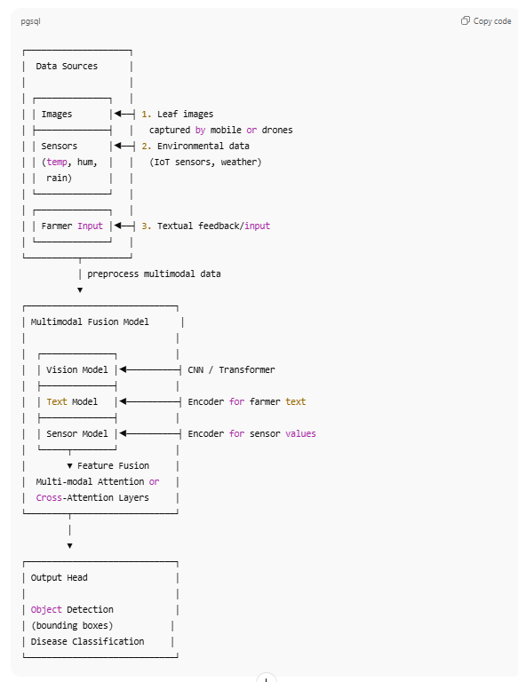

Key Architectural Components
Component | Role
Vision Model | Extract features from leaf images (CNN / transformer like YOLO/DINO)
Text Encoder | Processes farmer’s textual feedback (e.g., disease description)
Sensor Encoder | Encodes environmental factors (numeric inputs)
Fusion Layer | Combines modalities using attention
Detection Head | Generates bounding boxes & disease classes
This architecture resembles multimodal object detection systems where image and non-image inputs

🧪 2. Datasets

2.1 Image Dataset (Leaf Diseases)
You can use publicly available tomato leaf disease datasets with annotated disease regions:
📌 PlantVillage / Roboflow Tomato Leaf Disease
- Contains thousands of photos of different tomato leaf diseases with bounding boxes.
👉 Key dataset features:
- 8–14 disease classes (e.g., early blight, late blight, mosaic virus etc.)
- Images with bounding boxes or segmentation masks
💡 If you don’t want to manually label, use Roboflow version.

2.2 Text Annotations (Farmer Input)
You can simulate or collect:
- Farmer report sentences:
“Yellow spots, high humidity last 3 days”
“Leaf curling after rain”
Store these as TXT or CSV entries aligned with images.

2.3 Environmental Data
You can capture or synthesize:
- Temperature
- Humidity
- Rainfall
- Soil moisture

⚙️ 3. Execution Procedure

📌 Step 1 — Prepare Dataset
- Collect images & labels (bounding boxes + disease classes).
- Collect environmental data and align with timestamps and locations.
- Create text annotations from farmers.
Example CSV:
image_id,path,bboxes,class,text_report,temp,hum,rain

📌 Step 2 — Build Feature Extractors
- Vision Encoder: Pre-trained YOLOv8 or transformer vision model
- Text Encoder: Pre-trained CLIP or BERT
- Numeric Encoder: Small MLP for sensors

📌 Step 3 — Multimodal Fusion
Use an attention mechanism to combine features:
fused = Attention(VisionFeatures, TextFeatures + SensorFeatures)

📌 Step 4 — Detection & Classification
Use a detection head (e.g., FC layers) to predict:
- bounding box regression
- disease class score

📌 Step 5 — Training & Evaluation
Train with multimodal losses:
Loss = DetectionLoss + ClassificationLoss
Evaluate on mAP (mean average precision).

Sample code:
# multimodal_detection.py
import torch
import torch.nn as nn
import torchvision.models as models
from transformers import CLIPTextModel, CLIPTokenizer

class MultiModalDetector(nn.Module):
def __init__(self, vision_out=512, text_out=512, sensor_out=32):
super().__init__()

# Vision Encoder
self.vision = models.resnet50(pretrained=True)
self.vision.fc = nn.Linear(self.vision.fc.in_features, vision_out)

# Text Encoder (CLIP)
self.text_encoder = CLIPTextModel.from_pretrained("openai/clip-vit-base-patch32")
self.tokenizer = CLIPTokenizer.from_pretrained("openai/clip-vit-base-patch32")
self.text_proj = nn.Linear(self.text_encoder.config.hidden_size, text_out)

# Sensor Encoder
self.sensor_mlp = nn.Sequential(
nn.Linear(3, sensor_out),
nn.ReLU(),
nn.Linear(sensor_out, sensor_out)
)

# Fusion & Detection Head
self.fusion = nn.Linear(vision_out + text_out + sensor_out, 1024)
self.cls_head = nn.Linear(1024, num_classes)
self.box_head = nn.Linear(1024, 4)

def forward(self, img, text, sensor):
# Vision Features
v_feat = self.vision(img)

# Text Features
tokens = self.tokenizer(text, return_tensors="pt", padding=True, truncation=True)
t_out = self.text_encoder(**tokens).last_hidden_state
t_feat = self.text_proj(t_out[:,0,:])

# Sensor
s_feat = self.sensor_mlp(sensor)

# Fuse
fused = torch.cat([v_feat, t_feat, s_feat], dim=1)
emb = torch.relu(self.fusion(fused))

# Heads
cls_score = self.cls_head(emb)
box_pred = self.box_head(emb)

return cls_score, box_pred

model = MultiModalDetector()
print(model)
5. Training Script

# train.py
import torch, torch.optim as optim
from torch.utils.data import DataLoader

model = MultiModalDetector()
optimizer = optim.Adam(model.parameters(), lr=1e-4)
criterion_cls = nn.CrossEntropyLoss()
criterion_box = nn.MSELoss()

for epoch in range(epochs):
for img, text, sensor, labels, boxes in train_loader:
cls_score, box_pred = model(img, text, sensor)

loss_cls = criterion_cls(cls_score, labels)
loss_box = criterion_box(box_pred, boxes)

loss = loss_cls + loss_box
optimizer.zero_grad()
loss.backward()
optimizer.step()

print(f"Epoch {epoch}, Loss {loss.item():.4f}")

6. Deployment & Usage
- Export model to ONNX for mobile apps
- Integrate real-time sensors via APIs
- Build a mobile/web app for image & text input

