(Day:5\08\2025)

1. Write a program to print numbers from 1 to 100.

Input=print the number 1-100.

Program=The loop runs exactly 100 times.

Output=1-100 numbers.

Program:

#include <stdio.h>

Void main()

{

for (int i = 1; i <= 100; i++)

{

printf("%d\n", i);

}

}

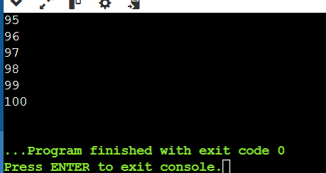

1. Write a program to print even numbers from 1 to 50.

Input=the program uses a hard-coded range (1 to 50).

Process=through numbers from **1 to 50** (inclusive).

Output=Even numbers between 1 and 50 (inclusive).

#include <stdio.h>

void main()

{

int i;

printf("Even numbers between 1 and 50:\n");

for (i = 1; i <= 50; i++)

{

if (i % 2 == 0)

{

printf("%d ", i);

}

}

printf("\n");

}

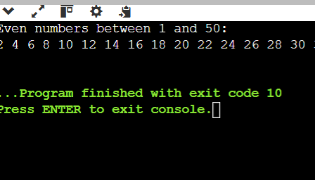

1. Write a program to find the factorial of a number.

Input=the user to enter an integer n.

Process= it prints an error because factorials are not defined for negative numbers,

Output= the computed factorial result clearly.

#include <stdio.h>

void main()

{

int n;

printf("Enter a non-negative integer: ");

if (scanf("%d", &n)

{

printf(stderr, "Invalid input: please enter an integer.\n");

}

if (n < 0)

{

printf("Error: factorial is not defined for negative numbers.\n");

}

else

{

for (int i = 2; i <= n; i++) {

fact *= (unsigned long long)i;

}

}

if (n >= 0)

{

printf("Factorial of %d\n", n, fact);

}

}

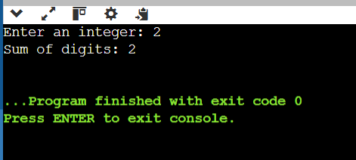

1. Write a program to calculate the sum of digits of a number.

Input=The program prompts the user to enter an integer.

Process=It uses a while loop to iterate through each digit of the number.

Output=The program prints the calculated sum of the digits.

Program:

#include <stdio.h>

void main()

{

int num, sum = 0;

printf("Enter any number to find sum of its digits: ");

scanf("%d", &num);

while (num != 0) {

sum += num % 10;

num = num / 10;

}

printf("Sum of digits = %d\n", sum);

}

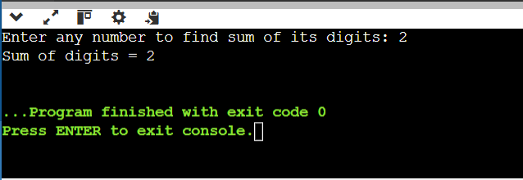

1. Write a program to reverse a number.

Input= Read an integer from the user.

Process= Extract each digit using modulus.

Output= Display the reversed number.

#include <stdio.h>

void main()

{

int num, reversedNum = 0, remainder;

printf("Enter an integer: ");

scanf("%d", &num);

while (num != 0)

{

remainder = num % 10;

reversedNum = reversedNum * 10 + remainder;

num /= 10;

}

printf("Reversed number: %d\n", reversedNum);

}

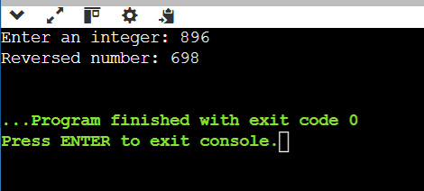

1. Write a program to check whether a number is a palindrome.

Input=The user enters an integer.

Process=The program reverses the digits of the number using a while loop.

Output=both are equal, the number is a palindrome

#include <stdio.h>

void main()

{

int num, original, reversed = 0, remainder;

printf("Enter an integer: ");

scanf("%d", &num);

original = num;

while (num != 0)

{

remainder = num % 10;

reversed = reversed * 10 + remainder;

num /= 10;

}

if (original == reversed)

printf("%d is a palindrome number.\n", original);

else

printf("%d is not a palindrome number.\n", original);

}

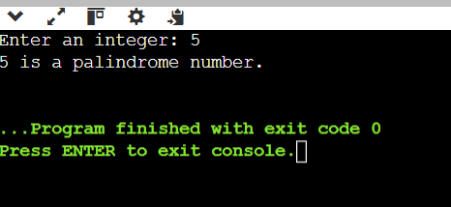

1. Write a program to print multiplication table of a number.

Input= The program prompts the user to enter an integer.

Process= A for loop iterates from 1 to 10.

Output= the entered number and the loop.

Program:

#include <stdio.h>

void main()

{

int num, i;

printf("Enter a number to print its multiplication table: ");

scanf("%d", &num);

printf("Multiplication table of %d:\n", num);

for(i = 1; i <= 10; ++i)

{

printf("%d x %d = %d\n", num, i, num * i);

}

}

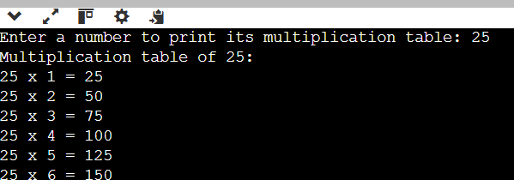

1. Write a program to count the number of digits in a number.

Input= The program prompts the user to enter an integer.

Process= the entered number is 0.

Output= The total count of digits is displayed to the user.

Program:

#include <stdio.h>

#include <stdio.h>

void main()

{

int count = 0;

printf("Enter an integer: ");

scanf("%lld", &number);

if (number == 0)

{

count = 1;

}

else

{

while (number != 0)

{

number /= 10;

++count;

}

}

printf("Number of digits: %d\n", count);

}

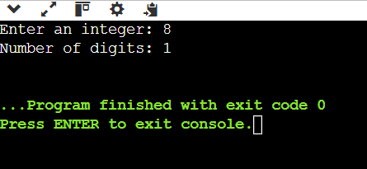

1. Write a program to print the Fibonacci series up to n terms.

Input= the number of terms you want to display in the Fibonacci series.

Process=the first two terms of the Fibonacci series (0 and 1).

Output= Fibonacci Series: 0 1 1 2 3 5 8.

Program:

#include <stdio.h>

void main()

{

int n, first = 0, second = 1, next, i;

printf("Enter the number of terms: ");

scanf("%d", &n);

printf("Fibonacci Series: ");

for (i = 0; i < n; i++)

{

if (i <= 1)

next = i;

else

{

next = first + second;

first = second;

second = next;

}

printf("%d ", next);

}

}

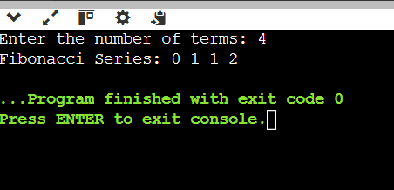

1. Write a program to calculate the sum of the first n natural numbers.

Input= the user to enter a positive integer n

Process= It initializes a variable sum to 0.

Output= it prints the calculated sum.

Program:

#include <stdio.h>

void main()

{

int n, sum = 0;

printf("Enter a positive integer: ");

scanf("%d", &n);

for (int i = 1; i <= n; ++i) {

sum += i;

}

printf("Sum of first %d natural numbers is: %d\n", n, sum);

}

