(Day:04\08\2025)

1.Write a program to check if a number is positive, negative, or zero.

Input=A number (integer or float) entered by the user.

Process=enter the three numbers

Output=the number is positive, negative, or zero.

Program:

#include <stdio.h>

Void main()

{

int num;

printf("Enter a number: ");

scanf("%d", &num);

if (num > 0)

{

printf("The number is Positive");

}

else if (num < 0)

{

printf("The number is Negative");

}

else

{

printf("The number is Zero”);

}

}

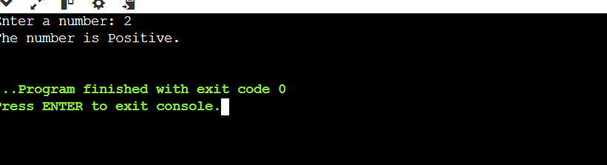

2. Write a program to find the largest among three numbers.

**input=**Three numbers entered by the user

**process=compare to the three numbers**

**output=the largest number**

**program:**

**#include <stdio.h>**

**Void main()**

**{**

**int a, b, c;**

**printf("Enter three numbers: ");**

**scanf("%d %d %d", &a, &b, &c);**

**if (a >= b && a >= c)**

**{**

**printf("%d is the largest number.\n", a);**

**}**

**else if (b >= a && b >= c)**

**{**

**printf("%d is the largest number.\n", b);**

**}**

**else**

**{**

**printf("%d is the largest number.\n", c);**

**}**

**}**

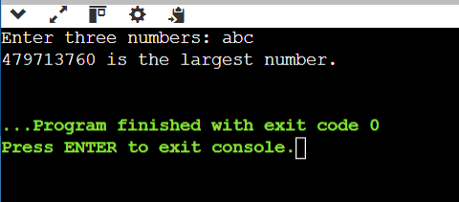

3. Write a program to check if a year is a leap year.

Input=A single integer Y.

Process=they find the leap year.

Output=To find the leap year or not

Program:

#include <stdio.h>

void main()

{

int year;

printf("Enter a year: ");

if scanf("%d", &year);

{

if (year % 400 == 0) || (year % 4 == 0) && (year % 100 != 0)

{

printf("%d is a leap year.\n", year);

}

else

{

printf("%d is not a leap year.\n", year);

}

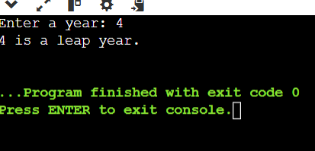

4. Write a program to check whether a character is a vowel or consonant.

Intput=A single character.

Process=they find the vowel and constant.

Output=vowel and constant

Program:

#include <stdio.h>

void main()

{

char ch;

printf("Enter a character: ");

scanf("%c", &ch);

if (ch == 'a' || ch == 'e' || ch == 'i' || ch == 'o' || ch == 'u' ||

ch == 'A' || ch == 'E' || ch == 'I' || ch == 'O' || ch == 'U')

{

printf("%c is a vowel.\n", ch);

}

else if ((ch >= 'a' && ch <= 'z') || (ch >= 'A' && ch <= 'Z'))

{

printf("%c is a consonant.\n", ch);

}

Else

{

printf("Invalid input! Please enter an alphabet.\n");

}

}

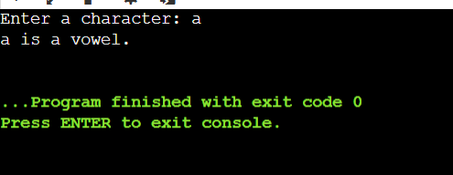

5. Write a program to assign grades based on marks.

Input=A numeric mark (assumed out of 100).

Process= To find the grades. A-f.

Output=to find all grades.

Program:

#include <stdio.h>

void main()

{

float marks;

printf("Enter the marks ");

scanf("%f", &marks);

{

else if (marks >= 90)

{

printf("Grade: A\n");

} else if (marks >= 80)

{

printf("Grade: B\n");

}

else if (marks >= 70)

{

printf("Grade: C\n");

}

else if (marks >= 60)

{

printf("Grade: D\n");

}

Else

{

printf("Grade: F\n");

}

}

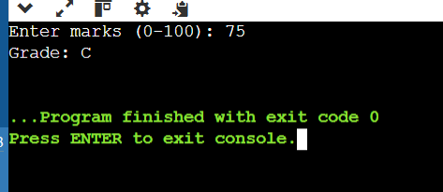

6. Write a program to check whether a number is divisible by 5 and 11.

Input=An integer entered by the user.

Process=They divisible to find the two numbers

Output=the number is divisible by both 5 and 11.

Program:

#include <stdio.h>

void main()

{

int num;

printf("Enter an integer: ");

scanf("%d", &num);

{

if (num % 5 == 0 && num % 11 == 0)

{

printf("%d is divisible by both 5 and 11.\n", num);

}

else

{

printf("%d is not divisible by both 5 and 11.\n", num);

}

}

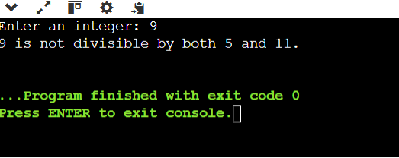

7. Write a program to find the absolute value of a number.

Input=A number

Process=the number is negative, multiply it by -1.

Output=Absolute value of the number

Program:

#include <stdio.h>

void main()

{

int num, absValue;

printf("Enter a number: ");

scanf("%d", &num);

if (num < 0)

{

absValue = -num;

}

else

{

absValue = num;

}

printf("Absolute value: %d\n", absValue);

}

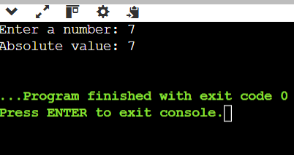

8.Write a menu-driven program to perform +, -, *, / operations.

#include <stdio.h>

void main()

{

int choice;

float num1, num2, result;

printf("Simple Calculator Menu:\n");

printf("1. Addition (+)\n");

printf("2. Subtraction (-)\n");

printf("3. Multiplication (*)\n");

printf("4. Division (/)\n");

printf("Enter your choice (1-4): ");

scanf("%d", &choice);

printf("Enter two numbers: ");

scanf("%f %f", &num1, &num2);

switch (choice)

{

case 1:

result = num1 + num2;

printf("Result: %.2f + %.2f = %.2f\n", num1, num2, result);

break;

case 2:

result = num1 - num2;

printf("Result: %.2f - %.2f = %.2f\n", num1, num2, result);

break;

case 3:

result = num1 * num2;

printf("Result: %.2f * %.2f = %.2f\n", num1, num2, result);

break;

case 4:

if (num2 == 0)

{

printf("Error: Division by zero is not allowed.\n");

}

else

{

result = num1 / num2;

printf("Result: %.2f / %.2f = %.2f\n", num1, num2, result);

}

break;

default:

printf("Invalid choice. Please enter a number between 1 and 4.\n");

}

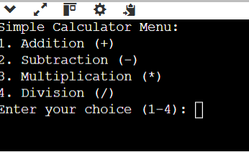

9. Write a program to find roots of a quadratic equation.

Input=Three numbers: coefficients a, b, and c.

Process=Compute discriminant.

Output=the roots

Program:

#include <stdio.h>

void main()

{

Int a, b, c;

double discriminant, realPart, imagPart, root1, root2;

printf("Enter coefficients a, b, c :\n");

if (scanf("%f %f %f", &a, &b, &c) != 3)

{

printf("Invalid input. Please enter three numbers.\n");

if (a == 0)

{

printf("Coefficient a cannot be zero for a quadratic equation.\n");

}

discriminant = b * b - 4 * a * c;

if (discriminant > 0)

{

root1 = (-b + sqrt(discriminant)) / (2 * a);

root2 = (-b - sqrt(discriminant)) / (2 * a);

printf("Roots are real and distinct:\n");

printf("Root 1 = %.6f\n", root1);

printf("Root 2 = %.6f\n", root2);

}

else if (discriminant == 0)

{

root1 = -b / (2 * a);

printf("Roots are real and equal:\n");

printf("Root = %.6f\n", root1);

}

else

{

realPart = -b / (2 * a);

imagPart = sqrt(-discriminant) / (2 * a);

printf("Roots are complex conjugates:\n");

printf("Root 1 = %.6f + %.6fi\n", realPart, imagPart);

printf("Root 2 = %.6f - %.6fi\n", realPart, imagPart);

}

}

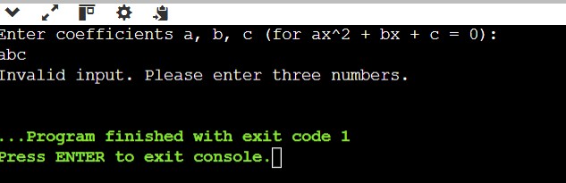

10. Write a program to find the number of digits in a number.

Input=An integer number.

Process=divide the number by 10 and count.

Output=Number of digits in the given number.

Program:

#include <stdio.h>

void main()

{

int num, count = 0;

printf("Enter an integer: ");

scanf("%d", &num);

if (num == 0)

{

count = 1;

}

else

{

if (num < 0)

{

num = -num;

}

while (num != 0)

{

num = num / 10;

count++;

}

}

printf("Number of digits: %d\n", count);

}

