HW3 CS 6347: Statistics for AI and ML

Thennannamalai Malligarjuan – txm230003

Problem 1: Gibbs Sampling for Weighted Coloring Problems (50pts)  
  
1. Use the Gibbs sampling algorithm to approximate the marginals of the probability distribution  
over weighted vertex colorings from problem 2 of problem set 2. Your solution should be  
written as a MATLAB function that takes as input an n ×n matrix A corresponding to the  
adjacency matrix of a graph G, a vector of weights w ∈ Rk, burnin which is the number of  
burn-in samples, and its which is an input that controls the total number of iterations of  
the Gibbs sampler after burn-in. The output should be an n ×k matrix of marginals whose  
ith, xthi entry is equal to the probability that i ∈V is colored with color xi ∈{1, . . . , k}.  
function m = gibbs(A, w, burnin, its)

**Answer:**

Tested the Gibbs sampler on a three node chain with three colors.



The vector w = [1,2,3]

Output:

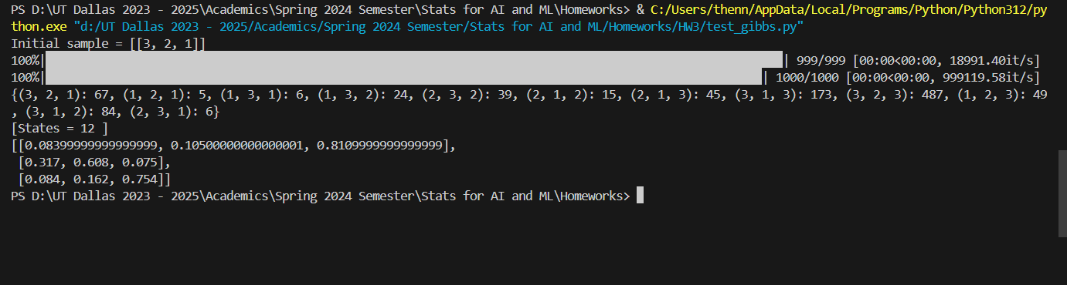

|  |  |  |  |
| --- | --- | --- | --- |
| Vertex(i) | P(Xi = 1) | P(Xi=2) | P(Xi=3) |
| a | 0.0839 | 0.105 | 0.8109 |
| b | 0.317 | 0.608 | 0.075 |
| c | 0.084 | 0.162 | 0.754 |

2. Run the Gibbs sampler to estimate the probability that a ∈ V is colored with color 4 using weights wi = i for each i ∈{1, 2, 3, 4} in the graph above. Construct a table of the estimated marginal as a function of burnin versus its for your implementation where burnin and its are chosen from the set {2^6, 2^10, 2^14, 2^18}. Does your answer depend on the initial choice of assignment used in your Gibbs sampling algorithm?

**Answer:**

Output:

Initial sample = [1,2,2,3]

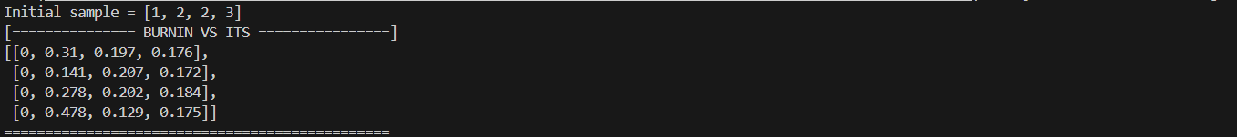

Initial sample = [4,2,2,1]

From the above outputs, we can observe that the probability that vertex a has color 4 does not depend on the initial assignment. The Gibbs sampler can travel throughout the state space for the given graph. This is because the state space graph does not have disconnected components. Hence there is only one steady state distribution and the sampler has approximated that distribution.

Problem 2: Maximum Likelihood for Colorings (50 pts)  
For this problem, we will use the same factorization as we have in past assignments. However, the weights will now be considered parameters of the model that need to be learned from samples.  
1. Use the belief propagation algorithm that you wrote on Problem Set 2 to perform (approximate) maximum likelihood estimation for the coloring counting problem. Your solution should be written as a MATLAB function that takes as input an n ×n matrix A corresponding to the adjacency matrix of the graph G and samples which is an n ×m k-ary matrix where samplesi,t corresponds to observed color for vertex i in the tth sample. The output should be a k-dimensional vector of weights w corresponding to the MLE parameters for the model.  
function w = colormle(A, samples)

**Answer:**

Program zipped with this file.

2. Validate your algorithm by showing that you obtain the correct maximum-likelihood parameters when the graph is a 3-node chain with 3 colors and weights wi = i using your Gibbs sampler that you wrote on Problem 1. Construct a table of the estimated partition function(from the MLE) after 10^1, 10^2, 10^3, 10^4, and 10^5 samples.  
**Answer:**

