
SJVN LIMITED
A Navratna CPSE | Ministry of Power, Government of India
RE COMMERCIAL & TRADING PLATFORM
REIA User Manual
Billing & Settlement — step by step, with screenshots
Document | REIA User Manual
Version | Version 1.0
Date | October 2026
For | SJVN REIA desk, Finance, Management, Sellers and Buyers
Prepared by | Commercial & IT team, SJVN Limited
For internal use of SJVN and its registered sellers and buyers

Contents
Getting Started
1. About this manual
1.1 What is the REIA module?
1.2 The work that happens every month
1.3 Who uses the platform
1.4 How to read this manual
1.5 Words used in this manual
2. Signing in and signing out
2.1 Before you start
2.2 How to sign in
2.3 If the platform does not let you in
2.4 If you forget your password
2.5 The first time you sign in
2.6 How to change your password
2.7 Quick Demo Login (training and test server only)
2.8 How to sign out
3. Finding your way around
3.1 The parts of the screen
3.2 How to use the menu
3.3 The screens of the REIA module
3.4 Making more room on the screen
3.5 Alerts: the bell
3.6 Things that work the same on every screen
4. Stakeholders (Sellers and Buyers)
4.1 The Stakeholder screen
4.2 Registering a new seller or buyer
4.3 The company’s file
4.4 Checking the bank account (penny drop)
4.5 Checking the regulatory papers
4.6 Logo and signature for invoices
4.7 Approving or rejecting the company
4.8 Opening and reading a company’s file later
4.9 Common questions
5. Company Users
5.1 The levels inside a company
5.2 Choosing the company
5.3 Adding a user to a company
5.4 Reading a member’s card
5.5 Resetting a user’s password
5.6 Changing a user’s details or level
5.7 Switching off a user
5.8 Who can do what
5.9 Common questions
6. Documents & KYC Desk
6.1 The desk at a glance
6.2 Checking a document
6.3 The KYC status of every company
6.4 Uploading a document on behalf of a company
6.5 Common questions
The Monthly Cycle
7. Contracts (PPA / PSA)
7.1 The Contracts screen
7.2 Entering a new contract
7.3 Making the contract active
7.4 Linking a PSA to a PPA
7.5 Amending a contract
7.6 The working file of a contract
7.7 Entering many contracts at once
7.8 Common questions
8. Contract Compliance
9. Energy Data & Validation
9.1 The four stages of an energy record
9.2 The Energy Data screen
9.3 Step 1: Record the energy
9.4 Step 2: Validate
9.5 Step 3: The seller accepts the figure
9.6 Step 4: Lock
9.7 Other ways to bring in energy data
9.8 The Settlement Trail
9.9 Common questions
10. Billing & Invoicing
10.1 The two bills of every month
10.2 The Billing screen
10.3 Step A: The seller submits its invoice
10.4 Step B: Generate the system invoice for the PPA
10.5 Step C: Check the seller’s invoice
10.6 Step D: Generate the bill on the buyer
10.7 Reading a bill
10.8 Returning an invoice to the seller
10.9 Supplementary and arrear bills
10.10 E-invoice number and signed copy
10.11 Common questions
11. Approving a bill
11.1 The rules of approval
11.2 How to approve a bill
11.3 How to reject a bill
11.4 What the messages in Approval Workflow mean
11.5 Common questions
12. Payments
12.1 How a buyer’s payment reaches the bill
12.2 What the buyer does
12.3 Confirming a buyer’s payment
12.4 Recording a payment directly on a bill
12.5 Paying the seller
12.6 Debit and credit notes
12.7 Common questions
13. Invoice Verification
14. Payment Monitoring
14.1 The Outstanding tab
14.2 What SJVN owes to sellers
14.3 Payments to confirm
14.4 Common questions
Disputes, Reconciliation and Control
15. Dispute Management
15.1 How a dispute works
15.2 The Dispute Management screen
15.3 Opening and reading a dispute
15.4 Reviewing a dispute
15.5 Giving the decision
15.6 When SJVN raises a dispute
15.7 Common questions
16. Reconciliation
16.1 The steps of a reconciliation
16.2 Running a reconciliation
16.3 Reading the statement
16.4 Dealing with lines that did not match
16.5 Signing for SJVN
16.6 The other party signs
16.7 The list of statements
16.8 Common questions
17. Payment Security
17.1 The Payment Security screen
17.2 Adding an instrument
17.3 Working on one instrument
17.4 Accepting a shortfall for the time being
17.5 Invoking security when a buyer defaults
17.6 Letters of credit opened by SJVN for sellers
17.7 Common questions
18. Deviation Settlement (DSM)
18.1 The normal way: from the NRPC statement
18.2 A manual estimate
18.3 From a recorded week to a bill
19. Power Diversion
20. Energy Banking
21. Counterparty Ledgers & TDS
21.1 The four tabs
22. Generation Performance
23. REIA Dashboard
23.1 Start your day here
23.2 The number boxes
24. Billing Reports
25. CERC Compliance
26. Finance Posting
27. SJVN Users
27.1 The roles
27.2 Looking after users
28. Notification Board and Quick Connect
28.1 Notification Board
28.2 Quick Connect
29. Audit Trail
For the Seller
30. The Seller’s home page
30.1 Your menu
30.2 Reading the dashboard
31. My Team (Seller)
31.1 The levels in your team
31.2 Adding a team member
31.3 Looking after your team
32. My Documents & KYC (Seller)
32.1 What you must upload
32.2 Uploading a document
32.3 If SJVN rejects a document
33. My Contracts (Seller)
33.1 Asking SJVN for an extension or amendment
34. Energy Data (Seller)
35. My Invoices (Seller)
35.1 Creating an invoice
35.2 Following your invoice
36. Payments & Ledger (Seller)
37. My Disputes (Seller)
38. Payment Security (Seller)
39. Reconciliation (Seller)
For the Buyer
40. The Buyer’s home page
40.1 Your menu
41. My Team and My Documents (Buyer)
41.1 The levels in your team
41.2 Adding a team member
41.3 Looking after your team
41.4 My Documents & KYC
42. My PSAs and Energy Allocation (Buyer)
42.1 My PSAs
42.2 Energy Allocation
43. Payable Invoices (Buyer)
43.1 Receiving a bill
43.2 Telling SJVN about a payment
43.3 Common questions
44. My Disputes (Buyer)
45. Payment Ledger, Payment Security and Reconciliation (Buyer)
45.1 Payment Ledger
45.2 Payment Security
45.3 Reconciliation
Putting It All Together
46. One month from start to end
46.1 The steps in order
46.2 What must be true before each step
47. Checklists
47.1 SJVN REIA desk: every day
47.2 SJVN REIA desk: every month
47.3 Finance: every day and every month
47.4 Seller: every month
47.5 Buyer: every month
48. Common questions
49. Meaning of every status and word
49.1 Status labels
49.2 Words

PART 1

Getting Started
Signing in, finding your way, and bringing a new seller or buyer onto the platform.

CHAPTER 1

1. About this manual
Read this short chapter first. It tells you what the REIA module does and how to read the rest of the book.

1.1 What is the REIA module?
SJVN works as a Renewable Energy Implementing Agency (REIA). In simple words, SJVN stands in the middle:
- SJVN buys power from a renewable energy generator. The generator is called the Seller. The agreement is called a PPA (Power Purchase Agreement).
- SJVN sells the same power to a DISCOM or another buyer. This party is called the Buyer. The agreement is called a PSA (Power Sale Agreement).
- SJVN keeps a small trading margin for doing this work.
The REIA module is the part of the platform where all of this work is done: who the sellers and buyers are, what the contracts say, how much energy was supplied, what the bill is, who has paid, and what is still pending.

1.2 The work that happens every month
Almost everything in this manual belongs to one monthly cycle. If you remember these seven steps, the whole module becomes easy.
Step | What happens | Who does it | Screen
1 | The energy supplied in the month is entered and checked. | SJVN REIA desk | Energy Data & Validation
2 | The seller looks at the energy figure and accepts it. SJVN then locks it. | Seller, then SJVN | Energy Data
3 | Bills are made from the locked energy: the seller’s bill on SJVN and SJVN’s bill on the buyer. | SJVN REIA desk / Seller | Billing & Invoicing
4 | Each bill is approved by SJVN officers, one after another. | REIA Ops, REIA Admin, Finance | Billing & Invoicing
5 | The buyer pays and tells SJVN. Finance confirms that the money has come. | Buyer, then Finance | Payable Invoices / Payment Monitoring
6 | If someone does not agree with a bill, a dispute is raised and settled. | Buyer or Seller, then SJVN | Dispute Management
7 | At the end, energy, bills and payments are matched and both sides sign. | SJVN, Seller, Buyer | Reconciliation

GOOD TO KNOW
Before the monthly cycle can start, the seller and buyer must be registered (Chapter 4), they must have logins (Chapter 5), their documents must be checked (Chapter 6) and the contract must be entered. This is done only once for each party.

1.3 Who uses the platform
Each person signs in with their own email. What you can see and do depends on your role.
Role | Who this is | What they mainly do
SJVN Admin | The administrator of the platform | Can open every screen. Adds SJVN users and resets passwords.
REIA Ops (REIA Desk) | Officers who do the daily REIA work | Enter energy, raise bills, check documents, give the first approval.
REIA Admin | Senior REIA officer | Second approval on bills. Manages company users.
Finance | SJVN Finance officers | Final approval on bills. Confirm payments received.
Management | Senior management | Only view dashboards and reports. Cannot change anything.
Seller | The generator that sells power to SJVN | Accept energy data, raise invoices, see payments, raise disputes.
Buyer | The DISCOM that buys power from SJVN | See bills, tell SJVN about payments, raise disputes.

1.4 How to read this manual
Every screen is explained in the same way, so that you always know where to look.
- A small grey table at the start tells you what the screen is for, who uses it and how to open it.
- Numbered steps tell you exactly what to click and what to type. Do them in the same order.
- Screenshots show the real screen. A red circle with a number on a screenshot points to the thing you must look at or click. The red table below the screenshot explains each number.
- Words written in `blue bold` are the exact names of buttons, menus and boxes on the screen. Look for the same words on your screen.
TIP
This green box gives a helpful suggestion.

GOOD TO KNOW
This blue box gives extra information that is good to know.

IMPORTANT
This orange box tells you something you must not miss.

BE CAREFUL
This red box warns you about an action that cannot be undone, or that can cause a problem.

WHAT YOU SHOULD SEE NOW
This box tells you what the screen should look like after you finish the steps. If your screen is different, go back and check the steps again.

1.5 Words used in this manual
Word | Meaning in simple words
Stakeholder | Any company that works with SJVN on the platform: a seller or a buyer.
Seller | The generator that sells power to SJVN.
Buyer | The DISCOM or company that buys power from SJVN.
PPA | Power Purchase Agreement: the contract between the seller and SJVN.
PSA | Power Sale Agreement: the contract between SJVN and the buyer.
KYC | “Know Your Customer”: checking that the company and its papers are genuine.
Penny drop | A test where ₹1 is sent to a bank account to confirm that the account is real.
Maker / Checker / Approver | Three levels of users inside a seller or buyer company. The maker prepares, the checker reviews, the approver approves.
Menu | The dark blue list of screens on the left side of the window.
Pop-up window | A small window that opens on top of the screen and asks you to fill something.

CHAPTER 2

2. Signing in and signing out
How to open the platform, enter with your email and password, change your password and leave safely.
What it is for | To enter the platform. You cannot do any work without signing in.
Who uses it | Everyone: SJVN officers, sellers and buyers.
How to open it | Open Google Chrome (or Microsoft Edge) and type the web address given to you by SJVN IT.
When to use it | Every time you start your work.

2.1 Before you start
Keep these three things ready:
- The web address of the platform. SJVN IT will give it to you.
- Your work email. This is your user name.
- Your password. The first time, the SJVN Administrator (or your Company Admin) gives you a temporary password.

2.2 How to sign in

To sign in
STEP  1 | Open Google Chrome. Type the web address in the address bar at the top and press the Enter key on your keyboard.

WHAT YOU SHOULD SEE NOW
The sign-in page opens. The left side shows a picture. The right side has the boxes to sign in.

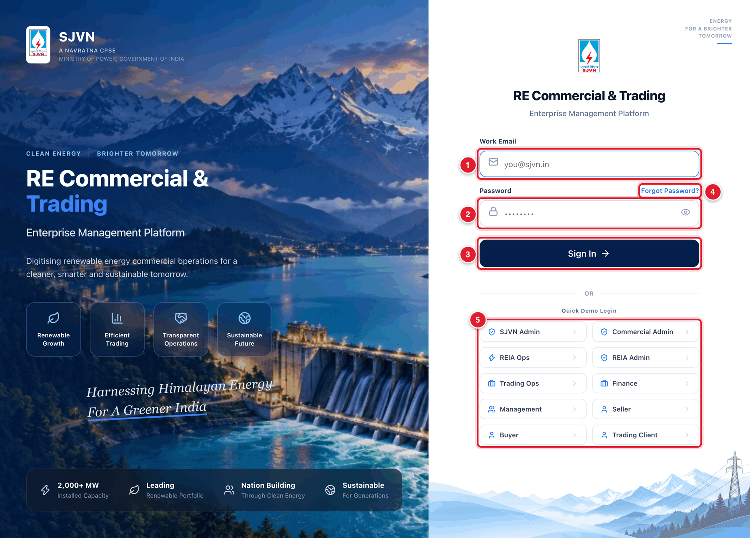
Figure 2.1 The sign-in page.
1 | Work Email: type your email address here.
2 | Password: type your password here.
3 | Sign In: click this button after typing your email and password.
4 | Forgot Password?: click this if you do not remember your password (see 2.4).
5 | Quick Demo Login: these buttons are only for training and testing. They are explained in 2.7.

STEP  2 | Click inside the box under Work Email. Type your full email address, for example reia@sjvn.in.  • Use small letters.  • Do not leave a blank space before or after the email.

STEP  3 | Click inside the box under Password. Type your password.  • The password shows as dots so that nobody can read it.  • Capital and small letters are different. Password1 and password1 are not the same.

STEP  4 | If you want to check what you typed, click the small eye picture at the right end of the password box. Click it again to hide the password.

STEP  5 | Click the dark blue button Sign In.

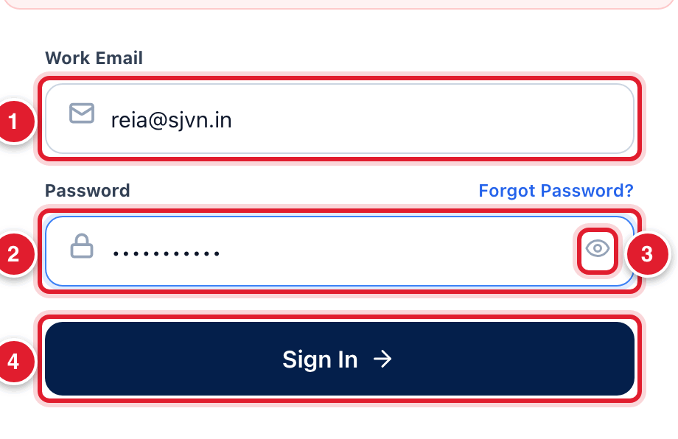
Figure 2.2 Email and password typed in, ready to sign in.
1 | Your email address.
2 | Your password (shown as dots).
3 | The eye picture: click to see or hide the password.
4 | Click Sign In.

WHAT YOU SHOULD SEE NOW
The sign-in page goes away and your home page opens. For an REIA officer this is the REIA Billing & Settlement Dashboard. A seller or buyer sees My Dashboard.

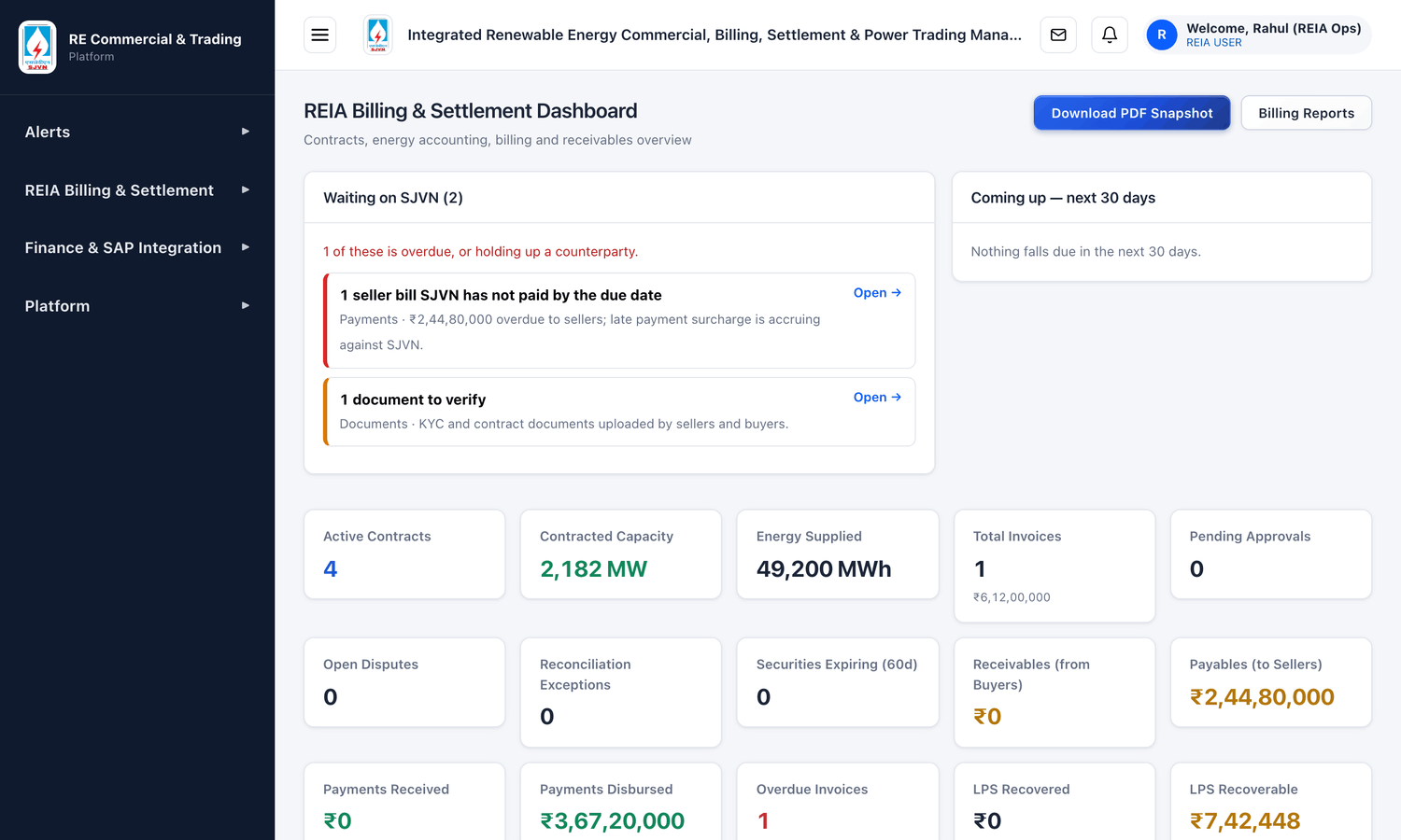
Figure 2.3 The home page of an REIA officer after signing in.

2.3 If the platform does not let you in
If the email or the password is wrong, you stay on the sign-in page and a red message appears above the email box.
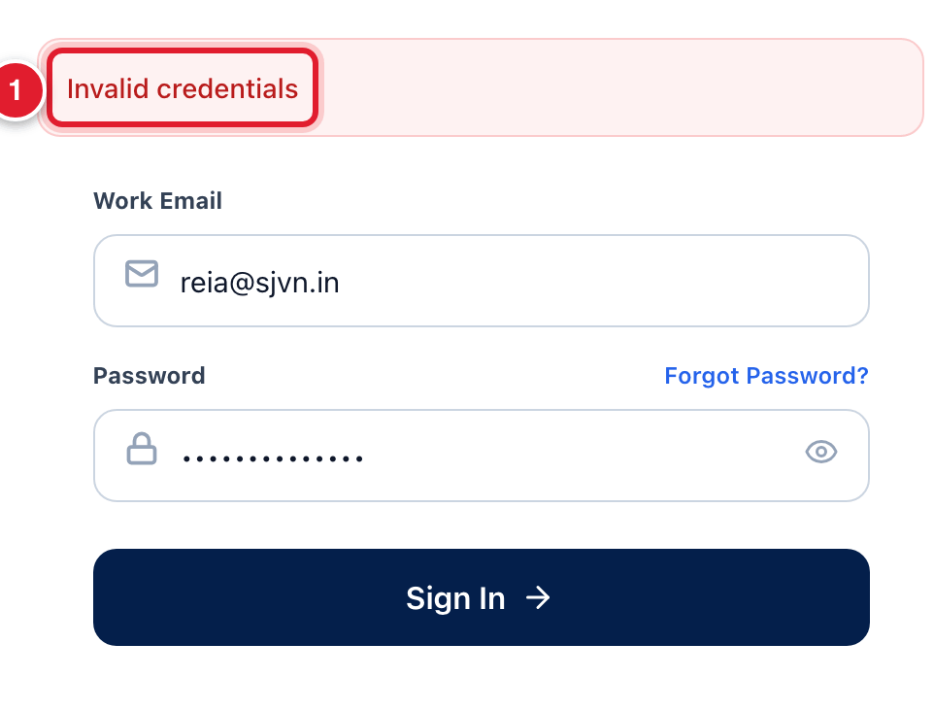
Figure 2.4 The red message when the email or password is wrong.
1 | The message Invalid credentials means the email or the password is not correct.

If you see this | Why it happens | What to do
Invalid credentials | The email or the password is typed wrongly. | Type both again slowly. Check that Caps Lock on the keyboard is off. Use the eye picture to see the password.
A message that the account is locked | A wrong password was typed 5 times. For safety the platform blocks sign-in for 15 minutes. | Wait for 15 minutes and try again with the correct password. If you do not remember it, ask for a password reset (see 2.4).
The page does not open at all | The web address is wrong, or the internet / office network is not working. | Check the address. Check that other websites open. If not, call SJVN IT.
You sign in, but you cannot see the REIA menu | Your role does not have REIA access. | Ask the SJVN Administrator to check your role.

2.4 If you forget your password
Do not keep guessing the password. After 5 wrong tries the account is locked for 15 minutes. Do this instead:
- SJVN officers: ask the SJVN Administrator to reset your password. The Administrator gives you a new temporary password.
- Seller and buyer users: ask your own Company Admin or Approver. If the Company Admin has forgotten the password, write to the SJVN REIA desk. SJVN can reset it from the Company Users screen (Chapter 5).
With the temporary password, sign in as usual. The platform will immediately ask you to choose your own new password (see 2.5).
GOOD TO KNOW
The sign-in page also has a link Forgot Password?. It opens a small window that asks for your work email. At present, the sure way to get a new password is to ask the Administrator as written above.

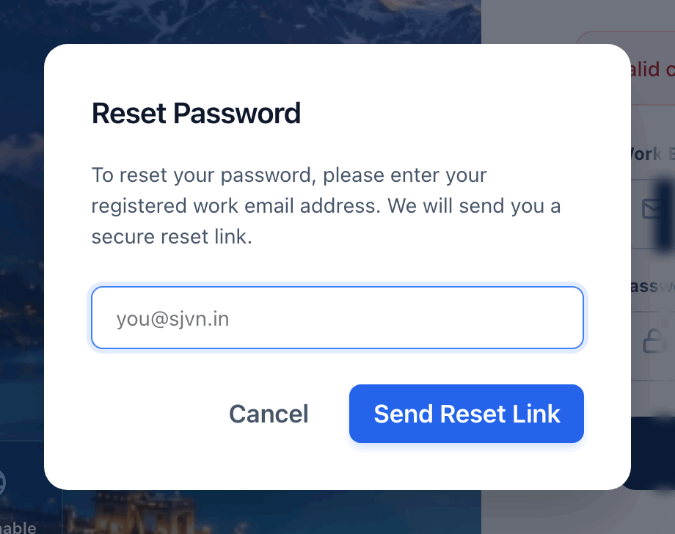
Figure 2.5 The window that opens when you click Forgot Password?.

2.5 The first time you sign in
When you sign in with a temporary password, a window named Choose your own password opens by itself. You cannot close it. You must choose a new password before you can work. This is for your safety: after this, only you know your password.
The window has the same three boxes as the Change Password window shown in 2.6. Fill them in the same way.

2.6 How to change your password
You can change your password at any time. It is a good habit to change it every few months.

To change your password
STEP  1 | Look at the top right corner of the screen. You will see your name, for example Welcome, Rahul (REIA Ops). Click on your name.

STEP  2 | A small list opens. Click Change Password.

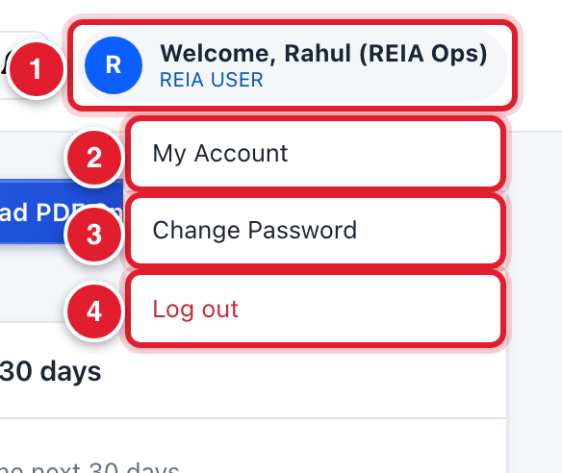
Figure 2.6 The small list that opens when you click your name.
1 | Your name and role. Click here to open the list.
2 | My Account: shows your profile details.
3 | Change Password: click this to change your password.
4 | Log out: click this to leave the platform (see 2.8).

STEP  3 | The Change Password window opens. In Current Password, type the password you use now.

STEP  4 | In New Password, type the new password you want.  • It must have at least 8 characters.  • It must have at least one letter and one number. Example: Shimla2026.

STEP  5 | In Confirm New Password, type the same new password once more.

STEP  6 | Click the blue button Change Password.

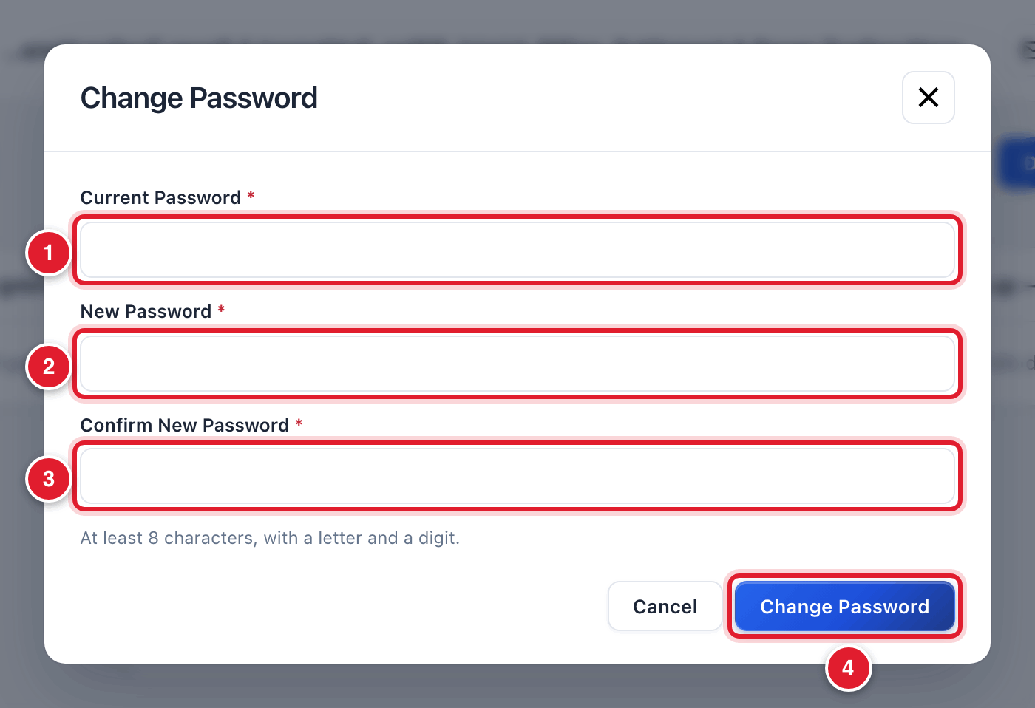
Figure 2.7 The Change Password window.
1 | Type your present password.
2 | Type your new password.
3 | Type the new password again.
4 | Click Change Password to save.

WHAT YOU SHOULD SEE NOW
A message tells you that the password is changed. Click Done. From the next time, sign in with the new password.

IMPORTANT
Never tell your password to anyone, not even to a colleague or to IT staff. Every action on the platform is recorded with your name. If someone else uses your login, the record will show that you did it.

2.7 Quick Demo Login (training and test server only)
On the training / test server, the sign-in page shows a list of buttons under the heading Quick Demo Login. Each button fills the email and password of a ready-made practice user, so that you can try the platform as different roles.

To sign in as a practice user
STEP  1 | On the sign-in page, click one of the demo buttons, for example REIA Ops. The email and password boxes get filled by themselves.

STEP  2 | Click Sign In.

Demo button | Signs you in as | Use it to practise
SJVN Admin | The platform administrator | Any screen in this manual
REIA Ops | REIA desk officer | Daily REIA work and first approval
REIA Admin | Senior REIA officer | Second approval
Finance | Finance officer | Final approval, confirming payments
Management | Management (view only) | Dashboards and reports
Seller | Sunrise Solar Pvt Ltd | The seller’s screens
Buyer | Punjab State Power Corp | The buyer’s screens

BE CAREFUL
The demo buttons are only for practice. On the real (production) server every person must sign in with their own email and password.

2.8 How to sign out

To sign out
STEP  1 | Click your name at the top right corner of the screen.

STEP  2 | In the small list, click Log out (written in red).

WHAT YOU SHOULD SEE NOW
The sign-in page opens again. You are now signed out.

IMPORTANT
Always sign out when you finish your work or leave your seat. Closing the Chrome window is not enough.

CHAPTER 3

3. Finding your way around
The parts of the screen, the menu on the left, and the small things that work the same way on every screen.

3.1 The parts of the screen
After you sign in, every screen has the same three parts: the menu on the left, the top bar at the top, and the work area in the middle.
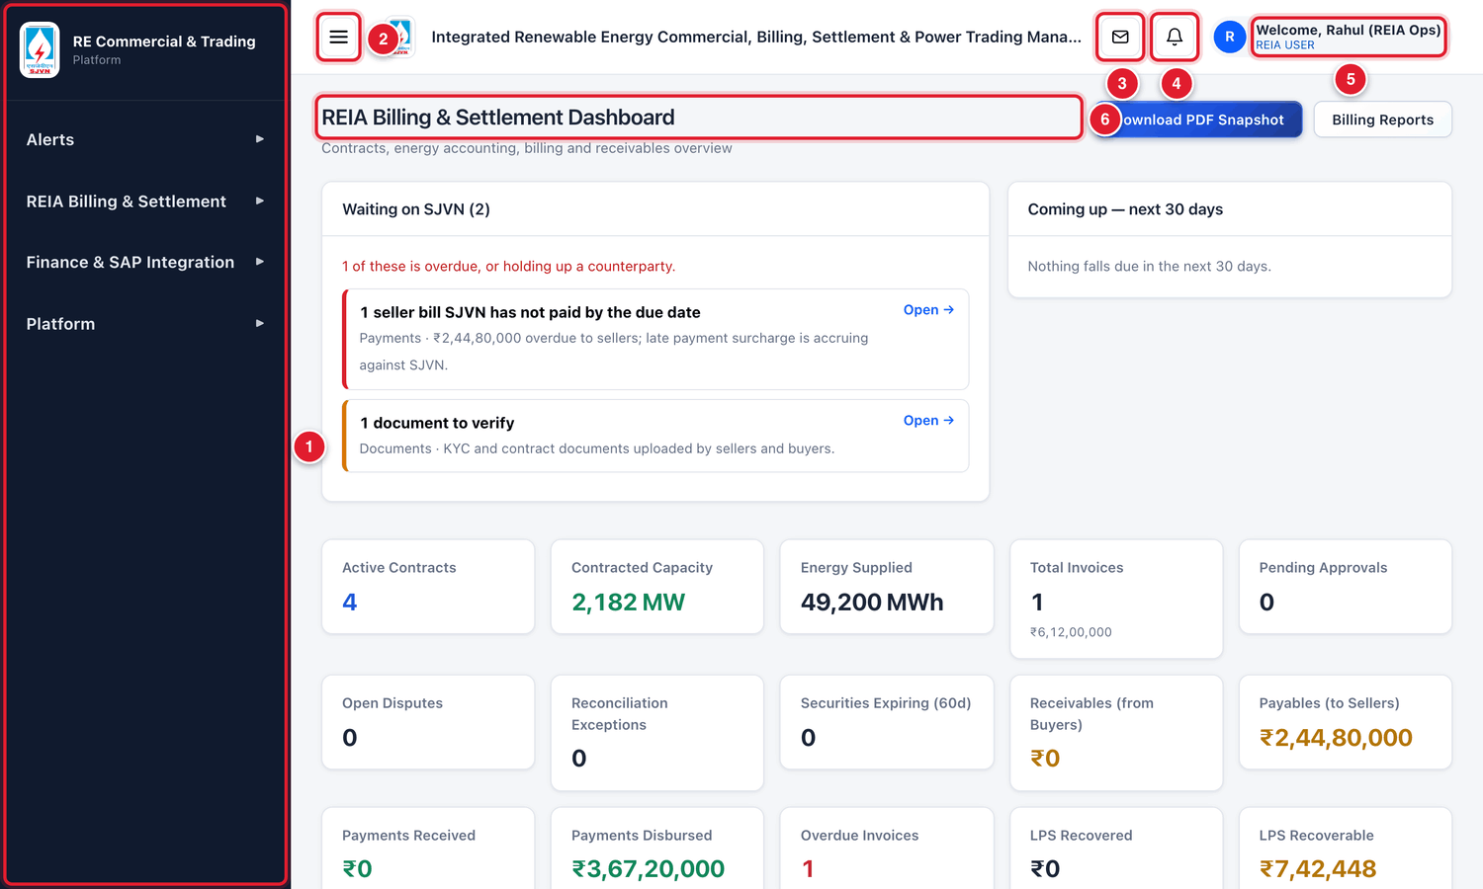
Figure 3.1 The parts of the screen.
1 | The menu. It is the dark blue strip on the left. All screens are opened from here.
2 | The three-lines button. Click it to hide the menu. Click it again to bring the menu back.
3 | The envelope button. It opens Quick Connect, the message box inside the platform.
4 | The bell button. It shows new alerts. A red number on the bell means you have unread alerts.
5 | Your name and role. Click it to change your password or to log out.
6 | The work area. The name of the screen is written at the top. Everything you do happens here.

3.2 How to use the menu
The menu is arranged in groups. Each group has a heading in bigger letters, for example REIA Billing & Settlement. A small arrow is shown at the right of each heading.

To open a screen from the menu
STEP  1 | Find the heading REIA Billing & Settlement in the menu on the left.

STEP  2 | Click on the heading. The list of REIA screens opens below it. (Click the heading again to close the list.)

STEP  3 | Click the name of the screen you want, for example REIA Dashboard.

WHAT YOU SHOULD SEE NOW
The screen opens in the work area. In the menu, the screen that is open now is shown with a bright blue background.

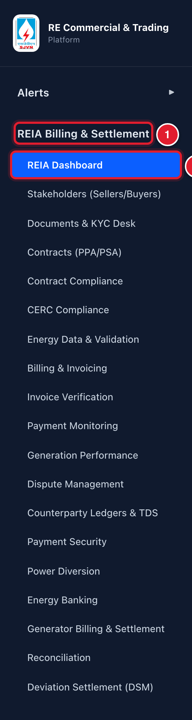
Figure 3.2 The menu with the REIA group opened.
1 | Click the group heading to open or close the list.
2 | The screen that is open now has a bright blue background.

TIP
If the list of screens is long and you cannot see the last names, keep the mouse pointer on the menu and roll the mouse wheel down.

3.3 The screens of the REIA module
This table is a quick map. Each screen has its own chapter in this manual.
Menu name | What you do there
REIA Dashboard | See the whole picture: what is waiting for SJVN, money to receive and to pay, and what is coming up.
Stakeholders (Sellers/Buyers) | Register a new seller or buyer and approve it.
Company Users | Give logins to the people of a seller or buyer company. Reset their passwords.
Documents & KYC Desk | Check the documents that sellers and buyers upload.
Contracts (PPA/PSA) | Enter and manage the contracts.
Contract Compliance | See which contracts have something missing or expiring.
CERC Compliance | Prepare the returns that go to CERC.
Energy Data & Validation | Enter the monthly energy, check it and lock it.
Billing & Invoicing | Make bills, send them for approval, and receive payments.
Invoice Verification | Check the bills sent by sellers before paying.
Payment Monitoring | See who has not paid, for how long, and the late payment surcharge.
Generation Performance | See how much each plant generated against what the contract needs.
Dispute Management | Handle disputes raised on bills.
Counterparty Ledgers & TDS | See the account statement of any seller or buyer, and TDS certificates.
Payment Security | Keep track of letters of credit and bank guarantees.
Power Diversion | Record power sold on the exchange when a buyer defaults.
Energy Banking | Keep account of banked energy.
Reconciliation | Match energy, bills and payments, and sign off with the other party.
Deviation Settlement (DSM) | Record the weekly deviation charges from NRPC.

GOOD TO KNOW
You will see only the screens that your role is allowed to use. If a screen named in this manual is not in your menu, your role does not have it.

3.4 Making more room on the screen
Some screens have wide tables. To give them more room, hide the menu.

To hide and show the menu
STEP  1 | Click the three-lines button at the top left of the work area. The menu goes away and the work area becomes wider.

STEP  2 | Click the same button again to bring the menu back.

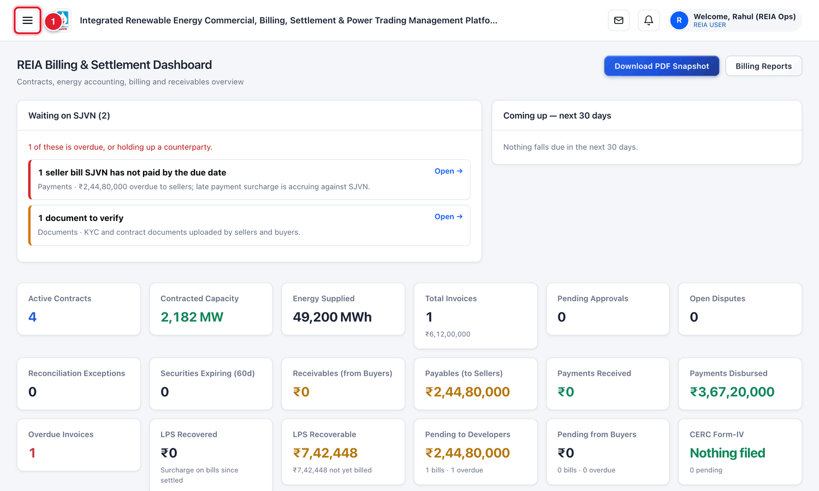
Figure 3.3 The same screen with the menu hidden.
1 | The three-lines button. Click it to bring the menu back.

3.5 Alerts: the bell
The platform tells you when something needs your attention, for example when a bill is waiting for your approval.

To read your alerts
STEP  1 | Click the bell button on the top bar. A small box named System Alerts opens with the newest alerts.

STEP  2 | Read the alerts. To clear the red number on the bell, click Mark all read.

STEP  3 | Click anywhere outside the box to close it.

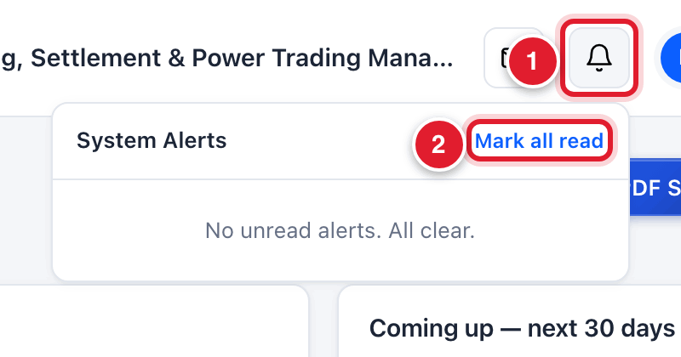
Figure 3.4 The alerts box.
1 | The bell button.
2 | Mark all read clears the red number on the bell.

GOOD TO KNOW
For the full list of alerts, open Alerts in the menu and click Notification Board.

3.6 Things that work the same on every screen
You see | What it is | How to use it
A blue button with + (for example + Onboard Stakeholder) | It starts something new. | Click it. A pop-up window opens with boxes to fill.
A box with a small down arrow (for example All statuses) | A filter. It shows only the rows you choose. | Click the box and click one choice from the list. To see everything again, choose the first line (All …).
A row in a table | One record: one company, one contract, one bill. | Click anywhere on the row to open its full details.
A small coloured label (for example APPROVED, PENDING) | The status of the record. | Green means done. Orange / yellow means waiting. Red means stopped or rejected.
A red star * next to a box name | This box must be filled. | If you leave it empty, the platform will not save.
An ✕ at the top right of a pop-up window | It closes the window. | Click it to close without saving.
A tab named FYI | A short help page for that screen. | Click it to read. Click the first tab to come back to your work.

CHAPTER 4

4. Stakeholders (Sellers and Buyers)
How to register a new seller or buyer, check its bank account and papers, and approve it.
What it is for | The register of all sellers and buyers. A company must be here, and must be APPROVED, before a contract can be made with it.
Who uses it | SJVN REIA desk, REIA Admin, SJVN Admin.
How to open it | Menu → REIA Billing & Settlement → Stakeholders (Sellers/Buyers).
When to use it | Once for each new seller or buyer. Later, whenever its details or papers change.

4.1 The Stakeholder screen
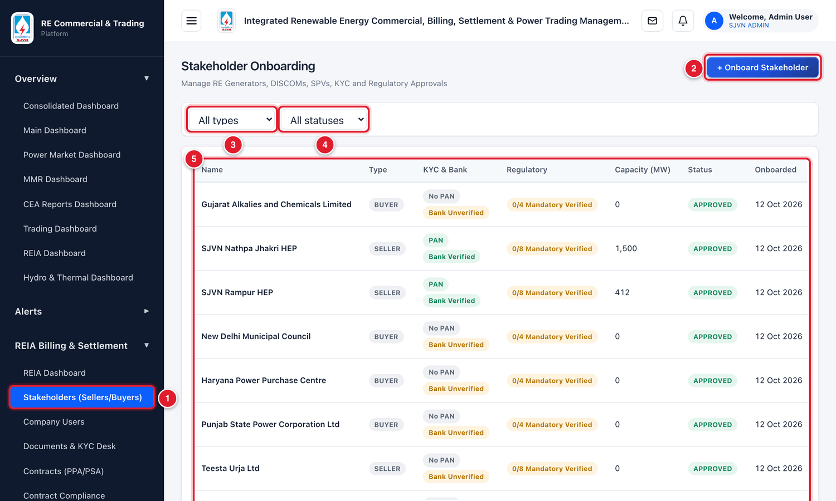
Figure 4.1 The Stakeholder Onboarding screen.
1 | The menu name to click to open this screen.
2 | + Onboard Stakeholder: click to register a new seller or buyer.
3 | The type filter: show only sellers or only buyers.
4 | The status filter: show only Pending, Approved or Rejected companies.
5 | The list of companies. Click any row to open that company’s file.

Each row in the list is one company. The columns mean:
Column | What it tells you
Name | The name of the company.
Type | SELLER or BUYER.
KYC & Bank | Two small labels. PAN / No PAN tells if the PAN number is entered. Bank Verified / Bank Unverified tells if the bank account has passed the penny drop test.
Regulatory | How many of the compulsory papers are verified, for example 3/8 Mandatory Verified. A seller has 8 compulsory papers, a buyer has 4.
Capacity (MW) | The capacity of the plant (seller) or the contracted capacity (buyer).
Status | PENDING: registered but not yet approved. APPROVED: can be used in contracts. REJECTED: not accepted.
Onboarded | The date on which the company was registered.

4.2 Registering a new seller or buyer
Registering has two parts. First you fill a form with the company’s details (this section). Then you check its bank account and papers and approve it (sections 4.3 to 4.7).
Keep these ready before you start: the company’s PAN, GST number, CIN, address, contact person, and bank account details.

To fill the registration form
STEP  1 | On the Stakeholder screen, click the blue button + Onboard Stakeholder at the top right.

WHAT YOU SHOULD SEE NOW
A pop-up window named Onboard New Stakeholder opens. It has four parts, numbered 1 to 4. Fill them from top to bottom.

Part 1 of the form: Entity Hierarchy & Type
STEP  2 | Parent Group (Optional): if this company is a subsidiary / SPV of a group that is already registered, choose the group from the list. Otherwise leave it as -- None (This is a Parent Group) --.

STEP  3 | Entity Type: choose Seller if the company sells power to SJVN. Choose Buyer if it buys power from SJVN.

STEP  4 | Name: type the full legal name of the company, exactly as written on its PAN card.

STEP  5 | Category: type what kind of company it is, for example RE Generator, DISCOM or C&I.

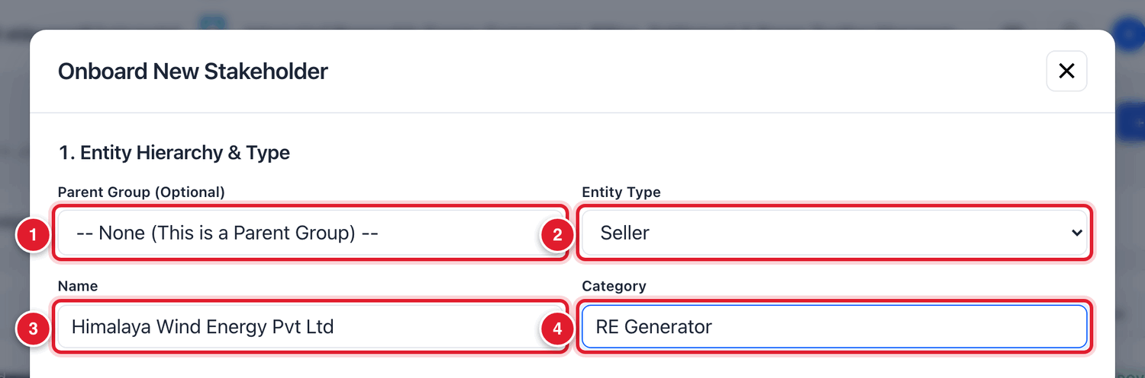
Figure 4.2 Part 1 of the form.
1 | Parent group: leave as it is, unless the company belongs to a registered group.
2 | Entity type: Seller or Buyer.
3 | Full legal name of the company.
4 | Category of the company.

IMPORTANT
Choose Entity Type carefully. The rest of the form changes with it. A seller is asked for technology and plant capacity. A buyer is asked for contracted capacity and PSA tariff. The list of compulsory papers is also different.

Part 2 of the form: Corporate & KYC
STEP  6 | Fill the boxes of this part. The table below explains each one.

Field | What to enter | Example
PAN No | The 10-character PAN of the company. | AAHCH4321K
GST No | The 15-character GSTIN. | 02AAHCH4321K1Z7
TAN No | The TAN of the company, if it has one. | PTLH01234E
CIN | The Corporate Identification Number. | U40108HP2019PTC007788
Corporate Email | The main office email of the company. | accounts@himalayawind.in
Corporate Phone | The main office phone number. | 9816012345
Corporate Website | The website, if any. | www.himalayawind.in
Address | The registered office address. | Mall Road, Shimla, HP 171001
Credit Rating | The latest credit rating, if known. | A+
Authorised Signatory Name | The person who signs invoices for the company. This name is printed on the invoice. | Anil Thakur
Signatory Designation | The designation of that person. | DGM (Finance)
Commercial Contact Name * | The person SJVN should write to about bills. This box must be filled. | Ritu Verma
Commercial Contact Email | The email of that person. | billing@himalayawind.in
Commercial Contact Phone | The phone number of that person. | 9816054321

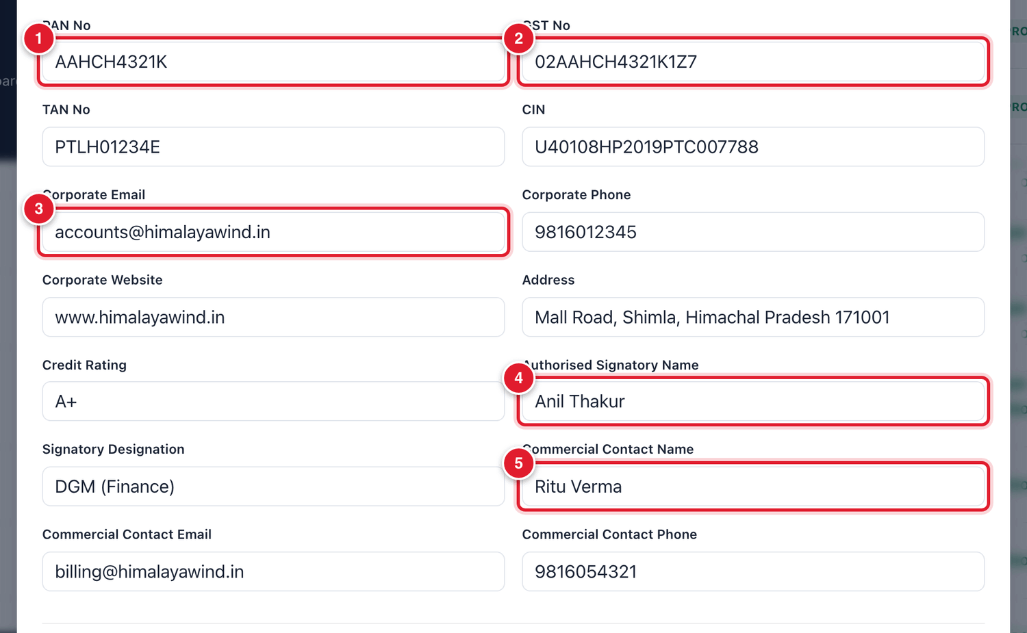
Figure 4.3 Part 2 of the form, filled.
1 | PAN number.
2 | GST number.
3 | Corporate email.
4 | The person who signs the invoices.
5 | The commercial contact person (compulsory).

Part 3 of the form: Technical & Banking
STEP  7 | For a seller, type the Technology (Solar, Wind, Hydro…) and the Capacity (MW) of the plant. For a buyer, type the Contracted Capacity (MW), the PSA Tariff (₹/kWh) and the Criteria for Supply of Power.

STEP  8 | Fill the four bank boxes. All four are compulsory. Copy them from the company’s cancelled cheque.

Field | What to enter | Example
Bank Name * | The name of the bank. | State Bank of India
Account No * | The bank account number. Type it very carefully. | 30214567890
IFSC Code * | The 11-character IFSC code of the branch. | SBIN0001234
Branch Address * | The branch name or address. | The Mall, Shimla

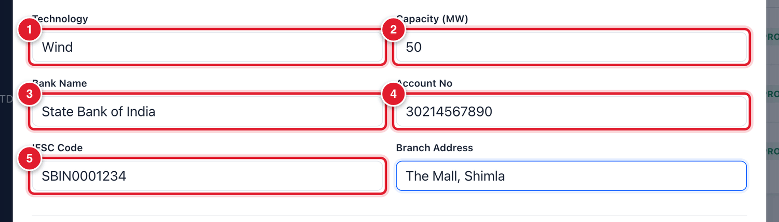
Figure 4.4 Part 3 of the form for a seller.
1 | Technology of the plant.
2 | Capacity in MW.
3 | Bank name.
4 | Account number.
5 | IFSC code.

BE CAREFUL
Payments are made to this bank account. A single wrong digit in the account number can send money to the wrong place. Read the number twice before you go on.

Part 4 of the form: Regulatory Approvals Checklist
This part shows the list of papers the company must give. For a seller there are 8, for a buyer there are 4. You do not upload anything here. You only tell the platform if any paper is not applicable to this company.
STEP  9 | Read the list. If a paper truly does not apply to this company, tick the small N/A box at the right of that line. Otherwise leave all boxes empty.  • Example: a plant that is still under construction has no COD Certificate yet.

STEP  10 | Click the blue button Save & Proceed to Documents at the bottom.

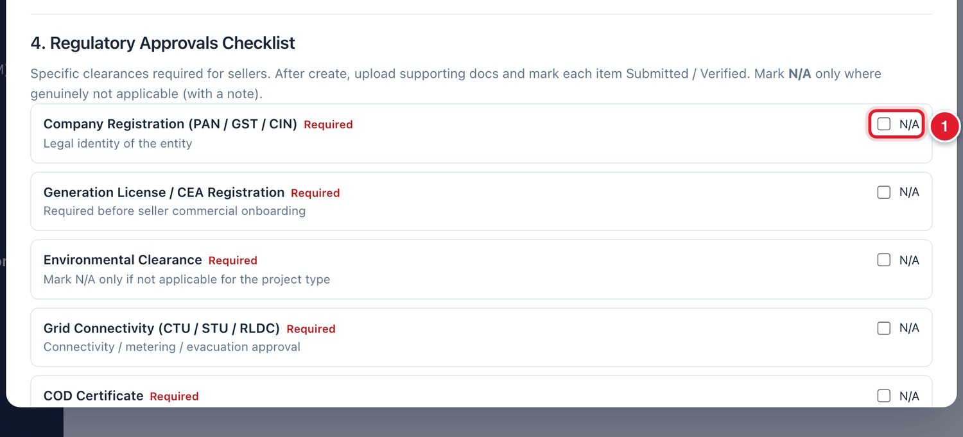
Figure 4.5 Part 4 of the form and the Save button.
1 | Tick N/A only if this paper does not apply to the company.
2 | Click Save & Proceed to Documents to save the form.

WHAT YOU SHOULD SEE NOW
The form closes. A new, bigger window opens with the heading Stakeholder: and the company name. This is the company’s file. Its status is PENDING.

If you see this | Why it happens | What to do
The form does not close and a box is highlighted | A compulsory box is empty. | Fill the highlighted box and click Save & Proceed to Documents again.
A red message at the top of the form | Something typed is not acceptable, for example an email without @. | Read the message, correct that box and save again.

4.3 The company’s file
The file opens by itself after you save the form. You can open it again at any time by clicking the company’s row in the list.
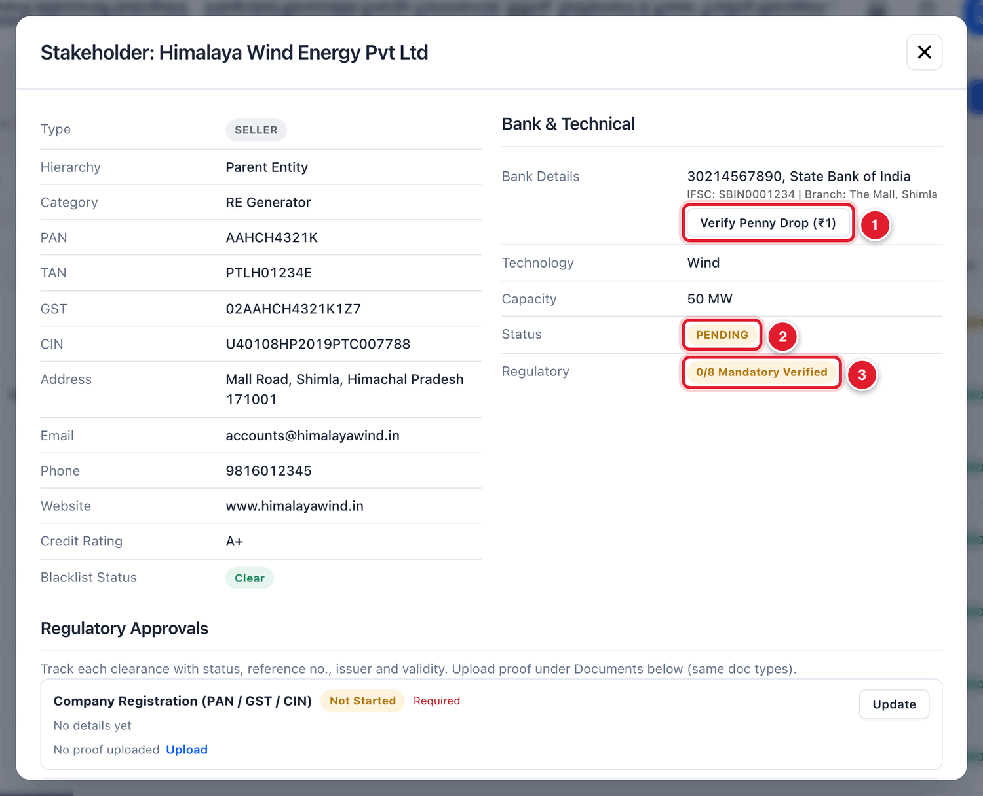
Figure 4.6 The top of the company’s file.
1 | Verify Penny Drop (₹1): click to test the bank account (see 4.4).
2 | The status of the company. A new company is PENDING.
3 | How many compulsory papers are verified so far.

The file is long. Move down with the mouse wheel to see all its parts:
Part of the file | What is there
Company details (top left) | Type, PAN, GST, CIN, address, email, phone and credit rating, as typed in the form.
Bank & Technical (top right) | Bank account, technology, capacity, status, and the penny drop button.
Regulatory Approvals | One line for each compulsory paper, with its status.
Contacts | The contact persons of the company.
Invoice Letterhead / Template and Digital Signature | The company’s logo and signature, which are printed on its invoices.
Stakeholder Documents | All documents uploaded for this company.
Approval Action (only for a PENDING company) | The buttons to approve or reject the company.

4.4 Checking the bank account (penny drop)
The platform will not allow you to approve a company until its bank account is verified.

To verify the bank account
STEP  1 | In the company’s file, look at the part named Bank & Technical. Check once more that the account number and IFSC code are correct.

STEP  2 | Click the button Verify Penny Drop (₹1).

WHAT YOU SHOULD SEE NOW
The button changes to Verified and becomes grey. In the list of companies, the label for this company changes from Bank Unverified to Bank Verified.

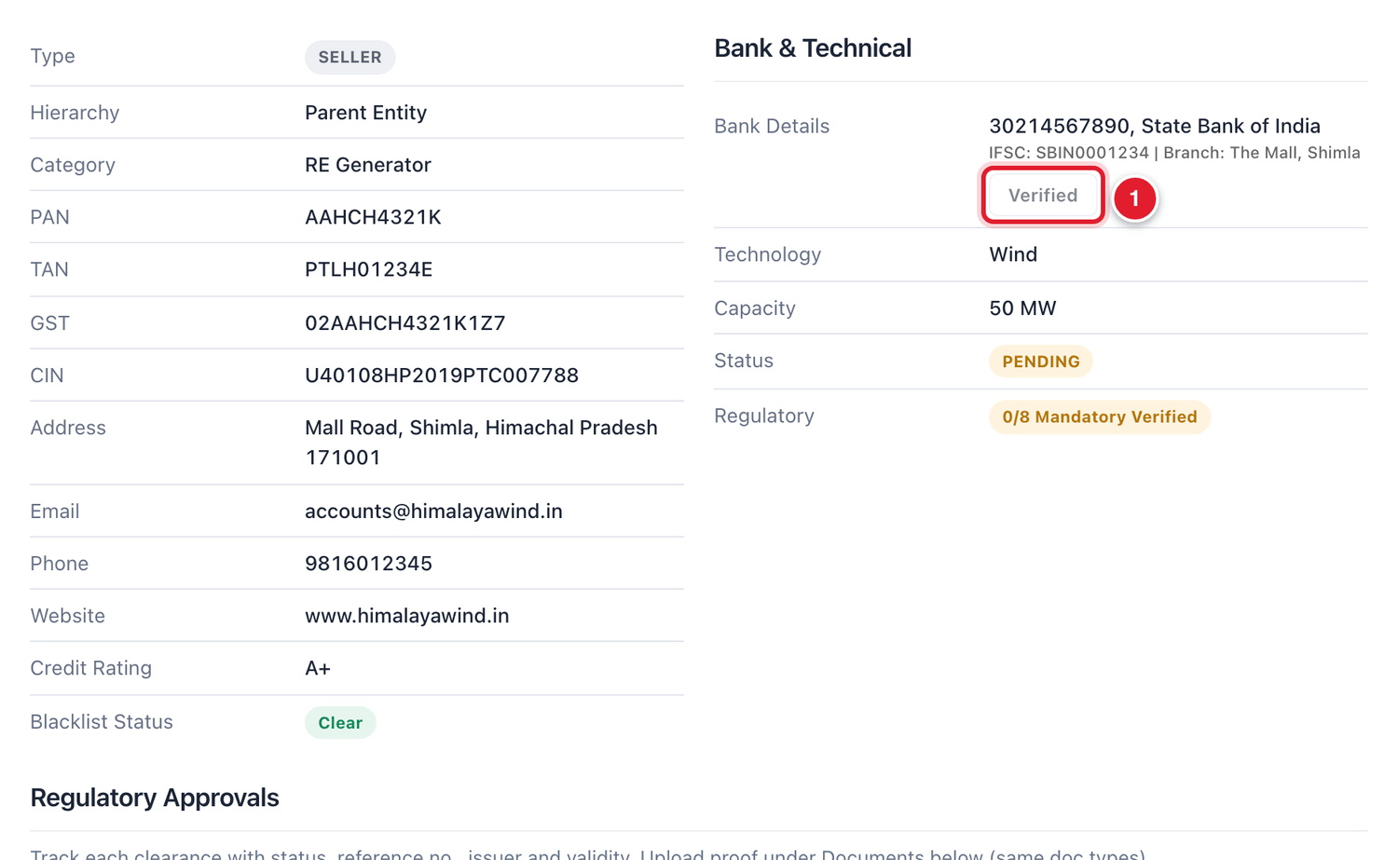
Figure 4.7 After the penny drop, the button shows Verified.
1 | The bank account is now verified.

4.5 Checking the regulatory papers
Each line in Regulatory Approvals is one paper. Each line has a status label:
Status | Meaning
Not Started | Nothing has been done for this paper yet.
Submitted | The paper has been uploaded and is waiting to be checked.
Verified | SJVN has checked the paper and accepted it.
Not Applicable | This paper does not apply to this company.
Expired | The validity date of the paper has passed. A fresh paper is needed.
Rejected | SJVN has checked the paper and not accepted it.

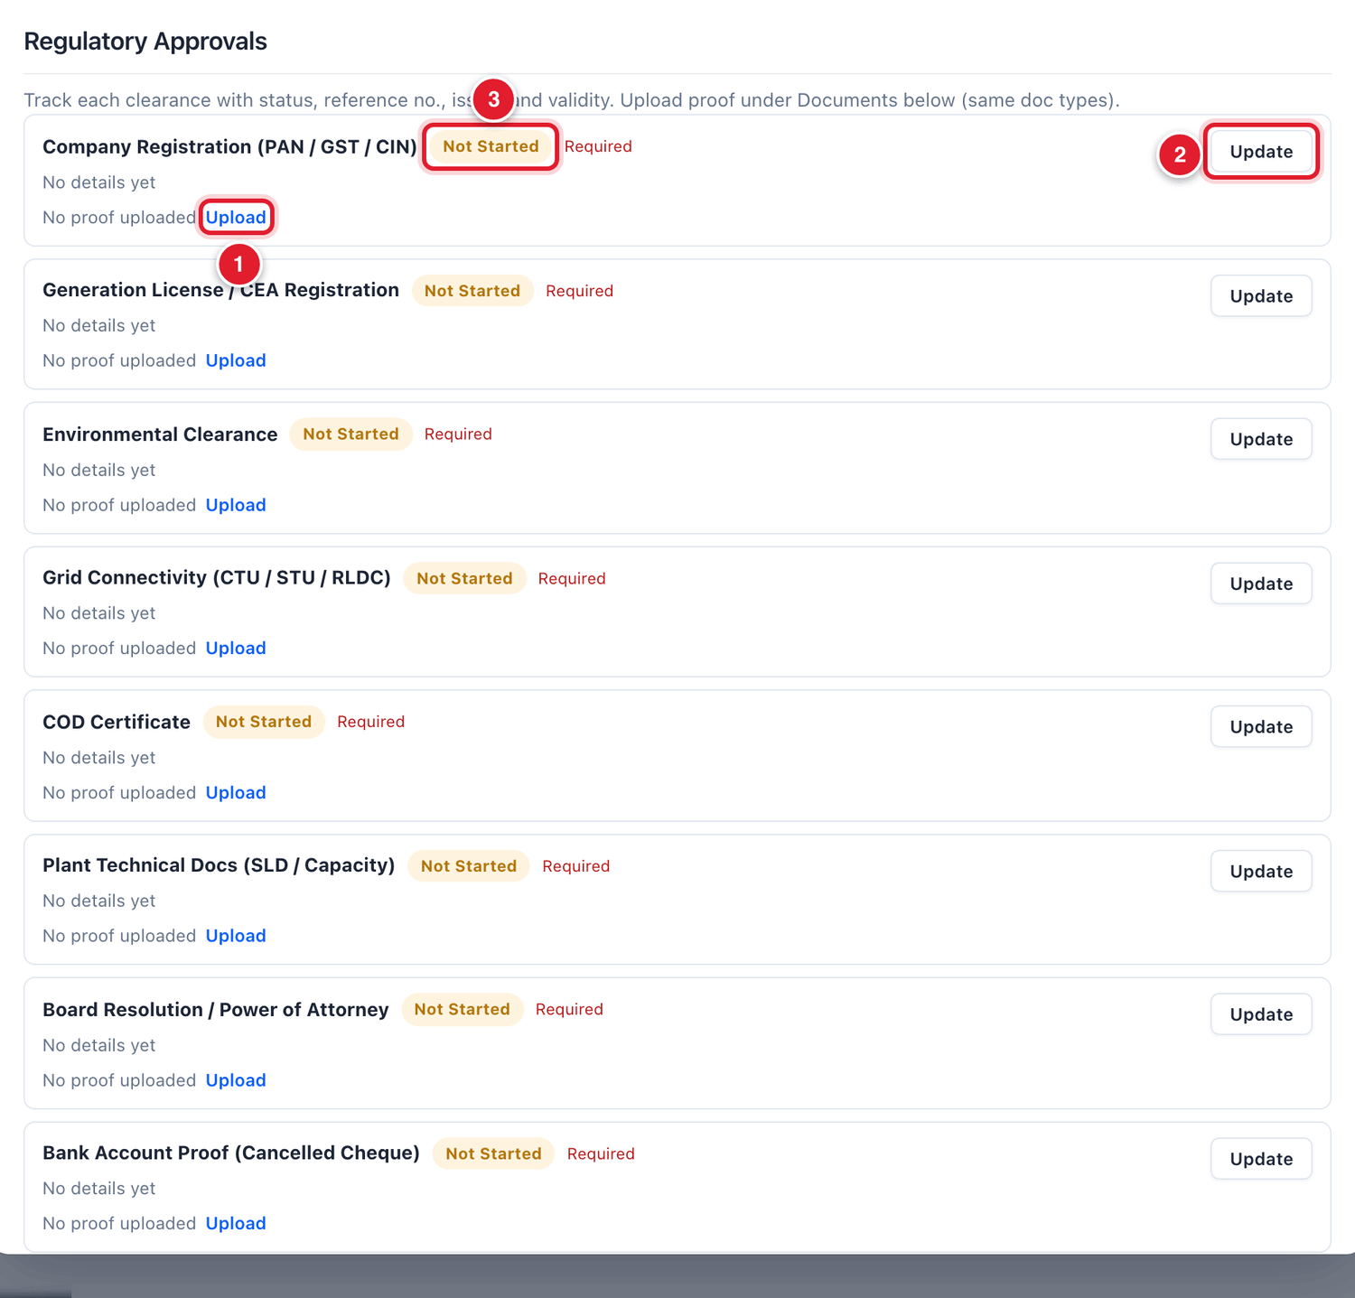
Figure 4.8 The Regulatory Approvals part of the file.
1 | Upload: attach the proof (a PDF or picture) for this paper.
2 | Update: record the status, number and dates of this paper.
3 | The present status of the paper.

For each paper, there are two things to do: attach the proof, and then record that you have verified it.

To attach the proof of a paper
STEP  1 | On the line of the paper, click the small blue word Upload.

STEP  2 | The Upload Document window opens. Click Choose File. A window of your computer opens. Find the file, click it once, and click Open.  • Allowed files: PDF, JPG, PNG and Excel.  • The file must be smaller than 10 MB.

STEP  3 | Valid until: if the paper has an expiry date, click the small calendar and choose the date. If it never expires, leave this empty.

STEP  4 | Title: a title is already filled in. You can leave it, or type a clearer one.

STEP  5 | Document Type and Classification Category are already set by the platform for this paper. You cannot change them.

STEP  6 | Look at the tick box at the bottom: Direct SJVN Admission: Auto-verify document upon upload.  • Keep it ticked if you have already checked the original paper yourself. The paper becomes Verified as soon as it is uploaded.  • Remove the tick if the paper should first go to the Documents & KYC Desk to be checked by another officer (Chapter 6).

STEP  7 | Click the blue button Upload.

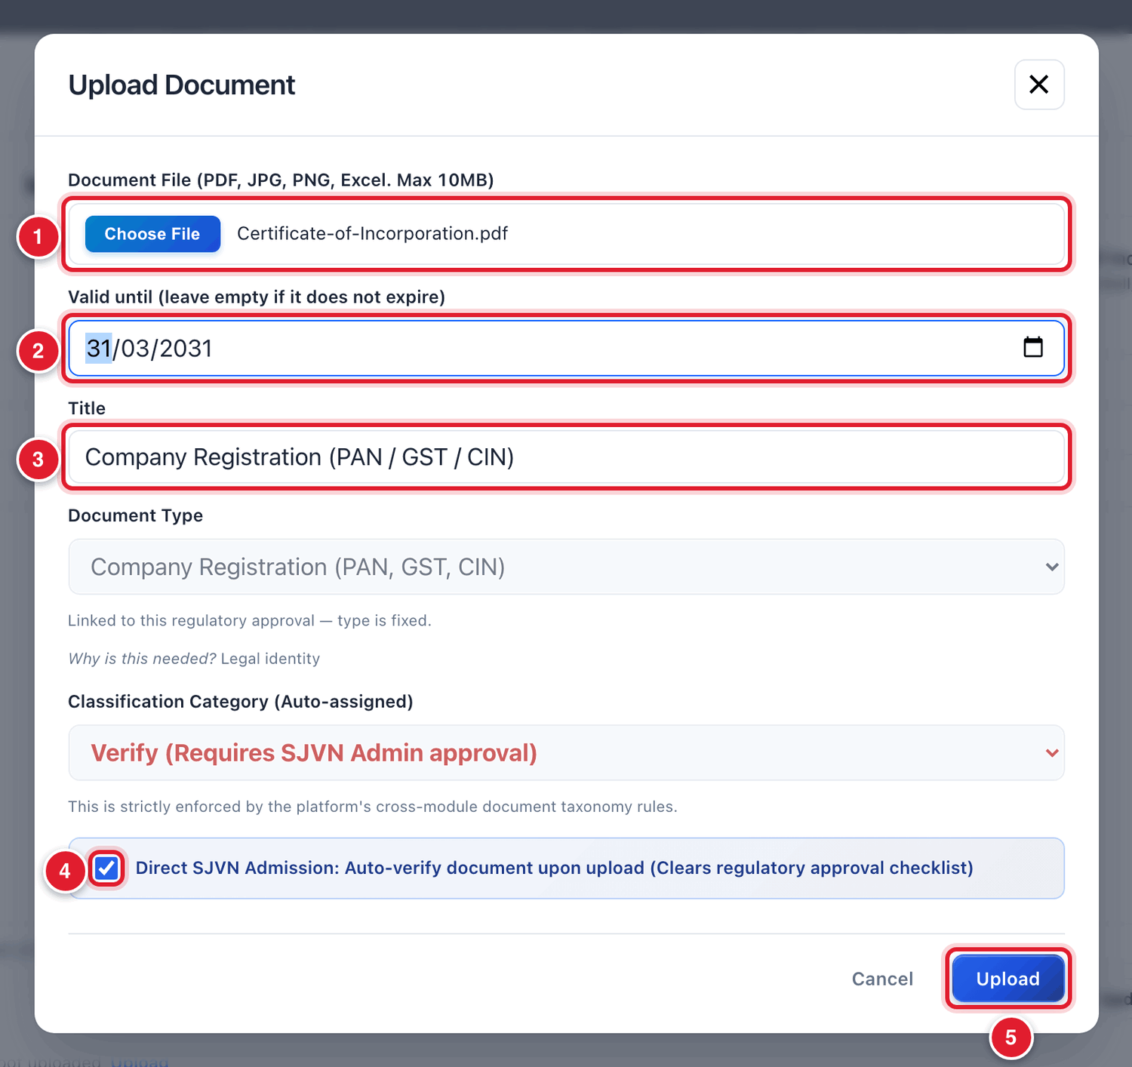
Figure 4.9 The Upload Document window.
1 | Choose the file from your computer.
2 | The expiry date of the paper, if it has one.
3 | The title of the document.
4 | Tick = verified at once. No tick = goes to the KYC Desk for checking.
5 | Click Upload.

WHAT YOU SHOULD SEE NOW
The window closes. On the line of that paper you now see Proof uploaded and a link View proof. Click View proof any time to open the file.

To record that a paper is verified
STEP  1 | On the line of the paper, click the button Update at the right.

STEP  2 | The Update window opens. In Status, choose Verified.

STEP  3 | Fill the other boxes from the paper itself. The table below explains them.

STEP  4 | Click the blue button Save.

Field | What to enter | Example
Status | The present position of this paper. | Verified
Reference / Approval No. | The number printed on the paper. | U40108HP2019PTC007788
Issued By | The office that issued the paper. | Registrar of Companies, HP
Issued On | The date of issue. Click the calendar to choose. | 14/06/2019
Valid Until | The expiry date. Leave empty if it does not expire. | —
Notes | Any short remark. For Not applicable, write the reason here. | Checked against MCA portal

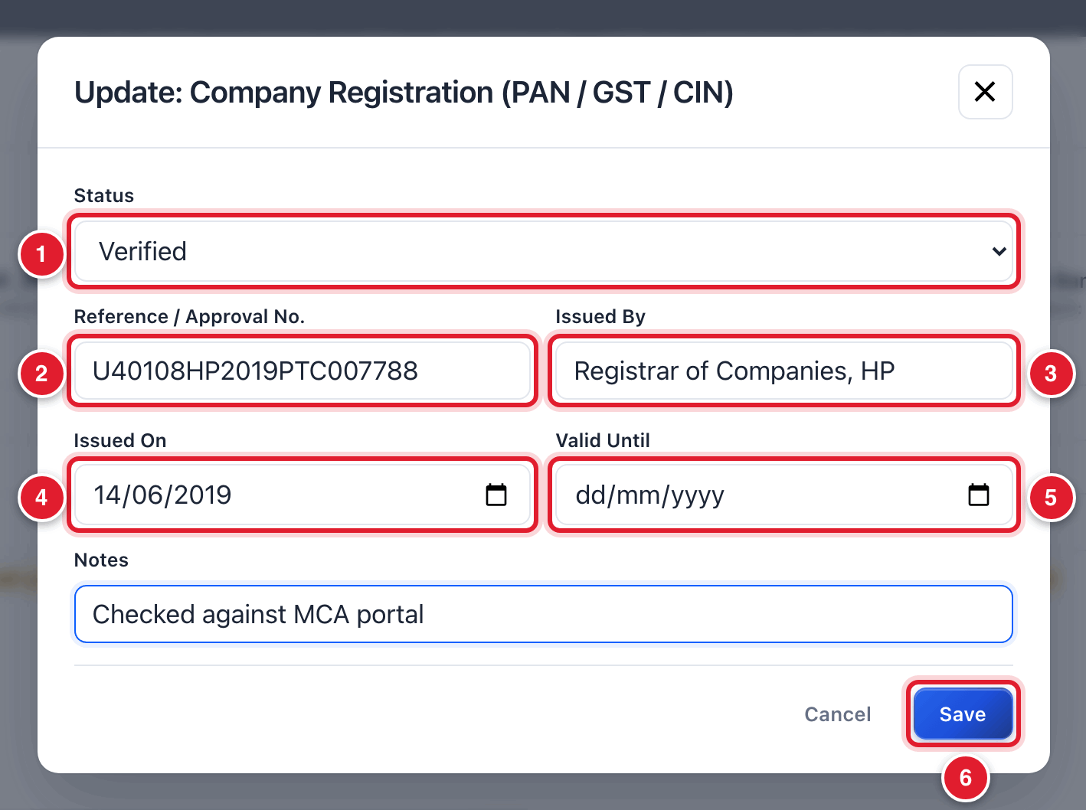
Figure 4.10 The Update window for one paper.
1 | Choose the status.
2 | The number on the paper.
3 | Who issued it.
4 | Date of issue.
5 | Expiry date, if any.
6 | Click Save.

WHAT YOU SHOULD SEE NOW
The label on the line changes to green Verified, and it shows who verified it and when. The count at the top of the file goes up, for example from 0/8 to 1/8 Mandatory Verified.

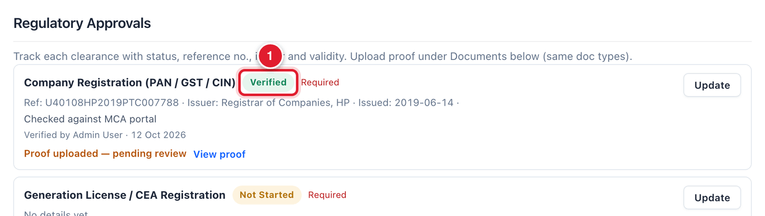
Figure 4.11 The paper is now marked Verified.
1 | The green Verified label.

Repeat these two procedures for every line in the list, until all compulsory papers are Verified or Not Applicable.
TIP
The company can also upload its own papers from its login (My Documents & KYC). Those papers come to the Documents & KYC Desk for checking. When they are verified there, the lines in this list turn green by themselves. See Chapter 6.

4.6 Logo and signature for invoices
Lower in the file there are two small parts that decide how the company’s invoice looks when the platform prints it as a PDF.
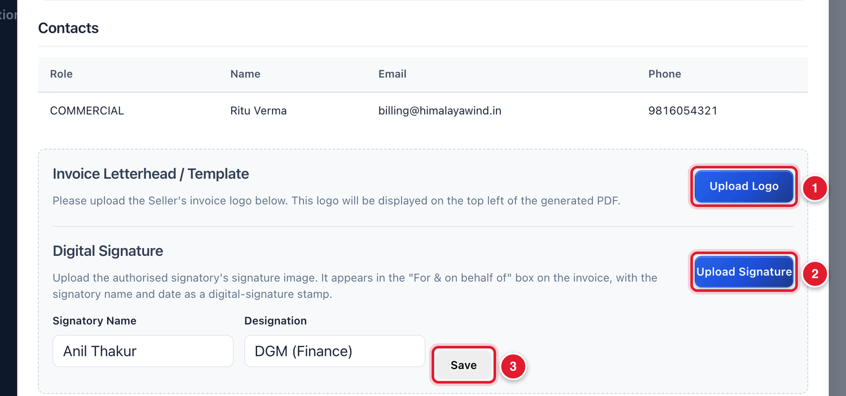
Figure 4.12 Contacts, invoice letterhead and digital signature.
1 | Upload Logo: the company’s logo. It is printed at the top left of the invoice.
2 | Upload Signature: a picture of the authorised signatory’s signature. It is printed in the “For & on behalf of” box of the invoice.
3 | Save: saves the signatory’s name and designation typed in the two boxes to its left.

To add the logo and signature
STEP  1 | Click Upload Logo, choose the logo picture from your computer and click Open.

STEP  2 | Click Upload Signature, choose the signature picture and click Open.

STEP  3 | Check the Signatory Name and Designation boxes. Correct them if needed and click Save.

GOOD TO KNOW
This part is optional. If you skip it, the invoice is printed without a logo and signature picture.

4.7 Approving or rejecting the company
At the bottom of the file of a PENDING company there is a part named Approval Action.
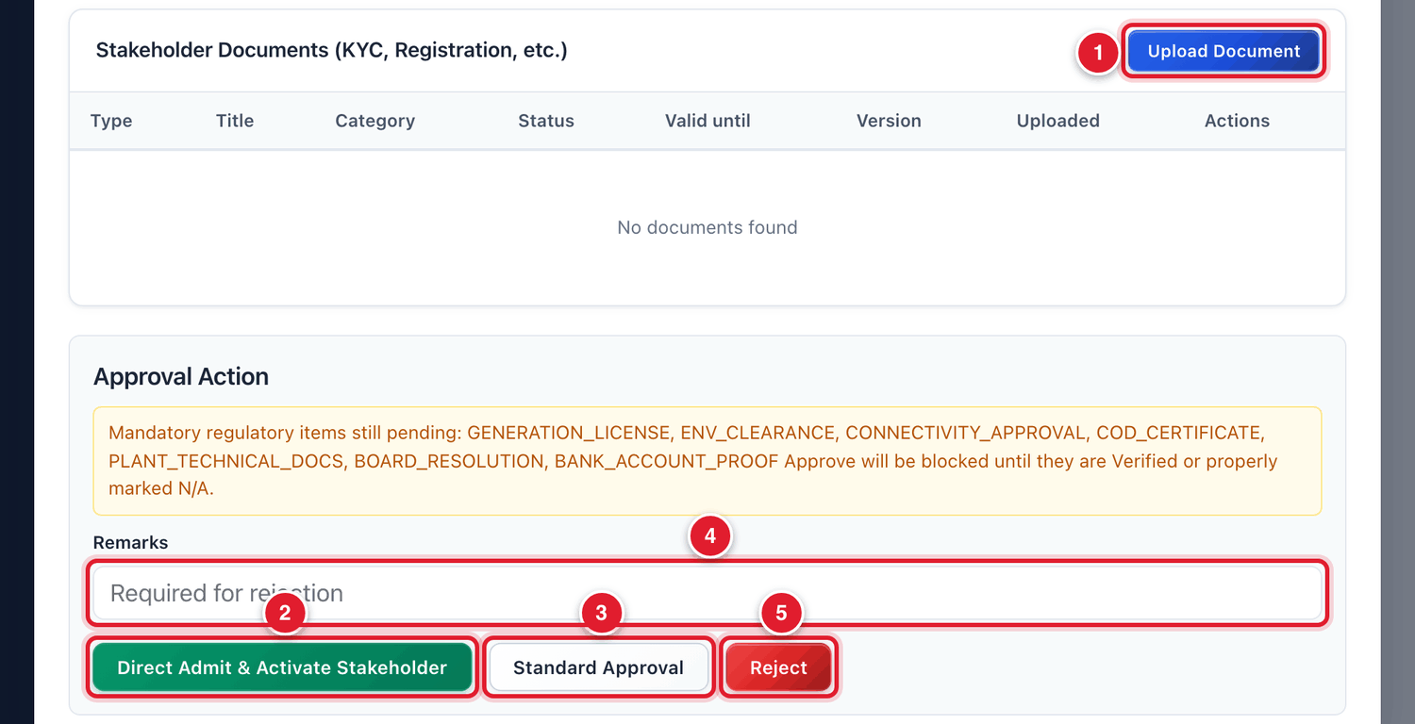
Figure 4.13 The Stakeholder Documents and Approval Action parts.
1 | Upload Document: add any other document to the company’s file.
2 | Direct Admit & Activate Stakeholder: approve immediately (read the warning below).
3 | Standard Approval: approve after all checks are complete.
4 | Remarks: type the reason here before you reject.
5 | Reject: do not accept the company.

There are three buttons. Choose the right one:
Button | When to use it | What happens
Standard Approval | The normal way. Use it when the bank account is verified and every compulsory paper is Verified or Not Applicable. | The status becomes APPROVED. If something is still pending, the platform refuses and tells you what is missing.
Direct Admit & Activate Stakeholder | Only when SJVN has already checked the company outside the platform and wants to admit it at once. | The status becomes APPROVED immediately, and all pending compulsory papers are marked as verified by SJVN.
Reject | When the company should not be accepted. | The status becomes REJECTED. You must type the reason in Remarks first.

To approve in the normal way
STEP  1 | Go to the bottom of the company’s file.

STEP  2 | Read the yellow box under Approval Action. If it lists papers that are still pending, finish them first (section 4.5). If there is a line saying the bank penny drop is required, do it first (section 4.4).

STEP  3 | Click Standard Approval.

WHAT YOU SHOULD SEE NOW
The file closes. In the list, the company’s status is now green APPROVED and the Regulatory column shows all compulsory papers verified.

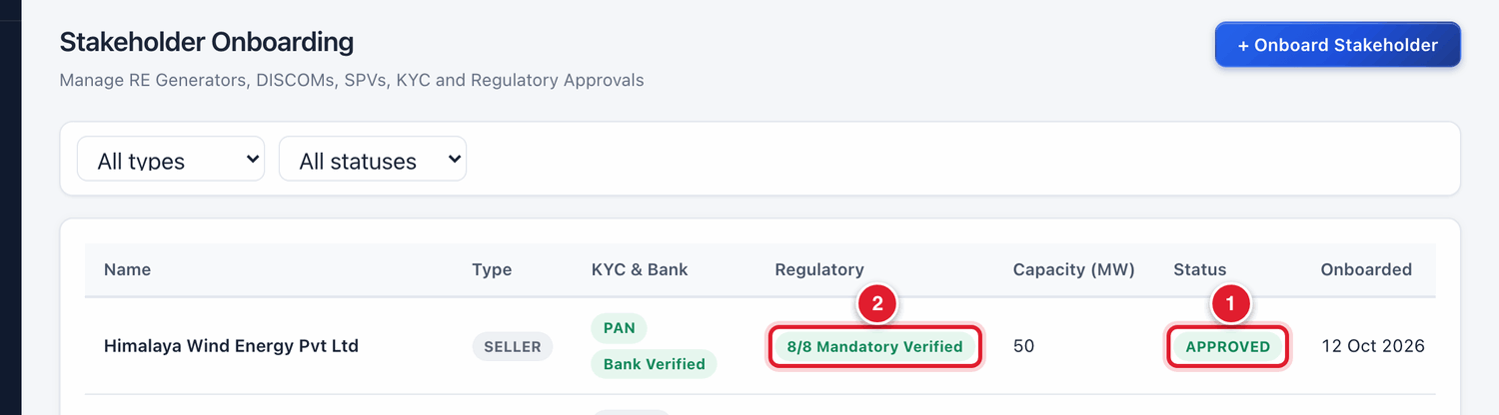
Figure 4.14 The company is now APPROVED.
1 | Status APPROVED.
2 | All compulsory papers verified.

If you click Standard Approval too early, the platform does not approve. It shows a red message that names the papers that are still pending:
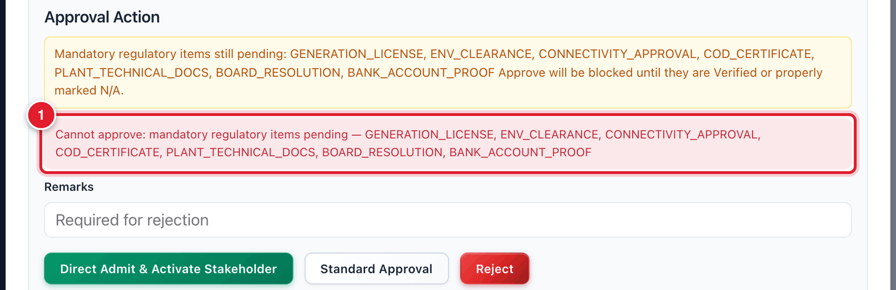
Figure 4.15 The platform refuses approval because papers are pending.
1 | The red message lists what is still pending. Complete these and try again.

BE CAREFUL
Direct Admit & Activate Stakeholder works at once, without asking “Are you sure?”. It approves the company and marks all its pending papers as verified. Use it only when you are fully sure, and only if you are authorised to do so.

To reject a company
STEP  1 | Go to the bottom of the company’s file.

STEP  2 | Click inside the Remarks box and type why the company is being rejected.

STEP  3 | Click the red button Reject.

WHAT YOU SHOULD SEE NOW
The company’s status becomes REJECTED. It cannot be used in any contract.

4.8 Opening and reading a company’s file later

To find a company and open its file
STEP  1 | Open Stakeholders (Sellers/Buyers) from the menu.

STEP  2 | To make the list shorter, click the first filter and choose Seller or Buyer. Click the second filter and choose Pending, Approved or Rejected.

STEP  3 | Click anywhere on the company’s row.

WHAT YOU SHOULD SEE NOW
The company’s file opens. For an approved company the Approval Action part is not shown, because the decision is already taken.

4.9 Common questions
If you see this | Why it happens | What to do
Standard Approval shows a red message | Some compulsory papers are not verified, or the bank account is not verified. | Verify the listed papers (4.5) and do the penny drop (4.4). Then click Standard Approval again.
I chose Seller but the company is a Buyer | The wrong Entity Type was chosen in the form. | Do not approve it. Reject it with the remark “wrong type”, and register the company again with the correct type.
The company is not in the list when I make a contract | Only APPROVED companies can be used in a contract. | Open the company’s file and complete the approval.
The same company appears twice | It was registered two times by mistake. | Use only one of them. Reject the extra one if it is still pending. If both are approved, inform the SJVN Administrator.

CHAPTER 5

5. Company Users
How to give the people of a seller or buyer company their own logins, and how to help them when they are locked out.
What it is for | Each seller or buyer company has its own team on the platform. From this screen SJVN can see that team, add people to it, reset passwords and switch off accounts.
Who uses it | SJVN Admin and REIA Admin.
How to open it | Menu → REIA Billing & Settlement → Company Users.
When to use it | After a new company is approved (to give its first login), and whenever a company asks for help with its users.

5.1 The levels inside a company
Every user of a seller or buyer company has a level. The level decides what that person can do.
Level | Name | What this person does
Level 1 | Maker | Prepares the work: fills an invoice, uploads a document. The work is saved as a draft and goes to a checker.
Level 2 | Checker | Reviews what the maker prepared and submits it to SJVN.
Level 3 | Approver | Approves and submits to SJVN. Can also add makers and checkers, reset their passwords and switch them off.
— | Company Admin | The main account of the company with SJVN. Can do everything a checker can and manages the whole team.

The reason for these levels is safety: what one person prepares, a second person checks before it reaches SJVN. This is called maker-checker.
GOOD TO KNOW
One company can have up to 15 active users. The screen shows how many seats are left.

5.2 Choosing the company
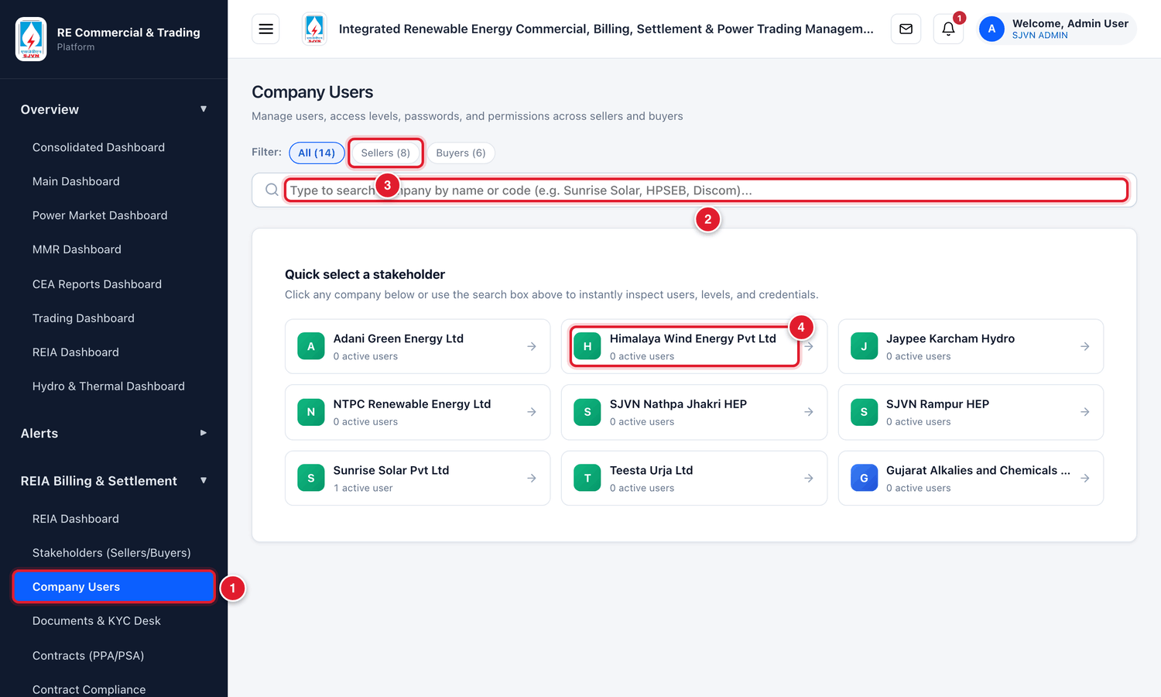
Figure 5.1 The Company Users screen when it opens.
1 | The menu name to click to open this screen.
2 | The search box. Type a few letters of the company’s name.
3 | Filter buttons: show all companies, only sellers, or only buyers.
4 | A company card. It shows how many active users the company has. Click it to open the company’s team.

To open a company’s team
STEP  1 | Open Company Users from the menu.

STEP  2 | Find the company. Either look in the cards under Quick select a stakeholder, or type a few letters of its name in the search box.

STEP  3 | Click the company’s card.

WHAT YOU SHOULD SEE NOW
The team of that company opens. The company’s name is shown at the top.

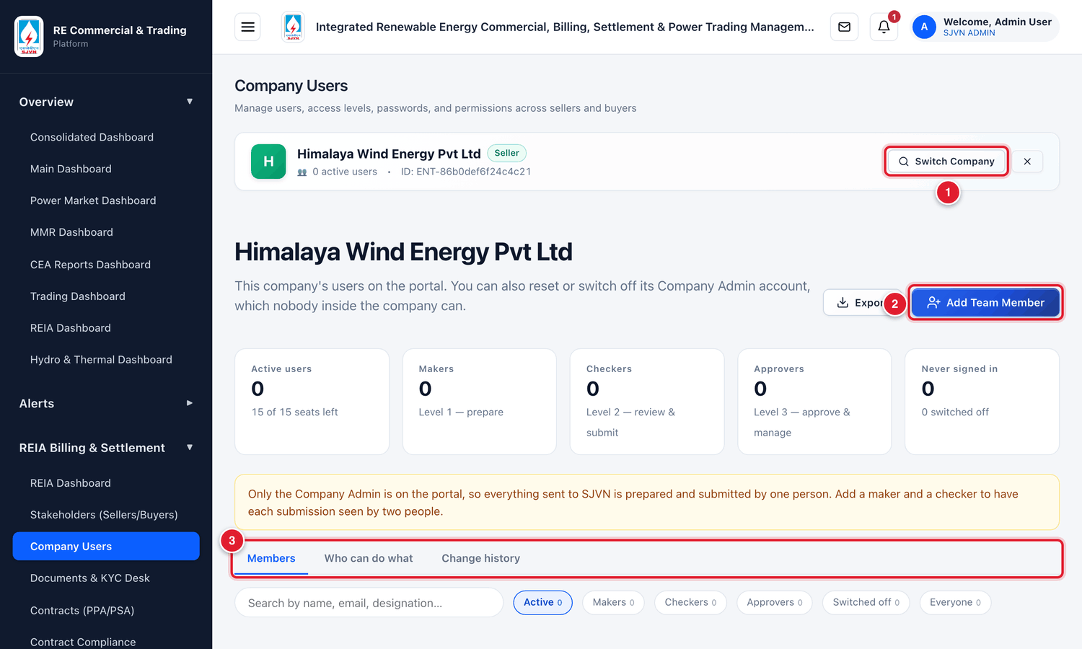
Figure 5.2 The team page of one company.
1 | Switch Company: go back and choose another company.
2 | Add Team Member: give a new person a login.
3 | Three tabs: Members (the people), Who can do what (a table of rights), Change history (what was changed and by whom).

The row of boxes in the middle counts the users: Active users, Makers, Checkers, Approvers, and Never signed in. A yellow line below the boxes gives advice, for example when a company has no checker.

5.3 Adding a user to a company

To add a team member
STEP  1 | Open the company’s team (section 5.2).

STEP  2 | Click the blue button Add Team Member.

STEP  3 | The Add Team Member window opens. Fill the boxes. The table below explains each one.

Field | What to enter | Example
Full Name * | The person’s full name. | Ritu Verma
Email Address (their sign-in) * | The person’s own official email. They will sign in with this email. It cannot be changed later. | ritu.verma@himalayawind.in
Designation | The person’s post in the company. | Manager (Accounts)
Phone | Mobile number, 10 to 15 digits. | +91 98160 54321
Access Level * | Choose Level 3 — Approver, Level 2 — Checker or Level 1 — Maker. | Level 3 — Approver
Set the temporary password myself | Leave this without a tick. The platform then makes a safe temporary password for you. | (no tick)

STEP  4 | Click the blue button Add to team.

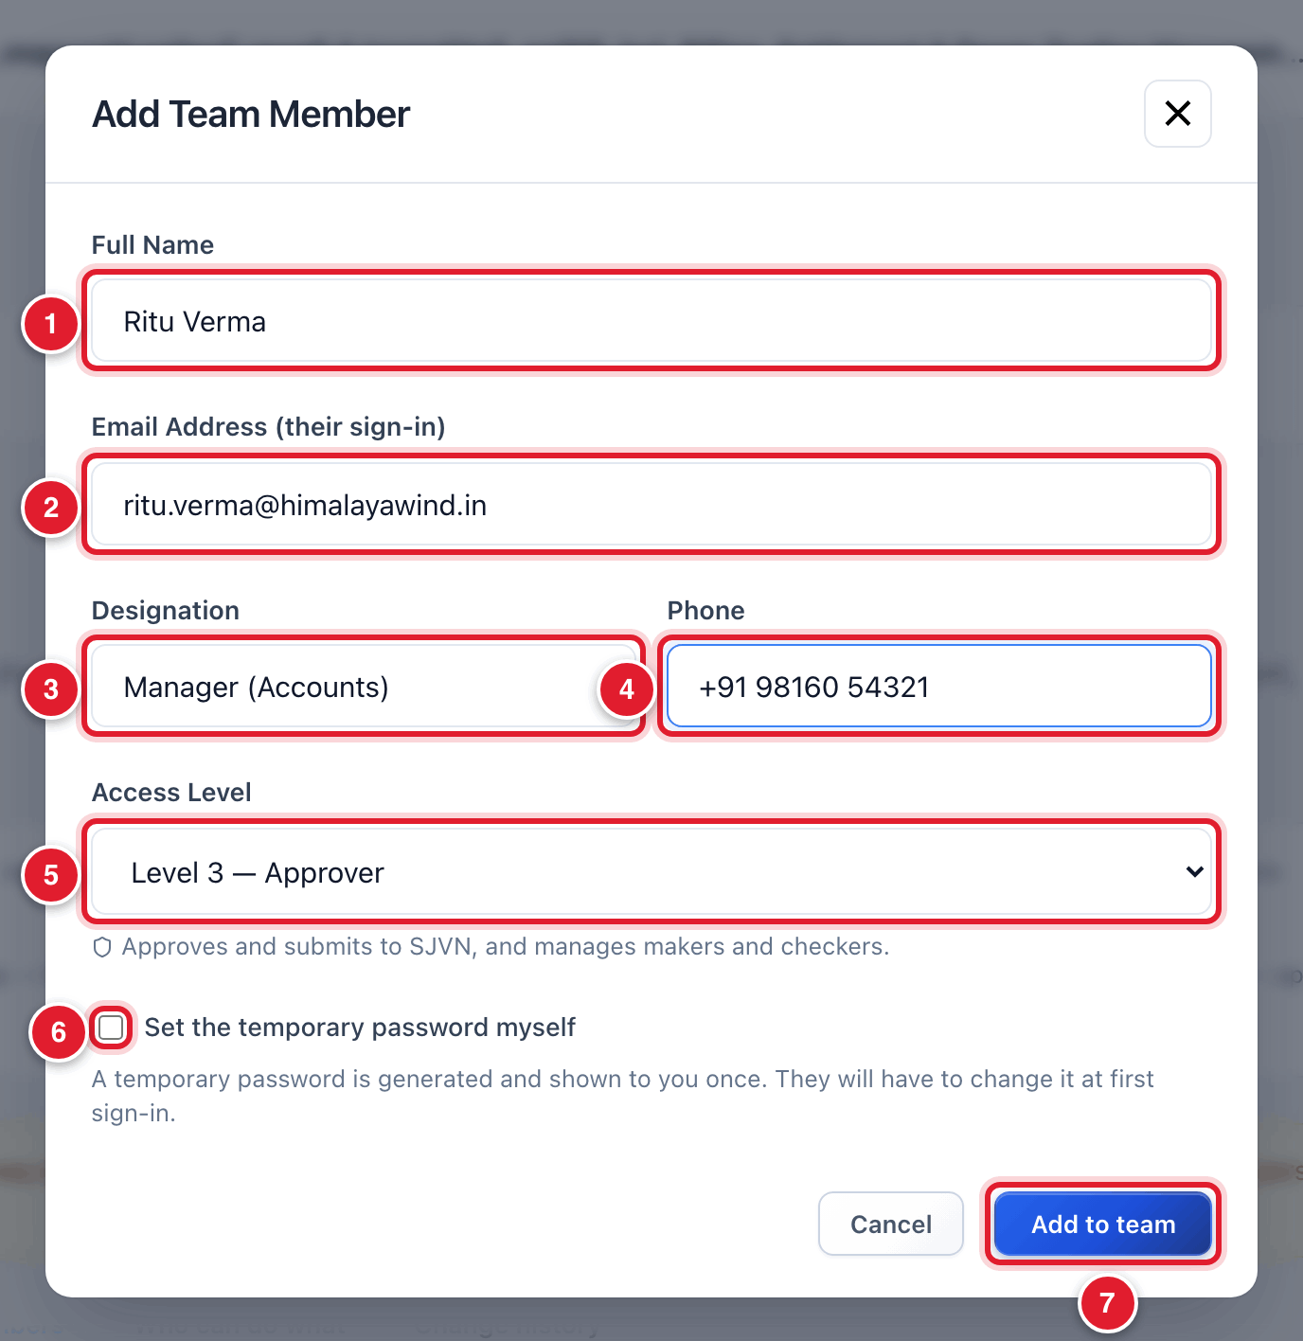
Figure 5.3 The Add Team Member window, filled.
1 | Full name.
2 | Email (this becomes the sign-in name).
3 | Designation.
4 | Phone.
5 | Access level.
6 | Leave without a tick.
7 | Click Add to team.

WHAT YOU SHOULD SEE NOW
A window named Temporary password opens. It shows the temporary password of the new user.

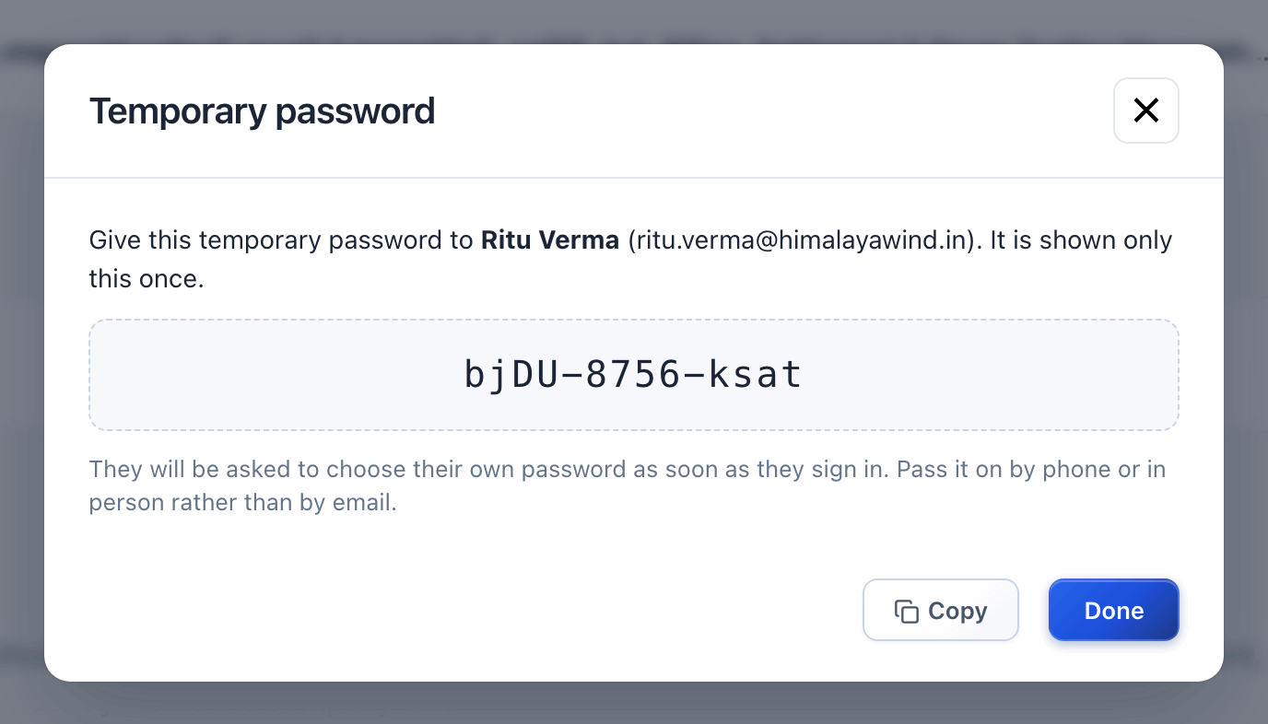
Figure 5.4 The temporary password is shown only once.
STEP  5 | Click Copy to copy the password, or write it down. Then click Done.

STEP  6 | Give the email and the temporary password to the person by phone or in person.

IMPORTANT
The temporary password is shown only this one time. If you close the window without noting it, you cannot see it again. In that case use Reset password (section 5.5) to make a new one.

TIP
For a newly approved company that has no users yet, add its main person first as Level 3 — Approver. That person can then add the company’s own makers and checkers from their login (My Team).

5.4 Reading a member’s card
In the Members tab, each person has a card. The card shows the name, designation, email, phone and level. Small labels tell you more, for example Temporary password not yet changed or Never signed in.
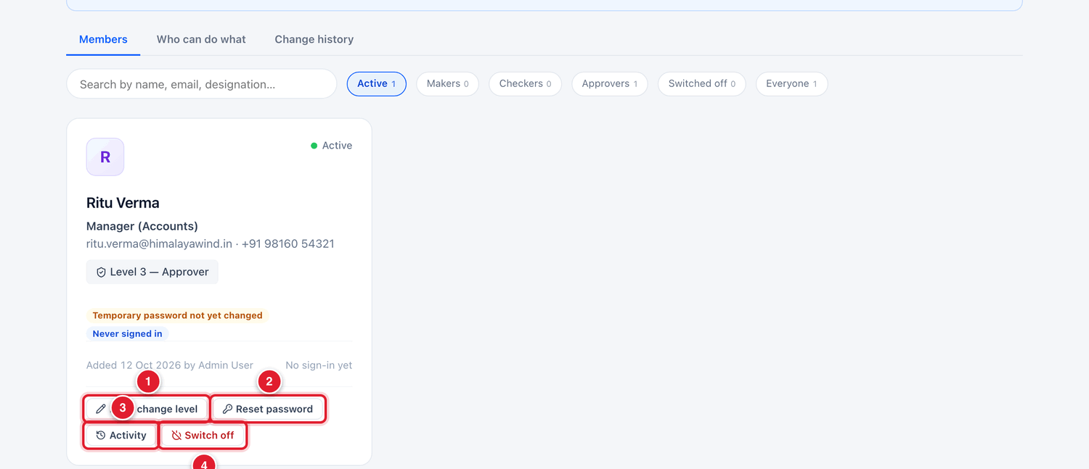
Figure 5.5 A member’s card and its buttons.
1 | Edit / change level: correct the name, designation or phone, or change the level.
2 | Reset password: make a new temporary password for this person.
3 | Activity: see what this person has done on the platform.
4 | Switch off: stop this person from signing in.

Above the cards there is a search box and a row of small buttons (Active, Makers, Checkers, Approvers, Switched off, Everyone). Click one to see only those users.

5.5 Resetting a user’s password
Do this when a user has forgotten the password, or when the temporary password was lost.

To reset a password
STEP  1 | Open the company’s team and find the person’s card.

STEP  2 | Click Reset password on the card.

STEP  3 | A window asks you to confirm. Read it and click the button Reset password.

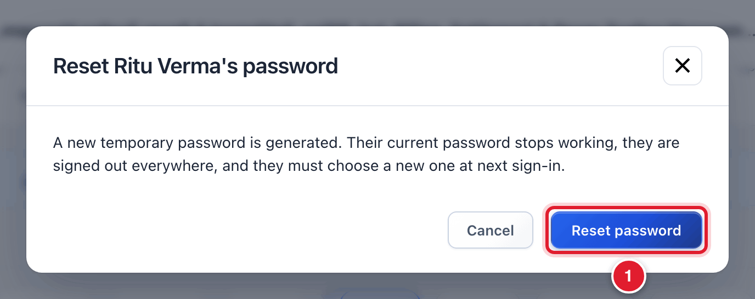
Figure 5.6 The confirmation before a password is reset.
1 | Click Reset password to go ahead.

WHAT YOU SHOULD SEE NOW
A new temporary password is shown once, in the same way as in section 5.3. Note it, click Done, and give it to the person by phone or in person.

GOOD TO KNOW
After a reset, the person’s old password stops working at once and they are signed out everywhere. At the next sign-in they must choose a new password of their own.

5.6 Changing a user’s details or level

To edit a member
STEP  1 | Click Edit / change level on the person’s card.

STEP  2 | Change the Full Name, Designation, Phone or Access Level as needed.

STEP  3 | Click Save changes.

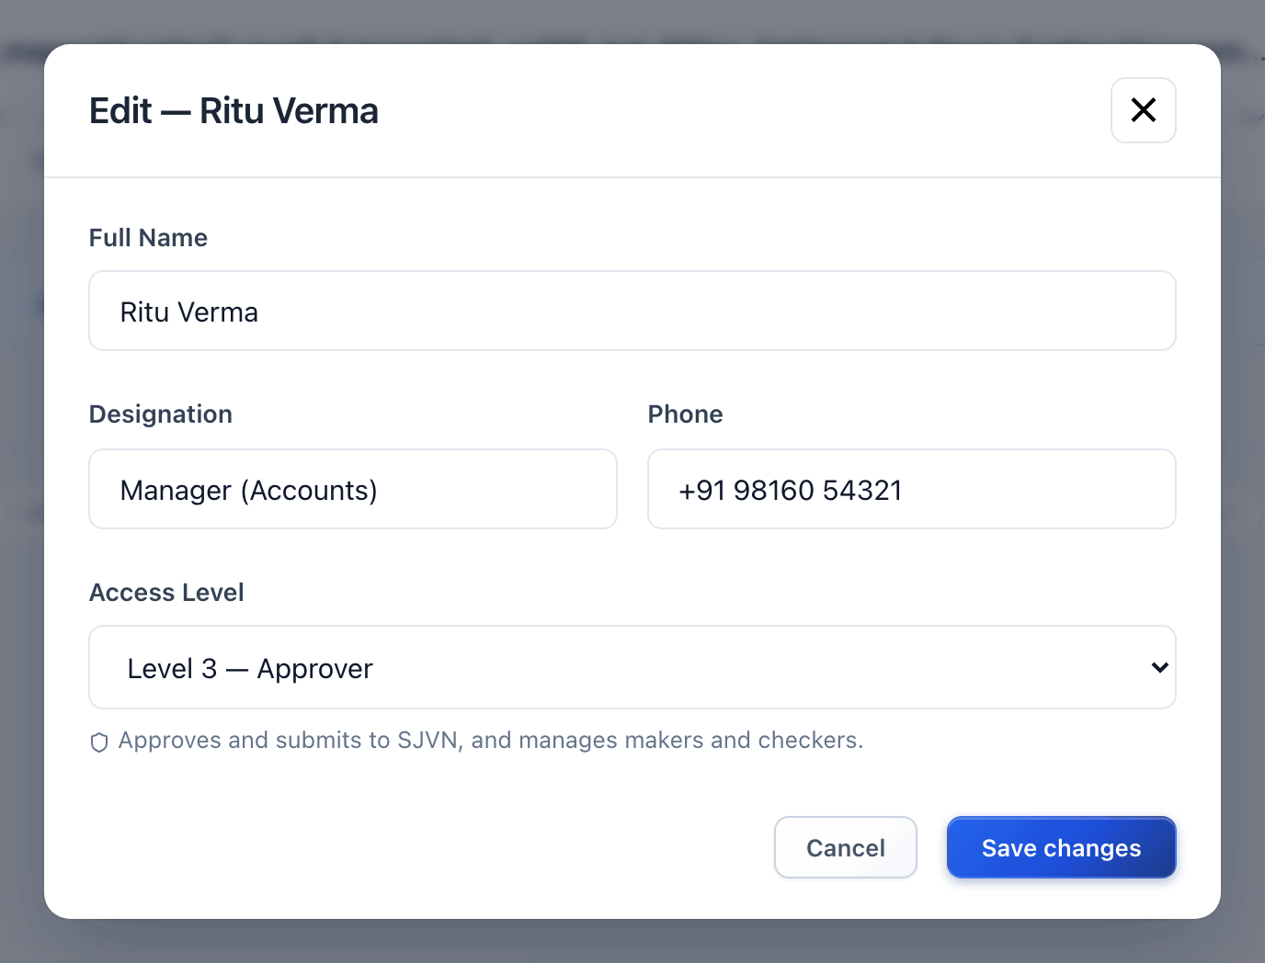
Figure 5.7 The Edit window.
GOOD TO KNOW
The email address cannot be changed. If a person’s email changes, switch off the old account and add the person again with the new email.

5.7 Switching off a user
Switch off a user who has left the company or should no longer have access. The account is not deleted. Everything the person did stays on record.

To switch off a user
STEP  1 | Click Switch off on the person’s card.

STEP  2 | In the Reason box, type why, for example Left the company. This box is compulsory.

STEP  3 | Click the button Switch off.

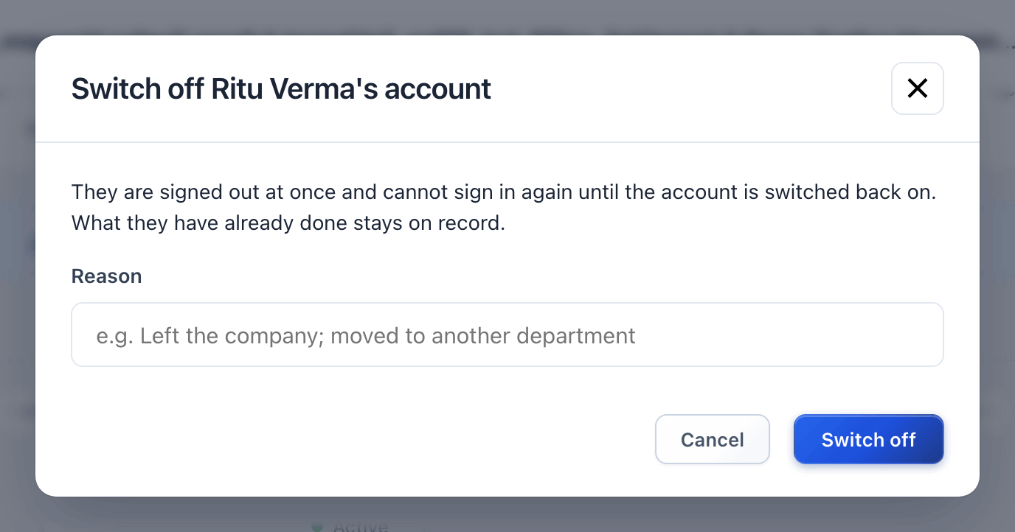
Figure 5.8 The Switch off window asks for a reason.
WHAT YOU SHOULD SEE NOW
The person is signed out at once and cannot sign in again. The card moves under the Switched off button. To give access back later, open that card and switch the account on again.

5.8 Who can do what
Click the tab Who can do what to see a table of rights for each level. Use it when a company asks why one of its users cannot do something.
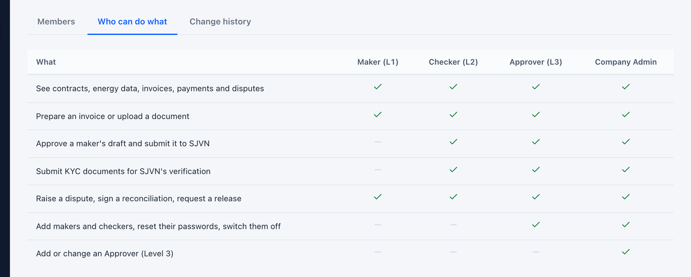
Figure 5.9 The “Who can do what” tab.
The tab Change history lists every change made to this company’s users: who was added, whose password was reset, who was switched off, by whom and when.

5.9 Common questions
If you see this | Why it happens | What to do
“This email is already in use” | Another user on the platform already has this email. | Each person needs their own email. Check if the person already has an account, perhaps switched off.
The company says “we did not get the password” | The platform does not send the temporary password by email. It is shown only to the person who creates the user. | Use Reset password and tell the new temporary password by phone.
Add Team Member says no seats are left | The company already has 15 active users. | Ask the company which user is no longer needed and switch that user off first.
A user cannot submit an invoice to SJVN | The user is a Maker. A maker’s work goes to a checker first. | This is correct. A checker or approver of the company must review and submit it.

CHAPTER 6

6. Documents & KYC Desk
One place to check all the documents that sellers and buyers upload, and to see which company’s papers are complete.
What it is for | A seller or buyer uploads its papers from its own login. Those papers wait here until an SJVN officer looks at them and either verifies or rejects them.
Who uses it | SJVN REIA desk, REIA Admin, SJVN Admin.
How to open it | Menu → REIA Billing & Settlement → Documents & KYC Desk.
When to use it | Every day. Look at the dashboard: if it says “document to verify”, there is work waiting here.

6.1 The desk at a glance
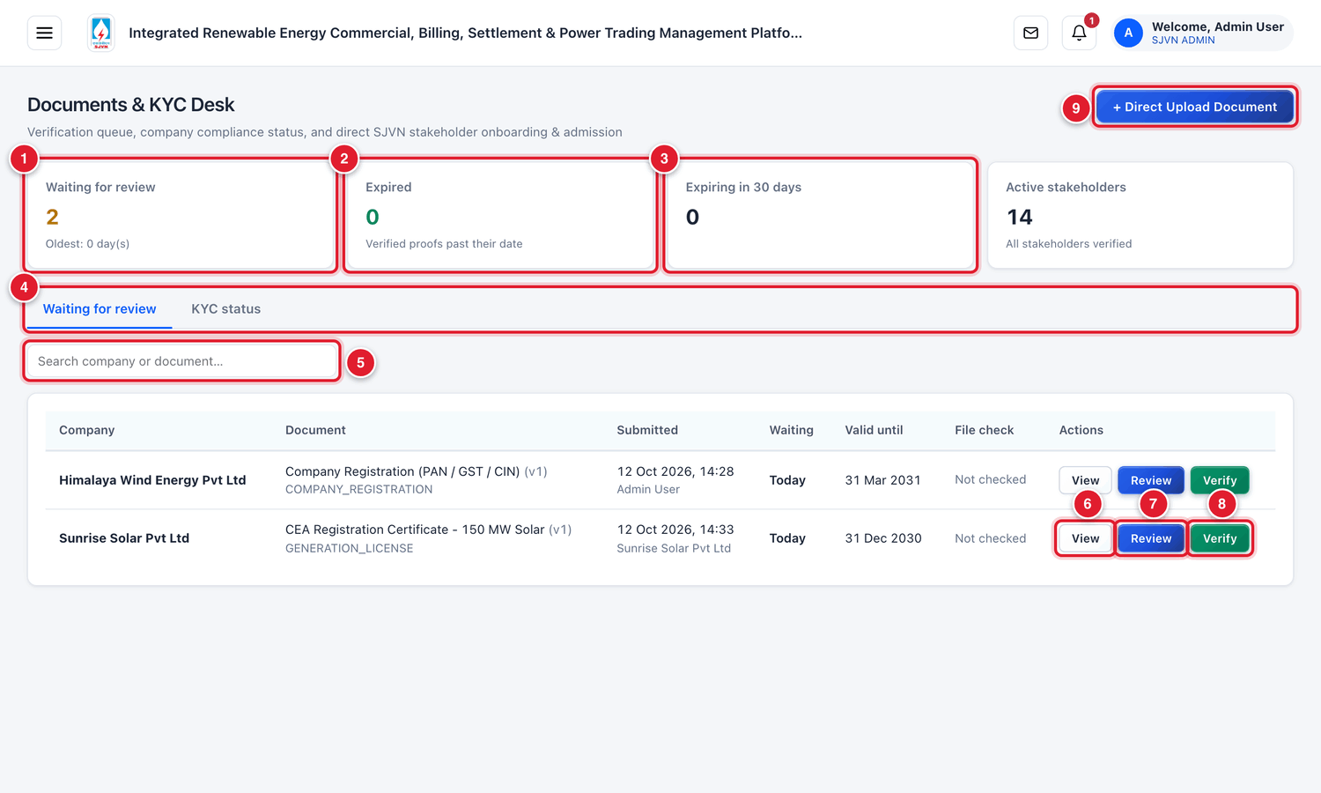
Figure 6.1 The Documents & KYC Desk (menu hidden to show the full table).
1 | Waiting for review: how many documents are waiting, and how old the oldest one is.
2 | Expired: verified papers whose validity date has passed.
3 | Expiring in 30 days: papers that will expire soon.
4 | Two tabs: Waiting for review (the work list) and KYC status (company-wise position).
5 | Search box: type a company name or a document name.
6 | View: open the uploaded file.
7 | Review: open the document with the choice to verify or reject.
8 | Verify: verify the document in one click.
9 | + Direct Upload Document: SJVN uploads a paper on behalf of a company.

The table in the Waiting for review tab has one row for each waiting document:
Column | What it tells you
Company | The seller or buyer that the document belongs to.
Document | The title of the document, its version (v1, v2…) and its type.
Submitted | The date and time of upload, and who uploaded it.
Waiting | For how long it has been waiting.
Valid until | The expiry date given by the uploader.
File check | The result of the platform’s own reading of the file (for example, whether it found the company’s PAN in it).
Actions | The buttons View, Review and Verify.

6.2 Checking a document

To check a waiting document
STEP  1 | Open Documents & KYC Desk from the menu. The tab Waiting for review is already open.

STEP  2 | Find the row of the document. Click the blue button Review.

WHAT YOU SHOULD SEE NOW
The Review Document window opens. It shows the document title, the company, who uploaded it and when, and the validity date.

STEP  3 | Click View file. The uploaded file opens. Read it fully. Check these points:  • Is it the right document for the type written (for example, really a generation licence)?  • Is the company name on it the same as the registered name?  • Are the numbers (PAN, GST, licence number) correct?  • Is it clear and complete, with all pages, signature and stamp?  • Is it still valid on today’s date?

STEP  4 | Decide. If everything is in order, click the green button Verify & Approve.

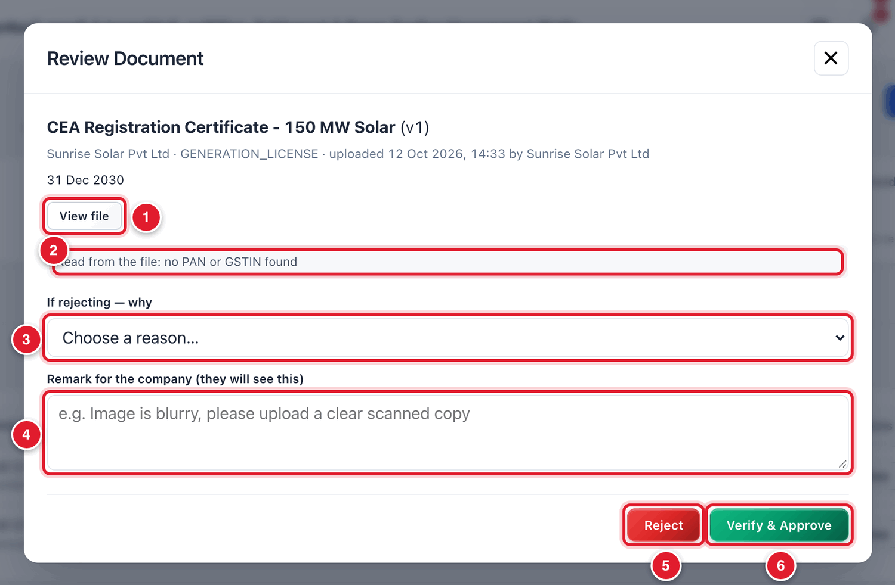
Figure 6.2 The Review Document window.
1 | View file: open and read the document first.
2 | What the platform could read from the file by itself. This is only a hint. You must still read the file.
3 | Reason for rejecting (used only when you reject).
4 | A remark that the company will see (used only when you reject).
5 | Reject: do not accept the document.
6 | Verify & Approve: accept the document.

WHAT YOU SHOULD SEE NOW
The window closes and the row disappears from the waiting list. The number in Waiting for review goes down by one. In the company’s file, the matching paper turns green Verified. The company gets an alert.

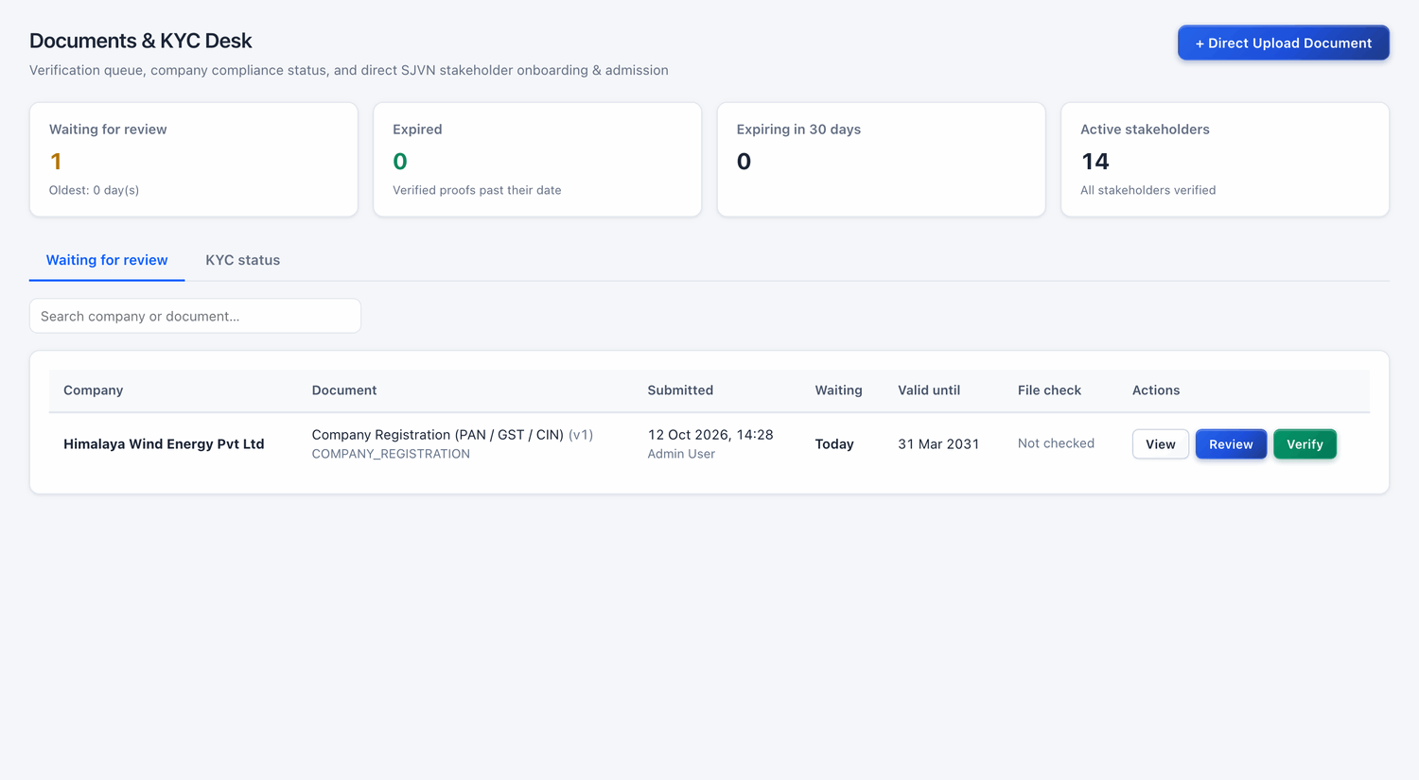
Figure 6.3 After verifying, the document has left the waiting list.

To reject a document
STEP  1 | Open the document with Review and read the file, as above.

STEP  2 | Click the box If rejecting — why and choose the reason from the list.

STEP  3 | In Remark for the company, type clearly what is wrong and what the company should do. The company will read this.  • Good example: The image is blurred. Please upload a clear scanned copy of all pages.

STEP  4 | Click the red button Reject.

Reason in the list | Use it when
Not legible — blurred, cropped or too dark | You cannot read the document properly.
The document has expired | The validity date on the document has passed.
Not the document asked for | A different paper was uploaded.
Name or number does not match the company record | The name, PAN, GST etc. on the paper is different from the registration.
Pages missing or incomplete | Some pages are not there.
Not signed, stamped or attested | Signature, stamp or attestation is missing.
Other | Any other reason. Explain it in the remark.

WHAT YOU SHOULD SEE NOW
The document is marked Rejected. The company gets an alert with your reason and remark, and can upload a corrected file. The corrected file comes to this desk again as the next version (v2).

BE CAREFUL
The button Verify in the table verifies the document in one click, without opening it. Use it only when you have already seen the file with View. If you have any doubt, use Review.

6.3 The KYC status of every company
The second tab shows, for each company, how complete its papers are.

To see the KYC status
STEP  1 | Click the tab KYC status.

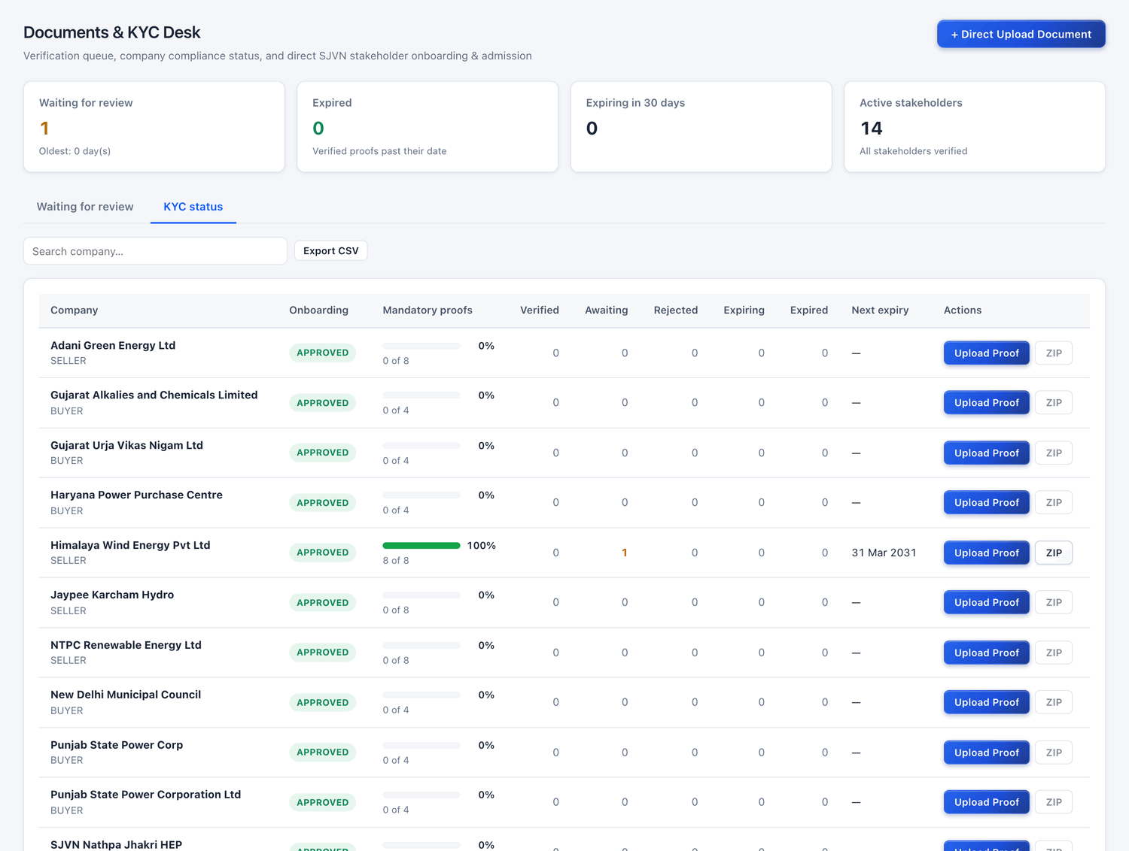
Figure 6.4 The KYC status tab.
Column | What it tells you
Company | The company name and whether it is a seller or a buyer.
Onboarding | The company’s status: PENDING, APPROVED or REJECTED.
Mandatory proofs | A bar and a percentage. 8 of 8 (100%) means all compulsory papers are verified.
Verified / Awaiting / Rejected | How many documents are in each position.
Expiring / Expired | How many verified papers will expire soon, or have already expired.
Next expiry | The nearest expiry date among the company’s papers.
Actions | Upload Proof: upload a paper for this company. ZIP: download all its documents in one file.

TIP
Click Export CSV above the table to download this list as a file that opens in Excel. It is useful for a monthly KYC status report.

6.4 Uploading a document on behalf of a company
Sometimes a company gives its papers to SJVN by post or by hand. SJVN can then upload them directly.

To upload a document for a company
STEP  1 | Click the blue button + Direct Upload Document at the top right of the desk. (Or click Upload Proof on the company’s row in the KYC status tab.)

STEP  2 | Fill the boxes. The table below explains each one.

Field | What to enter | Example
Stakeholder company * | Choose the company from the list. | Sunrise Solar Pvt Ltd (SELLER)
Document type * | Choose which paper this is. | Environmental Clearance
Valid until (optional) | The expiry date, if the paper has one. | 31/03/2031
Document title * | A title is filled in for you. Change it if you want. | Environmental Clearance - Sunrise Solar
Document file * | Click Choose File and pick the file from your computer (PDF, PNG, JPG or Excel, up to 10 MB). | —
Auto-verify & clear regulatory checklist item | With a tick, the document is marked Verified at once and the company’s checklist is updated. | (ticked)

STEP  3 | Click the green button Upload & auto-verify.

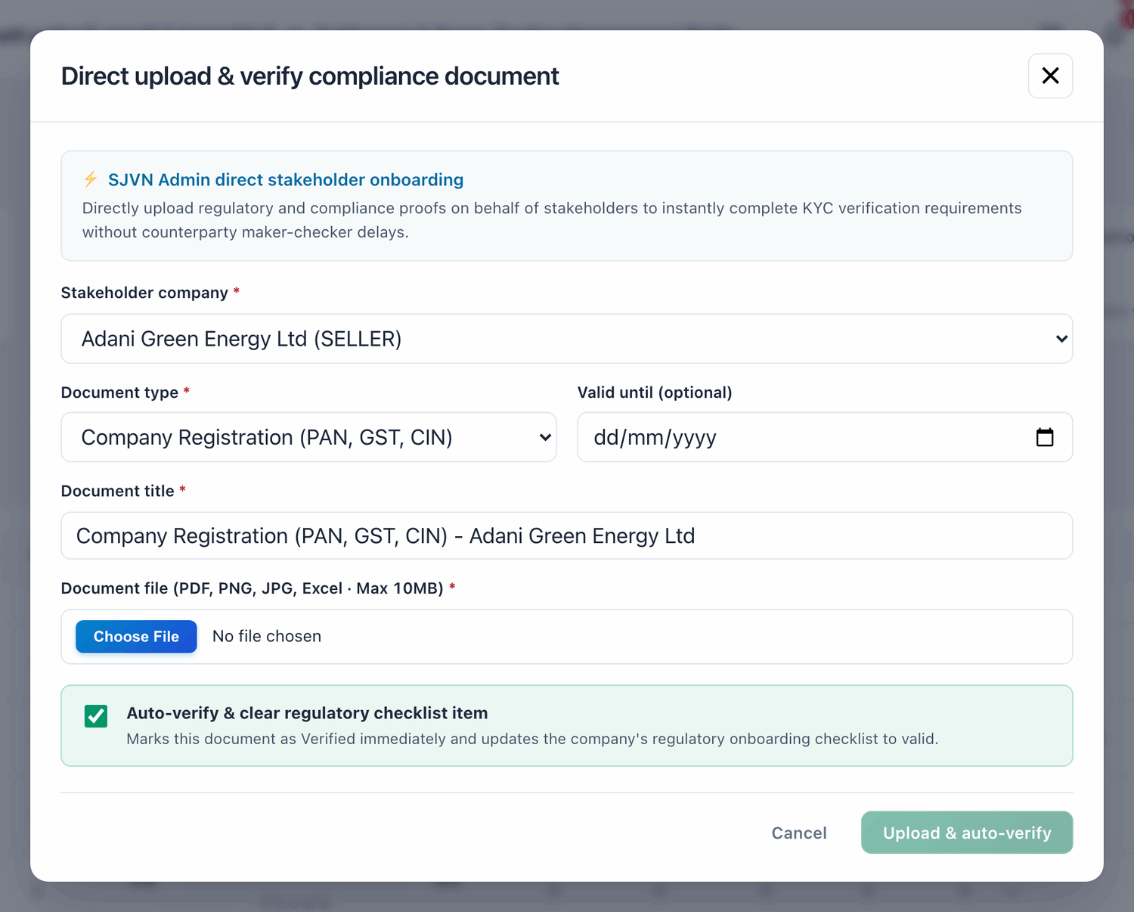
Figure 6.5 The Direct upload window.
IMPORTANT
When the tick is on, nobody else checks this document after you. Upload only papers that you have seen and found correct.

6.5 Common questions
If you see this | Why it happens | What to do
A company says it uploaded a paper but it is not in the waiting list | It may have been uploaded by a maker of the company and is still waiting for the company’s own checker. Or it was uploaded as “Record Only”. | Ask the company to check the status in My Documents & KYC. A maker’s upload must be submitted by a checker or approver.
I verified a wrong document by mistake | The Verify button was clicked without reading. | Open the company’s file in Stakeholders, click Update on that paper and change the status to Rejected or Not started, with a note.
A verified paper shows as Expired | Its “Valid until” date has passed. | Ask the company to upload the renewed paper. Check and verify it as a new document.

PART 2

The Monthly Cycle
Contracts, energy data, bills, approvals and payments: the work that is repeated every month.

CHAPTER 7

7. Contracts (PPA / PSA)
How to enter a contract, make it active, link a PSA to a PPA, and keep its file.
What it is for | The register of all contracts. Every bill is calculated from the contract: its tariff, capacity, payment days, rebate and surcharge rules.
Who uses it | SJVN REIA desk, REIA Admin, SJVN Admin.
How to open it | Menu → REIA Billing & Settlement → Contracts (PPA/PSA).
When to use it | When a new PPA or PSA is signed, when a contract is amended, and whenever you need to see what a contract says.

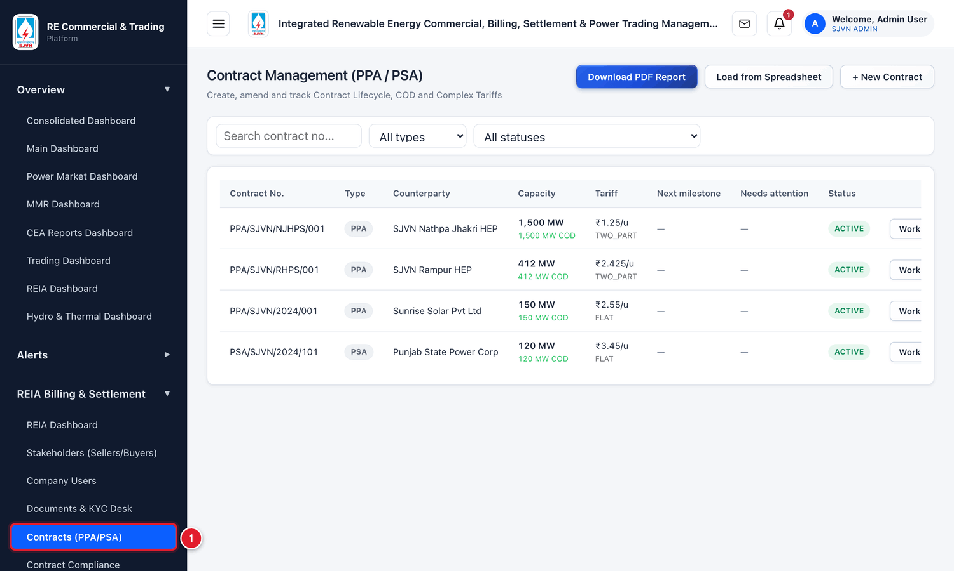
Figure 7.1 Opening the Contracts screen from the menu.
1 | Click Contracts (PPA/PSA) in the menu.

7.1 The Contracts screen
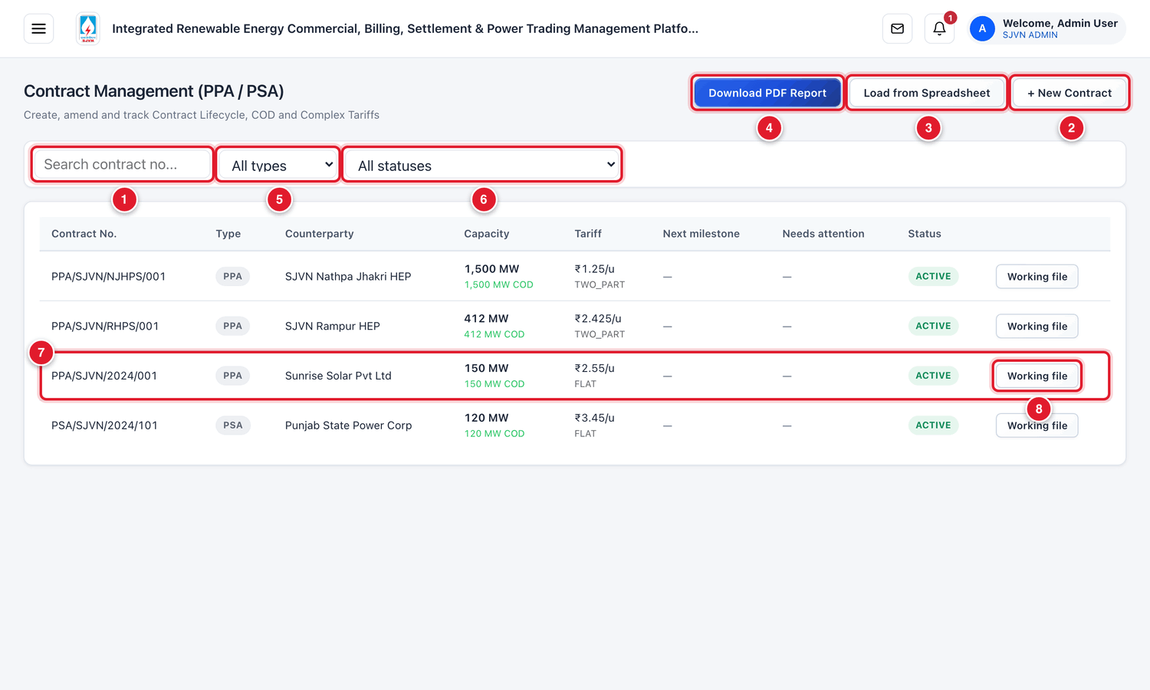
Figure 7.2 The Contract Management screen (menu hidden).
1 | Search box: type a contract number to find it.
2 | + New Contract: enter a new contract.
3 | Load from Spreadsheet: enter many contracts at once from an Excel / CSV file.
4 | Download PDF Report: download the list of contracts as a PDF.
5 | Type filter: show only PPAs or only PSAs.
6 | Status filter: show contracts of one status only.
7 | One contract. Click the row to open the contract window.
8 | Working file: open the contract’s file (documents, milestones, notices).

Column | What it tells you
Contract No. | The number of the contract.
Type | PPA (seller → SJVN) or PSA (SJVN → buyer).
Counterparty | The seller (for a PPA) or the buyer (for a PSA).
Capacity | The contracted capacity in MW. The green line below shows how much is commissioned (COD done).
Tariff | The tariff in ₹ per unit (kWh), and the tariff type (FLAT, TWO_PART…).
Next milestone | The next project date that is due, if any.
Needs attention | A short warning if something on this contract needs action.
Status | The present stage of the contract (see 7.3).

7.2 Entering a new contract
Keep the signed contract in front of you. You will copy the main terms from it. The seller or buyer must already be APPROVED in Stakeholders (Chapter 4), otherwise its name will not appear in the list.

To enter a new contract
STEP  1 | Click the button + New Contract at the top right.

WHAT YOU SHOULD SEE NOW
The pop-up window Create New Contract opens. It has five parts.

Part 1: Basic Details
STEP  2 | Fill the four boxes of Part 1.

Field | What to enter | Example
Contract No. * | The contract number exactly as written on the signed contract. | PPA/SJVN/2026/014
Contract Type | PPA (Seller → SJVN) when SJVN buys. PSA (SJVN → Buyer) when SJVN sells. | PPA (Seller → SJVN)
Seller * (or Buyer *) | Choose the company from the list. For a PSA this box is named Buyer. | Himalaya Wind Energy Pvt Ltd
Project Type | Solar, Wind, Hybrid, FDRE, Peak Power, Hydro, Pumped Storage or BESS. | Wind

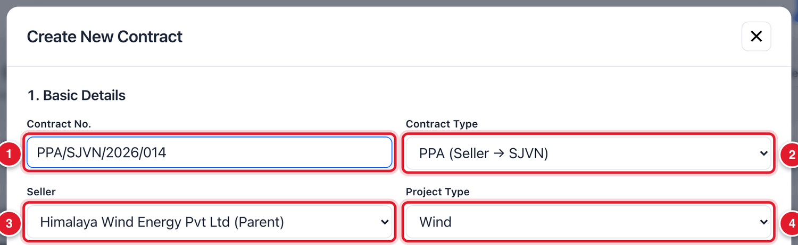
Figure 7.3 Part 1 of the contract form.
1 | Contract number.
2 | PPA or PSA.
3 | The seller (or buyer).
4 | Project type.

Part 2: Capacity & Tariff Structure
STEP  3 | Fill the capacity and tariff.

Field | What to enter | Example
Total Capacity (MW) * | The contracted capacity in MW. | 50
Tariff Type | Flat / Fixed for one fixed rate. Other choices: Two-Part, Escalating / Indexed, Time of Day / Slab. | Flat / Fixed
Base Tariff (₹/unit) * | The tariff in rupees per unit (kWh). | 3.10
Billing Cycle | How often bills are made: Monthly, Weekly or Daily. | Monthly

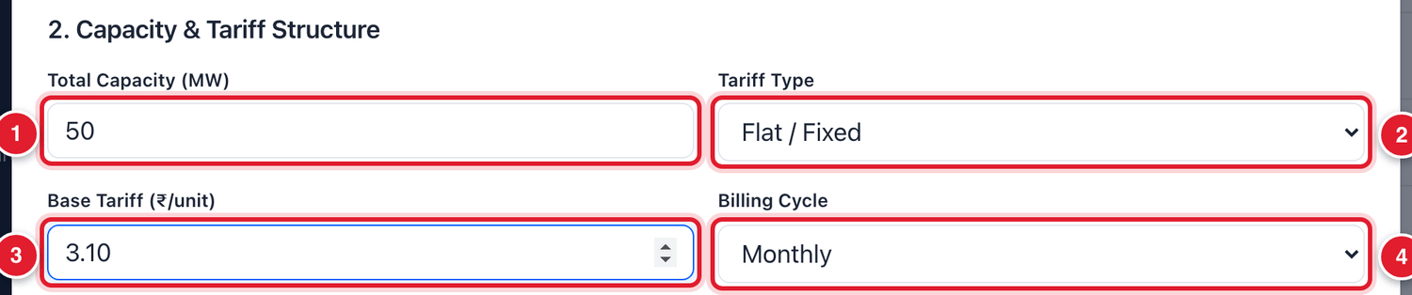
Figure 7.4 Part 2 of the contract form.
1 | Capacity in MW.
2 | Tariff type.
3 | Tariff in ₹ per unit.
4 | Billing cycle.

BE CAREFUL
The tariff typed here is used in every bill of this contract. Check it against the signed contract before you save. ₹3.10 and ₹3.01 look similar, but on a month’s energy the difference is lakhs of rupees.

Part 3: Tenure & Payment Security
STEP  4 | Fill the dates and the security.

Field | What to enter | Example
Tenure Start * | The date from which the contract is in force. Click the calendar to choose. | 01/11/2026
Tenure End * | The last date of the contract. | 31/10/2051
PBG / Security Amount (₹) | The amount of the performance bank guarantee or other security, in rupees. No commas. | 7500000
Security Type | The kind of security: BG, LC or ISB. | BG

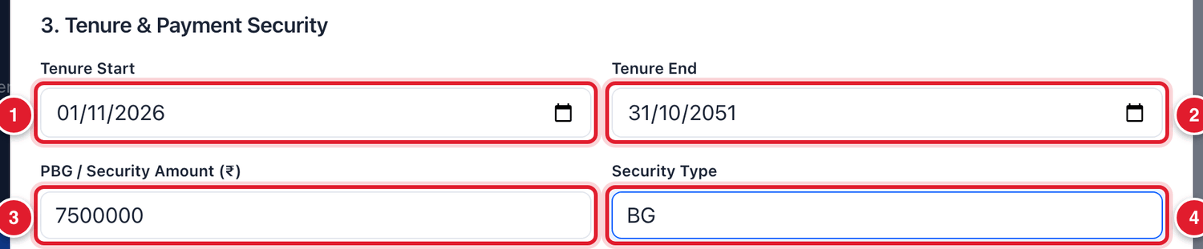
Figure 7.5 Part 3 of the contract form.
1 | Start date.
2 | End date.
3 | Security amount.
4 | Security type.

Part 4: Billing & Regulatory Rules
These rules decide the due date of each bill, the rebate for early payment and the surcharge for late payment. Copy them from the payment article of the contract.
STEP  5 | Fill the payment rules. As you type, a blue line under each rule shows the rule in words. Read it to check that it is what you mean.

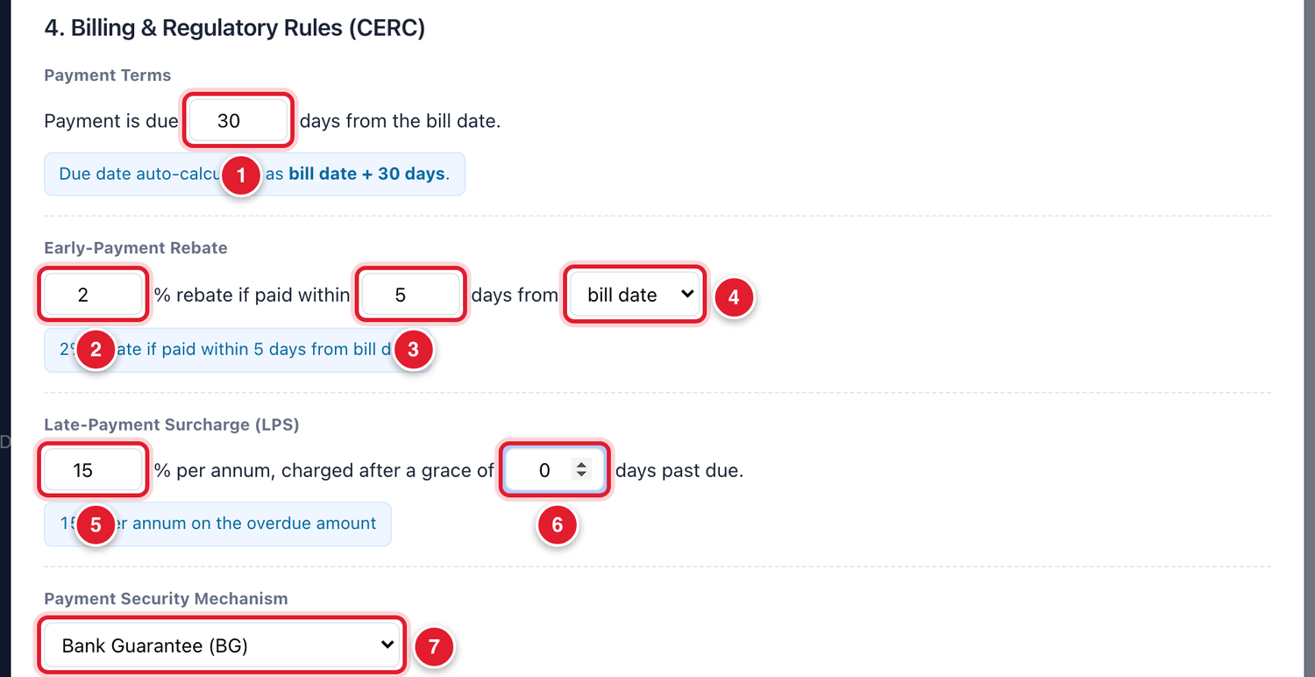
Figure 7.6 Part 4 of the contract form.
1 | Payment terms: the bill is due this many days after the bill date.
2 | Rebate %: the rebate given for early payment. Type 0 for no rebate.
3 | The rebate is given if payment comes within this many days.
4 | Count the rebate days from the bill date or the due date.
5 | Late Payment Surcharge: the rate in % per year.
6 | Grace days after the due date before surcharge starts.
7 | Payment Security Mechanism: LC, BG, Corpus Fund, Payment Security Fund, Escrow or None.

Parts 4b, 4c and 5: CUF, peak obligation and the document
STEP  6 | Min / Guaranteed CUF (%): type the minimum CUF the contract requires. If you leave it empty, the platform uses the standard value (Solar 22, Wind 30, Hybrid 25).

STEP  7 | Peak Availability Obligation: fill these four boxes only for a peak-power or FDRE contract. For other contracts leave them empty.

STEP  8 | Contract Document (PDF/Word): click Choose File and attach the scanned signed contract.

STEP  9 | Click the blue button Create Draft Contract.

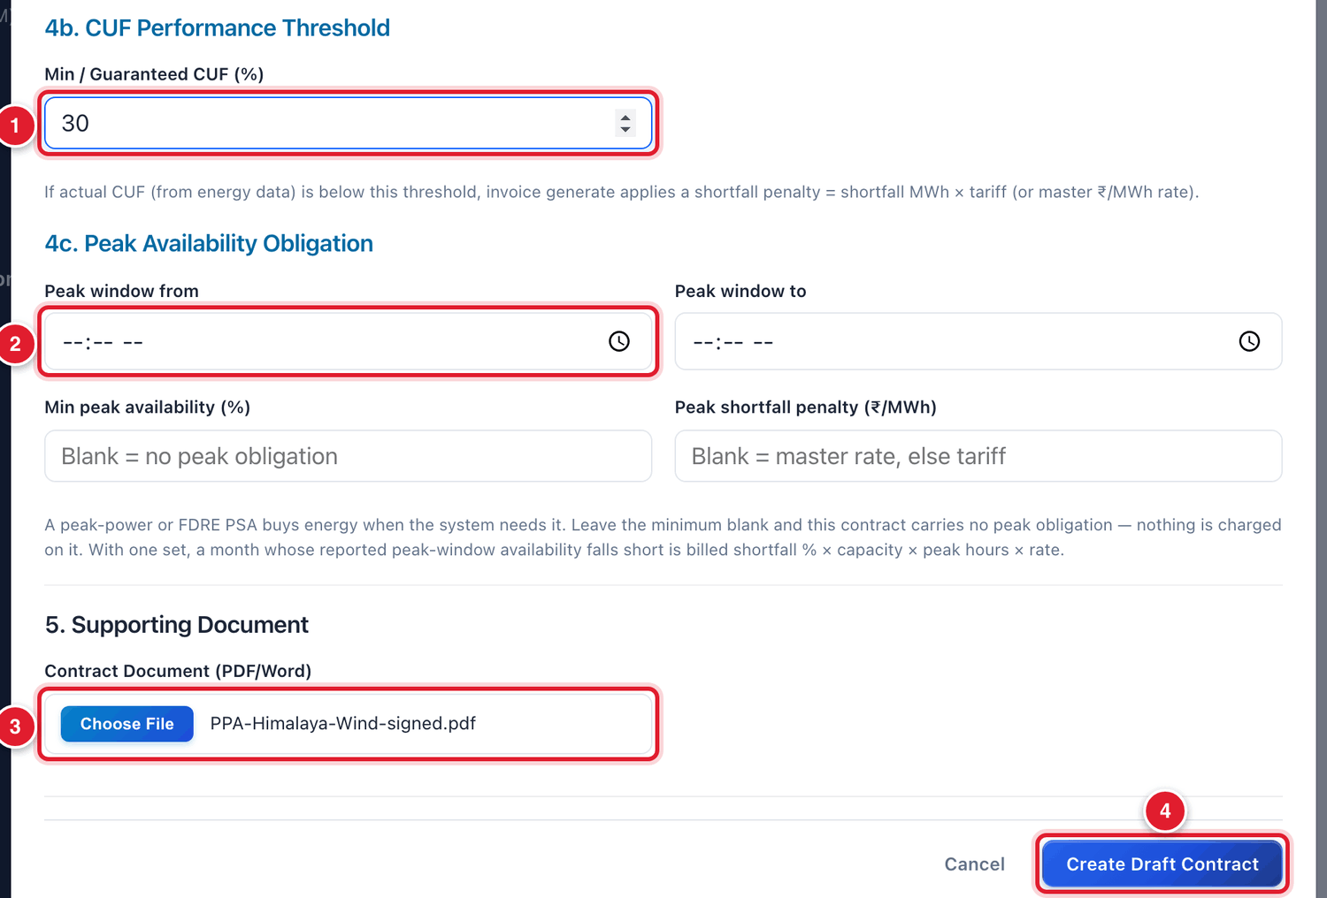
Figure 7.7 The last parts of the form and the Create button.
1 | Minimum CUF in %.
2 | Peak window boxes: only for peak-power / FDRE contracts.
3 | Attach the signed contract.
4 | Click Create Draft Contract.

WHAT YOU SHOULD SEE NOW
The window closes. The new contract is in the list with the status DRAFT.

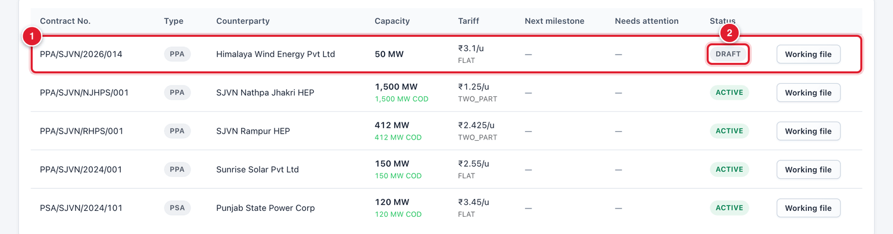
Figure 7.8 The new contract in the list.
1 | The new contract.
2 | Its status is DRAFT.

IMPORTANT
A DRAFT contract cannot be billed. You must take it to ACTIVE (section 7.3).

7.3 Making the contract active
A contract moves through stages. Only an ACTIVE contract can have energy data and bills.
Stage | Meaning
DRAFT | Entered on the platform but not yet signed.
UNDER_NEGOTIATION | Terms are still being discussed.
SIGNED | Signed by both parties.
PENDINGREGULATORYAPPROVAL | Signed, but waiting for a regulatory clearance.
ACTIVE | In force. Energy data and bills can be made.
AMENDED / RENEWED | The terms were changed or the contract was renewed.
NEARING_EXPIRY / EXPIRED | The end date is close or has passed.
TERMINATED / CLOSED | The contract has ended.

To move a contract from DRAFT to ACTIVE
STEP  1 | In the list, click the row of the contract. The Contract window opens.

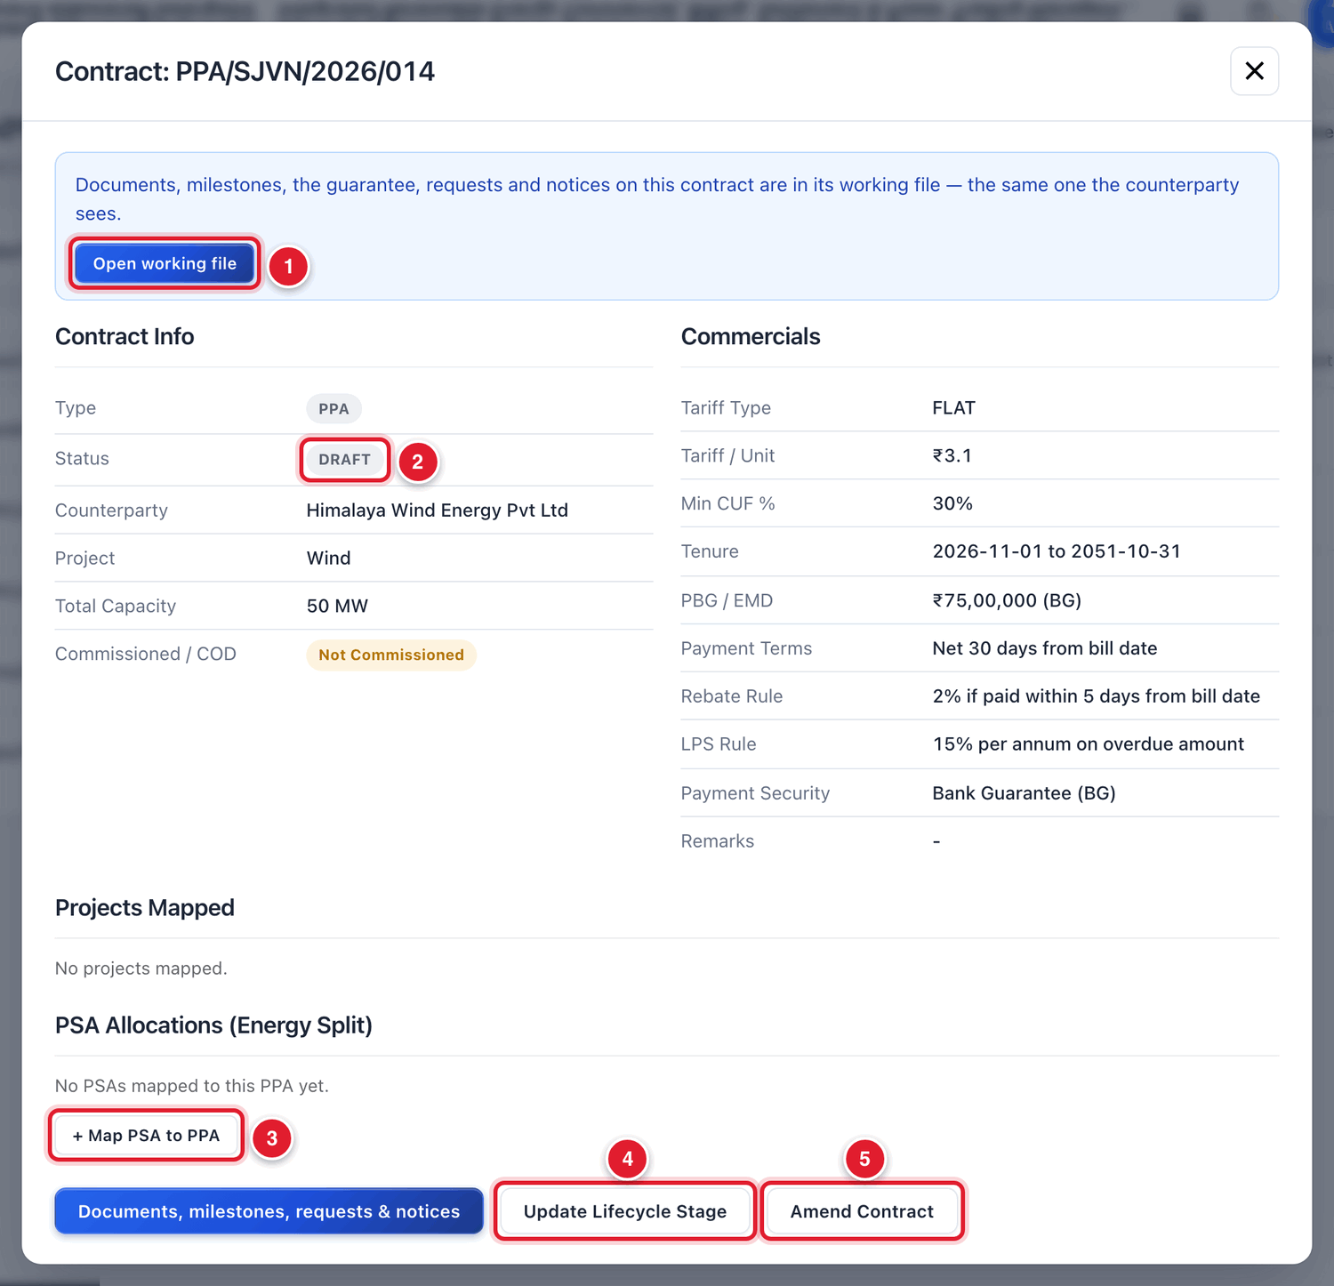
Figure 7.9 The Contract window of a new draft contract.
1 | Open working file: documents, milestones and notices of this contract.
2 | The present status.
3 | + Map PSA to PPA: link a PSA to this PPA (section 7.4).
4 | Update Lifecycle Stage: move the contract to the next stage.
5 | Amend Contract: change the terms (section 7.5).

STEP  2 | Click Update Lifecycle Stage at the bottom.

STEP  3 | In New Status, choose SIGNED. In Remarks, type a short note, for example the date of signing. Click Update Status.

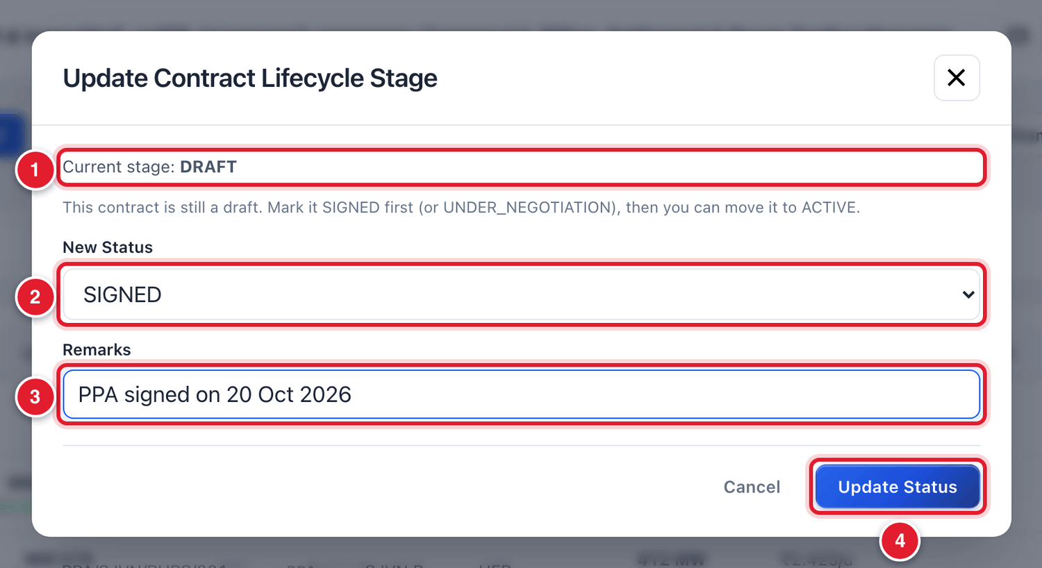
Figure 7.10 Moving the contract from DRAFT to SIGNED.
1 | The present stage.
2 | Choose the new stage.
3 | Type a remark.
4 | Click Update Status.

STEP  4 | Click Update Lifecycle Stage once more. This time choose ACTIVE in New Status, type a remark and click Update Status.

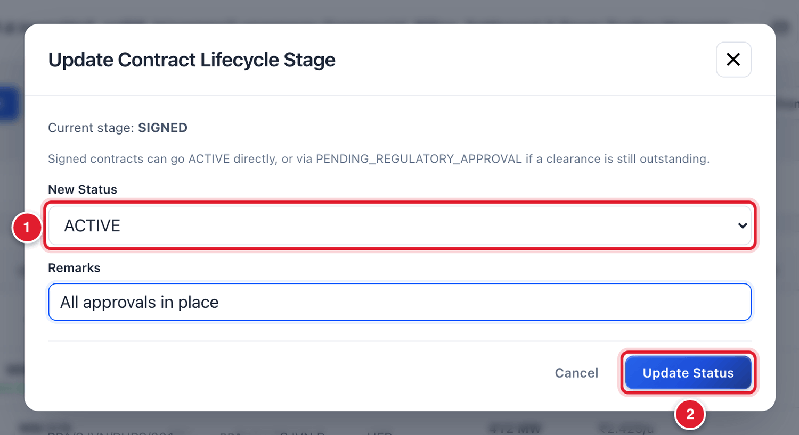
Figure 7.11 Moving the contract from SIGNED to ACTIVE.
1 | Choose ACTIVE.
2 | Click Update Status.

WHAT YOU SHOULD SEE NOW
The status in the Contract window is now green ACTIVE.

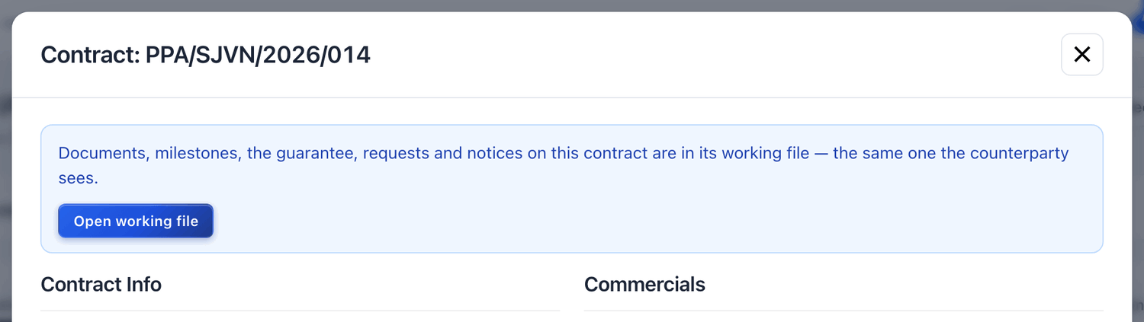
Figure 7.12 The contract is now ACTIVE.
1 | Status ACTIVE.

GOOD TO KNOW
The platform does not let you jump a stage. From DRAFT you can go only to UNDERNEGOTIATION, SIGNED or TERMINATED. From SIGNED you can go to ACTIVE directly, or through PENDINGREGULATORY_APPROVAL if a clearance is awaited.

7.4 Linking a PSA to a PPA
SJVN sells the power of a PPA to one or more buyers. The platform must know what share of the PPA’s energy goes to each PSA. This is called mapping. The buyer’s bill is calculated from it: PPA energy × share.
Example: if the PSA takes 80% of the PPA and the plant generated 24,840 MWh, the buyer is billed for 19,872 MWh.

To map a PSA to a PPA
STEP  1 | Open the Contract window of the PPA (click its row in the list).

STEP  2 | Go down to PSA Allocations (Energy Split) and click + Map PSA to PPA. Three boxes appear.

STEP  3 | Select PSA: choose the PSA from the list.

STEP  4 | Allocation %: type the share of this PPA’s energy that goes to this PSA. Type 100 if all of it goes to one buyer.

STEP  5 | Effective From: choose the date from which this share applies.

STEP  6 | Click Save Map.

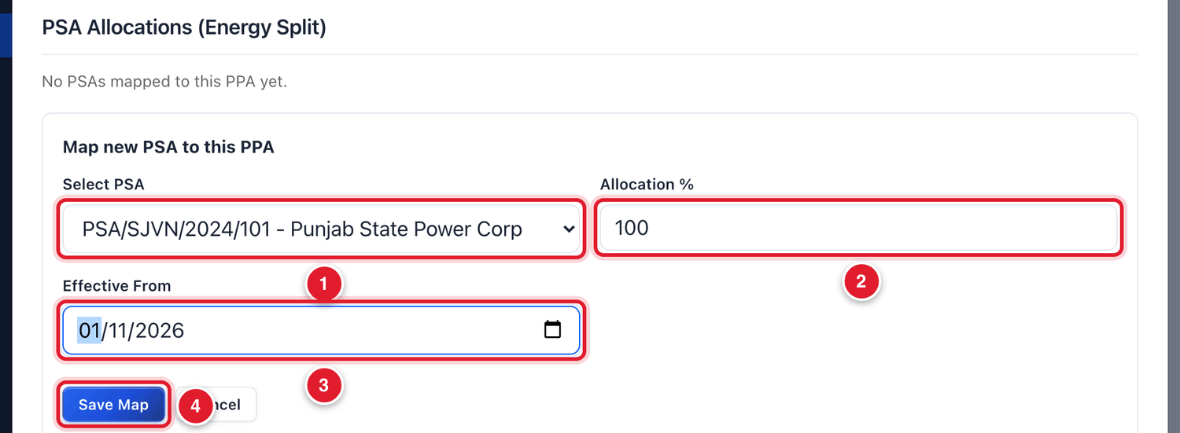
Figure 7.13 Mapping a PSA to a PPA.
1 | Choose the PSA.
2 | Share in %.
3 | Date from which it applies.
4 | Click Save Map.

WHAT YOU SHOULD SEE NOW
The PSA appears in the table PSA Allocations (Energy Split) with its share and date.

IMPORTANT
Without this mapping the platform cannot make the buyer’s bill, because it does not know how much energy belongs to that buyer. The shares of all PSAs mapped to one PPA should not add up to more than 100%.

7.5 Amending a contract
When the tariff, capacity, COD or CUF of a contract changes, do not make a new contract. Amend the existing one. The platform keeps the old terms as version 1 and the new terms as version 2, each with its own date.

To amend a contract
STEP  1 | Open the Contract window and click Amend Contract.

STEP  2 | Effective From: choose the date from which the new terms apply. It must be inside the tenure of the contract.

STEP  3 | Fill only the boxes that change. Leave the others empty.

STEP  4 | Amendment Reason: type why, and quote the order or letter number.

STEP  5 | Click Submit Amendment (Creates v2).

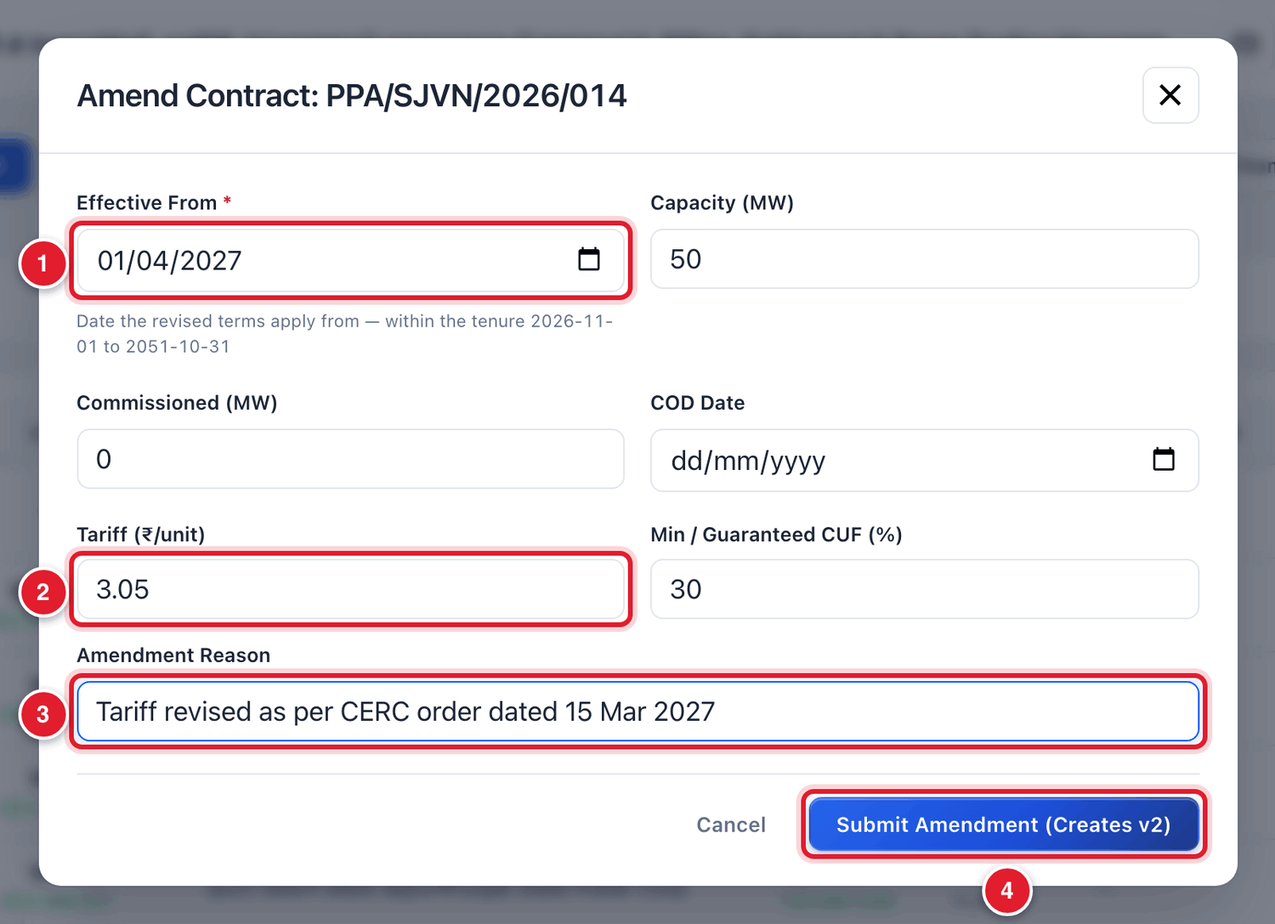
Figure 7.14 The Amend Contract window.
1 | Date from which the new terms apply.
2 | The new value (here, the tariff).
3 | The reason.
4 | Click to save the amendment.

WHAT YOU SHOULD SEE NOW
The contract now has a new version. Bills for months before the effective date still use the old terms. Bills from the effective date use the new terms. The History tab of the working file shows every amendment.

7.6 The working file of a contract
The working file keeps everything about one contract in one place. The seller or buyer sees the same file from its own login. To open it, click Working file on the contract’s row.
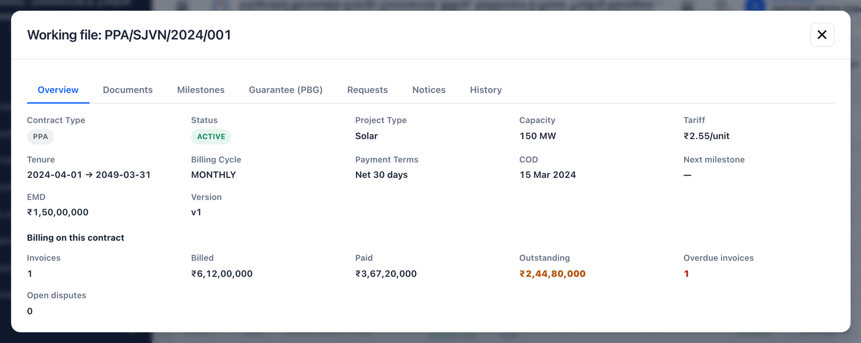
Figure 7.15 The working file: Overview tab.
Tab | What is there | What you can do
Overview | The main terms, and the billing position: invoices, billed, paid, outstanding, overdue, open disputes. | Read only.
Documents | The signed agreement, annexures and other papers of this contract. | Upload Document to add a paper.
Milestones | Project dates: Financial Closure, SCOD and COD. | Set the due dates. Confirm when a milestone is met.
Guarantee (PBG) | The guarantees SJVN holds for this contract, with amount and expiry. | Read only. Guarantees are managed in Payment Security.
Requests | What the counterparty has asked for: an extension, a renewed guarantee, an amendment. | Approve or reject each request.
Notices | Formal notices under the contract, in both directions. | + Issue a notice to send one.
History | Every amendment of the contract. | Read only.

To set the milestone dates
STEP  1 | Open the working file and click the tab Milestones.

STEP  2 | For a new contract the tab is empty. Click Add Financial Closure, SCOD and COD. Three lines are added.

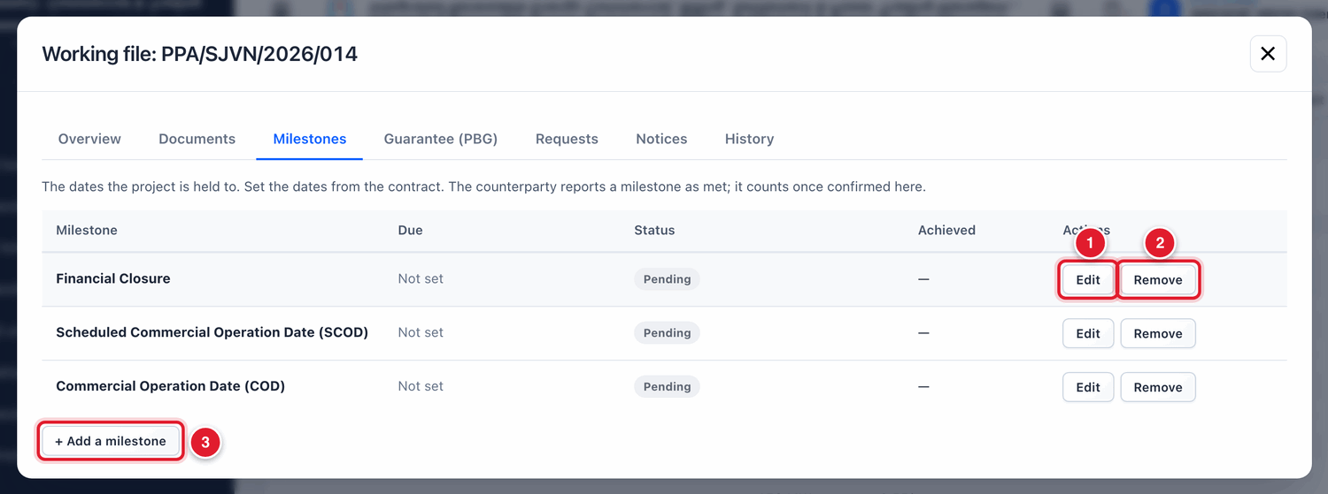
Figure 7.16 The three standard milestones.
1 | Edit: set the dates of this milestone.
2 | Remove: delete this milestone.
3 | + Add a milestone: add another milestone of your own.

STEP  3 | Click Edit on a line. Choose the Due date from the contract. Leave Achieved on empty if the milestone is not yet met. Type a remark if you want. Click Save.

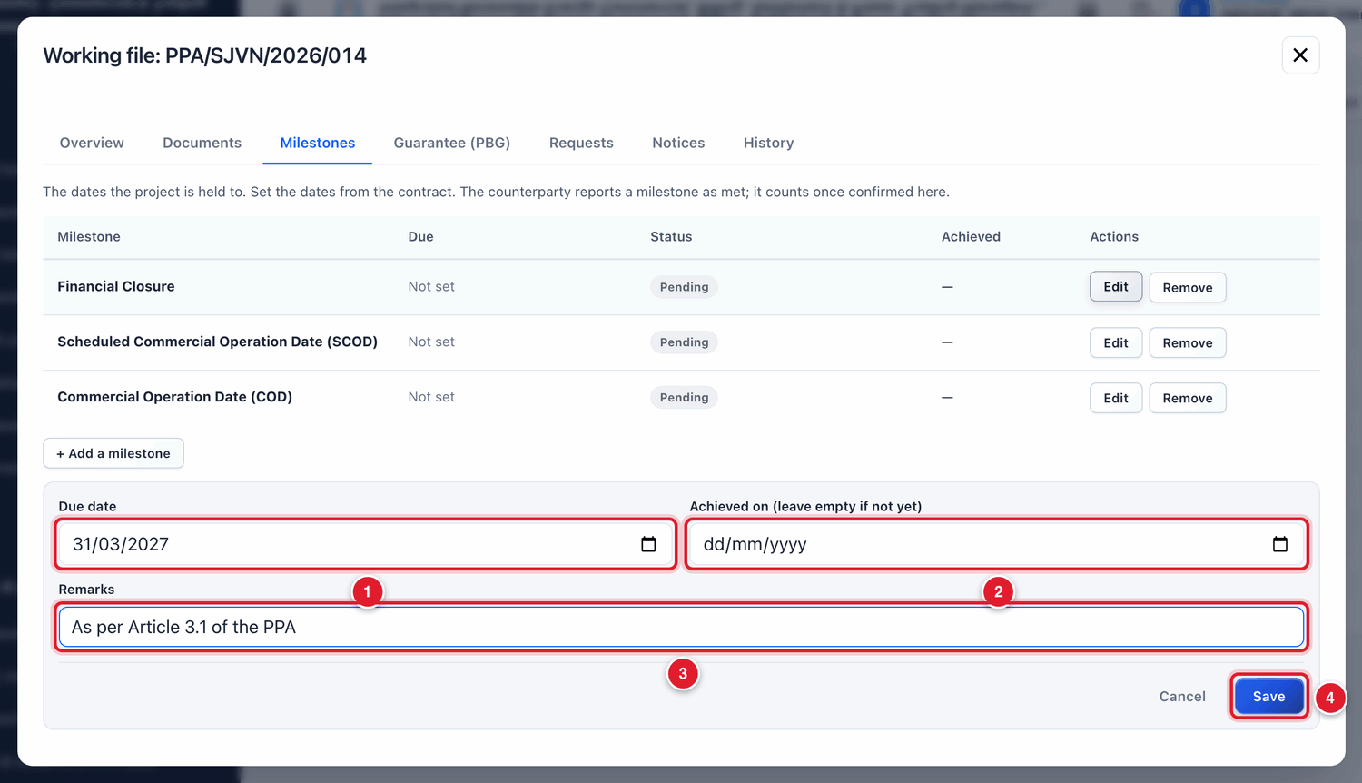
Figure 7.17 Setting the due date of a milestone.
1 | The due date from the contract.
2 | The date it was actually met. Leave empty for now.
3 | A remark.
4 | Click Save.

GOOD TO KNOW
The seller reports from its own login when a milestone is met. It counts only after SJVN confirms it here by filling Achieved on.

To issue a notice
STEP  1 | Open the working file, click the tab Notices, and click + Issue a notice.

STEP  2 | Fill the boxes and click Send notice.

Field | What to enter | Example
Kind of notice | Force Majeure, Event of Default, Cure / Rectification, Change in Law, Termination or General. | General
Date of the event (optional) | The date of the event the notice is about. | —
Reply needed by (optional) | The last date for a reply. | —
Subject * | A short heading. | Renewal of PBG
Notice * | The full text of the notice. Quote the article of the contract. | —
Attachment (optional) | A signed letter or other paper. | —

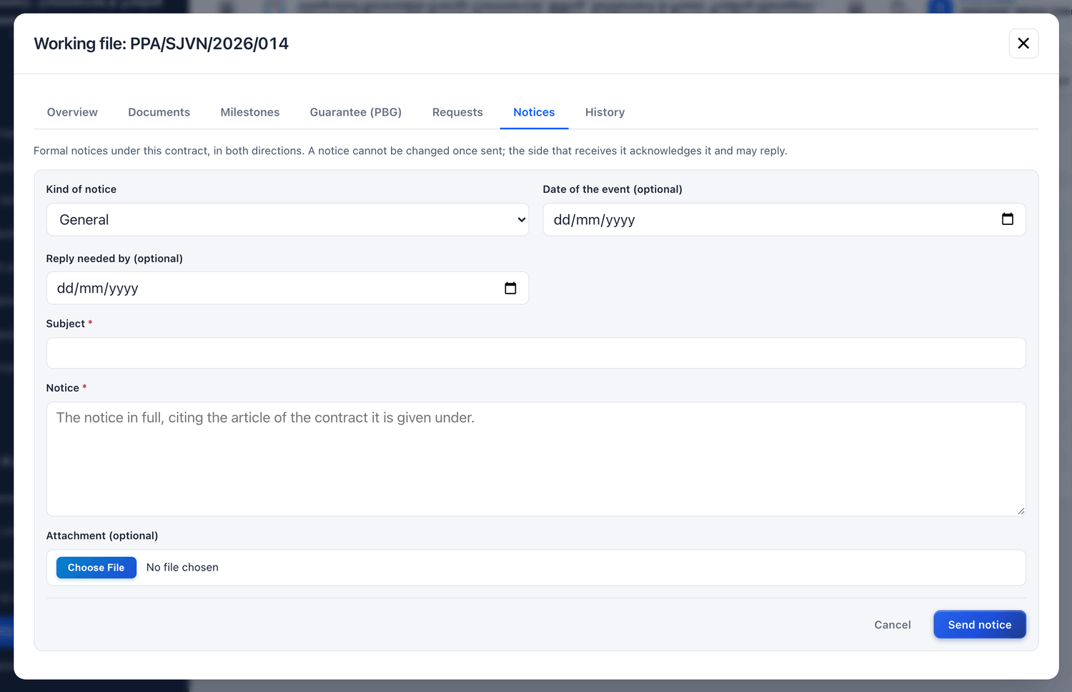
Figure 7.18 Issuing a notice.
BE CAREFUL
A notice cannot be changed or taken back after it is sent. Read it carefully before you click Send notice.

7.7 Entering many contracts at once
If you have many contracts to enter, you can load them from a spreadsheet.

To load contracts from a spreadsheet
STEP  1 | Click Load from Spreadsheet at the top of the Contracts screen.

STEP  2 | Click Download CSV Template. Open the file in Excel and fill one contract in each row. Do not change the headings in the first row. Save the file.

STEP  3 | Click the box Choose a file or drag and drop and pick your file. (You can also paste the rows in the big box.)

STEP  4 | Click Check the Sheet. The platform reads every row and shows the mistakes, if any. Nothing is saved yet.

STEP  5 | Correct the mistakes in your file and check again. When there are no mistakes, click Load Contracts.

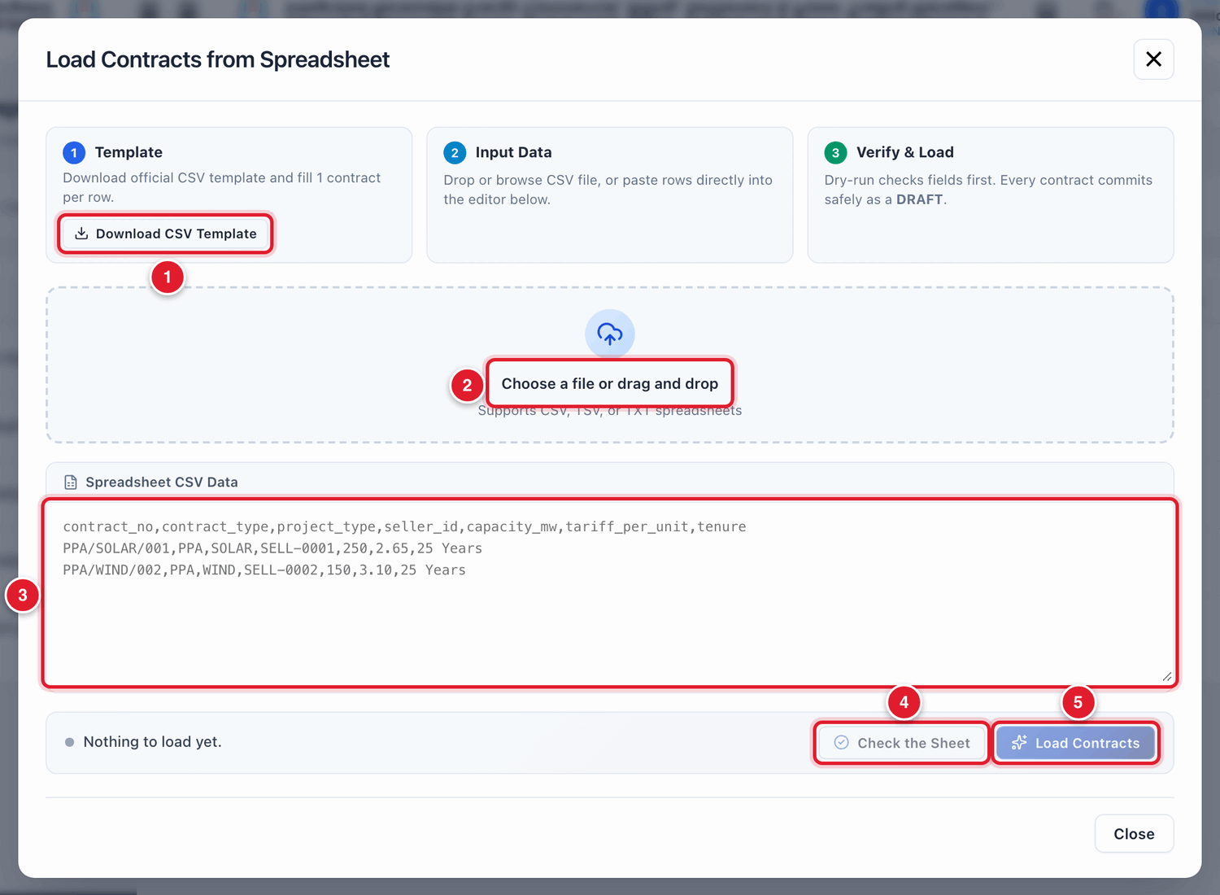
Figure 7.19 Loading contracts from a spreadsheet.
1 | Download the template.
2 | Choose your filled file.
3 | Or paste the rows here.
4 | Check the Sheet: test without saving.
5 | Load Contracts: save the contracts.

WHAT YOU SHOULD SEE NOW
Every contract is saved as a DRAFT. Open each one and move it to ACTIVE (section 7.3).

7.8 Common questions
If you see this | Why it happens | What to do
The seller or buyer is not in the list of the form | The company is not yet APPROVED in Stakeholders. | Approve the company first (Chapter 4).
I cannot choose ACTIVE in New Status | The contract is still DRAFT. | Move it to SIGNED first, then to ACTIVE.
The contract does not appear when I record energy or make a bill | The contract is not ACTIVE. | Open the contract and update its lifecycle stage.
The buyer’s bill shows zero energy | The PSA is not mapped to a PPA, or the share is 0. | Map the PSA to the PPA (section 7.4).
A wrong tariff was saved | A typing mistake in the form. | Use Amend Contract with the correct tariff, effective from the tenure start date, and write the reason.

CHAPTER 8

8. Contract Compliance
One screen that checks every contract and tells you which ones need attention.
What it is for | The platform checks five things on each contract: tenure, commercial operation, commissioned capacity, payment security and statutory approvals. This screen shows the result.
Who uses it | SJVN REIA desk, REIA Admin, Management.
How to open it | Menu → REIA Billing & Settlement → Contract Compliance.
When to use it | Once a week, and before any review meeting.

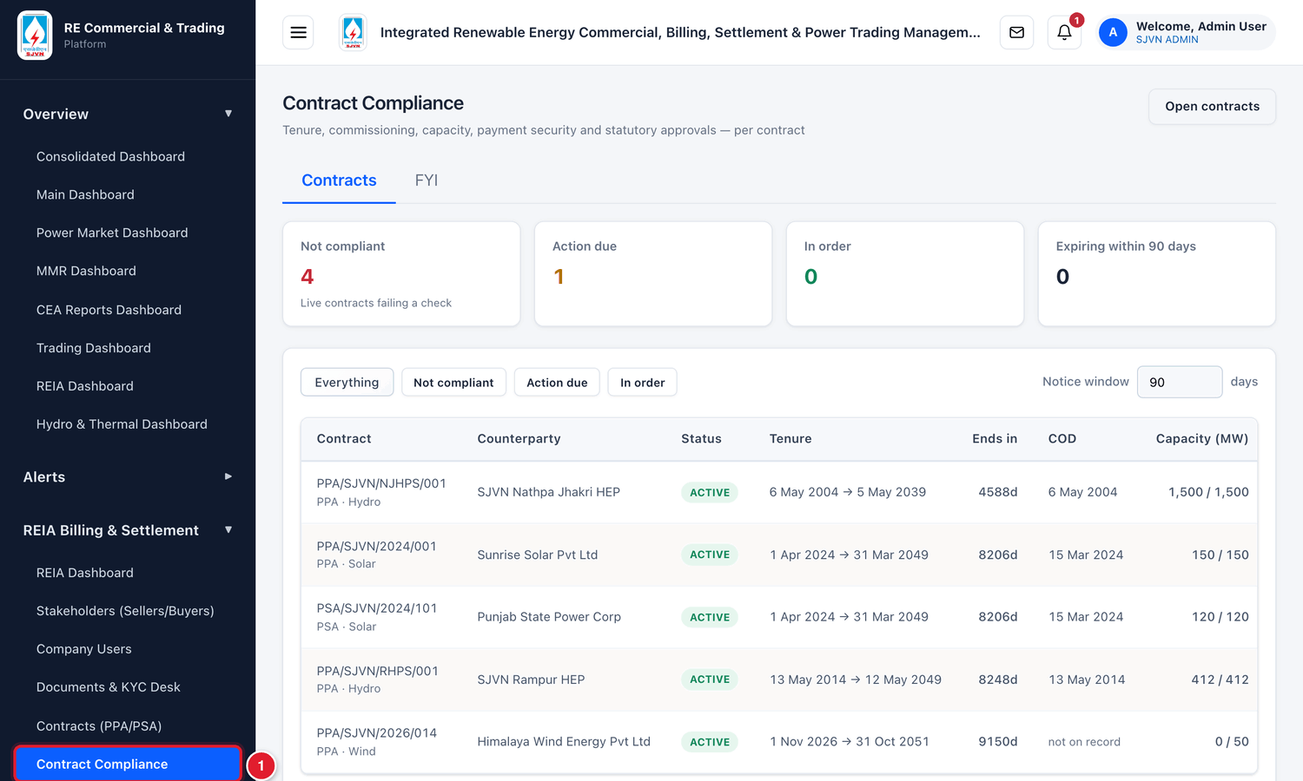
Figure 8.1 Opening Contract Compliance from the menu.
1 | Click Contract Compliance.

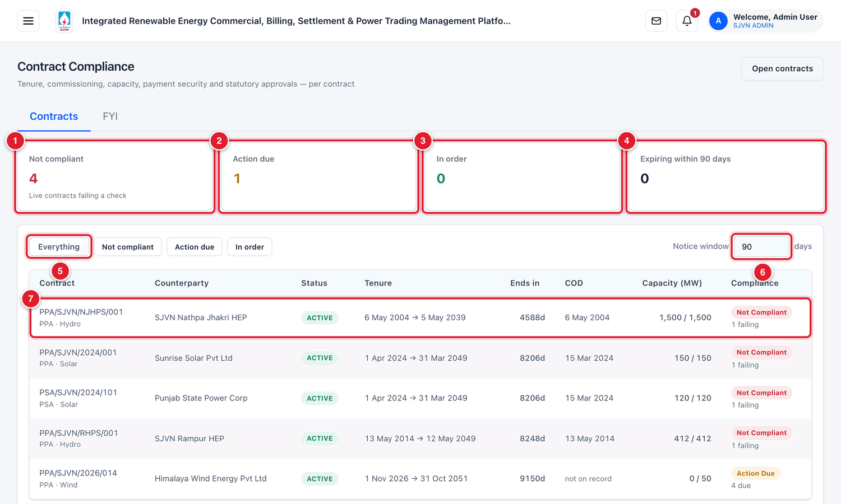
Figure 8.2 The Contract Compliance screen (menu hidden).
1 | Not compliant: live contracts that fail at least one check.
2 | Action due: contracts where something is due soon.
3 | In order: contracts with nothing pending.
4 | Expiring within 90 days: contracts close to their end date.
5 | Filter buttons: show everything, or only one group.
6 | Notice window: how many days ahead the platform should warn (for example 90).
7 | One contract. Click the row to see its five checks.

To see why a contract is not compliant
STEP  1 | Click the row of the contract.

WHAT YOU SHOULD SEE NOW
Five lines open below the row, one for each check. Each line shows In Order, Action Due or Not Compliant, and a short reason.

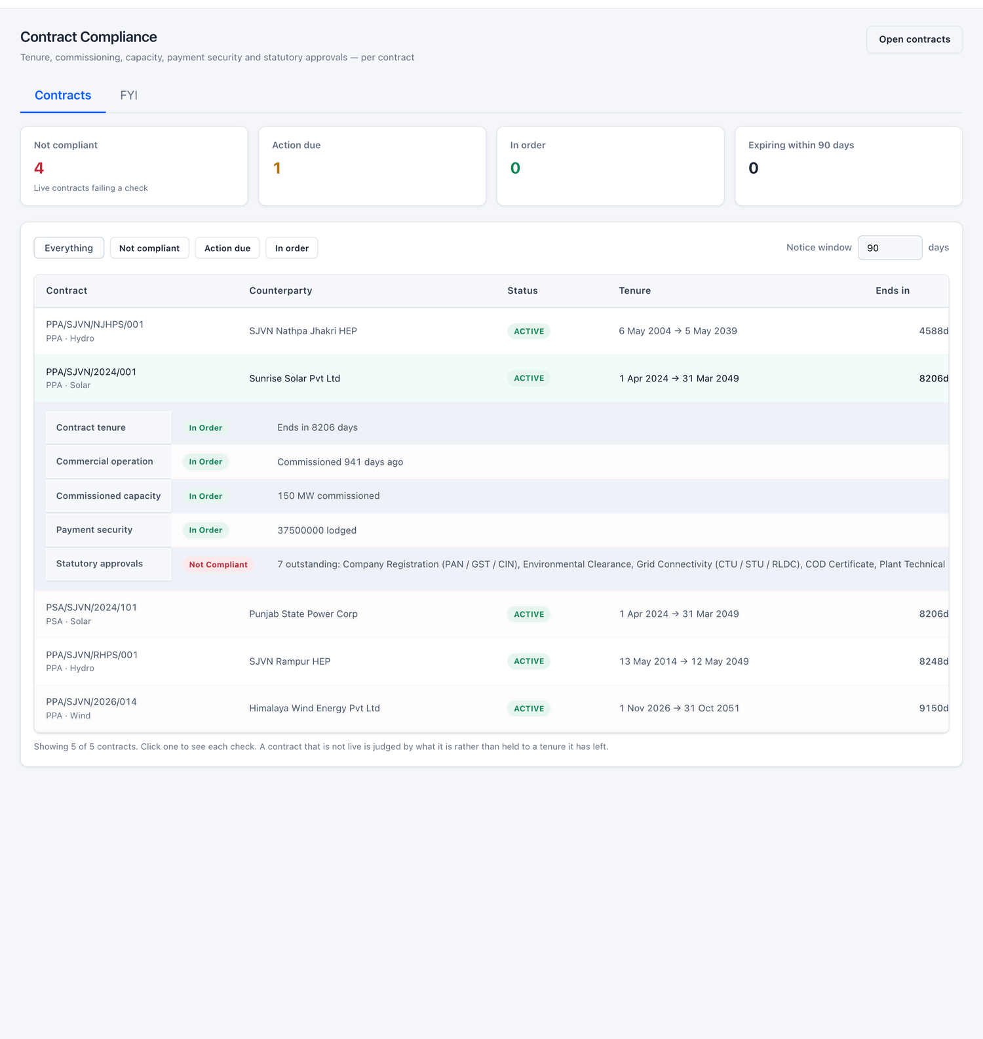
Figure 8.3 The five checks of one contract.
Check | What the platform looks at | How to set it right
Contract tenure | How many days are left before the contract ends. | Start renewal in time. Update the lifecycle stage.
Commercial operation | Whether a COD date is on record. | Fill Achieved on for the COD milestone, or amend the contract with the COD date.
Commissioned capacity | Whether the commissioned MW equals the contracted MW. | Amend the contract with the commissioned capacity.
Payment security | Whether a valid guarantee or LC is lodged for the contract. | Add or renew the instrument in Payment Security.
Statutory approvals | Whether all compulsory papers of the company are verified. | Verify the pending papers in Stakeholders or the Documents & KYC Desk.

TIP
The tab FYI on this screen explains each check in more detail.

CHAPTER 9

9. Energy Data & Validation
How the month’s energy is entered, checked, accepted by the seller and locked. Every bill stands on this number.
What it is for | Holds the energy (in MWh) supplied under each PPA in each month. A bill can be made only from energy that is LOCKED.
Who uses it | SJVN REIA desk enters, validates and locks. The seller accepts or objects from its own login.
How to open it | Menu → REIA Billing & Settlement → Energy Data & Validation.
When to use it | Every month, as soon as the JMR or the REA for the month is received.

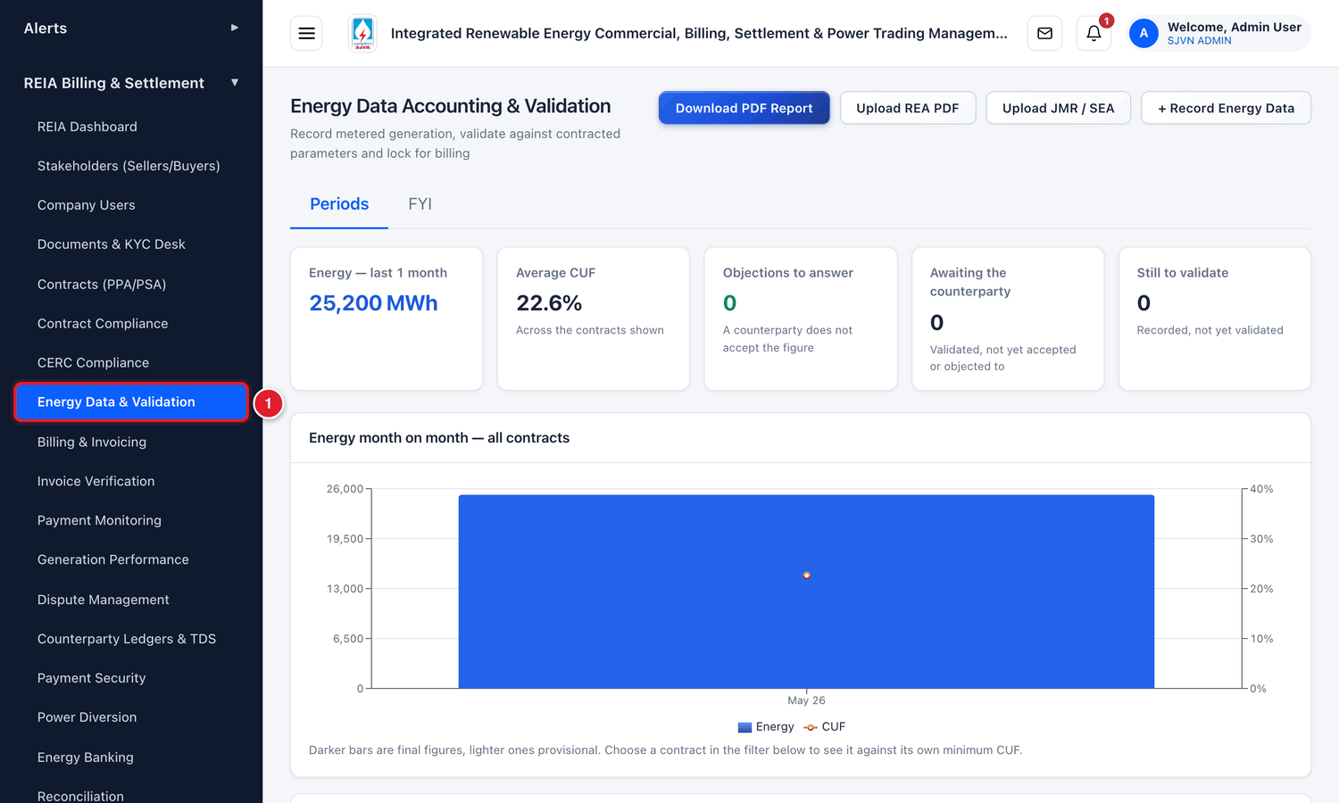
Figure 9.1 Opening Energy Data & Validation from the menu.
1 | Click Energy Data & Validation.

9.1 The four stages of an energy record
Each month’s energy for each contract is one record. A record moves through these stages:
Stage | Meaning | Can a bill be made?
DRAFT | Entered, but nobody has checked it. | No
VALIDATED | The platform has checked it and found it reasonable. It has gone to the seller to confirm. | Not yet. It must be locked first.
DISPUTED | The check failed, or the seller objected. | Only after SJVN locks it with a written reason.
LOCKED | Final. It cannot be changed any more. | Yes

So the work is always in this order: Record → Validate → Seller accepts → Lock.
GOOD TO KNOW
Provisional and Final. A *provisional* figure is an early figure, used when the final account is not yet available. The *final* figure comes later from the JMR or the REA. When the final figure is entered, it takes the place of the provisional one. The provisional figure is kept in the history and is not deleted.

9.2 The Energy Data screen
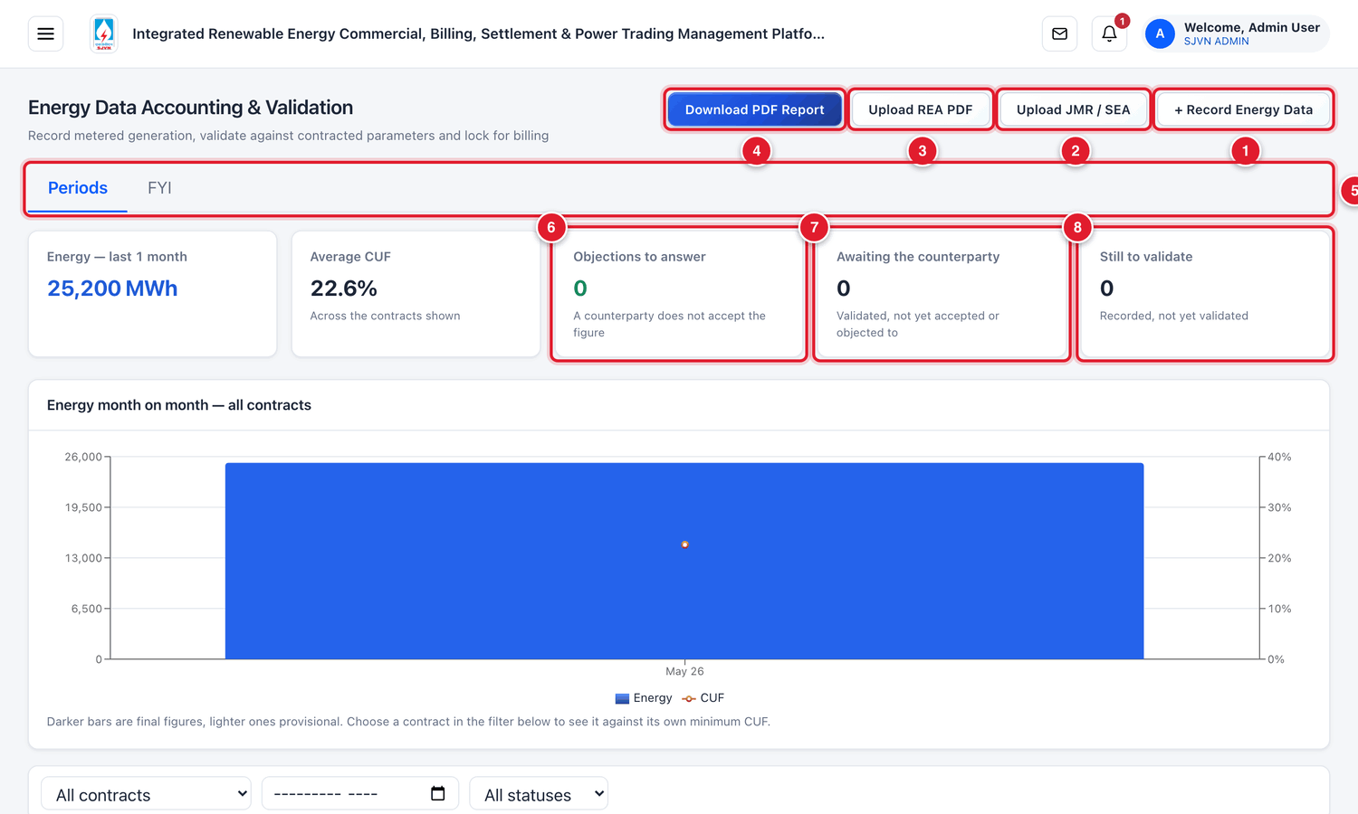
Figure 9.2 The top of the Energy Data screen (menu hidden).
1 | + Record Energy Data: type one month’s energy by hand.
2 | Upload JMR / SEA: load energy from an Excel / CSV file.
3 | Upload REA PDF: read the energy from the NRPC REA PDF.
4 | Download PDF Report: download the energy list as a PDF.
5 | Tabs: Periods (the work) and FYI (help).
6 | Objections to answer: records where the seller does not accept the figure.
7 | Awaiting the counterparty: validated records that the seller has not yet answered.
8 | Still to validate: records entered but not yet validated.

Below the chart is the table of records. The table is wide. To see the last columns and the buttons, move the table to the right with the bar at its bottom, or hide the menu.
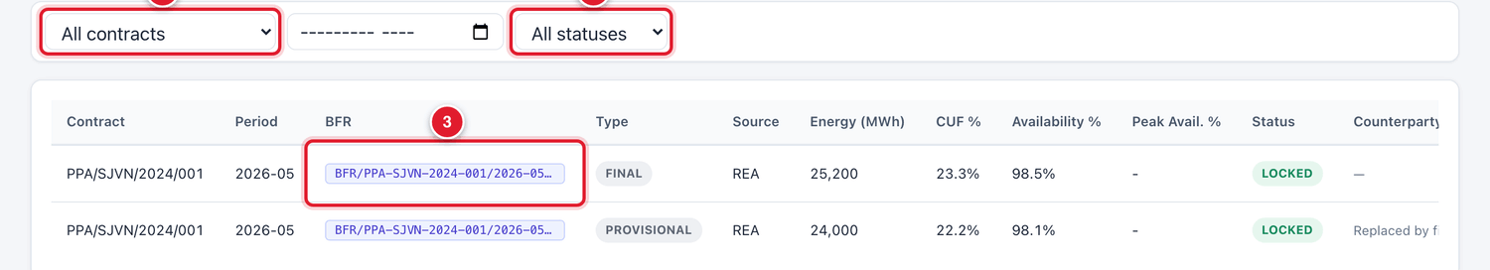
Figure 9.3 The left part of the table of energy records.
1 | Contract filter.
2 | Status filter.
3 | The BFR number. It is the common reference that ties the energy, the bills and the payments of one contract and month together.

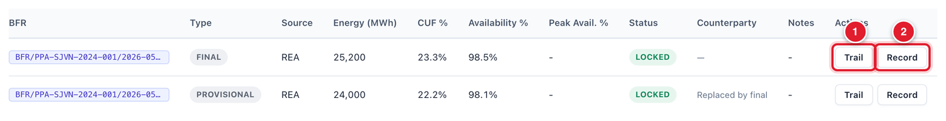
Figure 9.4 The right part of the same table, with the buttons.
1 | Trail: see the energy, bills and payments of this month in one view.
2 | Record: open the record: details, source document and the seller’s answer.

Column | What it tells you
Contract / Period | The contract and the month (year-month, for example 2026-09).
Type | PROVISIONAL or FINAL.
Source | Where the figure came from: JMR, REA, RLDC, SLDC or MANUAL.
Energy (MWh) | The energy of the month.
CUF % / Availability % | The capacity utilisation factor and plant availability of the month.
Status | DRAFT, VALIDATED, DISPUTED or LOCKED.
Counterparty | The seller’s answer: Awaiting Confirmation, Accepted, or Objected.
Notes | The result of the platform’s check, for example how far the figure is from the expected energy.
Actions | The buttons for the next step: Validate, Lock, Trail, Record.

9.3 Step 1: Record the energy

To record one month’s energy
STEP  1 | Click the blue button + Record Energy Data.

STEP  2 | Fill the boxes in the Record Energy Data window.

Field | What to enter | Example
Contract * | Choose the PPA for which the energy is being recorded. | PPA/SJVN/2024/001 (Solar)
Period (Month) * | Click the box and choose the month and year. | September 2026
Data Type | Final if the figure is from the signed JMR or the final REA. Provisional if it is an early figure. | Final
Source | JMR, REA, RLDC, SLDC or MANUAL. | JMR
Energy (MWh) * | The energy of the month in MWh. No commas. | 24840
CUF (%) | The CUF of the month, if it is given in the account. | 23
Availability (%) | The plant availability of the month. | 98.2
Peak-window Availability (%) | Only for peak-power contracts. Otherwise leave empty. | —

STEP  3 | Click Save.

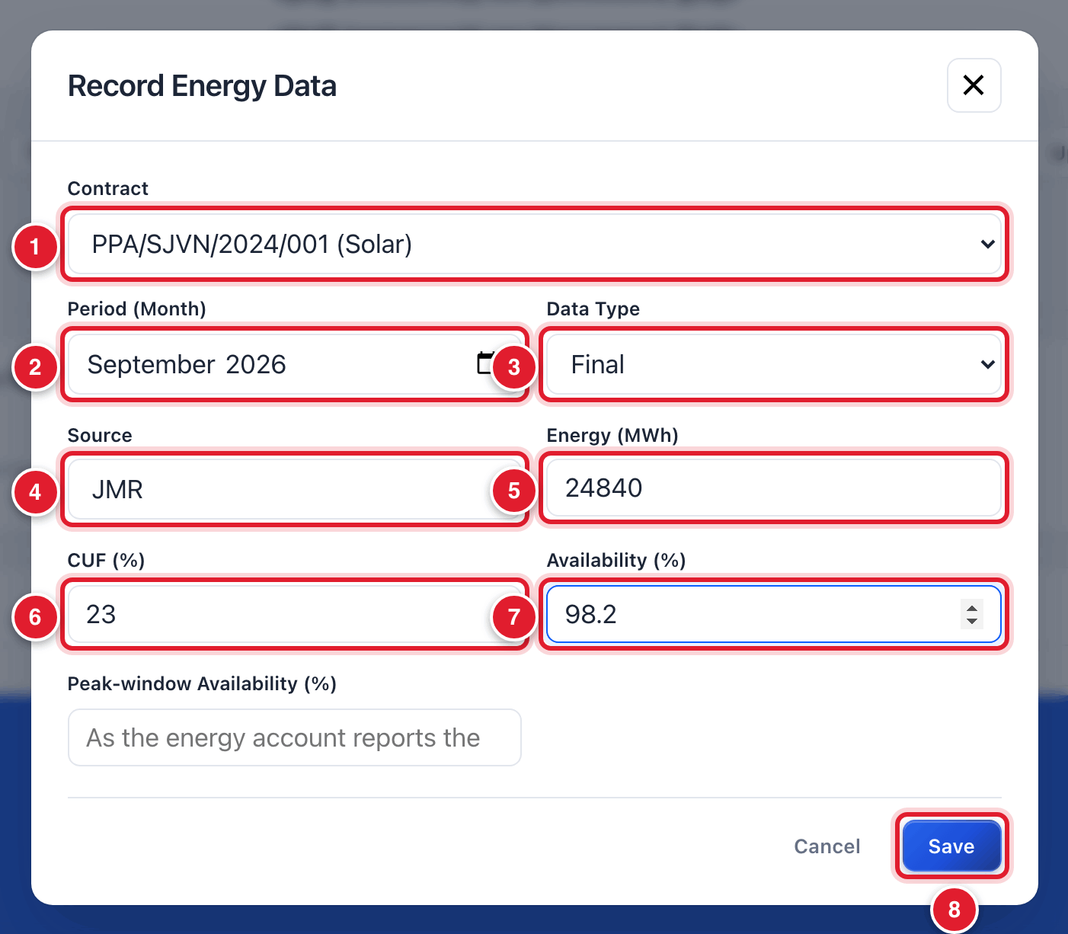
Figure 9.5 The Record Energy Data window, filled.
1 | The PPA.
2 | The month.
3 | Final or Provisional.
4 | The source of the figure.
5 | Energy in MWh.
6 | CUF.
7 | Availability.
8 | Click Save.

WHAT YOU SHOULD SEE NOW
A green message says the energy is recorded as a draft. A new row appears at the top of the table with the status DRAFT and a button Validate.

BE CAREFUL
Check the unit. The platform wants MWh. A state energy account often gives the figure in MU (million units). 1 MU = 1,000 MWh. So 24.84 MU must be typed as 24840.

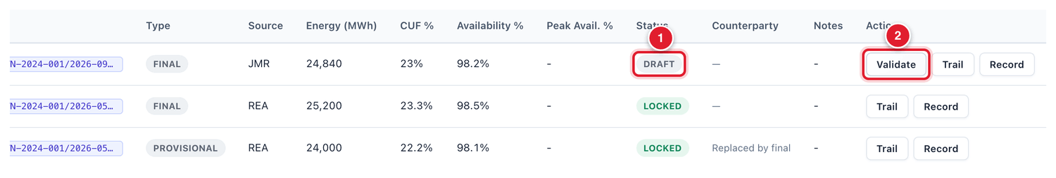
Figure 9.6 The new record is a DRAFT.
1 | Status DRAFT.
2 | The Validate button.

9.4 Step 2: Validate
When you validate, the platform checks whether the figure is reasonable. It works out what the plant could have generated in that month from its capacity and the normal CUF of its type, and compares.

To validate a record
STEP  1 | On the row of the record, click Validate.

WHAT YOU SHOULD SEE NOW
The status changes to blue VALIDATED. The Counterparty column shows Awaiting Confirmation. The Notes column shows the result of the check, for example: *Deviation 4.5% vs expected 23760 MWh … Tolerance: 30%*. The seller gets an alert to confirm the figure.

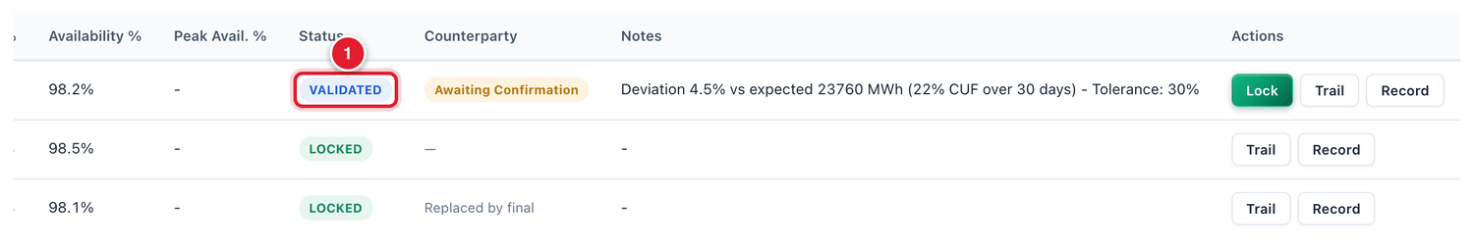
Figure 9.7 The record after validation.
1 | Status VALIDATED.

GOOD TO KNOW
If the figure is too far from the expected energy (more than 30% for solar and wind, more than 80% for hydro), the status becomes DISPUTED instead. Check for a typing mistake or a wrong unit first. A disputed record can still be locked, but only with a written reason (section 9.6).

Attaching the source document
It is good practice to attach the JMR or energy account from which the figure was taken, so that anyone can check it later.

To attach the source document
STEP  1 | On the row of the record, click Record.

STEP  2 | In the Energy record window, go to Source document. Click Choose File and pick the scanned JMR or energy account.

STEP  3 | In It is, choose A signed Joint Meter Reading or A regional / state energy account.

STEP  4 | Click Attach.

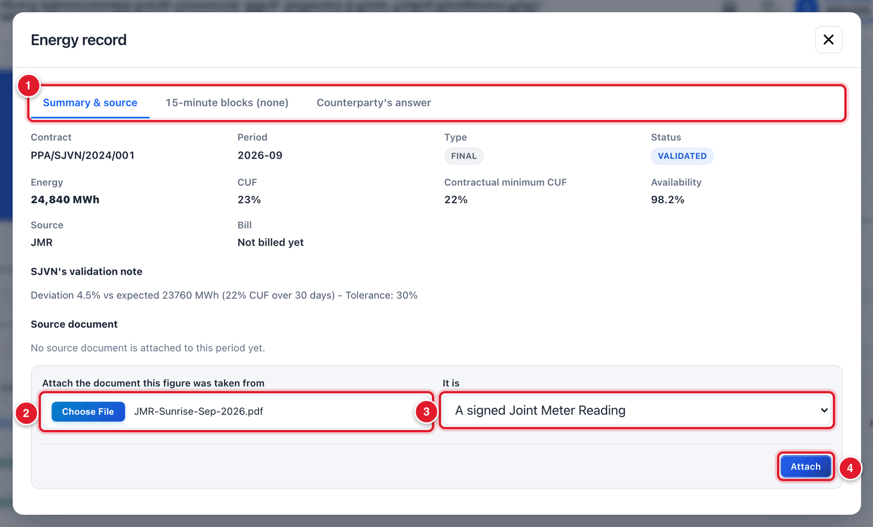
Figure 9.8 The Energy record window.
1 | Three tabs: Summary & source, 15-minute blocks, Counterparty’s answer.
2 | Choose the file.
3 | Say what kind of document it is.
4 | Click Attach.

9.5 Step 3: The seller accepts the figure
This step is done by the seller, from the seller’s login. It is shown here so that you know what happens. The seller’s manual (Part 4) explains it fully.
The seller opens Energy Data in its menu. The record is shown with the status VALIDATED and two buttons: Accept and Object.
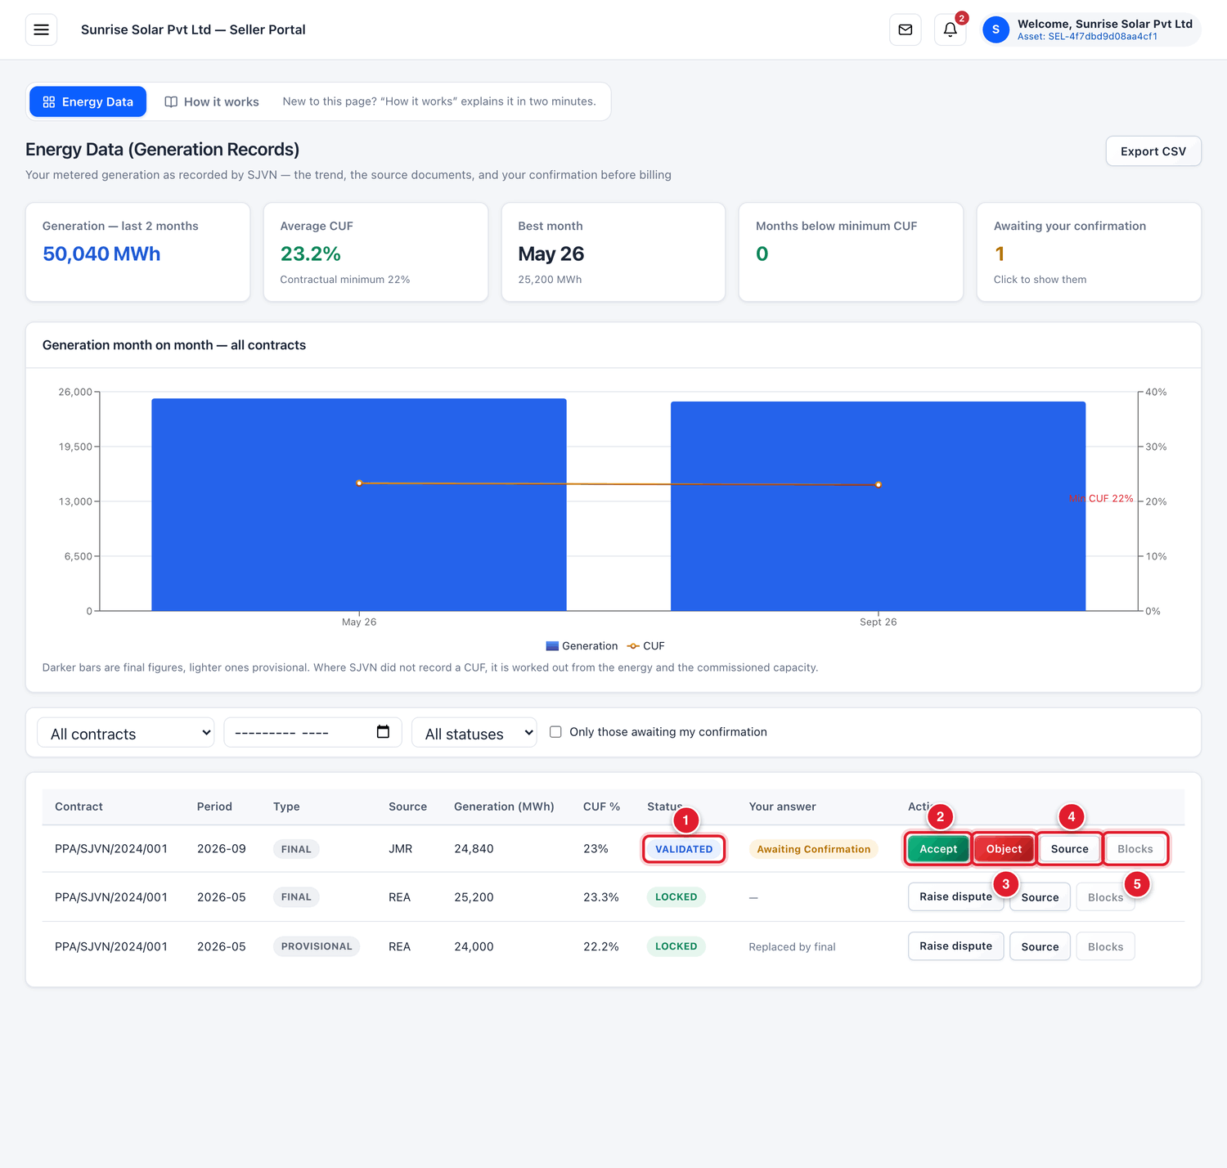
Figure 9.9 What the seller sees.
1 | The record waiting for the seller’s answer.
2 | Accept: the seller agrees with the figure.
3 | Object: the seller does not agree.
4 | Source: the seller can see the details and the source document.
5 | Blocks: 15-minute block data, if it was loaded.

When the seller clicks Accept, the answer is saved. On SJVN’s screen the Counterparty column changes to green Accepted, and the Lock button turns green.
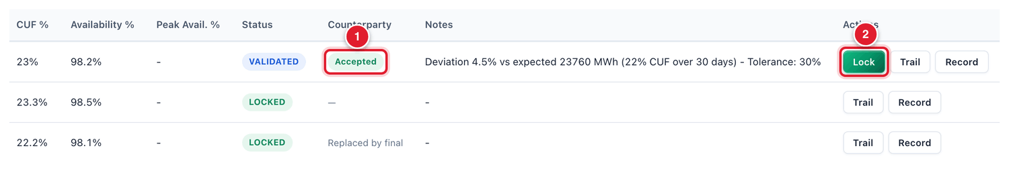
Figure 9.10 On SJVN’s screen: the seller has accepted.
1 | The seller’s answer: Accepted.
2 | The Lock button.

GOOD TO KNOW
If the seller clicks Object, the record appears under Objections to answer on SJVN’s screen. Open it with Record, read the objection in the tab Counterparty’s answer, check your figure against the JMR, and correct it or reply.

9.6 Step 4: Lock

To lock a record
STEP  1 | Check once more that the energy figure is correct and the seller has accepted it.

STEP  2 | On the row of the record, click Lock.

WHAT YOU SHOULD SEE NOW
A green message says the record is locked for billing. The status changes to green LOCKED. The Validate and Lock buttons are gone.

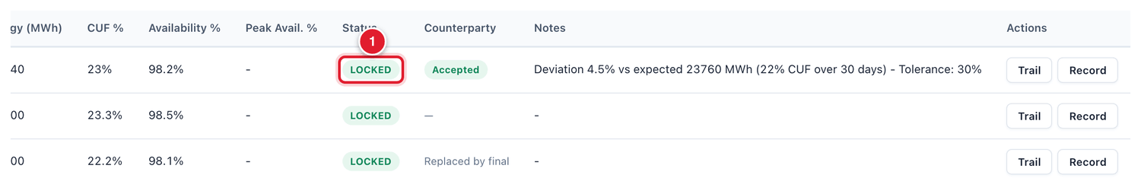
Figure 9.11 The record is LOCKED.
1 | Status LOCKED.

BE CAREFUL
A locked record cannot be edited. If a mistake is found after locking, the correction is made through a revised energy record and a supplementary bill. So check carefully before you lock.

Situation | What happens when you click Lock
Record is DRAFT | The platform refuses. Validate it first.
Record is VALIDATED and the seller accepted | It is locked at once.
Record is VALIDATED but the seller has not answered | It can be locked, but it is better to wait for the seller’s answer.
Record is DISPUTED, or the seller objected | The platform asks for a reason. Type why you are locking in spite of the dispute. The reason is kept on record.

9.7 Other ways to bring in energy data

Upload JMR / SEA (from an Excel or CSV file)
Use this when you have the energy of many contracts or many months in one file.

To upload an energy account file
STEP  1 | Click Upload JMR / SEA.

STEP  2 | Account: choose Joint meter reading, State energy account (SLDC) or RLDC statement.

STEP  3 | Energy is stated in: choose the unit used in your file (MWh, MU, kWh, LU or GWh). If the file itself names the unit in its heading, leave the first choice.

STEP  4 | Period and Data type: fill them if the file does not have these columns.

STEP  5 | Click Choose File, pick the file, and click Check file. The platform shows what it has read. Check the figures and confirm.

TIP
Click Download template in the same window to get a file with the correct column headings.

Upload REA PDF
Use this when you have the Regional Energy Account PDF from NRPC. Click Upload REA PDF, choose the PDF and click Parse Data. The platform reads the scheduled energy from the PDF and prepares the records. Check every figure against the PDF before you validate.

REA Automation pipeline
At the bottom of the screen there is a section REA Automation & Regional Power Committee Pipeline. It fetches the REA from the NRPC website by itself on fixed days of the month. The buttons Scan All RPCs Now and Trigger Fetch start a fetch at once.
IMPORTANT
Use Scan All RPCs Now and Trigger Fetch only if you are told to. Normally the platform fetches the REA on its own schedule.

9.8 The Settlement Trail
Click Trail on any row to see everything about that contract and month in one window: the provisional and final energy, the bills made from them, and what has been paid. Use it to answer the question “what is the position of this month?”.

9.9 Common questions
If you see this | Why it happens | What to do
The contract is not in the list of the form | The contract is not ACTIVE. | Make the contract ACTIVE (Chapter 7).
After Validate the status is DISPUTED | The figure is far from what the plant normally generates. | Check for a typing mistake and the unit (MWh, not MU). If the figure is right (for example, a long outage), lock it with a reason.
There is no Lock button | The record is still DRAFT. | Click Validate first.
“Energy already recorded for this period” | A record of the same type already exists for this contract and month. | Do not enter it again. If the first one is wrong and still DRAFT, correct that one.
The seller says it cannot see the record | The record is still DRAFT. The seller sees it only after validation. | Validate the record.

CHAPTER 10

10. Billing & Invoicing
How the two bills of a month are made: the seller’s invoice on SJVN, and SJVN’s bill on the buyer.
What it is for | All bills of the REIA business are made, checked and tracked here.
Who uses it | SJVN REIA desk makes and checks bills. REIA Ops, REIA Admin and Finance approve them (Chapter 11).
How to open it | Menu → REIA Billing & Settlement → Billing & Invoicing.
When to use it | Every month, after the energy of the month is LOCKED.

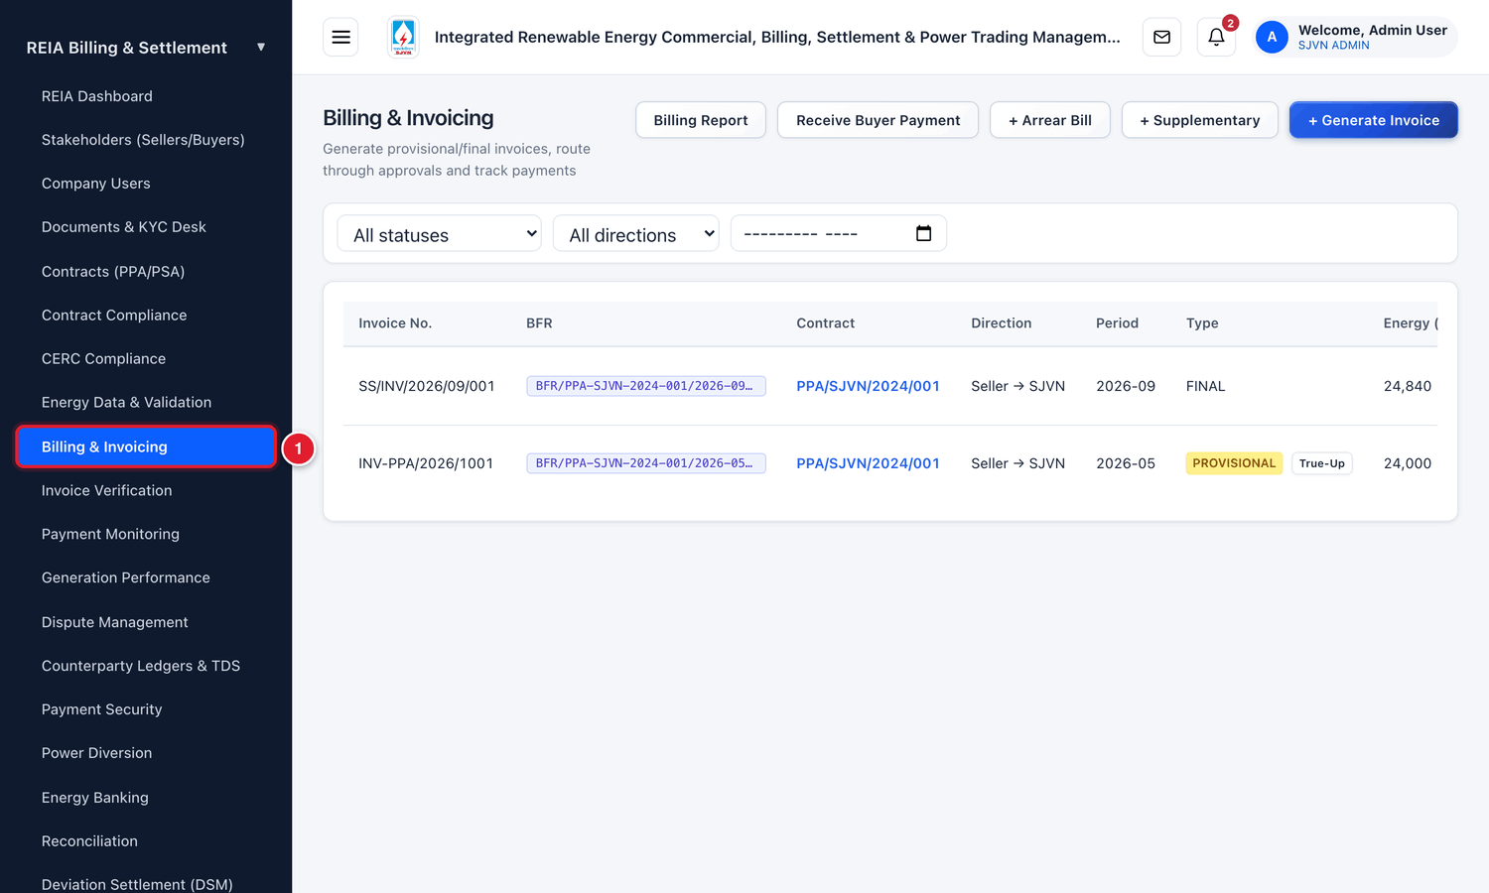
Figure 10.1 Opening Billing & Invoicing from the menu.
1 | Click Billing & Invoicing.

10.1 The two bills of every month
For each contract pair and month there are two bills, in two directions:
Bill | Direction on screen | Who raises it | Who pays whom
The seller’s invoice (PPA side) | Seller → SJVN | The seller, from its login. SJVN checks it. | SJVN pays the seller.
SJVN’s bill (PSA side) | SJVN → Buyer | SJVN, from this screen. | The buyer pays SJVN.

To check the seller’s invoice, SJVN also makes its own calculation of the PPA bill. This is called the system invoice. The platform compares the seller’s invoice with the system invoice line by line.
So in a normal month the work on this screen is:
- A. The seller submits its invoice (from the seller’s login).
- B. SJVN generates the system invoice for the PPA.
- C. SJVN checks the seller’s invoice against the system invoice, and sends it for approval.
- D. SJVN generates the bill on the buyer for the PSA, and sends it for approval.

10.2 The Billing screen
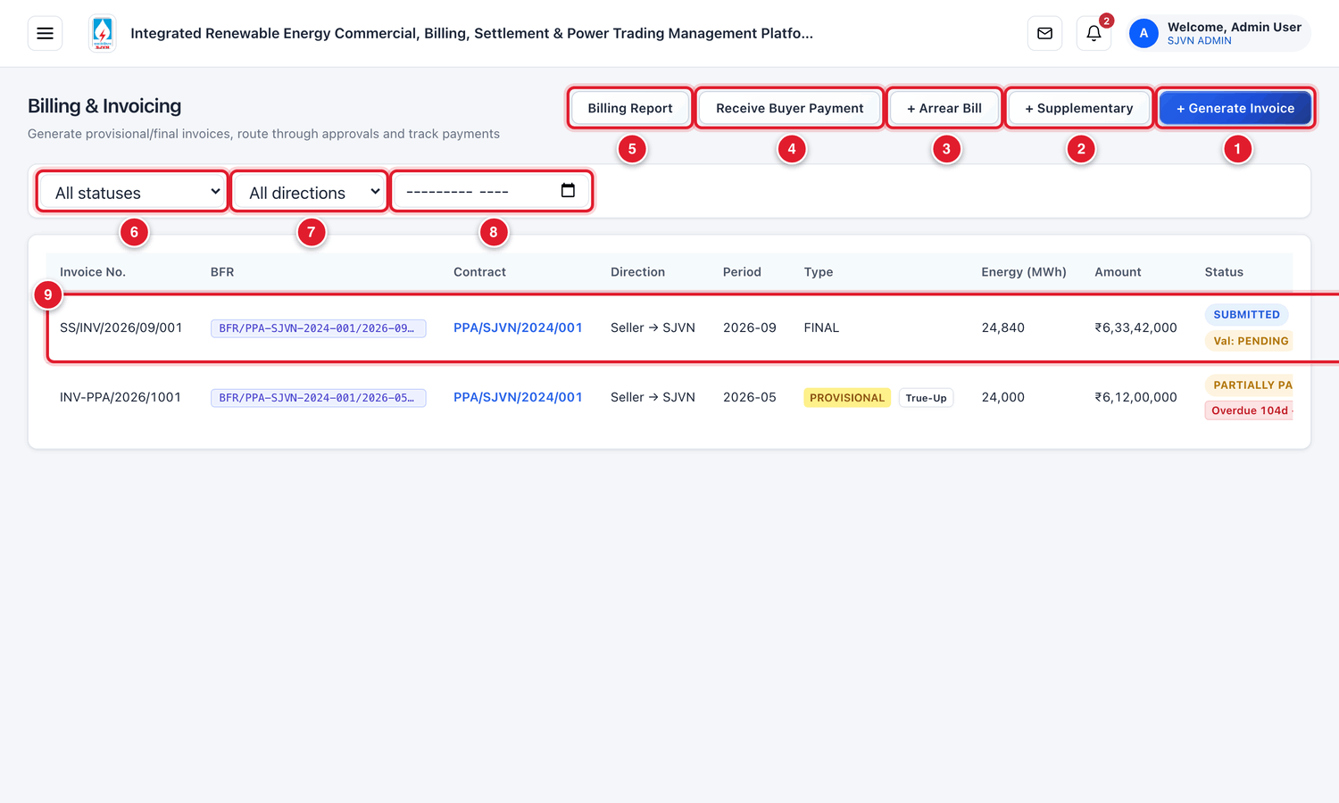
Figure 10.2 The Billing & Invoicing screen (menu hidden).
1 | + Generate Invoice: make a bill from locked energy.
2 | + Supplementary: make an extra bill for a correction (section 10.9).
3 | + Arrear Bill: recover an amount missed in an old month (section 10.9).
4 | Receive Buyer Payment: record a lump-sum payment from a buyer (Chapter 12).
5 | Billing Report: open the month-wise billing report.
6 | Status filter.
7 | Direction filter: Seller → SJVN or SJVN → Buyer.
8 | Month filter.
9 | One bill. Click the row to open it.

The status of a bill
Status | Meaning
DRAFT | Made, but not yet sent for approval. It can still be cancelled.
SUBMITTED | A seller’s invoice that has reached SJVN and is waiting to be checked.
UNDER APPROVAL | Sent for approval. It is with the approving officers.
APPROVED | All approvals are done. A PSA bill is now visible to the buyer.
REJECTED | An approver has rejected it.
PARTIALLY PAID | Some payment is recorded, but not the full amount.
PAID | Fully paid.
DISPUTED | A dispute is open on the bill.
CANCELLED | Cancelled. It does not count any more.

10.3 Step A: The seller submits its invoice
This step is done by the seller. It is shown here so that you know where the invoice comes from. Part 4 of this manual explains it for the seller.
The seller opens My Invoices and clicks + Create Invoice. After the seller chooses the contract and the month, the platform fills the energy, tariff and amount by itself from the locked energy data. The seller adds its own invoice number and clicks Submit to SJVN.
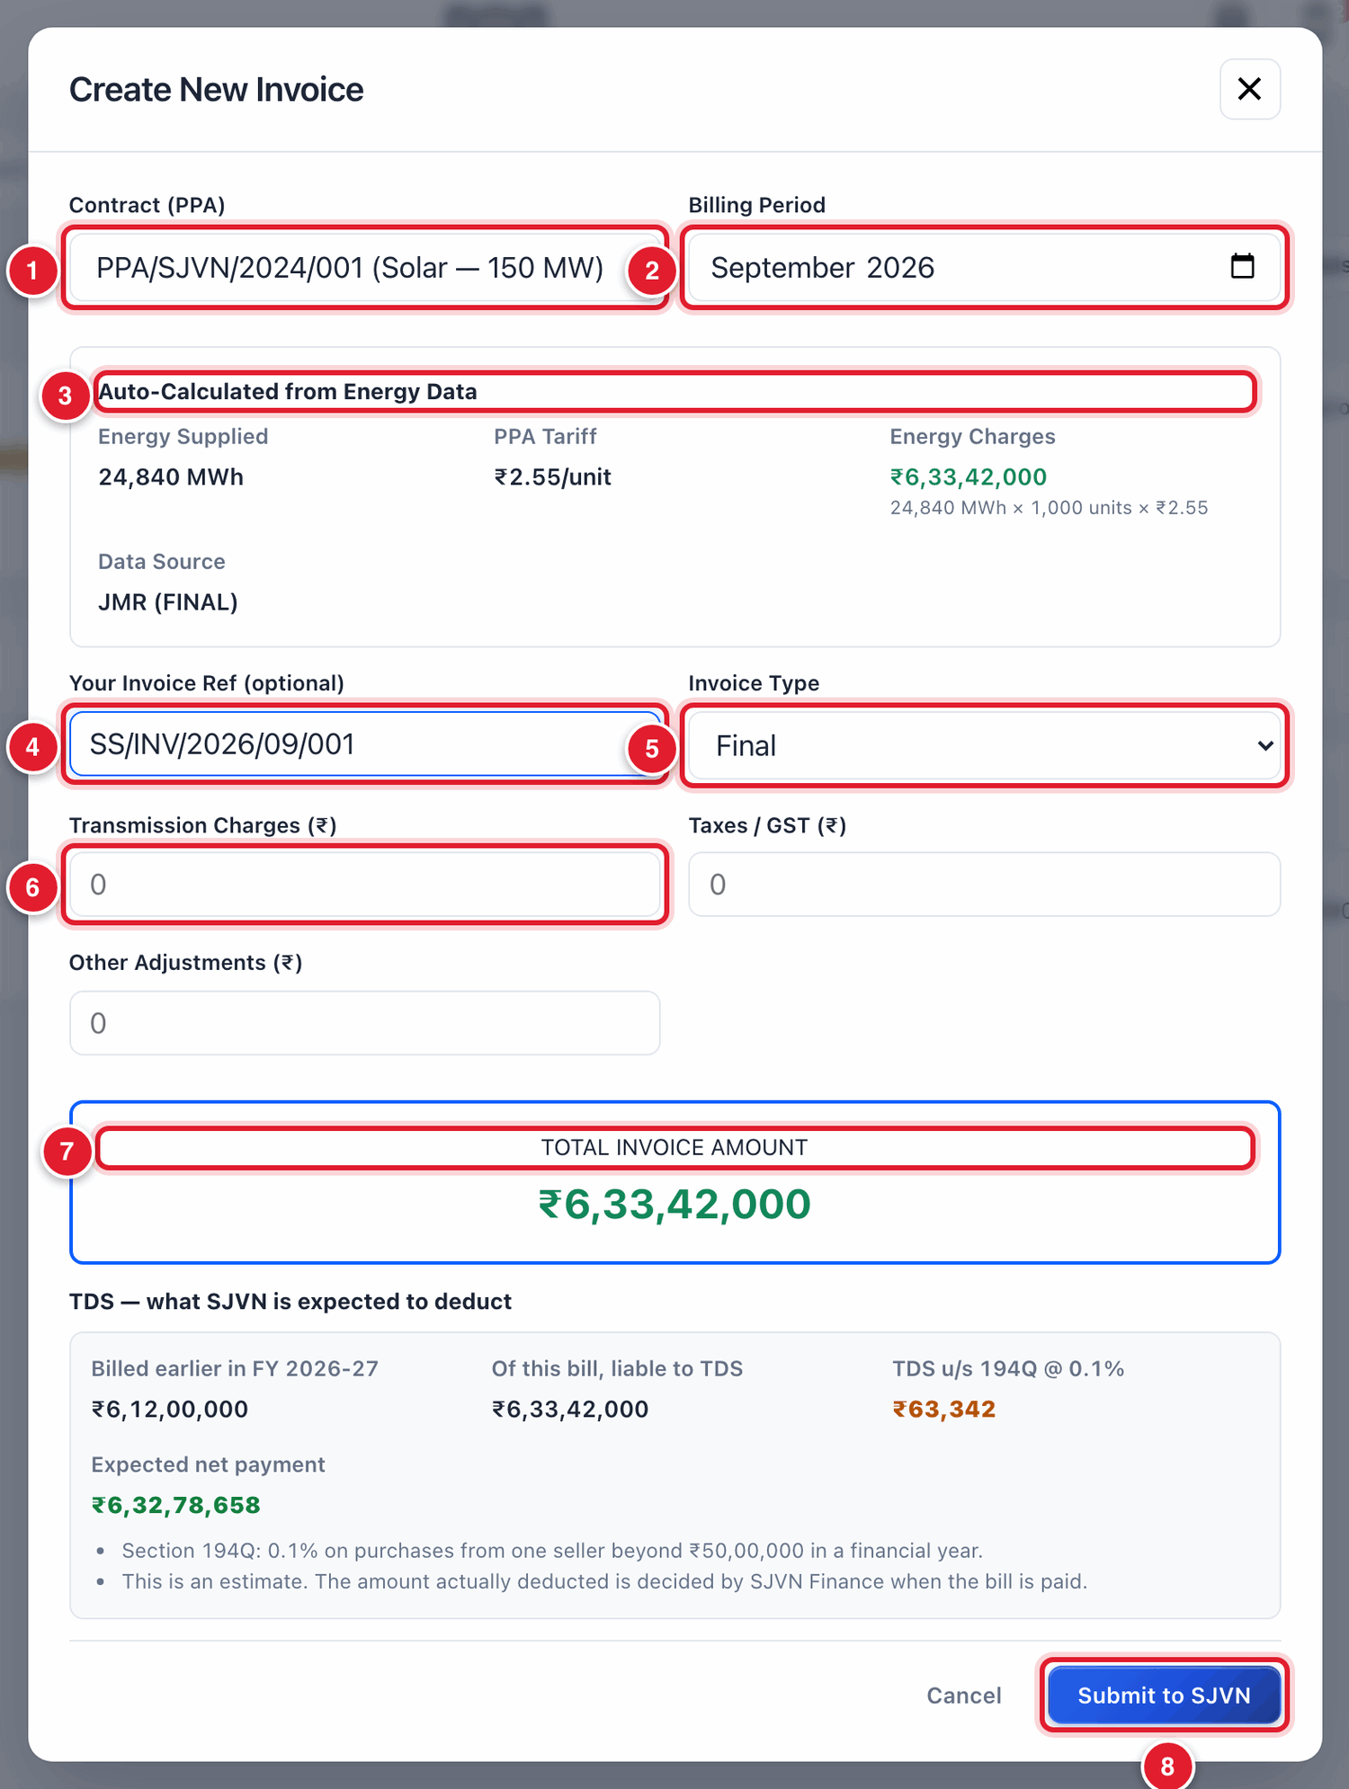
Figure 10.3 The seller’s Create New Invoice window.
1 | The seller’s PPA.
2 | The month.
3 | The energy, tariff and amount, filled by the platform from the locked energy.
4 | The seller’s own invoice number.
5 | Final, Provisional or Supplementary.
6 | Other charges, if any.
7 | The total of the invoice.
8 | Submit to SJVN.

The invoice then appears on SJVN’s Billing screen with the direction Seller → SJVN and the status SUBMITTED. Under the status a small line says Val: PENDING. It means the invoice has not yet been compared with SJVN’s own calculation.

10.4 Step B: Generate the system invoice for the PPA

To generate SJVN’s own calculation of the PPA bill
STEP  1 | On the Billing screen, click + Generate Invoice.

STEP  2 | Contract: choose the PPA.

STEP  3 | Billing Period: choose the month.

STEP  4 | Invoice Type: choose Final (when the energy of the month is final and locked). Choose Provisional only for an early bill on a provisional figure.

STEP  5 | Click Generate Invoice.

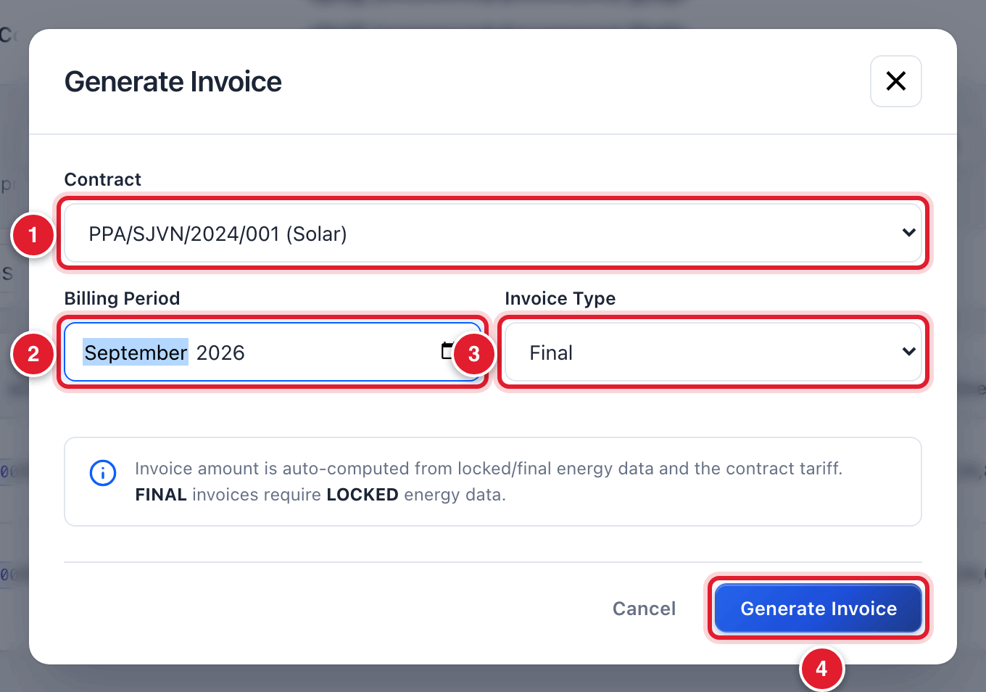
Figure 10.4 Generating the system invoice for the PPA.
1 | The PPA.
2 | The month.
3 | Final or Provisional.
4 | Click Generate Invoice.

WHAT YOU SHOULD SEE NOW
A green message says the invoice is generated as a draft and shows the amount. The new bill is at the top of the list with the status DRAFT. You do not have to type any amount: the platform calculates it as energy (MWh) × 1,000 × tariff (₹/unit).

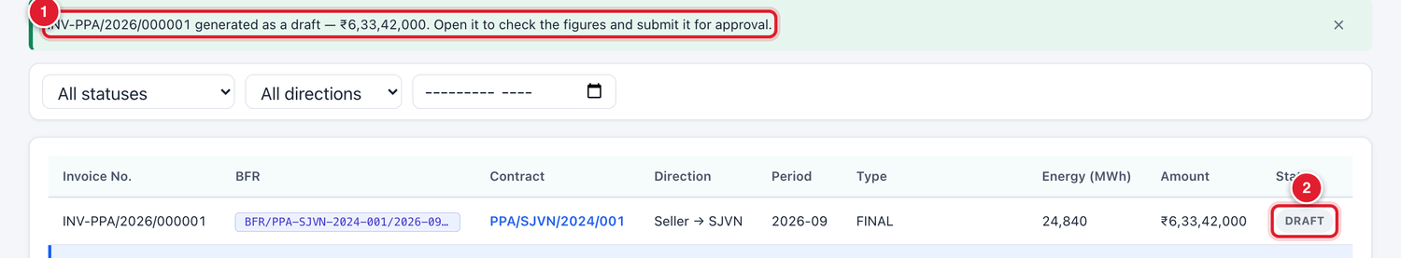
Figure 10.5 The system invoice is generated as a draft.
1 | The green message with the bill number and amount.
2 | Status DRAFT.

GOOD TO KNOW
This system invoice stays as a DRAFT. It is SJVN’s reference for checking. The bill that goes for approval and payment is the seller’s invoice.

10.5 Step C: Check the seller’s invoice
After steps A and B, the list has both PPA-side bills of the month.
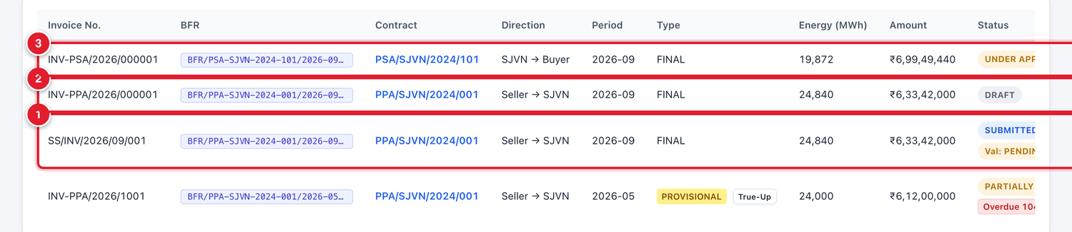
Figure 10.6 The bills of September 2026 in the list.
1 | The seller’s invoice (number given by the seller).
2 | The system invoice for the PPA (number starting with INV-PPA).
3 | SJVN’s bill on the buyer (number starting with INV-PSA). It is made in section 10.6.

To open and read the seller’s invoice
STEP  1 | Click the row of the seller’s invoice.

WHAT YOU SHOULD SEE NOW
The invoice opens in a big window. It is long. Move down with the mouse wheel to see all its parts.

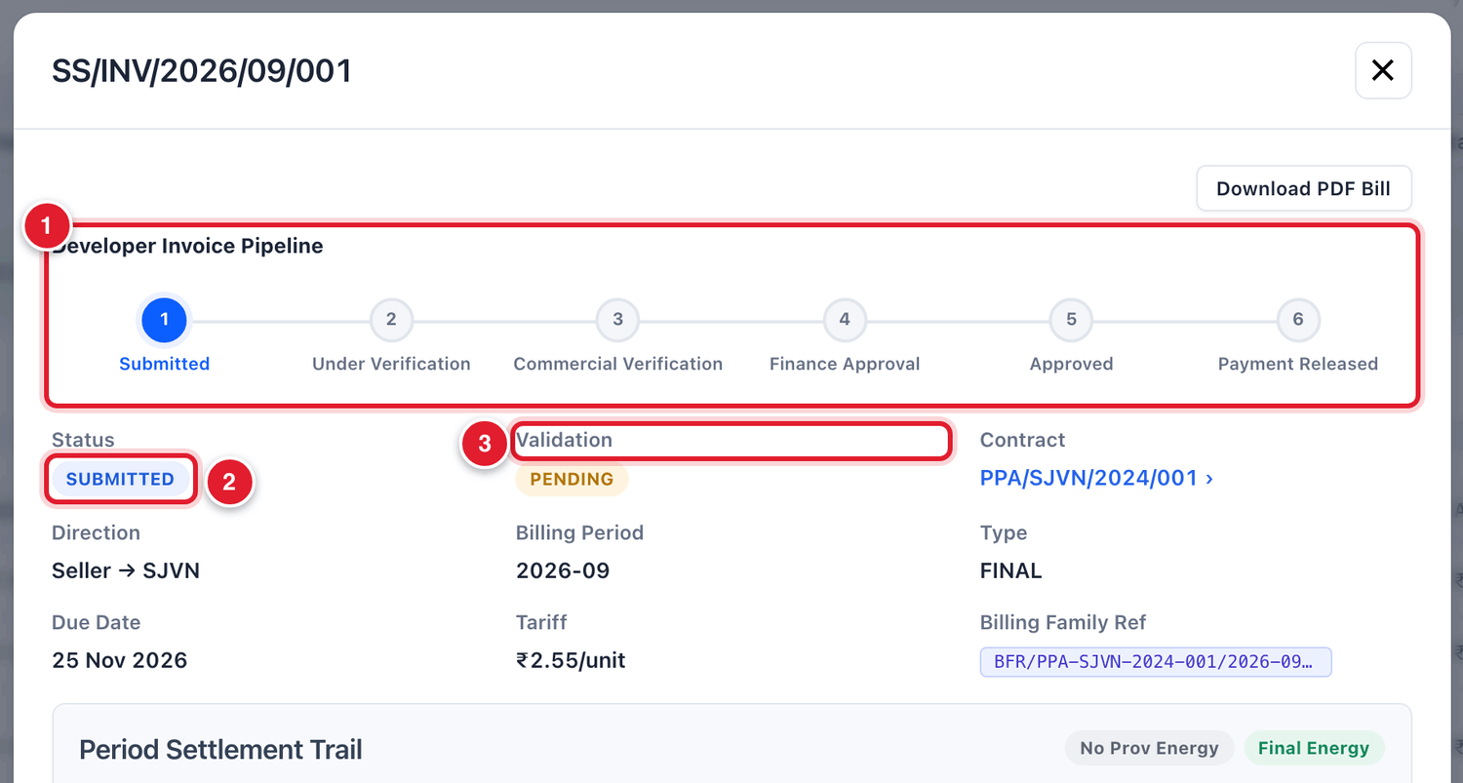
Figure 10.7 The top of the seller’s invoice.
1 | The pipeline: six stages from Submitted to Payment Released. The blue circle shows where the invoice is now.
2 | The status of the invoice.
3 | Validation: the result of comparing with the system invoice. PENDING means not yet compared.

Compare the seller’s invoice with the system invoice

To validate the seller’s invoice against the system
STEP  1 | Go to the bottom of the invoice window.

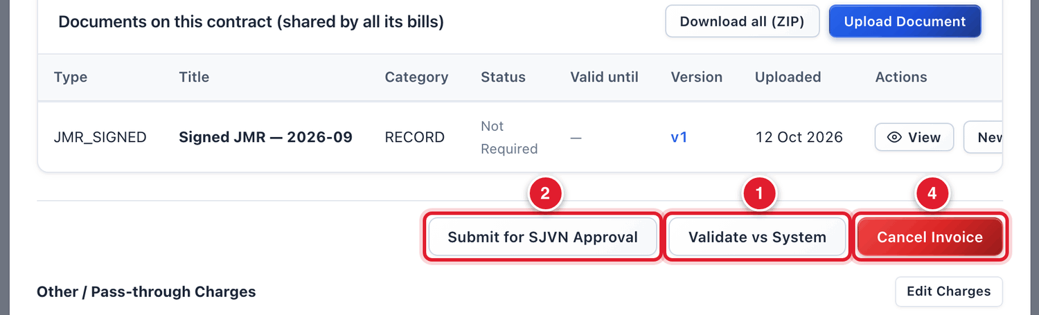
Figure 10.8 The buttons at the bottom of the seller’s invoice.
1 | Validate vs System: compare with SJVN’s own calculation.
2 | Submit for SJVN Approval: send the invoice for approval.
3 | Return to seller: send the invoice back for correction (section 10.8).
4 | Cancel Invoice: cancel the invoice.

STEP  2 | Click Validate vs System.

WHAT YOU SHOULD SEE NOW
A window named Seller vs System Validation opens. It shows the seller’s figure, the system’s figure and the difference for each line.

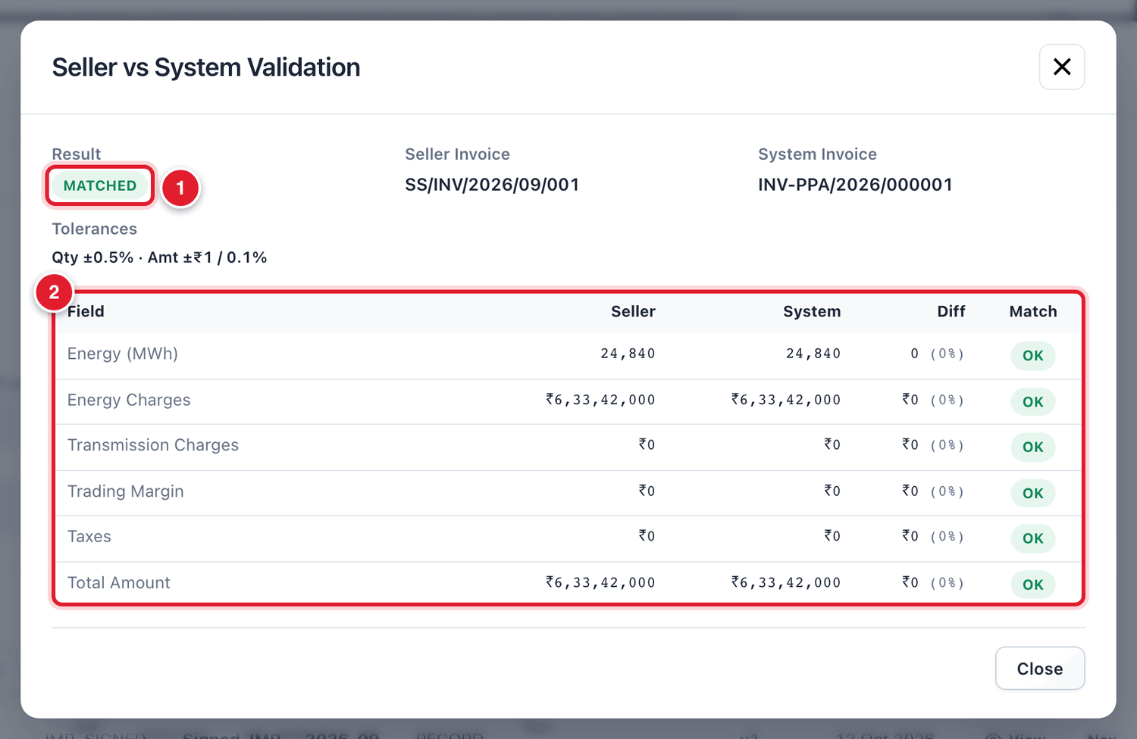
Figure 10.9 The result of the comparison.
1 | The result. MATCHED means the two invoices agree.
2 | Line by line: energy, energy charges, transmission, trading margin, taxes and total. OK means that line agrees.

STEP  3 | Read the result and click Close.

Result | Meaning | What to do
MATCHED | Every line agrees (within a very small tolerance). | Go on to the checklist.
A line shows a difference | The seller’s figure is different from SJVN’s. | Find out which is right. If the seller is wrong, return the invoice to the seller (section 10.8).
“No system counterpart invoice found” | The system invoice for this contract and month has not been generated. | Generate it (section 10.4) and validate again.

The verification checklist
In the middle of the invoice there is a Verification Checklist. It has eight technical checks. The platform fills what it can by itself and shows its finding under each check. You confirm each one.
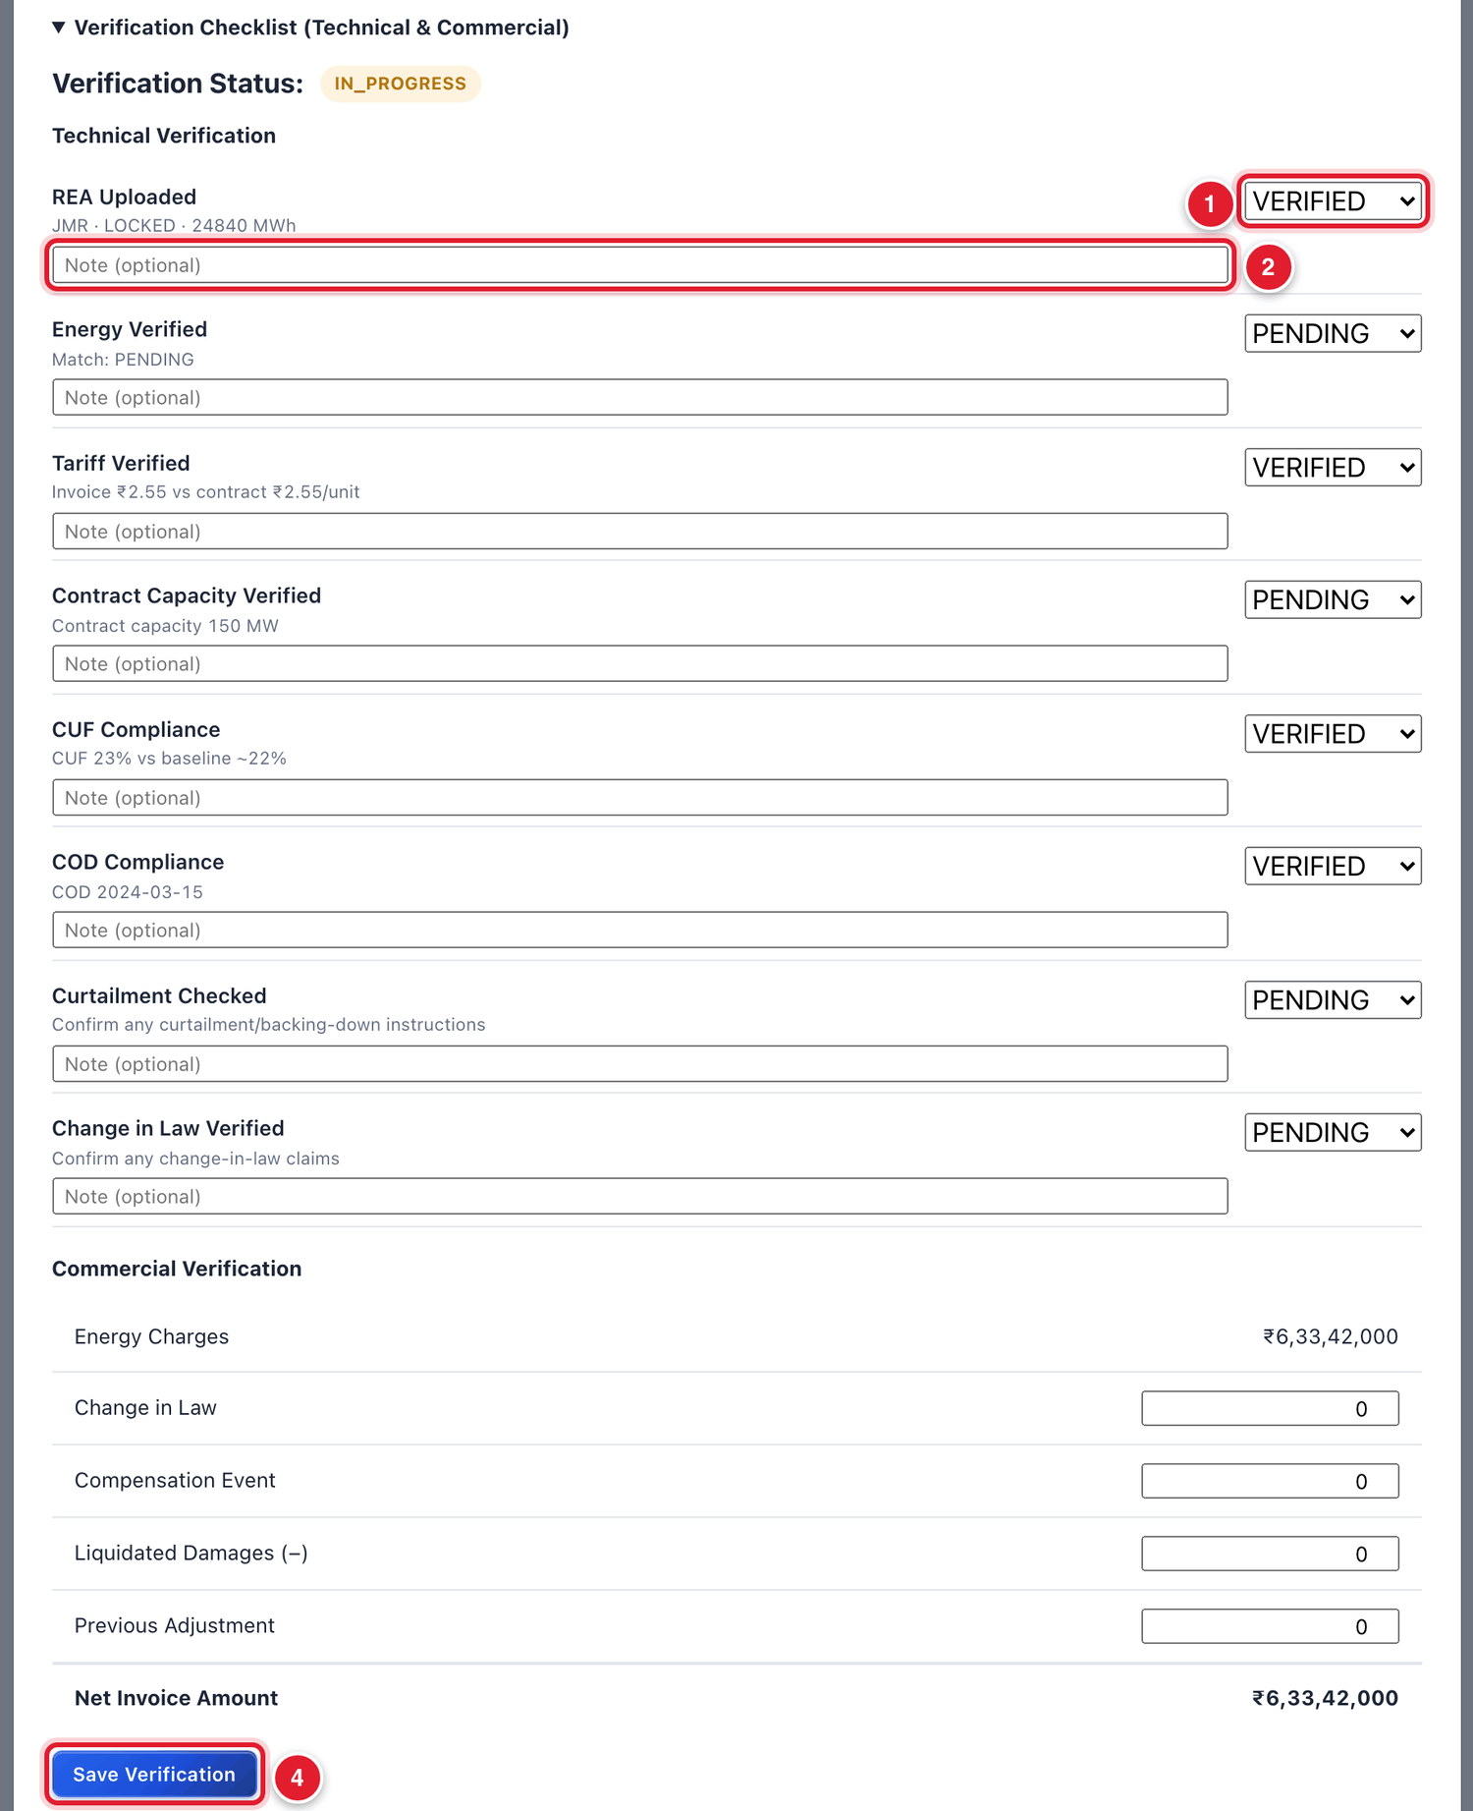
Figure 10.10 The verification checklist.
1 | The result of this check. Choose VERIFIED, PENDING, FAILED or NA.
2 | A short note for this check (optional).
3 | Commercial Verification: amounts for change in law, compensation, liquidated damages and previous adjustment, if any.
4 | Save Verification: save the checklist.

Check | What you confirm
REA Uploaded | The energy account (JMR / REA) of the month is on record and locked.
Energy Verified | The energy on the invoice is the same as the locked energy.
Tariff Verified | The tariff on the invoice is the contract tariff.
Contract Capacity Verified | The capacity is as per the contract.
CUF Compliance | The CUF of the month meets the contract’s minimum.
COD Compliance | The plant has achieved COD.
Curtailment Checked | Any curtailment or backing-down instruction of the month has been considered.
Change in Law Verified | Any change-in-law claim has been considered.

To complete the checklist
STEP  1 | For each of the eight checks, click the small box at the right and choose VERIFIED if it is in order. Choose FAILED if it is not, and NA if it does not apply.

STEP  2 | If you want, type a short note under a check.

STEP  3 | If there is a change-in-law amount, compensation, liquidated damages or previous adjustment, type the amount in Commercial Verification.

STEP  4 | Click Save Verification.

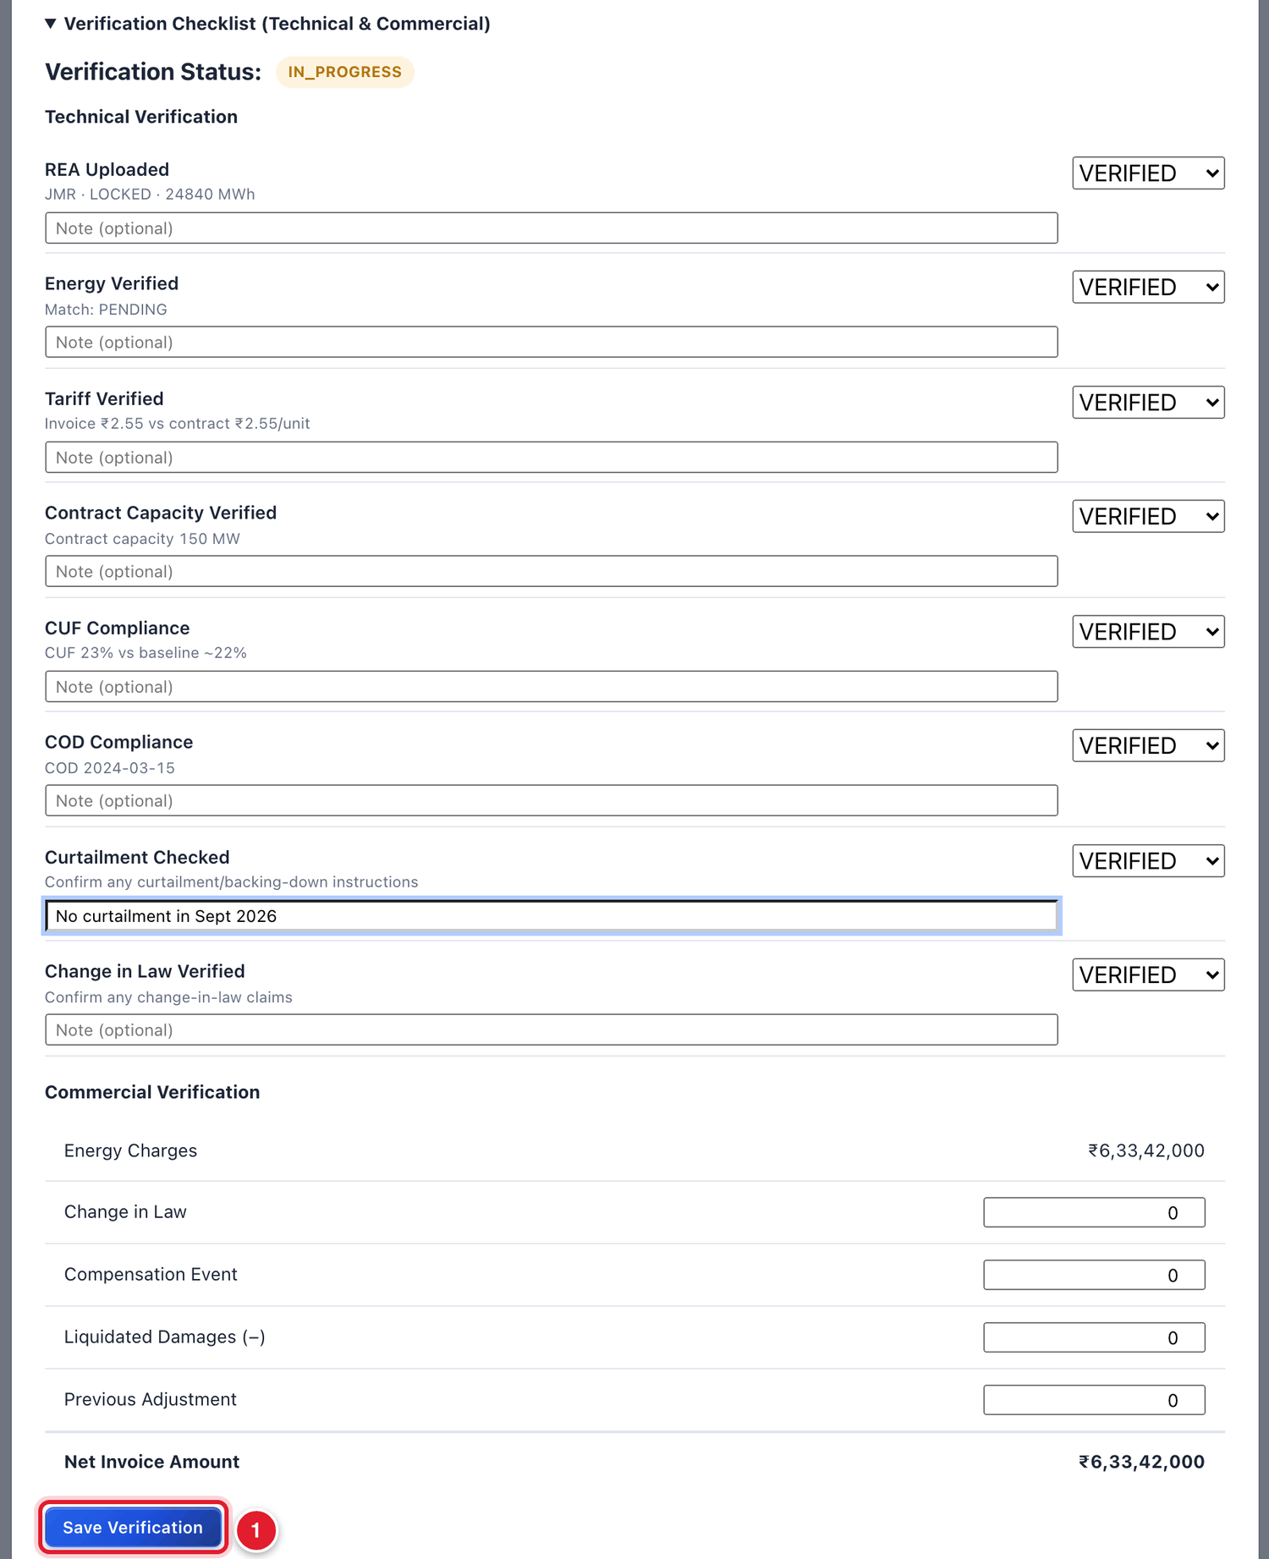
Figure 10.11 All checks marked VERIFIED.
1 | Click Save Verification.

WHAT YOU SHOULD SEE NOW
The words Verification saved appear next to the button. The Verification Status at the top of the checklist becomes VERIFIED.

Send the seller’s invoice for approval

To submit the seller’s invoice for approval
STEP  1 | Go to the bottom of the invoice window and click Submit for SJVN Approval.

WHAT YOU SHOULD SEE NOW
The status becomes UNDER APPROVAL. A part named Approval Workflow appears with the approval levels. Chapter 11 explains the approval.

10.6 Step D: Generate the bill on the buyer

To generate SJVN’s bill on the buyer
STEP  1 | On the Billing screen, click + Generate Invoice.

STEP  2 | Contract: choose the PSA. Billing Period: the same month. Invoice Type: Final.

STEP  3 | Click Generate Invoice.

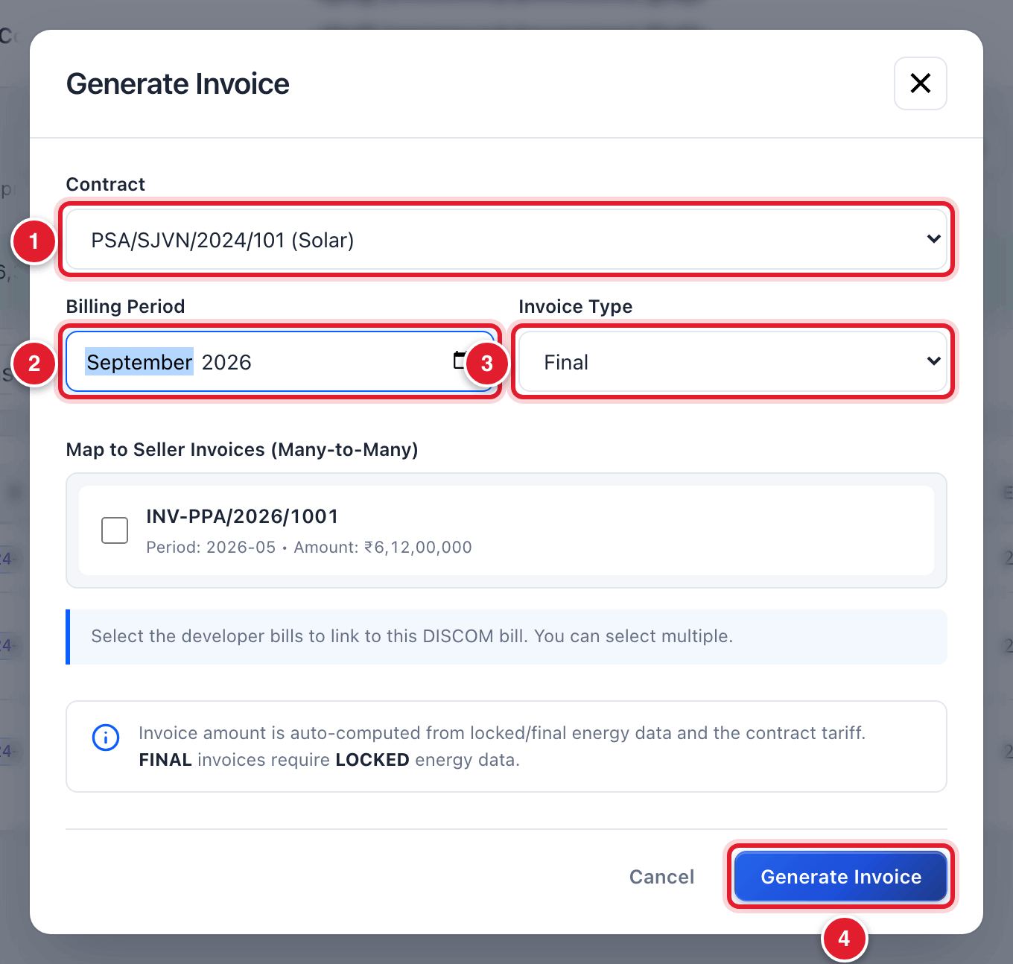
Figure 10.12 Generating the bill on the buyer.
1 | The PSA.
2 | The month.
3 | Final.
4 | Click Generate Invoice.

WHAT YOU SHOULD SEE NOW
The bill is made as a DRAFT with a number starting with INV-PSA.

GOOD TO KNOW
If you try to generate the same bill twice, the platform refuses and tells you the number of the bill that already exists. For a correction, cancel the draft first or raise a supplementary bill.

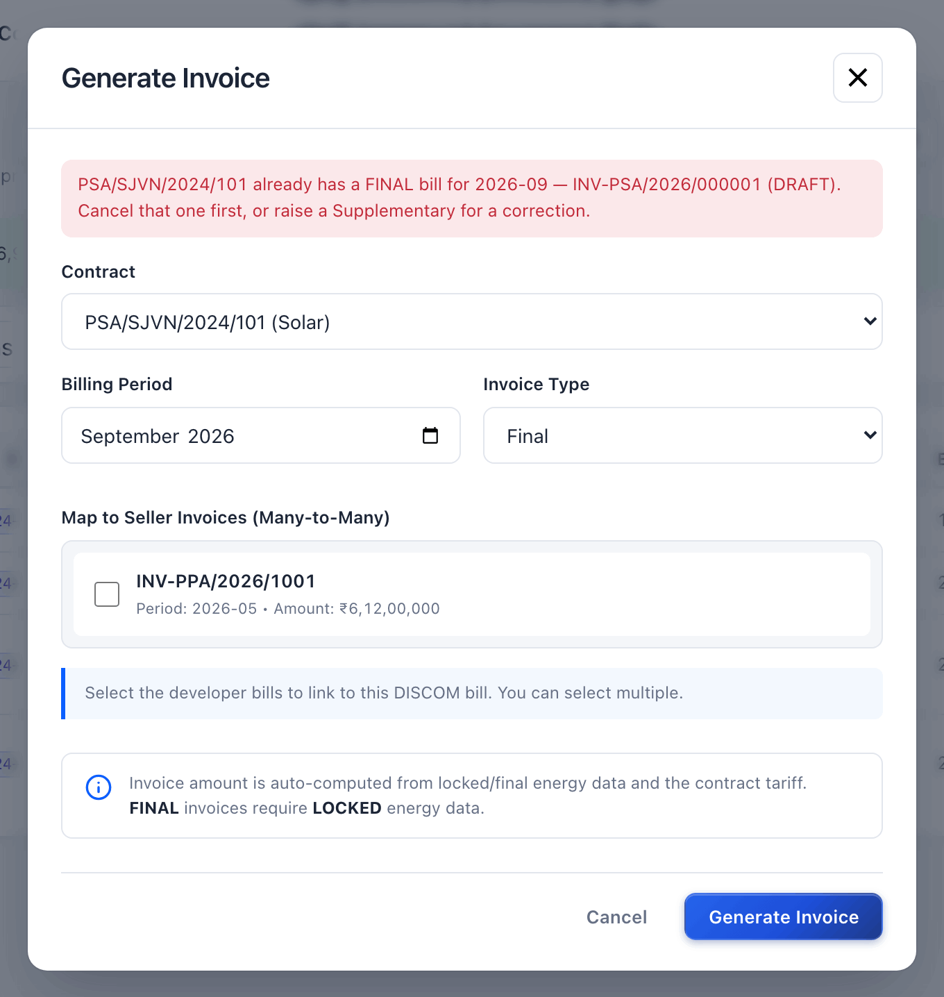
Figure 10.13 The platform refuses to make the same bill twice.

10.7 Reading a bill
Click the row of the PSA bill to open it. Always read a bill fully before sending it for approval.
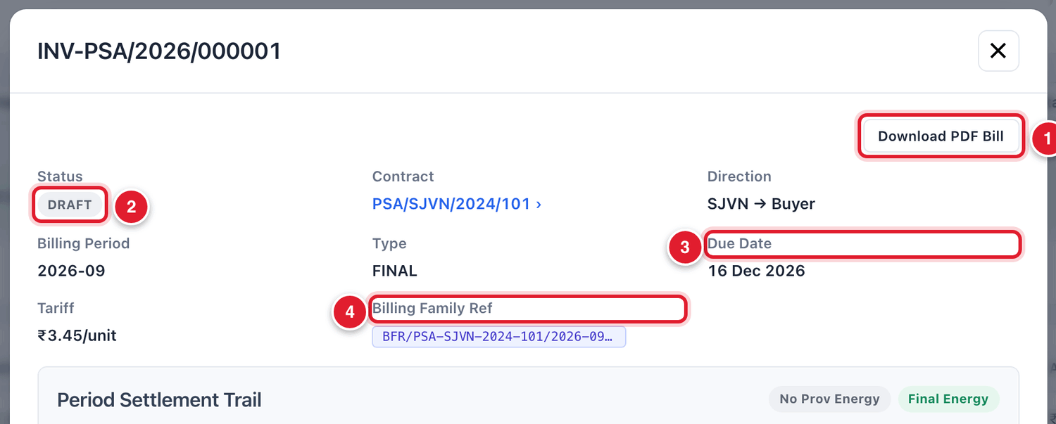
Figure 10.14 The top of the bill.
1 | Download PDF Bill: download the bill as a PDF, as the buyer will receive it.
2 | The status.
3 | The due date. It is worked out from the payment terms of the contract.
4 | The Billing Family Ref (BFR): the common reference of this contract and month.

Period Settlement Trail
This box shows the energy on which the bill stands and every bill of the same contract and month. For a PSA bill, it shows the energy of the source PPA.
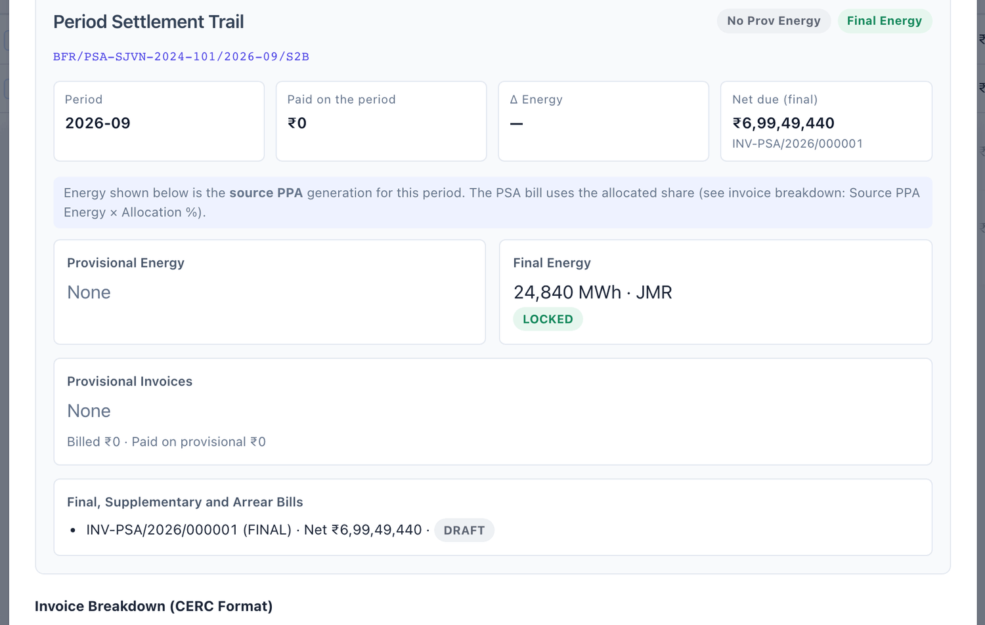
Figure 10.15 The Period Settlement Trail inside the bill.

Invoice Breakdown
This table shows how the amount was calculated. Check every line.
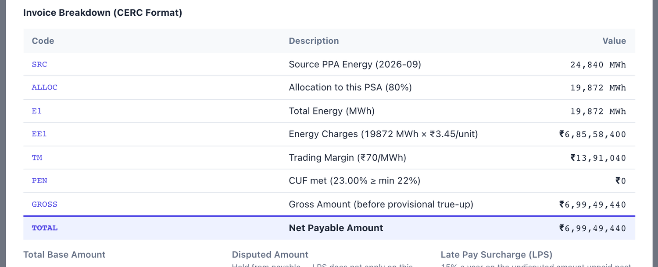
Figure 10.16 The invoice breakdown of a PSA bill.
Code | Line | Meaning
SRC | Source PPA Energy | The locked energy of the PPA for the month.
ALLOC | Allocation to this PSA | The share of that energy that belongs to this buyer (from the PSA mapping).
E1 | Total Energy (MWh) | The energy billed to this buyer.
EE1 | Energy Charges | Energy × 1,000 × tariff.
TM | Trading Margin | SJVN’s margin, in ₹ per MWh, as per the PSA.
PEN | CUF line | A penalty if the CUF of the month is below the minimum. ₹0 when the CUF is met.
GROSS | Gross Amount | The total before any provisional adjustment.
TOTAL | Net Payable Amount | The amount of the bill.

The amount boxes
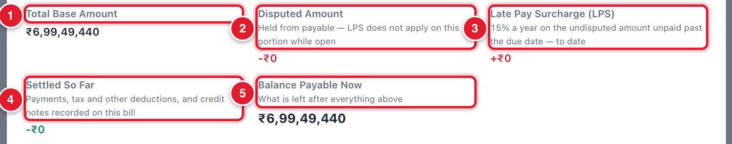
Figure 10.17 The amount boxes below the breakdown.
1 | Total Base Amount: the amount of the bill.
2 | Disputed Amount: any amount held because of an open dispute.
3 | Late Pay Surcharge (LPS): surcharge earned so far on the unpaid amount after the due date.
4 | Settled So Far: payments, deductions and credit notes recorded on the bill.
5 | Balance Payable Now: what is still to be paid.

The buttons at the bottom of a draft bill
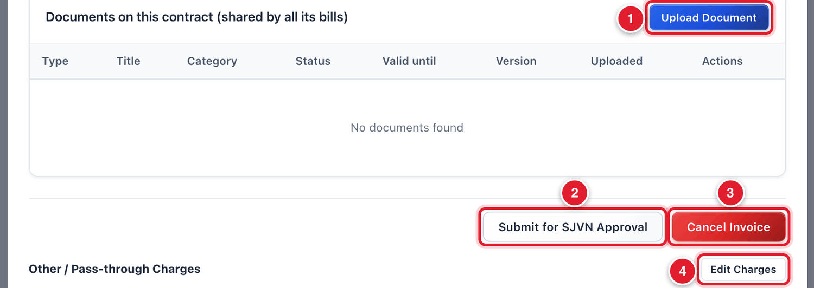
Figure 10.18 The bottom of a draft bill.
1 | Upload Document: attach a paper to the contract.
2 | Submit for SJVN Approval: send the bill for approval.
3 | Cancel Invoice: cancel this draft.
4 | Edit Charges: add pass-through charges such as transmission or RLDC charges.

To add a pass-through charge to a draft bill
STEP  1 | Click Edit Charges.

STEP  2 | Click + Add charge. Choose the Type (Transmission / wheeling, RLDC / SLDC, CTU / STU, Open access, Scheduling & SO, or Other pass-through) and type the Amount (₹).

STEP  3 | Click Save Charges.

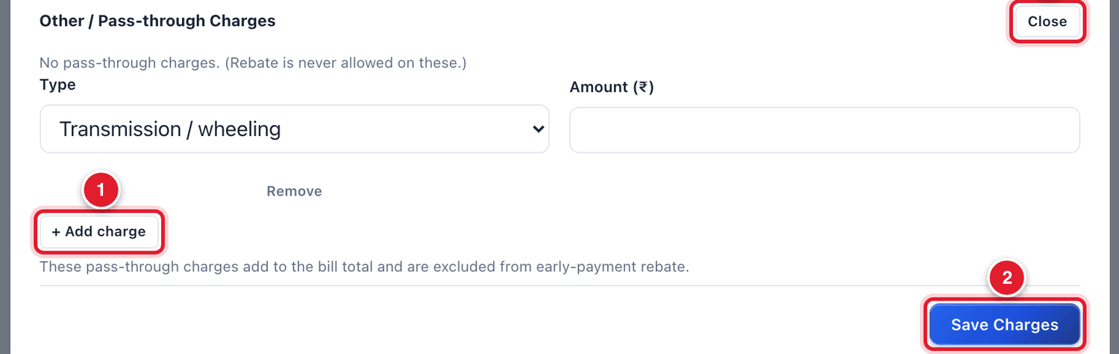
Figure 10.19 Adding a pass-through charge.
1 | + Add charge.
2 | Save Charges.
3 | Close without saving.

IMPORTANT
Charges can be changed only while the bill is a DRAFT. Once it goes for approval the total is fixed. A later change needs a debit or credit note.

To send the buyer’s bill for approval
STEP  1 | Read the whole bill once more. Check the energy, the tariff, the share and the total.

STEP  2 | Click Submit for SJVN Approval.

WHAT YOU SHOULD SEE NOW
The status becomes UNDER APPROVAL. The Approval Workflow part shows the levels. For the person who raised the bill it says: *You raised this bill, so someone else has to decide it.*

10.8 Returning an invoice to the seller
If the seller’s invoice is wrong, send it back with the reason. The seller corrects it and submits it again.

To return an invoice to the seller
STEP  1 | Open the seller’s invoice.

STEP  2 | Under Approval Workflow, click inside the comment box and type clearly what is wrong.

STEP  3 | Click the red button Return to seller.

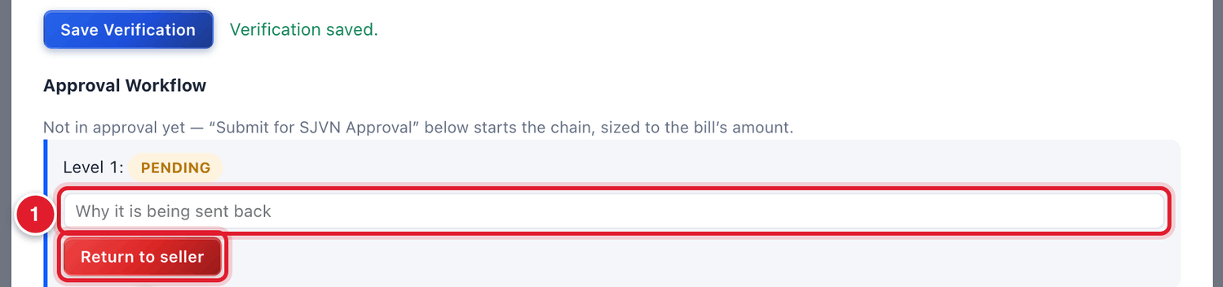
Figure 10.20 Returning an invoice to the seller.
1 | Type why it is being sent back.
2 | Click Return to seller.

10.9 Supplementary and arrear bills

Supplementary bill
A supplementary bill is an extra bill for a correction on a month that is already billed: a revised REA, a change in law, transmission charges, late payment surcharge and so on. A positive amount is a debit (the party owes more). A negative amount is a credit (the party owes less).

To raise a supplementary bill
STEP  1 | Click + Supplementary at the top of the Billing screen.

STEP  2 | Fill the boxes and click Create Supplementary.

Field | What to enter | Example
Contract * | The PPA or PSA. | PSA/SJVN/2024/101
Billing Period * | The month to which the correction belongs. | September 2026
Reason Category * | Revised / amended REA true-up, Change in Law, Transmission charges, Late Payment Surcharge, β true-up or Other. | Transmission charges
Adjustment Amount (₹) * | The amount. Positive = debit. Negative (with a minus sign) = credit. | 125000
Taxes / GST (₹), Transmission (₹) | Fill only if they apply. | 0
Link to Parent Invoice (optional) | The original bill that this one corrects. | INV-PSA/2026/000001
Reason / Reference * | Why, with the order or letter number. | ISTS charges for Sept 2026 as per RTA bill…

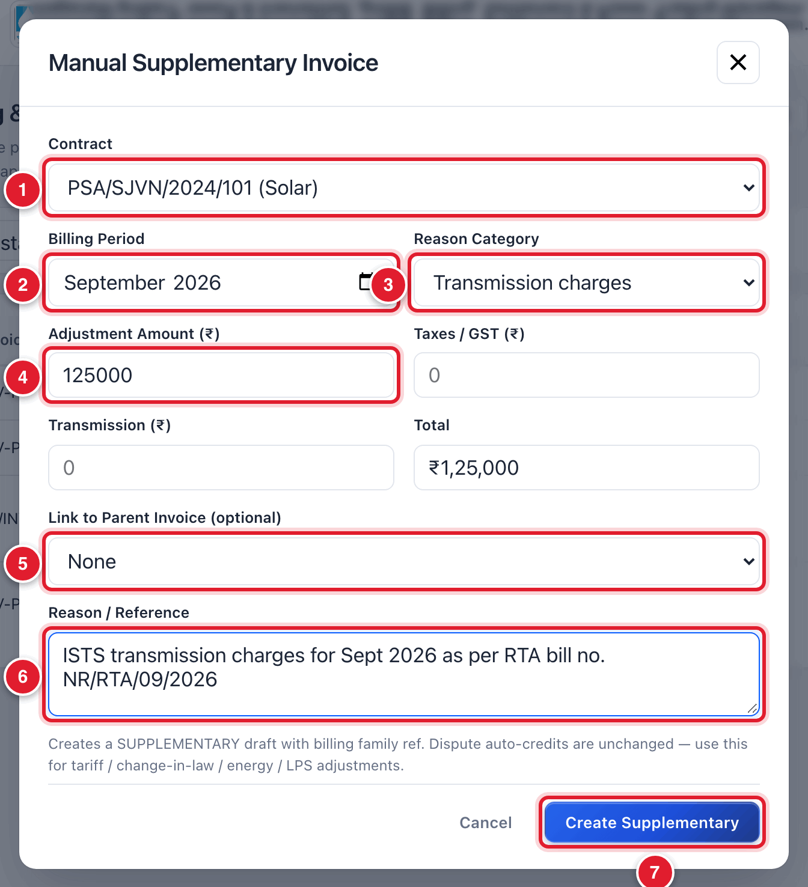
Figure 10.21 The Manual Supplementary Invoice window.
1 | Contract.
2 | Month.
3 | Reason category.
4 | Amount.
5 | The original bill (optional).
6 | Reason.
7 | Click Create Supplementary.

Arrear bill
An arrear bill recovers an amount that was missed or under-billed in a past month, for example after a tariff revision with a back date. It is always a positive amount.

To raise an arrear bill
STEP  1 | Click + Arrear Bill.

STEP  2 | Choose the Contract, the Arrear Period (the old month), type the Arrear Amount (₹) and the Reason for arrear.

STEP  3 | Click Raise Arrear.

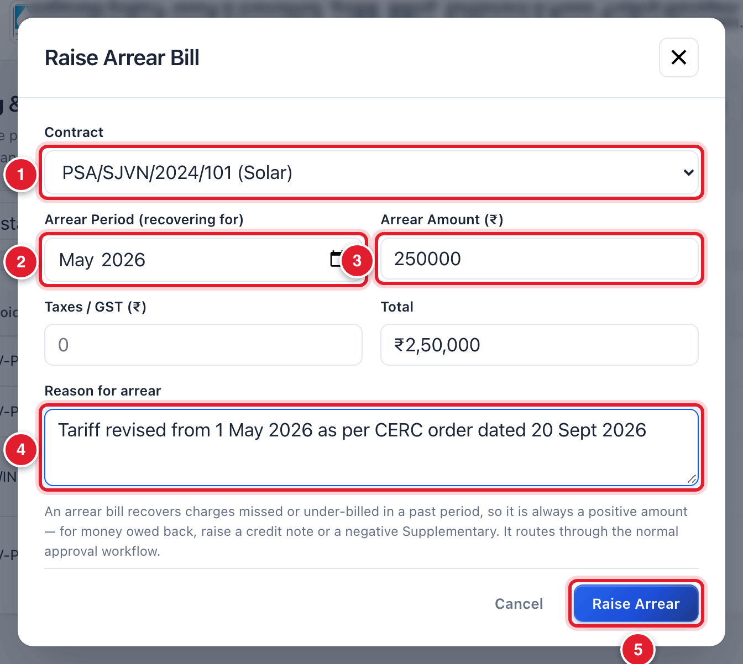
Figure 10.22 The Raise Arrear Bill window.
1 | Contract.
2 | The old month being recovered.
3 | Amount.
4 | Reason.
5 | Click Raise Arrear.

GOOD TO KNOW
Supplementary and arrear bills are made as DRAFT and go through the same approval as any other bill.

10.10 E-invoice number and signed copy
On a bill, two small parts keep the statutory references:
- E-invoice (IRN & QR): click Add IRN & QR. Either upload the JSON file downloaded from the e-invoice portal (the boxes get filled by themselves), or type the 64-character IRN, the acknowledgement number and date.
- Digitally signed copy: click Attach signed copy and choose the signed PDF of the bill.
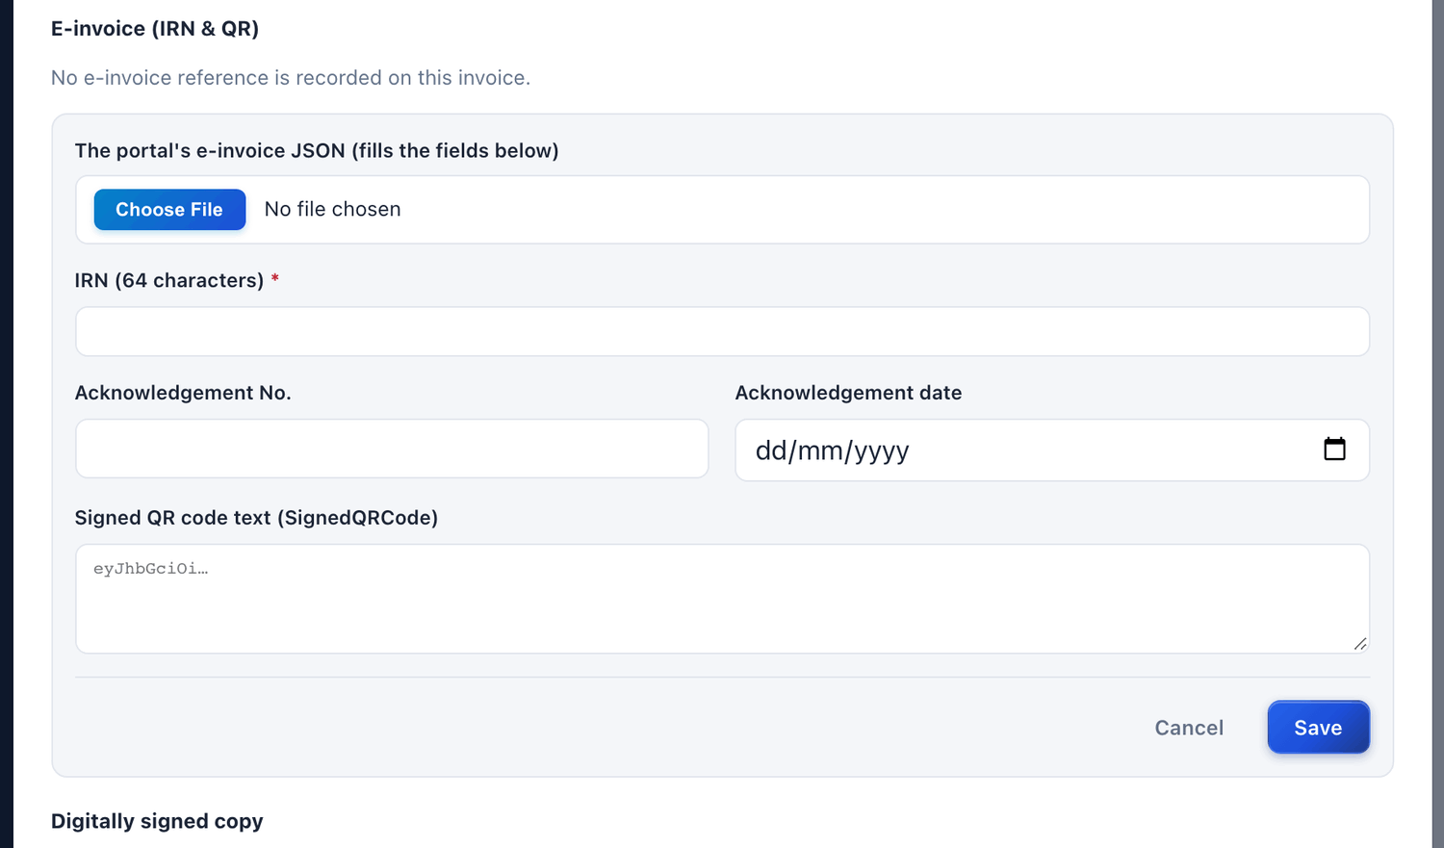
Figure 10.23 Adding the IRN and QR of the e-invoice.

10.11 Common questions
If you see this | Why it happens | What to do
“FINAL invoices require LOCKED energy data” | The energy of the month is not locked. | Lock the energy record first (Chapter 9).
“… already has a FINAL bill for …” | A bill for this contract, month and type already exists. | Open the existing bill. For a correction, raise a supplementary bill.
“No system counterpart invoice found” | The system invoice of the PPA for that month is not generated. | Generate it with + Generate Invoice and validate again.
The buyer says it cannot see the bill | The bill is still DRAFT or UNDER APPROVAL. The buyer sees it only after the final approval. | Complete the approval (Chapter 11).
The amount of the PSA bill is zero or too low | The PSA is not mapped to the PPA, or the share is wrong. | Check the mapping in the contract (section 7.4).
There is no Submit for SJVN Approval button | The bill is not a DRAFT any more. It is already submitted, approved or cancelled. | Look at the status at the top of the bill.

CHAPTER 11

11. Approving a bill
How a bill goes from officer to officer until it is approved.
What it is for | No bill is final until it is approved. Each level is approved by a different person, so that every bill is seen by more than one officer.
Who uses it | REIA Ops (Level 1), REIA Admin (Level 2), Finance (Level 3).
How to open it | Menu → REIA Billing & Settlement → Billing & Invoicing → open the bill.
When to use it | Whenever the dashboard or the bell says a bill is waiting for your approval.

11.1 The rules of approval
- A bill has one, two or three levels of approval. The number depends on the amount of the bill. Large bills need all three levels.
- The levels are done in order: Level 1 first, then Level 2, then Level 3.
- The person who raised the bill cannot approve it. Someone else must decide it.
- Each approver can Approve or Reject. To reject, a comment is compulsory.
- After the last level, the bill becomes APPROVED.
Level | Usually done by | What this officer checks
Level 1 | REIA Ops (REIA desk) | Energy, tariff and share are as per the records and the contract.
Level 2 | REIA Admin | The checks of Level 1 are complete. The bill is fit to be issued.
Level 3 | Finance | The amount, taxes and due date are correct from the accounts side.

11.2 How to approve a bill

To approve a bill at your level
STEP  1 | Sign in with your own login.

STEP  2 | Open Billing & Invoicing from the menu. To see only the bills that are waiting, click the status filter and choose UNDER APPROVAL.

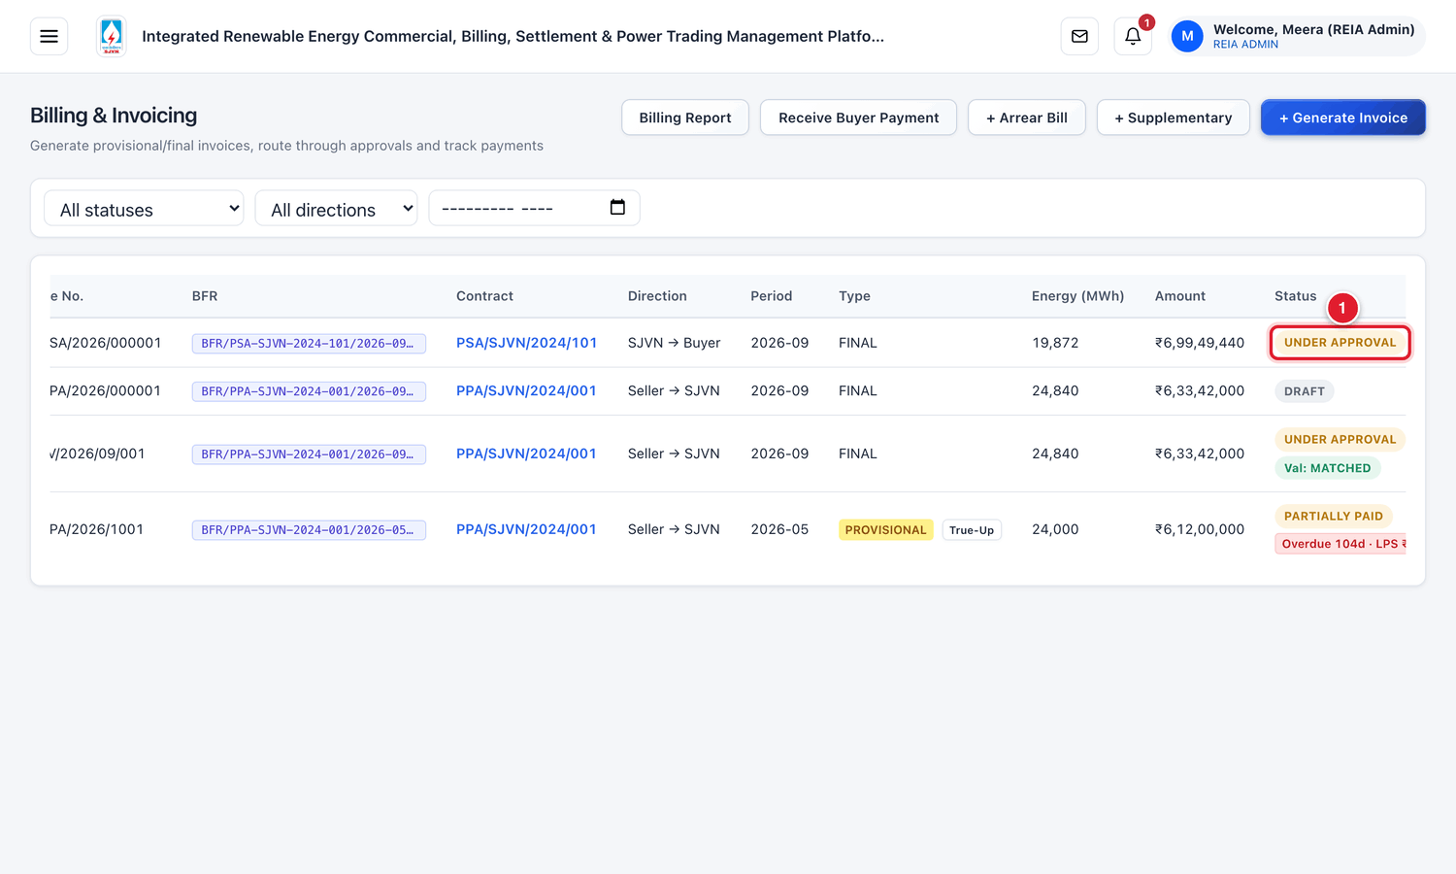
Figure 11.1 Bills waiting for approval in the list.
1 | The status UNDER APPROVAL.

STEP  3 | Click the row of the bill. The bill opens.

STEP  4 | Read the bill fully. Check the breakdown, the total and the due date (see section 10.7).

STEP  5 | Go down to the part named Approval Workflow. The level that is waiting for you shows a comment box and two buttons.

STEP  6 | Type a short comment in the box, for example what you checked.

STEP  7 | Click the green button Approve.

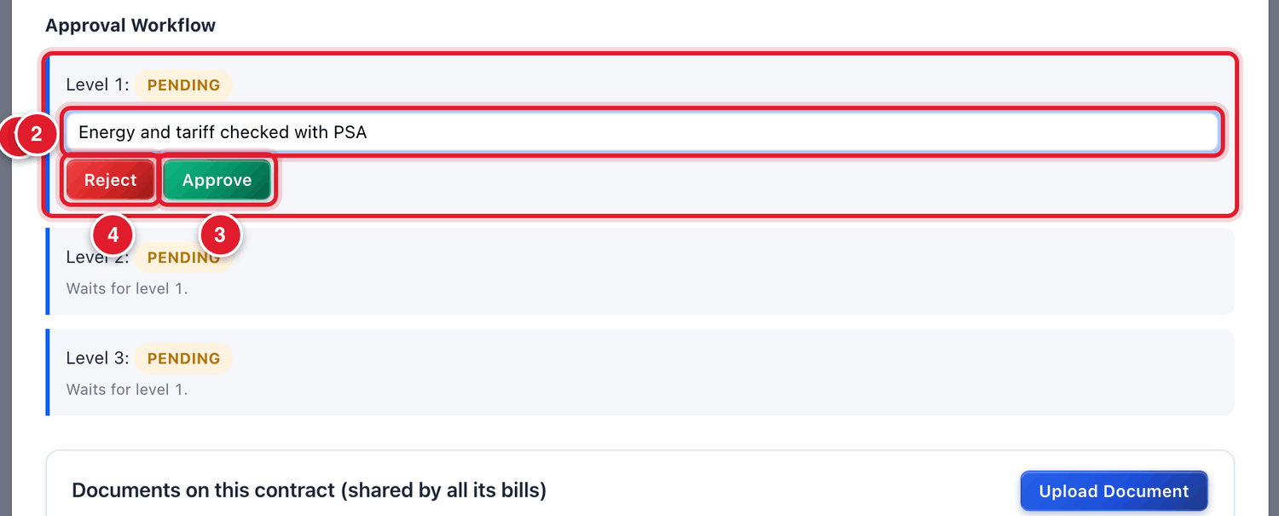
Figure 11.2 Level 1 approval.
1 | The level that is waiting. It shows PENDING.
2 | The comment box.
3 | Approve.
4 | Reject.

WHAT YOU SHOULD SEE NOW
Your level now shows APPROVED by your name, with the date, time and your comment. The next level becomes active for the next officer.

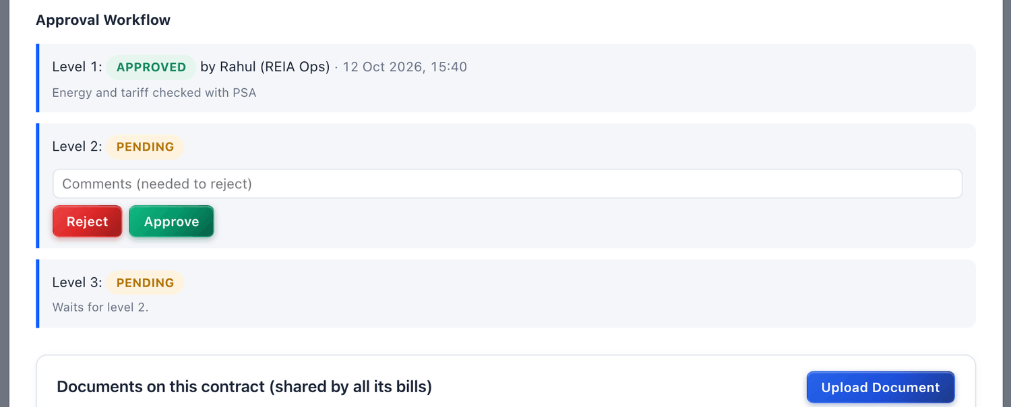
Figure 11.3 After Level 1 is approved.
The next officers do the same at Level 2 and Level 3.
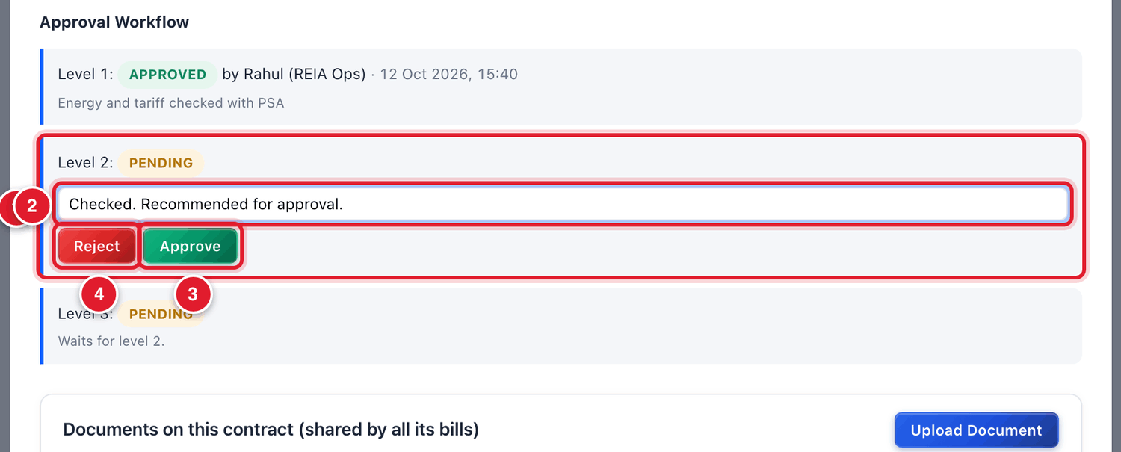
Figure 11.4 Level 2 approval by REIA Admin.
1 | Level 2 is now waiting.
2 | Comment.
3 | Approve.
4 | Reject.

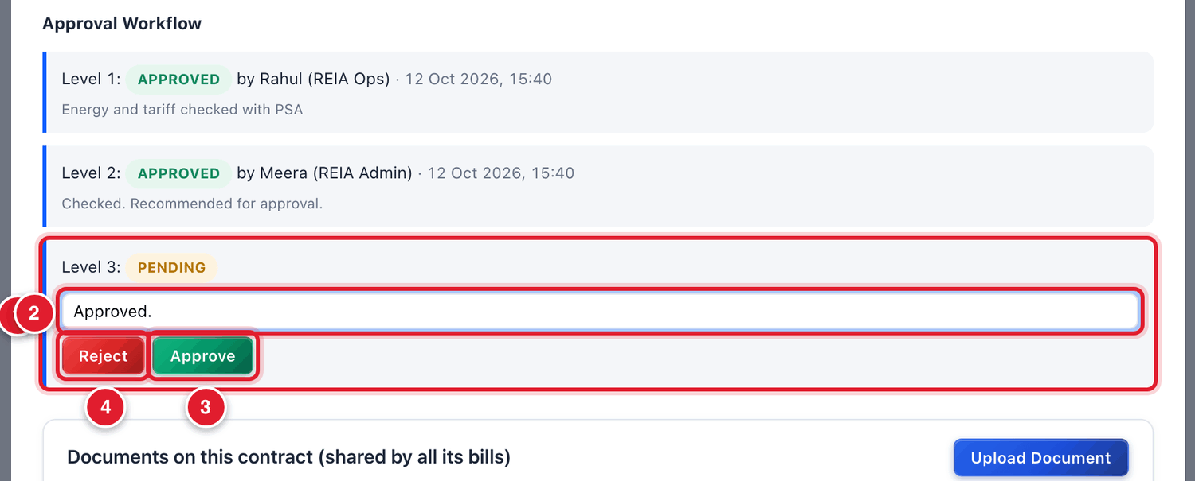
Figure 11.5 Level 3 approval by Finance.
1 | Level 3 is now waiting.
2 | Comment.
3 | Approve.
4 | Reject.

WHAT YOU SHOULD SEE NOW
After the last level, the status of the bill is green APPROVED. For a bill on a buyer, the buyer can now see it in its login and gets an alert. For a seller’s invoice, the seller sees that it is approved.

11.3 How to reject a bill

To reject a bill
STEP  1 | Open the bill and go to Approval Workflow.

STEP  2 | In the comment box, type clearly why you are rejecting. This is compulsory.

STEP  3 | Click the red button Reject.

WHAT YOU SHOULD SEE NOW
The status of the bill becomes REJECTED. The person who raised it gets an alert with your comment. The bill has to be corrected and raised again.

11.4 What the messages in Approval Workflow mean
Message under a level | Meaning
You raised this bill, so someone else has to decide it. | You are the person who raised the bill. You cannot approve it.
Waits for level 1. (or level 2) | An earlier level is not yet approved. This level cannot act now.
A different person is needed for this level. | You approved an earlier level of this bill. Another officer must approve this one.
APPROVED by … · date, time | This level is done.

11.5 Common questions
If you see this | Why it happens | What to do
I do not see Approve and Reject | It is not your turn, or you raised the bill, or your role does not approve at this level. | Read the message under the level (section 11.4).
Reject does nothing | The comment box is empty. | Type the reason and click Reject again.
On a seller’s invoice: “no system counterpart to check it against” | The seller’s invoice has not been validated against the system invoice. | Ask the REIA desk to generate the system invoice and run Validate vs System (section 10.5).
I approved a wrong bill by mistake | An approval cannot be taken back from this screen. | Inform the next approver at once so that the bill is rejected at the next level. If it is fully approved, raise a credit note or supplementary bill.

CHAPTER 12

12. Payments
How money received from the buyer is recorded, and how payment is released to the seller.
What it is for | A bill is not “paid” on the platform until SJVN Finance records the payment. This chapter covers both directions: money coming in from the buyer and money going out to the seller.
Who uses it | The buyer tells SJVN about a payment. SJVN Finance confirms it and releases payment to sellers.
How to open it | Payment Monitoring (to confirm buyers’ payments) and Billing & Invoicing (to record and release payments).
When to use it | Every day: look for payments waiting to be confirmed.

12.1 How a buyer’s payment reaches the bill
There are three small steps. The first is done by the buyer, the next two by SJVN Finance.
Step | Who | What happens
1 | Buyer | After paying through the bank, the buyer opens the bill in its login and clicks Tell SJVN about a payment. It gives the amount, date and UTR number.
2 | SJVN Finance | Finance checks the bank statement. If the money has come, Finance clicks Confirm receipt.
3 | Platform | Only now is the payment recorded on the bill. The bill becomes PARTIALLY PAID or PAID.

IMPORTANT
What the buyer tells is only an intimation. It does not reduce the outstanding amount. The outstanding amount comes down only when Finance confirms that the money is in SJVN’s bank account.

12.2 What the buyer does
This is shown so that Finance knows what the buyer has filled. Part 5 of this manual explains it for the buyer.
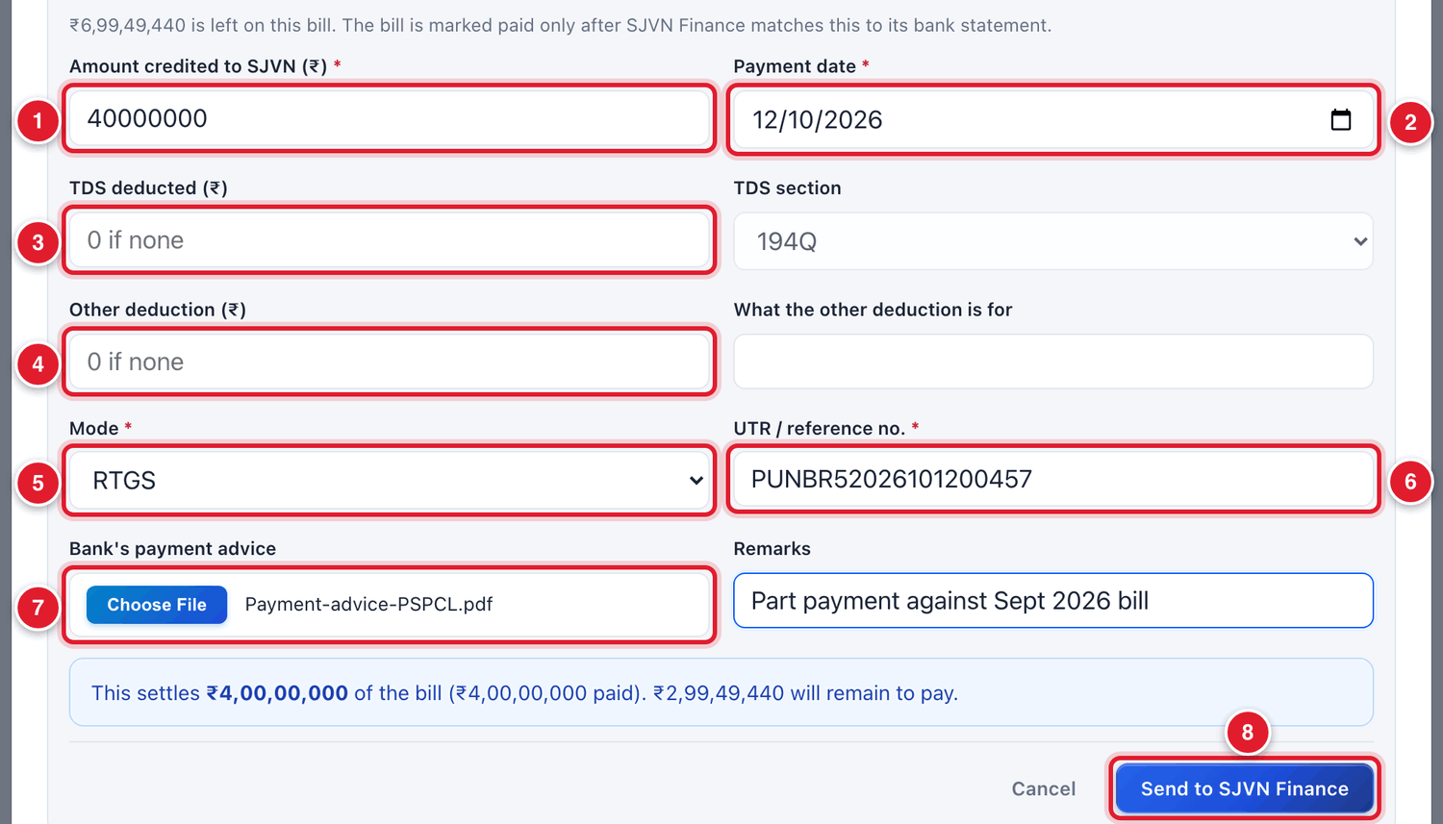
Figure 12.1 The buyer’s form “Tell SJVN about a payment”.
1 | The amount credited to SJVN.
2 | The payment date.
3 | TDS deducted by the buyer, if any, and the section.
4 | Any other deduction, with the reason.
5 | Mode: RTGS, NEFT, IMPS, cheque or other.
6 | The UTR / reference number.
7 | The bank’s payment advice (a file).
8 | Send to SJVN Finance.

12.3 Confirming a buyer’s payment

To confirm a payment told by a buyer
STEP  1 | Sign in as a Finance user. Open Payment Monitoring from the menu.

STEP  2 | Click the tab Payments to confirm. The number in brackets tells how many are waiting.

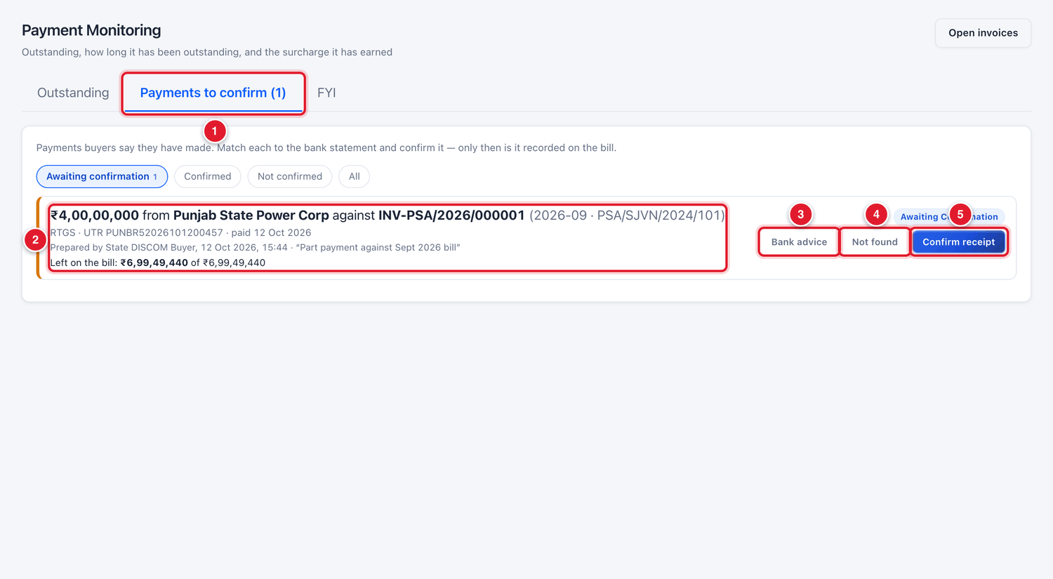
Figure 12.2 The “Payments to confirm” tab.
1 | The tab, with the number waiting.
2 | One payment told by a buyer: amount, buyer, bill, mode, UTR and date.
3 | Bank advice: open the paper attached by the buyer.
4 | Not found: the money is not in SJVN’s bank account.
5 | Confirm receipt: the money has come.

STEP  3 | Note the amount, the UTR number and the date. Open SJVN’s bank statement and look for this credit.

STEP  4 | If you find the credit in the bank statement, click Confirm receipt.

STEP  5 | Value date in SJVN’s bank: choose the date on which the money was actually credited in the bank statement.

STEP  6 | Note: type a short note if you want, for example which account it was seen in.

STEP  7 | Click Confirm and record the payment.

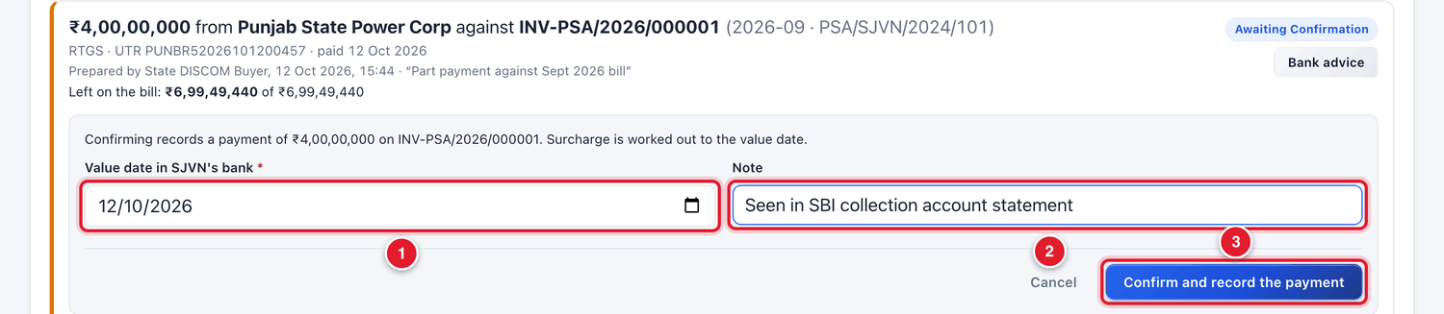
Figure 12.3 Confirming the payment.
1 | The value date from the bank statement.
2 | A note.
3 | Click Confirm and record the payment.

WHAT YOU SHOULD SEE NOW
The payment leaves the waiting list. It is now recorded on the bill. The bill becomes PARTIALLY PAID (or PAID if the full amount has come). The outstanding amount goes down. The buyer gets an alert.

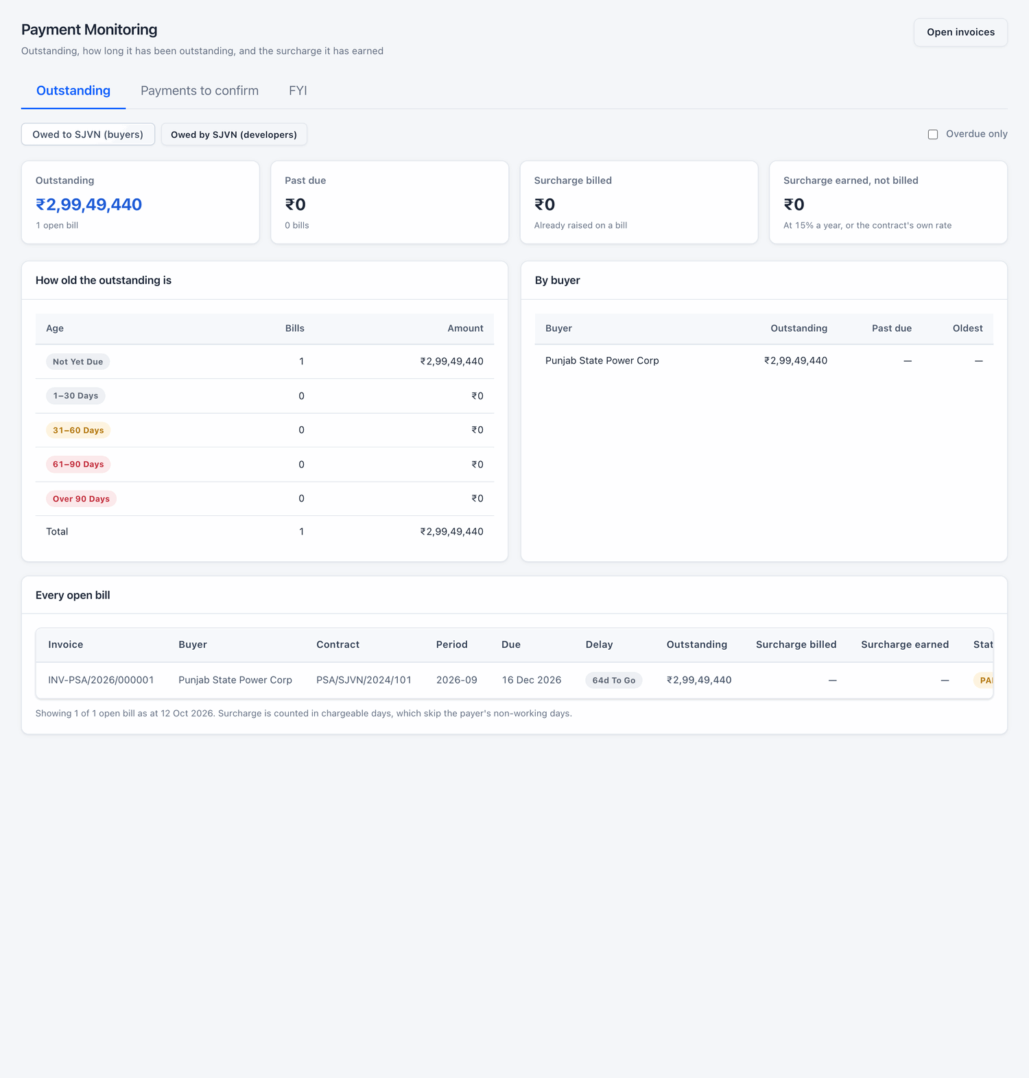
Figure 12.4 The outstanding has come down after the payment was confirmed.
BE CAREFUL
The value date decides the late payment surcharge. Surcharge is counted up to this date. Always take the date from the bank statement, not from the buyer’s form.

If the money is not found in the bank statement
STEP  1 | Do not confirm. Click Not found.

STEP  2 | Type the reason and confirm. The buyer gets an alert and can check with its bank.

12.4 Recording a payment directly on a bill
Sometimes the buyer pays but does not tell on the platform. Finance can then record the payment directly.

To record a buyer’s payment on a bill
STEP  1 | Open Billing & Invoicing and click the row of the buyer’s bill (it must be APPROVED).

STEP  2 | Go down to Record Payment (Incoming from Buyer).

STEP  3 | Fill the boxes and click Record Payment.

Field | What to enter | Example
Amount (₹) * | The amount received in the bank. | 40000000
Payment Date * | The date of credit in SJVN’s bank. | 12/10/2026
Mode | NEFT, RTGS, UPI, CHEQUE or OTHER. | RTGS
Reference | The UTR or cheque number. | PUNBR52026101200457
Deduction (₹) | TDS or any other amount the buyer deducted. | 0

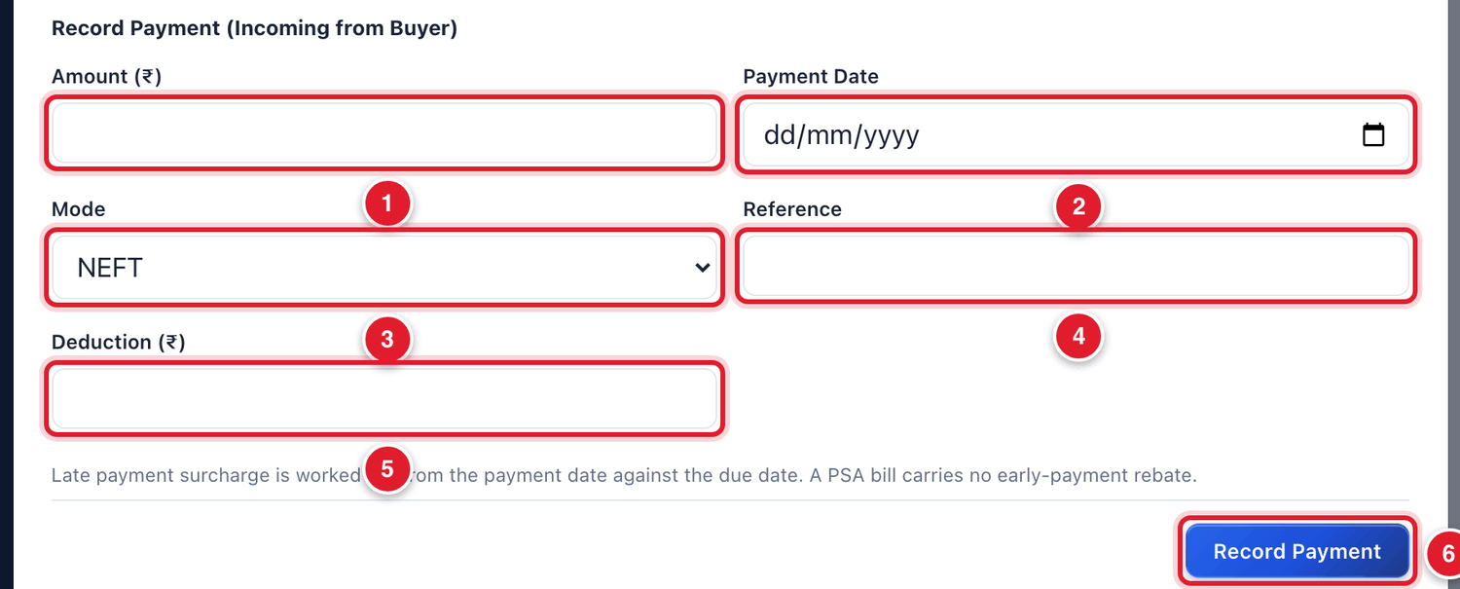
Figure 12.5 Recording a payment on a buyer’s bill.
1 | Amount.
2 | Date.
3 | Mode.
4 | Reference.
5 | Deduction.
6 | Click Record Payment.

IMPORTANT
Do not record the same payment twice. If the buyer has already told about it, confirm it from Payments to confirm instead of typing it again here.

A lump-sum payment from a buyer
When a buyer pays one lump sum against many bills, use Receive Buyer Payment at the top of the Billing screen. The platform spreads the amount by itself: first on late payment surcharge (oldest bill first), then on the principal of the oldest bill, and so on.

To record a lump-sum payment
STEP  1 | Click Receive Buyer Payment.

STEP  2 | Choose the Buyer (DISCOM), type the Amount Received (₹), the Payment Date and the Reference.

STEP  3 | Click Apply Payment.

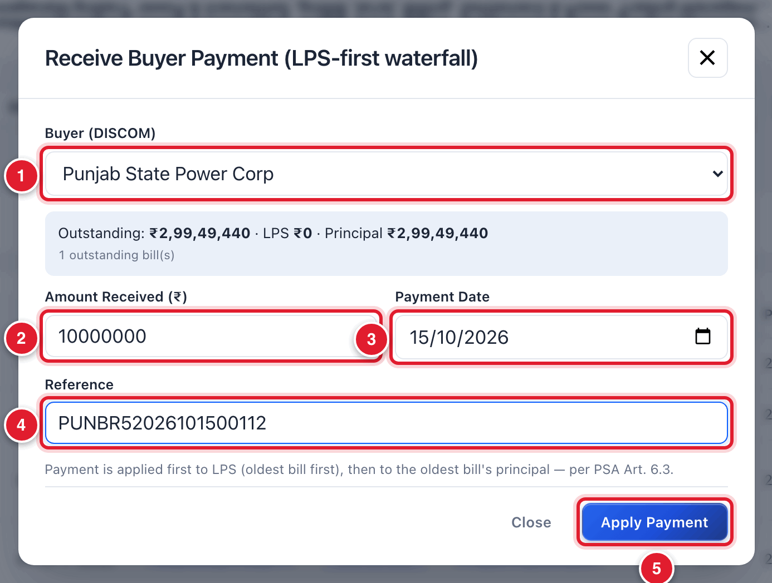
Figure 12.6 Receive Buyer Payment.
1 | The buyer.
2 | Amount received.
3 | Date.
4 | Reference.
5 | Click Apply Payment.

12.5 Paying the seller
After the seller’s invoice is APPROVED, Finance releases the payment and records it on the invoice.

To release a payment to the seller
STEP  1 | Open Billing & Invoicing and click the row of the seller’s invoice (status APPROVED).

STEP  2 | Go down to the part Release Payment to Generator (Pay-when-paid).

STEP  3 | Read the grey line at the top of this part. It tells how much the buyer has paid against this power, how much is already released, and how much is available.

STEP  4 | Fill the boxes.

Field | What to enter | Example
Net amount paid (₹) * | The amount actually sent to the seller’s bank (after TDS). | 30000000
Fund Source | DISCOM Realization: from money received from the buyer. SJVN Own Fund: from SJVN’s own money. Payment Security Fund: from the fund. | SJVN Own Fund
Payment Date * | The date of payment. | 12/10/2026
Reference | The UTR number of the payment. | SBINR52026101200981
TDS deducted (₹) | Tax deducted at source by SJVN. | 30000
Other deduction (₹) | Any other amount held back. | 0

STEP  5 | Read the small line below the boxes. It tells how much of the bill this payment settles.

STEP  6 | Click the blue button Release to Generator.

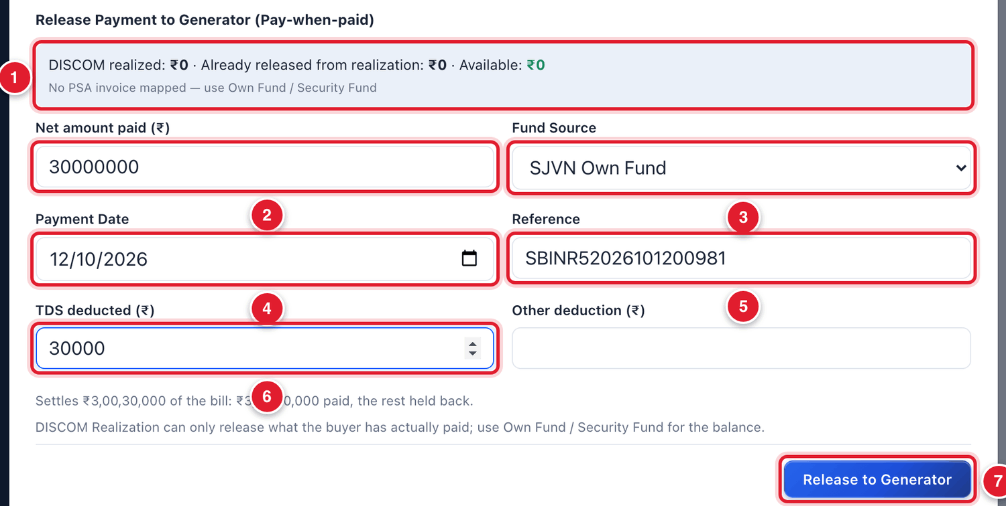
Figure 12.7 Releasing a payment to the seller.
1 | What the buyer has paid, what is already released, what is available.
2 | Net amount paid.
3 | Fund source.
4 | Payment date.
5 | Reference (UTR).
6 | TDS deducted.
7 | Click Release to Generator.

WHAT YOU SHOULD SEE NOW
The payment is recorded on the seller’s invoice. Its status becomes PARTIALLY PAID or PAID. The seller gets an alert and can see the payment in Payments & Ledger.

GOOD TO KNOW
DISCOM Realization can release only what the buyer has actually paid. If the platform says nothing is realized, or the buyer has not paid enough, choose SJVN Own Fund or Payment Security Fund for the balance.

TIP
The part TDS — what to expect on payment higher up in the invoice shows the TDS that should normally be deducted (for example under section 194Q). Use it as a guide. The final decision is of Finance.

12.6 Debit and credit notes
A debit note is raised when the party owes more than the bill says. A credit note is raised when the party owes less. Use a note for a change after the bill is approved.

To raise a debit or credit note on a bill
STEP  1 | Open the bill (it must be APPROVED or later). Go down to Debit / Credit Notes and click + Raise Note.

STEP  2 | Fill the boxes and click Save as draft.

Field | What to enter | Example
Type | Debit note (the party owes more) or Credit note (the party owes less). | Credit note
Reason code | Revised / amended REA, Change in Law, Transmission / wheeling charges, Late Payment Surcharge, Compensation event, Liquidated damages or Other. | Revised / amended REA
Taxable value (₹) * | The amount of the note, before tax. | 20000
Tax on the note (₹), Tax label | Tax, if any, and its name (for example IGST 18%). | 0
What the note is for * | A short description. It is printed on the note. | Energy revised as per REA rev-1

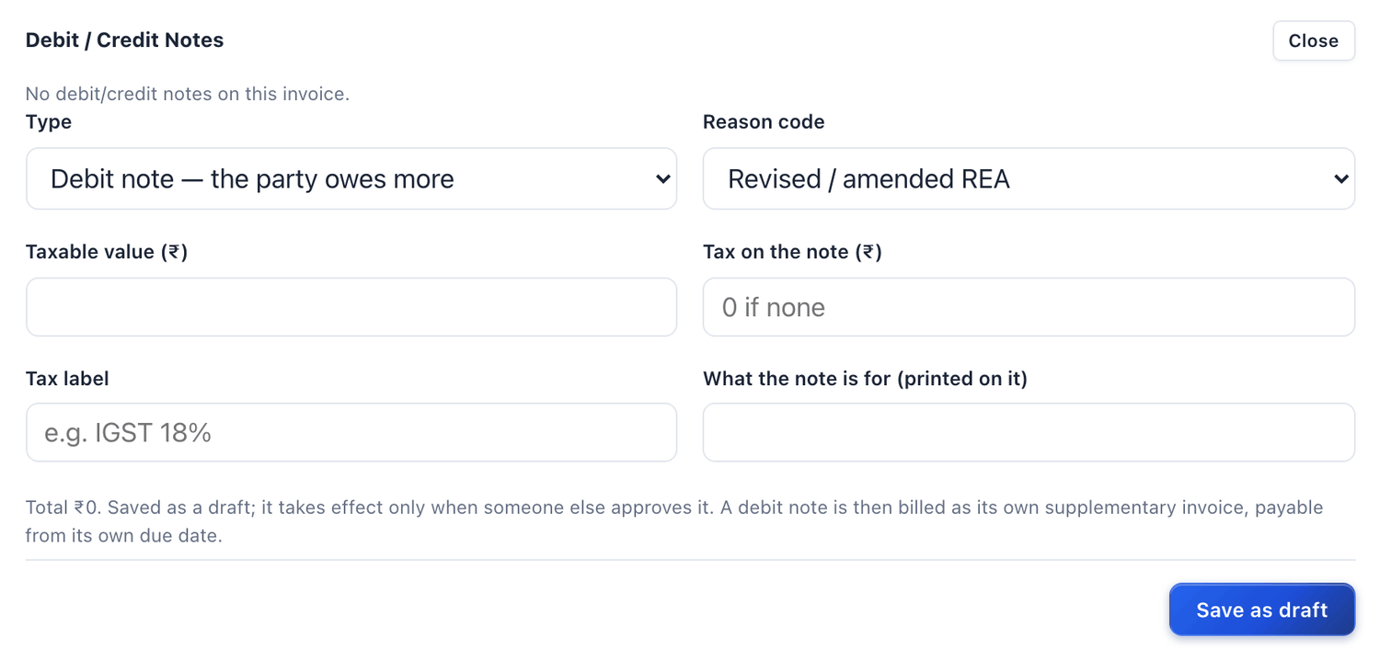
Figure 12.8 Raising a debit or credit note.
IMPORTANT
A note is saved as a draft. It takes effect only after another officer approves it. An approved debit note is billed as its own supplementary invoice with its own due date.

12.7 Common questions
If you see this | Why it happens | What to do
The buyer says it paid, but the bill still shows the full amount | The payment is waiting in Payments to confirm. | Check the bank statement and confirm it (section 12.3).
The bill shows PARTIALLY PAID, not PAID | The amount recorded is less than the bill, or a dispute amount is held. | Open the bill and read the amount boxes: Settled So Far and Balance Payable Now.
“DISCOM Realization … nothing realized” | The buyer has not paid yet, or the seller’s invoice is not linked to a buyer’s bill. | Choose SJVN Own Fund or Payment Security Fund as the fund source.
A wrong payment was recorded | A typing mistake. | Do not record a second payment to “balance” it. Inform the SJVN Administrator, with the bill number and the correct figures.

CHAPTER 13

13. Invoice Verification
One list of all sellers’ invoices and how far their checking has gone.
What it is for | A work list. It shows every seller’s invoice with the position of its verification checklist, so that nothing is left unchecked.
Who uses it | SJVN REIA desk, REIA Admin, Finance.
How to open it | Menu → REIA Billing & Settlement → Invoice Verification.
When to use it | Daily, to see which sellers’ invoices still need checking.

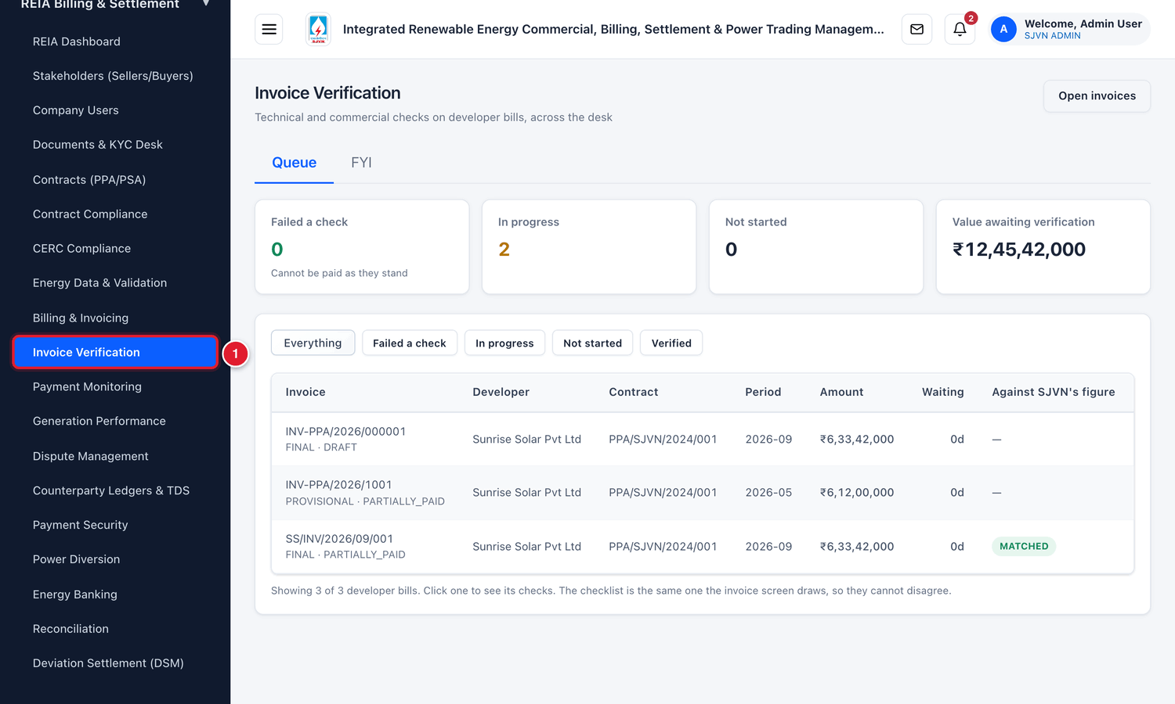
Figure 13.1 Opening Invoice Verification from the menu.
1 | Click Invoice Verification.

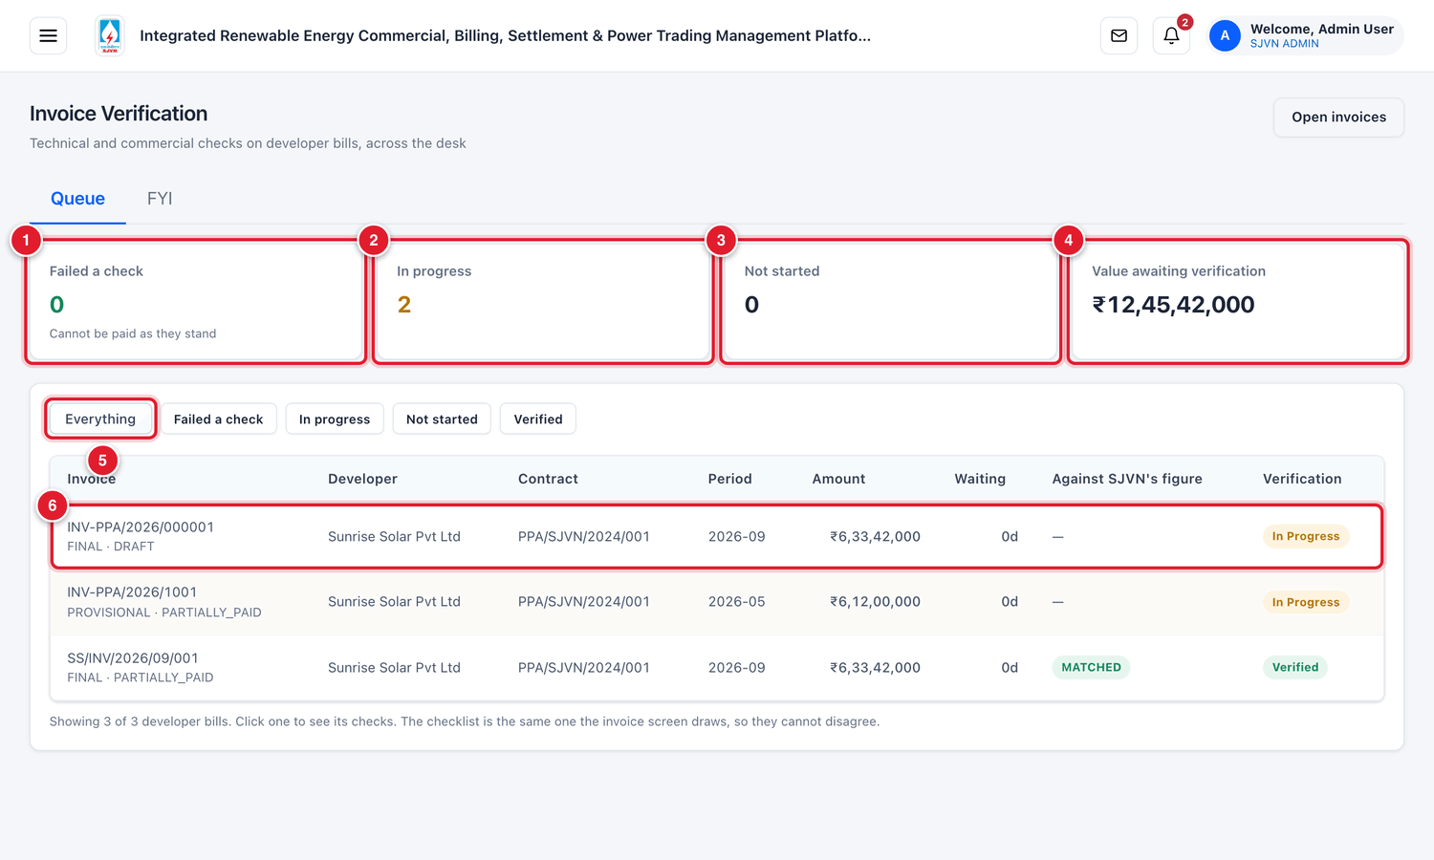
Figure 13.2 The Invoice Verification screen (menu hidden).
1 | Failed a check: invoices that cannot be paid as they are.
2 | In progress: checking has started but is not complete.
3 | Not started: nobody has checked these yet.
4 | Value awaiting verification: the total amount of invoices still being checked.
5 | Filter buttons: Everything, Failed a check, In progress, Not started, Verified.
6 | One invoice. Click the row to see its checks.

Column | What it tells you
Invoice | The invoice number, its type and status.
Developer / Contract / Period | The seller, the PPA and the month.
Amount | The amount of the invoice.
Waiting | For how many days the invoice has been waiting.
Against SJVN’s figure | The result of Validate vs System: MATCHED, a mismatch, or — if not yet compared.
Verification | Not Started, In Progress, Failed or Verified.

To see the checks of an invoice
STEP  1 | Click the row of the invoice. Its eight technical checks and the commercial build-up open below the row.

STEP  2 | To change a check, click Open the bill to verify it. The invoice opens in Billing & Invoicing, where you complete the checklist (section 10.5).

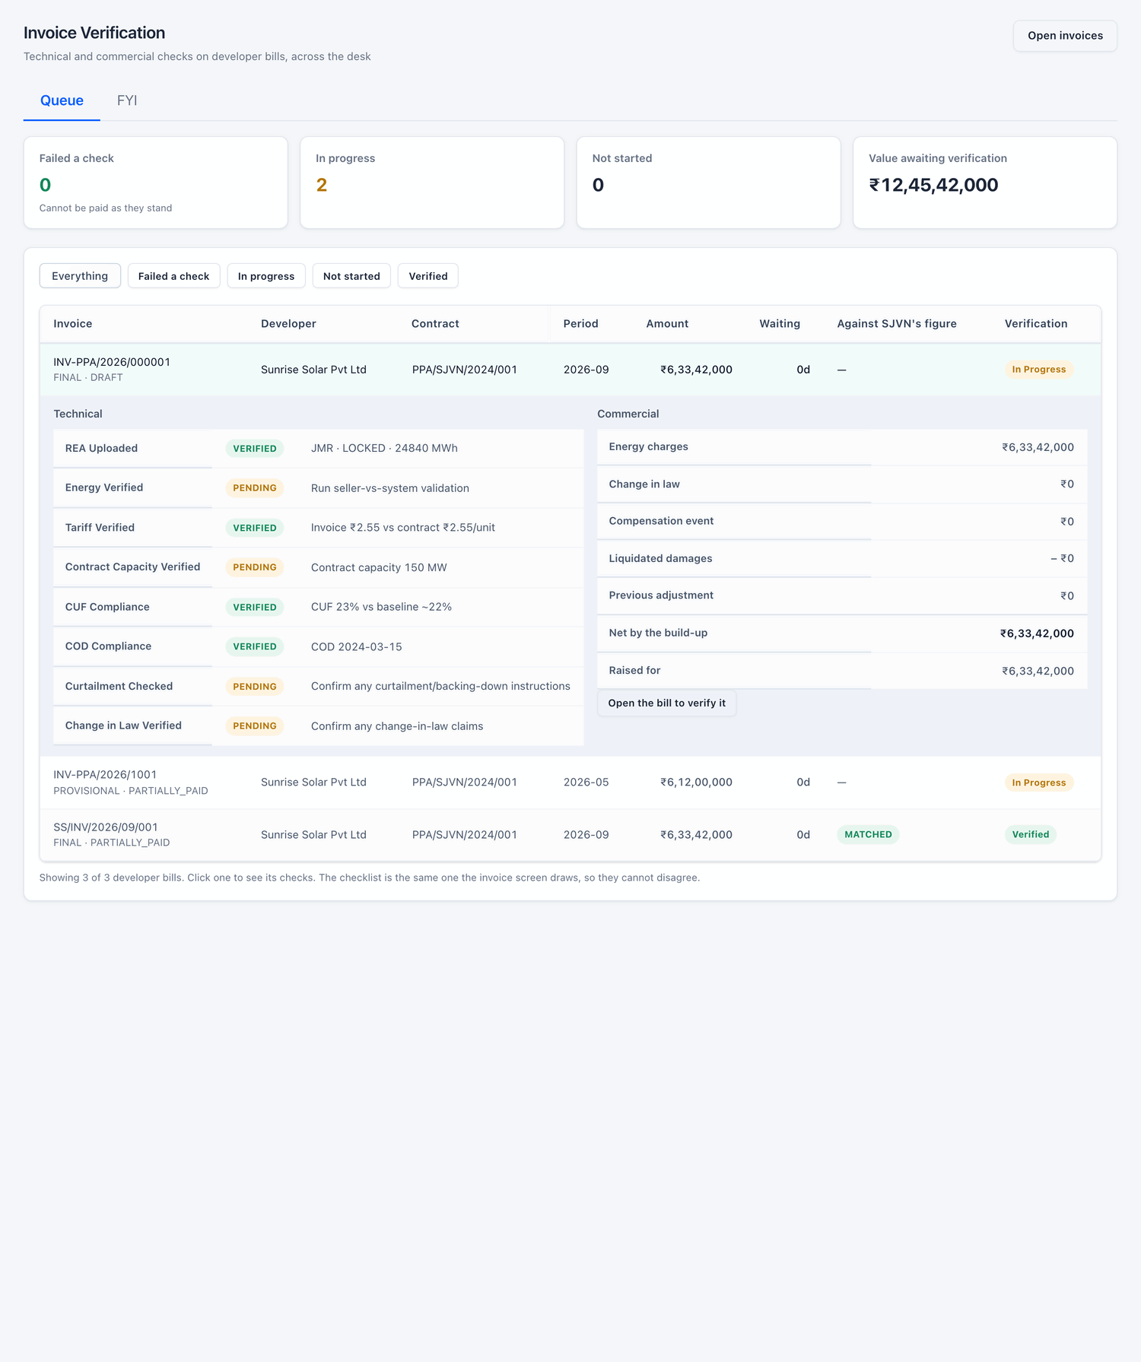
Figure 13.3 The checks of one invoice, opened below its row.
GOOD TO KNOW
This screen and the checklist inside the invoice show the same data. You change the checks only inside the invoice.

CHAPTER 14

14. Payment Monitoring
Who owes how much, for how long, and how much surcharge it has earned.
What it is for | Shows all unpaid bills with their age and late payment surcharge, in both directions: owed to SJVN by buyers, and owed by SJVN to sellers. It is also where buyers’ payments are confirmed.
Who uses it | Finance, SJVN REIA desk, Management.
How to open it | Menu → REIA Billing & Settlement → Payment Monitoring.
When to use it | Daily for confirming payments. Weekly for following up on overdue bills.

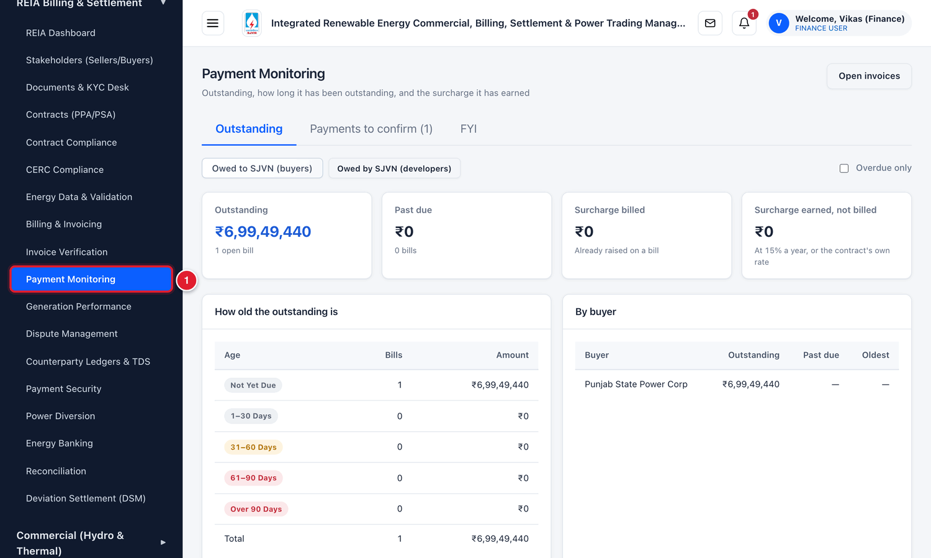
Figure 14.1 Opening Payment Monitoring from the menu.
1 | Click Payment Monitoring.

14.1 The Outstanding tab
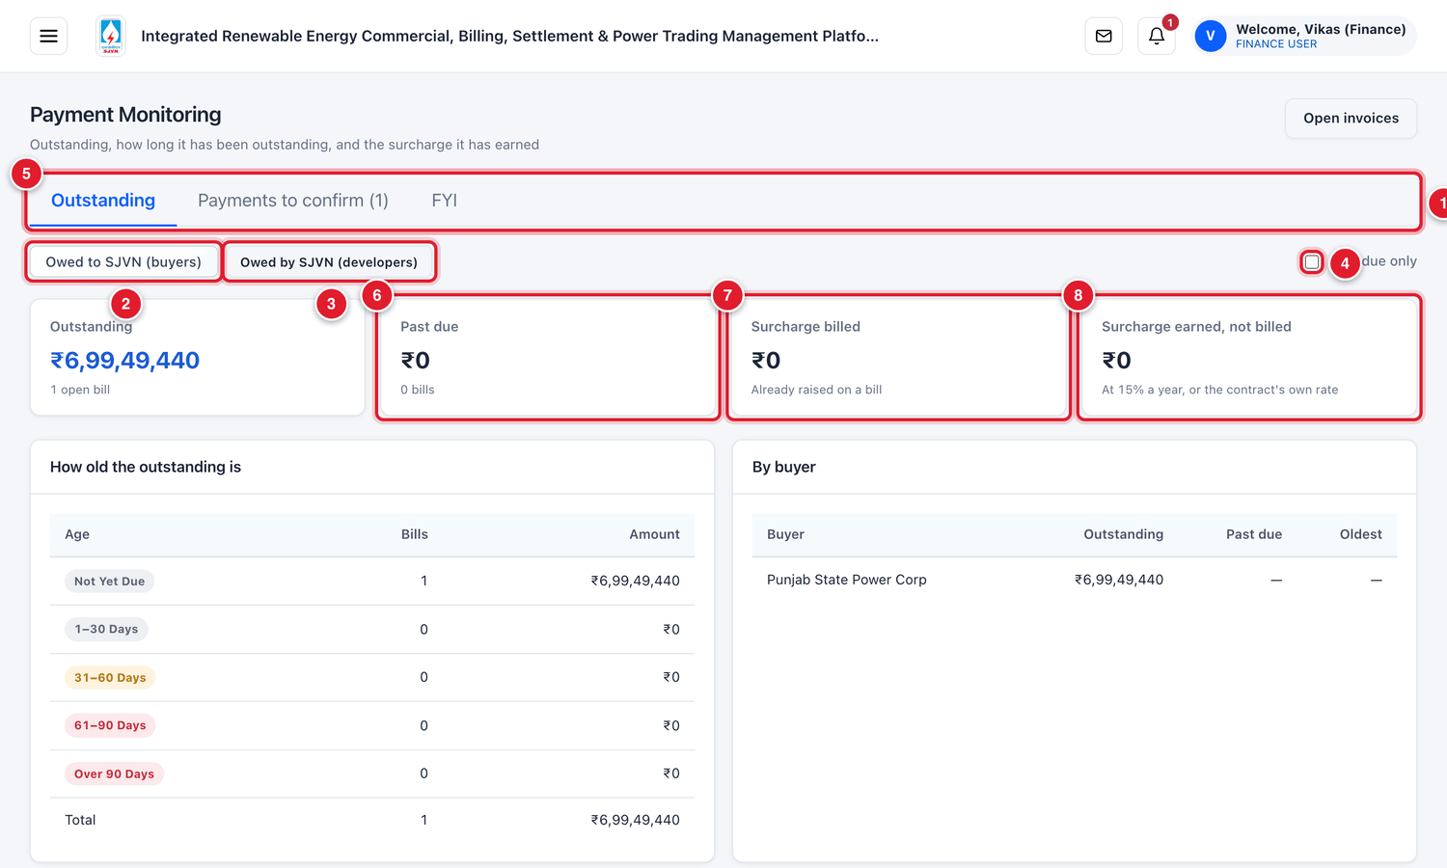
Figure 14.2 The Payment Monitoring screen (menu hidden).
1 | Tabs: Outstanding, Payments to confirm and FYI.
2 | Owed to SJVN (buyers): unpaid bills raised on buyers.
3 | Owed by SJVN (developers): unpaid invoices of sellers.
4 | Overdue only: tick to see only bills past their due date.
5 | Outstanding: the total unpaid amount and the number of open bills.
6 | Past due: the part of it that has crossed the due date.
7 | Surcharge billed: late payment surcharge already raised on a bill.
8 | Surcharge earned, not billed: surcharge that has built up but is not yet billed.

Below the boxes there are three tables.
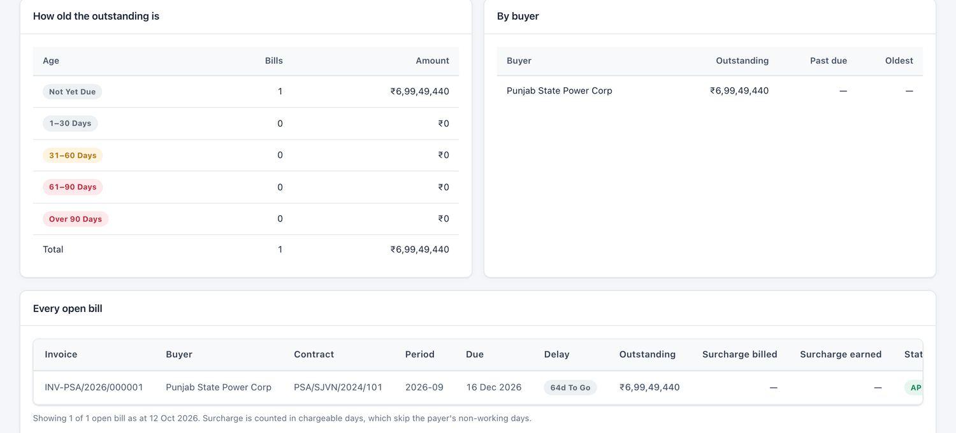
Figure 14.3 The three tables of the Outstanding tab.
Table | What it shows
How old the outstanding is | The outstanding amount split by age: Not yet due, 1–30 days, 31–60 days, 61–90 days, and over 90 days past the due date.
By buyer (or by developer) | The outstanding, the past-due amount and the oldest bill of each party.
Every open bill | Each unpaid bill with its due date, delay, outstanding amount, surcharge and status.

Column in “Every open bill” | Meaning
Due | The due date of the bill.
Delay | … To Go means days left before the due date. A number of days in red means the bill is late by that many days.
Outstanding | What is still unpaid on the bill, after payments and amounts held in dispute.
Surcharge billed | Late payment surcharge already raised on a bill for this delay.
Surcharge earned | Surcharge built up so far and not yet billed.

GOOD TO KNOW
Surcharge is counted at the rate given in the contract (15% a year if the contract does not say). It is counted in chargeable days, which leave out the payer’s non-working days.

14.2 What SJVN owes to sellers

To see what SJVN has to pay
STEP  1 | Click the button Owed by SJVN (developers).

WHAT YOU SHOULD SEE NOW
The same boxes and tables are shown for sellers’ invoices that SJVN has not yet fully paid.

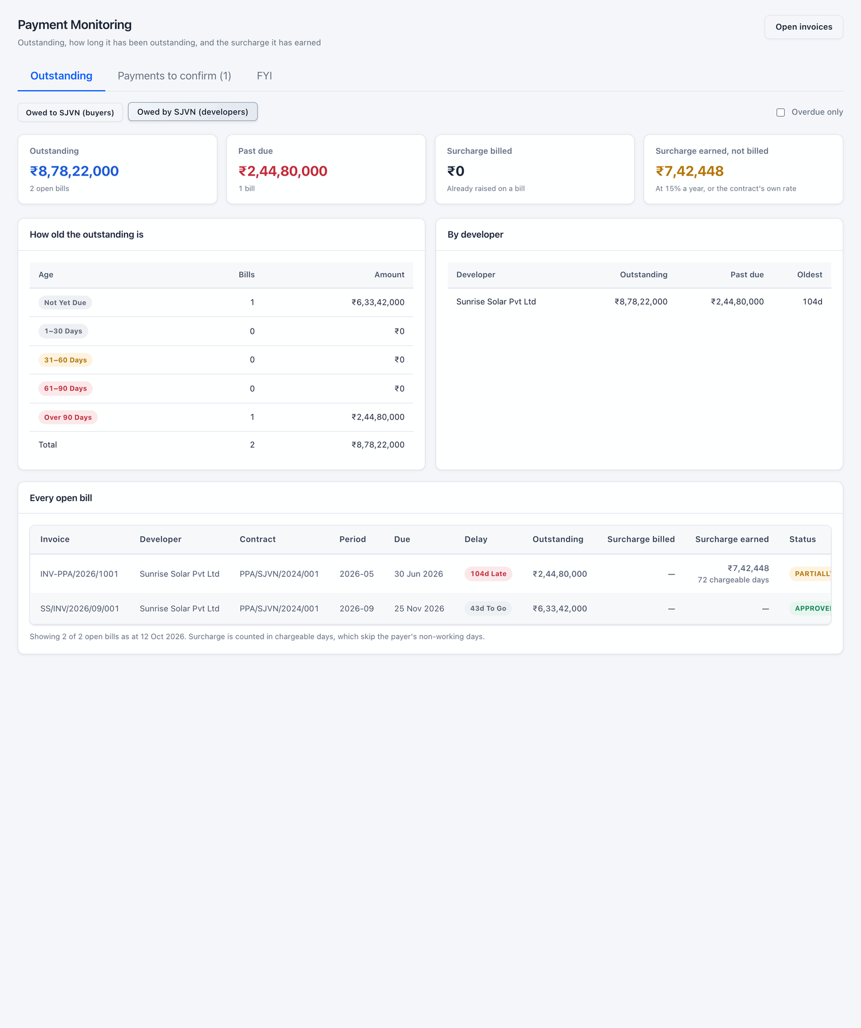
Figure 14.4 Owed by SJVN to developers.

14.3 Payments to confirm
The second tab lists the payments that buyers say they have made. Confirming them is explained step by step in section 12.3.
Inside this tab, four small buttons show the payments by position: Awaiting confirmation, Confirmed, Not confirmed and All.
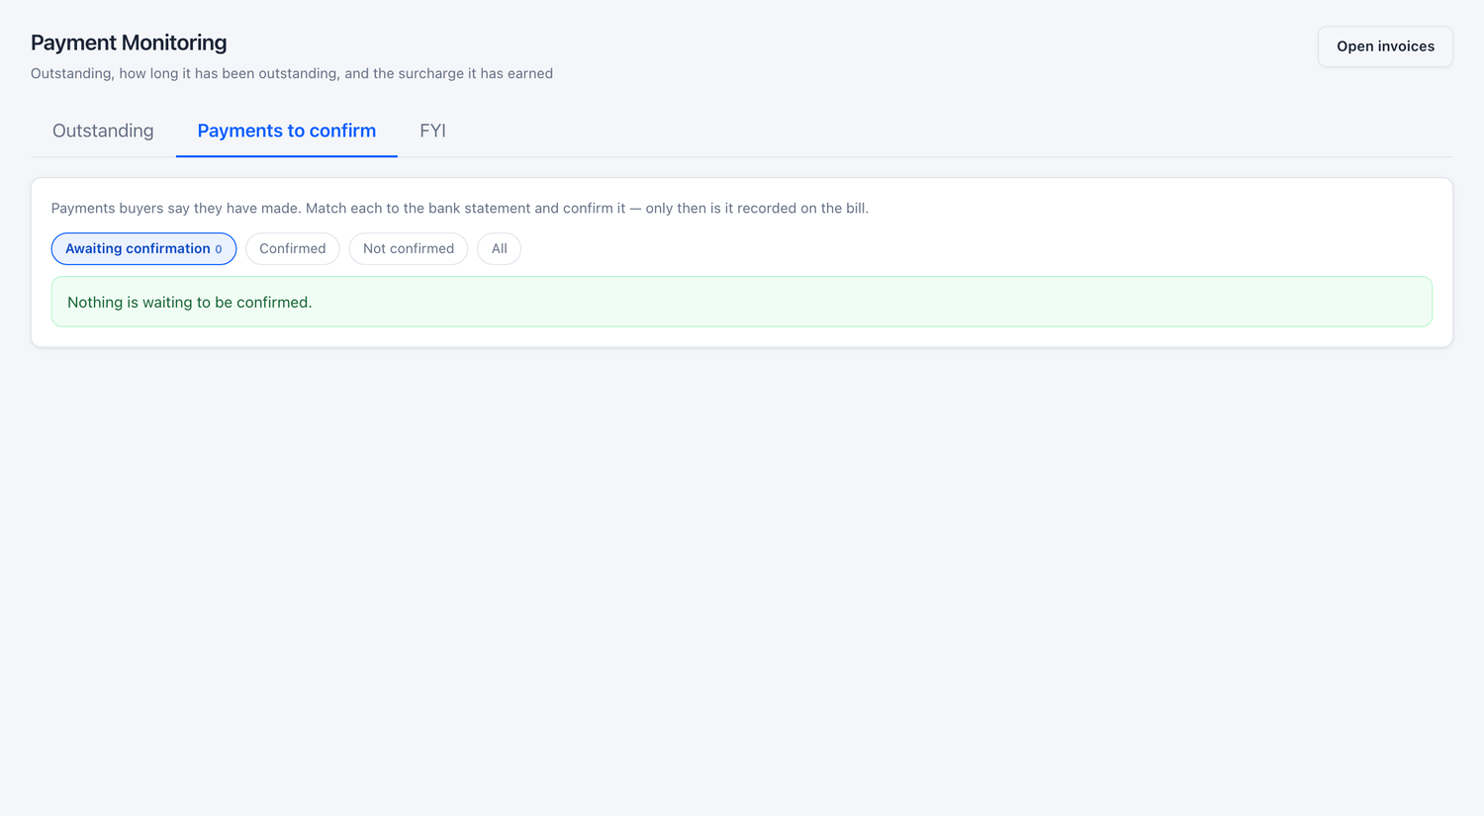
Figure 14.5 The tab after all payments are confirmed.

14.4 Common questions
If you see this | Why it happens | What to do
A bill is not in the list | The bill is fully paid, cancelled, or not yet approved. | Only approved, unpaid bills are shown. Check the bill in Billing & Invoicing.
The outstanding is less than bill minus payments | A part of the bill is held in an open dispute. | Open the bill and see Disputed Amount.
Surcharge is shown on a bill that was paid on time | The value date typed while confirming was later than the due date. | Check the value date against the bank statement. Inform the SJVN Administrator if it was typed wrongly.

PART 3

Disputes, Reconciliation and Control
Settling disagreements, closing the month with both parties, guarding payment security, and the other screens of the REIA module.

CHAPTER 15

15. Dispute Management
What to do when a buyer or a seller does not agree with a bill.
What it is for | A dispute is a formal objection on a part of a bill. This screen lists all disputes, shows how much time SJVN has to answer each, and records the decision.
Who uses it | SJVN REIA desk and REIA Admin answer disputes. Buyers and sellers raise them from their own logins.
How to open it | Menu → REIA Billing & Settlement → Dispute Management.
When to use it | Whenever the dashboard or the bell says a dispute is waiting. Each dispute has a time limit.

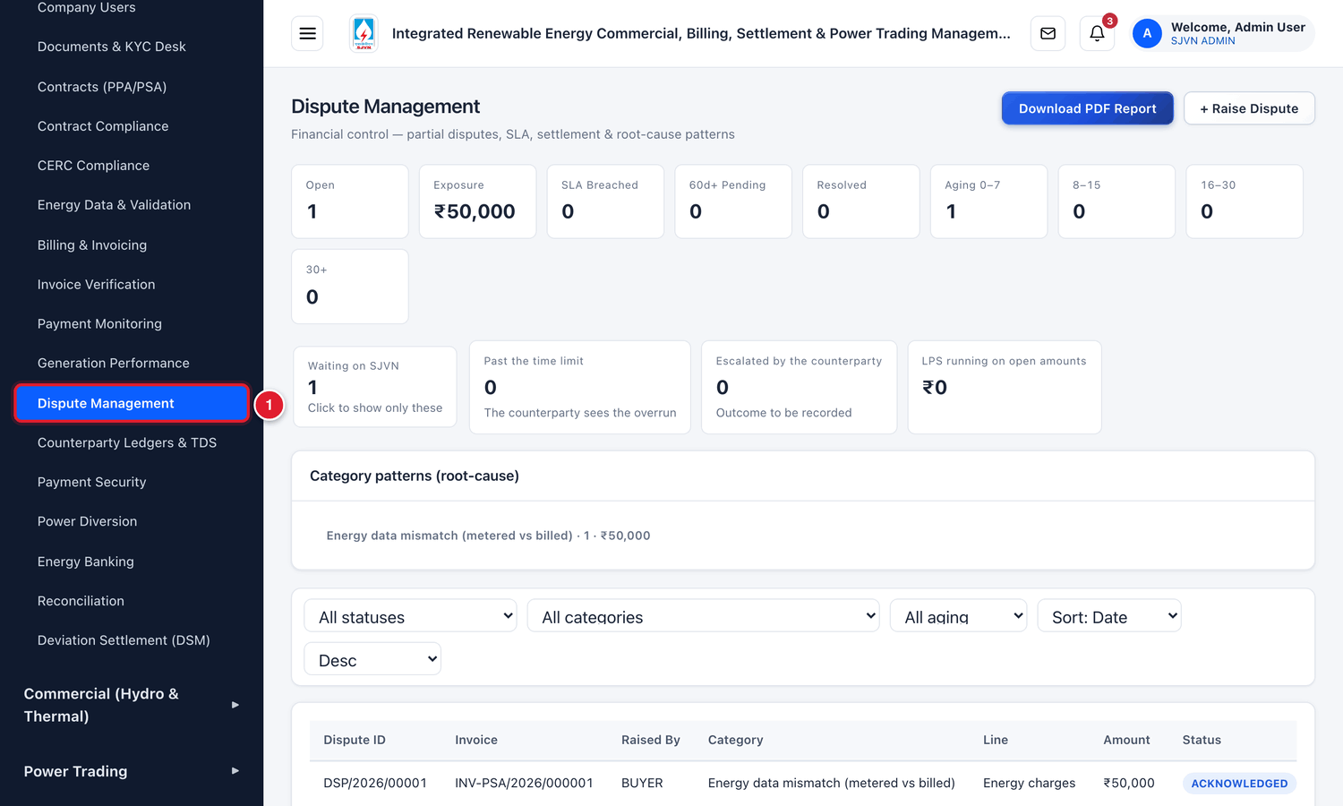
Figure 15.1 Opening Dispute Management from the menu.
1 | Click Dispute Management.

15.1 How a dispute works
Step | Who | What happens | Status of the dispute
1 | Buyer or seller | Raises a dispute on a bill: which charge, how much, and why. Attaches proof. | ACKNOWLEDGED
2 | SJVN | Starts the review and takes charge of the dispute. | UNDER REVIEW
3 | SJVN | If more facts are needed, asks the party for information. | INFO REQUESTED
4 | SJVN | Gives its decision: full credit, partial credit, or rejected. | RESOLVED ACCEPTED / RESOLVED REJECTED
5 | Buyer or seller | Accepts SJVN’s decision, or escalates if it does not agree. | CLOSED / ESCALATED

IMPORTANT
Only the disputed amount is held back. The rest of the bill must still be paid by the due date. While the dispute is open, late payment surcharge is not charged on the disputed amount.

15.2 The Dispute Management screen
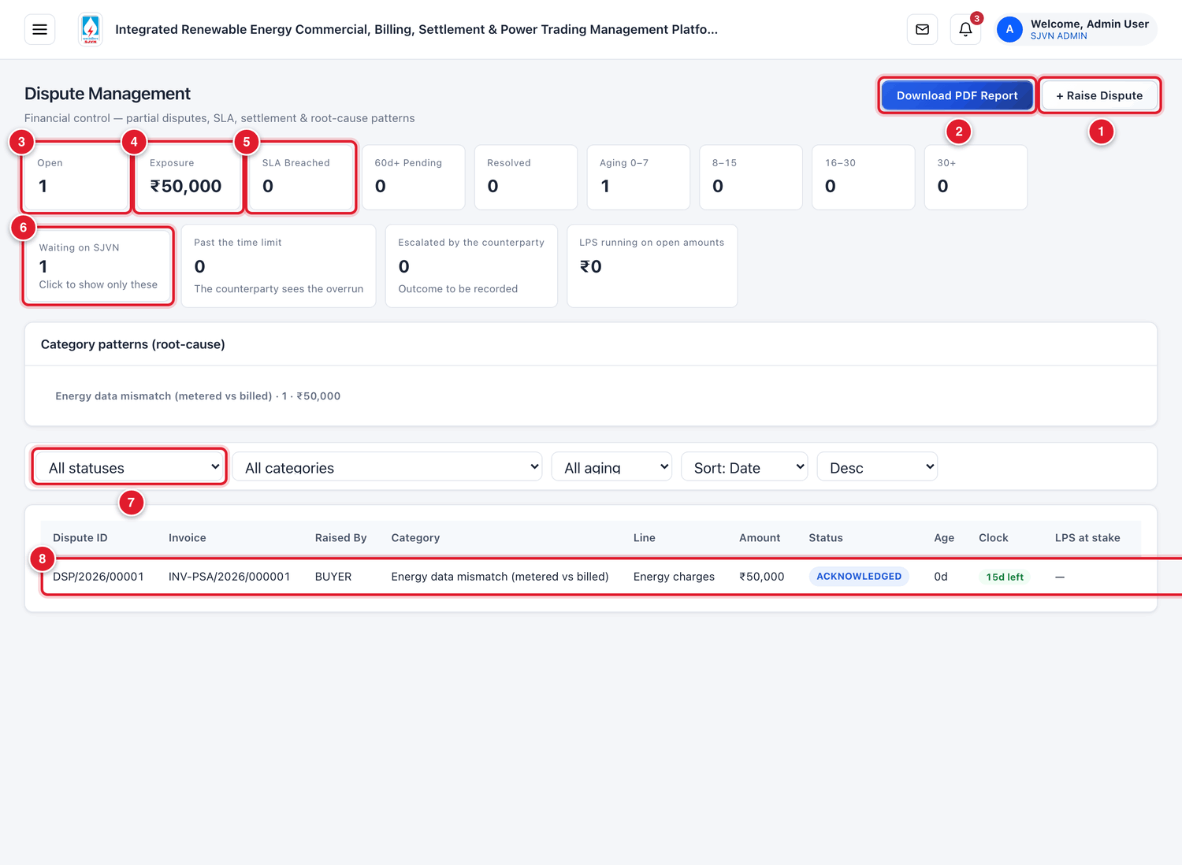
Figure 15.2 The Dispute Management screen (menu hidden).
1 | + Raise Dispute: SJVN raises a dispute itself (section 15.6).
2 | Download PDF Report: the list of disputes as a PDF.
3 | Open: disputes not yet closed.
4 | Exposure: the total amount under dispute.
5 | SLA Breached: disputes that have crossed SJVN’s time limit.
6 | Waiting on SJVN: click this box to see only the disputes where SJVN has to act.
7 | Filters: status, category, age and sorting.
8 | One dispute. Click the row to open it.

Column | What it tells you
Dispute ID | The number of the dispute, for example DSP/2026/00001.
Invoice | The bill that is disputed.
Raised By | BUYER, SELLER or SJVN.
Category / Line | The reason and the charge line in question.
Amount | The disputed amount.
Status | The present stage (see 15.1).
Age / Clock | How old the dispute is, and how many days SJVN has left to answer.
LPS at stake | The late payment surcharge that depends on the result.

15.3 Opening and reading a dispute

To open a dispute
STEP  1 | Click the row of the dispute.

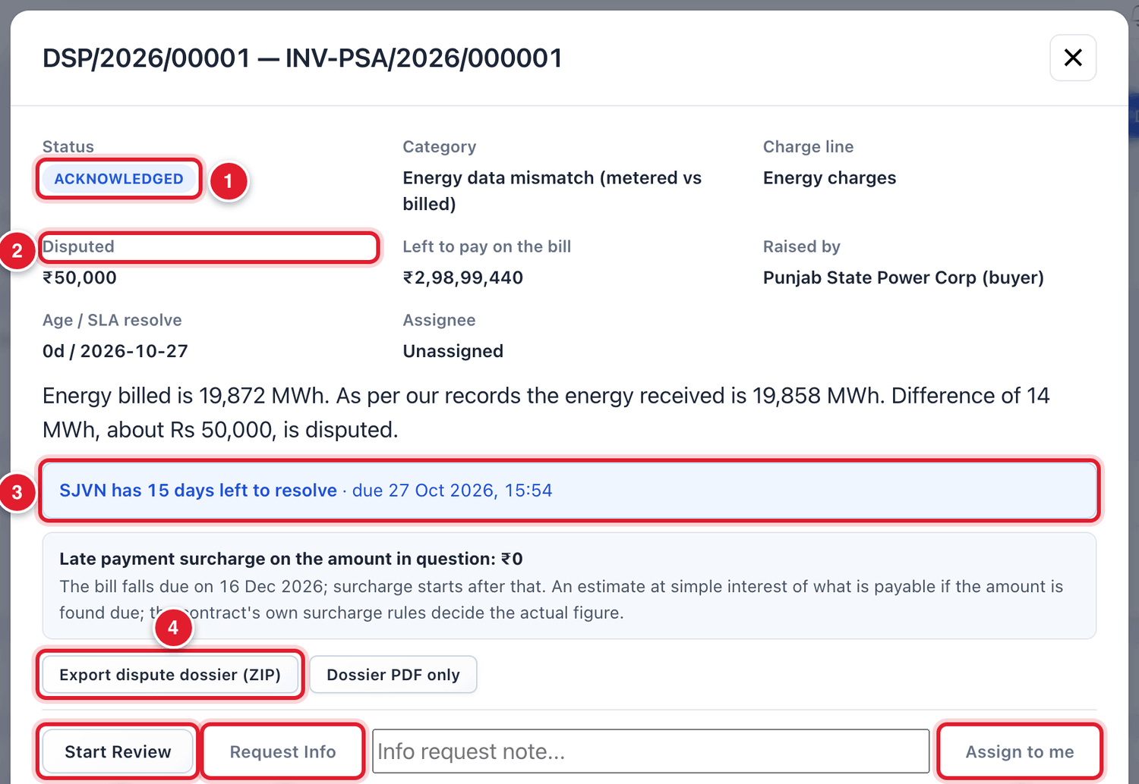
Figure 15.3 The top of the dispute window.
1 | The status.
2 | The disputed amount.
3 | The clock: how many days SJVN has left, and the last date.
4 | Export dispute dossier (ZIP): download everything about this dispute in one file.
5 | Start Review: tell the party that SJVN has taken up the dispute.
6 | Request Info: ask the party for more information.
7 | Assign to me: put your name on this dispute.

Lower in the window you find the proof given by the party, the messages exchanged, and the full history.
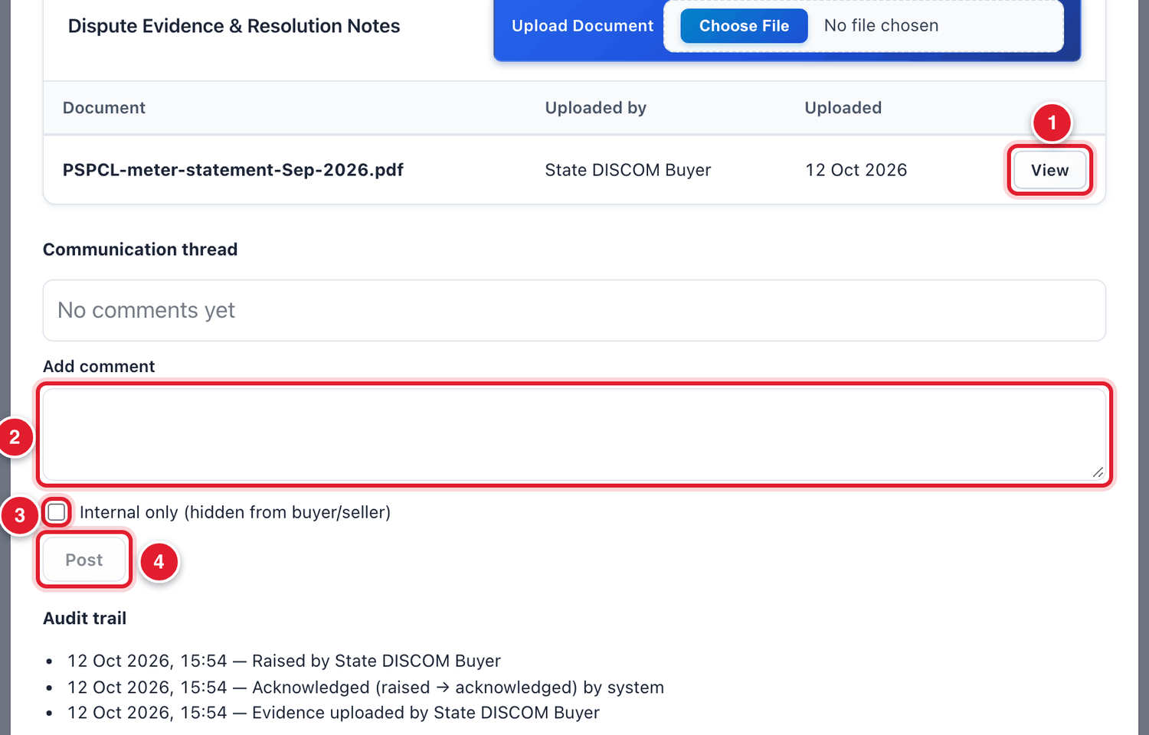
Figure 15.4 Evidence, messages and history.
1 | View: open the proof attached by the party.
2 | Type a message here.
3 | Tick Internal only if the message is a note for SJVN and should not be seen by the buyer or seller.
4 | Post: send the message.

15.4 Reviewing a dispute

To start the review
STEP  1 | Open the dispute and read the party’s description. Click View to open the attached proof and read it.

STEP  2 | Click Start Review. The status becomes UNDER REVIEW.

STEP  3 | Click Assign to me. Your name appears as Assignee, so that everyone knows who is handling it.

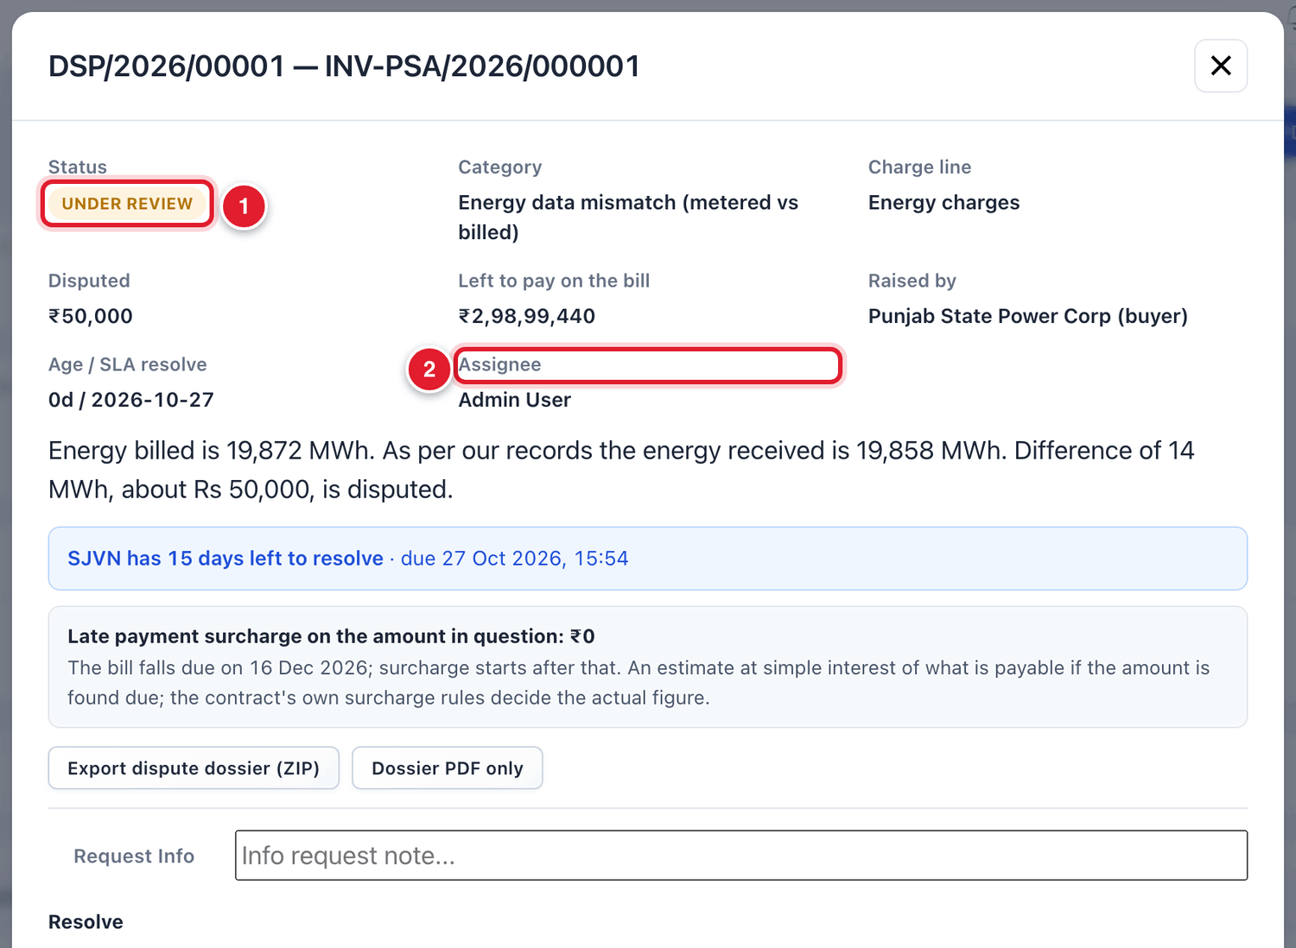
Figure 15.5 The dispute is now under review.
1 | Status UNDER REVIEW.
2 | The assignee.

STEP  4 | Check the facts: open the bill, the energy record, the JMR and the contract. Compare with what the party says.

To ask the party for more information
STEP  1 | Type your question in the box Info request note..., next to the button Request Info.

STEP  2 | Click Request Info. The status becomes INFO REQUESTED. The party gets an alert and answers from its login.

TIP
Use the message box to record what you checked, with the tick Internal only. Later, anyone who opens the dispute can see how the decision was reached.

15.5 Giving the decision
After the review, record SJVN’s decision in the part named Resolve.
Outcome | Use it when | What the platform does
Resolved – Accepted (full credit) | The party is right for the whole disputed amount. | Lowers the bill by the full disputed amount and makes a credit bill.
Resolved – Accepted (partial credit) | The party is right for a part of the amount. | Lowers the bill by the accepted amount and makes a credit bill. The rest becomes payable again.
Resolved – Rejected | The bill is correct. | Nothing changes on the bill. The full disputed amount becomes payable again.

To record the decision
STEP  1 | Outcome: choose one of the three outcomes.

STEP  2 | Accepted / credit amount (₹): for a full or partial credit, type the amount SJVN accepts. It cannot be more than the disputed amount.

STEP  3 | Resolution reasoning (shown to parties): explain the decision in clear words. The party will read this.

STEP  4 | LPS / interest on settlement (₹): fill only if interest is payable on the settled amount. The small link use this fills the amount worked out by the platform.

STEP  5 | Click Confirm Resolution.

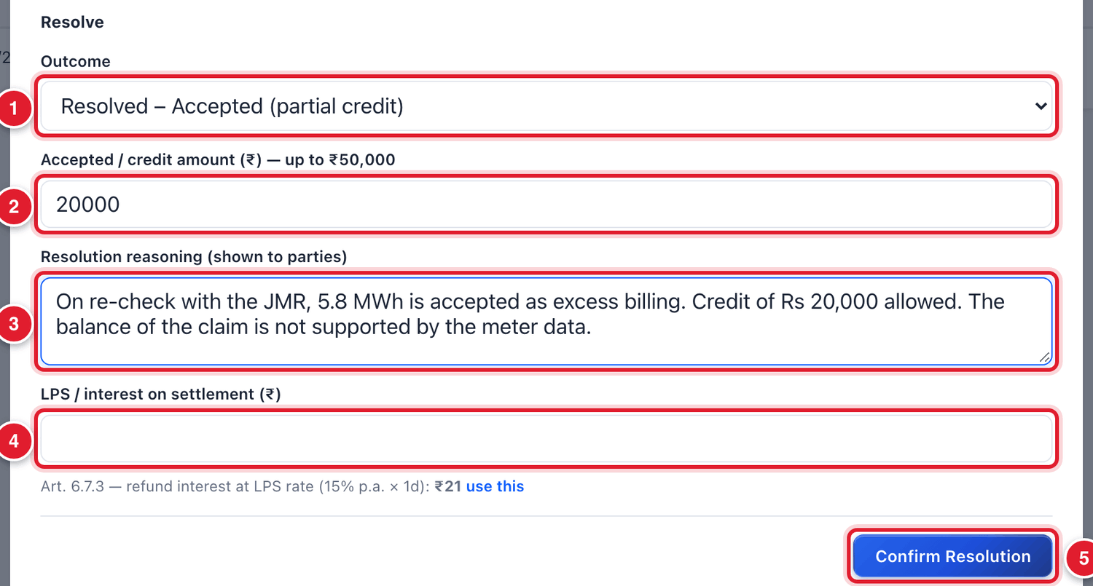
Figure 15.6 Recording the decision.
1 | The outcome.
2 | The amount accepted.
3 | The reasoning.
4 | Interest on the settlement, if any.
5 | Click Confirm Resolution.

WHAT YOU SHOULD SEE NOW
The status becomes RESOLVED ACCEPTED (or RESOLVED REJECTED). The window shows SJVN’s resolution and the words Awaiting Submitter’s Answer. For a credit, a line shows the bill amount before and after, and the number of the credit bill (starting with SUPP/).

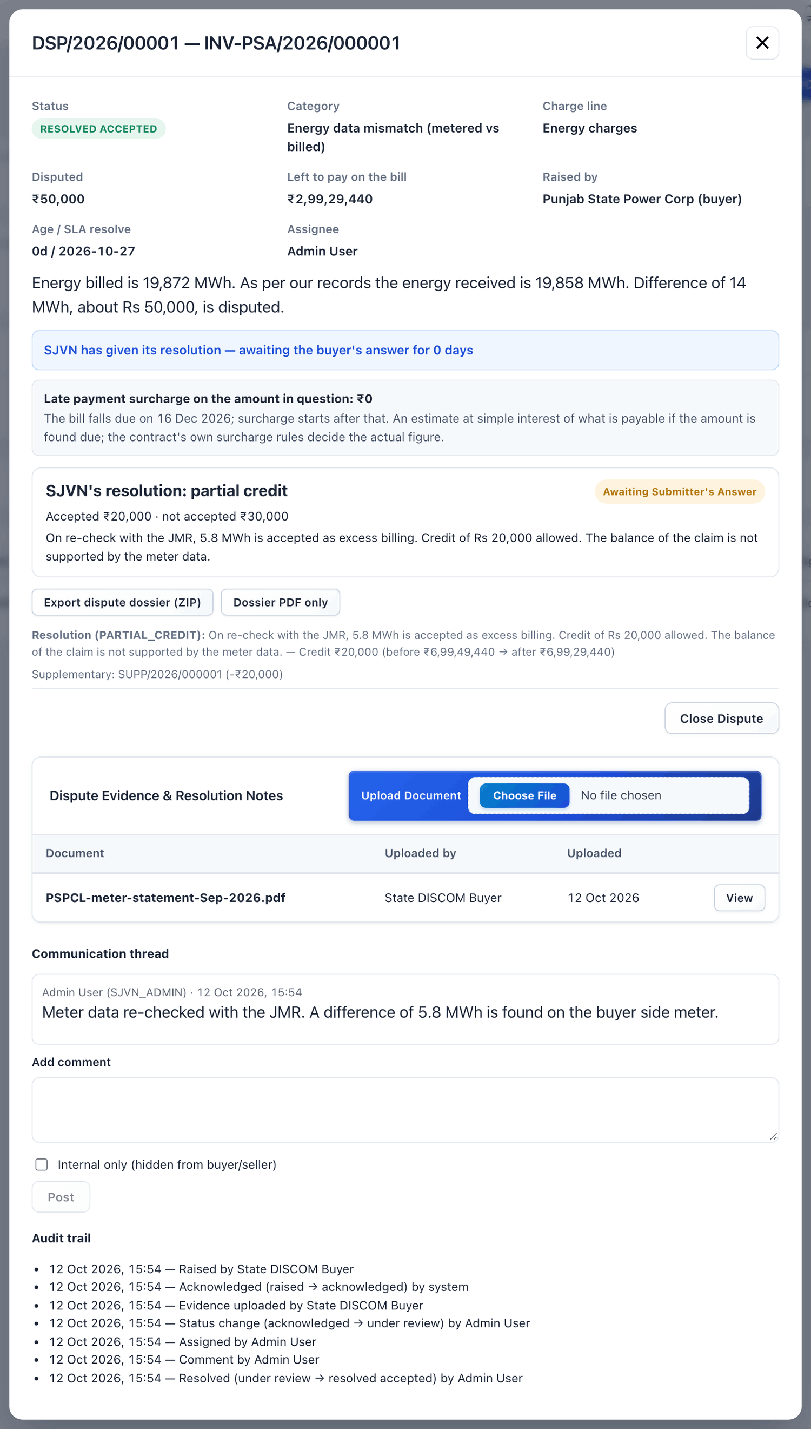
Figure 15.7 The dispute after SJVN’s decision.
BE CAREFUL
Confirm Resolution changes the amount of the bill at once. It cannot be undone from this screen. Read the outcome and the amount twice before you click.

After the decision
The party now answers from its own login:
- Accept resolution: the dispute becomes CLOSED.
- Escalate — not accepted: the dispute becomes ESCALATED and goes to a senior level in SJVN. It appears in the box Escalated by the counterparty.
If the party does not answer, SJVN can click Close Dispute in the dispute window.

15.6 When SJVN raises a dispute
SJVN can also raise a dispute itself, for example on a seller’s invoice.

To raise a dispute from SJVN’s side
STEP  1 | Click + Raise Dispute at the top of the screen.

STEP  2 | Fill the boxes and submit.

Field | What to enter | Example
Invoice * | The bill that is disputed. | SS/INV/2026/09/001
Raised for | On whose behalf the dispute is raised. | SJVN
Charge line * | Energy charges, Transmission / wheeling, Trading margin, Rebate, LPS, Penalty, Tax / GST or Other adjustments. | Energy charges
Reason code * | Choose the reason from the list. | Energy data mismatch (metered vs billed)
Disputed Amount (₹) * | Only the amount in question. The rest of the bill stays payable. | 50000
Description | Explain the issue clearly, with figures. | —

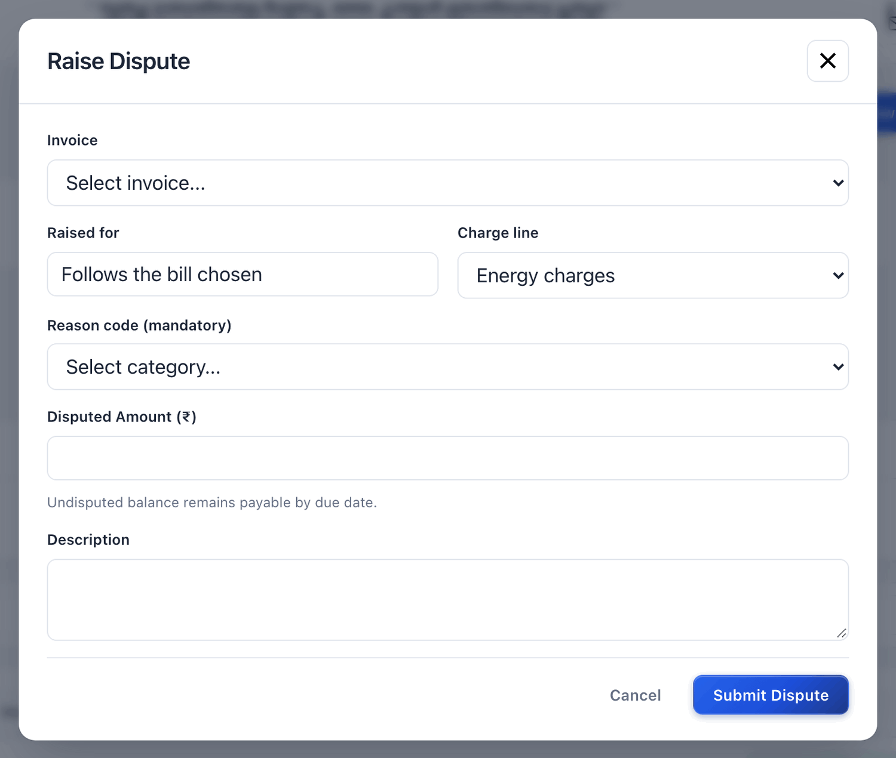
Figure 15.8 Raising a dispute from SJVN’s side.

15.7 Common questions
If you see this | Why it happens | What to do
The clock shows red / SLA breached | SJVN did not answer within the time limit. | Take up the dispute at once. The party can see the overrun and can escalate.
The bill still shows DISPUTED after my decision | The party has not yet accepted or escalated. | Wait for the party’s answer, or close the dispute if it does not answer.
The buyer’s outstanding went down by the disputed amount | The disputed amount is held back while the dispute is open. | This is correct. It comes back when the dispute is rejected or partly accepted.
I chose the wrong outcome | A mistake while confirming. | Inform the SJVN Administrator at once with the dispute number. Do not raise another dispute to correct it.

CHAPTER 16

16. Reconciliation
Matching energy, bills and payments for a period, and signing the statement with the other party.
What it is for | A reconciliation statement compares three things for a contract and period: what was metered, what was billed and what was paid. When both SJVN and the other party sign it, the period is closed.
Who uses it | SJVN REIA desk runs and signs it. The seller or buyer signs it from its own login.
How to open it | Menu → REIA Billing & Settlement → Reconciliation.
When to use it | After the bills of a month are raised and payments have come: monthly, quarterly or yearly.

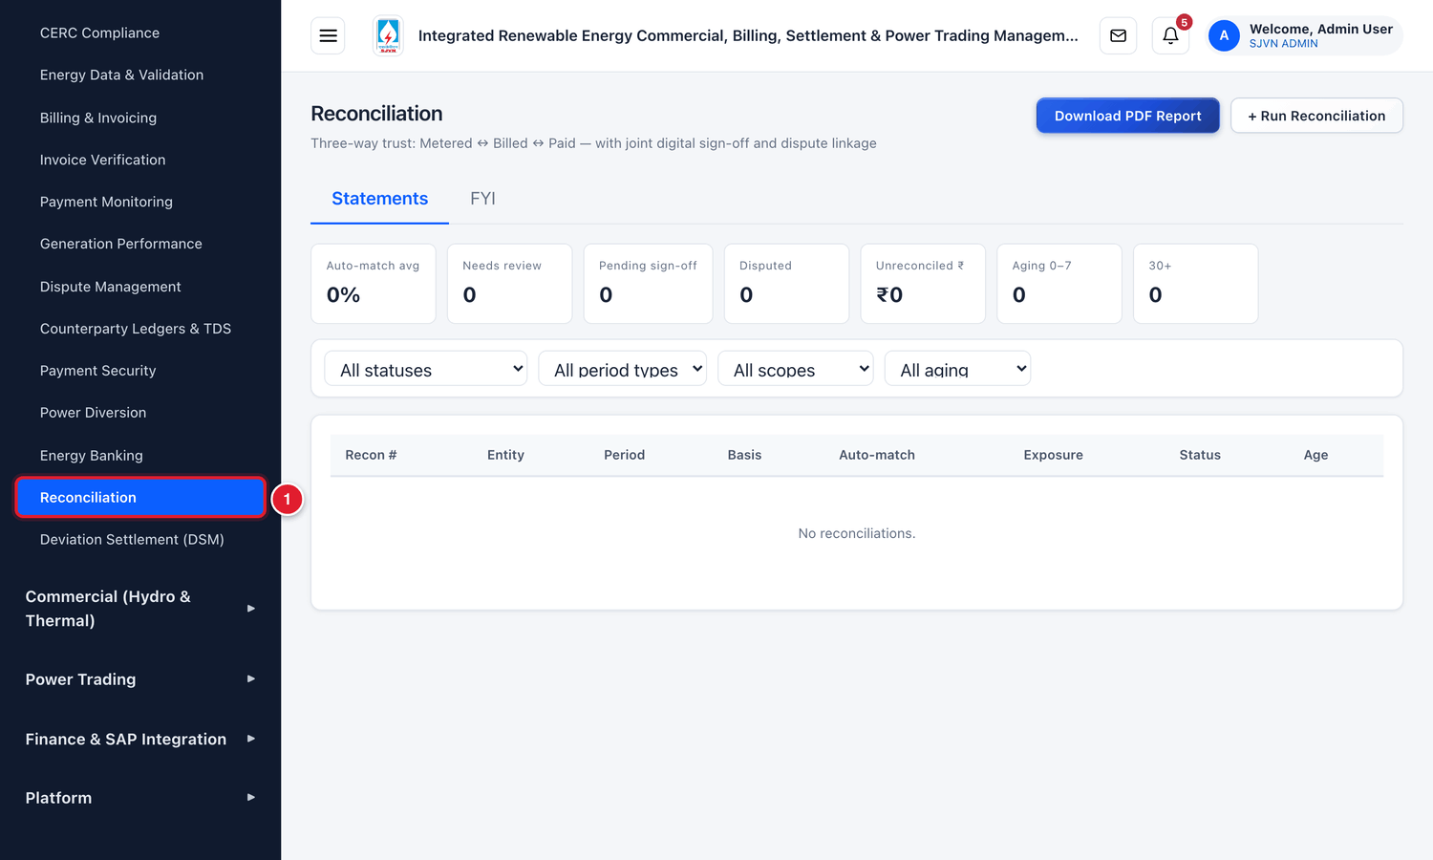
Figure 16.1 Opening Reconciliation from the menu.
1 | Click Reconciliation.

16.1 The steps of a reconciliation
Step | Who | What happens | Status
1 | SJVN | Runs the reconciliation for a contract and period. The platform compares the figures by itself. | AUTO MATCHED or NEEDS REVIEW
2 | SJVN | Looks at each line that did not match. Accepts it with a reason (override), or sends it to dispute. | PENDING SIGN OFF
3 | SJVN | Signs the statement. | PENDING SIGN OFF (1 of 2 signed)
4 | Seller / Buyer | Signs the statement, with or without exceptions. | CLOSED or AGREED

16.2 Running a reconciliation

To run a reconciliation
STEP  1 | Click + Run Reconciliation at the top right.

STEP  2 | Scope: leave it as REIA Contract (PPA/PSA).

STEP  3 | Contract: choose the PPA or PSA.

STEP  4 | Period type: choose MONTHLY, QUARTERLY or ANNUAL.

STEP  5 | Period: choose the month.

STEP  6 | Click Run.

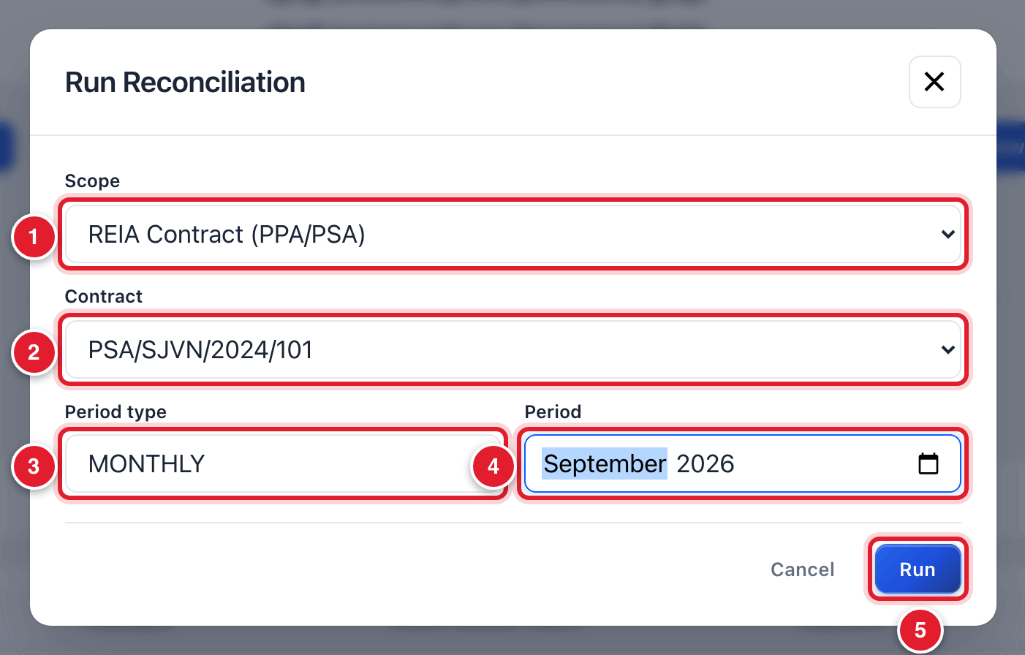
Figure 16.2 Running a reconciliation.
1 | Scope.
2 | Contract.
3 | Period type.
4 | The period.
5 | Click Run.

WHAT YOU SHOULD SEE NOW
The statement opens by itself. It has a number starting with RCN/.

16.3 Reading the statement
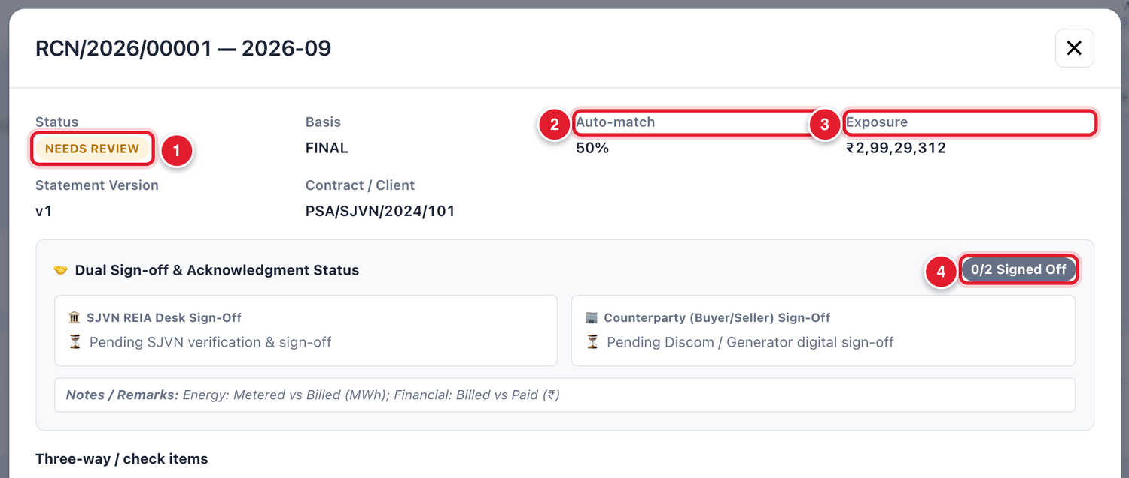
Figure 16.3 The top of the reconciliation statement.
1 | The status. NEEDS REVIEW means some lines did not match.
2 | Auto-match: the share of lines that matched by themselves.
3 | Exposure: the amount that is not yet reconciled.
4 | The sign-off position: how many of the two parties have signed.

The table Three-way / check items has one line for each check.
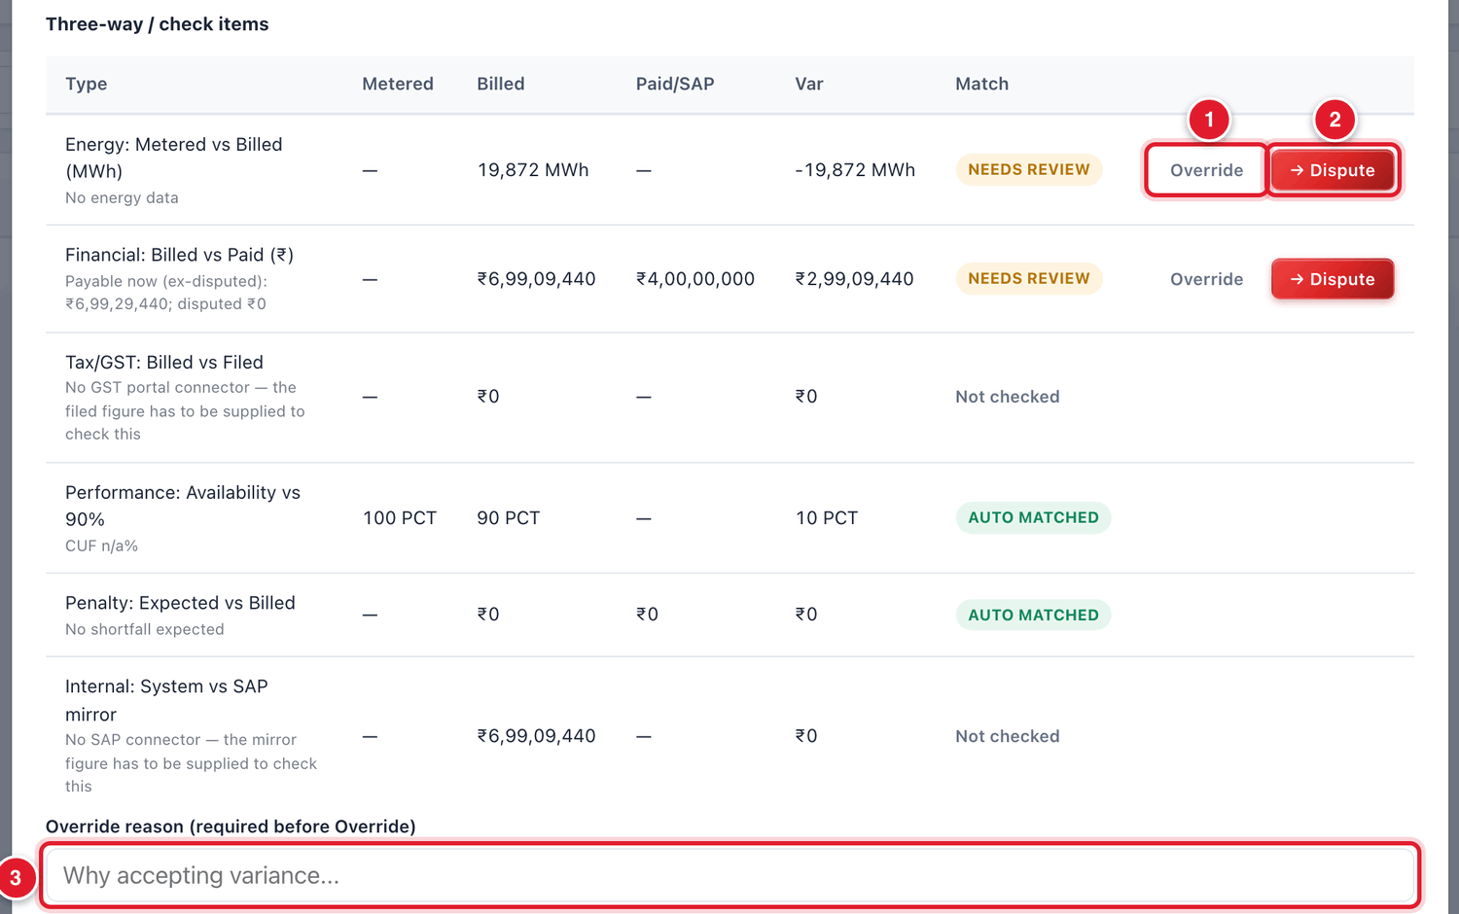
Figure 16.4 The check items.
1 | Override: accept the difference on this line, with a reason.
2 | → Dispute: send this line to dispute.
3 | The reason box. It must be filled before you click Override.

Check | What is compared
Energy: Metered vs Billed (MWh) | The energy in the energy record against the energy on the bills.
Financial: Billed vs Paid (₹) | The amount billed against the payments recorded.
Tax/GST: Billed vs Filed | Tax on the bills against tax filed. Shown as Not checked when the filed figure is not available.
Performance: Availability | The plant’s availability against the contract’s requirement.
Penalty: Expected vs Billed | The penalty that should apply against the penalty billed.
Internal: System vs SAP mirror | The platform’s figure against the accounts figure. Shown as Not checked when it is not available.

Result of a line | Meaning
AUTO MATCHED | The figures agree. Nothing to do.
NEEDS REVIEW | The figures do not agree. You must look at it.
Overridden | An officer accepted the difference and wrote the reason.
Not checked | The second figure is not available, so the platform could not compare.

The statement and the balance roll-forward
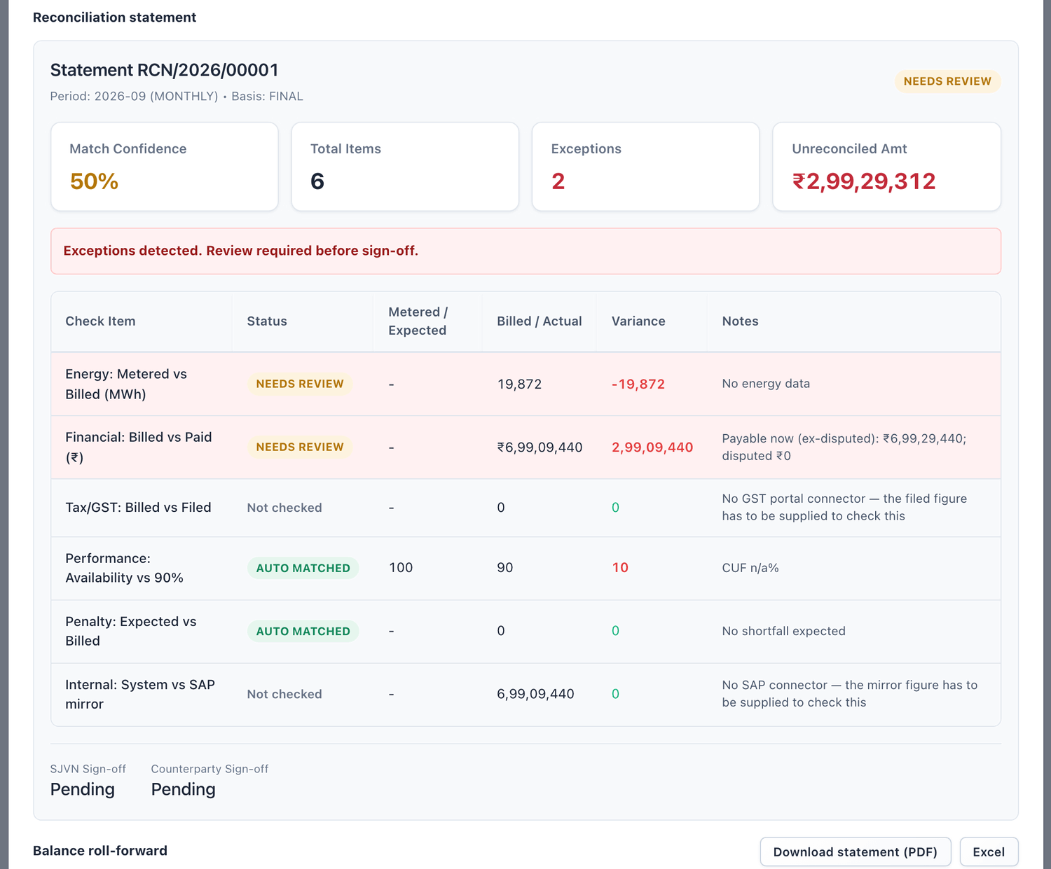
Figure 16.5 The statement summary.
The Balance roll-forward shows how the balance moved in the period: opening balance, plus billed in the period, minus payments received, equals closing balance.
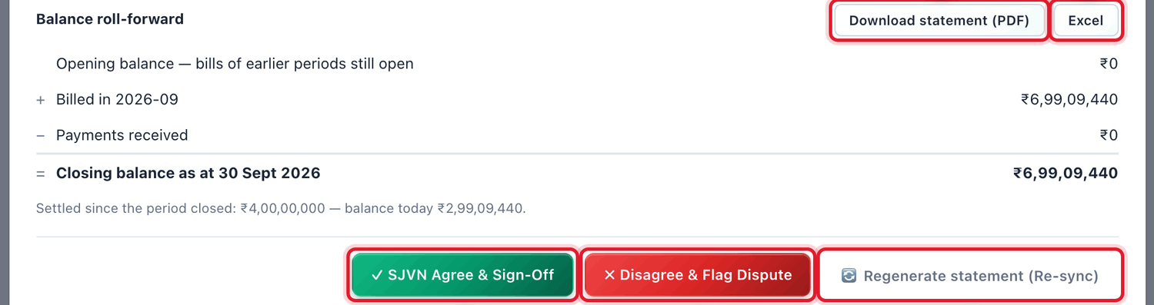
Figure 16.6 The balance roll-forward and the buttons.
1 | Download statement (PDF).
2 | Excel: download the statement as an Excel file.
3 | SJVN Agree & Sign-Off: sign for SJVN.
4 | Disagree & Flag Dispute: SJVN does not agree with the statement.
5 | Regenerate statement (Re-sync): run the comparison again with the latest data.

16.4 Dealing with lines that did not match
For each line that shows NEEDS REVIEW, first find out why. Common reasons are a part payment still within the due date, or energy taken from the source PPA for a PSA. Then choose:
- Override: the difference is understood and acceptable. You write the reason and accept the line.
- → Dispute: the difference is a real disagreement. The line goes to Dispute Management.

To override a line
STEP  1 | Click inside the box Override reason below the table. Type clearly why the difference is acceptable.

STEP  2 | Click Override on that line.

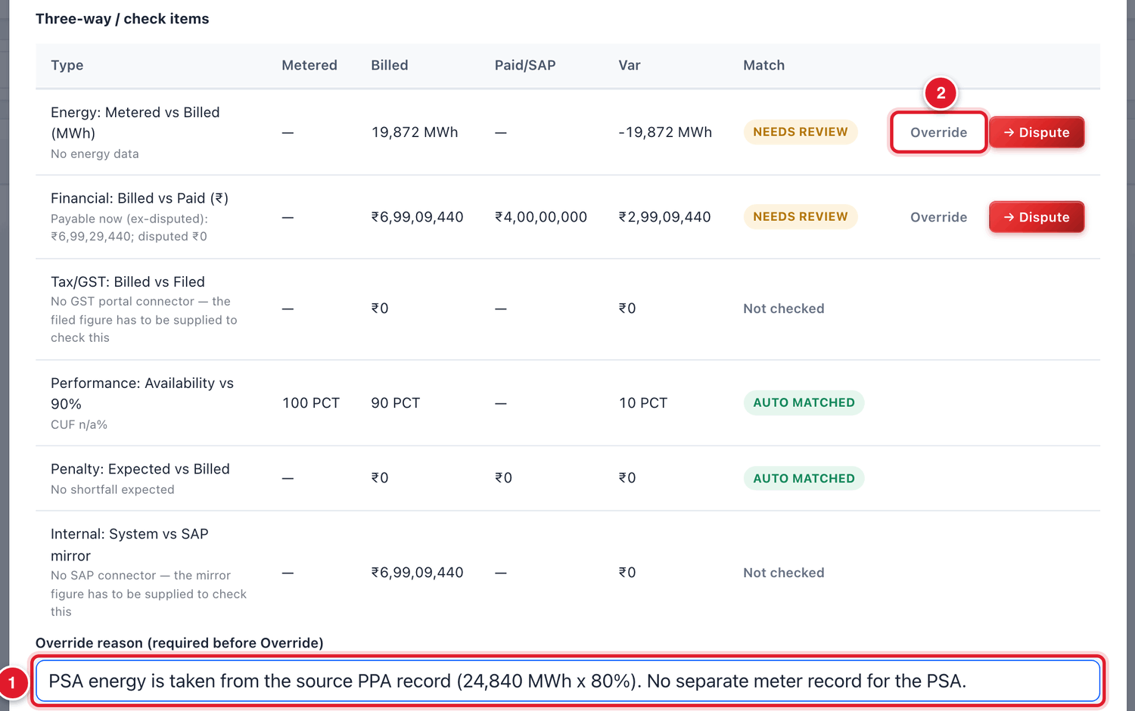
Figure 16.7 Overriding a line with a reason.
1 | Type the reason first.
2 | Then click Override on the line.

WHAT YOU SHOULD SEE NOW
A green message says the variance is overridden. The line shows Overridden. When no line is left in NEEDS REVIEW, the status of the statement becomes PENDING SIGN OFF and the auto-match becomes 100%.

IMPORTANT
The reason you type is shown to the other party and is kept in the audit trail. Write a real reason, not “ok” or “checked”.

16.5 Signing for SJVN

To sign the statement for SJVN
STEP  1 | Check that the status is PENDING SIGN OFF.

STEP  2 | Click the green button SJVN Agree & Sign-Off.

STEP  3 | A window named Sign-off & Acknowledgment opens. Type a remark if you want.

STEP  4 | Tick the box I confirm digital sign-off…. The button below becomes active only after you tick.

STEP  5 | Click Confirm & Sign Off.

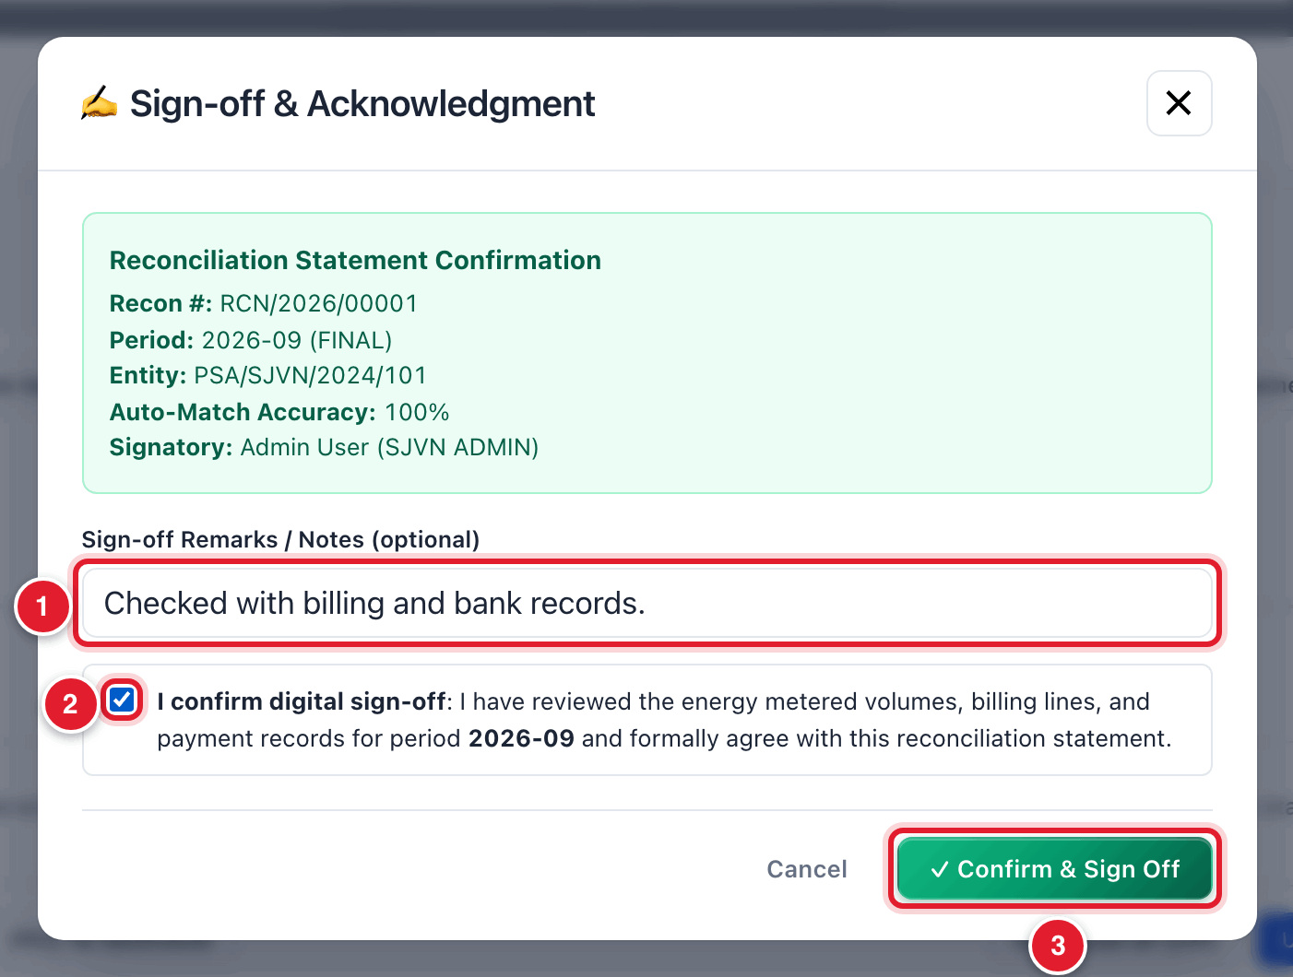
Figure 16.8 Confirming SJVN’s sign-off.
1 | Remarks (optional).
2 | Tick the confirmation.
3 | Click Confirm & Sign Off.

WHAT YOU SHOULD SEE NOW
A green message says Signed for SJVN. Awaiting the other party. The sign-off position shows 1/2. The seller or buyer gets an alert to sign.

16.6 The other party signs
The seller or buyer opens Reconciliation in its own menu and opens the statement. It has three choices:
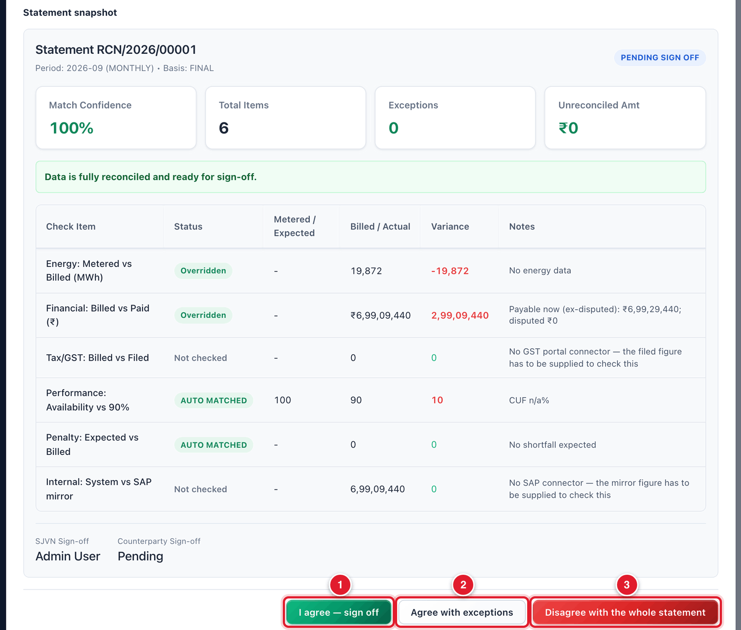
Figure 16.9 The three choices of the seller or buyer.
1 | I agree — sign off: agrees with the whole statement.
2 | Agree with exceptions: agrees, except for one or more items that it lists with amounts.
3 | Disagree with the whole statement.

The party’s choice | What happens on SJVN’s side
I agree — sign off | The statement is signed by both and becomes CLOSED.
Agree with exceptions | The statement becomes AGREED. SJVN must open it and answer each exception: accepted or not accepted, with a reason.
Disagree with the whole statement | The statement becomes DISPUTED. SJVN must discuss with the party and run the reconciliation again after correction.

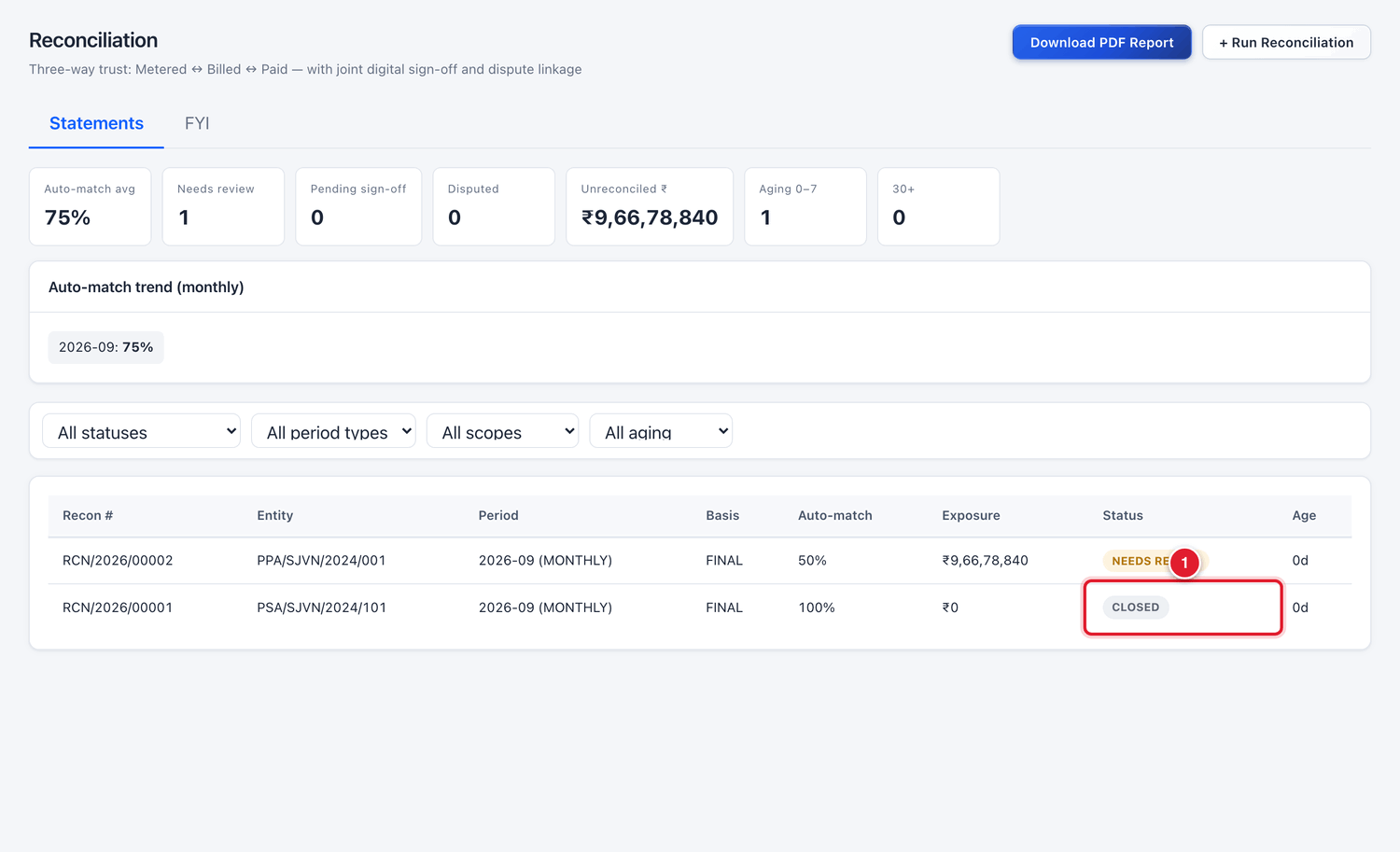
Figure 16.10 The list after both parties have signed.
1 | The status CLOSED.

16.7 The list of statements
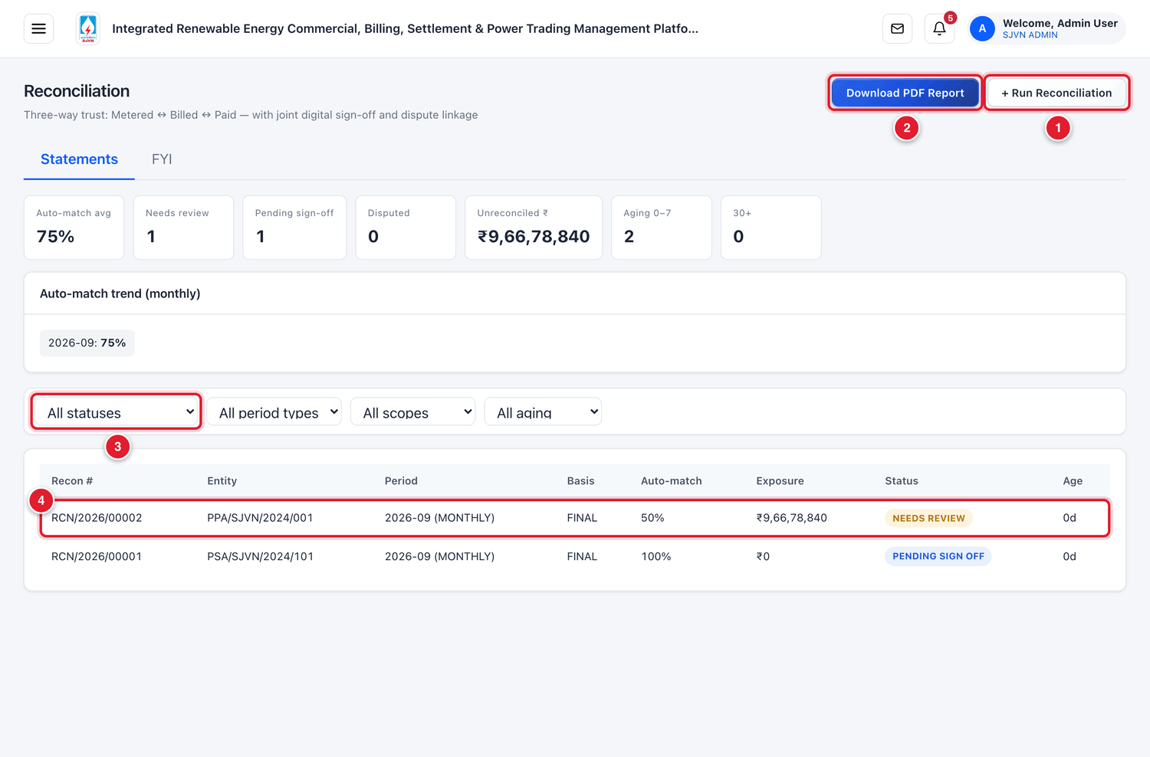
Figure 16.11 The Reconciliation screen (menu hidden).
1 | + Run Reconciliation.
2 | Download PDF Report.
3 | Filters: status, period type, scope and age.
4 | One statement. Click the row to open it.

16.8 Common questions
If you see this | Why it happens | What to do
Override does nothing | The reason box is empty. | Type the reason first, then click Override.
Confirm & Sign Off is grey | The confirmation box is not ticked. | Tick I confirm digital sign-off….
The figures changed after I ran the statement (a new payment came) | The statement shows the data of the time it was run. | Click Regenerate statement (Re-sync) before signing.
The party says it cannot sign | SJVN has not signed yet, or lines are still in NEEDS REVIEW. | Clear the lines and sign for SJVN first.

CHAPTER 17

17. Payment Security
Keeping track of letters of credit, bank guarantees and funds that stand behind the payments.
What it is for | A register of every security instrument: the buyer’s letter of credit (LC), the seller’s bank guarantees (EMD, PBG), corpus and payment security funds. It shows if the cover is enough and warns before an instrument expires.
Who uses it | SJVN REIA desk and Finance.
How to open it | Menu → REIA Billing & Settlement → Payment Security.
When to use it | When a new instrument is received, when one is renewed or amended, and every month to check cover and expiry.

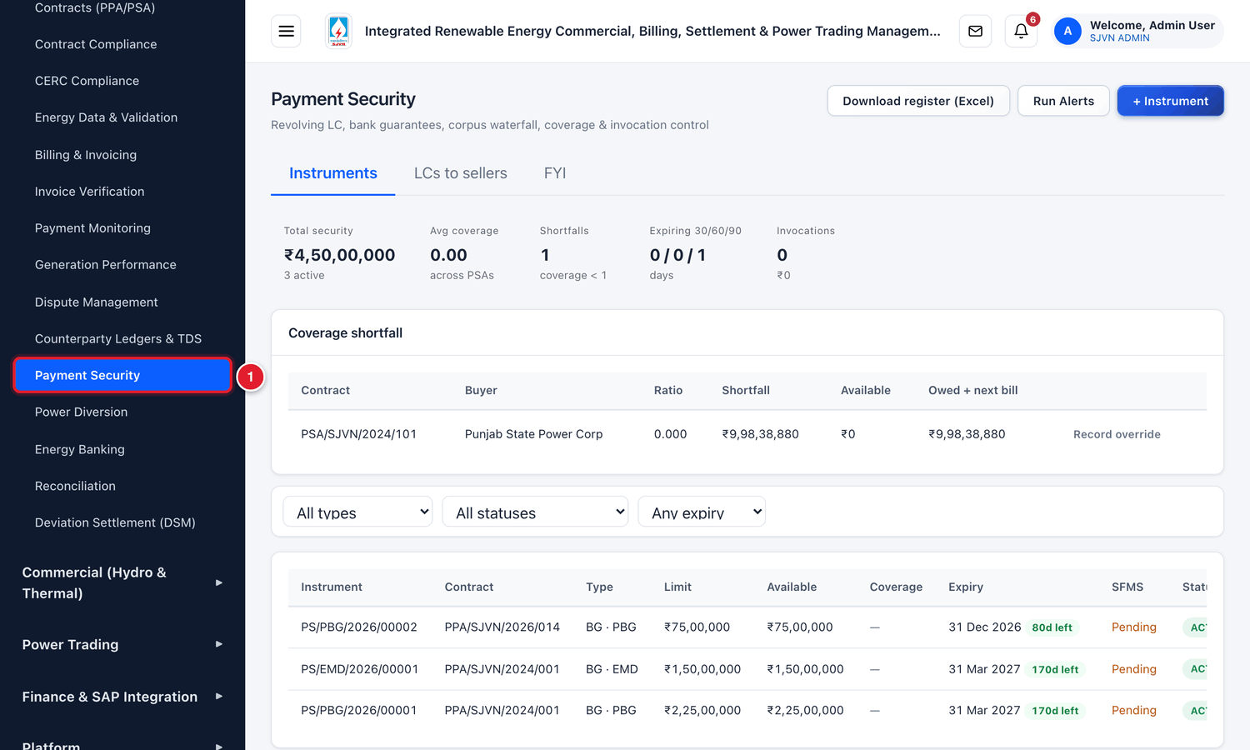
Figure 17.1 Opening Payment Security from the menu.
1 | Click Payment Security.

17.1 The Payment Security screen
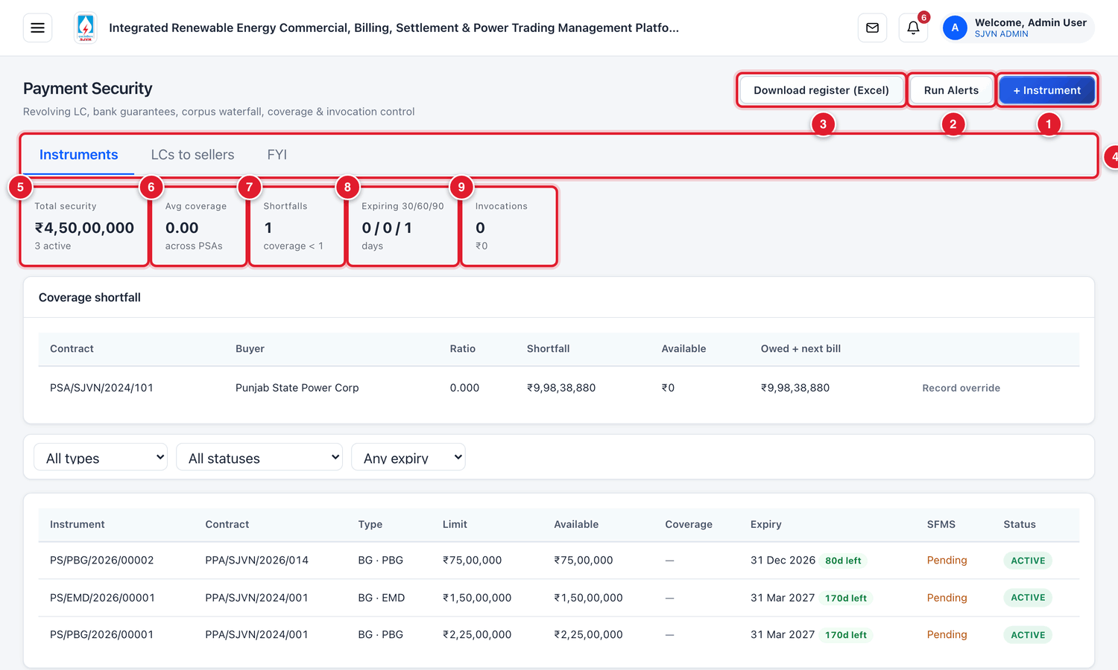
Figure 17.2 The top of the Payment Security screen (menu hidden).
1 | + Instrument: add a new LC, guarantee or fund.
2 | Run Alerts: check all instruments now and raise alerts for those expiring or short.
3 | Download register (Excel): the full register as an Excel file.
4 | Tabs: Instruments, LCs to sellers and FYI.
5 | Total security: the total value of active instruments.
6 | Avg coverage: how well the buyers’ dues are covered. 1.00 means fully covered.
7 | Shortfalls: PSAs whose cover is less than required.
8 | Expiring 30/60/90: instruments expiring within 30, 60 and 90 days.
9 | Invocations: how many times security was invoked, and for how much.

Coverage shortfall
If a PSA’s security is less than what the buyer owes plus the next bill, the PSA is listed under Coverage shortfall.
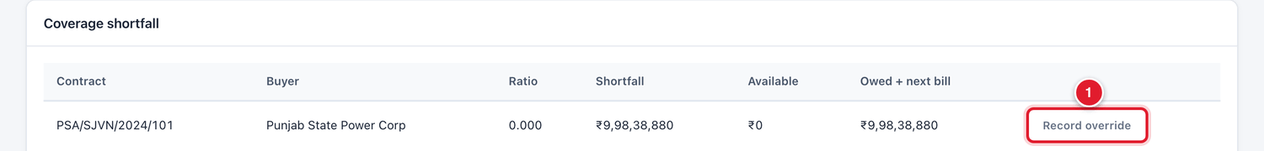
Figure 17.3 The coverage shortfall table.
1 | Record override: record why the shortfall is accepted for now.

Column | Meaning
Ratio | Available security ÷ (amount owed + next bill). Below 1 means a shortfall.
Shortfall | How much more security is needed.
Available | The security available now.
Owed + next bill | What the buyer owes now plus the expected next bill.

17.2 Adding an instrument

To add a new LC, guarantee or fund
STEP  1 | Click + Instrument.

STEP  2 | Fill the boxes and click Save.

Field | What to enter | Example
Contract * | The PSA (for a buyer’s LC) or the PPA (for a seller’s guarantee). | PSA/SJVN/2024/101 (PSA)
Mechanism | Letter of credit, Bank guarantee, Corpus fund, Payment security fund or Other. | Letter of credit
Limit (₹) * | The amount of the instrument, in rupees. No commas. | 70000000
Issuing bank | The bank and branch that issued it. | Punjab National Bank, Chandigarh
Validity start * | The date from which the instrument is valid. | 01/10/2026
Validity end * | The expiry date. | 30/09/2027
Revolving LC | Tick if the LC is revolving (its limit is restored after each drawal is made good). | (ticked)
Remarks | Any note, for example the article of the contract. | Revolving LC as per Article 6.5 of the PSA

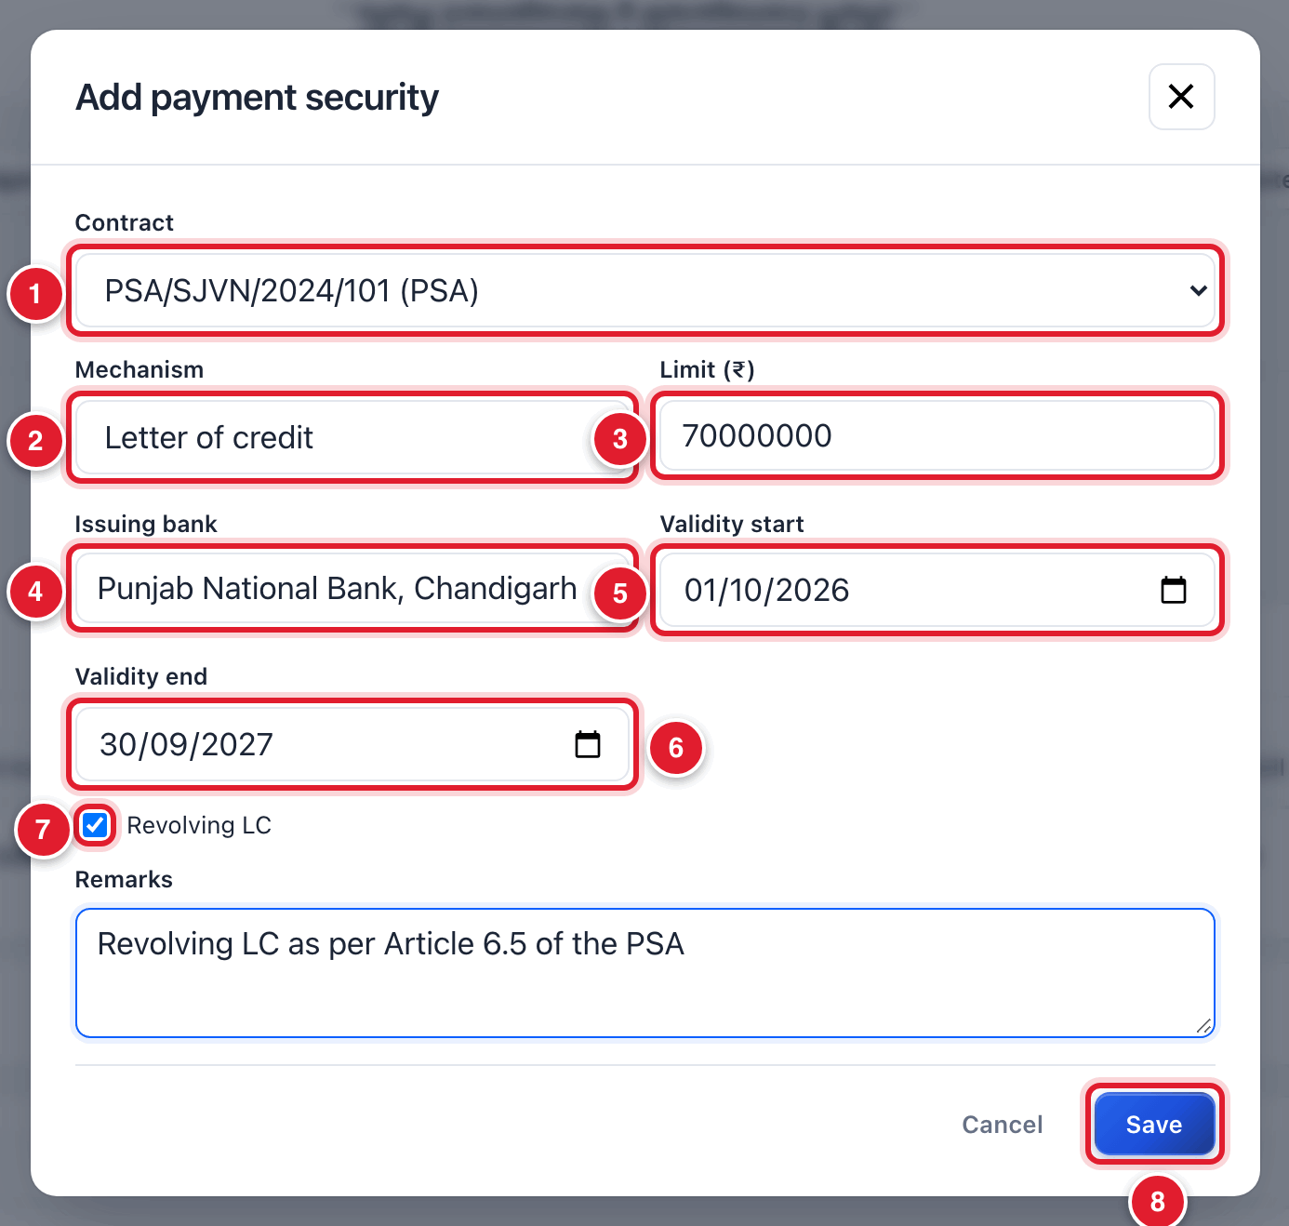
Figure 17.4 Adding a letter of credit.
1 | Contract.
2 | Mechanism.
3 | Limit.
4 | Issuing bank.
5 | Valid from.
6 | Valid until.
7 | Revolving LC.
8 | Click Save.

WHAT YOU SHOULD SEE NOW
A green message gives the number of the new instrument, for example PS/LC/2026/00001. It appears in the table with the status ACTIVE.

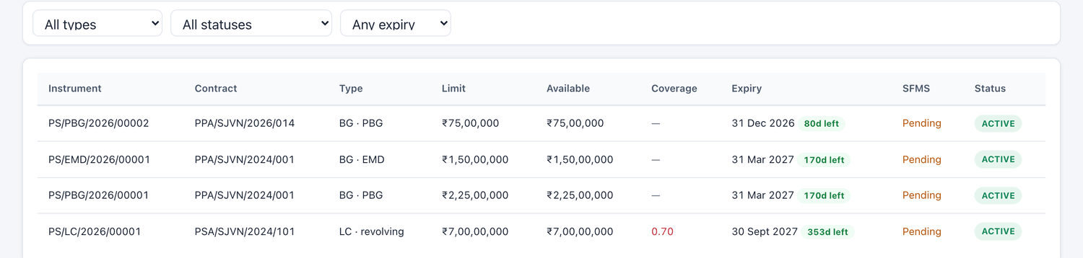
Figure 17.5 The table of instruments.
Column | Meaning
Instrument | The number given by the platform. Click it to open the instrument.
Contract / Type | The contract and the kind of instrument (LC, BG · EMD, BG · PBG…).
Limit / Available | The full amount and the amount still available.
Coverage | For a PSA: how well the buyer’s dues are covered.
Expiry | The expiry date and days left.
SFMS | Whether the bank’s confirmation message (SFMS) is recorded.
Status | ACTIVE, PARTIALLY UTILIZED, INVOKED, EXPIRED, RENEWED, RELEASE PENDING, RELEASED or CLOSED.

17.3 Working on one instrument

To open an instrument
STEP  1 | In the table, click the instrument number (for example PS/LC/2026/00001).

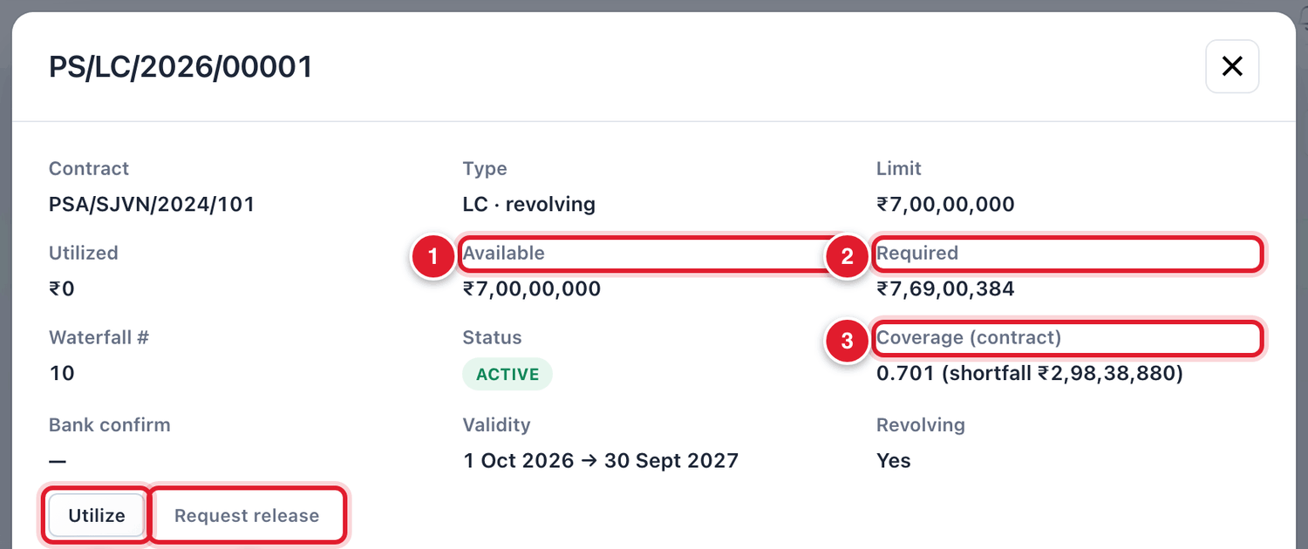
Figure 17.6 The top of the instrument window.
1 | Available: what can still be drawn.
2 | Required: what the contract needs.
3 | Coverage of the contract and the shortfall, if any.
4 | Utilize: record a drawal on the instrument.
5 | Request release: start returning the instrument.

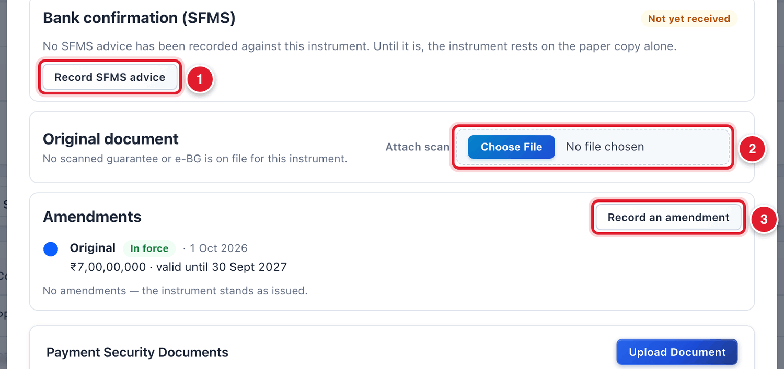
Figure 17.7 Bank confirmation, original document and amendments.
1 | Record SFMS advice: record the bank’s confirmation message.
2 | Attach scan: attach the scanned guarantee / LC.
3 | Record an amendment: record an extension or change in amount.

Recording the bank’s confirmation (SFMS)
A guarantee or LC on paper should be confirmed by the issuing bank through an SFMS message. Until this is recorded, the instrument rests on the paper copy alone.

To record the SFMS advice
STEP  1 | Click Record SFMS advice.

STEP  2 | Choose the SFMS message type (for example MT760 for a guarantee issued, MT700 for an LC issued). Fill the message date, the SFMS reference / UTR, the sender bank’s IFSC and the bank’s guarantee / LC number.

STEP  3 | Click Record confirmation.

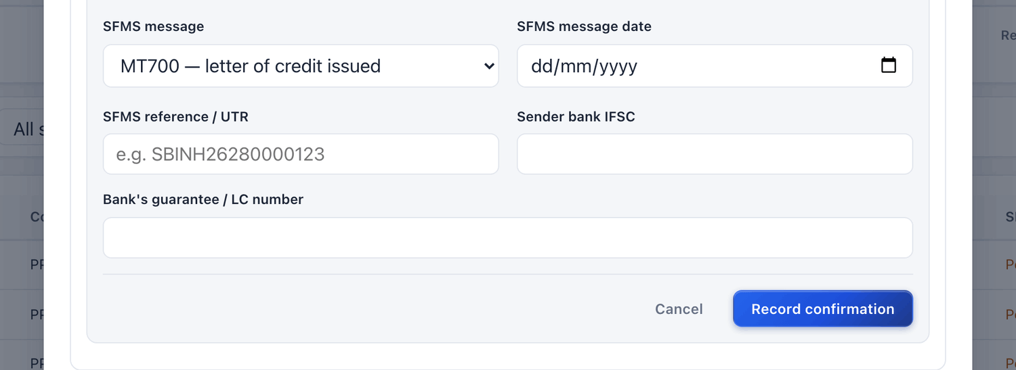
Figure 17.8 Recording the SFMS advice.

Recording an amendment (extension)

To record an extension or change
STEP  1 | Click Record an amendment.

STEP  2 | Fill what has changed: New validity, New claim period ends, New amount. Fill the bank’s amendment number and date, and attach the bank’s amendment letter.

STEP  3 | Reason for the amendment is compulsory. Type it, and click Record amendment.

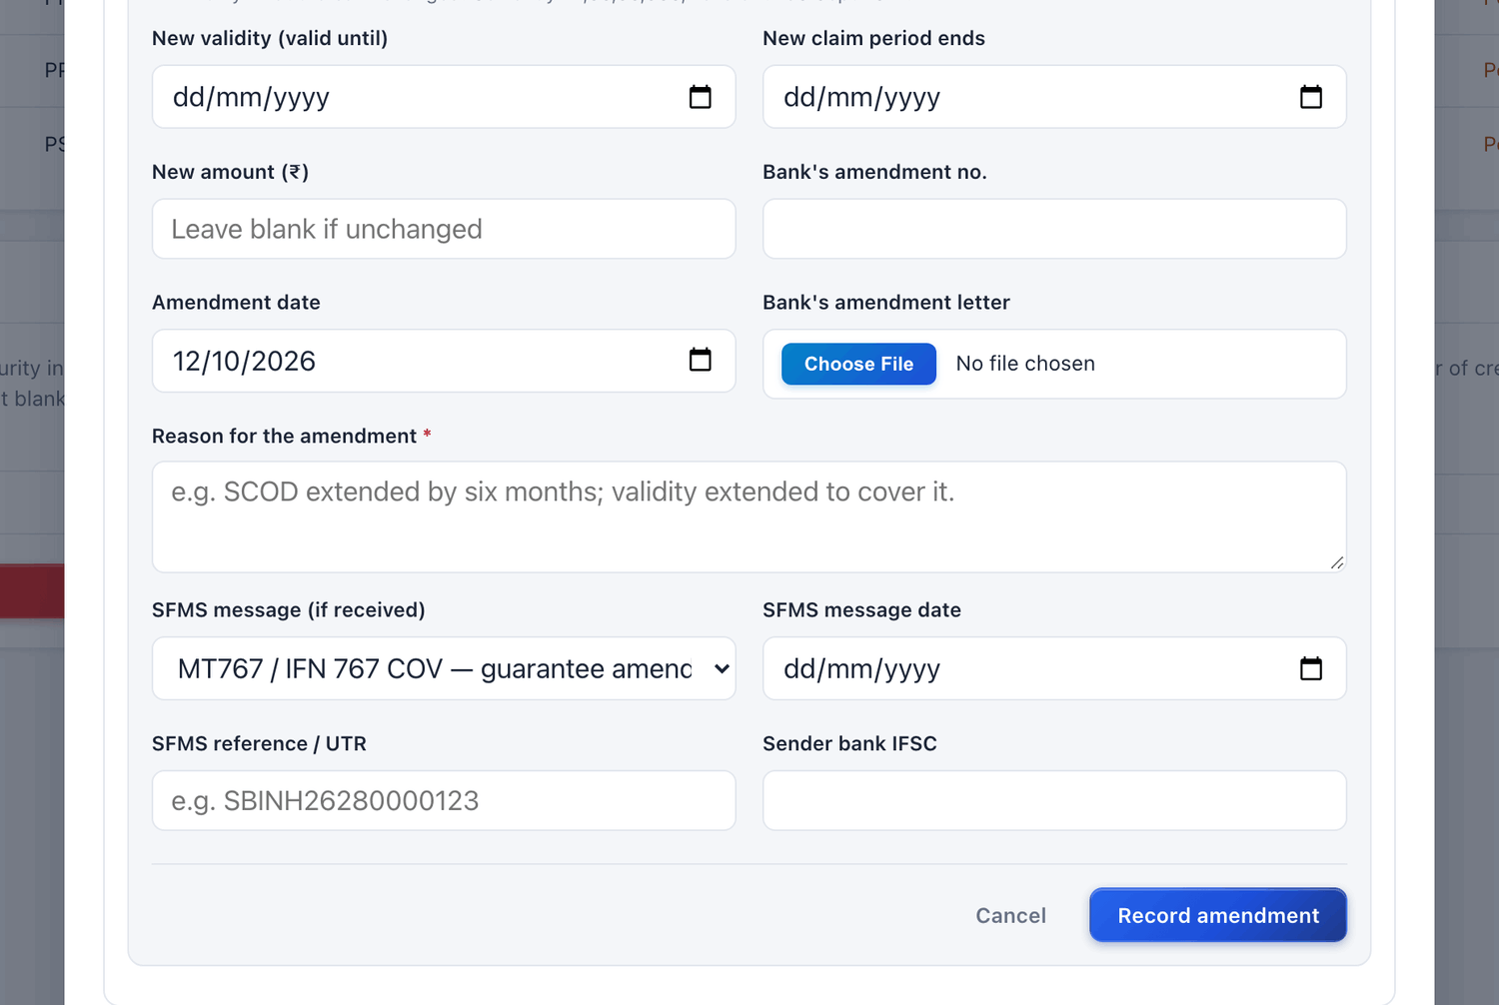
Figure 17.9 Recording an amendment.

Utilising (drawing on) an instrument

To record a drawal
STEP  1 | Click Utilize.

STEP  2 | Type the Amount (₹) and What it is drawn for. Click Confirm.

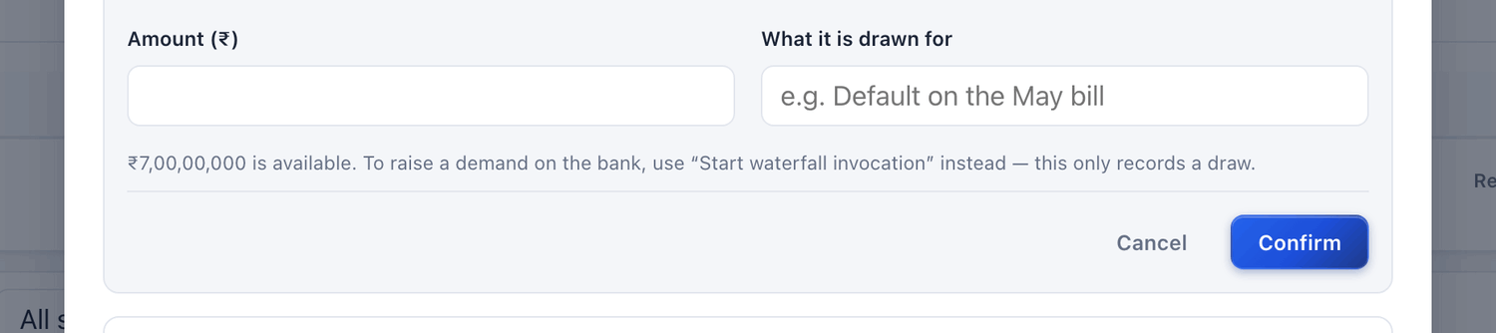
Figure 17.10 Recording a drawal.
BE CAREFUL
Record a drawal only after the bank has actually paid against the instrument. The available amount of the instrument goes down by this amount.

Releasing an instrument

To request the release of an instrument
STEP  1 | Click Request release, type the Reason and click Confirm.

WHAT YOU SHOULD SEE NOW
The status becomes RELEASE PENDING. The release takes effect only after approval. The platform will not release an instrument while money is still outstanding on its contract.

17.4 Accepting a shortfall for the time being

To record an override on a shortfall
STEP  1 | In the Coverage shortfall table, click Record override on the line of the PSA.

STEP  2 | Reason: type why, for example LC enhancement with the bank, advice awaited. Valid until: the date up to which the override should hold. Leave it empty to keep it until withdrawn.

STEP  3 | Click Save override.

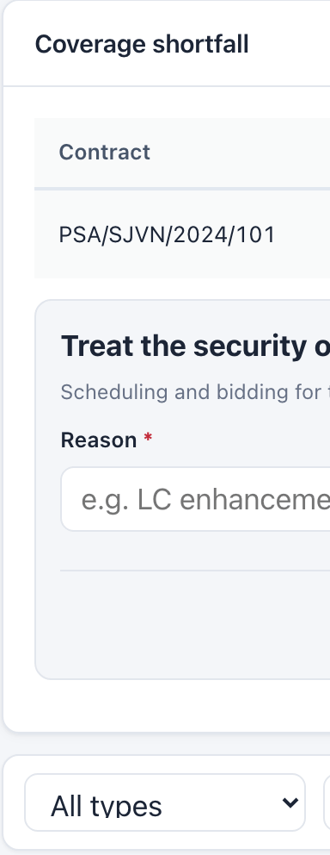
Figure 17.11 Recording an override on a shortfall.

17.5 Invoking security when a buyer defaults
When a buyer does not pay, SJVN can draw on the security in a fixed order, called the waterfall: the party’s own instrument first, pooled funds last. The platform also raises a demand notice.
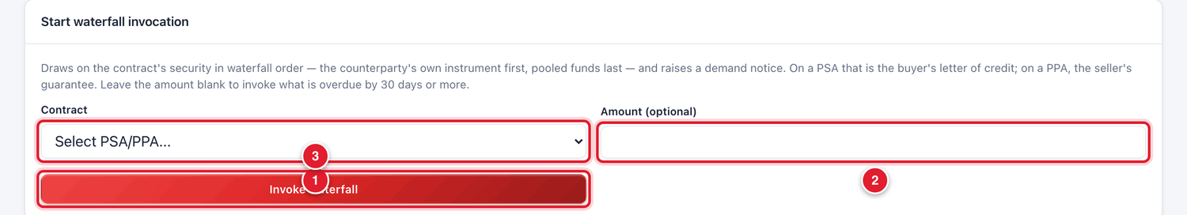
Figure 17.12 Starting a waterfall invocation.
1 | The contract.
2 | The amount. Leave empty to invoke what is overdue by 30 days or more.
3 | Invoke waterfall.

BE CAREFUL
Invoke waterfall is a serious step with legal effect. Use it only on the written approval of the competent authority. Never click it to “see what happens”.

17.6 Letters of credit opened by SJVN for sellers
Under some PPAs, SJVN opens an LC in favour of the seller. These are SJVN’s obligations, not security held by SJVN. They are kept in the second tab.

To record an LC opened for a seller
STEP  1 | Click the tab LCs to sellers, then click + Record an LC.

STEP  2 | Choose the PPA. Fill the issuing bank, the amount and Valid until (these are compulsory). Fill the other boxes if known, attach a copy of the LC, and click Record letter of credit.

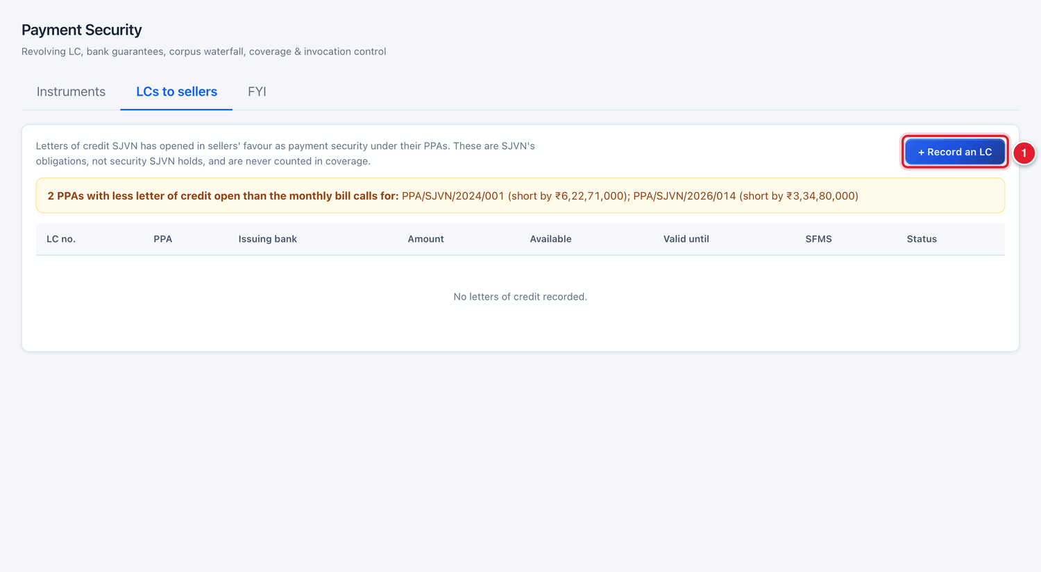
Figure 17.13 The “LCs to sellers” tab.
1 | + Record an LC.

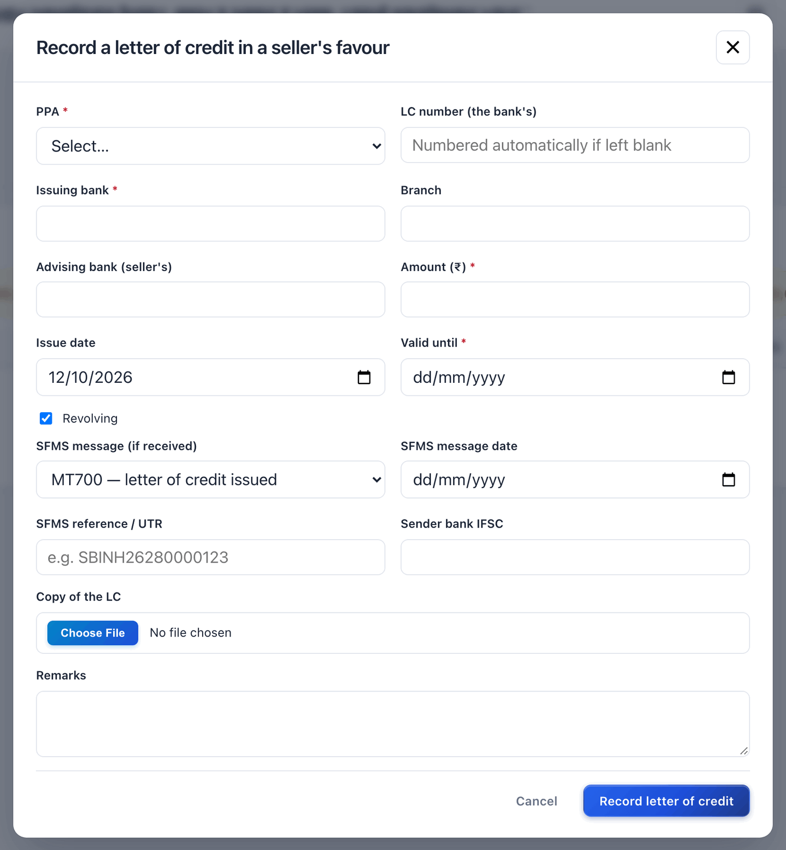
Figure 17.14 Recording an LC opened for a seller.
GOOD TO KNOW
A yellow line at the top of this tab lists the PPAs where the LC open is less than the monthly bill calls for.

17.7 Common questions
If you see this | Why it happens | What to do
An instrument shows EXPIRED | Its validity end date has passed. | Get the extension from the party and record it with Record an amendment.
Coverage is below 1 | The security is less than dues plus the next bill. | Ask the buyer to enhance the LC. Meanwhile record an override with the reason.
SFMS shows Pending | The bank’s confirmation is not recorded. | Get the SFMS advice from the bank and record it.
The party asks for release but the platform refuses | Money is still outstanding on the contract. | Release is possible only after the dues are cleared.

CHAPTER 18

18. Deviation Settlement (DSM)
Recording the weekly deviation charges published by NRPC.
What it is for | Every week NRPC publishes the Deviation Settlement Account (DSA). It tells, for each station, the charge payable or receivable for the difference between scheduled and actual energy. This screen keeps those weekly figures and turns them into bills.
Who uses it | SJVN REIA desk.
How to open it | Menu → REIA Billing & Settlement → Deviation Settlement (DSM).
When to use it | Every week, when NRPC publishes its statement.

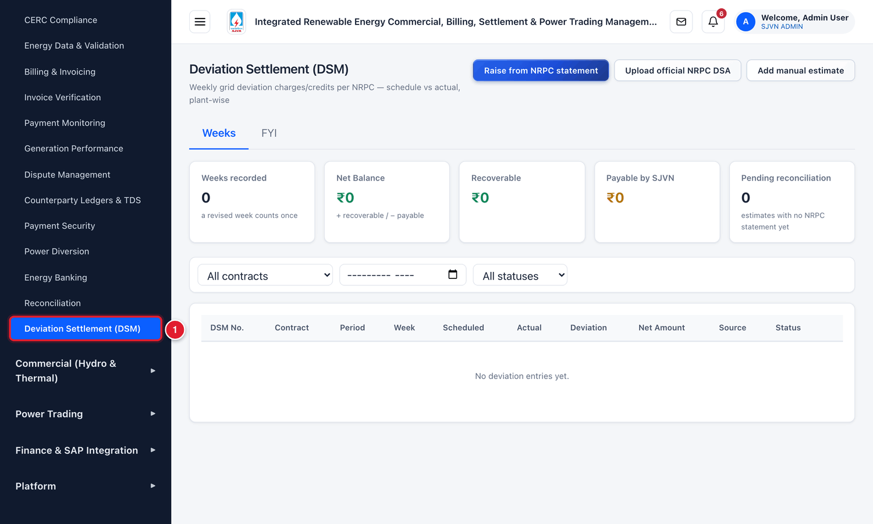
Figure 18.1 Opening Deviation Settlement from the menu.
1 | Click Deviation Settlement (DSM).

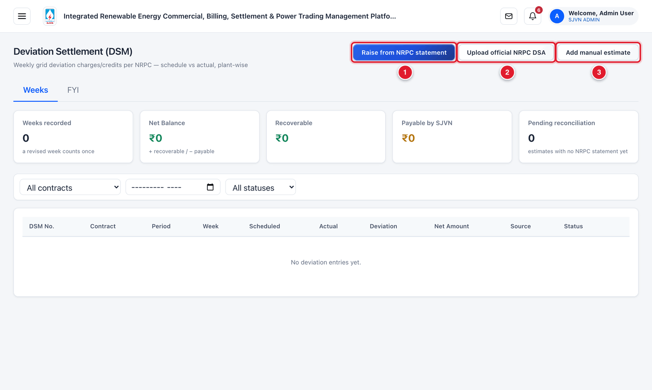
Figure 18.2 The DSM screen (menu hidden).
1 | Raise from NRPC statement: take a station’s week from an uploaded NRPC statement.
2 | Upload official NRPC DSA: upload the weekly PDF published by NRPC.
3 | Add manual estimate: type an estimate until the NRPC statement comes.

Box at the top | Meaning
Weeks recorded | The number of weeks on record. A revised week counts once.
Net Balance | Recoverable minus payable. + means recoverable, − means payable by SJVN.
Recoverable / Payable by SJVN | The two parts of the balance.
Pending reconciliation | Estimates for which the NRPC statement has not yet come.

18.1 The normal way: from the NRPC statement

Step 1: upload the NRPC statement
STEP  1 | Download the weekly DSA PDF from the NRPC website to your computer.

STEP  2 | Click Upload official NRPC DSA. Click Choose File, pick the PDF and click Import statement.

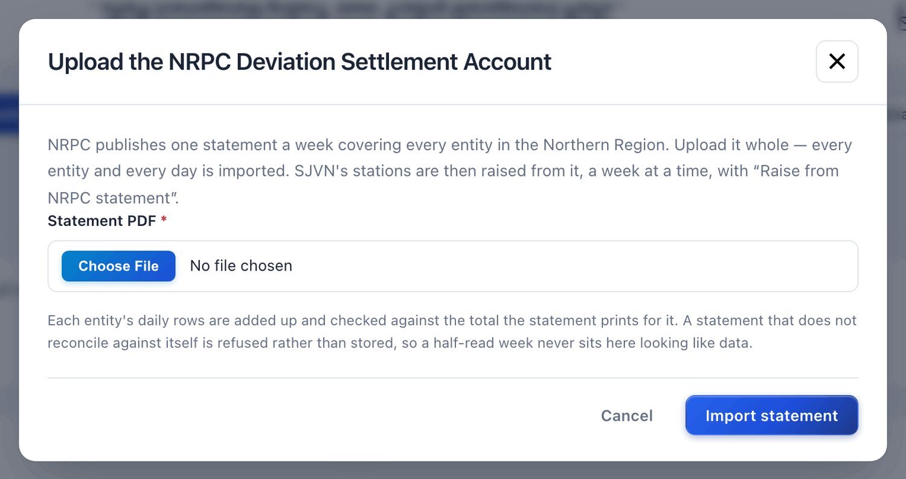
Figure 18.3 Uploading the NRPC statement.
GOOD TO KNOW
Upload the statement whole, as published. The platform reads every entity and every day, adds up the daily rows and checks them against the totals printed in the statement. If the statement does not add up, it is refused.

Step 2: raise the week for a station
STEP  1 | Click Raise from NRPC statement.

STEP  2 | Contract (the station’s PPA): choose the PPA.

STEP  3 | NRPC statement (week): choose the uploaded statement.

STEP  4 | Station, as the statement names it: choose the station’s name as written in the NRPC statement.

STEP  5 | Click Raise this week.

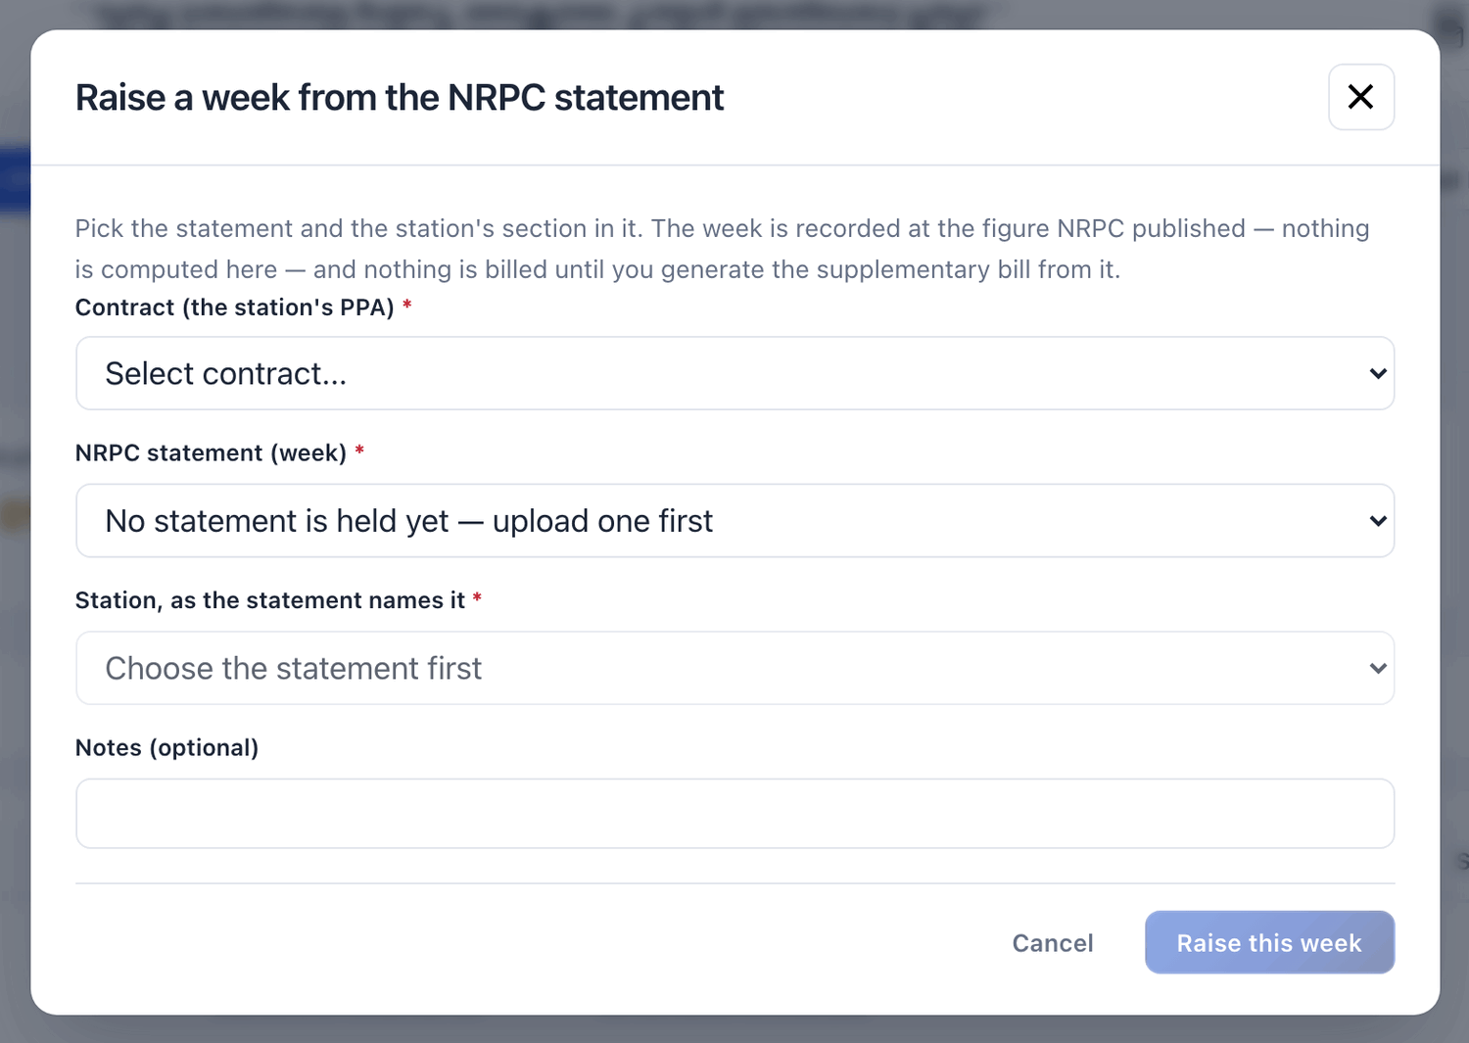
Figure 18.4 Raising a week from the NRPC statement.
WHAT YOU SHOULD SEE NOW
The week is recorded with the figure published by NRPC. Nothing is calculated by the platform, and nothing is billed yet.

18.2 A manual estimate
If the NRPC statement is late, you can enter an estimate. When the statement arrives, it replaces the estimate.

To add a manual estimate
STEP  1 | Click Add manual estimate.

STEP  2 | Fill the boxes and click Add Week.

Field | What to enter | Example
Contract * | The PPA of the station. | PPA/SJVN/2024/001 (Solar)
Plant Code / Plant Name | The code and name of the plant. | SUN01 / SUNRISE SOLAR 150 MW
Period (Month) * | The month. | September 2026
Week No. * | The week number of the financial year (1 to 53). | 25
Week Date | The first day of the week. | 21/09/2026
Entry Type | Primary for the first entry of a week. Revised for a revision. | Primary
Target (Scheduled MWh) * | The scheduled energy of the week. | 5800
Delivered (Actual MWh) * | The actual energy of the week. | 5725
Deviation Rate (₹/MWh) * | The DSM rate. | 3200

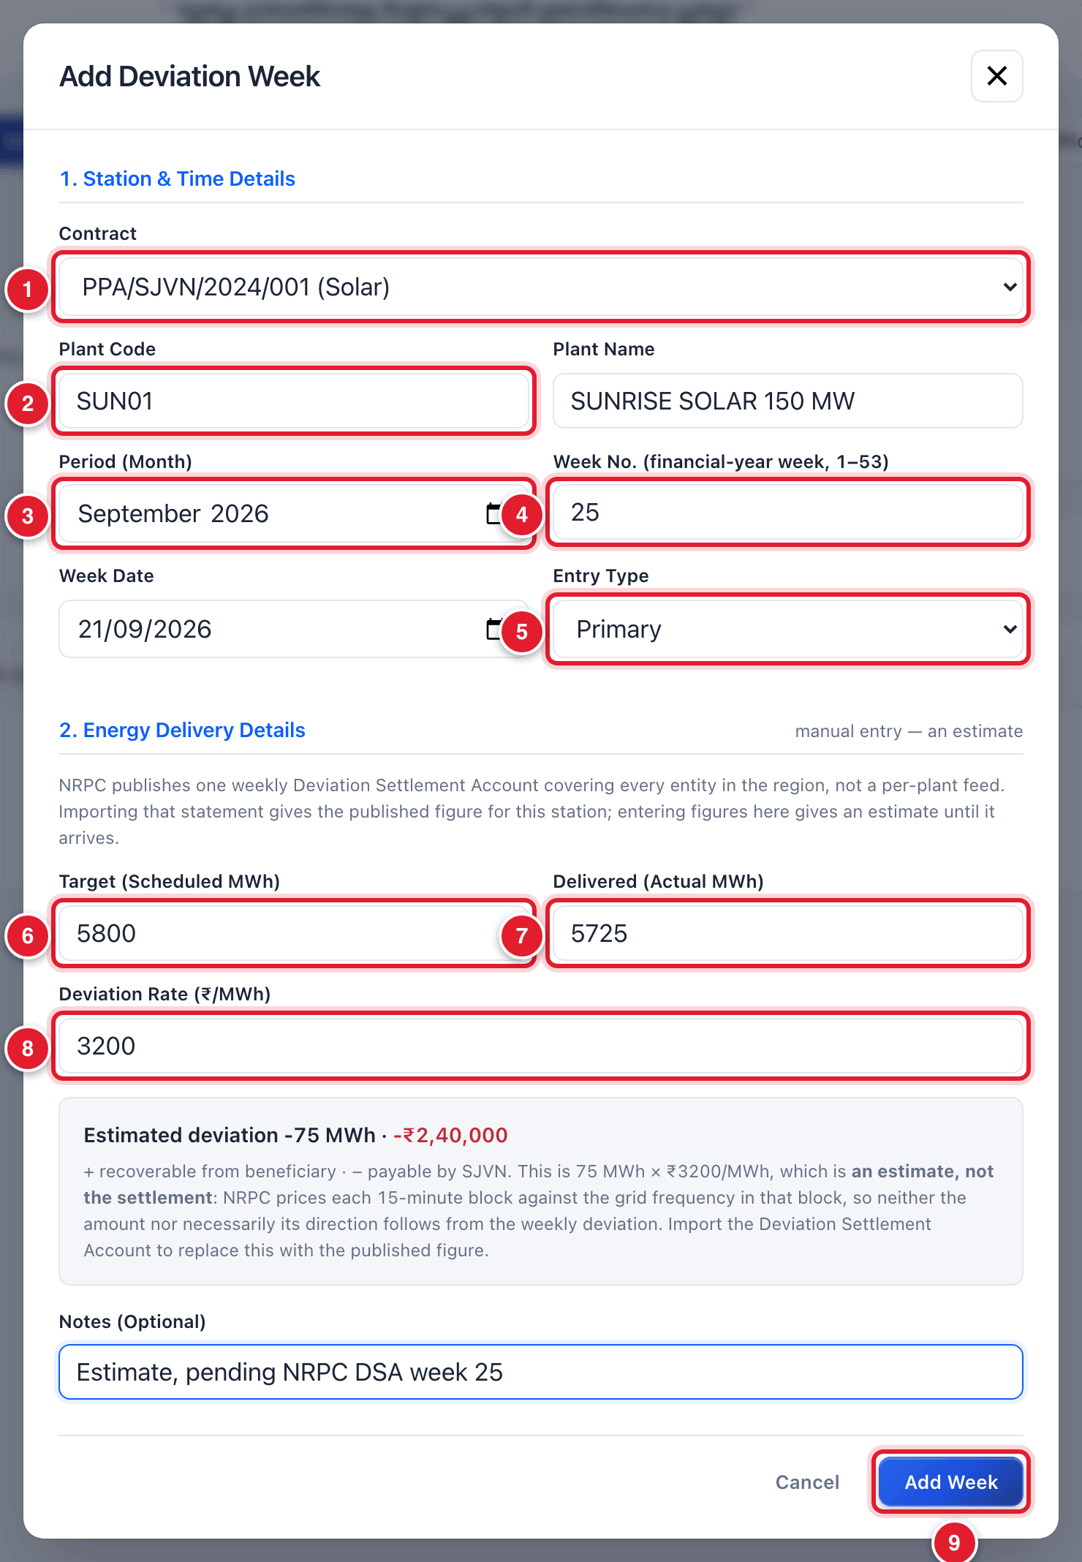
Figure 18.5 Adding a manual estimate.
1 | Contract.
2 | Plant code.
3 | Month.
4 | Week number.
5 | Primary or Revised.
6 | Scheduled MWh.
7 | Actual MWh.
8 | Rate.
9 | Click Add Week.

IMPORTANT
A manual figure is only an estimate. NRPC prices each 15-minute block against the grid frequency of that block, so the real amount can be different. The row shows the source as Estimated.

18.3 From a recorded week to a bill
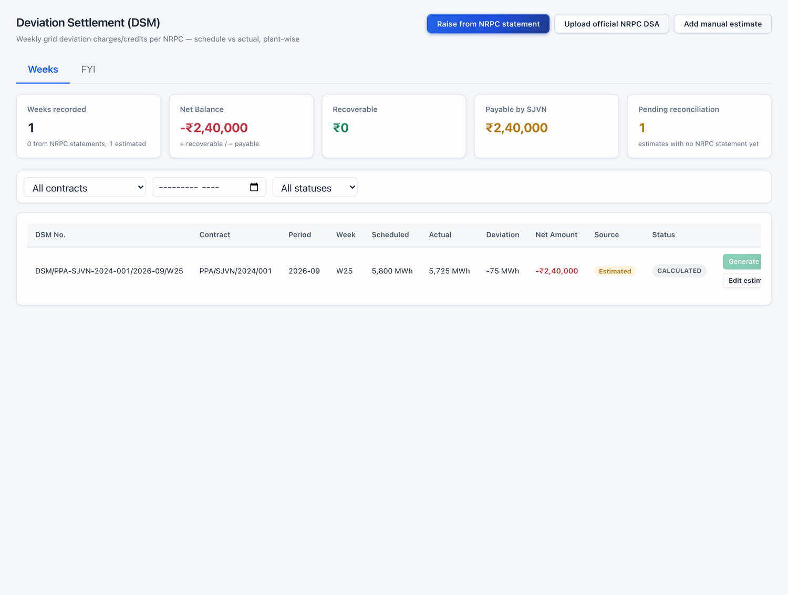
Figure 18.6 A recorded week in the table.
Each row has buttons at its right end:
- Generate supplementary bill: makes a supplementary bill for this week’s amount. The bill goes through the normal approval (Chapter 11).
- Edit estimate: change a manual estimate.
- Delete: remove a manual estimate entered by mistake.
Status | Meaning
CALCULATED | The week is recorded. No bill is made yet.
SUBMITTED | A supplementary bill is made and is in approval.
DISPATCHED | The bill has been issued.
CANCELLED | The entry is cancelled.

CHAPTER 19

19. Power Diversion
Recording power sold on the exchange when a buyer defaults or does not requisition.
What it is for | When a buyer does not pay or does not take its power, SJVN can sell that power on the exchange (PSA Article 6.6). This screen records each such sale and works out the gain or loss against the buyer.
Who uses it | SJVN REIA desk.
How to open it | Menu → REIA Billing & Settlement → Power Diversion.
When to use it | After power of a defaulting buyer is sold on the exchange.

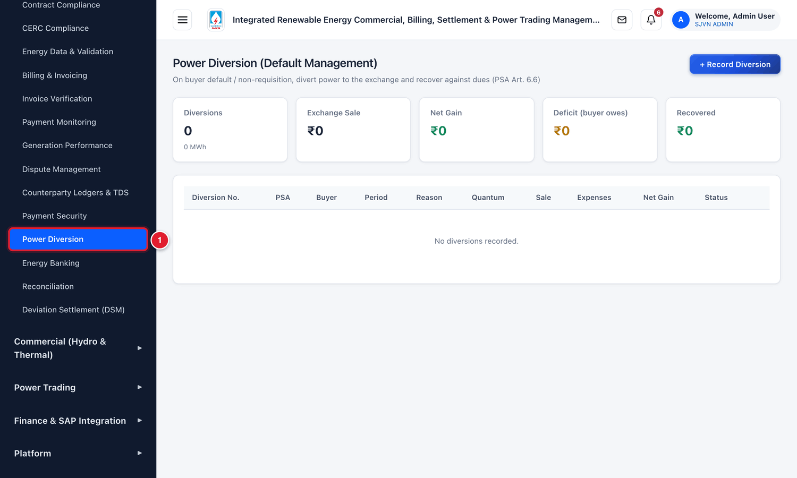
Figure 19.1 Opening Power Diversion from the menu.
1 | Click Power Diversion.

To record a diversion
STEP  1 | Click + Record Diversion.

STEP  2 | Fill the boxes and click Record.

Field | What to enter | Example
PSA Contract (defaulting buyer) * | The PSA of the buyer. | PSA/SJVN/2024/101
Period * | The month. | September 2026
Reason | Payment default or Power not requisitioned. | Power not requisitioned
Quantum Diverted (MWh) * | The energy sold on the exchange. | 500
Exchange | IEX or PXIL. | IEX
Sale Rate (₹/MWh) * | The rate at which it was sold. | 4100
Expenses (₹) | Energy cost, transmission and incidental expenses. | 1850000
Notes | A short note. | —

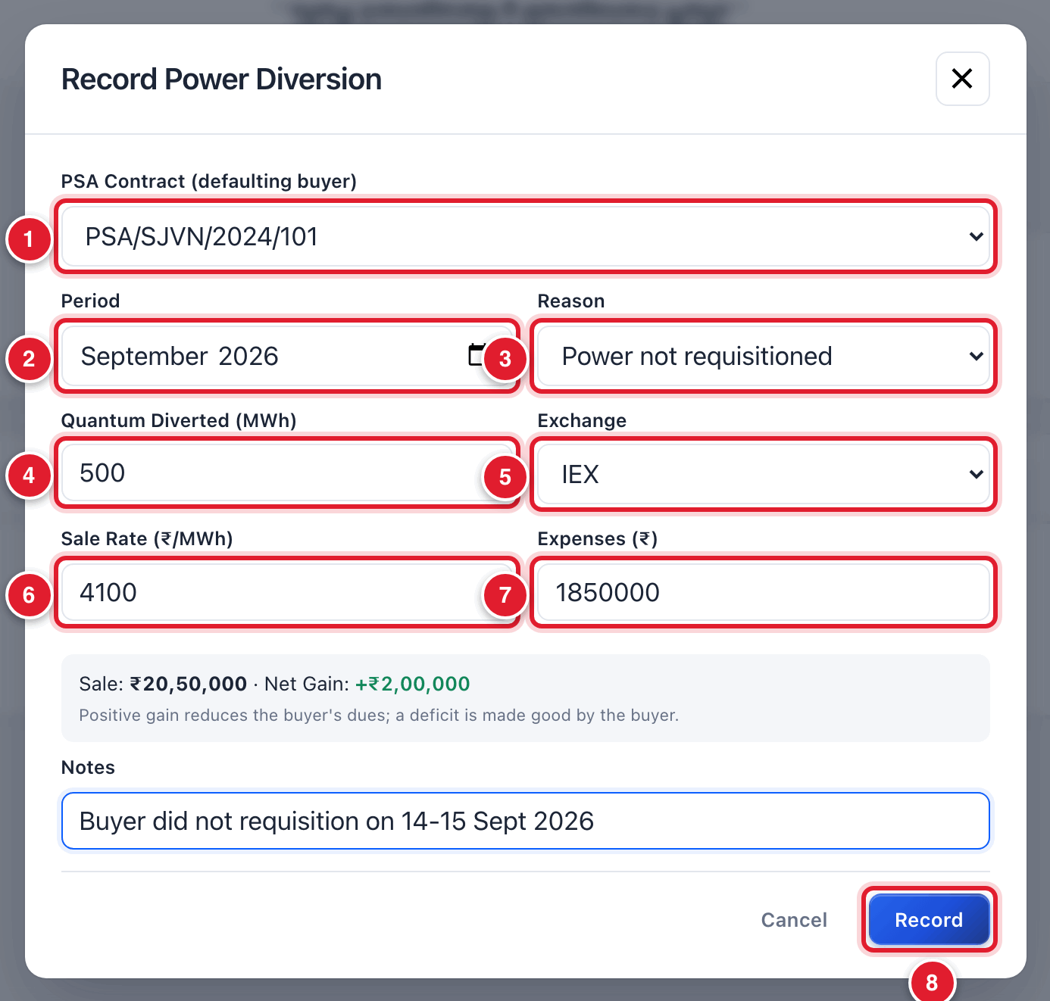
Figure 19.2 Recording a diversion.
1 | PSA.
2 | Month.
3 | Reason.
4 | Energy diverted.
5 | Exchange.
6 | Sale rate.
7 | Expenses.
8 | Click Record.

WHAT YOU SHOULD SEE NOW
The diversion is listed with a number starting with PDV/. The platform works out Sale = quantum × rate and Net Gain = Sale − Expenses.

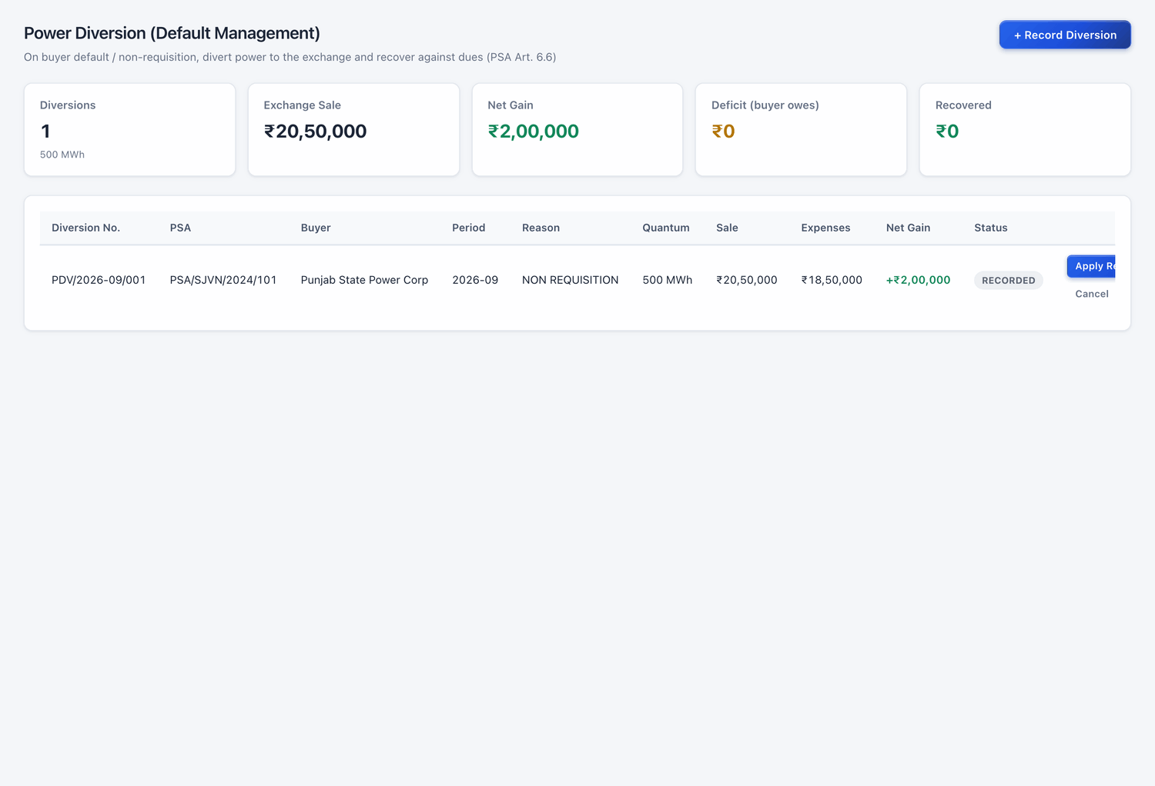
Figure 19.3 The diversion in the list.
Result | What it means for the buyer
Net gain (a + amount) | The gain reduces the buyer’s dues.
Deficit (a − amount) | The buyer has to make good the deficit.

Each row has two buttons: Apply Recovery adjusts the gain against the buyer’s dues, and Cancel cancels a diversion recorded by mistake.

CHAPTER 20

20. Energy Banking
Keeping account of energy that the buyer could not take and that is banked for later.
What it is for | Energy that the buyer could not take is credited to the seller as banked energy. It can be drawn back within the banking cycle. What is not drawn back by the end of the cycle is settled in cash at a discount to the tariff.
Who uses it | SJVN REIA desk.
How to open it | Menu → REIA Billing & Settlement → Energy Banking.
When to use it | When energy is banked or drawn back, and at the end of each banking cycle.

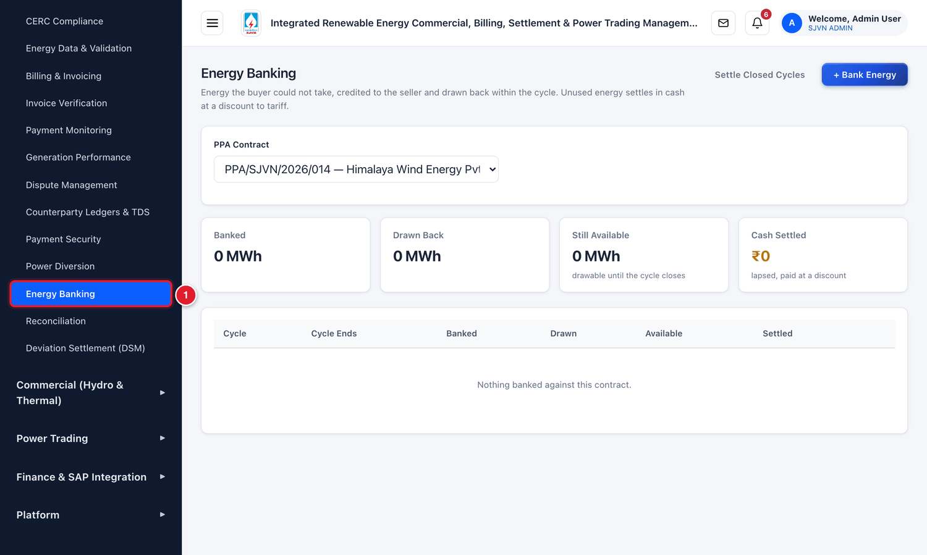
Figure 20.1 Opening Energy Banking from the menu.
1 | Click Energy Banking.

To bank energy
STEP  1 | In PPA Contract, choose the PPA.

STEP  2 | Click + Bank Energy.

STEP  3 | Fill the boxes and click Bank Energy.

Field | What to enter | Example
Banking Cycle * | The name of the cycle. | FY2026-27
Cycle Ends On * | The last date of the cycle. | 31/03/2027
Period | The month in which the energy was banked. | September 2026
Energy Banked (MWh) * | The energy banked. | 300
Tariff (₹/unit) | The tariff for valuing it. | 2.55

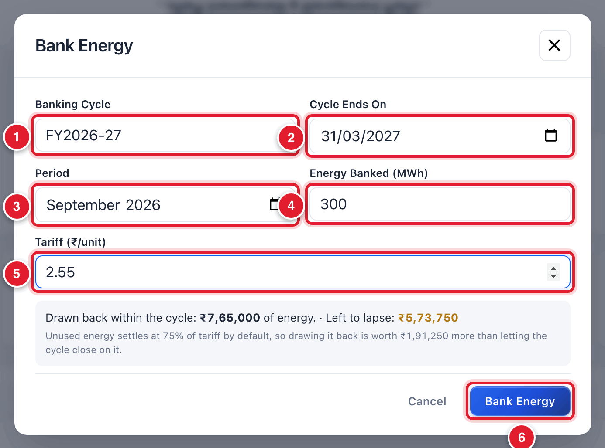
Figure 20.2 Banking energy.
1 | Cycle name.
2 | Cycle end date.
3 | Month.
4 | Energy banked.
5 | Tariff.
6 | Click Bank Energy.

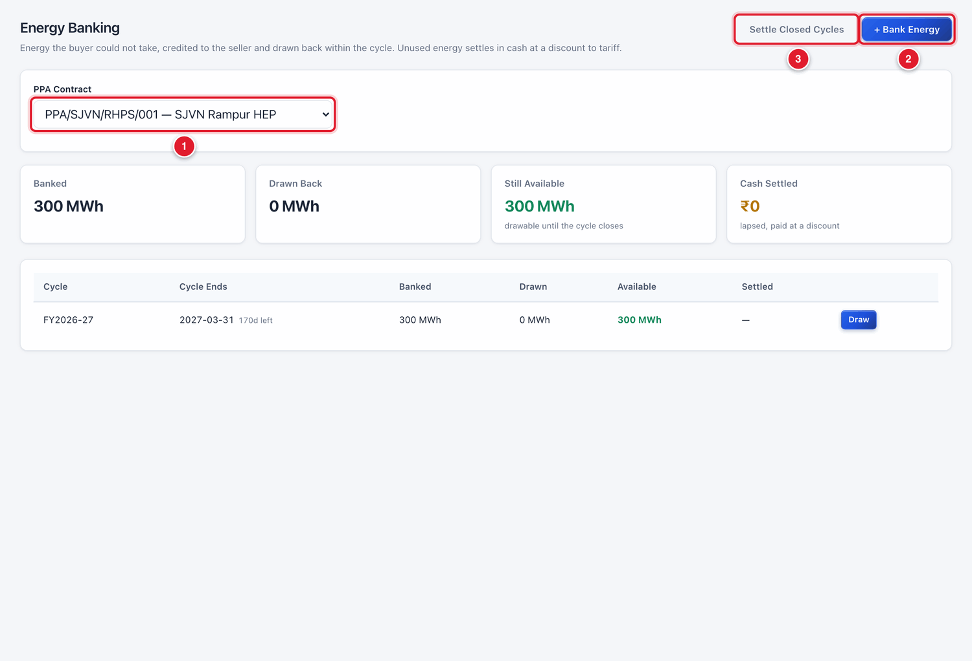
Figure 20.3 The banking position of a contract.
1 | Choose the PPA.
2 | + Bank Energy.
3 | Settle Closed Cycles.

Box / button | Meaning
Banked | Total energy banked in the cycle.
Drawn Back | Energy already drawn back.
Still Available | Energy that can still be drawn until the cycle closes.
Cash Settled | The value of energy that lapsed and was paid in cash at a discount.
Draw (on a row) | Record energy drawn back from the bank.
Settle Closed Cycles | For cycles that have ended: settle the unused energy in cash. By default it is valued at 75% of the tariff.

CHAPTER 21

21. Counterparty Ledgers & TDS
The statement of account of any seller or buyer, and its TDS certificates.
What it is for | For one seller or buyer, this screen shows everything in one place: what was billed, what was paid, what is outstanding and how old it is, each payment, and the TDS certificates (Form 16A).
Who uses it | Finance, SJVN REIA desk.
How to open it | Menu → REIA Billing & Settlement → Counterparty Ledgers & TDS.
When to use it | When a party asks for its account statement, for balance confirmation, and each quarter for TDS certificates.

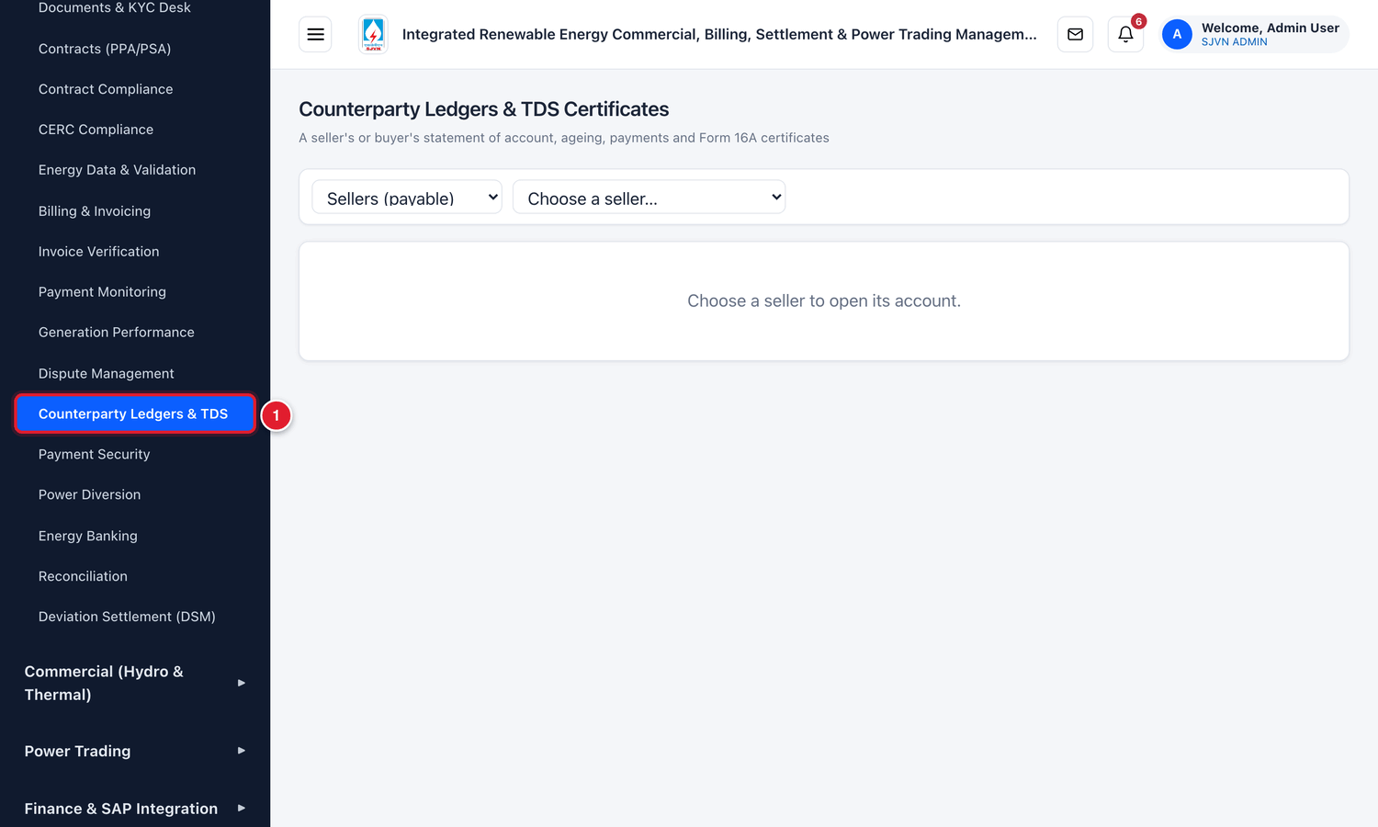
Figure 21.1 Opening Counterparty Ledgers & TDS from the menu.
1 | Click Counterparty Ledgers & TDS.

To open the account of a party
STEP  1 | In the first box, choose Sellers (payable) or Buyers (receivable).

STEP  2 | In the second box, choose the company.

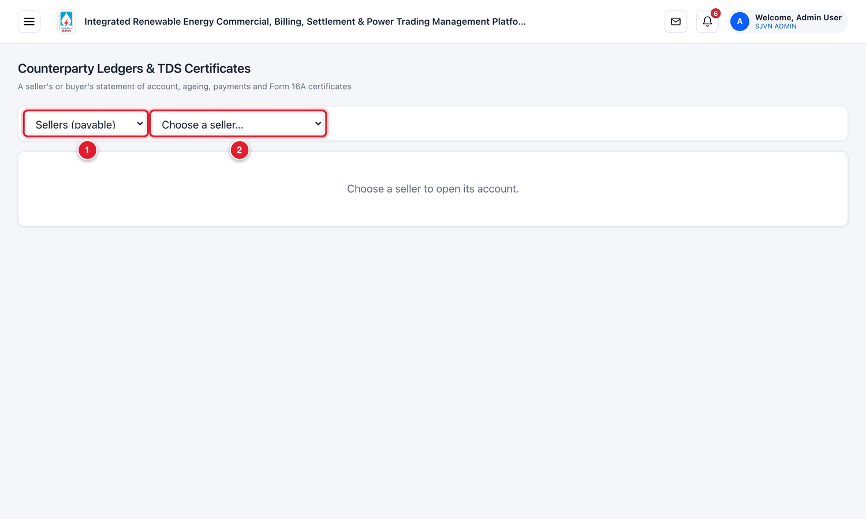
Figure 21.2 Choosing the party.
1 | Sellers or buyers.
2 | The company.

WHAT YOU SHOULD SEE NOW
The account of the company opens.

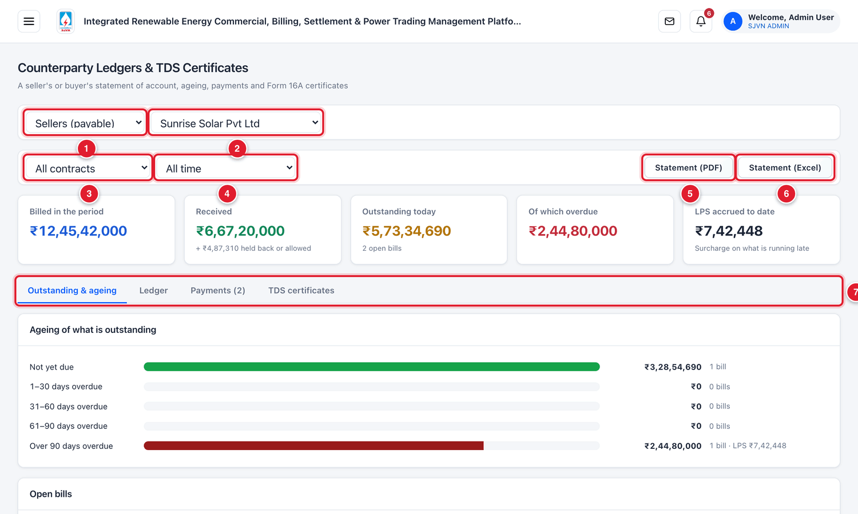
Figure 21.3 The account of a seller.
1 | Sellers or buyers.
2 | The company.
3 | One contract, or all contracts.
4 | The period: all time, this year, last year or custom dates.
5 | Statement (PDF): download the statement of account.
6 | Statement (Excel).
7 | Four tabs.

Box | Meaning
Billed in the period | The total of bills in the period chosen.
Received | Payments received by the party, and amounts held back or allowed (TDS, rebate).
Outstanding today | What is unpaid now, and the number of open bills.
Of which overdue | The part that has crossed the due date.
LPS accrued to date | Late payment surcharge built up on the overdue amount.

21.1 The four tabs

Outstanding & ageing
Shows the outstanding amount by age and the list of open bills with their balance.
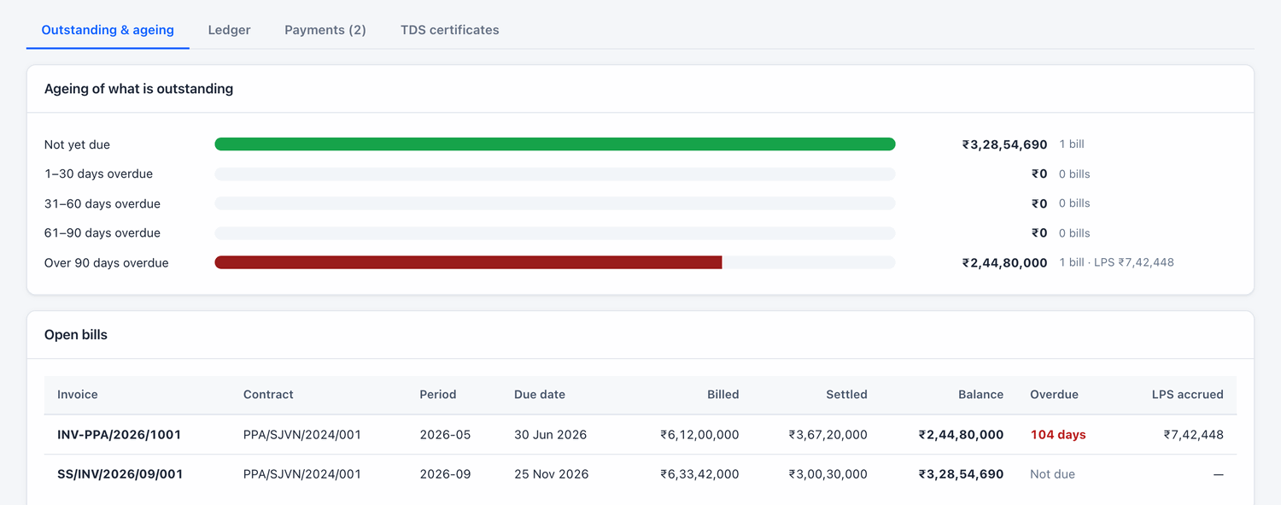
Figure 21.4 The Outstanding & ageing tab.

Ledger
The running account, date by date: each bill (debit), each payment, TDS, rebate and credit note (credit), and the balance after each line.
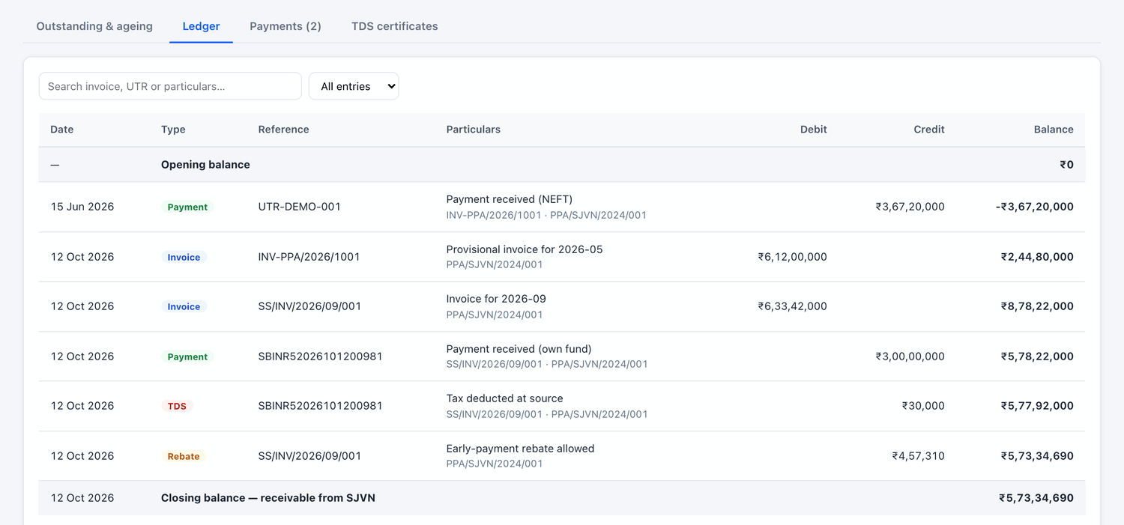
Figure 21.5 The Ledger tab.

Payments
Each payment with its UTR, the bill it settled, the TDS and other deductions, and the net amount. View payment advice opens the advice.
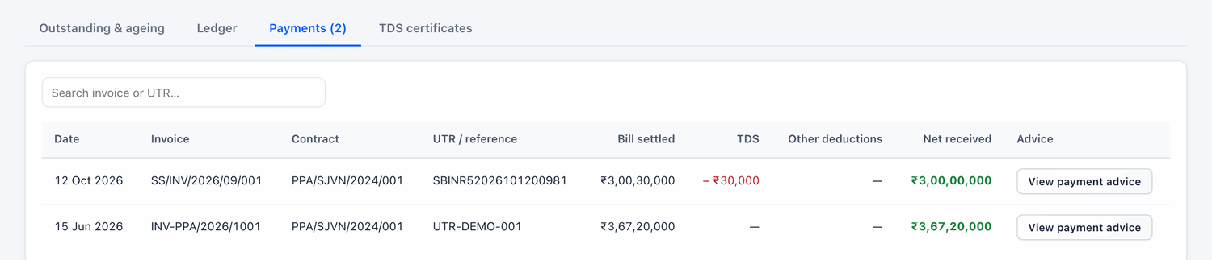
Figure 21.6 The Payments tab.

TDS certificates
One line for each quarter in which tax was deducted. It compares the TDS as per the ledger with the certificate filed.
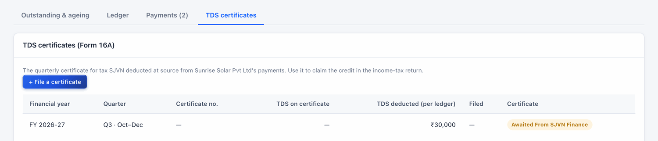
Figure 21.7 The TDS certificates tab.

To file a TDS certificate (Finance)
STEP  1 | Click + File a certificate.

STEP  2 | Choose the financial year and quarter, type the certificate number and the TDS amount on the certificate, attach the Form 16A PDF and save.

WHAT YOU SHOULD SEE NOW
The seller can now download the certificate from its login (Payments & Ledger).

GOOD TO KNOW
For a buyer, it is the buyer that deducts tax from SJVN’s bills. So the buyer files its certificate from its own login, and it appears here for SJVN.

CHAPTER 22

22. Generation Performance
How much each plant generated, and whether it met the CUF the contract requires.
What it is for | A report of monthly energy and CUF for each PPA, against the minimum CUF of the contract.
Who uses it | SJVN REIA desk, Management.
How to open it | Menu → REIA Billing & Settlement → Generation Performance.
When to use it | Monthly, and for reviews of plant performance.

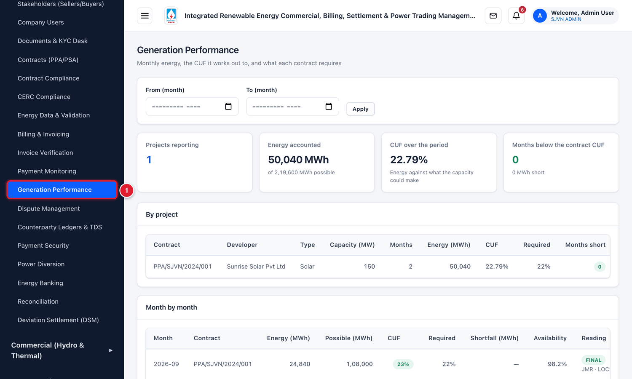
Figure 22.1 Opening Generation Performance from the menu.
1 | Click Generation Performance.

To see the performance for a period
STEP  1 | Choose From (month) and To (month).

STEP  2 | Click Apply.

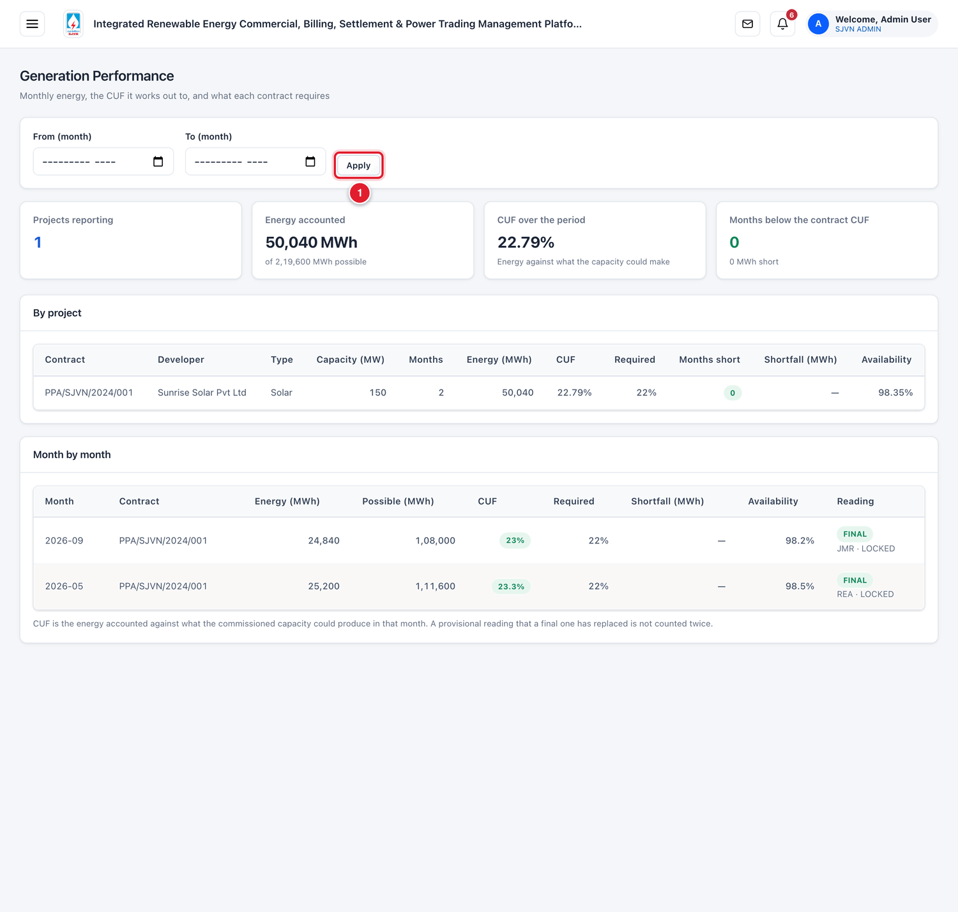
Figure 22.2 The Generation Performance screen (menu hidden).
1 | Apply: show the period chosen.

Box / column | Meaning
Projects reporting | The number of projects with energy data in the period.
Energy accounted | Total energy, and the energy that the capacity could have produced.
CUF over the period | Energy accounted ÷ energy possible, in %.
Months below the contract CUF | How many project-months fell short, and by how many MWh.
Required | The minimum CUF of the contract.
Shortfall (MWh) | Energy short of the minimum CUF. A shortfall can lead to a penalty on the bill.
Reading | Whether the month’s figure is PROVISIONAL or FINAL, its source and status.

GOOD TO KNOW
A provisional figure that has been replaced by a final one is not counted twice.

CHAPTER 23

23. REIA Dashboard
The first screen of the REIA module: what needs attention today, and the overall position.
What it is for | One page with the work waiting on SJVN, the dates coming up, and the key numbers of the REIA business.
Who uses it | Everyone in SJVN with REIA access.
How to open it | Menu → REIA Billing & Settlement → REIA Dashboard. It also opens by itself after an REIA officer signs in.
When to use it | Every morning, before starting work.

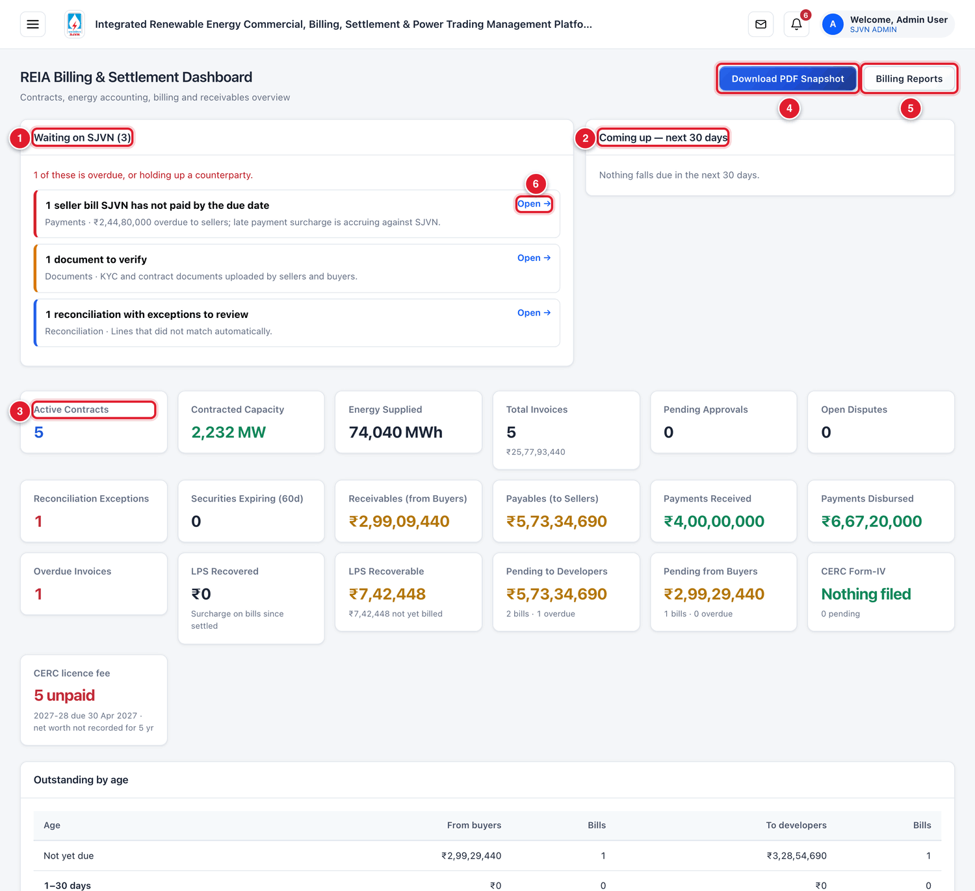
Figure 23.1 The REIA Dashboard (menu hidden).
1 | Waiting on SJVN: the work that is pending with SJVN. Items with a red bar are overdue or are holding up a seller or buyer.
2 | Coming up — next 30 days: dates that are near, such as a guarantee expiring.
3 | The number boxes (explained below).
4 | Download PDF Snapshot: save the dashboard as a PDF.
5 | Billing Reports: open the month-wise billing report (Chapter 24).
6 | Open →: go straight to the screen where that work is done.

23.1 Start your day here

To clear the work waiting on SJVN
STEP  1 | Read each line under Waiting on SJVN.

STEP  2 | Click Open → on a line. The right screen opens, already showing the items that need action.

STEP  3 | Do the work as explained in the chapter of that screen. Come back to the dashboard and take the next line.

A line like this | Means | See chapter
… seller invoice waiting for approval | A bill is waiting at an approval level. | 11
… buyer payment to confirm | A buyer has told about a payment. Finance must check the bank. | 12
… document to verify | A seller or buyer has uploaded a paper. | 6
… dispute to resolve | A dispute is waiting for SJVN’s answer. | 15
… reconciliation statements awaiting SJVN’s signature | A statement is ready for SJVN to sign. | 16
… guarantees within 30 days of expiry | An instrument is about to expire. | 17
… seller bill SJVN has not paid by the due date | SJVN’s payment to a seller is late. Surcharge is building up. | 12

23.2 The number boxes
Box | Meaning
Active Contracts / Contracted Capacity | The number of live contracts and their total MW.
Energy Supplied | Total energy on record.
Total Invoices / Pending Approvals | The number and value of bills, and how many are waiting for approval.
Open Disputes / Reconciliation Exceptions | Disputes not yet closed, and reconciliation lines that did not match.
Securities Expiring (60d) | Instruments expiring in the next 60 days.
Receivables (from Buyers) / Payables (to Sellers) | What buyers owe SJVN, and what SJVN owes sellers.
Payments Received / Payments Disbursed | Money received from buyers, and paid to sellers.
Overdue Invoices | Bills past their due date.
LPS Recovered / LPS Recoverable | Late payment surcharge collected, and still to be collected.
Pending to Developers / Pending from Buyers | Unpaid amounts on each side, with the number of bills overdue.
CERC Form-IV / CERC licence fee | The position of regulatory returns and fees (Chapter 25).

Lower on the page are a table of outstanding by age and three charts: monthly billing trend, contracted capacity by project type, and invoices by status.
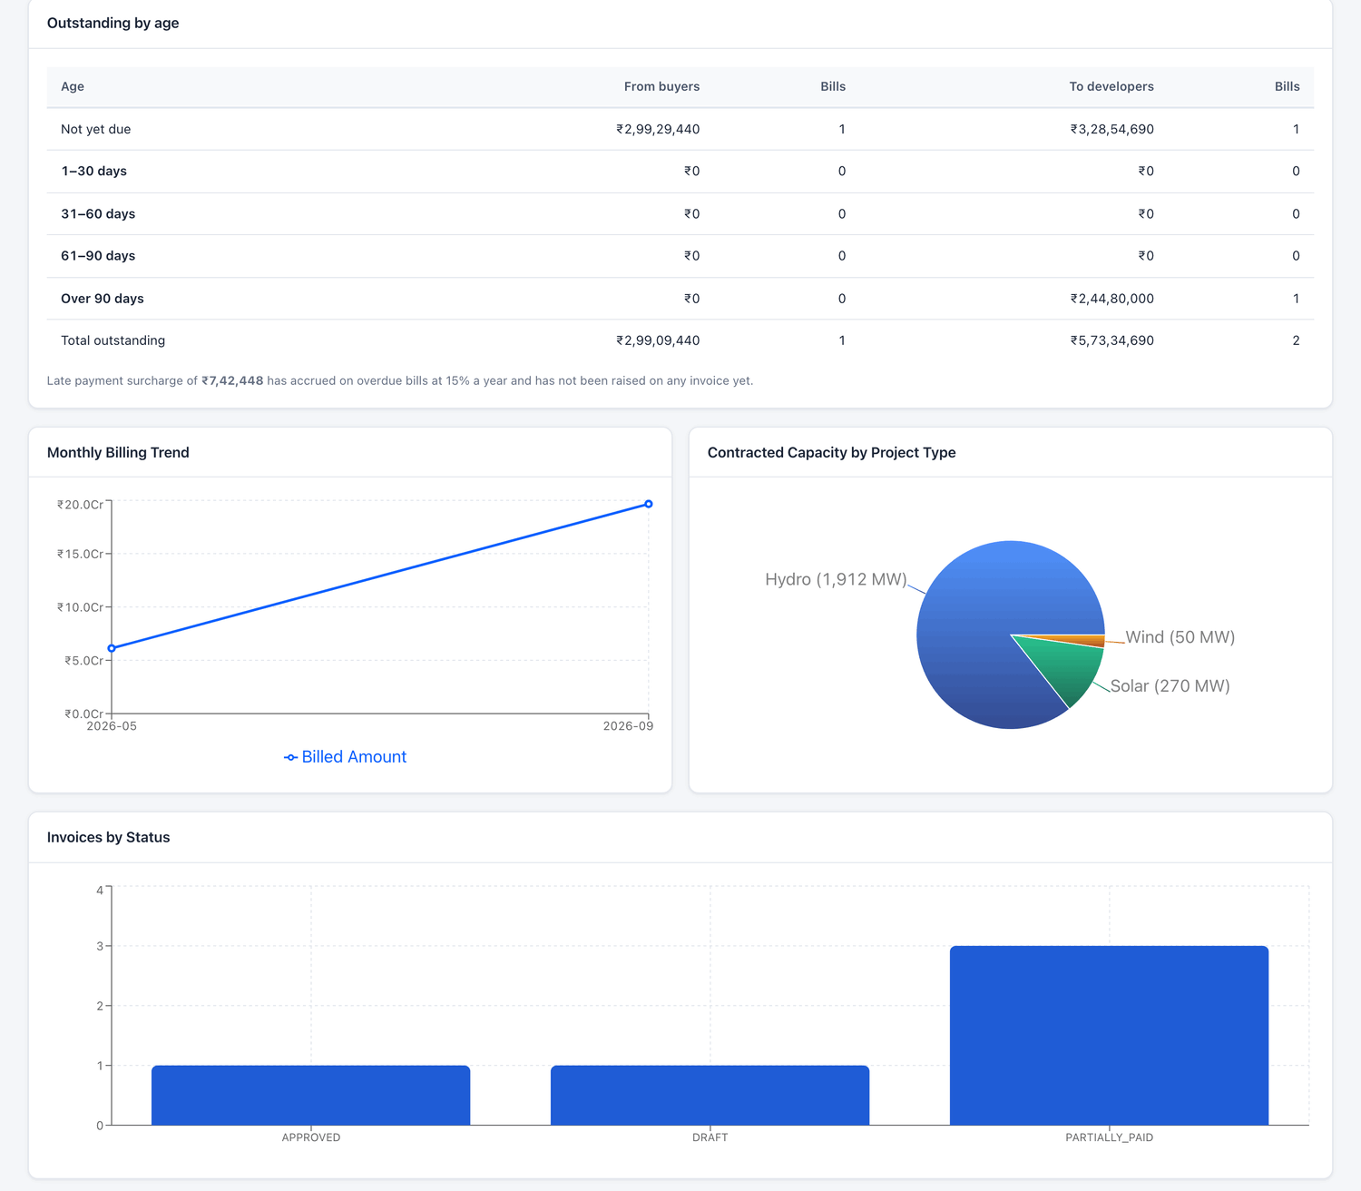
Figure 23.2 The lower part of the dashboard.

CHAPTER 24

24. Billing Reports
A month-wise summary of sales, purchases, margin and cash, ready to download.
What it is for | A report for any range of months: sales billed to buyers, purchases from sellers, gross margin, trading margin, rebate, surcharge, collections and payments.
Who uses it | SJVN REIA desk, Finance, Management.
How to open it | On the REIA Dashboard, click Billing Reports. Or on Billing & Invoicing, click Billing Report.
When to use it | Month end, quarter end, and whenever management asks for a summary.

To make a billing report
STEP  1 | Choose From (month) and To (month).

STEP  2 | Click Refresh Preview. The boxes and the month-wise table below show the figures.

STEP  3 | Click Download PDF Report for a formatted PDF with SJVN’s heading, or Export CSV for a file that opens in Excel.

Figure 24.1 The Billing & Invoicing Reports screen (menu hidden).
1 | Refresh Preview.
2 | Export CSV.
3 | Download PDF Report.

Figure | Meaning
Total Sales Billed | Bills raised on buyers (SJVN → Buyer).
Total Purchases | Invoices of sellers (Seller → SJVN).
Gross Margin | Sales minus purchases.
Trading Margin | SJVN’s margin billed on PSAs.
Rebate Saved | Early-payment rebates earned by SJVN.
Net Profit | Gross margin + rebate + surcharge received − surcharge paid.
Collected / Outstanding Receivable | Received from buyers, and still to be collected.
Paid Out / Net Cash Flow | Paid to sellers, and collected minus paid out.
Payment Security Held | The value of live security instruments.

CHAPTER 25

25. CERC Compliance
The returns and fees that are due to the Central Electricity Regulatory Commission.
What it is for | A calendar of every period for which a return (Form-IV) is due to CERC, with its due date and position, and a register of the licence fee and net worth.
Who uses it | SJVN REIA desk, Compliance.
How to open it | Menu → REIA Billing & Settlement → CERC Compliance.
When to use it | Every month, before the due date of the return.

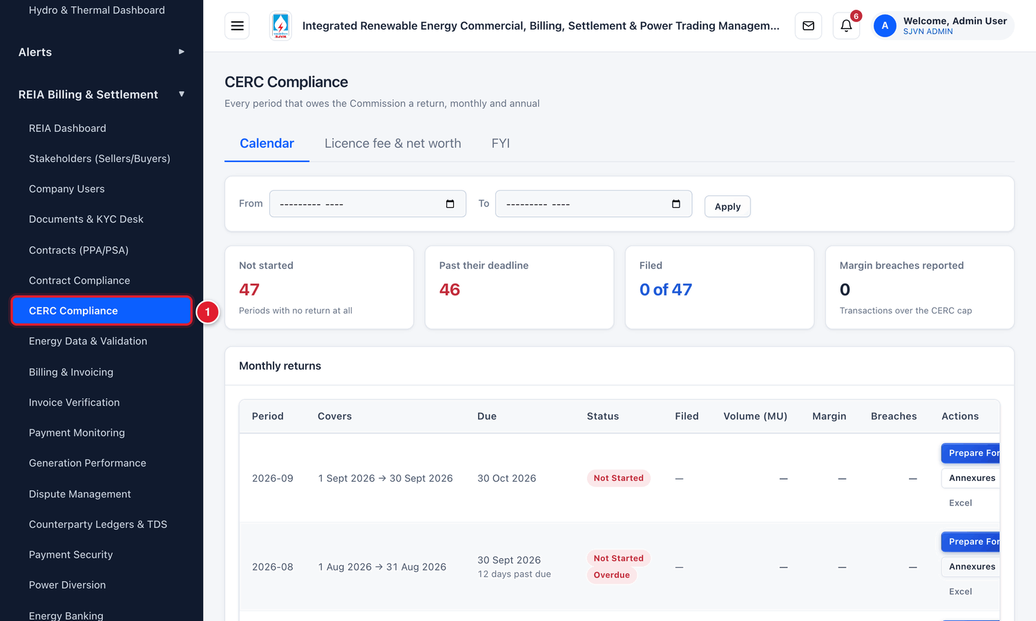
Figure 25.1 Opening CERC Compliance from the menu.
1 | Click CERC Compliance.

Figure 25.2 The CERC Compliance screen (menu hidden).
1 | Prepare Form-IV: start the return of that period.
2 | Annexures: open the annexures of that period.
3 | Excel: download the return as an Excel file.

Box / column | Meaning
Not started | Periods for which no return has been prepared.
Past their deadline | Periods whose due date has passed without filing.
Filed | How many periods are filed, out of the total.
Margin breaches reported | Transactions where the trading margin was above the CERC cap.
Period / Covers / Due | The month, the dates it covers and the due date of its return.
Status | Not Started, Draft, Filed, and Overdue when the due date has passed.

To prepare the return of a month
STEP  1 | Find the row of the month and click Prepare Form-IV.

STEP  2 | In the window New Form-IV Filing, check the Period Type (Monthly or Annual) and the Month.

STEP  3 | Leave the tick Pre-fill transactions from bilateral trade data on, so that the platform fills the transactions for you.

STEP  4 | Click Create Filing. The return is created as a draft. Check its figures and annexures.

STEP  5 | After the return is filed with CERC, enter the CERC Reference No. given on filing.

Figure 25.3 Starting a Form-IV filing.
The tab Licence fee & net worth keeps the yearly licence fee (due date, paid or unpaid) and the net worth recorded for each year. The tab FYI explains the rules and deadlines.
IMPORTANT
The platform prepares the return from its own data. Always check the figures against the books before filing with CERC. The officer who files remains responsible for the return.

CHAPTER 26

26. Finance Posting
Handing over the month’s REIA bills to corporate Finance for booking.
What it is for | At month end, the sales, purchases and credit notes of the REIA business are handed to Finance for booking in the accounts. This screen prepares that hand-over and keeps a record of each posting.
Who uses it | Finance.
How to open it | Menu → Finance & SAP Integration → REIA finance posting.
When to use it | At month end, after the month’s bills are approved.

To prepare the posting of a month
STEP  1 | Month: choose the month.

STEP  2 | What Finance is booking: choose Sale to buyers (receivable), Purchase from developers (payable) or Credit notes issued.

STEP  3 | The table Documents waiting lists the bills of that kind that are issued or accepted and not yet booked. Check the list and the totals.

STEP  4 | Click Prepare the posting.

Figure 26.1 The Finance Posting screen (menu hidden).
Column | Meaning
Energy | Energy, capacity and similar charges.
Margin | SJVN’s trading margin: SJVN’s own income.
Pass-through | Charges passed on, such as NRLDC and transmission charges.
Tax / Adj. | Taxes and adjustments.
Total | The total to be booked.

WHAT YOU SHOULD SEE NOW
The posting appears in the table Postings at the bottom, with its month, category, number of documents, amounts and status.

GOOD TO KNOW
A bill is offered here only once. After it is included in a posting, it no longer appears under Documents waiting.

CHAPTER 27

27. SJVN Users
Adding SJVN’s own officers to the platform and giving each the right role.
What it is for | The list of SJVN officers on the platform and the role of each. A role decides which screens a person can open and what they can change.
Who uses it | SJVN Administrator. A REIA Administrator can manage REIA desk users.
How to open it | Menu → Platform → SJVN Users.
When to use it | When an officer joins, is transferred, leaves, or forgets the password.

Figure 27.1 Opening SJVN Users from the menu.
1 | Click SJVN Users under Platform.

Figure 27.2 The SJVN Users screen (menu hidden).
1 | Add User: add a new SJVN officer.
2 | Export: download the list of users.

To add an SJVN user
STEP  1 | Click Add User.

STEP  2 | Fill the boxes.

Field | What to enter | Example
Full Name * | The officer’s full name. | Neha Sharma
Email Address (their sign-in) * | The officer’s official email. It becomes the sign-in name and cannot be changed later. | neha.sharma@sjvn.in
Designation | The officer’s post. | Dy. Manager (Commercial)
Phone | Mobile number. | +91 98765 43210
Role * | Choose the role (see the table below). | REIA Desk
Set the temporary password myself | Leave without a tick. The platform makes a temporary password. | (no tick)

STEP  3 | Click Add to team. The temporary password is shown once. Note it and give it to the officer by phone or in person.

Figure 27.3 Adding an SJVN user.

27.1 The roles
Role | What it is for
SJVN Administrator | Every section, and manages SJVN’s users and the companies’ users.
Management | Dashboards and reports, and approvals reserved for management. Does not enter data.
REIA Administrator | Everything the REIA desk does, and manages REIA desk users and companies’ admin accounts.
REIA Desk | Contracts, energy data, billing, disputes, payment security and reconciliation.
Finance | Payments and their confirmation, releases, TDS certificates and the hand-over to accounts.
Commercial Administrator | Hydro & Thermal station billing.
Trading Administrator / Trading Desk | The power trading module.
Compliance / Audit | Can read everything, including the audit trail. Cannot change anything.

The tab Roles and what they reach shows a full table of what each role can do. The tab Change history shows every change made to users.
Figure 27.4 The “Roles and what they reach” tab.

27.2 Looking after users
Each user has a card with buttons. They work in the same way as for company users (Chapter 5):
- Edit / change role: correct details or change the role. Changing a role signs the user out. The new role applies from the next sign-in.
- Reset password: make a new temporary password.
- Activity: see what the user has done.
- Switch off: stop the user from signing in. Use this when an officer is transferred or leaves.
IMPORTANT
Keep at least two active administrators. If the only administrator is away or locked out, nobody can add a user or reset a password. The screen shows a warning when there is only one.

CHAPTER 28

28. Notification Board and Quick Connect
Alerts from the platform, and short messages between desks.

28.1 Notification Board
What it is for | All live alerts in one place, grouped by importance and by subject.
Who uses it | Everyone.
How to open it | Menu → Alerts → Notification Board.
When to use it | Daily. The bell on the top bar shows only the newest alerts. The board shows all.

Figure 28.1 The Notification Board (menu hidden).
1 | Alert settings: choose which alerts are also sent to you by email or SMS.

On the board | Meaning
Critical | Needs action now, for example an overdue payment.
Attention | Due soon, or needs a look.
For information | Nothing to do. Only to know.
Group buttons | Billing & Payments, Payment Security, Reconciliation, Disputes, Contracts, Messages… Click one to see only those alerts.
View → | Go to the screen where the alert can be dealt with.
Acknowledge | Mark that you have seen the alert. It moves to History.
Live board / History | Alerts that are open now, and alerts already acknowledged or cleared.

To choose which alerts are sent to you
STEP  1 | Click Alert settings.

STEP  2 | In Email me and in SMS me, choose one: Nothing — I will look at the board, Critical alerts only, Critical and Attention alerts, or Every alert.

STEP  3 | Click Save.

Figure 28.2 Alert settings.
GOOD TO KNOW
Every alert is always shown on the board, whatever you choose here. SMS can reach you only if your mobile number is on your login.

28.2 Quick Connect
What it is for | A message box inside the platform, for quick questions between SJVN desks, sellers and buyers.
Who uses it | Everyone.
How to open it | Click the envelope button on the top bar. Or Menu → Alerts → Quick Connect.
When to use it | For day-to-day coordination and clarifications.

Figure 28.3 Quick Connect (menu hidden).
1 | New Message.
2 | Disclaimer: read what Quick Connect may and may not be used for.

To send a message
STEP  1 | Click New Message.

STEP  2 | In To, type a name, an email or a company, and pick the person from the list. Use Cc or Bcc if needed.

STEP  3 | Type the Subject and the message. Use Attach files to add a file.

STEP  4 | Click Send Message. (Save & close keeps it in Drafts. Discard throws it away.)

Figure 28.4 Writing a new message.
The folders on the left work like email: Inbox, Starred, Drafts, Sent, Archive and Trash.
BE CAREFUL
Quick Connect is an informal facility. It is not a legal or contractual way of communication. Formal notices (default, force majeure, termination, dispute intimation) must be sent in the manner given in the PPA / PSA, and recorded as a notice in the contract’s working file (Chapter 7).

CHAPTER 29

29. Audit Trail
The record of who did what, and when.
What it is for | Every action on the platform is recorded: sign-ins, records created or changed, approvals, downloads. The record cannot be edited or deleted.
Who uses it | Compliance / Audit, SJVN Administrator.
How to open it | Menu → Platform → Audit Trail.
When to use it | For an audit, for an inquiry, or to find out who changed a record.

Figure 29.1 Opening the Audit Trail from the menu.
1 | Click Audit Trail under Platform.

Figure 29.2 The Audit Trail (menu hidden).
1 | Verify full chain: check that no record of the trail has been tampered with.

On the screen | How to use it
Search box | Type a name, an action, a record number or a word. (Press the / key to jump to the search box.)
All activity, Data changes, Security, Exports & downloads | Show one kind of event.
Filters: Module, Action, User, Record type | Narrow the list. The number in brackets is the count of events.
Today, 7 days, 30 days, 90 days, From / To date | Choose the period.
An event line | Click it to see what changed: the old value and the new value.
Audit Report (PDF), Activity Report (PDF), Export CSV | Download the events shown.

Box at the top | Meaning
Events / People | The number of events and of different users.
Security events | Failed or blocked sign-ins and denied access.
Exports & downloads | Data that left the platform.
Duty conflicts | Cases where one person tried to do two duties that must be kept separate, such as raising and approving the same bill.
Record integrity | The result of the last Verify full chain check.

To find out who changed a record
STEP  1 | Type the number of the record (for example the bill number) in the search box.

STEP  2 | The events for that record are listed, newest first. Click an event to see the details.

GOOD TO KNOW
Because every action is recorded with the user’s name, never share your login. See section 2.6.

PART 4

For the Seller
What a generator that sells power to SJVN does on the platform: accept energy data, raise invoices, follow payments and settle the month.

CHAPTER 30

30. The Seller’s home page
What you see after signing in, and how to find your way.
What it is for | Your own page on the platform. It shows what SJVN owes you, what is waiting for your action, and what is coming up.
Who uses it | Users of a seller company.
How to open it | It opens by itself after you sign in. Or Menu → Seller Portal → My Dashboard.
When to use it | Every time you sign in.

Sign in as explained in Chapter 2 with the email and password of your company’s user.
Figure 30.1 The seller’s home page.

30.1 Your menu
Menu name | What you do there
My Dashboard | See your position at a glance.
Quick Connect | Send a quick message to the SJVN desk.
Notification Board | See all your alerts.
My Team | Add your colleagues and manage their access.
My Documents & KYC | Upload your company’s papers for SJVN to verify.
My Contracts (PPAs) | See your PPAs, milestones, guarantees, requests and notices.
Energy Data | See the energy recorded by SJVN, and accept or object to it.
My Invoices | Raise your invoice on SJVN and follow its approval and payment.
Payments & Ledger | Your account with SJVN: outstanding, ledger, payments and TDS certificates.
My Disputes | Raise a dispute and follow it.
Payment Security | Your bank guarantees, and SJVN’s LC in your favour.
Reconciliation | Sign the period’s reconciliation statement.

IMPORTANT
Until your company’s KYC is approved by SJVN, only My Dashboard, My Team, My Documents & KYC, Quick Connect and Notification Board work. The other screens open after SJVN approves your KYC. So upload your papers first (Chapter 32).

30.2 Reading the dashboard
Figure 30.2 The seller’s dashboard (menu hidden).
Box | Meaning
Billed to SJVN | The total of your invoices in the period chosen.
Received | What SJVN has paid you, and TDS deducted.
Outstanding now | What SJVN still owes you.
Overdue | The part that has crossed its due date.
SJVN pays in | The average number of days SJVN takes to pay.
Open disputes | Disputes not yet closed.

- Waiting on you: things that need your action, for example energy data to confirm. Click Open → to go there.
- Coming up — next 60 days: payments due from SJVN, guarantees expiring.
- The buttons FY, Last 12 months and Since the start change the period of the boxes.
- Download summary (PDF) saves this page as a PDF.
- Quick actions at the bottom take you straight to the common tasks.
TIP
Every screen of the seller portal has a button How it works at the top. Click it to read a short explanation of that screen.

CHAPTER 31

31. My Team (Seller)
Giving your colleagues their own logins.
What it is for | The people of your company who can use the platform, and what each may do.
Who uses it | Company Admin and Approvers.
How to open it | Menu → Seller Portal → My Team.
When to use it | When a colleague joins, leaves or forgets the password.

Figure 31.1 The My Team screen (menu hidden).

31.1 The levels in your team
Level | Name | What this person can do
Level 1 | Maker | Prepares the work (an invoice, a document). It is saved as a draft and goes to a checker.
Level 2 | Checker | Reviews the maker’s work and submits it to SJVN.
Level 3 | Approver | Approves and submits to SJVN. Adds makers and checkers, resets their passwords.
— | Company Admin | The main account of your company with SJVN. Can do everything and manages the whole team.

You can have up to 15 active users. It is good to have at least one maker and one checker, so that everything sent to SJVN is seen by two people.

31.2 Adding a team member

To add a person to your team
STEP  1 | Open My Team from the menu and click Add Team Member.

STEP  2 | Type the Full Name, the person’s own Email Address (this becomes their sign-in name), the Designation and the Phone.

STEP  3 | Access Level: choose Level 1 — Maker, Level 2 — Checker or Level 3 — Approver.

STEP  4 | Leave Set the temporary password myself without a tick, and click Add to team.

STEP  5 | A temporary password is shown once. Note it and give it to the person by phone or in person.

Figure 31.2 Adding a team member.
WHAT YOU SHOULD SEE NOW
The person can now sign in. At the first sign-in the platform asks them to choose their own password.

31.3 Looking after your team
Each person has a card with buttons:
- Edit details: correct the name, designation or phone, or change the level.
- Reset password: make a new temporary password for a person who has forgotten it.
- Activity: see what the person has done.
- Switch off: stop a person who has left from signing in. A reason must be typed.
GOOD TO KNOW
The Company Admin account cannot be switched off or changed by your team. If the Company Admin forgets the password, write to the SJVN REIA desk.

Figure 31.3 The “Who can do what” tab shows the rights of each level.

CHAPTER 32

32. My Documents & KYC (Seller)
Uploading your company’s papers so that SJVN can approve your KYC.
What it is for | The place to upload your registration, licences, clearances and bank proof, and to see whether SJVN has verified them.
Who uses it | All users of the seller. A maker’s upload goes through a checker.
How to open it | Menu → Seller Portal → My Documents & KYC.
When to use it | At the start, and whenever a paper is renewed.

Figure 32.1 The My Documents & KYC screen (menu hidden).

32.1 What you must upload
Your company must give SJVN 8 compulsory papers. The screen lists them under Regulatory Approvals — what to upload, each with its position: Not Started, Submitted, Verified, Rejected or Expired. A bar at the top shows how much of your KYC is complete.

32.2 Uploading a document

To upload a document
STEP  1 | Open My Documents & KYC from the menu and click Upload Document.

STEP  2 | Click Choose File and pick the file from your computer. Allowed: PDF, JPG, PNG, Excel, up to 10 MB.

STEP  3 | Valid until: choose the expiry date of the paper. Leave empty if it does not expire.

STEP  4 | Title: type a clear title.

STEP  5 | Document Type: choose which paper this is, for example Generation License or Bank Account Proof (Cancelled Cheque). This is important: the platform matches the paper to your checklist by this type.

STEP  6 | Classification Category is set by the platform. Click Upload.

Figure 32.2 The Upload Document window.
WHAT YOU SHOULD SEE NOW
The document appears in the table My Documents with the status Submitted. SJVN checks it. When SJVN verifies it, the matching line in your checklist turns green Verified.

GOOD TO KNOW
If the document is uploaded by a maker of your team, it first goes to your own checker or approver, who must submit it to SJVN.

32.3 If SJVN rejects a document
You get an alert. The document shows Rejected with SJVN’s reason and remark. Correct the problem (for example, scan it clearly), and upload the corrected file as a new version with the button on that document’s row.
The 8 compulsory papers of a seller
Company Registration (PAN / GST / CIN)
Generation License / CEA Registration
Environmental Clearance
Grid Connectivity (CTU / STU / RLDC)
COD Certificate
Plant Technical Docs (SLD / Capacity)
Board Resolution / Power of Attorney
Bank Account Proof (Cancelled Cheque)

CHAPTER 33

33. My Contracts (Seller)
Your PPAs with SJVN and everything filed against them.
What it is for | A list of your PPAs. Each has a working file with its documents, milestones, guarantee, requests and notices. SJVN sees the same file.
Who uses it | All users of the seller.
How to open it | Menu → Seller Portal → My Contracts (PPAs).
When to use it | To check terms, report a milestone, ask for an extension, or read a notice.

Figure 33.1 The My Contracts screen (menu hidden).

To open the working file of a contract
STEP  1 | Click the row of the contract.

Figure 33.2 The working file of a PPA.
Tab | What you can do
Overview | Read the main terms and your billing position on this contract.
Documents | Read the signed agreement and annexures. Upload a paper.
Milestones | See the project dates. Report a milestone as met.
Guarantee (PBG) | See the guarantees SJVN holds for this contract and their expiry.
Requests | Ask SJVN for an extension or an amendment, and follow the answer.
Notices | Read notices from SJVN, acknowledge and reply. Send a notice to SJVN.
History | See every amendment of the contract.

33.1 Asking SJVN for an extension or amendment

To raise a request
STEP  1 | Open the working file and click the tab Requests. Click + Raise a request.

STEP  2 | Fill the boxes and click Send to SJVN.

Field | What to enter | Example
What is being asked for | Extension of a milestone date, Amendment to the contract, or Other request. | Extension of a milestone date
Ground | Force majeure, Delay in grid connectivity / evacuation, Delay in land or clearances, Change in law, Commercial or Other. | Delay in grid connectivity / evacuation
Milestone * | The milestone to be extended. | SCOD
New date asked for * | The new date you request. | 30/06/2027
Explanation * | What happened, since when, and what you are asking for. | —
Supporting document (optional) | A letter or other proof. | —

Figure 33.3 Raising a request.
WHAT YOU SHOULD SEE NOW
The request goes to SJVN. You will get an alert when SJVN approves or rejects it. An approved extension changes the milestone date by itself.

CHAPTER 34

34. Energy Data (Seller)
Checking the energy recorded by SJVN and confirming it before billing.
What it is for | SJVN records your plant’s energy for each month. Before a bill is made, you are asked to confirm that the figure agrees with your own records.
Who uses it | Checker, Approver or Company Admin of the seller.
How to open it | Menu → Seller Portal → Energy Data.
When to use it | Every month, when you get an alert that energy data is ready for confirmation.

Figure 34.1 The Energy Data screen (menu hidden).
The box Awaiting your confirmation tells how many records are waiting for your answer. Tick Only those awaiting my confirmation to see only those rows.
Figure 34.2 A record waiting for your answer.
1 | The record. Its status is VALIDATED.
2 | Accept.
3 | Object.
4 | Source: see the details and the source document (JMR / REA).
5 | Blocks: 15-minute data, if loaded.

To check and accept the energy figure
STEP  1 | Click Source on the row. Compare the energy shown with your own JMR / meter records. Open the attached source document if there is one. Close the window.

STEP  2 | If the figure is correct, click the green button Accept and confirm.

WHAT YOU SHOULD SEE NOW
A green message says the period is accepted. The column Your answer shows Accepted. SJVN can now lock the energy and the bill can be made.

Figure 34.3 The record after you accept.
1 | Your answer: Accepted.

If the figure is not correct
STEP  1 | Click Object on the row. A window opens on the tab Accept or object.

STEP  2 | Click Object to this figure, type what the correct figure is and why, attach your proof, and submit.

Figure 34.4 The window to accept or object.
WHAT YOU SHOULD SEE NOW
SJVN must answer your objection before the period is locked for billing.

IMPORTANT
Check the figure carefully before you accept. Your acceptance is kept on record. After the period is LOCKED, a change is possible only through a dispute on the bill.

CHAPTER 35

35. My Invoices (Seller)
Raising your monthly invoice on SJVN and following it until payment.
What it is for | Where you create your invoice on SJVN, submit it, and see its approval and payment.
Who uses it | A maker prepares. A checker, approver or Company Admin submits to SJVN.
How to open it | Menu → Seller Portal → My Invoices.
When to use it | Every month, after the energy of the month is accepted and locked.

Figure 35.1 The My Invoices screen.
1 | Click My Invoices in the menu.
2 | + Create Invoice.
3 | Raise from a Sheet: raise many invoices from an Excel / CSV file.
4 | Export CSV.

35.1 Creating an invoice

To create and submit an invoice
STEP  1 | Click + Create Invoice.

STEP  2 | Contract (PPA): choose your PPA. Billing Period: choose the month.

WHAT YOU SHOULD SEE NOW
A box Auto-Calculated from Energy Data appears. It shows the energy supplied, the PPA tariff and the energy charges, taken from the energy data that you accepted. You do not type the amount.

STEP  3 | Your Invoice Ref: type your own invoice number.

STEP  4 | Invoice Type: Final for the final energy of the month. (Provisional or Supplementary in other cases.)

STEP  5 | If your PPA allows, type Transmission Charges, Taxes / GST or Other Adjustments. Otherwise leave them as 0.

STEP  6 | Check the TOTAL INVOICE AMOUNT. Then click Submit to SJVN.

Figure 35.2 The Create New Invoice window.
1 | Your PPA.
2 | The month.
3 | Energy, tariff and amount, filled by the platform.
4 | Your invoice number.
5 | Invoice type.
6 | Other charges, if any.
7 | The total.
8 | Submit to SJVN.

WHAT YOU SHOULD SEE NOW
The invoice is in your list with the status SUBMITTED.

Figure 35.3 The invoice is submitted.
1 | Your new invoice.
2 | Status SUBMITTED.

GOOD TO KNOW
The box TDS — what SJVN is expected to deduct in the form shows the tax that SJVN will normally deduct when paying (for example under section 194Q). It is an estimate.

If you see this | Why it happens | What to do
The energy box does not appear, or says no energy data | The energy of that month is not yet locked by SJVN. | Accept the energy figure (Chapter 34) and wait for SJVN to lock it.
An invoice for this period already exists | An invoice for the same PPA, month and type was already raised. | Open the existing invoice. For a correction, raise a Supplementary invoice.

35.2 Following your invoice
Status | Meaning
Draft / Company check | Prepared by a maker. Waiting for your own checker to submit.
Submitted to SJVN | With SJVN, waiting to be checked.
SJVN Verification | SJVN is checking and approving it.
Approved | Approved by SJVN. Payment will follow.
Rejected | Returned by SJVN with a reason. Correct it and submit again.
Partially Paid / Paid | SJVN has paid a part / the full amount.
Disputed | A dispute is open on the invoice.

To open an invoice
STEP  1 | Click the row of the invoice.

Figure 35.4 An invoice opened in the seller’s login.
- Download PDF Bill: download the invoice as a PDF.
- Validate vs System and Compare: see how your invoice compares with SJVN’s own calculation, line by line.
- Enter courier docket / AWB number: record the courier details when you send the hard copy.
- Raise Dispute: raise a dispute on this invoice (Chapter 37).

CHAPTER 36

36. Payments & Ledger (Seller)
Your account with SJVN.
What it is for | What SJVN owes you and how old it is, the ledger, each payment with its advice, and your TDS certificates.
Who uses it | All users of the seller.
How to open it | Menu → Seller Portal → Payments & Ledger.
When to use it | To check a payment, to reconcile your books, and each quarter for Form 16A.

Figure 36.1 The Payments & Ledger screen (menu hidden).
Tab | What it shows
Outstanding & ageing | What is unpaid, split by age, and the list of open invoices with their balance.
Ledger | The running account: each invoice, payment, TDS, rebate and credit note, with the balance after each line.
Payments | Each payment with its UTR, TDS, other deductions and net amount. View payment advice opens the advice.
TDS certificates | One line for each quarter. Download Form 16A when SJVN Finance has filed it.

Figure 36.2 The TDS certificates tab.
- Use the two boxes at the top to choose one contract and the period.
- Statement (PDF) and Statement (Excel) download your statement of account.
- LPS accrued to date shows the late payment surcharge built up on what SJVN is paying late.

CHAPTER 37

37. My Disputes (Seller)
Raising a dispute and answering SJVN’s decision.
What it is for | If you do not agree with an invoice amount, a deduction or a surcharge, you raise a dispute here. SJVN has a time limit to answer.
Who uses it | Checker, Approver or Company Admin of the seller.
How to open it | Menu → Seller Portal → My Disputes.
When to use it | When you disagree with a bill, and when SJVN has given its decision.

Figure 37.1 The My Disputes screen (menu hidden).

To raise a dispute
STEP  1 | Click + Raise Dispute.

STEP  2 | Tick the invoice (or invoices) that the dispute is about. A box appears next to it: type the amount disputed on that invoice.

STEP  3 | Charge line: choose the charge in question. Reason code: choose the reason.

STEP  4 | Issue Description: explain the issue clearly, with figures.

STEP  5 | Evidence: attach your proof. Click Submit Dispute.

Figure 37.2 Raising a dispute.
WHAT YOU SHOULD SEE NOW
The dispute gets a number starting with DSP/ and the status ACKNOWLEDGED. The column Clock shows how many days SJVN has to answer.

To answer SJVN’s decision
STEP  1 | When SJVN gives its decision, you get an alert and the dispute appears under Waiting on you. Click its row.

STEP  2 | Read SJVN’s resolution: the amount accepted, the amount not accepted and the reasoning.

STEP  3 | Click Accept resolution if you agree. Click Escalate — not accepted if you do not agree.

WHAT YOU SHOULD SEE NOW
If you accept, the dispute is CLOSED. If you escalate, it goes to a senior level in SJVN.

GOOD TO KNOW
Only the disputed amount is held. The rest of the invoice is payable as usual.

CHAPTER 38

38. Payment Security (Seller)
The guarantees you have given to SJVN, and SJVN’s LC in your favour.
What it is for | A register of your bank guarantees (EMD / PBG) with SJVN, with expiry and bank confirmation, and the letter of credit that SJVN keeps open for you.
Who uses it | Checker, Approver or Company Admin of the seller.
How to open it | Menu → Seller Portal → Payment Security.
When to use it | When you give a new guarantee, extend one, or ask for one back.

Figure 38.1 The seller’s Payment Security screen (menu hidden).
Tab | What it shows
My bank guarantees (EMD / PBG) | The guarantees you have given, with amount, bank, validity, bank confirmation (SFMS) and status.
SJVN LCs (My Payment Security) | The letter of credit that SJVN has opened in your favour under the PPA.
Required vs held | What each PPA requires against what is on record.

To submit a new bank guarantee
STEP  1 | Click + Submit a new BG.

STEP  2 | Fill the boxes. The compulsory ones are: PPA, Guarantee type, Bank’s BG number, Amount, Issuing bank, Valid until, and the Scanned guarantee / e-BG file.

STEP  3 | Tick This is an e-BG issued through NeSL if it is an electronic guarantee. Click Submit to SJVN.

Figure 38.2 Submitting a new bank guarantee.
WHAT YOU SHOULD SEE NOW
The guarantee goes to SJVN for acceptance. It appears under the small button With SJVN. After SJVN accepts it, its status becomes ACTIVE.

To extend or amend a guarantee, or to ask for its release, click the guarantee’s row and use the buttons in its window.
TIP
Watch the box Expiring within 60 days. Renew a guarantee well before it expires, otherwise SJVN may have to invoke it.

CHAPTER 39

39. Reconciliation (Seller)
Signing the period’s statement with SJVN.
What it is for | For each period SJVN prepares a statement that matches metered energy, invoices and payments. You check it and sign.
Who uses it | Checker, Approver or Company Admin of the seller.
How to open it | Menu → Seller Portal → Reconciliation.
When to use it | When you get an alert that a statement is ready for your sign-off.

Figure 39.1 The seller’s Reconciliation screen (menu hidden).

To check and sign a statement
STEP  1 | Click the row of the statement.

STEP  2 | Read the Balance roll-forward (opening balance, billed, payments, closing balance) and the Line checks. Compare with your own books. Use Download statement (PDF) or Excel if you want a copy.

STEP  3 | Choose one of the three buttons at the bottom.

Figure 39.2 A reconciliation statement in the seller’s login.
Button | Use it when
I agree — sign off | You agree with the whole statement. Tick the confirmation and click Sign off.
Agree with exceptions | You agree, except for one or more items. For each, say what it is, the amount not agreed and why. Then Sign with exceptions.
Disagree with the whole statement | The statement is wrong as a whole. Give your reason.

WHAT YOU SHOULD SEE NOW
When both SJVN and you have signed without exceptions, the statement is CLOSED.

GOOD TO KNOW
SJVN signs first. If you do not see the sign-off buttons, SJVN has not yet finished its review of the statement.

PART 5

For the Buyer
What a DISCOM or other buyer does on the platform: see bills, tell SJVN about payments, raise disputes and sign the reconciliation.

CHAPTER 40

40. The Buyer’s home page
What you see after signing in, and how to find your way.
What it is for | Your own page on the platform. It shows what you owe SJVN, what is due soon and what is waiting for your action.
Who uses it | Users of a buyer company.
How to open it | It opens by itself after you sign in. Or Menu → Buyer Portal → My Dashboard.
When to use it | Every time you sign in.

Sign in as explained in Chapter 2 with the email and password of your company’s user.
Figure 40.1 The buyer’s home page.

40.1 Your menu
Menu name | What you do there
My Dashboard | See your position at a glance.
Quick Connect / Notification Board | Messages to the SJVN desk, and all your alerts.
My Team | Add your colleagues and manage their access.
My Documents & KYC | Upload your company’s papers for SJVN to verify.
My PSAs | See your PSAs and their working files.
Energy Allocation | See the energy allocated to you each month.
Payable Invoices | See SJVN’s bills, acknowledge them and tell SJVN about payments.
Payment Ledger | Your account with SJVN, and your TDS certificates.
My Disputes | Raise a dispute and follow it.
Payment Security | Your letter of credit with SJVN.
Reconciliation | Sign the period’s reconciliation statement.

IMPORTANT
Until your company’s KYC is approved by SJVN, only the dashboard, My Team, My Documents & KYC, Quick Connect and Notification Board work.

Figure 40.2 The buyer’s dashboard (menu hidden).
Box | Meaning
Billed by SJVN | The total of SJVN’s bills on you in the period chosen.
Paid | What you have paid (confirmed by SJVN Finance).
Outstanding now | What you still owe.
Overdue | The part that has crossed its due date. Surcharge builds up on it.
You pay in | The average number of days you take to pay.
Open disputes | Disputes not yet closed.

TIP
Every screen of the buyer portal has a button How it works at the top. Click it to read a short explanation of that screen.

CHAPTER 41

41. My Team and My Documents (Buyer)
Giving logins to your colleagues and uploading your company’s papers.
What it is for | The same two housekeeping screens as for any company on the platform.
Who uses it | Company Admin and Approvers.
How to open it | Menu → Buyer Portal → My Team and My Documents & KYC.
When to use it | At the start, and when people or papers change.

Figure 41.1 The buyer’s My Team screen (menu hidden).

41.1 The levels in your team
Level | Name | What this person can do
Level 1 | Maker | Prepares the work (an invoice, a document). It is saved as a draft and goes to a checker.
Level 2 | Checker | Reviews the maker’s work and submits it to SJVN.
Level 3 | Approver | Approves and submits to SJVN. Adds makers and checkers, resets their passwords.
— | Company Admin | The main account of your company with SJVN. Can do everything and manages the whole team.

You can have up to 15 active users. It is good to have at least one maker and one checker, so that everything sent to SJVN is seen by two people.

41.2 Adding a team member

To add a person to your team
STEP  1 | Open My Team from the menu and click Add Team Member.

STEP  2 | Type the Full Name, the person’s own Email Address (this becomes their sign-in name), the Designation and the Phone.

STEP  3 | Access Level: choose Level 1 — Maker, Level 2 — Checker or Level 3 — Approver.

STEP  4 | Leave Set the temporary password myself without a tick, and click Add to team.

STEP  5 | A temporary password is shown once. Note it and give it to the person by phone or in person.

Figure 41.2 Adding a team member.
WHAT YOU SHOULD SEE NOW
The person can now sign in. At the first sign-in the platform asks them to choose their own password.

41.3 Looking after your team
Each person has a card with buttons:
- Edit details: correct the name, designation or phone, or change the level.
- Reset password: make a new temporary password for a person who has forgotten it.
- Activity: see what the person has done.
- Switch off: stop a person who has left from signing in. A reason must be typed.
GOOD TO KNOW
The Company Admin account cannot be switched off or changed by your team. If the Company Admin forgets the password, write to the SJVN REIA desk.

41.4 My Documents & KYC
Figure 41.3 The buyer’s My Documents & KYC screen (menu hidden).
A buyer has 4 compulsory papers. Upload each one with Upload Document: click Choose File, pick the file, fill Valid until and Title, choose the right Document Type, and click Upload. SJVN checks each paper. When all four are verified, your KYC is complete.
If SJVN rejects a paper, you get an alert with the reason. Correct it and upload it again as a new version.

CHAPTER 42

42. My PSAs and Energy Allocation (Buyer)
Your contracts with SJVN and the energy allocated to you each month.

42.1 My PSAs
What it is for | A list of your PSAs. Each has a working file with its documents, requests and notices.
Who uses it | All users of the buyer.
How to open it | Menu → Buyer Portal → My PSAs.
When to use it | To check terms, read a notice, or raise a request.

Figure 42.1 The My PSAs screen (menu hidden).
Click the row of a PSA to open its working file. The tabs are: Overview, Documents, Milestones, Guarantee, Requests, Notices and History. Use Requests to ask SJVN for something, and Notices to read and acknowledge notices from SJVN.
Figure 42.2 The working file of a PSA.

42.2 Energy Allocation
What it is for | The energy that SJVN has allocated to you from the generating plants for each month. Your bill is made from this figure.
Who uses it | All users of the buyer.
How to open it | Menu → Buyer Portal → Energy Allocation.
When to use it | Every month, before the bill comes, to check the energy figure.

Figure 42.3 The Energy Allocation screen (menu hidden).
The table lists the energy records allocated to your PSA, with the period, type, source, allocated energy and status. Where a record is waiting for your answer, you can accept it or object to it in the same way as explained for the bill.
GOOD TO KNOW
If this table is empty, it does not mean that no energy was supplied. The energy on which your bill is made is always shown inside the bill, in the Invoice Breakdown: the energy of the source plant, your share in %, and the energy billed to you. If you do not agree with it, raise a dispute on the bill (Chapter 44).

CHAPTER 43

43. Payable Invoices (Buyer)
Seeing SJVN’s bills, acknowledging them, and telling SJVN about your payments.
What it is for | All bills raised by SJVN on your PSAs: what is left on each, when it is due, and the payments you have told SJVN about.
Who uses it | A maker prepares a payment intimation. A checker, approver or Company Admin sends it.
How to open it | Menu → Buyer Portal → Payable Invoices.
When to use it | When a new bill arrives, and every time you make a payment.

Figure 43.1 Opening Payable Invoices from the menu.
1 | Click Payable Invoices.

Figure 43.2 The Payable Invoices screen (menu hidden).
1 | One bill. Click the row to open it.

Box | Meaning
To pay | The total you owe now, and the number of open bills.
Due within 10 days | Bills that fall due soon.
Overdue | Bills past their due date.
Surcharge to date | Late payment surcharge built up on what is late.
Awaiting SJVN’s confirmation | Payments you have told SJVN about that Finance has not yet confirmed.

The small buttons above the table (All, To pay, Overdue, Awaiting confirmation, In dispute, Paid) show one group of bills.

43.1 Receiving a bill

To open and acknowledge a new bill
STEP  1 | Click the row of the bill. A new bill shows the words Receipt not acknowledged under its number.

STEP  2 | Read the bill: the period, the due date, the amount and the Invoice Breakdown.

STEP  3 | Click Download PDF bill to save the bill for your records.

STEP  4 | Click Acknowledge receipt.

Figure 43.3 The top of a bill in the buyer’s login.
1 | Acknowledge receipt.
2 | Download PDF bill.
3 | The due date.
4 | What is left to pay.

WHAT YOU SHOULD SEE NOW
The line at the top changes to Receipt acknowledged by your name, with the date and time.

Figure 43.4 After acknowledging.
1 | Receipt acknowledged.

43.2 Telling SJVN about a payment
After you pay through your bank, tell SJVN on the platform. This helps SJVN Finance match the money quickly.

To tell SJVN about a payment
STEP  1 | Open the bill. Go down and click Tell SJVN about a payment.

Figure 43.5 The buttons at the bottom of the bill.
1 | Tell SJVN about a payment.
2 | Raise a dispute on this bill.

STEP  2 | Fill the form.

Field | What to enter | Example
Amount credited to SJVN (₹) * | The amount actually sent to SJVN’s bank account. | 40000000
Payment date * | The date of payment. | 12/10/2026
TDS deducted (₹) / TDS section | Tax deducted at source, if any, and its section. | 0
Other deduction (₹) / What it is for | Any other amount held back, with the reason. | 0
Mode * | RTGS, NEFT, IMPS, CHEQUE or Other. | RTGS
UTR / reference no. * | The UTR number given by your bank. | PUNBR52026101200457
Bank’s payment advice | Attach the advice from your bank. | —
Remarks | A short note. | Part payment against Sept 2026 bill

STEP  3 | Read the blue line below the boxes. It tells how much of the bill this payment settles and how much remains.

STEP  4 | Click Send to SJVN Finance.

Figure 43.6 Telling SJVN about a payment.
1 | Amount.
2 | Payment date.
3 | TDS deducted.
4 | Other deduction.
5 | Mode.
6 | UTR.
7 | Bank’s advice.
8 | Send to SJVN Finance.

WHAT YOU SHOULD SEE NOW
The payment is listed under Payments in the bill with the words With SJVN Finance.

Figure 43.7 The payment is with SJVN Finance.
IMPORTANT
The bill is marked paid only after SJVN Finance finds the money in its bank statement and confirms. Until then “Left to pay” does not change. You will get an alert when Finance confirms.

GOOD TO KNOW
If you made a mistake in the form, click Withdraw next to the payment (while it is still with SJVN Finance) and send it again.

43.3 Common questions
If you see this | Why it happens | What to do
I paid, but the bill still shows the full amount | SJVN Finance has not yet confirmed the payment. | Check that you told SJVN with the correct UTR. Wait for the confirmation.
SJVN says “Not found” | Finance could not find the credit in its bank statement. | Check the UTR, amount and date with your bank. Correct and send again.
Surcharge is shown on my bill | The payment reached SJVN after the due date. | Surcharge is counted to the date the money reached SJVN’s bank. Pay before the due date.
I cannot see a bill SJVN says it has raised | The bill is still in approval inside SJVN. | You will see it, and get an alert, as soon as it is approved.

CHAPTER 44

44. My Disputes (Buyer)
Raising a dispute on a bill and answering SJVN’s decision.
What it is for | If you do not agree with a part of a bill, raise a dispute. Only the disputed amount is held back. The rest must be paid by the due date.
Who uses it | Checker, Approver or Company Admin of the buyer.
How to open it | Menu → Buyer Portal → My Disputes. Or the button Raise a dispute on this bill inside a bill.
When to use it | As soon as you find a mistake in a bill.

Figure 44.1 The My Disputes screen.
1 | Click My Disputes in the menu.
2 | + Raise Dispute.

To raise a dispute
STEP  1 | Click + Raise Dispute.

STEP  2 | Tick the bill that the dispute is about. A box appears on the same line: type the amount disputed in rupees.

STEP  3 | Charge line: choose which charge you dispute (Energy charges, Transmission, Trading margin, LPS, Tax…).

STEP  4 | Reason code: choose the reason.

STEP  5 | Issue Description: explain clearly, with figures.

STEP  6 | Evidence: attach your proof, for example your own energy statement.

STEP  7 | Click Submit Dispute.

Figure 44.2 Raising a dispute.
1 | Tick the bill.
2 | The amount disputed.
3 | Charge line.
4 | Reason code.
5 | Description.
6 | Evidence.
7 | Submit Dispute.

WHAT YOU SHOULD SEE NOW
The dispute is listed with a number starting with DSP/ and the status ACKNOWLEDGED. The Clock shows how many days SJVN has to answer. On your bill, the disputed amount is no longer counted in “Left to pay”.

Figure 44.3 The dispute in your list.
1 | Your dispute.

To answer SJVN’s decision
STEP  1 | When SJVN decides, you get an alert. Open My Disputes and click the row of the dispute.

STEP  2 | Read SJVN’s resolution: how much is accepted, how much is not, and the reasoning.

STEP  3 | Click Accept resolution if you agree, or Escalate — not accepted if you do not.

Figure 44.4 SJVN’s decision in the buyer’s login.
WHAT YOU SHOULD SEE NOW
If you accept, the dispute is CLOSED. The bill is lowered by the accepted amount, and the rest becomes payable again.

Figure 44.5 The dispute is closed.

CHAPTER 45

45. Payment Ledger, Payment Security and Reconciliation (Buyer)
Your account with SJVN, your letter of credit, and the period’s statement.

45.1 Payment Ledger
What it is for | Your account with SJVN: what is outstanding and how old, the ledger, each payment, and the TDS certificates you file.
Who uses it | All users of the buyer.
How to open it | Menu → Buyer Portal → Payment Ledger.
When to use it | To reconcile your books, and each quarter to file your TDS certificate.

Figure 45.1 The Payment Ledger screen (menu hidden).
The four tabs are Outstanding & ageing, Ledger, Payments and TDS certificates. Statement (PDF) and Statement (Excel) download your statement of account.

To file a TDS certificate
STEP  1 | If you deducted tax at source from SJVN’s bills, click the tab TDS certificates and then + File a certificate.

STEP  2 | Type the Financial year (for example 2026-27), choose the Quarter, type the Certificate number and the TDS on the certificate (₹), and attach the Certificate (PDF).

STEP  3 | Click File certificate.

Figure 45.2 Filing a TDS certificate.

45.2 Payment Security
What it is for | The letter of credit (LC) that you keep open in favour of SJVN under the PSA.
Who uses it | Checker, Approver or Company Admin of the buyer.
How to open it | Menu → Buyer Portal → Payment Security.
When to use it | When you open a new LC, extend or enhance it, or ask for its release.

Figure 45.3 The buyer’s Payment Security screen (menu hidden).

To submit a new LC
STEP  1 | Click + Submit a new LC.

STEP  2 | Fill the boxes. The compulsory ones are: PSA, Bank’s LC number, Amount, Issuing bank, Valid until, and the Scanned letter of credit file.

STEP  3 | Click Submit to SJVN. The LC goes to SJVN for acceptance.

Figure 45.4 Submitting a new LC.

To extend an LC or ask for its release
STEP  1 | Click the row of the LC.

STEP  2 | Click Submit LC extension / amendment to send an extension or a change in amount, or Request release to ask for the LC back.

Figure 45.5 An LC opened in the buyer’s login.
GOOD TO KNOW
SJVN releases an LC only when no money is outstanding on the contract.

45.3 Reconciliation
What it is for | For each period SJVN prepares a statement that matches energy, bills and payments. You check it and sign.
Who uses it | Checker, Approver or Company Admin of the buyer.
How to open it | Menu → Buyer Portal → Reconciliation.
When to use it | When you get an alert that a statement is ready for your sign-off.

Figure 45.6 The buyer’s Reconciliation screen.
1 | Click Reconciliation in the menu.
2 | One statement. Click the row to open it.

To check and sign a statement
STEP  1 | Click the row of the statement.

Figure 45.7 The top of the statement.
1 | The status.
2 | Your sign-off is pending.
3 | Download statement (PDF).

STEP  2 | Read the Balance roll-forward and the Line checks. Compare with your own books.

STEP  3 | Go to the bottom and choose one of the three buttons.

Figure 45.8 The three choices.
1 | I agree — sign off.
2 | Agree with exceptions.
3 | Disagree with the whole statement.

STEP  4 | For I agree — sign off: type a remark if you want, attach an auditor’s certificate if you have one, tick the confirmation and click Sign off.

Figure 45.9 Confirming your sign-off.
WHAT YOU SHOULD SEE NOW
A green message says the statement is signed by both parties and closed.

Figure 45.10 The statement is closed.
For Agree with exceptions, list each item you do not agree with: what it is about, the amount not agreed and why. Then click Sign with exceptions. SJVN will answer each exception.
Figure 45.11 Signing with exceptions.

PART 6

Putting It All Together
One full month from start to end, checklists for each role, common questions and the meaning of every status.

CHAPTER 46

46. One month from start to end
The whole monthly cycle on one page, with who does each step and where to read more.
This chapter follows one month, September 2026, for one seller (Sunrise Solar, PPA/SJVN/2024/001) and one buyer (Punjab State Power Corp, PSA/SJVN/2024/101). The PSA takes 80% of the PPA’s energy. The same example is used in the screenshots of this manual.

46.1 The steps in order
No. | Who | What is done | Screen | Chapter
1 | SJVN REIA desk | Records the energy of the month: 24,840 MWh, Final, source JMR. | Energy Data & Validation | 9
2 | SJVN REIA desk | Validates the record. Attaches the JMR. | Energy Data & Validation | 9
3 | Seller | Checks the figure and clicks Accept. | Energy Data | 34
4 | SJVN REIA desk | Locks the record. | Energy Data & Validation | 9
5 | Seller | Creates its invoice (24,840 MWh × ₹2.55 = ₹6,33,42,000) and submits it to SJVN. | My Invoices | 35
6 | SJVN REIA desk | Generates the system invoice for the PPA and validates the seller’s invoice against it. Completes the checklist. Submits for approval. | Billing & Invoicing | 10
7 | SJVN REIA desk | Generates the bill on the buyer (19,872 MWh × ₹3.45 + trading margin = ₹6,99,49,440). Submits for approval. | Billing & Invoicing | 10
8 | REIA Ops, REIA Admin, Finance | Approve both bills, level by level. | Billing & Invoicing | 11
9 | Buyer | Opens the bill, acknowledges receipt, pays through the bank and tells SJVN about the payment. | Payable Invoices | 43
10 | Finance | Finds the credit in the bank statement and confirms the payment. | Payment Monitoring | 12
11 | Finance | Releases payment to the seller and records TDS. | Billing & Invoicing | 12
12 | Buyer / SJVN | If the buyer disputes a part of the bill, SJVN reviews and decides. The buyer accepts. | My Disputes / Dispute Management | 44, 15
13 | SJVN REIA desk | Runs the reconciliation for the PPA and the PSA. Clears the lines that did not match. Signs. | Reconciliation | 16
14 | Seller and Buyer | Sign their statements. The month is closed. | Reconciliation | 39, 45
15 | Finance | Hands over the month’s bills for booking in the accounts. | Finance Posting | 26

46.2 What must be true before each step
Before you can … | This must already be done
Make a contract | The seller / buyer is APPROVED in Stakeholders.
Record energy or make a bill | The contract is ACTIVE.
Make the buyer’s bill | The PSA is mapped to the PPA with its share.
Lock energy | The record is VALIDATED (and, in the normal case, accepted by the seller).
Make a FINAL bill | The energy of the month is LOCKED.
Approve a seller’s invoice | It is validated against the system invoice.
Let the buyer see a bill | All approval levels are complete.
Mark a bill as paid | Finance has confirmed the money in the bank statement.
Close a reconciliation | No line is left in NEEDS REVIEW, and both parties have signed.

CHAPTER 47

47. Checklists
Short lists to keep at your desk.

47.1 SJVN REIA desk: every day
- Open the REIA Dashboard. Clear every line under Waiting on SJVN.
- Open the Documents & KYC Desk. Check the documents waiting for review.
- Open Dispute Management. Look at the clock of each open dispute.
- Read the Notification Board. Acknowledge what you have dealt with.

47.2 SJVN REIA desk: every month
- Record, validate and lock the energy of every active PPA.
- Generate the system invoice for every PPA. Validate each seller’s invoice and complete its checklist.
- Generate the bill on every buyer. Read each bill before submitting.
- Follow the approvals until every bill is APPROVED.
- Record DSM weeks from the NRPC statements.
- Run the reconciliation for every contract and get it signed.
- Open Payment Security: check coverage and instruments expiring in 60 days.
- Open Contract Compliance: act on contracts that are Not compliant or Action due.
- Prepare the CERC return of the month before its due date.

47.3 Finance: every day and every month
- Daily: open Payment Monitoring → Payments to confirm. Match each with the bank statement and confirm.
- Daily: approve the bills waiting at Level 3.
- Weekly: look at Outstanding for overdue bills, on both sides.
- Monthly: release payments to sellers before their due dates, with TDS.
- Monthly: prepare the Finance Posting for sales, purchases and credit notes.
- Quarterly: file TDS certificates (Form 16A) for sellers.

47.4 Seller: every month
- Check the energy figure in Energy Data and accept it (or object).
- Create and submit your invoice in My Invoices.
- Follow its status. If SJVN returns it, correct it and submit again.
- Check the payment in Payments & Ledger.
- Sign the statement in Reconciliation.
- Keep your guarantees valid: watch Payment Security for expiry.

47.5 Buyer: every month
- Open the new bill in Payable Invoices. Acknowledge receipt and download the PDF.
- Pay before the due date. Tell SJVN about the payment with the UTR.
- If something is wrong, raise a dispute at once for that amount only, and pay the rest.
- Sign the statement in Reconciliation.
- Keep your LC valid and sufficient: watch Payment Security.
- Each quarter, file your TDS certificate in Payment Ledger.

CHAPTER 48

48. Common questions
Quick answers to the questions asked most often.
If you see this | Why it happens | What to do
I cannot sign in | Wrong email or password, or the account is locked after 5 wrong tries. | Wait 15 minutes. Ask your Administrator / Company Admin to reset the password. (Section 2.4)
A menu item named in the manual is missing | Your role does not have that screen, or your company’s KYC is not yet approved. | Ask the SJVN Administrator about your role. Sellers and buyers: complete the KYC.
A button named in the manual is missing | The record is in a different status, or it is not your turn. | Look at the status of the record. Each chapter tells which button appears in which status.
I clicked a button and nothing happened | A compulsory box is empty, or a reason is needed. | Look for a red message or a highlighted box. Fill it and click again.
The table is cut on the right and I cannot see the buttons | The table is wider than the screen. | Hide the menu with the three-lines button, or move the table to the right with the bar at its bottom.
A pop-up window is longer than the screen | The window has many parts. | Keep the mouse pointer on the window and roll the mouse wheel down.
I saved something wrong | A typing mistake. | Do not try to hide it with another entry. Use the correction route given in that chapter (amend, supplementary bill, credit note), or inform the SJVN Administrator.
The other party says it did not get an email | The platform shows alerts inside the platform. Email is sent only if the user has chosen it in Alert settings. | Ask the party to open the Notification Board, and to set Alert settings.
The figures on two screens do not agree | One screen may show the position on a different date, or one may leave out disputed amounts. | Open the bill itself: its amount boxes are the base. If they still do not agree, inform the SJVN Administrator with screenshots.
I need a printed copy | — | Most screens have Download PDF, Excel or Export CSV. Download and print.

TIP
When you report a problem, always send: your login email, the name of the screen, the number of the record (bill, contract, dispute…), what you clicked, and a screenshot. It saves a lot of time.

CHAPTER 49

49. Meaning of every status and word
One place to look up any status label or word used on the platform.

49.1 Status labels
Where | Status | Meaning
Stakeholder | PENDING / APPROVED / REJECTED | Registered and waiting / accepted / not accepted.
Document | Submitted / Verified / Rejected / Expired | Waiting for SJVN / accepted / not accepted / past its validity.
Contract | DRAFT → SIGNED → ACTIVE | Entered / signed / in force. Only ACTIVE contracts are billed.
Contract | AMENDED, NEARING_EXPIRY, EXPIRED, RENEWED, TERMINATED, CLOSED | Later stages in the life of a contract.
Energy record | DRAFT / VALIDATED / DISPUTED / LOCKED | Entered / checked / check failed or objected / final.
Bill | DRAFT | Made, not yet sent for approval.
Bill | SUBMITTED | A seller’s invoice waiting to be checked by SJVN.
Bill | UNDER APPROVAL / APPROVED / REJECTED | With the approvers / fully approved / refused by an approver.
Bill | PARTIALLY PAID / PAID | Part / all of the amount is recorded as paid.
Bill | DISPUTED / CANCELLED | A dispute is open / the bill no longer counts.
Payment told by buyer | With SJVN Finance / Confirmed / Not confirmed | Waiting for Finance / matched with the bank / not found in the bank.
Dispute | ACKNOWLEDGED / UNDER REVIEW / INFO REQUESTED | Received / being examined / waiting for information.
Dispute | RESOLVED ACCEPTED / RESOLVED REJECTED | SJVN allowed a credit / SJVN did not allow it.
Dispute | ESCALATED / CLOSED | Not accepted by the party / finished.
Reconciliation | NEEDS REVIEW / AUTO MATCHED | Some lines did not match / all lines matched.
Reconciliation | PENDING SIGN OFF / AGREED / CLOSED / DISPUTED | Ready for signatures / signed with exceptions / signed by both / not agreed.
Security instrument | ACTIVE / PARTIALLY UTILIZED / INVOKED | In force / partly drawn / drawn on default.
Security instrument | EXPIRED / RENEWED / RELEASE PENDING / RELEASED | Past validity / extended / return asked for / returned.
DSM week | CALCULATED / SUBMITTED / DISPATCHED | Recorded / bill in approval / bill issued.

49.2 Words
Word | Meaning
REIA | Renewable Energy Implementing Agency. SJVN’s role as the buyer of power from generators and seller to DISCOMs.
PPA | Power Purchase Agreement, between the seller (generator) and SJVN.
PSA | Power Sale Agreement, between SJVN and the buyer.
Seller / Developer / Generator | The company that generates power and sells it to SJVN.
Buyer / DISCOM | The company that buys power from SJVN.
Counterparty | The other party to a contract: the seller for a PPA, the buyer for a PSA.
MWh | Megawatt-hour, the unit of energy on the platform. 1 MWh = 1,000 units (kWh). 1 MU = 1,000 MWh.
Tariff | The price of energy in rupees per unit (kWh).
CUF | Capacity Utilisation Factor: the energy generated as a percentage of what the plant could generate at full capacity.
COD / SCOD | Commercial Operation Date / Scheduled Commercial Operation Date.
JMR | Joint Meter Reading: the meter reading signed by both parties.
REA | Regional Energy Account, published by the Regional Power Committee (NRPC).
SEA | State Energy Account, published by the SLDC.
DSM / DSA | Deviation Settlement Mechanism / Deviation Settlement Account: weekly charges for the difference between scheduled and actual energy.
BFR | Billing Family Reference: one common number that ties together the energy, bills and payments of one contract and month.
Provisional / Final | An early figure or bill / the confirmed figure or bill.
Supplementary bill | An extra bill that corrects a month already billed.
Arrear bill | A bill that recovers an amount missed in a past month.
Debit note / Credit note | A note that raises / lowers what a party owes on a bill.
Trading margin | SJVN’s margin for its role, in rupees per MWh, billed to the buyer.
Rebate | A discount for paying early, as per the contract.
LPS | Late Payment Surcharge: interest on an amount paid after the due date.
TDS | Tax Deducted at Source. Form 16A is the certificate for it.
UTR | Unique Transaction Reference: the number of a bank transfer.
LC | Letter of Credit, given by the buyer’s bank as payment security.
BG / PBG / EMD | Bank Guarantee / Performance Bank Guarantee / Earnest Money Deposit, given by the seller.
SFMS | The banks’ own message system. An SFMS message confirms that a guarantee or LC is genuine.
Waterfall | The fixed order in which security is drawn when a party defaults.
KYC | Know Your Customer: checking a company’s identity and papers.
Maker / Checker / Approver | The three levels of users in a company: one prepares, one reviews, one approves.
Override | Accepting a difference in a reconciliation, with a written reason.
Sign-off | Formally agreeing to a statement on the platform.
Audit trail | The permanent record of every action on the platform.

GOOD TO KNOW
This manual shows the screens as they were in October 2026. If a screen on your platform looks a little different, follow the names of the buttons: they are the best guide.

