Color Correction and Enhancement for Underwater Image using Fusion Techniques

Naga Harshith Bezawada | Tejas.V | Sandhya.S | R. Faerie Mattins
SCOPE | SCOPE | SCOPE | SCOPE
19BCE1547 | 19BCE1607 | 19BCE1614 | 19BCE1696

Abstract—Underwater images are enhanced and corrected using fusion techniques. This system is done keeping in mind the factors of a driver in a car and regarding the car safety in various situations. In this system we will be having a combination of algorithms for unlocking car doors using face detection and security and the other feature is going to be the alcohol monitor where it is used for checking the alcohol levels before the car is fit for usage preventing unauthorized usage in the former system and safety for the latter part of the system. We are also focussing on the security factors which are necessary for this system to work so that there are less unauthorized access to people with the same face features and there are less errors for situations when alcohol is present inside the car.

Index Terms—Underwater Image Enhancement, Guided Image Fusion, Gamma Correction, Image Sharpening

- INTRODUCTION

More than 70% of our earth’s surface is covered by water. Research shows that there are at least 240,00 different species in the aquatic world and at most 750,000 different species. With less than 5% of the aquatic world being explored, underwater images and videos are of major importance to Marine Engineers and Researchers. Underwater images suffer from various factors such as amount of light available, depth of time, nature of water, visibility in water, etc. Such factors cause an image to have low contrast and a foggy appearance. Light also behaves differently under water, thus images generally have an abundant green and blue hue compared to red. As a result, it’s critical to improve these images in order to broaden the scope of underwater image research and exploration. All of the underwater images and videos are important because they are needed to understand fish distribution, assess the impact of commercial activity such as seismic testing or hydroelectric turbines on fish in order to preserve biodiversity, count the number of fish in specific environments such as rivers and fish ladders, and so on. Multiple image classification, segmentation, and object detection approaches are used in these areas of research. As underwater images are the key input for these models, it is critical to improve the images in the dataset in order to achieve the best results. Hence, improving photographs is fundamental for any underwater image-based research project.

The technique of integrating two or more images into one composite image that combines the information contained within the separate images is known as image fusion. In

comparison to any of the input images, the outcome is an image with more information content. There are four main components to image fusion. They are fusion gain, fusion loss, fusion artifact and fusion algorithm. Fusion gain is the amount of information transferred from source images into the fused image. Fusion loss refers to the amount of data lost during the fusion process. Fusion artifact refers to visual information injected into the fused image that is unrelated to the source images. The amount of time it takes to execute the fusion algorithm is known as run time. An optimal image fusion algorithm must maximize fusion gain while reducing fusion loss, fusion artifacts, and run time from source images. In this research, a fusion based algorithm is used in order to fuse two images and get an enhanced output. To accurately obtain the edges of a blurry noisy image, edge sharpening and detecting algorithms are required. Color and brightness are perceived differently by our eyes than by digital camera sensors. Gamma correction is required for this purpose. Multi-scale decomposition and structure transferring are also used to alter image features at different scales and transfer the structure of one image to another. Saliency detection is primarily used to detect and generate weight maps from salient features in an underwater image. All of them are crucial elements in the guided image fusion process.

This paper explores a methodology of combining two images using Guided Image Fusion to enhance Underwater Images. Two images are generated from the original image with Gamma Correction and Image Sharpening after applying white balancing to the initial input image. Using guided filter fusion, the salient features are detected and the weight map is constructed. Further, the final fused output is produced.

- RELATED WORKS

Underwater images are generally degraded due to the scattering and absorption of light underwater. In this paper

- we will be looking at a fusion based approach to enhance the visibility of the images underwater. The method that we will be using here will have a single hazy image which will be used to derive the contrast improved and the color corrected original image versions. For each input entered in the method, the method will remove or reduce the distortion and increase the visibility of distant objects which are present in the image by applying weighted maps which would have

been derived for each input image entered.

Images captured from underwater environments always suffer from color distortion, detail loss, and contrast reduction due to the medium scattering and absorption. This paper [2] introduces an enhancement approach to improve the visual quality of underwater images, which does not require any dedicated devices or additional information more than the native single image. The strategy proposed in this paper will look at two steps where in the first step there will be an improved white-balancing approach and an artificial multiple under exposure image fusion strategy for underwater imaging. In the first approach the optimal color compensated will be determined by the sum of Underwater Color Image Quality Evaluation (UCIQE) and the Underwater Image Quality Measure (UIQM). An optimal white balanced version of the input image is obtained from the first method. In the second method a gamma correction operation is used to generate many underexposure versions of the input image. Three weights which are ‘contrast’, ‘saturation’, and ‘well-exposedness’ can be used to blend into a multi-fusion scheme. Images enhanced by this strategy will have a better visual quality of the input image.

In this paper[3] we will be introducing an effective technique to enhance underwater images which are degraded due to scattering and absorption.Our methodology is based on a single image and does not require any specific gear or knowledge of the underwater environment or scene organization. It is based on the blending of two images produced directly from a color-compensated and white-balanced version of the original degraded image. To enhance the transfer of edges and color contrast to the output image, the two images to fusion, as well as their related weight maps, are established. We also use a multiscale fusion technique to prevent artifacts in the low frequency components of the reconstructed image caused by the sharp weight map changes. Our thorough qualitative and quantitative analysis demonstrates that our upgraded photos and movies have superior dark region exposure, improved global contrast, and sharper edges.

In this paper[4] for the repair and enhancement of underwater photographs, a fusion method is presented. Color correction, contrast enhancement, and histogram stretching are all performed. The scalar values of the R, G, and B channels are updated to make the distributions of the three channels in the histogram identical, which reduces the effect of color shift in an underwater image. An optimum contrast algorithm is used to estimate the ideal transmittance instead of refining the transmittance in dark channel prior based restoration. A histogram stretching algorithm based on the red channel is provided to further increase the brightness and contrast of underwater photographs. Experimental underwater photos are processed to validate the effectiveness of the suggested fusion algorithm. The quality of underwater photos has substantially
increased, both in terms of subjective visual effect and objective evaluation, according to the findings. The proposed underwater image processing strategy is compared to other well-known methods. The results of the comparison show that the proposed technique has an edge over others.

This paper [5] looks at the low contrast, blurring details, color variations, non-uniform illumination, and other quality issues that are common in underwater images. The restoration and improvement of underwater images is a critical problem in image processing and computer vision for a variety of practical applications. Underwater picture repair and enhancement has attracted an increasing amount of study effort over the previous few decades. However, a full and in-depth study of relevant accomplishments and advancements is still lacking, particularly a survey of underwater picture datasets, which is a crucial issue in underwater image processing and intelligent applications. We begin by summarizing more than 120 publications on the most recent advances in underwater image restoration and enhancement, including approaches, datasets, downloadable scripts, and assessment criteria, in this presentation. To promote a full understanding of underwater picture restoration and enhancement, we examine the contributions and limits of existing approaches. We

also provide extensive objective assessments |  | and analyses
of | the representative approaches on five different types
of | underwater scenarios, demonstrating their | applicability

in various underwater conditions. Finally, we explore the potential problems and unsolved concerns associated with underwater picture restoration and enhancement, as well as future research objectives.

- PROPOSED METHODOLOGY

The amount of light available under water is highly depen-dent on several factors like :

- Interaction between sunlight and sea surface

- Time of day

- Rough or calm sea

- Location specific color cast

- Depth of dive

In addition to the above factors the density of material or matter that light has to pass through too causes a variance in the amount of light available. This is due to the fact that sea water is hundreds of times denser than normal air. Due to the above factors light is absorbed gradually. Red light with the longest wavelength is the first to be absorbed. This is followed by the absorption of orange and yellow. Due to this, images taken before 5ft of water tend to have less red light. As seen in the above image, White Balancing in the proposed method is aimed at compensating for the absorbed red, orange and yellow light for the underwater images. White Balancing removes undesired color casting due to light absorption and variable illumination.
between input and output is weighted toward higher (brighter) output values. For gamma values greater than 1, the mapping between input and output is weighted , toward lower (darker) output values.
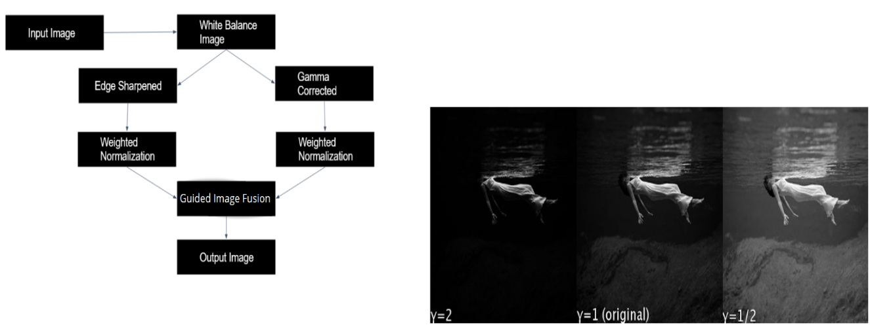

Fig. 1. Flowchart of the proposed model

A. Color Compensation

The images captured underwater suffer from low contrast and color distortion owing to the harsh underwater imaging environment. A color compensation method is proposed to compensate for the attenuated color information and improve the accuracy of estimated color lines. In underwater conditions, the information contained in at least one color channel is close to completely lost, making the traditional enhancing tech-niques subject to noise and color shifting. In those cases, our pre-processing method proposes to reconstruct the lost channel based on the opponent color channel. Our algorithm subtracts a local mean from each opponent color pixel. Thereby, it partly recovers the lost color from the two colors involved in the opponent color channel. (Irc = Ir + alpha*(Ig mean - Ir mean))

B. White Balancing

White balance (WB) is the process of removing unrealistic color casts, so that objects which appear white in person are rendered white in your photo. Proper camera white balance has to take into account the ”color temperature” of a light source, which refers to the relative warmth or coolness of white light. Underwater, we are doing the same thing, except instead of compensating for off-colored light, we are adjusting for red light frequencies being absorbed. When we tell the camera that something is white that looks blue, the camera adjusts by removing blues. We use the chromadapt() function to adjust the color balance of the RGB image according to the scene illuminant.

C. Gamma Correction

Gamma Correction is a non linear operation, i.e the change in input is not proportional to the change in output. It is generally used to encode and decode tristimulus values or luminance for images or videos. imadjust() is the matlab function that allows us to perform Gamma Correction. Gamma can be any value between zero and infinity. For gamma value 1 (default value of imadjust), the mapping between input and output is linear. For gamma values less than 1, the mapping

Fig. 2. Gamma Correction

D. Image Sharpening

Image sharpening is an effect applied to digital images to give them a sharper appearance. Sharpening enhances the definition of edges in an image. In our implementation Image sharpening is performed with Gaussian Blur using the imgaussfilt function in matlab. The function filters an image with a 2-D Gaussian smoothing kernel with standard deviation of 0.5, and returns the filtered image.

E. Guided Image Fusion

The guided image filtering accomplishes edge-preserving smoothing on an image by influencing the filtering with the content of a second image termed a guiding image. The guide image can be the original image, a modified version of the image, or a whole new image. When computing the value of the output pixel, guided image filtering is a neighborhood operation like other filtering operations, but it takes into account the statistics of a region in the appropriate spatial neighborhood in the guidance image. Guided Filter, like other edge-preserving filters, can keep edge information during the decomposition phase, reducing ringing effects. This characteristic makes Guided Filter valuable for colorization, upsampling, and image matting, among other things. Aside from the edge-preserving characteristic, Guided Filter also has a structure-transferring property. If the guide image and the input image are identical, edge-preserving smoothing will be applied, but the structural behavior will stay unchanged. The smoothing process is controlled by the guidance image structures when the guidance image differs from the input. Edge information can be represented at various resolutions via multi-scale decomposition. Simultaneous Guided Filter operation can aid in the transfer of edge structures at different scales. A fusion algorithm’s fundamental requirement is to transmit information from one image to another. It is evident that a multi-scale Guided Filter in structure transferring mode may handle this at different resolutions, hence enhancing performance. Moreover, Guided Filter is used to reconstruct

the image without loss of information after decomposition. The weight map creation approach employed in this Guided Filtering-based fusion uses a weight map construction process by producing saliency maps straight from the detail layers. The algorithm’s computational complexity is drastically reduced as a result of this method.

Guided image filtering is applied to the two input images, the edge sharpened (I1) and gamma corrected image (I2). We get two base layers and detailed levels in the first layer of multi-scale decomposition: B1, B2, D1, D2. It can be seen that I2 is used as a guidance image for filtering I1. As a result, I2’s structural information is employed to smooth I1. Using I1 as a guiding image, a similar operation may be seen on I2. Similarly, for four levels of multi-scale decomposition, the next levels of base and detailed layers are formed based on the base and detailed layers of the preceding layer. The difference between the previous and current level base layers is represented by the detailed layer. These detail layers give visually relevant source image information that can be used to extract visual saliency and generate weight maps. Visual saliency detection is the technique of extracting visually essential pieces of a scene. This method tries to imitate human visual attention to certain things in a scene. For image fusion, an innovative multi-scale Visual Saliency Detection technique is applied. This algorithm finds visual saliency of the entire scene from two visually different images. The visual saliency (S1,S2) is obtained by taking the absolute value of all the detailed layers. The visual saliency corresponding to each image is computer by averaging the saliency over each layer. The final visual saliency of the entire scene is computed by extracting the maximum value of S1 and S2 for each pixel in S1 and S2. The weights maps are obtained directly from the saliency maps by normalizing them in each layer (W1,W2). This weight map construction process integrates the detail layer information in each pixel. At each scale, the detailed layer is integrated with the weight maps using linear combination and finally added together to form the fused detail layer. At each scale, the average of base layers is taken and the fused base layer is formed. Finally, the detailed fused base layer is added to get the final fused output image.

IV. RESULTS AND DISCUSSION

This section discusses the results achieved in our system and a comparison of the results with a reference image.

Figure 3 shows the comparison between the reference image, original and the result achieved in our system. Color compensation allows us to increase the amount of red light in the resultant thus a clear difference between the reference image and the result image is the amount of green light present. Guided image fusion has also helped us generate a clearer and sharper image as it uses the contours of the image to combine them based on salience maps.

The same observations can be made in Figure 4. Our resultant image has less green light than the reference images and shows a clear representation of the rust on the object.

Fig. 3. Noisy image, ground truth and the enhanced image produced by the proposed model
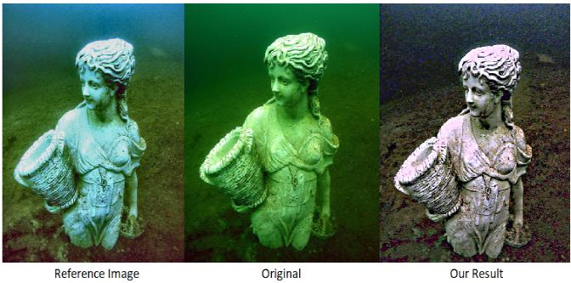

Guided image fusion along with Image sharpening generate a much clearer and sharper resultant image. The background objects along with the trash on the seafloor is more clearly visible due to the above reasons. The system’s time complexity is highly dependent on the size of the image. Figure 4 with a size of 480x360 pixels takes 3.380469 seconds to generate the resultant image. Figure 3 is of size 959x1230 pixels and takes 11.975596 seconds to generate the resultant image.
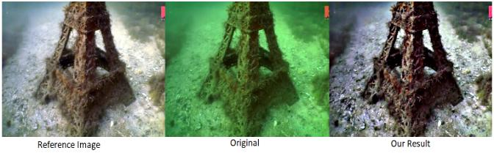

Fig. 4. Noisy image, ground truth and the enhanced image produced by the proposed model

Figure 5 and Figure 6 are the outcomes of using a challeng-ing image from the Underwater Image Enhancement Bench-mark Dataset. Challenging images do not have a reference image to be compared with. To the eyes, both the resultant images seem natural, clear and sharp. The yellow and green hue were handled using color compensation and the fuzzy edges and contours of the objects have been enhanced by image sharpening and guided image fusion.
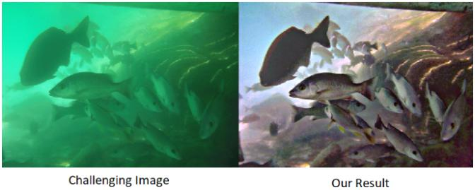

Fig. 5. Complex image and the enhanced image produced by the proposed model
 | 2019, doi: 10.1109/ACCESS.2019.2932611.
 | 6.Li, | C., Anwar, S., Hou, J., Cong, R., Guo, | C., | Ren,
 | W. (2021). Underwater image enhancement via medium
 | transmission-guided multi-color space embedding. IEEE
 | Transactions on Image Processing, 30, 4985-5000.
 | 7.Lu, H., Li, Y., Serikawa, S. (2013, September). Underwater
 | image | enhancement using guided trigonometric bilateral
Fig. 6. Complex image and the enhanced image produced by the proposed | filter | and fast automatic color correction. In | 2013 | IEEE
model | international conference on image processing |  | (pp. | 3412-
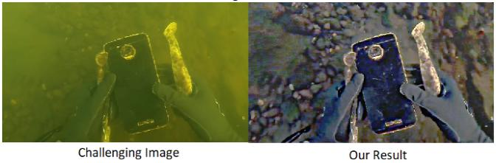
3416). IEEE.

- CONCLUSION

In this project, a method to enhance noisy underwater images has been used. From the input image which consists of several underwater based noise, white balancing is applied. After this, edge sharpening and gamma correction is applied to the white balanced image which is further taken into 2 input images. Using guided filter fusion, the salient features are detected and the weight map is constructed. Further, the final fused output is produced. It is evident that the proposed model performs better than the reference image making this model an excellent choice for underwater image enhancement process. In the future works, an even faster model can be implemented where the time taken to perform fusion is reduced. Also, better models can be proposed to work well on images which have more of blue color composition.

VI. REFERENCES

1.Singh, Ritu, and Mantosh Biswas. ”Adaptive histogram equalization based fusion technique for hazy underwater image enhancement.” 2016 IEEE International Conference on Computational Intelligence and Computing Research (ICCIC). IEEE, 2016.

2.Y. Tao, L. Dong and W. Xu, ”A Novel Two-Step Strategy Based on White-Balancing and Fusion for Underwater Image Enhancement,” in IEEE Access, vol. 8, pp. 217651-217670, 2020, doi: 10.1109/ACCESS.2020.3040505.

3.C. O. Ancuti, C. Ancuti, C. De Vleeschouwer and P. Bekaert, ”Color Balance and Fusion for Underwater Image Enhancement,” in IEEE Transactions on Image Processing, vol. 27, no. 1, pp. 379-393, Jan. 2018, doi: 10.1109/TIP.2017.2759252.

4.W. Luo, S. Duan and J. Zheng, ”Underwater Image Restoration and Enhancement Based on a Fusion Algorithm With Color Balance, Contrast Optimization, and Histogram Stretching,” in IEEE Access, vol. 9, pp. 31792-31804, 2021, doi: 10.1109/ACCESS.2021.3060947.

- M. Yang, J. Hu, C. Li, G. Rohde, Y. Du and K. Hu, ”An In-Depth Survey of Underwater Image Enhancement and Restoration,” in IEEE Access, vol. 7, pp. 123638-123657,

8.Liang, Z., Wang, Y., Ding, X., Mi, Z., Fu, X. (2021). Single underwater image enhancement by attenuation map guided color correction and detail preserved dehazing. Neurocomputing, 425, 160-172.

9.Patel, Z., Desai, C., Tabib, R. A., Bhat, M., Patil, U., Mudengudi, U. (2020). Framework for underwater image enhancement. Procedia Computer Science, 171, 491-497.

10.Zhou, J., Zhang, D., Zhang, W. (2022). Underwater image enhancement method via multi-feature prior fusion. Applied Intelligence, 1-23.

