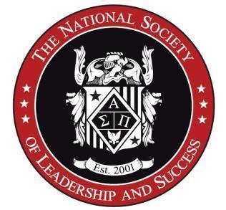

(Title)
The National Society of Leadership and Success - Remote

Imagine a community of students taking action toward their dreams and living happier lives. In this world, people are so fulfilled they reach out and positively contribute to the lives of others. That’s who we impact, and that’s what we are building. Want to be a part of it?

To determine whether you'd be a good fit, ask yourself…
- Would you like to go to work each day knowing that you are using your talents to help others and better the world?
- Are you inspired by the thought of positively impacting tens of thousands of students each year?
- Are you ready to work in an organization that is rapidly growing and embraces change?
- Would you like to work with people whom you respect and can learn from every day?
- Do you desire to work for an organization that cares about your growth, where your own drive and interests help you create your own future?

Our guiding question is: “Are we helping the greatest number of people in the greatest possible way?" Are you inspired? Let’s change the world together.

Overview:
The (title) will join a team of 80+ purpose-driven staff members in a friendly, focused, fast-paced entrepreneurial environment. The National Society of Leadership and Success (NSLS) is the largest accredited leadership honor society in the United States, with over 800 chapters and more than 2 million members. The (title) will be responsible for (high level overview of the purpose of the role. Please keep to 1-2 sentences) This should be in-sync with your Scorecard role “Mission”.

This role forms part of the (insert team and provide more insight in terms of the general purpose of the role in our organization. It is best to keep this as short and concise as possible. i.e. around 4 sentences).

Responsibilities:
- (this should be a list of key responsibilities for the role. Please keep the list high level, and under 10 bullets)
- (this list should have a direct correlation to the objectives for the role, pulled from the scorecard. You do not need to include specific metric numbers, but an overview)
- (please keep your verb tenses consistent throughout. Example: Hold, manage, run, etc. vs. hold, managing, responsibility. Note the latter has different types of verb tenses.

Qualifications:
- (include the min. education level)
- (include the min. number of years of experience)
- (include any key certifications or licenses needed)
- (include any key technology skills needed)
- (Keep it to specific objective qualifications needed to be successful in the role that are hard skills
- (this list should be 10 bullets or less.

Nice To Haves:

Who You Are:

How We Work:

The National Society of Leadership and Success is an equal opportunity employer committed to diversity, equality, and inclusion

Visit nsls.org to learn more about our organization

