***Pioneer Robot External Mode:***

**Requirements:**

1: MATLAB R2013a (32 bit) with:

Simulink

StateFlow

MATLAB Coder

Simulink Coder

Embedded Coder

2: Robot with onboard computer running Windows XP or Windows 7 (32bit) (or laptop connected to robot via serial or usb-serial cable)

3: Microsoft SDK 7.1

4: Wireless network connection.

Manuals for robots and onboard computers can be found on the following link:

<http://robots.mobilerobots.com/wiki/Manuals>

***Target (Robot onboard computer) Setup***

Installation:

In order to perform auxiliary commands for the robot, such as downloading a Simulink standalone executable and starting it, a SSH is necessary for these operations.

This implementation uses OpenSSH in conjunction with Putty commands PLINK and PSCP for sending system commands from the Host to the Pioneer Robot. As such OpenSSH will need to be installed on the Pioneer in order to establish a SSH connection.

Please refer to the following link for OpenSSH's homepage.

<http://www.openssh.org/>

Setting up a SSH server for the target computer:

Once installed, a server needs to be created on the Pioneer such that it can communicate with the Host computer. To setup a server for the Pioneer you will need to open a command prompt and type the following:

mkgroup -l >> ..\etc\group  
mkpasswd -l >> ..\etc\passwd

This will initialize the user permissions for the server to the user profiles set up on the computer.

Once the permissions are set, the following command can be executed in the DOS command prompt to start the SSH server.

net start opensshd

Passwordless Access to the computer:

Windows by default does not allow for remote connection to a profile that does not have a password.

One way to enable a passwordless connection to Windows is to disable the security setting, 'Limit local account use of blank passwords to consol logon only'. This can be disabled through the following workflow:

**1: Go to:** control panel > administrative tools > local security policy

2: Select: Local Policies > Security Options

3: Find the Option 'Accounts: Limit local account use of blank passwords to console logon only' and set this to 'Disabled' as shown in the following figure:

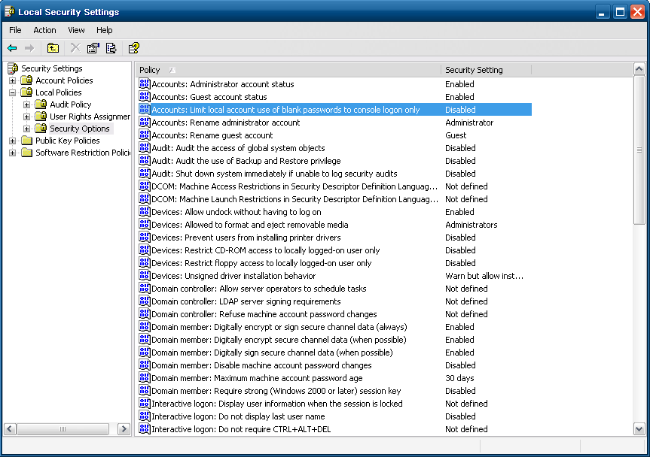

***Host Setup:***

1: Install ARIA on the onboard computer if not already installed. If necessary, copy a new version of the matlab directory into the ARIA installation directory.

2: In a 32-bit MATLAB session (Tested on R2013a), cd to the unzipped directory and execute the script 'Setup_Simulink_Target_Aria'

This will add all subdirectories to the MATLAB path and refresh the Simulink Environment.

**Simulink Configuration:**

The block sets can be found in the Simulink Library Browser as shown in figure below:

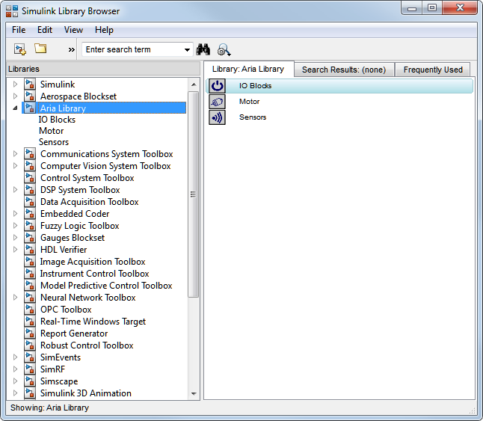

The library classifies blocks into 3 areas IO Blocks, Motor blocks and Sensor blocks.

**Simulink Configuration:**

The following workflow can be performed to select the Aria System Target File for code generation.

1: Open configuration parameters. For code generation the Solver will need to be a fixed solver in Single Tasking.

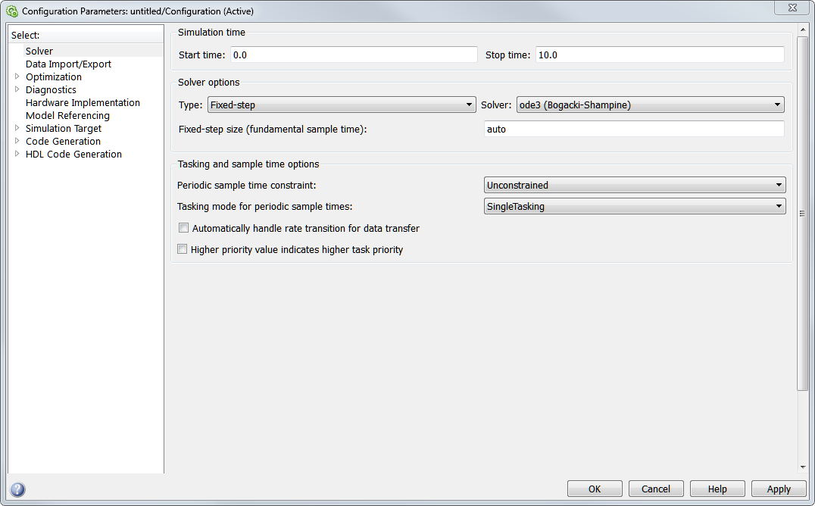

2: Go to the Code Generation pane and under the Parameter System Target File type 'Aria.tlc'.

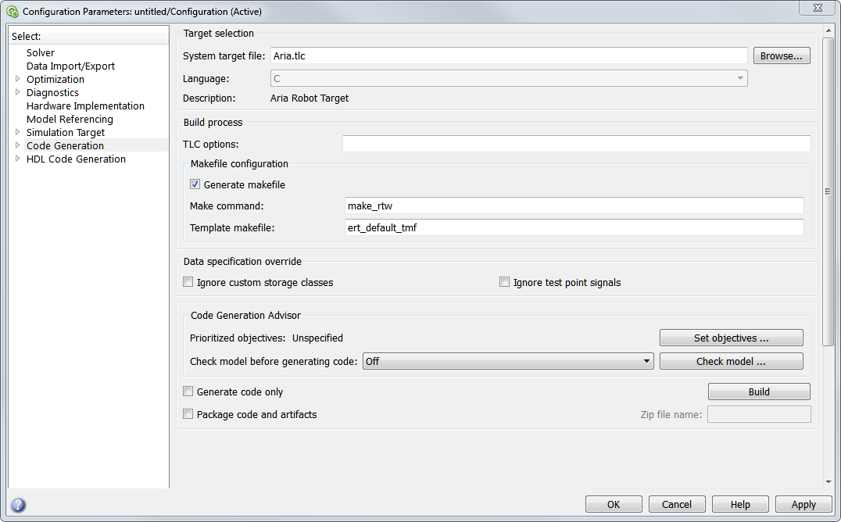

Applying this setting will reconfigure some of the configuration parameters for the Pioneer Target.

3: Under the Code Generation Pane select 'Aria Target Options'. This pane allows for the configuration of the Pioneer Robot the following table shows the parameters within this pane and their functionality.

|  |  |  |
| --- | --- | --- |
| **Name** | **Parameter Name** | **Description** |
| Robot's IP Address | RobotIPAddr | IP Address of the Pioneer Robot |
| TCPIP Port Number | RobotPortNum | TCPIP port number for External Mode |
| User Login | UserID | User account name on Robot e.g. Administrator |
| User Password | UserPW | If the User account has a password this field will need to contain the proper password for communication between the host and robot |
| Download and Run on Target | DL2Robot | When checked this will setup the external mode for the robot.  If not selected, External Mode is switched to off and the model will not be downloaded onto the target |
| Update External Model Parameters |  | Updates the External Mode Parameters located on the 'Interface' Pane in the Configuration Parameters |

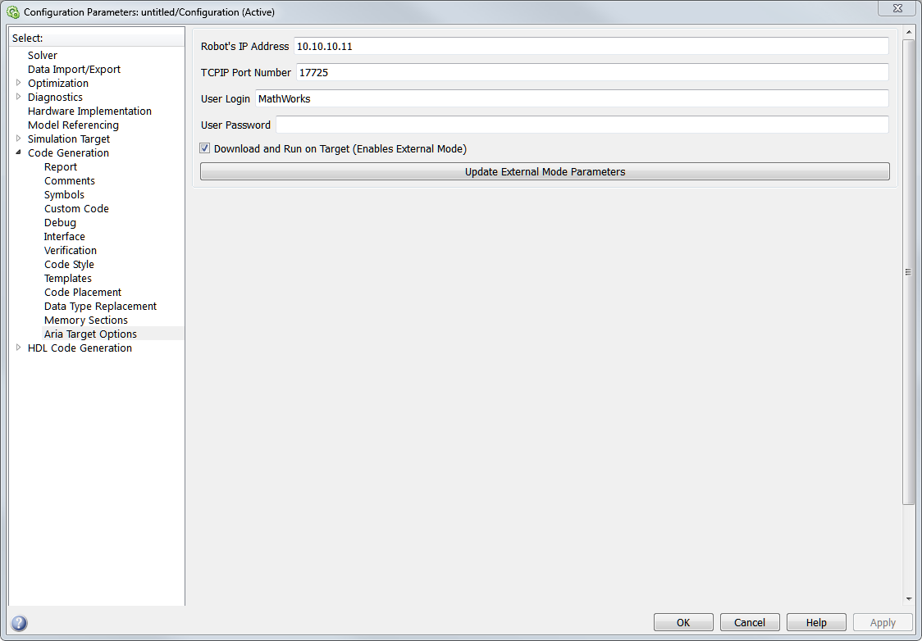

**Executing the Model:**

With the configuration parameters set for the Aria Target for download to the Robot, building the model (crtl+B) will generate C code for the Target and create an executable.

If the Download checkbox is selected for the robot, Simulink will then attempt to ping the target. If the ping is unsuccessful an error message will be thrown. Otherwise the executable will be downloaded to the Target and placed into a standby state.

Begin the Simulink model you will then need to switch the Simulation mode for the model to 'External'. Placing the model to external will cause the 'connect to target' button to appear.



Pressing this button will open the connection between the Simulink executable in Standby on the robot, and Simulink. Once the connection is established, pressing the Run/Play button will start the execution of the model on the robot.

The model will simulate until either the Stop button is pressed or the specified final time is reached. During the Simulation, data can be view within the model's scopes, and tunable parameters within the model can be updated.