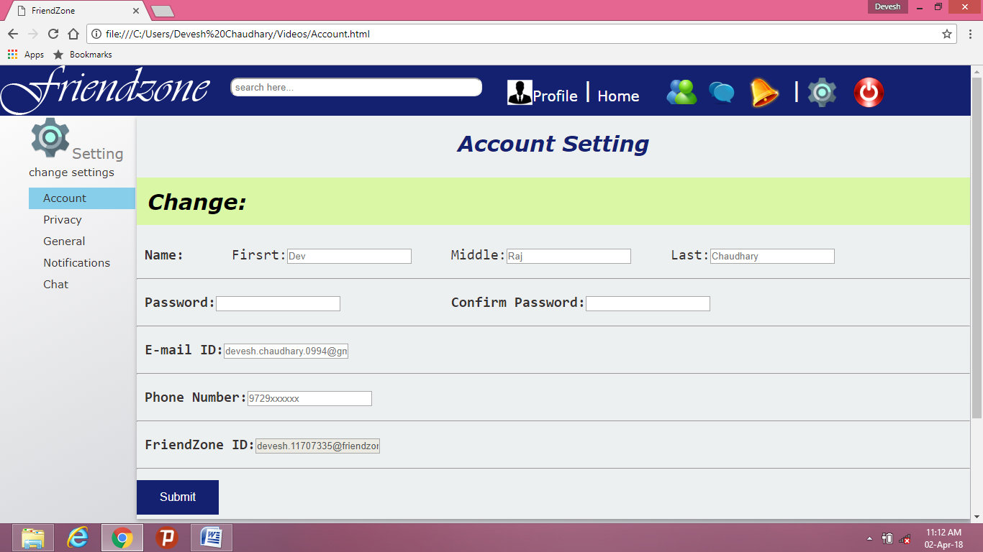

This is my setting page created by Devesh Chaudhary (Registration number:11707335).This is a page in which user can change their account settings for example: Account setting, Privacy setting, General setting, Notifications setting, and user can also change chat setting. In this overall page I have used all three concepts of our syllabus which are: HTML, CSS, and JavaScript. I have used different HTML Tags like<b>,<hr>, <i>,<pre><div>, <br>,etc which can be seen in my code. For the CSS part I mainly use External CSS which is a type of CSS in which I have used Element selectors like ID selector and Class selector to make my page more creative. I have also used different HTML forms ,Dropdown list, hover in CSS so that user can easily enter his/her data and can choose one option from many options that I have provided in my page.I also used Anchor tag in HTML to produce hyperlinks in my all different setting pages and I link them to my vertical tags that I made in my page so that if anyone click on any tag either chat or Privacy correct page get open in the shadow box that I have made using CSS.I have also used CSS to make my submit and radio button more attractive and colorful which is clearly visible in above photo .I have used hover over my vertical tags so that whenever I put my cursor on that tag or on that tag’s page it’s background appears colorful. And last I have also used some part of JavaScript to make my page more responsive so that whenever I submit my data or change my setting it shows alert message to the user that setting change successfully or not.