Report
Of
DESIGN AND DEVELOPMENT OF A WEB-BASED OSINT
(OPEN-SOURCE INTELLIGENCE) TOOL FOR IDENTIFYING AND
TRACING INDIVIDUALS VIA PHONE, AADHAAR, EMAIL, AND NAME

CONFIDENTIAL

Submitted
To
School of Computer Science and Engineering (Cybersecurity)
IILM University, Greater Noida, U.P.
In partial fulfilment of the requirement of degree of
B.Tech CSE (Cybersecurity)
Internship Organization
Indian Cyber Crime Coordination Centre (I4C)
Ministry of Home Affairs

By
CS-23411194
HIMANSHU BHARDWAJ
Batch: 2023-27

CANDIDATE'S DECLARATION
I, HIMANSHU BHARDWAJ, do hereby declare that the internship report titled “Design and Development of a Web-Based OSINT (Open-Source Intelligence) Tool for Identifying and Tracing Individuals via Phone, Aadhaar, Email, and Name” has been completed by me to fulfil the requirement for the award of the degree of Bachelor of Technology in Computer Science and Engineering (Cybersecurity). All the references have been quoted and I have not taken as such any material from any other source. I affirm that this report is my own and has not been submitted to any other institute for any degree/diploma requirement and further I shall be solely responsible for any kind of copyright violation in this regard.

Signature: ____Himanshu Bhardwaj__________
Student Name: HIMANSHU BHARDWAJ
Roll No.: CS-23411194

ACKNOWLEDGEMENT
I am using this opportunity to express my gratitude to everyone who supported me throughout my internship at the Indian Cyber Crime Coordination Centre (I4C), Ministry of Home Affairs, under the National Cybercrime Research and Innovation Centre (NCR&IC). I am thankful for their aspiring guidance, invaluably constructive criticism, and friendly advice during this work.
I would like to express my sincere gratitude to Mr. Pavan G Chavan for his continuous guidance and mentorship throughout the internship, and to Mr. Nishant Kumar, Director, NCR&IC, for the opportunity to work on real-world cybercrime investigation and digital-forensics tooling. I am also grateful to my faculty at the School of Computer Science and Engineering (Cybersecurity), IILM University, for their support throughout this endeavour.
I express my gratitude to my parents for their blessings.

Signature: ______Himanshu Bhardwaj____________________
Student Name: HIMANSHU BHARDWAJ
Roll No.: CS-23411194

INTERNSHIP COMPLETION CERTIFICATE
A Certificate of Internship Completion / Letter of Appreciation was issued by the National Cybercrime Research and Innovation Centre (NCR&IC), Ministry of Home Affairs, on 21/08/2026, signed by Mr. Nishant Kumar, Director, NCR&IC.
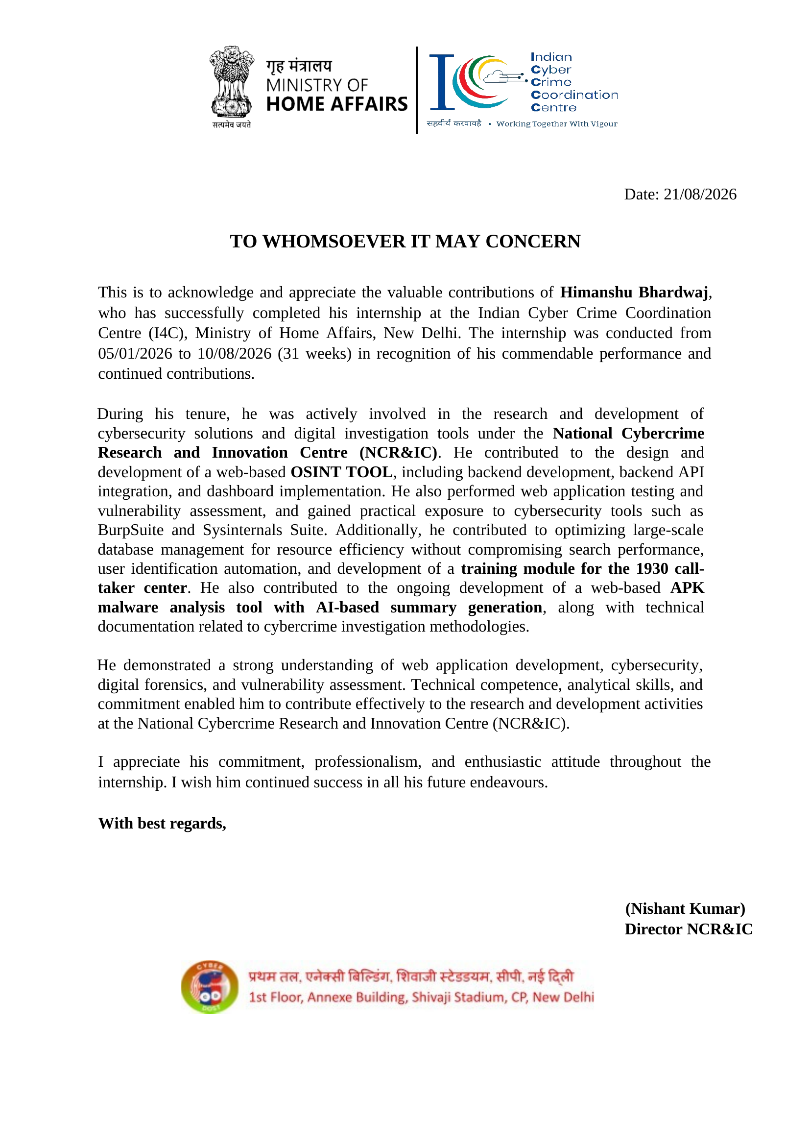

TABLE OF CONTENTS
Cover Page —
1. Candidate’s Declaration i
2. Acknowledgment ii
3. Internship Completion Certificate iii
4. Project Description 1
4.1 Introduction 1
4.2 Organization Profile 1
4.3 Project 1: OSINT Tool 2
4.4 Project 2: APK Malware Analysis Tool 4
4.5 Project 3: 1930 Call-Taker Training Module 5
4.6 Responsible Use and Human Oversight 6
4.7 Skills and Learning Outcomes 6
4.8 Limitations and Future Scope 6
4.9 Conclusion 7
4.10 Certificates and Communication Proof 8
5. Bibliography / References 9

LIST OF FIGURES
Figure 4.1 OSINT Tool system architecture (standalone) 3
Figure 4.2 APK Malware Analysis Tool system architecture (standalone) 5

4. PROJECT DESCRIPTION

4.1 Introduction
This project was built for a national cybercrime investigation unit. Its tools, data, and interface are confidential, so no screenshots or photographs of the actual system are included anywhere in this report; the figures in this report are original illustrative diagrams prepared for explanatory purposes only.
This report covers three independent projects completed during a 31-week internship at the Indian Cyber Crime Coordination Centre (I4C), Ministry of Home Affairs, under the National Cybercrime Research and Innovation Centre (NCR&IC). Each project was scoped, built, and delivered separately — they are standalone efforts and none of the three depends on, is integrated with, or shares functionality with the others.
The three projects are:
- OSINT Tool — a rule-based tool for identifying and tracing individuals from a phone number, Aadhaar number, email address, or name.
- APK Malware Analysis Tool — a separate, AI-assisted tool that inspects a submitted Android application and produces a behavioural summary.
- 1930 Call-Taker Training Module — separate training content developed for staff at the national cybercrime helpline.
Each is described independently in the sections that follow.

4.2 Organization Profile
The internship was completed at the Indian Cyber Crime Coordination Centre (I4C), Ministry of Home Affairs, New Delhi, under the National Cybercrime Research and Innovation Centre (NCR&IC). I4C coordinates national efforts against cybercrime and works with law-enforcement agencies, research bodies, and technology partners; NCR&IC focuses specifically on research, innovation, and tool development to support cybercrime investigation and prevention.
The internship ran from 05/01/2026 to 10/08/2026, a period of 31 weeks. The work was carried out under the mentorship of Mr. Pavan G Chavan, with overall guidance from Mr. Nishant Kumar, Director, NCR&IC, who also signed the internship completion certificate. The engagement covered requirement understanding, design and development, training-content development, and documentation across the three separate projects described in this report.

4.3 Project 1: OSINT Tool

4.3.1 Problem Statement
Investigators frequently start with just one identifier — a phone number, Aadhaar number, email address, or name — and need to trace the individual it belongs to. Doing this manually across many separate public sources is slow and error-prone.
The OSINT tool addresses this need directly: given a single identifier, it searches publicly available sources and returns a structured profile of the associated individual for analyst review. It is a standalone project, unrelated to the other two projects described in this report.

4.3.2 Objectives
- Design and build the backend and API layer of a web-based OSINT tool to identify and trace individuals via phone number, Aadhaar, email, and name.
- Keep identifier search fast and resource-efficient using DuckDB and an ART index.
- Build the production deployment tooling for the OSINT tool.
- Ensure every finding is presented for analyst review before it is treated as final.

4.3.3 Scope
Functional Scope
- Identifier-based person search — phone number, Aadhaar, email, and name — from publicly available sources.
- Backend and API development, including a DuckDB- and ART-index-backed dataset for fast search at scale.
- Production deployment tooling.

Out of Scope
- Direct, unsupervised action on findings without analyst review.
- Collection of data from non-public or unlawfully obtained sources.
- Linking or correlating different individuals to one another — each search looks up a single identifier.

4.3.4 Technologies Used
Table 4.1: OSINT Tool — technologies and tools used
Technology / Tool | Use | Purpose
Python | OSINT backend logic (rule-based identifier search) | Core application logic
Flask | REST API and web backend framework for the OSINT tool | Serves API endpoints consumed by the dashboard
DuckDB | Embedded analytical database for the case dataset | Fast, resource-efficient storage and querying
ART (Adaptive Radix Tree) Index | Indexing structure for phone / Aadhaar / email / name lookups | Fast identifier search across a large dataset

4.3.5 System Architecture
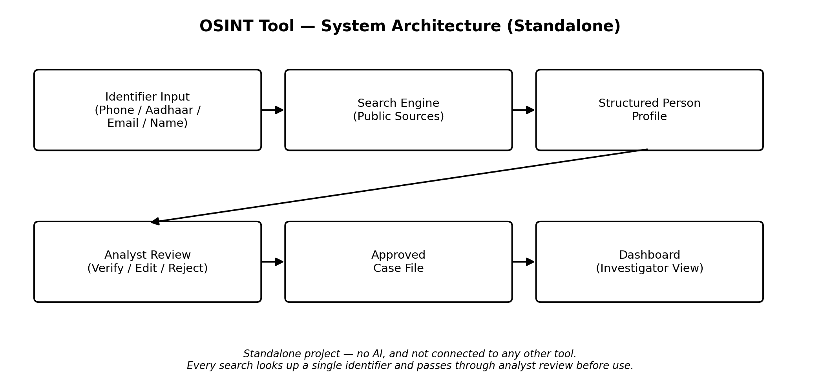
Figure 4.1: OSINT Tool system architecture (standalone)
An identifier (phone number, Aadhaar number, email address, or name) is run through a rule-based search engine that queries public sources. This does not use AI and does not link different individuals to one another. The result is a structured person profile, which is routed to analyst review before it becomes part of an approved case file and appears in the investigator dashboard. My personal contribution to this tool was the backend, the API layer, and the production deployment tooling; the investigator dashboard front-end that consumes this API was developed by a teammate as part of the same project.

4.3.6 Methodology
- Collect the identifier (phone number, Aadhaar number, email address, or name).
- Query public sources for matches to that identifier.
- Normalize and structure the results into a single person profile.
- Present the profile to an analyst for verification.
- Analyst approves, edits, or rejects the profile before it is used in a case file.

4.3.7 Outcomes
Status: Completed. The backend, API layer, and production deployment tooling were built and handed over. The case dataset is stored in DuckDB with an ART index over the identifier fields, so lookups stay fast as the dataset grows without requiring heavier infrastructure.

4.4 Project 2: APK Malware Analysis Tool

4.4.1 Problem Statement
The volume of Android applications flagged for review during cybercrime investigations makes manual, line-by-line APK inspection difficult to scale. Analysts need a faster way to triage a submitted APK and identify likely risk indicators.
This is a standalone project, separate from the OSINT tool and the 1930 training module described elsewhere in this report.

4.4.2 Objectives
- Contribute to a web-based APK malware analysis tool that produces an AI-generated behavioural summary to support analyst triage.
- Ensure every AI-generated finding is presented for analyst review before it is treated as final.

4.4.3 Scope
Functional Scope
- APK static/behavioural information extraction.
- AI-based summary generation.

Out of Scope
- Fully automated malware verdicts without analyst confirmation.

4.4.4 Technologies Used
Table 4.2: APK Malware Analysis Tool — technologies and tools used
Technology / Tool | Use | Purpose
Python | APK analysis pipeline and AI summary generation | Core analysis logic

4.4.5 System Architecture
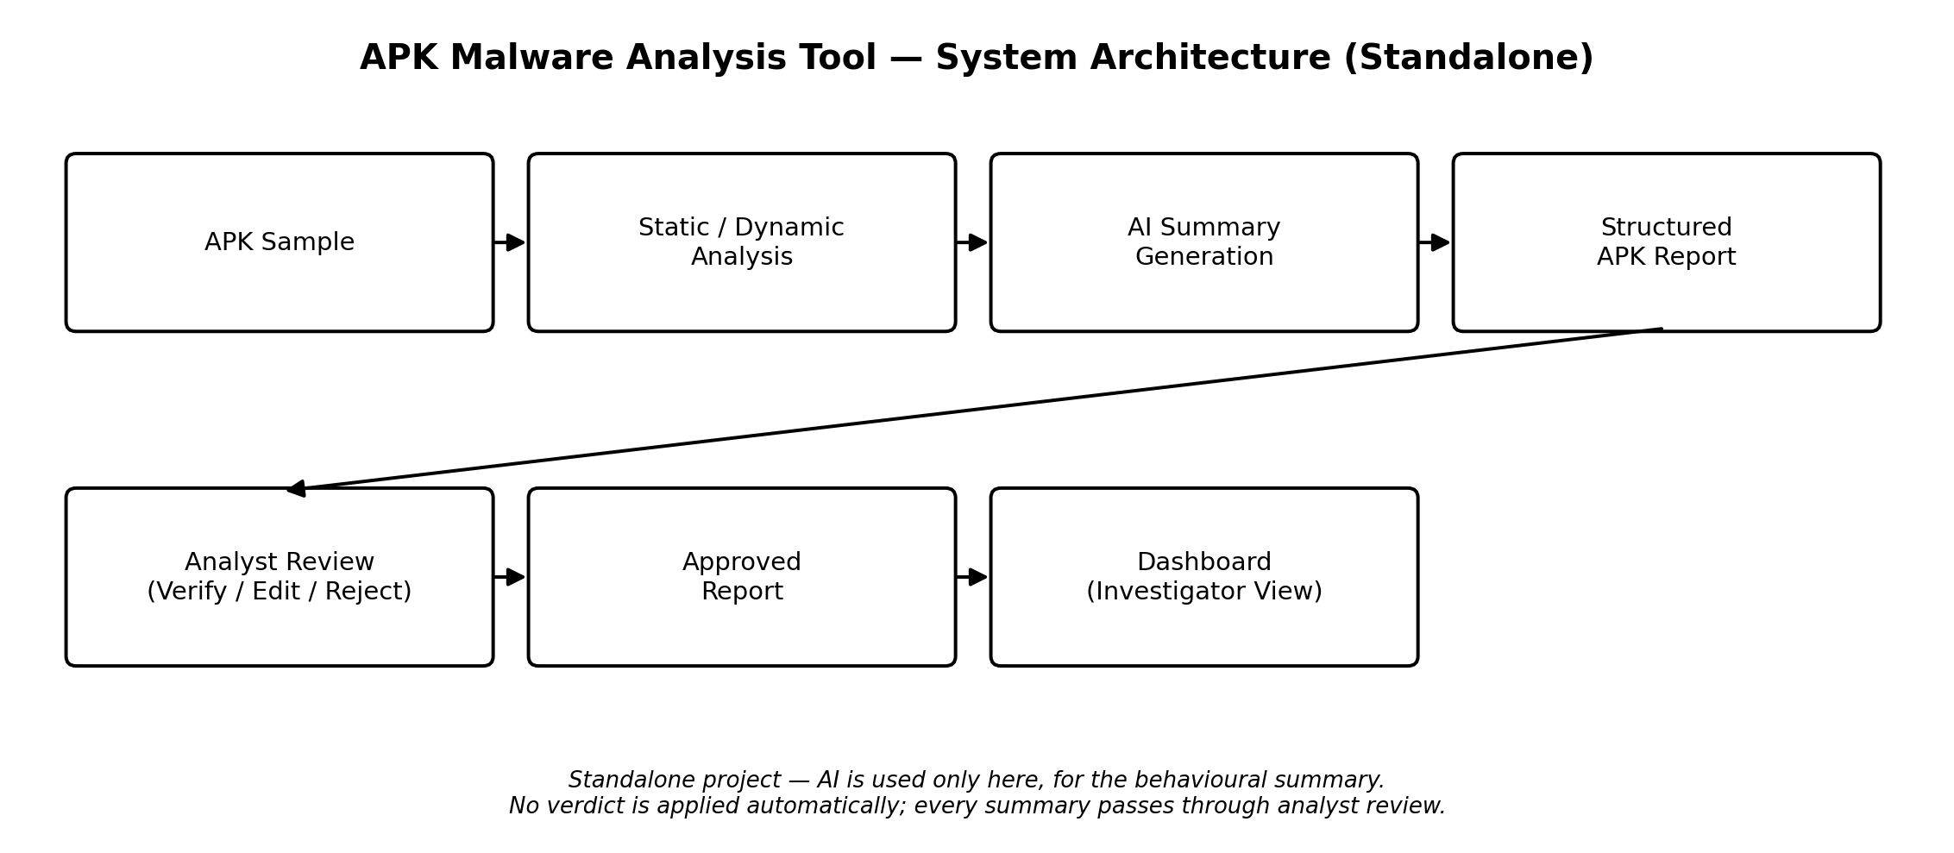
Figure 4.2: APK Malware Analysis Tool system architecture (standalone)
A submitted APK sample is processed through static/dynamic analysis to extract indicators — permissions requested, network behaviour, and other behavioural signals. These indicators are passed to an AI summarization step, which is the only place AI is used in this tool. The resulting structured report is routed to analyst review before it becomes an approved report in the investigator dashboard; no verdict is applied automatically.

4.4.6 Methodology
- Receive the submitted APK sample.
- Run static/dynamic analysis to extract indicators.
- Generate an AI-based behavioural summary from those indicators.
- Present the summary and indicators to an analyst.
- Analyst verifies, edits, or rejects the report before it is used.

4.4.7 Outcomes
Status: In Progress. At the close of the internship, the tool's core static-analysis pipeline was functional, while the dynamic-analysis and AI-summary refinement components remained under active development.

4.5 Project 3: 1930 Call-Taker Training Module

4.5.1 Problem Statement
Call-taker staff at the 1930 national cybercrime helpline need structured onboarding material to handle citizen complaints consistently. This is a standalone project, separate from the OSINT tool and the APK malware analysis tool described elsewhere in this report.

4.5.2 Objectives
- Develop training content for the 1930 cybercrime helpline call-taker center.

4.5.3 Scope
Functional Scope
- Training content development for call-taker staff.

Out of Scope
- Live delivery or certification of training, which remained with I4C/NCR&IC staff.

4.5.4 Outcomes
Status: Completed. Training content was developed and handed over to the 1930 call-taker center.

4.6 Responsible Use and Human Oversight
OSINT Tool:
Findings are presented to the investigator as leads to be verified, not confirmed facts, and are limited to publicly available sources. Sensitive identifiers such as Aadhaar numbers are handled carefully and used only for lawful, case-relevant search. This tool does not use AI.
APK Malware Analysis Tool:
AI-generated behavioural summaries are advisory and are checked by an analyst before they inform a case decision. No verdict is applied automatically.

4.7 Skills and Learning Outcomes
- OSINT investigation techniques and identifier-based search.
- Backend development and API integration.
- Resource-efficient database design using DuckDB and an ART index.
- Production deployment tooling.
- Fundamentals of APK/malware static analysis and AI-assisted summarization.
- Training-content development and technical documentation.
- Responsible, human-in-the-loop use of AI in an investigative context.

4.8 Limitations and Future Scope
OSINT Tool:
Source coverage reflects the sources integrated during this engagement rather than an exhaustive set. Future work could expand coverage to additional identifier types and public sources.
APK Malware Analysis Tool:
The dynamic-analysis and AI-summary components were not fully completed within the internship period. Future work could complete and refine these components, integrate threat-intelligence feeds, and formalize evaluation of tool accuracy against a labelled test set.
1930 Call-Taker Training Module:
Future work could extend the module with scenario-based exercises.

4.9 Conclusion
This internship comprised three independent projects at a national cybercrime unit: an OSINT tool for identifying and tracing individuals, an AI-assisted APK malware analysis tool, and a training module for the 1930 call-taker center. Each was scoped, built, and delivered separately, with automated or AI-generated findings always subject to analyst review rather than treated as final. The engagement offered practical exposure to cybersecurity, digital investigation, backend development, and responsible use of AI in a sensitive operational setting.

4.10 Certificates and Communication Proof
The certificate reproduced in Section 3 (Internship Completion Certificate) recognizes the contributions described above. Its full text is included below for reference.

Letter of Appreciation
This is to acknowledge and appreciate the valuable contributions of Himanshu Bhardwaj, who has successfully completed his internship at the Indian Cyber Crime Coordination Centre (I4C), Ministry of Home Affairs, New Delhi. The internship was conducted from 05/01/2026 to 10/08/2026 (31 weeks) in recognition of his commendable performance and continued contributions.
During his tenure, he was actively involved in the research and development of cybersecurity solutions and digital investigation tools under the National Cybercrime Research and Innovation Centre (NCR&IC). He contributed to the design and development of a web-based OSINT tool, including backend development, backend API integration, and dashboard implementation. He also performed web application testing and vulnerability assessment, and gained practical exposure to cybersecurity tools such as BurpSuite and Sysinternals Suite. Additionally, he contributed to optimizing large-scale database management for resource efficiency without compromising search performance, user identification automation, and development of a training module for the 1930 call-taker center. He also contributed to the ongoing development of a web-based APK malware analysis tool with AI-based summary generation, along with technical documentation related to cybercrime investigation methodologies.
He demonstrated a strong understanding of web application development, cybersecurity, digital forensics, and vulnerability assessment. Technical competence, analytical skills, and commitment enabled him to contribute effectively to the research and development activities at the National Cybercrime Research and Innovation Centre (NCR&IC).
I appreciate his commitment, professionalism, and enthusiastic attitude throughout the internship. I wish him continued success in all his future endeavours.
— Mr. Nishant Kumar, Director, NCR&IC

5. BIBLIOGRAPHY / REFERENCES
1. Indian Cyber Crime Coordination Centre (I4C), Ministry of Home Affairs — internship programme materials.
2. National Cybercrime Research and Innovation Centre (NCR&IC) — internship guidance and project briefs.
3. DuckDB Foundation. DuckDB documentation.
4. MITRE ATT&CK for Mobile — adversary tactics and techniques reference.
5. Python Software Foundation. Python 3 documentation.
6. Pallets Projects. Flask documentation.
7. Android Open Source Project. Android application (APK) package format documentation.
8. Project source files and internal documentation for each of the three projects (developed during the internship).

